Supplementary Figures

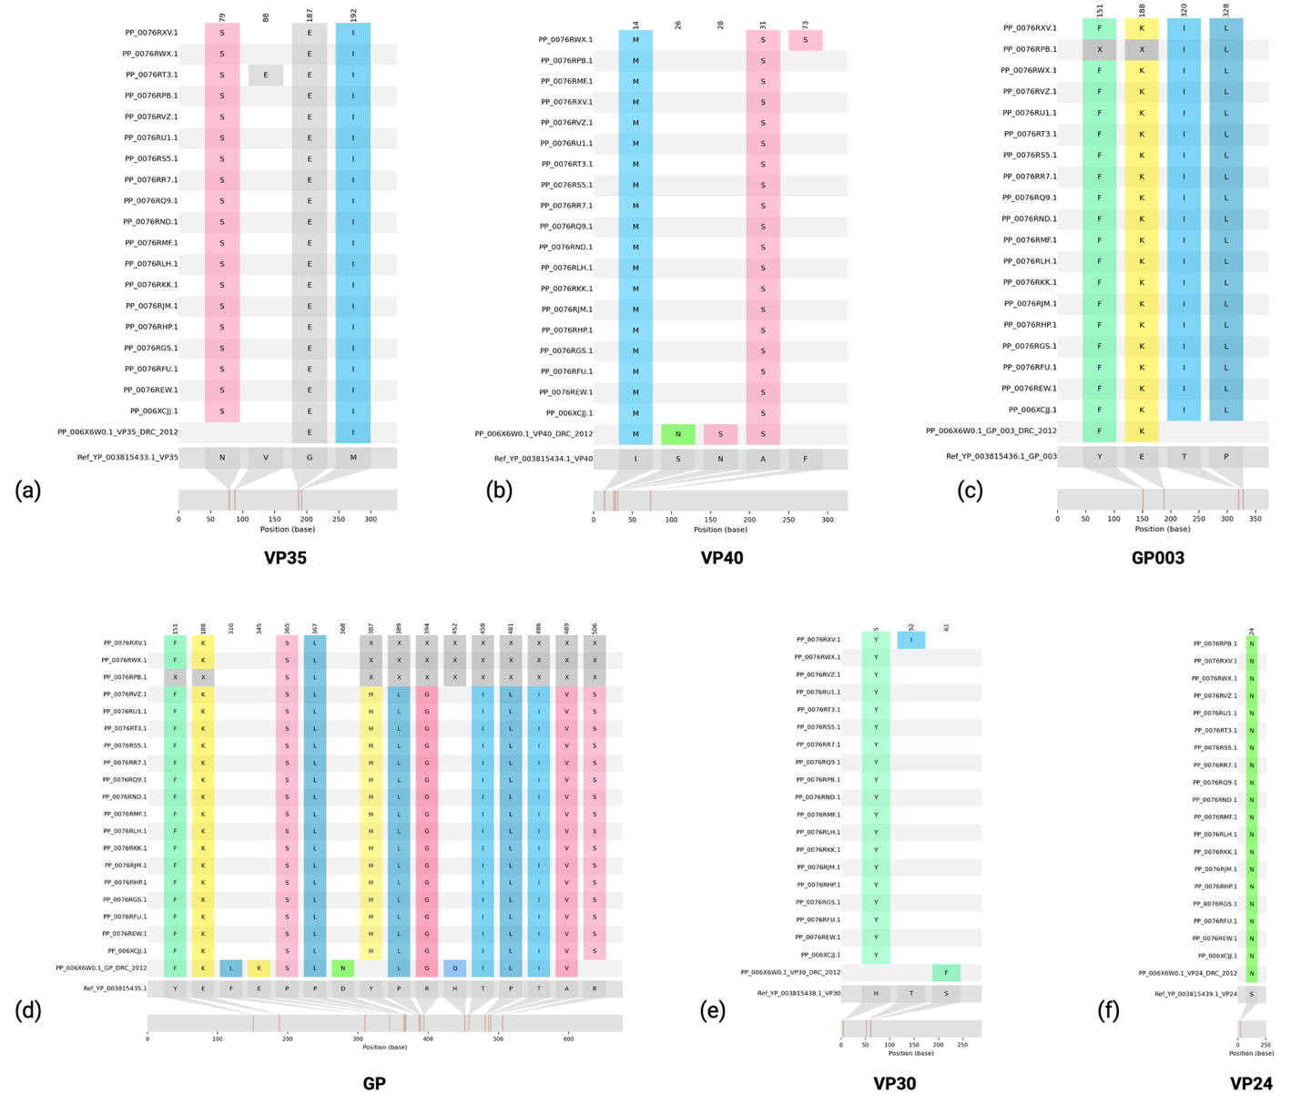
Supplementary Figure 1. Representations of amino acid substitutions: Representation of the multiple sequence alignment based amino acid substitutions in the BDBV-026 proteins.

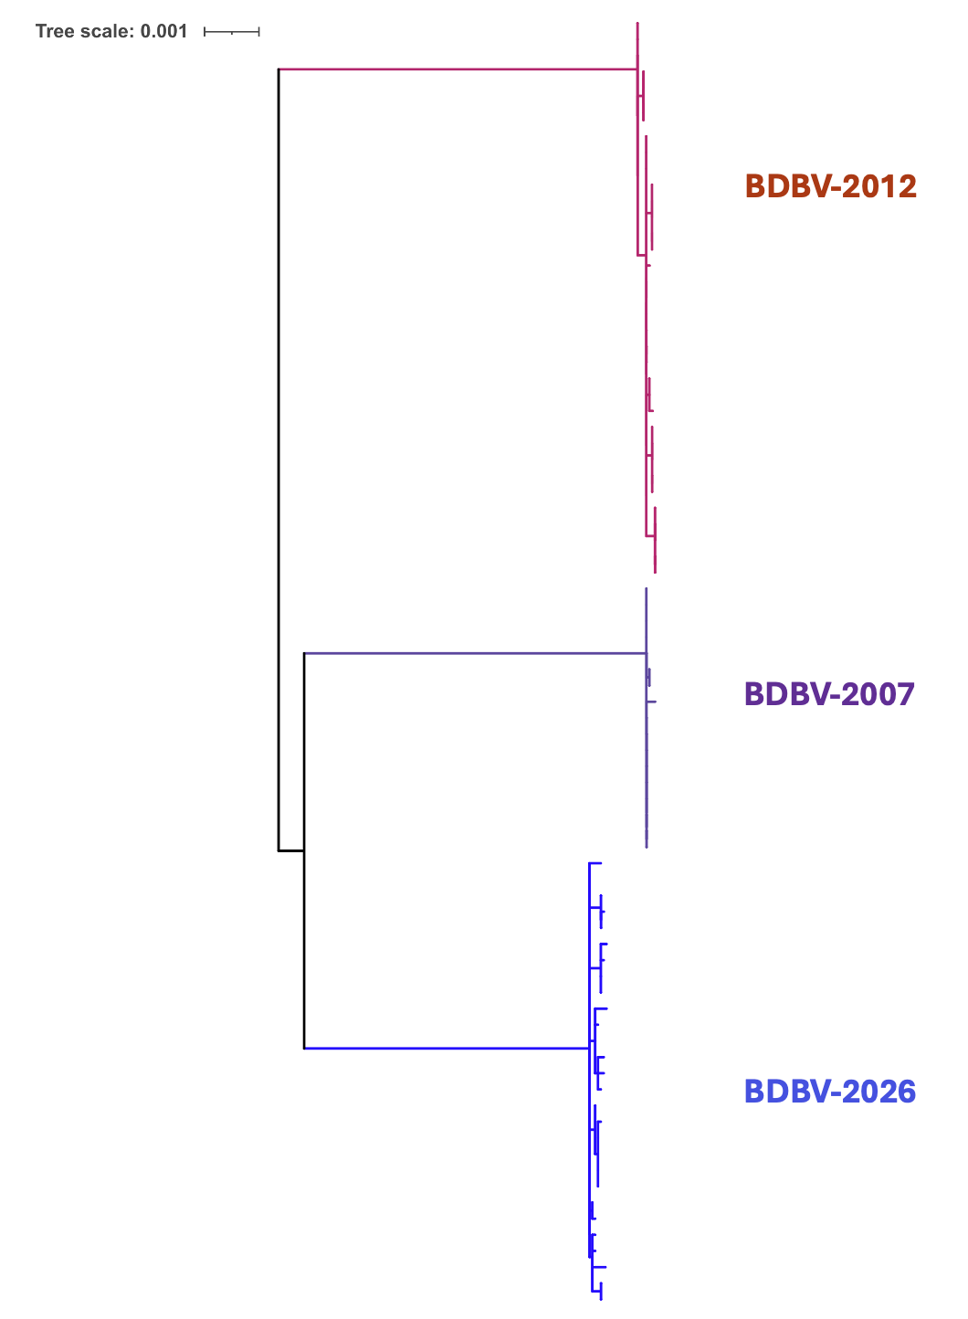
Supplementary Figure 2. Nextclade phylogenetic tree of BDBV genomes: Rectangular presentation of the phylogenetic tree of the BDBV genomes from the ongoing BDBV-2026, BDBV-2012, and BDBV-2007 genomes. This tree was calculated using the Nextclade platform with utilizing the BDBV genomes available in the public domain.

