Hybrid Explainable AI for Early Sepsis Prediction with Actionable Lead Time and Clinical Utility Validation
Keya Dobriyal

PhysioNet Dataset Preparation – Process Summary

1. Data Ingestion & Merging
- Raw data is loaded from PhysioNet 2019 Challenge datasets (training_setA & training_setB).
- All .psv files are read and merged into a single master dataframe.
- A unique Patient_ID is assigned to each file to maintain patient-level tracking.

2. Initial Data Audit & Missingness Analysis
- Feature-wise and patient-wise missing data percentages are computed.
- Visualization of sparsity helps identify highly missing variables (>90–95%).
- Temporal missingness patterns are analyzed relative to sepsis onset time.
----------------------------------------
PATIENT-LEVEL MISSING DATA STATISTICS
----------------------------------------
Total Patients : 40,336
Mean Missingness (%) : 77.65%
Median Missingness (%) : 77.55%
Std Deviation (%) : 5.34%
Min Missingness (%) : 43.10%
Patients with >90% Missing : 1,353
Patients with >75% Missing : 29,674
Patients with <25% Missing : 0

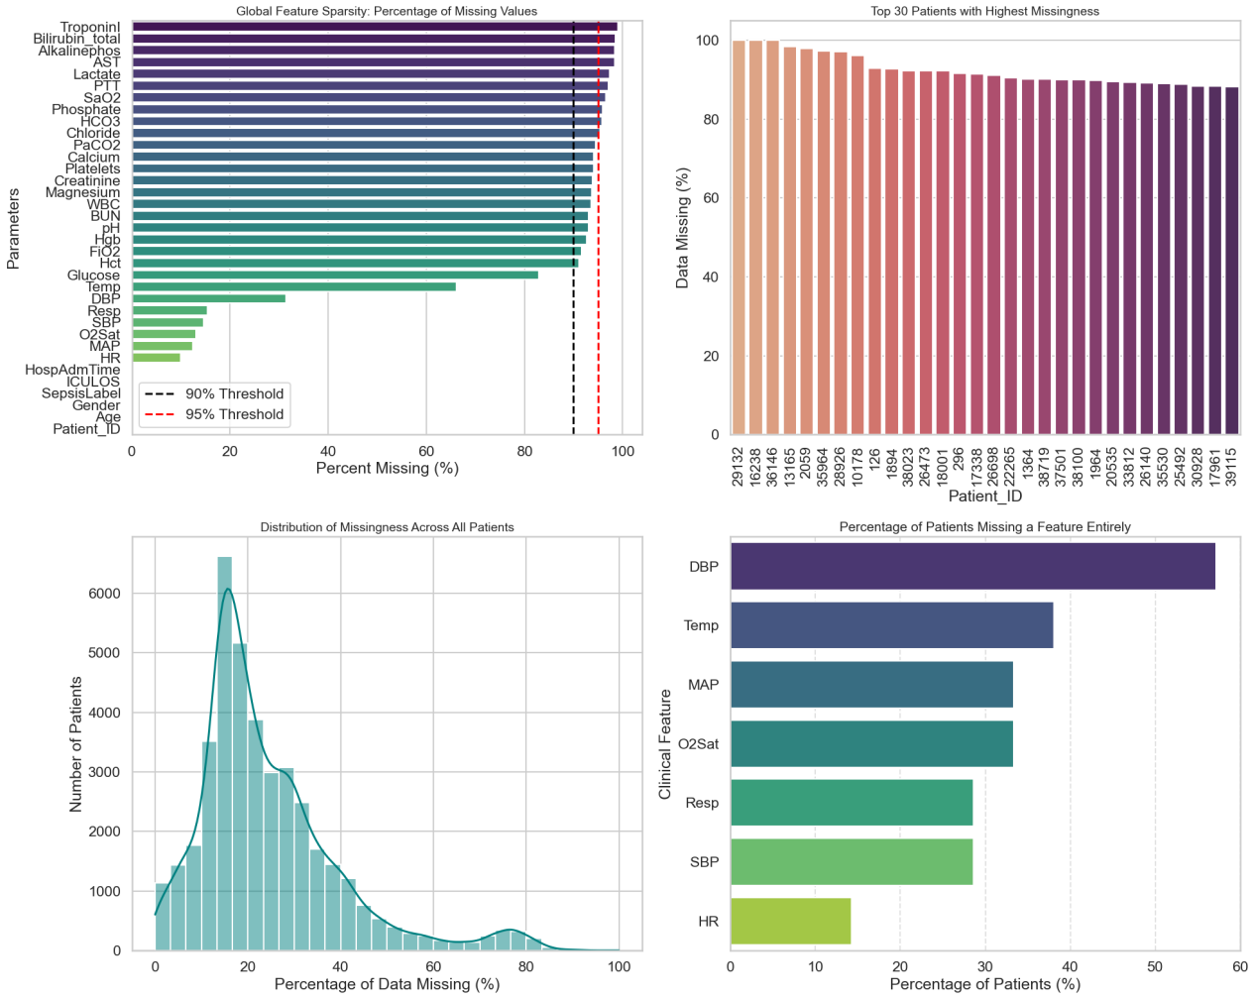

3. Patient Filtering (Data Quality Control)
- Patients with >90% missing clinical data are removed.
- Ensures dataset reliability and reduces noise from sparsely recorded patients.
----------------------------------------
DATA CLEANING SUMMARY: HIGH MISSINGNESS
----------------------------------------
Total Patients Initially : 40,336
Patients to Exclude (> 90%) : 1,353
Remaining Patients : 38,983
----------------------------------------

4. Clinical Data Cleaning & Imputation
- Physiological imputation applied (e.g., DBP estimated using MAP & SBP).
- Temporal imputation:
  - Forward fill (within patient timeline)
  - Median fill for remaining gaps
- Outliers are removed using clinical thresholds (e.g., HR <20 or >250).

5. Measurement Awareness Engineering
- Binary “_measured” flags created for each variable.
- Captures whether a lab/vital was recorded, improving model interpretability.

6. Temporal Structuring
- Data sorted by Patient_ID and ICU length of stay (ICULOS).
- Enables time-series consistency and downstream temporal modeling.

7. Feature Engineering
- Clinical indices derived:
  - Shock Index = HR / SBP
  - Pulse Pressure = SBP − DBP
  - SpO₂/HR ratio
- Aggregation at patient level:
  - Mean, max, min, std, median for each variable
- Target variable created as max SepsisLabel per patient

8. Sepsis-3 Oriented Validation Dataset Creation
- Patients filtered using ΔSOFA ≥ 2 (Sepsis-3 criteria) instead of raw labels.
- A balanced validation dataset (1:2 ratio) is constructed:
  - Sepsis : Non-sepsis
- Designed for robust clinical evaluation (FN/FP sensitivity)
--------------------------------------------------
CLINICAL POPULATION SUMMARY
--------------------------------------------------
Total Unique Patients : 38,982
Patients with SOFA scores : 38,982
Max SOFA Score (Overall) : 12.0
Average Max SOFA Score : 1.91
--------------------------------------------------
Sepsis-3 Patients (ΔSOFA ≥ 2) : 8,332
Sepsis Prevalence : 21.37%
--------------------------------------------------

9. Final Dataset Generation
- Cleaned and engineered dataset (df_final) includes:
  - Clinical variables
  - Engineered features
  - Measurement flags
  - Patient-level aggregates
- Exported datasets:
  - Model-ready training data
  - Patient-level statistics for audit/analysis
----------------------------------------
PATIENT POPULATION SUMMARY
----------------------------------------
Total Unique Patients : 38,982
Total Male (1) : 21,970
Total Female (0) : 17,012
----------------------------------------
Total Patients with Sepsis : 2,920
Total Male with Sepsis : 1,733
Total Female with Sepsis : 1,187
----------------------------------------
Overall Gender Ratio (M/F) : 1.29
Sepsis Patient Ratio : 0.07
Sepsis Gender Ratio (M/F) : 1.46
----------------------------------------
Age Statistics by Gender:

Gender | mean | median | std | min | max | count
Female | 62.362756 | 64.745 | 17.299041 | 14.0 | 100.0 | 17012
Male | 61.363181 | 63.000 | 15.801936 | 14.0 | 100.0 | 21970

10. Exploratory Data Analysis (EDA)
- Demographics: Age, Gender distribution
- Clinical & lab variable distributions
- Patient-level statistical summaries
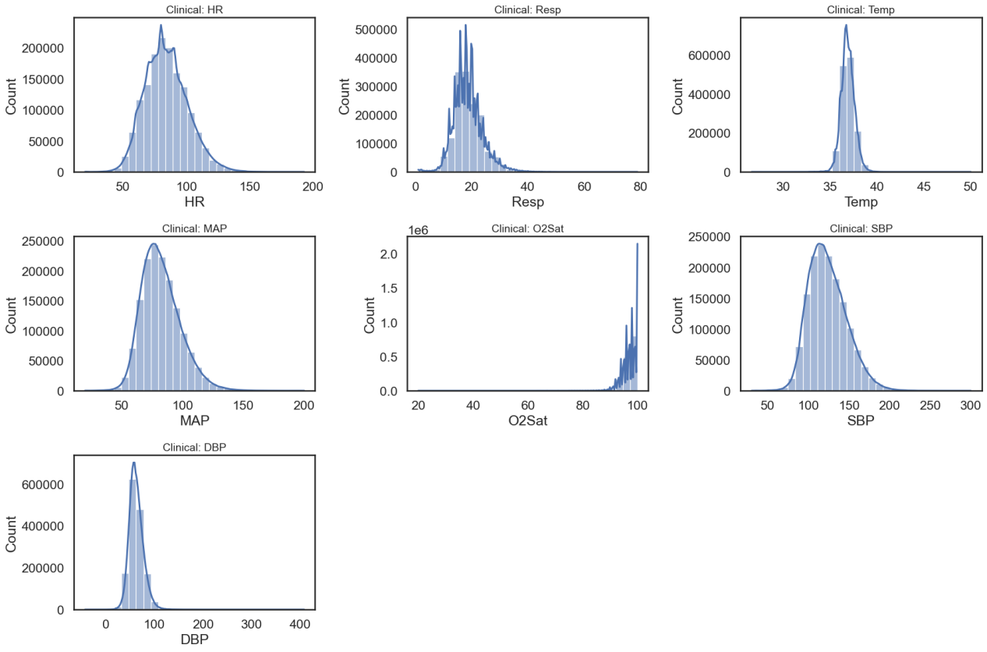

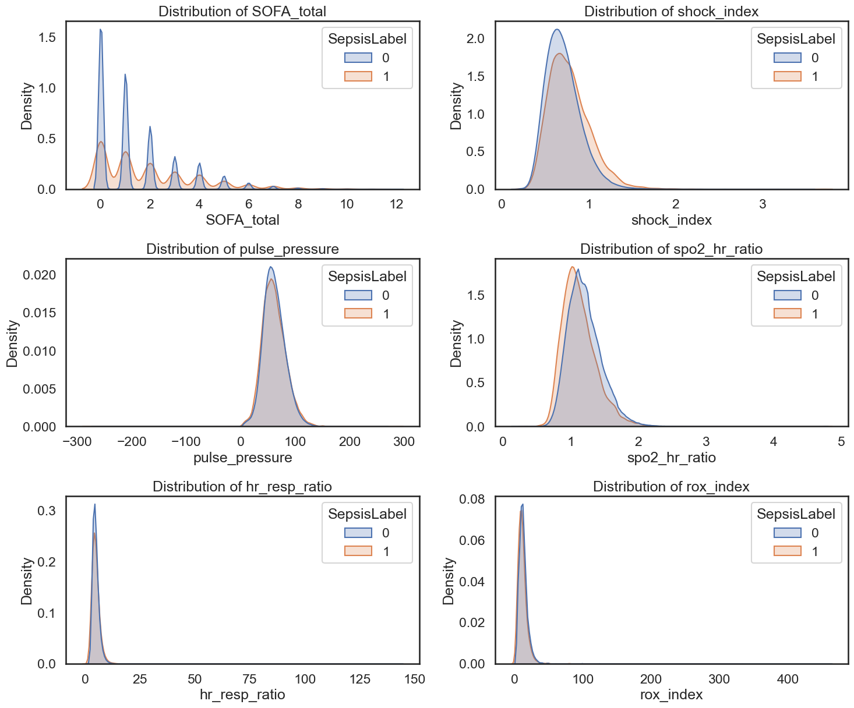

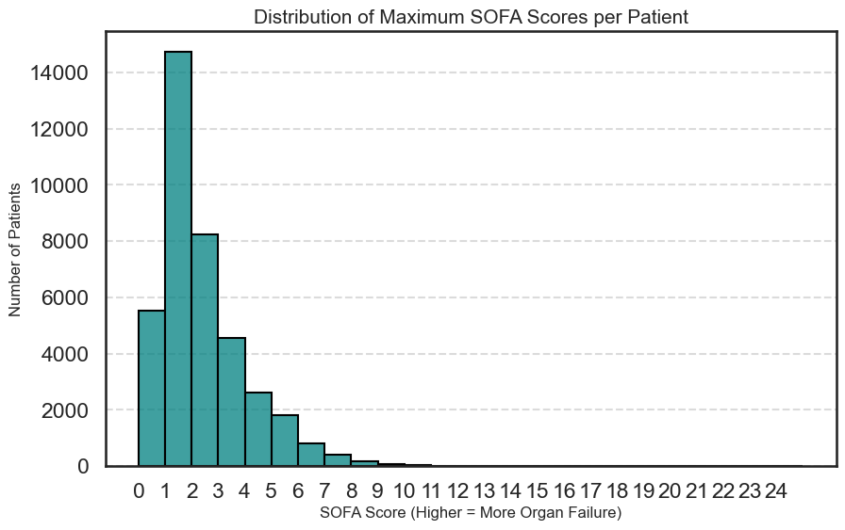

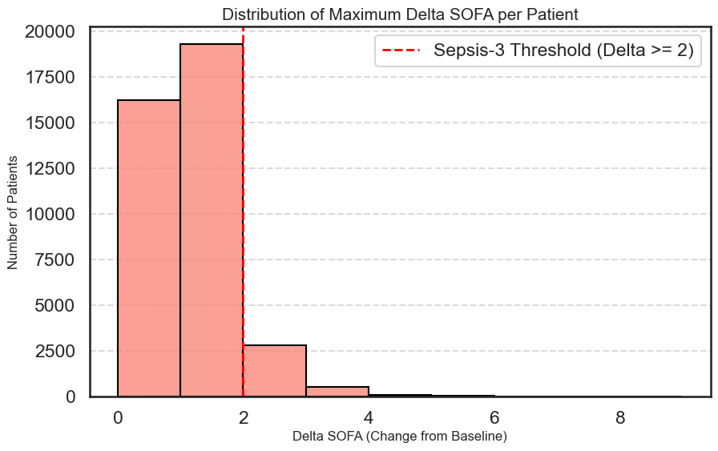

COHORT STATISTICS: SEPSIS VS NON-SEPSIS
--------------------------------------------------
Age ICULOS Gender
mean std median mean median mean
Non-Sepsis (0) 61.778269 16.487128 63.605 37.758915 39.0 0.561172
Sepsis (1) 62.060397 16.382426 64.000 59.380137 38.0 0.593493

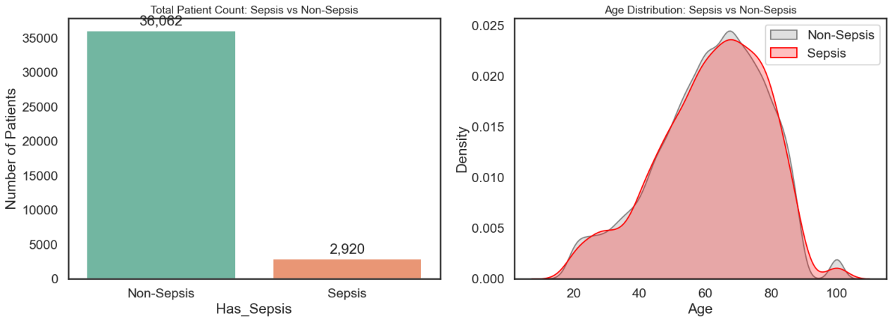

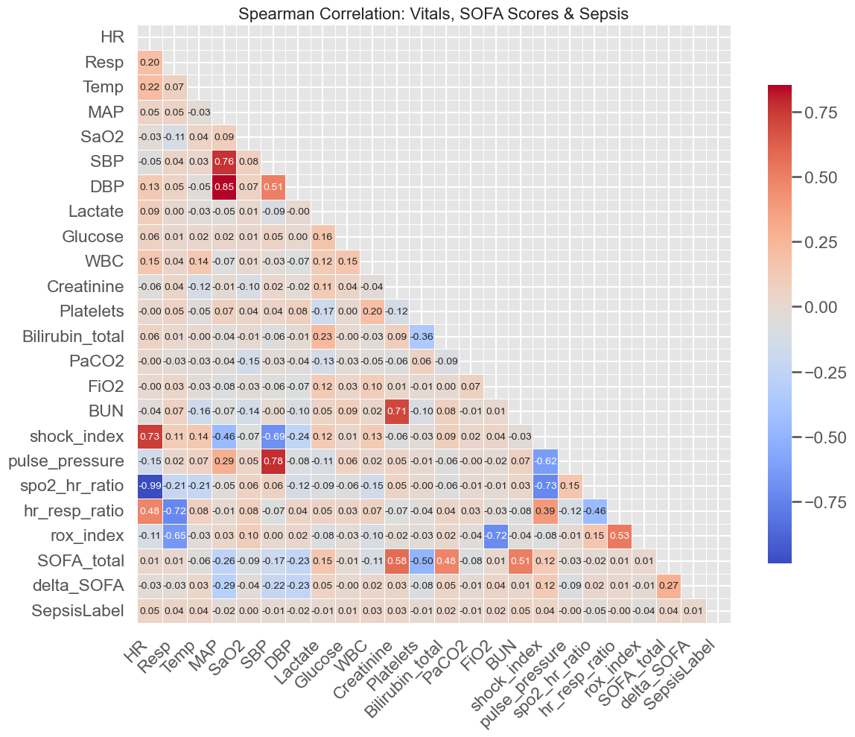

Top 15 Clinical Predictors of Sepsis:
- ICULOS: 0.063 (Positive (Increases with Sepsis))
- DBP_measured: -0.051 (Negative (Drops with Sepsis))
- FiO2_measured: 0.047 (Positive (Increases with Sepsis))
- spo2_hr_ratio: -0.046 (Negative (Drops with Sepsis))
- BUN: 0.046 (Positive (Increases with Sepsis))
- HR: 0.046 (Positive (Increases with Sepsis))
- Temp: 0.044 (Positive (Increases with Sepsis))
- rox_index: -0.042 (Negative (Drops with Sepsis))
- shock_index: 0.039 (Positive (Increases with Sepsis))
- SOFA_total: 0.038 (Positive (Increases with Sepsis))
- Resp: 0.037 (Positive (Increases with Sepsis))
- sepsis_3_criteria: 0.037 (Positive (Increases with Sepsis))
- Lactate_measured: 0.036 (Positive (Increases with Sepsis))
- HR_measured: -0.035 (Negative (Drops with Sepsis))
- SOFA_baseline: 0.034 (Positive (Increases with Sepsis))

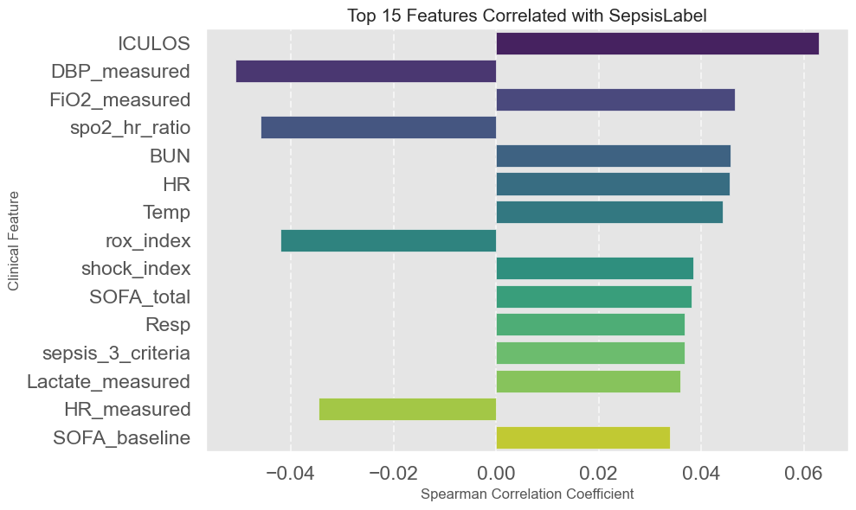

Key Outcome
A clinically cleaned, temporally consistent, feature-rich dataset aligned with Sepsis-3 definitions, ready for:
- Machine learning modeling
- Early prediction systems
- Clinical validation

