Supplementary Tables
Supplementary Table 1. PhilHealth-accredited physician density by region, ranked by ratio per 100,000 population served.
Region | Physicians | Population | Ratio /100k | % Physicians | % Population
NCR | 14,730 | 13,860,700 | 106.3 | 29.67% | 12.17%
CAR | 1,301 | 1,902,600 | 68.4 | 2.62% | 1.67%
Region 7 (Central Visayas) | 3,475 | 6,873,600 | 50.6 | 7.00% | 6.04%
Region 2 (Cagayan Valley) | 1,712 | 3,812,300 | 44.9 | 3.45% | 3.35%
Region 10 (Northern Mindanao) | 2,325 | 5,257,800 | 44.2 | 4.68% | 4.62%
Region 1 (Ilocos) | 2,165 | 5,357,200 | 40.4 | 4.36% | 4.70%
Region 3 (Central Luzon) | 5,144 | 12,970,700 | 39.7 | 10.36% | 11.39%
Region 6 (Western Visayas) | 1,843 | 4,879,500 | 37.8 | 3.71% | 4.29%
Region 9 (Zamboanga) | 1,493 | 4,079,200 | 36.6 | 3.01% | 3.58%
Region 4A (CALABARZON) | 6,130 | 17,204,700 | 35.6 | 12.35% | 15.11%
Region 11 (Davao) | 1,874 | 5,504,100 | 34.0 | 3.77% | 4.83%
Region 8 (Eastern Visayas) | 1,495 | 4,705,300 | 31.8 | 3.01% | 4.13%
Region 13 (CARAGA) | 901 | 2,953,400 | 30.5 | 1.81% | 2.59%
Region 12 (SOCCSKSARGEN) | 1,304 | 4,599,200 | 28.4 | 2.63% | 4.04%
NIR (Negros Island) | 1,347 | 4,841,800 | 27.8 | 2.71% | 4.25%
Region 4B (MIMAROPA) | 711 | 3,352,300 | 21.2 | 1.43% | 2.94%
Region 5 (Bicol) | 1,246 | 6,333,800 | 19.7 | 2.51% | 5.56%
BARMM | 453 | 5,374,900 | 8.4 | 0.91% | 4.72%
Philippines | 49,649 | 113,863,100 | 43.6 | 100% | 100%

Supplementary Table 2a. Regional physician counts and workforce gaps

Count = number of PhilHealth-accredited physicians. Gap = additional physicians needed to reach optimal physician-to-population ratio. Optimal ratios per 100,000 population served: GP 100.0 (total population); Anesthesiology 5.0 (total population); Family Medicine 25.2 (total population); General Surgery 9.7 (total population); Internal Medicine 18.5 (population aged 19+).

Values in parentheses indicate a surplus above the optimal ratio.
Region | General Practice  100 : 100,000 total population |  | Anesthesiology  5.0 : 100,000 total population |  | Family Medicine  25.2 : 100,000 total population |  | General Surgery  9.7 : 100,000 total population |  | Internal Medicine  18.5 : 100,000 population aged 19 and above
 | Count | Gap | Count | Gap | Count | Gap | Count | Gap | Count | Gap
BARMM | 342 | 5,033 | 7 | 262 | 2 | 1,352 | 5 | 516 | 42 | 495
CAR | 708 | 1,195 | 57 | 38 | 16 | 463 | 44 | 141 | 156 | 83
NCR | 4,056 | 9,805 | 841 | (148) | 189 | 3,304 | 822 | 522 | 2,802 | (1,027)
NIR | 601 | 4,241 | 66 | 176 | 18 | 1,202 | 50 | 420 | 233 | 348
Region I | 1,219 | 4,138 | 69 | 199 | 29 | 1,321 | 52 | 468 | 270 | 398
Region II | 1,128 | 2,684 | 48 | 143 | 12 | 949 | 30 | 340 | 170 | 302
Region III | 2,938 | 10,033 | 151 | 498 | 70 | 3,199 | 144 | 1,114 | 635 | 970
Region IV-A | 2,589 | 14,616 | 266 | 594 | 107 | 4,229 | 227 | 1,442 | 942 | 1,196
Region IV-B | 461 | 2,891 | 25 | 143 | 9 | 836 | 19 | 306 | 68 | 321
Region V | 741 | 5,593 | 35 | 282 | 6 | 1,590 | 38 | 576 | 168 | 558
Region VI | 785 | 4,095 | 79 | 165 | 58 | 1,172 | 75 | 398 | 329 | 274
Region VII | 1,665 | 5,209 | 139 | 205 | 116 | 1,616 | 133 | 534 | 582 | 246
Region VIII | 1,006 | 3,699 | 37 | 198 | 33 | 1,153 | 33 | 423 | 158 | 398
Region IX | 1,082 | 2,997 | 26 | 178 | 22 | 1,006 | 26 | 370 | 145 | 321
Region X | 1,224 | 4,034 | 88 | 175 | 69 | 1,256 | 94 | 416 | 301 | 309
Region XI | 750 | 4,754 | 98 | 177 | 69 | 1,318 | 100 | 434 | 306 | 355
Region XII | 866 | 3,733 | 26 | 204 | 16 | 1,143 | 29 | 417 | 150 | 378
Region XIII | 658 | 2,295 | 9 | 139 | 19 | 725 | 11 | 275 | 87 | 261

Supplementary Table 2b. Regional physician counts and workforce gaps

Count = number of PhilHealth-accredited physicians. Gap = additional physicians needed to reach optimal physician-to-population ratio. Optimal ratios per 100,000 population served: Obstetrics-Gynecology 8.2 (female population); Pathology 5.0 (total population); Pediatrics 10.0 (population aged 0-18); Psychiatry 10.0 (total population); Radiology 4.0 (total population).

Values in parentheses indicate a surplus above the optimal ratio.
Region | Obstetrics-  Gynecology  8.2 : 100,000 female population |  | Pathology  5.0 : 100,000 total population |  | Pediatrics  10.0 : 100,000 population aged 0-18 years |  | Psychiatry  10.0 : 100,000 total population |  | Radiology  4.2 : 100,000 total population
 | Count | Gap | Count | Gap | Count | Gap | Count | Gap | Count | Gap
BARMM | 18 | 202 | 3 | 266 | 19 | 228 | 0 | 537 | 3 | 212
CAR | 74 | 2 | 16 | 79 | 94 | (33) | 10 | 180 | 30 | 46
NCR | 1,478 | (908) | 120 | 573 | 1,646 | (1,220) | 120 | 1,266 | 376 | 178
NIR | 103 | 92 | 4 | 238 | 138 | 32 | 4 | 480 | 21 | 173
Region I | 133 | 84 | 13 | 255 | 144 | 30 | 6 | 530 | 39 | 175
Region II | 94 | 59 | 14 | 177 | 106 | 20 | 4 | 377 | 20 | 132
Region III | 329 | 196 | 29 | 620 | 394 | 36 | 14 | 1,283 | 56 | 463
Region IV-A | 572 | 129 | 40 | 820 | 704 | (139) | 28 | 1,692 | 74 | 614
Region IV-B | 32 | 102 | 5 | 163 | 38 | 87 | 3 | 332 | 8 | 126
Region V | 65 | 191 | 3 | 314 | 79 | 162 | 8 | 625 | 13 | 240
Region VI | 140 | 56 | 33 | 211 | 166 | (4) | 18 | 470 | 28 | 167
Region VII | 234 | 43 | 31 | 313 | 293 | (53) | 12 | 675 | 37 | 238
Region VIII | 60 | 128 | 10 | 225 | 99 | 71 | 3 | 468 | 6 | 182
Region IX | 40 | 124 | 10 | 194 | 67 | 89 | 4 | 404 | 22 | 141
Region X | 153 | 58 | 14 | 249 | 200 | (4) | 5 | 521 | 29 | 181
Region XI | 133 | 87 | 11 | 264 | 191 | 2 | 8 | 542 | 30 | 190
Region XII | 77 | 107 | 4 | 226 | 58 | 116 | 2 | 458 | 8 | 176
Region XIII | 25 | 93 | 2 | 146 | 37 | 70 | 2 | 293 | 7 | 111

Supplementary Table 3a. Regional and Provincial physician counts and workforce gaps: General Practice and specialties (A-I).

Count = number of PhilHealth-accredited physicians. Gap = additional physicians needed to reach optimal physician-to-population ratio. Optimal ratios per 100,000 population served: GP 100.0 (total population); Anesthesiology 5.0 (total population); Family Medicine 25.2 (total population); General Surgery 9.7 (total population); Internal Medicine 18.5 (population aged 19+)

Values in parentheses indicate a surplus above the optimal ratio.
Province | General Practice  100 : 100,000 total population |  | Anesthesiology  5.0 : 100,000 total population |  | Family Medicine  25.2 : 100,000 total population |  | General Surgery  9.7 : 100,000 total population |  | Internal Medicine  18.5 : 100,000 population aged 19 and above
 | Count | Gap | Count | Gap | Count | Gap | Count | Gap | Count | Gap
METRO MANILA | 4,056 | 9,805 | 841 | (148) | 189 | 3,304 | 822 | 522 | 2,802 | (1,027)

BARMM
BASILAN | 45 | 585 | 0 | 32 | 1 | 158 | 0 | 61 | 1 | 63
LANAO DEL SUR | 244 | 1,021 | 7 | 56 | 0 | 319 | 5 | 118 | 36 | 89
MAGUINDANAO DEL NORTE | 16 | 1,003 | 0 | 51 | 1 | 256 | 0 | 99 | 2 | 104
MAGUINDANAO DEL SUR | 23 | 787 | 0 | 40 | 0 | 204 | 0 | 79 | 2 | 74
SULU | 55 | 1,050 | 1 | 54 | 0 | 279 | 1 | 106 | 1 | 110
TAWI-TAWI | 14 | 437 | 0 | 23 | 0 | 114 | 0 | 44 | 1 | 45

CAR
ABRA | 56 | 204 | 1 | 12 | 0 | 66 | 1 | 24 | 3 | 30
APAYAO | 66 | 65 | 0 | 7 | 0 | 33 | 0 | 13 | 2 | 14
BENGUET | 349 | 539 | 53 | (9) | 16 | 208 | 39 | 47 | 137 | (22)
IFUGAO | 61 | 156 | 2 | 9 | 0 | 55 | 0 | 21 | 3 | 23
KALINGA | 111 | 135 | 1 | 11 | 0 | 62 | 2 | 22 | 8 | 22
MOUNTAIN PROVINCE | 65 | 96 | 0 | 8 | 0 | 40 | 2 | 14 | 3 | 17

NIR
NEGROS OCCIDENTAL | 402 | 2,894 | 59 | 106 | 4 | 827 | 39 | 281 | 173 | 221
NEGROS ORIENTAL | 187 | 1,254 | 7 | 65 | 14 | 349 | 11 | 129 | 59 | 114

Region I
ILOCOS NORTE | 131 | 473 | 15 | 15 | 7 | 145 | 14 | 45 | 42 | 37
ILOCOS SUR | 198 | 501 | 12 | 23 | 1 | 175 | 9 | 59 | 47 | 44
LA UNION | 172 | 656 | 14 | 27 | 13 | 196 | 3 | 77 | 58 | 48
PANGASINAN | 718 | 2,509 | 28 | 133 | 8 | 805 | 26 | 287 | 123 | 269

Region II
BATANES | 24 | (5) | 0 | 1 | 0 | 5 | 1 | 1 | 1 | 2
CAGAYAN | 459 | 845 | 22 | 43 | 4 | 325 | 10 | 116 | 64 | 98
ISABELA | 394 | 1,360 | 19 | 69 | 5 | 437 | 13 | 157 | 77 | 140
NUEVA VIZCAYA | 217 | 307 | 7 | 19 | 3 | 129 | 6 | 45 | 26 | 38
QUIRINO | 34 | 178 | 0 | 11 | 0 | 53 | 0 | 21 | 2 | 24

Region III
AURORA | 35 | 205 | 0 | 12 | 0 | 61 | 0 | 23 | 5 | 23
BATAAN | 306 | 591 | 13 | 32 | 5 | 221 | 12 | 75 | 50 | 60
BULACAN | 539 | 3,400 | 35 | 162 | 10 | 983 | 21 | 361 | 146 | 344
NUEVA ECIJA | 557 | 1,809 | 24 | 94 | 10 | 586 | 30 | 199 | 100 | 192
PAMPANGA | 939 | 2,110 | 55 | 97 | 29 | 739 | 56 | 240 | 225 | 154
TARLAC | 398 | 1,141 | 11 | 66 | 12 | 376 | 17 | 132 | 64 | 124
ZAMBALES | 164 | 777 | 13 | 34 | 4 | 233 | 8 | 83 | 45 | 72

Region IV-A
BATANGAS | 725 | 2,283 | 50 | 100 | 25 | 733 | 60 | 232 | 230 | 145
CAVITE | 533 | 4,290 | 83 | 158 | 28 | 1,187 | 60 | 408 | 211 | 399
LAGUNA | 539 | 3,023 | 43 | 135 | 25 | 873 | 45 | 300 | 215 | 237
QUEZON | 294 | 1,909 | 22 | 88 | 11 | 544 | 13 | 201 | 71 | 187
RIZAL | 498 | 3,112 | 68 | 112 | 18 | 892 | 49 | 301 | 215 | 227

Region IV-B
MARINDUQUE | 28 | 206 | 2 | 10 | 0 | 59 | 0 | 23 | 0 | 28
OCCIDENTAL MINDORO | 54 | 487 | 1 | 26 | 0 | 136 | 1 | 51 | 5 | 56
ORIENTAL MINDORO | 141 | 792 | 7 | 40 | 3 | 232 | 9 | 82 | 26 | 83
PALAWAN | 196 | 1,141 | 14 | 53 | 5 | 332 | 9 | 121 | 30 | 125
ROMBLON | 42 | 266 | 1 | 14 | 1 | 77 | 0 | 30 | 7 | 29

Region V
ALBAY | 206 | 1,221 | 13 | 58 | 2 | 357 | 9 | 129 | 64 | 105
CAMARINES NORTE | 81 | 586 | 1 | 32 | 0 | 168 | 3 | 62 | 6 | 71
CAMARINES SUR | 205 | 1,961 | 15 | 93 | 3 | 543 | 22 | 188 | 76 | 171
CATANDUANES | 48 | 233 | 1 | 13 | 1 | 70 | 1 | 26 | 5 | 28
MASBATE | 79 | 853 | 2 | 45 | 0 | 235 | 0 | 90 | 4 | 96
SORSOGON | 122 | 740 | 3 | 40 | 0 | 217 | 3 | 81 | 13 | 87

Region VI
AKLAN | 100 | 541 | 3 | 29 | 2 | 159 | 6 | 56 | 29 | 50
ANTIQUE | 104 | 527 | 4 | 28 | 5 | 154 | 3 | 58 | 14 | 62
CAPIZ | 123 | 704 | 7 | 34 | 3 | 205 | 8 | 72 | 35 | 68
GUIMARAS | 15 | 181 | 1 | 9 | 3 | 46 | 1 | 18 | 1 | 23
ILOILO | 443 | 2,142 | 64 | 65 | 45 | 607 | 57 | 194 | 250 | 71

Region VII
BOHOL | 286 | 1,114 | 12 | 58 | 5 | 348 | 8 | 128 | 59 | 111
CEBU | 1,379 | 4,095 | 127 | 147 | 111 | 1,268 | 125 | 406 | 523 | 135
SIQUIJOR | 12 | 93 | 0 | 5 | 0 | 26 | 0 | 10 | 1 | 13

Region VIII
BILIRAN | 32 | 154 | 1 | 8 | 0 | 47 | 2 | 16 | 2 | 20
EASTERN SAMAR | 111 | 384 | 2 | 23 | 0 | 125 | 1 | 47 | 7 | 52
LEYTE | 575 | 1,548 | 28 | 78 | 26 | 509 | 22 | 184 | 123 | 132
NORTHERN SAMAR | 95 | 559 | 3 | 30 | 5 | 160 | 2 | 61 | 8 | 65
SAMAR | 97 | 713 | 0 | 41 | 1 | 203 | 4 | 75 | 9 | 84
SOUTHERN LEYTE | 96 | 342 | 3 | 19 | 1 | 109 | 2 | 40 | 9 | 46

Region IX
ZAMBOANGA DEL NORTE | 174 | 905 | 3 | 51 | 5 | 267 | 4 | 101 | 23 | 99
ZAMBOANGA DEL SUR | 773 | 1,371 | 22 | 85 | 16 | 524 | 21 | 187 | 117 | 132
ZAMBOANGA SIBUGAY | 80 | 627 | 0 | 35 | 1 | 177 | 0 | 69 | 4 | 75

Region X
BUKIDNON | 168 | 1,457 | 16 | 65 | 19 | 391 | 17 | 141 | 45 | 139
CAMIGUIN | 21 | 73 | 0 | 5 | 0 | 24 | 1 | 8 | 2 | 9
LANAO DEL NORTE | 212 | 924 | 9 | 48 | 4 | 282 | 15 | 95 | 51 | 75
MISAMIS OCCIDENTAL | 224 | 398 | 16 | 15 | 16 | 141 | 10 | 50 | 39 | 37
MISAMIS ORIENTAL | 599 | 1,181 | 47 | 42 | 30 | 419 | 51 | 122 | 164 | 50

Region XI
COMPOSTELA VALLEY | 33 | 752 | 1 | 38 | 1 | 197 | 0 | 76 | 3 | 89
DAVAO DEL NORTE | 137 | 1,052 | 11 | 48 | 8 | 292 | 10 | 105 | 36 | 107
DAVAO DEL SUR | 529 | 2,095 | 85 | 46 | 57 | 604 | 89 | 165 | 262 | 61
DAVAO OCCIDENTAL | 9 | 310 | 0 | 16 | 0 | 80 | 0 | 31 | 0 | 35
DAVAO ORIENTAL | 42 | 546 | 1 | 28 | 3 | 145 | 1 | 56 | 5 | 63

Region XII
COTABATO | 360 | 1,228 | 9 | 70 | 3 | 397 | 13 | 141 | 45 | 135
SARANGANI | 18 | 555 | 0 | 29 | 0 | 144 | 0 | 56 | 2 | 61
SOUTH COTABATO | 340 | 1,457 | 17 | 73 | 11 | 442 | 14 | 160 | 82 | 130
SULTAN KUDARAT | 148 | 737 | 0 | 44 | 2 | 221 | 2 | 84 | 21 | 79

Region XIII
AGUSAN DEL NORTE | 166 | 645 | 6 | 35 | 11 | 193 | 6 | 73 | 32 | 65
AGUSAN DEL SUR | 130 | 638 | 0 | 38 | 0 | 194 | 2 | 73 | 7 | 79
DINAGAT ISLANDS | 11 | 115 | 0 | 6 | 0 | 32 | 0 | 12 | 0 | 15
SURIGAO DEL NORTE | 165 | 411 | 1 | 28 | 5 | 140 | 2 | 54 | 28 | 42
SURIGAO DEL SUR | 186 | 487 | 2 | 32 | 3 | 167 | 1 | 64 | 20 | 59

Supplementary Table 3b. Regional and Provincial physician counts and workforce gaps: Specialties (O-R).

Count = number of PhilHealth-accredited physicians. Gap = additional physicians needed to reach optimal physician-to-population ratio. Optimal ratios per 100,000 population served: Obstetrics-Gynecology 8.2 (female population); Pathology 5.0 (total population); Pediatrics 10.0 (population aged 0-18); Psychiatry 10.0 (total population); Radiology 4.0 (total population).

Values in parentheses indicate a surplus above the optimal ratio.
Province | Obstetrics-  Gynecology  8.2 : 100,000 female population |  | Pathology  5.0 : 100,000 total population |  | Pediatrics  10.0 : 100,000 population aged 0-18 years |  | Psychiatry  10.0 : 100,000 total population |  | Radiology  4.2 : 100,000 total population
 | Count | Gap | Count | Gap | Count | Gap | Count | Gap | Count | Gap
METRO MANILA | 1,478 | (908) | 120 | 573 | 1,646 | (1,220) | 120 | 1,266 | 376 | 178

BARMM
BASILAN | 0 | 26 | 0 | 32 | 2 | 27 | 0 | 63 | 0 | 25
LANAO DEL SUR | 15 | 37 | 3 | 60 | 15 | 44 | 0 | 127 | 3 | 48
MAGUINDANAO DEL NORTE | 2 | 39 | 0 | 51 | 0 | 44 | 0 | 102 | 0 | 41
MAGUINDANAO DEL SUR | 1 | 32 | 0 | 40 | 1 | 39 | 0 | 81 | 0 | 32
SULU | 1 | 44 | 0 | 55 | 2 | 48 | 0 | 111 | 0 | 44
TAWI-TAWI | 0 | 18 | 0 | 23 | 1 | 19 | 0 | 45 | 0 | 18

CAR
ABRA | 4 | 6 | 0 | 13 | 3 | 5 | 0 | 26 | 0 | 10
APAYAO | 1 | 4 | 1 | 6 | 5 | (1) | 0 | 13 | 1 | 4
BENGUET | 65 | (29) | 15 | 29 | 79 | (52) | 10 | 79 | 21 | 15
IFUGAO | 2 | 7 | 0 | 11 | 2 | 6 | 0 | 22 | 2 | 7
KALINGA | 0 | 10 | 0 | 12 | 5 | 4 | 0 | 25 | 3 | 7
MOUNTAIN PROVINCE | 2 | 4 | 0 | 8 | 0 | 5 | 0 | 16 | 3 | 3

NIR
NEGROS OCCIDENTAL | 83 | 50 | 2 | 163 | 107 | 10 | 3 | 327 | 18 | 114
NEGROS ORIENTAL | 20 | 38 | 2 | 70 | 31 | 19 | 1 | 143 | 3 | 55

Region I
ILOCOS NORTE | 25 | 0 | 1 | 29 | 21 | (4) | 0 | 60 | 6 | 18
ILOCOS SUR | 23 | 5 | 3 | 32 | 24 | (3) | 1 | 69 | 1 | 27
LA UNION | 18 | 16 | 2 | 39 | 23 | 2 | 1 | 82 | 5 | 28
PANGASINAN | 67 | 63 | 7 | 154 | 76 | 35 | 4 | 319 | 27 | 102

Region II
BATANES | 1 | 0 | 0 | 1 | 1 | 0 | 0 | 2 | 0 | 1
CAGAYAN | 27 | 26 | 8 | 57 | 39 | 4 | 3 | 127 | 11 | 41
ISABELA | 47 | 24 | 1 | 87 | 45 | 13 | 1 | 174 | 5 | 65
NUEVA VIZCAYA | 16 | 5 | 5 | 21 | 18 | 0 | 0 | 52 | 4 | 17
QUIRINO | 3 | 5 | 0 | 11 | 3 | 4 | 0 | 21 | 0 | 8

Region III
AURORA | 0 | 10 | 0 | 12 | 0 | 9 | 0 | 24 | 0 | 10
BATAAN | 25 | 11 | 5 | 40 | 46 | (16) | 3 | 87 | 6 | 30
BULACAN | 113 | 46 | 4 | 193 | 115 | 14 | 4 | 390 | 4 | 154
NUEVA ECIJA | 45 | 51 | 6 | 112 | 50 | 29 | 2 | 235 | 12 | 83
PAMPANGA | 108 | 15 | 11 | 141 | 118 | (18) | 3 | 302 | 27 | 95
TARLAC | 20 | 42 | 3 | 74 | 45 | 7 | 1 | 153 | 2 | 60
ZAMBALES | 18 | 20 | 0 | 47 | 20 | 11 | 1 | 93 | 5 | 33

Region IV-A
BATANGAS | 99 | 24 | 11 | 139 | 147 | (49) | 5 | 296 | 20 | 100
CAVITE | 173 | 23 | 6 | 235 | 174 | (22) | 6 | 476 | 8 | 185
LAGUNA | 135 | 10 | 8 | 170 | 192 | (80) | 4 | 352 | 16 | 126
QUEZON | 34 | 55 | 3 | 107 | 36 | 45 | 5 | 215 | 7 | 81
RIZAL | 131 | 16 | 12 | 168 | 155 | (33) | 8 | 353 | 23 | 121

MIMAROPA
MARINDUQUE | 3 | 7 | 0 | 12 | 0 | 8 | 0 | 23 | 0 | 9
OCCIDENTAL MINDORO | 1 | 20 | 0 | 27 | 1 | 20 | 0 | 54 | 0 | 22
ORIENTAL MINDORO | 10 | 28 | 2 | 45 | 10 | 24 | 2 | 91 | 3 | 34
PALAWAN | 15 | 38 | 3 | 64 | 25 | 25 | 1 | 133 | 5 | 48
ROMBLON | 3 | 9 | 0 | 15 | 2 | 9 | 0 | 31 | 0 | 12

Region V
ALBAY | 16 | 42 | 1 | 70 | 32 | 19 | 2 | 141 | 5 | 52
CAMARINES NORTE | 9 | 18 | 0 | 33 | 6 | 19 | 0 | 67 | 1 | 26
CAMARINES SUR | 34 | 53 | 1 | 107 | 29 | 54 | 4 | 213 | 5 | 82
CATANDUANES | 1 | 10 | 0 | 14 | 2 | 8 | 1 | 27 | 1 | 10
MASBATE | 0 | 38 | 0 | 47 | 2 | 37 | 1 | 92 | 0 | 37
SORSOGON | 5 | 30 | 1 | 42 | 8 | 24 | 0 | 86 | 1 | 33

Region VI
AKLAN | 10 | 16 | 2 | 30 | 6 | 15 | 1 | 63 | 1 | 25
ANTIQUE | 7 | 18 | 2 | 30 | 5 | 17 | 0 | 63 | 0 | 25
CAPIZ | 12 | 21 | 2 | 39 | 20 | 7 | 2 | 81 | 2 | 31
GUIMARAS | 0 | 8 | 0 | 10 | 1 | 5 | 0 | 20 | 0 | 8
ILOILO | 111 | (7) | 27 | 102 | 134 | (49) | 15 | 244 | 25 | 78

Region VII
BOHOL | 19 | 37 | 7 | 63 | 25 | 23 | 1 | 139 | 0 | 56
CEBU | 215 | 6 | 24 | 250 | 268 | (76) | 11 | 536 | 37 | 182
SIQUIJOR | 0 | 4 | 0 | 5 | 0 | 3 | 0 | 11 | 0 | 4

Region VIII
BILIRAN | 0 | 7 | 0 | 9 | 0 | 7 | 0 | 19 | 0 | 7
EASTERN SAMAR | 3 | 17 | 0 | 25 | 2 | 16 | 0 | 49 | 1 | 19
LEYTE | 48 | 37 | 8 | 98 | 78 | (3) | 1 | 211 | 3 | 82
NORTHERN SAMAR | 4 | 22 | 1 | 32 | 9 | 17 | 1 | 64 | 1 | 25
SAMAR | 3 | 29 | 1 | 40 | 5 | 26 | 1 | 80 | 1 | 31
SOUTHERN LEYTE | 2 | 16 | 0 | 22 | 5 | 9 | 0 | 44 | 0 | 18

Region IX
ZAMBOANGA DEL NORTE | 9 | 34 | 3 | 51 | 10 | 32 | 0 | 108 | 5 | 38
ZAMBOANGA DEL SUR | 29 | 58 | 7 | 100 | 52 | 28 | 4 | 210 | 16 | 70
ZAMBOANGA SIBUGAY | 1 | 27 | 0 | 35 | 3 | 25 | 0 | 71 | 1 | 27

Region X
BUKIDNON | 26 | 38 | 1 | 80 | 37 | 26 | 0 | 163 | 2 | 63
CAMIGUIN | 2 | 2 | 0 | 5 | 2 | 1 | 0 | 9 | 0 | 4
LANAO DEL NORTE | 19 | 27 | 1 | 56 | 31 | 14 | 1 | 113 | 4 | 41
MISAMIS OCCIDENTAL | 21 | 4 | 0 | 31 | 20 | 1 | 0 | 62 | 0 | 25
MISAMIS ORIENTAL | 85 | (14) | 12 | 77 | 110 | (47) | 4 | 174 | 23 | 48

Region XI
COMPOSTELA VALLEY | 1 | 30 | 0 | 39 | 3 | 26 | 0 | 78 | 0 | 31
DAVAO DEL NORTE | 16 | 32 | 1 | 58 | 24 | 17 | 0 | 119 | 1 | 47
DAVAO DEL SUR | 134 | (28) | 10 | 121 | 164 | (76) | 8 | 254 | 29 | 76
DAVAO OCCIDENTAL | 0 | 13 | 0 | 16 | 0 | 13 | 0 | 32 | 0 | 13
DAVAO ORIENTAL | 2 | 21 | 0 | 29 | 0 | 22 | 0 | 59 | 0 | 24

Region XII
COTABATO | 28 | 36 | 1 | 78 | 23 | 39 | 1 | 158 | 3 | 61
SARANGANI | 0 | 23 | 0 | 29 | 0 | 23 | 0 | 57 | 0 | 23
SOUTH COTABATO | 37 | 35 | 3 | 87 | 30 | 35 | 1 | 179 | 5 | 67
SULTAN KUDARAT | 12 | 23 | 0 | 44 | 5 | 30 | 0 | 88 | 0 | 35

CARAGA
AGUSAN DEL NORTE | 9 | 24 | 2 | 39 | 18 | 11 | 1 | 80 | 1 | 31
AGUSAN DEL SUR | 2 | 28 | 0 | 38 | 4 | 26 | 0 | 77 | 0 | 31
DINAGAT ISLANDS | 0 | 5 | 0 | 6 | 0 | 5 | 0 | 13 | 0 | 5
SURIGAO DEL NORTE | 8 | 15 | 0 | 29 | 10 | 10 | 1 | 57 | 3 | 20
SURIGAO DEL SUR | 6 | 21 | 0 | 34 | 5 | 19 | 0 | 67 | 3 | 24

Supplementary Table 4. Number of medical schools and accredited residency training programs by region.
Regions | Med Schools | Anes (PBA) | Fam  Med (PAFP) | Gen Surg (PCS) | IM (PCP) | OB-  GYN (POGS) | Patho (PSP) | Pedia (PPS) | Psych (PPA) | Radio (PCR)
Country Total | 85 | 66 | 132 | 74 | 148 | 87 | 53 | 126 | 20 | 56
Institutions in NCR | 23.5% | 45.5% | 28.8% | 47.3% | 32.4% | 48.3% | 49.1% | 45.2% | 40.0% | 55.4%
NCR | 20 | 30 | 38 | 35 | 48 | 42 | 26 | 57 | 8 | 31
BARMM | 0 | 2 | 3 | 1 | 2 | 2 | 0 | 2 | 0 | 1
CAR | 4 | 2 | 2 | 3 | 5 | 2 | 2 | 1 | 1 | 1
Negros Island Region (NIR) | 2 | 2 | 5 | 2 | 7 | 2 | 1 | 5 | 0 | 1
Ilocos Region (R1) | 5 | 3 | 4 | 2 | 5 | 3 | 3 | 3 | 0 | 1
Cagayan Valley (R2) | 4 | 3 | 3 | 2 | 4 | 3 | 3 | 3 | 1 | 1
Central Luzon (R3) | 6 | 4 | 12 | 5 | 14 | 5 | 3 | 11 | 2 | 3
CALABARZON (R4A) | 7 | 3 | 13 | 3 | 13 | 4 | 2 | 7 | 2 | 3
MIMAROPA Region (R4B) | 3 | 0 | 0 | 0 | 1 | 0 | 0 | 1 | 0 | 0
Bicol Region (R5) | 3 | 2 | 4 | 2 | 5 | 2 | 1 | 3 | 1 | 1
Western Visayas (R6) | 3 | 2 | 8 | 4 | 7 | 5 | 2 | 5 | 1 | 2
Central Visayas (R7) | 8 | 6 | 13 | 7 | 12 | 10 | 4 | 11 | 1 | 5
Eastern Visayas (R8) | 4 | 1 | 4 | 1 | 3 | 1 | 1 | 3 | 1 | 1
Zamboanga Peninsula (R9) | 3 | 1 | 4 | 1 | 4 | 1 | 1 | 1 | 1 | 0
Northern Mindanao (R10) | 5 | 1 | 3 | 2 | 5 | 1 | 1 | 4 | 0 | 1
Davao Region (R11) | 4 | 4 | 8 | 4 | 7 | 4 | 3 | 7 | 1 | 4
SOCCSKSARGEN (R12) | 3 | 0 | 4 | 0 | 4 | 0 | 0 | 2 | 0 | 0
Caraga (R13) | 1 | 0 | 4 | 0 | 2 | 0 | 0 | 0 | 0 | 0
Legend: Color intensity reflects counts per category: darker green indicates higher counts, lighter green indicates lower counts, and gray indicates a complete absence of the medical school/training institution.
Supplementary Maps

SET A: REGIONAL MAPS
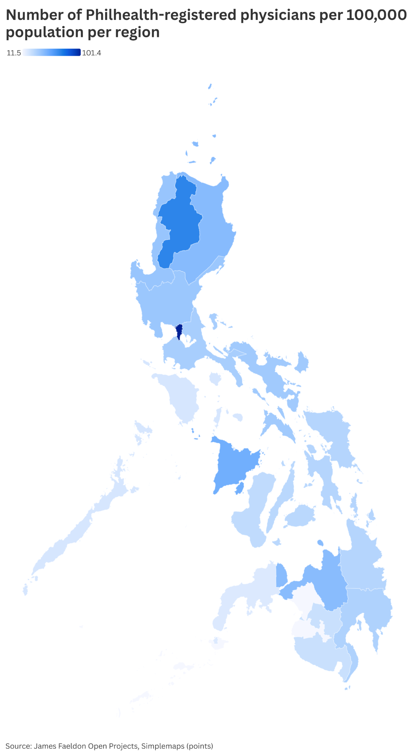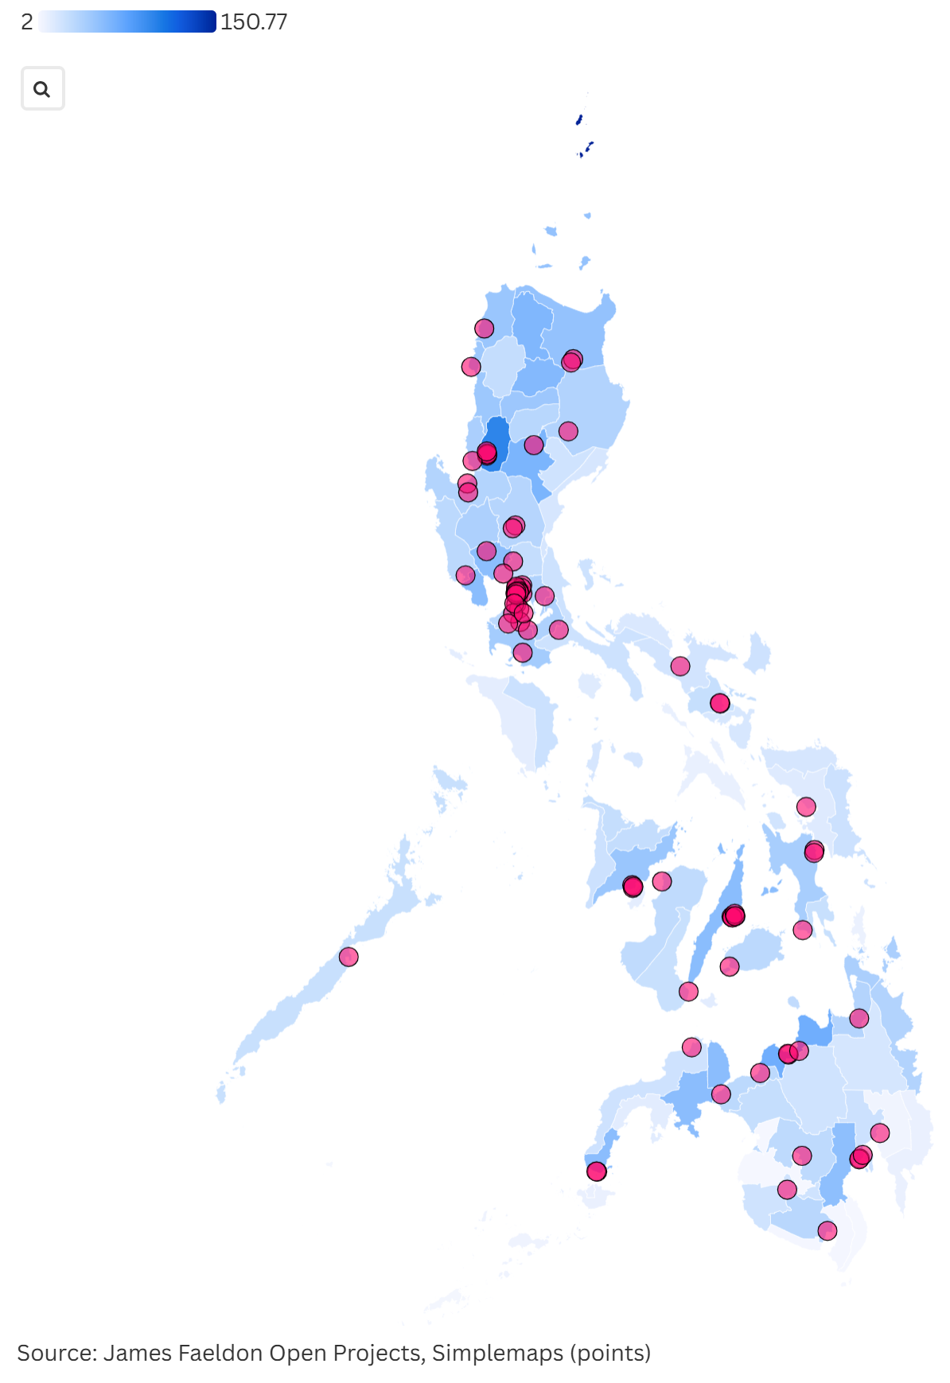
Supplementary Figure 1. Regional distribution of all PhilHealth-accredited physicians per 100,000 population (May 2025).
Left map: Base distribution. Right map: With 85 medical schools overlaid
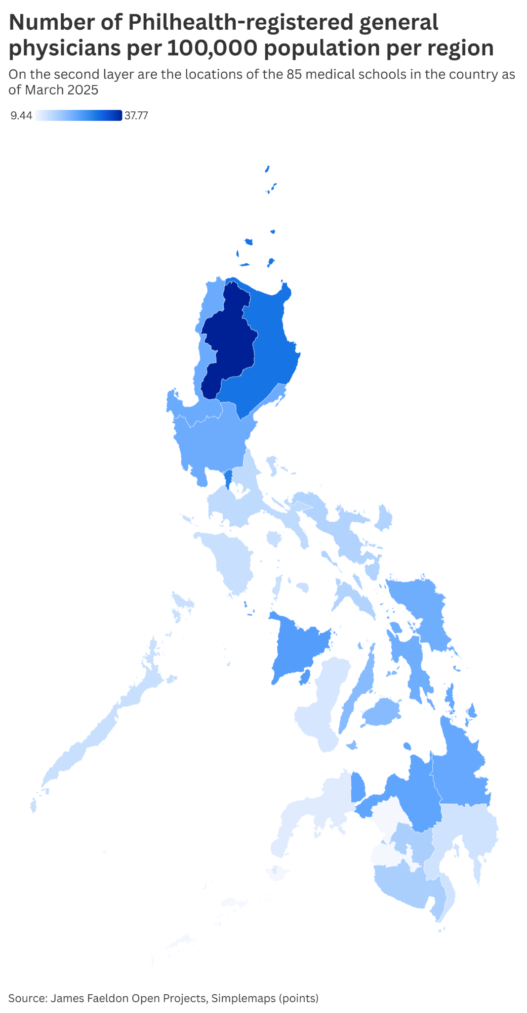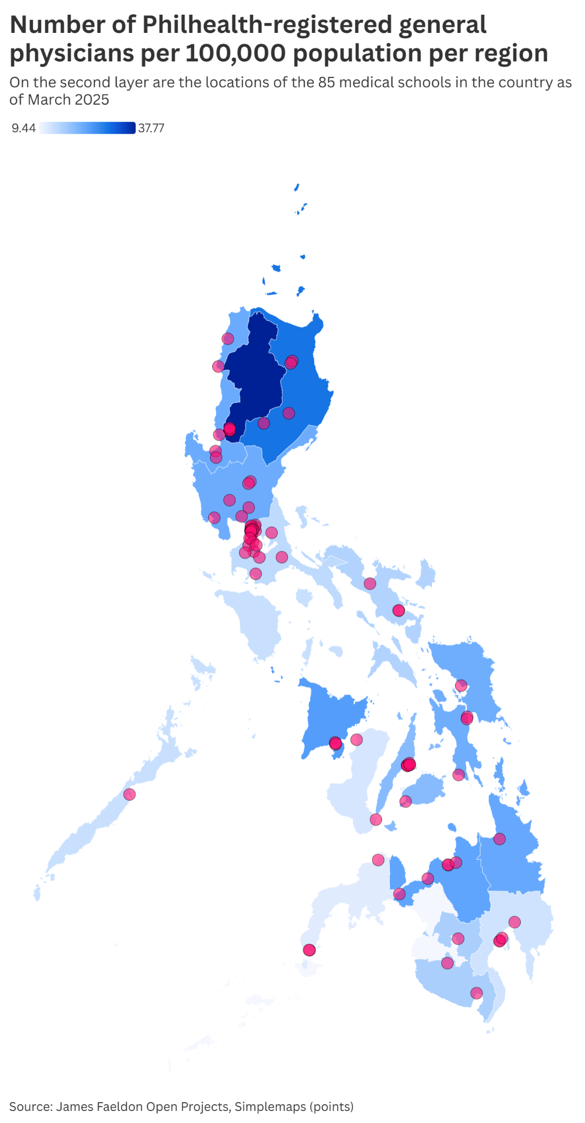
Supplementary Figure 2. Regional distribution of PhilHealth-accredited general physicians per 100,000 population (May 2025).
Left map: Base distribution. Right map: With 85 medical schools overlaid
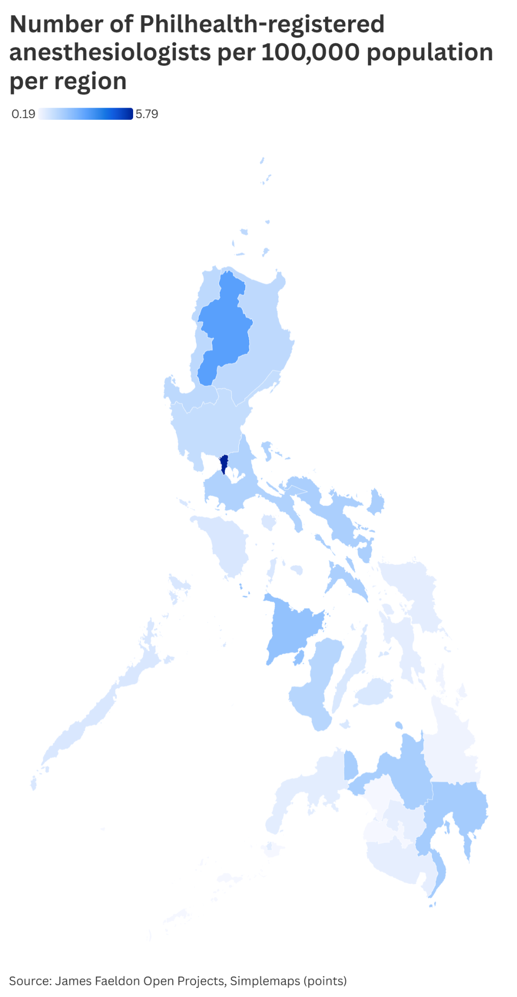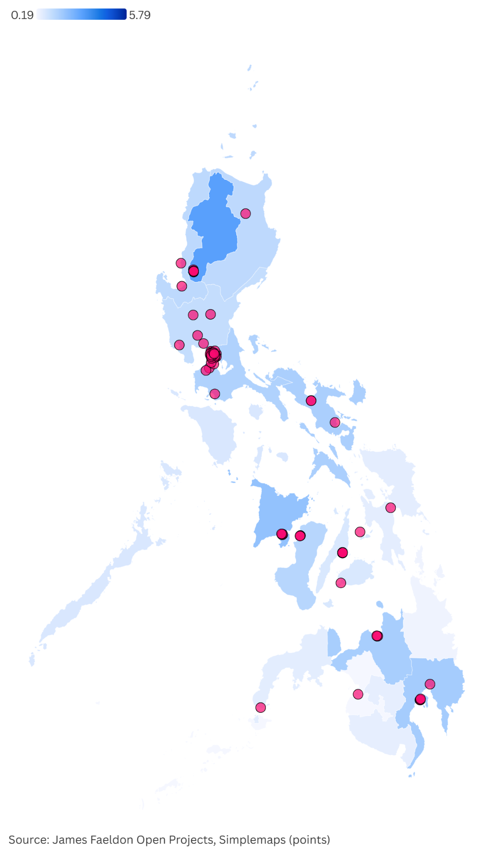
Supplementary Figure 3. Regional distribution of PhilHealth-accredited anesthesiologists per 100,000 population (May 2025).
Left map: Base distribution. Right map: With 66 training institutions overlaid
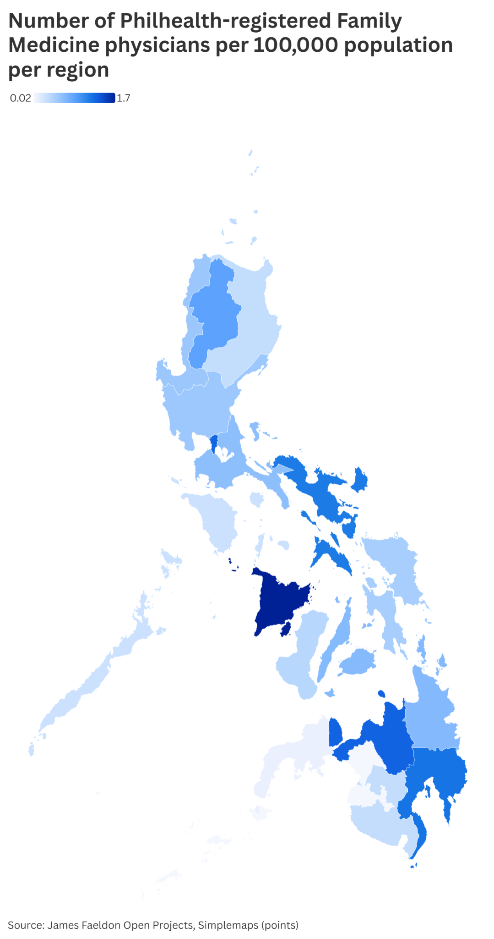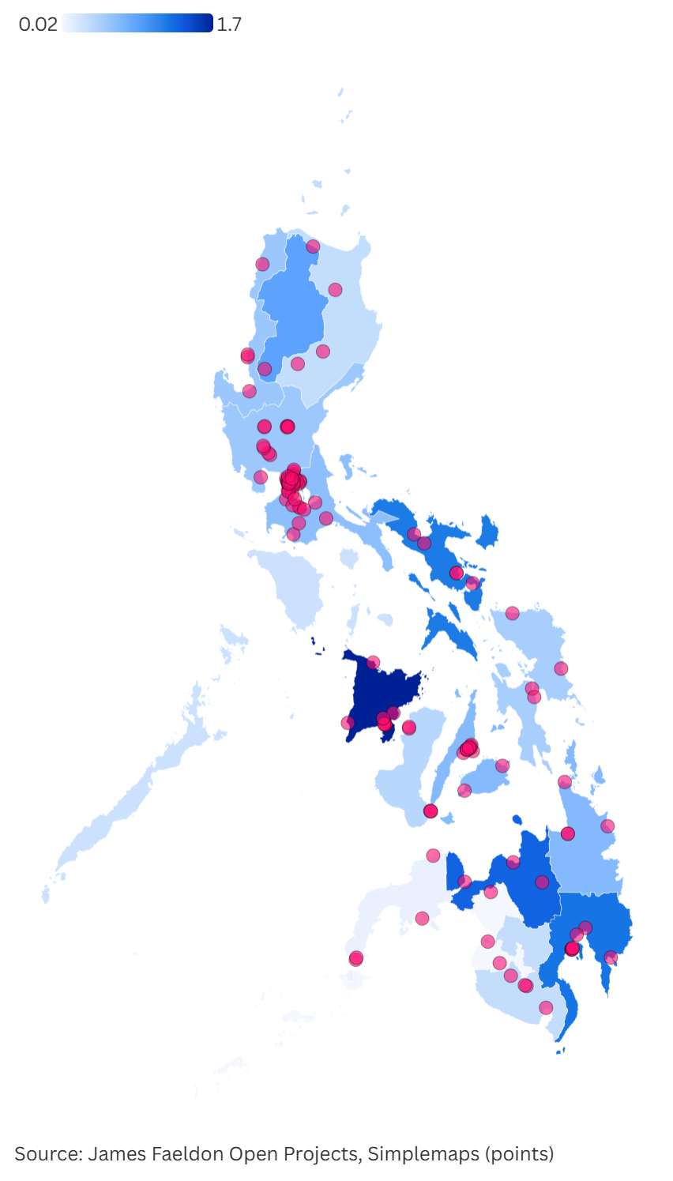
Supplementary Figure 4. Regional distribution of PhilHealth-accredited family medicine specialists per 100,000 population (May 2025).
Left map: Base distribution. Right map: With 132 training institutions overlaid
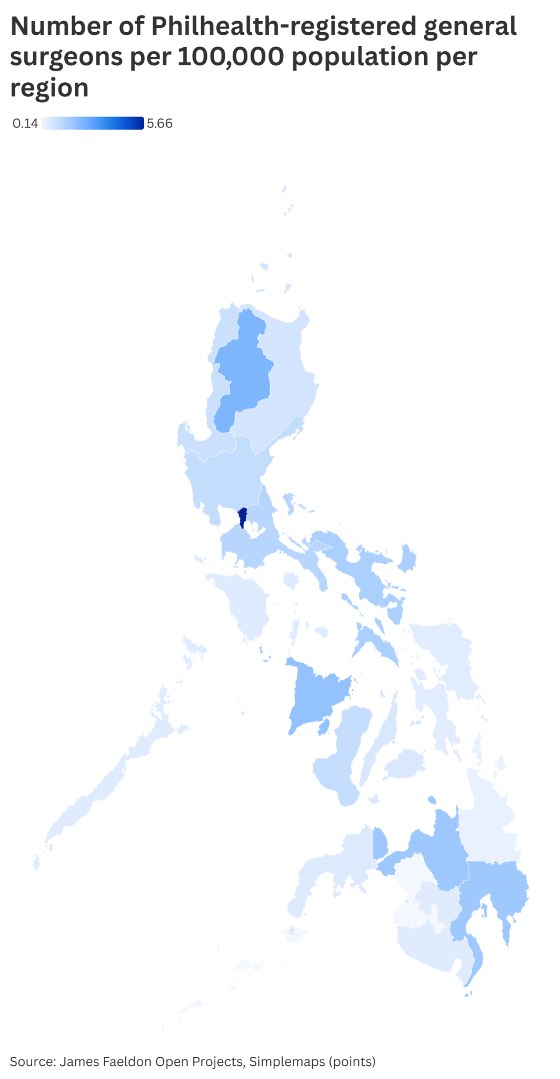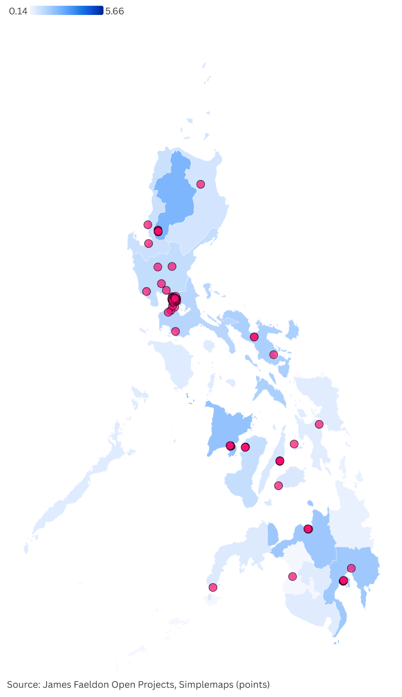
Supplementary Figure 5. Regional distribution of PhilHealth-accredited general surgeons per 100,000 population (May 2025).
Left map: Base distribution. Right map: With 74 training institutions overlaid
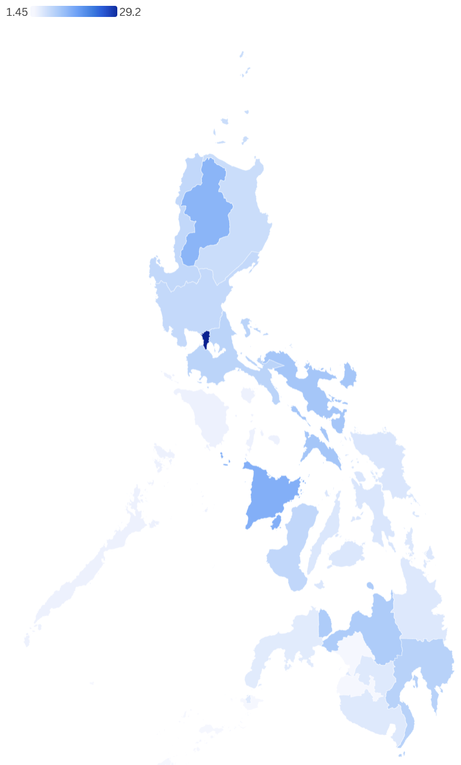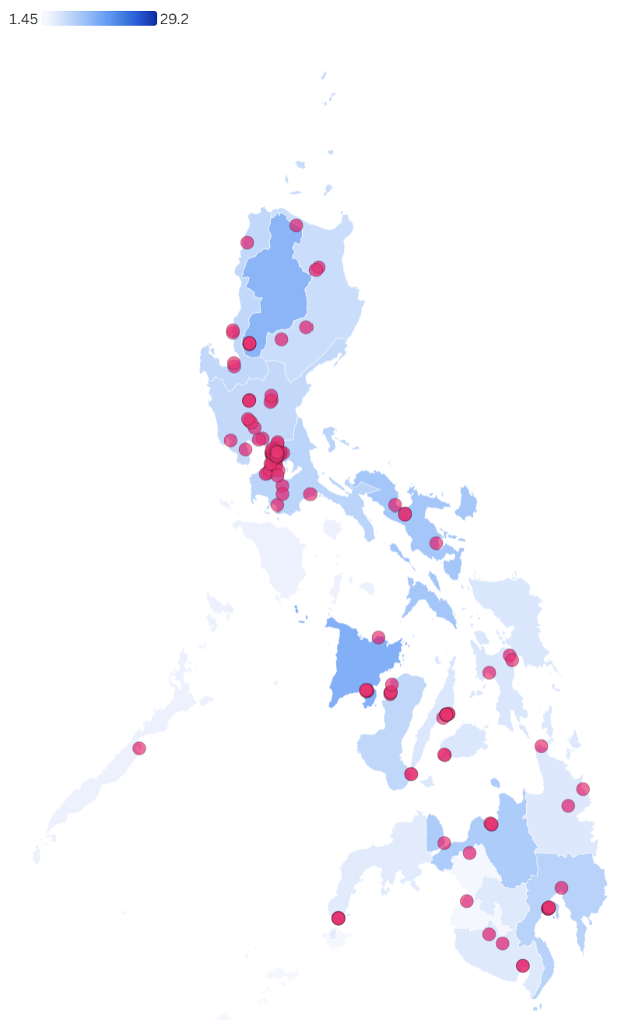
Supplementary Figure 6. Regional distribution of PhilHealth-accredited internists per 100,000 population (May 2025).
Left map: Base distribution. Right map: With 148 training institutions overlaid
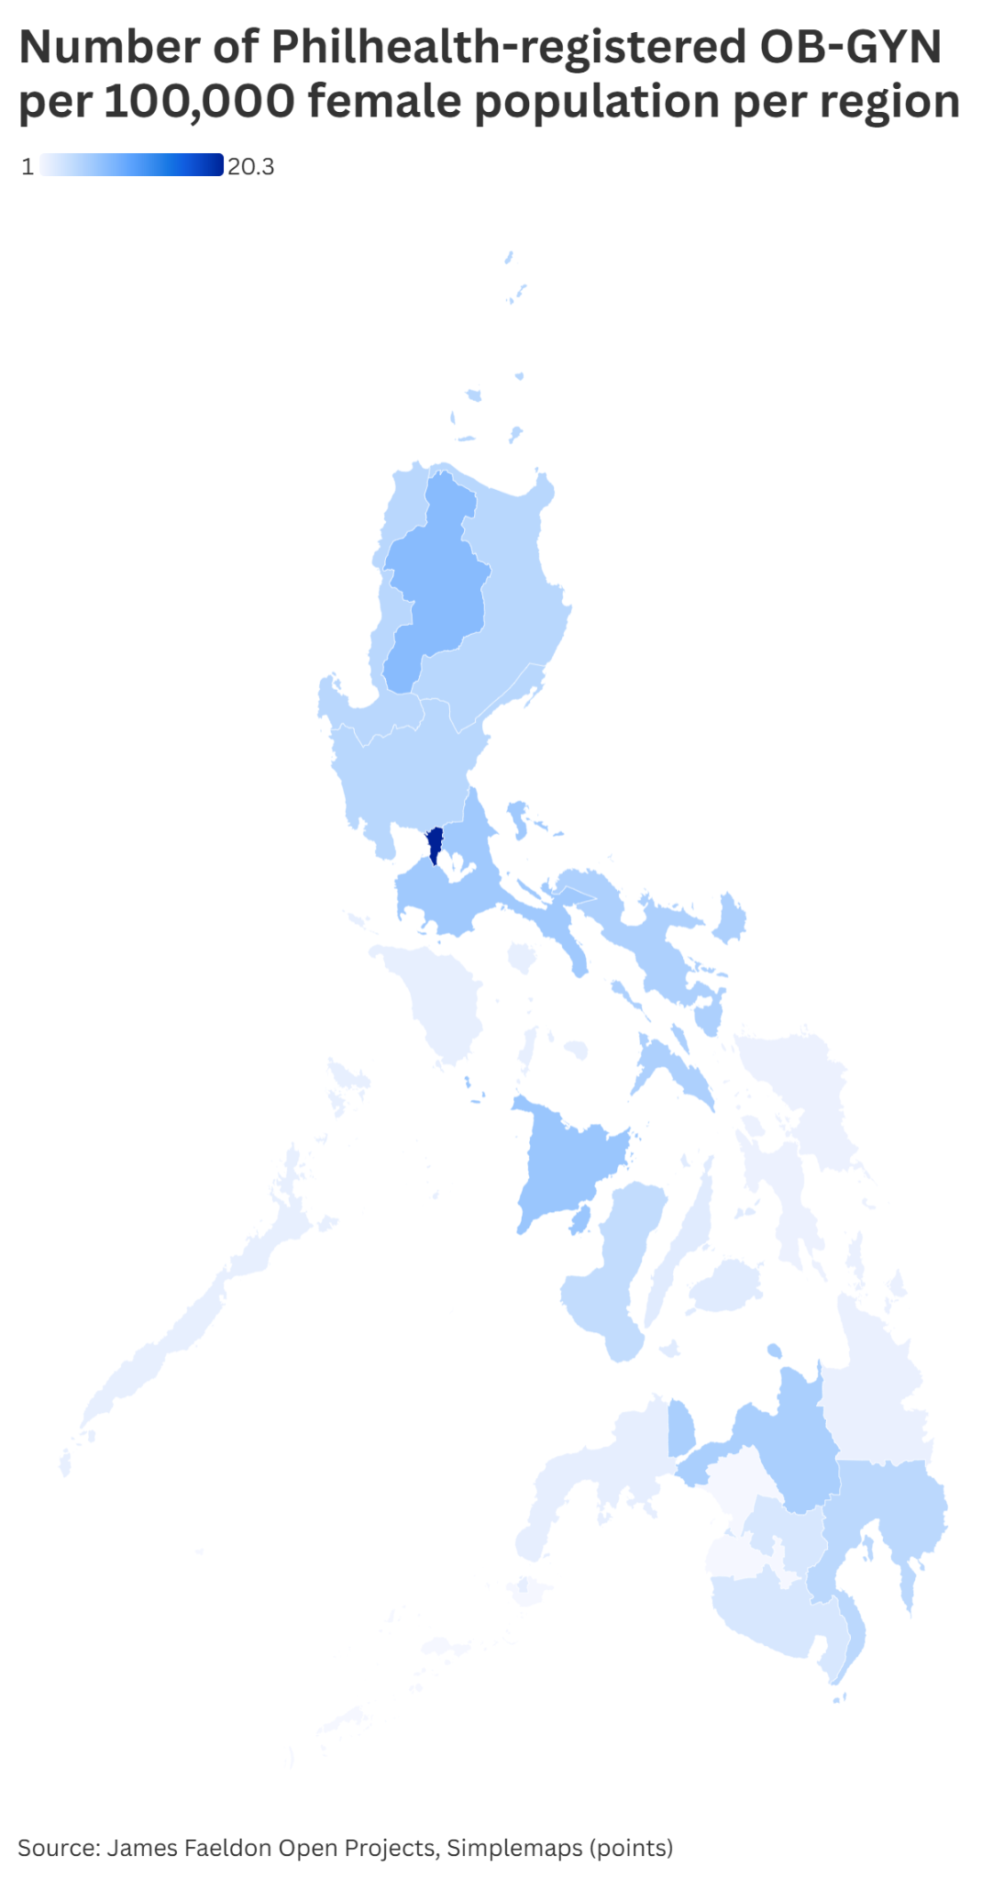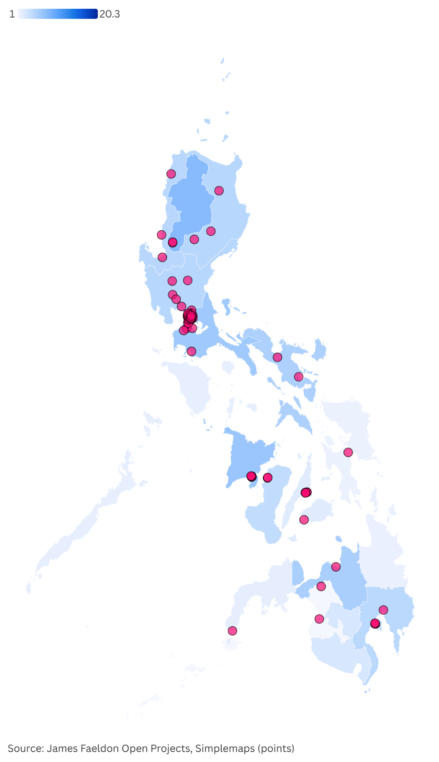
Supplementary Figure 7. Regional distribution of PhilHealth-accredited obstetricians-gynecologists per 100,000 female population (May 2025).
Left map: Base distribution. Right map: With 87 training institutions overlaid
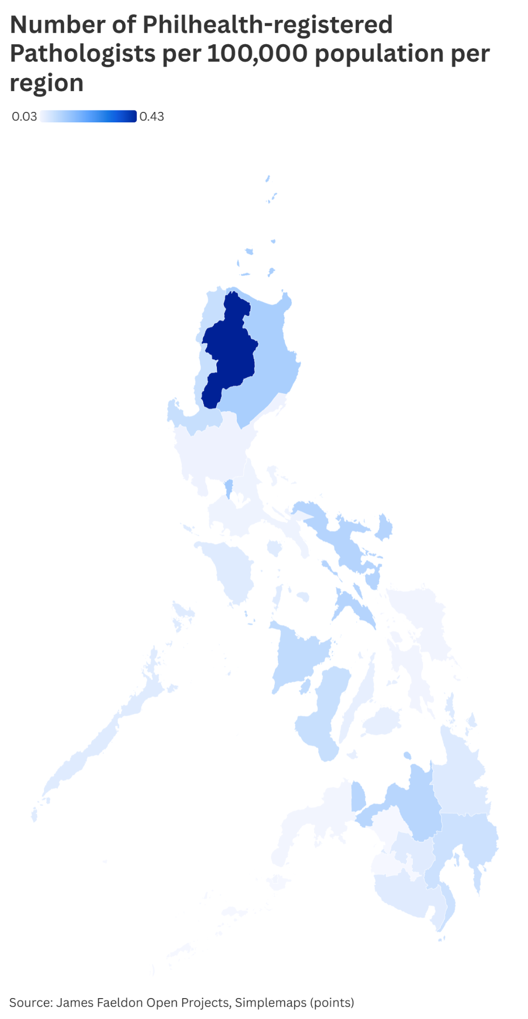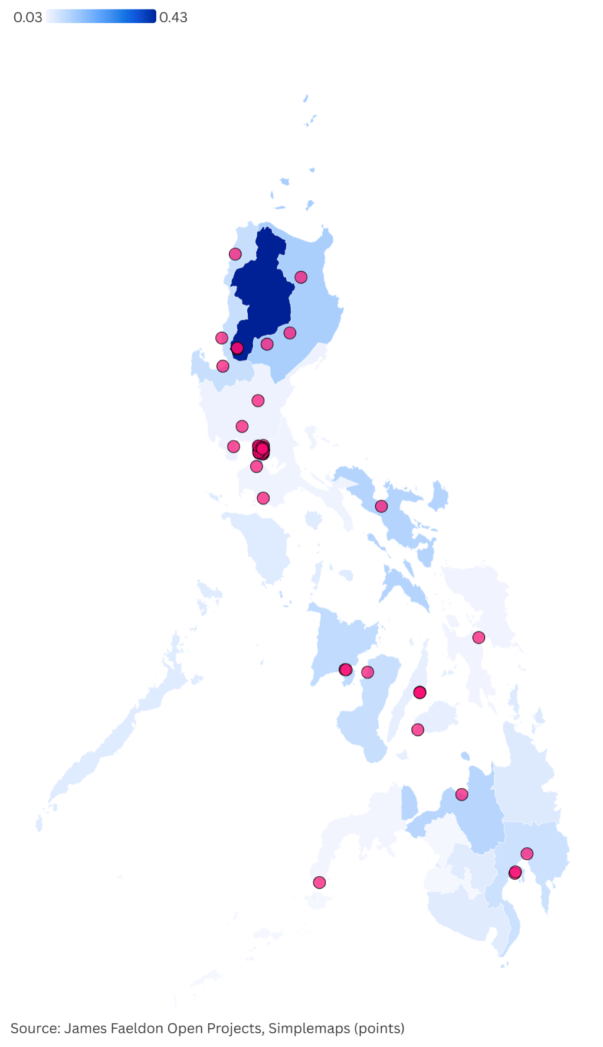
Supplementary Figure 8. Regional distribution of PhilHealth-accredited pathologists per 100,000 population (May 2025).
Left map: Base distribution. Right map: With 53 training institutions overlaid
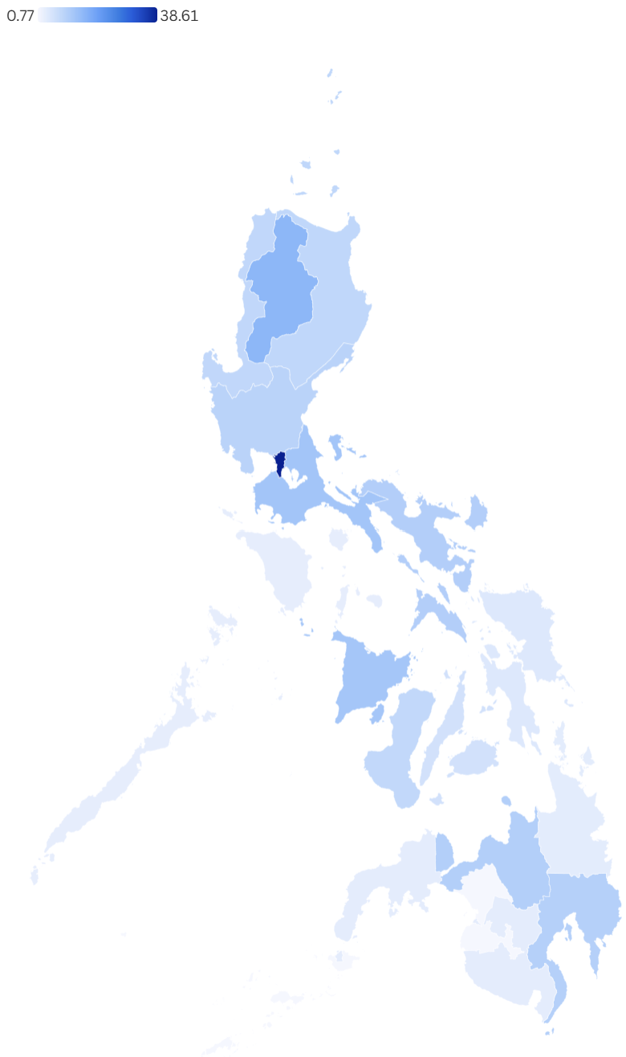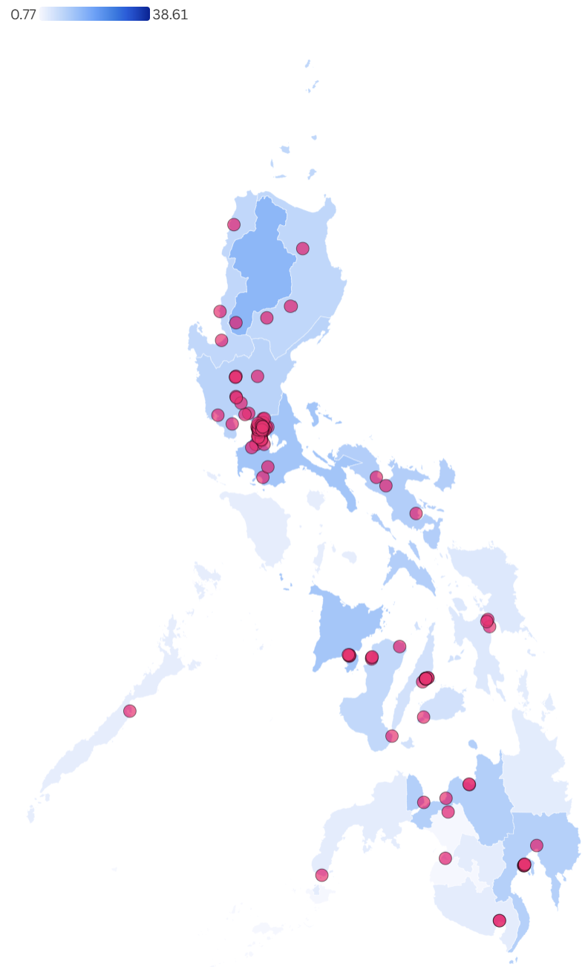
Supplementary Figure 9. Regional distribution of PhilHealth-accredited pediatricians per 100,000 population ages 0-18 (May 2025).
Left map: Base distribution. Right map: With 126 training institutions overlaid
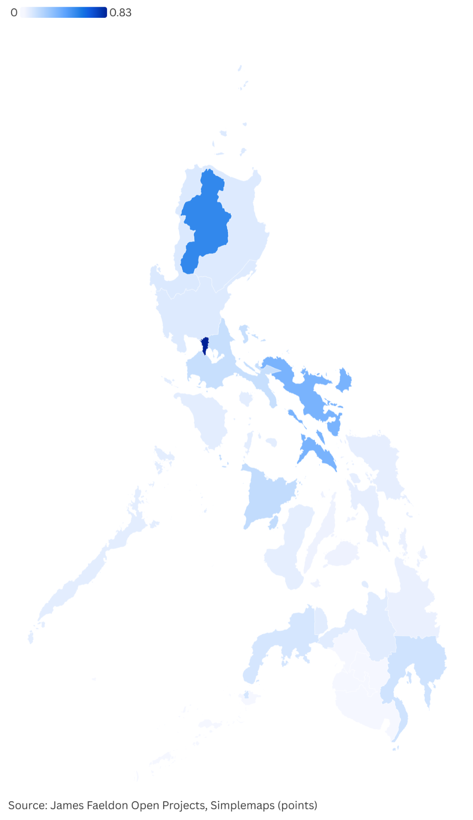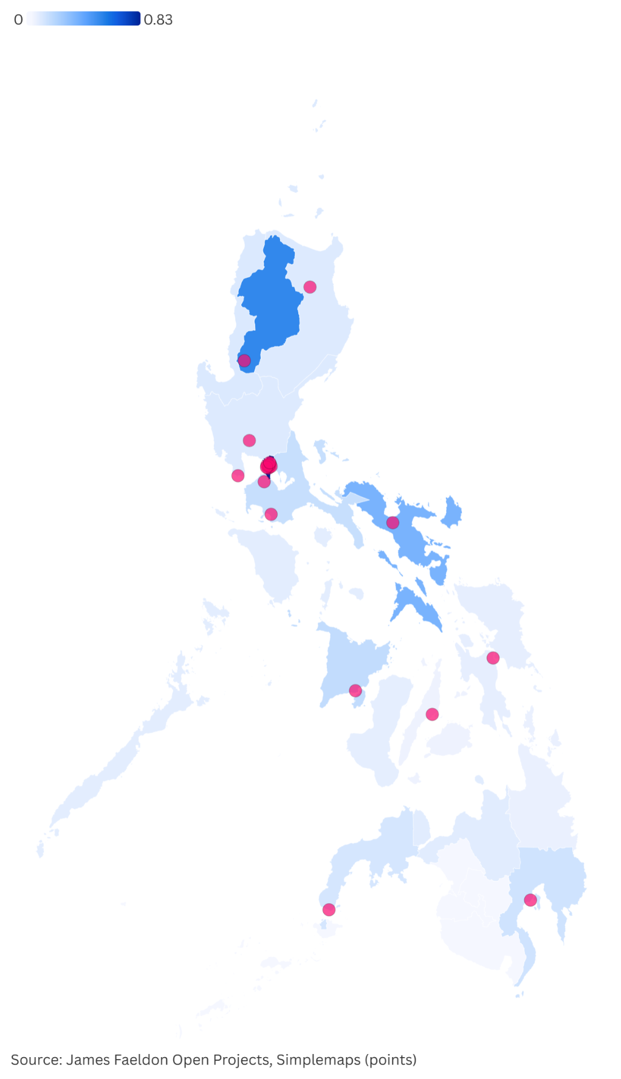
Supplementary Figure 10. Regional distribution of PhilHealth-accredited psychiatrists per 100,000 population (May 2025).
Left map: Base distribution. Right map: With 20 training institutions overlaid
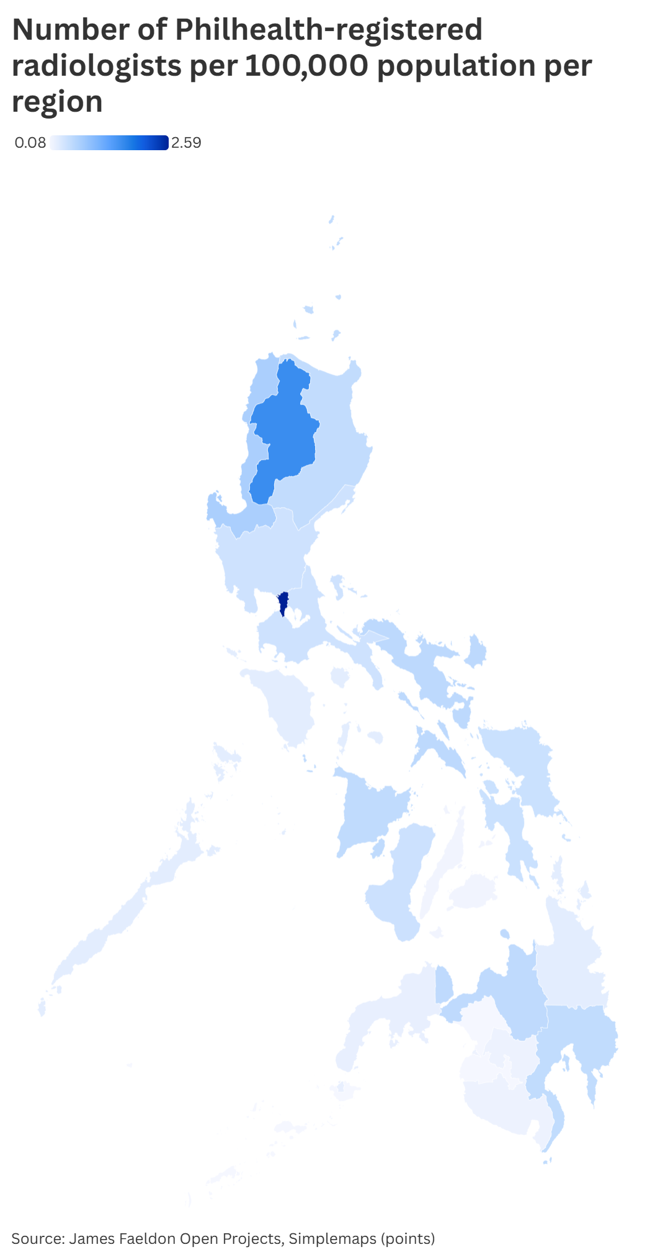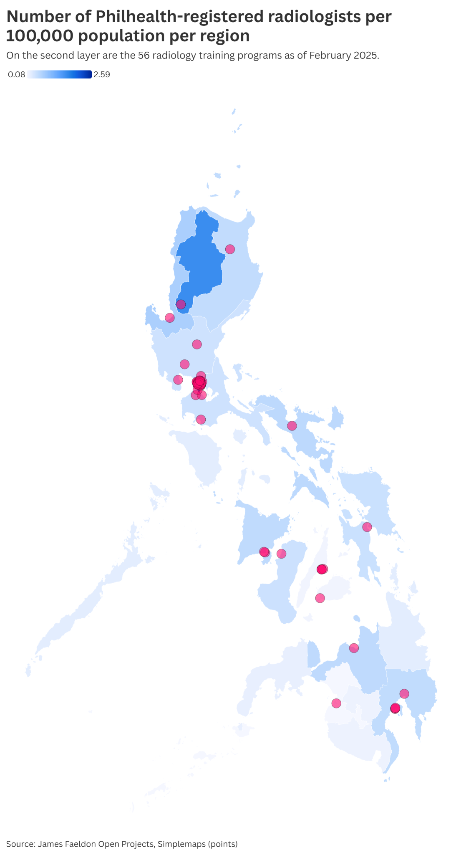
Supplementary Figure 11. Regional distribution of PhilHealth-accredited radiologists per 100,000 population (May 2025).
Left map: Base distribution. Right map: With 56 training institutions overlaid
SET B: PROVINCIAL MAPS
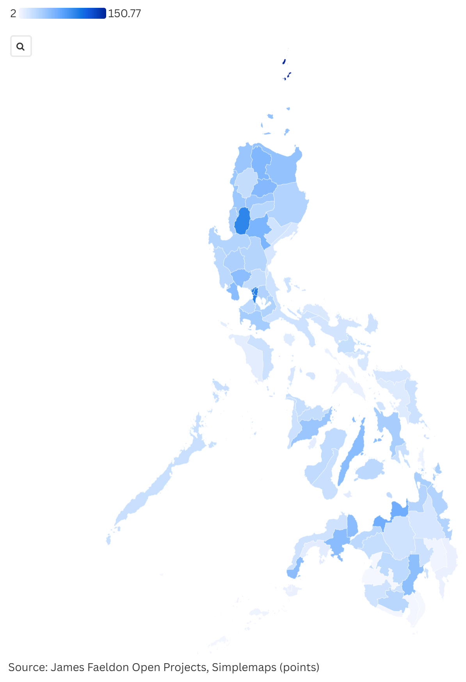
Supplementary Figure 12. Provincial distribution of all PhilHealth-accredited physicians per 100,000 population (May 2025).
Left map: Base distribution. Right map: With 85 medical schools overlaid
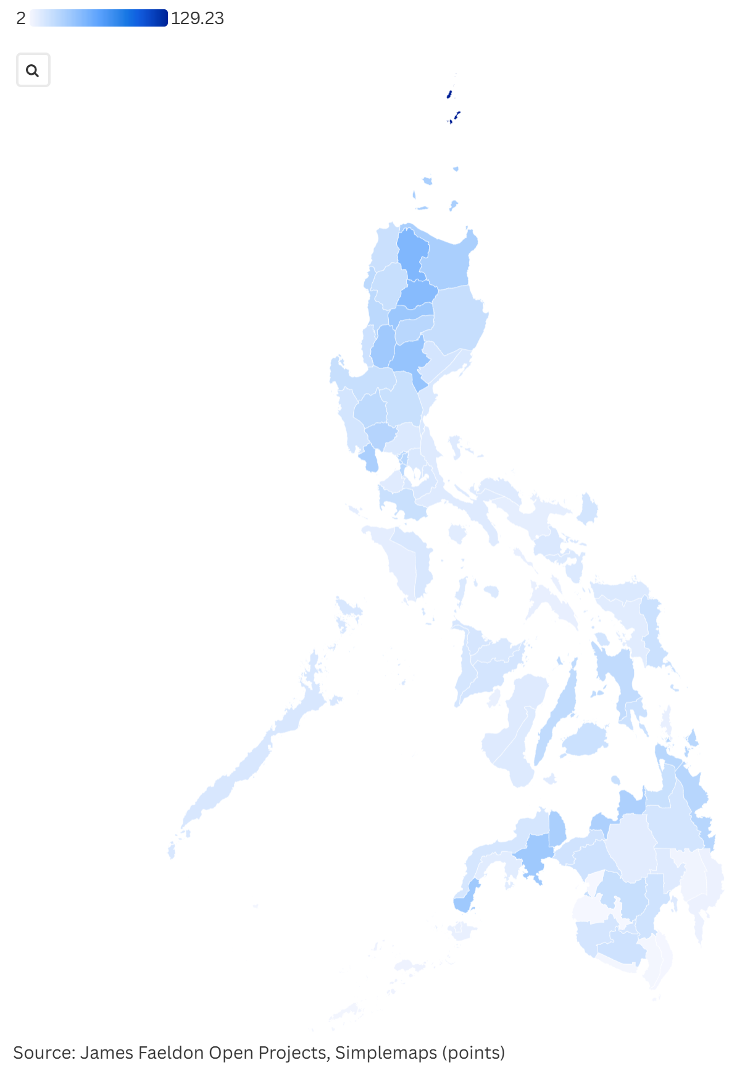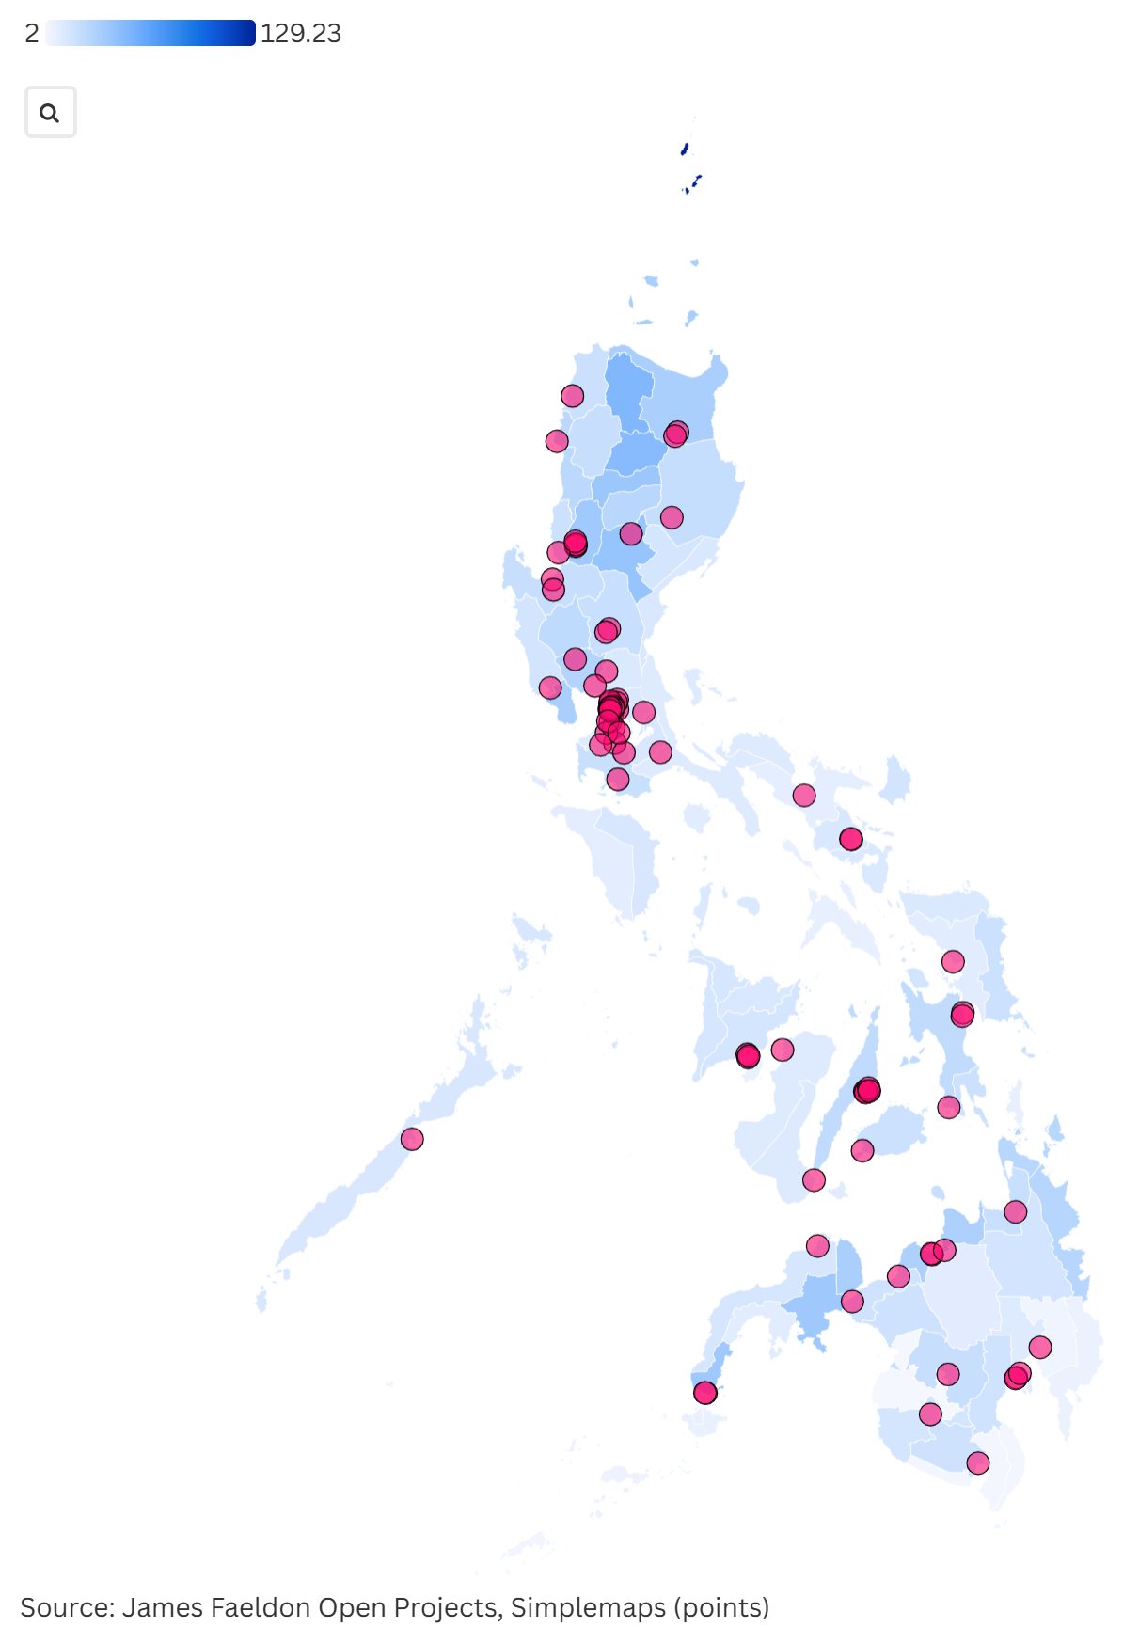
Supplementary Figure 13. Provincial distribution of PhilHealth-accredited general physicians per 100,000 population (May 2025).
Left map: Base distribution. Right map: With 85 medical schools overlaid
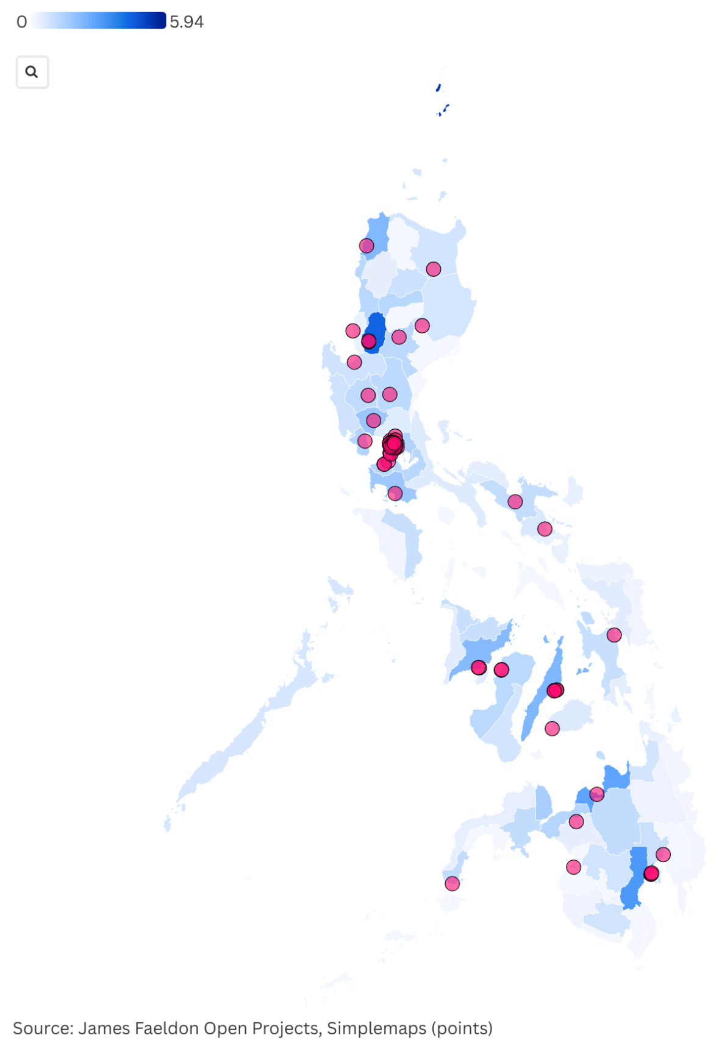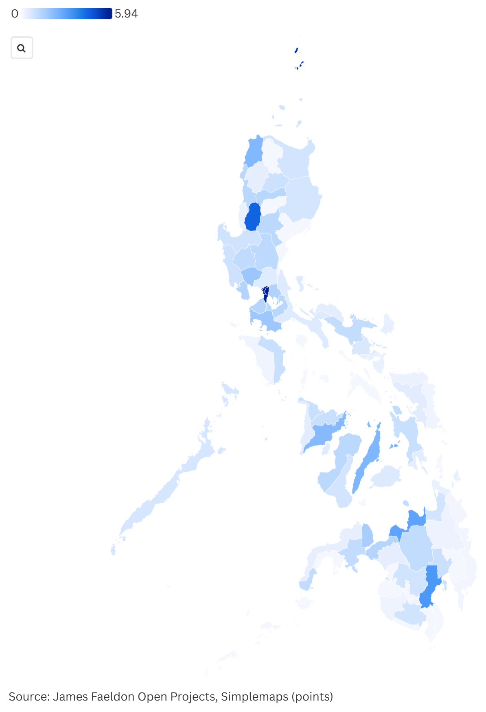
Supplementary Figure 14. Provincial distribution of PhilHealth-accredited anesthesiologists per 100,000 population (May 2025).
Left map: Base distribution. Right map: With 66 training institutions overlaid
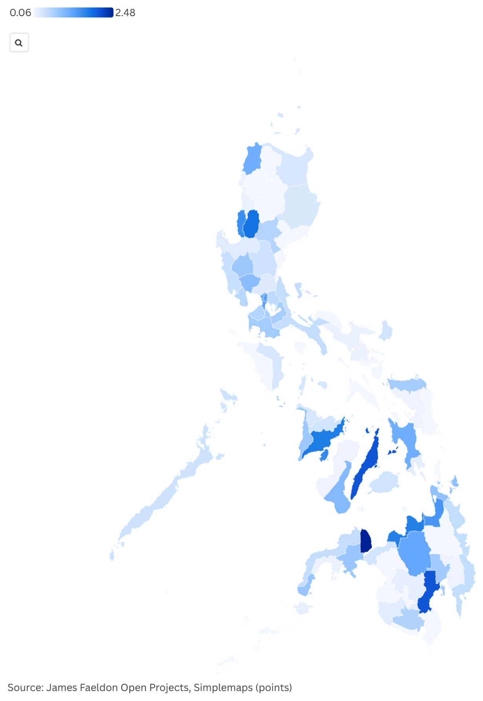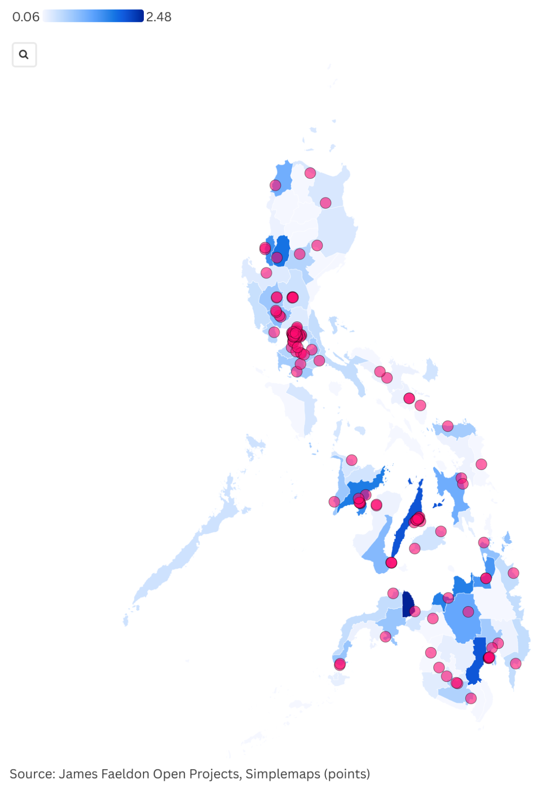
Supplementary Figure 15. Provincial distribution of PhilHealth-accredited family medicine physicians per 100,000 population (May 2025).
Left map: Base distribution. Right map: With 132 training institutions overlaid
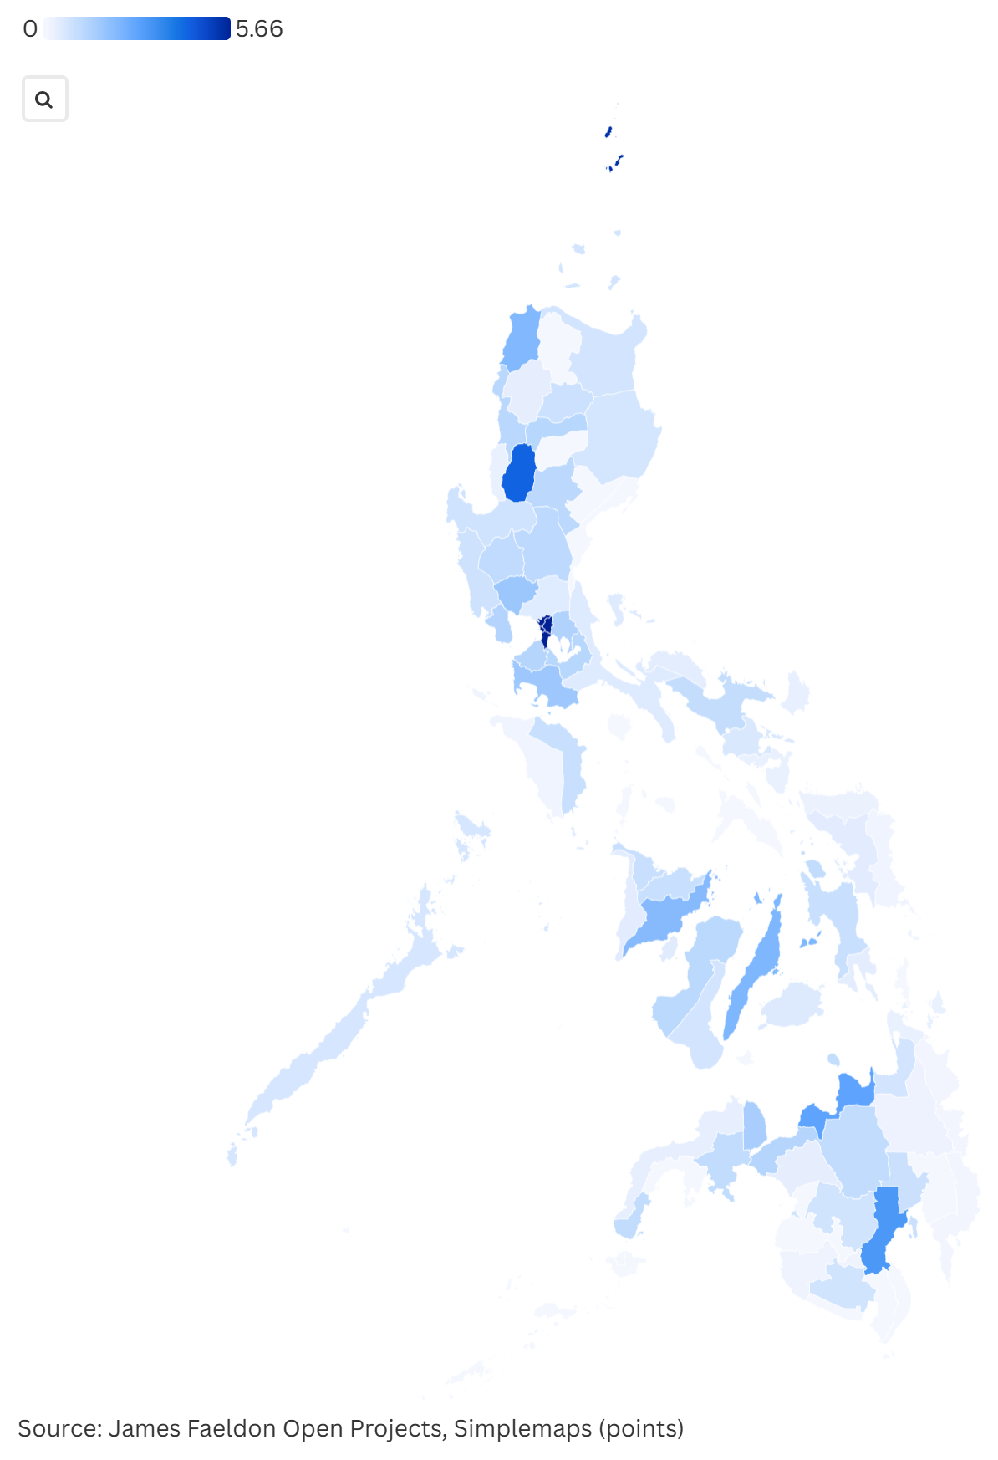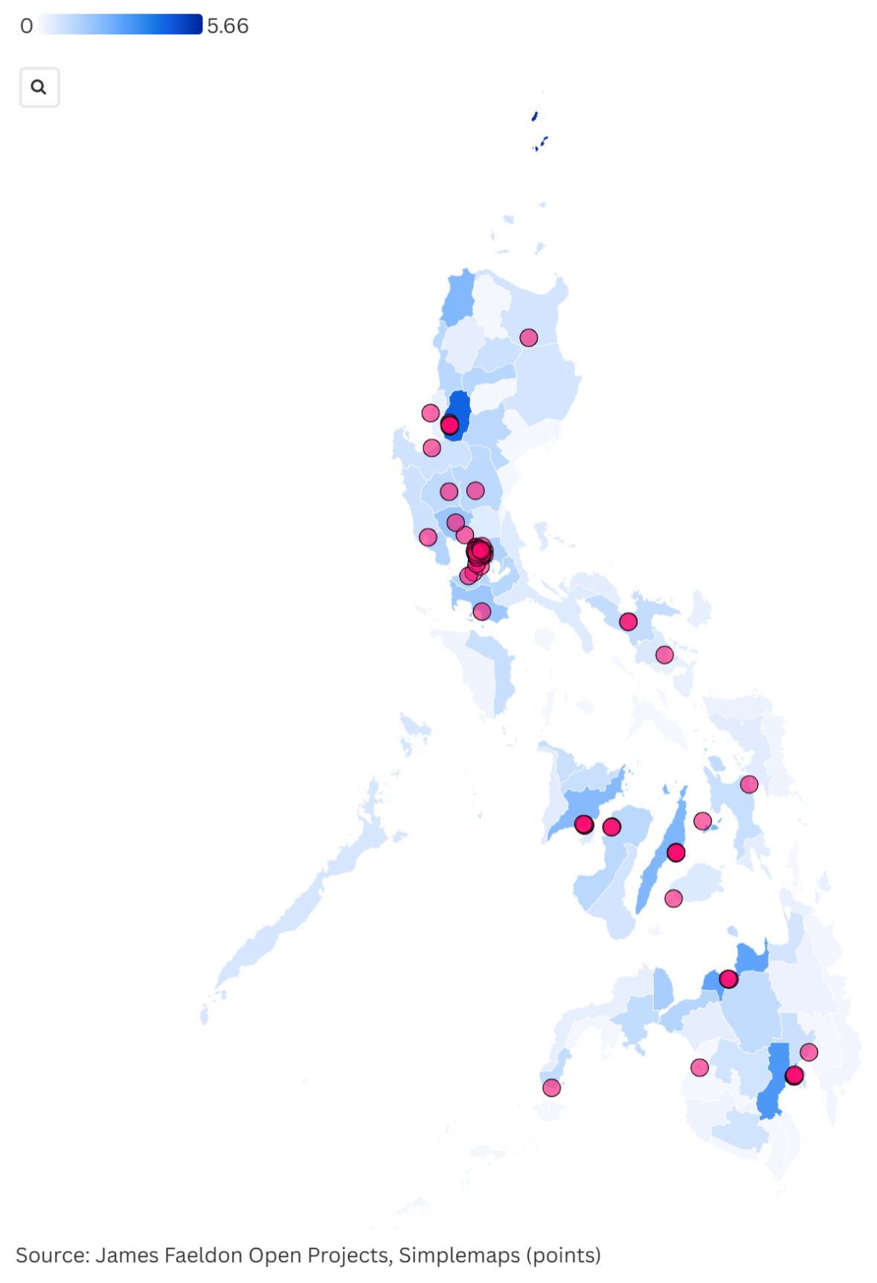
Supplementary Figure 16. Provincial distribution of PhilHealth-accredited general surgeons per 100,000 population (May 2025).
Left map: Base distribution. Right map: With 74 training institutions overlaid
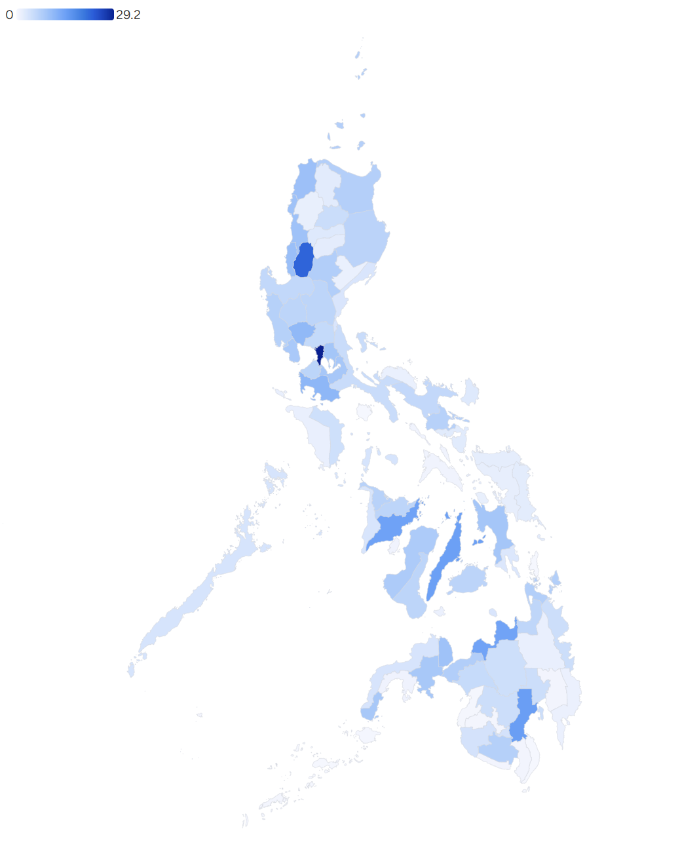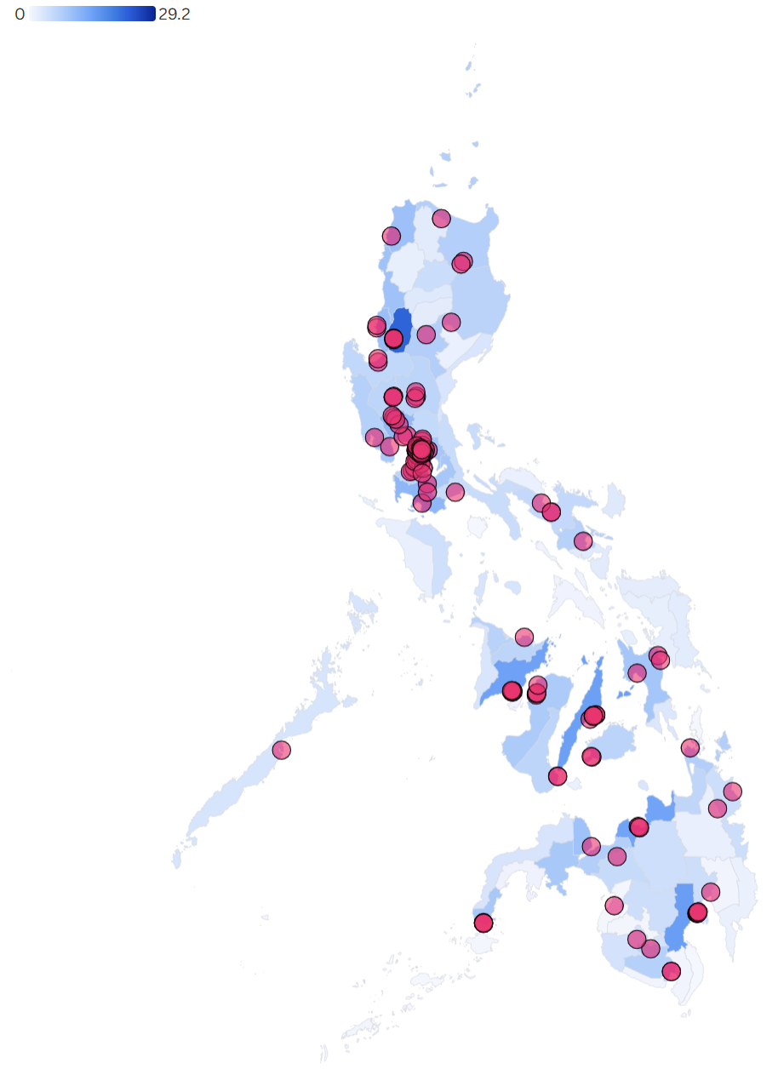
Supplementary Figure 17. Provincial distribution of PhilHealth-accredited internists per 100,000 population (May 2025).
Left map: Base distribution. Right map: With 148 training institutions overlaid
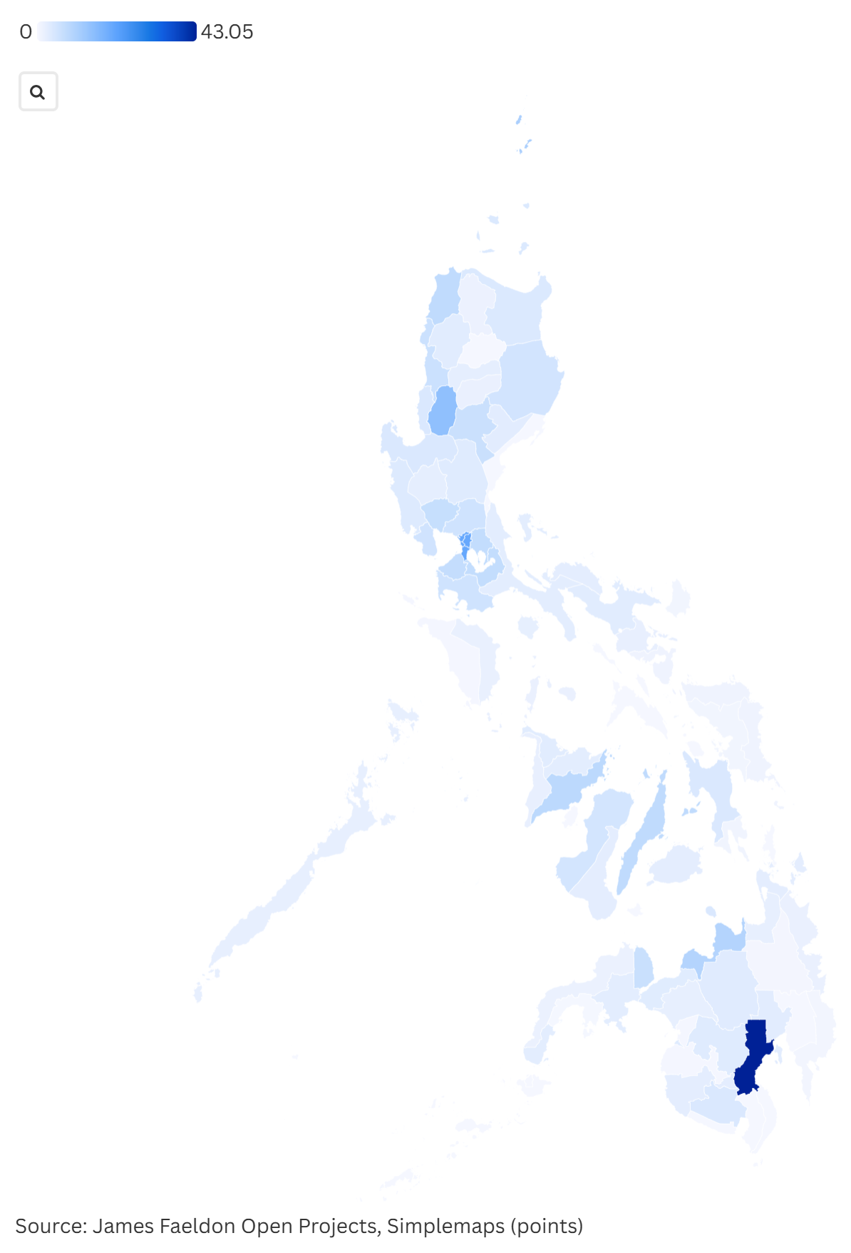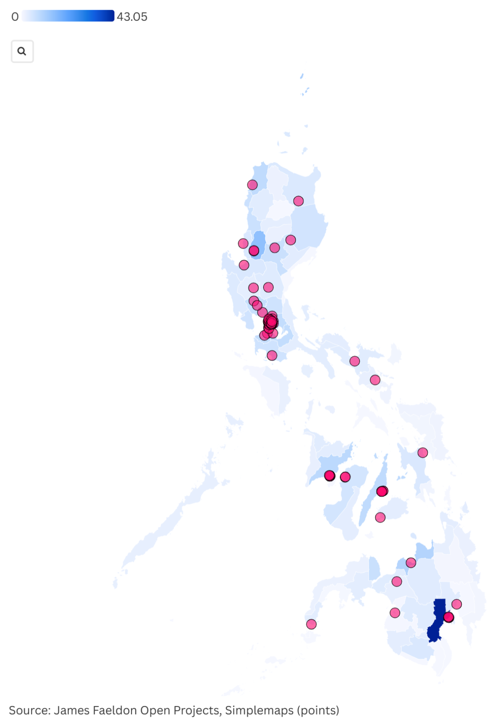
Supplementary Figure 18. Provincial distribution of PhilHealth-accredited obstetricians-gynecologists per 100,000 female population (May 2025).
Left map: Base distribution. Right map: With 87 training institutions overlaid
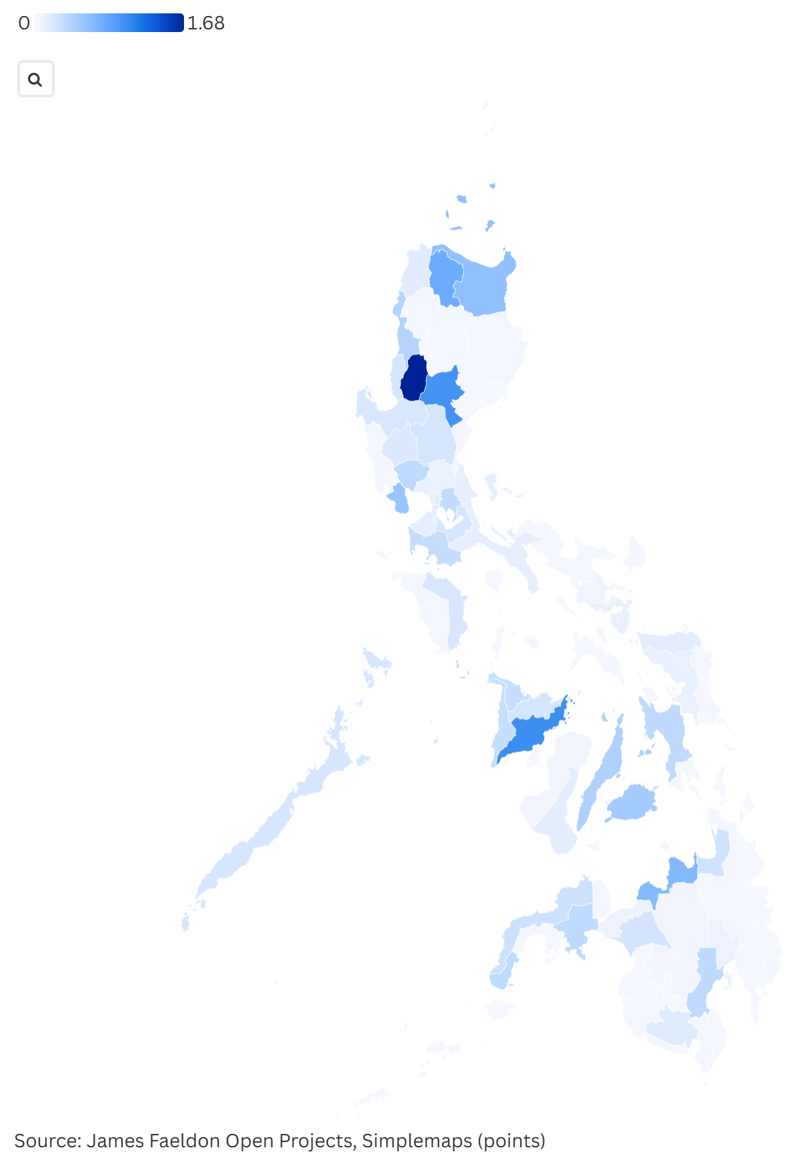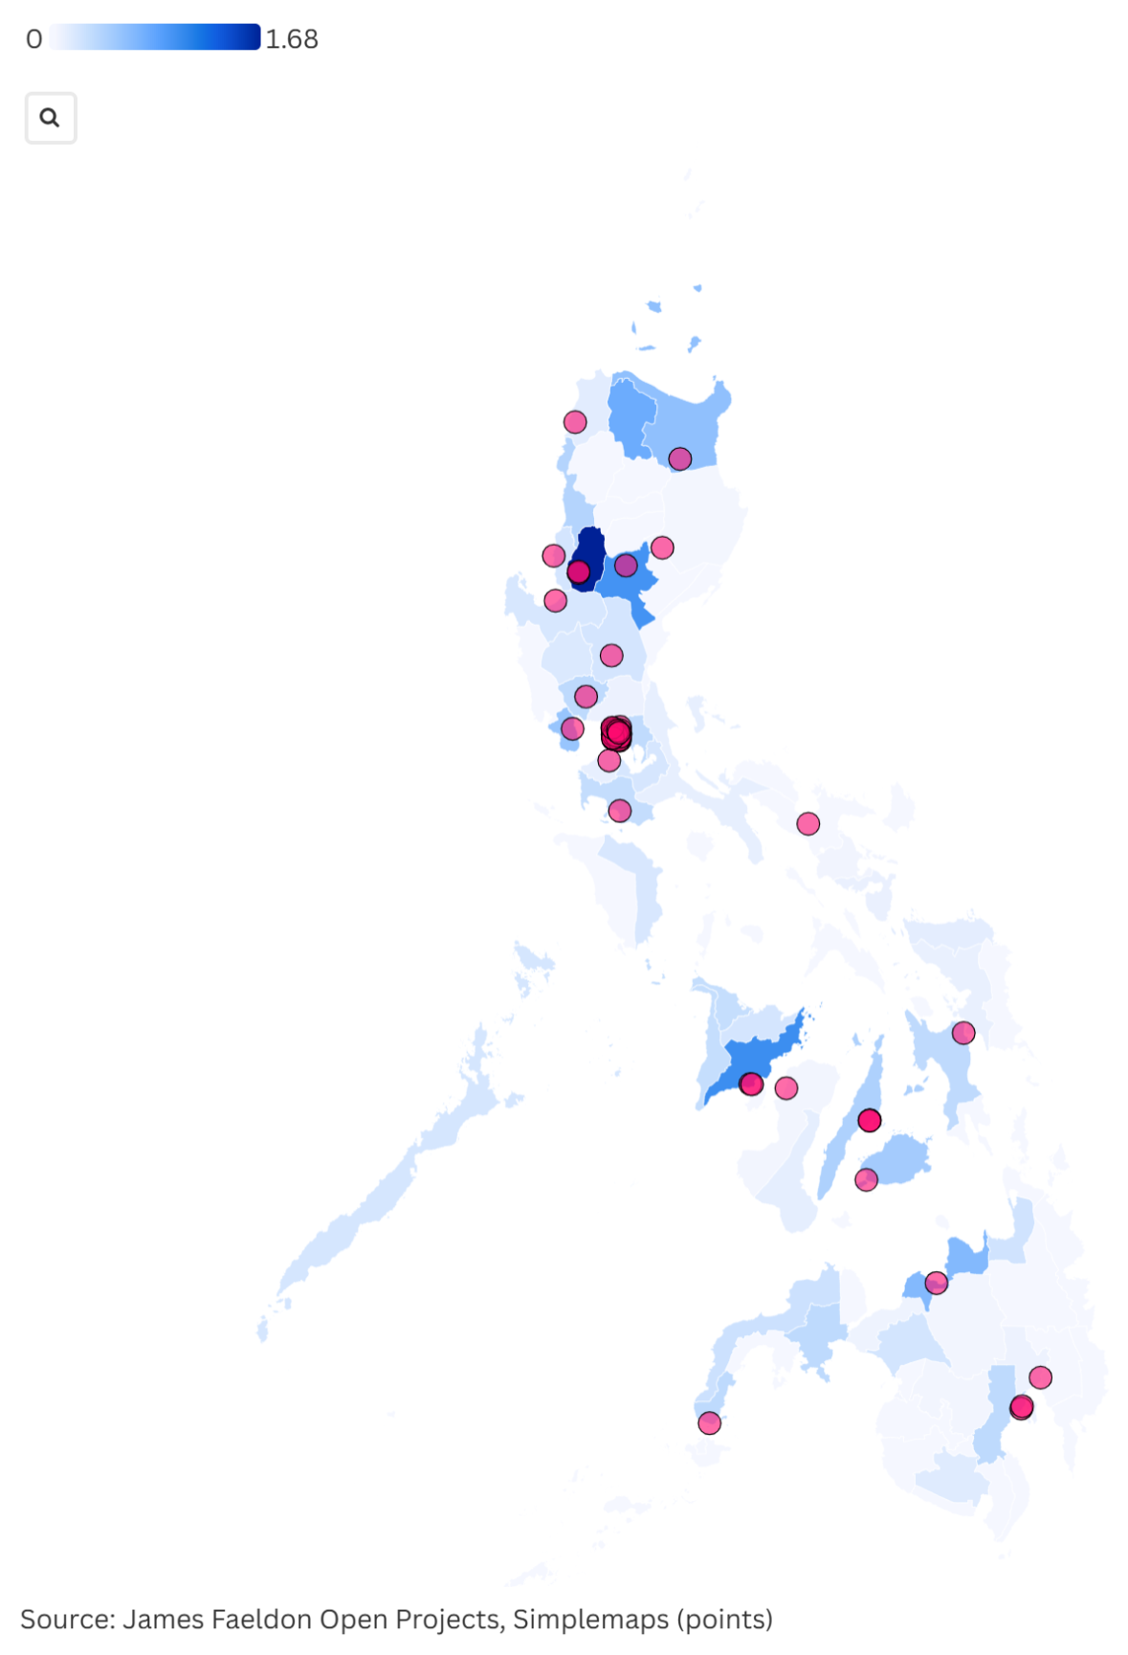
Supplementary Figure 19. Provincial distribution of PhilHealth-accredited pathologists per 100,000 population (May 2025).
Left map: Base distribution. Right map: With 53 training institutions overlaid
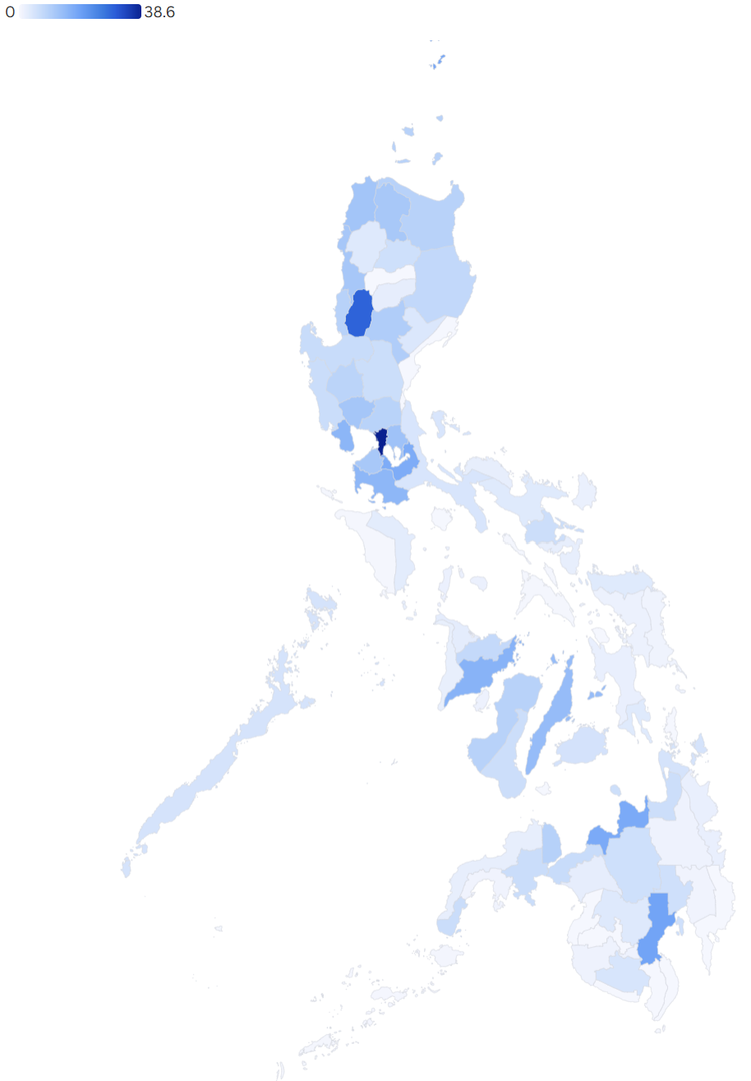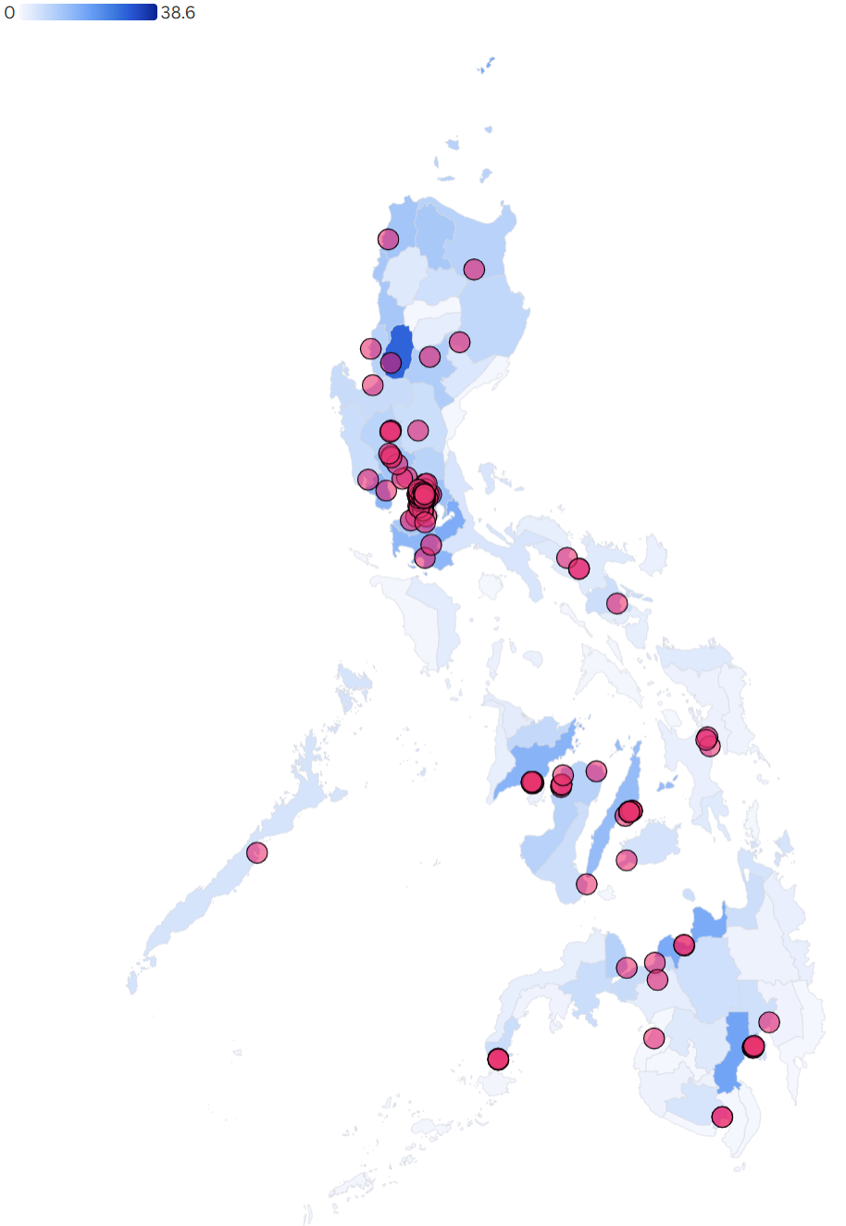
Supplementary Figure 20. Provincial distribution of PhilHealth-accredited pediatricians per 100,000 population ages 0-18 (May 2025).
Left map: Base distribution. Right map: With 126 training institutions overlaid
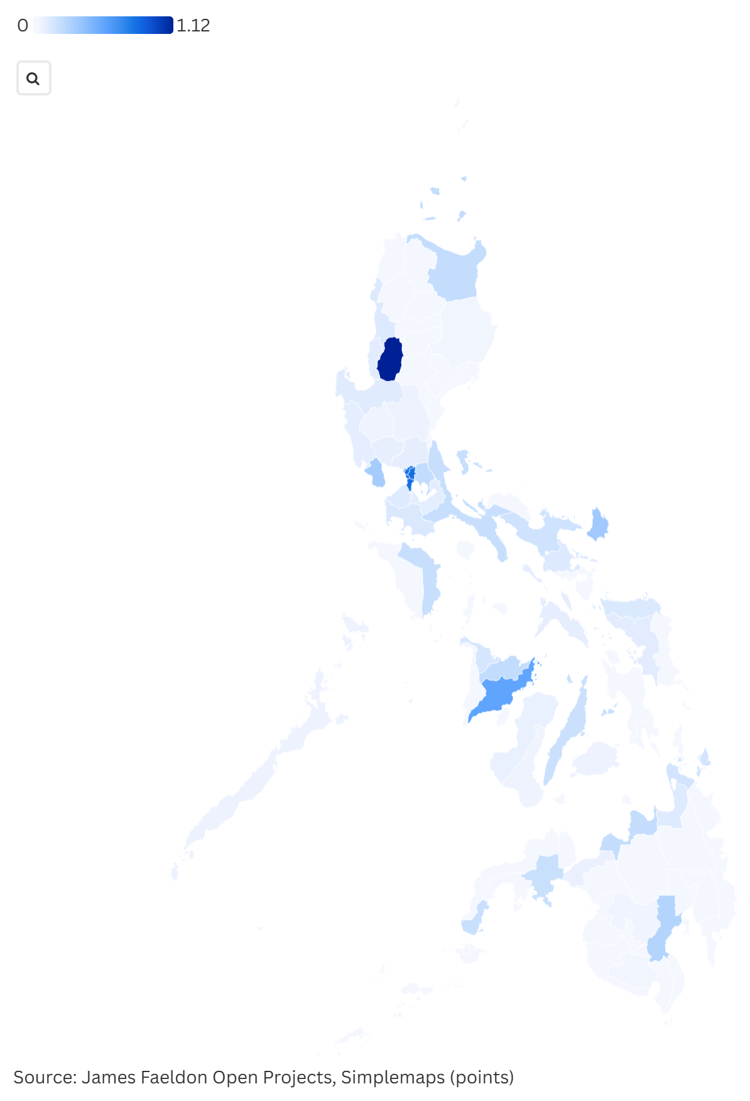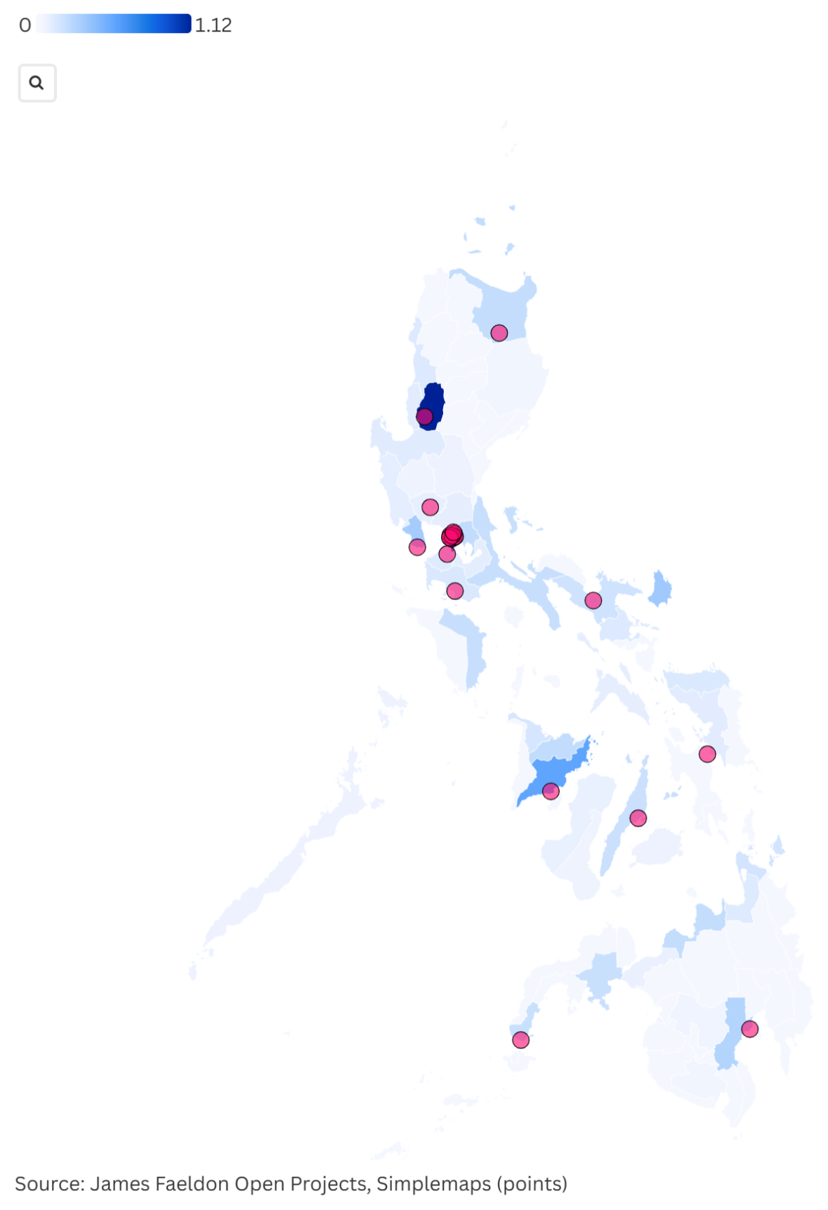
Supplementary Figure 21. Provincial distribution of PhilHealth-accredited psychiatrists per 100,000 population (May 2025).
Left map: Base distribution. Right map: With 20 training institutions overlaid
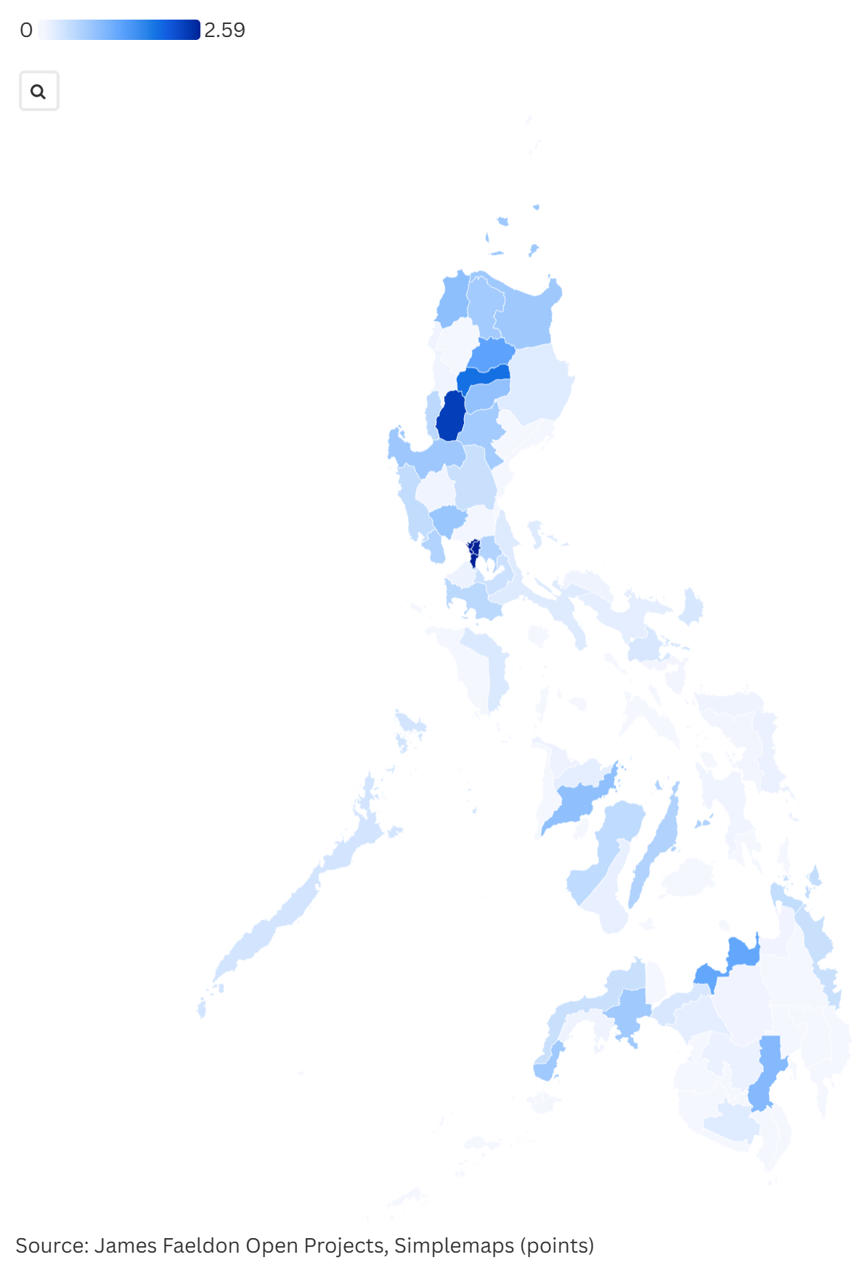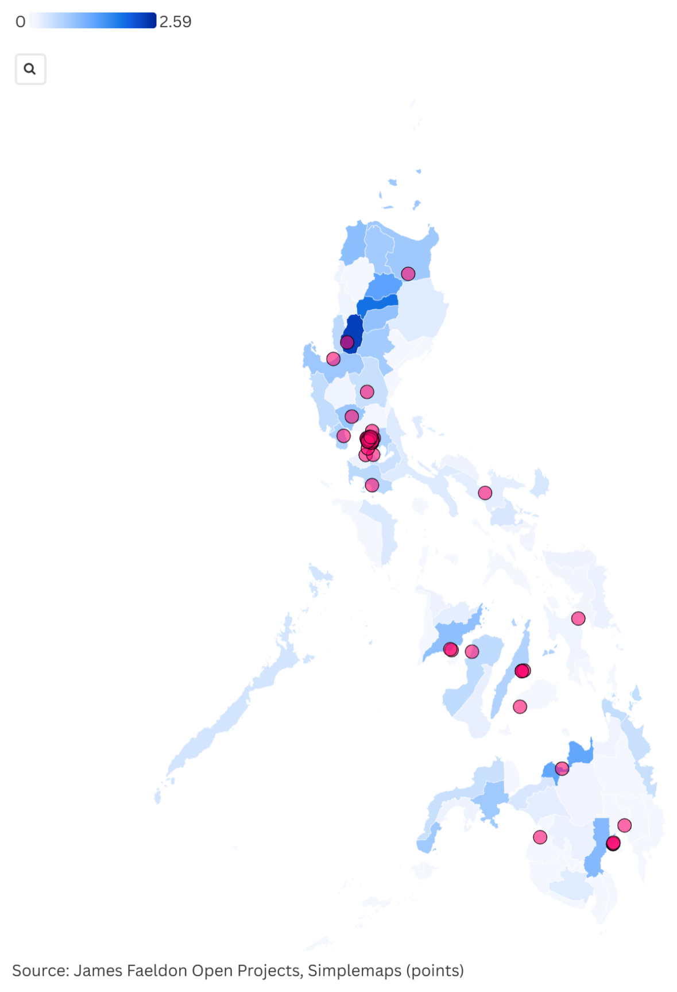
Supplementary Figure 22. Provincial distribution of PhilHealth-accredited radiologists per 100,000 population (May 2025).
Left map: Base distribution. Right map: With 56 training institutions overlaid

