Supplementary Information
Supplementary Methods
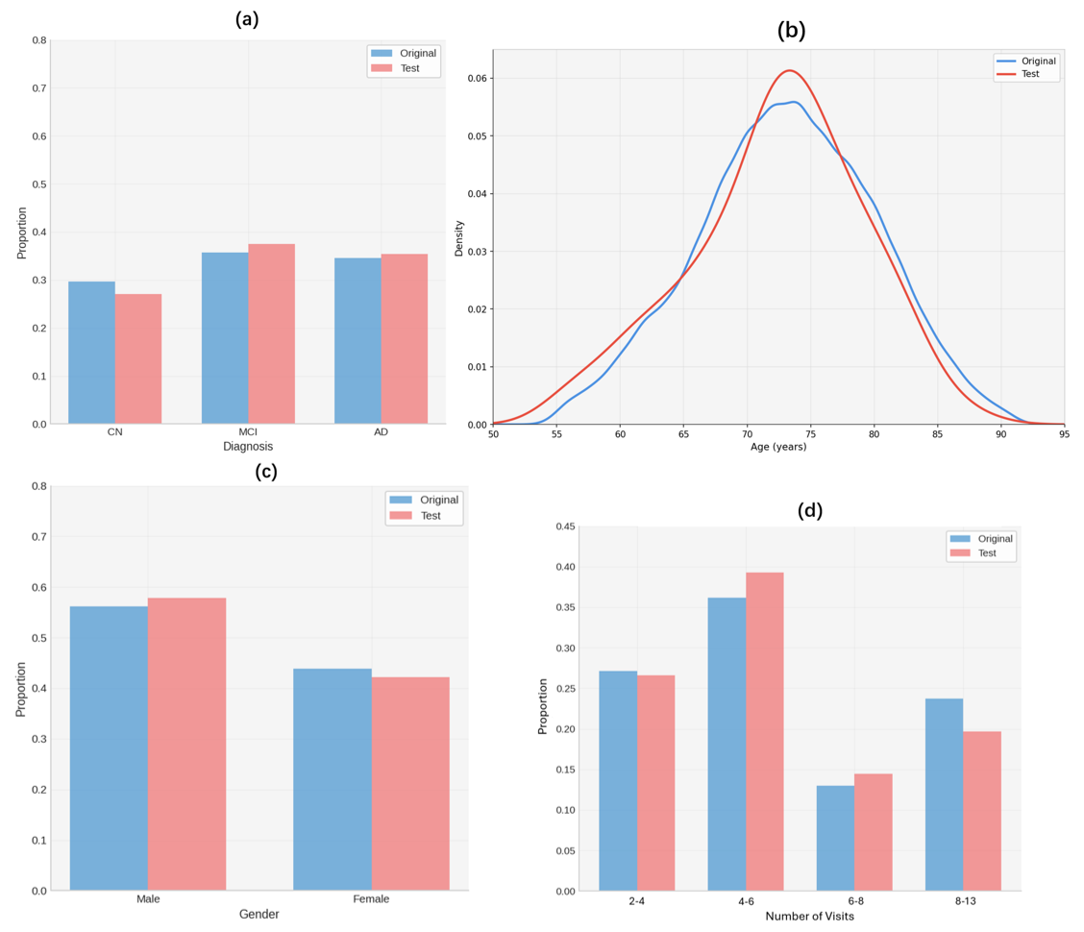
Supplementary Figure 1: Stratified data splitting strategy for TADPOLE dataset. (a) Diagnosis distribution in original and test sets. (b) Age distribution in original and test sets. (c) Gender distribution in original and test sets. (d) Number of clinical visits distribution in original and test sets. The distribution plots showed that the stratified data splitting strategy considered multiple factors to retain the almost same characteristics between the original dataset and the hold-out testing set, ensuring the proposed framework was evaluated fairly.

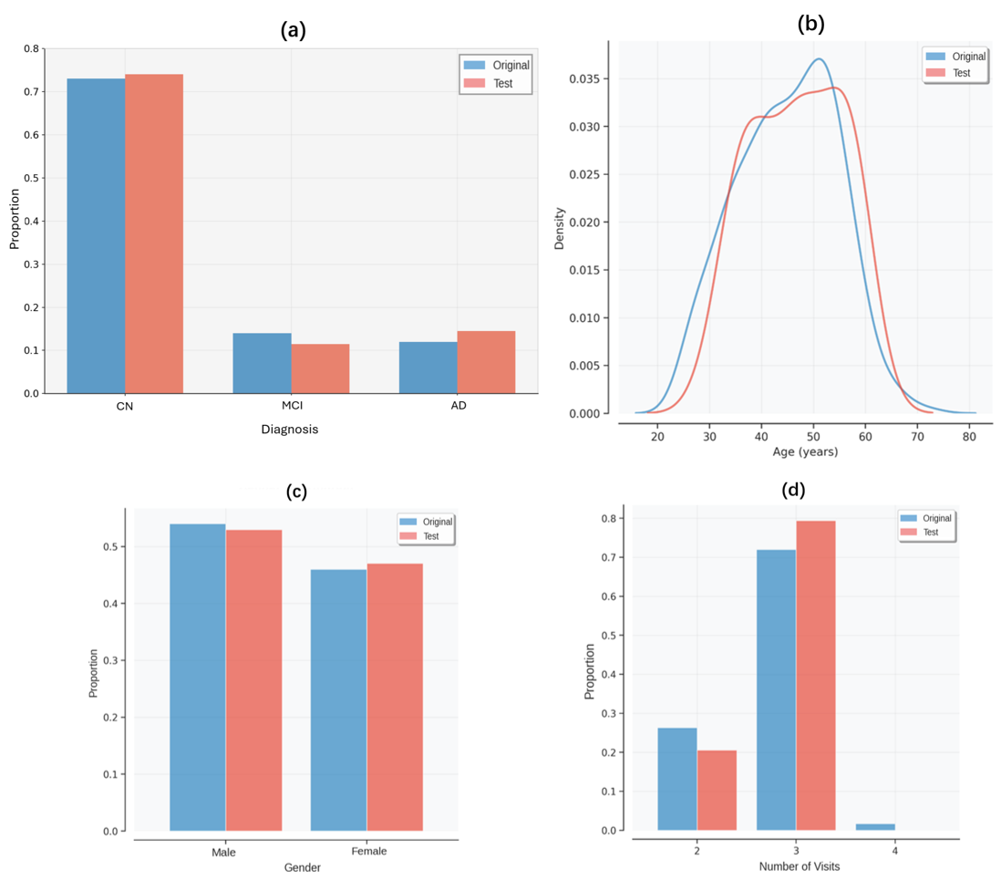
Supplementary Figure 2: Stratified data splitting strategy for ABC-DS dataset. (a) Diagnosis distribution in original and test sets. (b) Age distribution in original and test sets. (c) Gender distribution in original and test sets. (d) Number of clinical visits distribution in original and test sets.
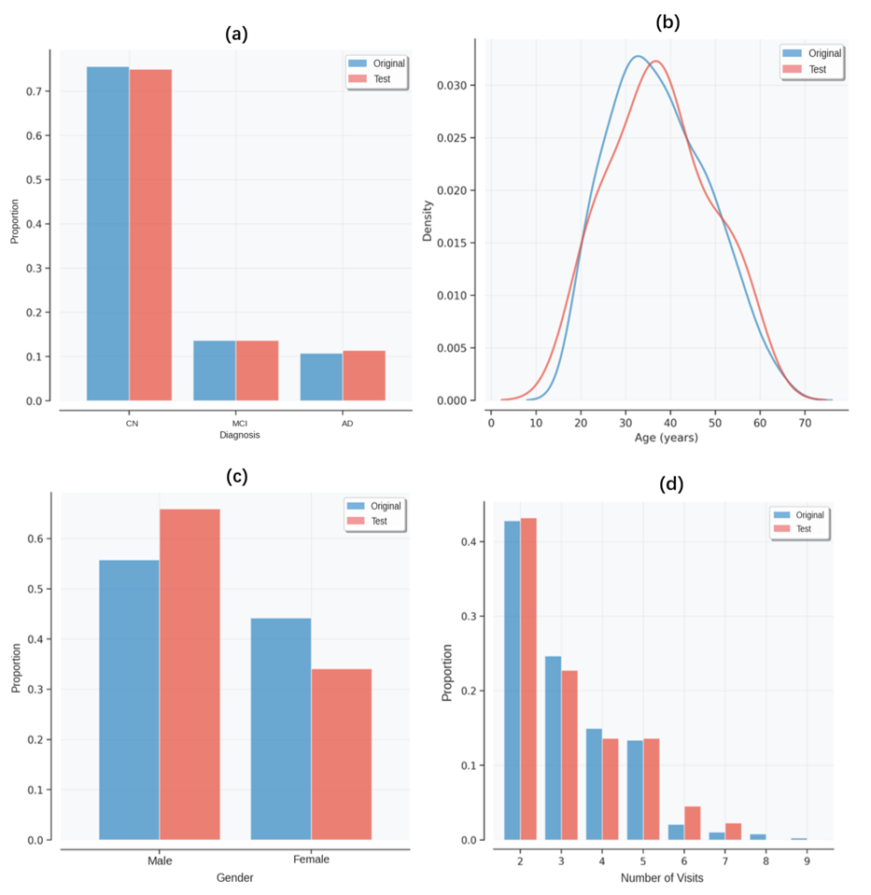
Supplementary Figure 3: Stratified data splitting strategy for DIAN dataset. (a) Diagnosis distribution in original and test sets. (b) Age distribution in original and test sets. (c) Gender distribution in original and test sets. (d) Number of clinical visits distribution in original and test sets.

