Table 1. Calculated pK_{a} of some coupling additives using pK_{a} GALAS prediction algorithm from ACD/Percepta.[25] The uncertainty of the prediction reported after the ± sign can be used as a reference point for the prediction quality with the value of 0.4 indicating the highest accuracy offered by the algorithm.
Sl. No | IUPAC name | Structure | Abbreviation | GALAS | Ref
1 | Ethyl-2-cyano-2-(hydroxyimino)acetate | 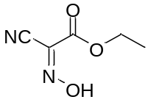 | OxymaPure | 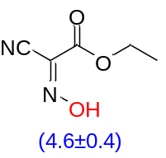 | [31, 32]
2 | tert-Butyl-2-cyano-2-(hydroxyimino)acetate | 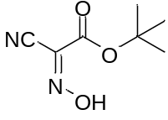 | - | 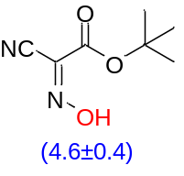 | [33]
3 | (2,2-Dimethyl-1,3-dioxolan-4-yl)methyl-2-cyano-2-(hydroxyimino)acetate | 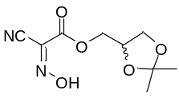 | - | 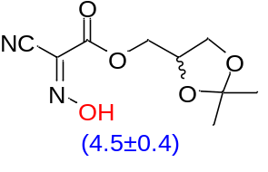 | [34]
4 | 2-Amino-N-hydroxy-2-oxoacetimidoyl cyanide | 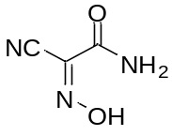 | Amox | 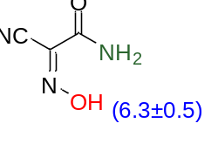 | [24]
5 | 2-(Ethylamino)-N-hydroxy-2-oxoacetimidoyl cyanide | 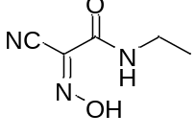 | N-Oxyma | 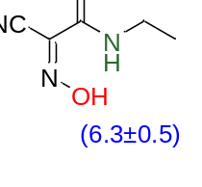 | [24]
6 | 2-(Dimethylamino)-N-hydroxy-2-oxoacetimidoyl cyanide | 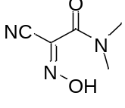 | DmOX | 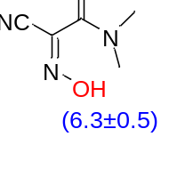 | [24]
7 | N-Dydroxy-2-oxo-2-(piperidin-1-yl)acetimidoyl cyanide | 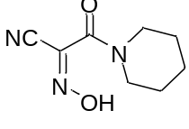 | PipOX | 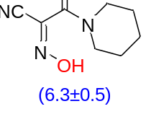 | [24]
8 | N-Hydroxy-2-morpholino-2-oxoacetimidoyl cyanide | 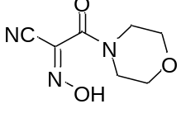 | MorOX | 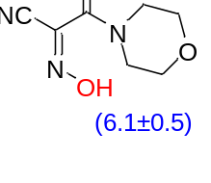 | [24]
9 | 5-(Hydroxyimino)-1,3-dimethylpyrimidine-2,4,6(1H,3H,5H)-trione | 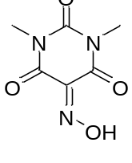 | Oxyma-B | 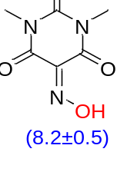 | [23]
10 | 1,3-Diethyl-5-(hydroxyimino)-2-thioxodihydropyrimidine-4,6(1H,5H)-dione | 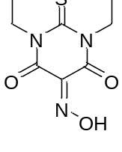 | Oxyma-T | 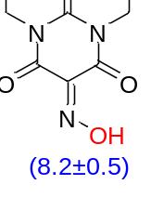 | [35]
11 | Hydroxyimino-2-phenylacetonitrile | 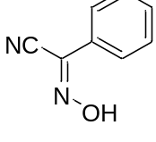 | - | 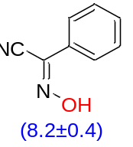 | [36-38]
12 | Hydroxyimino-2-(4-chloro)phenylacetonitrile | 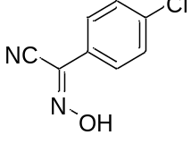 | - | 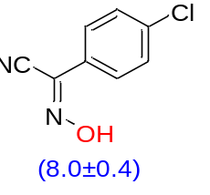 | [37]
13 | Hydroxypicolinimidoyl cyanide | 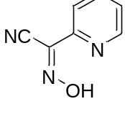 | - | 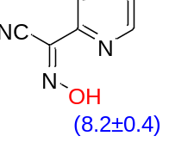 | [32, 36]
14 | Hydroxyimino-2-(1-naphtyl)phenylacetonitrile | 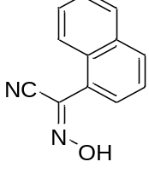 | - | 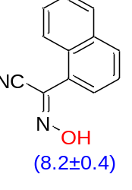 | [37]
15 | Hydroxycarbonimidoyl dicyanide | 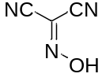 | - | 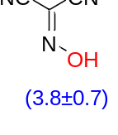 | [32]
16 | 1-Ethyl 3-methyl-2-(hydroxyimino)malonate | 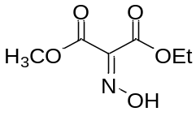 | - | 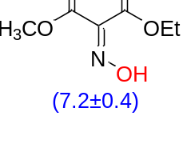 | [37]
17 | Diethyl 2-(hydroxyimino)malonate | 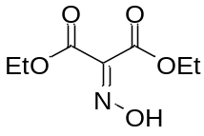 | - | 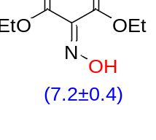 | [37]
18 | Diisopropyl 2-(hydroxyimino)malonate | 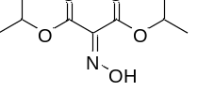 | - | 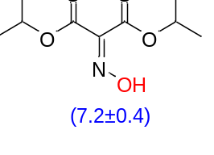 | [39]
19 | 5-(Hydroxyimino)-2,2-dimethyl-1,3-dioxane-4,6-dione | 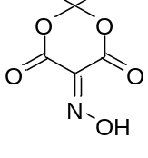 | HONM | 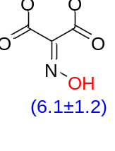 | [40]
20 | 1-Hydroxypyrrolidine-2,5-dione | 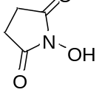 | HOSu | 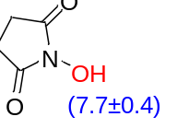 | [41]
21 | (4S,7S)-2-Hydroxy-3a,4,7,7a-tetrahydro-1H-4,7-methanoisoindole-1,3(2H)-dione | 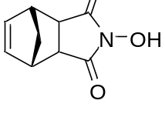 | HONB | 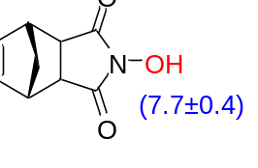 | [42]
22 | 1-Hydroxypyridin-2(1H)-one | 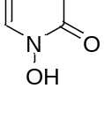 | HOPO | 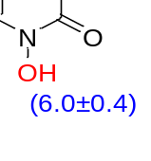 | [43]
23 | 2-Phenyl-1H-benzo[d]imidazol-1-ol | 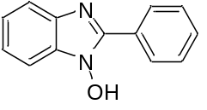 | HOBI | 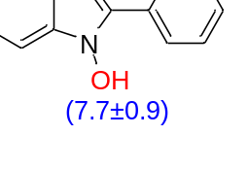 | [43]
24 | 6-Chloro-2-phenyl-1H-benzo[d]imidazol-1-ol | 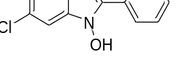 | 6-Cl-HOBI | 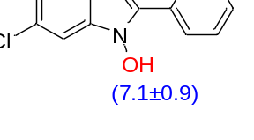 | [43]
25 | 3-Hydroxypyrido[3,2-d]pyrimidin-4(3H)-one | 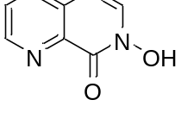 | HODhad | 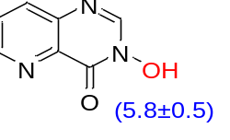 | [44]
26 | 2H-Tetrazol-2-ol | 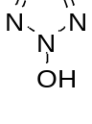 | - | 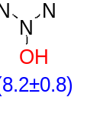 | [45]
27 | 1-Hydroxyindolin-2-one | 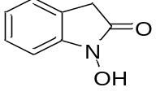 | HOI | 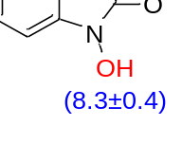 | [43]
28 | 2-(Hydroxyimino)-2-(pyrazin-2-yl)acetamide | 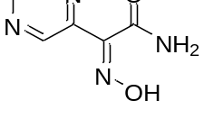 | - | 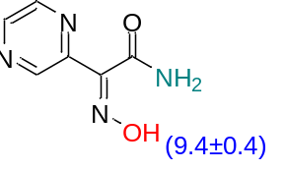 | -
29 | Ethyl-2-(hydroxyimino)-2-(pyrazin-2-yl)acetate | 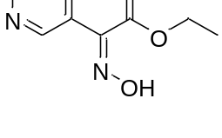 | - | 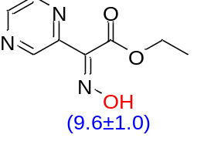 | -
30 | Ethyl-2-(furan-2-yl)-2-(hydroxyimino)acetate | 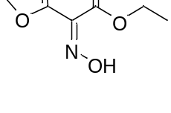 | - | 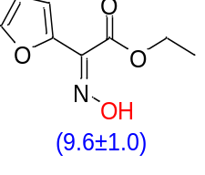 | -
31 | 2-(Furan-2-yl)-2-(hydroxyimino)acetamide | 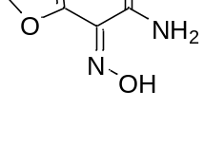 | - | 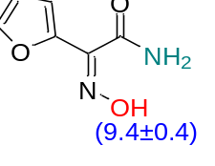 | -
32 | Ethyl 2-(hydroxyimino)-2-(thiazol-2-yl)acetate | 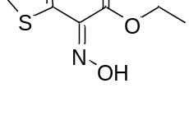 | - | 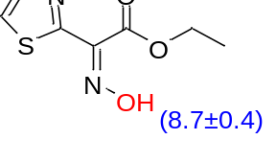 | -
33 | 2-(Hydroxyimino)-2-(thiazol-2-yl)acetamide | 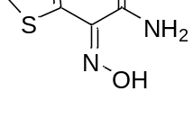 | - | 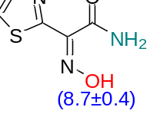 | -
34 | Ethyl 2-(hydroxyimino)-2-(pyrimidin-2-yl)acetate | 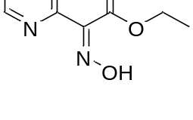 | - | 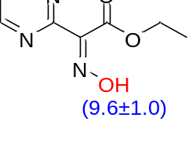 | -
35 | 2-(Hydroxyimino)-2-(pyrimidin-2-yl)acetamide | 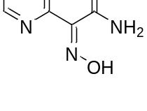 | - | 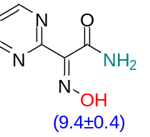 | -
36 | 2-(Hydroxyimino)-2-(pyrimidin-2-yl)ethanethioamide | 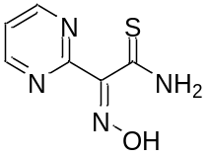 | - | 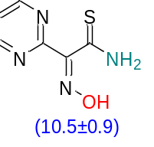 | -
37 | Ethyl 2-(furan-2-yl)-2-(hydroxyimino)acetate |  | - |  | -
38 | 2-(Hydroxyimino)-2-(1H-pyrrol-2-yl)acetamide | 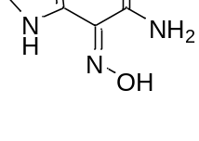 | - | 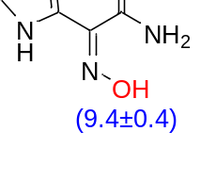 | -
39 | 2-(Hydroxyimino)-2-(thiophen-2-yl)acetamide | 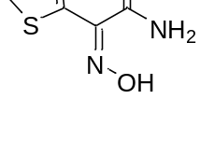 | - | 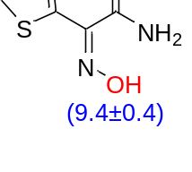 | -
40 | Ethyl 2-(hydroxyimino)-2-(1H-pyrrol-2-yl)acetate | 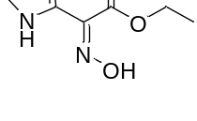 | - | 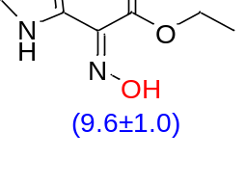 | -
41 | Ethyl 2-(hydroxyimino)-2-(thiophen-2-yl)acetate | 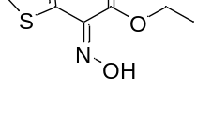 | - | 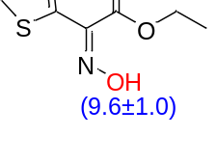 | -
42 | Ethyl 2-(hydroxyimino)-2-(pyridin-2-yl)acetate | 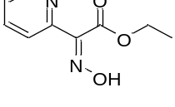 | - | 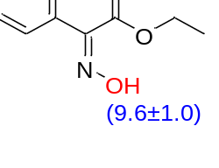 | [36]
43 | Ethyl 2-(hydroxyimino)-2-(pyridin-4-yl)acetate | 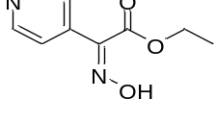 | - | 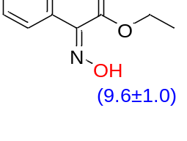 | -
44 | 2-(Hydroxyimino)but-3-ynamide | 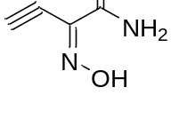 | - | 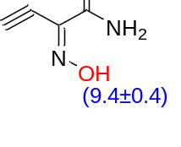 | -
45 | Ethyl 2-(hydroxyimino)but-3-ynoate | 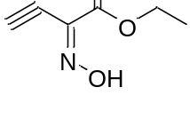 | - | 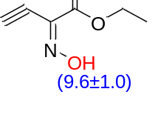 | -
46 | Ethyl 2-(hydroxyimino)-2-nitroacetate | 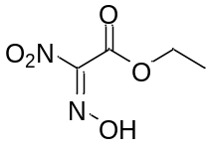 | - | 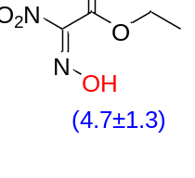 | [46, 47]
47 | Dinitromethanone oxime | 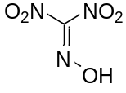 | - | 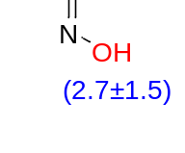 | [48]
48 | Nitro(phenyl)methanone oxime | 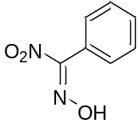 | - | 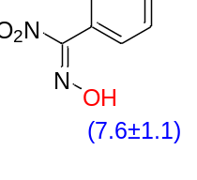 | [46]
49 | 1-Nitro-3-phenylpropan-1-one oxime | 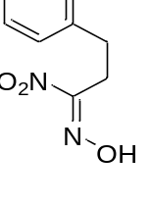 | - | 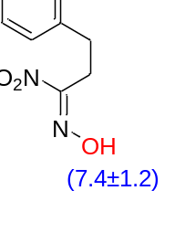 | [46]
50 | 1-(Hydroxyimino)-N,N-dimethyl-1-phenylmethanesulfinamide | 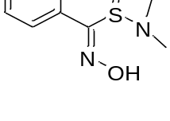 | - | 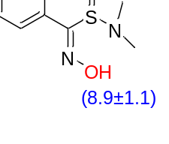 | -
51 | Ethyl-2-(hydroxyimino)-2-sulfamoylacetate | 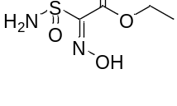 | - | 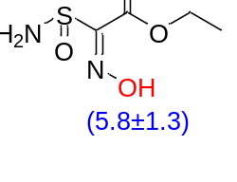 | -
52 | (Hydroxyimino)(methylsulfonyl)methanesulfinamide | 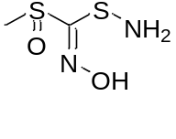 | - | 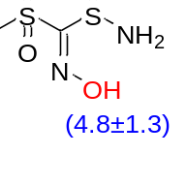 | -
53 | 2-(Hydroxyimino)-2-(methylsulfonyl)acetamide | 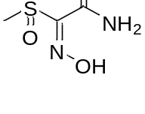 | - | 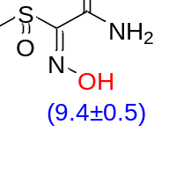 | -
54 | Ethyl 2-(hydroxyimino)-2-((trifluoromethyl)sulfonyl)acetate | 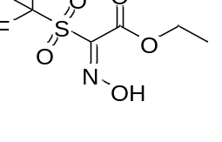 | - | 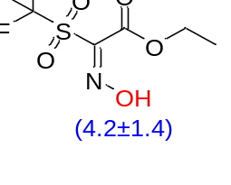 | -
55 | 2-Ethoxy-N-hydroxy-2-oxoacetimidic trifluoromethanesulfonic anhydride | 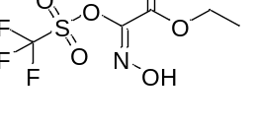 | - | 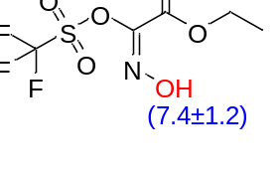 | -
56 | Diphenylmethanone oxime | 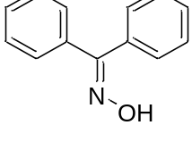 | - | 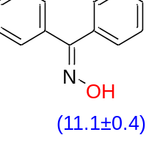 | [37]
57 | 2-((Hydroxyimino)(pyridin-2-yl)methyl)-1-methylpyridin-1-ium iodide | 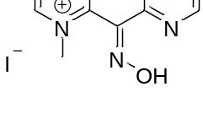 | - | 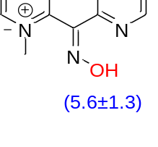 | [49]
58 | 9H-Fluoren-9-one oxime | 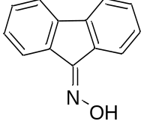 | - | 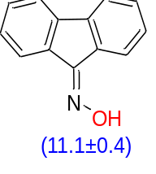 | [48]
59 | Anthracene-9,10-dione dioxime | 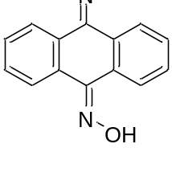 | - | 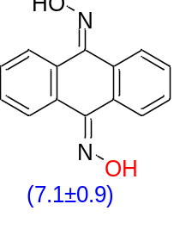 | [50]
60 | Pyrido[3,4-g]isoquinoline-5,10-dione dioxime | 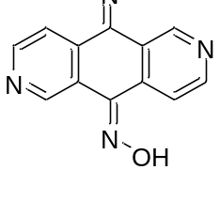 | - | 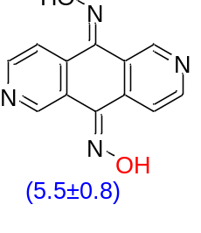 | [50]
61 | Imidazolidin-2-one oxime | 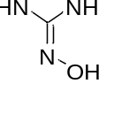 | - | 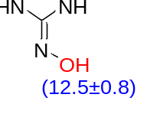 | [51]
62 | 1,3-Dihydro-2H-imidazol-2-one oxime | 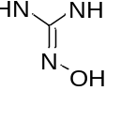 | - | 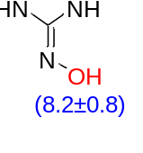 | [51]
63 | Oxazolidin-2-one oxime | 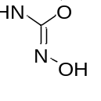 | - | 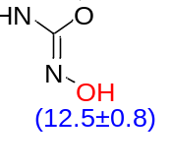 | -
64 | Oxazol-2(3H)-one oxime | 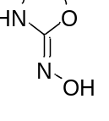 | - | 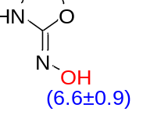 | -
65 | 2-(Hydroxyimino) malonamide | 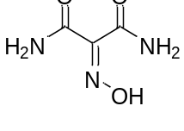 | - | 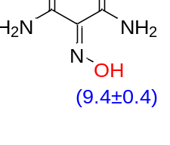 | -
66 | N¹,N³-Dihydroxy-2-(hydroxyimino)malonamide | 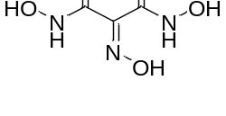 | - | 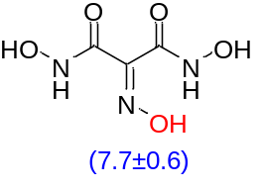 | -
67 | Butane-2,3-dione dioxime | 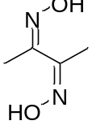 | - | 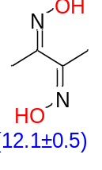 | [48]
68 | N'¹,N'²-Dihydroxyoxalimidoyl dichloride | 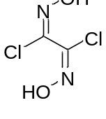 | - | 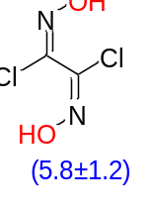 | [48]
69 | N'-Hydroxypyrazine-2-carboximidamide | 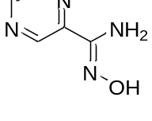 | - | 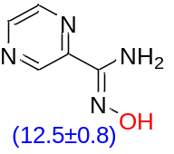 | [50]
70 | 3-Methyl-1,2,4-oxadiazole-5-carbaldehyde oxime | 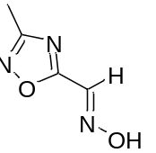 | - | 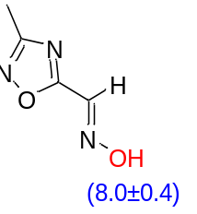 | [52]
71 | 3-(Hydroxyimino)-1-phenylindolin-2-one | 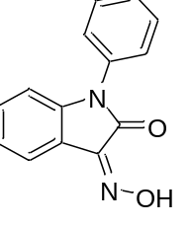 | - | 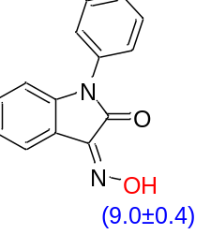 | [53]
72 | 3-(Hydroxyimino)-1-methylindolin-2-one | 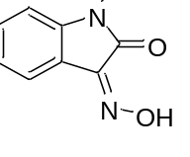 | - | 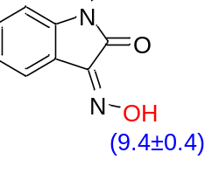 | [53]
73 | 2-((Hydroxyimino)methyl)-1-methylpyridin-1-ium | 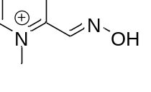 | - | 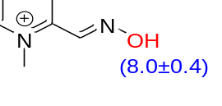 | [49]
74 | 2,3,4,5,6-Pentafluorophenol | 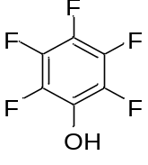 | - | 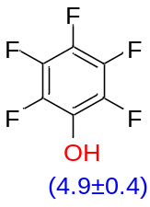
75 | 2,3,5-Trichlorophenol | 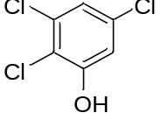 | - | 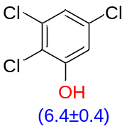
76 | 4-Nitrophenol | 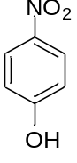 | - | 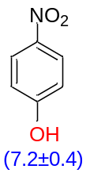
77 | Phenol | 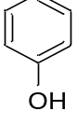 |  | 