Supplementary Material 1
DATA COLECTION FORM (English Version)
Research Thesis: Evaluation of an Eight-Week Simulation-Based Fundamentals of Laparoscopic Surgery Training Program in Coloproctology Residents at the Antiguo Hospital Civil de Guadalajara “Fray Antonio Alcalde”.
Date:
Participant:
Age:
Sex:

Previous practice (> 3 times per week) | Yes | No
Videogame playing | Yes | No
Videogame playing (> 3 times per week) | Yes | No

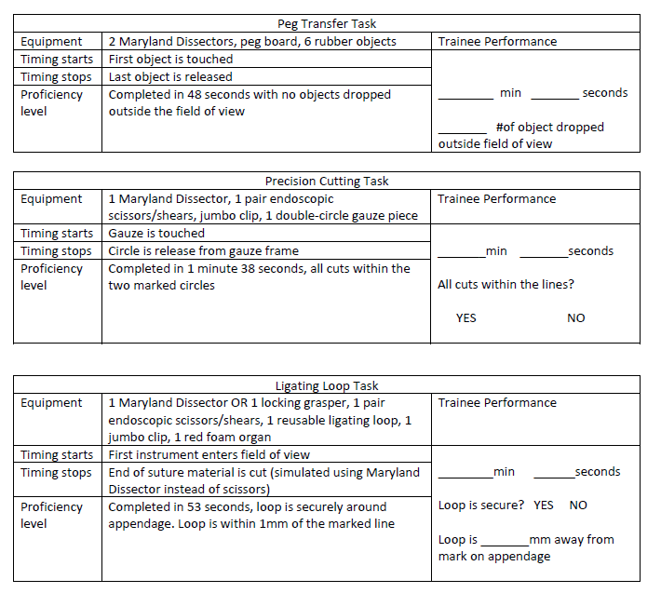
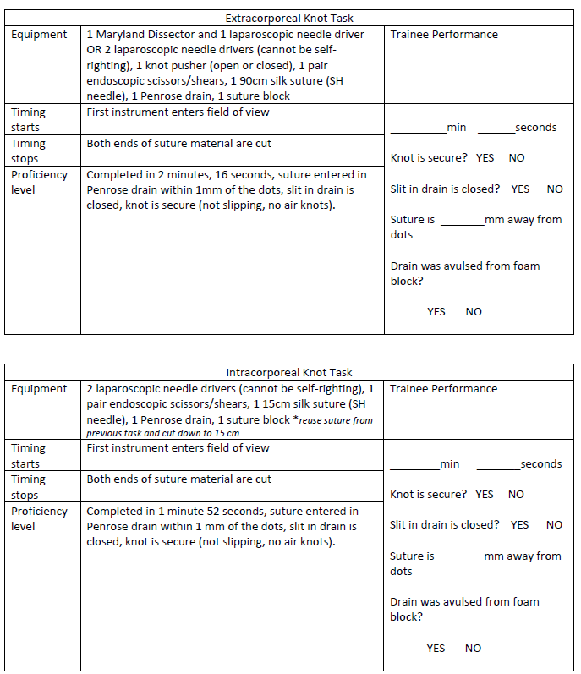

HOJA DE RECOLECCIÓN DE DATOS (Versión en Español)
