STROBE Item | Recommendation | Manuscript Section | Page
Title and Abstract | Study design indicated | Title / Abstract | 1
Background/Rationale | Scientific background explained | Introduction | 2–3
Objectives | Specific objectives and hypothesis | Introduction | 4
Study Design | Presented early in Methods | Methods | 5
Setting | Recruitment and follow-up described | Methods | 5
Participants | Eligibility criteria | Methods | 5–6
Variables | Outcomes and exposures defined | Methods | 6–8
Data Sources | Measurements described | Methods | 6–8
Bias | Statistical adjustment | Statistical Analysis | 8
Study Size | Sample reported | Results | 9
Quantitative Variables | Explained | Methods | 8
Statistical Methods | Fully described | Methods | 8–9
Participants | Flow diagram | Figure 1 | 9
Descriptive Data | Baseline characteristics | Table 1 | 10
Outcome Data | Tables 1–7 | Results | 10–15
Main Results | Adjusted analyses | Tables 3–4 | 11–12
Other Analyses | IPTW | Table 4 | 12
Key Results | Discussion | 16
Limitations | Discussion | 18
Interpretation | Discussion | 16–19
Generalizability | Discussion | 18
Strengthening the Reporting of Observational Studies in Epidemiology (STROBE) checklist

Title
Procedure-Specific Effects Versus Weight Loss Maintenance on Long-Term Endoscopic, Metabolic, Nutritional, and Inflammatory Outcomes After Sleeve Gastrectomy and Roux-en-Y Gastric Bypass: A 10-Year Comparative Cohort

Sincerely,

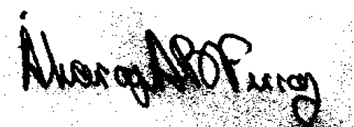
Álvaro Antônio Bandeira Ferraz, MD, PhD, FACS Corresponding Author
Full Professor of Surgery, Department of Medicine
Federal University of Pernambuco (UFPE)
Recife, PE, Brazil
Email: alvaro.ferraz@ufpe.br
ORCID: 0000-0002-3832-3927

