Online Resource 2. Synthetic five-signal audit demonstration case
Promotion-linked authorship signals: A five-signal bibliometric framework and validation study of highly cited
Purpose and status of this demo case
This file is a fully synthetic demonstration case. It does not describe, resemble or encode any real researcher, institution, publication record or source archive. Its purpose is to show how the five-signal framework in the main article is applied when all five signals are observable and strongly convergent. It is therefore a procedural demonstration, not empirical evidence and not an allegation of inappropriate authorship.
The demo follows the formulae used in the main manuscript. Equations (1)-(3) define the pre- and post-career-node windows and their observed averages. Equation (4) calculates growth. Equation (5) calculates an approximate within-case deviation score. Equation (6) calculates visible authorship-role shares. Equation (7) sums binary signal flags into an integrated audit-trigger count. The final interpretation is bounded: one or two isolated signals may have plausible benign explanations, but simultaneous and large changes across all five signals make closer audit necessary before the visible authorship-credit pattern can be treated as self-explanatory.
Synthetic case setup
The synthetic researcher DEMO-001 is assigned a focal career node in 2020. The default half-window length is h = 3. Following the main manuscript, the focal year is not included in either comparison window: the pre-node window is 2017-2019 and the post-node window is 2021-2023. The career node is a senior leadership appointment that is assumed, for demonstration only, to involve approximately 50% management responsibility.
Table OR3.1 gives the synthetic annual values used in the demonstration.
Year | Window status | Publications P_i,y | Co-authors C_i,y | Active fields F_i,y | Interpretive use
2017 | Pre-node window | 3 | 6 | 2 | Used in W-
2018 | Pre-node window | 4 | 7 | 2 | Used in W-
2019 | Pre-node window | 3 | 8 | 2 | Used in W-
2020 | Career node | 5 | 10 | 3 | Anchoring year; excluded from W-/W+
2021 | Post-node window | 8 | 18 | 4 | Used in W+
2022 | Post-node window | 9 | 22 | 5 | Used in W+
2023 | Post-node window | 10 | 25 | 6 | Used in W+
Note. The values are synthetic and are used only to illustrate the formula-based workflow.
Formula-based calculation
Equation (1): W⁻ᵢ,ₜ,ₕ = { y : t - h ≤ y < t }; W⁺ᵢ,ₜ,ₕ = { y : t < y ≤ t + h }
For DEMO-001: t = 2020 and h = 3, so W⁻ = {2017, 2018, 2019} and W⁺ = {2021, 2022, 2023}.
Equation (2): P̄⁻ᵢ,ₜ,ₕ = Σ(Pᵢ,ᵧ for y ∈ W⁻ᵢ,ₜ,ₕ) / |W⁻ᵢ,ₜ,ₕ|
For DEMO-001: P̄⁻ = (3 + 4 + 3) / 3 = 3.33.
Equation (3): P̄⁺ᵢ,ₜ,ₕ = Σ(Pᵢ,ᵧ for y ∈ W⁺ᵢ,ₜ,ₕ) / |W⁺ᵢ,ₜ,ₕ|
For DEMO-001: P̄⁺ = (8 + 9 + 10) / 3 = 9.00.
Equation (4): Gᵢ,ₜ,ₕ = 100 × (P̄⁺ᵢ,ₜ,ₕ - P̄⁻ᵢ,ₜ,ₕ) / P̄⁻ᵢ,ₜ,ₕ, where P̄⁻ᵢ,ₜ,ₕ > 0
For DEMO-001: G = 100 × (9.00 - 3.33) / 3.33 = 170.0%.
Equation (5): Dᵢ,ₜ = (P*ᵢ,ₜ - μᵢ(-t)) / σᵢ(-t)
For DEMO-001: P* = 10, μ(-t) = 3.33, σ(-t) = 0.58, so D = (10 - 3.33) / 0.58 = 11.55.
Equation (6): Aᵢ,ᵣ = Nᵢ,ᵣ / Nᵢ, where r ∈ {first, corresponding, last}
For DEMO-001 in the post-node window: A_first = 4 / 27 = 14.8%; A_corresponding = 22 / 27 = 81.5%; A_last = 18 / 27 = 66.7%.
Equation (7): ISCᵢ = Σⱼ I(Sᵢ,ⱼ = 1)
For DEMO-001: S1 = 1, S2 = 1, S3 = 1, S4 = 1 and S5 = 1, so ISC = 1 + 1 + 1 + 1 + 1 = 5.
Table OR3.2 summarises how each signal is triggered in the synthetic case using the main manuscript’s window and signal logic.
Signal | Calculation / evidence rule used | Synthetic result | Trigger status
S1 publication-output acceleration | Eq. (1)-(4): W- avg = 3.33; W+ avg = 9.00; G = 170.0%; Eq. (5): D = 11.55. | Large post-node growth and strong within-case deviation. | Triggered
S2 co-authorship expansion | Same window logic as Eq. (1)-(4), substituting co-author counts: pre avg = 7.00; post avg = 21.67; growth = 209.5%. | Collaboration breadth expands sharply after the career node. | Triggered
S3 field expansion | Same window logic as Eq. (1)-(4), substituting active field counts: pre avg = 2.00; post avg = 5.00; growth = 150.0%. | The publication profile moves from two core fields to six active fields. | Triggered
S4 authorship-role positioning | Eq. (6): post-node A_first = 14.8%; A_corresponding = 81.5%; A_last = 66.7%. | Visible credit is concentrated in senior authorship positions. | Triggered
S5 management-output tension | Leadership responsibility estimated at 50%; post-node P avg = 9.00; management-adjusted output intensity = 9.00 / (1 - 0.50) = 18.00. | High output coincides with heavy management responsibility. | Triggered
Visual summary
Fig. OR3.1 displays the synthetic publication and co-authorship trajectories around the focal career node.
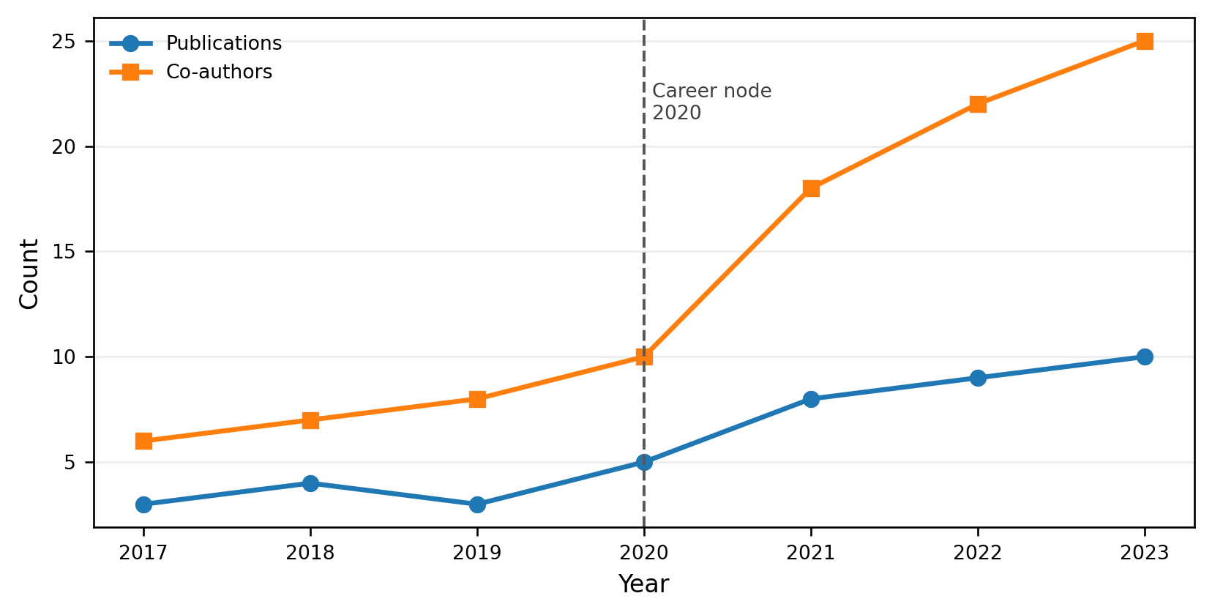
Fig. OR3.1 Synthetic publication and co-authorship trajectory around the career node
Note. The focal career node is 2020. The pre-node and post-node windows follow Eq. (1).

Fig. OR3.2 summarises the binary trigger profile used in the integrated signal count.
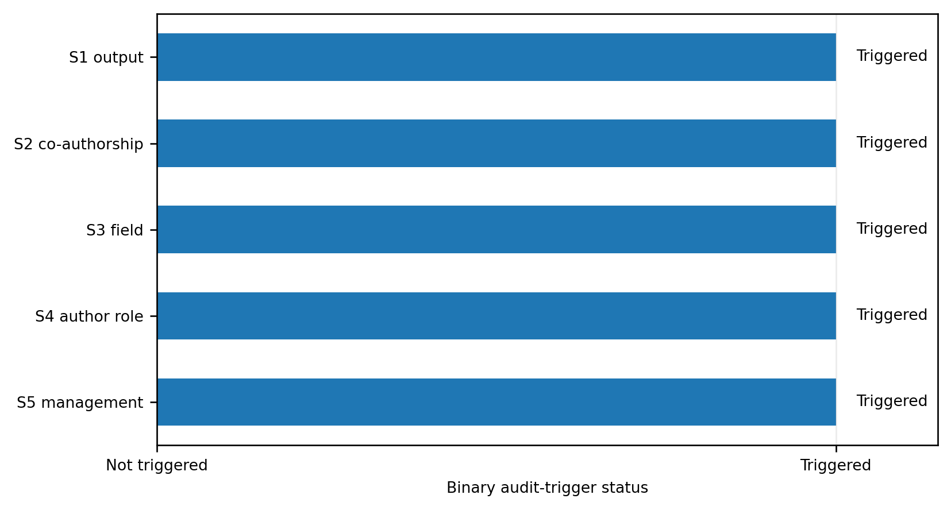
Fig. OR3.2 Synthetic five-signal trigger profile
Note. Triggered means that the signal is observable and exceeds the demonstration threshold. It does not mean that inappropriate authorship has been verified.
Audit inference from signal convergence
The audit inference is cumulative rather than single-indicator based. A publication spike alone may be a coincidence, a delayed-publication effect, a new grant cycle or a normal consequence of laboratory growth. Senior corresponding-author visibility alone may reflect legitimate supervision. Co-authorship expansion alone may reflect genuine team science. Field expansion alone may reflect interdisciplinary collaboration. Management-output tension alone may reflect successful research organisation through delegation and supervision.
The pattern becomes audit-relevant when several large signals occur together in the same career-node window. In DEMO-001, publication output increases by 170.0%, the approximate within-case deviation score is 11.55, co-authorship breadth increases by 209.5%, active field breadth increases by 150.0%, corresponding-author visibility reaches 81.5%, last-author visibility reaches 66.7%, and the higher output occurs alongside a synthetic 50% management-responsibility assumption. This combination is not treated as proof of inappropriate authorship, but it is too strong to be dismissed as ordinary random variation without further checking.
The appropriate conclusion is therefore not an accusation. It is a necessity judgement about review depth: when all five signals are triggered and several of them are large, a closer audit is warranted before accepting the visible credit pattern as self-explanatory. Such an audit would need evidence outside the bibliometric record, such as contribution statements, project documentation, manuscript-drafting records, laboratory records, supervision evidence, editorial correspondence or interviews. The bibliometric workflow identifies the need for review; it does not complete the ethical judgement.

Table OR3.3 states the inference rule that prevents both under-reaction to convergent evidence and over-reaction to isolated indicators.
Signal pattern | Default interpretation | Recommended audit response
One isolated signal | May reflect coincidence, field norm, delayed output, new funding or normal career development. | Record the signal, but do not escalate unless supported by other evidence.
Two moderate signals | Suggests a pattern that needs explanation, but benign alternatives remain plausible. | Check source quality, career timing and missingness before interpretation.
Three or four convergent signals | Indicates a stronger audit-trigger pattern, especially if at least one metric is large. | Conduct closer review of contribution evidence and collaboration structure.
All five signals, several large | Indicates high-priority audit need. The signal combination is unlikely to be interpretable from a single benign explanation alone. | Escalate to structured audit, while maintaining the boundary that bibliometric signals are not misconduct findings.
Conclusion of the synthetic demo
DEMO-001 is a demonstration of maximum signal convergence. Equations (1)-(7) produce an integrated signal count of 5 because all five signals are observable and triggered. The correct inference is that a structured audit would be necessary in a real case with this pattern. The correct boundary is equally important: even all five signals together do not verify hidden contribution, do not establish misconduct and do not identify guest, gift or honorary authorship. They justify closer audit because the visible authorship-credit pattern is unusually strong, multi-dimensional and temporally aligned with the career node.

