Online Resource 1. Combined supplementary materials

Purpose of this package
The main article remains self-contained: it presents the research problem, five-signal framework, operational formulae, evidence-layer design, core validation results, interpretive boundaries and conclusions. This supplementary file strengthens transparency, auditability and reuse; it is not required for the article to form a complete argument.
This index maps each supplementary file to the exact commitment made in the main manuscript and clarifies the role of each file in the submission package.
Table S0.1. Mapping between main-text commitments and supplementary files
Main-text commitment | Supplementary file | Contents delivered | Role
Data-construction and missingness audit | Supplementary File 1 | Quota screening; identity review; duplicate consolidation; evidence-layer allocation; variable availability; blocking conditions. | Transparency and data-readiness audit
Metadata and data-dictionary information | Supplementary File 2 | Variable names; coding rules; source categories; anonymised identifiers; evidence-quality and coding-status flags. | Reusability and reproducibility
De-identified detailed case-record structure for 27 validation cases | Supplementary File 3 | Case-record template; de-identified 27-case validation matrix; signal eligibility and evidence notes. | Validation-layer audit trail
Robustness and sensitivity materials | Supplementary File 4 | Alternative windows; deviation-score thresholds; high-evidence subsets; unresolved measurement boundaries. | Sensitivity review
AuthorshipTrack software information | Supplementary File 5 | Version description; module overview; screenshots; source-log functions; implementation limits. | Methodological infrastructure documentation
Software user guide and procedural manual | Supplementary File 6 | Step-by-step workflow; data-entry rules; QA checks; export guidance. | Replicability and training
Ethics and data-governance documentation | Supplementary File 7 | Public-data basis; anonymisation; sharing limits; governance decisions; why formal human-participant ethics approval was not required. | Ethical transparency

Supplementary File 1
Data construction and missingness audit

The main article remains self-contained: it presents the research problem, five-signal framework, operational formulae, evidence-layer design, core validation results, interpretive boundaries and conclusions. This supplementary file strengthens transparency, auditability and reuse; it is not required for the article to form a complete argument.

S1.1 Data-construction logic
The dataset was constructed as a layered Highly Cited Researchers (HCR) working dataset rather than as a uniform population sample. The full 329-row layer is used for descriptive context, evidence-readiness assessment and institutional-context coding. The 27 evidence-rich validation cases are used to test whether the five-signal framework can be applied to real public career and bibliometric records. The 302 less-detailed cases are retained but analytically restricted.
Table S1.1. Data-construction audit stages
Audit stage | Records | Status | Interpretive note
Original sampling records | 372 | Initial | Before quota screening and identity review
Proportional quota removals | 31 | Removed | Did not conform to the intended disciplinary allocation
Records entering identity disambiguation | 341 | Screened | 372 original records minus 31 quota-based removals
Duplicate cross-disciplinary records | 12 | Consolidated | Extra category entries, not independent researchers
Final independent researchers | 329 | Retained | Final sample for the present study

Table S1.2. Evidence-layer allocation
Analytical layer | Cases | Analytical function | Interpretive boundary
Full HCR working dataset | 329 | Sampling frame, descriptive audit, institutional-context coding | Not a national population sample of all academics in China
Less-detailed HCR rows | 302 | Descriptive and institution-level context only | Not used for full individual promotion-window interpretation
Evidence-rich validation cases | 27 | Validation of the five-signal framework using career timelines, publication windows and authorship-role evidence | Not a prevalence sample; not used to estimate misconduct frequency

S1.2 Variable availability and missingness
Missingness is treated as an analytical condition rather than a nuisance. A variable is counted as available only where the field contains usable evidence. Fields marked N/A, not available, data unavailable or blank are treated as unavailable for the relevant analysis.
Table S1.3. Key-variable availability in the 329-row working dataset
Variable | Available in 329-row layer | Missing / unavailable | Interpretive consequence
category | 329/329 | 0/329 | Used for descriptive sampling context.
primary_affiliation | 311/329 | 18/329 | Used for descriptive sampling context.
detail_gender | 51/329 | 278/329 | Available mainly in the 27-case validation layer.
detail_phd_year | 27/329 | 302/329 | Available mainly in the 27-case validation layer.
detail_avg_pre_promotion_pubs | 27/329 | 302/329 | Available mainly in the 27-case validation layer.
detail_avg_post_promotion_pubs | 27/329 | 302/329 | Available mainly in the 27-case validation layer.
detail_avg_pub_growth_rate | 27/329 | 302/329 | Available mainly in the 27-case validation layer.
detail_extreme_promotion_year | 27/329 | 302/329 | Available mainly in the 27-case validation layer.
detail_z_score | 27/329 | 302/329 | Available mainly in the 27-case validation layer.
detail_avg_first_author_pct | 27/329 | 302/329 | Available mainly in the 27-case validation layer.
detail_avg_corr_author_pct | 27/329 | 302/329 | Available mainly in the 27-case validation layer.
detail_avg_last_author_pct | 27/329 | 302/329 | Available mainly in the 27-case validation layer.
detail_mgmt_resp_pct | 27/329 | 302/329 | Available mainly in the 27-case validation layer.
detail_avg_pre_promotion_coauthors | 0/329 | 329/329 | Co-authorship expansion retained as under-validated signal.
detail_avg_post_promotion_coauthors | 0/329 | 329/329 | Co-authorship expansion retained as under-validated signal.
detail_avg_coauthor_growth_rate | 0/329 | 329/329 | Co-authorship expansion retained as under-validated signal.
detail_pre_fields_of_study | 0/329 | 329/329 | Field expansion retained as under-validated signal.
detail_post_fields_of_study | 0/329 | 329/329 | Field expansion retained as under-validated signal.
detail_avg_field_expansion_index | 0/329 | 329/329 | Field expansion retained as under-validated signal.
institution_policy_status | 329/329 | 0/329 | Used for contextual coding, not direct individual exposure.
policy_evidence_strength | 329/329 | 0/329 | Used for contextual coding, not direct individual exposure.
policy_career_alignment | 329/329 | 0/329 | Used for contextual coding, not direct individual exposure.
gender_final | 51/329 | 278/329 | Used only where reliable evidence exists; no imputation.

Table S1.4. Key-variable availability in the 27 evidence-rich validation cases
Variable | Available in 27 validation cases | Missing / unavailable | Validation status
category | 27/27 | 0/27 | Operationalised in validation layer.
primary_affiliation | 9/27 | 18/27 | Partially operationalised.
detail_gender | 27/27 | 0/27 | Operationalised in validation layer.
detail_phd_year | 27/27 | 0/27 | Operationalised in validation layer.
detail_avg_pre_promotion_pubs | 27/27 | 0/27 | Operationalised in validation layer.
detail_avg_post_promotion_pubs | 27/27 | 0/27 | Operationalised in validation layer.
detail_avg_pub_growth_rate | 27/27 | 0/27 | Operationalised in validation layer.
detail_extreme_promotion_year | 27/27 | 0/27 | Operationalised in validation layer.
detail_z_score | 27/27 | 0/27 | Operationalised in validation layer.
detail_avg_first_author_pct | 27/27 | 0/27 | Operationalised in validation layer.
detail_avg_corr_author_pct | 27/27 | 0/27 | Operationalised in validation layer.
detail_avg_last_author_pct | 27/27 | 0/27 | Operationalised in validation layer.
detail_mgmt_resp_pct | 27/27 | 0/27 | Operationalised in validation layer.
detail_avg_pre_promotion_coauthors | 0/27 | 27/27 | Under-validated in current public metadata.
detail_avg_post_promotion_coauthors | 0/27 | 27/27 | Under-validated in current public metadata.
detail_avg_coauthor_growth_rate | 0/27 | 27/27 | Under-validated in current public metadata.
detail_pre_fields_of_study | 0/27 | 27/27 | Under-validated in current public metadata.
detail_post_fields_of_study | 0/27 | 27/27 | Under-validated in current public metadata.
detail_avg_field_expansion_index | 0/27 | 27/27 | Under-validated in current public metadata.
institution_policy_status | 27/27 | 0/27 | Operationalised in validation layer.
policy_evidence_strength | 27/27 | 0/27 | Operationalised in validation layer.
policy_career_alignment | 27/27 | 0/27 | Operationalised in validation layer.
gender_final | 27/27 | 0/27 | Operationalised in validation layer.

S1.3 Blocking conditions for full case-level interpretation
Table S1.5. Data-availability audit for detailed case-level eligibility
Audit outcome | Cases | Analytical status | Consequence
Final independent researchers | 329 | Retained | Available for at least descriptive or institution-level analysis
Eligible for detailed case-level analysis | 27 | Eligible | All three core evidential conditions met
Not eligible for detailed case-level analysis | 302 | Retained, analytically restricted | Primary reasons below sum to 302
Researcher-publication linkage insufficient for detailed reconstruction | 58 | Primary blocking condition | No safe annual-series attribution for formal window analysis
Multiple core variables incomplete | 109 | Primary blocking condition | At least two of timeline, career point and annual sequence were not usable
Annual publication sequence incomplete | 124 | Primary blocking condition | Timeline and career point usable; annual series remained partial or unavailable
Severe data insufficiency | 11 | Primary category; counted once | Evidence was too limited to construct a defensible identity-linked career and publication record
PhD / early-career average unavailable within detailed cases | 2 of 27 | Variable-specific omission | Omitted only from the early-career derived summary
Case-level policy-career alignment not fully assessed | 9 of 27 | Variable-specific restriction | Institution-level policy context only
Quantitative co-authorship change unavailable | 27 of 27 | Indicator unavailable | No aggregate quantitative co-authorship-change analysis
Quantitative field expansion unavailable | 27 of 27 | Indicator unavailable | No aggregate quantitative field-expansion analysis

The four primary blocking conditions sum to 302 less-detailed HCR rows. These rows are not removed from the study. They remain in the descriptive and institutional-context layer, but they do not support full five-signal validation because at least one core evidential axis is insufficient.

S1.4 Institutional policy evidence summary
Table S1.6. Institutional policy-evidence groups in the 329-row layer
Policy-evidence group | Cases | Interpretive use
D. No clear public evidence in current coding | 127 | Institutional-context coding only; not treated as proof of individual exposure.
B. Comparable fixed-term / performance-based evidence | 91 | Institutional-context coding only; not treated as proof of individual exposure.
A. Explicit tenure-track / pre-tenure evidence | 84 | Institutional-context coding only; not treated as proof of individual exposure.
C. General or later appointment evidence | 22 | Institutional-context coding only; not treated as proof of individual exposure.
N/A. Not applicable | 5 | Institutional-context coding only; not treated as proof of individual exposure.

S1.5 Quota removals and duplicate consolidation
The following tables document the quota-removal and duplicate-consolidation stages. The quota-removal records are source-level records, not ethical exclusions. Duplicate consolidation refers to cross-disciplinary HCR entries that represented the same independent researcher and were therefore merged before the final 329-row count was fixed.
Table S1.7. Proportional quota-removal records
Source record ID | Discipline | Decision | Reason
HCR-CN25-0004 | Agricultural Sciences | Quota removal | Outside the intended disciplinary allocation
HCR-CN25-0005 | Agricultural Sciences | Quota removal | Outside the intended disciplinary allocation
HCR-CN25-0006 | Agricultural Sciences | Quota removal | Outside the intended disciplinary allocation
HCR-CN25-0007 | Agricultural Sciences | Quota removal | Outside the intended disciplinary allocation
HCR-CN25-0008 | Agricultural Sciences | Quota removal | Outside the intended disciplinary allocation
HCR-CN25-0009 | Agricultural Sciences | Quota removal | Outside the intended disciplinary allocation
HCR-CN25-0010 | Agricultural Sciences | Quota removal | Outside the intended disciplinary allocation
HCR-CN25-0033 | Chemistry | Quota removal | Outside the intended disciplinary allocation
HCR-CN25-0034 | Chemistry | Quota removal | Outside the intended disciplinary allocation
HCR-CN25-0035 | Chemistry | Quota removal | Outside the intended disciplinary allocation
HCR-CN25-0036 | Chemistry | Quota removal | Outside the intended disciplinary allocation
HCR-CN25-0037 | Chemistry | Quota removal | Outside the intended disciplinary allocation
HCR-CN25-0038 | Chemistry | Quota removal | Outside the intended disciplinary allocation
HCR-CN25-0039 | Chemistry | Quota removal | Outside the intended disciplinary allocation
HCR-CN25-0054 | Computer Science | Quota removal | Outside the intended disciplinary allocation
HCR-CN25-0055 | Computer Science | Quota removal | Outside the intended disciplinary allocation
HCR-CN25-0056 | Computer Science | Quota removal | Outside the intended disciplinary allocation
HCR-CN25-0318 | Geosciences | Quota removal | Outside the intended disciplinary allocation
HCR-CN25-0326 | Mathematics | Quota removal | Outside the intended disciplinary allocation
HCR-CN25-0327 | Mathematics | Quota removal | Outside the intended disciplinary allocation
HCR-CN25-0328 | Mathematics | Quota removal | Outside the intended disciplinary allocation
HCR-CN25-0329 | Mathematics | Quota removal | Outside the intended disciplinary allocation
HCR-CN25-0330 | Mathematics | Quota removal | Outside the intended disciplinary allocation
HCR-CN25-0331 | Mathematics | Quota removal | Outside the intended disciplinary allocation
HCR-CN25-0341 | Microbiology | Quota removal | Outside the intended disciplinary allocation
HCR-CN25-0342 | Microbiology | Quota removal | Outside the intended disciplinary allocation
HCR-CN25-0343 | Microbiology | Quota removal | Outside the intended disciplinary allocation
HCR-CN25-0344 | Microbiology | Quota removal | Outside the intended disciplinary allocation
HCR-CN25-0105 | Physics | Quota removal | Outside the intended disciplinary allocation
HCR-CN25-0106 | Physics | Quota removal | Outside the intended disciplinary allocation
HCR-CN25-0116 | Plant and Animal Science | Quota removal | Outside the intended disciplinary allocation

Table S1.8. Duplicate cross-disciplinary records consolidated before final count
Anonymous duplicate ID | Retained group | Clarivate categories | Evidence summary | Treatment
DR-01 | D1 | Chemistry; Environment and Ecology | Same institution, coherent research profile and team continuity | Merged into retained group
DR-02 | D2 | Chemistry; Environment and Ecology | Same institution, coherent research profile and team continuity | Merged into retained group
DR-03 | D2 | Chemistry; Materials Science | Same institution, coherent research profile and team continuity | Merged into retained group
DR-04 | D3 | Agricultural Sciences; Microbiology | Same institution, coherent research profile and team continuity | Merged into retained group
DR-05 | D4 | Biology and Biochemistry; Plant and Animal Science | Same institution, coherent research profile and team continuity | Merged into retained group
DR-06 | D5 | Chemistry; Materials Science | Same institution, coherent research profile and team continuity | Merged into retained group
DR-07 | D6 | Chemistry; Materials Science | Same institution, coherent research profile and team continuity | Merged into retained group
DR-08 | D7 | Chemistry; Materials Science | Same institution, coherent research profile and team continuity | Merged into retained group
DR-09 | D8 | Chemistry; Materials Science | Same institution, coherent research profile and team continuity | Merged into retained group
DR-10 | D9 | Engineering; Materials Science | Same institution, coherent research profile and team continuity | Merged into retained group
DR-11 | D10 | Environment and Ecology; Geosciences | Same institution, coherent research profile and team continuity | Merged into retained group
DR-12 | D11 | Environment and Ecology; Social Sciences | Same institution, coherent research profile and team continuity | Merged into retained group

Supplementary File 2
Metadata and data dictionary

S2.1 Data dictionary
This file documents the working-file variables used to construct the manuscript. Restricted identifiers are described in the dictionary but are not reproduced as identifiable values in the public supplementary case matrix. The variable list is taken from the current one-sheet working dataset.
Table S2.1. Full data dictionary for the current working file
Variable | Group | Definition / coding rule | Main analytic use
final_record_id | Identity and linkage | Anonymised or internal record identifier used to link rows across the audit trail; not interpreted as a public identity claim. | Sampling, linkage or audit
record_id | Identity and linkage | Anonymised or internal record identifier used to link rows across the audit trail; not interpreted as a public identity claim. | Sampling, linkage or audit
country_region | Sampling frame | Country/region field from the HCR sampling frame. | Sampling, linkage or audit
full_name | Restricted identifier | Researcher name retained in the restricted working file only; omitted or replaced by case label in de-identified supplements. | Restricted archive only / de-identified before public sharing
full_name_original | Restricted identifier | Researcher name retained in the restricted working file only; omitted or replaced by case label in de-identified supplements. | Restricted archive only / de-identified before public sharing
category | Sampling frame | Clarivate HCR category or source-category label used for sampling and descriptive context. | Sampling, linkage or audit
primary_affiliation | Sampling frame | Affiliation field used for descriptive and institutional-context coding; not treated as proof of individual policy exposure. | Sampling, linkage or audit
secondary_affiliation | Sampling frame | Affiliation field used for descriptive and institutional-context coding; not treated as proof of individual policy exposure. | Sampling, linkage or audit
source_url | Source log | Public source or source list used for traceability in the restricted evidence log. | Sampling, linkage or audit
detail_gender | Detailed case variable | Gender field preserved from detailed report evidence where available; not inferred where public evidence is insufficient. | Sampling, linkage or audit
detail_phd_year | Career timeline | PhD-year or PhD-window information used to reconstruct early-career baseline where available. | Sampling, linkage or audit
detail_phd_window | Career timeline | PhD-year or PhD-window information used to reconstruct early-career baseline where available. | Sampling, linkage or audit
detail_phd_avg_pubs | Career timeline | PhD-year or PhD-window information used to reconstruct early-career baseline where available. | Sampling, linkage or audit
detail_avg_pre_promotion_pubs | Publication-window metric | Pre-career-node average used in window-based comparison. | Five-signal validation layer
detail_avg_post_promotion_pubs | Publication-window metric | Post-career-node average used in window-based comparison. | Five-signal validation layer
detail_avg_pub_growth_rate | Signal metric | Growth-rate or expansion metric calculated from pre/post fields where evidence supports calculation. | Five-signal validation layer
detail_extreme_promotion_year | Signal metric | Extreme-year or extreme-change field used as descriptive anomaly-screen information. | Five-signal validation layer
detail_extreme_promotion_year_pub | Signal metric | Extreme-year or extreme-change field used as descriptive anomaly-screen information. | Five-signal validation layer
detail_extreme_pub_growth_rate | Signal metric | Growth-rate or expansion metric calculated from pre/post fields where evidence supports calculation. | Five-signal validation layer
detail_avg_first_author_pct | Authorship-role metric | Authorship-role share or role-change field used for visible credit-position analysis. | Five-signal validation layer
detail_avg_corr_author_pct | Authorship-role metric | Authorship-role share or role-change field used for visible credit-position analysis. | Five-signal validation layer
detail_avg_last_author_pct | Authorship-role metric | Authorship-role share or role-change field used for visible credit-position analysis. | Five-signal validation layer
detail_mgmt_resp_pct | Management-output tension | Management responsibility field or interpretation note used to contextualise publication output against leadership duties. | Five-signal validation layer
detail_pub_efficiency | Detailed case variable | Detailed case-level field used in the evidence-rich validation layer. | Sampling, linkage or audit
detail_mean | Deviation-score metric | Approximate within-case baseline fields used to standardise focal publication spikes descriptively. | Five-signal validation layer
detail_sd | Deviation-score metric | Approximate within-case baseline fields used to standardise focal publication spikes descriptively. | Five-signal validation layer
detail_z_score | Deviation-score metric | Approximate within-case baseline fields used to standardise focal publication spikes descriptively. | Five-signal validation layer
detail_mgmt_resp_analysis | Management-output tension | Management responsibility field or interpretation note used to contextualise publication output against leadership duties. | Five-signal validation layer
detail_anomaly_type | Detailed case variable | Detailed case-level field used in the evidence-rich validation layer. | Sampling, linkage or audit
detail_anomaly_interpretation | Interpretive note | Case-level interpretation note from detailed reports; used cautiously and de-identified for public sharing. | Sampling, linkage or audit
detail_publication_growth_interpretation | Signal metric | Growth-rate or expansion metric calculated from pre/post fields where evidence supports calculation. | Five-signal validation layer
detail_coauthorship_trend_interpretation | Co-authorship signal | Co-authorship expansion field; retained in the schema but under-validated because consistent public metadata were unavailable. | Sampling, linkage or audit
detail_field_expansion_interpretation | Field-expansion signal | Field-expansion field; retained in the schema but under-validated because consistent public metadata were unavailable. | Sampling, linkage or audit
detail_authorship_roles_interpretation | Interpretive note | Case-level interpretation note from detailed reports; used cautiously and de-identified for public sharing. | Sampling, linkage or audit
detail_summary_findings | Interpretive note | Case-level interpretation note from detailed reports; used cautiously and de-identified for public sharing. | Sampling, linkage or audit
detail_avg_pre_promotion_coauthors | Publication-window metric | Pre-career-node average used in window-based comparison. | Five-signal validation layer
detail_avg_post_promotion_coauthors | Publication-window metric | Post-career-node average used in window-based comparison. | Five-signal validation layer
detail_avg_coauthor_growth_rate | Signal metric | Growth-rate or expansion metric calculated from pre/post fields where evidence supports calculation. | Five-signal validation layer
detail_extreme_coauthor_growth_rate | Signal metric | Growth-rate or expansion metric calculated from pre/post fields where evidence supports calculation. | Five-signal validation layer
detail_pre_fields_of_study | Field-expansion signal | Field-expansion field; retained in the schema but under-validated because consistent public metadata were unavailable. | Sampling, linkage or audit
detail_post_fields_of_study | Field-expansion signal | Field-expansion field; retained in the schema but under-validated because consistent public metadata were unavailable. | Sampling, linkage or audit
detail_avg_field_expansion_index | Field-expansion signal | Field-expansion field; retained in the schema but under-validated because consistent public metadata were unavailable. | Sampling, linkage or audit
detail_extreme_field_expansion_index | Signal metric | Extreme-year or extreme-change field used as descriptive anomaly-screen information. | Five-signal validation layer
detail_avg_pre_first_author_pct | Authorship-role metric | Authorship-role share or role-change field used for visible credit-position analysis. | Five-signal validation layer
detail_avg_post_first_author_pct | Authorship-role metric | Authorship-role share or role-change field used for visible credit-position analysis. | Five-signal validation layer
detail_avg_pre_corr_author_pct | Authorship-role metric | Authorship-role share or role-change field used for visible credit-position analysis. | Five-signal validation layer
detail_avg_post_corr_author_pct | Authorship-role metric | Authorship-role share or role-change field used for visible credit-position analysis. | Five-signal validation layer
detail_avg_pre_last_author_pct | Authorship-role metric | Authorship-role share or role-change field used for visible credit-position analysis. | Five-signal validation layer
detail_avg_post_last_author_pct | Authorship-role metric | Authorship-role share or role-change field used for visible credit-position analysis. | Five-signal validation layer
detail_extreme_first_author_change | Signal metric | Extreme-year or extreme-change field used as descriptive anomaly-screen information. | Five-signal validation layer
detail_extreme_corr_author_change | Signal metric | Extreme-year or extreme-change field used as descriptive anomaly-screen information. | Five-signal validation layer
detail_extreme_last_author_change | Signal metric | Extreme-year or extreme-change field used as descriptive anomaly-screen information. | Five-signal validation layer
institution_for_policy_coding | Institutional context | Institutional field used to code public evidence of performance-based, tenure-track or comparable appointment systems. | Contextual coding, not causal treatment
institution_policy_status | Institutional context | Institutional field used to code public evidence of performance-based, tenure-track or comparable appointment systems. | Contextual coding, not causal treatment
has_up_or_out_or_comparable_policy | Institutional policy coding | Policy-coding field used to document public evidence, target group, assessment logic and evidence strength. | Contextual coding, not causal treatment
institution_policy_name_original | Institutional context | Institutional field used to code public evidence of performance-based, tenure-track or comparable appointment systems. | Contextual coding, not causal treatment
institution_policy_start_year | Institutional context | Institutional field used to code public evidence of performance-based, tenure-track or comparable appointment systems. | Contextual coding, not causal treatment
first_public_evidence_year | Other | Auxiliary field retained for auditability. | Sampling, linkage or audit
policy_level | Institutional policy coding | Policy-coding field used to document public evidence, target group, assessment logic and evidence strength. | Contextual coding, not causal treatment
policy_target_group | Institutional policy coding | Policy-coding field used to document public evidence, target group, assessment logic and evidence strength. | Contextual coding, not causal treatment
policy_assessment_cycle | Institutional policy coding | Policy-coding field used to document public evidence, target group, assessment logic and evidence strength. | Contextual coding, not causal treatment
policy_exit_rule | Institutional policy coding | Policy-coding field used to document public evidence, target group, assessment logic and evidence strength. | Contextual coding, not causal treatment
policy_main_evaluation_criteria | Institutional policy coding | Policy-coding field used to document public evidence, target group, assessment logic and evidence strength. | Contextual coding, not causal treatment
policy_evidence_source_1 | Institutional policy coding | Policy-coding field used to document public evidence, target group, assessment logic and evidence strength. | Contextual coding, not causal treatment
policy_evidence_source_2 | Institutional policy coding | Policy-coding field used to document public evidence, target group, assessment logic and evidence strength. | Contextual coding, not causal treatment
policy_evidence_strength | Institutional policy coding | Policy-coding field used to document public evidence, target group, assessment logic and evidence strength. | Contextual coding, not causal treatment
policy_career_alignment | Institutional policy coding | Policy-coding field used to document public evidence, target group, assessment logic and evidence strength. | Contextual coding, not causal treatment
institutional_context_note | Other | Auxiliary field retained for auditability. | Sampling, linkage or audit
case_report_status | Evidence-layer flag | Status flag indicating how the row may be used analytically. | Sampling, linkage or audit
institutional_context_coding_status | Evidence-layer flag | Status flag indicating how the row may be used analytically. | Sampling, linkage or audit
policy_coding_research_date | Institutional policy coding | Policy-coding field used to document public evidence, target group, assessment logic and evidence strength. | Contextual coding, not causal treatment
gender_final | Gender coding | Gender coding field used only where public or detailed-case evidence is reliable; otherwise left uncoded. | Descriptive coding only where reliable
gender_code_final | Gender coding | Gender coding field used only where public or detailed-case evidence is reliable; otherwise left uncoded. | Descriptive coding only where reliable
gender_evidence_basis | Gender coding | Gender coding field used only where public or detailed-case evidence is reliable; otherwise left uncoded. | Descriptive coding only where reliable
gender_source_url | Gender coding | Gender coding field used only where public or detailed-case evidence is reliable; otherwise left uncoded. | Descriptive coding only where reliable
gender_coding_status | Gender coding | Gender coding field used only where public or detailed-case evidence is reliable; otherwise left uncoded. | Descriptive coding only where reliable
gender_coding_date | Gender coding | Gender coding field used only where public or detailed-case evidence is reliable; otherwise left uncoded. | Descriptive coding only where reliable

S2.2 Evidence-quality flags
Table S2.2. Institutional policy-evidence strength flags
Evidence flag | Cases | Meaning in analysis
low / unverified | 127 | Indicates strength of public institutional-policy evidence; does not establish individual exposure.
medium-strong | 87 | Indicates strength of public institutional-policy evidence; does not establish individual exposure.
medium | 56 | Indicates strength of public institutional-policy evidence; does not establish individual exposure.
strong | 33 | Indicates strength of public institutional-policy evidence; does not establish individual exposure.
low-medium | 18 | Indicates strength of public institutional-policy evidence; does not establish individual exposure.
not applicable | 5 | Indicates strength of public institutional-policy evidence; does not establish individual exposure.
low | 3 | Indicates strength of public institutional-policy evidence; does not establish individual exposure.

Table S2.3. Coding-status variables and observed categories
Status variable | Observed categories | Coding meaning
case_report_status | HCR_base_row_no_detailed_report: 302; detailed_case_readable: 27 | Determines analytical use and reporting boundary.
institutional_context_coding_status | institution_level_coded: 171; institution_level_unverified_or_not_applicable: 131; case_level_coded: 18; institution_level_coded; case_alignment_not_fully_reviewed: 9 | Determines analytical use and reporting boundary.
gender_coding_status | blank_no_explicit_web_evidence: 278; existing_detail_gender_preserved: 26; web_verified: 25 | Determines analytical use and reporting boundary.

S2.3 Source and evidence-log schema
Table S2.4. Source and evidence-log schema
Field | Required? | Description
case_id | Yes | Anonymised case label used in public supplementary material.
source_type | Yes | Database, institutional profile, CV, announcement, policy document, article metadata, or software-generated note.
source_title | Yes | Short title sufficient for audit without exposing unnecessary personal data.
source_url_or_archive_ref | Restricted | URL or restricted archive reference. Public release may omit direct URLs when identifiability risk is high.
access_date | Yes | Date on which the source was accessed or checked.
evidence_claim | Yes | Which variable or claim the source supports.
evidence_strength | Yes | Strong, medium-strong, medium, low-medium, low, or not applicable.
uncertainty_note | If needed | Any ambiguity, conflict, missingness or same-name risk.

Supplementary File 3
De-identified detailed case-record structure for the 27 evidence-rich validation cases

S3.1 De-identification rule
The public case matrix uses anonymous labels Case 001 to Case 027. Researcher names, full source URLs, exact institutional biographies and personally identifying narrative details are not reproduced in this public supplement. Numeric validation variables are retained because they are needed to document how the five-signal framework was applied.
Table S3.1. De-identified case-record template
Record block | Fields retained in de-identified structure | Purpose
Identity block | case_id; source type; evidence status; HCR category where non-identifying | Keeps cases traceable within the analysis without reproducing names.
Career timeline block | PhD year; PhD window; focal career node year; career-node evidence note | Defines the temporal anchor for the validation workflow.
Publication-window block | pre-node average; post-node average; growth rate; extreme year; extreme-year output | Operationalises Signal 1.
Deviation block | reference mean; reference standard deviation; approximate within-case deviation score | Descriptive standardisation of focal publication spikes.
Authorship-role block | first-author share; corresponding-author share; last-author share | Operationalises Signal 4.
Management-context block | management-responsibility category; management-output note | Operationalises Signal 5 as contextual tension rather than direct proof.
Co-authorship and field block | schema fields retained; values generally unavailable in current public evidence | Documents under-validation of Signals 2 and 3.
Institutional-context block | policy-status group; evidence strength; alignment status | Conditions interpretation without claiming individual exposure.
Interpretive boundary block | signal eligibility; missingness note; no-misconduct-judgement statement | Prevents over-interpretation.

Table S3.2a. Core publication-window and deviation metrics for the 27 validation cases
Case | PhD year | Pre avg | Post avg | Growth % | Deviation score
Case 001 | 2011 | 6.33 | 11.00 | 73.8 | 2.71
Case 002 | 1987 | 14.78 | 28.45 | 92.4 | 2.71
Case 003 | 1990 | 15.25 | 16.83 | 10.4 | 1.68
Case 004 | 1990 | 9.36 | 13.72 | 46.6 | 2.18
Case 005 | 1991 | 13.33 | 14.67 | 10.1 | 2.19
Case 006 | 2014 | 6.67 | 9.00 | 34.9 | 2.11
Case 007 | 2001 | 14.33 | 29.00 | 102.4 | 1.77
Case 008 | 1990 | 21.67 | 29.33 | 35.3 | 2.06
Case 009 | 1992 | 15.25 | 16.83 | 10.4 | 2.18
Case 010 | 1996 | 8.67 | 16.67 | 92.3 | 2.22
Case 011 | 1993 | 5.33 | 11.00 | 106.4 | 2.36
Case 012 | Not Provided | 29.00 | 88.00 | 142.3 | 2.10
Case 013 | Not Provided | 6.00 | 16.67 | 178.0 | 1.88
Case 014 | 2011 | 6.67 | 14.33 | 114.7 | 1.28
Case 015 | 2018 | 4.67 | 7.33 | 56.9 | 1.59
Case 016 | 2008 | 4.33 | 7.00 | 61.6 | 1.79
Case 017 | 1998 | 0.67 | 2.33 | 247.8 | 2.62
Case 018 | 2003 | 4.00 | 3.83 | -4.1 | 2.06
Case 019 | 1999 | 6.00 | 6.67 | 11.1 | 1.47
Case 020 | 2011 | 6.33 | 8.66 | 36.8 | 1.19
Case 021 | 2017 | 1.00 | 10.67 | 966.7 | 1.93
Case 022 | 2010 | 6.67 | 13.00 | 95.0 | 1.85
Case 023 | 2013 | 7.33 | 5.33 | -27.3 | 1.60
Case 024 | 1998 | 5.17 | 5.83 | 13.0 | 1.85
Case 025 | Not specified | 12.35 | 15.30 | 23.9 | 1.55
Case 026 | 2010 | 9.00 | 8.70 | -3.3 | 1.62
Case 027 | 2021 | 17.00 | 21.50 | 26.5 | 1.13
Table S3.2b. Authorship, management and institutional context fields for the 27 validation cases
Case | First % | Corr % | Last % | Mgmt category | Policy group
Case 001 | 4 | 64 | 28 | 30-40% | A
Case 002 | 3 | 35 | 74 | 30-50% | B
Case 003 | 4 | 65 | 73 | 40-60% | B
Case 004 | 9 | 19 | 52 | 30-40% | B
Case 005 | 25 | 35 | 24 | 30-40% | B
Case 006 | 23 | 50 | 5 | 20-30% | B
Case 007 | 0 | 19 | 56 | 30-40% | D
Case 008 | 3 | 24 | 42 | 30-40% | A
Case 009 | 3 | 35 | 60 | 30-40% | B
Case 010 | 17 | 50 | 24 | 20-30% | B
Case 011 | 10 | 41 | 72 | 30-40% | C
Case 012 | 4 | 41 | 45 | 30-40% | C
Case 013 | 19 | 55 | 27 | 20-30% | B
Case 014 | 12 | 39 | 27 | 20-30% | B
Case 015 | 18 | 16 | 26 | 10-20% | A
Case 016 | 11 | 43 | 21 | 20-30% | C
Case 017 | 17 | 53 | 34 | 30-40% | B
Case 018 | 10 | 31 | 58 | 30-40% | A
Case 019 | 25 | 61 | 43 | 30-40% | B
Case 020 | 10 | 31 | 58 | 20-30% | A
Case 021 | 29 | 35 | 18 | 20-30% | A
Case 022 | 22 | 39 | 27 | 20-30% | C
Case 023 | 10 | 51 | 41 | 20-30% | C
Case 024 | 8 | 35 | 44 | 30-40% | A
Case 025 | 11 | 30 | 15 | 15-25% | A
Case 026 | 31 | 70 | 44 | 30-40% | B
Case 027 | 28 | 21 | 10 | 10-20% | B
Table S3.2c. Five-signal validation status for the 27 validation cases
Case | S1 growth | S4 senior | S5 tension | S2 coauth | S3 field
Case 001 | Yes | Yes | Yes | Under-validated | Under-validated
Case 002 | Yes | Yes | Yes | Under-validated | Under-validated
Case 003 | Yes | Yes | Yes | Under-validated | Under-validated
Case 004 | Yes | Yes | Yes | Under-validated | Under-validated
Case 005 | Yes | No | No | Under-validated | Under-validated
Case 006 | Yes | Yes | No | Under-validated | Under-validated
Case 007 | Yes | Yes | Yes | Under-validated | Under-validated
Case 008 | Yes | No | No | Under-validated | Under-validated
Case 009 | Yes | Yes | Yes | Under-validated | Under-validated
Case 010 | Yes | Yes | No | Under-validated | Under-validated
Case 011 | Yes | Yes | Yes | Under-validated | Under-validated
Case 012 | Yes | No | No | Under-validated | Under-validated
Case 013 | Yes | Yes | No | Under-validated | Under-validated
Case 014 | Yes | No | No | Under-validated | Under-validated
Case 015 | Yes | No | No | Under-validated | Under-validated
Case 016 | Yes | No | No | Under-validated | Under-validated
Case 017 | Yes | Yes | Yes | Under-validated | Under-validated
Case 018 | No | Yes | No | Under-validated | Under-validated
Case 019 | Yes | Yes | Yes | Under-validated | Under-validated
Case 020 | Yes | Yes | No | Under-validated | Under-validated
Case 021 | Yes | No | No | Under-validated | Under-validated
Case 022 | Yes | No | No | Under-validated | Under-validated
Case 023 | No | Yes | No | Under-validated | Under-validated
Case 024 | Yes | No | No | Under-validated | Under-validated
Case 025 | Yes | No | No | Under-validated | Under-validated
Case 026 | No | Yes | No | Under-validated | Under-validated
Case 027 | Yes | No | No | Under-validated | Under-validated

S3.2 Integrated validation categories
Table S3.3. Integrated validation-pattern counts
Validation pattern | Count | Definition
Positive publication growth | 24 | Post-node average greater than pre-node average.
Approximate deviation score ≥ 2.0 | 12 | Descriptive strong anomaly screen; not inferential test.
Strong senior-author visibility | 16 | Corresponding-author share ≥ 50% or last-author share ≥ 50%.
Positive growth + strong senior visibility | 13 | Convergence of output growth and visible senior-credit position.
Deviation ≥ 2.0 + strong senior visibility | 9 | Convergence of focal publication spike and senior-credit position.
High management + deviation ≥ 2.0 + strong senior visibility | 7 | Highest-priority audit-trigger pattern in presently measurable signals.

Note. These counts are validation outcomes, not prevalence estimates and not ethical judgements about individual researchers.

Supplementary File 4
Robustness and sensitivity materials

S4.1 Purpose of robustness checks
The robustness checks examine whether the interpretation depends on one window length, one deviation-score threshold or one evidence subset. These checks are exploratory because the validation layer contains 27 evidence-rich cases rather than a statistical population sample.
Table S4.1. Sensitivity to publication-window length
Specification | Source / basis | Computable cases | Mean growth (%) | Median growth (%) | Interpretive note
2-year window | Reconstructed from verified detailed-case records where paired windows were available | 26 | 68.6 | 33.7 | Checks whether findings are driven by short-term spikes.
3-year window | Main structured analytic specification in current one-sheet dataset | 27 | 94.6 | 46.6 | Main specification used in the present study.
5-year window | Exact reconstruction where five pre- and five post-node annual counts were available | 14 | 144.8 | 77.0 | Limited check because complete ten-year sequences were not available for all cases.

Table S4.2. Sensitivity to approximate within-case deviation-score thresholds
Approximate within-case deviation-score threshold | Cases meeting approximate threshold | Valid detailed cases | Percentage | Interpretive note
Deviation score ≥ 1.5 | 23 | 27 | 85.2% | Moderate anomaly screen
Deviation score ≥ 2.0 | 12 | 27 | 44.4% | Main strong-signal screen
Deviation score ≥ 2.5 | 3 | 27 | 11.1% | Stricter outlier screen
Deviation score ≥ 3.0 | 0 | 27 | 0.0% | Stricter outlier screen

Table S4.3. High-evidence and institutional-context subset checks
Analytical subset | Cases | Mean 3-year growth (%) | Median 3-year growth (%) | Mean approximate within-case deviation score | Approx. Deviation score ≥ 2.0 | Interpretive use
All detailed cases | 27 | 94.6 | 46.6 | 1.91 | 12/27 (44.4%) | Baseline detailed-case interpretation
Strong or medium-strong policy evidence | 16 | 123.9 | 51.8 | 2.01 | 9/16 (56.3%) | Tests whether the pattern remains in cases with stronger institutional-policy evidence
Case-level institutional context coded | 18 | 95.4 | 35.1 | 1.85 | 7/18 (38.9%) | Tests whether the pattern remains where policy-career context was reviewed at case level
Strong/medium-strong evidence and case-level coded | 8 | 154.9 | 36.1 | 1.95 | 4/8 (50.0%) | Most conservative contextual subset

S4.2 Formula and threshold notes
Table S4.4. Robustness interpretation guide
Element | Use | Boundary
2-year window | Checks whether findings are driven by immediate short-term change. | More sensitive to one-off spikes and publication delay.
3-year window | Main specification used in the manuscript. | Balances short-term and sustained change.
5-year window | Checks whether longer-term growth changes interpretation. | Computable for fewer cases because full ten-year sequences are not always available.
Deviation score ≥ 1.5 | Moderate descriptive anomaly screen. | Sensitive; should not be used as strong signal alone.
Deviation score ≥ 2.0 | Main strong descriptive screen. | Not a statistical significance threshold.
Deviation score ≥ 2.5 / ≥ 3.0 | Strict outlier screens. | Useful for sensitivity but may miss meaningful moderate signals.
High-evidence-only subset | Tests whether interpretation remains when institutional evidence is stronger. | Does not establish causal exposure to policy.

S4.3 Unresolved measurement boundaries
- Co-authorship expansion was retained as a planned signal but could not be quantified consistently from the available public metadata.
- Field expansion was retained as a planned signal but could not be consistently operationalised without more reliable article-level subject coding.
- Deviation scores are descriptive within-case standardisation devices, not distributional tests.
- Robustness checks do not transform the evidence-rich validation layer into a prevalence sample.

Supplementary File 5
AuthorshipTrack software information

S5.1 Software status and purpose
AuthorshipTrack is a software-assisted workflow developed to standardise repeated case-level operations in the study. It is methodological infrastructure rather than an automated misconduct detector. It records identity evidence, source notes, career nodes, annual publication counts, window calculations, authorship-role fields, management-context notes and export logs. It supports the five-signal framework by making each case auditable and comparable.
Table S5.1. AuthorshipTrack status summary
Item | Description
Software name | AuthorshipTrack
Manuscript role | Software-assisted procedural support for the five-signal case-level workflow
Status | Research workflow tool developed during the present study; not a certified diagnostic system
Input type | Public bibliometric records, public career information, institutional policy evidence and analyst notes
Output type | Case-level evidence summaries, source logs, missingness flags, window metrics and exportable audit records
What it does not do | It does not infer hidden contribution, rank individuals, calculate a misconduct probability or replace ethical review

Table S5.2. AuthorshipTrack module overview
Software function | Analytical output generated | Methodological role in the present study
Researcher identity module | Structured researcher profile, including name, institution, discipline, category and profile links. | Supports identity verification and reduces author-disambiguation risk.
Source log | Traceable source list with source type, URL, access date, reliability level and evidence notes. | Links coded variables to public evidence and strengthens auditability.
Career milestone module | Career timeline containing PhD completion, appointments, promotions, leadership roles and other career progress points. | Provides the temporal structure needed for promotion-linked analysis.
Publication count module | Year-by-year publication sequence and peak-publication information. | Creates the empirical basis for publication-trajectory analysis.
Promotion-window module | Defined pre- and post-career-point comparison windows linked to specific milestones. | Standardises comparison periods and reduces arbitrary window selection.
Publication metric module | Pre/post publication averages, growth rates, extreme-growth indicators, publication efficiency and approximate within-case deviation score where calculable. | Converts annual publication sequences into comparable bibliometric indicators.
Authorship role fields | First-author, corresponding-author and last-author role profile where data are available. | Connects publication growth to visible credit position.
Co-authorship and field fields | Collaboration and field-expansion notes or indicators where public evidence is sufficient. | Provides contextual evidence without forcing calculation where data are weak.
Quality-assurance module | Completeness status, support strength, confidence level, warnings, missing-data log and review flag. | Makes uncertainty visible and prevents over-interpretation of weak-evidence cases.
Chart module | Visual summaries of publication trajectories, authorship-role mix and career timeline. | Assists pattern review while requiring confirmation against source records.
Export module | Filtered researcher lists, full dataset, milestone records and source logs. | Supports audit trail, appendix preparation and future replication.

S5.2 Workflow module documentation
This section documents the workflow interface and module logic using demonstration screenshots. The screenshots show synthetic demo records only. Names, affiliations, URLs and profile details shown in the interface are fictitious demonstration data and are not drawn from the study dataset or restricted archive.

Supplementary Fig. S5.1 Researcher identity and source evidence module.
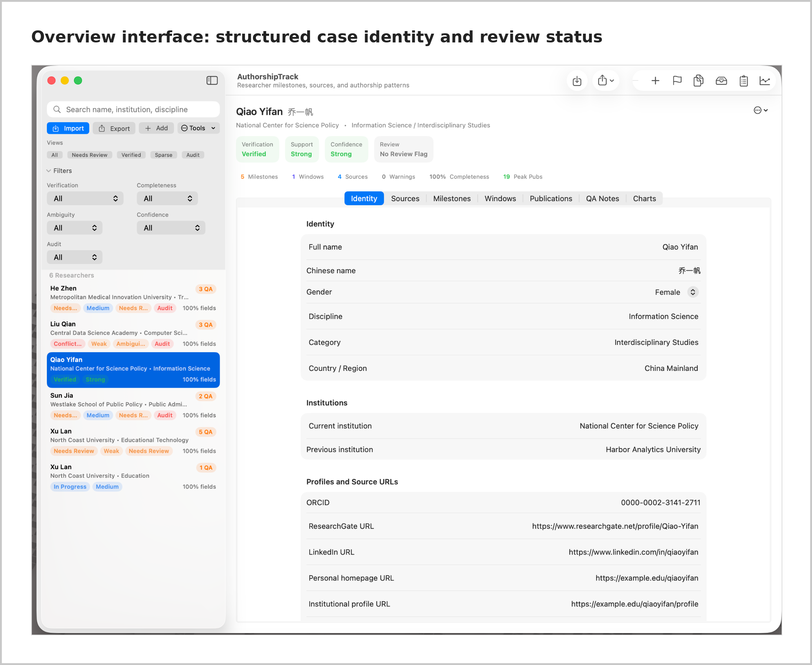
Note. This screenshot uses synthetic demonstration data only. It does not display any real researcher, source URL, institutional record or case-level evidence from the study.
Supplementary Fig. S5.2 Source documentation and review module.
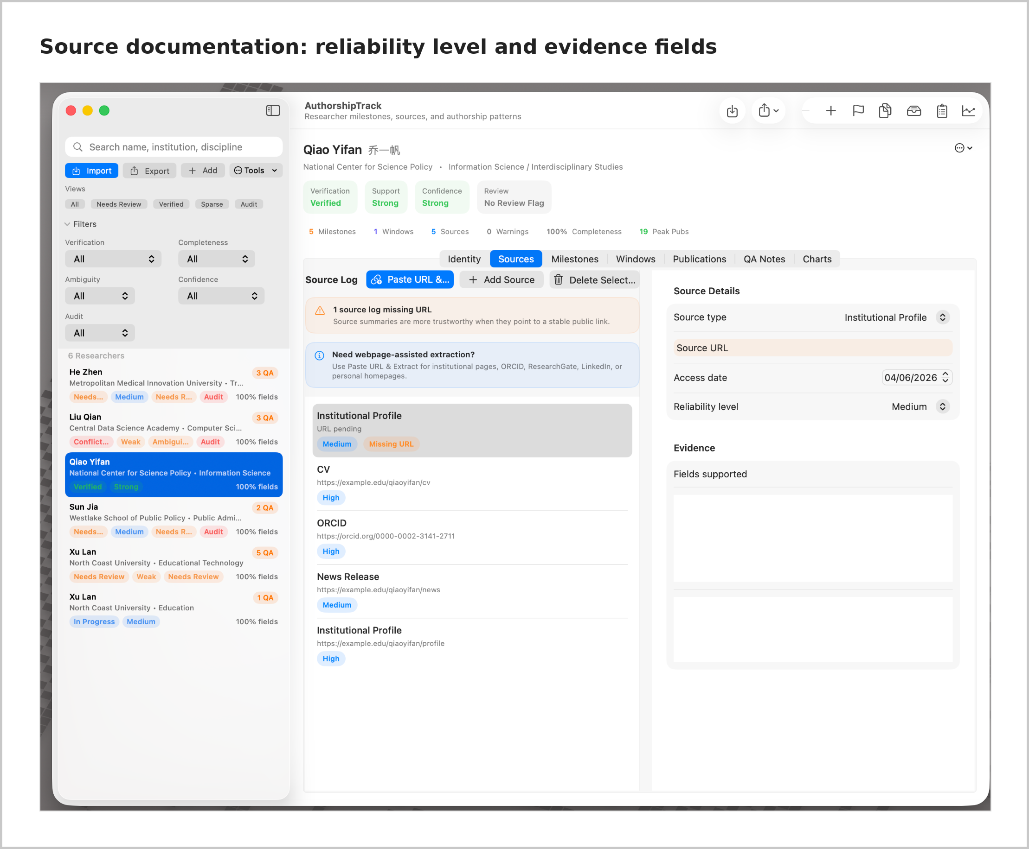
Note. This screenshot uses synthetic demonstration data only. It does not display any real researcher, source URL, institutional record or case-level evidence from the study.
Supplementary Fig. S5.3 Dataset management, charts and export-support views.
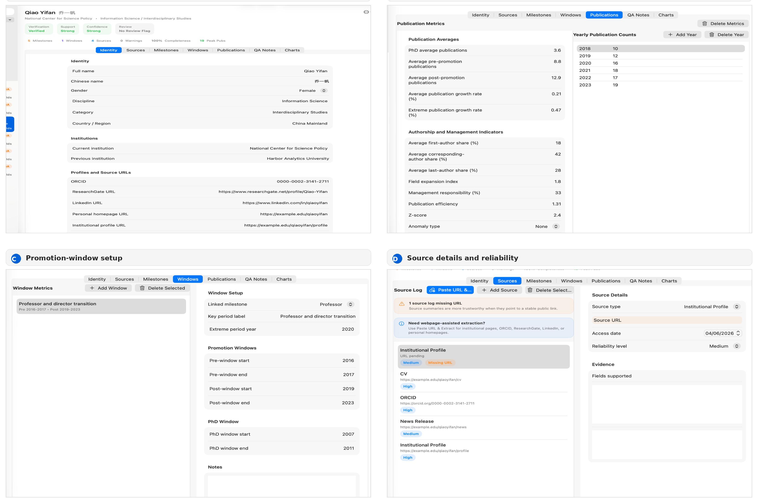
Note. This screenshot uses synthetic demonstration data only. It does not display any real researcher, source URL, institutional record or case-level evidence from the study.

S5.3 Implementation limits
Table S5.3. Implementation limits and methodological responses
Limit | Explanation | Methodological response
No automatic misconduct detection | Bibliometric data cannot prove actual author contribution | Treat outputs as signals, not conclusions
Dependence on researcher judgement | Career nodes, identity and evidence quality still require interpretation | Keep human verification and review notes
Dependence on input data quality | Incorrect or incomplete data affect later calculations | Record missing data, confidence and source reliability
Author-disambiguation problems | Same-name researchers and inconsistent profiles can distort publication records | Use identity checks and audit flags
No access to internal contribution | The programme cannot observe laboratory labour, writing contribution or authorship negotiation | Avoid individual accusation
Disciplinary variation | Authorship order and collaboration norms differ across fields | Interpret indicators in context
Risk of false precision | Calculated indicators may appear more exact than the underlying evidence allows | Mark evidence level and avoid overclaiming

Supplementary File 6
Software user guide and procedural manual

S6.1 Overview
This manual describes how the workflow should be used to process a case. It is written as a reproducible procedure rather than as a product manual. The aim is to make the analyst’s decisions visible and auditable.

1. Create or import case record
Assign a stable case ID. Do not begin interpretation until the identity record is created.

2. Enter identity evidence
Record name variants, affiliation evidence, ORCID/WoS or other database traces, and same-name risk notes.

3. Create source log
For each source, record source type, title, URL or archive reference, access date, supported claim and uncertainty note.

4. Reconstruct career timeline
Enter PhD year, appointments, promotions, leadership roles, academic honours and focal career nodes.

5. Enter annual publication counts
Enter year-by-year counts only when researcher-publication linkage is sufficiently safe. Do not impute missing years.

6. Select comparison window
Use the default three-year pre/post window unless there is a documented reason to test alternative windows.

7. Calculate publication metrics
Calculate pre-node average, post-node average, growth rate, focal spike and approximate within-case deviation score.

8. Code authorship roles
Record first-, corresponding- and last-author shares from available metadata; flag missing or partial evidence.

9. Code management and institutional context
Record public leadership responsibilities and public institutional-policy evidence. Do not infer personal exposure from institutional policy alone.

10. Export and review
Export a case summary, missingness report and source log. Review before interpretation and mark unsupported signals as under-validated.
Table S6.1. Required quality-assurance checks
QA check | Required action | Reason
Same-name risk | Compare institution, field, co-authors and publication sequence. | Prevents author-record conflation.
Career-node clarity | Mark node as confirmed, approximate or unavailable. | Protects window analysis from false timing.
Annual sequence completeness | Mark missing years; do not impute. | Prevents artificial growth or stability.
Zero or near-zero pre-window | Flag rather than inflate growth rate mechanically. | Avoids misleading percentage growth.
Authorship role metadata | Record whether roles are full, partial or unavailable. | Protects Signal 4 interpretation.
Co-author and field metadata | Record if not consistently available. | Preserves Signals 2 and 3 as under-validated rather than deleted.
Management context | Separate leadership role from direct contribution claim. | Prevents unsupported ethical inference.
Export log | Save case summary and missingness report. | Supports auditability.

Table S6.2. Export components and sharing status
Export component | Contents | Public / restricted status
De-identified case summary | Case ID, metrics, signal eligibility, missingness notes | Public supplement
Source log | Source types, evidence claims, uncertainty notes | Partly public; direct URLs may be restricted if identifiability risk is high
Full source archive | Downloaded pages, screenshots, CVs, institutional records | Restricted research archive
Calculation log | Window length, included years, pre/post averages, deviation score | Public where de-identified
Interpretive memo | Analyst judgement, alternative explanations, boundary notes | Public in summarised/de-identified form or restricted where identifying

S6.2 Prohibited uses
- Do not use the workflow to declare misconduct.
- Do not use the integrated signal count as a probability or score of inappropriate authorship.
- Do not compare researchers as if the cases were a ranking table.
- Do not treat missing co-author or field metadata as evidence that no expansion occurred.
- Do not infer that institutional policy directly affected a specific person unless direct evidence exists.

Supplementary File 7
Ethics and data-governance documentation

S7.1 Public-data basis
The manuscript uses publicly available bibliometric and institutional records. It does not involve recruitment, intervention, private communication, survey responses or interview data. For this bibliometric manuscript, formal human-participant ethics approval was therefore not required. The ethical risk lies instead in how public traces are interpreted and reported.

S7.2 Anonymisation and reporting boundaries
The public manuscript and supplementary case matrix use anonymous case labels. Researcher names, direct source URLs for specific people, complete institutional biographies and full narrative case reports are kept in the restricted research archive unless a future journal data policy requires a de-identified alternative. The article reports patterns, signal categories and validation outcomes rather than individual allegations.
Table S7.1. Data-sharing and governance decisions
Data category | Public sharing decision | Reason
Aggregate counts and validation summaries | Shared in main manuscript and supplement | Needed to evaluate the article independently.
De-identified 27-case validation matrix | Shared in Supplementary File 3 | Documents how the five-signal framework was applied without naming individuals.
Researcher names and full biographical records | Restricted | Avoids unnecessary identifiability and reputational risk.
Direct source URLs tied to named researchers | Restricted or selectively shared | Some links may re-identify cases when combined with metrics.
AuthorshipTrack screenshots | Shared where screenshots do not reveal sensitive identifiers, otherwise cropped or described | Documents method without exposing unnecessary personal data.
Full source archive | Restricted research archive | Needed for audit but not appropriate for open public release.
Software executable or source code | Conditional / de-identified sharing | Can be shared where technically and ethically appropriate.

S7.3 Interpretive safeguards
- The article does not verify inappropriate authorship.
- The article does not claim that any named researcher engaged in misconduct.
- The article does not treat high productivity, senior authorship or management roles as unethical.
- The five-signal framework produces audit triggers and validation outcomes, not accusations.
- Institutional policy evidence is treated as contextual unless direct personal exposure can be demonstrated.
- Missing data are reported rather than filled by inference.

S7.4 Data-retention and restricted archive
The restricted archive should retain the full working spreadsheet, source logs, source snapshots where legally permissible, AuthorshipTrack exports, calculation notes and versioned manuscript files. Public supplements should contain only the de-identified structures and summary matrices needed for transparent evaluation.

S7.5 Risk assessment
Table S7.2. Ethical and interpretive risk assessment
Risk | Mitigation
Re-identification through rare metric combinations | Remove names and direct URLs; report case labels and summary metrics only.
Reputational harm from over-interpretation | Use signal/audit-trigger language; avoid misconduct claims.
False precision in short annual sequences | Call deviation scores approximate; avoid statistical-significance language.
Policy-context overreach | State that institutional policy is contextual, not proof of individual exposure.
Uneven public data availability | Separate operationalised, partially operationalised and under-validated signals.

