Supplementary Information
Financial markets are betting on failure of the Paris Agreement
Contents: Supplementary Note 1; Supplementary Figures S1–S5; Supplementary Tables S1–S2.
Supplementary Note 1 | Variation in proven oil reserves across sources, and the cross-source mean
Motivation
National proven crude-oil reserves R enter our valuation linearly: each country’s reserve value scales directly with R. Reported reserves, however, differ across the major statistical authorities because they use different estimation methodologies, reporting vintages, and definitions of what counts as a “proven” reserve. Rather than adopt any single source — each of which carries its own institutional and methodological idiosyncrasies — we compile reserves from three independent primary sources (OPEC Annual Statistical Bulletin 2025, year-end 2024; CIA World Factbook, mostly 2021 est.; and the BP / Energy Institute Statistical Review of World Energy 2021, year-end 2020) and use their arithmetic mean as the reserve input for each country. The OPEC series excludes Canadian oil sands and aggregates small producers into regional “Others”; the BP/EI series is the final edition before the proved-reserves series was discontinued and includes oil sands and tight oil.
How much do the sources disagree?
Across the 100 countries for which at least one source reports reserves, 52 are reported by two or more sources and can be compared directly. Of these, 28 (54%) agree to within 5% across sources, 20 (38%) differ by more than 10%, and 6 (12%) differ by more than 50%. The median coefficient of variation across multi-source countries is just 0.008 — for a typical country the sources are nearly identical — while the mean CV of 0.075 is inflated by a small number of large disagreements. At the global level the totals span roughly 12%: OPEC sums to 1,539, the CIA Factbook to 1,697, and BP/EI to 1,724 billion barrels.
The largest cross-source disagreements are definitional or vintage-driven. Canada differs by a factor of 39 because OPEC excludes the oil sands (4.3 Bbbl) while the CIA and BP/EI include them (≈168–170 Bbbl); Ecuador (6.4×), Angola (3.1×), the United States (1.8×), the United Kingdom (1.7×) and Russia (1.3×) differ because of booking, scope, and revision differences across vintages. These differences are illustrated in Supplementary Figure S2 and tabulated in Supplementary Table S2.
Why the disagreements arise
Four factors drive the variation: (1) the definition of the resource (most starkly the treatment of Canadian oil sands and Venezuelan extra-heavy Orinoco crude); (2) reporting vintage, as the sources are anchored to different years (2020, 2021, 2024) and reserves change as fields are depleted, revised, or newly booked; (3) estimation methodology and governance, since OPEC figures are member-country submissions, BP/EI publishes an independent assessment, and the CIA/Oil & Gas Journal lineage compiles industry and government filings; and (4) the scope of “crude,” as some series count crude oil plus lease condensate while others count crude only.

Rationale for using the cross-source mean
No single authority is definitive: each reflects a particular methodology, vintage, and resource definition. We therefore use the arithmetic mean across the available sources as each country’s reserve input. Averaging avoids hard-coding the institutional bias of any one publisher; it is immaterial where sources agree (median CV ≈ 0.8%); and where they do not, Supplementary Table S2 reports every source value alongside the mean, median, and dispersion statistics so the sensitivity of any country’s valuation to the reserve choice can be assessed directly.
Caveat (Canada). Because the mean blends OPEC’s oil-sands-excluded figure with the oil-sands-inclusive figures of the other two sources, Canada’s mean (≈114 Bbbl) lies below the value any single inclusive source reports (≈168–170 Bbbl) and understates its reserves by roughly one third. We retain the mean for methodological consistency and report the median (≈168 Bbbl) in Table S2 as a robustness reference. Canada’s breakeven costs are high, so its economically recoverable reserve value under climate-aligned prices is modest regardless of which reserve figure is used.

Supplementary Figures
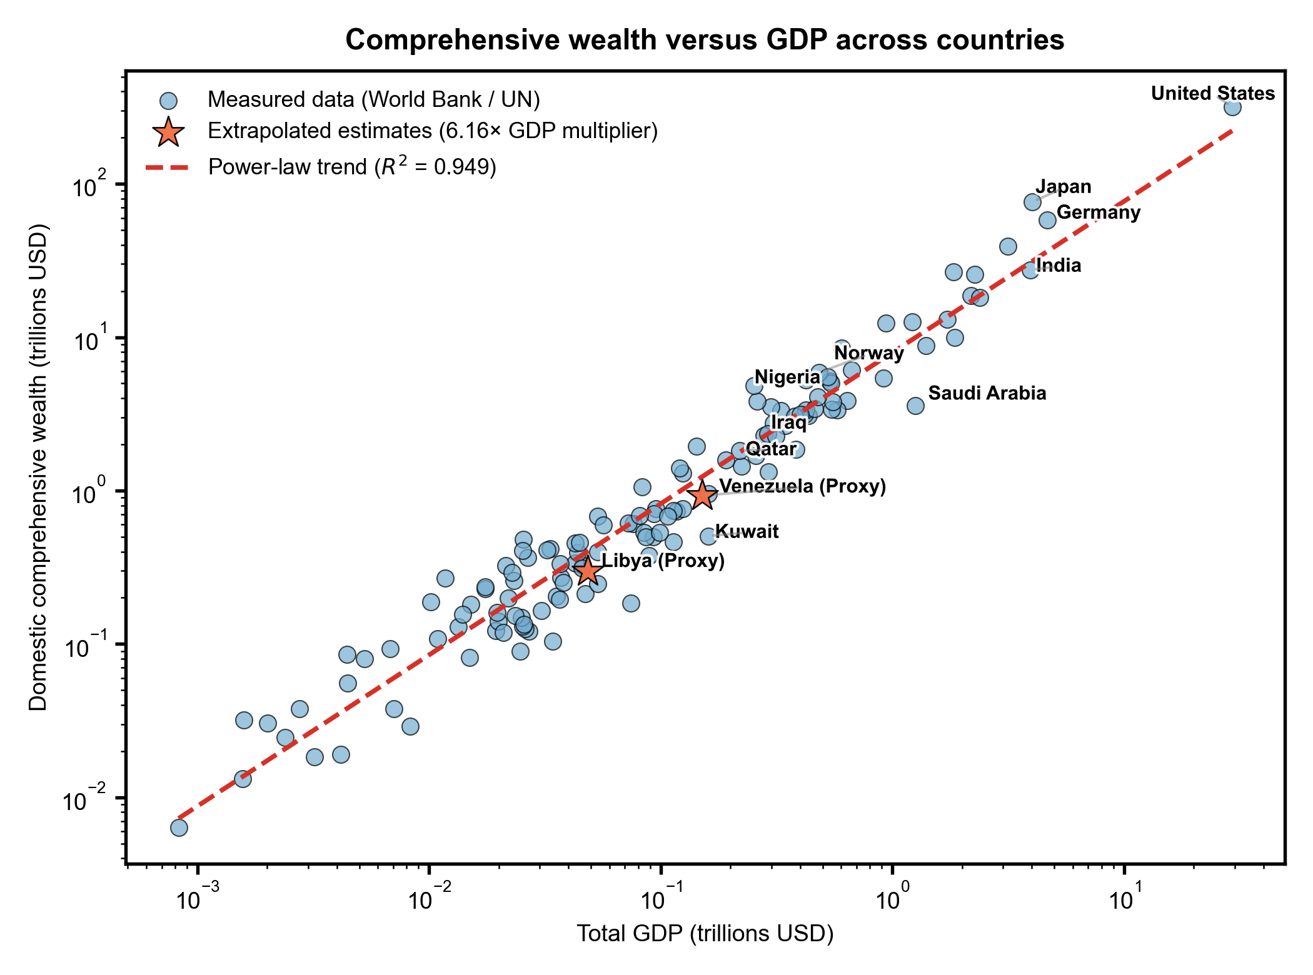
Supplementary Fig. S1 | Estimating comprehensive wealth from GDP. Domestic comprehensive wealth (World Bank Changing Wealth of Nations) against GDP (UN National Accounts) for 134 countries, on log–log axes. The dashed line shows the fitted power-law relationship (R² = 0.949), implying comprehensive wealth ≈ 6.16 × GDP. This multiplier is used to estimate comprehensive wealth for countries absent from the World Bank dataset (Venezuela and Libya, shown as stars).
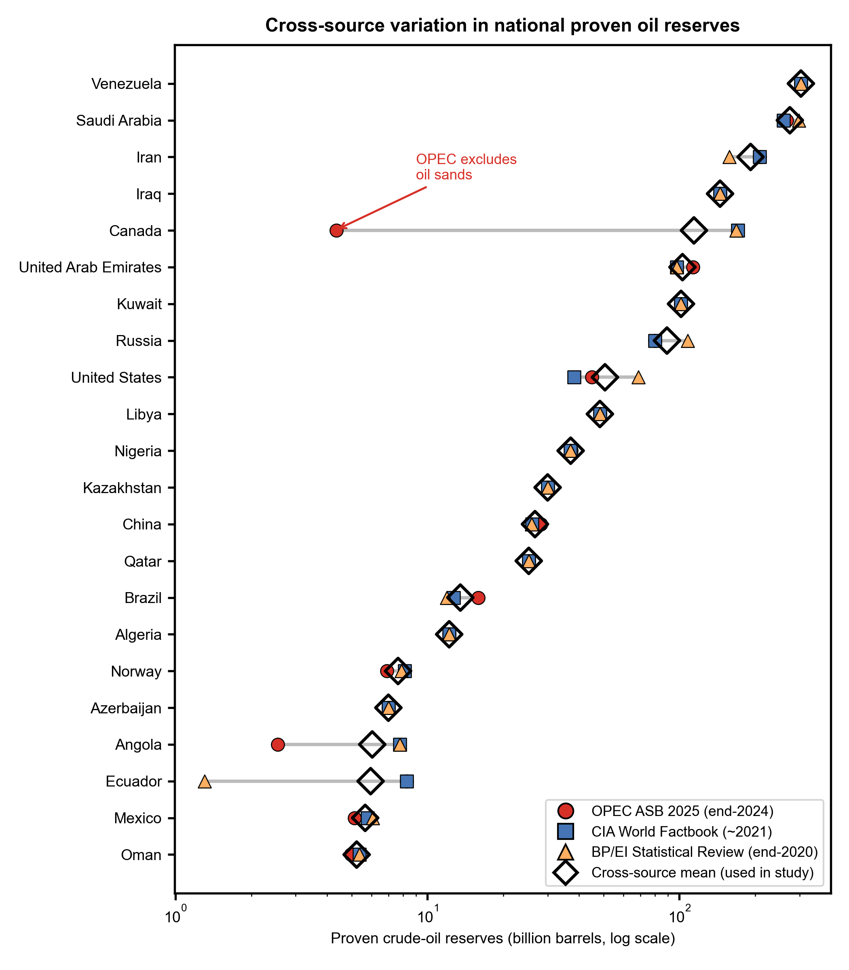
Supplementary Fig. S2 | Proven oil reserve estimates by source. Country-level proven oil reserves reported by the OPEC Annual Statistical Bulletin, the CIA World Factbook, and the Energy Institute (formerly BP) Statistical Review of World Energy, for the major reserve holders. The analysis uses the cross-source arithmetic mean (Supplementary Table S2 lists all values).
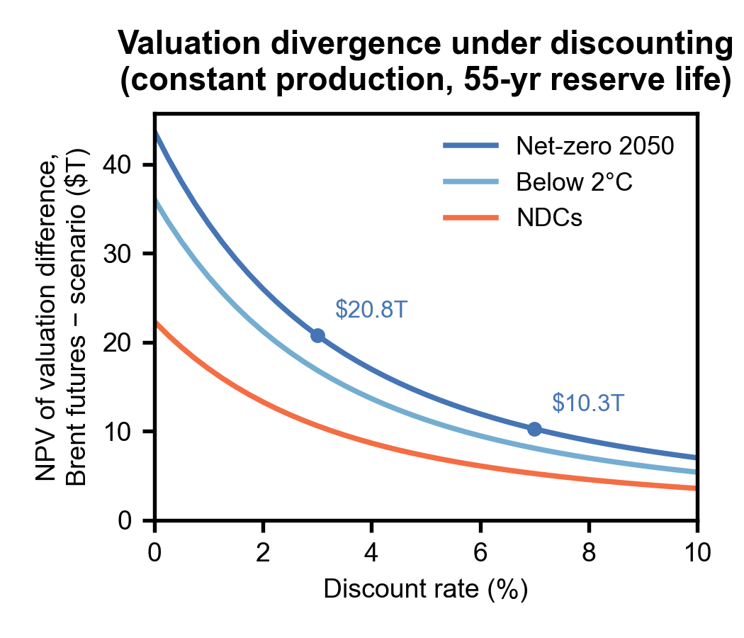
Supplementary Fig. S3 | The valuation divergence under discounting. Net present value of the difference between Brent-futures and scenario reserve valuations as a function of discount rate (0–10%), assuming constant production over a 55-year reserve life (global proven reserves ≈ 1,659 billion barrels at ≈ 30 billion barrels per year) with scenario prices held constant in real terms beyond the futures horizon (2034). Holding the Net-zero 2050 price flat is conservative, as the underlying NGFS producer prices continue to decline after 2034. The Brent-minus-Net-zero gap is $20.8 trillion at a 3% discount rate and $10.3 trillion at 7%; the six most-exposed countries hold 76% of the gap at all rates and the country ranking is unchanged (Spearman ρ = 1.00).

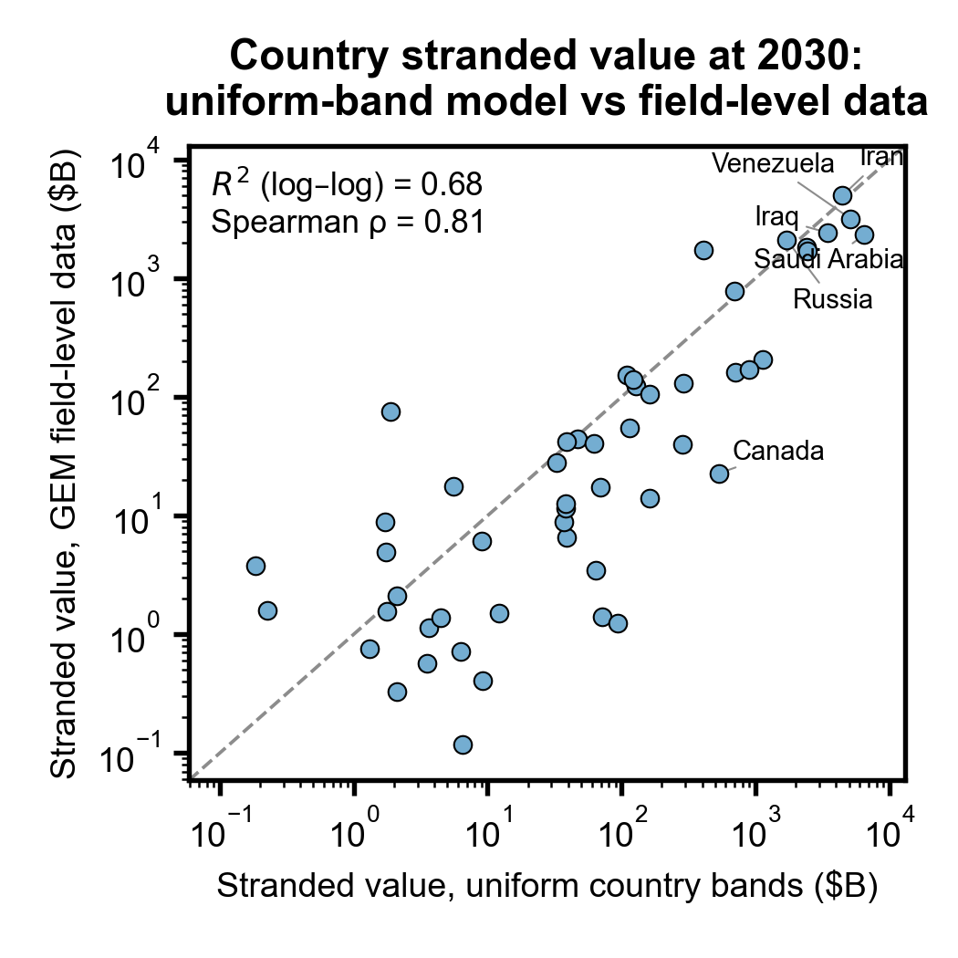
Supplementary Fig. S4 | Country stranded value: uniform-band model versus field-level data. 2030 stranded value (Brent futures minus Net-zero 2050) for each country computed two ways: with the manuscript’s uniform-cost country bands applied to cross-source mean reserves (x-axis), and bottom-up from field-level reserves and breakeven estimates in the Global Energy Monitor Global Oil and Gas Extraction Tracker (y-axis). Across the 51 countries present in both datasets, the two approaches agree strongly (log–log R² = 0.68; Spearman ρ = 0.81). Canada falls below the 1:1 line because field-level disclosure under-represents oil-sands reserves, consistent with the company-level estimates being conservative lower bounds.
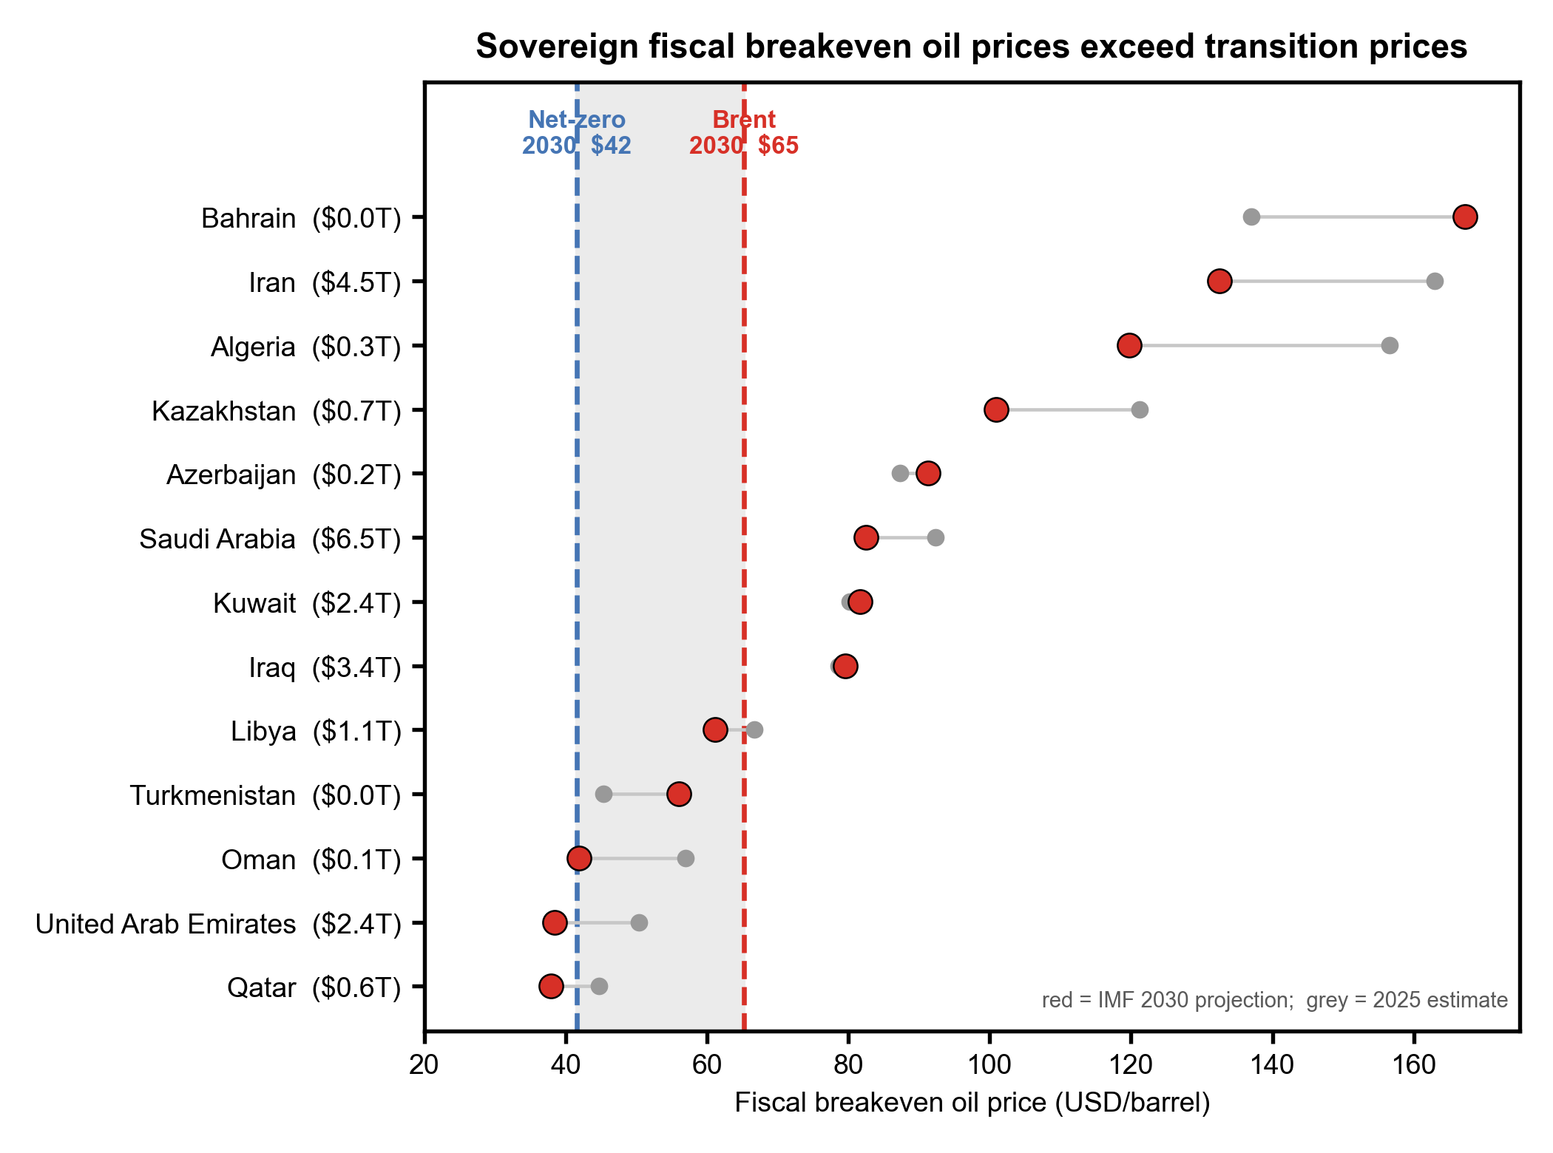
Supplementary Fig. S5 | Sovereign fiscal breakeven oil prices exceed Paris-aligned prices. Fiscal breakeven oil price — the Brent price at which a government’s budget balances — for the 13 Middle East, North Africa, Caucasus and Central Asia oil exporters assessed by the IMF (Regional Economic Outlook: Middle East and Central Asia, May 2025, Statistical Appendix, Table 6). Grey markers show the 2025 estimate and red markers the 2030 projection; each country’s 2030 stranded oil value (Brent futures minus Net-zero 2050) from this study is given in parentheses after its name. The shaded band spans the 2030 Net-zero 2050 price ($42/barrel) and the 2030 Brent-futures price ($65/barrel). Eleven of the thirteen countries have a 2030 fiscal breakeven above the Net-zero price and eight above even the Brent-futures price; only Qatar and the United Arab Emirates remain fiscally solvent at the Paris-aligned price. Weighting by stranded value, the mean 2030 breakeven is $86/barrel. Venezuela (this study’s second-largest stranded exposure) is omitted because the IMF has not assessed it since 2004 and it is already in chronic fiscal crisis; Russia is omitted because its Article IV consultations are suspended and available breakeven estimates (≈$77/barrel, Institute of International Finance) are referenced to a discounted Urals price rather than Brent.

Supplementary Tables
Supplementary Table S1. Extraction breakeven cost estimates and published sources for major oil-producing countries.
Country | Proven Reserves (billion bbl) | Breakeven Min ($/bbl) | Breakeven Max ($/bbl) | Production Type | Published Source(s) | Source URL(s)
Venezuela | 303.8 | 35 | 60 | Conventional + Orinoco heavy/extra-heavy | Rystad Energy via UK BEIS Fossil Fuel Supply Curves (2019), pp. 17; UC Berkeley Haas School analysis of Venezuelan oil economics (2024) | https://assets.publishing.service.gov.uk/media/5e3ad916e5274a08e229ca27/fossil-fuel-supply-curves.pdf  https://newsroom.haas.berkeley.edu/too-dirty-too-late-why-the-economics-of-venezuela-s-oil-dont-pencil-out/
Saudi Arabia | 258.6 | 25 | 35 | Onshore conventional | Saudi Aramco IPO prospectus (2019): production cost <$10/bbl after tax; Aramco Annual Report (2023): lifting cost $3.5/bbl; OilPrice.com (2023) reporting Aramco after-tax breakeven <$10/bbl; Rystad via UK BEIS (2019): Middle East onshore lowest-cost supply group | https://oilprice.com/Energy/Oil-Prices/Aramcos-Breakeven-Costs-Are-The-Lowest-In-The-World.html  https://assets.publishing.service.gov.uk/media/5e3ad916e5274a08e229ca27/fossil-fuel-supply-curves.pdf
Iran | 208.6 | 30 | 45 | Onshore conventional; sanctions add logistics variance | Rystad via UK BEIS (2019), pp. 17: Iran breakevens mostly $10-50/bbl; UK DESNZ Fossil Fuel Supply Curves (2023): Iran production outlook included | https://assets.publishing.service.gov.uk/media/5e3ad916e5274a08e229ca27/fossil-fuel-supply-curves.pdf  https://assets.publishing.service.gov.uk/media/656753ce312f400013e5d5e7/rystad-energy-desnz-fossil-fuel-supply-curves.pdf
Canada | 170.3 | 50 | 75 | Oil sands (SAGD + mining) | CERI Study 152 (archived at Natural Resources Canada): existing SAGD ~C$63.50/bbl, mining C$70/bbl; Dallas Fed Energy Survey Q1 2024: related shale context; Enverus (2025): existing SAGD half-cycle ~$27/bbl, new standalone SAGD ~$60/bbl, new mining $75-85/bbl | https://natural-resources.canada.ca/sites/nrcan/files/energy/energy-resources/CERI_Study_152_Final_Report.pdf  https://www.enverus.com/newsroom/the-canadian-oil-sandslow-breakeven-resource-advantage/
Iraq | 145 | 25 | 35 | Low-cost onshore conventional | Rystad via UK BEIS (2019): Middle East onshore is lowest-cost supply group globally; OilPrice.com (2023): Iraq among lowest global production costs | https://assets.publishing.service.gov.uk/media/5e3ad916e5274a08e229ca27/fossil-fuel-supply-curves.pdf  https://oilprice.com/Energy/Oil-Prices/Aramcos-Breakeven-Costs-Are-The-Lowest-In-The-World.html
Kuwait | 101.5 | 25 | 35 | Low-cost onshore conventional | Rystad via UK BEIS (2019): Middle East onshore conventional breakevens among lowest globally ($10-30/bbl for producing fields) | https://assets.publishing.service.gov.uk/media/5e3ad916e5274a08e229ca27/fossil-fuel-supply-curves.pdf
UAE | 97.8 | 28 | 40 | Onshore/offshore mix; low-cost | OilPrice.com (2023): UAE after-tax production breakeven just over $20/bbl; Rystad via UK BEIS (2019): Middle East conventional among lowest-cost globally | https://oilprice.com/Energy/Oil-Prices/Aramcos-Breakeven-Costs-Are-The-Lowest-In-The-World.html  https://assets.publishing.service.gov.uk/media/5e3ad916e5274a08e229ca27/fossil-fuel-supply-curves.pdf
Russia | 80 | 35 | 55 | Onshore conventional; Arctic/offshore higher | FXEmpire (2024): Russia comfortable at ~$40/bbl; OilPrice.com (2023): Russian production breakeven >$40/bbl; Carnegie Endowment (2026): significant proportion of Russian fields uneconomic below $40/bbl; Rystad via UK DESNZ (2023): Russia production outlook included | https://www.fxempire.com/education/article/breakeven-crude-oil-production-costs-around-the-world-646083  https://oilprice.com/Energy/Oil-Prices/Aramcos-Breakeven-Costs-Are-The-Lowest-In-The-World.html  https://assets.publishing.service.gov.uk/media/656753ce312f400013e5d5e7/rystad-energy-desnz-fossil-fuel-supply-curves.pdf
Libya | 48.4 | 30 | 45 | Onshore conventional; security/logistics variability | Rystad via UK BEIS (2019), pp. 17: Libya breakevens mostly $10-50/bbl with majority in lower range; production outlook ~1 million bbl/d long-term | https://assets.publishing.service.gov.uk/media/5e3ad916e5274a08e229ca27/fossil-fuel-supply-curves.pdf
United States | 38.2 | 40 | 55 | Shale/tight oil (Permian, Eagle Ford, Bakken) | Dallas Fed Energy Survey Q1 2024: operating breakeven $39/bbl (existing wells), new well drilling $64/bbl; Permian $65/bbl; MIT CEEPR WP 2016-012: tight oil full-cycle $60-90/bbl, half-cycle $50-70/bbl; Rystad via UK BEIS (2019): shale breakevens shown in supply curves | https://www.dallasfed.org/research/surveys/des/2024/2401  https://ceepr.mit.edu/wp-content/uploads/2021/09/2016-012.pdf  https://assets.publishing.service.gov.uk/media/5e3ad916e5274a08e229ca27/fossil-fuel-supply-curves.pdf
Nigeria | 36.9 | 35 | 55 | Onshore/offshore mix; security adds cost | OilPrice.com (2023): Nigerian production breakeven almost $50/bbl; Carbon Tracker, PetroStates of Decline (2023): Nigeria among highest-cost African producers | https://oilprice.com/Energy/Oil-Prices/Aramcos-Breakeven-Costs-Are-The-Lowest-In-The-World.html  https://carbontracker.org/reports/petrostates-of-decline/
Kazakhstan | 30 | 30 | 45 | Onshore conventional; sour crude quality factors | Rystad via UK DESNZ (2023): Kazakhstan included in global supply curves; IEA Kazakhstan 2022 Report: development costs for new upstream projects relatively high with long export routes | https://assets.publishing.service.gov.uk/media/656753ce312f400013e5d5e7/rystad-energy-desnz-fossil-fuel-supply-curves.pdf  https://www.iea.org/reports/kazakhstan-2022/executive-summary
China | 26 | 40 | 60 | Mature fields; EOR increases costs | Oxford Institute for Energy Studies (2025): Chinese lifting costs declining but EOR at scale raises full-cycle breakevens; UK DESNZ (2023): global supply curves include China | https://www.oxfordenergy.org/wpcms/wp-content/uploads/2025/08/OIES-Presentation-Crude-oil-production-in-China.pdf  https://assets.publishing.service.gov.uk/media/656753ce312f400013e5d5e7/rystad-energy-desnz-fossil-fuel-supply-curves.pdf
Qatar | 25.2 | 28 | 40 | Low-cost liquids associated with gas; offshore | Rystad via UK BEIS (2019): Middle East offshore among lowest-cost supply groups; Qatar petroleum operations benefit from associated gas production synergies | https://assets.publishing.service.gov.uk/media/5e3ad916e5274a08e229ca27/fossil-fuel-supply-curves.pdf
Brazil | 12.7 | 35 | 50 | Deepwater pre-salt | Petrobras Annual Report (2024): portfolio-wide breakeven ~$28/bbl; OilPrice.com (2025): pre-salt breakeven <$40/bbl; Rystad via UK DESNZ (2023): Brazil deepwater in global supply curves | https://oilprice.com/Energy/Crude-Oil/Brazils-Pre-Salt-Oil-Gains-Unprecedented-Global-Popularity.html  https://assets.publishing.service.gov.uk/media/656753ce312f400013e5d5e7/rystad-energy-desnz-fossil-fuel-supply-curves.pdf
Algeria | 12.2 | 30 | 45 | Onshore conventional | Rystad via UK BEIS (2019): North African onshore conventional among lower-cost producers; UK DESNZ (2023): Algeria included in global supply curves | https://assets.publishing.service.gov.uk/media/5e3ad916e5274a08e229ca27/fossil-fuel-supply-curves.pdf  https://assets.publishing.service.gov.uk/media/656753ce312f400013e5d5e7/rystad-energy-desnz-fossil-fuel-supply-curves.pdf
Norway | 8.1 | 35 | 50 | Offshore conventional; efficient operations | Norwegian Petroleum Directorate (2025): total UKCS operating costs ~NOK 94 billion; Equinor reports Johan Sverdrup breakeven <$15/bbl; Offshore Magazine: UK/Norway offer lowest offshore breakevens | https://www.norskpetroleum.no/en/economy/investments-operating-costs/  https://www.offshore-mag.com/field-development/article/14195748/uk-norway-offer-lowest-breakevens-for-offshore-projects
Ecuador | 8.3 | 35 | 55 | Heavy crude; remote logistics | IEA Ecuador Oil Profile; Rystad via UK DESNZ (2023): Latin American producers included in global supply curves | https://www.iea.org/countries/ecuador/oil  https://assets.publishing.service.gov.uk/media/656753ce312f400013e5d5e7/rystad-energy-desnz-fossil-fuel-supply-curves.pdf
Angola | 7.8 | 35 | 50 | Offshore deepwater | TotalEnergies Kaminho project breakeven below $30/bbl (Offshore Energy, 2024); average deepwater breakeven ~$40/bbl | https://www.offshore-energy.biz/totalenergies-launch-of-deepwater-project-opens-new-oil-frontiers-offshore-angola/
Azerbaijan | 7 | 30 | 45 | Offshore shelf; mature assets | SOCAR (2016): average production cost $20/bbl; EIA Caspian Sea regional analysis | https://www.eia.gov/international/analysis/regions-of-interest/Caspian_Sea
Global supply curve references applicable to multiple countries above:
[1] | Rystad Energy for UK BEIS |  | BEIS Fossil Fuel Supply Curves (May 2019) |  |  | https://assets.publishing.service.gov.uk/media/5e3ad916e5274a08e229ca27/fossil-fuel-supply-curves.pdf
[2] | Rystad Energy for UK DESNZ |  | DESNZ Fossil Fuel Supply Curves (April 2023) |  |  | https://assets.publishing.service.gov.uk/media/656753ce312f400013e5d5e7/rystad-energy-desnz-fossil-fuel-supply-curves.pdf
[3] | McGlade & Ekins (2015) |  | Nature 517, 187-190. "The geographical distribution of fossil fuels unused when limiting global warming to 2C" |  |  | https://www.nature.com/articles/nature14016
[4] | Dallas Fed Energy Survey |  | Quarterly survey of E&P firms on breakeven prices (ongoing since 2016) |  |  | https://www.dallasfed.org/research/surveys/des
[5] | Carbon Tracker Initiative |  | Multiple reports on stranded assets and unburnable carbon |  |  | https://carbontracker.org/reports/
Note: This table covers the 20 largest holders of proven oil reserves, which together account for approximately 95% of global proven reserves. For the remaining ~60 countries with proven reserves included in our analysis, country-specific published extraction cost data is generally unavailable. Breakeven estimates for these smaller producers are assigned using production-type analogues derived from the BEIS/DESNZ global supply curves, which report breakevens by resource type: onshore conventional ($25-45/bbl), offshore shelf ($30-50/bbl), offshore deepwater ($35-55/bbl), oil sands ($50-75/bbl), and shale/tight oil ($40-65/bbl). These regional benchmarks are adjusted where possible using publicly available project-level disclosures or national oil company reporting. Full country-level estimates are provided in the accompanying dataset.
Breakeven costs refer to full-cycle extraction costs (capex + opex), not fiscal breakeven prices required to balance government budgets. All values in 2024 USD/bbl unless noted.

Supplementary Table S2. Proven crude-oil reserves by country across independent primary sources, and the cross-source mean used in this study.
Country | OPEC (Bbbl) | CIA (Bbbl) | BP/EI (Bbbl) | N sources | Mean (Bbbl) [used] | Median (Bbbl) | Max/Min | CV
Venezuela | 303.22 | 303.81 | 303.81 | 3 | 303.61 | 303.81 | 1 | 0.001
Saudi Arabia | 267.2 | 258.6 | 297.53 | 3 | 274.44 | 267.2 | 1.15 | 0.061
Iran | 208.6 | 208.6 | 157.8 | 3 | 191.67 | 208.6 | 1.32 | 0.125
Iraq | 145.02 | 145.02 | 145.02 | 3 | 145.02 | 145.02 | 1 | 0
Canada | 4.34 | 170.3 | 168.09 | 3 | 114.24 | 168.09 | 39.2 | 0.68
United Arab Emirates | 113 | 97.8 | 97.8 | 3 | 102.87 | 97.8 | 1.16 | 0.07
Kuwait | 101.5 | 101.5 | 101.5 | 3 | 101.5 | 101.5 | 1 | 0
Russia | 80 | 80 | 107.8 | 3 | 89.27 | 80 | 1.35 | 0.147
United States | 45.01 | 38.21 | 68.76 | 3 | 50.66 | 45.01 | 1.8 | 0.259
Libya | 48.36 | 48.36 | 48.36 | 3 | 48.36 | 48.36 | 1 | 0
Nigeria | 37.28 | 36.89 | 36.89 | 3 | 37.02 | 36.89 | 1.01 | 0.005
Kazakhstan | 30 | 30 | 30 | 3 | 30 | 30 | 1 | 0
China | 28.18 | 26.02 | 25.96 | 3 | 26.72 | 26.02 | 1.08 | 0.039
Qatar | 25.24 | 25.24 | 25.24 | 3 | 25.24 | 25.24 | 1 | 0
Brazil | 15.89 | 12.71 | 11.93 | 3 | 13.51 | 12.71 | 1.33 | 0.127
Algeria | 12.2 | 12.2 | 12.2 | 3 | 12.2 | 12.2 | 1 | 0
Norway | 6.91 | 8.12 | 7.9 | 3 | 7.65 | 7.9 | 1.18 | 0.069
Azerbaijan | 7 | 7 | 7 | 3 | 7 | 7 | 1 | 0
Angola | 2.55 | 7.78 | 7.78 | 3 | 6.04 | 7.78 | 3.05 | 0.408
Ecuador | 8.27 | 8.27 | 1.3 | 3 | 5.95 | 8.27 | 6.35 | 0.552
Mexico | 5.14 | 5.79 | 6.07 | 3 | 5.66 | 5.79 | 1.18 | 0.069
Oman | 4.97 | 5.37 | 5.37 | 3 | 5.24 | 5.37 | 1.08 | 0.036
Sudan and South Sudan | 5 |  |  | 1 | 5 | 5 | 1 | 0
India | 4.98 | 4.61 | 4.54 | 3 | 4.71 | 4.61 | 1.1 | 0.041
Vietnam | 4.4 | 4.4 | 4.4 | 3 | 4.4 | 4.4 | 1 | 0
South Sudan |  | 3.75 | 3.5 | 2 | 3.62 | 3.62 | 1.07 | 0.035
Egypt | 3.3 | 3.3 | 3.15 | 3 | 3.25 | 3.3 | 1.05 | 0.022
Malaysia | 2.7 | 3.6 | 2.73 | 3 | 3.01 | 2.73 | 1.33 | 0.139
Yemen |  | 3 | 3 | 2 | 3 | 3 | 1 | 0
Argentina | 3 | 2.48 | 2.48 | 3 | 2.65 | 2.48 | 1.21 | 0.092
Republic of the Congo | 1.81 | 2.88 | 2.88 | 3 | 2.52 | 2.88 | 1.59 | 0.2
Syria |  | 2.5 | 2.5 | 2 | 2.5 | 2.5 | 1 | 0
Uganda |  | 2.5 |  | 1 | 2.5 | 2.5 | 1 | 0
Indonesia | 2.41 | 2.48 | 2.44 | 3 | 2.44 | 2.44 | 1.03 | 0.012
Australia | 1.8 | 2.45 | 2.39 | 3 | 2.21 | 2.39 | 1.36 | 0.131
United Kingdom | 1.5 | 2.5 | 2.5 | 3 | 2.17 | 2.5 | 1.67 | 0.218
Colombia | 2.02 | 2.04 | 2.04 | 3 | 2.03 | 2.04 | 1.01 | 0.004
Gabon | 2 | 2 | 2 | 3 | 2 | 2 | 1 | 0
Chad |  | 1.5 | 1.5 | 2 | 1.5 | 1.5 | 1 | 0
Sudan |  | 1.25 | 1.5 | 2 | 1.38 | 1.38 | 1.2 | 0.091
Brunei | 1.1 | 1.1 | 1.1 | 3 | 1.1 | 1.1 | 1 | 0
Equatorial Guinea | 1.1 | 1.1 | 1.1 | 3 | 1.1 | 1.1 | 1 | 0
Peru |  | 0.86 | 0.75 | 2 | 0.8 | 0.8 | 1.15 | 0.07
Ghana |  | 0.66 |  | 1 | 0.66 | 0.66 | 1 | 0
Romania |  | 0.6 | 0.6 | 2 | 0.6 | 0.6 | 1 | 0
Turkmenistan | 0.6 | 0.6 | 0.6 | 3 | 0.6 | 0.6 | 1 | 0
Uzbekistan | 0.59 | 0.59 | 0.59 | 3 | 0.59 | 0.59 | 1 | 0
Italy |  | 0.5 | 0.6 | 2 | 0.55 | 0.55 | 1.21 | 0.096
Pakistan |  | 0.54 |  | 1 | 0.54 | 0.54 | 1 | 0
Tunisia |  | 0.42 | 0.42 | 2 | 0.42 | 0.42 | 1 | 0
Denmark | 0.36 | 0.44 | 0.43 | 3 | 0.41 | 0.43 | 1.21 | 0.081
Ukraine | 0.4 | 0.4 |  | 2 | 0.4 | 0.4 | 1 | 0
Turkiye |  | 0.37 |  | 1 | 0.37 | 0.37 | 1 | 0
Thailand |  | 0.25 | 0.25 | 2 | 0.25 | 0.25 | 1 | 0
Trinidad and Tobago |  | 0.24 | 0.24 | 2 | 0.24 | 0.24 | 1 | 0
Bolivia |  | 0.24 |  | 1 | 0.24 | 0.24 | 1 | 0
Cameroon |  | 0.2 |  | 1 | 0.2 | 0.2 | 1 | 0
Belarus | 0.2 | 0.2 |  | 2 | 0.2 | 0.2 | 1 | 0
Bahrain |  | 0.19 |  | 1 | 0.19 | 0.19 | 1 | 0
DR Congo |  | 0.18 |  | 1 | 0.18 | 0.18 | 1 | 0
Papua New Guinea |  | 0.16 |  | 1 | 0.16 | 0.16 | 1 | 0
Albania |  | 0.15 |  | 1 | 0.15 | 0.15 | 1 | 0
Chile | 0.15 | 0.15 |  | 2 | 0.15 | 0.15 | 1 | 0
Niger |  | 0.15 |  | 1 | 0.15 | 0.15 | 1 | 0
Spain |  | 0.15 |  | 1 | 0.15 | 0.15 | 1 | 0
Myanmar |  | 0.14 |  | 1 | 0.14 | 0.14 | 1 | 0
Philippines |  | 0.14 |  | 1 | 0.14 | 0.14 | 1 | 0
Netherlands |  | 0.14 |  | 1 | 0.14 | 0.14 | 1 | 0
Cuba |  | 0.12 |  | 1 | 0.12 | 0.12 | 1 | 0
Germany |  | 0.12 |  | 1 | 0.12 | 0.12 | 1 | 0
Poland |  | 0.11 |  | 1 | 0.11 | 0.11 | 1 | 0
Ivory Coast |  | 0.1 |  | 1 | 0.1 | 0.1 | 1 | 0
Suriname |  | 0.09 |  | 1 | 0.09 | 0.09 | 1 | 0
Guatemala |  | 0.09 |  | 1 | 0.09 | 0.09 | 1 | 0
Serbia |  | 0.08 |  | 1 | 0.08 | 0.08 | 1 | 0
Croatia |  | 0.07 |  | 1 | 0.07 | 0.07 | 1 | 0
France |  | 0.06 |  | 1 | 0.06 | 0.06 | 1 | 0
Japan |  | 0.04 |  | 1 | 0.04 | 0.04 | 1 | 0
New Zealand |  | 0.04 |  | 1 | 0.04 | 0.04 | 1 | 0
Kyrgyzstan |  | 0.04 |  | 1 | 0.04 | 0.04 | 1 | 0
Austria |  | 0.04 |  | 1 | 0.04 | 0.04 | 1 | 0
Georgia |  | 0.04 |  | 1 | 0.04 | 0.04 | 1 | 0
Bangladesh |  | 0.03 |  | 1 | 0.03 | 0.03 | 1 | 0
Mauritania |  | 0.02 |  | 1 | 0.02 | 0.02 | 1 | 0
Bulgaria |  | 0.01 |  | 1 | 0.01 | 0.01 | 1 | 0
Czechia |  | 0.01 |  | 1 | 0.01 | 0.01 | 1 | 0
South Africa |  | 0.01 |  | 1 | 0.01 | 0.01 | 1 | 0
Israel |  | 0.01 |  | 1 | 0.01 | 0.01 | 1 | 0
Hungary |  | 0.01 |  | 1 | 0.01 | 0.01 | 1 | 0
Lithuania |  | 0.01 |  | 1 | 0.01 | 0.01 | 1 | 0
Tajikistan |  | 0.01 |  | 1 | 0.01 | 0.01 | 1 | 0
Greece |  | 0.01 |  | 1 | 0.01 | 0.01 | 1 | 0
Slovakia |  | 0.01 |  | 1 | 0.01 | 0.01 | 1 | 0
Benin |  | 0.01 |  | 1 | 0.01 | 0.01 | 1 | 0
Beliz |  | 0.01 |  | 1 | 0.01 | 0.01 | 1 | 0
Taiwan |  | 0 |  | 1 | 0 | 0 | 1 | 0
Barbados |  | 0 |  | 1 | 0 | 0 | 1 | 0
Jordan |  | 0 |  | 1 | 0 | 0 | 1 | 0
Morocco |  | 0 |  | 1 | 0 | 0 | 1 | 0
Ethiopia |  | 0 |  | 1 | 0 | 0 | 1 | 0
Values in billion barrels. OPEC = Annual Statistical Bulletin 2025 (year-end 2024); CIA = World Factbook crude-oil proved reserves (mostly 2021 est.); BP/EI = BP Statistical Review of World Energy 2021 (year-end 2020), the final edition before the proved-reserves series was discontinued. "Mean" is the arithmetic mean across the sources reporting a value and is the figure used in the main analysis. "Max/Min" and "CV" (coefficient of variation) summarise cross-source disagreement. Blank = not reported by that source (OPEC aggregates small producers into regional "Others"). Full provenance, URLs and access dates: docs/Reserves_Data_Sources.md.

