Influence of the dry and rainy period on trace metal enrichments in
sediments of the southern coast of the state of Pernambuco, Brazil

Silvio J.J.C. do Nascimento, Iasmim M.S. de Miranda, Lucas F.C. da Silva, Ryan G.M.F. da Silva, Suelen N. dos Santos, Suennia C.S. Sena, Ana P.S. Paim, Laís A. Souza*

Supplementary Material

Table S1 - Parameters used in the ICP-OES analysis.

Instrumental Parameter | ICP OES
RF Power | 1250
Nebulizing gas flow rate (L min⁻¹) | 0.50
Auxiliary gas flow rate (L min⁻¹) | 0.50
Plasma gas flow rate (L min⁻¹) | 13.5
Reading time (min) | 1
Replicates | 3
Nebulizer | Seaspray
Nebulizing chamber | Cyclonic
Plasma observation view | Axial
Wavelength (nm) | Ba – (233.527); Cd (228.802); Co – (228.616); Cr – (267.716); Cu – (324.754); Fe – (238.204); Mn – (257.610); Ni – (221.647); Pb – (220.353); Zn – (206.200).

Table S2 – Analytical validation parameters for the determination of trace elements in sediments by ICP-OES.

Element | Equation of a line | Dynamic range (mg L⁻¹) | r2 | LOD (μg g⁻¹) | LOQ (μg g⁻¹) | RSD (%) n = 10
Ba | y = 202219x - 1533.8 | 0.08 a 0.1 | 0.9995 | 0.69 | 2.10 | 6.9
Cd | y = 122966x + 51481 | 0.003 a 20 | 0.9960 | 0.02 | 0.08 | < 0.02
Co | y = 94959x + 27593 | 0.0012 a 20 | 0.9970 | 0.01 | 0.03 | 5.6
Cr | y = 129266x + 420.73 | 0.0017 a 0.1 | 0.9991 | 0.01 | 0.04 | 9.3
Cu | y = 271260x - 176.21 | 0.02 a 0.1 | 0.9999 | 0.14 | 0.43 | < 0.14
Fe | y = 131530x + 48913 | 0.16 a 20 | 0.9958 | 1.30 | 3.94 | < 1.30
Mn | y = 1000000x + 4997.7 | 0.03 a 4 | 1.0000 | 0.23 | 0.69 | 7.8
Ni | y = 47145x - 437.07 | 0.02 a 0.1 | 0.9986 | 0.16 | 0.47 | 8.2
Pb | y = 6422.7x + 434.6 | 0.05 a 0.1 | 0.9997 | 0.42 | 1.28 | < 0.42
Zn | y = 20055x + 100.62 | 0.008 a 1 | 0.9996 | 0.07 | 0.21 | 6.7

Table S3 - Pearson's correlation between metal concentrations and their relationship to particle size results in different beaches during the dry season.
 | Coarse sand (%) | Medium sand (%) | Fine sand (%) | Silt  (%) | Ba | Cd | Pb | Co | Cu | Cr | Fe | Mn | Ni | Zn
Coarse sand (%) | 1.0
Medium sand (%) | -0.4 | 1.0
Fine sand (%) | -1.0 | 0.4 | 1.0
Silt  (%) | -1.0 | 0.4 | 1.0 | 1.0
Ba | 0.4 | -0.4 | -0.3 | -0.2 | 1.0
Cd |  |  |  |  |  | 1.0
Pb |  |  |  |  |  |  | 1.0
Co | 0.6 | -0.1 | -0.6 | -0.4 | 0.5 |  |  | 1.0
Cu |  |  |  |  |  |  |  |  | 1.0
Cr | 0.7 | -0.3 | -0.7 | -0.5 | 0.6 |  |  | 1.0 |  | 1.0
Fe | 0.8 | -0.6 | -0.7 | -0.7 | 0.8 |  |  | 0.5 |  | 0.7 | 1.0
Mn | 0.3 | -0.6 | -0.2 | -0.3 | 0.7 |  |  | -0.2 |  | -0.1 | 0.6 | 1.0
Ni | 0.6 | -0.1 | -0.6 | -0.4 | 0.6 |  |  | 1.0 |  | 1.0 | 0.7 | 0.0 | 1.0
Zn | 0.7 | -0.4 | -0.7 | -0.6 | 0.5 |  |  | 0.9 |  | 1.0 | 0.7 | -0.1 | 0.9 | 1.0

Table S4 - Pearson's correlation between metal concentrations and their relationship to particle size results in different beach conditions during the rainy season.
 | Coarse sand (%) | Medium sand (%) | Fine sand (%) | Silt  (%) | Ba | Cd | Pb | Co | Cu | Cr | Fe | Mn | Ni | Zn
Coarse sand (%) | 1.0
Medium sand (%) | -0.3 | 1.0
Fine sand (%) | -1.0 | 0.1 | 1.0
Silt  (%) | -0.7 | 0.1 | 0.7 | 1.0
Ba | -0.6 | 0.2 | 0.6 | 1.0
Cd |  |  |  |  |  | 1.0
Pb | 0.5 | -0.5 | -0.5 | -0.3 |  |  | 1.0
Co | 0.7 | -0.7 | -0.6 | -0.3 |  |  | 0.9 | 1.0
Cu |  |  |  |  |  |  |  |  | 1.0
Cr | 0.7 | 0.2 | -0.7 | -0.5 | -0.3 |  | 0.6 | 0.5 |  | 1.0
Fe | 0.7 | 0.1 | -0.7 | -0.5 | -0.3 |  | 0.7 | 0.5 |  | 1.0 | 1.0
Mn | -0.4 | 0.8 | 0.3 | 0.0 | 0.0 |  | -0.6 | -0.8 |  | 0.1 | 0.0 | 1.0
Ni | 0.5 | -0.5 | -0.5 | -0.3 | -0.2 |  | 1.0 | 0.9 |  | 0.6 | 0.7 | -0.6 | 1.0
Zn | 0.6 | -0.3 | -0.6 | -0.4 | -0.2 |  | 1.0 | 0.8 |  | 0.8 | 0.8 | -0.4 | 1.0 | 1.0

Table S5 – Geoaccumulation Index (Igeo) values ​​for the elements Cd, Cr, Pb, and Zn in sediments during the dry and rainy seasons.
Local | Cd | Cr | Pb | Zn
Dry seasons
Boa viagem | -2.88 | -10.6 | -6.3 | -8.0
Carneiro | -2.88 | -9.6 | -6.3 | -7.7
Piedade | -2.88 | -10.6 | -6.3 | -8.2
Pina | -2.88 | -10.7 | -6.3 | -7.5
Enseadas | -2.88 | -4.9 | -6.3 | -5.2
Toquinho | -2.88 | -5.1 | -3.7 | -3.5
Rainy seasons
Boa viagem | -2.88 | -5.2 | -6.3 | -3.6
Carneiro | -2.88 | -5.1 | -6.3 | -3.3
Piedade | -2.88 | -10.7 | -6.3 | -9.1
Pina | -2.88 | -10.2 | -6.3 | -7.6
Enseadas | -2.88 | -5.2 | -6.3 | -3.6
Toquinho | -2.88 | -5.2 | -6.3 | -3.7

Table S6 – Ecological risk index (Er) values ​​for the elements Cd, Cr, Pb, and Zn in sediments during the dry and rainy seasons.
Local | Cd | Cr | Pb | Zn
Dry seasons
Boa viagem | 6.12 | 0.001 | 0.12 | 0.004
Carneiro | 6.12 | 0.002 | 0.12 | 0.005
Piedade | 6.12 | 0.001 | 0.12 | 0.003
Pina | 6.12 | 0.001 | 0.12 | 0.006
Enseadas | 6.12 | 0.075 | 0.12 | 0.026
Toquinho | 6.12 | 0.066 | 0.29 | 0.086
Rainy seasons
Boa viagem | 6.12 | 0.084 | 0.12 | 0.053
Carneiro | 6.12 | 0.086 | 0.12 | 0.069
Piedade | 6.12 | 0.001 | 0.12 | 0.001
Pina | 6.12 | 0.002 | 0.12 | 0.005
Enseadas | 6.12 | 0.075 | 0.12 | 0.053
Toquinho | 6.12 | 0.079 | 0.12 | 0.050

Figure S1 - Absorption spectra in the infrared region of sediment samples from Pina during the dry and rainy seasons, respectively.
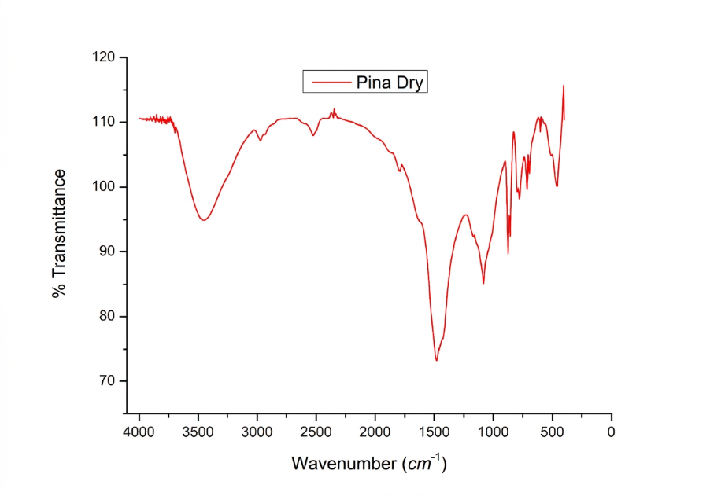
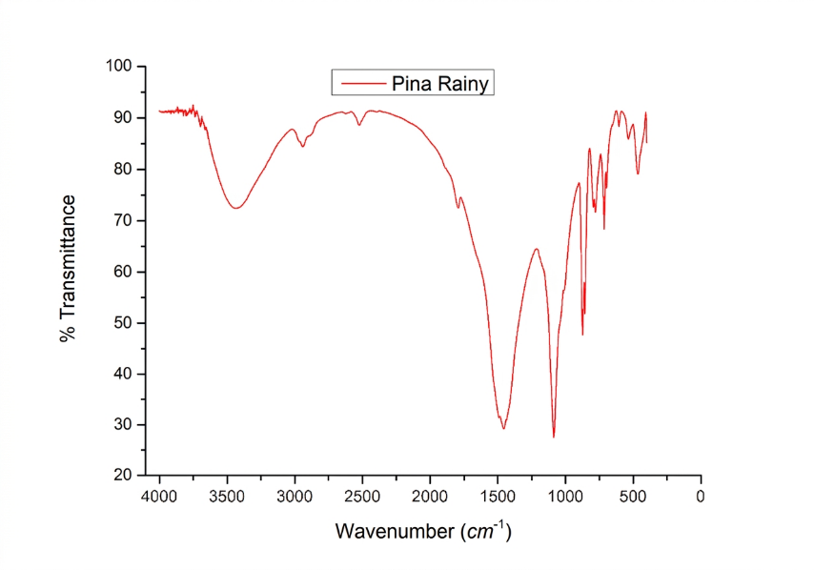

Figure S2 - Infrared absorption spectra of sediment samples from Piedade during the dry and rainy seasons, respectively.
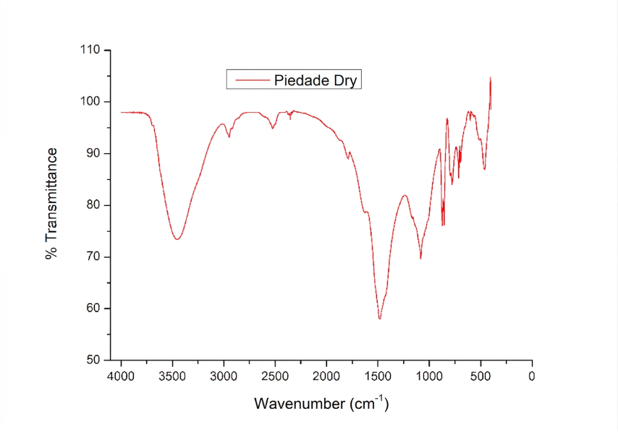
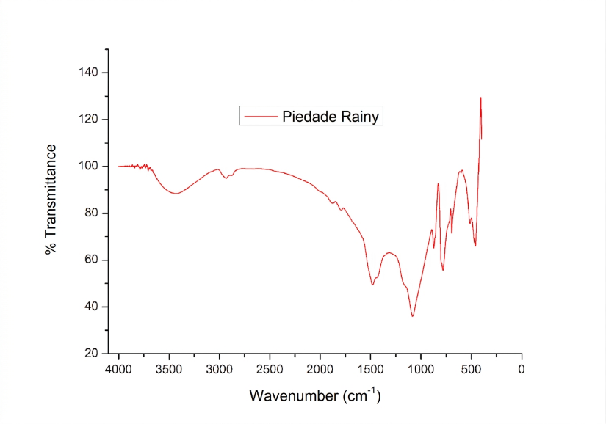

Figure S3 - Infrared absorption spectra of sediment samples from Toquinho during the dry and rainy seasons, respectively.
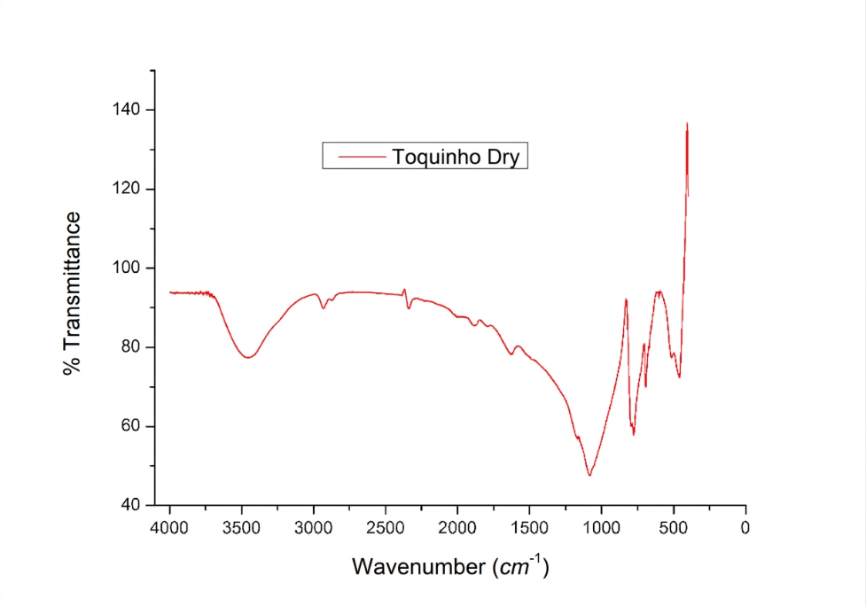
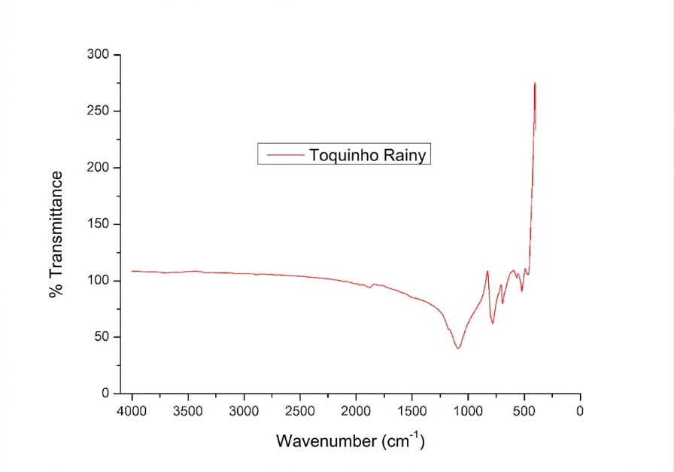

Figure S4 - Absorption spectra in the infrared region of sediment samples from Carneiros during the dry and rainy seasons, respectively.
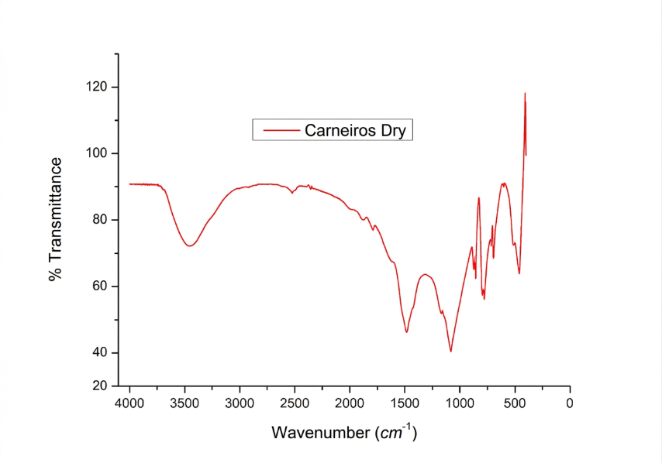
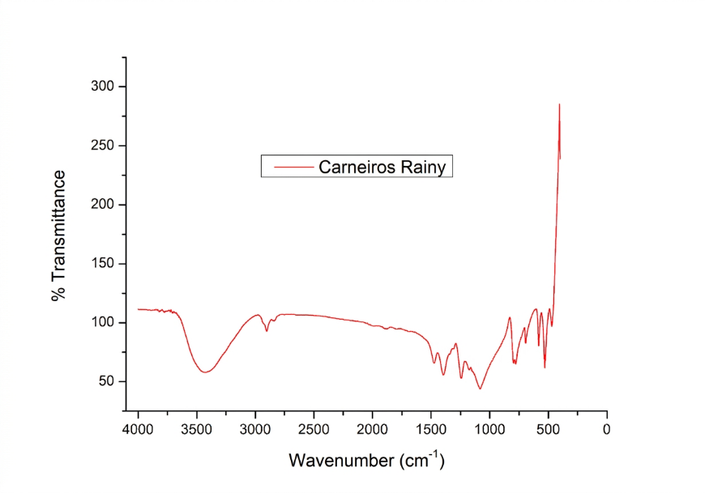

Figure S5 - Thermograms of sediment samples from Enseada during the dry and rainy periods.
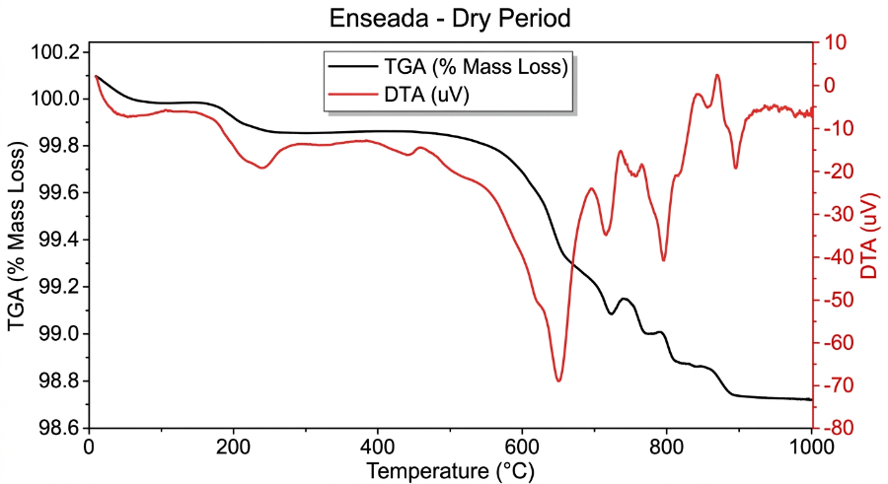
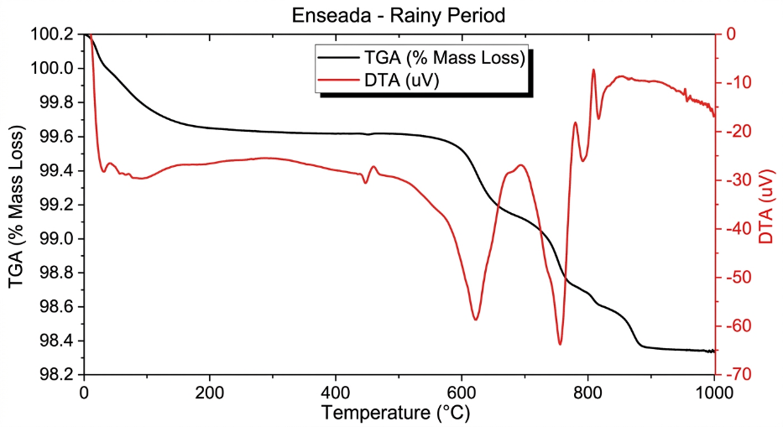

Figure S6 - Thermograms of sediment samples from Pina during the dry and rainy periods.
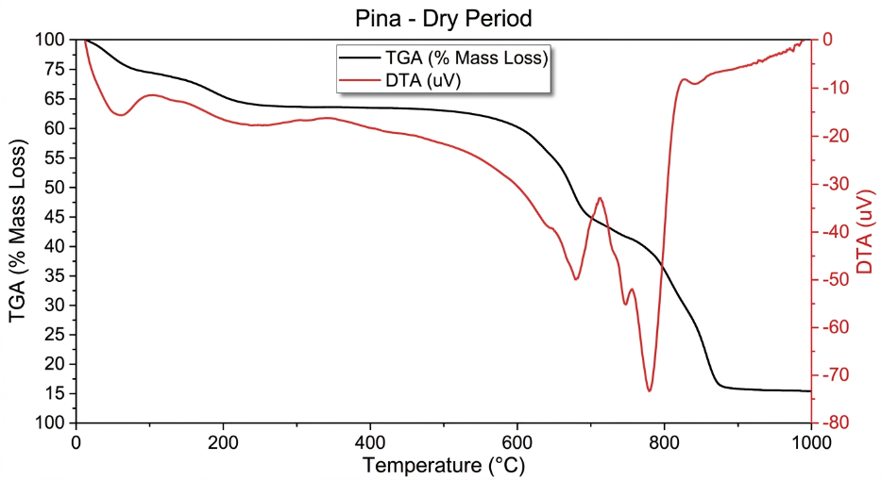

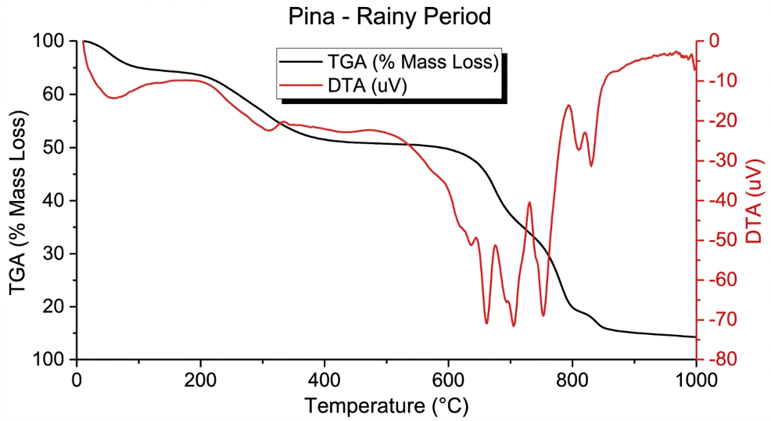

Figure S7 - Thermograms of sediment samples from Piedade during the dry and rainy seasons.
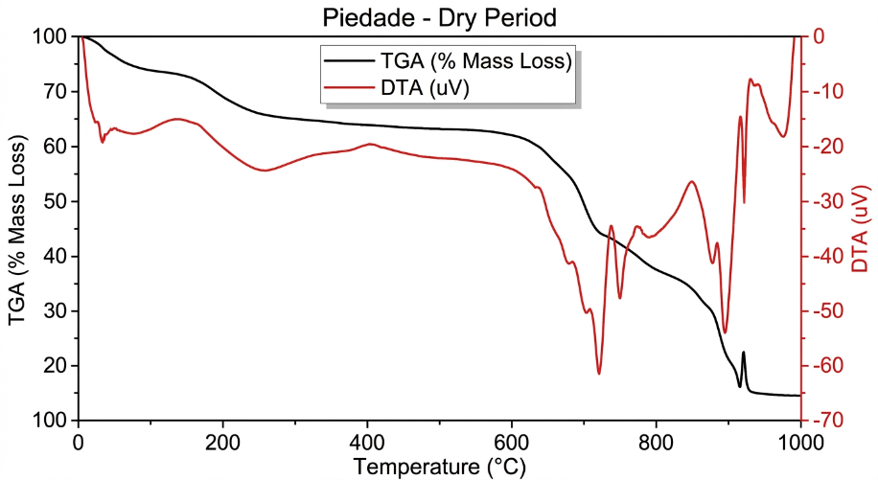

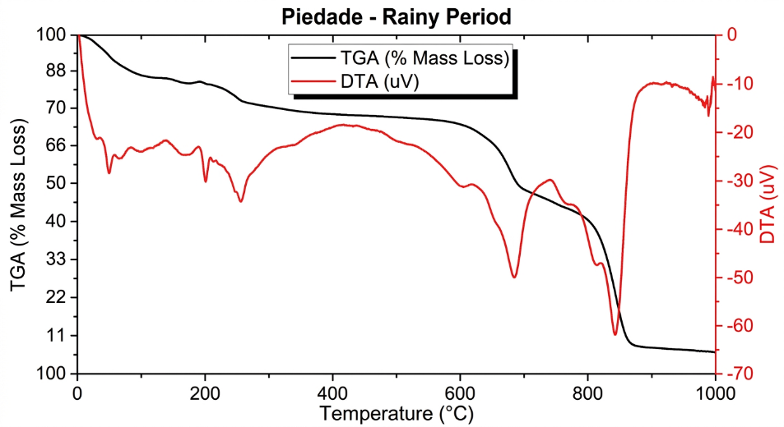

Figure S8 - Thermograms of sediment samples from Toquinho during the dry and rainy seasons.
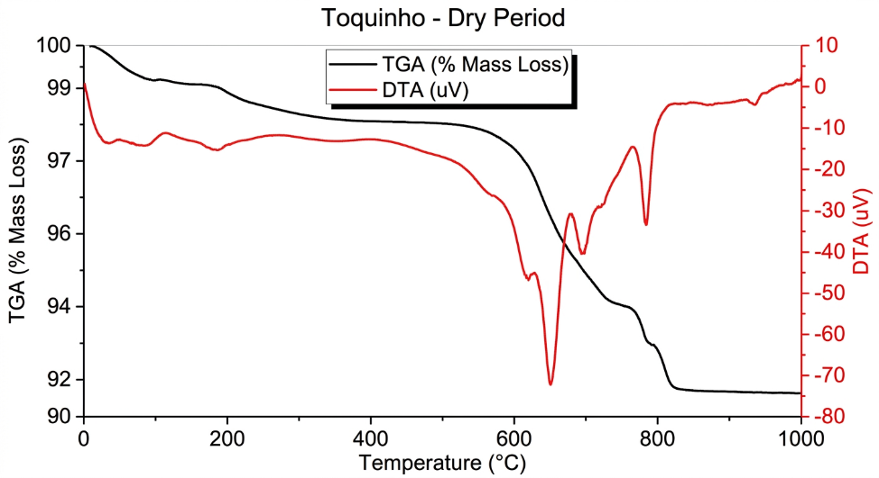
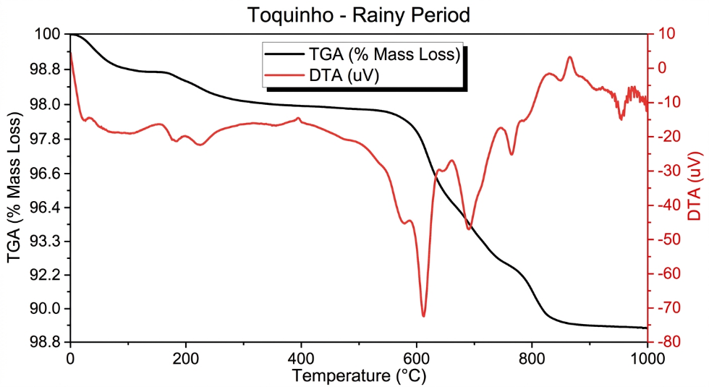

Figure S9 - Thermograms of sediment samples from Carneiros during the dry and rainy seasons.
