Vasorin as a multi-omic biomarker of cardiometabolic health in paediatric obesity

Álvaro Torres-Martos^{1,2,3}•, Augusto Anguita-Ruiz³⁻⁴•*, Francisco Javier Ruiz-Ojeda^{1,2,3,5}, Mireia Bustos-Aibar^{1,3,6}, Abel Plaza-Florido⁷, Ángel Gil^{1,2,3}, Mercedes Gil-Campos^{3,8}, Gloria Bueno^{3,6,9}, Rosaura Leis^{3,10,11}, Jesus Alcala-Fdez^{2,12}┼, Concepcion M. Aguilera^{1,2,3}┼

Table S1. Primer sequence used to measure the gene expression of VASN in VAT.
Table S2. General descriptive of the subset of pubertal children (discovery population) with RNA-seq.
Table S3. General descriptive of the validation population I.
Table S4. General descriptive of validation population II in which VASN expression in VAT was measured.
Table S5. Significant and non-significant associations between DNA methylation levels at selected CpG sites and adiposity traits or obesity-related cardiometabolic outcomes.
Table S6. Trans CpG-transcript pairs identified in the eQTM analysis.
Table S7. Cis and trans SNP-CpG pairs identified in the mQTL analysis.
Table S8. Serum VASN concentrations in both discovery populations and validation population I and subset of the discovery population with RNA-seq.
Table S9. Significant and non-significant associations between VASN protein levels and adiposity and cardiometabolic outcomes.
Figure S1. Heatmap displays significant associations between DNA methylation levels at selected CpG sites and adiposity traits or obesity-related cardiometabolic outcomes in pool analysis combining both the discovery population and validation population I. Only CpG sites that reach significance (FDR < 0.05) in at least one outcome are shown. The colour scale represents the standardized regression coefficients, with red indicating positive associations and blue indicating negative associations. CpG–outcome pairs that did not reach significance are displayed in gray. Significance thresholds are denoted as follows: FDR < 0.05 (*), FDR < 0.01 (**), and FDR < 0.001 (***). Results are fully detailed in Table S4.
Figure S2. Boxplots show the statistical distribution of serum levels of VASN in children with normal-weight, overweight and obesity in both discovery populations and validation population I, stratifying by pubertal status.
Figure S3. Boxplots show the statistical distribution of serum levels of VASN in female and male children in both discovery populations and validation population I, stratifying by pubertal status.

Table S1. Primer sequence used to measure the gene expression of VASN in VAT.
Gene | Primer sequence
human_VASN_forward | GAGAGCCACGTCACACTGG
human_VASN_reverse | CAAAGTCGGCGTAGTCAAGC

Table S2. General descriptive of the subset of pubertal children (discovery population) with RNA-seq.
Characteristic | N = 44¹
Sex
Male | 19 (43.18%)
Female | 25 (56.82%)
Age (years) | 13.51 (2.08)
Recruitment center
Córdoba | 14 (31.82%)
Santiago de Compostela | 18 (40.91%)
Zaragoza | 12 (27.27%)
Tanner scale
2 | 11 (25.00%)
3 | 5 (11.36%)
4 | 6 (13.64%)
5 | 22 (50.00%)
Obesity status
Normal-weight | 22 (50.00%)
Overweight | 6 (13.64%)
Obesity | 16 (36.36%)
BMI (kg/m²) | 23.40 (4.91)
BMI z-score | 1.06 (1.48)
WC (cm) | 78.28 (13.16)
WC z-score | 0.60 (1.81)
FMI (kg/m²) | 9.76 (3.85)
Height (m) | 1.59 (0.12)
Height z-score | 0.31 (1.09)
Glucose (mg/mL) | 90.05 (32.90)
Glucose z-score | -0.17 (4.59)
Insulin (μU/mL) | 12.91 (8.58)
Insulin z-score | 0.41 (1.30)
HOMA-IR | 2.81 (2.00)
HOMA-IR zscore | 0.28 (1.21)
DBP (mmHg) | 66.55 (7.73)
DBP z-score | 0.21 (0.69)
SBP (mmHg) | 111.29 (10.00)
SBP z-score | 0.15 (0.92)
BP z-score | 0.18 (0.74)
TAG (mg/mL) | 75.02 (40.46)
TAG z-score | 0.09 (1.10)
HDL-c (mg/mL) | 52.73 (12.11)
HDL-c z-score | -0.29 (1.03)
LDL-c (mg/mL) | 89.91 (26.89)
LDL-c z-score | 0.04 (1.09)
¹ n (%), Mean (Standard deviation)

Table S3. General descriptive of the validation population I.
Characteristic | Prepubertal children  (N = 113¹) | Pubertal children  (N = 124¹) | p-value²
Sex |  |  | 0.85
Male | 56 (49.56%) | 63 (50.81%)
Female | 57 (50.44%) | 61 (49.19%)
Age (years) | 8.91 (2.19) | 12.61 (2.11) | <0.001
Recruitment Center |  |  | <0.001
Santiago de Compostela | 105 (92.92%) | 94 (75.81%)
Zaragoza | 8 (7.08%) | 30 (24.19%)
Tanner scale |  |  | <0.001
1 | 113 (100.00%) | 0 (0.00%)
2 | 0 (0.00%) | 42 (33.87%)
3 | 0 (0.00%) | 30 (24.19%)
4 | 0 (0.00%) | 24 (19.35%)
5 | 0 (0.00%) | 28 (22.58%)
Obesity status |  |  | 0.047
Overweight | 5 (4.42%) | 16 (12.90%)
Obesity | 108 (95.58%) | 108 (87.10%)
BMI (kg/m²) | 26.03 (3.41) | 29.14 (3.76) | <0.001
BMI z-score | 3.02 (1.14) | 2.88 (1.20) | 0.17
WC (cm) | 82.33 (10.96) | 91.36 (11.31) | <0.001
WC z-score | 3.15 (1.53) | 2.55 (1.68) | <0.001
FMI | 11.07 (2.56) | 12.35 (2.77) | 0.001
Height (m) | 1.37 (0.13) | 1.58 (0.10) | <0.001
Height z-score | 0.76 (1.07) | 0.68 (1.55) | 0.17
Glucose (mg/mL) | 82.80 (9.20) | 86.66 (9.91) | <0.001
Glucose z-score | -0.68 (1.22) | -0.64 (1.34) | 0.79
Insulin (μU/mL) | 14.78 (9.79) | 20.54 (12.128) | <0.001
Insulin z-score | 1.71 (1.00) | 1.55 (1.02) | 0.071
HOMA-IR | 3.10 (2.27) | 4.49 (2.98) | <0.001
HOMA-IR z-score | 1.50 (1.04) | 1.34 (1.05) | 0.10
DBP (mmHg) | 65.45 (10.26) | 68.15 (9.88) | 0.015
DBP z-score | 0.45 (0.92) | 0.36 (0.89) | 0.80
SBP (mmHg) | 111.83 (11.17) | 119.59 (12.26) | <0.001
SBP z-score | 0.93 (0.97) | 0.99 (1.03) | 0.96
BP z-score | 0.69 (0.78) | 0.67 (0.79) | 0.88
TAG (mg/mL) | 83.30 (39.81) | 97.16 (57.48) | 0.10
TAG z-score | 0.59 (1.05) | 0.67 (1.21) | 0.59
HDL-c (mg/mL) | 46.29 (11.42) | 44.66 (12.03) | 0.2
HDL-c z-score | -1.01 (0.92) | -0.99 (1.01) | 0.95
LDL-c (mg/mL) | 96.40 (24.54) | 91.61 (25.33) | 0.30
LDL-c z-score | 0.09 (0.99) | 0.08 (1.02) | 0.95
1 N (%), Mean (Standard deviation)
2 Pearson’s Chi-squared test; Wilcoxon rank sum test; Welch Two Sample t-test

Table S4. General descriptive of validation population II in which VASN expression in VAT was measured.
Characteristic | Normal-weight  N = 6¹ | Obesity  N = 7¹ | p-value²
Sex |  |  | 0.56
Male | 4 (66.67%) | 6 (85.71%)
Female | 2 (33.33%) | 1 (14.29%)
Decimal age | 10.67 (2.16) | 9.14 (1.21) | 0.24
BMI (kg/m²) | 18.02 (1.37) | 25.99 (2.58) | 0.003
BMI z-score | 0.52 (0.47) | 0.52 (0.47) | 0.003
¹ n (%), Mean (Standard deviation)
² Fisher’s exact test; Wilcoxon rank sum test; Wilcoxon rank sum exact test

Table S5. Significant and non-significant associations between DNA methylation levels at selected CpG sites and adiposity traits or obesity-related cardiometabolic outcomes.
Table S5 is provided in an additional file because it could not be included in the main document of the supplementary material due to their size and high level of detail.

Table S6. Trans CpG-transcript pairs identified in the eQTM analysis.
Table S6 is provided in an additional file because it could not be included in the main document of the supplementary material due to their size and high level of detail.

Table S7. Cis and trans SNP-CpG pairs identified in the mQTL analysis.
DISCOVERY POPULATION (POPULATION I)
Prepubertal Cis Regulatory Associations
SNP |  | CpG site |  | Gene |  | P-Value |  | FDR |  | Beta
rs3742476 |  | cg01050076 |  | ATG2B |  | 0.02 |  | 0.67 |  | 0.27
GSA.rs3791414 |  | cg01390479 |  | HDAC4 |  | 0.03 |  | 0.67 |  | -0.43
rs12282 |  | cg21561989 |  | GOLGA3 |  | 0.03 |  | 0.67 |  | 0.42
Pubertal Cis Regulatory Associations
SNP |  | CpG site |  | Gene |  | P-Value |  | FDR |  | Beta
GSA.rs78267041 | cg00418943 |  | MEGF6 |  | <0.001 |  | 0.02 |  | 1.56
rs12282 | cg21561989 |  | GOLGA3 |  | 0.001 |  | 0.04 |  | -0.52
rs7774197 | cg24252708 |  | TNXB |  | 0.003 |  | 0.06 |  | -0.93
GSA.rs114659838 | cg07504762 |  | TINAGL1 |  | 0.004 |  | 0.06 |  | 1.23
rs73186452 | cg00978808 |  | ADCY5 |  | 0.015 |  | 0.17 |  | 0.67
rs2067011 | cg10648542 |  | GRM6 |  | 0.025 |  | 0.24 |  | 0.25
rs3742476 | cg12913090 |  | ATG2B |  | 0.036 |  | 0.29 |  | -0.25
rs625839 | cg22877230 |  | HDAC4 |  | 0.042 |  | 0.30 |  | -0.22
Pubertal Trans Regulatory Associations
SNP |  | CpG site |  | Gene |  | P-Value |  | FDR |  | Beta
rs1009321 (12:132784538) | cg21561989 (12:133346281) |  | GOLGA3 |  | <0.001 |  | <0.01 |  | -0.69
rs2824560 (21:17930900) | cg20401955 (21:19288538) |  | CHODL |  | <0.001 |  | <0.01 |  | 0.68
GSA.rs116307526 (1:186148964) | cg10987850 (1:186051470) |  | HMCN1 |  | <0.001 |  | 0.03 |  | -2.23
rs10870544 (12:132914512) | cg21561989 (12:133346281) |  | GOLGA3 |  | <0.001 |  | 0.03 |  | -0.67
VALIDATION POPULATION (POPULATION II)
Prepubertal Cis Regulatory Associations
SNP |  | CpG site |  | Gene |  | P-Value |  | FDR |  | Beta
rs16851382 |  | cg15434576 |  | SCN1A |  | 0.004 |  | 1 |  | -1.10
Pubertal Cis Regulatory Associations
SNP |  | CpG site |  | Gene |  | P-Value |  | FDR |  | Beta
rs73186452 | cg00978808 |  | ADCY5 |  | 0.001 |  | 0.09 |  | 0.89
rs12282 | cg21561989 |  | GOLGA3 |  | 0.002 |  | 0.09 |  | -0.61
GSA.rs114659838 | cg07504762 |  | TINAGL1 |  | 0.003 |  | 0.09 |  | 1.60
GSA.rs117733790 | cg23792592 |  | MIR1-1 |  | 0.005 |  | 0.10 |  | 1.21
GSA.rs35882398 | cg12001846 |  | ESR1 |  | 0.021 |  | 0.27 |  | -1.32
rs2067011 | cg10648542 |  | GRM6 |  | 0.022 |  | 0.27 |  | 0.31
Pubertal Trans Regulatory Associations
SNP |  | CpG site |  | Gene |  | P-Value |  | FDR |  | Beta
rs138843  (22:50181906) |  | cg16053902 |  | BRD1 |  | <0.001 |  | <0.001 |  | -1.08
rs14065  (11:124958934) |  | cg20872261 |  | SLC37A2 |  | <0.001 |  | <0.001 |  | -0.90
Gene symbols, CpG sites, and SNPs in bold appear in pre-pubertal and pubertal analysis.

Table S8. Serum VASN concentrations in both discovery populations and validation population I and subset of the discovery population with RNA-seq.
Discovery population | Prepubertal children (baseline, N = 102¹) | Pubertal children  (follow-up, N = 138¹) | p-value²
VASN (pg/mL) | 458.20 (356.34) | 623.56 (482.70) | 0.026
Validation population I | Prepubertal children  (N = 113¹) | Pubertal children  (N = 124¹) | p-value²
VASN (pg/mL) | 570.20 (325.50) | 615.12 (416.81) | 0.89
Subset of pubertal children of the discovery population with RNA-seq (discovery population) | - | Pubertal children  (N = 44) | -
VASN (pg/mL) | - | 645.92 (489.44) | -
¹ n (%), Mean (Standard deviation)
² Wilcoxon rank sum test

Table S9. Significant and non-significant associations between VASN protein levels and adiposity and cardiometabolic outcomes.
Table S9 is provided in an additional file because it could not be included in the main document of the supplementary material due to its size and high level of detail.

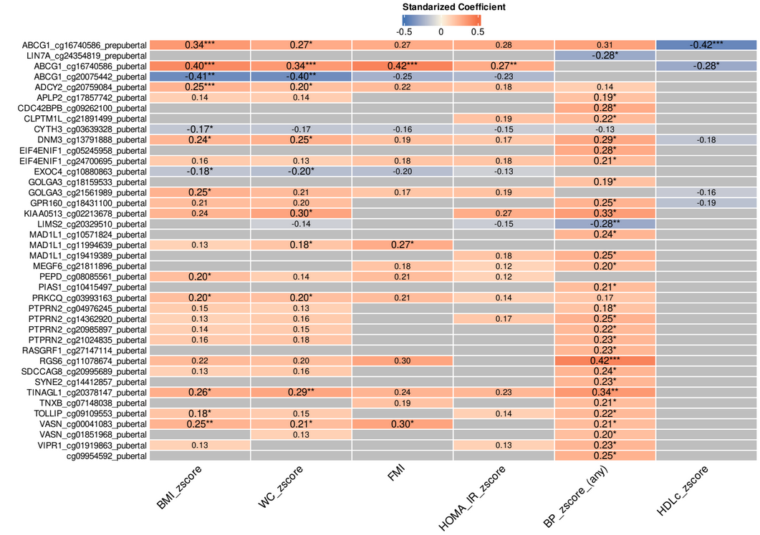

Figure S1. Heatmap displays significant associations between DNA methylation levels at selected CpG sites and adiposity traits or obesity-related cardiometabolic outcomes in pool analysis combining both the discovery population and validation population I. Only CpG sites that reach significance (FDR < 0.05) in at least one outcome are shown. The colour scale represents the standardized regression coefficients, with red indicating positive associations and blue indicating negative associations. CpG–outcome pairs that did not reach significance are displayed in gray. Significance thresholds are denoted as follows: FDR < 0.05 (*), FDR < 0.01 (**), and FDR < 0.001 (***). Results are fully detailed in Table S4.

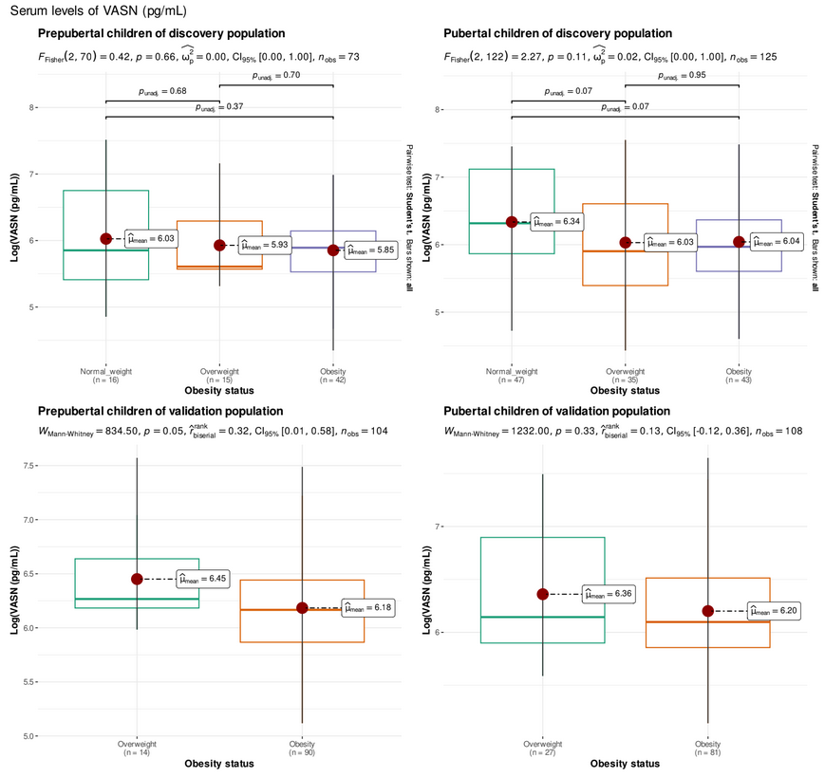Figure S2. Boxplots show the statistical distribution of serum levels of VASN in children with normal-weight, overweight and obesity in both discovery populations and validation population I, stratifying by pubertal status.

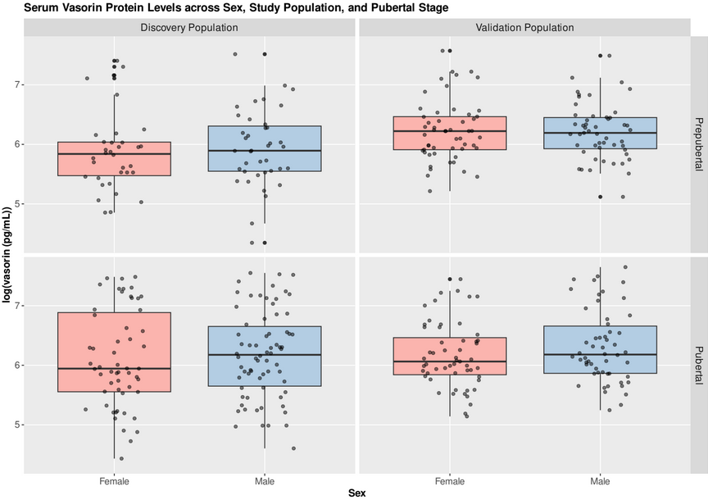

Figure S3. Boxplots show the statistical distribution of serum levels of VASN in female and male children in both discovery populations and validation population I, stratifying by pubertal status.

