Supplementary Table 1 - Multivariable-Adjusted Linear Model for the Association of Dietary Patterns and Log H-scores for IHC Tumor Tissue Markers^{a,b}
Dietary pattern | Statistical model | Quartile 1  (n=98) | Quartile 2 [%(95%CI)]  (n=99) | Quartile 3  [%(95%CI)]  (n=99) | Quartile 4 [%(95%CI)]  (n=98) | Percent [%(95%CI)] Change for 1-SD Increment | P for continuous dietary score^{c}
MTOR Cytoplasm Log H-score
rEDIH | MV | 1 (reference) | -31.35  (-63.26, 0.56) | -26.94  (-58.85, 4.97) | -8.43  (-40.34, 23.48) | -2.92  (-14.23, 8.40) | 0.61
rEDIH | MV+BMI | 1 (reference) | -28.28  (-60.26, 3.69) | -11.44  (-43.41, 20.54) | -5.22  (-37.20, 26.75) | -2.23  (-13.56, 9.10) | 0.70
rEDIP | MV | 1 (reference) | -41.25  (-72.70, -9.79) | -13.17  (-44.62, 18.29) | 22.49  (-8.96, 53.95) | 3.52  (-7.80, 14.84) | 0.54
rEDIP | MV+BMI | 1 (reference) | -47.91  (-79.29, 16.53) | -14.43  (-45.70, 17.06) | 18.39  (-13.00, 49.77) | 3.82  (-7.51, 15.14) | 0.51
AHEI-2010 | MV | 1 (reference) | 15.06  (-16.84, 46.95) | 24.93  (-6.96, 56.82) | 36.65  (4.75, 68.54) | 11.95  (0.69, 23.22) | 0.04
AHEI-2010 | MV+BMI | 1 (reference) | 18.80  (-13.10, 50.69) | 25.16  (-6.74, 57.05) | 36.95  (5.06, 68.85) | 12.39  (1.13, 23.64) | 0.03
p- MTOR Cytoplasm Log H-score
rEDIH | MV | 1 (reference) | -12.45  (-80.99, 56.09) | -38.97  (-107.51, 9.57) | 12.74  (-55.80, 81.28) | -5.82  (-30.05, 18.41) | 0.64
rEDIH | MV+BMI | 1 (reference) | -17.52  (-86.18, 51.14) | -15.91  (-84.56, 52.75) | 14.11  (-54.54, 82.77) | -2.88  (-27.14, 21.38) | 0.82
rEDIP | MV | 1 (reference) | -83.44  (-151.28, -15.61) | -31.11  (-98.94, 36.73) | 23.00  (-44.83, 90.83) | 5.97  (-18.27, 30.21) | 0.63
rEDIP | MV+BMI | 1 (reference) | -93.02  (-160.64, -25.41) | -29.01  (-96.62, 38.60) | 25.99  (-41.63, 93.60) | 7.21  (-17.03, 31.46) | 0.56
AHEI-2010 | MV | 1 (reference) | -4.89  (-73.61, 63.83) | 4.70  (-64.01, 73.42) | 16.83  (-51.89. 85.55) | 4.35  (-19.89, 28.59) | 0.72
AHEI-2010 | MV+BMI | 1 (reference) | -5.31  (-74.00, 63.37) | -2.39  (-71.08, 66.30) | 21.78  (-46.91, 90.47) | 6.20  (-18.03, 30.43) | 0.62
Total Phosphoprotein Log H-Score
rEDIH | MV | 1 (reference) | -181.46  (-330.54, -32.37) | -136.06  (-285.15, 13.02) | -70.37  (-219.46, 78.71) | -33.39  (-86.27, 19.50) | 0.22
rEDIH | MV+BMI | 1 (reference) | -140.34  (-289.92, 9.25) | -108.31  (-257.90, 41.27) | -59.31  (-208.89, 90.28) | -34.53  (-87.46, 18.41) | 0.20
rEDIP | MV | 1 (reference) | -272.34  (-415.71, -128.97) | -185.88  (-329.25, -42.51) | 140.43  (-2.94, 283.80) | -4.06  (-57.08, 48.95) | 0.88
rEDIP | MV+BMI | 1 (reference) | -319.82  (-462.39, -177.24) | -215.85  (-358.43, -73.27) | 107.56  (-35.02, 250.13) | -4.46  (-57.49, 48.58) | 0.87
AHEI-2010 | MV | 1 (reference) | -132.28  (-281.59, 17.03) | 24.05  (-125.26, 173.37) | 3.31  (-146.00, 152.63) | 8.33  (-44.67, 61.33) | 0.76
AHEI-2010 | MV+BMI | 1 (reference) | -110.35  (-260.11, 39.42) | -10.68  (-160.45. 139.08) | -2.20  (-151.96, 147.57) | 7.77  (-45.21, 60.76) | 0.77
p-AKT Cytoplasm Log H-Score
rEDIH | MV | 1 (reference) | -71.85  (-144.97, 1.28) | -35.49  (-108.62, 37.63) | -19.58  (-92.70, 53.55) | -10.85  (-36.74, 15.03) | 0.41
rEDIH | MV+BMI | 1 (reference) | -54.70  (-127.94, 18.53) | -45.17  (-117.30, 28.16) | -14.42  (-87.65, 58.82) | -11.93  (-37.84, 13.98) | 0.37
rEDIP | MV | 1 (reference) | -128.42  (-199.69, -57.15) | -102.09  (-173.35, -30.82) | 20.62  (-50.64, 91.89) | -11.01  (-36.91, 14.89) | 0.40
rEDIP | MV+BMI | 1 (reference) | -150.87  (-221.69, -80.04) | -107.98  (-178.80, -37.16) | 13.18  (-57.65, 84.00) | -11.45  (-37.35, 14.46) | 0.39
AHEI-2010 | MV | 1 (reference) | -77.81  (-150.79, -4.84) | -9.33  (-82.30, 63.65) | -10.40  (-83.38, 62.58) | -0.03  (-26.24, 25.60) | 0.98
AHEI-2010 | MV+BMI | 1 (reference) | -69.53  (-142.67, 3.61) | -32.75  (-105.89, 40.39) | -15.45  (-88.59, 57.69) | -0.09  (-26.82, 24.99) | 0.95
p-AKT Nuclear Log H-Score
rEDIH | MV | 1 (reference) | -66.40  (-144.27, 11.46) | -62.50  (-140.37, 15.36) | -15.41  (-93.28, 62.45) | -14.98  (-42.54, 12.58) | 0.29
rEDIH | MV+BMI | 1 (reference) | -42.64  (-120.63, 35.35) | -61.19  (-139.18, 16.80) | -11.77  (-89.76, 66.22) | -15.62  (-43.20, 11.96) | 0.27
rEDIP | MV | 1 (reference) | -126.51  (-202.18, -50.84) | -109.54  (-185.21, -33.87) | 41.95  (-33.72, 117.62) | -6.65  (-34.26, 20.95) | 0.64
rEDIP | MV+BMI | 1 (reference) | -153.11  (-228.20, -78.02) | -119.31  (-194.40, -44.22) | 34.81  (-40.28, 109.90) | -6.90  (-34.51, 20.71) | 0.62
AHEI-2010 | MV | 1 (reference) | -92.70  (-170.24, -15.16) | -0.43  (-77.97, 77.10) | -13.64  (-91.17, 63.90) | 4.47  (-23.13, 32.07) | 0.75
AHEI-2010 | MV+BMI | 1 (reference) | -84.94  (-162.72, -7.16) | -26.59  (-104.37, 51.19) | -19.77  (-97.55, 58.01) | 4.18  (-23.41, 31.77) | 0.77
p-AKT Total Log H-Score
rEDIH | MV | 1 (reference) | -63.65  (-138.18, 10.88) | -47.06  (-121.59, 27.47) | -15.45  (-89.97, 59.08) | -13.22  (-39.58, 13.13) | 0.33
rEDIH | MV+BMI | 1 (reference) | -46.14  (-120.77, 28.48) | -48.79  (-123.42, 25.83) | -11.25  (-85.87, 63.37) | -14.04  (-40.42, 12.34) | 0.30
rEDIP | MV | 1 (reference) | -127.64  (-199.89, -55.40) | -103.02  (-175.27, -30.77) | 40.03  (-32.22, 112.28) | -6.35  (-32.74, 20.05) | 0.64
rEDIP | MV+BMI | 1 (reference) | -154.31  (-225.99, - 82.63) | -110.01  (-181.69, -38.33) | 32.72  (-38.96, 104.40) | -6.67  (-33.08, 19.73) | 0.62
AHEI-2010 | MV | 1 (reference) | -86.84  (-161.05, -12.64) | -4.56  (-78.76, 69.64) | -14.35  (-88.55, 59.85) | 1.77  (-24.63, 28.16) | 0.90
AHEI-2010 | MV+BMI | 1 (reference) | -78.78  (-153.20, -4.37) | -29.81  (-104.22, 44.61) | -20.08  (-94.50, 54.34) | 1.35  (-25.04, 27.74) | 0.92
p-P70S6K Cytoplasm Log H-Score
rEDIH | MV | 1 (reference) | -90.12  (-171.75, -8.49) | -59.25  (-140.88, 22.38) | -44.67  (-126.29, 36.96) | -16.15  (-45.06, 12.75) | 0.27
rEDIH | MV+BMI | 1 (reference) | -68.41  (-150.25, 13.43) | -50.14  (-131.98, 31.69) | -42.24  (-124.07, 39.60) | -17.05  (-45.99, 11.88) | 0.25
rEDIP | MV | 1 (reference) | -115.65  (-195.08, -36.22) | -74.51  (-153.94, 4.92) | 79.06  (-0.37,158.50) | -1.19  (-30.16, 27.78) | 0.94
rEDIP | MV+BMI | 1 (reference) | -137.51  (-216.76, -58.26) | -101.14  (-180.39, -21.89) | 54.10  (-25.15, 133.35) | -1.52  (-30.49, 27.46) | 0.92
AHEI-2010 | MV | 1 (reference) | -62.93  (-144.71, 18.84) | 7.94  (-73.83, 89.72) | -15.75  (-97.52, 66.03) | -4.08  (-33.04, 24.88) | 0.78
AHEI-2010 | MV+BMI | 1 (reference) | -50.07  (-132.02, 31.88) | -3.63  (-85.58, 78.32) | -15.32  (-97.27, 66.63) | -4.60  (-33.54, 24.35) | 0.76
p-P70S6K Nuclear Log H-score
rEDIH | MV | 1 (reference) | -82.99  (-153.05, -12.92) | -79.54  (-149.61, -9.48) | -49.69  (-119.76, 20.38) | -22.22  (-47.04, 2.60) | 0.08
rEDIH | MV+BMI | 1 (reference) | -66.81  (-137.13, 3.51) | -58.35  (-128.67, 11.97) | -41.69  (-112.00, 28.63) | -22.77  (-47.61, 2.07) | 0.07
rEDIP | MV | 1 (reference) | -89.98  (-158.32, -21.65) | -77.88  (-146.22, -9.54) | 69.24  (0.09, 137.58) | -4.87  (-29.80, 20.05) | 0.70
rEDIP | MV+BMI | 1 (reference) | -99.08  (-167.44, -30.71) | -93.98  (-162.35, -25.62) | 51.60  (-16.77, 119.97) | -5.05  (-29.98, 19.89) | 0.69
AHEI-2010 | MV | 1 (reference) | -54.97  (-125.40, 15.45) | -4.01  (-74.44, 66.41) | -23.54  (-93.96, 46.89) | -6.24  (-31.16, 18.68) | 0.62
AHEI-2010 | MV+BMI | 1 (reference) | -48.18  (-118.69, 22.33) | -10.94  (-81.45, 59.57) | -24.00  (-94.51, 46.51) | -6.51  (-31.42, 18.40) | 0.61
p-P70S6K Total Log H-Score
rEDIH | MV | 1 (reference) | -86.45  (-162.02, -10.88) | -62.06  (-137.63, 13.51) | -46.50  (-122.07, 29.07) | -17.25  (-44.02, 9.52) | 0.21
rEDIH | MV+BMI | 1 (reference) | -65.91  (-141.69, 9.87) | -48.08  (-123.87, 27.70) | -42.83  (-118.62, 32.95) | -18.25  (-45.04, 8.54) | 0.18
rEDIP | MV | 1 (reference) | -103.44  (-176.97, -29.92) | -69.69  (-143.22, 3.84) | 77.91  (4.38, 151.44) | -1.23  (-28.07, 25.06) | 0.93
rEDIP | MV+BMI | 1 (reference) | -117.60  (-191.10, -44.10) | -91.52  (-165.02, -18.02) | 56.45  (-17.05, 129.95) | -1.60  (-28.45, 25.24) | 0.91
AHEI-2010 | MV | 1 (reference) | -60.49  (-136.24, 15.26) | 3.69  (-72.06, 79.44) | -18.99  (-94.74, 56.76) | -5.39  (-32.22, 21.43) | 0.69
AHEI-2010 | MV+BMI | 1 (reference) | -50.36  (-126.25, 25.54) | -6.03  (-81.93, 69.86) | -19.07  (-94.96, 56.82) | -5.96  (-32.78, 20.85) | 0.66
* H-scores were log-transformed to improve the normality of the data for linear regression analysis. Regression coefficients (β) were converted to percentages using the formula:(exp(β) - 1) x 100% and were interpreted as the estimated percentage difference of protein expression for each quartile of dietary patterns (Q2, Q3, and Q4) as compared to the reference quartile (Q1)
a - Adjusted for calories, age, menopause status, smoking status, alcohol consumption, waist-hip ratio, diabetes, number of full-term pregnancies, breastfeeding, oral contraceptive use, hormone replacement therapy use, educational attainment, family history of breast cancer, family history of cancer, history of benign breast disease, number of reproductive years, moderate, and vigorous physical activity.
b – Adjusted for MV adjustments plus BMI
c - Dietary score was input in the corresponding multivariable-adjusted models as a continuous variable
Supplementary Table 2 - Distribution of Participants Outcomes in Quartiles of Dietary Indicesª
 |  |  | Reverse Empirical Dietary Index for Hyperinsulinemia (rEDIH) Score^{b} |  |  |  | Reverse Empirical Dietary Inflammatory Pattern (rEDIP) Score^{b} |  |  |  | Alternative Health Eating Index-2010 (AHEI-2010) Score^{b}
Outcome |  | Total  (n=394) | Quartile  1 (n =98) | Quartile  2 (n =99) | Quartile  3 (n =99) | Quartile  4 (n =98) | Quartile  1 (n =98) | Quartile  2 (n =99) | Quartile  3 (n =99) | Quartile  4 (n =98) | Quartile  1 (n =98) | Quartile  2 (n =99) | Quartile  3 (n =99) | Quartile 4 (n =98)
ER Receptor Status, n (%)^{c}
Positive |  | 281  (71.3) | 70 (71.4) | 66 (66.7) | 73 (73.7) | 72 (73.5) | 67 (68.4) | 72 (72.7) | 69 (69.7) | 73 (74.5) | 73 (74.5) | 71 (71.7) | 71 (71.7) | 66 (67.4)
Negative |  | 110  (27.9) | 26 (26.5) | 33 (33.3) | 26 (26.3) | 25 (25.5) | 31 (31.6) | 27 (27.3) | 29 (29.3) | 23 (23.5) | 25 (25.5) | 27 (27.3) | 28 (28.3) | 30 (30.6)
Unknown |  | 3  (0.8) | 2  (2.1) | 0  (0.00) | 0  (0.00) | 1  (1.0) | 0  (0.00) | 0  (0.00) | 1  (1.0) | 2  (2.0) | 0  (0.00) | 1  (1.0) | 0  (0.00) | 2  (2.0)
PR Receptor Status, n (%)^{d}
Positive |  | 259  (66.1) | 63 (65.0) | 58 (58.6) | 67 (67.7) | 71 (73.2) | 61 (62.2) | 60 (60.6) | 69 (69.7) | 69 (71.9) | 67 (68.4) | 59  (60.2) | 65  (65.7) | 68 (70.1)
Negative |  | 133  (33.9) | 34 (35.0) | 41 (41.4) | 32 (32.3) | 26 (26.8) | 37 (37.8) | 39 (39.4) | 30 (30.3) | 27 (28.1) | 31  (31.6) | 39 (39.8) | 34 (34.3) | 29 (29.9)
HER2 Receptor Status, n (%)^{e}
Positive |  | 67  (17.2) | 16 (16.5) | 18 (18.2) | 13 (13.4) | 20 (20.6) | 18 (18.8) | 19 (19.2) | 13 (13.1) | 17 (17.7) | 18 (18.6) | 17 (17.3) | 18 (18.2) | 14 (14.6)
Negative |  | 323  (82.8) | 81 (83.5) | 81 (81.8) | 84 (86.6) | 77 (79.4) | 78 (81.3) | 80 (80.8) | 86 (86.9) | 79 (82.3) | 79 (81.4) | 81 (82.7) | 81 (81.8) | 82 (85.4)
Breast Cancer Subtype, n (%)
ER+/PR+/HER2- |  | 249  (63.2) | 64 (65.3) | 58 (58.6) | 67 (67.7) | 60 (61.2) | 58 (59.2) | 63 (63.6) | 67 (67.7) | 61 (62.2) | 66 (67.4) | 63 (63.6) | 60 (60.6) | 60 (61.2)
ER+/PR+/HER2+ |  | 43  (10.9) | 12 (12.2) | 7  (7.1) | 7  (7.1) | 17 (17.4) | 9  (9.2) | 14 (14.2) | 6  (6.1) | 14 (14.3) | 10 (10.2) | 9  (9.1) | 14 (14.2) | 10 (10.2)
ER-/PR-/HER2+ |  | 15  (3.8) | 3  (3.1) | 5  (5.1) | 4  (4.0) | 3  (3.1) | 6  (6.1) | 4  (4.0) | 4  (4.0) | 1  (1.0) | 6  (6.1) | 5  (5.1) | 2  (2.0) | 2  (2.0)
ER-/PR-/HER2- |  | 74  (18.8) | 17 (17.5) | 23 (23.2) | 17 (17.2) | 17 (17.3) | 20 (20.4) | 17 (17.2) | 19  (19.2) | 18 (18.4) | 13 (13.3) | 18 (18.2) | 21 (21.2) | 22 (22.5)
Unknown |  | 13  (3.3) | 2  (2.0) | 6  (6.0) | 4  (4.0) | 1  (1.0) | 5  (5.1) | 1  (1.0) | 3  (3.0) | 4  (4.1) | 3  (3.0) | 4  (4.0) | 2  (2.0) | 4  (4.1)
p-MTOR Cytoplasm Staining, n (%)
Positive |  | 246  (62.4) | 63 (64.3) | 57 (57.6) | 60 (60.6) | 66 (67.4) | 59 (60.2) | 54 (55.6) | 61 (61.6) | 72 (73.5) | 56 (57.1) | 63 (63.6) | 63 (63.6) | 64 (65.3)
Negative |  | 148  (37.6) | 35 (35.7) | 42 (42.4) | 39 (39.4) | 32 (32.6) | 39 (39.8) | 45 (45.4) | 38 (38.4) | 26 (26.5) | 42 (42.9) | 36 (36.4) | 36 (36.4) | 34 (34.7)
MTOR Cytoplasm Staining, n (%)
Positive |  | 378  (95.9) | 97 (99.0) | 96 (97.0) | 92 (93.0) | 93 (94.9) | 95 (97.0) | 94 (94.0) | 95 (96.0) | 95 97.0) | 91 (92.9) | 96 (97.0) | 97 (98.0) | 94 (95.9)
Negative |  | 16  (4.1) | 1  (1.0) | 3  (3.0) | 7  (7.0) | 5  (5.1) | 3  (3.0) | 6  (6.0) | 4  (4.0) | 3  (3.0) | 7  (7.1) | 3  (3.0) | 2  (2.0) | 4  (4.1)
MTOR H-Score, n (%)^{f}
H-Score < 56 |  | 52  (13.2) | 5  (5.1) | 14 (14.1) | 18 (18.2) | 15 (15.3) | 9  (9.2) | 23 (23.2) | 13 (13.1) | 7  (7.1) | 21 (21.4) | 14 (14.1) | 10 (10.1) | 7  (7.2)
56 ≤ H-Score < 135 |  | 115  (29.2) | 26 (26.5) | 35 (35.4) | 31 (31.3) | 23 (23.5) | 29 (29.6) | 29 (29.3) | 33 (33.3) | 24 (24.5) | 34 (34.7) | 29 (29.3) | 26 (26.3) | 26 (26.5)
H-Score ≥ 135 |  | 227  (57.6) | 67 (68.4) | 50 (50.5) | 50 (50.5) | 60 (61.2) | 60 (61.2) | 47 (47.5) | 53 (53.6) | 67 (68.4) | 43 (43.9) | 56 (56.6) | 63 (63.6) | 65 (66.3)
p-AKT Cytoplasm Staining, n (%)
Positive |  | 135  (34.3) | 42 (42.9) | 28 (28.3) | 24 (24.2) | 41 (41.8) | 43 (43.9) | 24 (24.2) | 24 (24.2) | 44 (44.9) | 36 (36.7) | 29 (29.3) | 32 (32.3) | 38 (38.8)
Negative |  | 259  (65.7) | 56 (57.1) | 71 (71.7) | 75 (75.8) | 57 (58.2) | 55 (56.1) | 75 (75.8) | 75 (75.8) | 54 (55.1) | 62 (63.3) | 70 (70.7) | 67 (67.7) | 60 (61.2)
p-AKT Nuclear Staining, n (%)
Positive |  | 183  (46.4) | 57 (58.2) | 41 (41.4) | 30 (30.3) | 43 (43.9) | 55 (56.1) | 32 (32.3) | 34 (34.3) | 62 (63.3) | 47  (48.0) | 40  (40.4) | 43 (43.4) | 53 (54.1)
Negative |  | 211  (53.6) | 41 (41.8) | 58 (58.6) | 69 (69.70) | 55 (56.1) | 43 (43.9) | 67 (67.7) | 65 (65.7) | 36 (36.7) | 51 (52.0) | 59  (59.6) | 56 (56.6) | 45 (45.9)
p-P70S6k Cytoplasm Staining, n (%)
Positive |  | 192  (48.7) | 55 (56.1) | 45 (45.4) | 40 (40.4) | 52 (53.1) | 53 (54.1) | 41 (41.4) | 37 (37.4) | 61 (61.2) | 46 (46.9) | 49 (49.5) | 45 (45.4) | 52 (53.1)
Negative |  | 202  (51.3) | 43 (43.9) | 54 (54.6) | 59 (59.6) | 46 (46.9) | 45 (45.9) | 58 (58.6) | 62 (62.6) | 37 (37.8) | 52 (53.1) | 50 (50.5) | 54 (54.6) | 46 (46.9)
p-P70S6k Nuclear Staining, n (%)
Positive |  | 134  (34.0) | 44 (44.9) | 32 (32.3) | 22 (22.2) | 36 (36.7) | 35 (35.7) | 31 (31.3) | 20 (20.2) | 48 (49.0) | 30 (30.6) | 37 (37.4) | 30 (30.3) | 37 (37.8)
Negative |  | 260  (66.0) | 54 (55.1) | 67 (67.7) | 77 (77.8) | 62 (63.3) | 63 (64.3) | 68 (68.7) | 79 (79.8) | 50 (51.0) | 68 (69.4) | 62 (62.6) | 69 (69.7) | 61 (62.2)
a – Percentages may be greater or less than 100% due to rounding
b – rEDIH, rEDIP, and AHEI-2010 scores were adjusted for total energy intake using the residual method. Lower scores for rEDIH represent a pro-hyperinsulinemic diet while higher scores represent an anti-hyperinsulinemic diet. Lower scores for rEDIP represent a pro-inflammatory diet while higher scores represent an anti-inflammatory diet. Lower scores for AHEI-2010 represent lower adherence to the recommendations in the scientific report for the Dietary Guidelines for Americans (2010-2015) while higher scores represent higher adherence to the recommendations in the scientific report for the dietary guidelines.
c – Missing estrogen receptor status at diagnosis from three participants
 | d – Missing progesterone receptor status at diagnosis from two participants
 | e – Missing human epidermal growth factor receptor 2 status at diagnosis from four participants
 | f - Categorical cutoffs were defined based on the mean mTOR H-score of 135: H-score < 56 was classified as more than 1 SD below the mean; 56 ≤ H-score < 135 as between 1 SD below and the mean; and H-score ≥ 135 as greater than or equal to the mean.
Supplementary Table 3 - Multivariable- Adjusted Hazard Ratios for the Association Between Dietary Patterns and All-Cause and Breast Cancer-Specific Mortality^{a,b,c,d}
Dietary pattern | Statistical model | Quartile 1 (n=98) | Quartile 2 (n=99) | Quartile 3 (n=99) | Quartile 4 (n=98) | P-value for linear trend^{e} | 1-SD Increment | P-value for continuous dietary score^{f}
All-Cause Mortality
rEDIH | dead/alive^{g} | 16/81 | 20/77 | 17/80 | 19/78
rEDIH | MV | 1 (reference) | 1.21 (0.63, 2.34) | 0.96 (0.48, 1.90) | 1.18 (0.61, 2.29) | 0.86 | 0.84 (0.73, 0.95) | 0.008
rEDIH | dead/alive^{h} | 18/79 | 18/79 | 18/79 | 18/79
rEDIH | MV+BMI | 1 (reference) | 0.93 (0.49, 1.80) | 0.92 (0.48, 1.76) | 0.98 (0.51, 1.88) | 0.99 | 0.85 (0.73, 0.97) | 0.02
rEDIP | dead/alive^{g} | 15/82 | 23/74 | 18/79 | 16/18
rEDIP | MV | 1 (reference) | 1.47 (0.77, 2.82) | 1.23 (0.62, 2.43) | 1.16 (0.57, 2.35) | 0.70 | 0.89 (0.69, 1.14) | 0.34
rEDIP | dead/alive^{h} | 17/80 | 18/79 | 20/77 | 17/80
rEDIP | MV+BMI | 1 (reference) | 1.01 (0.52, 1.95) | 1.21 (0.64, 2.32) | 1.08 (0.55, 2.13) | 0.93 | 0.90 (0.70, 1.16) | 0.42
AHEI | dead/alive^{g} | 16/81 | 22/75 | 19/78 | 15/82
AHEI | MV | 1 (reference) | 1.61 (0.84, 3.07) | 1.35 (0.69, 2.62) | 1.07 (0.53, 2.17) | 0.45 | 0.99 (0.79, 1.24) | 0.90
AHEI | dead/alive^{h} | 17/80 | 21/76 | 19/78 | 15/82
AHEI | MV+BMI | 1 (reference) | 1.44 (0.76, 2.74) | 1.25 (0.65, 2.41) | 1.00 (0.50, 2.00) | 0.61 | 1.01 (0.80, 1.26) | 0.95
All-Cause Mortality – Sensitivity Analysis
rEDIH | dead/alive^{i} | 16/80 | 20/76 | 17/79 | 18/78
rEDIH | MV | 1 (reference) | 1.23 (0.64, 2.38) | 0.94 (0.48, 1.87) | 1.12 (0.57, 2.20) | 0.85 | 0.86 (0.74, 0.99) | 0.03
rEDIH | dead/alive^{j} | 16/80 | 14/82 | 23/73 | 18/78
rEDIH | MV+BMI | 1 (reference) | 0.84 (0.41, 1.73) | 1.34 (0.71, 2.54) | 1.14 (0.58, 2.23) | 0.56 | 0.87 (0.74, 1.01) | 0.07
rEDIP | dead/alive^{i} | 15/81 | 24/72 | 17/79 | 15/81
rEDIP | MV | 1 (reference) | 1.52 (0.80, 2.90) | 1.17 (0.59, 2.35) | 1.08 (0.53, 2.22) | 0.57 | 0.94 (0.73, 1.20) | 0.61
rEDIP | dead/alive^{j} | 15/81 | 23/73 | 16/80 | 17/79
rEDIP | MV+BMI | 1 (reference) | 1.46 (0.76, 2.79) | 1.08 (0.54, 2.19) | 1.23 (0.61, 2.47) | 0.68 | 0.95 (0.74, 1.22) | 0.69
AHEI | dead/alive^{i} | 17/79 | 18/78 | 20/76 | 16/80
AHEI | MV | 1 (reference) | 1.21 (0.62, 2.35) | 1.36 (0.71, 2.60) | 1.08 (0.54, 2.14) | 0.81 | 1.01 (0.80, 1.27) | 0.95
AHEI | dead/alive^{j} | 16/80 | 19/77 | 20/76 | 16/80
AHEI | MV+BMI | 1 (reference) | 1.37 (0.70, 2.67) | 1.45 (0.75, 2.81) | 1.16 (0.58, 2.32) | 0.68 | 1.03 (0.82, 1.29) | 0.82
Breast Cancer-Specific Mortality
rEDIH | dead/alive^{g} | 11/81 | 14/77 | 9/80 | 11/78
rEDIH | MV | 1 (reference) | 1.29 (0.58, 2.84) | 0.81 (0.33, 1.95) | 1.04 (0.45, 2.41) | 0.74 | 0.81 (0.71, 0.92) | 0.001
rEDIH | dead/alive^{h} | 12/79 | 12/79 | 11/79 | 10/79
rEDIH | MV+BMI | 1 (reference) | 0.97 (0.44, 2.17) | 0.88 (0.39, 2.00) | 0.85 (0.37, 1.96) | 0.98 | 0.81 (0.72, 0.93) | 0.002
rEDIP | dead/alive^{g} | 12/82 | 12/74 | 11/79 | 10/81
rEDIP | MV | 1 (reference) | 1.05 (0.47, 2.33) | 0.94 (0.41, 2.12) | 0.88 (0.38, 2.03) | 0.98 | 0.80 (0.61, 1.05) | 0.11
rEDIP | dead/alive^{h} | 12/80 | 11/79 | 11/77 | 11/80
rEDIP | MV+BMI | 1 (reference) | 0.89 (0.39, 2.02) | 0.94 (0.41, 2.13) | 0.94 (0.42, 2.14) | 0.99 | 0.81 (0.62, 1.06) | 0.13
AHEI | dead/alive^{g} | 11/81 | 14/75 | 11/78 | 9/82
AHEI | MV | 1 (reference) | 1.43 (0.65, 3.16) | 1.10 (0.48, 2.53) | 0.86 (0.36, 2.09) | 0.66 | 0.87 (0.66, 1.17) | 0.36
AHEI | dead/alive^{h} | 12/80 | 13/76 | 11/78 | 9/82
AHEI | MV+BMI | 1 (reference) | 1.21 (0.55, 2.64) | 1.00 (0.44, 2.26) | 0.78 (0.33, 1.86) | 0.81 | 0.89 (0.67, 1.19) | 0.43
Breast Cancer-Specific Mortality – Sensitivity Analysis
rEDIH | dead/alive^{i} | 10/80 | 13/76 | 9/79 | 12/78
rEDIH | MV | 1 (reference) | 1.34 (0.59, 3.06) | 0.87 (0.35, 2.14) | 1.22 (0.53, 2.84) | 0.74 | 0.83 (0.72, 0.95) | 0.01
rEDIH | dead/alive^{j} | 10/80 | 10/82 | 13/73 | 11/78
rEDIH | MV+BMI | 1 (reference) | 0.99 (0.41, 2.37) | 1.32 (0.58, 3.00) | 1.13 (0.48, 2.67) | 0.89 | 0.84 (0.73, 0.96) | 0.01
rEDIP | dead/alive^{i} | 10/81 | 14/72 | 11/79 | 9/81
rEDIP | MV | 1 (reference) | 1.42 (0.63, 3.19) | 1.09 (0.46, 2.58) | 0.93 (0.38, 2.28) | 0.74 | 0.87 (0.65, 1.16) | 0.34
rEDIP | dead/alive^{j} | 11/81 | 12/73 | 10/80 | 11/79
rEDIP | MV+BMI | 1 (reference) | 1.13 (0.50, 2.55) | 0.90 (0.38, 2.13) | 1.04 (0.45, 2.40) | 0.97 | 0.88 (0.66, 1.17) | 0.38
AHEI | dead/alive^{i} | 12/79 | 11/78 | 11/76 | 10/80
AHEI | MV | 1 (reference) | 1.00 (0.44, 2.27) | 1.02 (0.45, 2.32) | 0.89 (0.38, 2.05) | 0.99 | 0.91 (0.68, 1.22) | 0.54
AHEI | dead/alive^{j} | 11/80 | 12/77 | 11/76 | 10/80
AHEI | MV+BMI | 1 (reference) | 1.20 (0.53, 2.73) | 1.12 (0.49, 2.60) | 0.97 (0.41, 2.30) | 0.95 | 0.93 (0.69, 1.24) | 0.61
a - Adjusted for calories, age, menopause status, smoking status, alcohol consumption, waist-hip ratio, diabetes, number of full-term pregnancies, breastfeeding, oral contraceptive use, hormone replacement therapy use, educational attainment, family history of breast cancer, family history of cancer, history of benign breast disease, number of reproductive years, moderate, and vigorous physical activity
b - Adjusted for MV adjustments plus BMI
c - Sensitivity Analysis: Adjusted for MV adjustments plus cancer stage at diagnosis, treatment with chemotherapy, and treatment with surgery (lumpectomy, mastectomy)
d - Sensitivity Analysis: Adjusted for MV adjustments plus BMI, cancer stage at diagnosis, treatment with chemotherapy, and treatment with surgery (lumpectomy, mastectomy)
e - The p-value for linear trend was estimated in the same multivariable-adjusted models by assigning the quartile-specific median value of each dietary pattern to all participants in the quartile and modeling as an ordinal variable.
f - Dietary score was input in the corresponding multivariable-adjusted models as a continuous variable
g – Multivariable-adjusted hazard ratio
h - Multivariable plus BMI adjusted hazard ratio
i - Sensitivity Analysis: Multivariable plus cancer stage at diagnosis, treatment with chemotherapy, and treatment with surgery (lumpectomy, mastectomy) adjusted prevalence
j - Sensitivity Analysis: Multivariable plus BMI, cancer stage at diagnosis, treatment with chemotherapy, and treatment with surgery (lumpectomy, mastectomy) adjusted prevalence

Supplementary Table 4 - Distribution of Participant Characteristics in Quartiles of Dietary Indices Computed Using the Standardized Methodª
 |  |  | Reverse Empirical Dietary Index for Hyperinsulinemia (rEDIH) Score^{b} |  |  |  |  |  |  | Reverse Empirical Dietary Inflammatory Pattern (rEDIP) Score^{b} |  |  |  |  |  |  |  | Alternative Healthy Eating Index-2010 (AHEI-2010) Score^{b}
Characteristic |  | Total  (n=394) | Quartile 1 (n =98) | Quartile 2  (n =99) |  | Quartile 3  (n =99) |  | Quartile  4  (n =98) |  | Quartile  1  (n =98) |  | Quartile 2  (n =99) |  | Quartile 3  (n =99) |  | Quartile  4  (n =98) |  | Quartile 1  (n =98) | Quartile  2  (n =99) |  | Quartile 3  (n =99) | Quartile  4  (n =98)
Dietary Score, median (range) |  |  | -0.46 (5.4) |  | -0.18 (0.68) |  | -0.14 (0.45) |  | -0.12 (1.09) |  | -0.35 (1.52) |  | -0.16 (0.46) |  | -0.09 (0.35) |  | -0.06 (0.61) | 41.4 (18.5) |  | 46.7 (9.0) | 50.0 (8.9) |  | 54.7 (26.0)
Age (years), mean (SD) |  | 52.5  (11.4) | 49.4 (11.4) |  | 53.4 (11.0) |  | 55.2 (11.3) |  | 52.1 (11.1) |  | 50.7 (11.8) |  | 53.4 (11.3) |  | 54.8 (10.8) |  | 51.1 (11.2) | 52.2 (10.5) |  | 51.6 (12.6) | 51.8 (11.9) |  | 54.6 (10.1)
BMI (kg/m²), mean (SD) |  | 31.8(6.9) | 32.0(6.3) |  | 32.5(7.0) |  | 32.0(6.8) |  | 30.6(7.5) |  | 32.2(6.8) |  | 31.8(7.3) |  | 31.5(6.8) |  | 31.6(6.9) | 33.0(8.1) |  | 31.1(5.9) | 31.7(6.5) |  | 31.2(6.9)
BMI (kg/m²) category, n (%)
BMI < 25 |  | 56 (14.2) | 12 (12.2) |  | 11 (11.1) |  | 14 (14.1) |  | 19 (19.4) |  | 9 (9.2) |  | 18 (18.2) |  | 13 (13.1) |  | 16 (16.3) | 12 (12.2) |  | 18 (18.2) | 16 (16.2) |  | 10 (10.2)
25 ≤ BMI < 30 |  | 121 (30.7) | 23 (23.5) |  | 29 (29.3) |  | 30 (30.3) |  | 39 (39.8) |  | 24 (24.5) |  | 25 (25.3) |  | 35 (35.4) |  | 37 (37.8) | 29 (29.6) |  | 26 (26.3) | 28 (28.3) |  | 38 (38.8)
BMI ≥ 30 |  | 217 (55.1) | 63 (64.3) |  | 59 (59.6) |  | 55 (55.6) |  | 40 (40.8) |  | 65 (66.3) |  | 56 (56.5) |  | 51 (51.5) |  | 45 (45.9) | 57 (58.2) |  | 55 (55.5) | 55 (55.6) |  | 50 (51.0)
Waist-to-Hip Ratio, mean (SD) |  | 0.88  (0.08) | 0.89  (0.07) |  | 0.89 (0.09) |  | 0.88 (0.07) |  | 0.88 (0.08) |  | 0.89 (0.08) |  | 0.90 (0.08) |  | 0.88 (0.07) |  | 0.87 (0.07) | 0.89 (0.06) |  | 0.89 (0.08) | 0.88 (0.08) |  | 0.88 (0.09)
Education, n (%)
High School or Less |  | 176 (44.7) | 44 (44.8) |  | 44 (44.4) |  | 50 (50.5) |  | 38 (38.8) |  | 45 (45.9) |  | 46 (46.5) |  | 48 (48.5) |  | 37 (37.8) | 50 (51.0) |  | 45 (45.5) | 41 (41.4) |  | 40 (40.8)
Some College |  | 106 (26.9) | 27 (27.6) |  | 26 (26.3) |  | 26 (26.3) |  | 27 (27.6) |  | 25 (25.5) |  | 27 (27.3) |  | 27 (27.3) |  | 27 (27.5) | 25 (25.5) |  | 24 (24.2) | 26 (26.3) |  | 31 (31.6)
College Graduate or More |  | 112 (28.4) | 27 (27.6) |  | 29 (29.3) |  | 23 (23.2) |  | 33 (33.6) |  | 28 (28.6) |  | 26 (26.2) |  | 24 (24.2) |  | 34 (34.7) | 23 (23.5) |  | 30 (30.3) | 32 (32.3) |  | 27 (27.6)
Age at Menarche (years), mean (SD) |  | 1.4(2.0) | 12.3(1.7) |  | 12.7(1.9) |  | 12.4(2.5) |  | 12.2(1.7) |  | 12.4(1.8) |  | 12.7(2.0) |  | 12.3(1.5) |  | 12.1(2.4) | 12.4(2.4) |  | 12.5(1.8) | 12.1(1.8) |  | 12.5(1.8)
Oral Contraceptive Use, n (%)^{c}
Yes |  | 275 (70.0) | 72 (73.5) |  | 65 (66.3) |  | 67 (67.7) |  | 71 (72.5) |  | 62 (63.3) |  | 73 (73.7) |  | 68 (69.4) |  | 72 (73.5) | 65 (66.3) |  | 76 (76.8) | 79 (80.6) |  | 55 (56.1)
No |  | 118 (30.0) | 26 (26.5) |  | 33 (33.7) |  | 32 (32.3) |  | 27 (27.5) |  | 36 (36.7) |  | 26 (26.3) |  | 30 (30.6) |  | 26 (26.5) | 33 (33.7) |  | 23 (23.2) | 19 (19.4) |  | 43 (43.9)
Number of Full-Term Pregnancies, mean (SD) |  | 2.1 (1.5) | 2.0 (1.4) | 2.1 (1.5) |  | 2.2 (1.7) |  | 2.2 (1.3) |  | 2.1 (1.5) |  | 2.2 (1.5) |  | 2.1 (1.4) |  | 2.0 (1.5) |  | 2.3 (1.5) | 2.2 (1.6) |  | 2.1 (1.5) | 2.0 (1.4)
Breastfeeding, n (%)
Nulliparous |  | 53  (13.5) | 16 (16.3) | 12 (12.1) |  | 14 (14.1) |  | 11  (11.2) |  | 15  (15.3) |  | 14 (14.1) |  | 7  (7.1) |  | 17  (17.4) |  | 13 (13.3) | 12  (12.1) |  | 12  (12.1) | 16  (16.4)
Yes |  | 201  (51.0) | 46 (46.9) | 51 (51.5) |  | 50 (50.5) |  | 54  (55.1) |  | 40  (40.8) |  | 54 (54.6) |  | 59 (59.6) |  | 48  (49.0) |  | 56 (57.1) | 58  (58.6) |  | 46  (46.5) | 41  (41.8)
No |  | 140 (35.5) | 36 (36.7) | 36 (36.4) |  | 35 (35.4) |  | 33  (33.7) |  | 43  (43.9) |  | 31 (31.3) |  | 33 (33.3) |  | 33  (33.6) |  | 29 (29.6) | 29  (29.3) |  | 41  (41.4) | 41  (41.8)
Number of Reproductive Years, mean (SD) |  | 33.8 (7.1) | 32.5  (6.7) | 34.8  (7.4) |  | 34.1  (7.0) |  | 33.8  (7.1) |  | 32.6  (7.4) |  | 34.1  (7.4) |  | 35.2  (5.9) |  | 33.4  (7.4) |  | 34.0 (7.1) | 32.6  (8.0) |  | 34.1 (7.2) | 34.6  (5.9)
Age at Menopause (year), mean (SD)^{d} |  | 49.1 (5.4) | 49.0  (4.2) | 50.5  (5.2) |  | 48.1  (6.3) |  | 48.7  (5.1) |  | 48.8  (5.6) |  | 49.3  (6.1) |  | 49.6  (4.9) |  | 48.6  (4.9) |  | 48.9 (5.0) | 48.7  (6.0) |  | 50.4 (5.6) | 48.6  (4.9)
Cause of Menopause, n (%)
Premenopausal |  | 175 (44.4) | 52 (53.1) | 40 (40.4) |  | 40 (40.4) |  | 43  (43.9) |  | 44  (44.9) |  | 45 (45.5) |  | 38 (38.4) |  | 48  (49.0) |  | 40 (40.8) | 50  (50.5) |  | 50  (50.5) | 35  (35.7)
Naturally Occurring |  | 108 (27.4) | 26 (26.5) | 26 (26.3) |  | 26 (26.3) |  | 30  (30.6) |  | 28  (28.6) |  | 24 (24.2) |  | 31 (31.3) |  | 25  (25.5) |  | 24 (24.5) | 30  (30.3) |  | 23  (23.2) | 31  (31.6)
Other Cause^{e} |  | 111 (28.2) | 20 (20.4) | 33 (33.3) |  | 33 (33.3) |  | 25  (25.5) |  | 26  (26.5) |  | 30 (30.3) |  | 30 (30.3) |  | 25  (25.5) |  | 34 (34.7) | 19  (19.2) |  | 26  (26.3) | 32  (32.7)
Hormone Replacement Therapy Use, n (%)^{f}
Yes |  | 56 (14.4) | 12 (12.5) | 11 (11.2) |  | 16 (16.3) |  | 17  (17.4) |  | 12  (12.4) |  | 15 (15.3) |  | 16 (16.3) |  | 13  (13.4) |  | 12 (12.2) | 10  (10.2) |  | 14  (14.3) | 20  (20.8)
No |  | 334 (85.6) | 84 (87.5) | 87 (88.8) |  | 82 (83.7) |  | 81  (82.6) |  | 85  (27.6) |  | 83 (84.7) |  | 82 (83.7) |  | 84  (86.6) |  | 86 (87.8) | 88  (89.8) |  | 84  (85.7) | 76  (79.2)
Smoking Status, n (%)
Never |  | 233 (59.1) | 60 (61.2) | 57 (57.6) |  | 60 (60.6) |  | 56  (57.1) |  | 54  (55.1) |  | 59 (59.6) |  | 60 (60.6) |  | 60  (61.2) |  | 54 (55.0) | 50  (50.5) |  | 64  (64.7) | 65  (66.3)
Former |  | 100 (25.4) | 21 (21.4) | 27 (27.3) |  | 23 (23.2) |  | 29  (29.6) |  | 25  (25.5) |  | 23 (23.2) |  | 26 (26.3) |  | 26  (26.5) |  | 22 (22.5) | 30  (30.3) |  | 25  (25.2) | 23  (23.5)
Current |  | 61 (15.5) | 17 (17.4) | 15 (15.2) |  | 16 (16.2) |  | 13  (13.3) |  | 19  (19.4) |  | 17 (17.2) |  | 13 (13.1) |  | 12  (12.3) |  | 22 (22.5) | 19  (19.2) |  | 10  (10.1) | 10  (10.2)
At Least One Alcoholic Beverage Per Week, n (%)^{g}
Yes |  | 155 (39.3) | 37 (37.8) | 41 (41.4) |  | 41 (41.4) |  | 36  (36.7) |  | 43  (43.9) |  | 33 (33.3) |  | 37 (37.4) |  | 42  (42.9) |  | 41 (41.8) | 35  (35.4) |  | 37  (37.4) | 42  (42.9)
No |  | 239 (60.7) | 61 (62.2) | 58 (58.6) |  | 58 (58.6) |  | 62  (63.3) |  | 55  (56.1) |  | 66 (66.7) |  | 62 (62.6) |  | 56  (57.1) |  | 57 (58.2) | 64  (64.6) |  | 62  (62.6) | 56  (57.1)
Physical Activity, Moderate Intensity^{h}
Sufficient |  | 92  23.4) | 19 (19.4) | 25 (25.2) |  | 23 (23.2) |  | 25  (25.5) |  | 26  (26.5) |  | 23 (23.2) |  | 22 (22.2) |  | 21  (21.4) |  | 22 (22.5) | 20  (20.2) |  | 26  (26.3) | 24  (24.5)
Insufficient |  | 62 (15.7) | 22 (22.5) | 15 (15.2) |  | 12 (12.1) |  | 13  (13.3) |  | 17  (17.4) |  | 18 (18.2) |  | 13 (13.1) |  | 14  (14.3) |  | 16 (15.3) | 17  (17.2) |  | 14  (14.1) | 16  (16.3)
No Moderate Physical Activity |  | 240 (60.9) | 57 (58.1) | 59 (59.6) |  | 64 (64.7) |  | 60  (61.2) |  | 55  (56.1) |  | 58 (58.6) |  | 64 (64.7) |  | 63  (64.3) |  | 61 (62.2) | 62  (62.6) |  | 59  (59.6) | 58  (59.2)
Physical Activity, Vigorous Intensity^{h}

Sufficient |  | 59 (15.0) | 11 (11.2) | 16 (16.2) |  | 18 (18.2) |  | 14  (14.3) |  | 10  (10.2) |  | 16 (16.2) |  | 16 (16.2) |  | 17  (17.3) |  | 9  (9.2) | 19  (19.2) |  | 13  (13.1) | 18  (18.4)
Insufficient |  | 17  (4.3) | 9  (9.2) | 2  (2.0) |  | 2  (2.0) |  | 4  (4.1) |  | 7  (7.1) |  | 3  (3.0) |  | 4  (4.0) |  | 3  (3.1) |  | 4  (4.1) | 5  (5.0) |  | 3  (3.0) | 5  (5.1)
No Vigorous Physical Activity |  | 318 (80.7) | 78 (79.6) | 81 (81.8) |  | 79 (79.8) |  | 80  (81.6) |  | 81  (82.7) |  | 80 (80.8) |  | 79 (79.8) |  | 78  (79.6) |  | 85 (86.7) | 75  (75.8) |  | 83 (83.9) | 75  (76.5)
1st Degree Relative with Breast Cancer, n (%)
Yes |  | 65 (15.5) | 14 (14.3) | 15 (15.2) |  | 18 (18.2) |  | 18  (18.4) |  | 13  (13.3) |  | 16 (16.2) |  | 23 (23.2) |  | 13  (13.3) |  | 16 (16.3) | 9  (9.1) |  | 20  (20.2) | 20  (20.4)
No |  | 329 (83.5) | 84 (85.7) | 84 (84.8) |  | 81 (81.8) |  | 80  (81.6) |  | 85  (86.7) |  | 83 (83.8) |  | 76 (76.8) |  | 85  (86.7) |  | 82 (83.7) | 90  (90.9) |  | 79  (79.8) | 78  (79.6)
History of Benign Breast Disease, n (%)^{i}
Yes |  | 135 (34.4) | 38 (39.2) | 29 (29.3) |  | 35 (35.4) |  | 33  (33.7) |  | 32  (33.0) |  | 36 (36.4) |  | 37 (37.4) |  | 30  (30.6) |  | 26 (26.5) | 36  (36.4) |  | 37  (37.8) | 36  (36.7)
No |  | 258 (65.6) | 59 (60.8) | 70 (70.7) |  | 64 (64.6) |  | 65  (66.3) |  | 65  (67.0) |  | 63 (63.6) |  | 62 (62.6) |  | 68  (69.4) |  | 72 (73.5) | 63  (63.6) |  | 61  (62.2) | 62  (63.3)
1st Degree Relative with Any Cancer, n (%)
Yes |  | 198 (50.3) | 47 (48.0) | 45 (45.4) |  | 55 (55.6) |  | 51  (52.0) |  | 38  (38.8) |  | 54 (54.5) |  | 51 (51.5) |  | 55  (56.1) |  | 55 (56.1) | 50  (50.5) |  | 47  (47.5) | 46  (46.9)
No |  | 196 (49.7) | 51 (52.0) | 54 (54.6) |  | 44 (44.4) |  | 47  (48.0) |  | 60  (61.2) |  | 45 (45.5) |  | 48 (48.5) |  | 43  (43.9) |  | 43 (43.9) | 49  (49.5) |  | 52  (52.5) | 52  (53.1)
Diabetes History or Medication Use, n (%)^{j}
Yes |  | 62 (15.7) | 20 (20.4) | 23 (23.2) |  | 11 (11.1) |  | 8  (8.2) |  | 20  (20.4) |  | 26 (26.3) |  | 8  (8.1) |  | 8  (8.2) |  | 18 (18.4) | 11  (11.1) |  | 21  (21.2) | 12  (12.2)
No |  | 209 (53.1) | 73 (74.5) | 49 (49.5) |  | 54 (54.6) |  | 33  (33.7) |  | 72  (73.5) |  | 44 (44.4) |  | 51 (51.5) |  | 42  (42.9) |  | 44 (44.9) | 51  (51.5) |  | 51  (51.5) | 63  (64.3)
Unknown |  | 123 (31.2) | 5  (5.1) | 27 (27.3) |  | 34 (34.3) |  | 57  (58.1) |  | 6  (6.1) |  | 29 (29.3) |  | 40 (40.4) |  | 48  (48.9) |  | 36 (36.7) | 37  (37.4) |  | 27  (27.3) | 23  (23.5)
Tumor Grade, n (%)^{k}
Low |  | 50 (13.1) | 7  (7.2) | 14 (14.4) |  | 16 (16.8) |  | 13  (13.8) |  | 7  (7.3) |  | 13 (13.7) |  | 14 (14.6) |  | 16  (16.7) |  | 13 (13.3) | 12  (12.4) |  | 10  (10.4) | 15  (16.3)
Intermediate |  | 124 (32.4) | 35 (36.1) | 32 (33.0) |  | 32 (33.7) |  | 25  (26.6) |  | 41  (42.7) |  | 23 (24.2) |  | 31 (32.3) |  | 29  (30.2) |  | 30 (30.6) | 29  (29.9) |  | 30  (31.3) | 35  (38.0)
High |  | 209 (54.5) | 55 (56.7) | 51 (52.6) |  | 47 (49.5) |  | 56  (59.6) |  | 48  (50.0) |  | 59 (62.1) |  | 51 (53.1) |  | 51  (53.1) |  | 55 (56.1) | 56  (57.7) |  | 56  (58.3) | 42  (45.7)
AJCC Tumor Stage, n (%)^{l}
I |  | 172 (44.1) | 44 (45.8) | 46 (46.5) |  | 47 (48.5) |  | 35  (35.7) |  | 51  (52.6) |  | 31 (31.6) |  | 52 (53.6) |  | 38  (38.8) |  | 41 (42.3) | 37  (37.7) |  | 38  (38.8) | 56  (57.7)
II |  | 167 (42.8) | 39 (40.6) | 40 (40.4) |  | 39 (40.2) |  | 49  (50.0) |  | 34  (35.1) |  | 52 (53.1) |  | 32 (33.0) |  | 49  (50.0) |  | 47 (48.4) | 47  (48.0) |  | 43  (43.9) | 30  (30.9)
III, IV |  | 51 (31.1) | 13 (13.6) | 13 (13.1) |  | 11 (11.3) |  | 14  (14.3) |  | 12  (12.3) |  | 15 (15.3) |  | 13 (13.4) |  | 11  (11.2) |  | 9 (9.3) | 14  (14.3) |  | 17  (17.3) | 11  (11.4)
Tumor Size (cm), n (%)^{m}
< 1.0 |  | 50 (13.1) | 11 (11.7) | 18 (18.4) |  | 15 (15.8) |  | 6  (6.2) |  | 13  (13.7) |  | 11 (11.7) |  | 17 (17.5) |  | 9  (9.3) |  | 9 (9.4) | 15  (15.4) |  | 9  (9.6) | 17  (17.7)
1.0 – 1.9 |  | 143 (37.3) | 39 (41.5) | 29 (29.6) |  | 33 (34.7) |  | 42  (43.8) |  | 40  (42.1) |  | 27 (28.7) |  | 35 (36.1) |  | 41  (42.3) |  | 41 (42.7) | 28  (28.9) |  | 36  (38.3) | 38  (39.6)
≥ 2 |  | 190 (49.6) | 44 (46.8) | 51 (52.0) |  | 47 (49.5) |  | 48  (50.0) |  | 42  (44.2) |  | 56 (59.6) |  | 45 (46.4) |  | 47  (48.4) |  | 46 (47.9) | 54  (55.7) |  | 49  (52.1) | 41  (42.7)
Lymph Node Status, n (%)º
Positive |  | 137 (39.4) | 37 (42.1) | 33 (37.1) |  | 28 (32.9) |  | 39  (45.4) |  | 30  (34.9) |  | 40 (46.0) |  | 32 (36.8) |  | 35  (39.8) |  | 31 (37.8) | 41  (47.7) |  | 39  (44.3) | 26  (28.3)
Negative |  | 211 (60.6) | 51 (57.9) | 56 (62.9) |  | 57 (67.1) |  | 47  (54.6) |  | 56  (65.1) |  | 47 (54.0) |  | 55 (63.2) |  | 53  (60.2) |  | 51 (62.2) | 45  (52.3) |  | 49  (55.7) | 66  (71.7)
Total Energy Intake (kcal/d), mean (SD) |  | 1858 (1150) | 2084 (980) | 1399 (776) |  | 1474 (575) |  | 2483 (1625) |  | 2220 (1211) |  | 1502 (834) |  | 1458 (658) |  | 2259 (1470) |  | 1991 (1231) | 1793 (970) |  | 1627 (726) | 2023 (1502)
Macronutrient Intake, mean % kcal (SD)
Carbohydrates |  | 49 (8.8) | 45 (9.1) | 47 (8.6) |  | 50 (8.3) |  | 52 (7.1) |  | 46 (8.9) |  | 49 (8.1) |  | 48 (9.4) |  | 52 (8.0) |  | 51 (7.9) | 49 (10.9) |  | 47 (8.1) | 48 (7.8)
Total Protein |  | 16 (3.3) | 17 (3.5) | 17 (3.2) |  | 16 (3.2) |  | 15 (2.6) |  | 17 (3.4) |  | 17 (2.9) |  | 16 (3.5) |  | 15 (3.2) |  | 15 (3.3) | 16 (3.2) |  | 16 (3.3) | 17 (3.1)
Total Fat |  | 36 (6.8) | 39 (7.0) | 37 (6.3) |  | 35 (6.6) |  | 34 (6.6) |  | 38 (6.5) |  | 36 (6.7) |  | 37 (7.1) |  | 34 (6.5) |  | 36 (6.2) | 36 (8.0) |  | 38 (6.0) | 36 (6.7)
Saturated Fat |  | 11 (2.6) | 12 (2.7) | 11 (2.1) |  | 11 (2.6) |  | 10 (2.6) |  | 12 (2.6) |  | 11 (2.4) |  | 11 (2.7) |  | 11 (2.4) |  | 11 (2.6) | 11 (2.9) |  | 11 (2.2) | 10 (2.3)
Polyunsaturated Fat |  | 8 (2.1) | 9 (2.0) | 8 (2.4) |  | 8 (1.9) |  | 8 (2.0) |  | 8 (2.1) |  | 9 (2.0) |  | 9 (2.2) |  | 8 (1.9) |  | 7 (1.7) | 8 (1.9) |  | 9 (2.0) | 9 (2.3)
Monounsaturated Fats |  | 14 (3.1) | 15 (3.1) | 14 (2.6) |  | 14 (3.1) |  | 13 (3.3) |  | 15 (2.7) |  | 14 (2.9) |  | 14 (3.4) |  | 13 (3.1) |  | 14 (2.7) | 14 (3.6) |  | 15 (2.9) | 14 (3.1)
Total Trans Fats |  | 2 (0.7) | 2 (0.6) | 2 (0.6) |  | 2 (0.7) |  | 2 (0.7) |  | 2 (0.6) |  | 2 (0.7) |  | 2 (0.7) |  | 2 (0.7) |  | 2 (0.7) | 2 (0.8) |  | 2 (0.7) | 2 (0.7)
Micronutrient Intake, mean per 1,000kcal (SD)
Total Fiber (g) |  | 9.8  (3.5) | 8.6  (3.1) | 9.4  (2.9) |  | 10.9 (3.7) |  | 10.2  (3.7) |  | 9.1  (3.4) |  | 10.0 (3.1) |  | 10.1 (3.9) |  | 9.9  (3.3) |  | 8.1  (3.0) | 9.5  (3.6) |  | 9.7  (2.5) | 11.7  (3.6)
Total Sodium (mg) |  | 1593  (281) | 1651 (300) | 1644 (286) |  | 1574 (254) |  | 1501 (257) |  | 1642 (309) |  | 1625 (234) |  | 1587 (277) |  | 1516 (285) |  | 1565 (295) | 1609 (280) |  | 1612 (266) | 1586 (284)
a- Percentages may be greater or less than 100% due to rounding
b – rEDIH, rEDIP, and AHEI-2010 scores were adjusted for total energy intake using the residual method. Lower scores for rEDIH represent a pro-hyperinsulinemic diet while higher scores represent an anti-hyperinsulinemic diet. Lower scores for rEDIP represent a pro-inflammatory diet while higher scores represent an anti-inflammatory diet. Lower scores for AHEI-2010 represent lower adherence to the recommendations in the scientific report for the Dietary Guidelines for Americans (2010-2015) while higher scores represent higher adherence to the recommendations in the scientific report for the dietary guidelines.
 | c – Missing history or oral contraceptive use from one participant
 | d – Mean age of the 219 participants who were menopausal
 | e – Menopause caused by reproductive surgery (i.e. uterus or ovary removal) or medication
 | f – Missing history of hormone replacement therapy use from four participants
 | g – Defined as having consumed an alcoholic beverage at least once a week for six months
h – Individuals were classified as having sufficient (150 minutes/week for moderate PA or 75 minutes/week for vigorous PA), insufficient (any PA but less than either 150 minutes/week or 75 minutes/per), or no PA based on the aerobic component of the 2008 Physical Activity Guidelines for Americans by the Centers for Disease Control and Prevention.
i – Missing history of benign breast disease from 1 participant
j – Missing responses from 122 participants – WCHS I did not ask about diabetes history; however, information about the use of diabetes medication was obtained. WCHS II obtained information on participants’ history of diabetes (yes/no), as well as the method of diabetes management (oral medication or injections). Participants who provided information on diabetes medication in WCHS I and any history of or medication for diabetes in WCHS II were classified as having a history of diabetes or medication use, with no response classified as no, and missing information classified as unknown. k – Missing tumor grade at diagnosis from 11 participants
l – Missing tumor stage at diagnosis from 4 participants
m – Missing tumor size diagnosis from 11 participants
n – Missing lymph node involvement results from 46 participants

Supplementary Table 5 - Multivariable-Adjusted Prevalence Odds Ratios for the Association Between Dietary Patterns and Immunohistochemical Biomarkers in Breast Tumor Tissue^{a,b}
Dietary pattern | Statistical model | Quartile 1 (n=98) | Quartile 2 (n=99) | Quartile 3 (n=99) | Quartile 4 (n=98) | P-value for linear trend^{c} | 1-SD Increment | P-value for continuous dietary score^{d}
MTOR Cytoplasm Staining
rEDIH | positive/negative^{e} | 96/2 | 96/3 | 95/4 | 91/7
rEDIH | MV | 1 (reference) | 0.48 (0.12, 1.99) | 0.59 (0.14, 2.53) | 1.52 (0.25, 9.28) | 0.49 | 0.97 (0.56, 1.69) | 0.92
rEDIH | positive/negative^{f} | 96/2 | 96/3 | 95/4 | 91/7
rEDIH | MV+BMI | 1 (reference) | 0.41 (0.10, 1.64) | 0.74 (0.16, 3.41) | 1.52 (0.25, 9.28) | 0.34 | 0.98 (0.57, 1.69) | 0.93
rEDIP | positive/negative^{e} | 96/2 | 97/2 | 91/8 | 94/4
rEDIP | MV | 1 (reference) | 0.36 (0.09, 1.38) | 1.52 (0.25, 9.28) | 1.00 (0.20, 5.08) | 0.16 | 1.03 (0.63, 1.68) | 0.90
rEDIP | positive/negative^{f} | 96/2 | 96/3 | 92/7 | 94/4
rEDIP | MV+BMI | 1 (reference) | 0.36 (0.09, 1.38) | 1.00 (0.20, 5.08) | 1.52 (0.25, 9.28) | 0.16 | 1.03 (0.63, 1.68) | 0.90
AHEI | positive/negative^{e} | 93/5 | 94/5 | 96/3 | 95/3
AHEI | MV | 1 (reference) | 0.79 (0.21, 3.04) | 1.00 (0.24, 4.12) | 1.35 (0.29, 6.19) | 0.92 | 1.18 (0.71, 1.95) | 0.52
AHEI | positive/negative^{f} | 94/4 | 93/6 | 96/3 | 95/3
AHEI | MV+BMI | 1 (reference) | 0.79 (0.21, 3.04) | 1.00 (0.24, 4.12) | 1.35 (0.29, 6.19) | 0.92 | 1.19 (0.72, 1.98) | 0.49
p-MTOR Cytoplasmic Staining
rEDIH | positive/negative^{e} | 64/34 | 62/37 | 67/32 | 53/45
rEDIH | MV | 1 (reference) | 0.80 (0.44, 1.44) | 0.67 (0.38, 1.21) | 0.83 (0.46, 1.51) | 0.62 | 0.73 (0.52, 1.02) | 0.06
rEDIH | positive/negative^{f} | 67/31 | 55/44 | 67/32 | 57/41
rEDIH | MV+BMI | 1 (reference) | 0.67 (0.37, 1.21) | 0.67 (0.37, 1.21) | 0.83 (0.46, 1.51) | 0.48 | 0.75 (0.54, 1.04) | 0.09
rEDIP | positive/negative^{e} | 67/31 | 56/43 | 62/37 | 61/37
rEDIP | MV | 1 (reference) | 0.41 (0.23, 0.75) | 0.65 (0.36, 1.20) | 0.65 (0.36, 1.20) | 0.03 | 0.80 (0.64, 1.01) | 0.06
rEDIP | positive/negative^{f} | 65/33 | 57/42 | 61/38 | 63/35
rEDIP | MV+BMI | 1 (reference) | 0.45 (0.25, 0.81) | 0.69 (0.38, 1.26) | 0.69 (0.38, 1.26) | 0.07 | 0.81 (0.64, 1.01) | 0.07
AHEI | positive/negative^{e} | 63/35 | 56/43 | 63/36 | 64/34
AHEI | MV | 1 (reference) | 0.70 (0.40, 1.26) | 0.80 (0.45, 1.44) | 0.96 (0.53, 1.73) | 0.62 | 0.98 (0.80, 1.20) | 0.83
AHEI | positive/negative^{f} | 63/35 | 57/42 | 63/36 | 63/35
AHEI | MV+BMI | 1 (reference) | 0.74 (0.41, 1.32) | 0.77 (0.43, 1.38) | 0.96 (0.53, 1.73) | 0.65 | 1.01 (0.82, 1.23) | 0.96
p-AKT Cytoplasmic Staining
rEDIH | positive/negative^{e} | 38/60 | 24/75 | 43/56 | 30/68
rEDIH | MV | 1 (reference) | 0.66 (0.36, 1.20) | 0.88 (0.49, 1.57) | 0.92 (0.51, 1.64) | 0.56 | 1.00 (0.81, 1.23) | 0.99
rEDIH | positive/negative^{f} | 38/60 | 27/72 | 37/62 | 33/65
rEDIH | MV+BMI | 1 (reference) | 0.73 (0.40, 1.32) | 0.80 (0.44, 1.44) | 0.92 (0.55, 1.64) | 0.72 | 1.00 (0.81, 1.23) | 0.97
rEDIP | positive/negative^{e} | 34/64 | 39/60 | 30/69 | 32/66
rEDIP | MV | 1 (reference) | 0.53 (0.29, 0.96) | 0.58 (0.32, 1.05) | 0.84 (0.47, 1.50) | 0.12 | 0.94 (0.76, 1.16) | 0.56
rEDIP | positive/negative^{f} | 31/67 | 42/57 | 31/68 | 31/67
rEDIP | MV+BMI | 1 (reference) | 0.50 (0.27, 0.92) | 0.55 (0.31, 1.01) | 0.92 (0.52, 1.63) | 0.05 | 0.94 (0.76, 1.15) | 0.54
AHEI | positive/negative^{e} | 38/60 | 30/69 | 29/70 | 38/60
AHEI | MV | 1 (reference) | 0.96 (0.53, 1.72) | 0.65 (0.35, 1.20) | 1.19 (0.67, 2.13) | 0.26 | 1.01 (0.82, 1.25) | 0.90
AHEI | positive/negative^{f} | 39/59 | 30/69 | 28/71 | 38/60
AHEI | MV+BMI | 1 (reference) | 0.84 (0.47, 1.50) | 0.53 (0.29, 0.99) | 1.14 (0.64, 2.02) | 0.09 | 1.01 (0.82, 1.24) | 0.96
p-AKT Nuclear Staining
rEDIH | positive/negative^{e} | 56/42 | 35/64 | 56/43 | 36/62
rEDIH | MV | 1 (reference) | 0.56 (0.32. 0.99) | 0.61 (0.35, 1.07) | 0.61 (0.35, 1.07) | 0.17 | 0.76 (0.56, 1.02) | 0.07
rEDIH | positive/negative^{f} | 57/41 | 37/62 | 50/49 | 39/59
rEDIH | MV+BMI | 1 (reference) | 0.63 (0.36, 1.12) | 0.56 (0.32, 0.99) | 0.58 (0.33, 1.03) | 0.16 | 0.76 (0.56, 1.02) | 0.07
rEDIP | positive/negative^{e} | 55/43 | 42/57 | 41/58 | 45/53
rEDIP | MV | 1 (reference) | 0.35 (0.19, 0.62) | 0.40 (0.22, 0.71) | 0.74 (0.42, 1.32) | 0.0006 | 0.84 (0.68, 1.03) | 0.10
rEDIP | positive/negative^{f} | 52/46 | 46/53 | 40/59 | 45/53
rEDIP | MV+BMI | 1 (reference) | 0.36 (0.20, 0.65) | 0.43 (0.24, 0.77) | 0.78 (0.44, 1.37) | 0.001 | 0.84 (0.68, 1.03) | 0.10
AHEI | positive/negative^{e} | 51/47 | 42/57 | 37/62 | 53/45
AHEI | MV | 1 (reference) | 0.81 (0.46, 1.43) | 0.56 (0.31, 0.98) | 1.04 (0.60, 1.83) | 0.12 | 1.00 (0.82. 1.23) | 0.97
AHEI | positive/negative^{f} | 51/47 | 42/57 | 38/61 | 52/46
AHEI | MV+BMI | 1 (reference) | 0.88 (0.50, 1.56) | 0.49 (0.27, 0.87) | 1.09 (0.62, 1.91) | 0.03 | 1.00 (0.83, 1.23) | 0.95
p-p70S6K Cytoplasmic Staining
rEDIH | positive/negative^{e} | 54/44 | 45/54 | 54/45 | 39/59
rEDIH | MV | 1 (reference) | 1.28 (0.73, 2.26) | 0.85 (0.48, 1.49) | 0.81 (0.46, 1.43) | 0.38 | 0.83 (0.63, 1.08) | 0.17
rEDIH | positive/negative^{f} | 55/43 | 46/53 | 50/49 | 41/57
rEDIH | MV+BMI | 1 (reference) | 0.96 (0.55, 1.69) | 0.96 (0.55, 1.69) | 0.81 (0.46, 1.43) | 0.89 | 0.82 (0.63, 1.08) | 0.16
rEDIP | positive/negative^{e} | 48/50 | 50/49 | 47/52 | 47/51
rEDIP | MV | 1 (reference) | 0.66 (0.38, 1.16) | 0.88 (0.50, 1.55) | 0.92 (0.52, 1.62) | 0.51 | 0.89 (0.73, 1.09) | 0.28
rEDIP | positive/negative^{f} | 47/51 | 53/46 | 45/54 | 47/51
rEDIP | MV+BMI | 1 (reference) | 0.72 (0.41, 1.26) | 0.88 (0.50, 1.55) | 1.00 (0.57, 1.76) | 0.62 | 0.89 (0.73, 1.09) | 0.27
AHEI | positive/negative^{e} | 46/52 | 49/50 | 45/54 | 52/46
AHEI | MV | 1 (reference) | 0.92 (0.52, 1.62) | 1.09 (0.62, 1.91) | 1.04 (0.59, 1.83) | 0.95 | 1.00 (0.83, 1.23) | 0.95
AHEI | positive/negative^{f} | 46/52 | 51/48 | 44/55 | 51/47
AHEI | MV+BMI | 1 (reference) | 0.88 (0.50, 1.55) | 1.00 (0.57, 1.76) | 1.00 (0.57, 1.76) | 0.96 | 1.00 (0.82, 1.22) | 0.98
p-p70S6K Nuclear Staining
rEDIH | positive/negative^{e} | 44/54 | 33/66 | 35/64 | 22/76
rEDIH | MV | 1 (reference) | 0.96 (0.54, 1.70) | 0.60 (0.33, 1.10) | 0.60 (0.33, 1.10) | 0.17 | 0.66 (0.48, 0.91) | 0.01
rEDIH | positive/negative^{f} | 46/52 | 29/70 | 37/62 | 22/76
rEDIH | MV+BMI | 1 (reference) | 0.77 (0.43, 1.38) | 0.64 (0.35, 1.15) | 0.61 (0.34, 1.10) | 0.33 | 0.66 (0.47, 0.91) | 0.01
rEDIP | positive/negative^{e} | 37/61 | 35/64 | 30/69 | 32/66
rEDIP | MV | 1 (reference) | 0.57 (0.31, 1.05) | 0.67 (0.37, 1.20) | 0.92 (0.52, 1.63) | 0.22 | 0.82 (0.66, 1.01) | 0.07
rEDIP | positive/negative^{f} | 35/63 | 39/60 | 26/73 | 34/64
rEDIP | MV+BMI | 1 (reference) | 0.63 (0.35, 1.15) | 0.70 (0.38, 1.26) | 0.96 (0.54, 1.71) | 0.33 | 0.82 (0.66, 1.01) | 0.07
AHEI | positive/negative^{e} | 31/67 | 36/63 | 25/74 | 42/56
AHEI | MV | 1 (reference) | 0.79 (0.43, 1.45) | 1.10 (0.61, 1.98) | 1.20 (0.67, 2.15) | 0.56 | 1.06 (0.86, 1.31) | 0.59
AHEI | positive/negative^{f} | 31/67 | 37/62 | 26/73 | 40/58
AHEI | MV+BMI | 1 (reference) | 0.79 (0.43, 1.44) | 0.91 (0.50, 1.65) | 1.19 (0.67, 2.14) | 0.58 | 1.06 (0.86, 1.30) | 0.60
a - Adjusted for age, total energy intake, waist-hip ratio, education, age at menarche and menopause, oral contraceptive and hormone replacement therapy use, parity, breastfeeding, reproductive years, smoking, alcohol use, benign breast disease history, family history of BrCa and cancer, recreational physical activity, and diabetes history.
b - Adjusted for MV adjustments plus BMI
c - The p-value for linear trend was estimated in the same multivariable-adjusted models by assigning the quartile-specific median value of each dietary pattern to all participants in the quartile and modeling as an ordinal variable.
d - Dietary score was input in the corresponding multivariable-adjusted models as a continuous variable
e – Multivariable-adjusted prevalence odds ratio
f - Multivariable plus BMI adjusted prevalence odds ratio

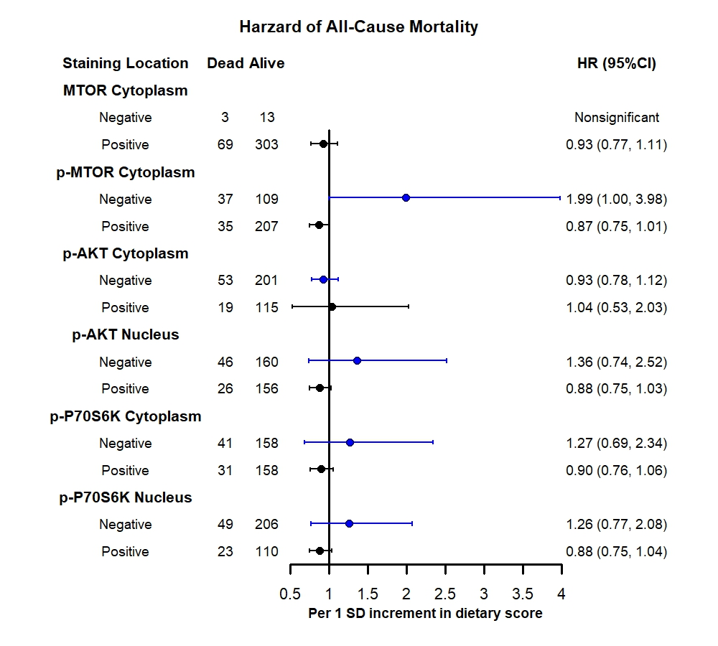
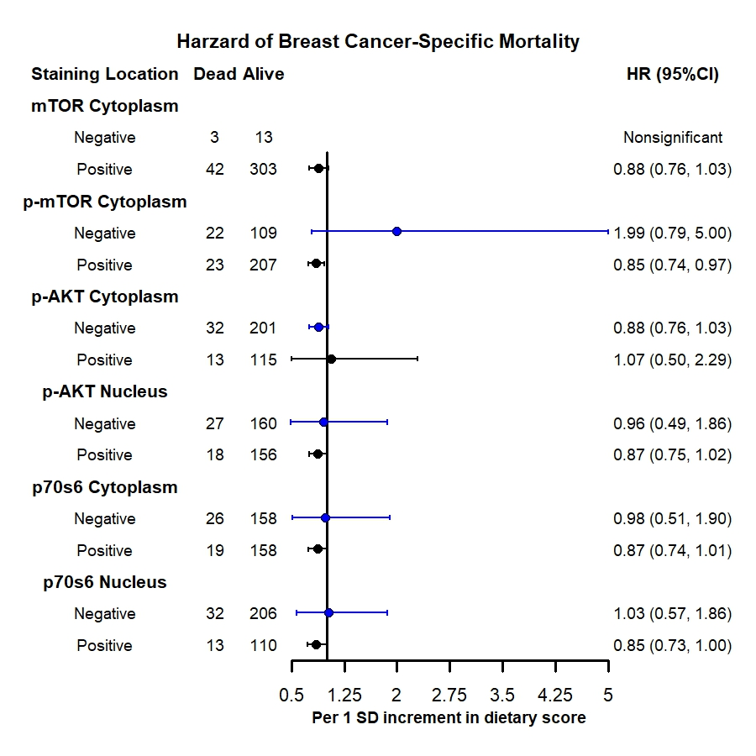
s
A
B
Supplementary Figure 1: A. Multivariable-adjusted (MV)-adjusted association between rEDIH and all-cause mortality by expression of markers along PI3K/AKT/MTOR pathway; B. MV-adjusted association between rEDIH and breast cancer-specific mortality by expression of markers along PI3K/AKT/MTOR pathway. Hazard ratios were derived from Cox proportional hazard analysis adjusted for age, total energy intake, waist-hip ratio, education, age at menarche and menopause, oral contraceptive and hormone replacement therapy use, parity, breastfeeding, reproductive years, smoking, alcohol use, benign breast disease history, family history of BrCa and cancer, recreational physical activity, diabetes history and BMI. Dietary scores were computed using the standardized method.

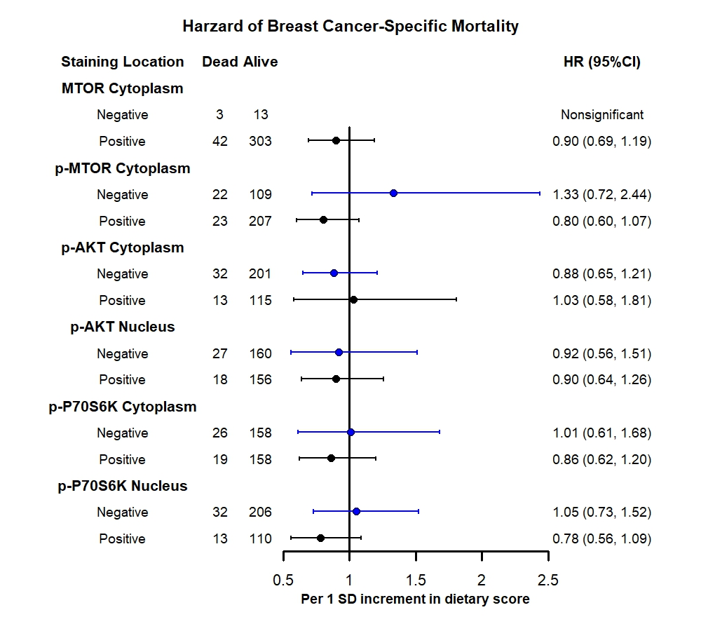
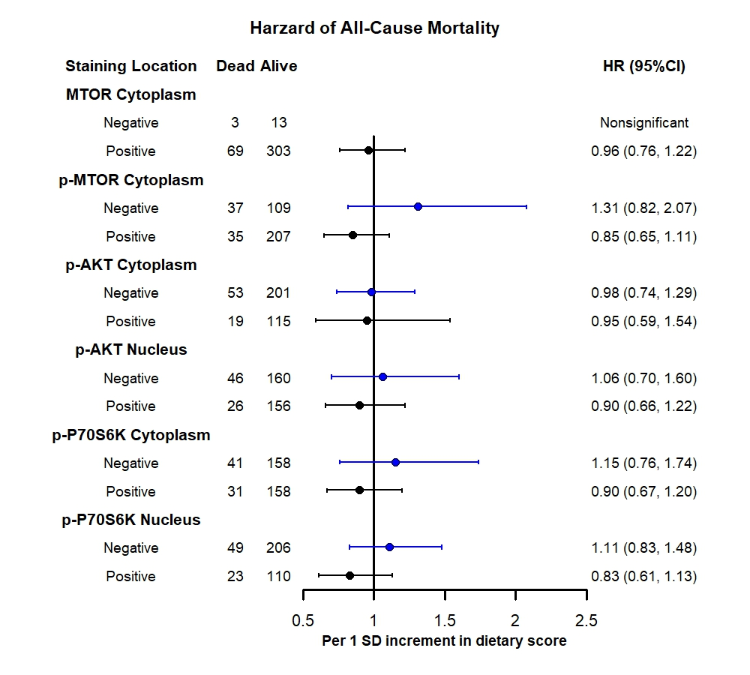
A
B
Supplementary Figure 2: A. Multivariable-adjusted (MV)-adjusted association between rEDIP and all-cause mortality by expression of markers along PI3K/AKT/MTOR pathway; B. MV-adjusted association between rEDIP and breast cancer-specific mortality by expression of markers along PI3K/AKT/MTOR pathway. Hazard ratios were derived from Cox proportional hazard analysis adjusted for age, total energy intake, waist-hip ratio, education, age at menarche and menopause, oral contraceptive and hormone replacement therapy use, parity, breastfeeding, reproductive years, smoking, alcohol use, benign breast disease history, family history of BrCa and cancer, recreational physical activity, diabetes history and BMI. Dietary scores were computed using the standardized method.

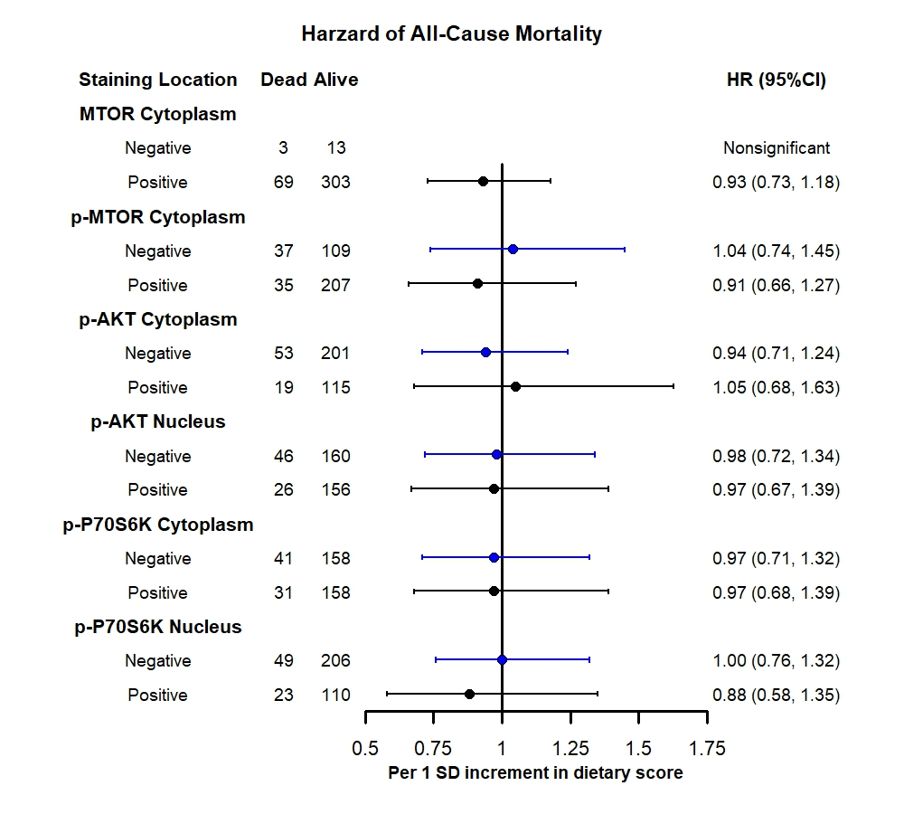
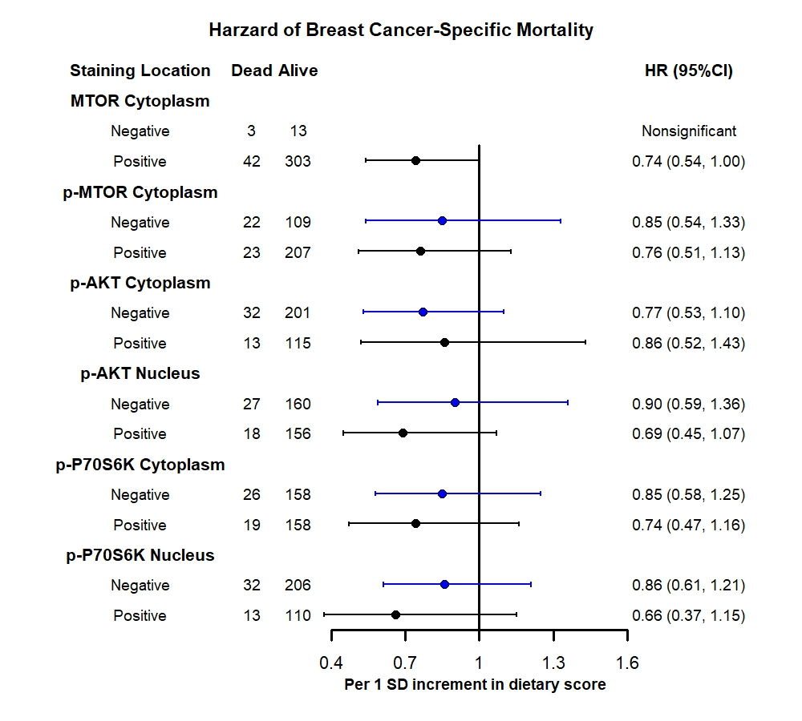
B
A
Supplementary Figure 3: A. Multivariable-adjusted (MV)-adjusted association between AHEI-2010 and all-cause mortality by expression of markers along PI3K/AKT/MTOR pathway; B. MV-adjusted association between AHEI-2010 and breast cancer-specific mortality by expression of markers along PI3K/AKT/MTOR pathway. Hazard ratios were derived from Cox proportional hazard analysis for age, total energy intake, waist-hip ratio, education, age at menarche and menopause, oral contraceptive and hormone replacement therapy use, parity, breastfeeding, reproductive years, smoking, alcohol use, benign breast disease history, family history of BrCa and cancer, recreational physical activity, diabetes history and BMI. Dietary scores were computed using the standardized method.

