Supplementary
Appendix. Statistical methods and contextual analyses
Appendix S1. Drug-form-level uptake analysis among comparable drug forms
S1.1 Analysis unit and aggregation
The primary analytical unit was the drug form, defined as a unique combination of drug name and dosage form. This unit was used because the observed coexistence of originator/innovative products and generic/biosimilar products may differ across dosage forms under the same drug name.
For each drug form $d$, sales volumes were aggregated across all study years from 2020 to 2024 and across all distribution channels, including hospitals, retail pharmacies, and online channels. The following quantities were calculated:
$$G_{d}=\sum{s}ales volume_{generic/biosimilar}$$
$$O_{d}=\sum{s}ales volume_{originator/innovative}$$
$$T_{d}=G_{d}+O_{d}$$
where $G_{d}$denotes the total observed sales volume of generic/biosimilar products, $O_{d}$denotes the total observed sales volume of originator/innovative products, and $T_{d}$denotes their combined volume.
Drug forms with $G_{d}>0$and $O_{d}>0$were defined as comparable drug forms. The primary uptake analysis was restricted to these comparable drug forms.
S1.2 Uptake measure
For each comparable drug form, generic/biosimilar uptake was calculated as:
$$uptake_{d}=\frac{G_{d}}{G_{d}+O_{d}}$$
This value represents the sales-volume share of generic/biosimilar products within the identifiable sales universe of originator/innovative and generic/biosimilar products for the same drug form.
This measure should not be interpreted as patient counts, prescription counts, treatment episodes, or whole-market share. Sales volumes were measured using the source database unit and were used to describe relative sales structure.
S1.3 Therapeutic-area summary measures
For each therapeutic area $a$, the following summary measures were calculated among comparable drug forms:$n_{a}=N\left(d∈a\right)，median_{a}=median\left(uptake_{d}\right), d∈a$
$$IQR_{a}=Q3_{a}-Q1_{a}$$
$$mean_{unweighted,a}=mean\left(uptake_{d}\right), d∈a$$
The unweighted median, IQR, and mean describe the distribution of uptake across typical drug forms.
In addition, a volume-weighted uptake estimate was calculated as:
$$weighted uptake_{a}=\frac{\sum_{d∈a}{G_{d}}}{\sum_{d∈a}{T_{d}}}$$
The volume-weighted estimate describes the sales-volume structure within the therapeutic area and aligns with the main manuscript’s aggregation principle of summing underlying sales volumes before calculating percentages.
Both unweighted and weighted estimates were reported because they answer different questions. The unweighted estimates describe the typical drug form, whereas the weighted estimates describe the sales-volume structure and may be influenced by high-volume products.
Appendix S2. Therapeutic-area comparisons of drug-form-level uptake
S2.1 Overall comparison
Therapeutic-area differences in drug-form-level uptake were first assessed using the Kruskal-Wallis test among comparable drug forms.
The null hypothesis was that the distribution of $uptake_{d}$was the same across therapeutic areas. The test was used as an exploratory structure-screening tool rather than as strict confirmatory inference.
The following quantities were reported:
- Kruskal-Wallis H statistic;
- degrees of freedom;
- p value;
- epsilon-squared effect size.
S2.2 One-vs-rest lower-uptake comparisons
To identify therapeutic areas with lower uptake relative to the remaining comparable drug forms, one-vs-rest Mann-Whitney U tests were performed.
For each therapeutic area $a$, the uptake distribution of drug forms in that area was compared with the uptake distribution of all comparable drug forms outside that area:
$$\left\{uptake_{d}:d∈a\right\} vs \left\{uptake_{d}:d∉a\right\}$$
For each comparison, the following were reported:
- number of comparable drug forms in the therapeutic area;
- median uptake in the therapeutic area;
- median uptake in the remaining therapeutic areas;
- Mann-Whitney U statistic;
- raw p value;
- Benjamini-Hochberg false-discovery-rate adjusted q value;
- rank-biserial correlation;
- Hodges-Lehmann median difference and confidence interval;
- direction of difference.
A therapeutic area was considered to show a lower-uptake signal if the one-vs-rest comparison indicated lower uptake and the FDR-adjusted q value was below 0.05.
No fixed threshold was used to define “sufficient substitution” in the primary analysis. Therefore, the analysis identified therapeutic areas with relatively lower uptake compared with other therapeutic areas, rather than determining whether substitution was sufficient according to an external benchmark.
S2.3 Sequential lower-uptake screening
Sequential lower-uptake screening was conducted as an exploratory procedure to assess whether additional lower-uptake therapeutic areas were masked by the most prominent low-uptake area.
The procedure was as follows:
- All eligible therapeutic areas were included in the first round.
- One-vs-rest Mann-Whitney U tests were performed for all therapeutic areas.
- If at least one therapeutic area had lower uptake and FDR-adjusted $q<0.05$, the area with the lowest median uptake among significant lower-uptake areas was selected and removed from the candidate set.
- The procedure was repeated among the remaining therapeutic areas.
- Screening stopped when no additional therapeutic area showed lower uptake with FDR-adjusted $q<0.05$.
This analysis was exploratory and was not used as the primary criterion for interpretation.

Appendix S3. Identification of low-uptake drug forms
To support interpretation of therapeutic-area-level findings, specific drug forms with low uptake were identified descriptively.
No statistical hypothesis tests were conducted for individual drug forms.
Two descriptive lists were generated.
S3.1 Lowest uptake drug forms
Comparable drug forms were ranked by $uptake_{d}$from lowest to highest. The table included:
- drug name;
- dosage form;
- therapeutic area;
- generic/biosimilar sales volume;
- originator/innovative sales volume;
- total sales volume;
- uptake.
This table was used to identify drug forms with very low generic/biosimilar sales shares.
S3.2 Within-area low outliers
Within each therapeutic area, low outlier drug forms were identified using the IQR rule:
$$uptake_{d}<Q1_{a}-1.5×IQR_{a}$$
where $Q1_{a}$and $IQR_{a}$were calculated within therapeutic area $a$.
These drug forms were described as within-area low outliers. They were not interpreted as statistically significant individual products.
Appendix S4. Observed supply-structure analysis
S4.1 Classification of observed supply structure
All drug forms, not only comparable drug forms, were classified according to observed sales structure in the study database:
$$O_only:O_{d}>0, G_{d}=0 \\ G_only:G_{d}>0, O_{d}=0 \\ Both:O_{d}>0, G_{d}>0$$
These categories were based solely on positive sales records in the study database.
S4.2 Supply-structure measures
For each therapeutic area, the following measures were calculated:
$$presence_{a}=\frac{N\left(G_{d} , >0 d∈a\right)}{N\left(d∈a\right)} \\ comparable_{a}=\frac{N\left(B , oth d∈a\right)}{N\left(d∈a\right)}$$
In addition, the proportions of $O_only$, $G_only$, and $Both$drug forms were reported.
These analyses were used to contextualise the extent to which drug forms entered the comparable subset. They were not used as the primary answer to the uptake question.
S4.3 Supply-structure heterogeneity
Therapeutic-area differences in observed supply structure were described using a contingency table of:
$$therapeutic area×\left\{O , _ , only Both G_only\right\}$$
A chi-square test was used when expected cell counts were sufficient. If sparse cells were present, exact or Monte Carlo methods were preferred.
Adjusted standardized residuals were reported to identify cells contributing to the observed structure. For sparse cells, residuals were interpreted descriptively and were not converted into definitive cell-level p values.
For selected one-vs-rest comparisons, risk differences, odds ratios, and FDR-adjusted q values were reported. Risk differences were prioritised over p values for interpretation.
S4.4 Distribution-shape analysis of drug-form-level uptake
To explore whether uptake within each therapeutic area followed a gradual distribution or showed concentration near the extremes, we conducted an exploratory distribution-shape analysis among comparable drug forms.
For each therapeutic area with sufficient comparable drug forms, Hartigan’s dip test was used to assess whether the distribution of drug-form-level uptake deviated from unimodality. P values were adjusted using the Benjamini-Hochberg false-discovery-rate method.
To aid interpretation, we also calculated the proportion of comparable drug forms with uptake in the following ranges:
$$uptake_{d}≤10\% \\ uptake_{d}≥90\% \\ 40\%≤uptake_{d}≤60\%$$
The proportions at $uptake_{d}≤10\%$and $uptake_{d}≥90\%$were used to describe concentration near the lower and upper extremes, whereas the 40%–60% range was used to describe the middle of the distribution.This analysis was exploratory and descriptive. A significant dip test indicated deviation from unimodality but did not identify the underlying mechanism.
Appendix S5. Reimbursement-class paired comparison
S5.1 Analysis objective
A paired therapeutic-area analysis was conducted to assess whether Class B medicines showed systematically higher generic/biosimilar uptake than Class A medicines within the same therapeutic areas.
This analysis was descriptive and did not estimate the causal effect of reimbursement class.
S5.2 Paired uptake calculation
For each therapeutic area that contained both Class A and Class B comparable drug forms, volume-weighted uptake was calculated separately for Class A and Class B medicines:
$$uptake_{A,a}=\frac{\sum{G_{A,a}}}{\sum{T_{A,a}}} \\ uptake_{B,a}=\frac{\sum{G_{B,a}}}{\sum{T_{B,a}}}$$
The paired difference was defined as:
$$Δ_{a}=uptake_{B,a}-uptake_{A,a}$$
where $a$denotes therapeutic area.
S5.3 Statistical comparison
The paired differences $Δ_{a}$were assessed using the Wilcoxon signed-rank test.
The primary direction tested was whether Class B uptake was systematically higher than Class A uptake across therapeutic areas.
The following were reported:
- number of paired therapeutic areas;
- number of therapeutic areas with Class B uptake higher than Class A;
- number of therapeutic areas with Class A uptake higher than Class B;
- median paired difference;
- Wilcoxon signed-rank p value.

Appendix S6. Time-trend analysis
S6.1 Annual uptake calculation
Annual uptake was calculated for 2020–2024.
For each year, uptake was calculated using aggregated sales volumes:
$$uptake_{t}=\frac{\sum{G_{t}}}{\sum{T_{t}}}$$
Annual uptake was calculated for four scopes:
- Overall: hospital, retail pharmacy, and online channels combined;
- Hospital;
- Retail pharmacy;
- Online.
The same calculations were repeated for each therapeutic area.
S6.2 Linear trend model
For descriptive trend summaries, a simple linear model was fitted:
$$uptake_{t}=α+β×year_{t}$$
The slope $β$was expressed as percentage points per year.
For example, a slope of $+1.0$percentage points per year indicates that uptake increased by approximately one percentage point per year on average, not by 1% relative growth per year.
The model was used only to describe the direction and magnitude of annual changes. It was not used to infer policy effects.

Appendix S7. Rheumatoid arthritis tracer analysis
S7.1 Rationale
Rheumatoid arthritis was selected as a tracer pathway because its treatment pathway includes conventional first-line therapy and escalation to biological agents or biosimilar products.
The tracer analysis was used to provide treatment-pathway context for interpreting observed sales structures. It was not intended to estimate precise substitution rates between biosimilar and originator products.
S7.2 Tracer products
The tracer products included:
- methotrexate, representing conventional first-line therapy;
- rhTNFR:Fc / Yisaipu-related products, representing domestic biological or biosimilar-related tracer products;
- originator etanercept injection, used as a reference originator product.
S7.3 Time window
The analysis was restricted to 2021–2024 because originator etanercept entered the NRDL statistical scope from March 2021 onwards. Data from 2020 were therefore not considered comparable for this tracer pathway.
S7.4 Analysis
Sales volumes were described by year and distribution channel.
The analysis did not estimate patient-level switching, prescription substitution, or causal effects of reimbursement listing.
Appendix S8. Physician survey
S8.1 Survey design
An anonymous cross-sectional physician survey was conducted to provide contextual information on prescribing considerations and perceived implementation barriers.
The survey was supplementary to the sales-data analysis and was not used as primary evidence for estimating uptake.
S8.2 Participants and recruitment
The survey targeted clinicians involved in relevant prescribing decisions, mainly rheumatologists. Participants were recruited using convenience sampling.
A total of 202 valid responses were obtained.
Because the sample was not randomly selected and was not designed to be nationally representative, survey findings were interpreted as explanatory context only.
S8.3 Questionnaire domains
The questionnaire covered:
- factors influencing prescribing decisions;
- perceived importance of affordability;
- perceived importance of evidence on efficacy and safety;
- hospital formulary access;
- patient preferences;
- awareness of NRDL policy;
- awareness of volume-based procurement policy.
S8.4 Consent
The anonymous physician survey was reviewed by the Ethics Committee of China Pharmaceutical University and was determined to be exempt from ethical review (Exemption No. CPU20260451). The survey was conducted in accordance with the Declaration of Helsinki and relevant institutional guidelines and regulations. Before participation, respondents were informed of the study purpose and the voluntary and anonymous nature of participation. Electronic informed consent to participate was obtained from all respondents; completion and submission of the questionnaire constituted consent to participate. No directly identifiable personal or patient-level information was collected.
S8.5 Statistical description
Categorical variables were summarised using frequencies and percentages.
Ordinal or rating-scale variables were summarised using:
- mean;
- standard deviation;
- median;
- interquartile range.
Because perceived-importance ratings were generally high, interpretation focused on the relative ranking of factors rather than on whether a single factor exceeded a predefined threshold.

Supplementary Figure S1. Generic/biosimilar uptake by therapeutic area and distribution channel: all drug forms versus comparable drug forms, 2020-2024
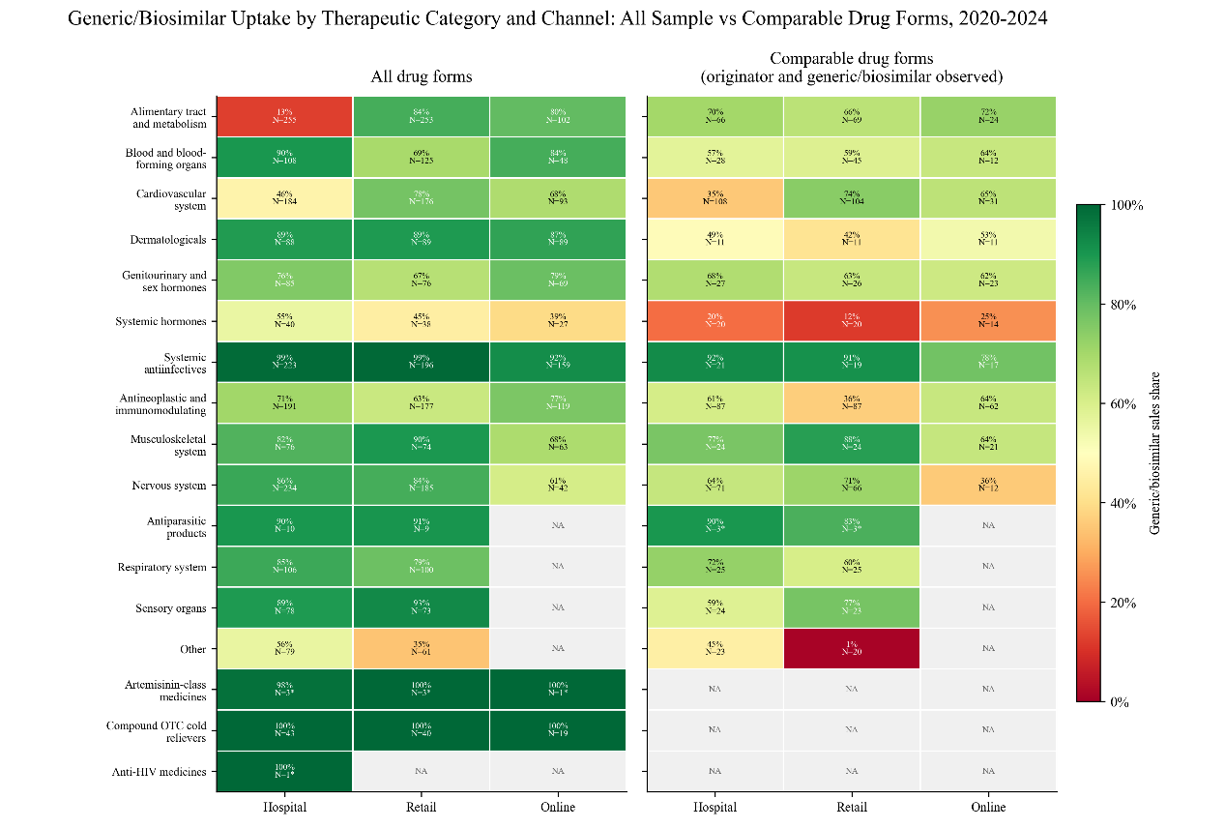
The figure shows the uptake share of generics and biosimilars by therapeutic area and distribution channel in the specified year. The left panel includes all drug forms, whereas the right panel is restricted to comparable drug forms, defined as drug name–dosage form combinations in which both originator/innovative and generic/biosimilar products had observed positive sales during the 2020–2024 study period. Uptake share was defined as the proportion of generic/biosimilar sales volume among the combined sales volume of originator/innovative and generic/biosimilar products. Sales volume was measured in minimum formulation units recorded in the database. Percentages in each cell were calculated after aggregating underlying sales volumes, and N denotes the number of drug forms with positive sales records in that analytical stratum. An asterisk indicates N<5 and should be interpreted with caution. NA indicates structural absence of relevant sales records or comparable drug forms and was not imputed. Sales records with unknown or unclassifiable product origin were excluded from both the numerator and denominator of the uptake-share calculation. The measure represents a relative sales-volume structure within the identifiable originator/innovative and generic/biosimilar sales universe and should not be interpreted as patient counts, prescription counts, treatment episodes, or whole-market share.

Supplementary Table S1. Kruskal-Wallis overall test
test | N areas | N observations | H | df | p | Epsilon squared | notes
Kruskal-Wallis | 13 | 511 | 24.8 | 12 | 0.016 | 0.0 | Eligible areas require n>=5 comparable drug forms

Supplementary Table S2. One-vs-rest Mann-Whitney results by therapeutic category
category | n | Median uptake | IQR | Mean uptake | Median other | Mann whitney u | p | q | HL diff | HL 95CI | RBC | signal
Sensory Organs | 24 | 27.4 | 2.1-50.6 | 33.3 | 59.4 | 3823.0 | 0.004 | 0.049 | -20.9 | -37.1 to -6.6 | -0.350 | yes
Antiparasitic Products | 3 | 35.5 | 18.1-63.6 | 42.6 | 57.7 | NA | NA | NA | NA | NA | NA | no
Cardiovascular System | 67 | 42.4 | 13.1-73.4 | 44.5 | 59.8 | 12449.0 | 0.026 | 0.169 | -9.8 | -19.4 to -0.9 | -0.169 | no
Other | 20 | 44.4 | 7.5-79.8 | 44.3 | 58.2 | 4111.0 | 0.203 | 0.440 | -7.8 | -25.8 to 4.3 | -0.168 | no
Dermatologicals | 11 | 48.4 | 26.4-65.0 | 46.6 | 57.8 | 2396.0 | 0.448 | 0.663 | -7.1 | -25.3 to 8.1 | -0.134 | no
Systemic Hormones | 20 | 56.1 | 28.5-89.1 | 55.3 | 57.6 | 5217.0 | 0.671 | 0.715 | 2.5 | -12.8 to 16.5 | 0.056 | no
Musculoskeletal System | 24 | 57.1 | 21.6-89.2 | 55.6 | 57.6 | 6214.0 | 0.639 | 0.715 | 2.6 | -10.7 to 14.8 | 0.057 | no
Antineoplastic and Immunomodulating Agents | 86 | 57.5 | 6.4-85.8 | 50.3 | 57.6 | 17515.0 | 0.480 | 0.663 | -1.9 | -10.2 to 4.3 | -0.048 | no
Alimentary Tract and Metabolism | 69 | 63.0 | 43.9-82.8 | 60.2 | 56.8 | 17297.0 | 0.090 | 0.294 | 7.0 | -0.0 to 13.9 | 0.127 | no
Blood and Blood-Forming Organs | 47 | 64.9 | 33.8-81.2 | 56.6 | 56.8 | 11615.0 | 0.510 | 0.663 | 2.3 | -4.9 to 11.9 | 0.058 | no
Nervous System | 69 | 65.2 | 24.1-85.9 | 54.3 | 57.0 | 15772.0 | 0.715 | 0.715 | 1.2 | -6.5 to 8.9 | 0.027 | no
Genitourinary System and Sex Hormones | 27 | 70.6 | 25.7-96.1 | 58.1 | 57.1 | 7379.0 | 0.284 | 0.528 | 5.7 | -6.9 to 19.0 | 0.122 | no
Respiratory System | 26 | 71.5 | 47.5-85.3 | 64.6 | 56.1 | 7667.0 | 0.073 | 0.294 | 10.6 | -0.0 to 21.6 | 0.208 | no
Systemic Antiinfectives | 21 | 74.9 | 41.1-88.9 | 64.1 | 57.0 | 6231.0 | 0.114 | 0.296 | 9.9 | -1.2 to 24.1 | 0.204 | no

Supplementary Table S3. Drug names represented by comparable drug forms with generic/biosimilar uptake below 50%, by therapeutic category, 2020–2024
Therapeutic category | n | Drugs with uptake below 50%
Alimentary Tract and Metabolism | 26 | Ademetionine; Alogliptin; Dapagliflozin; Diosmectite; Domperidone; Esomeprazole; Exenatide; Hydrotalcite; Insulin aspart; Insulin aspart 30; Insulin aspart 50; Insulin degludec; Lactulose; Linaclotide; Linagliptin; Loperamide; Mesalazine; Oryz-Aspergillus enzyme and pancreatin; Pancreatin; Pinaverium bromide; Potassium magnesium aspartate; Saxagliptin/metformin; Silymarin; Sitagliptin; Terlipressin; Ursodeoxycholic acid
Antineoplastic and Immunomodulating Agents | 37 | Afatinib; Apremilast; Baricitinib; Busulfan; Cyclosporine; Cytarabine; Dimethyl fumarate; Elemene; Eribulin mesylate; Everolimus; Ibrutinib; Interferon alfa-2a; Interferon alfa-2b; Interleukin-2; Interleukin-2 (125Ala); Interleukin-2 (I); Mitoxantrone; Mizoribine; Mycophenolate mofetil; Mycophenolate sodium; Neratinib maleate; Nilotinib; Olaparib; Palbociclib; Pazopanib; Pegylated recombinant human granulocyte colony-stimulating factor; Pirfenidone; Rabbit anti-human T-cell immunoglobulin; Recombinant human granulocyte colony-stimulating factor; Regorafenib; Sirolimus; Tacrolimus; Teriflunomide; Tocilizumab; Toremifene; Trastuzumab; Triptorelin
Antiparasitic Products | 2 | Albendazole; Mebendazole
Blood and Blood-Forming Organs | 18 | Avatrombopag maleate; Cilostazol; Clopidogrel/aspirin; Dabigatran etexilate; Edoxaban tosylate; Eltrombopag olamine; Hemocoagulase atrox; Hydroxyethyl starch 130/0.4 and electrolytes; Iron dextran; Lauromacrogol (polidocanol); Mecobalamin; Omega-3 fish oil lipid emulsion; Peritoneal dialysis solution; Recombinant human coagulation factor VIII; Rivaroxaban; Roxadustat; Ticagrelor; Tranexamic acid
Cardiovascular System | 32 | Amiodarone; Arotinolol; Benazepril; Benidipine; Bisoprolol; Compound reserpine and triamterene; Diltiazem; Doxazosin; Esmolol; Ezetimibe; Felodipine; Fenofibrate; Fluvastatin; Irbesartan; Ivabradine; Lacidipine; Lercanidipine; Losartan; Macitentan; Metoprolol; Nifedipine; Nimodipine; Olmesartan medoxomil; Perindopril; Perindopril/indapamide; Ramipril; Sacubitril/valsartan sodium; Telmisartan/hydrochlorothiazide; Troxerutin; Valsartan; Valsartan/amlodipine; Valsartan/hydrochlorothiazide
Dermatologicals | 6 | Calcipotriol; Miconazole; Mupirocin; Pimecrolimus; Tacalcitol; Tacrolimus
Genitourinary System and Sex Hormones | 10 | Clotrimazole; Dienogest; Dinoprostone; Dydrogesterone; Estradiol valerate; Ethinylestradiol/cyproterone acetate; Miconazole; Mirabegron; Silodosin; Tibolone
Musculoskeletal System | 11 | Alendronate; Denosumab; Diclofenac; Diclofenac diethylamine; Eperisone; Etoricoxib; Ibuprofen; Ibuprofen arginine; Loxoprofen; Meloxicam; Tetrandrine
Nervous System | 27 | Acetaminophen; Atomoxetine; Betahistine; Blonanserin; Carbamazepine; Desflurane; Entacapone; Flupentixol/melitracen; Gastrodin; Lacosamide; Lamotrigine; Levetiracetam; Levodopa/benserazide; Lidocaine gel plaster; Lurasidone hydrochloride; Oxcarbazepine; Paliperidone; Paroxetine; Perampanel; Rasagiline; Risperidone; Rivastigmine; Selegiline; Sodium valproate; Topiramate; Tramadol; Zolpidem
Other | 11 | Compound alpha-ketoacid; Deferasirox; Enteral nutrition formula (TPF-D); Gadobutrol; Gadoteridol; Iomeprol; Iopamidol; Iopromide; Lanthanum carbonate; Penehyclidine; Sevelamer
Respiratory System | 7 | Acetylcysteine; Budesonide; Compound ipratropium bromide; Fluticasone; Ipratropium bromide; Omalizumab; Terbutaline
Sensory Organs | 16 | Aflibercept; Betaxolol; Bimatoprost; Brimonidine; Brinzolamide; Carteolol; Emedastine; Fluorometholone; Latanoprost; Pemirolast; Ranibizumab; Sodium fluorescein; Tafluprost; Tobramycin; Tobramycin/dexamethasone; Travoprost
Systemic Antiinfectives | 7 | Bedaquiline fumarate; Botulinum toxin type A; Cefathiamidine; Lamivudine; Letermovir; Lopinavir/ritonavir; Tenofovir alafenamide
Systemic Hormones | 9 | Cinacalcet; Compound betamethasone; Desmopressin; Levothyroxine; Methimazole; Methylprednisolone; Octreotide acetate microspheres; Salmon calcitonin; Somatropin
The table lists drug names represented by low-uptake comparable drug forms; therefore, the same drug name may appear in different therapeutic categories when classified under different NRDL therapeutic contexts or dosage-form-specific entries. The threshold of <50% was used as a descriptive screening criterion and should not be interpreted as a clinical or policy-defined standard for insufficient substitution. Sales volumes were measured in source units and do not represent patient counts, prescription counts, treatment episodes, or whole-market share.

Supplementary Figure S2. Annual generic/biosimilar uptake trends among comparable drug forms by distribution channel, 2020–2024
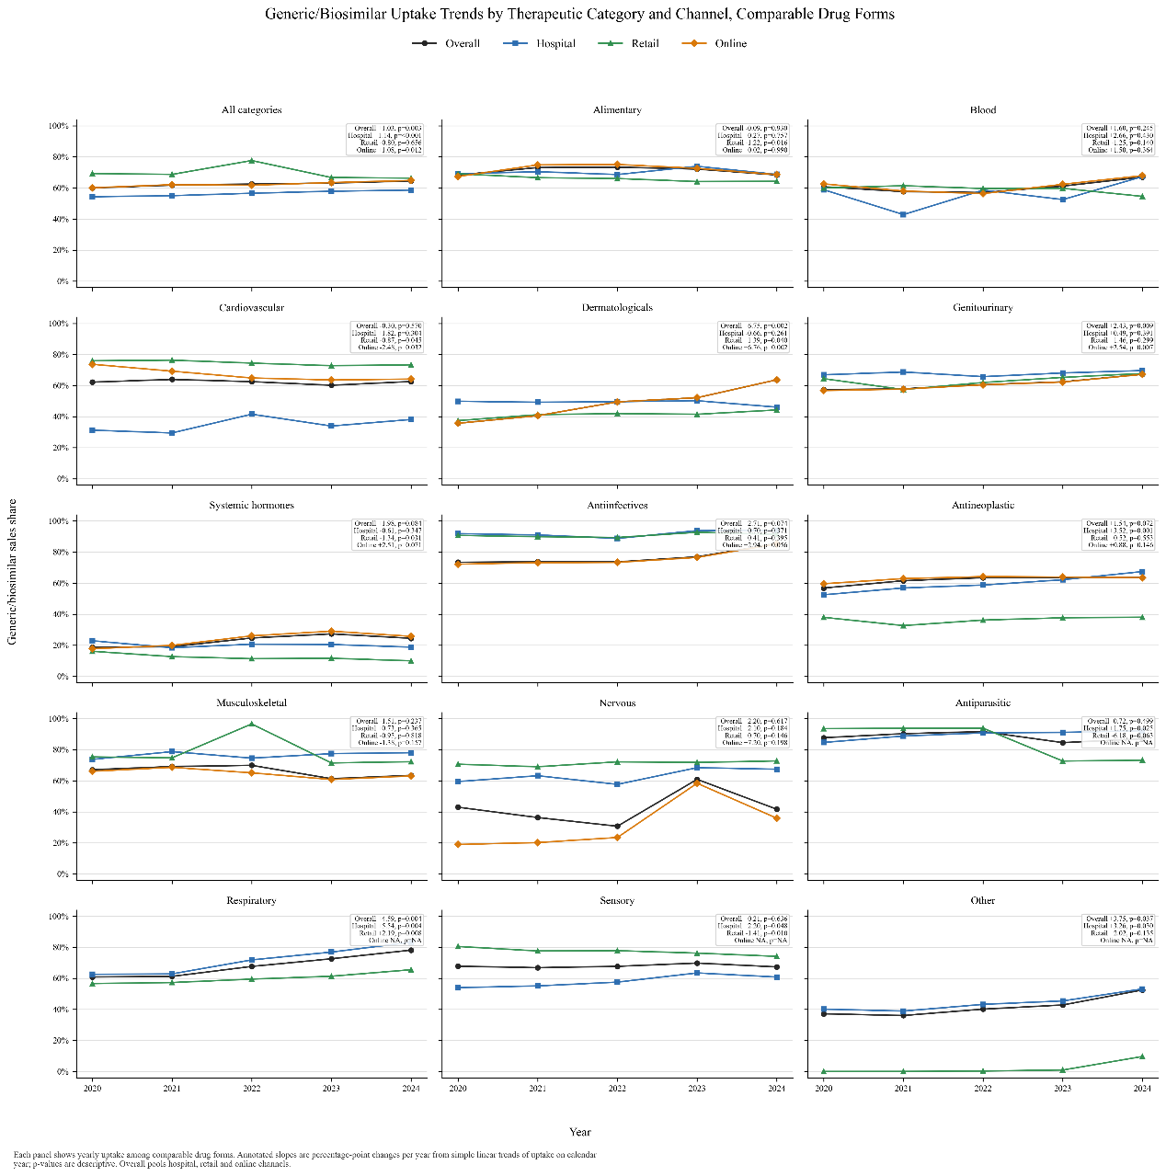
The black line shows overall uptake across all distribution channels, and the coloured lines show uptake in hospital, retail-pharmacy, and online channels. Slopes were estimated using simple linear models of annual uptake on calendar year and are expressed as percentage-point changes per year, not relative percent growth rates. P values are descriptive. Sales volumes are source units and do not represent patient counts, prescription counts, treatment episodes, or whole-market share.

Supplementary Figure S3. Therapeutic-category-level paired difference in generic/biosimilar uptake between Class B and Class A medicines, 2020–2024
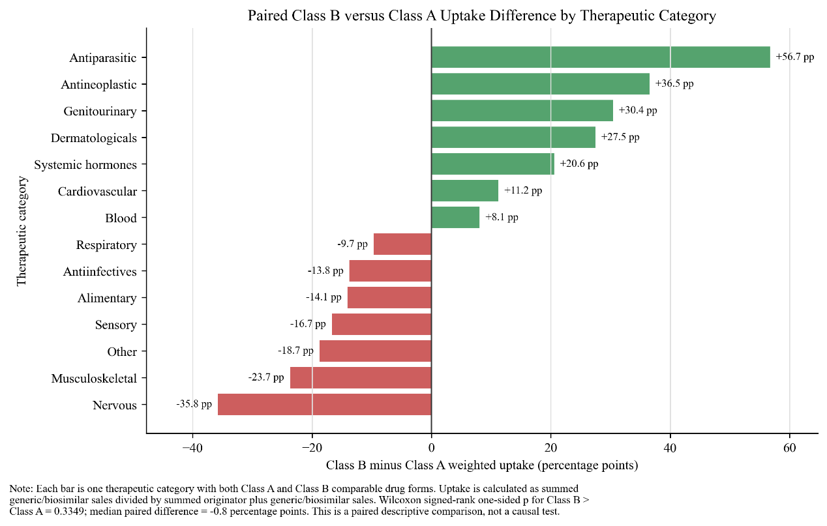
Each bar represents one therapeutic category that contained both Class A and Class B comparable drug forms. The x-axis shows the weighted uptake difference, calculated as Class B minus Class A generic/biosimilar sales-volume uptake in percentage points. Uptake was defined as the generic/biosimilar sales-volume share among the combined sales volume of originator/innovative products and generics/biosimilars. Positive values indicate higher uptake among Class B medicines, whereas negative values indicate higher uptake among Class A medicines.

Supplementary Figure S4. Therapeutic-category-specific distribution of drug-form-level generic/biosimilar uptake among comparable drug forms, 2020–2024
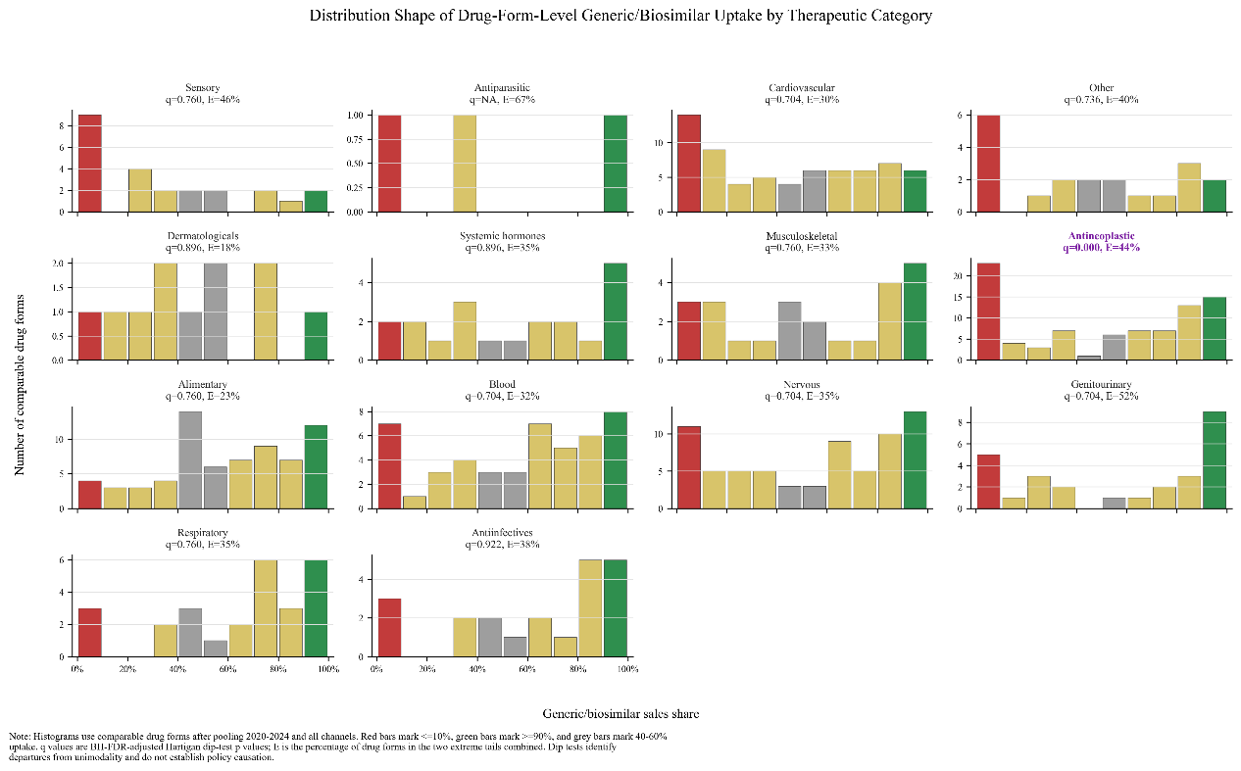
Colours indicate uptake ranges: red, <10%; orange, 10% to <40%; grey, 40% to <60%; yellow, 60% to <90%; and green, ≥90%. The panel labels report distribution-shape statistics used for descriptive screening. The analysis was exploratory and intended to identify therapeutic categories with marked within-category heterogeneity or possible polarisation in uptake. Sales volumes are source units and do not represent patient counts, prescription counts, treatment episodes, or whole-market share.

Supplementary Table S4. Characteristics of valid respondents in the physician questionnaire survey
Characteristic | Category | All responses (N=202), n (%)
Gender | Male | 83 (41.1)
 | Female | 116 (57.4)
 | Prefer not to disclose | 3 (1.5)
Age group | <30 | 0 (0.0)
 | 30-39 | 111 (55.0)
 | 40-49 | 54 (26.7)
 | 50-59 | 37 (18.3)
 | >=60 | 0 (0.0)
Department | Rheumatology | 83 (41.1)
 | Internal medicine, non-rheumatology | 75 (37.1)
 | General medicine | 11 (5.4)
 | Other | 33 (16.3)
Highest education | Bachelor | 49 (24.3)
 | Master | 92 (45.5)
 | Doctorate | 61 (30.2)
Professional title | Resident physician | 34 (16.9)
 | Attending physician | 73 (36.3)
 | Associate chief physician | 36 (17.9)
 | Chief physician | 58 (28.9)
Years in practice | <5 | 24 (11.9)
 | 5-10 | 61 (30.2)
 | 11-20 | 53 (26.2)
 | >20 | 64 (31.7)
Hospital level | Tertiary A | 175 (86.6)
 | Tertiary B | 7 (3.5)
 | Secondary hospital | 20 (9.9)
Region | East | 85 (42.1)
 | Central | 37 (18.3)
 | West | 17 (8.4)
 | Northeast | 63 (31.2)
Annual RA patient volume | <=50 | 19 (9.4)
 | 51-100 | 36 (17.8)
 | 101-200 | 70 (34.7)
 | >200 | 77 (38.1)
Biosimilar training frequency | Never | 1 (0.5)
 | 1-2 times | 26 (12.9)
 | 3-5 times | 50 (24.8)
 | >5 times | 125 (61.9)
Perceived helpfulness of training | Very helpful | 94 (46.5)
 | Helpful | 86 (42.6)
 | Neutral | 19 (9.4)
 | Less helpful | 3 (1.5)
 | Not helpful | 0 (0.0)
Data are presented as n (%), based on all valid questionnaire responses (N=202). Percentages may not sum to 100% because of rounding. RA denotes rheumatoid arthritis. Because the survey used convenience sampling and respondents were predominantly from tertiary hospitals, the sample should not be considered nationally representative.

Supplementary Figure S5. Sales volumes of methotrexate, rhTNFR:Fc/Yisaipu-related products, and originator etanercept injection by distribution channel, 2021–2024
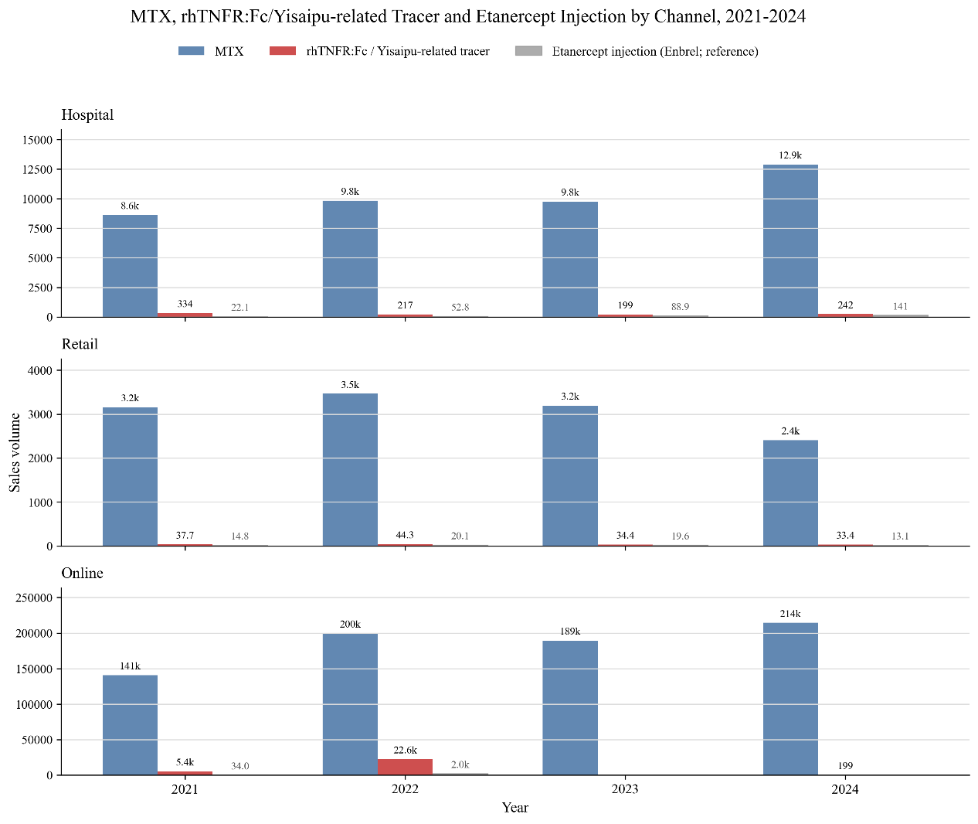
The figure shows annual sales volumes of methotrexate (MTX), rhTNFR:Fc/Yisaipu-related tracer products, and originator etanercept injection (Enbrel; reference product) across hospital, retail pharmacy, and online channels from 2021 to 2024. Sales volume was measured in minimum formulation units recorded in the database. MTX was used as the conventional first-line therapy tracer in the rheumatoid arthritis pathway, whereas rhTNFR:Fc/Yisaipu-related products and originator etanercept injection were used as biological therapy tracers. The analysis started in 2021 because originator etanercept was included in the National Reimbursement Drug List from March 2021 onwards. The figure is intended to describe the relative sales-volume structure of basic and escalation therapies in the rheumatoid arthritis tracer pathway and should not be interpreted as patient counts, prescription counts, treatment episodes, or direct substitution rates between biosimilar and originator products

Supplementary Figure S6. Ranked perceived importance of prescribing decision factors in the rheumatoid arthritis tracer pathway
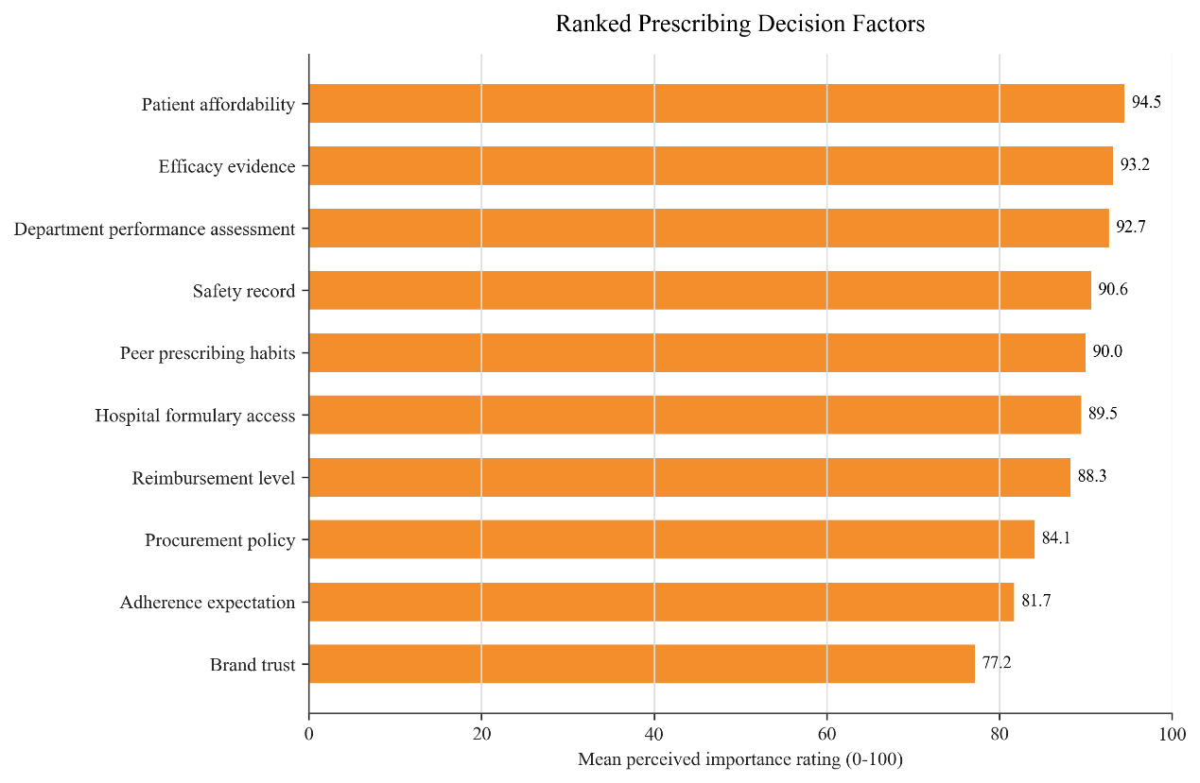
The figure shows the mean perceived importance ratings of prescribing decision factors reported in the clinician questionnaire survey. Ratings ranged from 0 to 100, with higher scores indicating greater perceived importance for prescribing decisions. Bars are ranked in descending order of mean rating. Patient affordability, efficacy evidence, department performance assessment, safety record, peer prescribing habits, hospital formulary access, and reimbursement level received relatively high ratings. Because ratings were generally high across factors, indicating a ceiling effect, the figure should be interpreted mainly in terms of relative ranking rather than as evidence that a single factor is absolutely important or unimportant. The survey used convenience sampling and was intended as an exploratory prescribing-level supplement to the rheumatoid arthritis tracer pathway; findings should not be generalized to all therapeutic areas or healthcare settings.

STROBE Statement—checklist of items that should be included in reports of observational studies
Item | STROBE section | Recommendation | Location in manuscript
1a | Title and abstract | Indicate the study’s design with a commonly used term in the title or the abstract. | Abstract: Methods
1b | Title and abstract | Provide in the abstract an informative and balanced summary of what was done and what was found. | Abstract: Background, Methods, Results, Conclusions
2 | Introduction: Background/rationale | Explain the scientific background and rationale for the investigation being reported. | Introduction
3 | Introduction: Objectives | State specific objectives, including any prespecified hypotheses. | End of Introduction
4 | Methods: Study design | Present key elements of study design early in the paper. | Methods: Study design and data sources
5 | Methods: Setting | Describe the setting, locations, and relevant dates, including periods of recruitment, exposure, follow-up, and data collection. | Methods: Study design and data sources; Rheumatoid arthritis tracer analysis; Physician survey
6a | Methods: Participants | Cross-sectional study—Give the eligibility criteria, and the sources and methods of selection of participants. | Methods: Inclusion and exclusion criteria; Physician survey
6b | Methods: Participants | For matched studies, give matching criteria and number of exposed and unexposed. | Not applicable
7 | Methods: Variables | Clearly define all outcomes, exposures, predictors, potential confounders, and effect modifiers. Give diagnostic criteria, if applicable. | Methods: Unit of analysis and variable definitions; Uptake measure; Comparable drug forms and observed supply structure
8 | Methods: Data sources/measurement | For each variable of interest, give sources of data and details of methods of assessment. Describe comparability of assessment methods if there is more than one group. | Methods: Study design and data sources; Unit of analysis and variable definitions; Uptake measure
9 | Methods: Bias | Describe any efforts to address potential sources of bias. | Methods: Inclusion and exclusion criteria; Comparable drug forms; Statistical analysis; Discussion: Limitations
10 | Methods: Study size | Explain how the study size was arrived at. | Methods: Inclusion and exclusion criteria; Results: Observed supply structure; Physician survey
11 | Methods: Quantitative variables | Explain how quantitative variables were handled in the analyses. If applicable, describe which groupings were chosen and why. | Methods: Uptake measure; Statistical analysis
12a | Methods: Statistical methods | Describe all statistical methods, including those used to control for confounding. | Methods: Statistical analysis
12b | Methods: Statistical methods | Describe any methods used to examine subgroups and interactions. | Methods: Statistical analysis; Comparable drug forms and observed supply structure
12c | Methods: Statistical methods | Explain how missing data were addressed. | Methods: Inclusion and exclusion criteria; Statistical analysis
12d | Methods: Statistical methods | If applicable, explain how loss to follow-up, matching, or sampling strategy was addressed. | Methods: Physician survey; Statistical analysis
12e | Methods: Statistical methods | Describe any sensitivity analyses. | Not applicable; no formal sensitivity analysis was prespecified. Supplementary descriptive analyses are described in Methods: Statistical analysis and Supplementary Appendix.
13a | Results: Participants | Report numbers of individuals at each stage of study—for example, potentially eligible, examined, included and analysed. | Results: Observed sales structure and generic/biosimilar uptake; Supplementary Appendix S8.2 for the physician survey sample.
13b | Results: Participants | Give reasons for non-participation at each stage. | For the sales-data analysis, reasons for record exclusion are described in Methods. For the supplementary physician survey, detailed non-participation data were not available because convenience sampling was used.
13c | Results: Participants | Consider use of a flow diagram. | No participant flow diagram was used; sample derivation and numbers of analysed drug forms are described in Methods and Results.
14a | Results: Descriptive data | Give characteristics of study participants and information on exposures and potential confounders. | Results: Observed supply structure; Association between uptake and reimbursement class; Supplementary table
14b | Results: Descriptive data | Indicate number of participants with missing data for each variable of interest. | Methods: Analytical sample and variable definitions; Statistical analysis. Records with unknown or unclassifiable product source were excluded, and structural missingness was presented as NA without imputation.
14c | Results: Descriptive data | Cohort study—Summarise follow-up time. | Not applicable
15 | Results: Outcome data | Cross-sectional study—Report numbers of outcome events or summary measures. | Results: Uptake in the full sample and among comparable drug forms; Association between uptake and reimbursement class; Temporal trends
16a | Results: Main results | Give unadjusted estimates and, if applicable, confounder-adjusted estimates and their precision. Make clear which confounders were adjusted for and why. | Results: Generic/biosimilar uptake among comparable drug forms; Reimbursement class and temporal trends. Estimates were unadjusted because the analyses were descriptive and exploratory; no causal or confounder-adjusted effects were estimated.
16b | Results: Main results | Report category boundaries when continuous variables were categorised. | Results: Generic/biosimilar uptake among comparable drug forms; Supplementary Appendix S3 and S4.4. Category boundaries and the descriptive uptake thresholds are reported where applicable.
16c | Results: Main results | If relevant, consider translating estimates of relative risk into absolute risk for a meaningful time period. | Not applicable
17 | Results: Other analyses | Report other analyses done, including subgroup analyses, interaction analyses and sensitivity analyses. | Methods and Supplementary Appendix S7–S8; selected contextual findings are discussed in the Discussion.
18 | Discussion: Key results | Summarise key results with reference to study objectives. | Discussion opening paragraph
19 | Discussion: Limitations | Discuss limitations of the study, taking into account sources of potential bias or imprecision. Discuss both direction and magnitude of any potential bias. | Discussion: Limitations
20 | Discussion: Interpretation | Give a cautious overall interpretation considering objectives, limitations, multiplicity of analyses, results from similar studies and other relevant evidence. | Discussion
21 | Discussion: Generalisability | Discuss the generalisability or external validity of the study results. | Discussion: Limitations; Conclusions
22 | Other information: Funding | Give the source of funding and the role of the funders for the present study and, if applicable, for the original study. | Declarations: Funding

