Celllines_Figure 1
PHOX2B
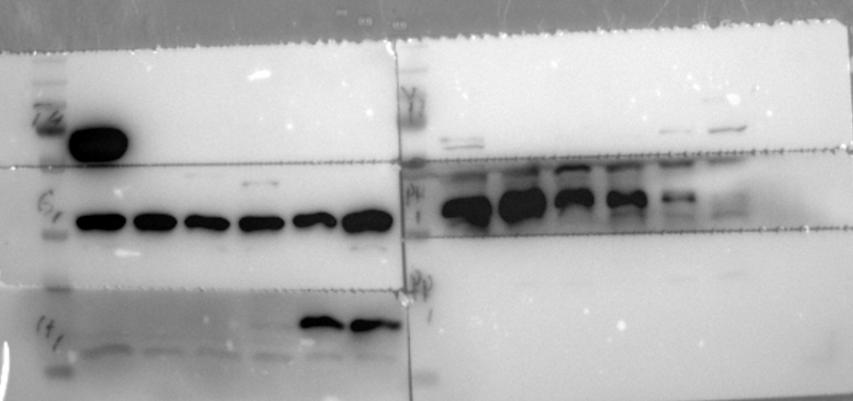
HMGA2
GAPDH
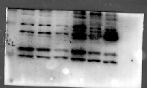
PRRX1
Celllines_VIM_MYCN_GAPDH
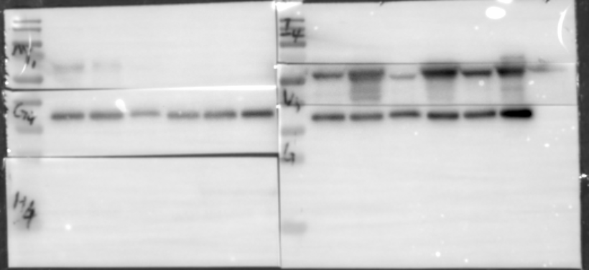
MYCN
GAPDH
GAPDH
VIM
Celllines_yap1_gapdh
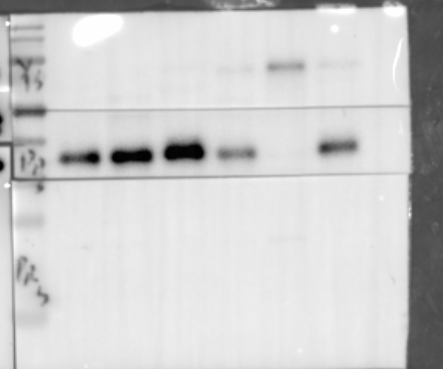
YAP1
PHOX2B
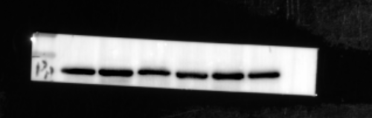
GAPDH
GAPDH
GAPDH
GAPDH
GAPDH
GAPDH
Celllines_IGF2BP2_ALKBH5_GAPDH
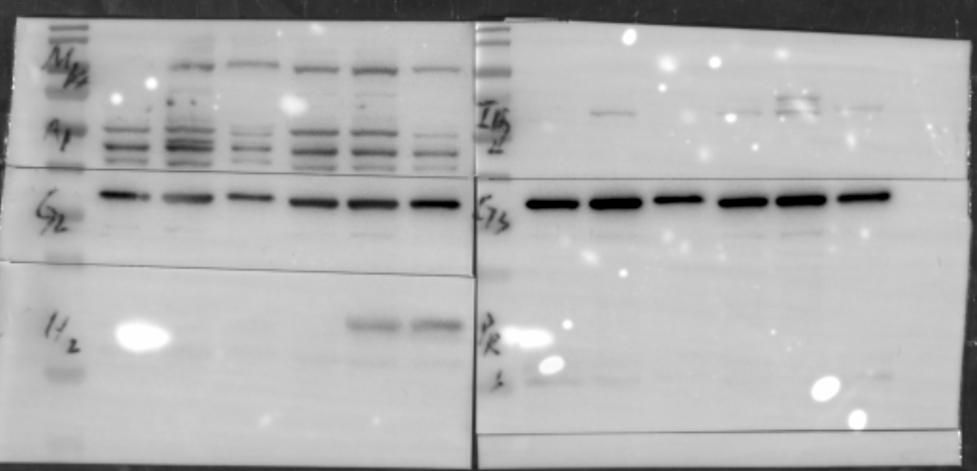
HMGA2
GAPDH
GAPDH

SK-N-SH_MES-ADRN_like
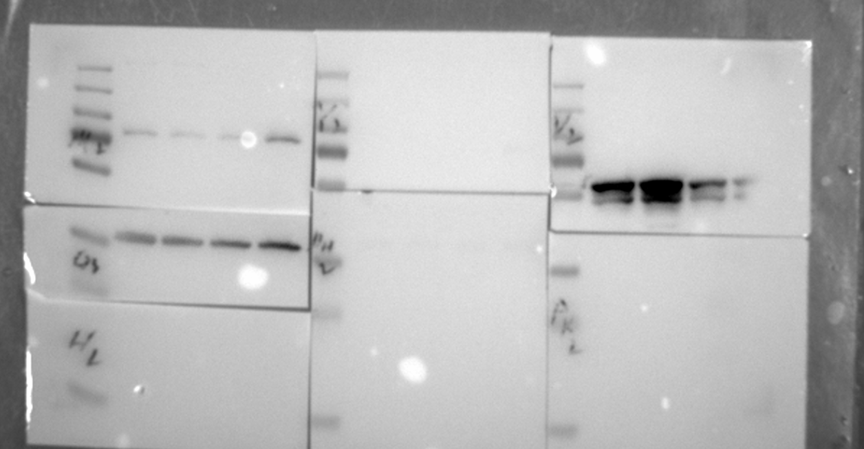
VIM
GAPDH
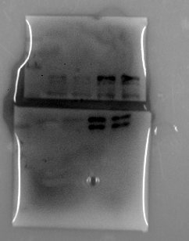
PRRX1
YAP1
Phox2b_igf2bp2_vim
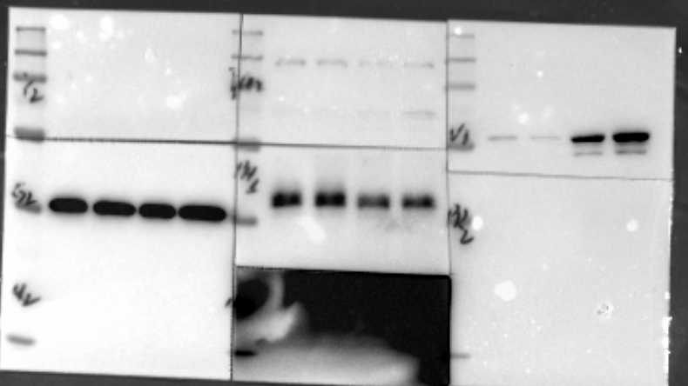
VIM
PHOX2B

Figure 2 AS_shHMGA2
PHOX2B_VIM_HM
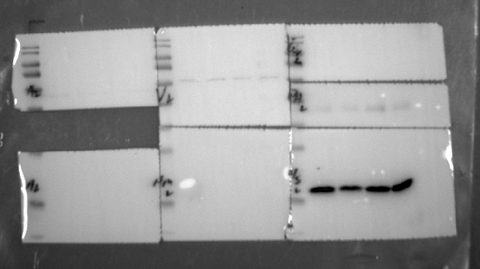
H3
PHOX2B

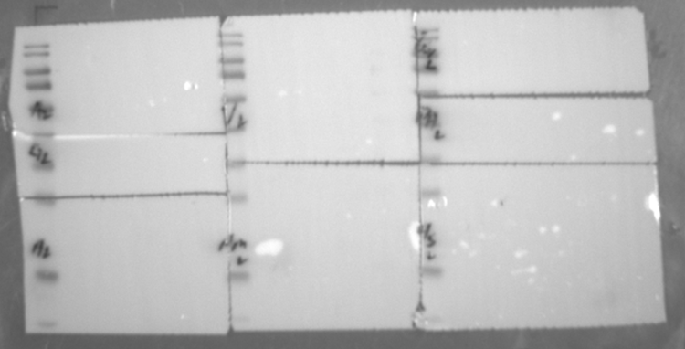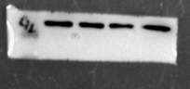
GAPDH
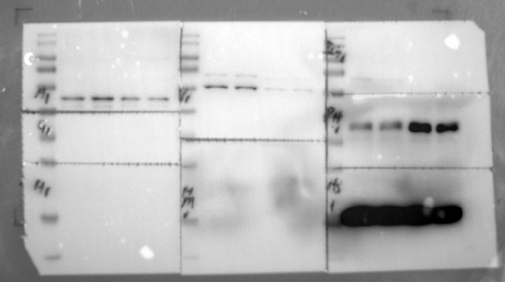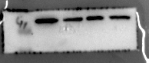
GAPDH
VIM
IGF2BP2
PHOX2B
YAP1
HMGA2_PHOX2B
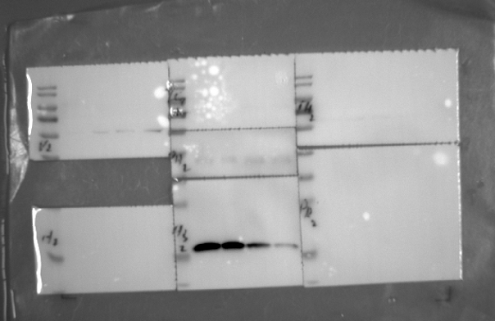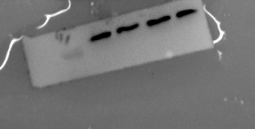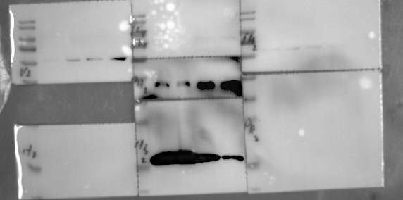
GAPDH
HMGA2
PHOX2B

EP_shHMGA2
H3_PHOX2B_HMGA2
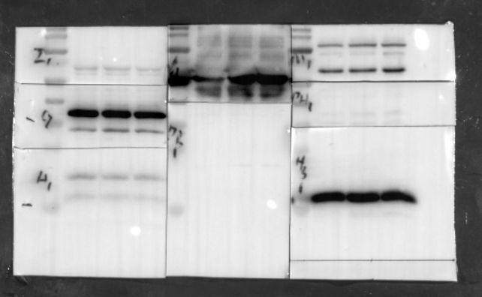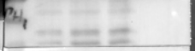
H3
PHOX2B
HMGA2
GAPDH
PRRX1_HMGA2_YAP1_IGF2BP2
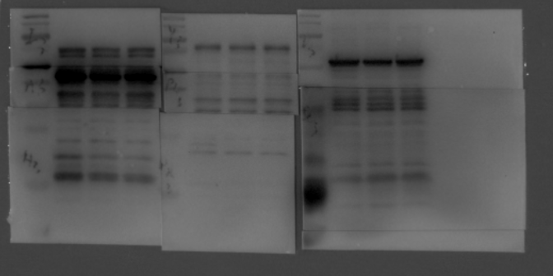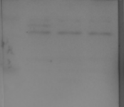
HMGA2
PRRX1
IGF2BP2_HMGA2_GAPDH
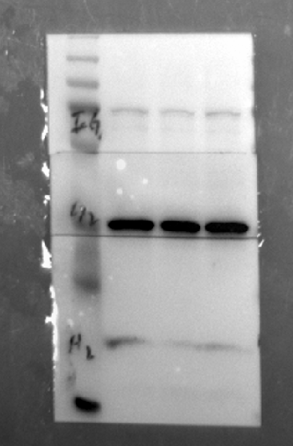
HMGA2
GAPDH
IGF2BP2
HMGA2_VIM_SLUG_IGF2BP2

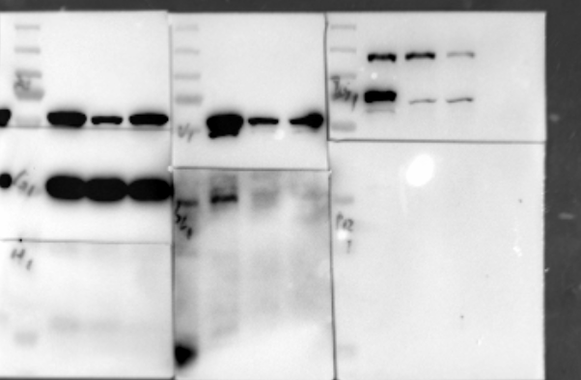
HMGA2
IGF2BP2
VIM
BE2_oeHMGA2
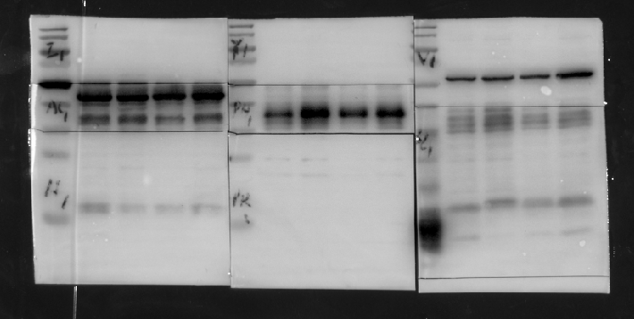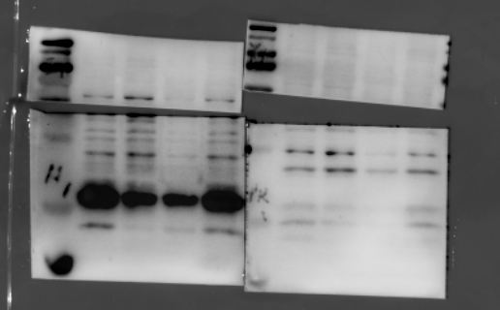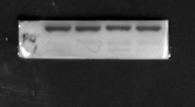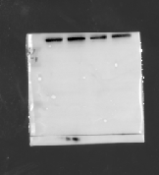
GAPDH
YAP1
PRRX1
HMGA2
PRRX1
VIM
GAPDH
PHOX2B
GAPDH
HMGA2

5Y_oeHMGA2
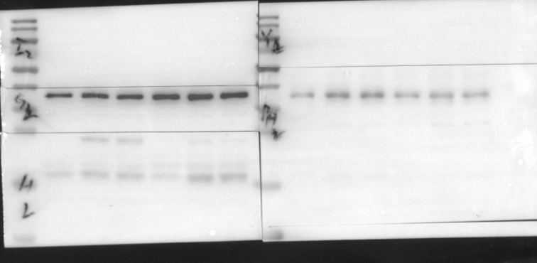
PHOX2B
HMGA2
GAPDH
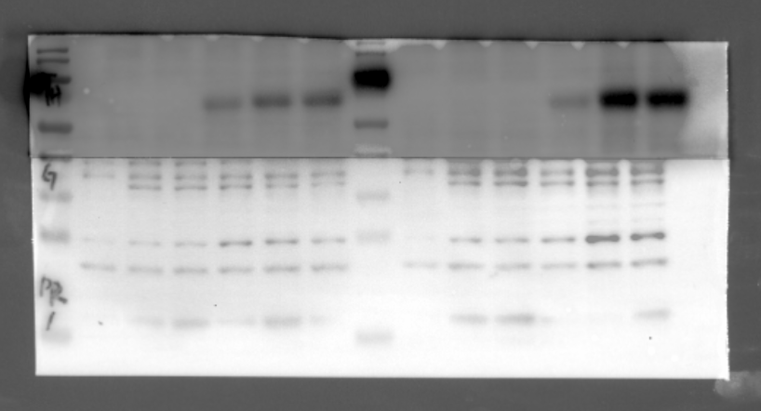
PRRX1
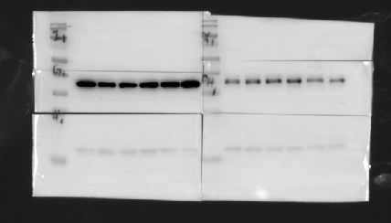
H3
GAPDH
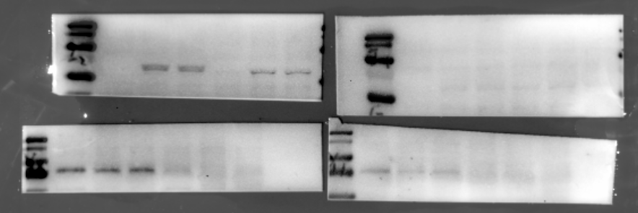
IGF2BP2
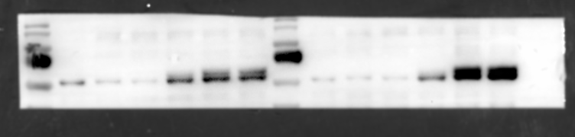
VIM
VIM
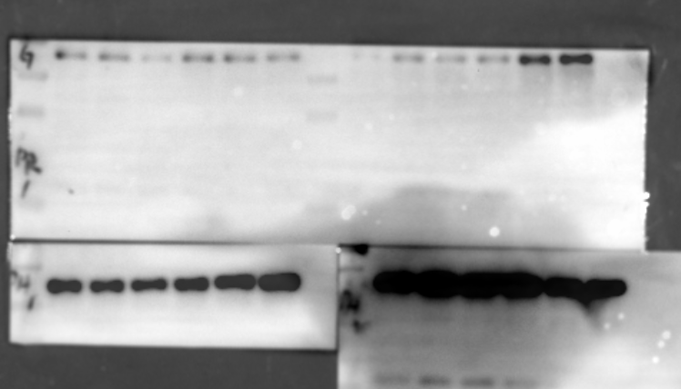
GAPDH
GAPDH
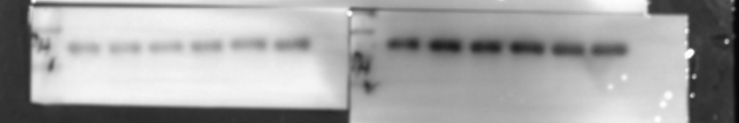
GAPDH

Figure 5
siIGF2BP2_EP IGF2BP2_HMGA2_VIM
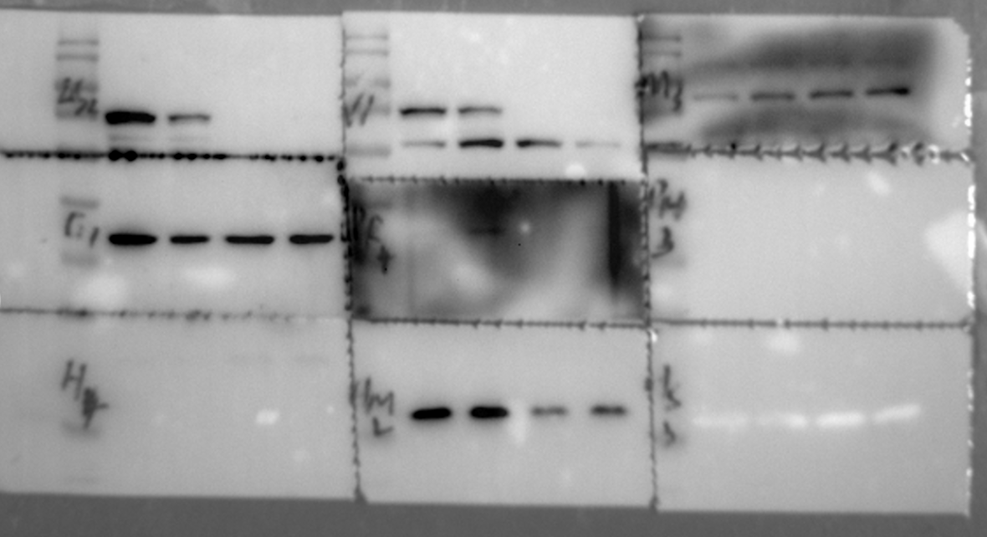
GAPDH
HMGA2
VIM
IGF2BP2
IGF2BP2
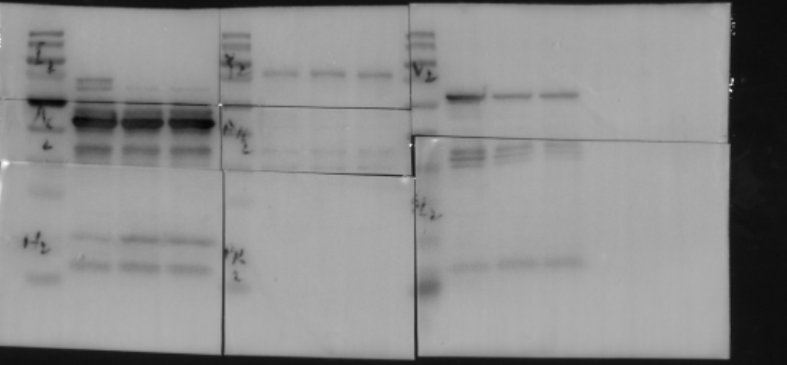
PHOX2B
VIM
GAPDH
PRRX1
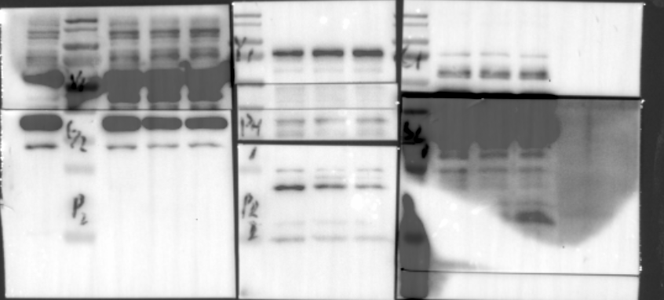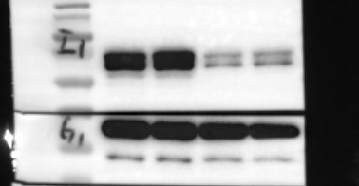
PRRX1
IGF2BP2
GAPDH
GAPDH
GAPDH

AS_siIGF2BP2
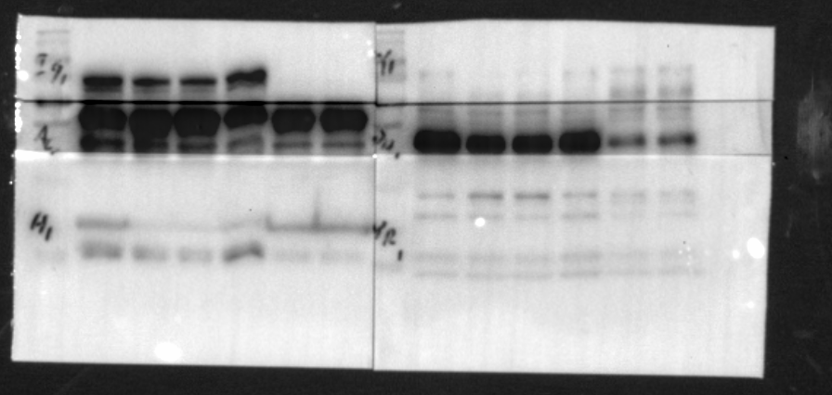
PRRX1
HMGA2
GAPDH
IGF2BP2

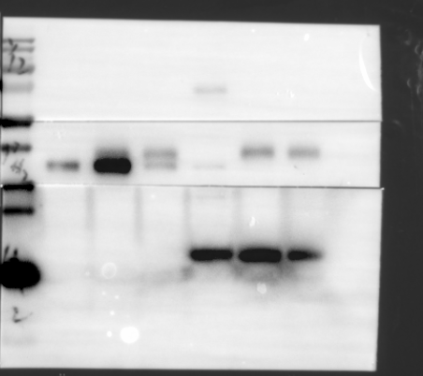
Yap1
PHOX2B

H3
EP_shIGF2BP2_AP1_RUNX2
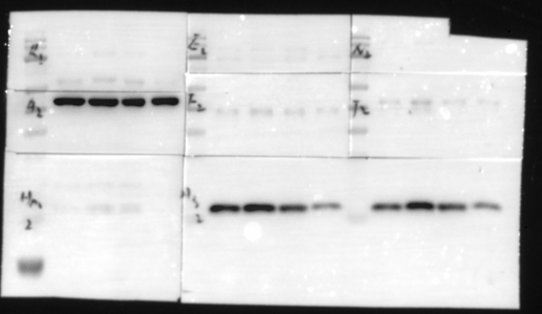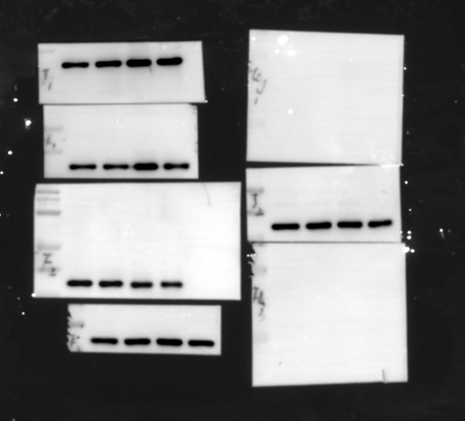
HMGA2
RUNX2
GAPDH
JUNB
FOSL1
GAPDH
ShIGF2BP2
OeHMGA2
AS_shIGF2BP2_AP1_RUNX2

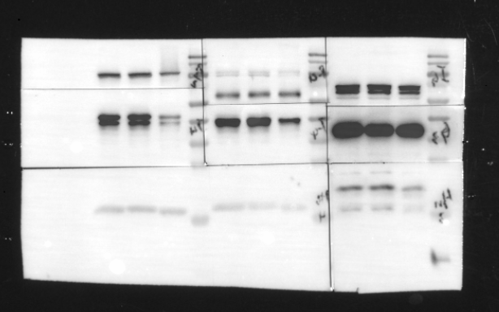
HMGA2
H3
JUNB
FOSL1
RUNX2

Figure 6 5Y_SH_EP_alkbh5
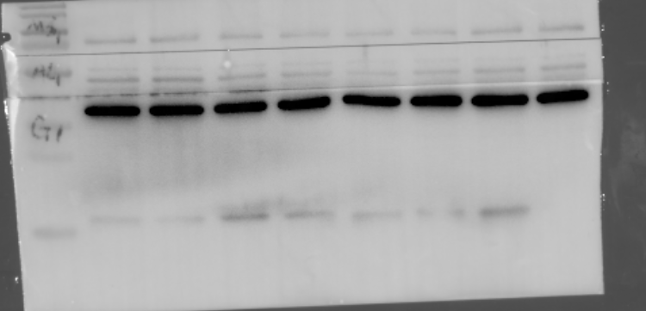
ALKBH5
Cell_ALKBH5_METTL3_IGF2BP2
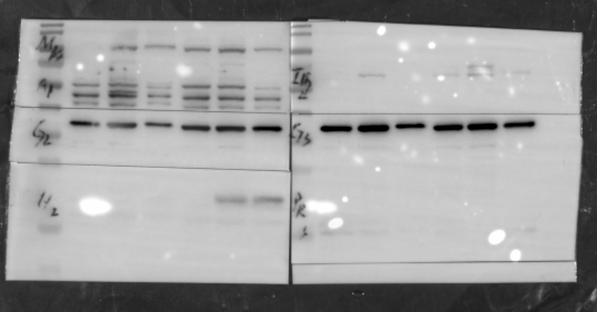
GAPDH
METTL3
ALKBH5

SiMETTL3
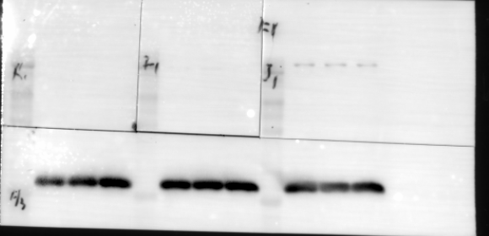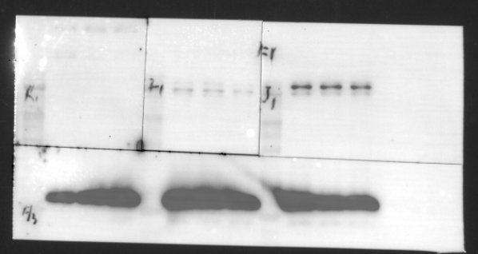
RUNX2
H3
FOSL1
JUNB

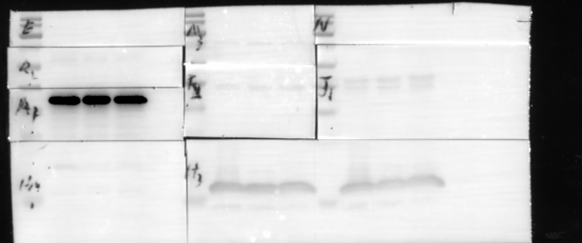
H3
GAPDH
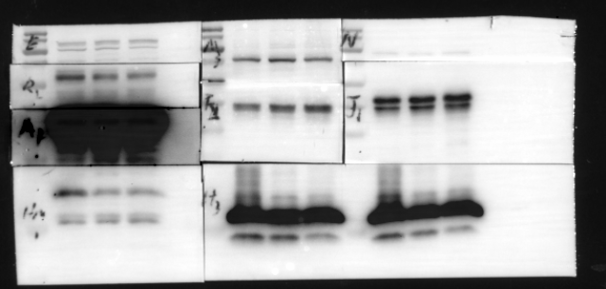
RUNX2
METTL3
JUNB
FOSL1

OeALKBH5_AP1

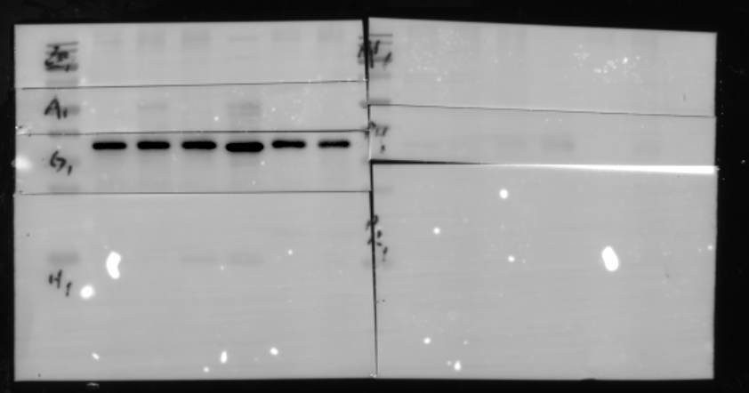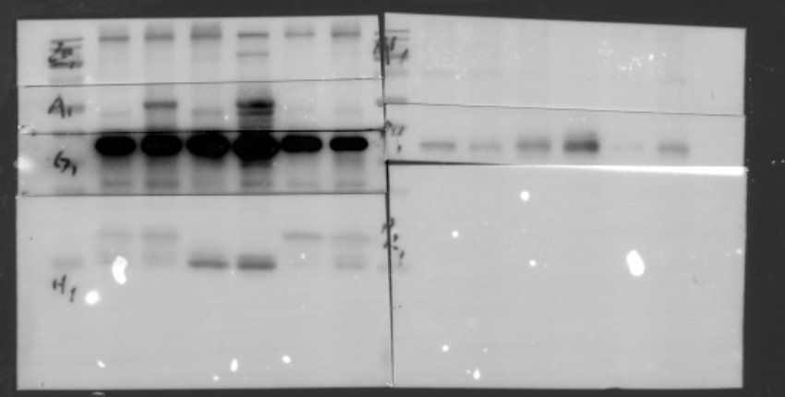
GAPDH
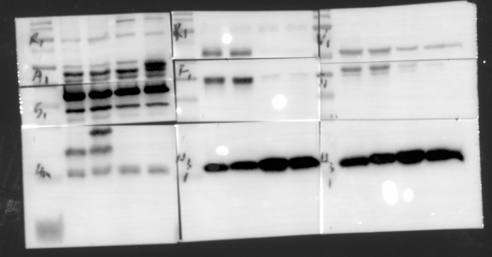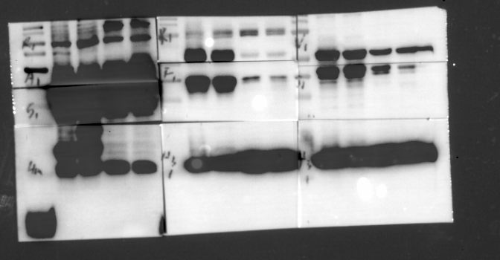
ALKBH5
H3
GAPDH
RUNX2
JUNB
FOSL1

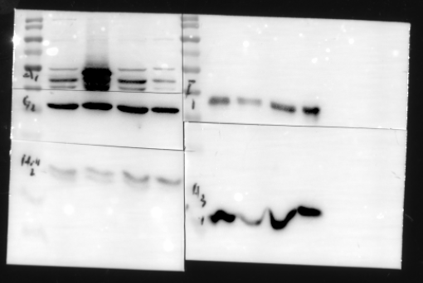
FOSL1
HMGA2
ALKBH5
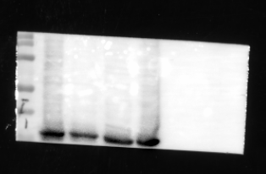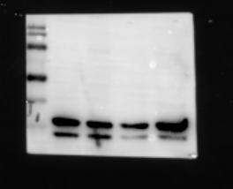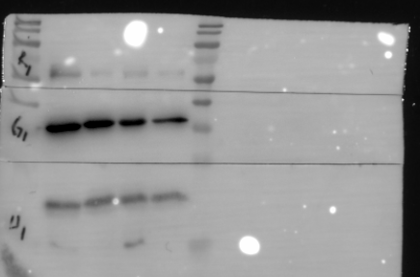
GAPDH
RUNX2
JUNB
GAPDH

STM2457
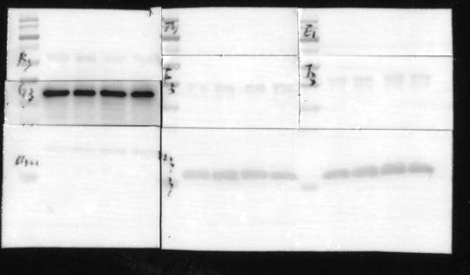
H3
GAPDH

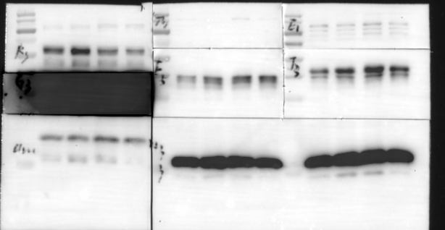
JUNB
FOSL1
HMGA2
RUNX2

