Supplementary figures:
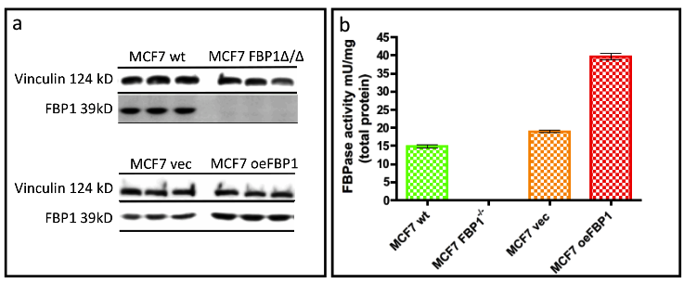

Figure S1 Verification of FBP1 over-expression and deletion in MCF7 cells.
a) Western-blots comparing the established stable FBP1 deletion and over-expression cell types to the wild type and empty-vector cells, respectively. The blots feature biologically independent triplets of each cell type. b) The measured FBPase catalysis in native protein extracts of the stably modified cell types.

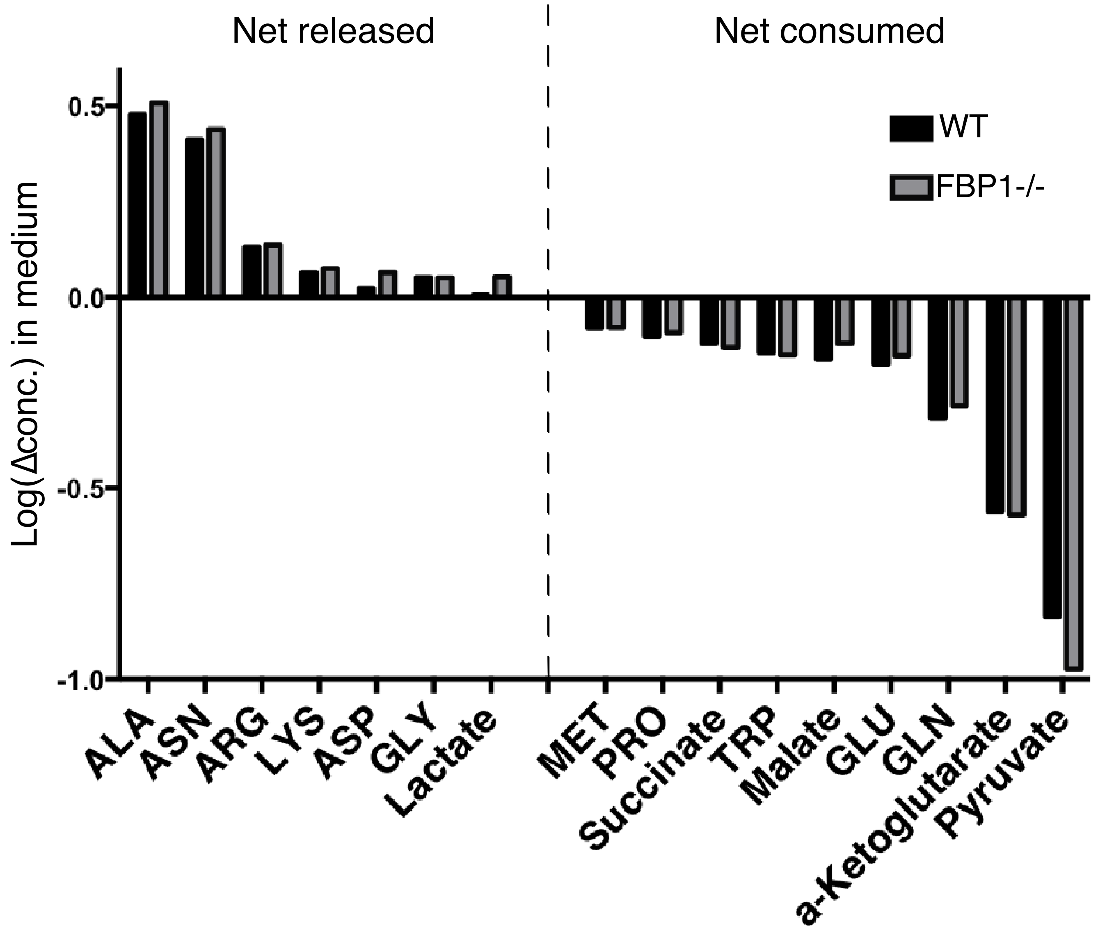

Figure S2 Net change of metabolites in medium when incubated with MCF-7 cells. Only statistically significant (p-Value≤0.05) are depicted. The values of change where calculated from HPLC-MS quantification as follows; log (concentration in medium covering cells/concentration in medium without cells).

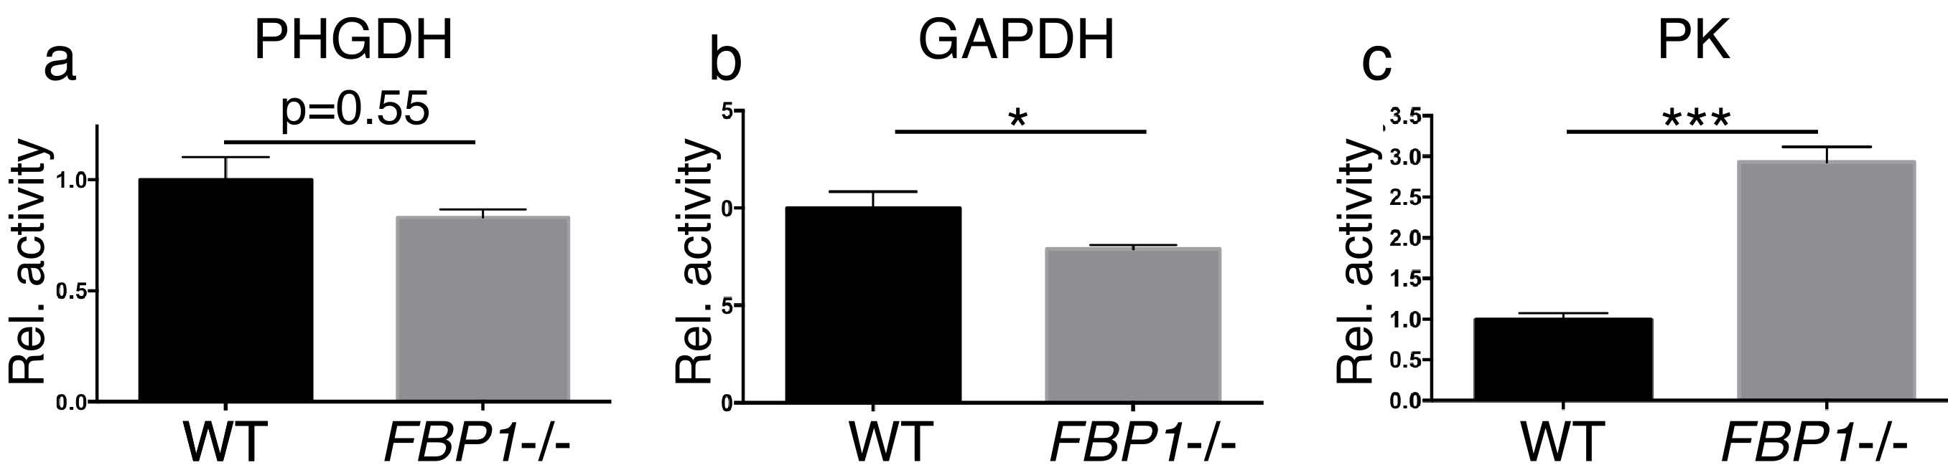
Figure S3 catalytic activity of enzymes in FBP1 KO vs wild type MCF-7 cells
a) PHGDH; b) GAPDH; c) PK. Featured are mean values± SD (n=3; technical replicates).

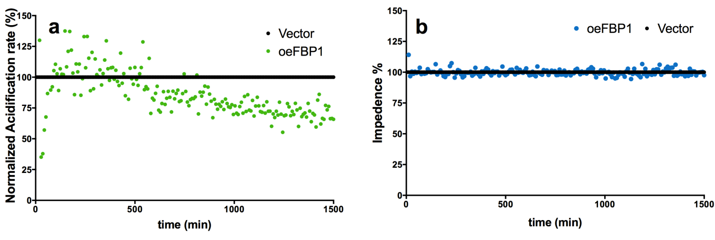
Figure S4 online monitoring of acidification and impedance in MDA-MB-231 cells with FBP1 over-expression using the Bionas flow-through system
a) Acidification rate (%) over time in MDA-mb231 oeFBP1 relative to that of the control cells with the empty vector. b) Impedance (%) over time in MDA-mb231 oeFBP1 relative to that of the control cells with the empty vector.

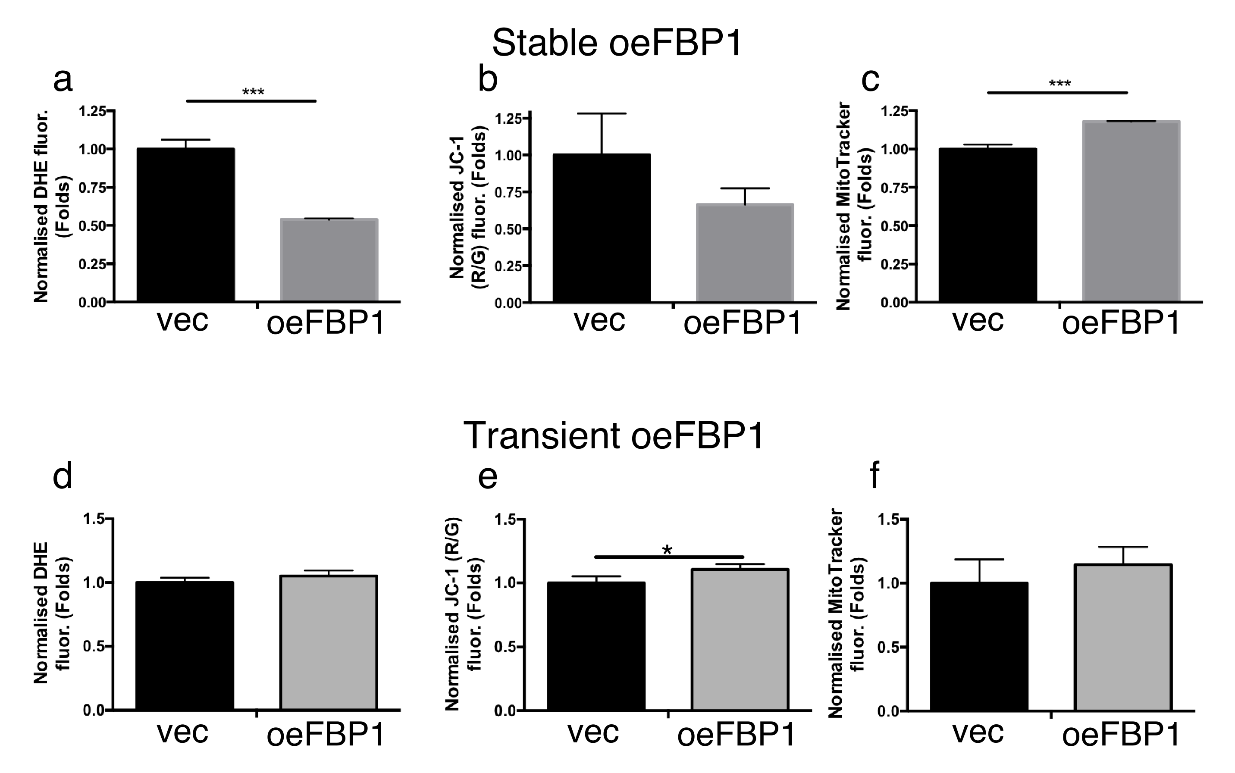

Figure S5 transient and long-term effects of FBP1 on mitochondrial variables in MDA-MB231 cells.
a,b) and c) ROS accumulation (DHE), mitochondrial inner-membrane potential MIMP (JC-1) and mitochondrial biomas (MItoTracker Green), respectively. Measured in stably transfected MDA-MB231 oeFBP1 cells vs vec. 5000 stained cells were analyzed using FACS, values indicate the mean±SD, n≥3. d,e&f) ROS accumulation (DHE), mitochondrial inner-membrane potential MIMP (JC-1) and mitochondrial biomas (MItoTracker Green), respectively. Measured in transiently transfected MDA-MB231 oeFBP1 cells vs vec. 5000 stained cells were analyzed using FACS, values indicate the mean±SD, n=3.

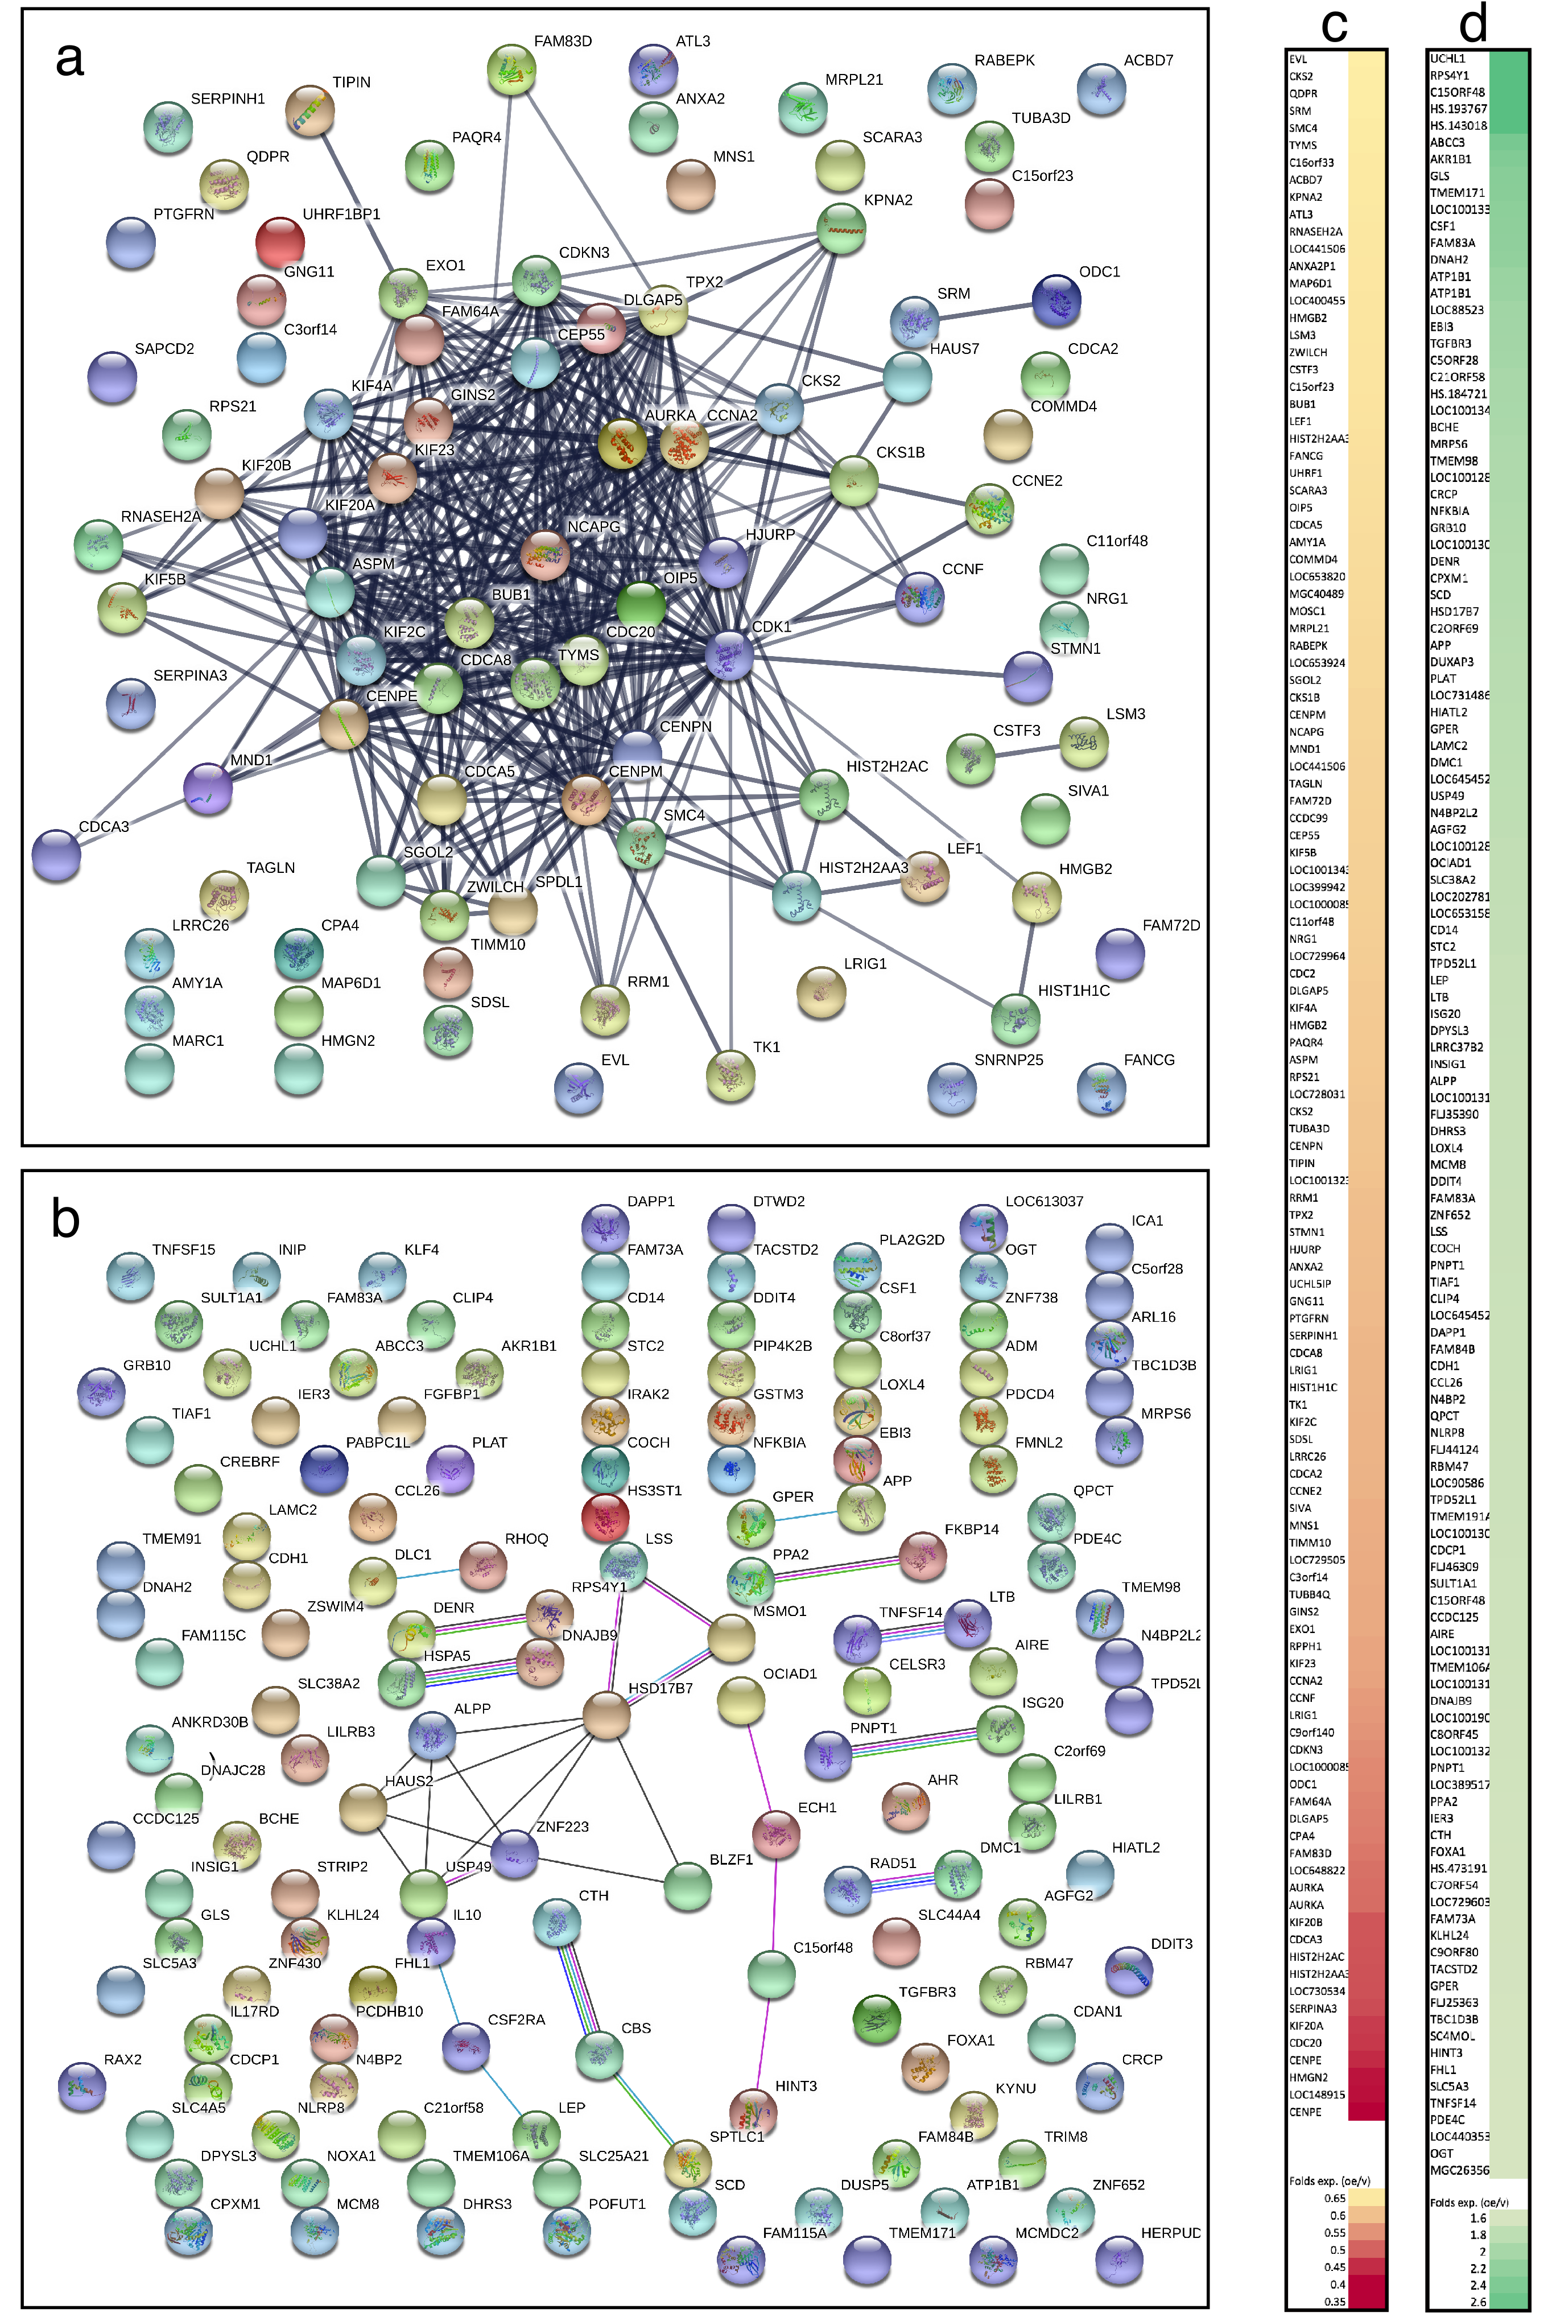
Figure S6 a) An interaction network of the down-regulated genes in the MDA-MB-231 cells with oeFBP1 stable over-expression. Network generated using the STRING (Functional protein association network). The depicted interactions include only those with an interaction score of 0.7 or higher (high confidence). b) Heat-map depicting the down-regulated genes (oeFBP1/vector) based on the level of down-regulation (ascending).
c) An interaction network of the up-regulated genes in the MDA-MB-231 cells with FBP1 stable over-expression. Network generated using the STRING (Functional protein association network). The depicted interactions include only those with an interaction score of 0.4 or higher (medium confidence). d) Heat-map depicting the up-regulated genes (oeFBP1/vector) based on the level of down-regulation (descending)

Supplementary Methods:
I) Cell culture:
All cell cultivation and treatments were performed in full DMEM containing 10(v/v%) FCS (Gibco, Germany), and 1%(v/v) penicillin/streptomycin solution (10000 U/ml) (Gibco, Germany).
For treatments with varying glucose concentrations, customised DMEM media were prepared starting from DMEM powder (Pan-Biotech GMBH, Germany).
In the various reported experiments the following agents were also used to treat the cells: ascorbic acid L-dehydroascorbic acid, Menadione sodium-bisulfide, n-acetyl cysteine, L-Glutathione (reduced) (Sigma-Aldrich, Germany), catalase, and superoxide dismutase (Sigma-Aldrich, Germany). Hydrogen peroxide (AppliChem, Darmstadt, Germany).

II) Molecular cloning and construction of plasmids
A restriction cloning strategy was followed with restriction sites introduced on 5`end of each primer so that to flank the resulting Fbp1 PCR product. The restriction sites were chosen as to avoid cutting the insert and to have matching sites in the multiple cloning region of the pcDNA3.1 vector.
The following steps were implemented to construct the plasmids:
- PCR amplification of the FBP1 cNDA (Using Phusion polymerase, NEB®).
The following primers were used
Forward: tttttgaattcATGGCTGACCAGGCGCC
Reverse: tttttaagctttcactgggcagagtgcttctc

- Column purification of the PCR product.
- Overnight restriction digest of the purified PCR product and the plasmid using EcoRI-HF and HindIII-HF (Both form NEB®) at 37° followed by a 20 min inactivation step at 80°.
- Gel purification of the digested vector and PCR product (insert).
- Overnight ligation of the vector and insert at molar ration of 1:3 (vector::insert) (T4 DNA ligase, NEB®).
- Transformation of the resulting ligation product into E.coli.
- Following transformation and selection, Mini-preps were made of picked colonies and these were sent for sequencing (Eurofins Genomics, Ebersberg).

III) The following protocol was used to transfect and establish the stable over-expression and deletion of FB1
- Transfection of cell lines and establishing stable over-expressions and deletions
Lipid-based transfection was used, LipofectaminTM3000 (Thermo Fisher®, Waltham MA), for introducing the constructed FBP1 over-expression vector into the cell lines. The transfections were performed using the protocols provided with the transfection reagents.
(Detailed method in the supplementary methods S2.)
The following steps were adhered to:
- After trypsinisation cells were counted and seeded in a 6 well-plate at a density of 300.000-500.000 cells per well.
- Following 24 to 48 hours incubation and after reaching a confluency of 70% to 90%, cells were transfected.
- The transfection mixture was prepared by adding pre-mixed 2.5 µg plasmid DNA with 5 µl p3000 reagent in 125 µl Opti-MEM to pre-mixed 7.5 µl in 125 µl Opti-MEM, for each transformation
- The trnasfection mixtures were mixed by inverting the containing tubes and then incubated for 15 minutes at room temperature.
- 250 µl transfection mixture were pipetted onto each well, slowly and drop-wise.
- The 6 well-plates containing the newly transfected cells were subsequently shaken gently.
- Following 24 hours of incubation, medium was replaced and cells were further incubated for 24 more hours.

i) Establishing cell lineages with stable over-expression
- After giving cells 24 hours of recovery from the transfection, cells were treated with medium containing G418 sulphate (900 µg/ml for MCF-7, 1200 µg/ml for MDA-MB231).
- Medium with antibiotic was replaced once every 3 to 4 days.
- Following 3 to 4 weeks of selection in 6 well plate format (control non-transfected cells completely wiped out), transfected cells were trypsinised and transferred into a T25 cell culture flask.
- The G418 selection pressure was maintained as part of the cell culture medium in which the transfected cells were cultivated.
- Over-expression of Fbp1 was then verified on the mRNA and protein levels, using qPCR and immunoblotting, respectively.

ii) Establishing the stable CRISPR-Cas9 deletion of Fbp1 in MCF-7
- To achieve the knock-out of fbp1 in MCF-7, cells were double transfected with a CRISPR-Cas9 Double Nickase (Cas9 D10A mutant) plasmid containing two gRNAs directed to the opposite strands of the fbp1 gene (Santa Cruz Biotech sc-404693-NIC)
and an HDR plasmid (Santa Cruz Biotech sc-404693-HDR) containing the selectable Puromycin resistance marker flanked with sequences matching the disruption site indicated by the gRNAs.
- 24 hours post-transfection, medium was replaced and cells were given 48 hours for recovery and developing Puromycin resistance.
- Subsequently cells were selected using 200 ng/ml Puromycin with medium containing the same concentration of Puromycin changed every 3 to 4 days.
- 6 weeks following transfection, cells were trypsinised and transferred into a T25 cell culture flask, and Puromycin was withdrawn from the culture medium.
- The successful deletion was verified on Protein expression and enzymatic function levels (Fig S), and the resulting deletion cell lineage was continuously monitored to ensure the stability and irreversibility of the Fbp1 deletion.

IV) Detailed SRB assay method
SRB sulforhodamin-B, is a water-soluble dye that stoichiometrically binds to proteins in weak acidic conditions. In alkaline conditions, this SRB-protein bond is destabilized and the dye is released and dissolved into the solution allowing colourimetric determination of the amounts of bound SRB, and thus the correlating amount of total proteins reflecting cell density. These properties are exploited in the SRB growth/survival assay, in which viable adherent cells are first fixed onto the cell-culture modified surface and then measured using the following protocol derived from Vichai and Kirtikara 2006.
Cells were cultivated in 96 well plates at a density of 5000 cells/well with 200 µl medium per well. Cells were incubated for 24 or 48 hours following seeding and then washed with 200 µl PBS and treated with the indicated media conditions. Treatments were performed in n≥4. At the indicated time intervals, cells were fixed by adding half a volume (100µl) of pre-chilled 10% tricholroacetic acid TCA and incubating at +4° for 1 hour. Subsequently, the plates were washed with deionised water three times and then dried for 20 min at 60°c. Afterwards, 75 µl of SRB and 1% acetic acid solution was added into each well and incubated for 30 minutes in the dark. Subsequently, all wells were washed twice with 1% acetic acid solution and plates were then dried for 20 min at 60°c. Finally, 150µl of 10 mM Tris (pH=10.5) were added and plates were shaken at 450 rpm for 5 minutes to dissolve the SRB dye. The absorption of SRB was measured at 535 nm using the Tecan-Ultra microplate reader. Optical-density reads were then normalized to the non-treated and the resulting survival curves were plotted using GraphPad Prism.

V) Detailed FACS-analysis methods and mechanisms of the utilised fluorescent probes

- Measuring glucose uptake using fluorescently labelled 2-Deoxy-Glucose 2-NBDG
Akin to 2-deoxyglucose, 2-NBDG is taken up by cells and phosphorylated. The resulting 6-Phopsho-2-NBDG is sequestered in the cytosole and cannot undergo further glycolytic steps. Therefore, it accumulates in the cells and is used in low concentrations as an indicator of intracellular glucose uptake
Fluorescently labelled 2-deoxyglucose 2-NBDG was added to the cell culture medium at a concentration of 50 µM so that cells were treated with both indicated agents and the labelled 2-DG simultaneously. After 3 hours cells were washed once with PBS, trypsinized, pelleted (200x g, 3 minutes) and re-suspended in DMEM without phenol red (colourless), round-bottom 96 well plate and analysed. The 2-NBDG green fluorescence was then quantified (mean-value of the sample population) and plotted.

- Assessing ROS levels using dehydroethidium DHE
Dehydroethedium DHE, is a RedOx probe that interacts to reactive oxygen species, including superoxide, forming fluorescence ethedium and other derivatives thereof that chelate the DNA and hence generate a stable red fluorescence signal proportional to the amount of intracellular ROS.
Following the intended duration of treatment, cells were washed once with PBS, trypsinised, pelleted (200x g, 3 minutes) and re-suspended in full DMEM with 30 µg/ml dehydroethidium DHE (Biomol, Germany) and incubated for 15 minutes. Subsequently cells were pelleted again, and resuspended in DMEM without phenol red (colourless), transferred into round-bottom 96 well plate and analysed. The DHE red fluorescence was then quantified (mean-value of the sample population) and plotted.

- Assessing mitochondrial mass using MitoTracker® Green
MitoTracker® Green To compare assess the variations in mitochondrial mass between cells with different Fbp1-expression status. MitoTracker Green is a fluorescent dye that localises to the mitochondria independent of mitochondrial inner-membrane potential, making it suitable for assessing mitochondrial mass independent of mitochondrial function. For measuring mitochondrial mass, treated cells were washed once with PBS, trypsinized, pelleted (200x g, 3 minutes) and re-suspended in DMEM without FCS with MitoTracker Green (2nM) (Thermo-Fischer Scientific, Weltham, MA) and incubated for 30 minutes. Subsequently cells were pelleted again, and resuspended in DMEM without phenol red (colourless), transferred into round-bottom 96 a well plate and analysed. The mean values of green fluorescence of each population were calculated as an indicator of the mitochondrial mass was.
- Determining mitochondrial inner-membrane potential using JC-1
JC-1 is a cyanine dye suitable for the fluorescent assessment of mitochondrial function by measuring the mitochondrial inner membrane potential. Healthy and active mitochondria maintain high levels of inner-membrane potential as a result of an active respiratory chain. The JC-1 dye concentrates on the inner-side of the polarised mitochondrial membranes undergoing a fluorescent shift from green (free monomeric dye) to red (aggregated JC-1). Therefore, the ration of red/green fluorescence signals of JC-1 dye enables the assessment of the mitochondrial membrane polarisation and function[48].
For measuring mitochondrial membrane potential with JC-1, treated cells were washed once with PBS, trypsinized, pelleted (200x g, 3 minutes) and re-suspended in full DMEM with 2µM JC-1 (Biomol, Germany) and incubated for 15 minutes. Subsequently cells were pelleted again, and resuspended in DMEM without phenol red (colourless), transferred into round-bottom 96 a well plate and analysed. The mean values of red and green fluorescence of each population were calculated and the mitochondrial inner membrane potential was then quantified as a ratio of mitochondrial aggregated to free (cytosolic) JC-1 red/green fluorescence.

VI) LC-MS Metabolic flux analysis:
MCF-7, MDA-mb231 and HT29 cells were seeded at 300.000 cells/ well. After 24 hours, media were replaced and cells were incubated for 16 hours. Subsequently, media was replaced and cells were incubated with full medium for 24 hours. Afterwards, cells were washed with ice-cold PBS and metabolites were extracted in 1 mL of methanol/acetonitrile/H₂O (2:2:1). Samples were shaken for 10 minutes, centrifuged for 15 minutes at at 4 °C and supernatants were collected for LC-MS analysis.
LC-MS analysis was performed on an Exactive mass spectrometer (Thermo Scientific) coupled to a Dionex Ultimate 3000 auto-sampler and pump (Thermo Scientific). Metabolites were separated using a Sequant ZIC-pHILIC column (2.1 x 150 mm, 5 m, guard column 2.1 x 20 mm, 5 m; Merck) using a linear gradient of acetonitrile (A) and eluent B (20 mM (NH4)2CO3, 0.1% NH4OH in ULC/MS grade water (Biosolve)). Flow rate was set at 150 l/min and the gradient ran from 20% B to 60% B, followed by a wash step and equilibration at 20% B. The MS operated in polarity-switching mode with spray voltages of 4.5 kV and -3.5 kV. Metabolites were identified on the basis of exact mass within 5 ppm and further validated by concordance with retention times of standards. Quantification was based on peak area using LCquan software (Thermo Scientific) Peak intensities were normalized based on median peak intensity.

VII) Detailed method of the triazole/chloroform RNA extraction
- Medium was aspirated and cells were washed with 2 ml PBS.
- 200 µl Triazole (Sigma-Aldrich) were added directly onto the cells, and cells were thoroughly scratched.
- The triazole was incubated on top of the cells for 5 minutes at room temperature.
- The Triazole lysates were aspirated and transferred into fresh Eppendorf tubes.
- 40 µl of chloroform were added to each tube.
- Tubes were vortexed for 15 seconds each, and then incubated for 15 minutes on ice.
- Tubes were centrifuged at 12000 x g for 15 minutes at 4°C to fully separate the aqueous and chloroform phases, with the genomic DNA condensed on the interface.
- The RNA-containing upper aqueous layer was transferred into fresh Eppendorf tubes.
- 100 µl of isopropanol were added to each tube to precipitate the RNA.
- Tubes were incubated for 10 minutes at room temperature.
- Tubes were centrifuged at 12000 x g for 4 minutes at room temperature, washed twice with 500 µl 70% ethanol.
- RNA was pelleted by centrifugation at 7500 x g for 5 minutes at 4°C.
- Pellets were air dried under laminar flow bench and the RNA was dissolved in 20 µl of nulcease-free water.

