Photocatalytic remediation of methylene blue and antibacterial activity study using Schiff base - Cu complexes

Fathima Fasna P. Hª, Sreesha Sasi^{a,*}, Bindu Sharmila T. Kª, Julie Chandra C.Sª, Jolly V Antonyª, Vidya Raman^{b}
ª Department of Chemistry, Maharaja’s College, Park Avenue Road, Ernakulam, Kerala, India Pin- 682301
Department of Chemistry, TMJM Government College, Manimalakunnu, Koothattukulam, Kerala, India
*Corresponding author: E-mail: sreeshasasi@maharajas.ac.in
Supplementary Information
Fig S1. Electronic spectra of HL and C1
Electronic spectra of HL

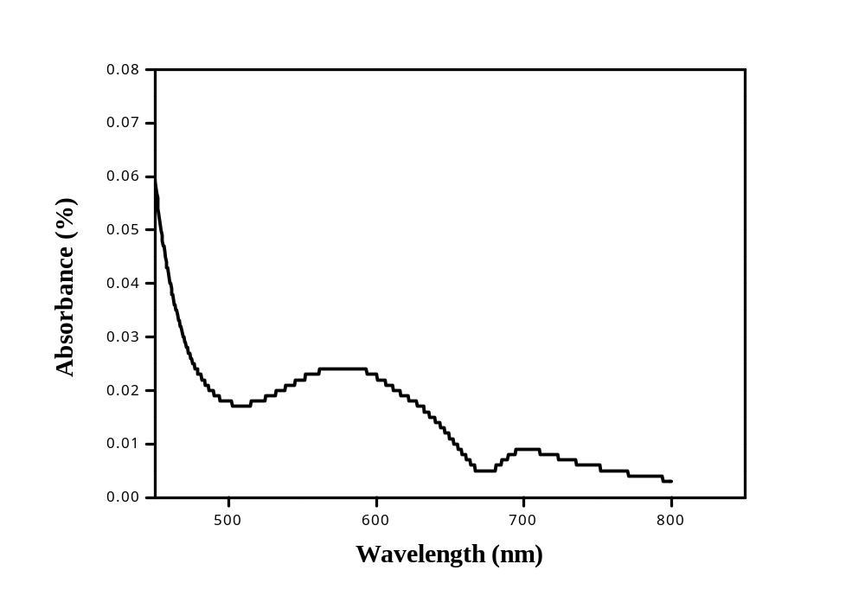
Electronic spectra of C1

Fig S2. The 1H NMR spectrum of the ligand HL

