Supplementary Figures
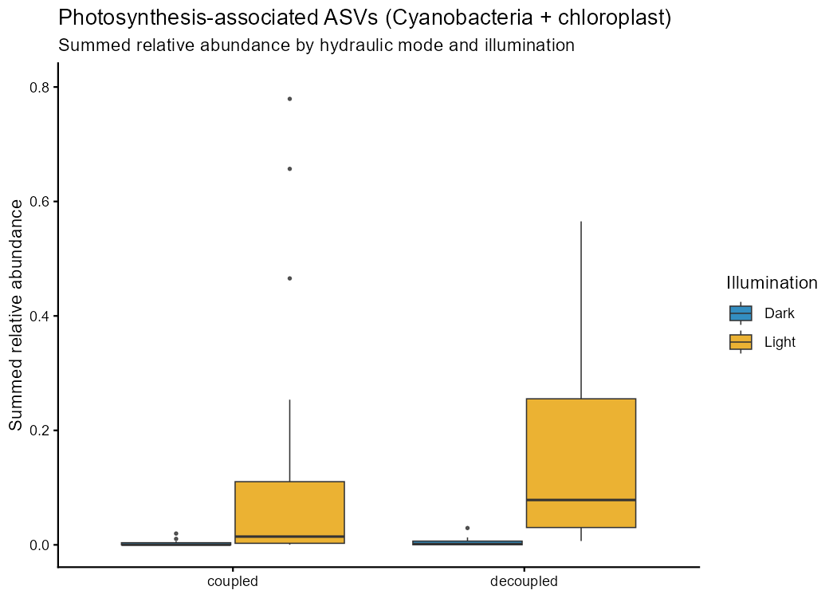
Supplementary Figure S1. Photosynthesis-associated proxy abundance (Cyanobacteria plus chloroplast-assigned ASVs) stratified by hydraulic mode and illumination. Boxplots show summed relative abundance across 2024 microbiome samples.

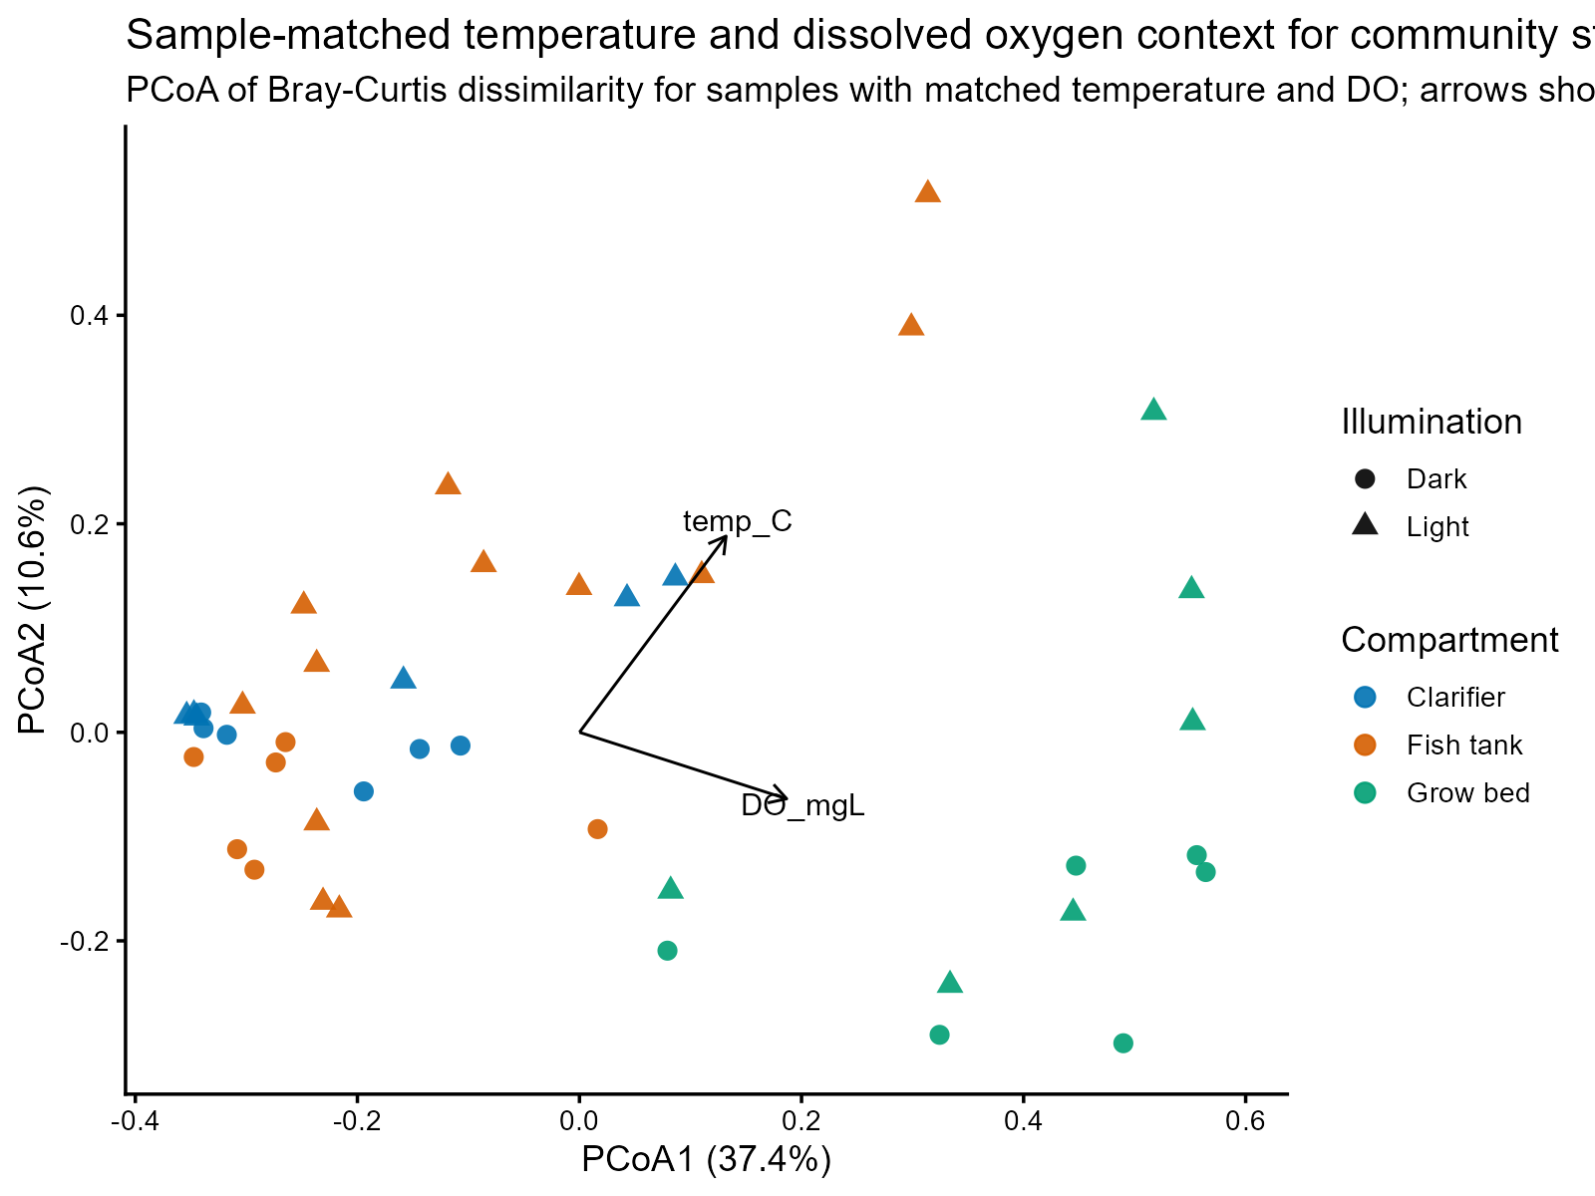
Supplementary Figure S2. Sample-matched temperature and dissolved oxygen context for microbial community structure. Points show Bray-Curtis PCoA scores for samples with matched temperature and dissolved oxygen data (n = 42), coloured by compartment and shaped by illumination; arrows show envfit vectors for temperature and dissolved oxygen.

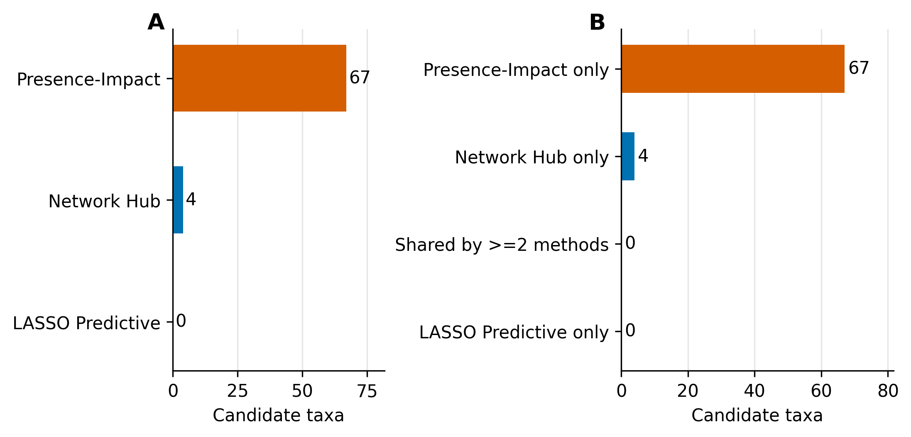
Supplementary Figure S3. Method-specific recovery of keystone candidates across the three analytical approaches: presence-impact PERMANOVA, co-occurrence network centrality, and LASSO temporal regression. (A) Number of candidate taxa identified by each method. (B) Cross-method overlap; no taxon was identified by all three methods simultaneously. See main Figure 6 for the consensus-score summary.
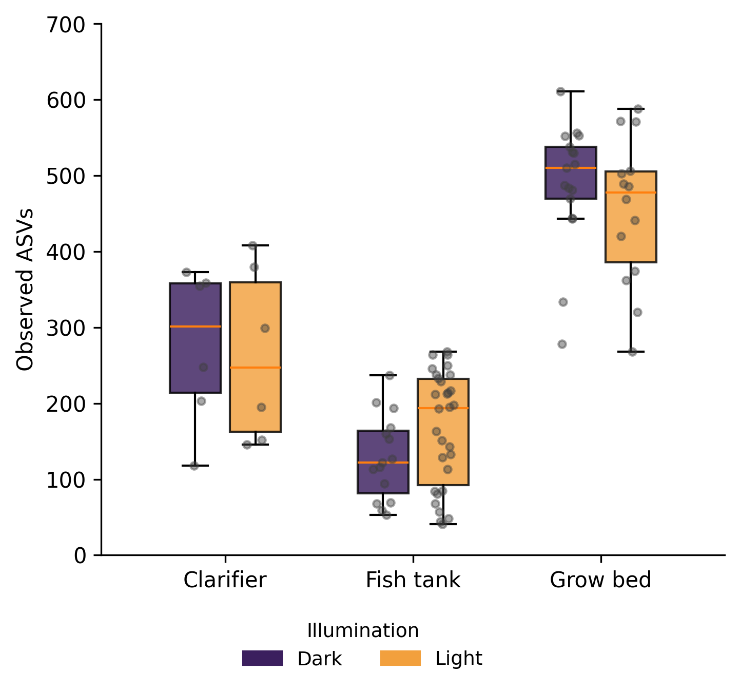
Supplementary Figure S4. Observed ASV richness (number of observed ASVs) by compartment, split by illumination (dark/light). Boxes show median and interquartile range; points represent individual samples. Richness follows the same compartment ordering as the Shannon index in Figure 2 (grow bed > clarifier > fish tank), indicating the compartment diversity gradient is driven by richness.
Supplementary Tables
Supplementary Table S1. Full list of the 71 keystone candidate taxa identified by at least one method, with taxonomic assignment (phylum, family, genus), consensus score, number of supporting methods, presence-impact effect size (R²) and adjusted p-value, and co-occurrence network centrality metrics (degree, betweenness, closeness). Provided in Supplementary Tables.xlsx (sheet 'Table S1').
Supplementary Table S2. Sample key for the abundance heatmap (Figure 8), mapping each of the 88 heatmap columns to its sample ID, system, stratum, compartment, and sampling date. Provided in Supplementary Tables.xlsx (sheet 'Table S2').
Supplementary Table S3. PERMANOVA of Bray–Curtis community structure across design and environmental terms (compartment, coupling, illumination, season, and sample-matched temperature and dissolved oxygen), reporting R², pseudo-F, and adjusted p-values. Provided in Supplementary Tables.xlsx (sheet 'Table S3').
Supplementary Table S4. Environmental vector fit (envfit) of temperature and dissolved oxygen onto the sample-matched Bray–Curtis PCoA ordination, reporting axis loadings, r², and p-values. Provided in Supplementary Tables.xlsx (sheet 'Table S4').
Supplementary Table S5. Treatment-stratified presence-impact analysis results for coupled (n = 38) and decoupled (n = 50) subsets. Provided in Supplementary Tables.xlsx (sheet 'Table S5').

