Supplementary Information
Regional Mapping of Tau Oligomers in Postmortem Progressive Supranuclear Palsy Brain Tissues with pTP-TFE
Yanyan Zhao ^{1,*}, Jaehoon Yi ¹, Qianrui Bai ¹, Annelies Quaegebeur ^{2,5}, James B Rowe ^{2, 4}, David Klenerman ^{3,4} and Franklin I Aigbirhio ^{1,} *
- Molecular Imaging Chemistry Laboratory, Wolfson Brain Imaging Centre, Department of Clinical Neurosciences, University of Cambridge, CB2 0SZ United Kingdom.
- Department of Clinical Neurosciences and Cambridge University Hospitals NHS Trust, University of Cambridge, CB2 0SZ Cambridge, UK
- Yusuf Hamied Department of Chemistry, University of Cambridge, Lensfield Road, Cambridge, CB2 1EW, United Kingdom
- UK Dementia Research Institute, Cambridge, United Kingdom
- Department of Imaging & Pathology, University of Leuven, Belgium

* Correspondence: fia20@medschl.cam.ac.uk;
yz458@cam.ac.uk

Table of contents:
- White/Grey matter differentiation method S3
- Table S1 numbers of grey/white matter in brain regions S4
- Figure S1 images of white matter S5

White/Grey matter differentiation method
DAPI images were analyzed in Python to calculate nuclear density as a surrogate of tissue cellularity. Each image was smoothed with a Gaussian filter, and nuclei were segmented using Otsu thresholding, followed by binary opening and removal of objects smaller than 20 pixels, and connected components were counted as individual nuclei. Nuclear density was calculated as density = image pixels/nuclei count. GP images were used as the grey matter reference, and OC and FC images with DAPI densities within the GP-derived 95% prediction interval were classified as grey matter, whereas those outside it were classified as white matter.

Table S1 numbers of grey/white matter in brain regions
Region | Grey matter count | White matter count
Control | 8 | 4
FC | 32 | 4
OC | 34 | 2

Figure S1 images of white matter
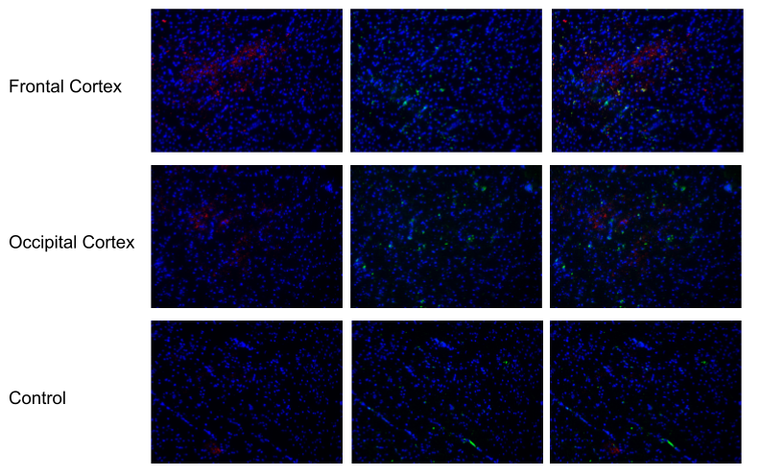
Figure S1. Representative fluorescence micrographs (white matter selected for all) comparing AT8 immuno-fluorescence (left column, red), pTP-TFE labelling (center column, green), and merged images with DAPI (right column, blue) across three brain regions in a PSP case (Kovacs stage 4) and control tissue. Top row: globus pallidus; second row: frontal cortex; third row: occipital cortex; bottom row: control (frontal cortex). Scale bar = 100 µm.

