Supplementary Materials for

• Recent and ongoing selection in the Parascaris univalens genome drive population divergence for their adaptation

Lei Han, Tianming Lan, Yaxian Lu, Mengchao Zhou, Haimeng Li, Haorong Lu, Qing Wang, Xiuyun Li, Shan Du, Chunyu Guan, Yong Zhang, Sunil Kumar Sahu, Puyi Qian, Shaofang Zhang, Hongcheng Zhou, Wei Guo, Hongliang Chai, Sibo Wang, Quan Liu, Huan Liu, Zhijun Hou
Corresponding author. Email: houzhijundb@163.com; liuhuan@genomics.cn; lantianming@genomics.cn; liuquan1973@hotmail.com

Supplementary Tables
- Table S1 - Sequencing data
- Table S2 - Summary of sequencing data
- Table S3 - Estimates of expected heterozygosity and observed heterozygosity
- Table S4 - Four rounds of increasingly focused optimizations used in δaδi
- Table S5 - Maximum-likelihood parameter estimates obtained from the joint demographic inference analysis 2D and 3D
- Table S6 - Genomic regions identified as candidate divergent regions
- Table S7 - GO enrichment (Top 20) of iHS significant selection sites in PEc and PEz&PEa clades
- Table S8 - KEGG enrichment of XP_EHH significant selection sites in PEc and PEz&PEa clades

Supplementary Figures
- Figure S1 - SNPdensity
- Figure S2 - Sequencing depth
- Figure S3 - Karyotyping
- Figure S4 - The mapping ratio and shared SNPs distribution
- Figure S5 - Shared identity-by-descent (IBD) region among PEa, PEc and PEz populations
- Figure S6 - The shared IBD and paired Fst values of the three populations
- Figure S7 - Observed SFS between PEc and PEz & PEa clades
- Figure S8 - 3D divergence model used in δaδi
- Figure S9 - 2D divergence model used in δaδi
- Figure S10 - Fst distribution of PEc vs PEa & PEz
- Figure S11 - The iHS score distribution of PEc, PEa and PEz populations
- Figure S12 - KEGG enrichment of iHS significant selection locis of PEc and PEa & PEz respectively
- Figure S13 - GO enrichment of XP_EHH analysis of PEa and PEc & PEz respectively
- Figure S14 - Network diagram of GO function enrichment obtained by XPEHH analysis of PEa and PEc & PEz clades
- Figure S15 - Detection of mutations in three drug-resistant sites of β-tubulin
- Figure S16 - The π distribution and tajima’D distribution in the pgp-3 regions
- Figure S17 - The π distribution and tajima’D distribution in the unc-38, nrf-6, glc-1 and cup-4 regions
- Figure S18 - The π distribution and tajima’D distribution in the CYP3A31, CYP4C1, mrp-1 and CYP4V2 regions

Table S1 Sequencing data used for P. univalens populations.
 | Sequencing  platform | Raw data (Gb) | coverage (X)
WGS (44 samples) | DNBSEQ-T1 | ~5.4 × 44 | Average: ~20

Table S2 Summary of sequencing data.
Samples | Map ratio | Mapped Length | Genome | Total Base Number | Sequencing
Samples | Map ratio | Mapped Length | Coverage | Total Base Number | Depth
PEc8 | 98.06 | 242939043 | 0.924623 | 7379191103 | 28.0851
PEc35 | 99.5 | 243005286 | 0.924875 | 9660443672 | 36.7675
PEc31 | 99.67 | 242603209 | 0.923345 | 6463458930 | 24.5998
PEc40 | 98.94 | 241063989 | 0.917486 | 3291407118 | 12.5271
PEc2 | 96.31 | 243181907 | 0.925547 | 10307911619 | 39.2318
PEc19 | 99.72 | 242305463 | 0.922211 | 4538632266 | 17.274
PEc55 | 97.73 | 241300242 | 0.918386 | 3498495752 | 13.3152
PEc37 | 97.86 | 241248856 | 0.91819 | 5051469951 | 19.2258
PEc15 | 95.37 | 242793475 | 0.924069 | 5471281685 | 20.8236
PEc51 | 94.67 | 241461752 | 0.919 | 3952951607 | 15.0449
PEc33 | 98.46 | 242524982 | 0.923047 | 6216298886 | 23.6592
PEc1 | 93.9 | 242715410 | 0.923772 | 6500114364 | 24.7393
PEc9 | 95.59 | 243253965 | 0.925821 | 5368055141 | 20.4307
PEc18 | 97.43 | 241730291 | 0.920022 | 3892908745 | 14.8164
PEc54 | 95.26 | 241321158 | 0.918465 | 3542201759 | 13.4816
PEc36 | 99.69 | 242637039 | 0.923473 | 6468187825 | 24.6178
PEc14 | 98.96 | 242757776 | 0.923933 | 6743570299 | 25.6659
PEc41 | 94.67 | 242603716 | 0.923347 | 6506319256 | 24.763
PEc16 | 98.36 | 241299919 | 0.918384 | 3259468966 | 12.4055
PEz22 | 99.54 | 240886927 | 0.916812 | 3657342910 | 13.9198
PEz31 | 99.53 | 242954049 | 0.92468 | 10613902328 | 40.3964
PEz2002 | 98.87 | 239079701 | 0.909934 | 2160977871 | 8.22465
PEz44 | 96.88 | 241686392 | 0.919855 | 5034378816 | 19.1608
PEz51 | 96.3 | 243094953 | 0.925216 | 9866269911 | 37.5509
PEz77 | 99.68 | 241584614 | 0.919468 | 3744986382 | 14.2534
PEz46 | 99.38 | 240569563 | 0.915605 | 2965641622 | 11.2872
PEz41 | 95.2 | 243015007 | 0.924912 | 8070319092 | 30.7155
PEz410 | 99.74 | 243016021 | 0.924916 | 11159801482 | 42.4741
PEz67 | 99.66 | 241057921 | 0.917463 | 3289862672 | 12.5212
PEz49 | 99.2 | 241798652 | 0.920282 | 4852035556 | 18.4668
PEz58 | 99.37 | 239821070 | 0.912756 | 2557394655 | 9.73341
PEz45 | 99.31 | 242115894 | 0.92149 | 5779447504 | 21.9965
PEz9 | 99.83 | 241400268 | 0.918766 | 3542887397 | 13.4842
PEz1 | 99.4 | 241574409 | 0.919429 | 3724282343 | 14.1746
PEz43 | 99.26 | 242179370 | 0.921731 | 5389356615 | 20.5118
PEz7 | 99.53 | 242069922 | 0.921315 | 4894423856 | 18.6281
PEa28 | 98.71 | 241669848 | 0.919792 | 4196242910 | 15.9708
PEa33 | 98.6 | 242528784 | 0.923061 | 6524840829 | 24.8335
PEa24 | 98.31 | 241730658 | 0.920024 | 4272115519 | 16.2596
PEa25 | 99.2 | 240612736 | 0.915769 | 3123987980 | 11.8899
PEa34 | 99.38 | 241041915 | 0.917402 | 3480956061 | 13.2485

Table S3 Estimates of expected heterozygosity and observed heterozygosity of all individuals in this study.
ID | observed heterozygosity (HOM) | expected heterozygosity (HOM) | N SITES | inbreeding coefficient (F)
PEa24 | 2362551 | 2416978 | 3179889 | -0.07134
PEa25 | 2426727 | 2413281 | 3174635 | 0.01766
PEa28 | 2380409 | 2416666 | 3179440 | -0.04753
PEa33 | 2409400 | 2417248 | 3180316 | -0.01028
PEa34 | 2406611 | 2414374 | 3176096 | -0.01019
PEc1 | 2455638 | 2417130 | 3180152 | 0.05047
PEc14 | 2453819 | 2416982 | 3179979 | 0.04828
PEc15 | 2404701 | 2417280 | 3180375 | -0.01648
PEc16 | 2478428 | 2415316 | 3177491 | 0.08281
PEc18 | 2489762 | 2415957 | 3178476 | 0.09679
PEc19 | 2411363 | 2417004 | 3179929 | -0.00739
PEc2 | 2492557 | 2417274 | 3180357 | 0.09866
PEc31 | 2461873 | 2417296 | 3180404 | 0.05842
PEc33 | 2483245 | 2417509 | 3180678 | 0.08614
PEc35 | 2485215 | 2417568 | 3180754 | 0.08864
PEc36 | 2493935 | 2417101 | 3180076 | 0.1007
PEc37 | 2479863 | 2415901 | 3178418 | 0.08388
PEc40 | 2488701 | 2415316 | 3177478 | 0.09628
PEc41 | 2479002 | 2416833 | 3179809 | 0.08148
PEc51 | 2371335 | 2415781 | 3178230 | -0.05829
PEc54 | 2422355 | 2415467 | 3177797 | 0.00904
PEc55 | 2447710 | 2415418 | 3177702 | 0.04236
PEc8 | 2463603 | 2416896 | 3179866 | 0.06122
PEc9 | 2010315 | 2417716 | 3180884 | -0.53383
PEz1 | 2458139 | 2416242 | 3178797 | 0.05494
PEz2002 | 2510895 | 2404938 | 3162154 | 0.13993
PEz21 | 2442735 | 2414302 | 3175906 | 0.03733
PEz22 | 2441096 | 2416308 | 3178870 | 0.03251
PEz31 | 2535115 | 2417097 | 3180110 | 0.15467
PEz41 | 2437046 | 2417088 | 3180136 | 0.02616
PEz410 | 2492239 | 2417565 | 3180747 | 0.09785
PEz43 | 2500404 | 2417321 | 3180413 | 0.10888
PEz44 | 2581733 | 2417068 | 3180050 | 0.21582
PEz45 | 2493310 | 2417233 | 3180289 | 0.0997
PEz46 | 2517975 | 2414748 | 3176463 | 0.13552
PEz49 | 2485880 | 2417281 | 3180298 | 0.08991
PEz51 | 2519051 | 2417071 | 3180084 | 0.13365
PEz58 | 2537745 | 2409812 | 3169303 | 0.16845
PEz67 | 2455407 | 2414795 | 3176610 | 0.05331
PEz7 | 2432535 | 2416829 | 3179699 | 0.02059
PEz77 | 2487031 | 2416071 | 3178636 | 0.09305
PEz9 | 2476484 | 2415953 | 3178364 | 0.07939
Average | 2453903 | 2416000 | 3178480 | -

Table S4 Four rounds of increasingly focused optimizations used in δaδi, and the values of the arguments across rounds.
Argument | Round 1 | Round 2 | Round 3 | Round 4
reps | 10 | 20 | 30 | 40
maxiter | 3 | 5 | 10 | 15
fold | 3 | 2 | 2 | 1

Table S5 Maximum-likelihood parameter estimates obtained from the joint demographic inference analysis 2D and 3D
3D Model
 | Replicate | log-likelihood | AIC | chi-squared | theta | nu1 | nuA | nu2 | nu3 | mA | T1 | T2
ancmig_  adj_2 | Round_4_  Replicate_4 | -3414.73 | 6843.46 | 65320.56 | 53.59 | 7.67 | 5.40 | 1.09 | 4.76 | 0.52 | 29.91 | 0.05
2D Model
 | Replicate | log-likelihood | AIC | chi-squared | theta | nu1a | nu2a | nu1b | nu2b | m | T1 | T2
anc_sym  _mig_size | Round_4_  Replicate_5 | -1318.53 | 2651.06 | 1614.23 | 170.66 | 5.79 | 1.26 | 0.96 | 0.47 | 9.26 | 16.04 | 0.04

Table S6 Genomic regions (top 100) identified as candidate divergent regions (CDRs) among PEc, PEz and PEa. Max Fst refers to the maximal windowed Fst value of the CDRs. The ln ratio refers to the maximal π ln ratio value of the CDRs.
No. | Scaff. | Start（bp） | End（bp） | Fst (PEc-PEz) | Fst (PEc-PEa) | Fst (PEz-PEa) | ln ratio (θ_{π,PEc}/θ_{π，PEz}) | ln ratio (θ_{π,PEc}/θ_{π，PEa}) | ln ratio (θ_{π,PEz}/θ_{π，PEa}) |  | Candidate genes
1 | PgR001X | 1870001 | 1880000 | 0.7109 | 0.2027 | 0.4392 | 0.1985 | 0.4211 | 0.2226
2 | PgB02X | 2140001 | 2150000 | 0.6654 | 0.4946 | -0.0074 | 0.8591 | -0.0368 | -0.8959 | HHATL
3 | PgB02X | 2870001 | 2880000 | 0.6509 | 0.4488 | 0.059 | 0.0841 | -0.5328 | -0.6169 | VhaA
4 | PgB02X | 3460001 | 3470000 | 0.6361 | 0.22 | 0.2243 | 1.3601 | 0.1237 | -1.2364
5 | PgR001X | 1840001 | 1850000 | 0.6041 | 0.1609 | 0.2974 | -0.3601 | -0.8441 | -0.4839 | MTTP
6 | PgR009X | 3020001 | 3030000 | 0.5946 | 0.0315 | 0.5918 | 2.6068 | -0.016 | -2.6228 | rhy-1
7 | PgB02X | 2130001 | 2140000 | 0.5761 | 0.3711 | 0.019 | 1.0579 | 0.5289 | -0.5291
8 | PgR035X | 1450001 | 1460000 | 0.5729 | 0.4923 | -0.0707 | 2.4802 | 3.448 | 0.9678 | Ctsf
9 | PgR009X | 2990001 | 3000000 | 0.5659 | 0.0582 | 0.4514 | 1.6174 | 0.182 | -1.4354 | rhy-1
10 | PgR004 | 3540001 | 3550000 | 0.5641 | 0.5162 | -0.0487 | 0.0602 | 0.0418 | -0.0183
11 | PgB07 | 1120001 | 1130000 | 0.5594 | 0.0624 | 0.2995 | 0.7811 | -0.2528 | -1.0339 | attf-4
12 | PgR028 | 310001 | 320000 | 0.5573 | 0.6361 | 0.0194 | 0.4948 | 3.6939 | 3.1991
13 | PgR035X | 1690001 | 1700000 | 0.557 | 0.5114 | -0.1219 | 1.2159 | 1.1012 | -0.1146 | T09B9.5
14 | PgB02X | 2850001 | 2860000 | 0.5492 | 0.3765 | 0.015 | 0.1618 | -0.1346 | -0.2963
15 | PgB02X | 770001 | 780000 | 0.5417 | 0.451 | -0.0089 | 1.108 | 0.5947 | -0.5133
16 | PgR035X | 510001 | 520000 | 0.5339 | 0.3074 | 0.0579 | -0.236 | -1.2834 | -1.0474 | ANP32A
17 | PgB02X | 600001 | 610000 | 0.5272 | 0.4639 | -0.0637 | 0.9591 | 1.1191 | 0.16 | PHYHD1
18 | PgR007 | 10001 | 20000 | 0.5269 | 0.4751 | -0.0044 | 1.8481 | 1.9774 | 0.1293 | ATP6V1A
19 | PgR002 | 2350001 | 2360000 | 0.5193 | 0.0341 | 0.3182 | -0.5419 | 0.0221 | 0.564
20 | PgB02X | 2980001 | 2990000 | 0.5189 | 0.458 | 0.0099 | 1.4813 | 1.3935 | -0.0878 | FASN
21 | PgB02X | 610001 | 620000 | 0.511 | 0.4547 | -0.0446 | 1.2035 | 1.367 | 0.1635 | cntn5
22 | PgR028 | 280001 | 290000 | 0.5102 | 0.6125 | 0.0077 | 0.3213 | 4.5174 | 4.196
23 | PgB02X | 590001 | 600000 | 0.5095 | 0.3913 | -0.0461 | 2.3947 | 2.4264 | 0.0318 | ARRDC3
24 | PgR035X | 1660001 | 1670000 | 0.5081 | 0.5661 | 0.0002 | 0.7496 | 1.1549 | 0.4053 | Dennd2a
25 | PgR009X | 2590001 | 2600000 | 0.5038 | 0.082 | 0.1932 | -0.075 | -0.3566 | -0.2816 | Asic4
26 | PgR004 | 3520001 | 3530000 | 0.5032 | 0.5263 | -0.0557 | -0.0733 | 0.8717 | 0.945
27 | PgR002 | 2330001 | 2340000 | 0.4991 | 0.2274 | 0.1171 | 0.0657 | 0.0998 | 0.0341 | ARRDC3
28 | PgR001X | 800001 | 810000 | 0.4951 | 0.2103 | 0.0696 | 2.5168 | 1.3246 | -1.1921 | Etnk1
29 | PgR002 | 2340001 | 2350000 | 0.4865 | 0.0931 | 0.2378 | -0.5309 | -0.1405 | 0.3904 | Plb1
30 | PgB02X | 670001 | 680000 | 0.48 | 0.4168 | 0.0007 | 1.38 | 0.7793 | -0.6007 | mek-1
31 | PgB07 | 1110001 | 1120000 | 0.4794 | 0.2239 | 0.0421 | 1.1652 | 0.0721 | -1.0932
32 | PgR063X | 220001 | 230000 | 0.4786 | 0.0446 | 0.2261 | 0.9485 | 0.1355 | -0.8131
33 | PgR063X | 230001 | 240000 | 0.4719 | 0.0641 | 0.1947 | 0.7112 | 0.0363 | -0.6749 | ARMC9
34 | PgR001X | 1410001 | 1420000 | 0.4712 | 0.3903 | 0.0581 | 0.7865 | 0.1148 | -0.6717 | SSRP1
35 | PgR050X | 1060001 | 1070000 | 0.4698 | 0.3783 | -0.067 | 2.0565 | 2.4994 | 0.4429 | CBSL
36 | PgB02X | 2830001 | 2840000 | 0.469 | 0.303 | -0.0009 | 0.7349 | -0.088 | -0.8229
37 | PgB02X | 720001 | 730000 | 0.4684 | 0.4317 | -0.0965 | 0.706 | 1.2225 | 0.5165
38 | PgR035X | 1720001 | 1730000 | 0.4664 | 0.4844 | -0.1028 | 0.5939 | 1.0238 | 0.43 | GABBR1
39 | PgB02X | 330001 | 340000 | 0.4662 | -0.0557 | 0.3627 | 1.0163 | 0.2381 | -0.7781
40 | PgR001X | 1520001 | 1530000 | 0.4649 | 0.2884 | -0.0307 | 1.6695 | 0.7469 | -0.9225 | HNRNPA1，FBXL17
41 | PgR035X | 1710001 | 1720000 | 0.4622 | 0.4594 | -0.0869 | 0.7617 | 1.346 | 0.5844 | Gabbr1
42 | PgR063X | 200001 | 210000 | 0.462 | 0.0403 | 0.1892 | 0.4306 | 0.044 | -0.3866
43 | PgR009X | 3180001 | 3190000 | 0.4605 | 0.4817 | 0.0525 | 0.2024 | 0.0281 | -0.1744 | Pik3c3
44 | PgR035X | 1740001 | 1750000 | 0.4594 | 0.4778 | -0.1112 | 0.8681 | 0.8183 | -0.0498
45 | PgB07 | 1520001 | 1530000 | 0.4592 | 0.1572 | 0.0655 | 0.4291 | 0.4837 | 0.0545 | CNN1
46 | PgR009X | 1480001 | 1490000 | 0.4577 | 0.2764 | 0.1249 | 0.3557 | -0.6611 | -1.0167 | Grm1
47 | PgR009X | 3450001 | 3460000 | 0.4529 | 0.3808 | 0.0205 | 1.4049 | 1.3476 | -0.0573 | B3GAT3
48 | PgB02X | 3470001 | 3480000 | 0.4506 | 0.124 | 0.181 | 1.9388 | 0.4861 | -1.4527 | F13H6.3，Bche
49 | PgR035X | 1440001 | 1450000 | 0.4488 | 0.348 | -0.0783 | 2.1105 | 1.9546 | -0.1559 | Dnajb4
50 | PgR035X | 1750001 | 1760000 | 0.444 | 0.4724 | -0.0977 | 0.9683 | 0.5416 | -0.4267
51 | PgR023 | 1680001 | 1690000 | 0.4391 | 0.5662 | -0.0315 | -0.2945 | 0.3111 | 0.6056 | inx-11
52 | PgR023 | 200001 | 210000 | 0.4388 | 0.2472 | -0.0162 | 1.7276 | 0.4268 | -1.3009 | Prss30，CTSL
53 | PgB07 | 1130001 | 1140000 | 0.4369 | 0.0543 | 0.1524 | 0.818 | -0.2329 | -1.0509 | faeA
54 | PgB02X | 1210001 | 1220000 | 0.4352 | 0.3003 | -0.0476 | 1.1219 | 0.3689 | -0.753 | MME
55 | PgR028 | 80001 | 90000 | 0.4343 | 0.2158 | 0.1303 | -0.3728 | -0.2946 | 0.0782 | CACNA1C
56 | PgR028 | 160001 | 170000 | 0.4334 | 0.2176 | 0.141 | -0.4833 | -0.3252 | 0.1581
57 | PgR009X | 3430001 | 3440000 | 0.4332 | 0.2954 | 0.0698 | 0.3558 | -0.1296 | -0.4854 | SSBP2
58 | PgR001X | 1420001 | 1430000 | 0.4301 | 0.3574 | 0.1094 | 0.9423 | 0.3177 | -0.6246 | GLY1
59 | PgB02X | 320001 | 330000 | 0.4264 | 0.0098 | 0.3147 | 1.343 | 0.3923 | -0.9507
60 | PgB02X | 2940001 | 2950000 | 0.4263 | 0.2489 | 0.0318 | 0.7795 | 0.4177 | -0.3618
61 | PgR020 | 1930001 | 1940000 | 0.4256 | -0.0284 | 0.5657 | 0.8096 | 0.3003 | -0.5093
62 | PgR062 | 390001 | 400000 | 0.4191 | 0.4428 | 0.0093 | 0.8223 | 2.0612 | 1.2389 | HK2
63 | PgR004 | 4100001 | 4110000 | 0.4191 | 0.3273 | 0.0162 | -0.431 | -0.2922 | 0.1387
64 | PgR010 | 1220001 | 1230000 | 0.4171 | -0.0623 | 0.4697 | 0.5085 | 0.4659 | -0.0426
65 | PgR020 | 1770001 | 1780000 | 0.4164 | 0.0371 | 0.1816 | -0.6591 | -0.1046 | 0.5545 | Mto1
66 | PgR023 | 490001 | 500000 | 0.4152 | 0.2444 | 0.0916 | 4.0672 | 2.039 | -2.0281
67 | PgB02X | 1230001 | 1240000 | 0.4152 | 0.3194 | -0.0456 | 1.7848 | 1.3232 | -0.4616
68 | PgR035X | 1460001 | 1470000 | 0.4152 | 0.3747 | -0.1076 | 1.2012 | 1.0814 | -0.1198 | Gls2
69 | PgR009X | 1990001 | 2000000 | 0.4143 | 0.1635 | 0.2804 | 0.4593 | -0.4405 | -0.8999 | Snd1
70 | PgR024 | 1500001 | 1510000 | 0.4112 | 0.1405 | 0.0766 | 0.181 | 0.1489 | -0.032 | Abat
71 | PgR009X | 1500001 | 1510000 | 0.409 | 0.1937 | 0.0816 | 0.1824 | -0.6085 | -0.7909
72 | PgR050X | 1090001 | 1100000 | 0.4081 | 0.3268 | -0.054 | 2.2878 | 2.5722 | 0.2843
73 | PgR035X | 520001 | 530000 | 0.4067 | 0.128 | 0.0849 | 0.9689 | -0.133 | -1.102 | dus4
74 | PgR028 | 170001 | 180000 | 0.4 | 0.1894 | 0.1376 | -0.3015 | -0.3333 | -0.0318 | Rab28
75 | PgR052 | 1080001 | 1090000 | 0.3977 | 0.2993 | -0.0275 | -0.2826 | -0.9411 | -0.6585
76 | PgR032X | 750001 | 760000 | 0.397 | 0.2099 | -0.0324 | -0.1067 | -0.512 | -0.4053 | Col6a4
77 | PgR040 | 440001 | 450000 | 0.3924 | 0.3307 | -0.0265 | 0.0576 | 0.4177 | 0.3602 | CAT2
78 | PgR009X | 1440001 | 1450000 | 0.3904 | 0.3711 | 0.0803 | 0.1115 | -0.9474 | -1.0589 | nas-36，TLL1
79 | PgB07 | 160001 | 170000 | 0.3903 | 0.2478 | 0.04 | 2.6927 | 2.6492 | -0.0435
80 | PgB12X | 1260001 | 1270000 | 0.3903 | 0.4377 | -0.0998 | -0.2056 | -0.703 | -0.4974
81 | PgR002 | 600001 | 610000 | 0.3892 | 0.1292 | 0.1236 | -0.5981 | -0.4967 | 0.1014 | ADAMTS6
82 | PgR052 | 1120001 | 1130000 | 0.3884 | 0.2425 | -0.0837 | -0.0675 | -0.6626 | -0.5951 | RAB38
83 | PgR051X | 540001 | 550000 | 0.3862 | 0.0203 | 0.1325 | 0.7459 | -0.0814 | -0.8274 | lem-3
84 | PgR028 | 180001 | 190000 | 0.3862 | 0.2062 | 0.1276 | -0.2621 | -0.2197 | 0.0424 | FOXP2
85 | PgR063X | 90001 | 100000 | 0.3815 | 0.3009 | -0.0755 | 1.8505 | 0.9368 | -0.9137 | nop2，foxg1
86 | PgB07 | 150001 | 160000 | 0.3799 | 0.2396 | 0.06.65 | 3.153 | 3.4065 | 0.2535
87 | PgB02X | 2910001 | 2920000 | 0.3781 | 0.1993 | 0.0673 | 1.0475 | 0.5919 | -0.4556
88 | PgR028 | 1520001 | 1530000 | 0.3758 | 0.5723 | 0.0154 | -0.3074 | 0.6108 | 0.9182
89 | PgR010 | 2830001 | 2840000 | 0.3753 | 0.1523 | 0.0419 | 0.8499 | 0.9656 | 0.1157 | UMOD
90 | PgR040 | 210001 | 220000 | 0.3744 | 0.0681 | 0.1228 | -0.5397 | -0.5082 | 0.0315 | R3hdm4
91 | PgR035X | 500001 | 510000 | 0.3736 | 0.1177 | 0.038 | 0.4049 | -0.3625 | -0.7674
92 | PgR029 | 820001 | 830000 | 0.3732 | 0.452 | -0.0174 | -0.0998 | 0.5685 | 0.6683 | Fer
93 | PgB11 | 1270001 | 1280000 | 0.3716 | 0.2902 | -0.0319 | 2.133 | 3.0858 | 0.9528
94 | PgR023 | 1690001 | 1700000 | 0.3714 | 0.5576 | 0.0664 | -0.2191 | 0.0549 | 0.2739 | Qki
95 | PgR011 | 1610001 | 1620000 | 0.3701 | 0.2414 | 0.1012 | -0.6603 | 0.0218 | 0.6822
96 | PgB04 | 620001 | 630000 | 0.3693 | 0.2399 | 0.1097 | 1.0757 | 0.4818 | -0.5938
97 | PgR009X | 2570001 | 2580000 | 0.3692 | 0.0037 | 0.1336 | 0.8624 | 0.2917 | -0.5708
98 | PgR001X | 630001 | 640000 | 0.3689 | 0.1489 | 0.0011 | 0.6627 | 0.2676 | -0.3951
99 | PgR023 | 100001 | 110000 | 0.3687 | 0.3876 | -0.1086 | -0.18 | -0.6179 | -0.4379 | nAChRalpha2
100 | PgR007 | 320001 | 330000 | 0.3681 | 0.4682 | 0.0234 | 0.5874 | 1.458 | 0.8706 | Lgr4

Table S7 GO enrichment (Top 20) of iHS significant selection sites in PEc and PEz&PEa clades.
No. | TermID | Name | Frequency
PEc
1 | GO:0008152 | metabolic process | 47.116
2 | GO:0010468 | regulation of gene expression | 15.97
3 | GO:0006355 | regulation of transcription DNA-templated | 11.07
4 | GO:0007186 | G protein-coupled receptor signaling pathway | 7.434
5 | GO:0006396 | RNA processing | 5.164
6 | GO:0016192 | vesicle-mediated transport | 4.464
7 | GO:0044255 | cellular lipid metabolic process | 4.252
8 | GO:0007399 | nervous system development | 3.584
9 | GO:0006886 | intracellular protein transport | 3.521
10 | GO:0051603 | proteolysis involved in cellular protein catabolic process | 3.043
11 | GO:0010629 | negative regulation of gene expression | 2.715
12 | GO:0006511 | ubiquitin-dependent protein catabolic process | 2.471
13 | GO:0006397 | mRNA processing | 2.333
14 | GO:0042254 | ribosome biogenesis | 2.121
15 | GO:0006281 | DNA repair | 1.951
16 | GO:0006631 | fatty acid metabolic process | 1.516
17 | GO:0000398 | mRNA splicing via spliceosome | 1.326
18 | GO:0006486 | protein glycosylation | 1.304
19 | GO:0006351 | transcription DNA-templated | 1.22
20 | GO:0034976 | response to endoplasmic reticulum stress | 1.05
PEz & PEa
1 | GO:0008152 | metabolic process | 47.116
2 | GO:0010468 | regulation of gene expression | 15.97
3 | GO:0006355 | regulation of transcription DNA-templated | 11.07
4 | GO:0007186 | G protein-coupled receptor signaling pathway | 7.434
5 | GO:0006396 | RNA processing | 5.164
6 | GO:0016192 | vesicle-mediated transport | 4.464
7 | GO:0044255 | cellular lipid metabolic process | 4.252
8 | GO:0007399 | nervous system development | 3.584
9 | GO:0006886 | intracellular protein transport | 3.521
10 | GO:0051603 | proteolysis involved in cellular protein catabolic process | 3.043
11 | GO:0010629 | negative regulation of gene expression | 2.715
12 | GO:0006511 | ubiquitin-dependent protein catabolic process | 2.471
13 | GO:0006397 | mRNA processing | 2.333
14 | GO:0042254 | ribosome biogenesis | 2.121
15 | GO:0006281 | DNA repair | 1.951
16 | GO:0006631 | fatty acid metabolic process | 1.516
17 | GO:0000398 | mRNA splicing via spliceosome | 1.326
18 | GO:0006486 | protein glycosylation | 1.304
19 | GO:0006351 | transcription DNA-templated | 1.22
20 | GO:0034976 | response to endoplasmic reticulum stress | 1.05

Table S8 KEGG enrichment of XP-EHH significant selection sites in PEc and PEz&PEa clades
Pathway |  |  | Sample1 |  | Sample2 | Pvalue |  |  | Qvalue |  |  | Pathway ID
PEc
Fc gamma R-mediated phagocytosis |  |  | 9 |  | 60 | 0.0022 |  |  | 0.4685 |  |  | ko04666
RNA polymerase |  |  | 7 |  | 52 | 0.0121 |  |  | 0.8222 |  |  | ko03020
Butanoate metabolism |  |  | 5 |  | 32 | 0.0178 |  |  | 0.8222 |  |  | ko00650
Cytosolic DNA-sensing pathway |  |  | 5 |  | 35 | 0.0256 |  |  | 0.8222 |  |  | ko04623
Glutamatergic synapse |  |  | 8 |  | 74 | 0.0262 |  |  | 0.8222 |  |  | ko04724
Propanoate metabolism |  |  | 6 |  | 48 | 0.0274 |  |  | 0.8222 |  |  | ko00640
Sphingolipid metabolism |  |  | 6 |  | 48 | 0.0274 |  |  | 0.8222 |  |  | ko00600
Lysine degradation |  |  | 7 |  | 63 | 0.0319 |  |  | 0.8222 |  |  | ko00310
Synthesis and degradation of ketone bodies |  |  | 3 |  | 16 | 0.0396 |  |  | 0.8222 |  |  | ko00072
ABC transporters |  |  | 5 |  | 40 | 0.0426 |  |  | 0.8222 |  |  | ko02010
PEz & PEa
RNA transport |  |  | 21 |  | 160 | 0.0066 |  |  | 0.9989 |  |  | ko03013
Selenocompound metabolism |  |  | 4 |  | 15 | 0.0206 |  |  | 0.9989 |  |  | ko00450
Mismatch repair |  |  | 5 |  | 25 | 0.0329 |  |  | 0.9989 |  |  | ko03430
Inositol phosphate metabolism |  |  | 8 |  | 54 | 0.0423 |  |  | 0.9989 |  |  | ko00562
Nicotinate and nicotinamide metabolism |  |  | 5 |  | 31 | 0.0735 |  |  | 0.9989 |  |  | ko00760
Pentose phosphate pathway |  |  | 5 |  | 31 | 0.0735 |  |  | 0.9989 |  |  | ko00030
Pantothenate and CoA biosynthesis |  |  | 4 |  | 23 | 0.0841 |  |  | 0.9989 |  |  | ko00770
Aminoacyl-tRNA biosynthesis |  |  | 8 |  | 64 | 0.0958 |  |  | 0.9989 |  |  | ko00970
mRNA surveillance pathway |  |  | 16 |  | 154 | 0.1007 |  |  | 0.9989 |  |  | ko03015
Basal transcription factors |  |  | 6 |  | 47 | 0.1284 |  |  | 0.9989 |  |  | ko03022

Supplementary Figures
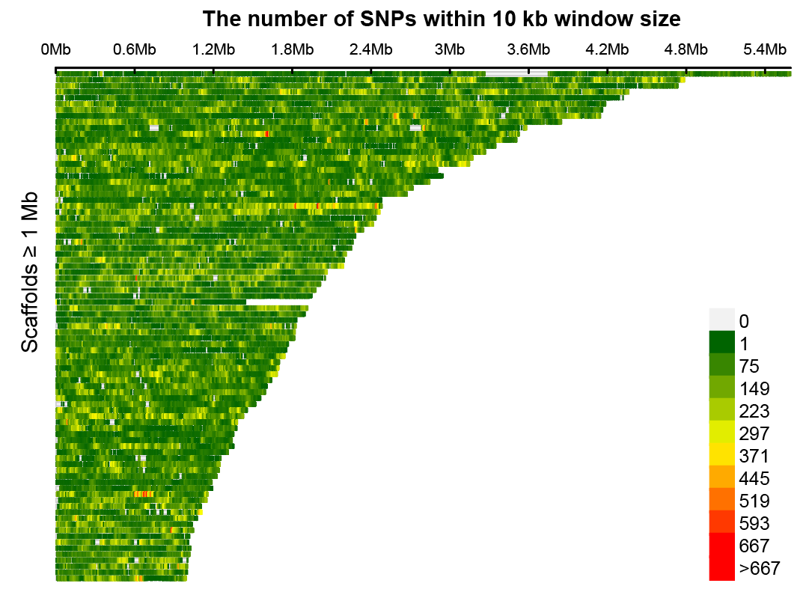
Figure S1 SNP density of P. univalens populations.

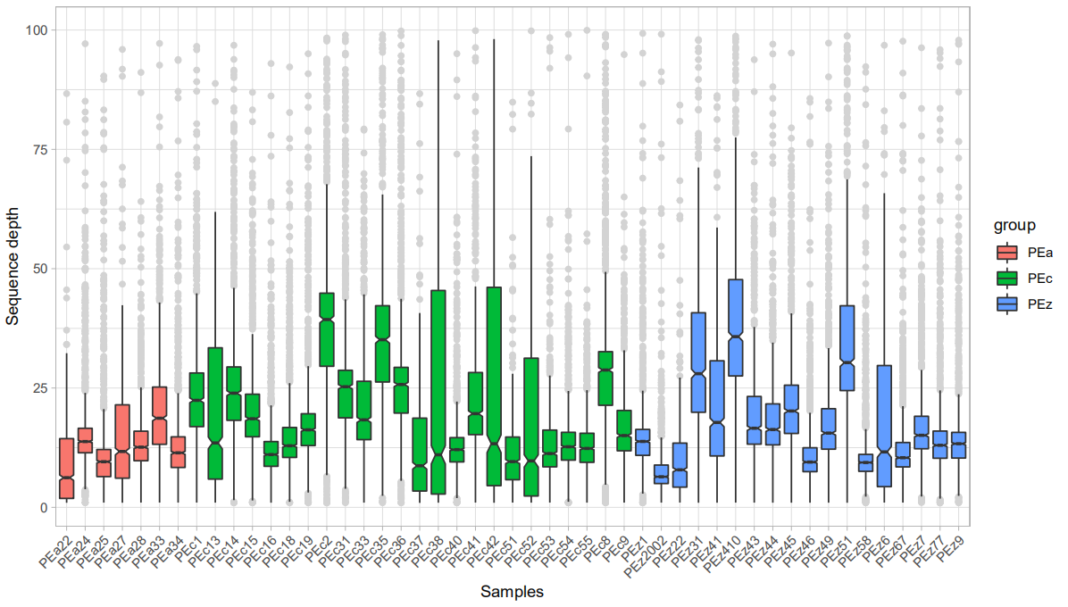
Figure S2 Sequencing depth of PEa, PEc and PEz populations.

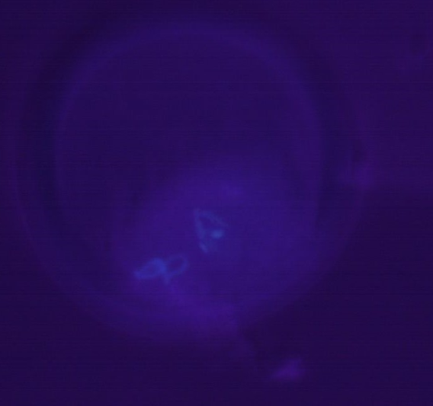
Figure S3 Karyotyping of P. univalens.

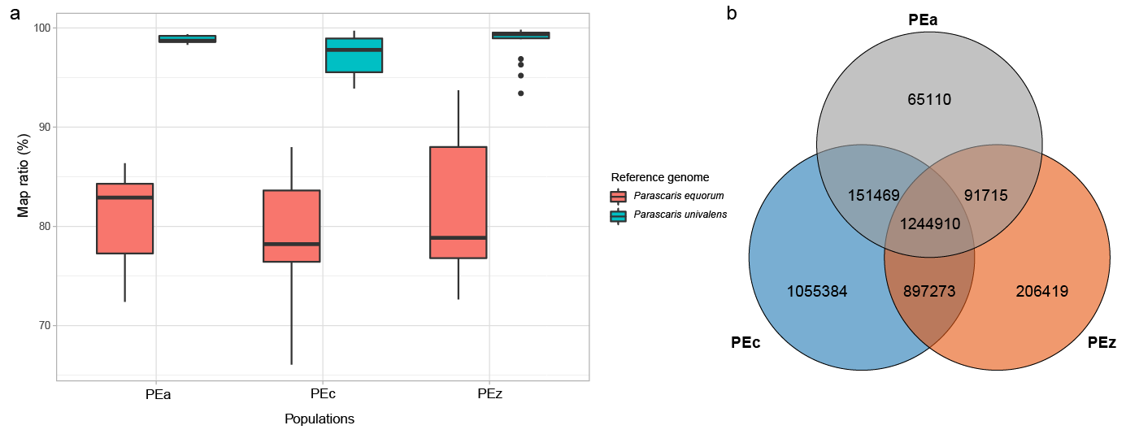
Figure S4 The mapping ratio and shared SNPs distribution. (a) The mapping ratio distribution using P. equorum and P. univalens as the reference genome. (b) Shared SNPs among three populations.

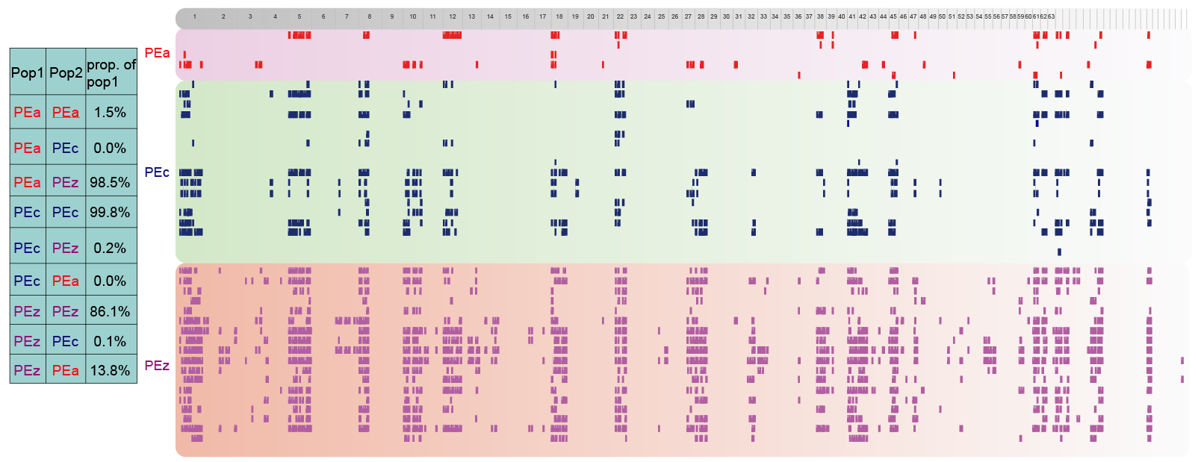
Figure S5 Shared identity-by-descent (IBD) regions among PEa, PEc and PEz populations.

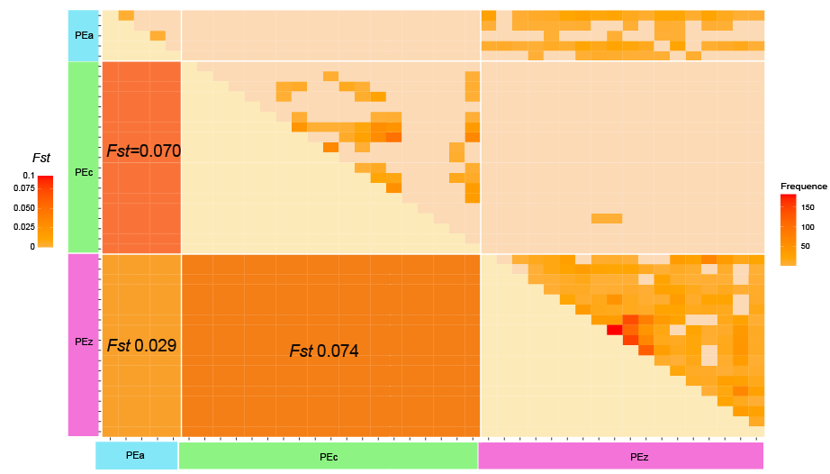
Figure S6 The shared IBD and paired Fst values of the three populations.

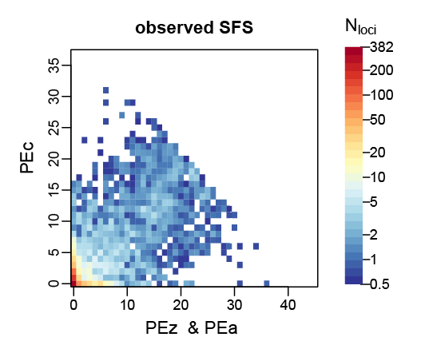
Figure S7 Observed SFS between PEc and PEz & PEa clades.

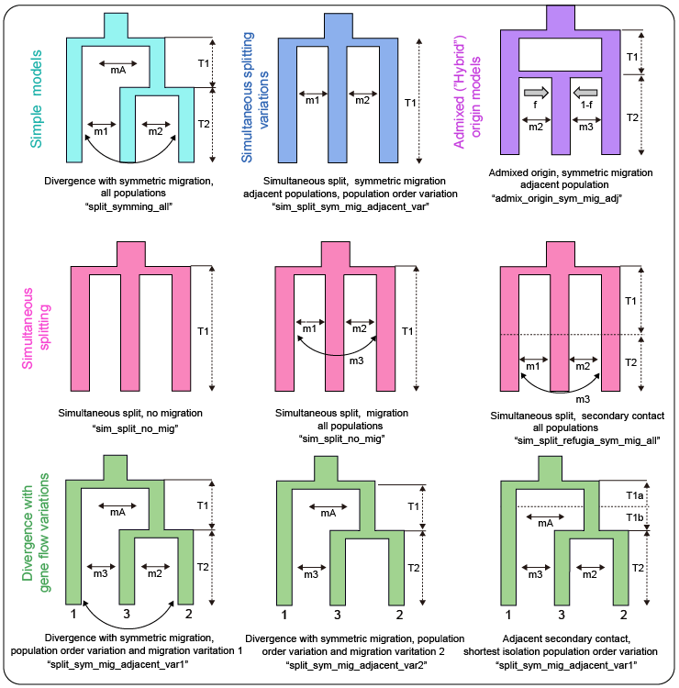
Figure S8 3D divergence model used in δaδi.

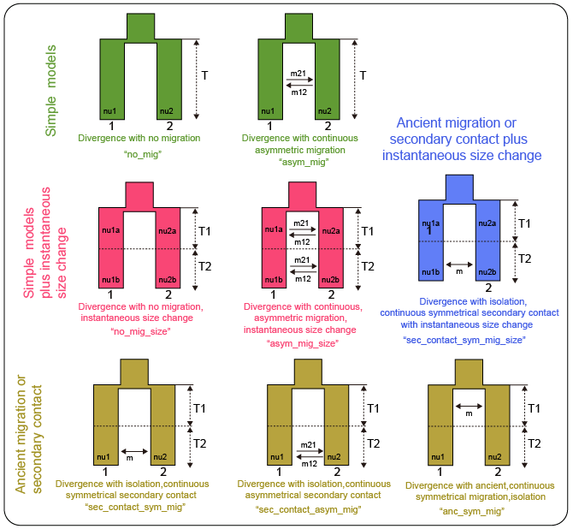
Figure S9 2D divergence model used in δaδi.

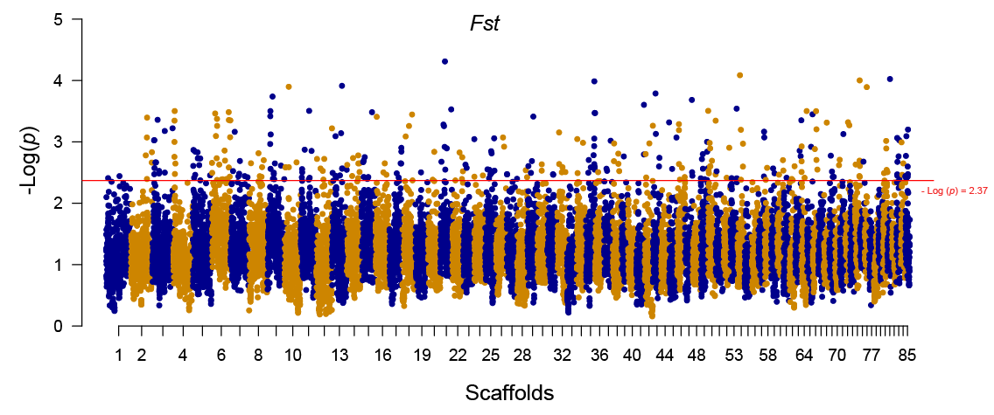
Figure S10 Fst distribution of PEc vs PEa & PEz.

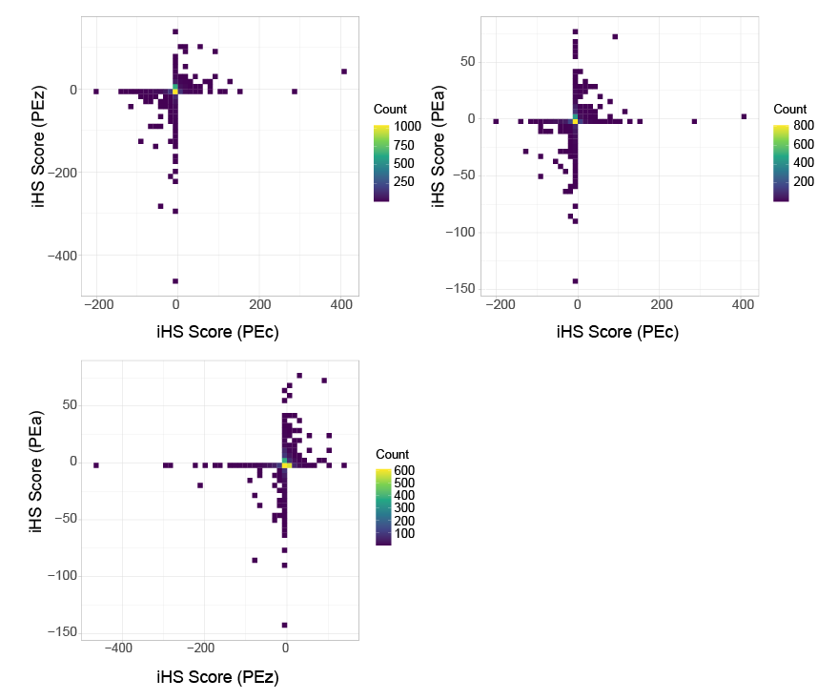
Figure S11 The iHS score distribution of PEc, PEa and PEz populations.

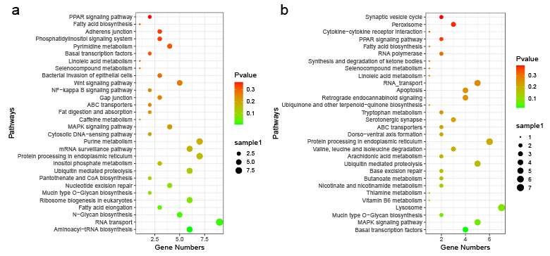
Figure S12 KEGG enrichment of iHS significant selection locis of PEc and PEa & PEz respectively.

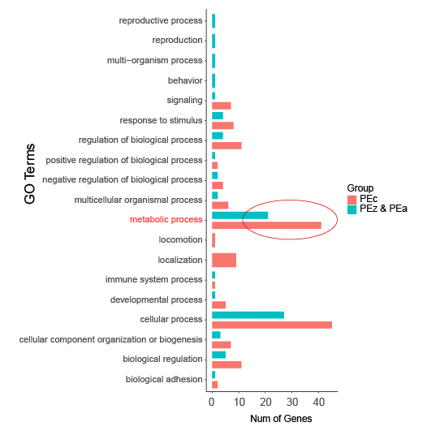
Figure S13 GO enrichment of XP-EHH analysis of PEa and PEc & PEz respectively.

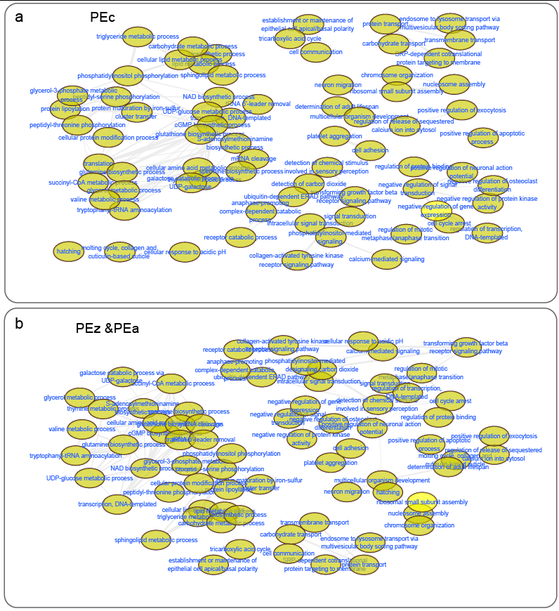
Figure S14 Network diagram of GO function enrichment obtained by XP-EHH analysis of PEa and PEc & PEz clades.

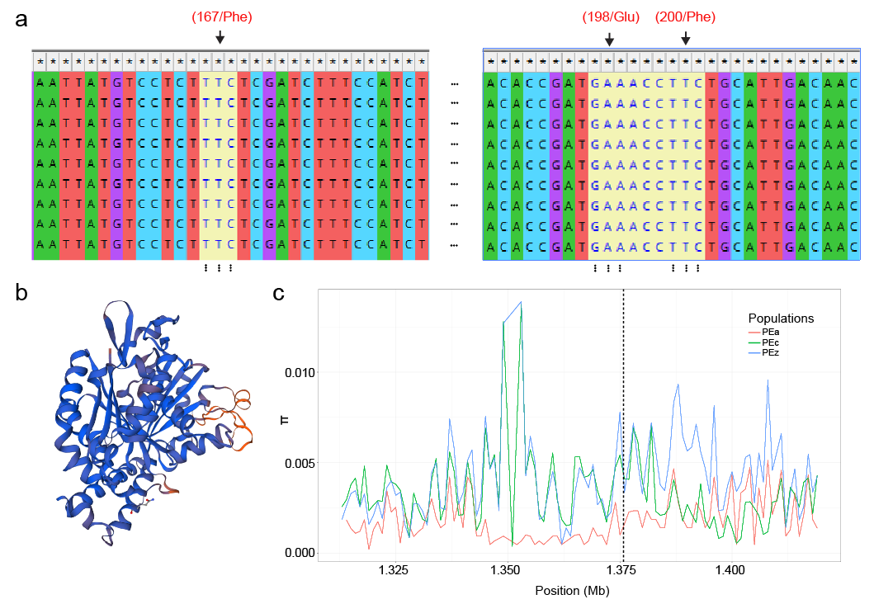
Figure S15 Detection of mutations in three drug-resistant sites of β-tubulin. (a) No drug-resistant base mutations were detected at positions 167/Phe, 198/Glu and 200/Phe in all individuals. (b) The 3D structure of β-tubulin. (c) The π distribution around β-tubulin region of the three populations.

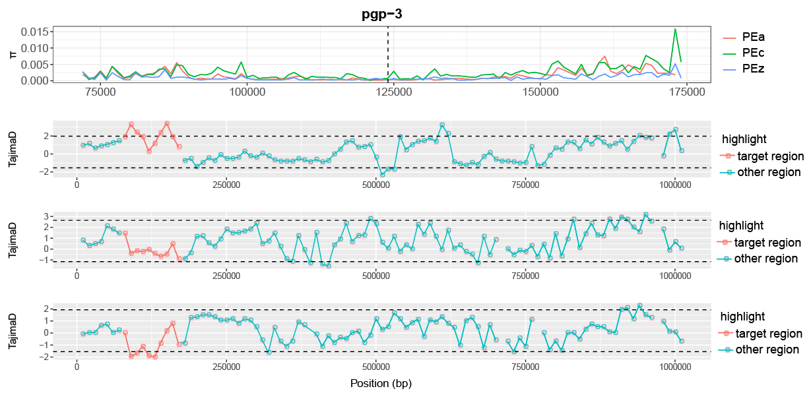
Figure S16 The π distribution and Tajima’D distribution in the pgp-3 regions of PEc, PEz and PEa populations.

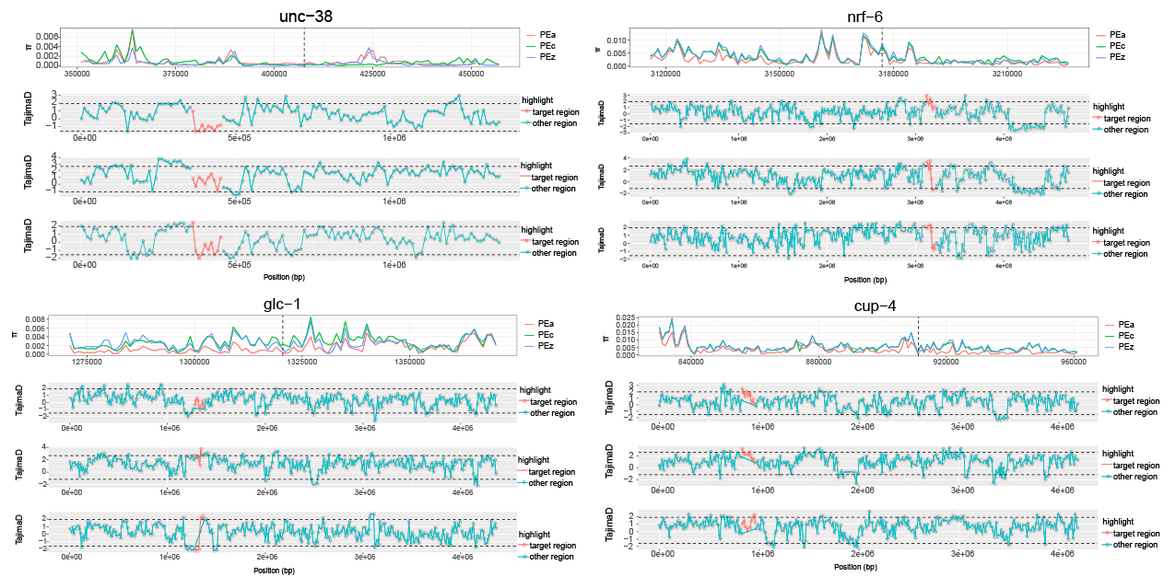
Figure S17 The π distribution and tajima’D distribution in the unc-38, nrf-6, glc-1 and cup-4 regions of PEc, PEz and PEa populations.

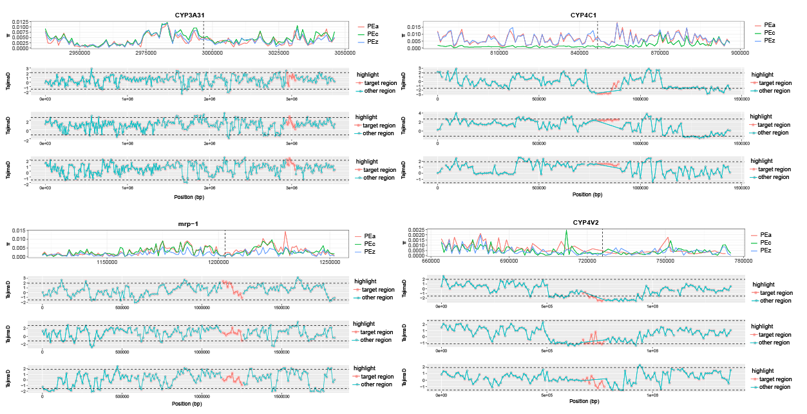
Figure S18 The π distribution and tajima’D distribution in the CYP3A31, CYP4C1, mrp-1 and CYP4V2 regions of PEc, PEz and PEa populations.

