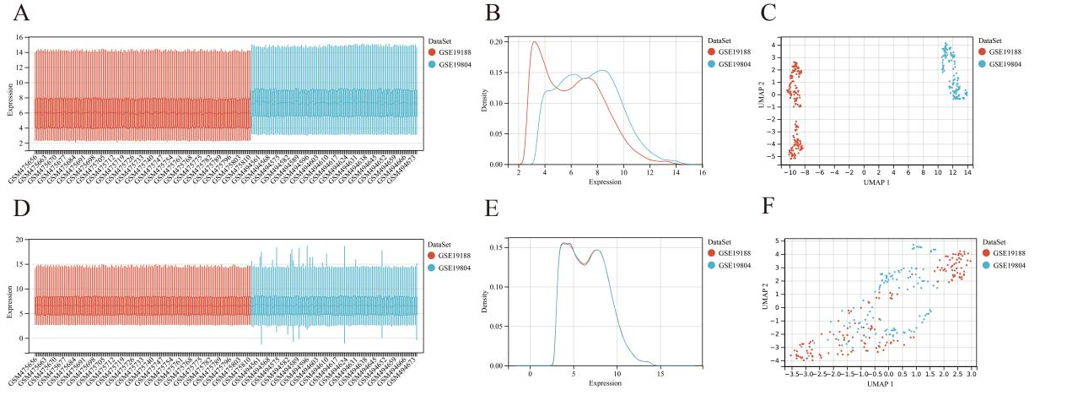
Supplementary Figure 1 Evaluation of Dataset Merging and Batch Effect Correction. (A) Boxplot before batch correction. (B) Density distribution plot before batch correction. (C) UMAP dimensionality reduction plot before batch correction. (D) Boxplot after batch correction. (E) Density distribution plot after batch correction. (F) UMAP dimensionality reduction plot after batch correction.

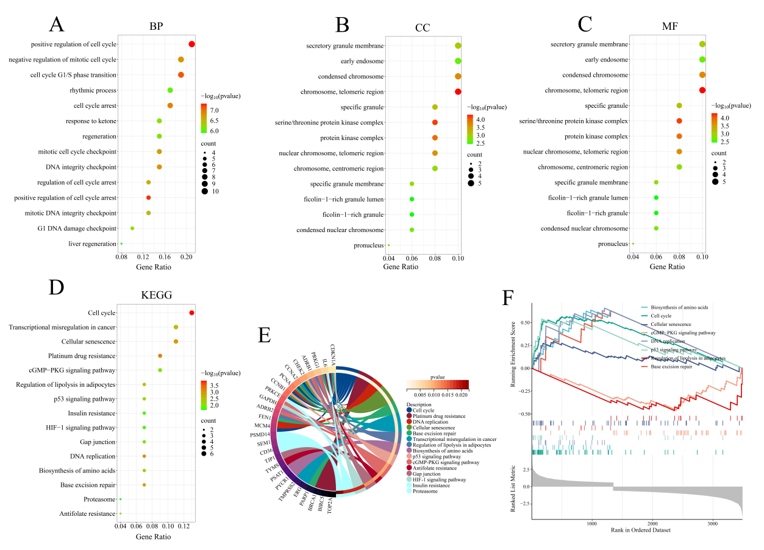
Supplementary Figure 2 Enrichment Analysis. (A-C) GO enrichment of BP (A), CC (B), and MF (C) as bubble plots of candidate genes, showing the top 15 most significant terms. (D) KEGG pathway enrichment analysis of candidate genes, showing the top 15 most significant pathways. (E) Chord diagram of the relationships between candidate genes and significantly enriched KEGG pathways. (F) Gene set enrichment analysis (GSEA) results.

Supplementary Table 1. Binding Free Energies between Key Genes and Small Molecule Drugs (kcal/mol).
Ligand  Receptor | SRPK1 | SEM1
chelidonine | -7.230 | -5.879
clobenpropit | -5.549 | -4.245
chlorambucil | -5.088 | -4.130
balsalazide | -7.421 | -5.384
idebenone | -4.760 | -4.772
pentamidine | -4.726 | -4.739
diosmin | -9.418 | -6.360
rotenone | -8.107 | -6.160
chelerythrine | -6.683 | -6.663
olaparib | -7.102 | -5.816

