Supplementary material
A sulfur-doped bimetallic nanozyme for colorimetric detection of chlorogenic acid in homologous medicinal and edible plants
Jiayi Jiang¹, Yifeng Zhou^{1*}, Liling Wang^{2*}
¹ School of Biological and Chemical Engineering, Zhejiang University of Science and Technology, Hangzhou 310023, China
² Zhejiang Academy of Forestry, Hangzhou 310023, China
* Corresponding authors.
E-mail addresses: zhouyf3000@163.com (Zhou Y); echo22239@163.com (Wang L)

Experimental section
Apparatus
Ultraviolet–visible (UV–vis) spectroscopy measurement was performed with a Varioskan Flash reader (ThermoFisher, USA). The fluorescence spectra were recorded on a F-7000 fluorescence spectrophotometer (Hitachi, Japan). The scanning electron microscope (SEM) images were taken on Hitachi model S-4800 field emission electron microscope (Hitachi, Japan) with an accelerating voltage of 20 kV. The microstructure of the catalysts was characterized with transmission electron microscopy (TEM; JEOL, JEM-2100F) with energy dispersive X-ray spectroscopy (EDS). The X-ray diffraction (XRD) patterns were recorded on a SmartLab 9kW diffractometer (Rigaku, Japan) under the conditions of nickel filtered Cu Kα radiation (λ = 0.15406 nm). X-ray photoelectron spectroscopy (XPS) data were measured using ThermoFisher ESCALAB 250XI (ThermoFisher Scientific, USA). The specific surface areas were determined by the Brunauer-Emmett-Teller (BET) method based on the N₂ adsorption-desorption isotherm data, which were obtained on an ASAP 2020 Micromeritics instrument (Maike, USA). Electron paramagnetic resonance (EPR) spectrum was measured on a Bruker EMXplus-6/1 spectrometer (Bruker, Germany) to detect the free radicals.
Electrochemical Research
All electrochemical measurements were carried out at room temperature using the CHI760E electrochemical workstation within a standard three-electrode system. The working electrode was a glassy carbon electrode (GCE), the counter electrode was a platinum foil electrode, and the reference electrode was an Ag/AgCl electrode. The electrolyte was a 0.5 M Na₂SO₄ solution. The preparation procedure of the catalyst ink is as follows: 5 mg of the catalyst was dispersed in a mixed solvent consisting of 335 μL isopropanol, 145 μL deionized water, and 20 μL of a 5% Nafion solution. The resulting suspension was subjected to ultrasonic treatment for 30 minutes to guarantee uniform dispersion. Subsequently, the obtained suspension was dropped onto the surface of the GCE and allowed to dry naturally at room temperature to form a film. This process was repeated, and then the film was left to air-dry naturally.

Fig. S1 SEM images of (a) FePd₂S₄, (b) FePd₂O₃; (c) EDS Spectrum and (d)TEM images of FePd₂S₄

Fig. S2 XRD patterns of the synthesized (a) FePd₂S₄ and (b) FePd₂O₃

Fig. S3 (a) N₂ adsorption-desorption curves and (b) pore size distributions of the FePd₂S₄ and FePd₂O₃

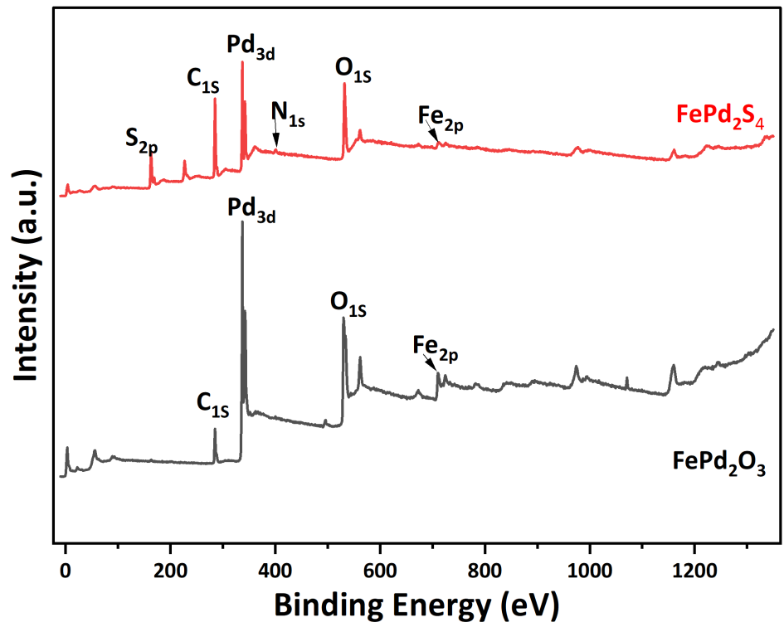
Fig. S4 XPS survey spectrum of FePd₂S₄ and FePd₂O₃

Fig. S5 The XPS high-resolution spectra of FePd₂S₄: (a) Fe 2p, (b) Pd 3d and (c) S 2p; the XPS high-resolution spectra of FePd₂O₃: (d) Fe 2p, (e) Pd 3d and (f) O 1s.

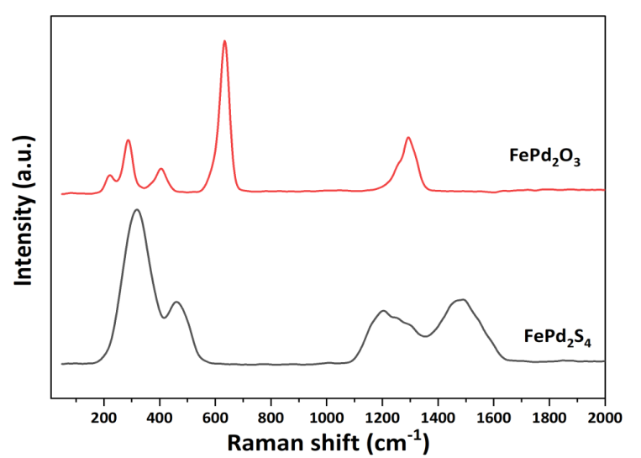
Fig. S6 Raman spectra of FePd₂O₃ and FePd₂S₄

Table S1 The BET surface area and pore volume of two catalysts
Catalysts | BET surface area  (m² g⁻¹) | Pore volume  (cm³ g⁻¹) | Pore Diameter  (nm)
FePd₂S₄ | 11.555 | 0.034 | 3.296
FePd₂O₃ | 34.781 | 0.051 | 3.707

Table S2 Comparison of kinetic parameters between FePd₂S₄ and other preoxidase
Catalyst | K_{m} (mM) |  | V_{max} (10⁻⁸ M s⁻¹) |  | Refs
Catalyst | TMB | H₂O₂ | TMB | H₂O₂ | Refs
HRP | 0.434 | 3.7 | 10.0 | 8.71 | (Gao et al., 2007)
Pt hollow nanodendrites | 0.81 | 6.9 | 12 | 9.9 | (Ge et al., 2018)
Hemin-Au@MOF | 2.67 | 2.58 | - |  | (Zhang et al., 2018)
G₂₀–Cu(II) complex | 0.257 | 102.3 | 24.29 | 25.67 | (Yang et al., 2016)
Cu-NC-700 | 0.077 | 0.928 | 5.97 | 42.54 | (Hou et al., 2021)
FePd₂S₄ | 0.204 | 0.0504 | 277.78 | 103.37 | This work
References
Gao L, Zhuang J, Nie L, Zhang J, Zhang Y, Gu N, Wang T, Feng J, Yang D, Perrett S, Yan X (2007) Intrinsic peroxidase-like activity of ferromagnetic nanoparticles. Nat Nanotechnol 2 (9): 577-583. https://doi.org/10.1038/nnano.2007.260.
Ge C, Wu R, Chong Y, Fang G, Jiang X, Pan Y, Chen C, Yin JJ (2018) Synthesis of Pt hollow nanodendrites with enhanced peroxidase-like activity against bacterial infections: implication for wound healing. Adv Funct Mater 28 (28): 1801484. https://doi.org/10.1002/adfm.201801484.
Hou Y, Lu Y, Chen Q, Zhang X, Huang Y (2021) Ultrathin two-dimensional carbon nanosheets with highly active Cu-Nx sites as specific peroxidase mimic for determining total antioxidant capacity. Sens Actuators B: Chem 333: 129549. https://doi.org/10.1016/j.snb.2021.129549.
Yang J, Zheng L, Wang Y, Li W, Zhang J, Gu J, Fu Y (2016) Guanine-rich dna-based peroxidase mimetics for colorimetric assays of alkaline phosphatase. Biosens Bioelectron 77: 549-556. https://doi.org/10.1016/j.bios.2015.10.003.
Zhang L, Fan C, Liu M, Liu F, Bian S, Du S, Zhu S, Wang H (2018) Biominerized gold-Hemin@MOF composites with peroxidase-like and gold catalysis activities: A high-throughput colorimetric immunoassay for alpha-fetoprotein in blood by ELISA and gold-catalytic silver staining. Sens Actuators B: Chem 266: 543-552. https://doi.org/10.1016/j.snb.2018.03.153.

