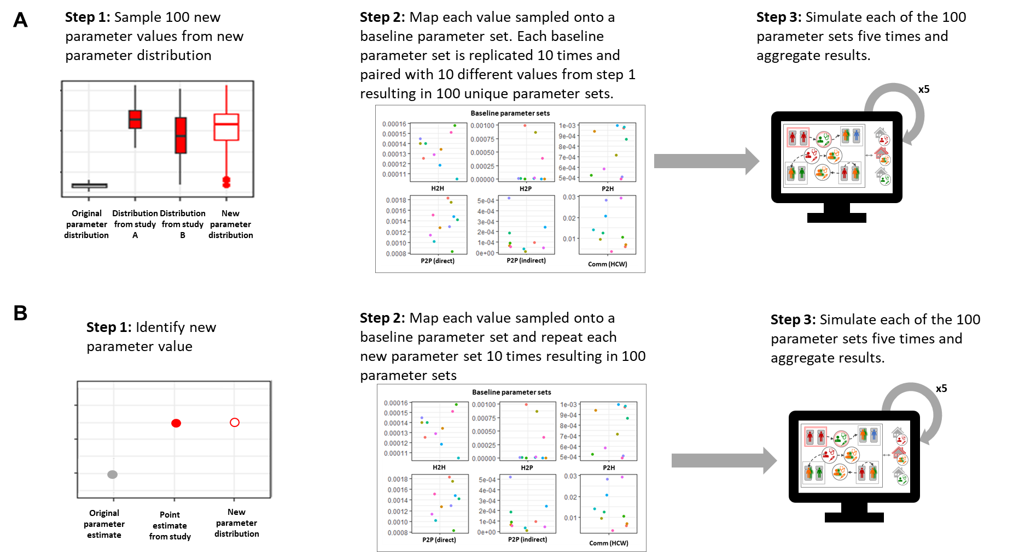
Figure S1: Parameter generation and simulation procedure. A) Procedure for generating parameters from a range of value, B) procedure for generating parameter sets from a single value

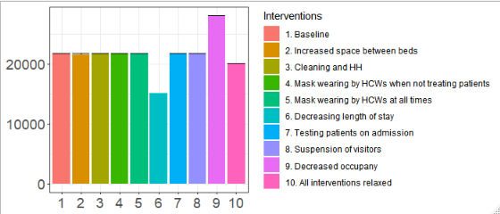
Figure S2: Number of susceptible inpatients admitted to simulated hospital under each modelled scenario.

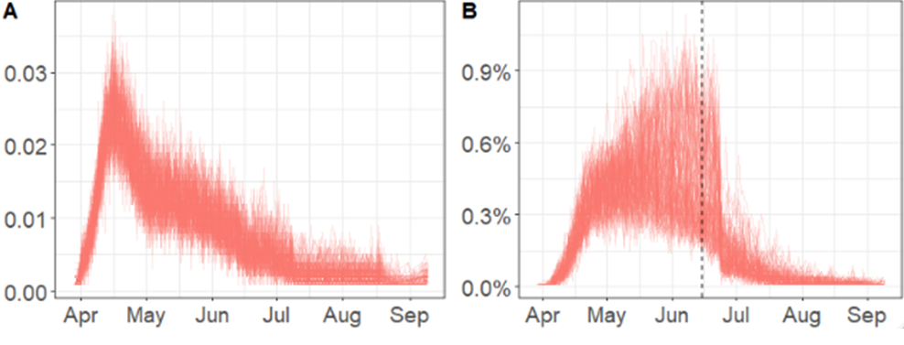
Figure S3: Infections under baseline scenario. A) Number of infected patients (imported and nosocomial combined) per day, scaled by the number of beds in the simulated hospital (/1000). B) Proportion of simulated HCWs infected every day. Dashed line: Implementation of universal masking in HCWs.

Table S1: Parameterising the reversal of interventions in the model
Source | What did they do? | Results | Interpretation
Efficacy of PPE & Hand-hygiene/IPC
Loeb et al [9] | Retrospective cohort study among 43 nurses who worked in two Toronto critical care units with SARS patients | Any mask RR: 0.23 (0.07 to 0.78)* (p<0.05)  N95 RR: 0.22 (0.05 to 0.93, p > 0.05)  Surgical mask RR: 0.45 (0.07 to 2.71, p > 0.05)  N95 vs surgical mask RR: 0.50 (0.06 to 4.23, p > 0.05) | No PPE = 1/0.23 times worse = 4.35 x calibrated value (since no other parameters significant)
Nishiyama at al [10] | Nosocomial infection of severe acute respiratory syndrome (SARS) in Vietnam in 2003 and attempted to identify risk factors for SARS infection. (03-Mar-2003 to 17-Mar-2003) | Mask use:  Always AOR: 1.0  Sometimes AOR: 2.90 (0.13)  No: 12.6 (p < 0.02) | Not wearing a mask increases infection probability to 2.9-12.6 x calibrated value
Raboud et al [11] | A retrospective cohort study was conducted to identify risk factors for transmission of SARS-CoV during intubation from laboratory confirmed SARS patients to HCWs involved in their care. (643 HCWs caring for SARS patients)  05-Mar-2003 to 05-Jun-2003 | Always wore recommended PPE OR: 0.70 (0.19, 2.58, p = 0.59)  - | No PPE has increased risk of~ 1.43 x Always wearing PPE
Seto et al [12] | Case-control study in five Hong Kong hospitals, with 241 non-infected and 13 infected staff with documented exposures to 11 index patients with severe acute respiratory syndrome (SARS) during patient care  15-Mar-2003 to 24-Mar-2003 | Masks (reduction) OR: 13 (3–60, p = 0.0001) | Not wearing a mask increases transmission probability to 13 x calibrated value
Teleman et al [13] | Between 1 and 22 March 2003, a nosocomial outbreak of Severe Acute Respiratory Syndrome (SARS) occurred at the Communicable Disease Centre in Tan Tock Seng Hospital, Singapore, the national treatment and isolation facility for patients with SARS. A case-control study with 36 cases and 50 controls was conducted of factors associated with the transmission of SARS within the hospital. | Wearing of N95 masks: aOR 0.1, (0.02-0.86, P=0.04) | Not wearing a mask increases transmission probability to 1.16-50 x calibrated value
Kua et al. [8] | To establish the prevalence, risk factors and implications of suspected or confirmed coronavirus disease 2019 (COVID-19) infection among healthcare workers in the United Kingdom (UK) between 01-Feb-2020 and 25-May-2020 | Treating patients without PPE has an odds ratio of 3.65 | Not wearing PPE increases transmission probability to 3.65 x calibrated value
Cheng et al [7] | Quantitative model of airborne virus exposure that can explain these contrasting results and provide a basis for quantifying the efficacy of face masks | Universal masking reduces transmission by 90%. Wearer protection is 65-75%. Source control protection is close to 80%. | Without PPE, transmission is 2.85-4 times calibrated value  Source isolation scale up transmission by 1.25 in absence of interventions
Howard et al [14] | An analytical framework to examine mask usage, synthesizing the relevant literature to inform multiple areas: population impact, transmission characteristics, source control, wearer protection, sociological considerations, and implementation considerations. | Univeral masking with 100% adherence can reduce transmission by 40-80% when mask is 25-80% effective at blocking particle . | Transmission probabilty between HCWs both wearing masks (assuming 100% masking) ia reduced by 25-80% so no masks increases transmission probability by 1.25-4 times
Clapp et al [32] | Evaluated the fitted filtration efficiency (FFE) of various consumer-grade and improvised face masks, as well as several popular modifications of medical procedure masks that are intended to improve mask fit or comfort. | Medical grade masks had a filtration efficacy of 25-80%
Wong et al [15] | Systematic review and meta-analysis evaluating the impact of hand hygiene interventions in preventing influenza  virus transmission in the community setting. | Hand hygiene reduces transmission of influenza with RR: 0.78 (0.68-0.90) | Indirect transmission between patients could be increased by 0.16 in absence of HH interventions (i.e. 1.28 (1.11, 1.47)*calibrated value)
NHS Providers – Recovery position [33] | NHS Providers conducted a short snapshot survey of chairs and chief executives between the 21 - 31 May. The survey aims to capture the views of the sector on:  current demand  capacity and workforce challenges  the readiness of the NHS to reopen  the barriers to returning to a level of service where trusts can meet the needs of all patients and service users who require care.  The survey received 158 responses representing 126 trusts, or 58% of the provider sector, with all regions and trust types represented in the data. | Average bed spacing in hospitals ranges between 1.6m in older buildings and 1.8m in newer hospitals, and space between staff around beds must also be taken into account. Trusts estimated that the 2m rule reduced bed space by up to a third. | Distance between each other bed in a 4 bed a bay is 2.5, 6, 5.5m. Transmission probability when social distancing is observed = mean(exp(dist*(-1.5)) = 0.0080 per day ~0.0013 per timestep.  If this is relaxed to allow beds to be closer than 2m then distances become 1.5, 5.7, 5.5m Transmission probability when social distancing not observed =0.0352~ 0.005 per time step.
Martos et al [34] | Theoretical model of transmission rate between beds based on space between them | Probability distribution of a transmission event in a day given by β(dij)=exp(−dij x 3/2) where dij is distance between beds i and j.
Occupancy
NHS digital [17] | Average Daily Available and Occupied Beds Timeseries Q1 2010/11 to Q4 2020/21. NHS digital | Historical bed occupancy (2010-2019) averages at 87.0% | 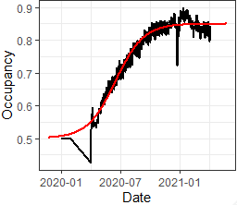  Logistic curve (red line) with parameters A=0.35, k=0.02322, mu= 107.5 fits the median occupancy data for acute NHSE trusts (black line) and can be used for occupancy in IBM. (0 = 01-03-2020)
NHS Situation Report [17] + bed counts from ESR data | Number of beds occupied was recorded daily as part of the NHS COVID-19 Situation Report and total beds available (ESR data) was collected in February 2020 | Occupancy gradually increases from 50% to 85% over the course 2020-2021
Length of stay (LoS)
SUS/SGSS [35] | LOS decreased from 2.7 to 1.9 days at the start of the pandemic |  | Scale LOS by down by factor of 1.42.
Testing/Cohorting
May and Powis [5] | Letter: Expansion of patient testing for Covid-19 of all non-elective admissions that require a bed overnight, effective from Monday 27th April. | Symptomatic patients should be tested from 01-Mar-2020 to 26-Apr-2020.  All admissions tested from 27-Apr-2020 onward.  Test: PCR swab test with sensitivity 0.95 and specificity 0.99. | Testing probability after day 57 = 0.0.
PHE [36] | COVID-19: Guidance for maintaining services within health and care settings Infection prevention and control recommendations Version 1.2 | Triaging and SARS-CoV-2 testing must be undertaken for all patients either at point of admission or as soon as possible/practical following admission across all the pathways | See Supplementary File 1.
Suspension of visitors
Cohen et al [20] | Patients were observed in seven units of three US academic hospitals, with recording of  each occurrence of someone’s entry into the patient’s room. | Visitors stay for an average of 14 minutes in the patient room but close contact is observed | If patients have one visitor a day this is 0.15 per step. The transmission rate per minute from an infected visitor would be 0.00125 [21].
Scaria et al [19] | Simulation study, conducted between July 27, 2020, and August 11, 2020, used an established agent-based simulation model of C difficile transmission (CDI) in a 200-bed acute care adult hospital to estimate the association between visitor contact precautions and HO-CDI | Model assumes that patients have a maximum of 2 visitors a day | If patients have a maximum of two visitors per day this is 0-0.3 per step. The transmission rate per minute would be 0.00125 per infected visitor [21]

Table S2: Classification of data sources for parameterising the reversal of interventions. Studies were categorised as follows; Theoretical studies (T), Single study, other respiratory virus (S), Single study, SARS-CoV-2 (S*), Meta-analysis/Systematic review of multiple studies (no SARS-CoV-2 specific, M), Meta-analysis/Systematic review of multiple studies (including SARS-CoV-2 specific, M*).
Intervention | Evidence type | Reference | Type
- Increased spacing between beds (bP2P) | Theoretical model of transmission rate between beds based on space between them | Martos et al [37] | T
Total number of studies: 1 Type: T
- Increased cleaning and hand-hygiene (bP2P_indir) | Systematic review and meta-analysis evaluating the impact of hand hygiene interventions in preventing influenza virus transmission in the community setting from 10 studies | Wong et al [38] | M
Total number of studies: 1 (10) Type: M
- Mask wearing when treating patients  - bP2H  - bH2P | Quantitative model of airborne virus exposure that can explain these contrasting results and provide a basis for quantifying the efficacy of face masks based on data from medical facilities on SARS-CoV-2 in air samples | Cheng et al [7] | S*
- Mask wearing when treating patients  - bP2H  - bH2P | Cross-sectional observational study on 6,152 HCWs in the UK between 1st Feb and 25th May 2020. Composite endpoint of laboratory-confirmed diagnosis of SARS-CoV-2, or self-isolation or hospitalisation due to suspected or confirmed COVID-19 | Kua et al [8] | S*
- Mask wearing when treating patients  - bP2H  - bH2P | Retrospective cohort study among 43 nurses in Toronto working with SARS-CoV-1 patients | Loeb et al [9] | S
- Mask wearing when treating patients  - bP2H  - bH2P | Case-control study of SARS-CoV-1 infection in staff that had exposure (or not) to infected patients at 3 hospitals in Vietnam | Nishiyama et al [10] | S
- Mask wearing when treating patients  - bP2H  - bH2P | Retrospective cohort study to identify risk factors for transmission of SARS-CoV-1 during intubation from laboratory confirmed SARS patients to HCWs involved in their care (multicentre) | Raboud et al [11] | S
- Mask wearing when treating patients  - bP2H  - bH2P | Case-control study in five hospitals with 241 non-infected and 14 infected staff exploring the effectiveness of masks against SARS-CoV-1 | Seto et al [12] | S
- Mask wearing when treating patients  - bP2H  - bH2P | Case-control study with 36 cases and 50 controls of factors associated with SARS-CoV-1 transmission in hospital in a single site in Singapore | Teleman et al [13] | S
Total number of studies: 1 (a) 6(b) Type: S*(a) M/M*(b)
- Universal masking of HCWs (H2H) | Quantitative model of airborne virus exposure that can explain these contrasting results and provide a basis for quantifying the efficacy of face masks based on data from medical facilities on SARS-CoV-2 in air samples | Cheng et al [7] | S*
- Universal masking of HCWs (H2H) | Narrative review developing an analytical framework to examine efficacy of mask usage against COVID-19, synthesizing the relevant literature to inform multiple areas: population impact, transmission characteristics, source control,  wearer protection, sociological considerations, and implementation considerations. | Howard et al [14] | M*
Total number of studies: 2 Type: S*/M

https://www.ons.gov.uk/peoplepopulationandcommunity/healthandsocialcare/conditionsanddiseases/methodologies/covid19infectionsurveypilotmethodsandfurtherinformation#test-sensitivity-and-specificity

