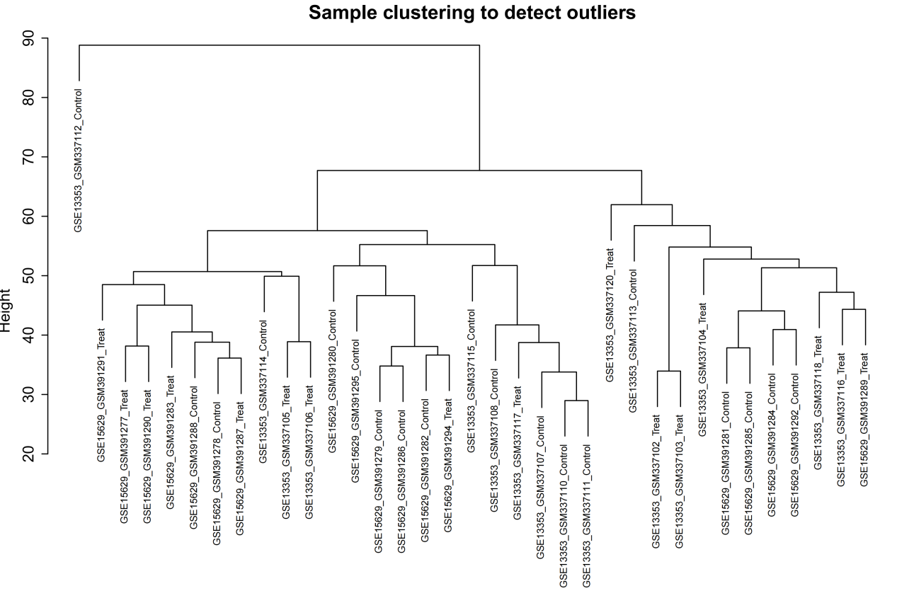
Supplementary Figure S1. Unsupervised sample hierarchical clustering for WGCNA quality control. Hierarchical clustering analysis was executed on the batch-corrected expression matrix of all 38 human tissue samples (GSE13353 and GSE15629 combined) to screen for potential technical outliers. The resulting dendritic tree demonstrated a homogeneous sample distribution without distinct individual branches or remote outliers, verifying the rigorous dataset integration and structural readiness for scale-free topology co-expression network modeling.

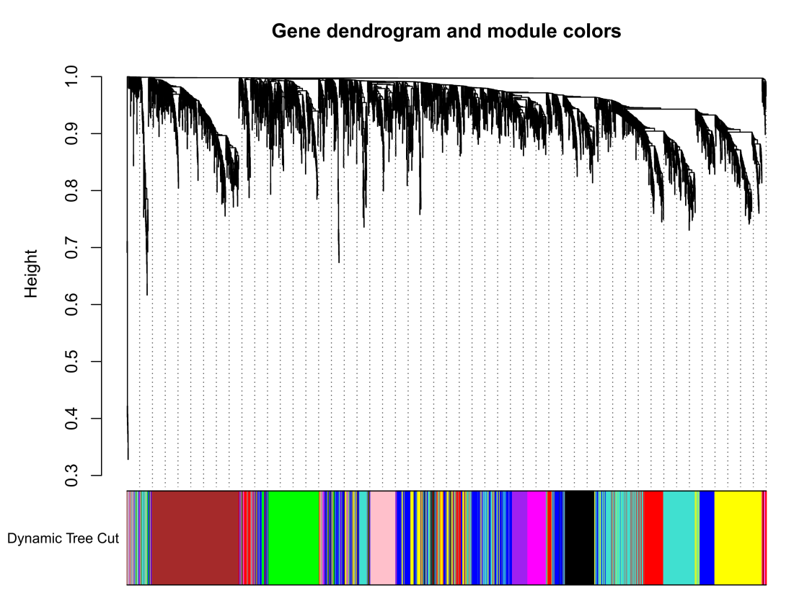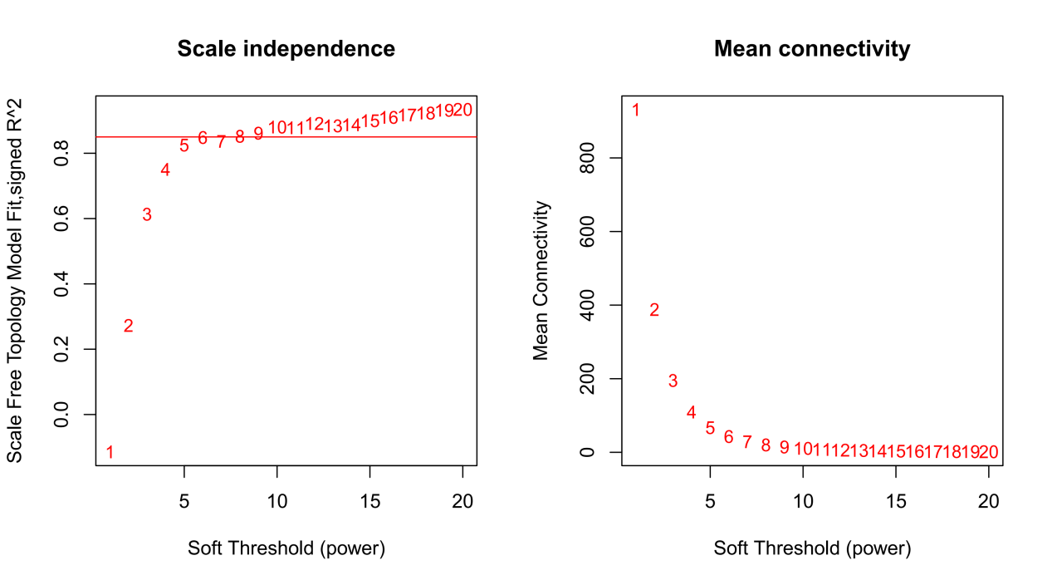
Supplementary Figure S2. Mathematical parameters and cluster trees for weighted gene co-expression network analysis (WGCNA). (A) Scale-free topology fit index (left) and mean connectivity (right) plotted against various soft-thresholding powers (beta), with beta = 4 chosen as the optimal threshold achieving a scale-free topology fit R2 > 0.85. (B) Hierarchical gene dendrogram constructed via dynamic tree cutting based on topological overlap matrix dissimilarity, illustrating the assignment of merged, co-expressed transcripts into distinct color-coded functional modules.

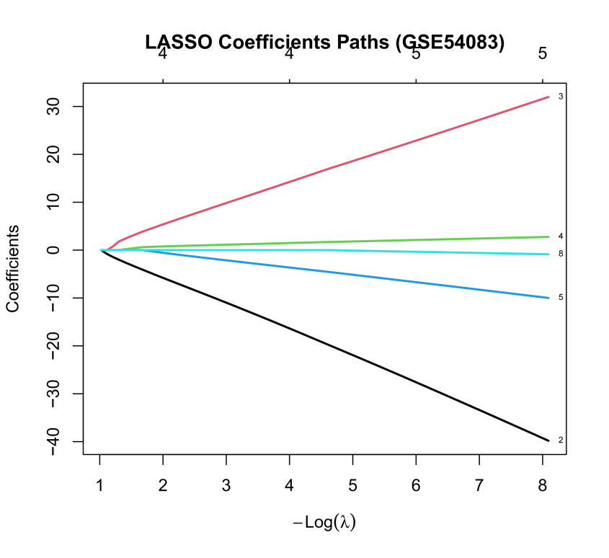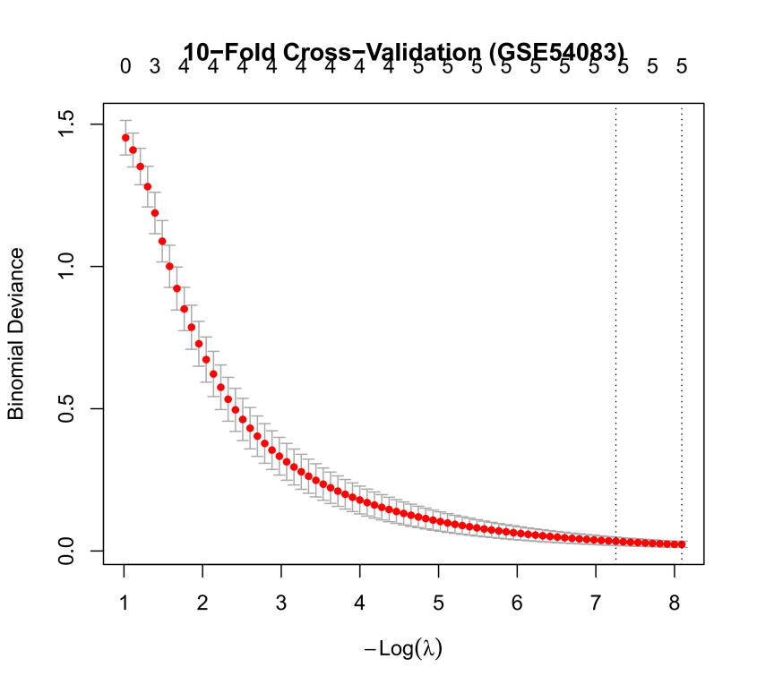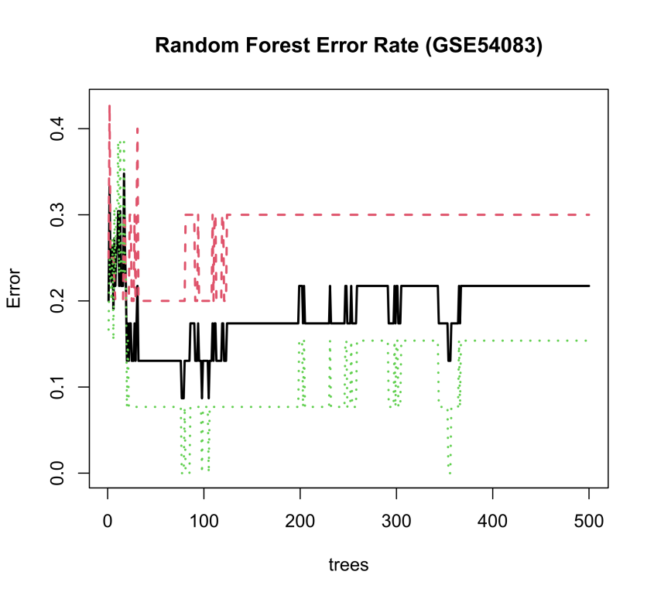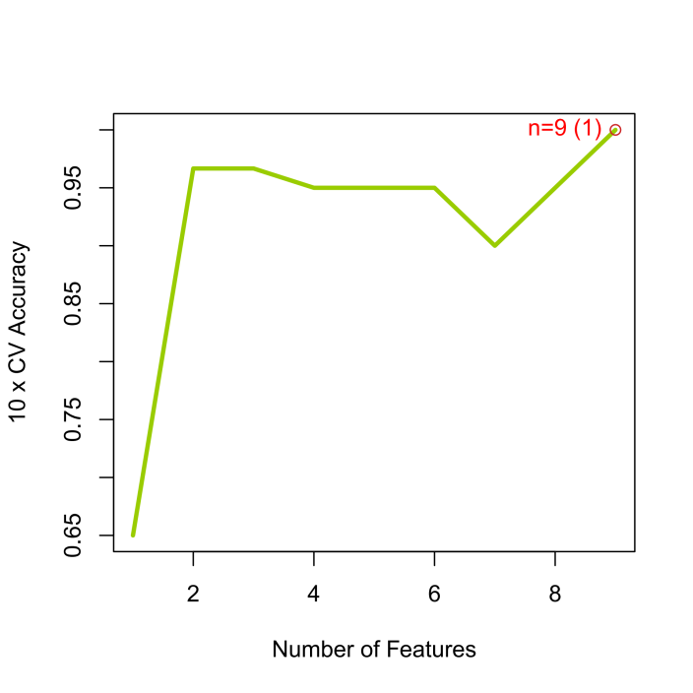
Supplementary Figure S3. De novo machine learning feature selection process within the independent validation cohort (GSE54083). (A, B) LASSO regression coefficient paths and ten-fold cross-validation deviance optimization under independent fitting parameters. (C, D) SVM-RFE feature-accuracy profiles and error-rate estimates under cross-validation showing model convergence on the unseen dataset. (E, F) Random Forest out-of-bag error minimization tracking and hierarchical feature importance ranking determined by Mean Decrease Gini metrics.

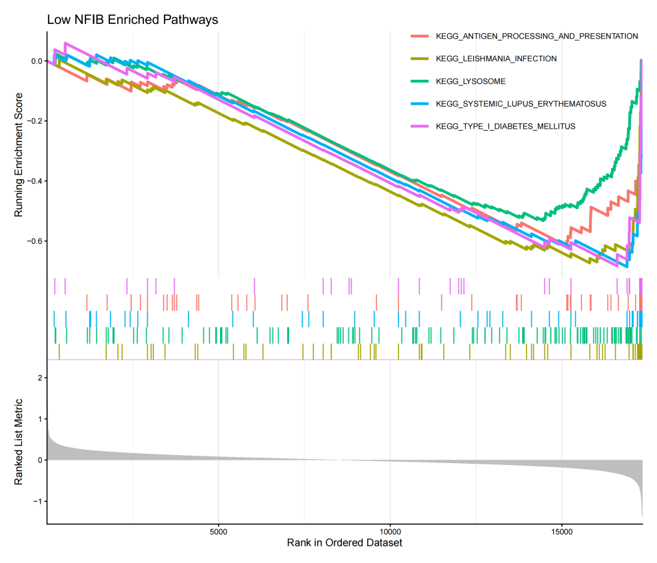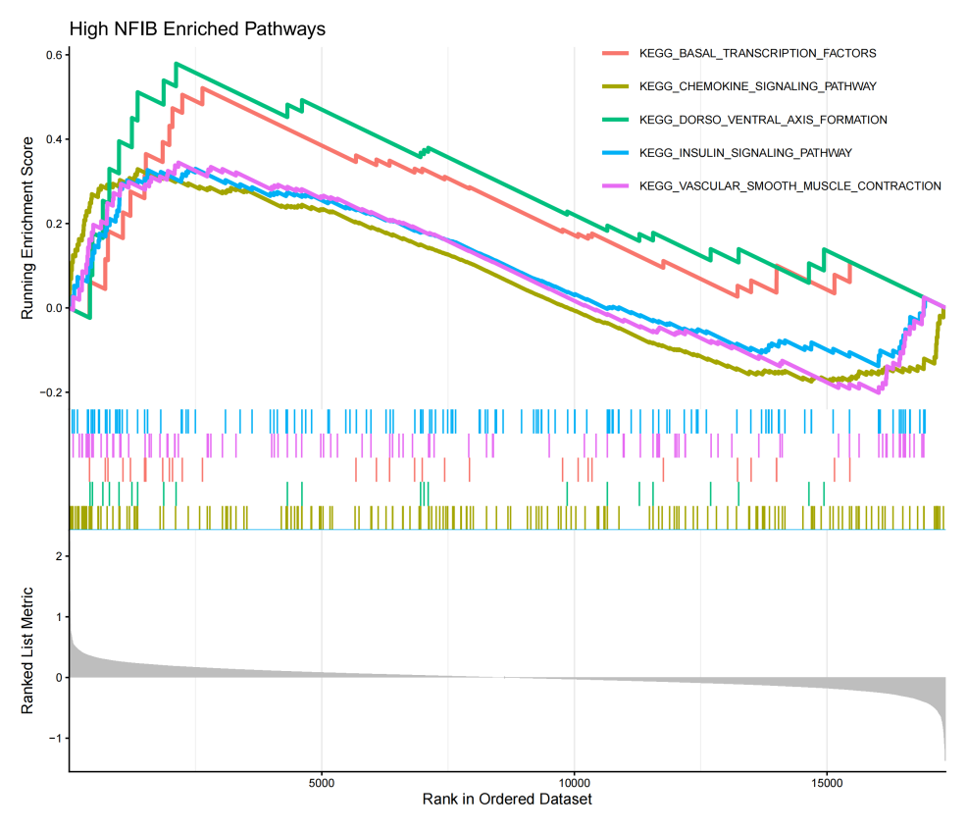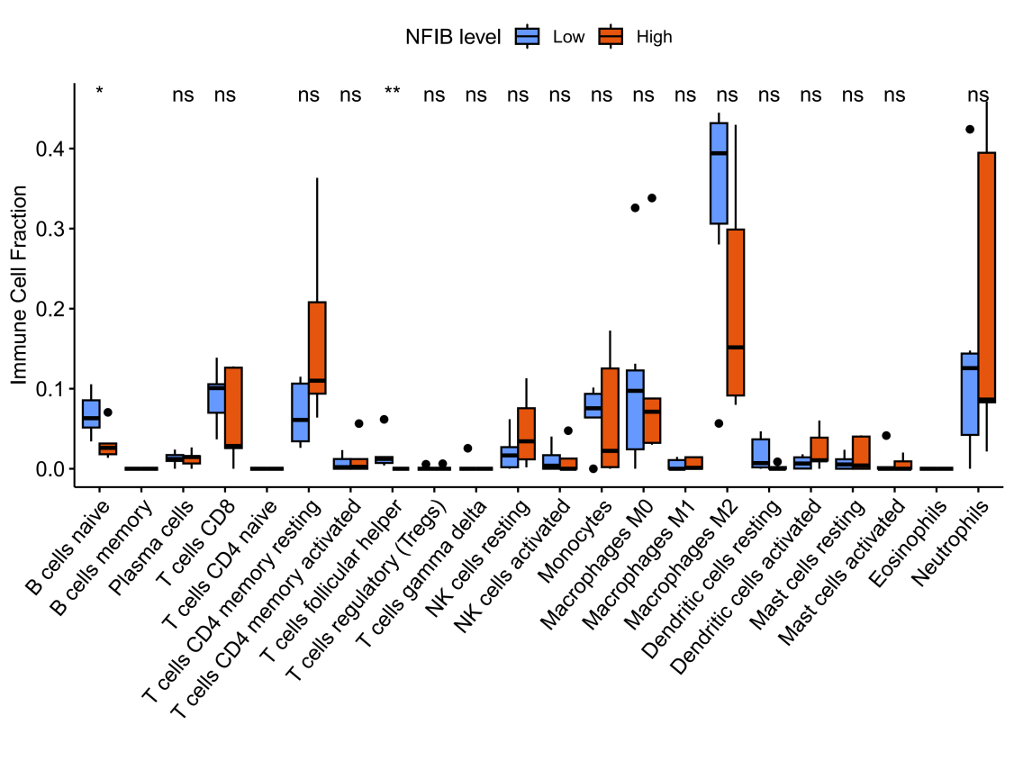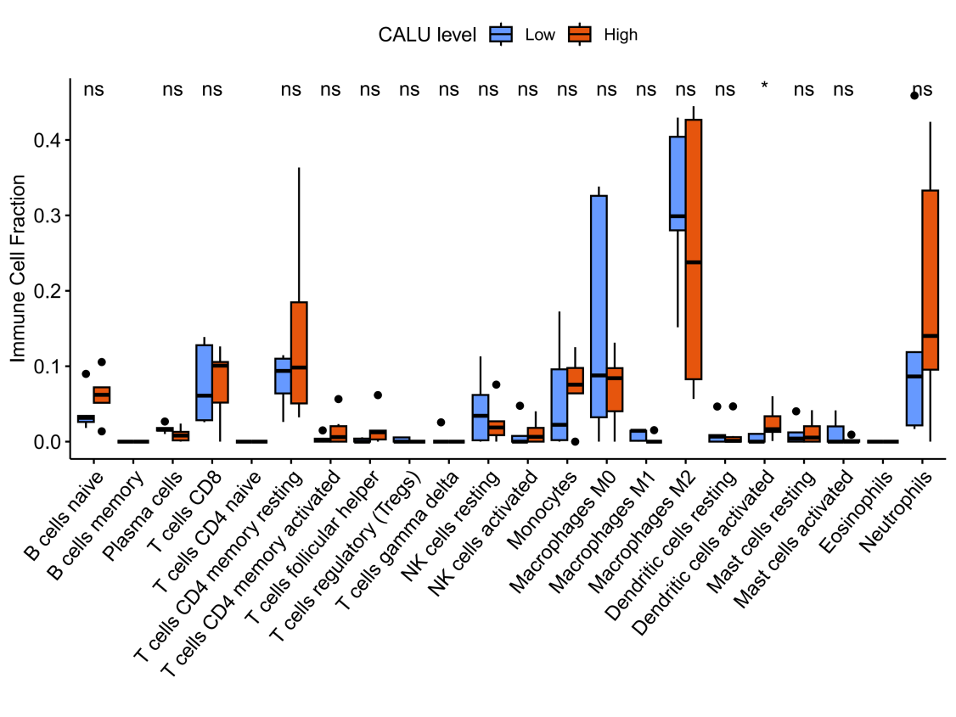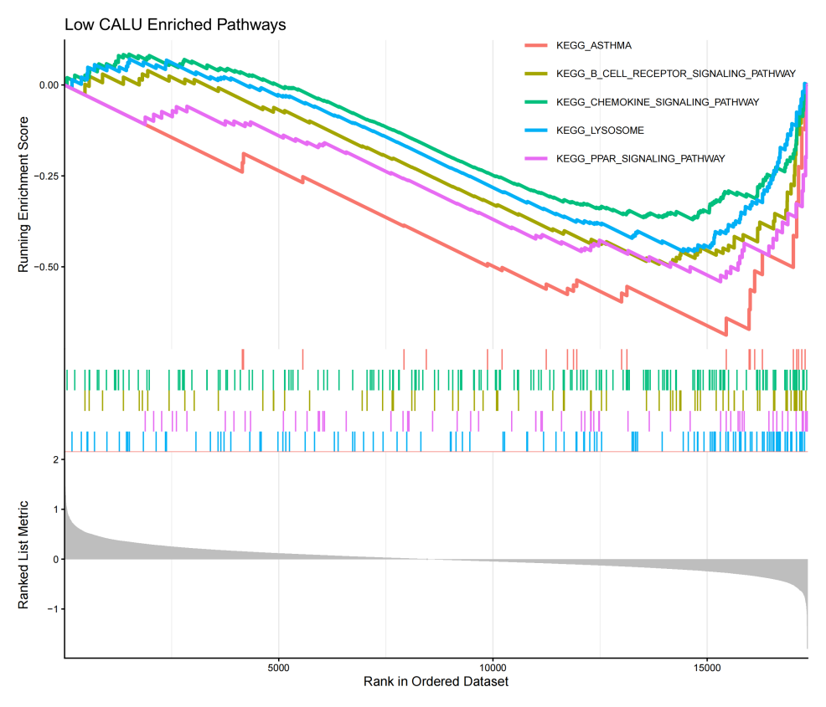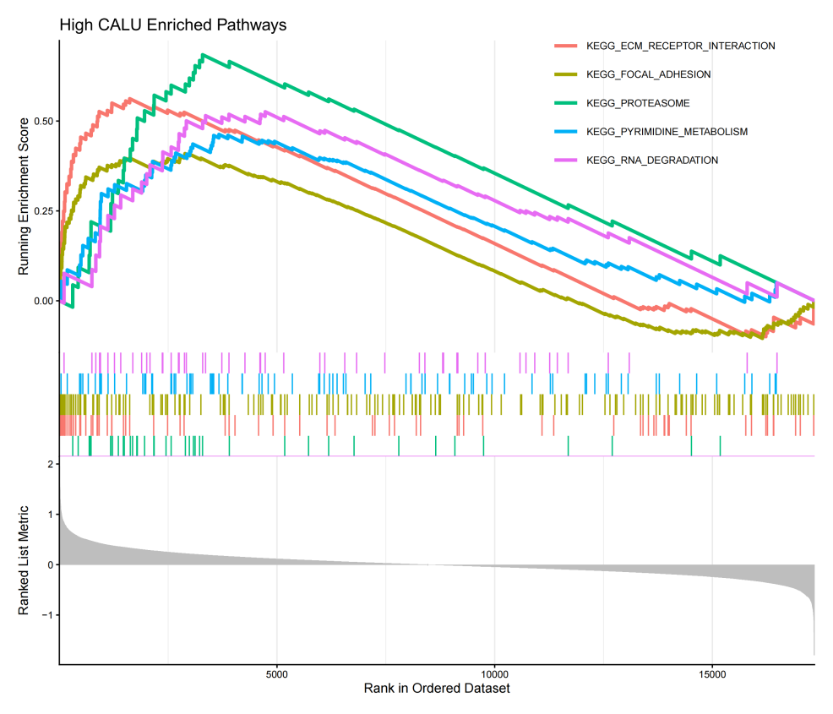
Supplementary Figure S4. Transcriptomic pathway profiles and leukocyte infiltration patterns for alternative candidate biomarkers. (A, B) GSEA profiles detailing activated canonical biological cascades within patient subgroups stratified by median expression levels of CALU and NFIB, respectively. (C, D) Grouped boxplots deconvoluting the relative fraction of 22 immune cell types via CIBERSORT between high and low expression status of CALU and NFIB within the aneurysmal wall tissue.

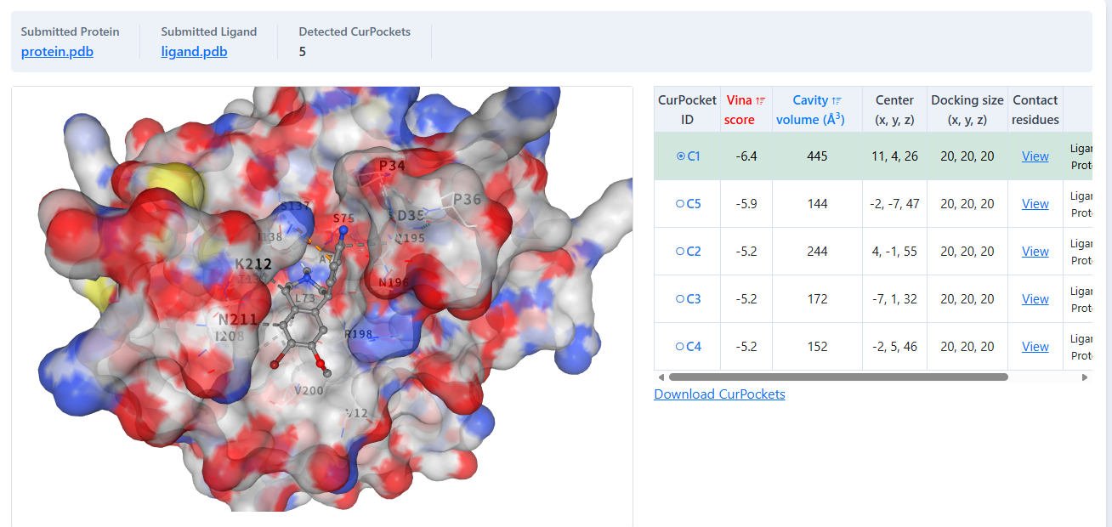
A
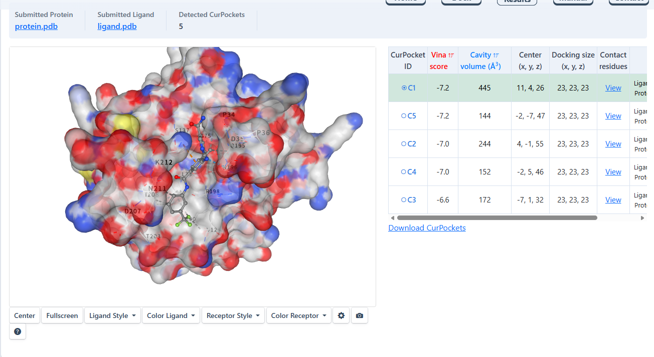
B
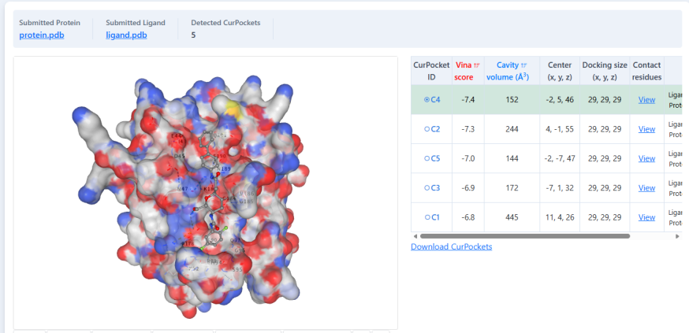
C
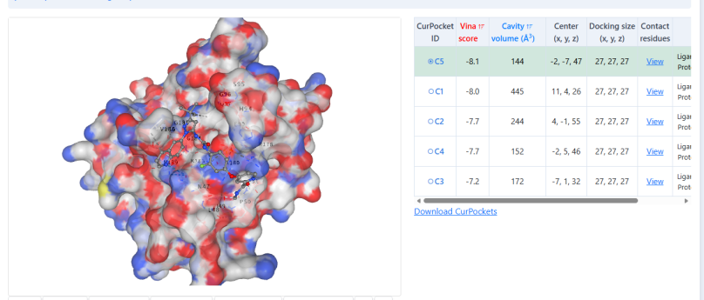
D
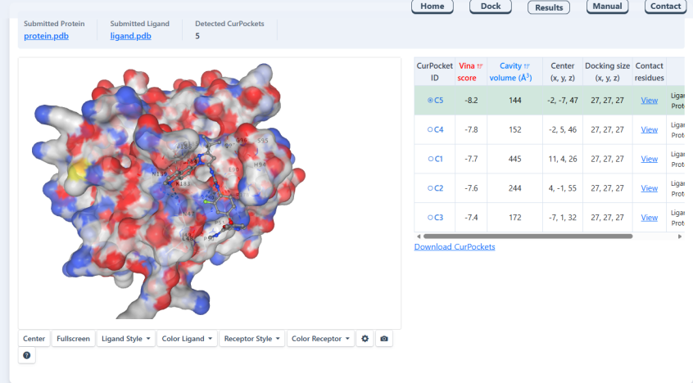
E
Supplementary Figure S5. Automated blind molecular docking web interfaces and pocket parameters via CB-Dock2. Automated geometric cavity detection and grid-free blind molecular docking profiling for the top five candidate small-molecule ligands against the three-dimensional tertiary structure of the target THBS1 receptor. Panels display the localized surface pockets (C1–C5) alongside server-calculated pocket parameters, spatial center coordinates (x, y, z), box docking sizes, and raw baseline Vina score affinities for: (A) BRD-A78236793, (B) BRD-K22096725, (C) BRD-K41719870, (D) BRD-K63945320 (dihydrosamidin), and (E) BRD-K76694128 (rebastinib).

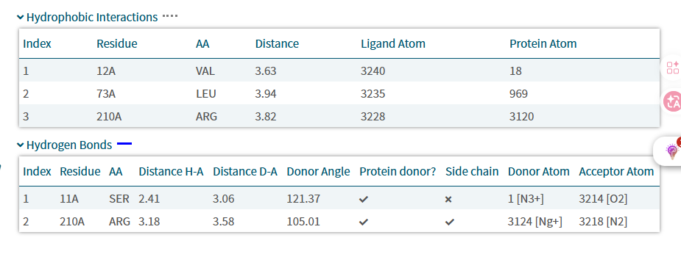
A
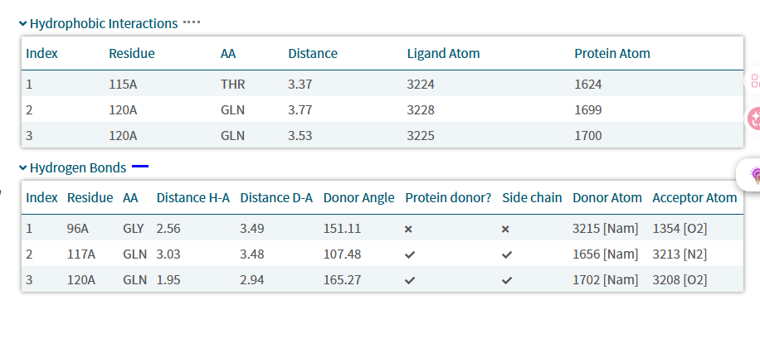
B
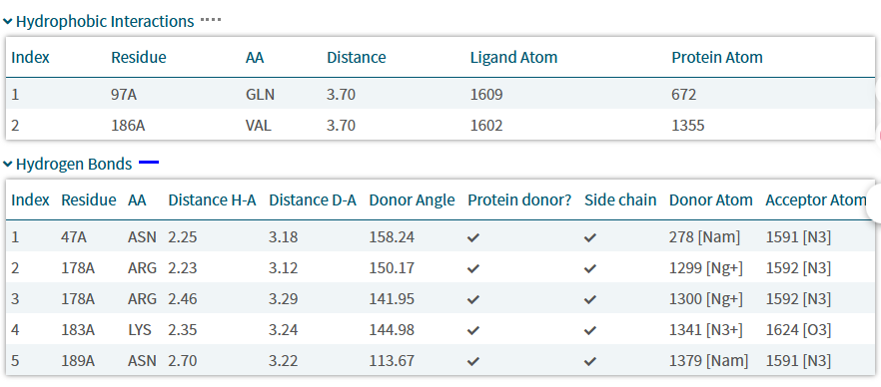
C
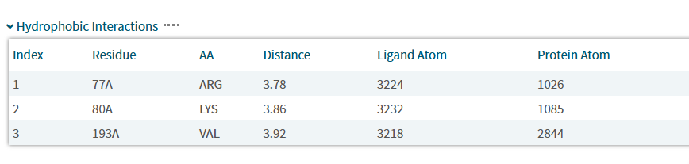
D
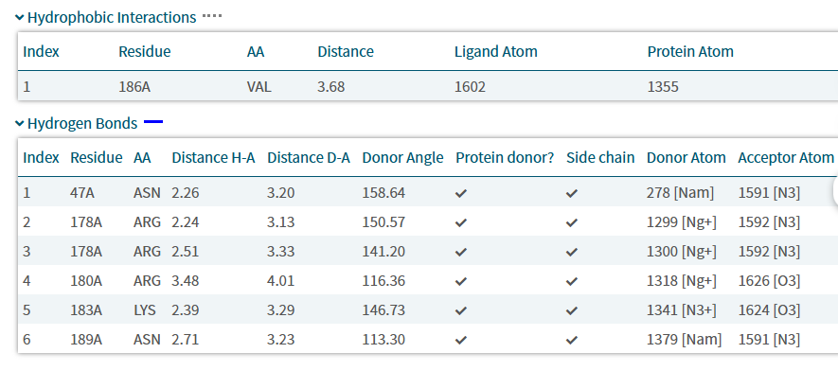
E
Supplementary Figure S6. Atomic-level non-covalent interaction matrices determined via PLIP. High-resolution tabular and schematic profiling mapping specific local non-covalent anchors between the candidate ligands and surrounding THBS1 pocket amino acid residues. Detailed tables provide precise index parameters, spatial binding distance metrics (Å), specific hydrogen bond donor/acceptor angles, and hydrophobic contact coordinates for: (A) BRD-A78236793, (B) BRD-K22096725, (C) BRD-K41719870, (D) BRD-K63945320, and (E) BRD-K76694128.

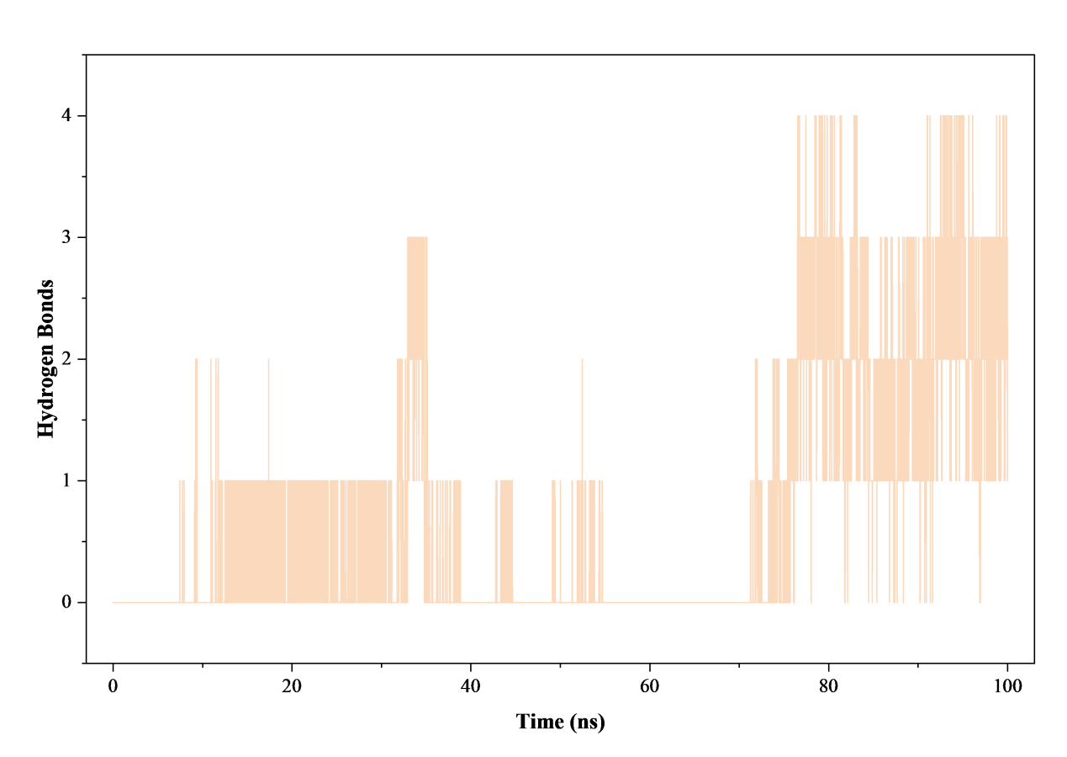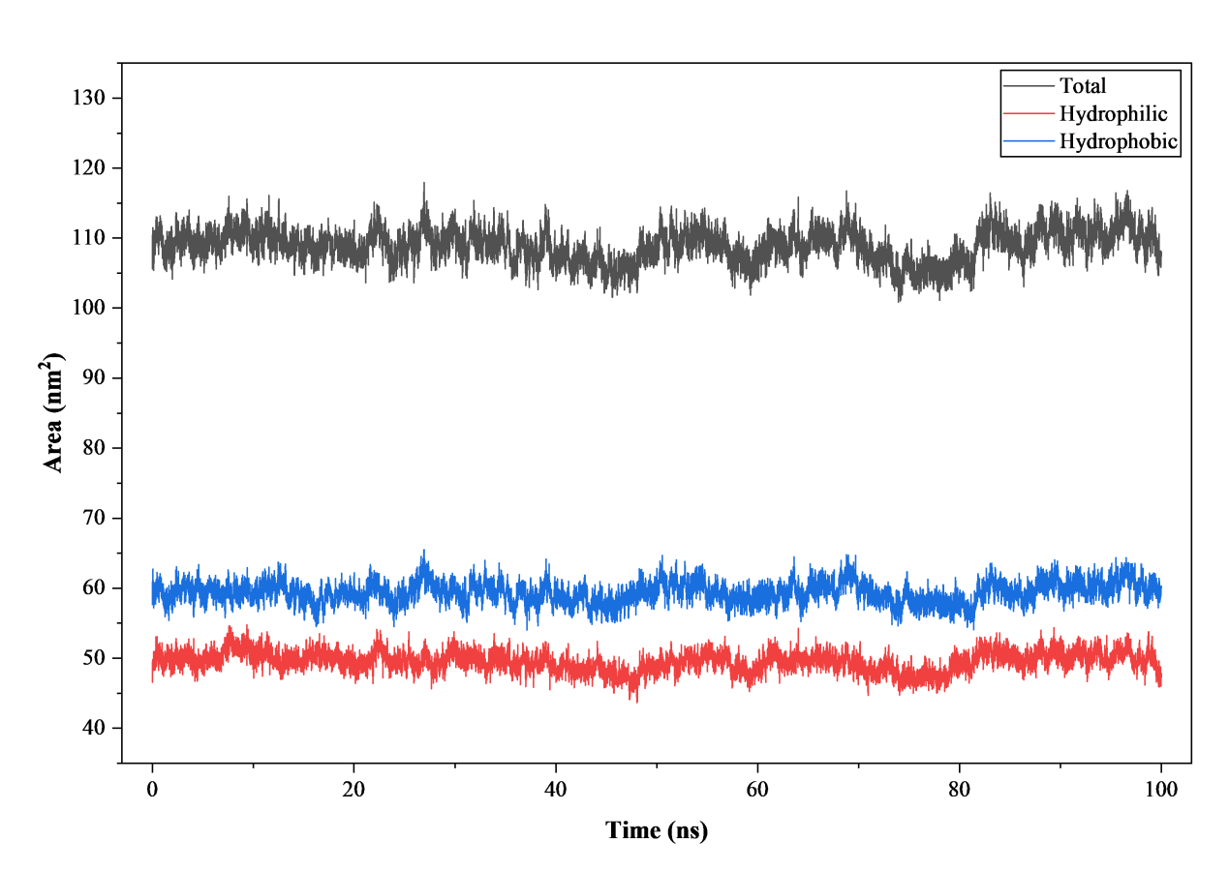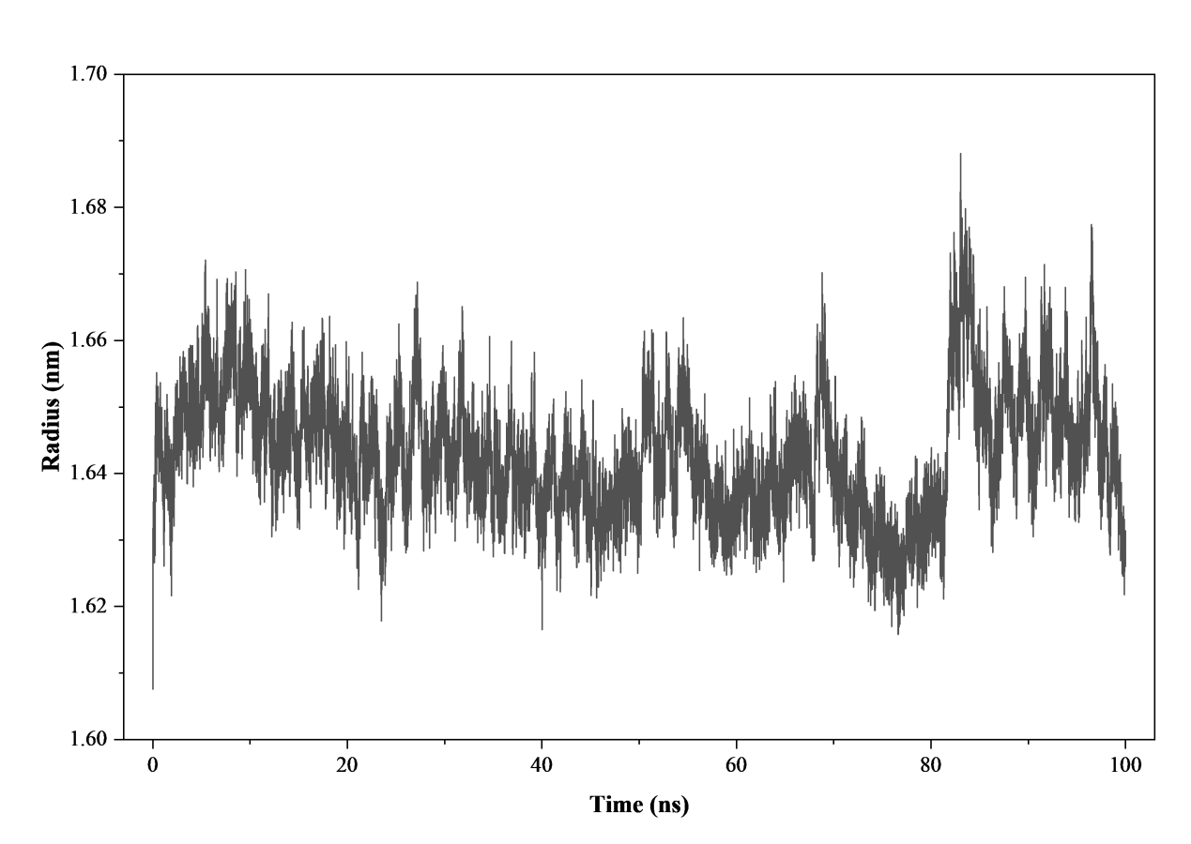
A
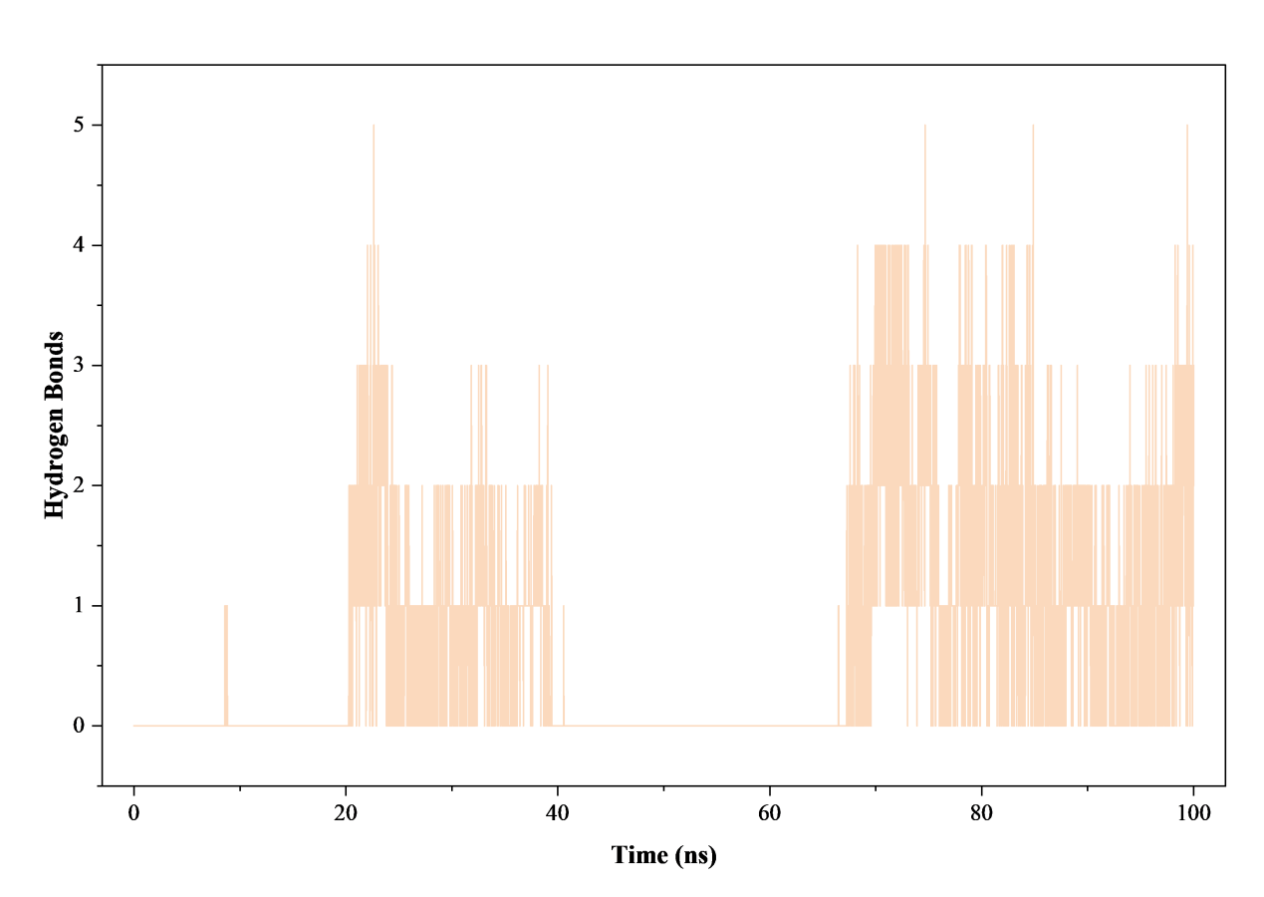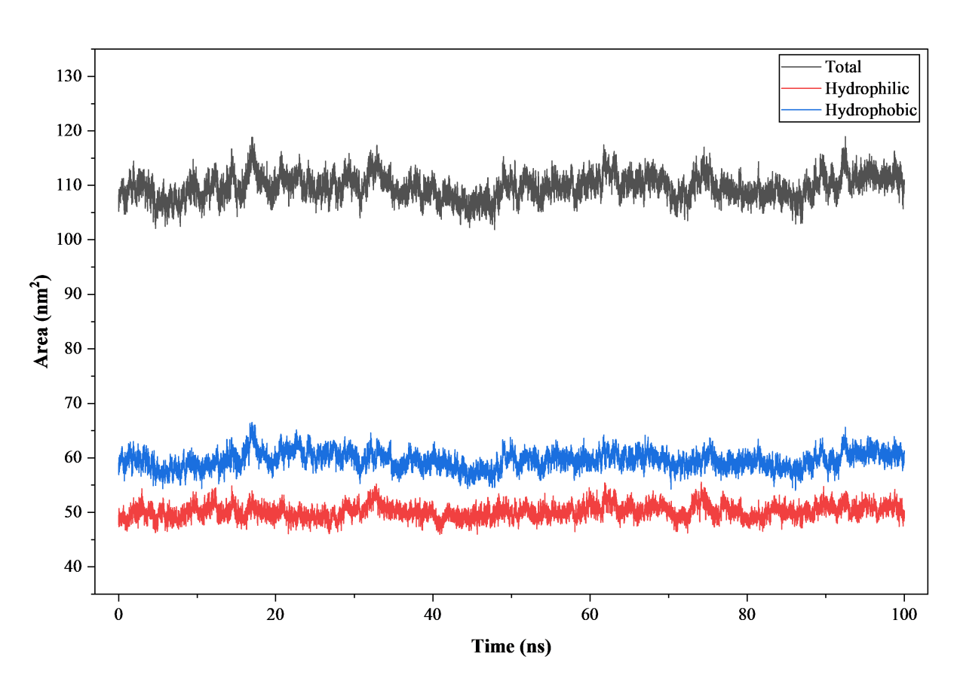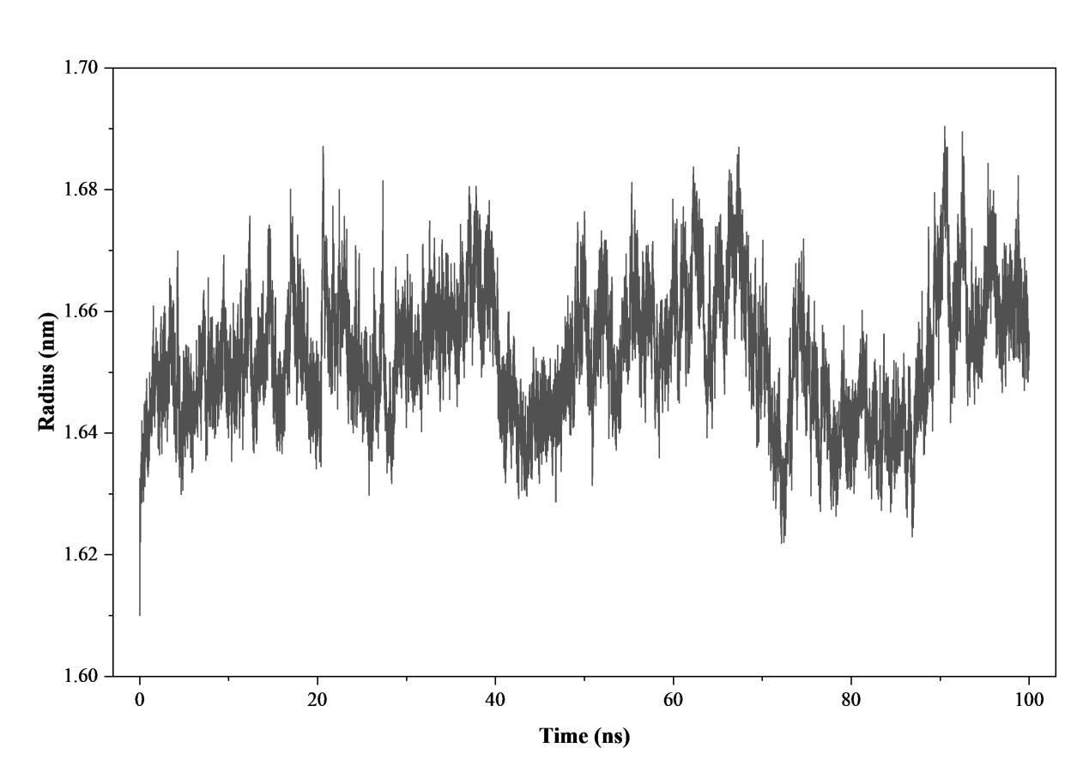
B
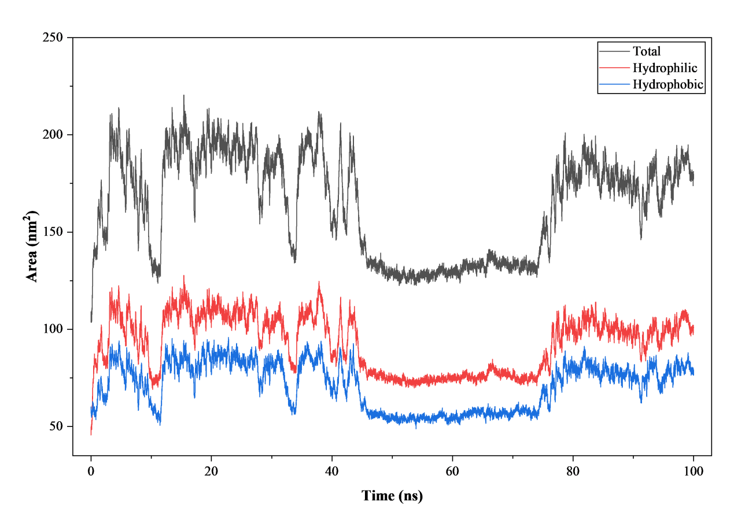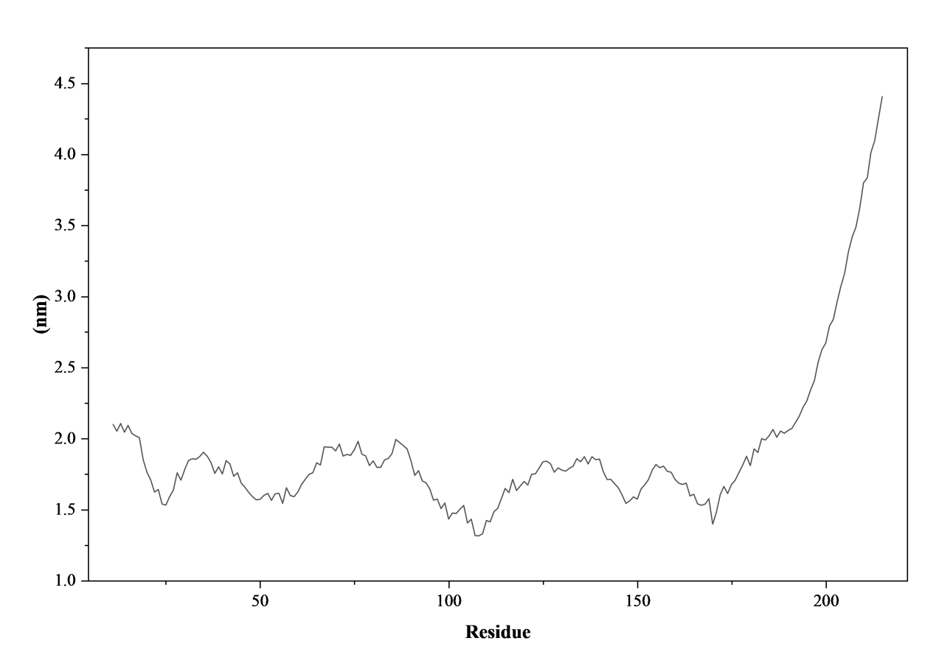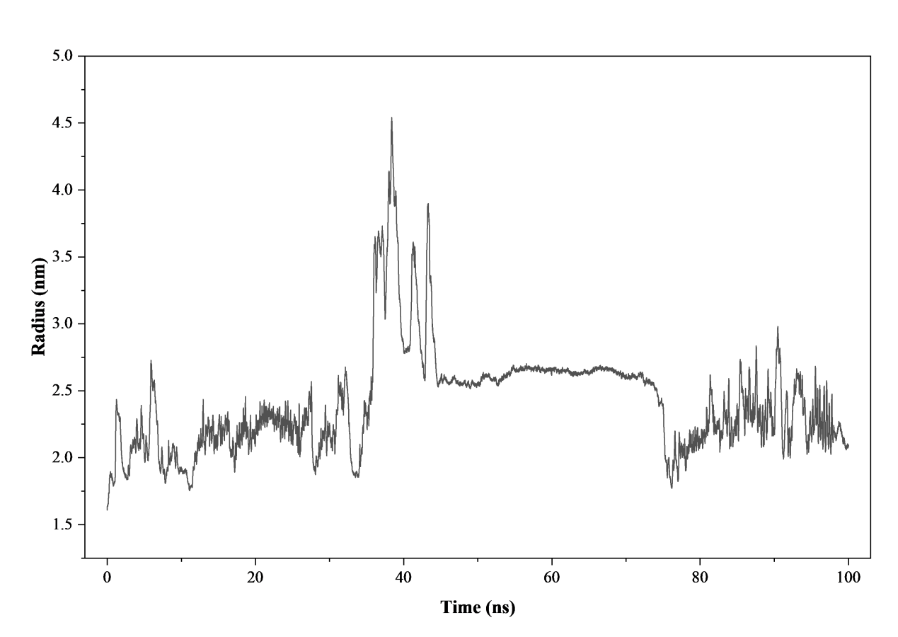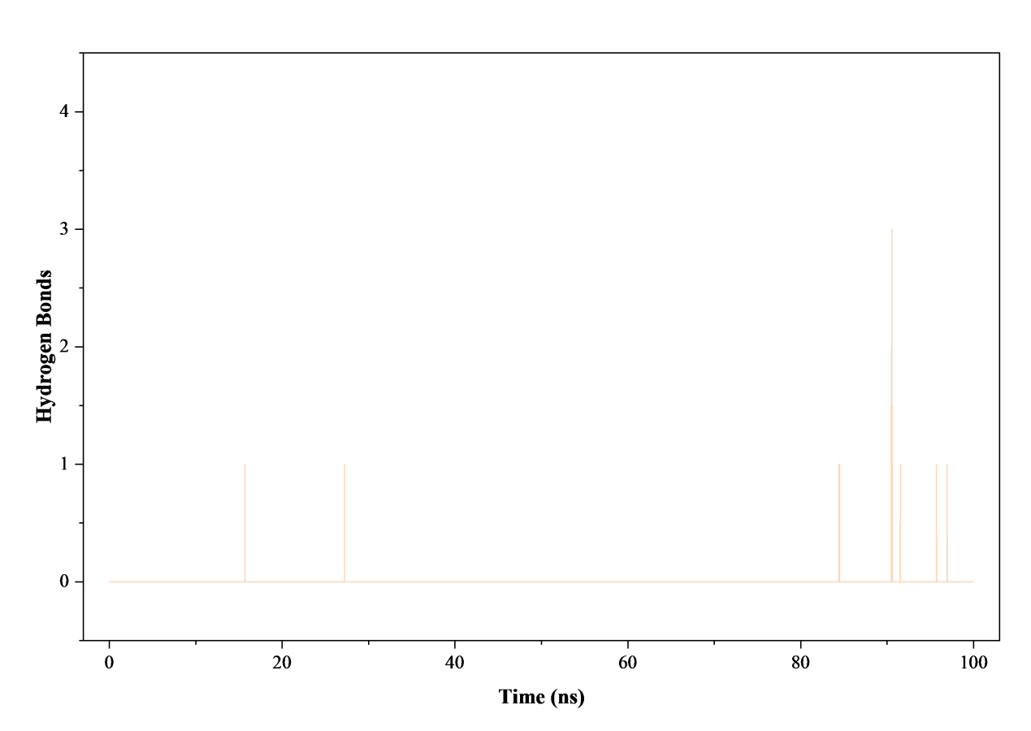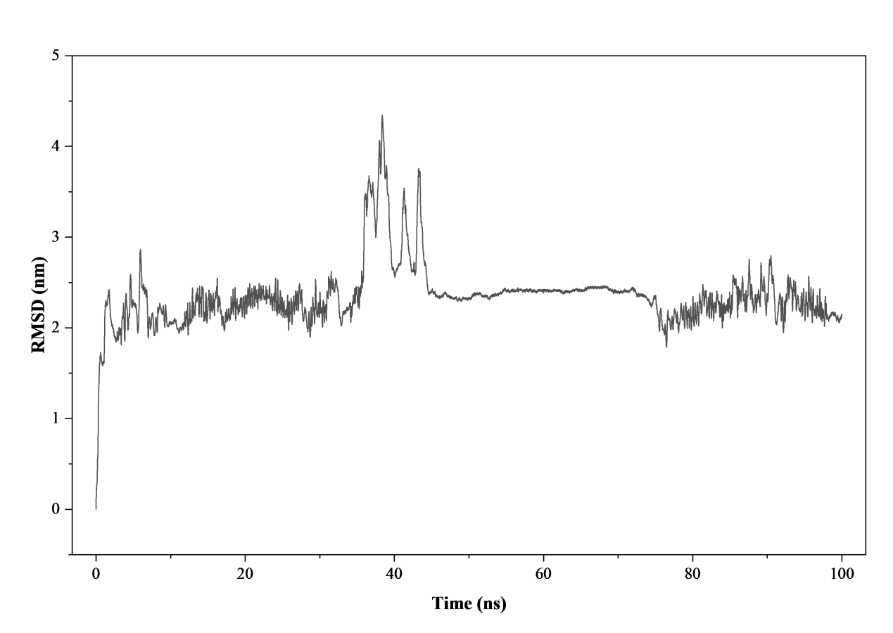
C
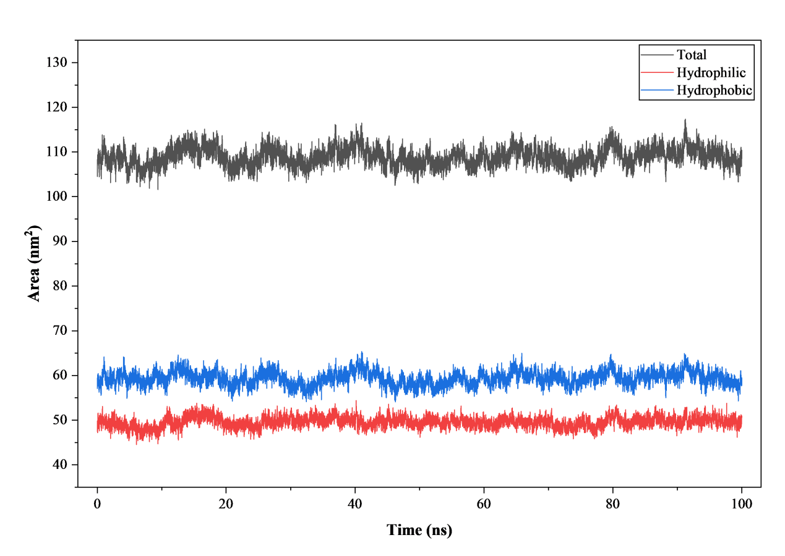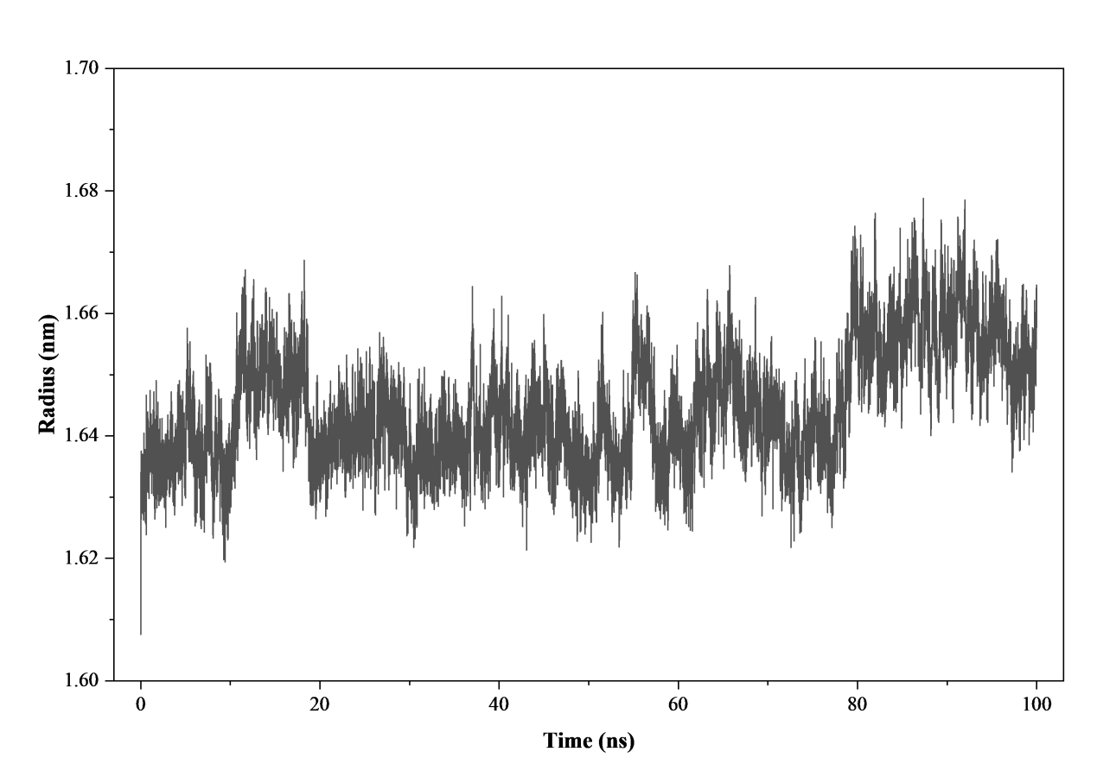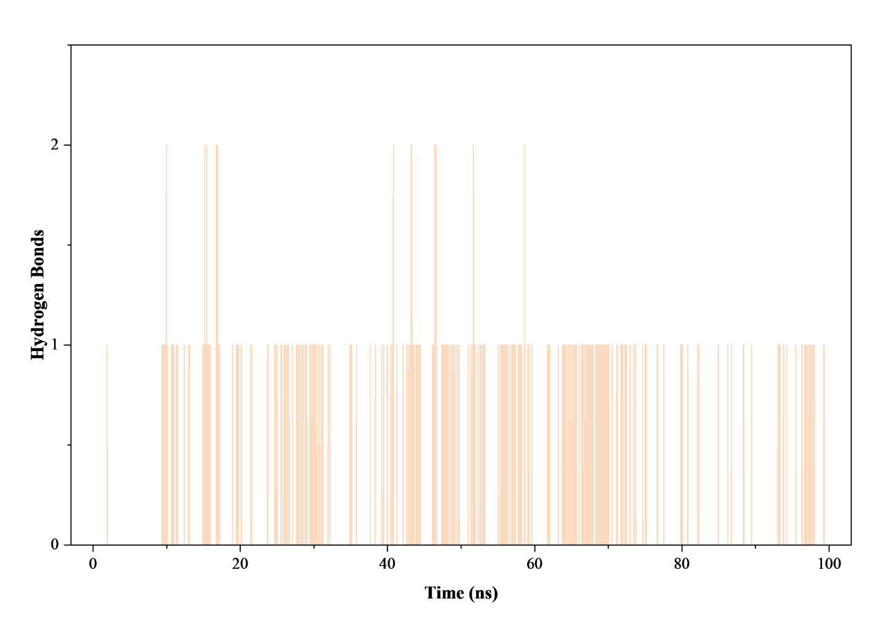
D
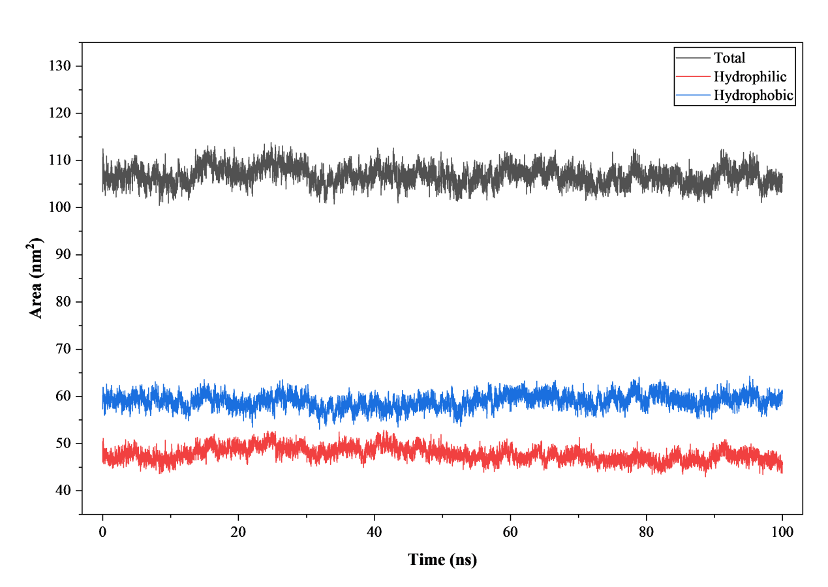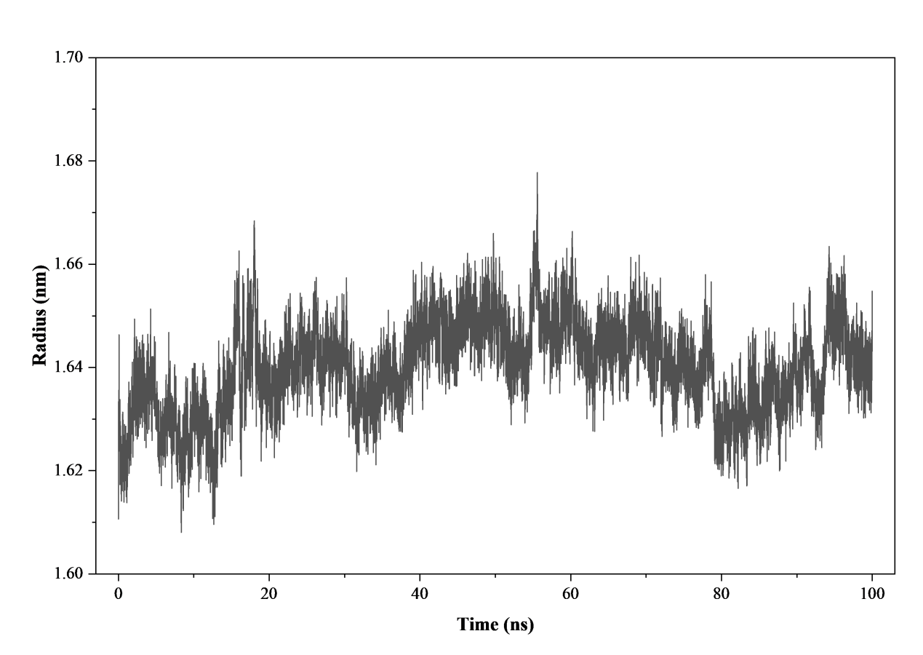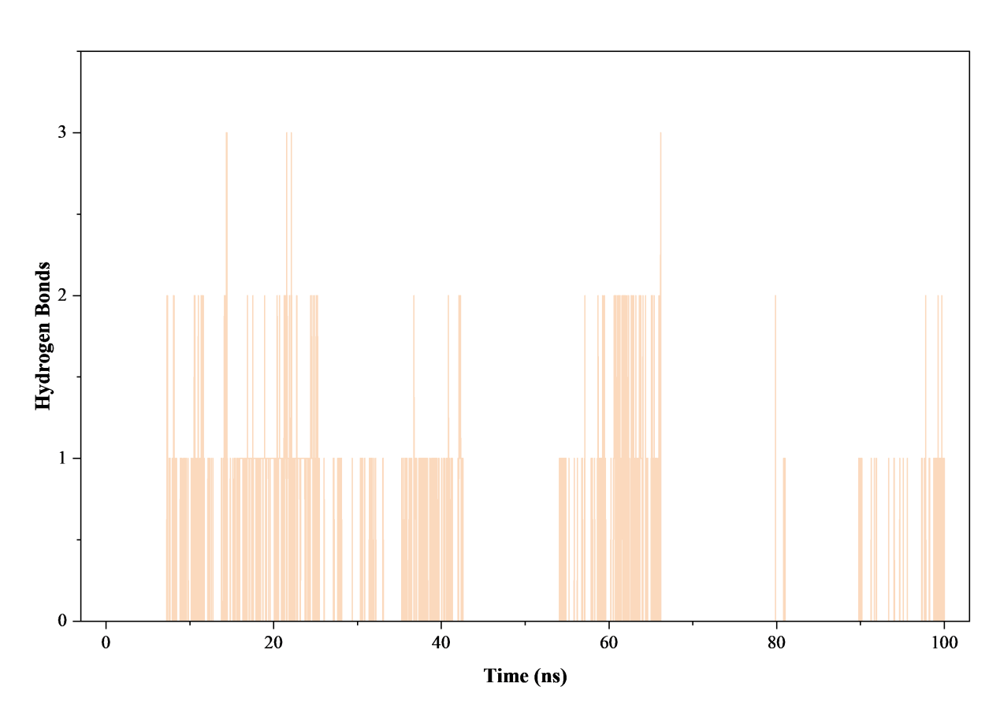
E
Supplementary Figure S7. Structural flexibility and contact dynamics over 100 ns molecular dynamics trajectories. Individual atomistic properties tracking the structural properties of all five protein-ligand complexes evaluated in explicit solvent production runs. Tracking matrices illustrate the time-dependent evolution (0 to 100 ns) of localized radius of gyration (Rg) profiles, individual total/hydrophilic/hydrophobic solvent-accessible surface area (SASA) values, and explicit intermolecular hydrogen bond survival counts for: (A) BRD-A78236793, (B) BRD-K22096725, (C) BRD-K41719870, (D) BRD-K63945320, and (E) BRD-K76694128.

Supplementary Table S1. Binding free energy calculation and thermodynamic components of the candidate compounds targeting THBS1 determined via MM-GBSA.
Compound | VDWAALS_Average | VDWAALS_SD | EEL_Average | EEL_SD | EGB_Average | EGB_SD | ESURF_Average | ESURF_SD | GGAS_Average | GGAS_SD | GSOLV_Average | GSOLV_SD | TOTAL_Average | TOTAL_SD
BRD-A78236793 | -14.32 | 2.61 | -7.68 | 5.07 | 15.8 | 4.42 | -1.99 | 0.4 | -22 | 6.63 | 13.81 | 4.09 | -8.2 | 2.73
BRD-K22096725 | -17.2 | 1.6 | -28.03 | 9.83 | 35.36 | 8.23 | -3.11 | 0.13 | -45.23 | 9.02 | 32.26 | 8.16 | -12.97 | 1.75
BRD-K63945320 | -28.86 | 1.58 | -10.88 | 4.37 | 22.33 | 4.37 | -3.21 | 0.14 | -39.75 | 5.2 | 19.12 | 4.34 | -20.63 | 1.42
BRD-K76694128 | -0.18 | 0.07 | -1.06 | 0.38 | 1.65 | 0.48 | 0 | 0 | -1.25 | 0.41 | 1.65 | 0.48 | 0.41 | 0.11

