Supplementary information

to

Using the interrelationships between rat arterial pulse waveform parameters to study connections/disconnections between NO signaling pathways

Karol Ondrias*

Institute of Clinical and Translational Research, Biomedical Research Center, Slovak Academy of Sciences, Dubravska cesta 9, 845 05 Bratislava, Slovak Republic.
*Correspondence: karol.ondrias@savba.sk;

ORCID
Karol Ondrias https://orcid.org/0000-0001-8329-3563

Definition of 44 arterial pulse waveform parameters (APW-Ps) from SHR rat arterial pulse waveform (APW) (Kurakova et al. 2020; Misak et al. 2025)

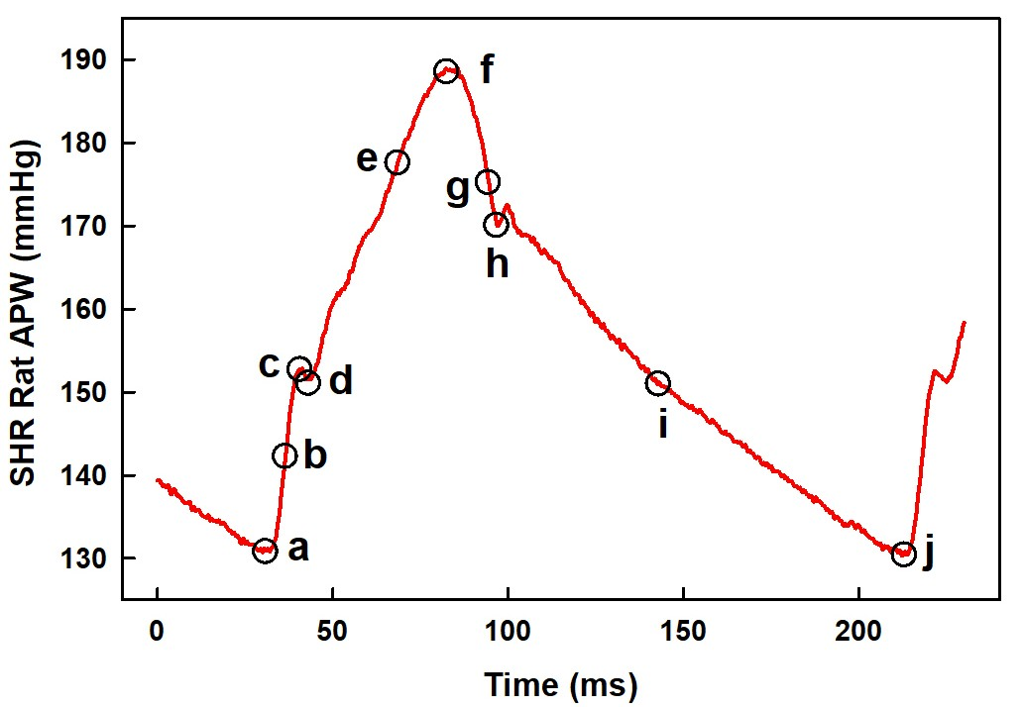

Fig. S1 The left common carotid artery pulse waveform (APW) in the anesthetized SHR rat with marked ten points a - j (black circles)

Ten points a - j are from Fig. S1 and they mark the values of blood pressure and time that are used to define (calculate) specific APW-Ps (Kurakova et al. 2020; Misak et al. 2025).

(a) Systolic blood pressure in mmHg; point c or f.
(b) Heart rate in min^{–1}; 60 / (j – a); (j – a) represents time interval between a and j, a and j are two reference points to diastolic BP value.
(c) Systolic area in mmHg.s; integral BP of a to h; h refers to BP at the dicrotic notch (dicrotic BP).
(d) dP/dt_{max} in mmHg/ms; maximum derivative at the point b; P is BP in mmHg.
(e) dP/dt_{max} relative level; relative level (RL) of point b; (b – a) / (c (or f) – a) in mmHg/mmHg (dimensionless).
(f) dP/dt_{d} in mmHg/ms; negative derivative at the point i; the point i is the BP in the middle of the time interval between h and j.
(g) dP/dt_{d} relative level, relative level of point i; (i – a) / (c (or f) – a) in mmHg/mmHg (dimensionless).
(h) dP/dt_{d} – dP/dt_{max} in s; time interval between b and i, dP/dt_{d} – dP/dt_{max} = (i – b).
(i) dP/dt_{d} – dP/dt_{min} in s; time interval between g and i, dP/dt_{d} – dP/dt_{min} = (i – g); dP/dt_{min} is maximum negative derivative at the point g.
(j) Diastolic blood pressure in mmHg; the point a or j.
(k) Pulse BP in mmHg; (c – a) or (f – a).
(l) Diastolic area in mmHg.s; integral BP of h to j.
(m) dP/dt_{min} in mmHg/ms; dP/dt_{min} is maximum negative derivative at the point g.
(n) dP/dt_{min} relative level, relative level of point g; (g – a) / (c (or f) – a) in mmHg/mmHg (dimensionless).
(o) dP/dt_{min} delay in s; delay in s of point g; (g – a) time interval between a and g.
(p) dP/dt_{d} delay in s; delay in s of point i; (i – a) time interval between a and i.
(q) dP/dt_{d} – dP/dt_{max} in mmHg; (i – b) BP difference between b and i.
(r) dP/dt_{d} – dP/dt_{min} in mmHg; (i – g) BP difference between g and i.
(s) [AnN in ms (point d)] – [Diast. BP in ms (point a)] in ms; (d – a) time interval between d and a.
(t) [AnN in ms (point d)] – [dP/dt in ms (point b)] in ms; (d – b) time interval between d and b.
(u) [dP/dt_{max}, position in ms (point b)] – [Diast. BP in ms (point a)] in ms; (b – a) time interval between b and a.
(v) [Systolic blood pressure in ms (point c or f)] – [Diastolic blood pressure in ms (point a)] in ms;
(w) [Systolic blood pressure in ms (point c or f)] – [dP/dt_{max}, position in ms (point b)] in ms;
(y) [1Max (point c or the 1st. maximum) in mmHg] – Diastolic blood pressure in mmHg; the point a or j. BP interval between 1Max–Dias.BP in mmHg.
(z) [Anacrotic notch in mmHg; BP at the point d] – [Diastolic blood pressure in mmHg; the point a or j]. BP interval between AnN and diastolic BP in mmHg.

(bb) Anacrotic notch in mmHg; BP at the point d.
(cc) Anacrotic notch relative level; relative level of point d; (d – a) / (c (or f) – a) in mmHg/mmHg (dimensionless).
(dd) Anacrotic notch delay in ms; delay in ms of point d; (d – a) time interval between a and d.
(ee) Anacrotic notch relative delay; relative delay (RD) of point d; (d – a) / (j – a) in ms/ms (dimensionless).
(ff) [Dicrotic notch (DiN) in ms] – [Anacrotic notch (AnN) in ms] in ms; (h – d) time interval between d and h.
(gg) [(DiN – AnN) in s] / [dP/dt_{min} in mmHg/µs] in s/(mmHg/µs); (h – d) / g.
(hh) [(DiN – AnN) in s] / [dP/dt_{max} in mmHg/µs] in s/(mmHg/µs); (h – d) / b.
(ii) [AnN in ms] – [1Max (point c or the 1st. maximum) in ms] in ms; (d – c) time interval between c and d.
(jj) Augmentation index relative; (f – c) / (f – a) in mmHg/mmHg (dimensionless)*.
(kk) Dicrotic notch in mmHg; BP at the point h.
(ll) Dicrotic notch relative level; relative level of point h; (h – a) / (c (or f) – a) in mmHg/mmHg (dimensionless).
(mm) Dicrotic notch delay in ms, delay in ms of point h; (h – a).time interval between a and h.
(nn) Dicrotic notch relative delay; relative delay of point h; (h – a) / (j – a); in ms/ms (dimensionless).
(oo) [DiN in mmHg] – [AnN in mmHg] in mmHg; (h – d) BP difference between d and h.
(pp) [(DiN – AnN) in mmHg] / [dP/dt_{min} in mmHg/ms] in mmHg/(mmHg/ms); (h – d) / g.
(qq) [(DiN – AnN) in mmHg] / [dP/dt_{max} in mmHg/ms] in mmHg/(mmHg/ms); (h – d) / b.
(rr) [AnN in mmHg] – [1Max (point c or the 1st. maximum) in mmHg] in mmHg; (d – c) BP difference between c and d.
(ss) [Dicrotic notch (DiN), point h, in ms] – [dP/dt_{d}; position of negative derivative at the point i, in ms], time interval between h and i in ms, (h – i).
(tt) [Dicrotic notch (DiN), point h, in ms] – [dP/dt_{max}, position in ms (point b)]; time interval between h and b in ms, (h–b).

*The plot of augmentation index relative (jj) was not possible to determine in cases when the highest point at APW was “c” and not “f” and it was set to zero (Kurakova et al. 2020; Misak et al. 2025).

Effects of intravenous (i.v.) bolus administration of GSNO

Briefly, the right jugular vein of ISO anesthetized rats was cannulated for intravenous (i.v.) bolus administration of GSNO. The stock solution of NO donor GSNO (160 µmol/L in syringe) prepared in 0.9% saline solution was administered into the right jugular vein (500 µl/kg) over 15 s period. The final concentration in rat was 80 nmol/kg GSNO. The left carotid artery was cannulated for the detection of APW from which 44 APW parameters were evaluated using a microcatheter pressure transducer (Kurakova et al. 2020, Misak et al.2020).

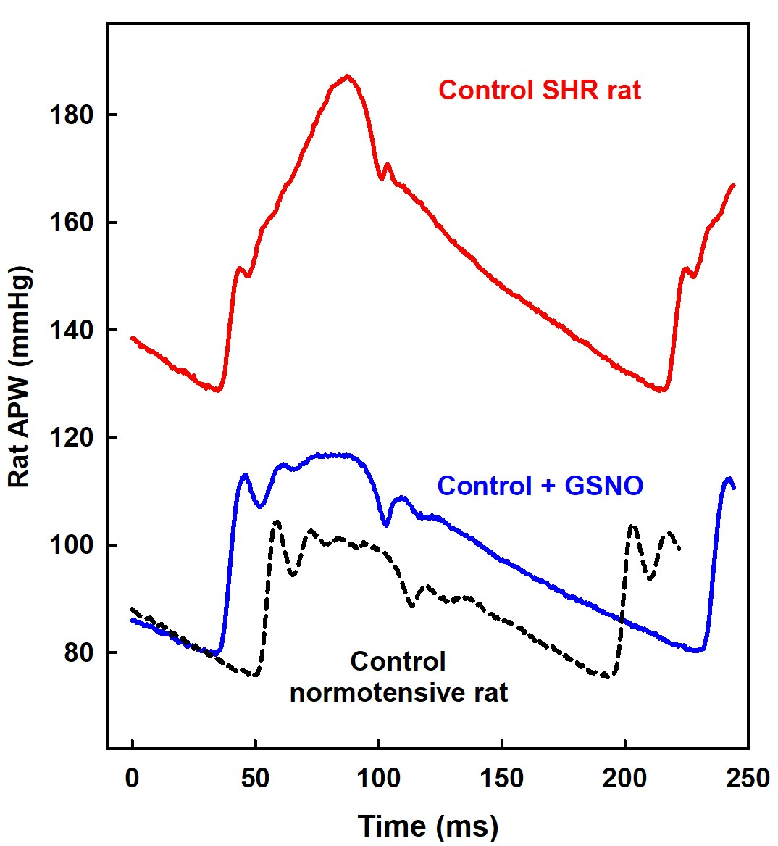

Fig. S2 Time-dependent record of the left common carotid APW of anesthetized SHR rat before (red) and after i.v. bolus administration of 80 nmol/kg S-Nitrosoglutathione (GSNO) recorded at time of maximal decrease of systolic BP (blue). For comparison, an example of time-dependent record of APW of anesthetized normotensive rat is shown (data from Misak et al. 2023, dashed black)

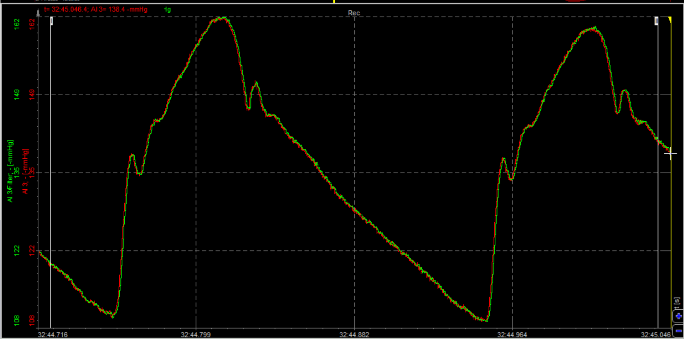

Fig S3A Exp1. The original time-dependent record of the left common carotid APW of anesthetized SHR rat before i.v. administration of 80 nmol/kg GSNO

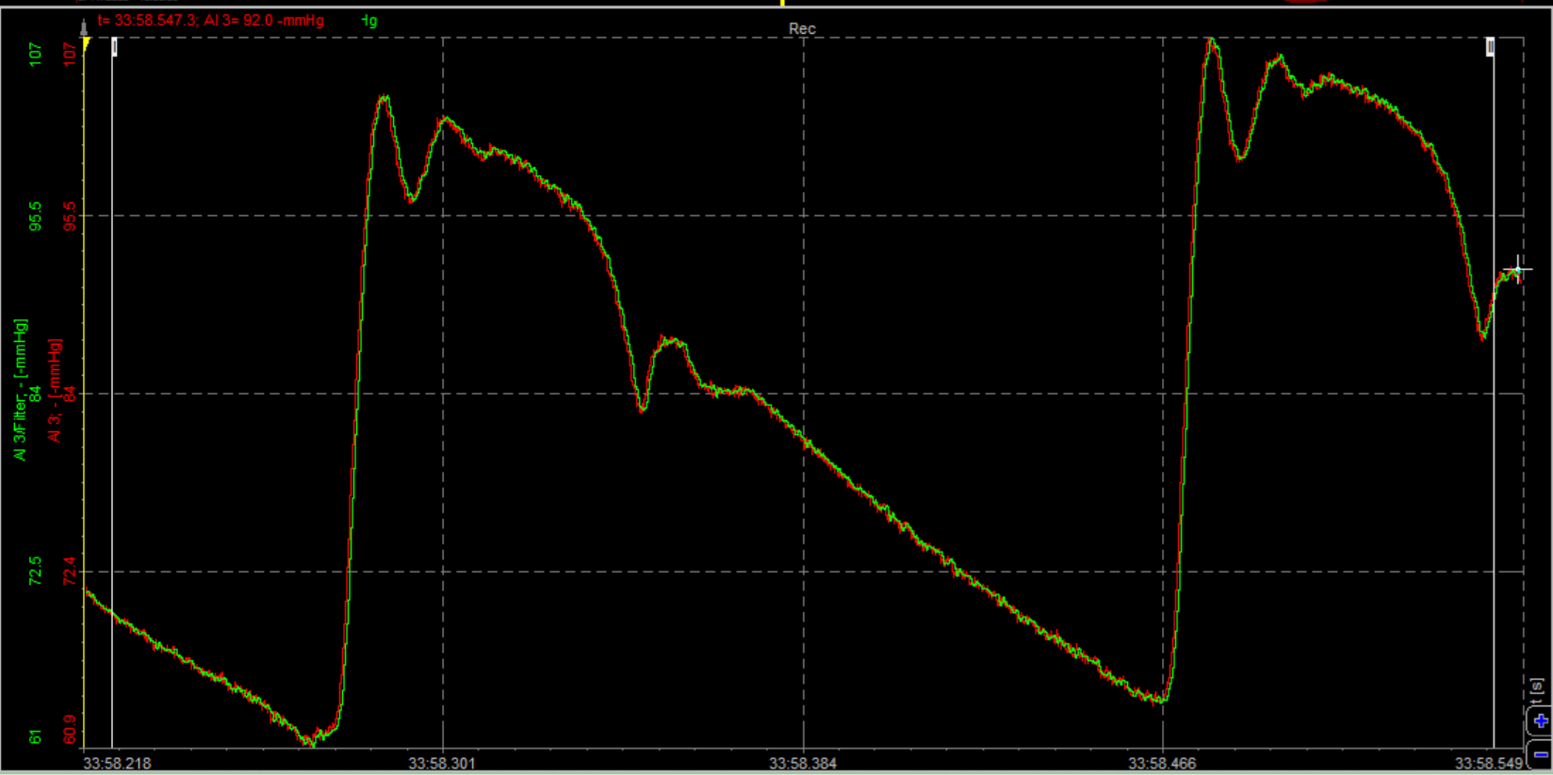

Fig S3B Exp1. Original time-dependent record of the left common carotid APW of anesthetized SHR rat after i.v. administration of 80 nmol/kg GSNO at time of maximal decrease of systolic blood pressure (Sys.BP)

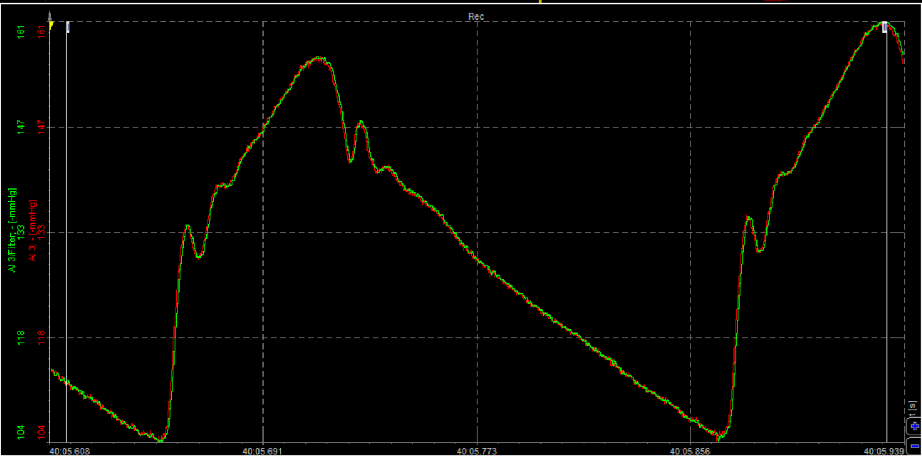

Fig S3C Exp1. Original time-dependent record of the left common carotid APW of anesthetized SHR rat after i.v. administration of 80 nmol/kg GSNO at time when systolic BP returned to approximately control Sys.BP value

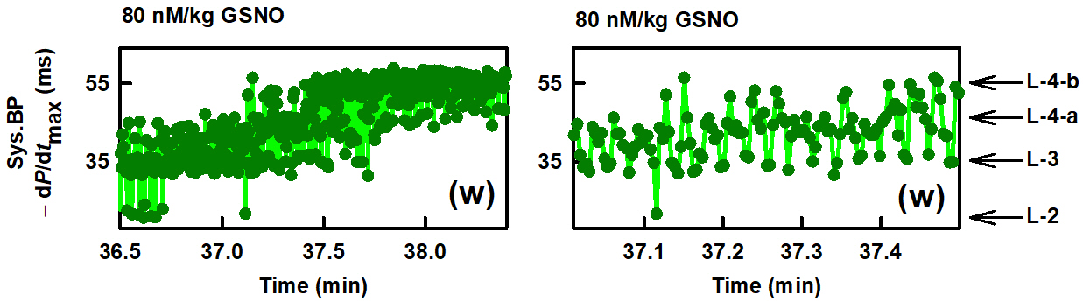

Fig S3D Exp-1. Details of time-dependent fluctuation of APW-P (w) in the presence of 80 nmol/kg GSNO of anesthetized rat. Dark green dots are individual heartbeats, which are mostly not resolved at low resolution (left), but are resolved at high resolution (right). The arrows indicate the proposed levels L-2 and L-3, as well as the subdivided levels L-4-a and L-4-b (n-gital) levels (Misak et al. 2025). Definitions, units, and abbreviations of APW-Ps evaluated from APW are explained in Fig. S1

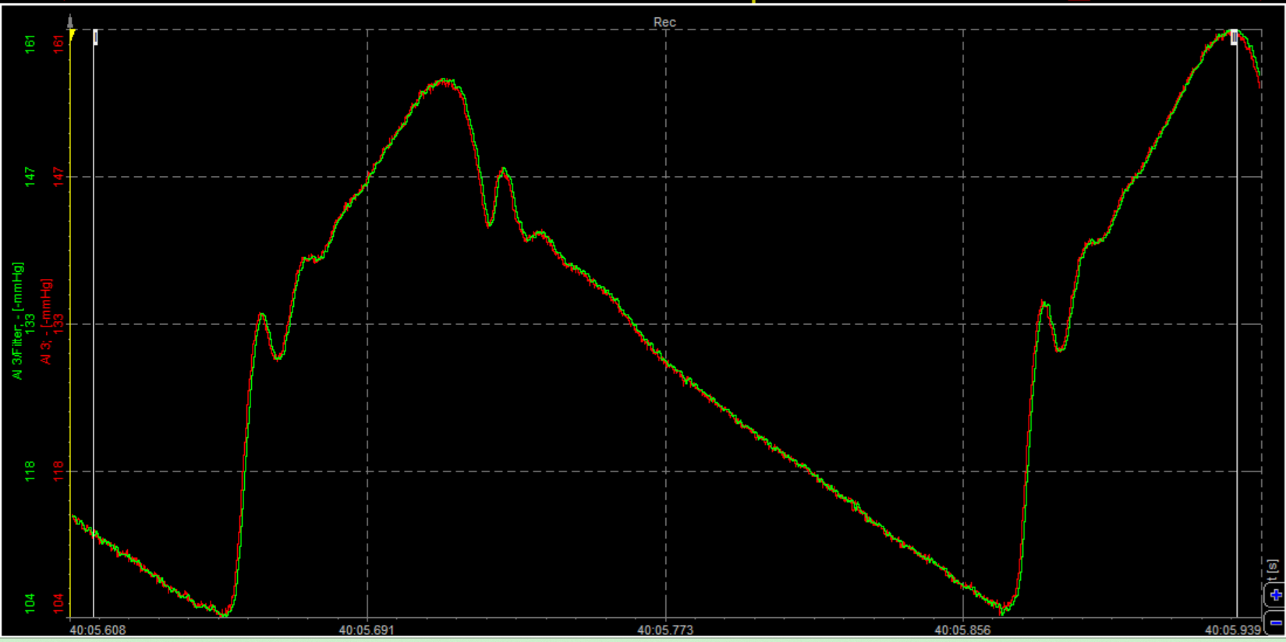

Fig S4A Exp2. The original time-dependent record of the left common carotid APW of anesthetized SHR rat before i.v. administration of 80 nmol/kg GSNO

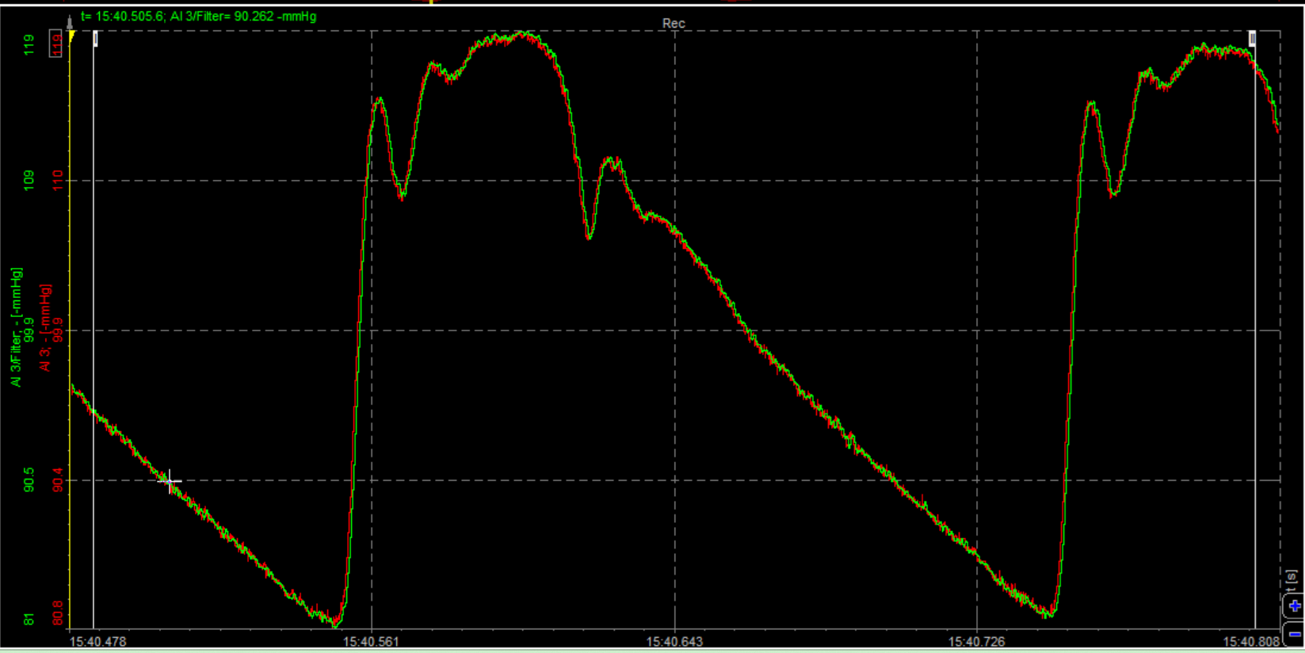

Fig S4B Exp2. Original time-dependent record of the left common carotid APW of anesthetized SHR rat after i.v. administration of 80 nmol/kg GSNO at time of maximal decrease of Sys.BP

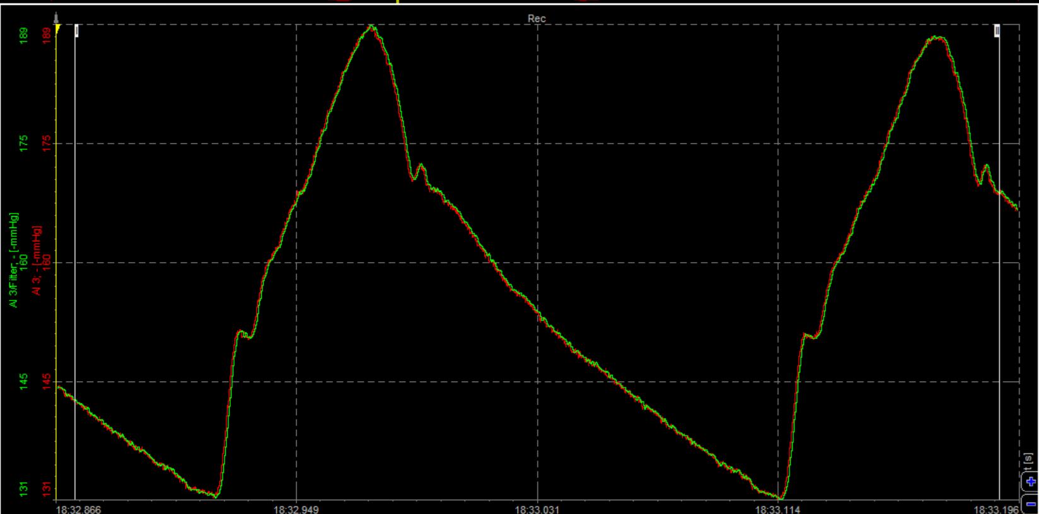

Fig S4C Exp2. Original time-dependent record of the left common carotid APW of anesthetized SHR rat after i.v. administration of 80 nmol/kg GSNO at time when systolic BP returned to approximately control Sys.BP value

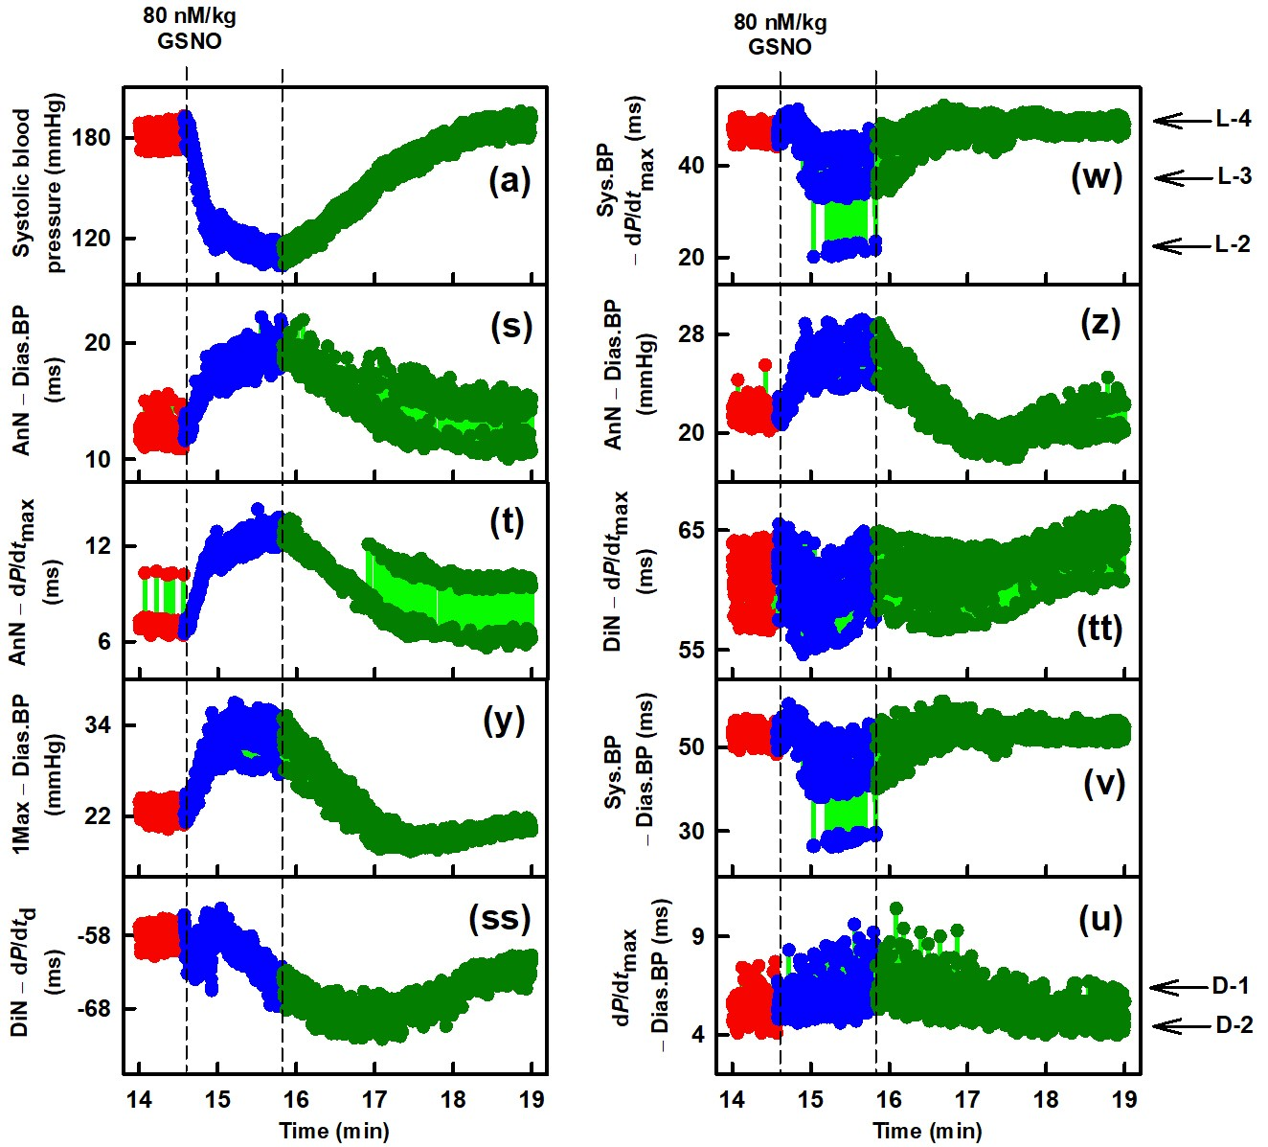

Fig S4D Exp2. Time-dependent changes in ten APW-Ps at control and after i.v. administration of 80 nmol/kg GSNO of anesthetized rat. Red, blue, and dark green dots are individual heartbeats, which are not resolved at this low resolution. The bright green lines show the connection between adjacent heartbeats. Control (red), decreasing (blue) and increasing (dark green) Sys.BP after GSNO administration. Vertical dashed lines indicate administration of GSNO (left dashed line) and minimal value of Sys.BP (right dashed line). Horizontal arrows indicate predicted D-1 and D-2 (di-gital) levels and L-2 to L-4 (n-gital) levels (Misak et al. 2025). Definitions, units, and abbreviations of APW-Ps evaluated from APW are explained in Fig. S1

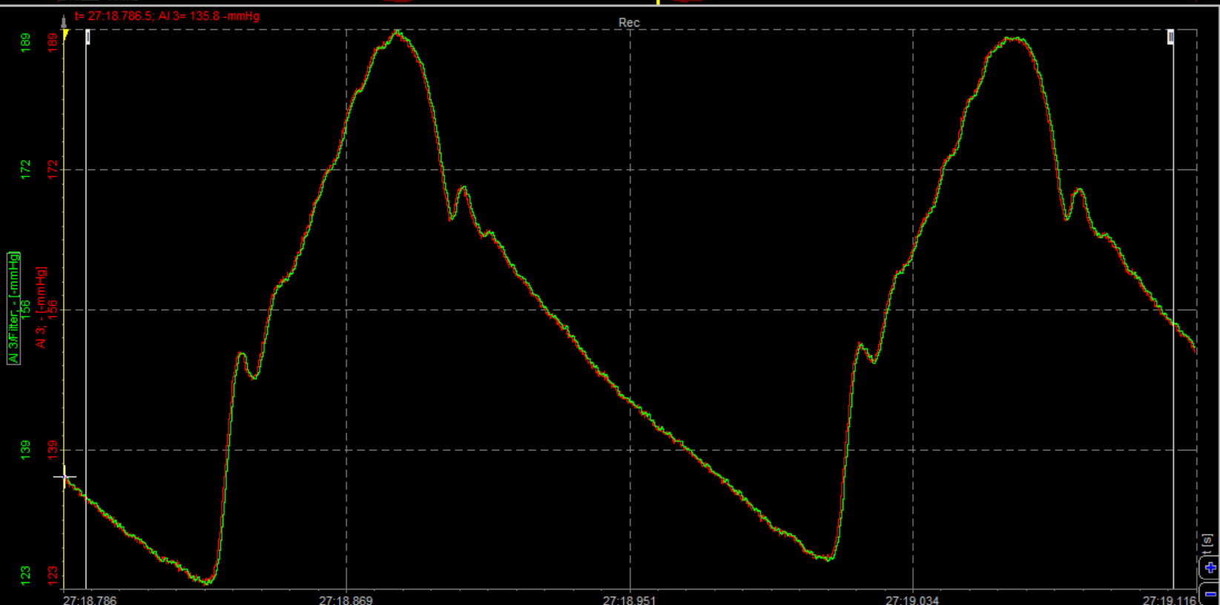

Fig S5A Exp3. The original time-dependent record of the left common carotid APW of anesthetized SHR rat before i.v. administration of 80 nmol/kg GSNO

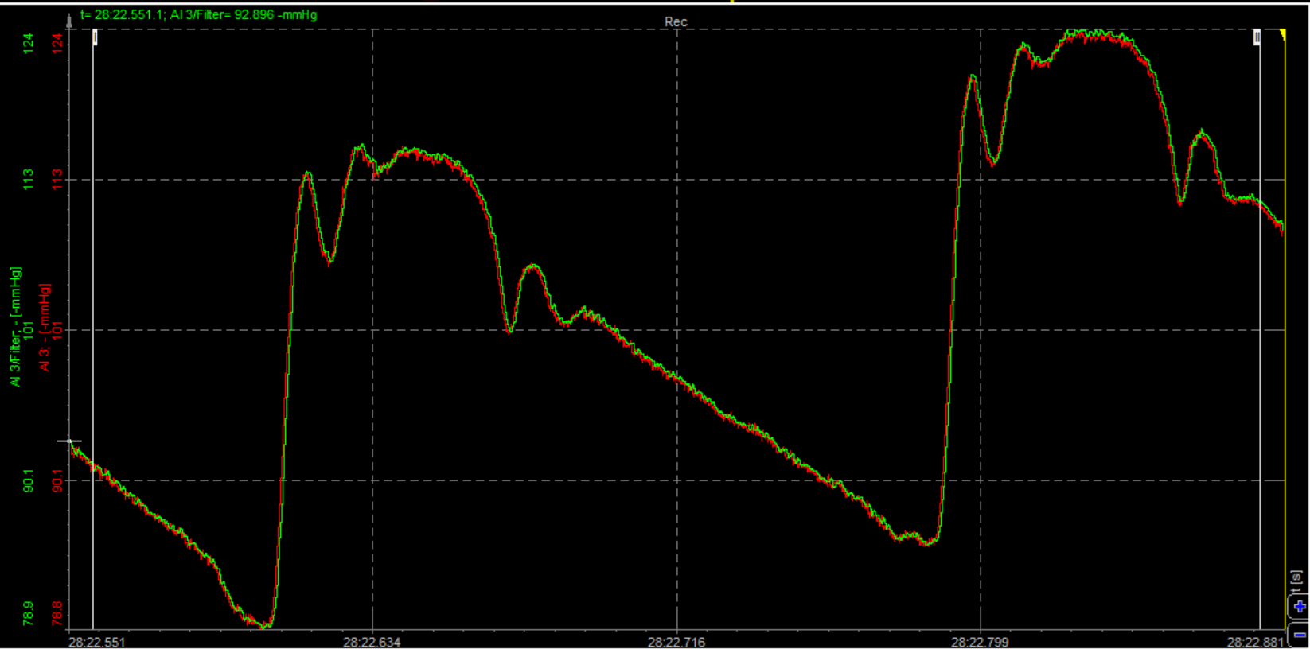

Fig S5B Exp3. Original time-dependent record of the left common carotid APW of anesthetized SHR rat after i.v. administration of 80 nmol/kg GSNO at time of maximal decrease of Sys.BP

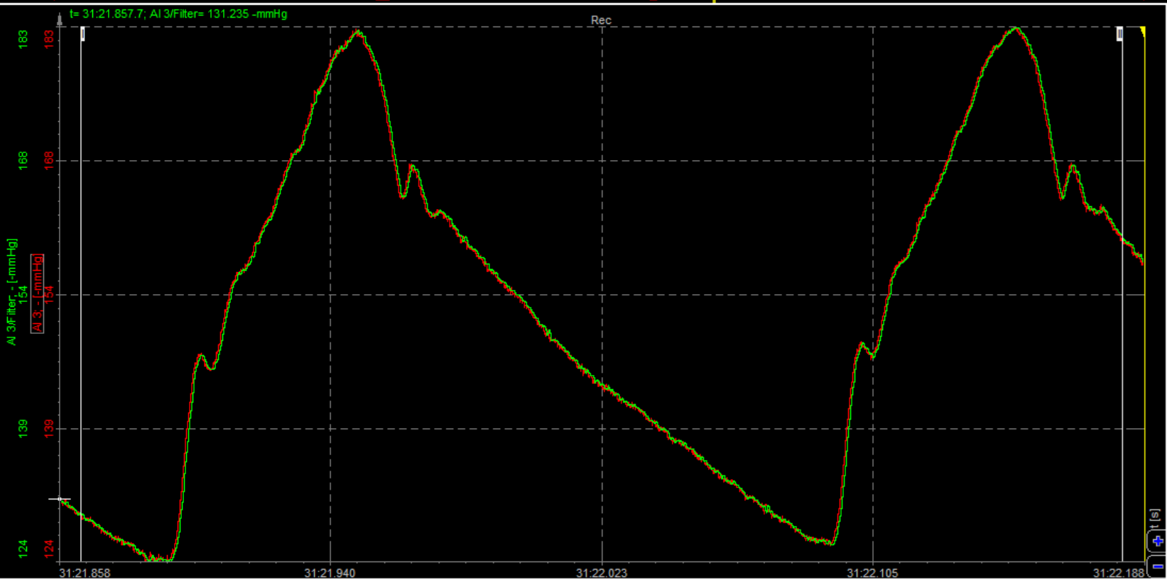

Fig S5C Exp3. Original time-dependent record of the left common carotid APW of anesthetized SHR rat after i.v. administration of 80 nmol/kg GSNO at time when systolic BP returned to approximately control Sys.BP value

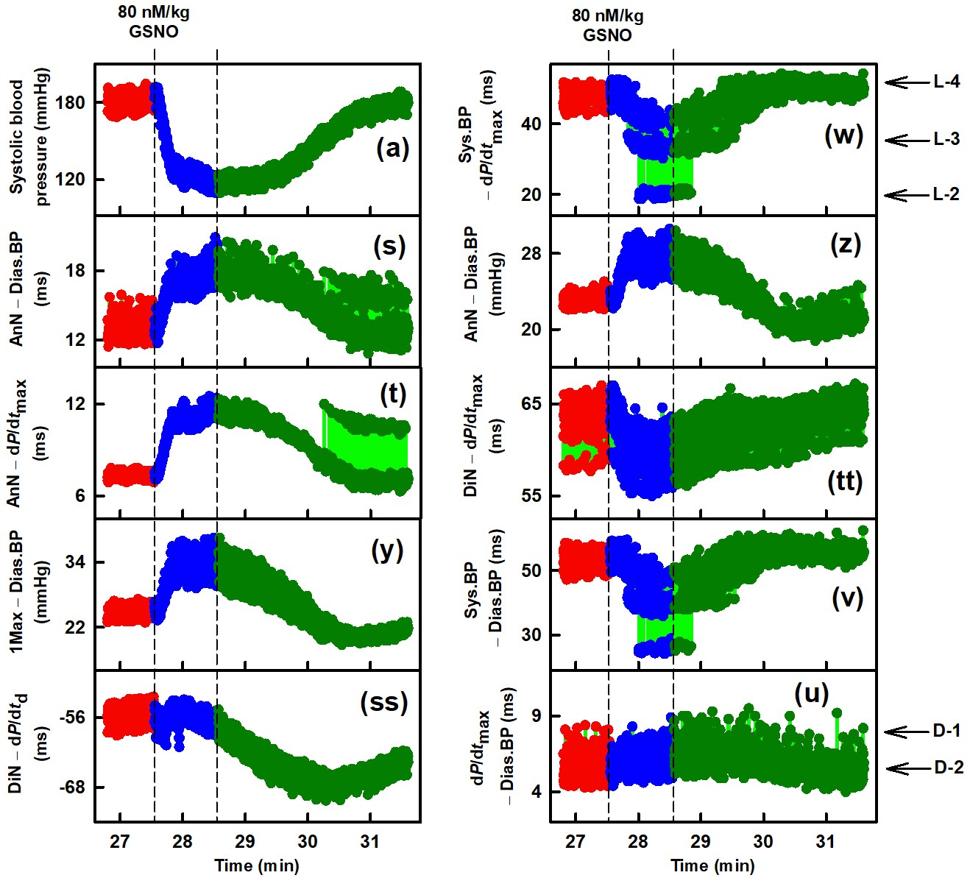

Fig S5D Exp3. Time-dependent changes in ten APW-Ps at control and after i.v. administration of 80 nmol/kg GSNO of anesthetized rat. Red, blue, and dark green dots are individual heartbeats, which are not resolved at this low resolution. The bright green lines show the connection between adjacent heartbeats. Control (red), decreasing (blue) and increasing (dark green) Sys.BP after GSNO administration. Vertical dashed lines indicate administration of GSNO (left dashed line) and minimal value of Sys.BP (right dashed line). Horizontal arrows indicate predicted D-1 and D-2 (di-gital) levels and L-2 to L-4 (n-gital) levels (Misak et al. 2025). Definitions, units, and abbreviations of APW-Ps evaluated from APW are explained in Fig. S1

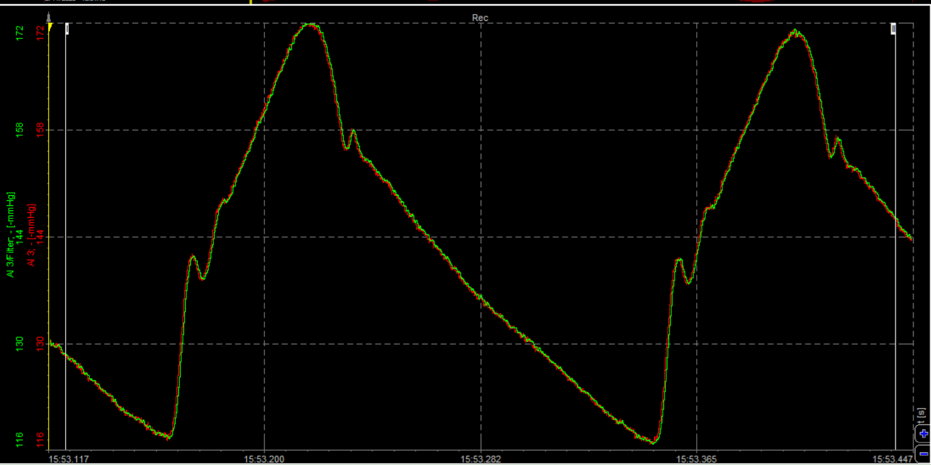

Fig S6A Exp4. The original time-dependent record of the left common carotid APW of anesthetized SHR rat before i.v. administration of 80 nmol/kg GSNO

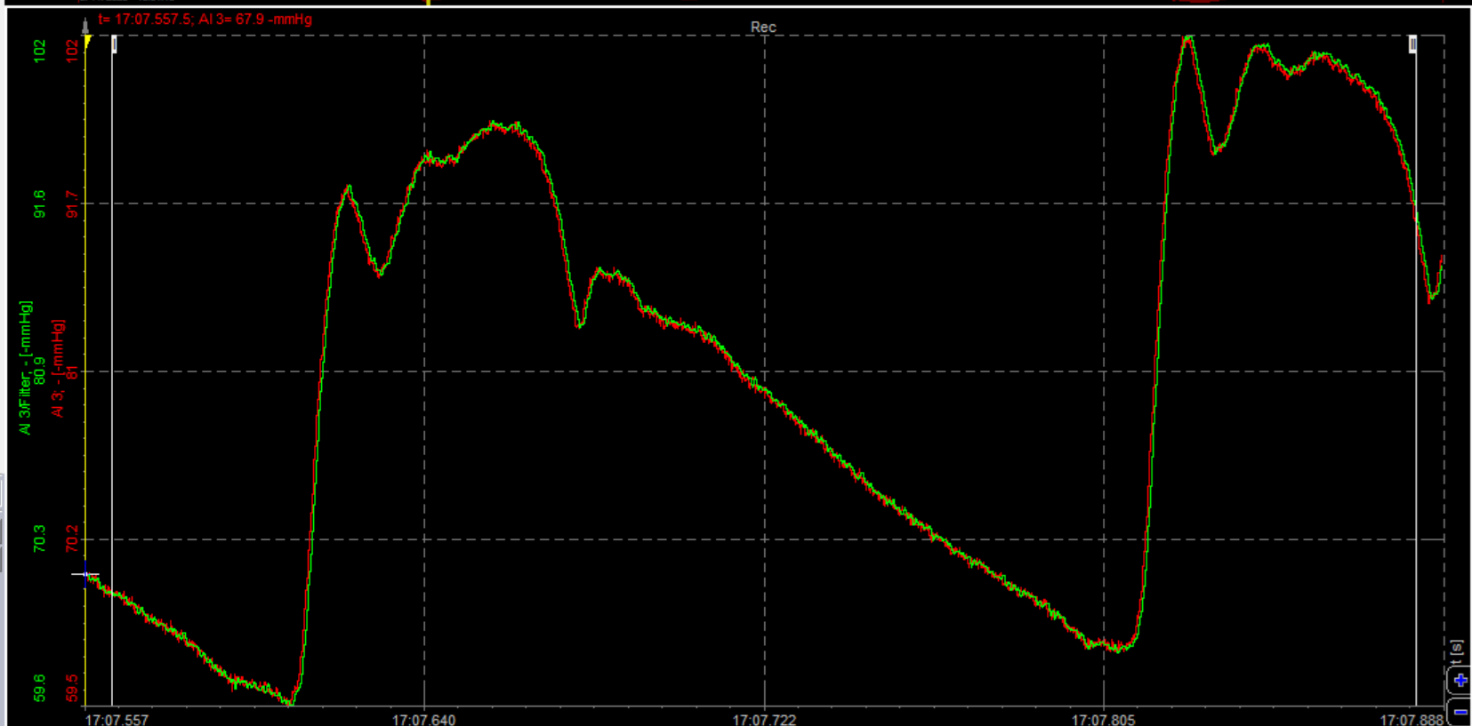

Fig S6B Exp4. Original time-dependent record of the left common carotid APW of anesthetized SHR rat after i.v. administration of 80 nmol/kg GSNO at time of maximal decrease of Sys.BP

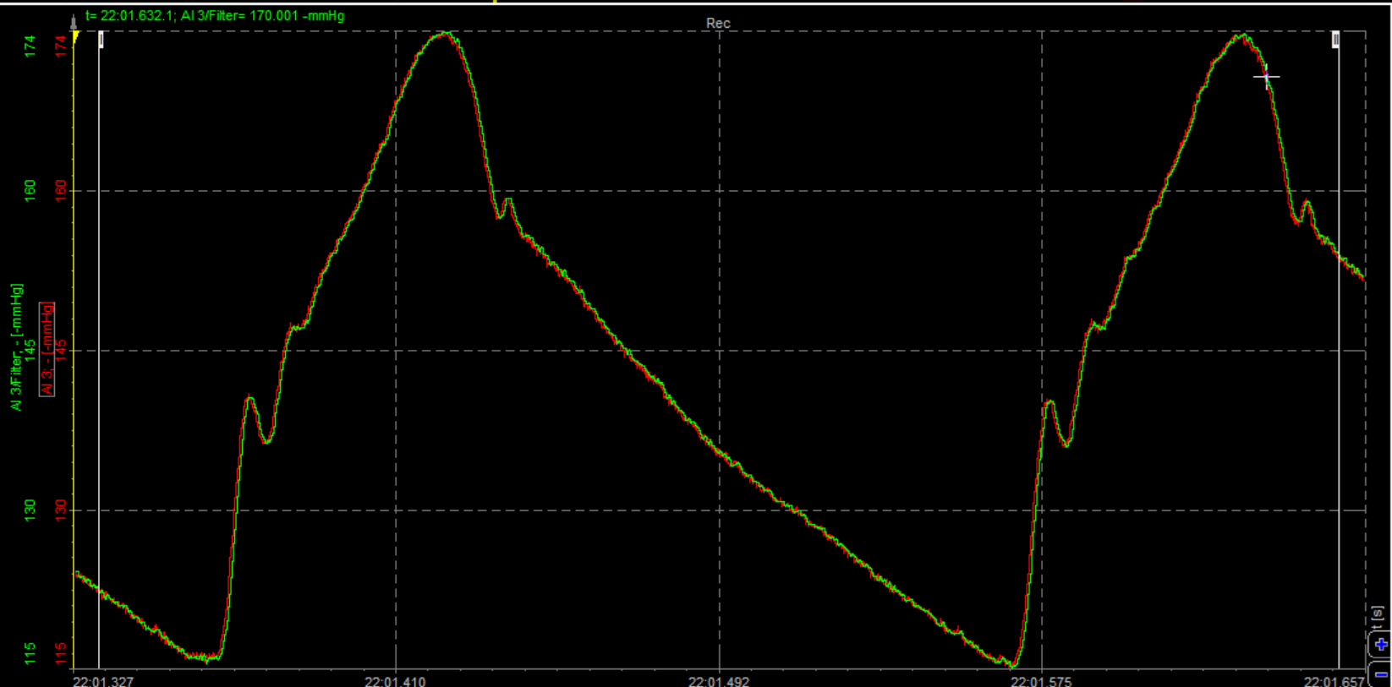

Fig S6C Exp4. Original time-dependent record of the left common carotid APW of anesthetized SHR rat after i.v. administration of 80 nmol/kg GSNO at time when systolic BP returned to approximately control Sys.BP value

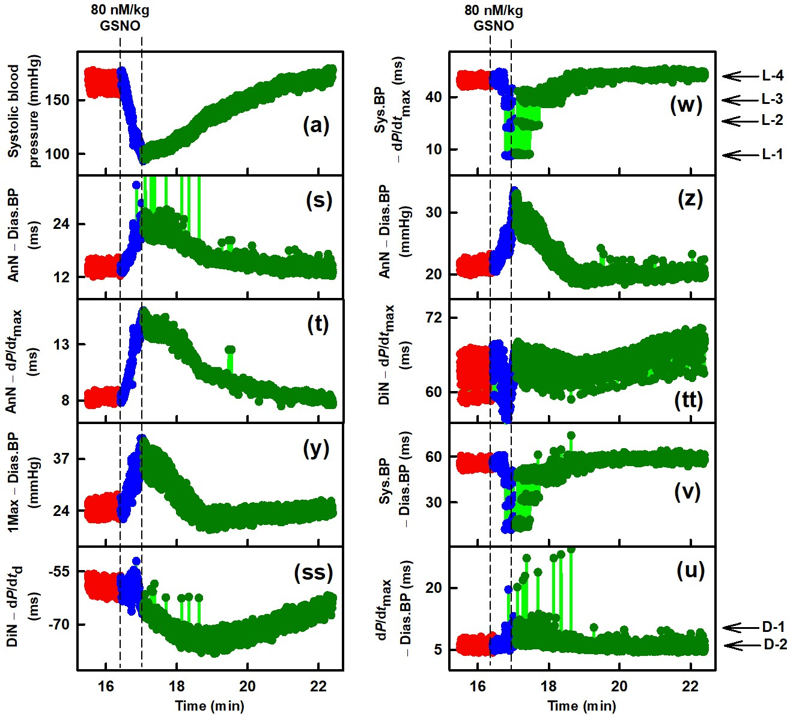

Fig S6D Exp4. Time-dependent changes in ten APW-Ps at control and after i.v. administration of 80 nmol/kg GSNO of anesthetized rat. Red, blue, and dark green dots are individual heartbeats, which are not resolved at this low resolution. The bright green lines show the connection between adjacent heartbeats. Control (red), decreasing (blue) and increasing (dark green) Sys.BP after GSNO administration. Vertical dashed lines indicate administration of GSNO (left dashed line) and minimal value of Sys.BP (right dashed line). Horizontal arrows indicate predicted D-1 and D-2 (di-gital) levels and L-1 to L-4 (n-gital) levels (Misak etal. 2025). Definitions, units, and abbreviations of APW-Ps evaluated from APW are explained in Fig. S1

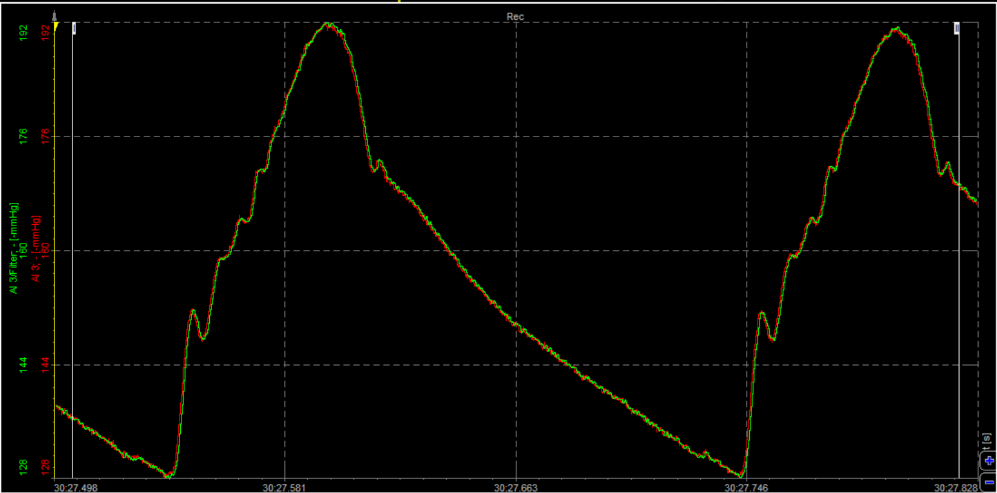

Fig S7A Exp5. The original time-dependent record of the left common carotid APW of anesthetized SHR rat before i.v. administration of 80 nmol/kg GSNO

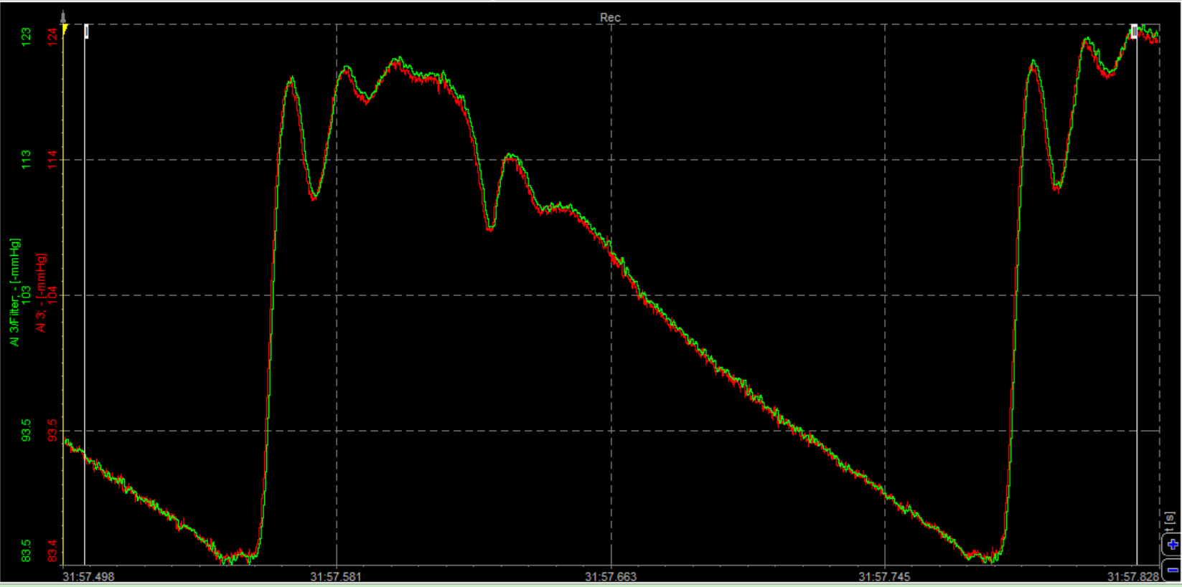

Fig S7B Exp5. Original time-dependent record of the left common carotid APW of anesthetized SHR rat after i.v. administration of 80 nmol/kg GSNO at time of maximal decrease of Sys.BP

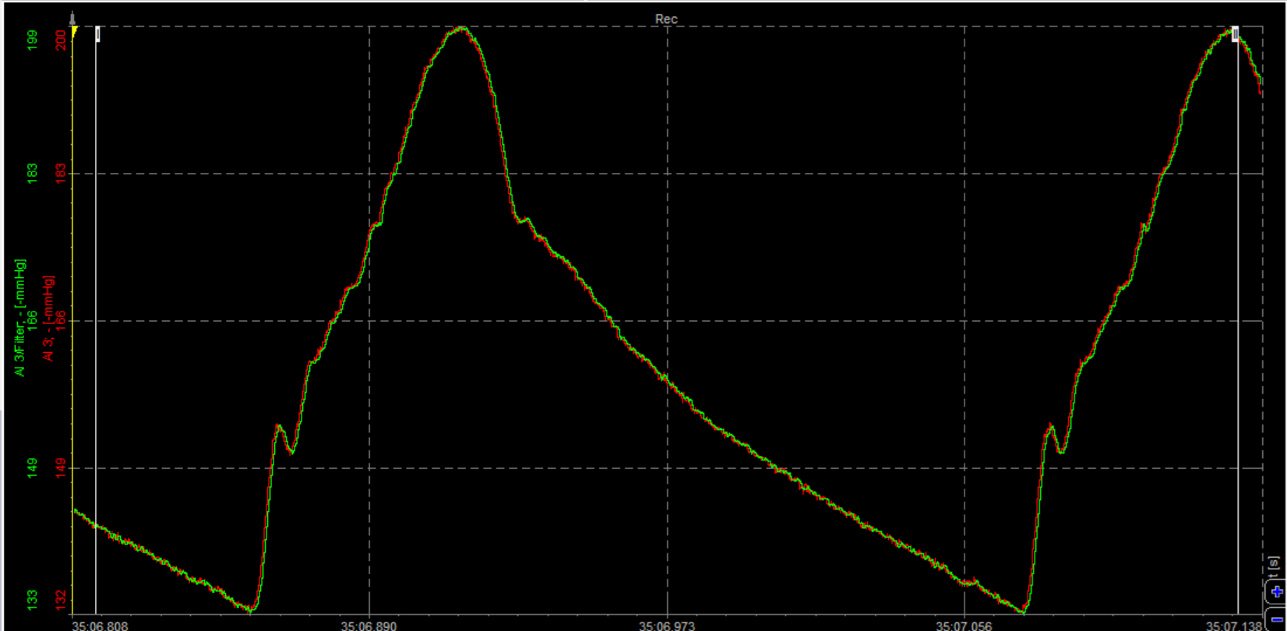

Fig S7C Exp5. Original time-dependent record of the left common carotid APW of anesthetized SHR rat after i.v. administration of 80 nmol/kg GSNO at time when systolic BP returned to approximately control Sys.BP value

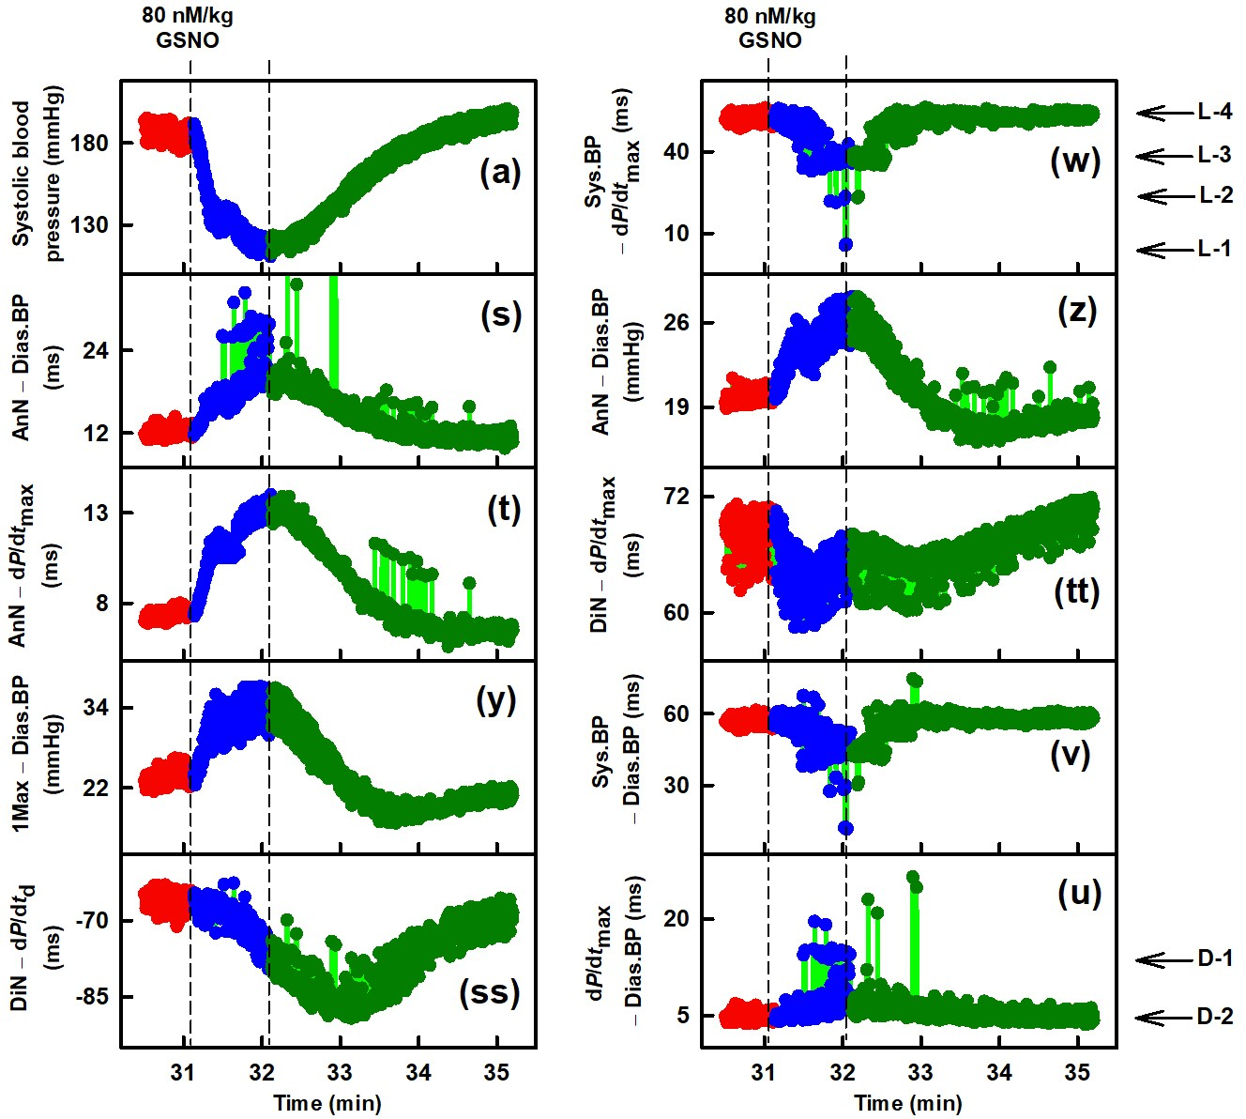

Fig S7D Exp5. Time-dependent changes in ten APW-Ps at control and after i.v. administration of 80 nmol/kg GSNO of anesthetized rat. Red, blue, and dark green dots are individual heartbeats, which are not resolved at this low resolution. The bright green lines show the connection between adjacent heartbeats. Control (red), decreasing (blue) and increasing (dark green) Sys.BP after GSNO administration. Vertical dashed lines indicate administration of GSNO (left dashed line) and minimal value of Sys.BP (right dashed line). Horizontal arrows indicate predicted D-1 and D-2 (di-gital) levels and L-1 to L-4 (n-gital) levels (Misak et al. 2025). Definitions, units, and abbreviations of APW-Ps evaluated from APW are explained in Fig. S1

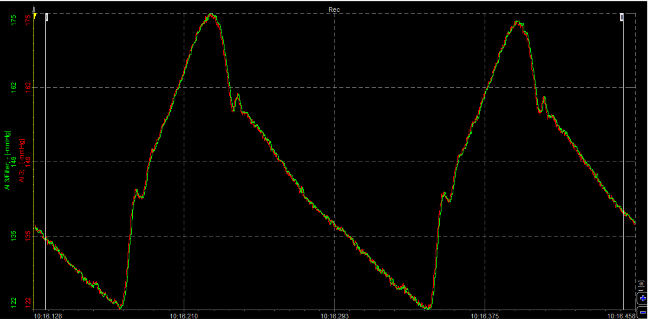

Fig S8A Exp6. The original time-dependent record of the left common carotid APW of anesthetized SHR rat before i.v. administration of 80 nmol/kg GSNO

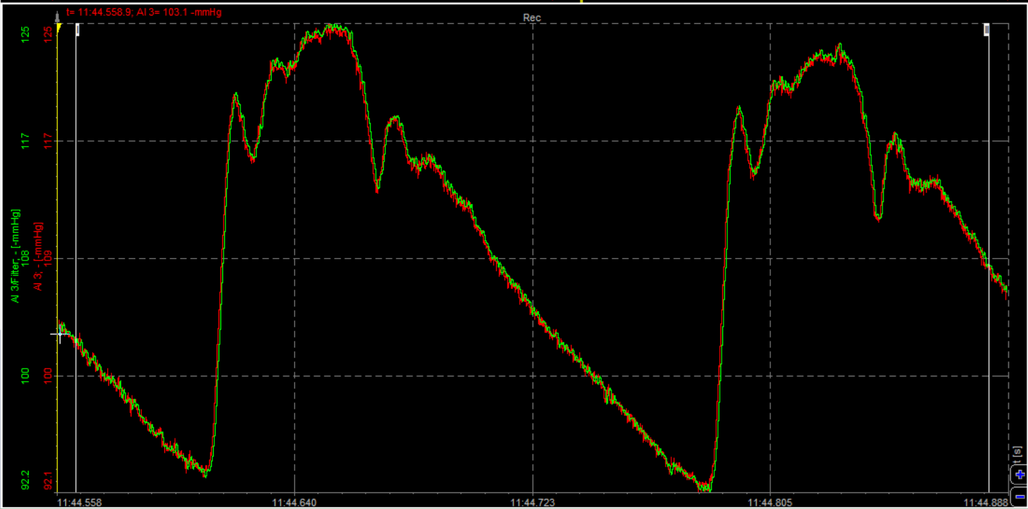

Fig S8B Exp6. Original time-dependent record of the left common carotid APW of anesthetized SHR rat after i.v. administration of 80 nmol/kg GSNO at time of maximal decrease of Sys.BP

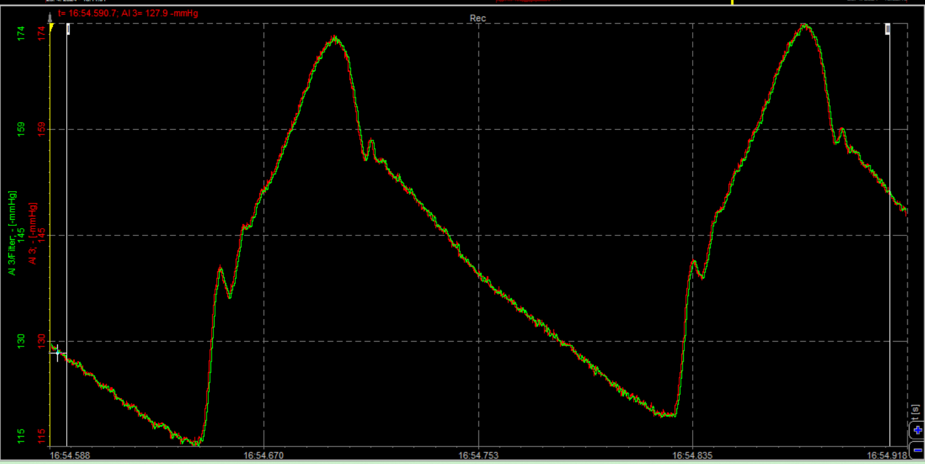

Fig S8C Exp6. Original time-dependent record of the left common carotid APW of anesthetized SHR rat after i.v. administration of 80 nmol/kg GSNO at time when systolic BP returned to approximately control Sys.BP value

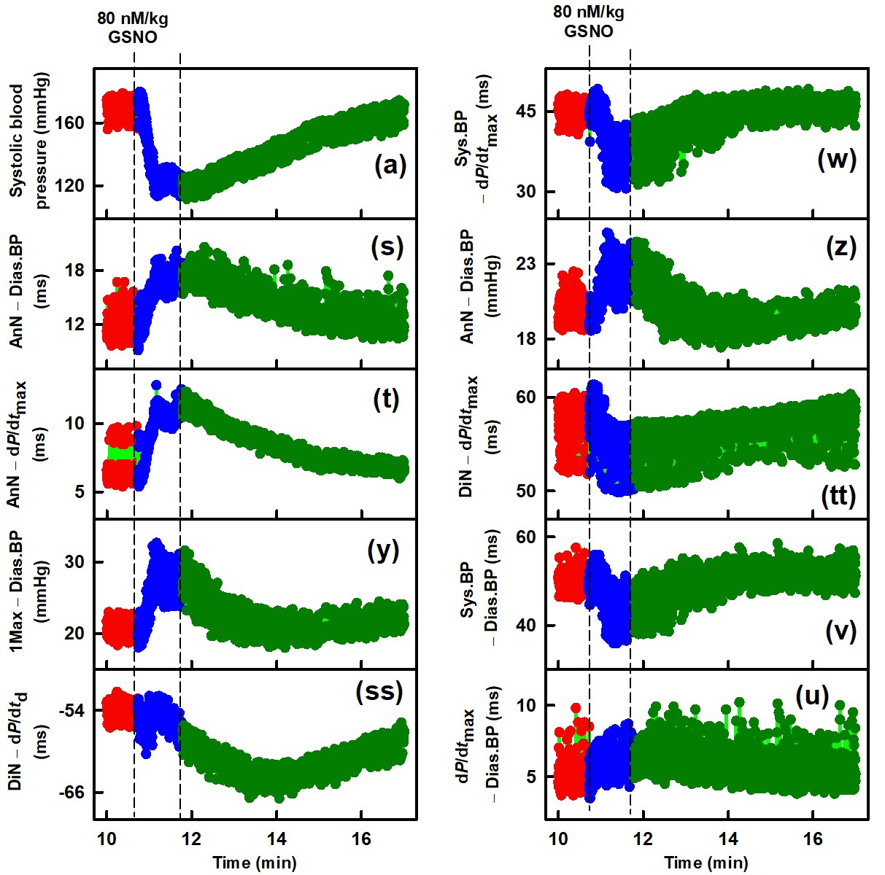

Fig S8D Exp6. Time-dependent changes in ten APW-Ps at control and after i.v. administration of 80 nmol/kg GSNO of anesthetized rat. Red, blue, and dark green dots are individual heartbeats, which are not resolved at this low resolution. The bright green lines show the connection between adjacent heartbeats. Control (red), decreasing (blue) and increasing (dark green) Sys.BP after GSNO administration. Vertical dashed lines indicate administration of GSNO (left dashed line) and minimal value of Sys.BP (right dashed line). Definitions, units, and abbreviations of APW-Ps evaluated from APW are explained in Fig. S1

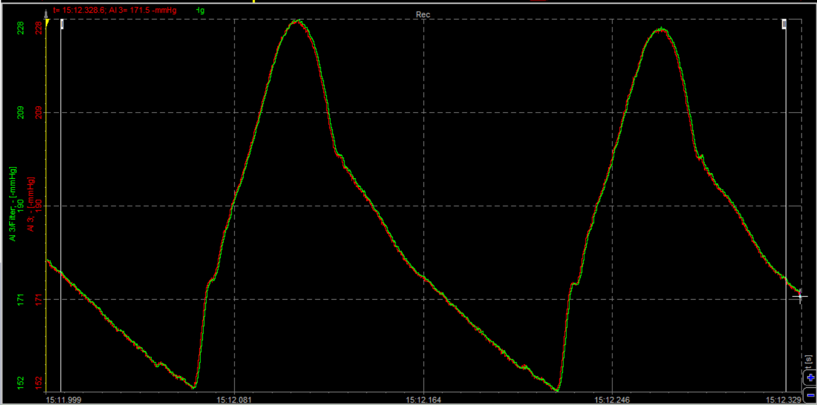

Fig S9A Exp7. The original time-dependent record of the left common carotid APW of anesthetized SHR rat before i.v. administration of 80 nmol/kg GSNO

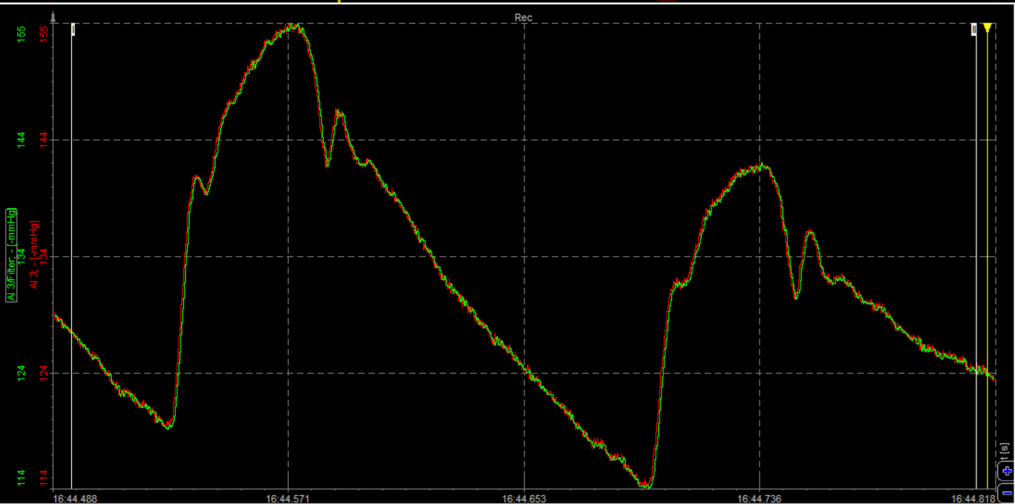

Fig S9B Exp7. Original time-dependent record of the left common carotid APW of anesthetized SHR rat after i.v. administration of 80 nmol/kg GSNO at time of maximal decrease of Sys.BP

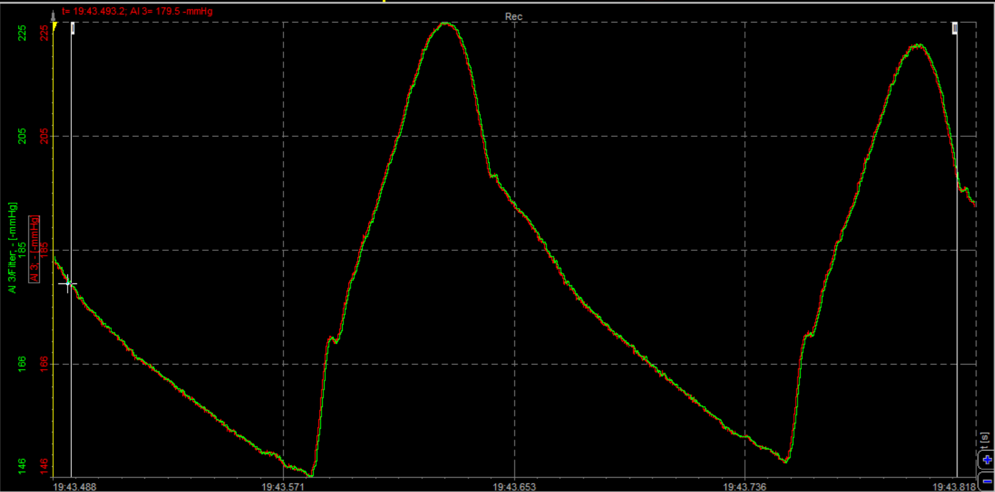

Fig S9C Exp7. Original time-dependent record of the left common carotid APW of anesthetized SHR rat after i.v. administration of 80 nmol/kg GSNO at time when systolic BP returned to approximately control Sys.BP value

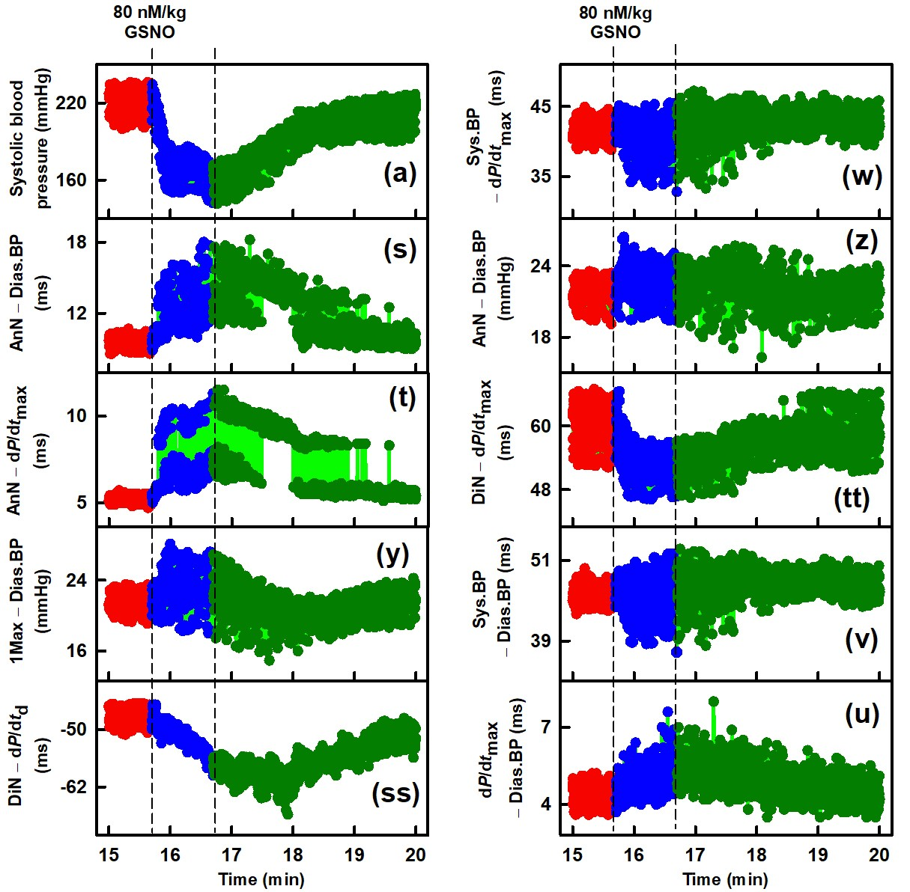

Fig S9D Exp7. Time-dependent changes in ten APW-Ps at control and after i.v. administration of 80 nmol/kg GSNO of anesthetized rat. Red, blue, and dark green dots are individual heartbeats, which are not resolved at this low resolution. The bright green lines show the connection between adjacent heartbeats. Control (red), decreasing (blue) and increasing (dark green) Sys.BP after GSNO administration. Vertical dashed lines indicate administration of GSNO (left dashed line) and minimal value of Sys.BP (right dashed line). Definitions, units, and abbreviations of APW-Ps evaluated from APW are explained in Fig. S1

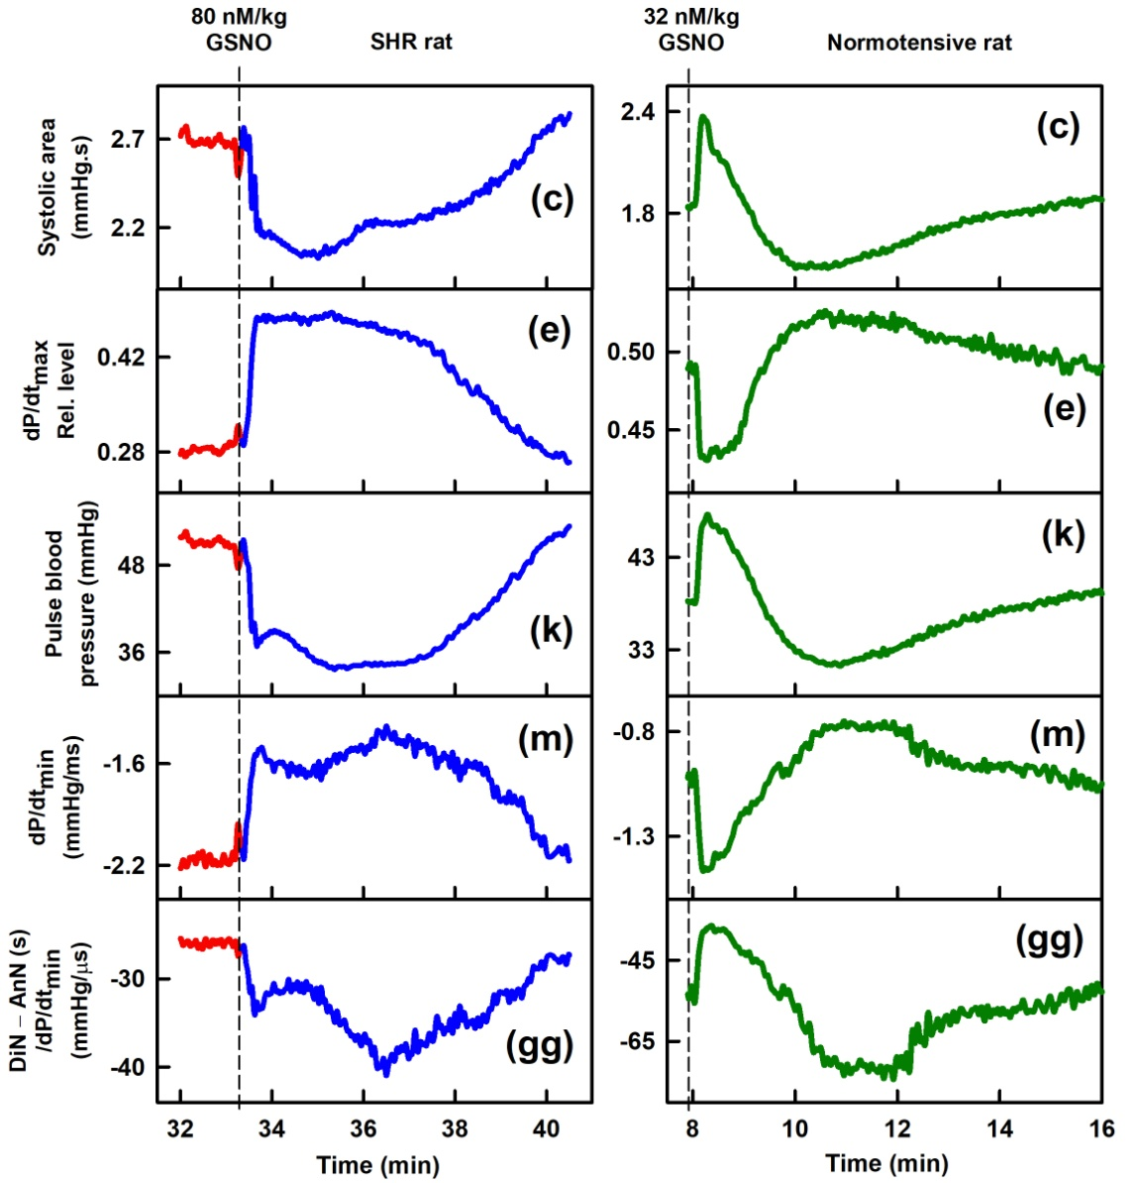

Fig. S10 Comparison the effects of GSNO on SHR and NORM rats. Time-dependent changes in 5 APW-Ps of anesthetized SHR (left plots) and NORM (right plots) rats after bolus administration of 80 nmol/kg and 32 nmol/kg GSNO, respectively. Vertical dashed lines indicate GSNO administration. The data for the left plots are taken from Fig. 1. The data for the right plots are taken from Fig. 2A in Misak et al.2020

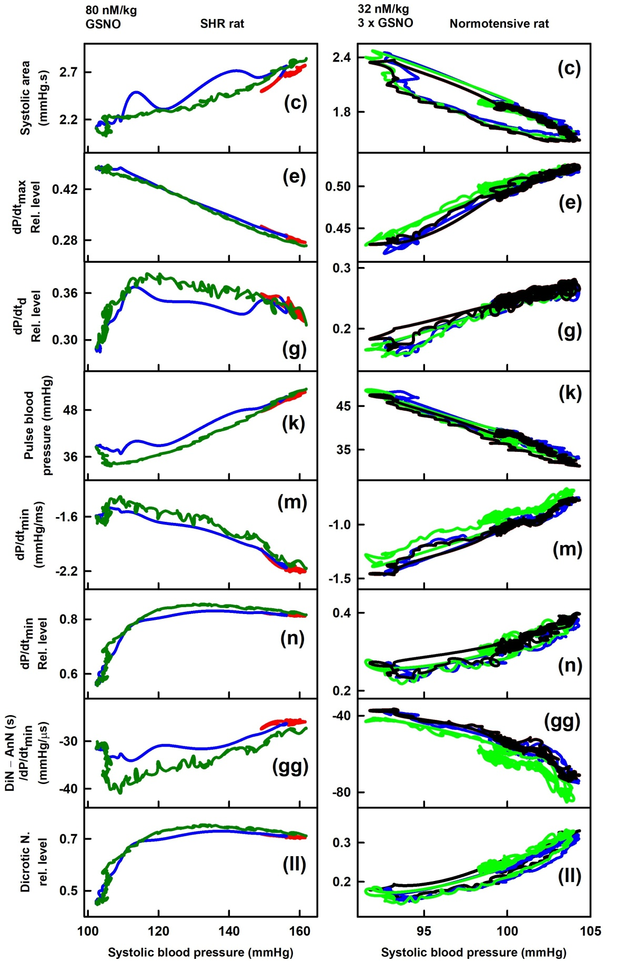

Fig. S11 Comparison of interrelationships of 8 APW-Ps to Sys.BP in SHR (left plots) and NORM (right plots) rats after bolus administration of 80 nmol/kg and 32 nmol/kg GSNO, respectively. The data and colors for left plots are taken from Fig. 1. The data for the right plots are taken from Fig. 2B in Misak et al.2020

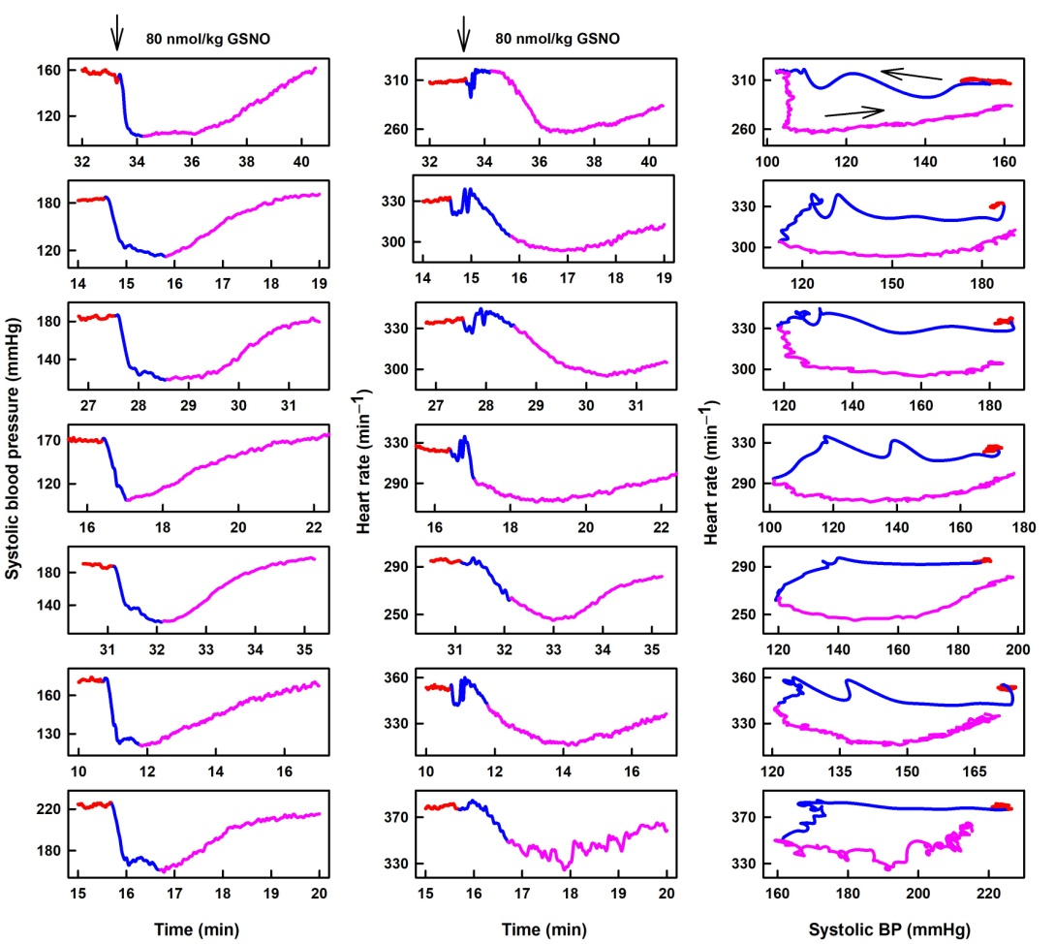

Fig. S12 Comparison of detail GSNO (80 nmol/kg) effect on Sys.BP (left plots), heart rate (HR) (middle plots) and interrelationships of HR to Sys.BP (right plots) in 7 SHR rats experiments. Control (red), decrease (blue) and increase Syst.BP (pink). Right plots: Interrelationships of HR with Sys.BP after administration of GSNO. After administration of GSNO, Sys.BP is decreasing (arrow, blue line) and later is increasing to reach control value of Sys.BP (arrow, pink line). Each layer of the graphs is from the same experiment

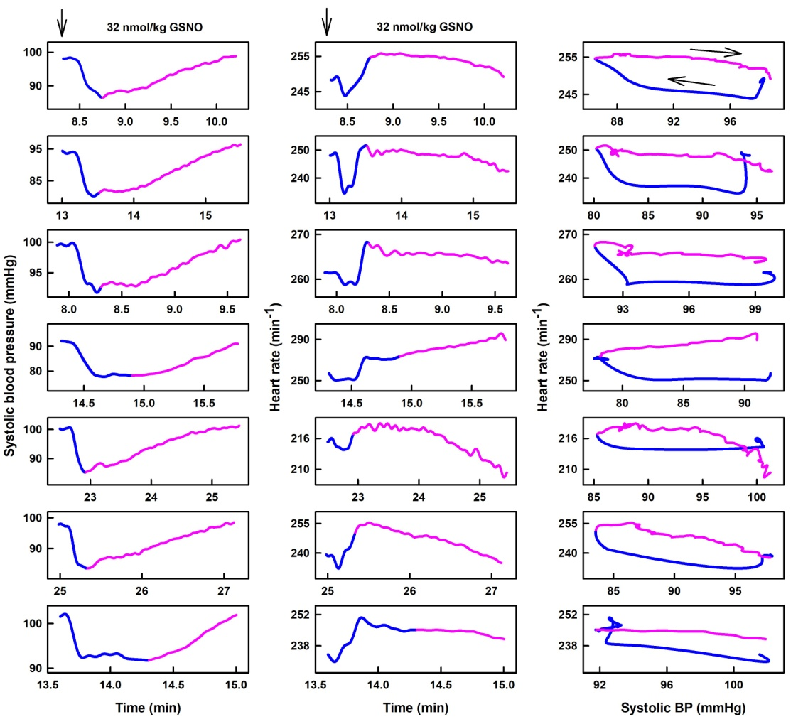

Fig. S13 Comparison of detail GSNO (32 nmol/kg) effect on Sys.BP (left plots), HR (middle plots) and interrelationships of HR to Sys.BP (right plots) in 7 NORM rats experiments. Data from Misak et al.2020. Decrease (blue) and increase Syst.BP (pink). Right plots: Interrelationships of HR with Sys.BP after administration of GSNO. After administration of GSNO, Sys.BP is decreasing (arrow, blue line) and later is increasing to reach control value of Sys.BP (arrow, pink line). Each layer of the graphs is from the same experiment

Table S1
The qualitative response of 44 hemodynamic APW-Ps in 7 experiments after administrations of 80 nmol/kg of GSNO in SHR rats. APW-Ps were evaluated empirically from Fig. 1 and from other 6 experiments. GSNO effect: Black arrows indicate transient increase or decrease of particular APW-P after GSNO administration. The red arrows indicate the initial direction of the biphasic response. For comparison, green arrows indicate average (n=10) transient increase or decrease of particular APW-P after 32 nmol/kg GSNO administration in NORM rats (data taken from Table 1. in Misak et al.2020. Time shift: The time shift of the maximum effect of 80 nmol/kg GSNO on 43 APW-Ps of 7 experiments in SHR rats compared to the maximum effect on Sys.BP (right dashed line). The time shift ≥ 40 s was evaluated empirically from Fig. 1 and from other 6 experiments. Hyphen ‘-‘ indicates time shift less than 40 s. Letters ‘d’ and ‘s’ indicate the time shift towards higher (delayed) and lower (shorter) time with comparison to the minimum of Sys.BP induced by GSNO (see right dashed line in Fig. 1). Red letters ‘sd’ indicate biphasic respond, in which shorter and prolonged responses were observed.

 | SHR rats, APW-Ps | GSNO effect | Time shift
(a) | Systolic BP (mmHg) | ↓↓↓↓↓↓↓ ↓ | -------
(b) | Heart rate (min^{–1}) | ↓↓↓↓↓↓↓ ~ | ddddddd
(c) | Systolic area (mmHg.s) | ↓↓↓↓↓↓↓ ↑ | dd-ddd-
(d) | dP/dt_{max} (mmHg/ms) | ↑↑↑↑↑↑↓ ↑ | d(sd)(sd)d(sd)(sd)d
(e) | dP/dt_{max} rel. level (mmHg/mmHg) | ↑↑↑↑↑↑↑ ↓ | ss---s-
(f) | dP/dt_{d} (mmHg/ms) | ↑↑↑↑↑↑↑ ↓↑ | dddddd-
(g) | dP/dt_{d} rel. level (mmHg/mmHg) | ↓↑↑↑↑↑↑ ↓ | -(sd)(sd)d---
(h) | dP/dt_{d} – dP/dt_{max} (s) | ↑↑↓↑↑↓↓ ↑ | ddd(sd)dd(sd)
(i) | dP/dt_{d} – dP/dt_{min} (s) | ↑↑↑↑↑↑↑ ↑↓ | ddddddd
(j) | Diastolic BP (mmHg) | ↓↓↓↓↓↓↓ ↓ | -------
(k) | Pulse BP (mmHg) | ↓↓↓↓↓↓↓ ↑ | d--d---
(l) | Diastolic area (mmHg.s) | ↓↓↓↓↓↓↓ ↓ | -s-d(sd)s(sd)
(m) | dP/dt_{min} (mmHg/ms) | ↑↑↑↑↑↑↑ ↓ | d(sd)(sd)d-(sd)-
(n) | dP/dt_{min} rel. level (mmHg/mmHg) | ↑↑↑↓↑↓↑ ↓ | -(sd)(sd)-(sd)--
(o) | dP/dt_{min} delay (s) | ↑↑↓↓↓↑↓ ↑ | dss-ss-
(p) | dP/dt_{d} delay (s) | ↑↑↓↑↑↑↓ ↑ | dd(sd)dddd
(q) | dP/dt_{d} – dP/dt_{max} (mmHg) | ↓↓↓↓↓↓↓ ↓ | -s--d--
(r) | dP/dt_{d} – dP/dt_{min} (mmHg) | ↑↑↑↑↑↑↑ ↑ | -------
(s) | AnN – Diast. BP (ms) | ↑↑↑↑↑↑↑ | ------d
(t) | AnN – dP/dt_{max} (ms) | ↑↑↑↑↑↑↑ | ------d
(u) | dP/dt_{max} – Diast. BP (ms) | ↑↑↑↑↑↑↑ | -------
(v) | Syst. BP – Diast. BP (ms) | ↓↓↓↓↓↓↓ | ss----(sd)
(w) | Syst. BP – dP/dt_{max} (ms) | ↓↓↓↓↓↓↓ | ss----(sd)
(y) | 1Max – Dias. BP (mmHg) | ↑↑↑↑↑↑↑ | -s(sd)---(sd)
(z) | AnN – Diast. BP (mmHg) | ↑↑↑↑↑↑↑ | ------(sd)
(aa) | Systolic BP (mmHg) | ↓↓↓↓↓↓↓ ↓ | ------
(bb) | Anacrotic notch (mmHg) | ↓↓↓↓↓↓↓ ↓ | -------
(cc) | Anacrotic notch rel. level (mmHg/mmHg) | ↑↑↑↑↑↑↑ ↑ | -------
(dd) | Anacrotic notch delay (ms) | ↑↑↑↑↑↑↑ ↑ | ------d
(ee) | Anacrotic notch rel. delay (ms/ms) | ↑↑↑↑↑↑↑ ↑ | -------
(ff) | DiN – AnN (s) | ↓↓↓↓↓↓↓ ↑ | -s-ss--
(gg) | DiN – AnN / dP/dt_{min} ((s/mmHg)/µs) | ↓↓↓↓↓↓↓ ↑ | ddddddd
(hh) | DiN – AnN / dP/dt_{max} ((s/mmHg)/µs) | ↓↓↓↓↓↓↓ ↓ | -(sd)(sd)(sd) (sd)-sd)
(ii) | AnN – 1Max (ms) | ↑↑↑↑↑↑↑ ↑ | ------s
(jj) | Augmentation index rel. (mmHg/mmHg) | ↓↓↓↓↓↓↓ ~ | -s-----
(kk) | Dicrotic notch (mmHg) | ↓↓↓↓↓↓↓ ↓ | -------
(ll) | Dicrotic notch rel. level (mmHg/mmHg) | ↓↑↑↓↑↓↑ ↓ | -(sd)(sd)-(sd)-d
(mm) | Dicrotic notch delay (ms) | ↑↑↓↓↓↑↑ ↑ | d(sd)s(sd)(sd)s-
(nn) | Dicrotic notch rel. delay (ms/ms) | ↑↓↓↓↓↓↓ ↑ | dddddd-
(oo) | DiN – AnN (mmHg) | ↓↓↓↓↓↓↓ ↓ | -------
(pp) | (DiN – AnN) / dP/dt_{min} (mmHg)/ms) | ↑↑↑↑↑↑↑ ↑ | -------
(qq) | (DiN – AnN) / dP/dt_{max} (mmHg)/ms) | ↓↓↓↓↓↓↓ ↓ | -------
(rr) | AnN – 1Max (mmHg) | ↓↓↓↓↓↓↓ ~ | -s--s-(sd)
(ss) | DiN – dP/dtd (ms) | ↑↓↓↓↓↓↓ | ddddddd
(tt) | DiN – dP/dtmax (ms) | ↓↓↓↓↓↓↓ | d(sd)s(sd)ss-

References

Kurakova L, Misak A, Tomasova L, Cacanyiova S, Berenyiova A, Ondriasova E, Balis P, Grman M, Ondrias K (2020) Mathematical relationships of patterns of 35 rat haemodynamic parameters for conditions of hypertension resulting from decreased nitric oxide bioavailability. Exp Physiol 105:312–334. https://doi.org/10.1113/EP088148

Misak A, Kurakova L, Berenyiova A, Tomasova L, Grman M, Cacanyiova S, Ondrias K (2020) Patterns and Direct/Indirect Signaling Pathways in Cardiovascular System in the Condition of Transient Increase of NO. Biomed Res Int 2020:6578213. https://doi.org/:10.1155/2020/6578213

Anton Misak, Marian Grman, Lenka Tomasova, Ondrej Makara, Zuzana Rostakova, Iveta Waczulikova, Karol Ondrias. Use of a rat model to characterize 35 arterial pulse wave parameters in a comparative study of isoflurane and Zoletil/xylazine anesthesia and the effect of Acanthopanax senticosus extract.
Anim Models Exp Med 2023, 6:474-488. https://doi.org/10.1002/ame2.12354

Misak A, Tomasova L, Grman M, Ondrias K. Characterization of di-gital, tri-gital, and tetra-gital temporal movement of systolic blood pressure on the arterial pulse waveform of rats at different vascular stiffness. Anim Models Exp Med. 2025;8:2266-2279. doi:10.1002/ame2.70108

