Supplementary Figure S1 Distribution of AFP in patient groups
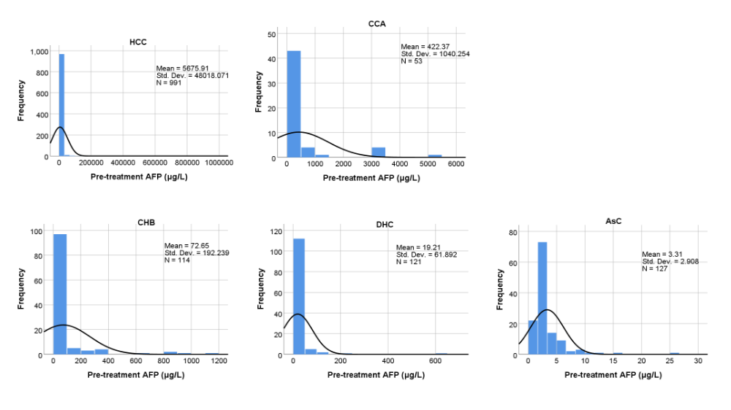

Supplementary Figure S1 Distribution of serum AFP in patient groups
Supplementary Figure S1 shows that the distribution of AFP in all patient groups is in the lower level range (left side on the histogram), thus leading to a skewed normality test result.

Supplementary Figure S2 Comparison of serum AFP levels among patient groups, clinical pathologic features
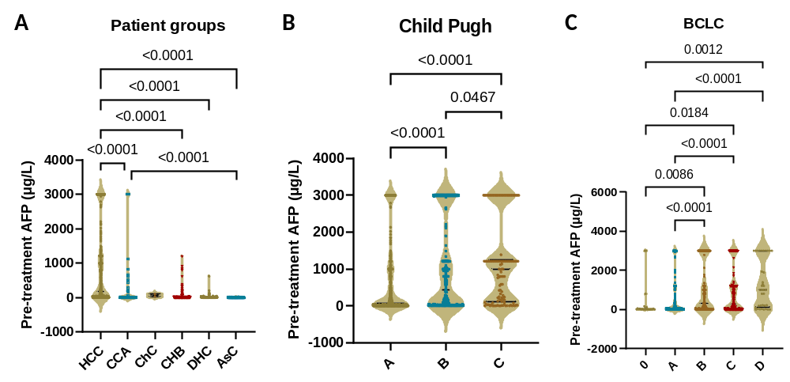
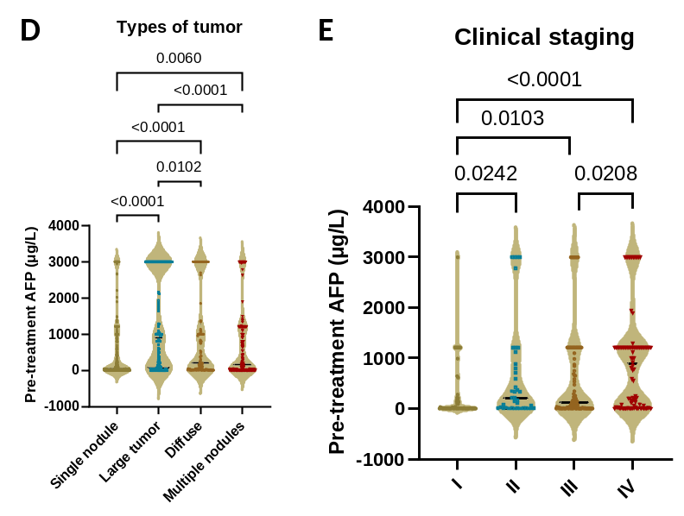
Supplementary Figure S2 Comparison of serum AFP levels among patient groups, clinical pathologic features
Figure S2 further demonstrate the comparison results of serum AFP levels among patient groups, among different clinical pathologic features. A p value is marked for those parameters with significant difference.

