Supplementary Information
Self-Soldering Enables Binder-Free 3D-Printed Thermoelectrics
Pingping Qian¹†, Yi Wen²†, Hongyao Xie², Kaiyi Luo¹, Chen Wang¹, Xinyuan Tang^{3,5}, Lei Yang⁴, Qiang Sun⁵*, Ying Liu⁶*, Shengduo Xu⁷*, Li-Dong Zhao², Jun Tang¹*

1 Key Laboratory of Radiation Physics and Technology of Ministry of Education, Institute of Nuclear Science and Technology, Sichuan University, Chengdu 610064, PR. China.
2 School of Materials Science and Engineering, Beihang University, Beijing 10019l, PR. China
3 Pittsburgh Institute, Sichuan University, Chengdu, Sichuan 610041, P.R. China
4 School of Materials Science & Engineering, Sichuan University, Chengdu 610064, P.R. China
5 State Key Laboratory of Oral Diseases, National Center for Stomatology, National Clinical Research Center for Oral Diseases, West China Hospital of Stomatology, Sichuan University, Chengdu, Sichuan 610041, P.R. China
6 ª CAS Key Laboratory for Biomedical Effects of Nanomaterials and Nanosafety & CAS Center for Excellence in Nanoscience, National Center for Nanoscience and Technology of China, Beijing 100190, China
^{b} The GBA National Institute for Nanotechnology Innovation, Guangdong 510700, China
7 Department of Mechanical Engineering, The Hong Kong Polytechnic University, Hong Kong 999077, PR China

†These authors contributed equally to this work.
*Corresponding author. Email: qiangsun@scu.edu.cn (Q.S.), liuy@nanoctr.cn (Y. Liu), shengduo.xu@polyu.edu.hk, tangjun@scu.edu.cn

This PDF file includes:
Methods
Figs. S1 to S56
Tables S1 to S11
References
Other Supplementary materials for this paper include the following:
Video S1
Video S2
Video S3
Video S4

Supplemental Methods
Rheological behaviors of inks containing organic rheological modifiers
The dynamic rheological properties of TE inks with different organic rheology modifier contents were measured at room temperature using a rheometer (MCR302) with plate geometry. The frequency sweep tests were performed at a constant stress of 1 Pa, and the stress sweep tests with stress values ranging from 0.01 to 300 Pa were performed at a frequency of 0.5 rad s⁻¹. The rheological properties of the ink were assessed using different organic contents. Additionally, based on the BST/PPM0.55 (denotes the TE ink synthesized from 0.55 wt% PPM solution and 87 wt% BST powder) formulation, the effect of particle content on the rheological behavior of the ink was also measured. The strength of TE inks can be quantitatively characterized by the τ_{y}, which represents the critical stress threshold for irreversible breakdown of their internal three-dimensional network structure, marking the transition point from elastic deformation (G'-dominated regime) to viscous flow (G''-dominated regime). The τ_{y} values were determined from the y-intercept of Casson plots obtained through frequency sweep tests.

Mechanical tests
The compressive strength (σ_{c}) and flexural strength (σ_{b}) of the specimens were measured using a universal testing machine. The compressive and flexural strength specimens were rectangular prisms with dimensions of 3 mm × 5 mm × 5 mm and 3 mm × 3 mm × 10 mm, respectively. The σ_{c} was calculated using the formula: σ_{c} = F_{c}/S_{c}, where F_{c} is the force applied to the sample during compression (N), and S_{c} is the initial cross-sectional area of the sample (mm²). The σ_{b} was calculated using the formula: σ_{b} = 3F_{b}L/2bh², where F_{b} is the maximum load at fracture (N), L is span (distance between the supports, m), b is specimen width (m), and h is specimen height (m). The compressive strain (ε) was calculated using the formula: ε_{c} = Δl/l, where Δl is the change in length of the sample during compression or bend, and l is the initial length of the sample.

The uniformity of ultra-low-binder ink printed TE filaments
To assess the uniformity of ink printed TE filaments, we employed nozzles with varying inner diameters to print TE filament lines, which were subsequently dried. The line width variation of a segment of the TE filament was then measured using optical microscopy (OM) and scanning electron microscopy (SEM).

Detection of residual organic rheology modifier after annealing
Elemental composition and chemical states were characterized by an X-ray photoelectron spectroscope (XPS, ESCALAB Xi+; Thermo Fisher Scientific). To investigate the presence of residual organic rheology modifier in ink printed materials post-annealing, to avoid impacting the comprehensive properties of the materials. We prepared p- and n-type samples using TE ink containing PPM organic rheological modifiers. These samples were then annealed at 460 °C for 2 hours.

Calculation of average distance between the pores
Several areas of the sample were randomly selected, and 10 electron microscopy images were captured. The number and size of pores in each image were then measured.

Simulation of w-TEG design
A 3D finite element model (FEM) was used to evaluate the effects of the width (w_{ds}) and waist thickness (t_{ds}) of the dumbbell-shaped TE legs in the w-TEG on the output voltage (V_{oc}​), power (P), effective temperature difference (ΔT_{e}​), power density (P_{d}), and efficiency (η). The height (H_{ds}) and length (l_{ds}) of the TE legs were fixed at 5 mm and 3.5 mm, respectively. To accurately simulate the power generation of the w-TEG under the temperature difference between the human body and the environment, boundary conditions included a fixed hot-side (human skin temperature) temperature of 34 ℃, cold-side (ambient temperature) temperature of 16 ℃, with a heat transfer coefficient (h_{c}) of 50 W m⁻² K⁻¹ for the top and bottom surfaces. Adiabatic conditions were applied to lateral sides.

Orientation factor of p- and n-type materials
The orientation factor F, which quantifies the degree of preferred grain orientation in polycrystalline materials, can be calculated using the following equation¹:
$F=\frac{P-P_{0}}{1-P_{0}}, P_{0}=\frac{I_{0}\left(00l\right)}{\sum{I_{0}\left(hkl\right)}}, P=\frac{I\left(00l\right)}{\sum{I\left(hkl\right)}}$ (S1)
where P and P₀ represent the integrated intensities of the (00l) planes and (hkl) planes for the preferentially oriented and randomly oriented samples, respectively.

The lattice thermal conductivity of the 3D printed materials
The value of κ_{l} was calculated by subtracting the electronic thermal conductivity κ_{ele} from the measured total thermal conductivity κ, where κ_{e} was calculated using the Wiedemann-Franz law:
${}_{ele} = LσΤ$ (S2)
where the L, σ and T are Lorentz number, absolute temperature and electrical conductivity, respectively. The L was estimated using the single parabolic band model equation²:
$L={\left(\frac{k_{B}}{e}\right)}^{2}\frac{3F_{0}F_{2}-{4F}_{1}^{2}}{F_{0}^{2}}$ (S3)
where the k_{B} and F_{i} are the Boltzmann's constant and Fermi integral, respectively. The value of F_{i} can be obtained from the following formula:
$F_{i}=\int_{0}^{∞}{\frac{ε^{i}dε}{1+exp\left(ε-η\right)}}$ (S4)

where η = E_{F}/k_{B}T is the reduced Fermi level, it is derived from the following equation:
$S=±\frac{k_{B}}{e}\left(\frac{{2F}_{1}}{F_{0}}-η\right)$ (S5)

Model of lattice thermal conductivity for p- or n-type samples
We employed the Debye-Callaway model to explain the theoretical lattice thermal conductivity (κlat) of the printed sample³, which can be expressed as:
${}_{lat}=\frac{k_{B}}{2π^{2}ν}{\left(\frac{k_{B}T}{ℏ}\right)}^{3}\int_{0}^{θ_{a}/T}{τ_{tot}(x)\frac{e^{x}x^{4}}{{(e^{x}-1)}^{2}}}dx$ (S6)
where va, 𝜃a, x, and 𝜏tot represent average sound velocity, Debye temperature, reduced phonon frequency (x = ħω/kBT), and total phonon relaxation time, respectively. For the printed Bi₂Te₃ sample, considering the three main scattering mechanisms associated with polycrystalline samples: Umklapp process scattering (U), grain boundary scattering (GB), and point defect scattering (PD), the relaxation times are calculated as follows:
$τ_{U}^{-1}= A_{N}\frac{2}{{(6π^{2})}^{1/3}}\frac{K_{B}V^{1/3}γ^{2}ω^{2}T}{M_{a}ν_{a}}$ (S7)
$τ_{PD}^{-1}= \frac{K_{B}^{4}V_{PUC}}{{4πℏ^{4}ν}_{a}^{3}}Γω^{4}T^{4}$ (S8)
$τ_{B}^{-1}= \frac{ν_{a}}{d}$ (S9)
where AN, V, γ, Ma, νa, VPUC and d are pre-factor of Umklapp scattering time, average volume per atom, Grüneisen parameter, average atomic mass, out-of-plane average speed of sound, volume of the primitive unit cell and grain size of of Bi0.5Sb1.5Te3 or Bi2Te2.5Se0.5Ag_{0.01}, respectively.
Beyond these dominant scattering effects, high densities of dislocations and twin boundaries (2D defects), as well as the nano-Ag dopant phase (3D defects), were indeed observed in the printed samples, thus necessitating the consideration of associated additional relaxation times. Based on previous reports, dislocation-induced phonon scattering can be categorized into dislocation strain (DS) scattering and dislocation core (DC) scattering⁴, corresponding to two distinct relaxation times, namely, τ_{DS} and τ_{DC}, respectively⁵. Furthermore, aggregated Ag nanoprecipitates exert another scattering effect on phonon propagation (τ_{np}​)^{6–8}. The three relaxation times are given by:
$τ_{DC}^{-1}= N_{D}\frac{V^{4/3}}{ν_{a}^{2}}ω^{4}$ (S10)
$τ_{DS}^{-1}= {0.6B_{D}^{2}N}_{D}{γ_{modified}}^{2}ω[0.5+ \frac{1}{24}{\left(\frac{1-2r}{1-r}\right)}^{2}{\left(1 + \sqrt{2}{\left(\frac{υ_{L}}{υ_{T}}\right)}^{2}\right)}^{2}]$ (S11)
$τ_{np}^{-1}= υ_{a}{\left[{\left(2πR^{2}\right)}^{-1}+{\left(πR^{2}\frac{4}{9}{\left(\frac{Δρ}{ρ_{m}}\right)}^{2}{\left(\frac{ωR}{υ_{a}}\right)}^{4}\right)}^{-1}\right]}^{-1}N_{p}$ (S12)
where B_{D}, N_{D}, γ_{modified}, r, ν_{L}/ν_{T}, R, ρ_{m}, Δρ and N_{p} are effective Burger’s vector, dislocation density, modified Grüneisen parameter, Possion’s ratio, ratio of longitudinal phonon velocity to transverse phonon velocity, radius of nanoprecipitates, matrix density, density difference between matrix material and nanoprecipitate phase, and nanoprecipitate concentration respectively (values can be found in Table S9-S11). The γ_{modified}​ describes the impact of solute concentration on the strain field surrounding dislocations. Therefore, it is calculated by superimposing the variation of the Grüneisen parameter arising from the impurity atmosphere (γ₁​)⁹ onto the intrinsic Grüneisen parameter (γ):
$γ_{modified}= γ+ γ_{1}$ (S13)
$γ_{1}= \frac{V_{{Sb}_{2}{Te}_{3} }f_{{Bi}_{2}{Te}_{3}}K_{{Sb}_{2}{Te}_{3}}}{K_{B}T_{a}}\left(γα^{2}- αβ\right)$ (S14)
$γ_{1}= \frac{V_{{Bi}_{2}{Te}_{3} }f_{{Bi}_{2}{Se}_{3}}K_{{Bi}_{2}{Te}_{3}}}{K_{B}T_{a}}\left(γα^{2}- αβ\right)$ (S15)
In addition to these main scattering effects in the polycrystalline Bi₂Te₃ system, the high porosity present in the printed sample induces additional scattering effects caused by the pore interface, thus introducing a Casimir-like phonon interface scattering term¹⁰:
$τ_{Pores}^{-1}= \frac{ν_{a}}{D}$ (S13)
The average sound velocity (νa,porous) of the porous sample was calculated using the following equation:
$ν_{a,porous}= {\left[\frac{1}{3}\left(\frac{1}{ν_{L,porous}^{3}}+ \frac{2}{ν_{T,porous}^{3}}\right)\right]}^{-1/3}$ (S14)
where the longitudinal wave (ν_{L,porous}) and transverse wave (ν_{T,porous}) speed at room temperature were obtained by anultrasonic pulse-echo method. The characteristic signal features of the material based on the acoustoelastic theory were obtained and used to calculate key material parameters, including phonon velocity, young's modulus, and poisson's ratio. All echo signals were received using a 5MHz transducer. The results indicate that the average sound velocity in the 3D-printed porous bulk samples is lower than that in the dense bulk samples, while the average sound velocities along the in-plane and out-of-plane directions are nearly identical. The data can be seen in Table S9.
The reduction in sound velocity resulted in a decrease of the Debye temperature from 94 K to 73 K, as calculated using the following equation¹¹:
$θ_{a}= \frac{hν_{a}}{K_{B}}{\left[\frac{3n}{4π}\left(\frac{N_{A}ρ}{M_{molecular}}\right)\right]}^{1/3}$ (S15)
where N_{A}, ρ, h, Mmolecular and n are the Avogadro's number, density, Planck's constant, molecular weight, number of atoms in the molecule, respectively. It is noteworthy that ν_{a,bulk} and θ_{a,bulk} are employed to characterize the contribution of scattering effects from pore-free dense bulk materials to the reduction in κ_{lat}, whereas ν_{a,porous} and θ_{a,porous} are used to quantify the contribution of pore defects to the decrease in κ_{lat}.

Porosity calculation
The total mass of a specimen can be expressed as the sum of the matrix material mass and the contained air mass, following the relation:
$ρV= ρ_{m}V_{m}+ ρ_{air}V_{air}$ (S16)
where ρ, ρ_{m}, ρ_{air}, V, V_{m}, V_{air} denotes density of the sample, density of matrix material, density of air, volume of the sample, volume of the matrix material and volume of the pores. The porosity (Φ) is defined as the volumetric fraction of pores in the specimen, which can be expressed as Φ = V_{air}/V. Based on Equation S16, the following derivation can be made:
$ρ= \frac{ρ_{m}V_{m}+ρ_{air}V_{air}}{V}= ρ_{m}\left(1-Φ\right)+ρ_{air}Φ$ (S17)
Given that the air density is negligible compared to the matrix material, the porosity is derived as:
$Φ = 1-ρ/ρ_{m}$ (S18)
The sample density shows a negative correlation with the g-value, exhibiting higher density values when the Φ value approaches zero. Table S6 presented the density and porosity of both p- and n-type samples.

Effective medium theory
We employed the revised equations of the effective medium theory (EMT) to quantitatively analyze the influence of porosity on the κ_{lat} of 3D-printed samples¹². The modified equation for the κ_{l} of porous materials based on the EMT is as follows:
${}_{lat}= {}_{h}\frac{2-2Φ}{2+Φ}$ (S19)
where κ_{h} and Φ are the κ_{lat} of host materials and the porosity, respectively.
Thermoelectric compatibility factor
The distinct variations in the intrinsic properties of different thermoelectric materials dictate the efficiency and compatibility of assembled cascaded devices. Thus, maximizing the alignment of compatibility factors between two materials is critical for achieving a superior overall efficiency in the combined device. The thermoelectric compatibility factor (s) for power generation is defined as¹³:
$$s= \frac{\sqrt{1+zT}-1}{ST}$$
where S denotes Seebeck coefficient of the material.

Supplementary Figures

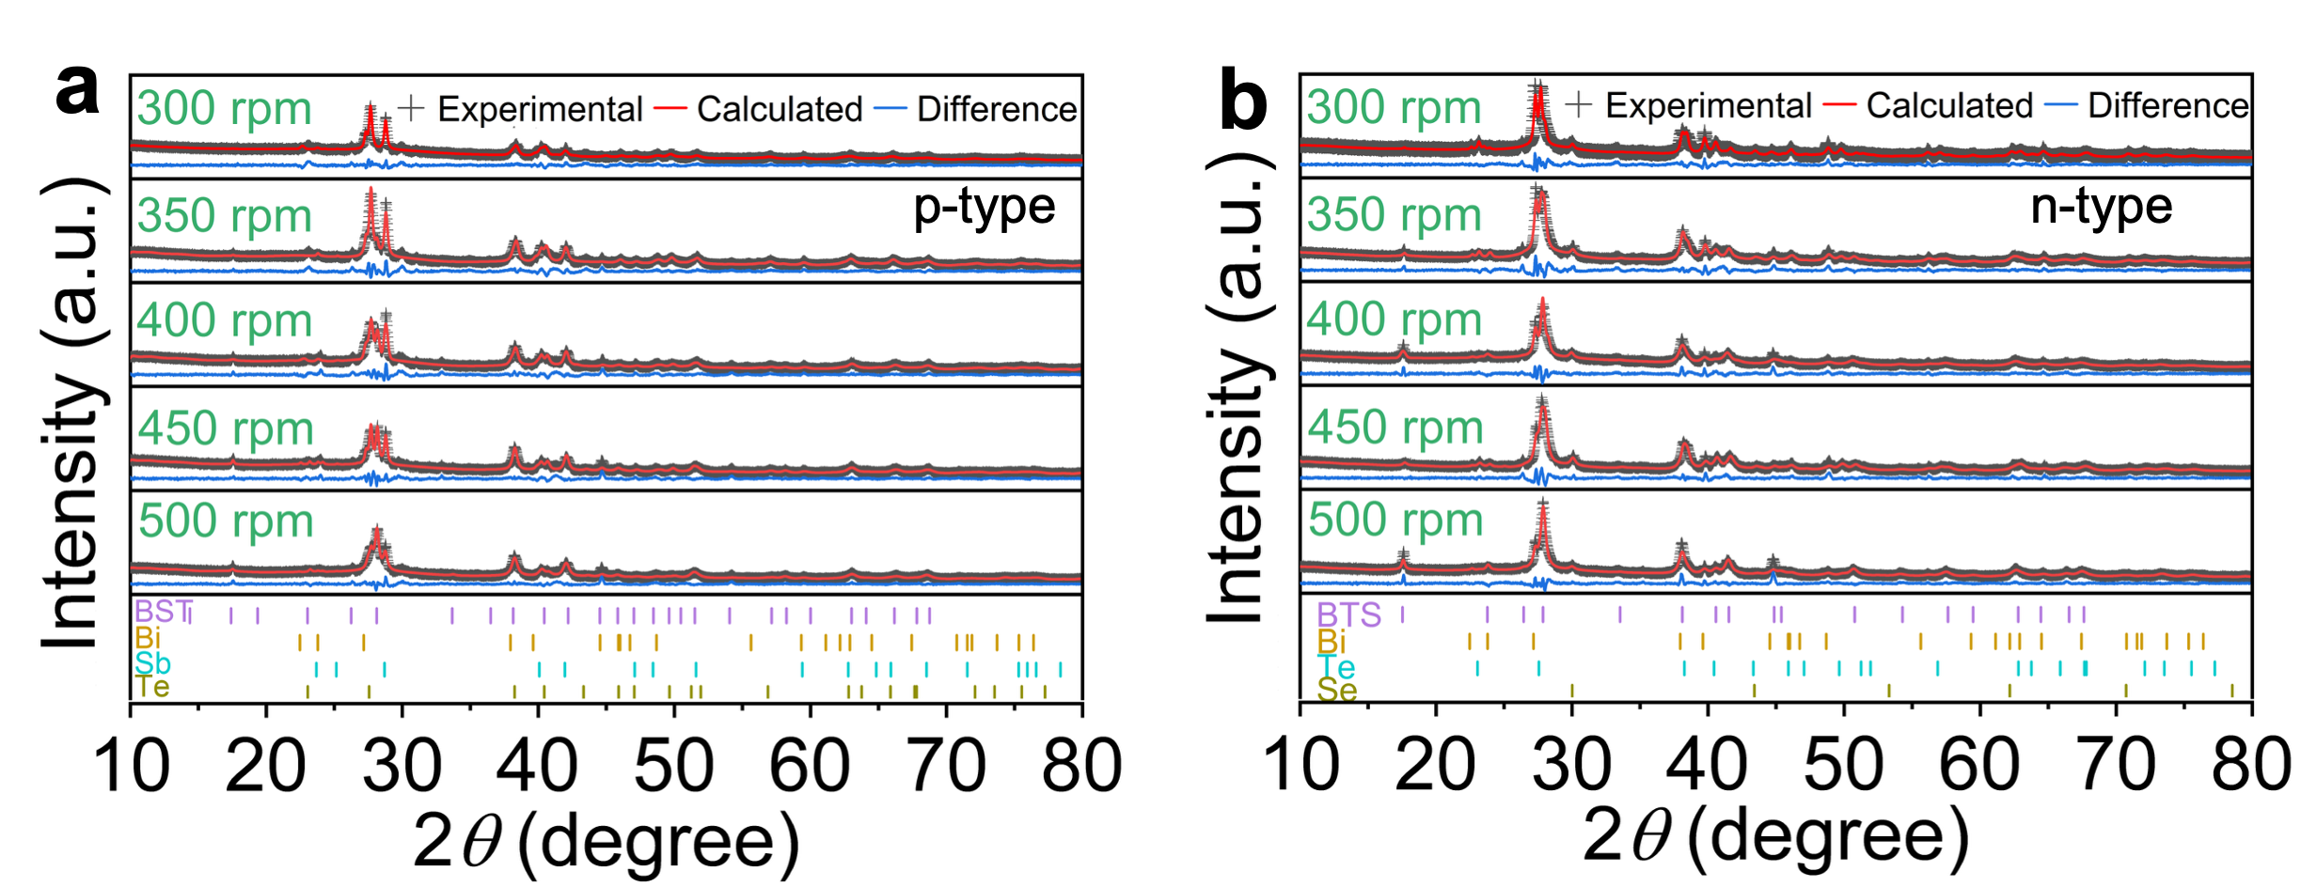
Fig. S1. Rietveld refinement results of various phases for powders at different ball milling rotation speeds. a, p-type powder sieved through a 200-mesh sieve and b, n-type powder sieved through an 800-mesh sieve.

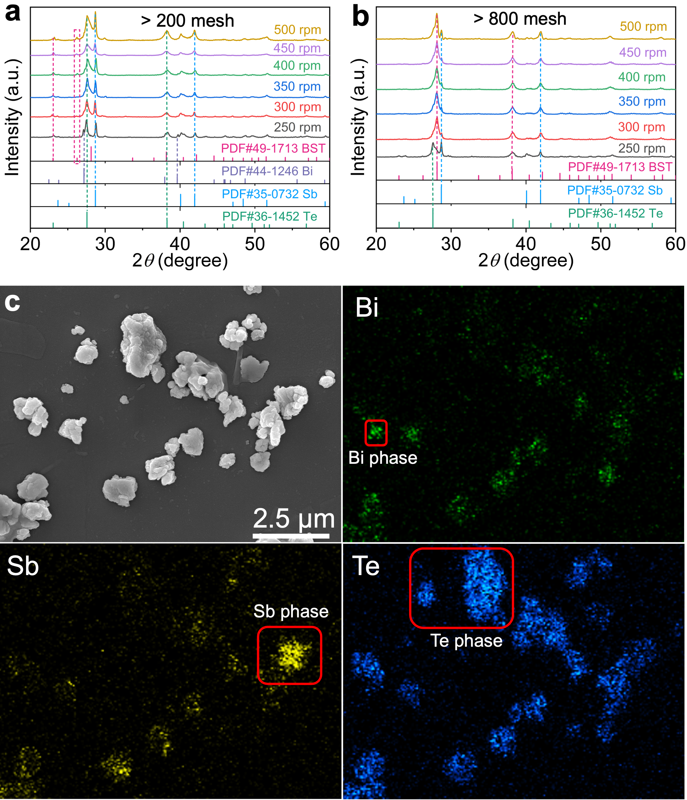
Fig. S2. Effect of ball milling rotation speed on the phase composition of p-type Bi_{0.5}Sb_{1.5}Te₃ materials. a,b, XRD patterns of powders passed through (a) 200-mesh and (b) 800-mesh sieves. c, SEM image of the powders with the corresponding Energy-Dispersive X-ray Spectroscopy (EDS) map.

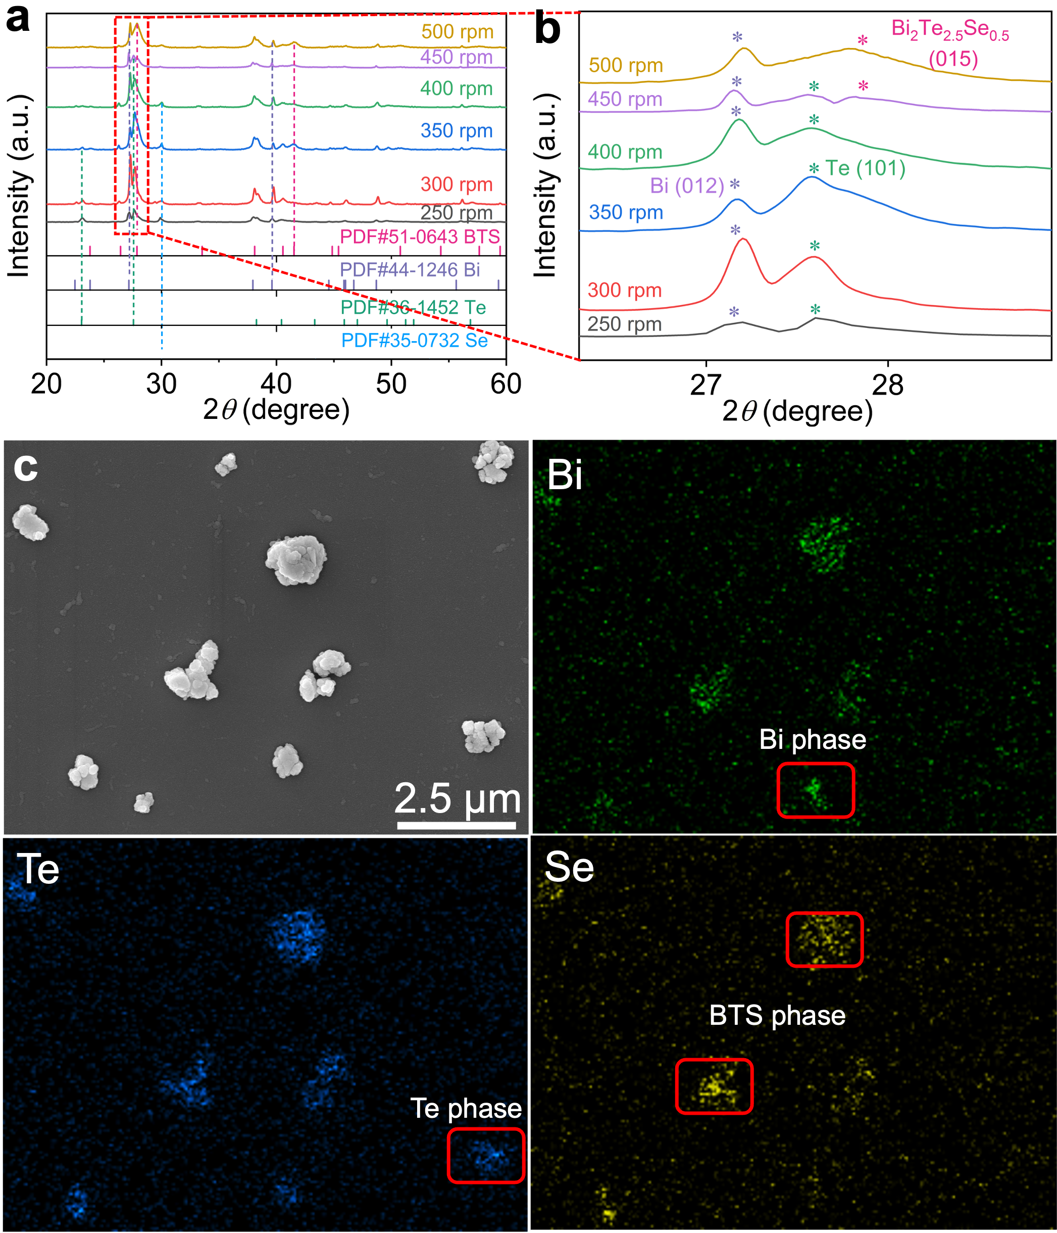
Fig. S3. Effect of ball milling rotation speed on the phase composition of n-type Bi₂Te_{2.5}Se_{0.5} materials. a, XRD patterns of powders passed through an 800-mesh sieve, and b, the corresponding magnified local region. c, SEM image of the powders with the corresponding Energy-Dispersive X-ray Spectroscopy (EDS) map.

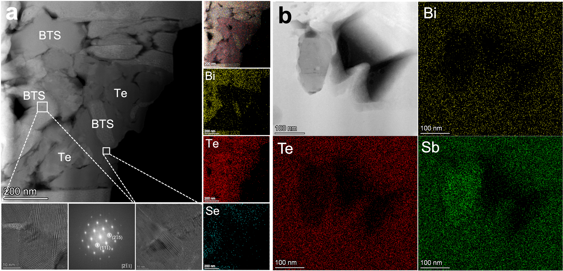
Fig. S4. a,b, TEM images revealing the post-sintering phase microstructures of the (a) p- and (b) n-type non-equilibrium multiphase powders milled at 300 rpm, alongside the corresponding EDS elemental mappings and FFT patterns.

The results reveal that lower ball milling speeds result in a higher content of elemental phases; the incomplete transformation of these elemental phases into the BST or BTS phase during sintering consequently leads to the presence of elemental phases in the sintered bulks.

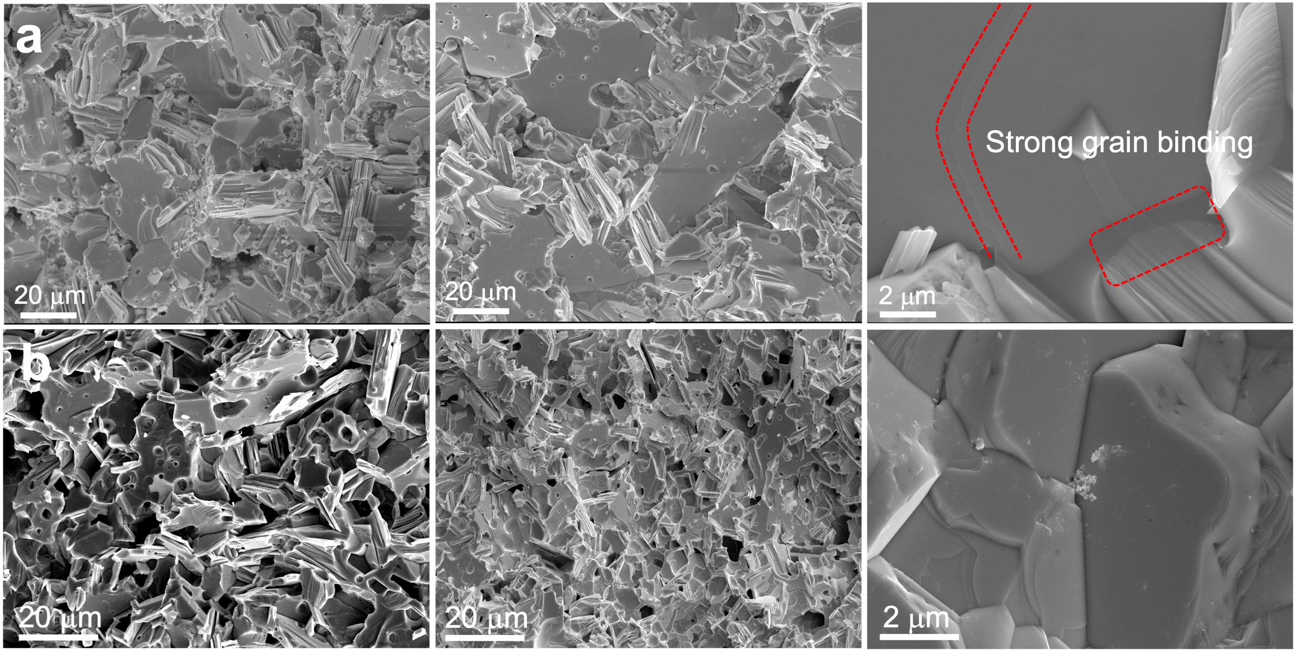
Fig. S5. The SEM images of printed materials after annealing. a,b, Fracture surface morphologies of (a) p- and (b) n-type samples after annealing at 460 °C and 480 °C, respectively.

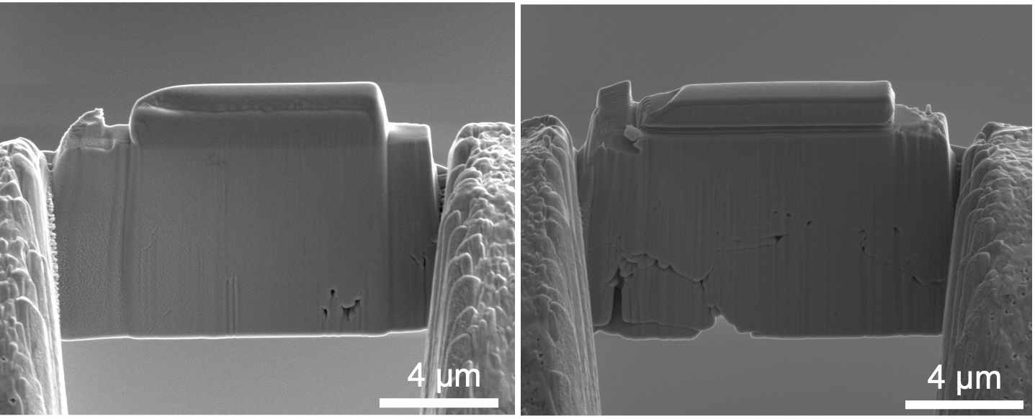
Fig. S6. SEM images of focused ion beam (FIB) cross-sectional area of the printing smaples after annealing. The left and right correspond to the p- and n-type samples, respectively, and the p-type sample exhibits higher density.

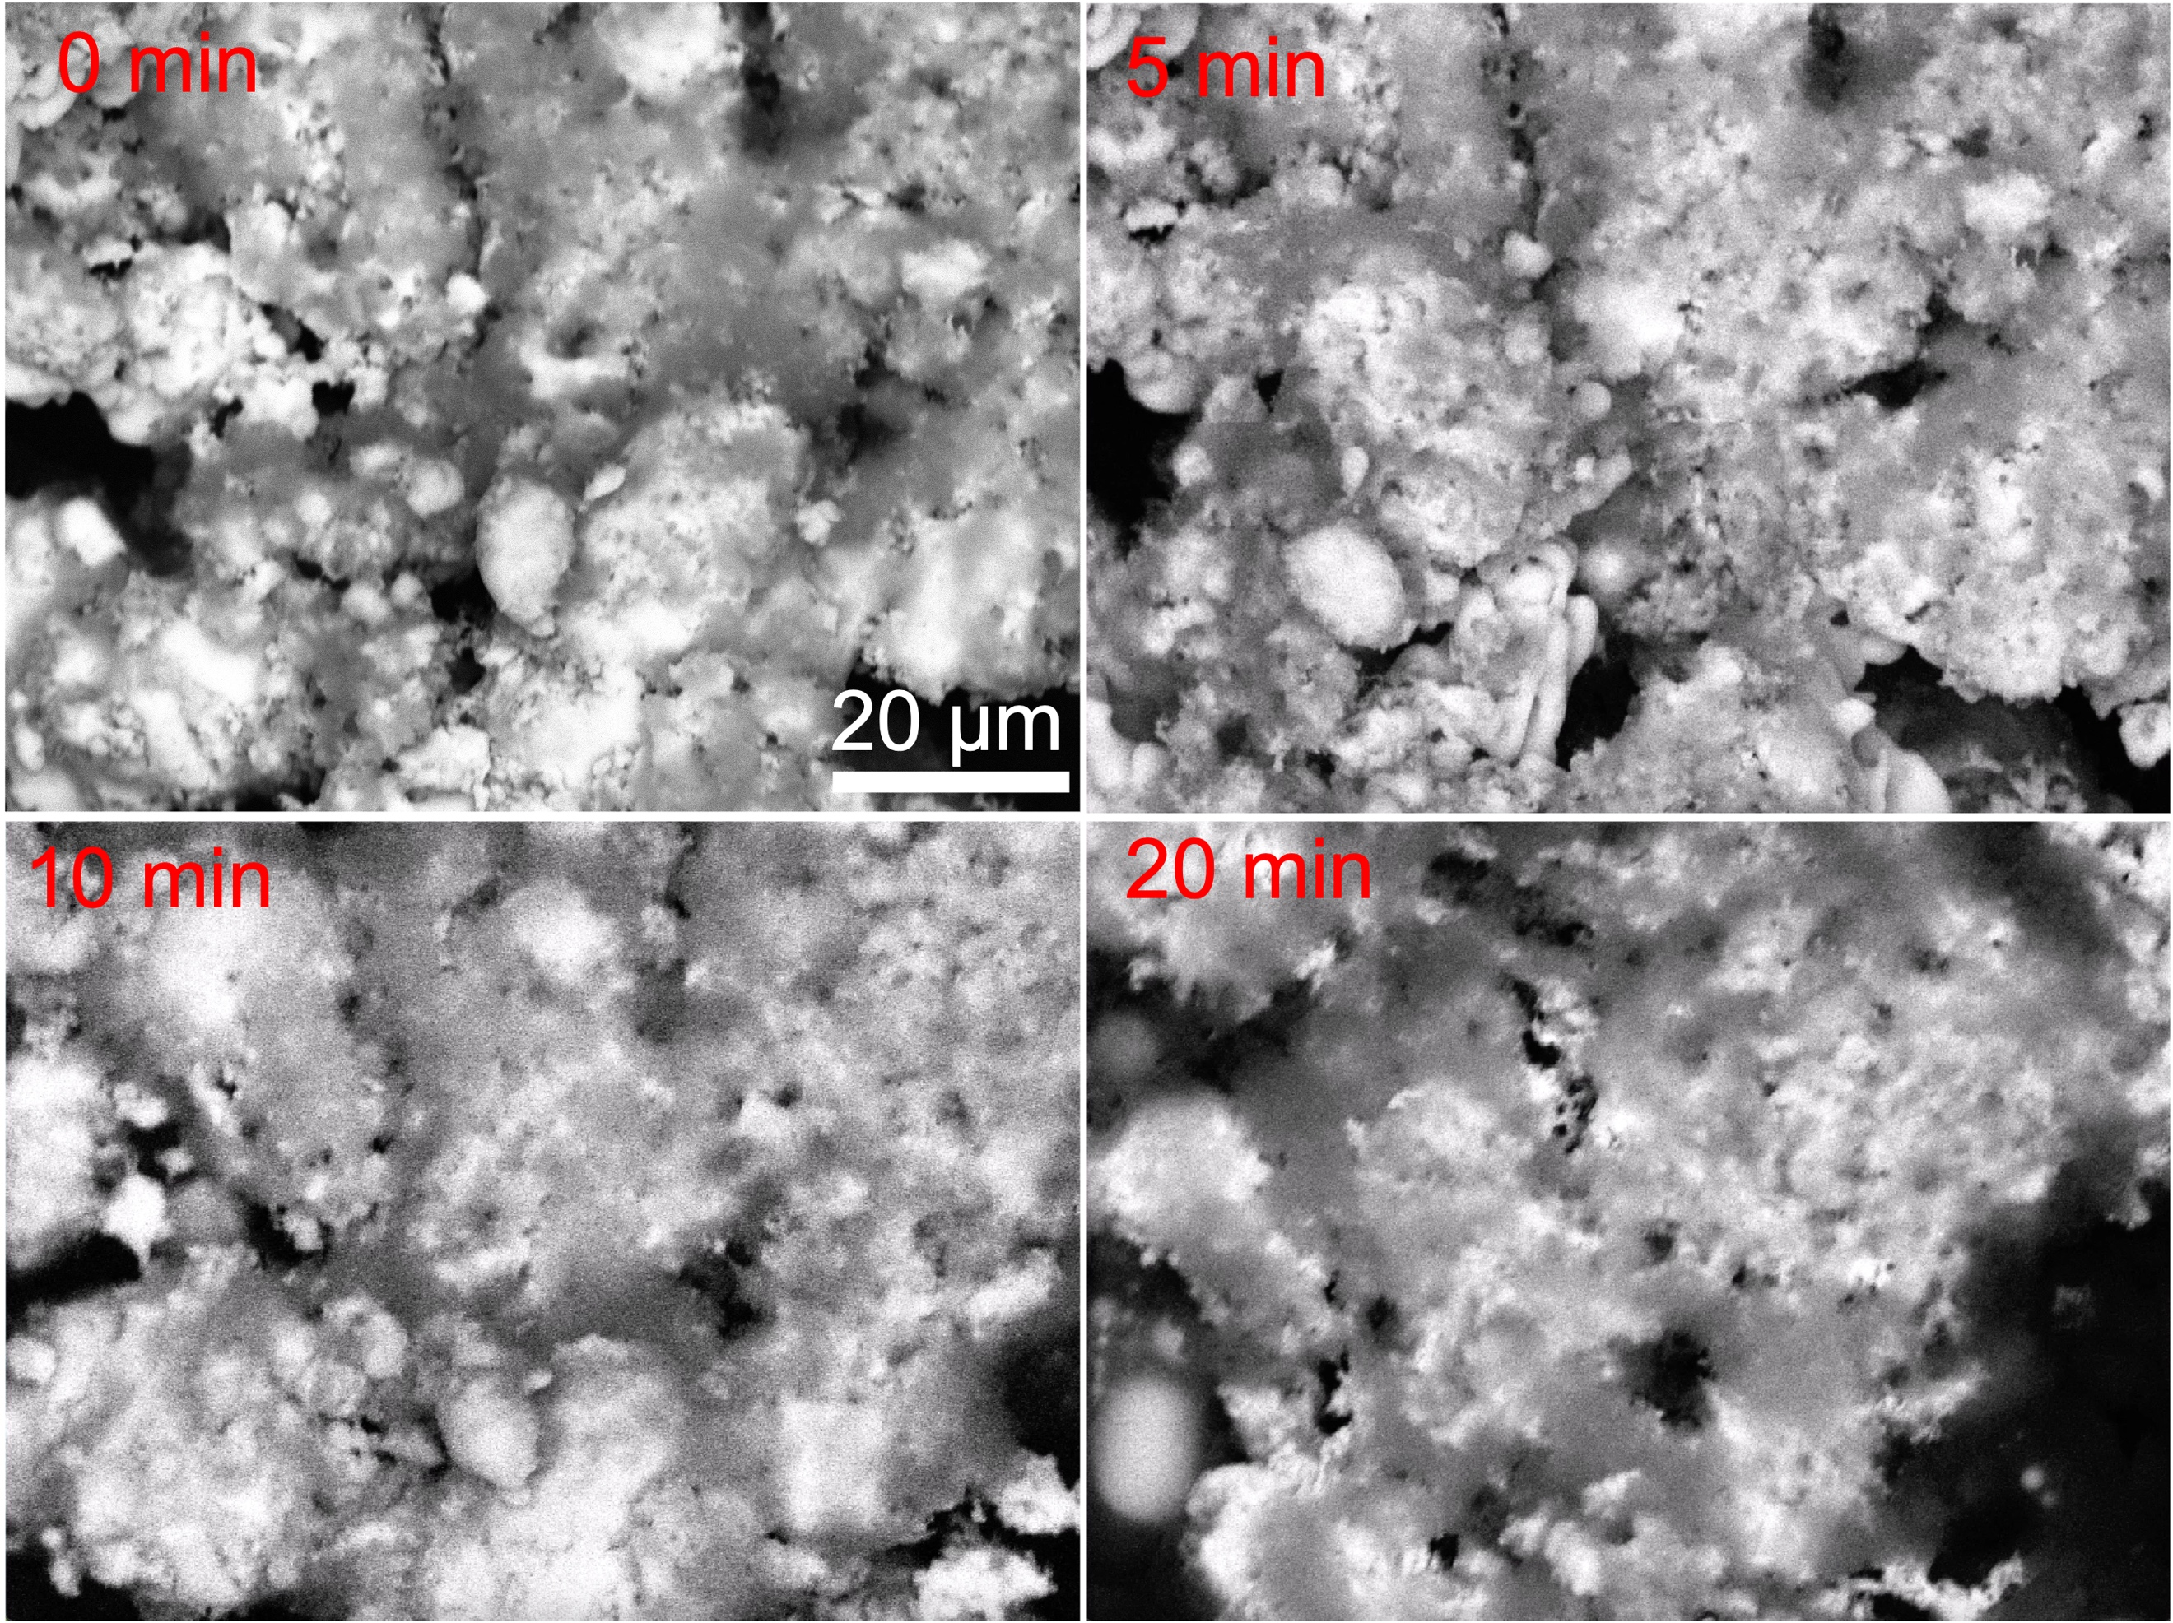
Fig. S7. In-situ annealing scanning electron microscopy (SEM) images of p-type TE ink annealed at 460 °C as a function of time. The TE ink was composed of multiphase powder particles mixed with 0.55% PPM.

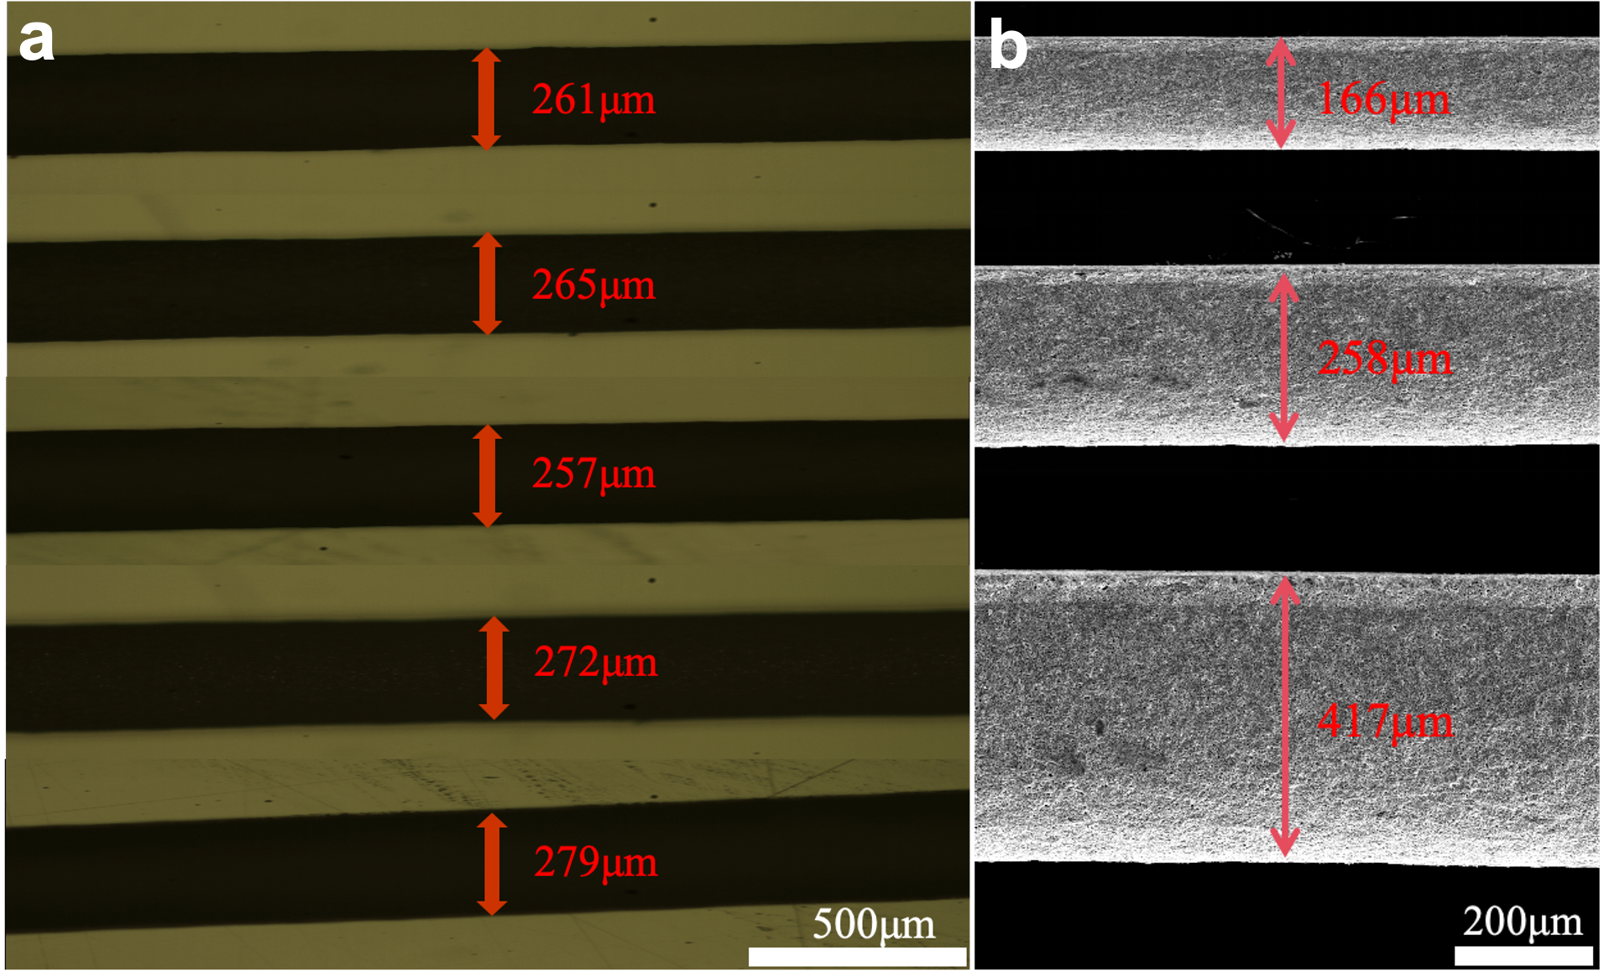Fig. S8. Photographs of TE filaments printed using 3D printing. a, Optical microscope (OM) images and b, scanning electron microscope (SEM) images of TE filaments with various diameters after drying.

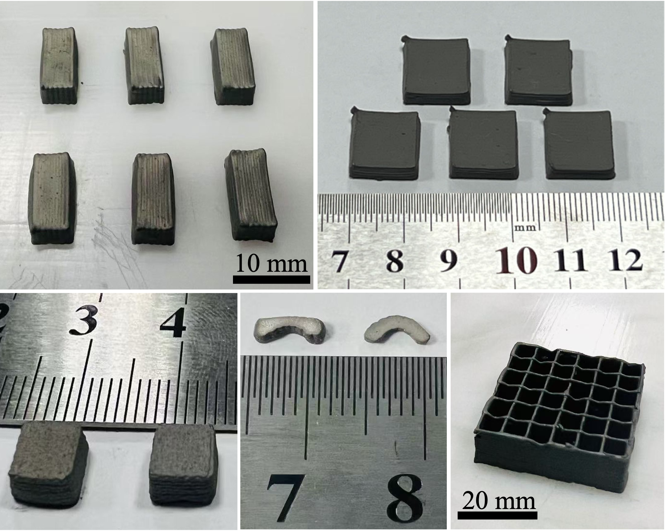
Fig. S9. 3D-printed samples with various geometries and sizes. A photograph of the sample with cuboid, arch-bridge and half-ring structures after drying at 70 ℃ for 24h.
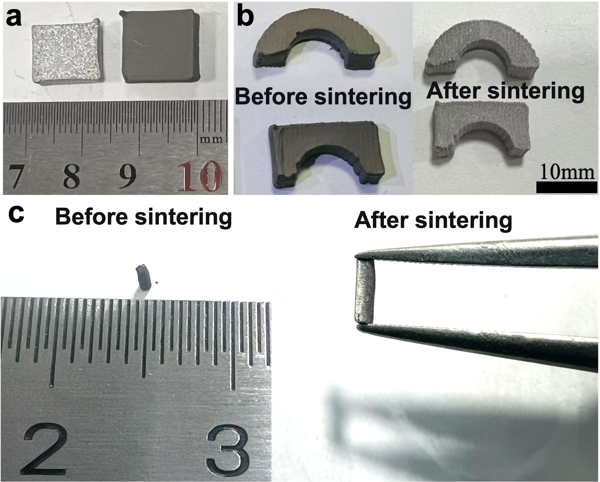
Fig. S10. Morphological evolution of printed samples before and after sintering. a,b, Comparison of photographs of (a) p- and (b) n-type Bi₂Te₃-based samples before and after annealing at 460 °C and 480 °C, respectively. c, Comparison of morphology changes of 3D-printed micro-pillars before and after sintering.

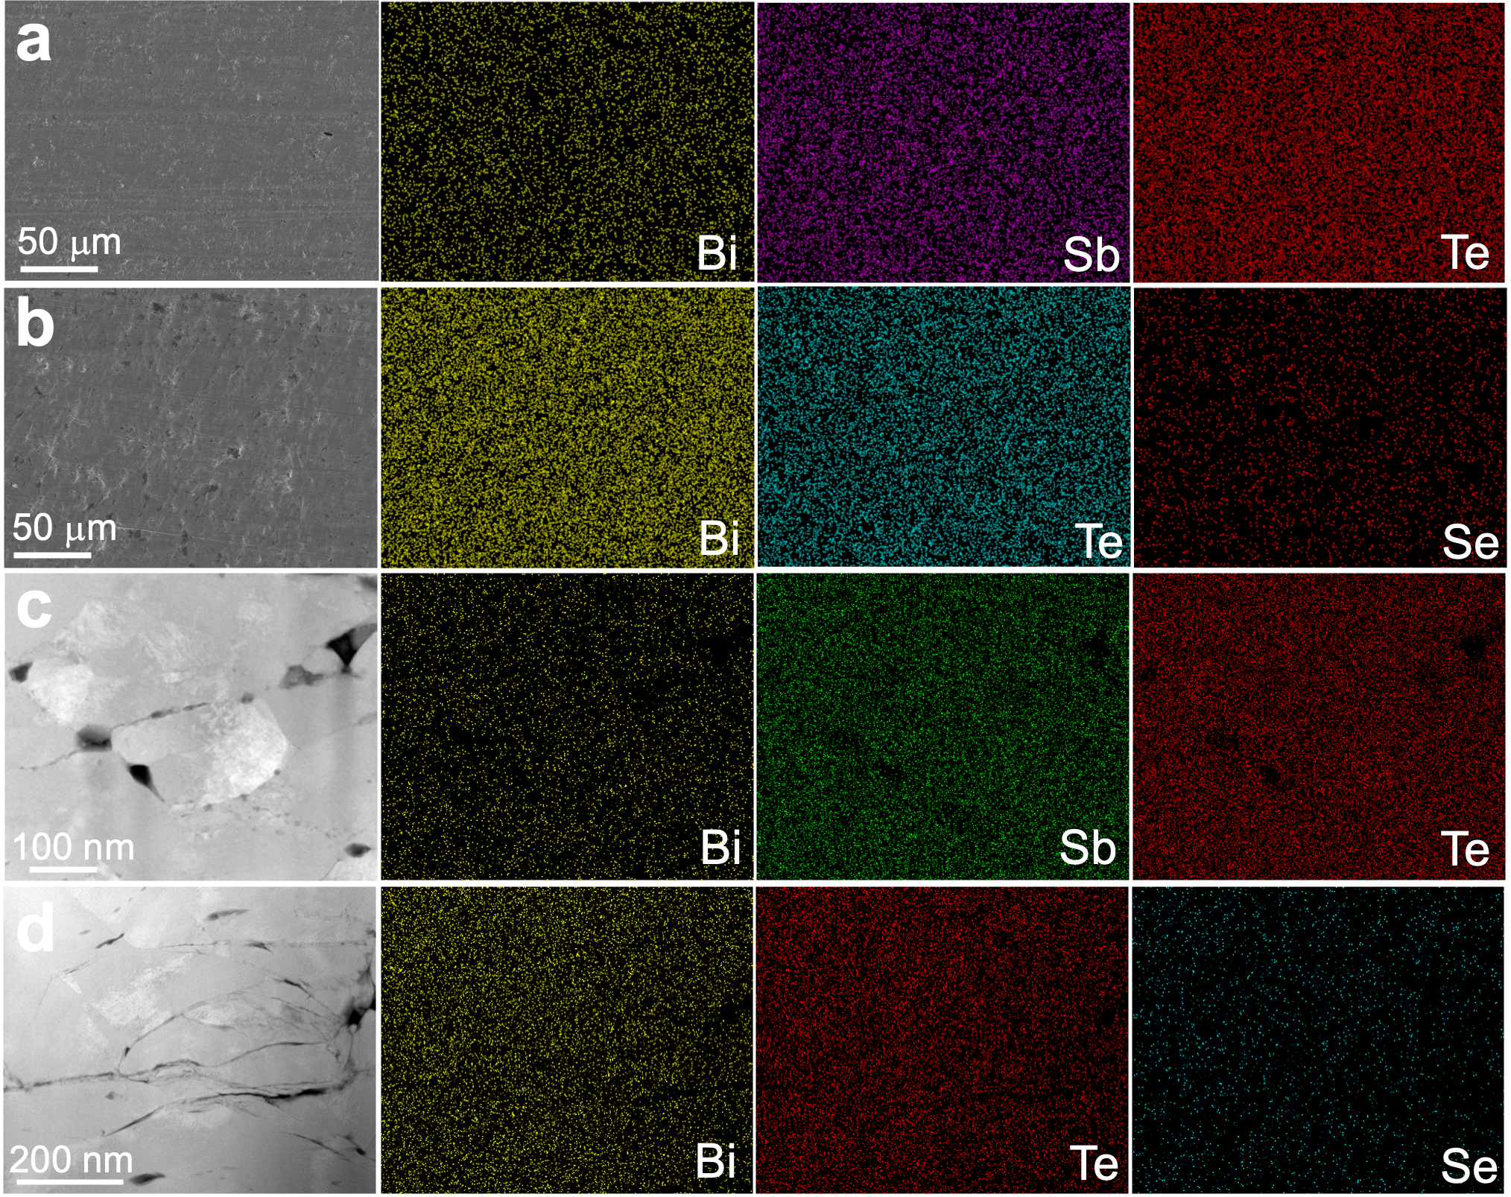
Fig. S11. Element distribution of printing materials after annealing. a,b, Scanning electron microscopy (SEM) images and the corresponding energy dispersive x-ray spectrometry elemental maps of the (a) p- and (b) n-type samples. c,d, High-angle annular dark-field transmission electron microscopy (HAADF TEM) images and the corresponding energy dispersive x-ray spectrometry elemental maps of the (c) p- and (d) n-type samples.

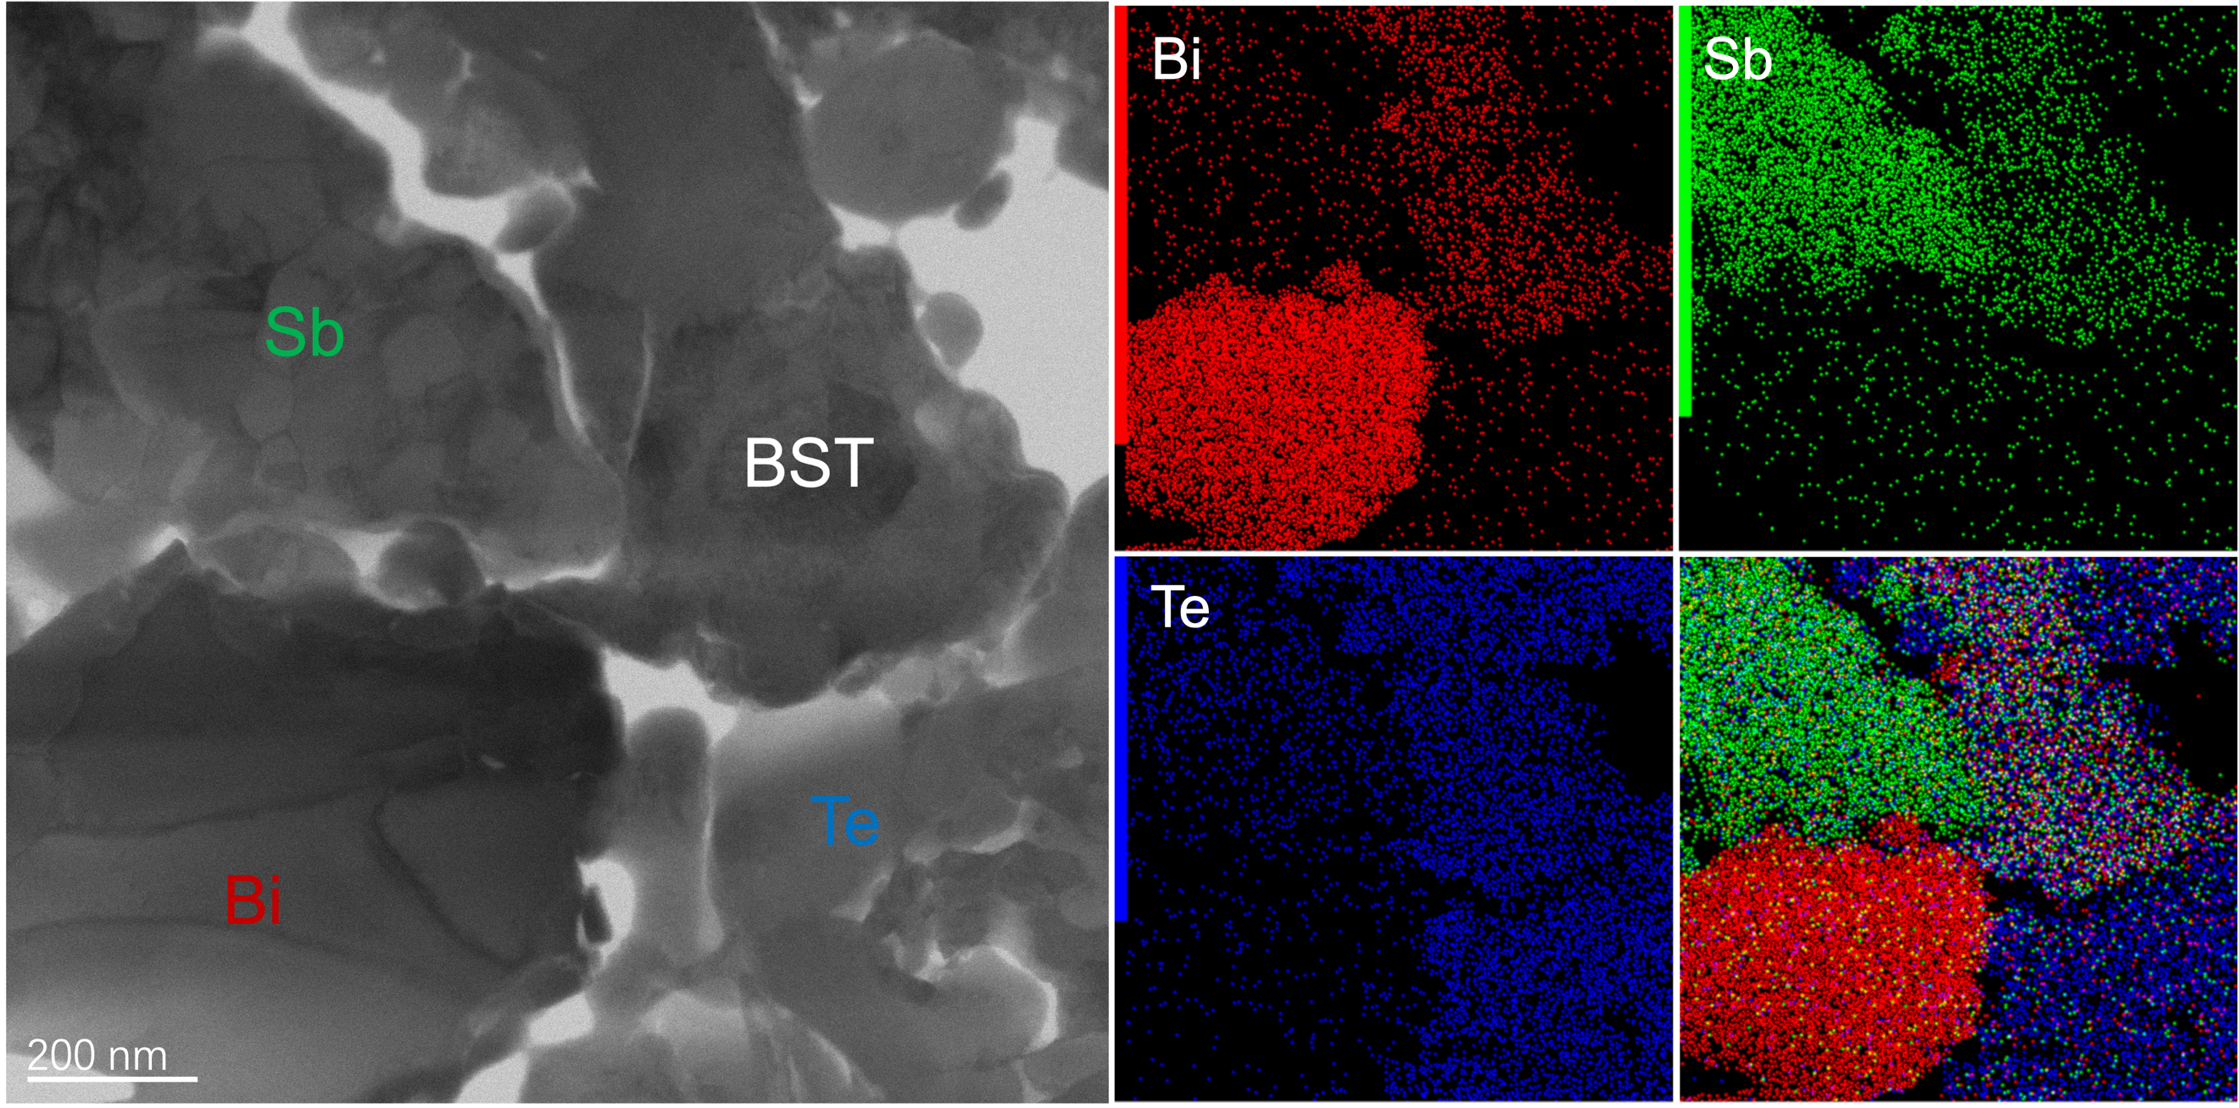
Fig. S12. STEM characterization of p-type multiphase particles before in situ heating and the corresponding EDS elemental distribution maps.

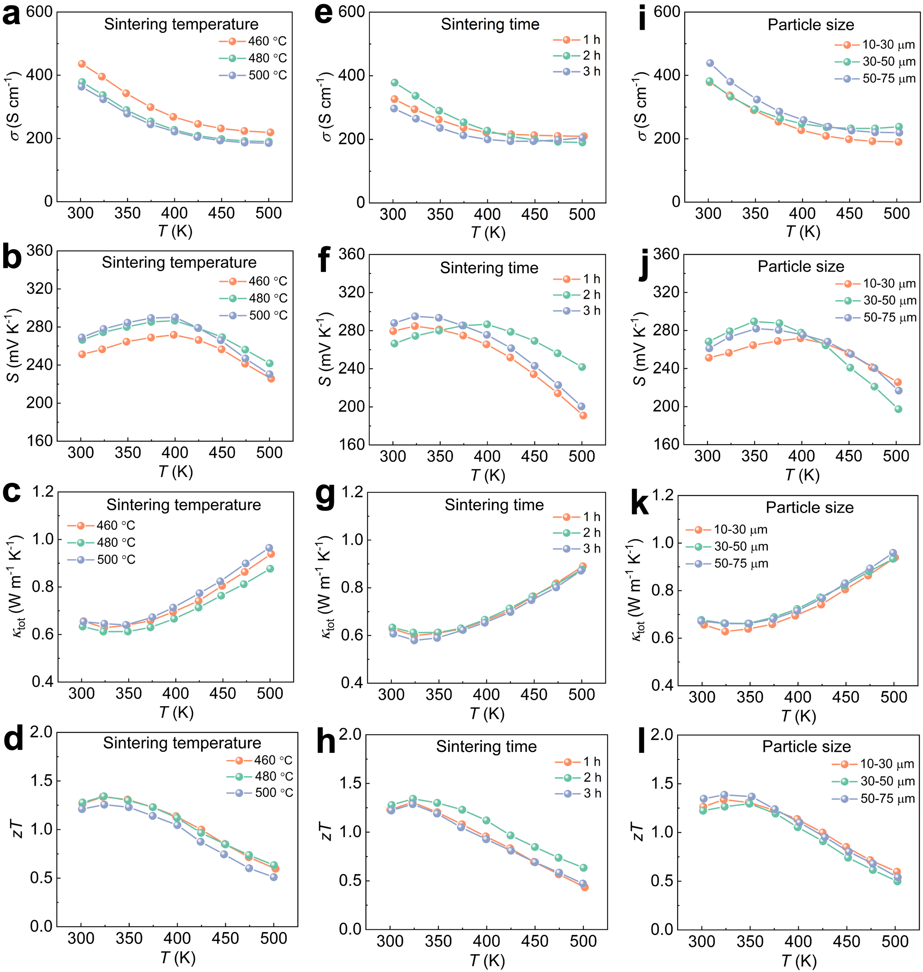
Fig. S13. Effect of different synthesis parameters on the thermoelectric properties of p-type Bi_{0.5}Sb_{1.5}Te₃ samples. a-d, Temperature dependence of TE properties under different sintering temperatures: (a) S, (b) σ, (c) κ_{tot} and (d) zT. e-h, Temperature dependence of TE properties under different sintering times: (e) S, (f) σ, (g) κ_{tot} and (h) zT. i-l, Temperature dependence of TE properties under different particle sizes: (i) S, (j) σ, (k) κ_{tot} and (l) zT.

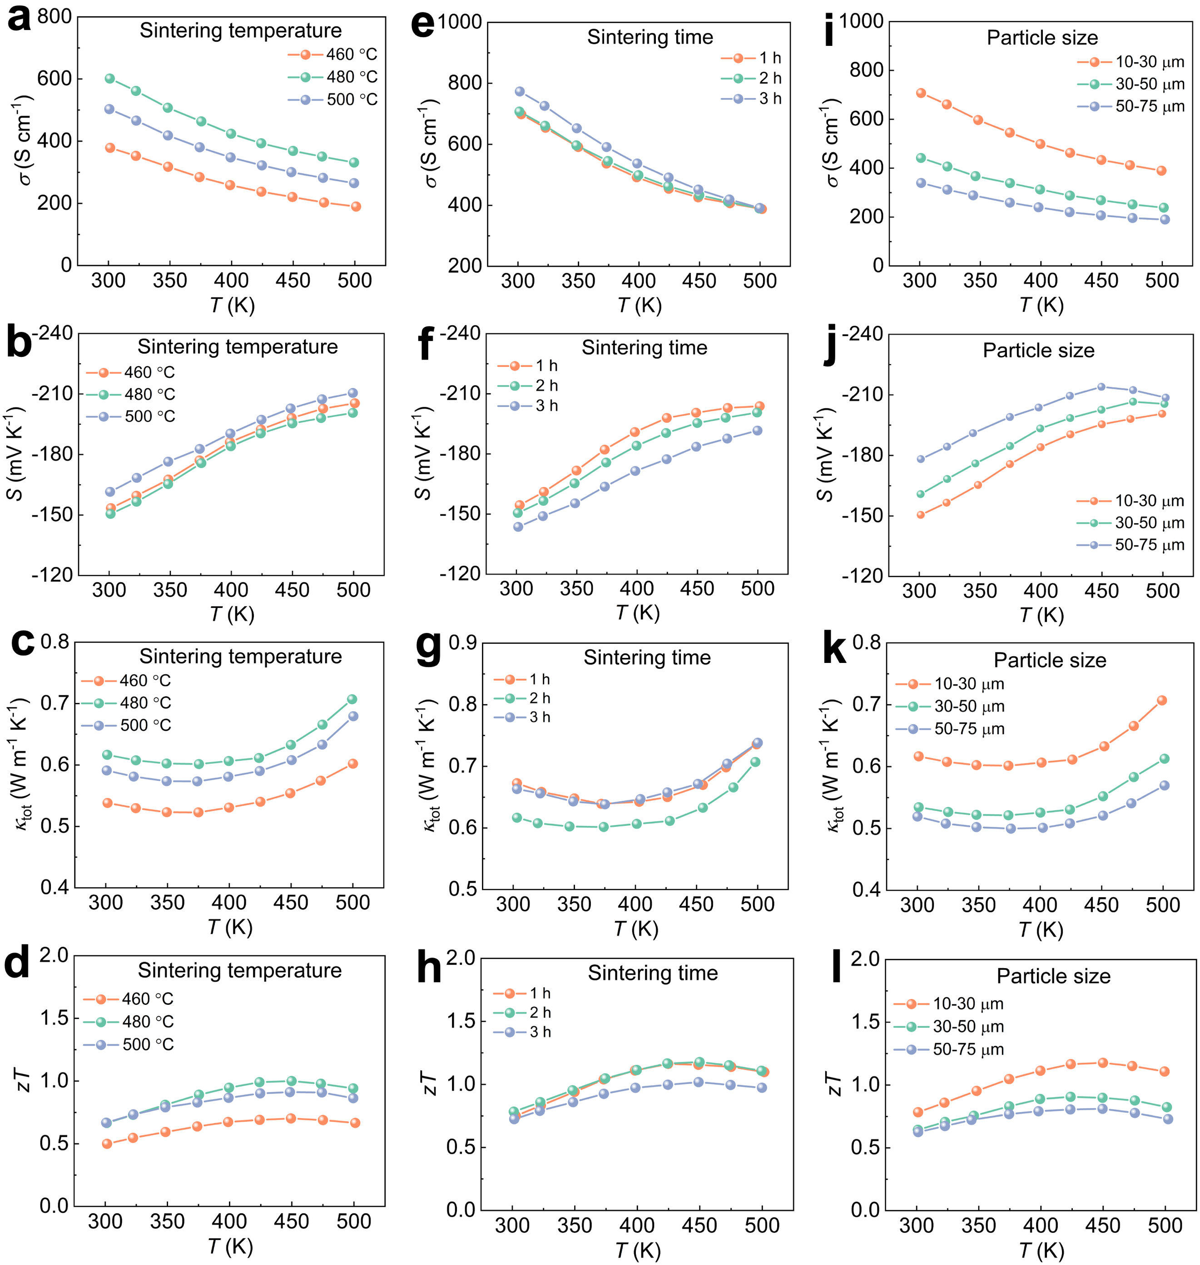
Fig. S14. Effect of different synthesis parameters on the thermoelectric properties of n-type Bi₂Te_{2.5}Se_{0.5} samples. a-d, Temperature dependence of TE properties under different sintering temperatures: (a) S, (b) σ, (c) κ_{tot} and (d) zT. e-h, Temperature dependence of TE properties under different sintering times: (e) S, (f) σ, (g) κ_{tot} and (h) zT. i-l, Temperature dependence of TE properties under different particle sizes: (i) S, (j) σ, (k) κ_{tot} and (l) zT.

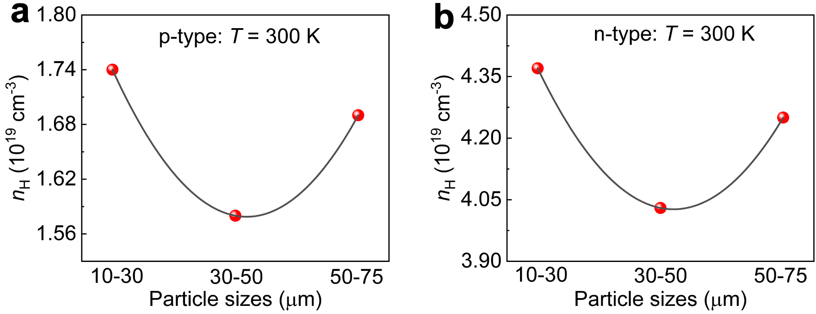
Fig. S15. Carrier concentration at different particle sizes. a,d, Effect of particle sizes on the concentration of charge carriers in (a) p- and (b) n-type Bi₂Te₃-based materials at 300 K.

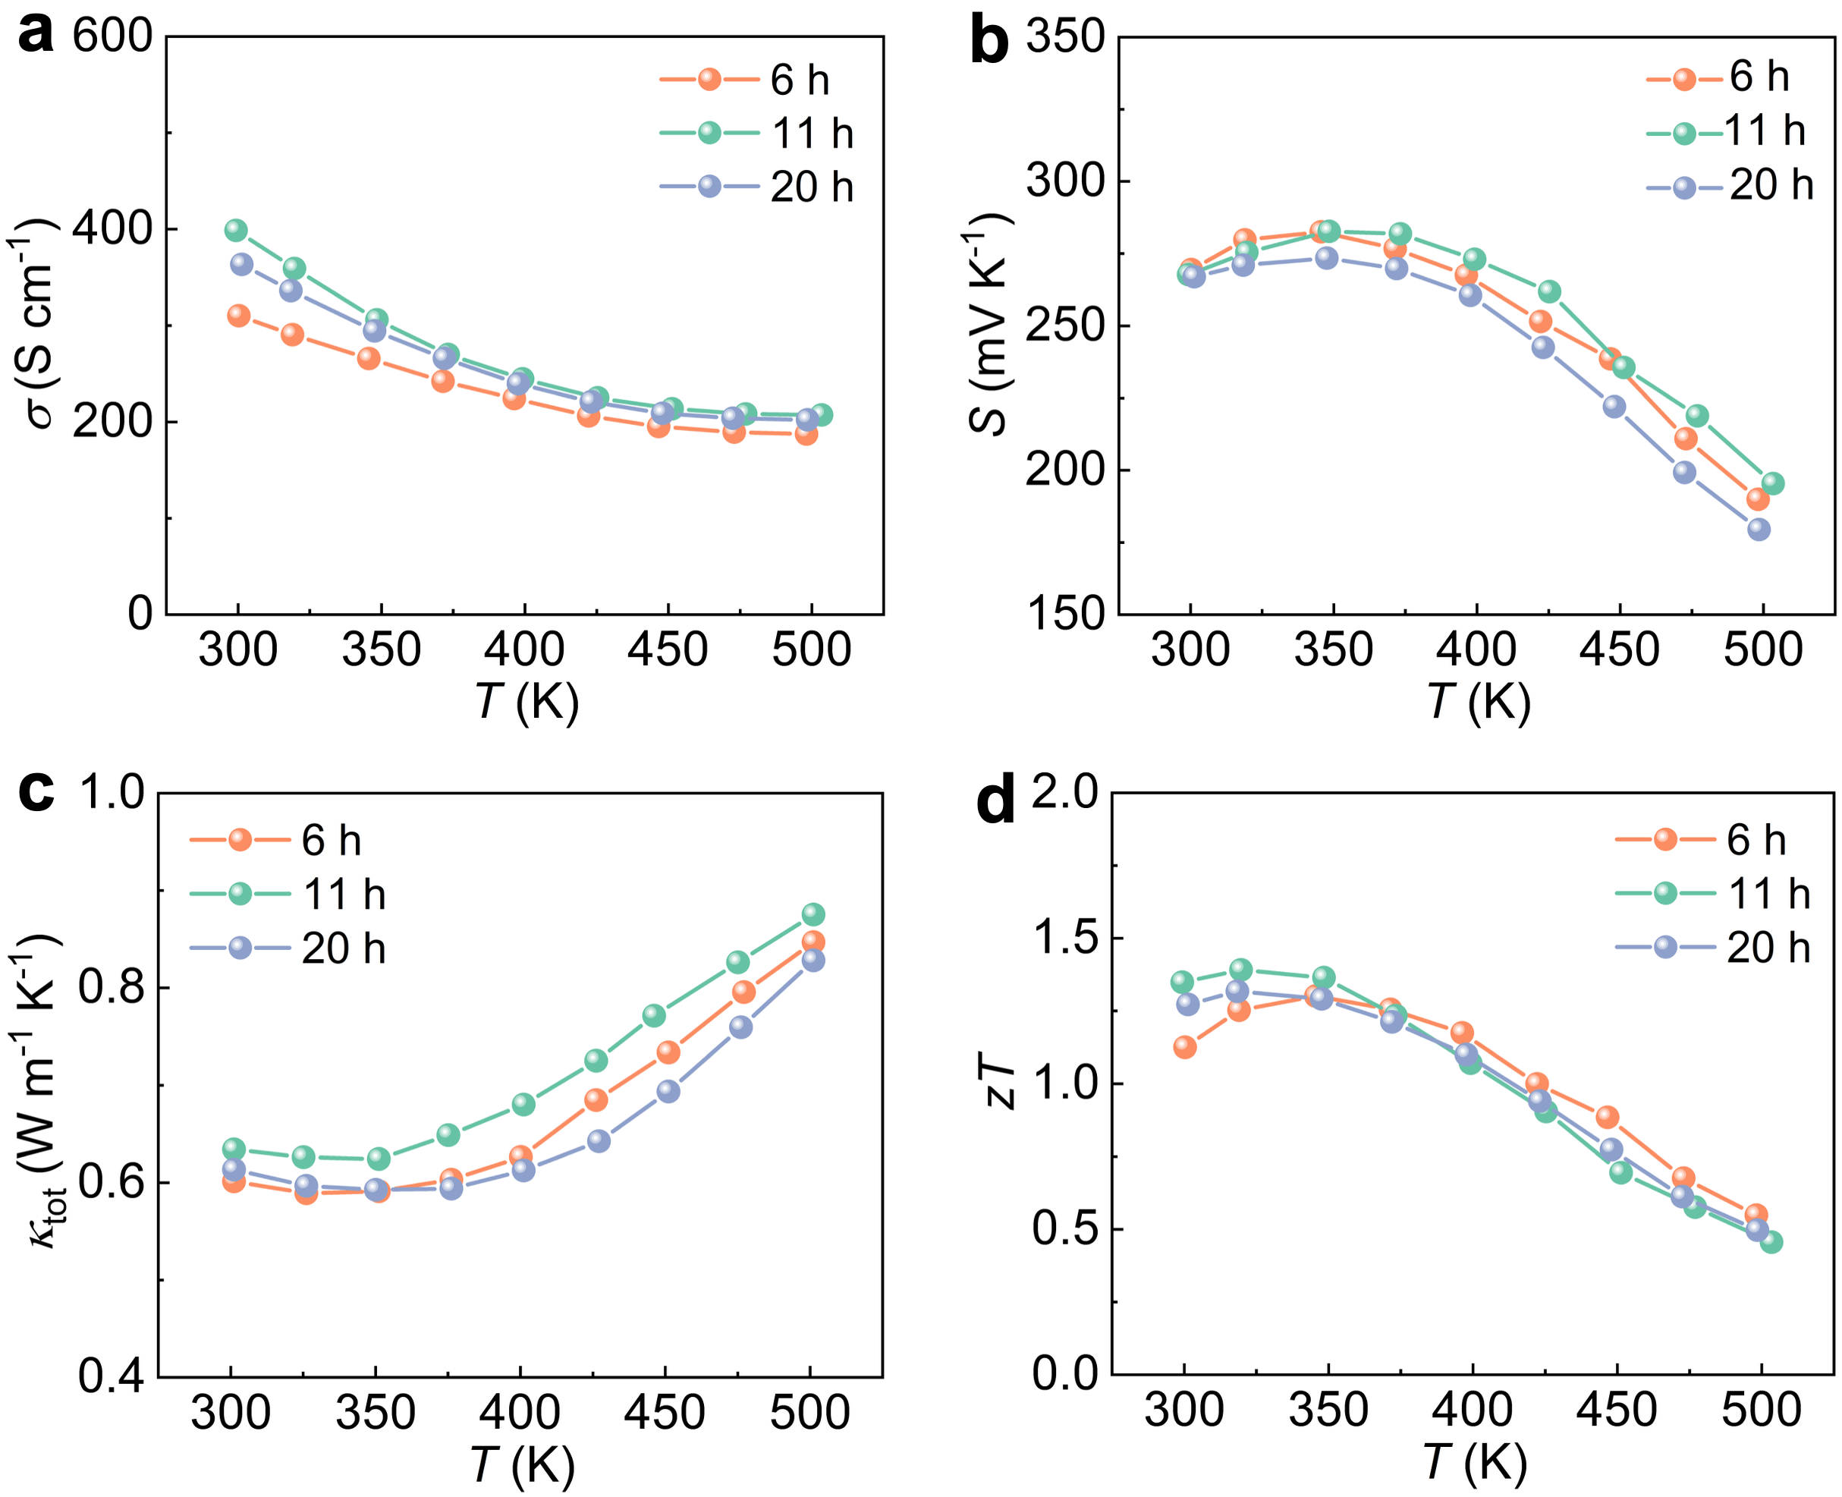
Fig. S16. Effect of different ball milling times on the thermoelectric performance of p‑type Bi_{0.5}Sb_{1.5}Te₃ samples. a-d, Temperature dependence of TE properties under different ball milling times: (a) S, (b) σ, (c) κ_{tot} and (d) zT. The results indicate that controlling the ball milling input power is more important than the input energy.

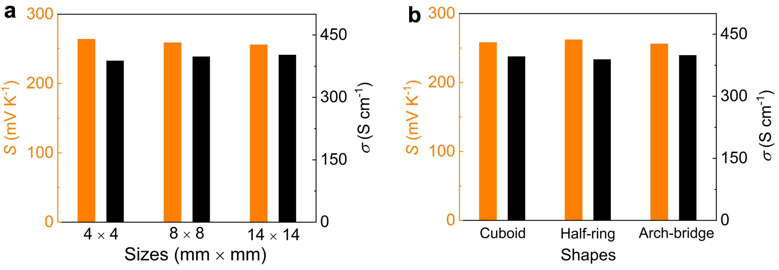
Fig. S17. Effect of size and shape of printed samples on electrical properties. a, The room-temperature σ and S of the p-type printed cuboids with widths of 4 × 4, 8 × 8 and 14 ×14 mm. b, The room-temperature σ and S of the p-type printed samples with cuboid and half-ring and arch-bridge shapes.

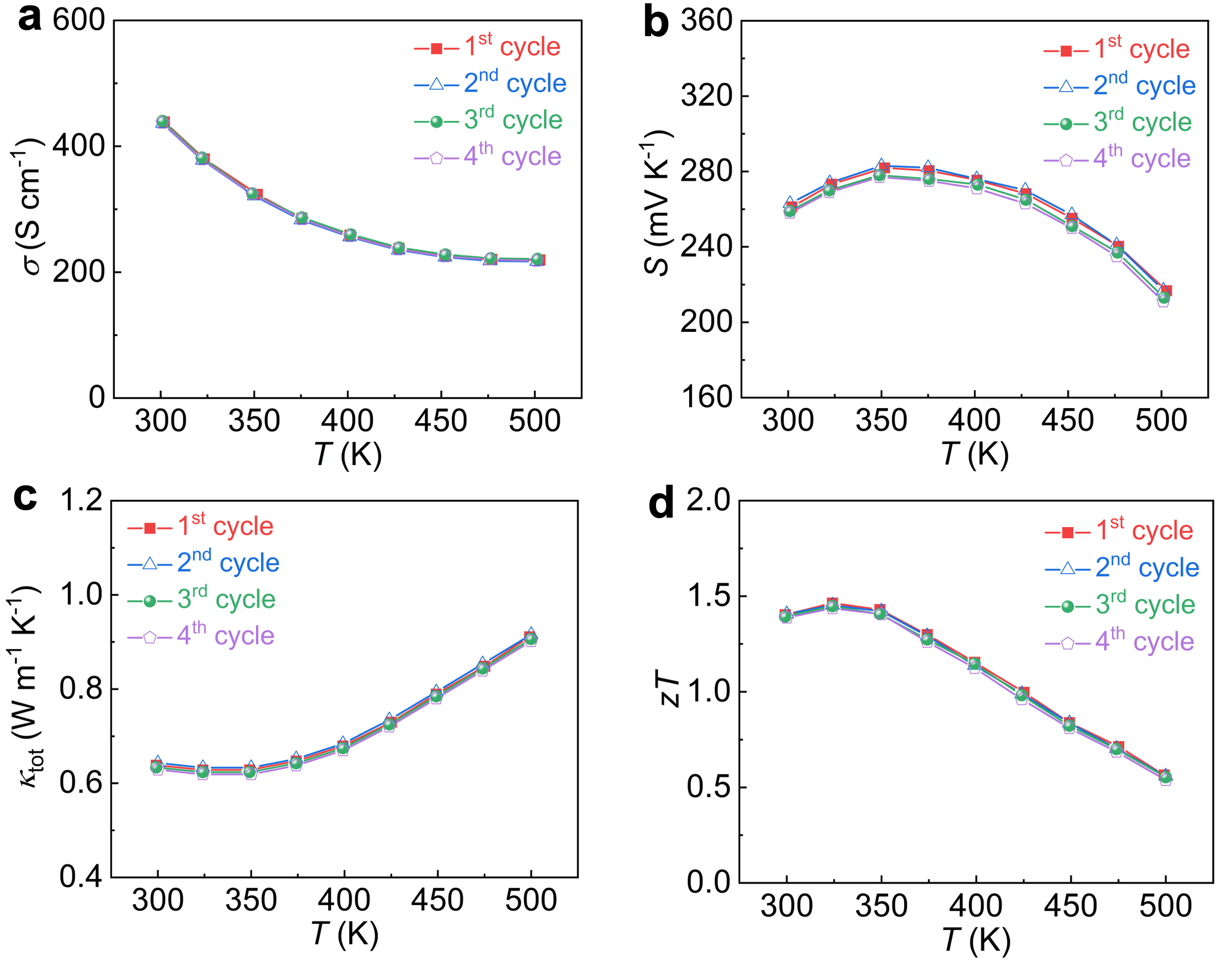
Fig. S18. Reproducibility tests of one printed p-type Bi_{0.5}Sb_{1.5}Te₃ samples. a-d, Temperature dependent of (a) S, (b) σ, (c) κ_{tot} and (d) zT.

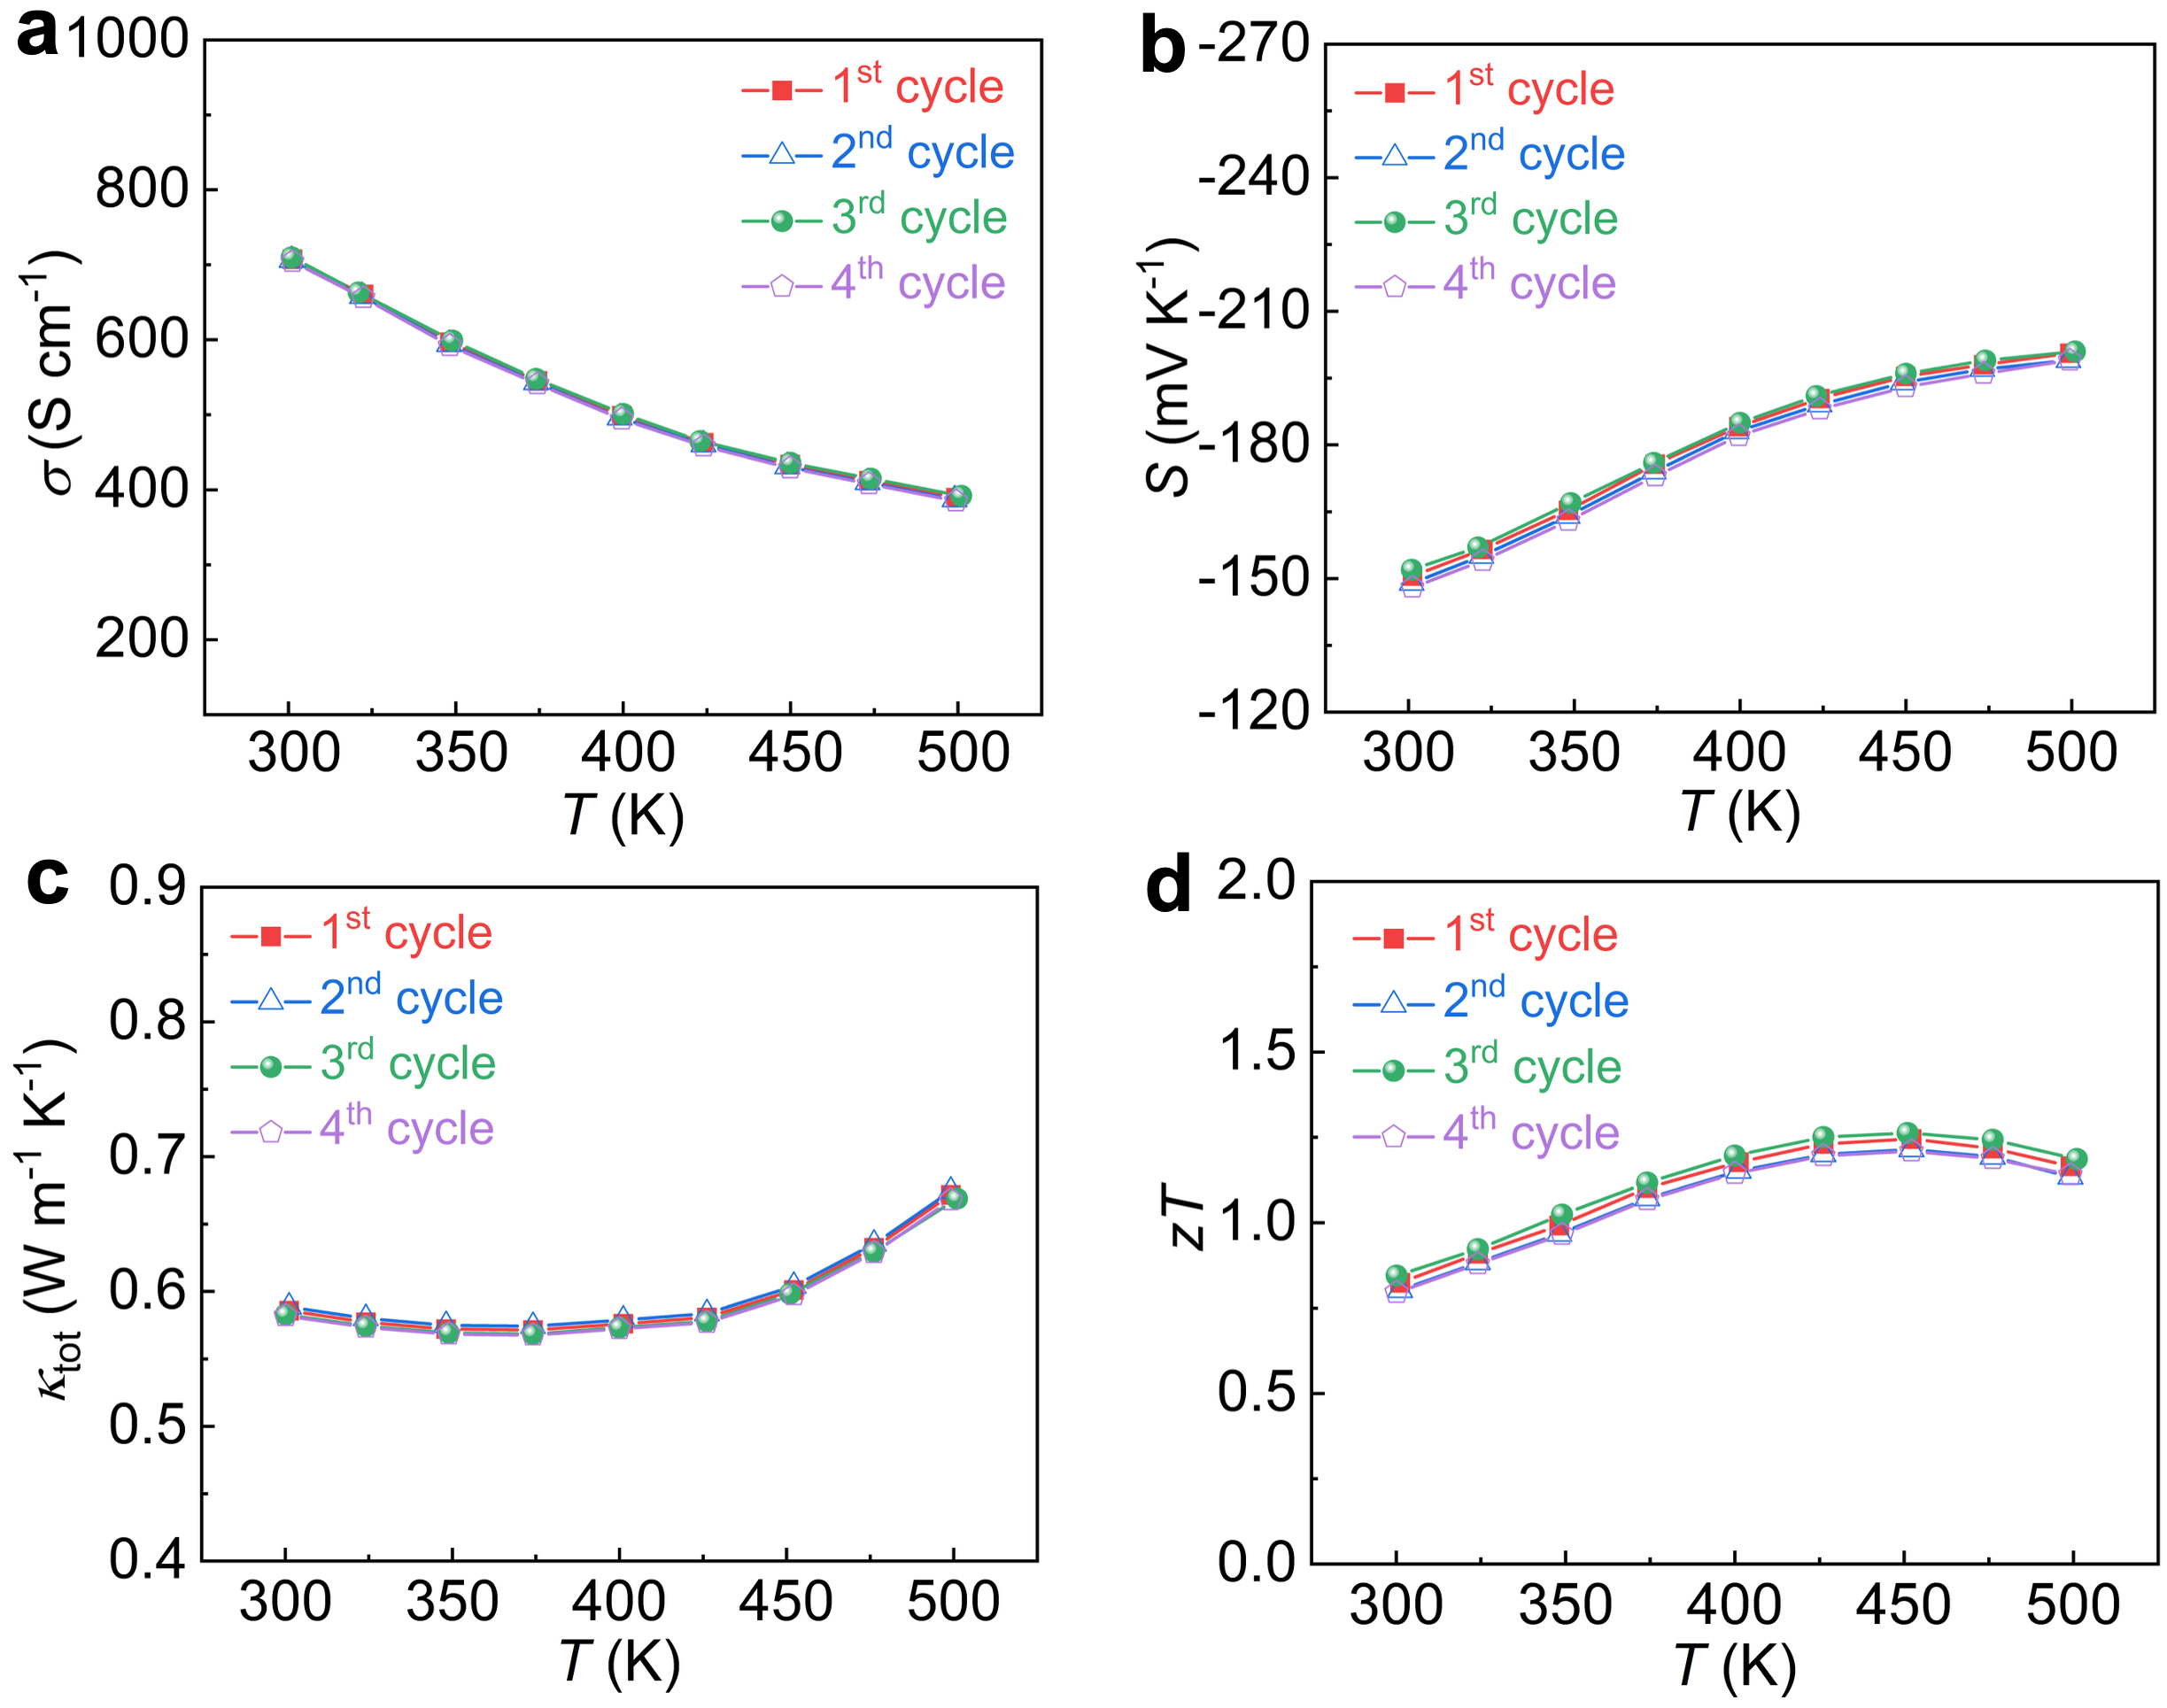
Fig. S19. Reproducibility tests of one printed n-type Bi₂Te_{2.5}Se_{0.5} samples. a-d, Temperature dependent of (a) S, (b) σ, (c) κ_{tot} and (d) zT.

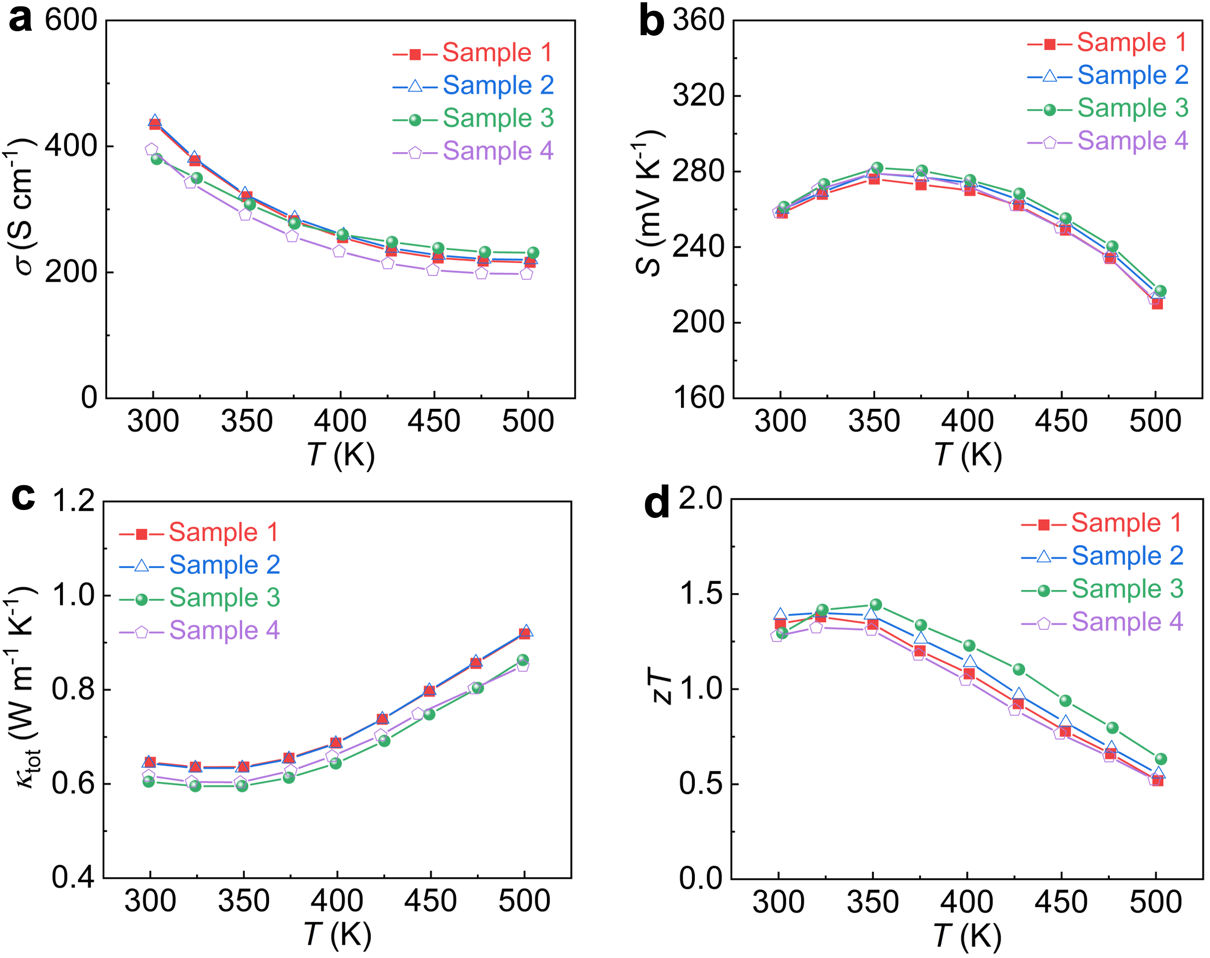
Fig. S20. Reproducibility tests for four printed p-type Bi_{0.5}Sb_{1.5}Te₃ samples. a-d, Temperature dependent of (a) S, (b) σ, (c) κ_{tot} and (d) zT.

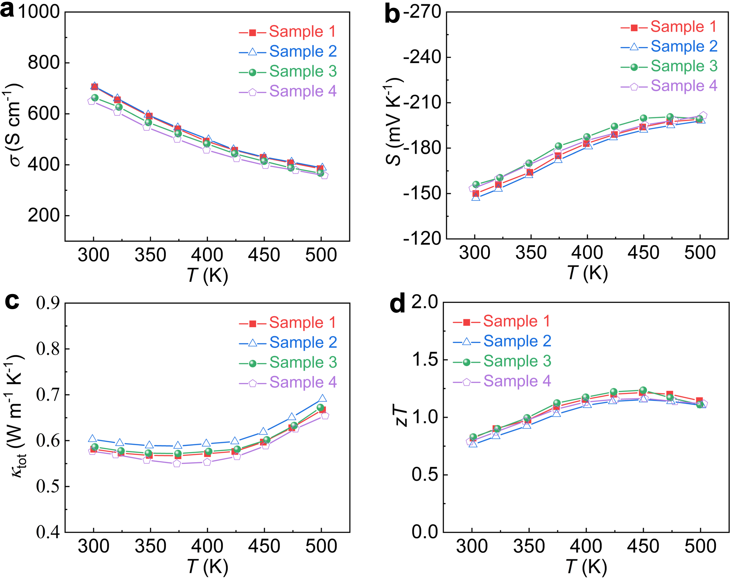
Fig. S21. Reproducibility tests for four printed n-type Bi₂Te_{2.5}Se_{0.5} samples. a-d, Temperature dependent of (a) S, (b) σ, (d) κ_{tot} and (d) zT.

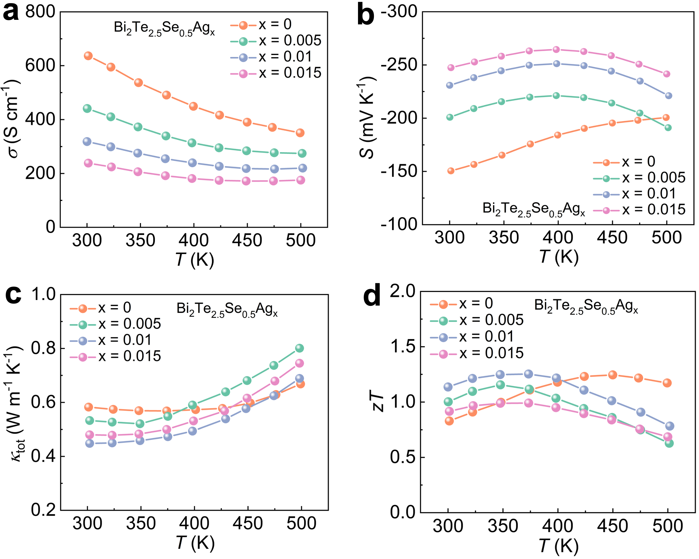
Fig. S22. Regulation of thermoelectric properties of n-type Bi₂Te_{2.5}Se_{0.5} samples by nano-Ag. a-d, Temperature dependent of (a) S, (b) σ, (d) κ_{tot} and (d) zT.

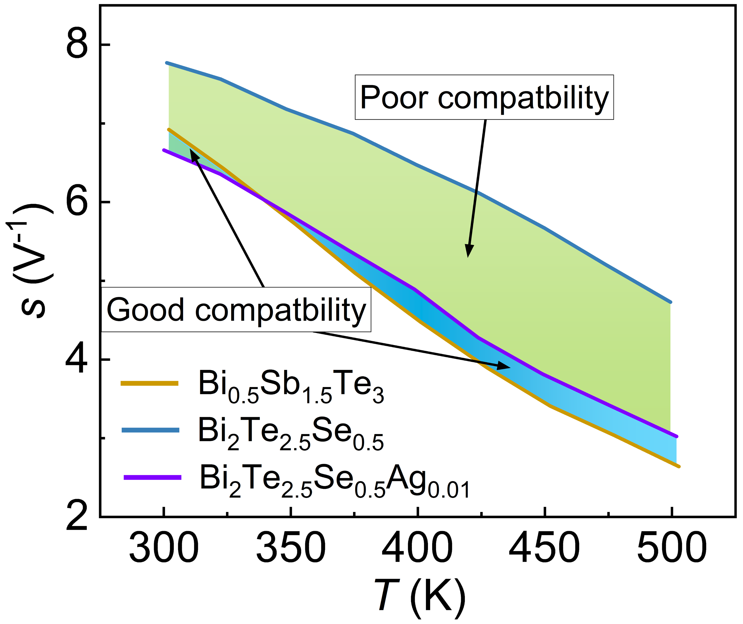
Fig. S23. Comparison of the compatibility factor (s) of undoped and Ag-doped n-type Bi₂Te_{2.5}Se_{0.5} with p-type Bi_{0.5}Sb_{1.5}Te₃. Doping n-type samples with Ag significantly improves the s between them and the p-type samples, thereby enhancing the output efficiency of the device.

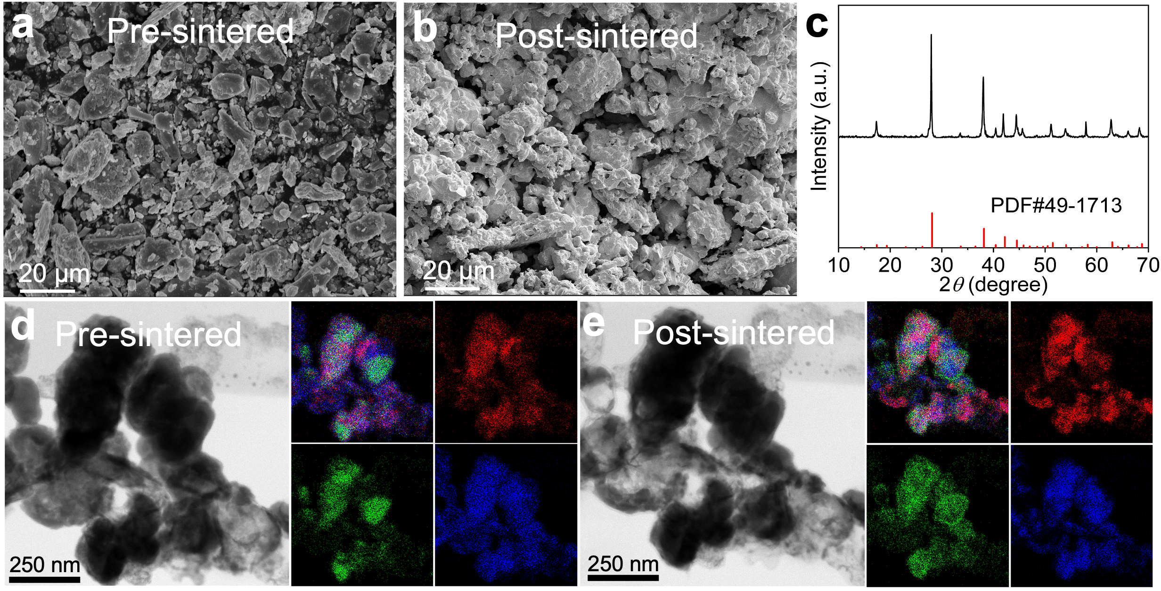
Fig. S24. Microstructural evolution of pure Bi_{0.5}Sb_{1.5}Te₃ phase powders before and after sintering. a,b, SEM images (a) the powder pre-sintered and (b) interior of the post-sintered bulk. c, XRD patterns of the powder pre-sintering. d,e, In-situ STEM observation of the morphology and Energy-Dispersive X-ray Spectroscopy (EDS) map of powder particles (d) pre-sintered and (e) post-sintered.

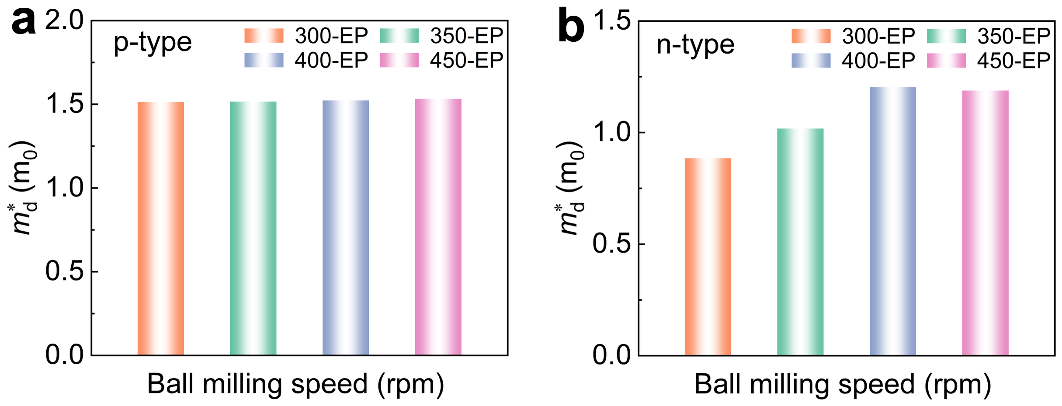
Fig. S25. The relationship between the effective mass of charge carriers ($m_{d}^{*}$) and ball milling speed at 300 K. a,b, Effective mass evolution of (a) p-type (Bi_{0.5}Sb_{1.5}Te₃) and (b) n-type (Bi₂Te_{2.5}Se_{0.5}Ag_{0.01}) bulk samples fabricated from elemental powders with varying ball-milling speeds.

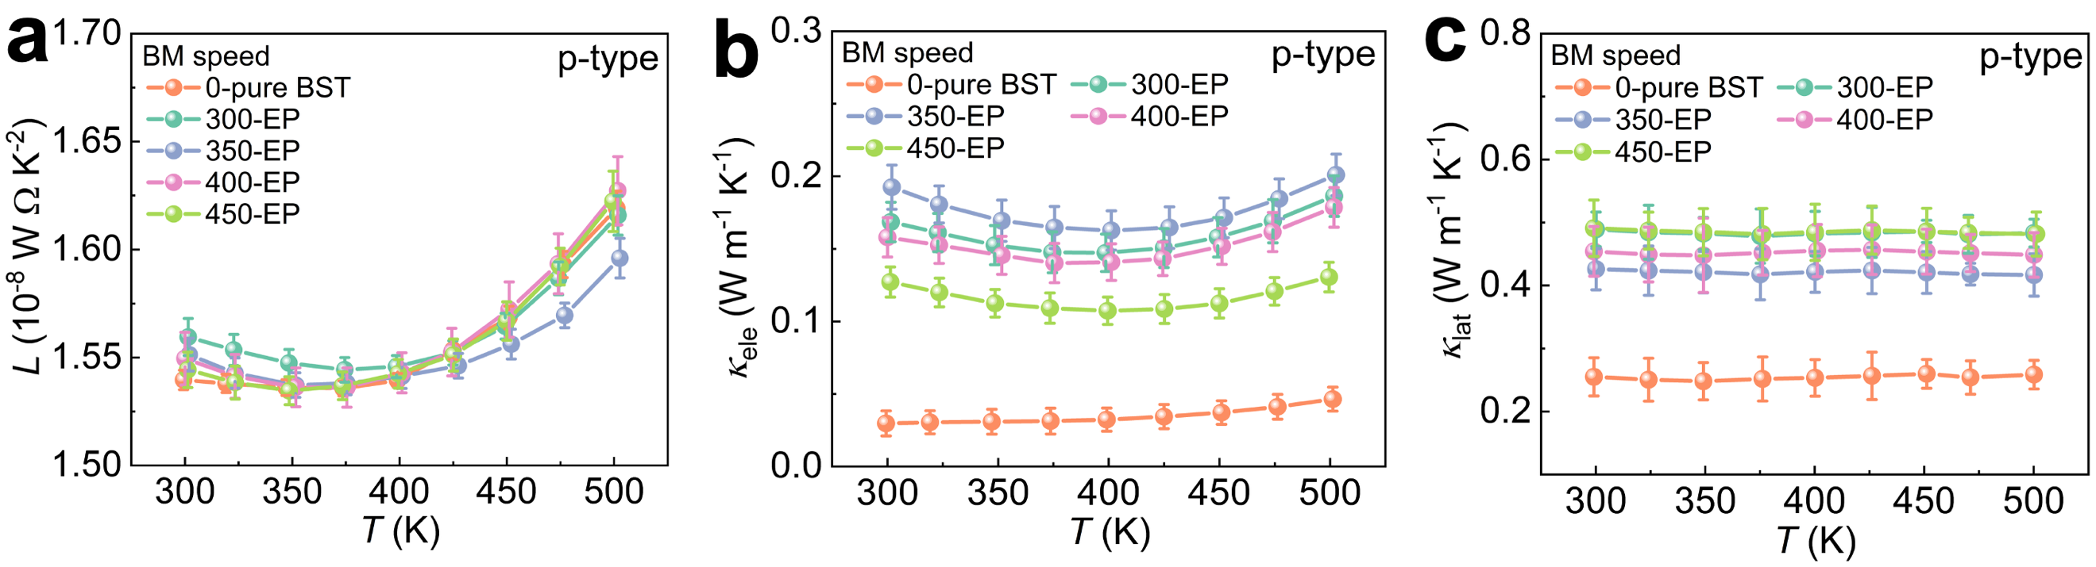
Fig. S26. Determination of 𝜅_{lat} for p-type (Bi_{0.5}Sb_{1.5}Te₃) by calculating the 𝜅_{ele} using the L values. a, Lorentz number L as a function of temperature calculated using single parabolic band (SPB) model. b, Based on the calculated L we obtained the calculated 𝜅_{ele}. c, Determination of 𝜅lat by calculating the 𝜅ele using the L values.

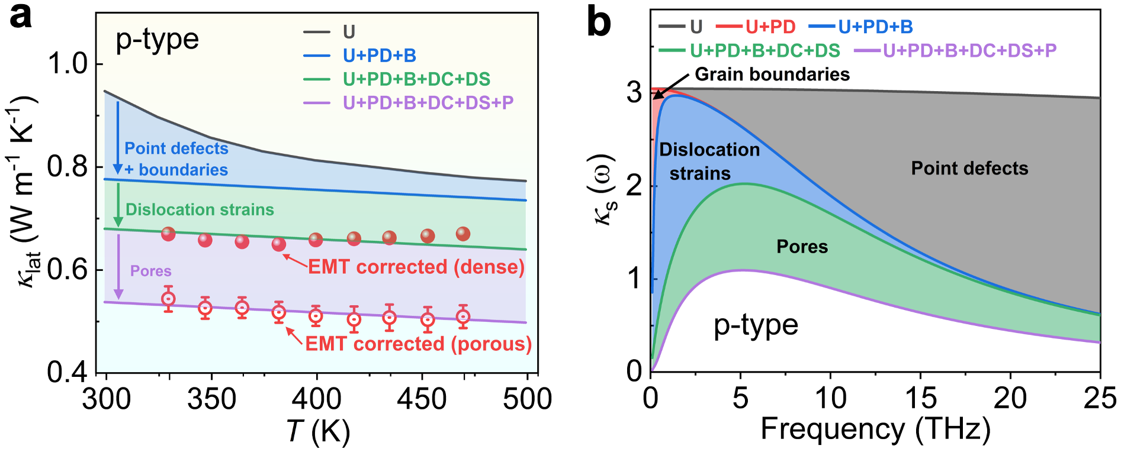
Fig. S27. The 𝜅_{lat} of the p-type Bi_{0.5}Sb_{1.5}Te₃ sample. a, 𝜅_{lat} and b, 𝜅_{s} by taking Umklapp (U), point defect (PD), grain boundaries (B), dislocation strains (DC+DS) and pores (P) into account.

We utilized modified EMT to subtract the reduction in κ_{lat} caused by the thermal insulation properties of pores, hereby deriving the equivalent value for the material in its fully dense material. Consequently, the pores can significantly impede phonon thermal transport, leading to reduced lattice thermal conductivity. Hence, the presence of voids can markedly impede phonon-based thermal conduction, resulting in a decrease in the lattice thermal conductivity. However, this also leads to a significant degradation in the material's mechanical strength, necessitating a trade-off between these two properties. In this work, materials printed from binder-free inks demonstrate superior thermoelectric performance coupled with enhanced mechanical properties.

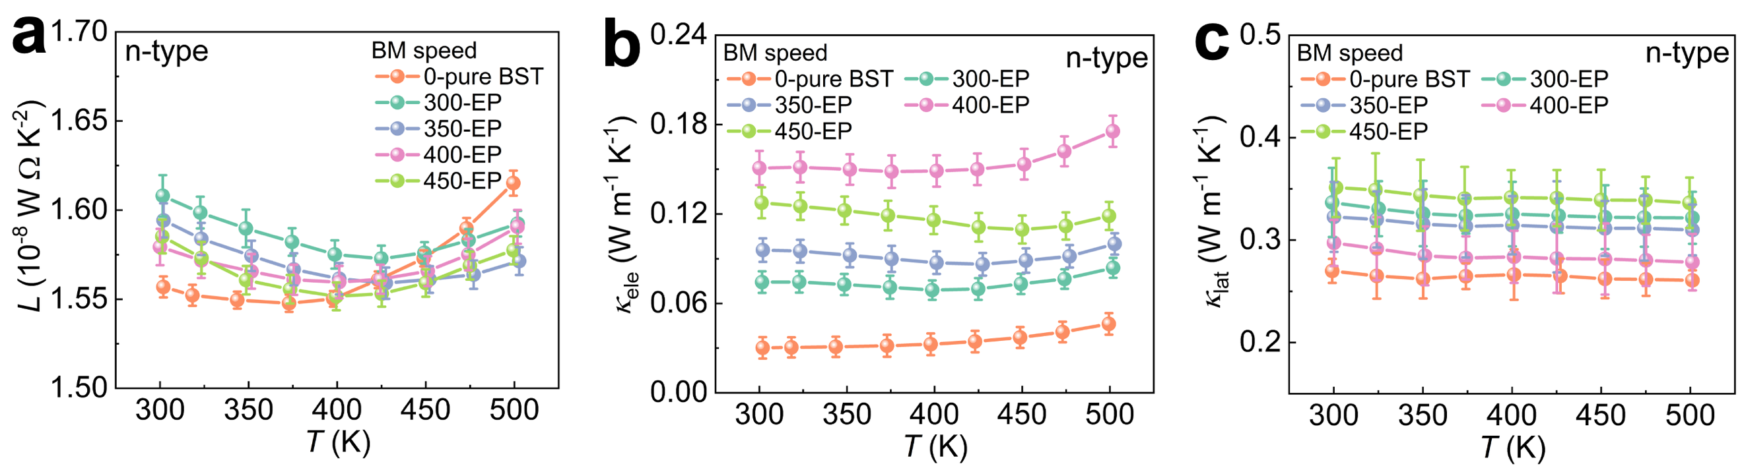
Fig. S28. Determination of 𝜅_{lat} for n-type (Bi₂Te_{2.5}Se_{0.5}Ag_{0.01}) by calculating the 𝜅_{ele} using the L values. a, Lorentz number L as a function of temperature calculated using single parabolic band (SPB) model. b, Based on the calculated L we obtained the calculated 𝜅_{ele}. c, Determination of 𝜅lat by calculating the 𝜅ele using the L values.

The calculated κ_{lat} values for n-type samples were determined to be 0.25-0.35 W m⁻¹ K⁻¹, respectively, with the n-type sample approaching the theoretically predicted minimum limit of the lattice thermal conductivity for Bi₂Te₃-based materials¹⁴ (0.2 W m⁻¹ K⁻¹).

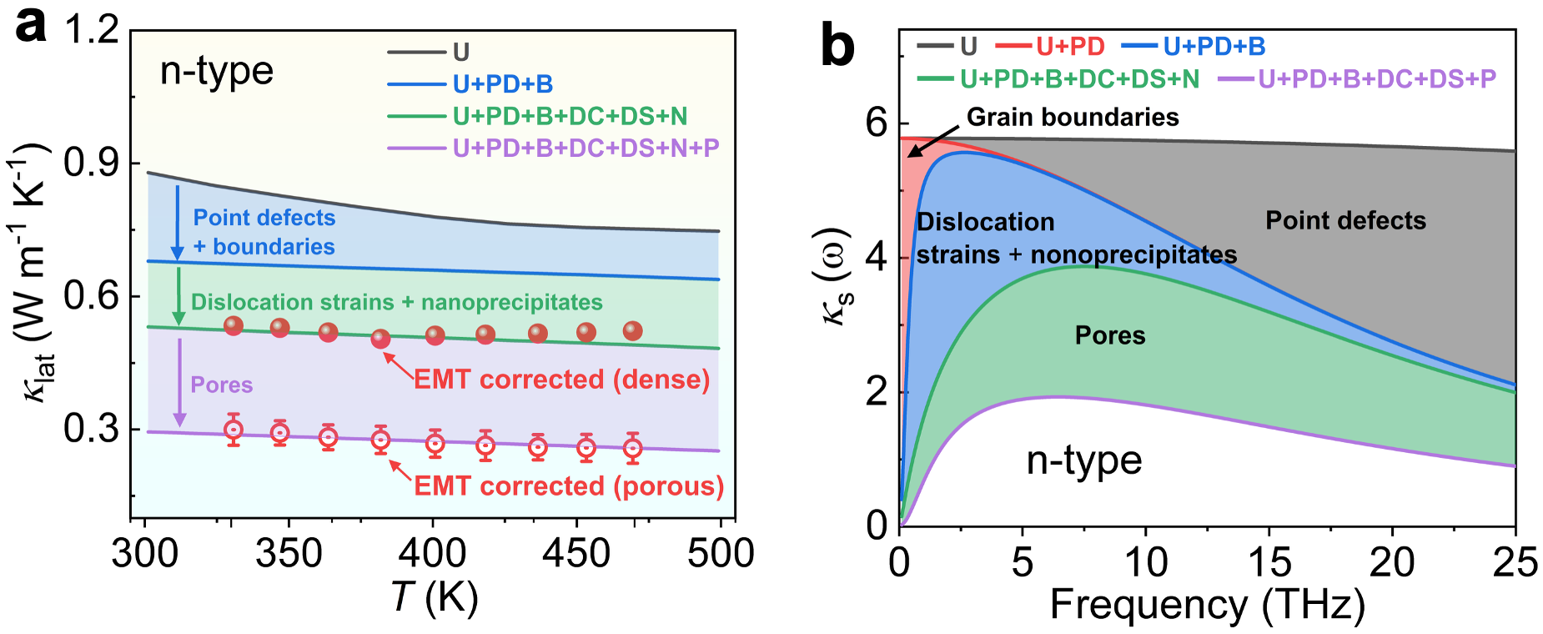
Fig. S29. The 𝜅_{lat} of the n-type Bi₂Te_{2.5}Se_{0.5}Ag_{0.01} sample. a, 𝜅_{lat} and b, 𝜅_{s} by taking Umklapp (U), point defect (PD), grain boundaries (B), dislocation strains (DC+DS), nanoprecipitates (N), and pores (P) into account.

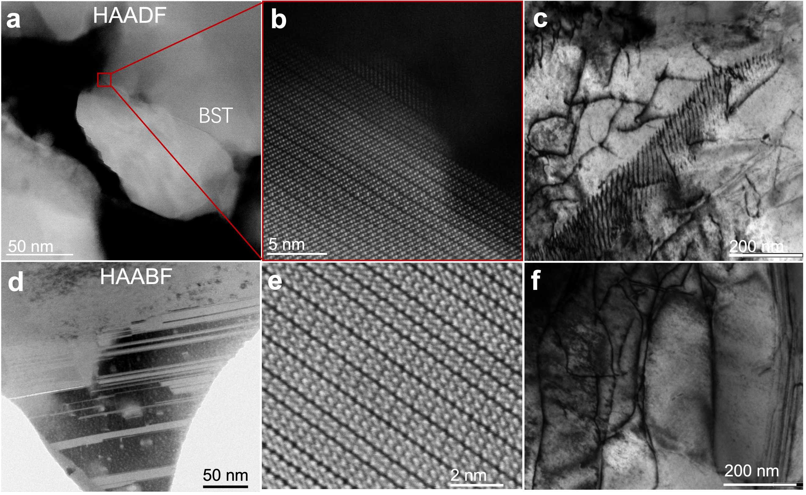
Fig. S30. Microstructural TEM characterization of various defects in 3D-printed Bi₂Te₃-based samples. For the p-type sample: a, HAADF image showing strong grains binding. b, An enlarged image depicting high density stacking fault and nanoscale distortions. c, High-density dislocations. For the n-type sample: d, HAADF image showing twin structure. e, An enlarged image depicting high density stacking fault. f, High-density dislocations.

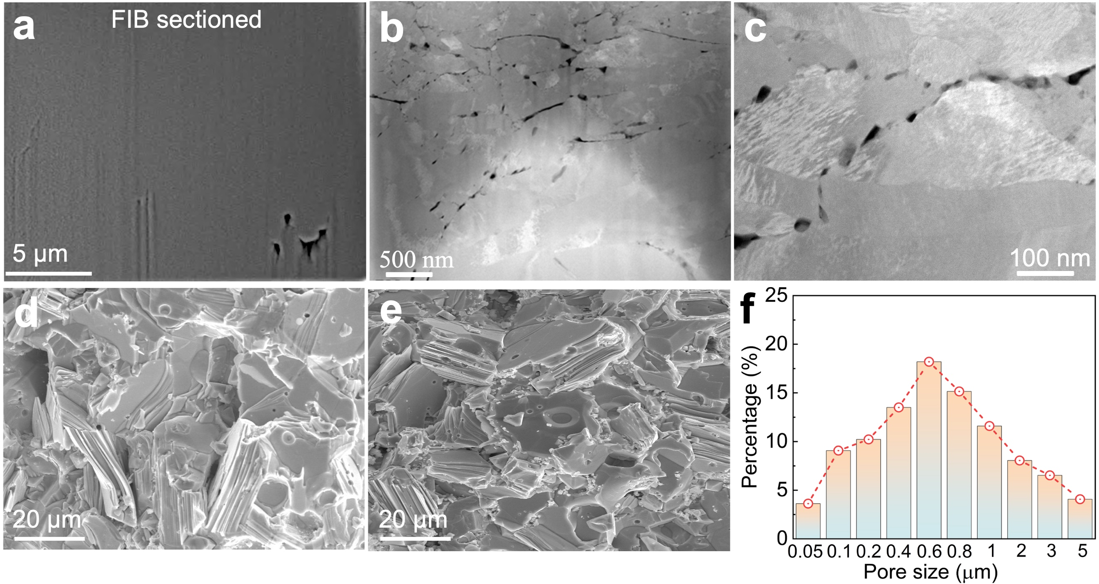Fig. S31. Porous microstructures and sizes distribution of printed p-type Bi_{0.5}Sb_{1.5}Te₃ samples. a,b, (a) SEM images of the focused ion beam (FIB) cross-sectional with the corresponding (b) TEM images and surface show formation of numerous nanopores near the grain boundaries. c, Pores at grain boundaries in the magnified TEM image. d, and e, correspond to the fracture surface porosity images after sintering of self-soldering multiphase powder particles. f, Pore size distribution.

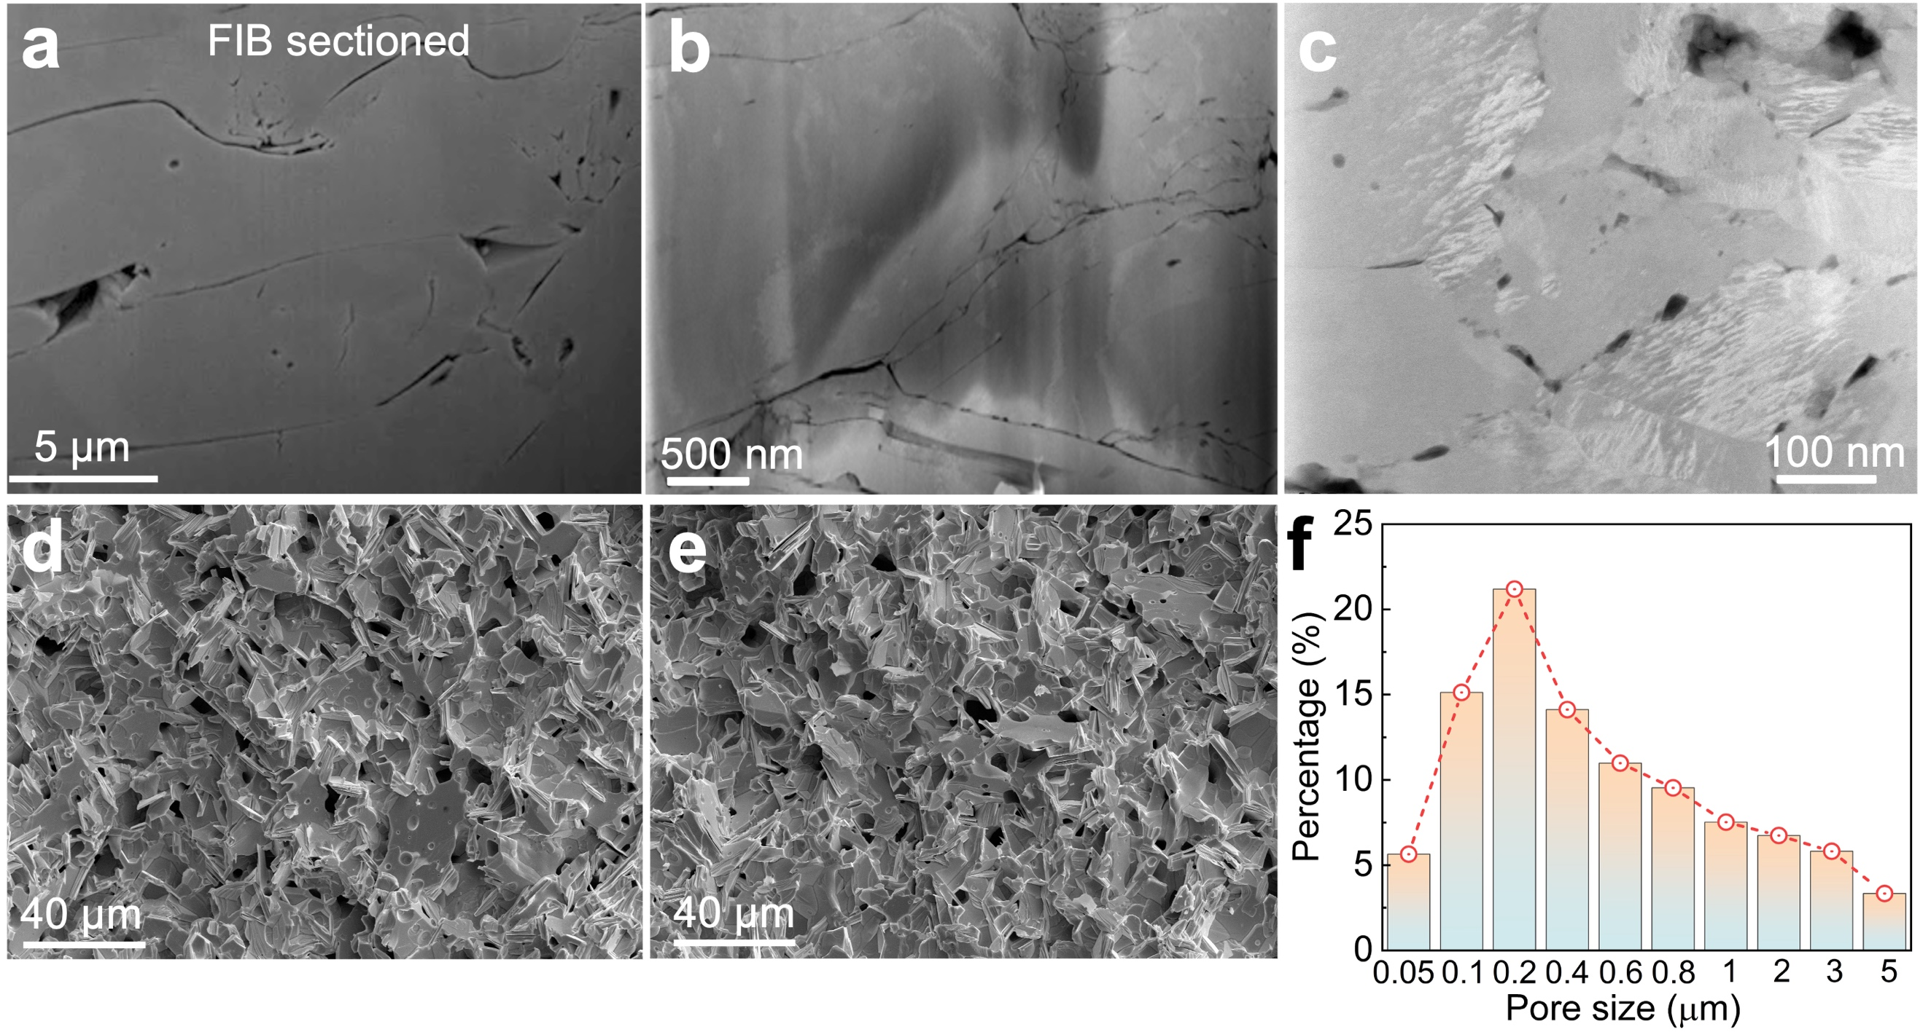
Fig. S32. Porous microstructures and sizes distribution of printed n-type Bi₂Te_{2.5}Se_{0.5}Ag_{0.01} samples. a,b, (a) SEM images of the focused ion beam (FIB) cross-sectional with the corresponding (b) TEM images and surface show formation of numerous nanopores near the grain boundaries. c, Pores at grain boundaries in the magnified TEM image. d, and e, correspond to the fracture surface porosity images after sintering of self-soldering multiphase powder particles. f, Pore size distribution.

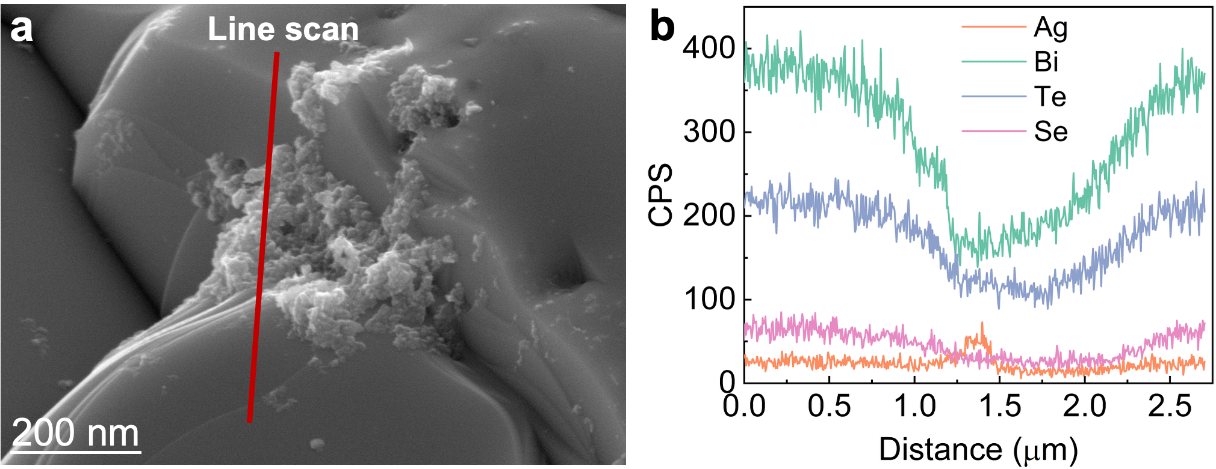
Fig. S33. SEM characterization of nano-Ag doping in 3D-printed n-type Bi₂Te_{2.5}Se_{0.5}Ag_{0.01} samples. a, Morphology image showing nano-Ag segregated at grain boundaries. b, EDS line scan spectra of the matrix and nano-Ag region.

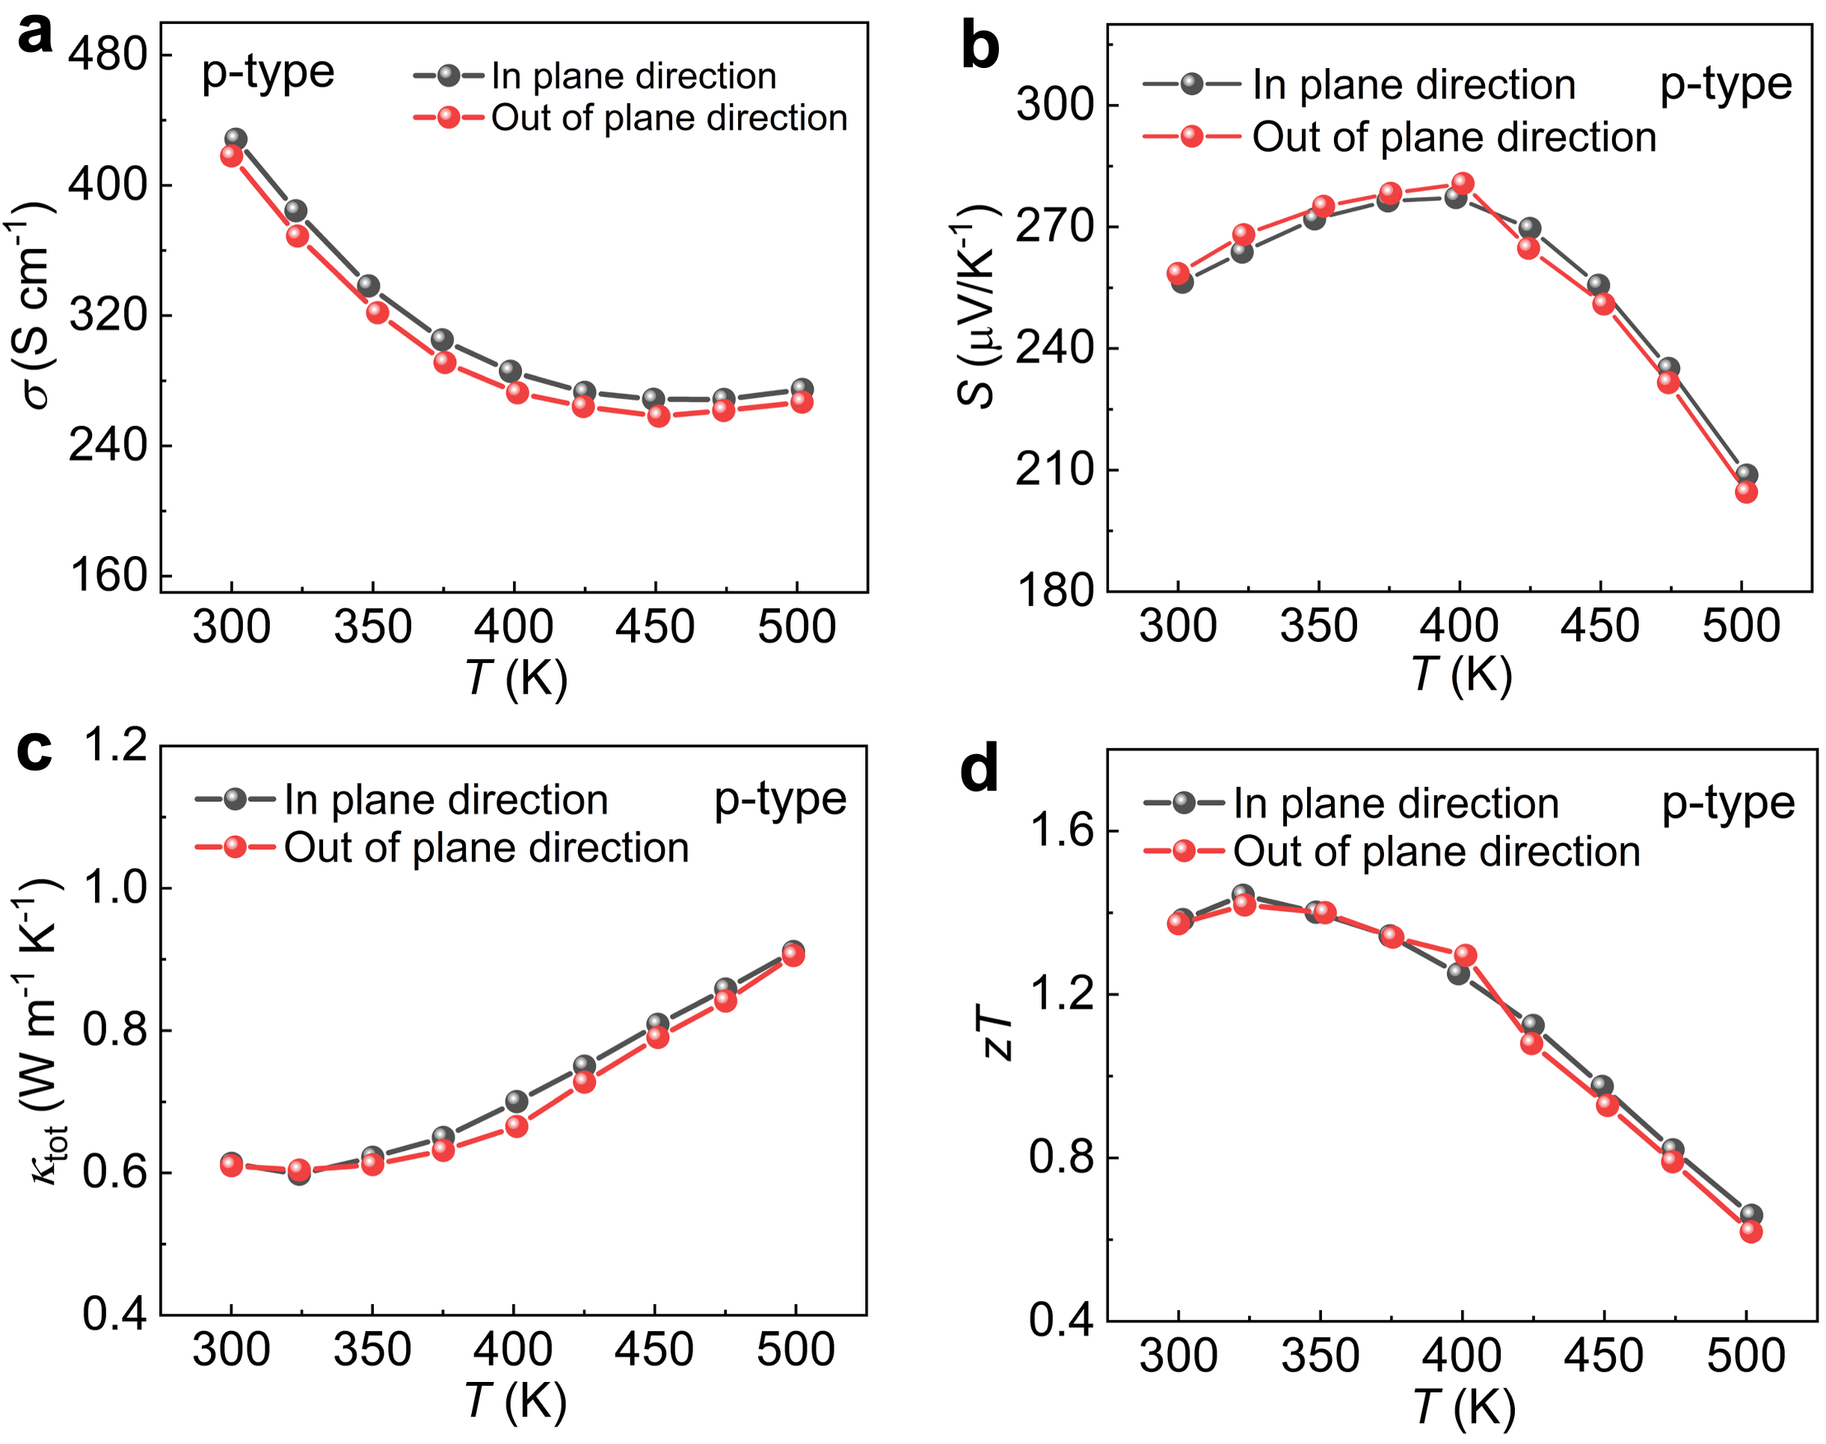
Fig. S34. Thermoelectric properties of printed p-type Bi_{0.5}Sb_{1.5}Te₃ bulks along in-plane and out-of-plane directions. a-d,Temperature dependent of (a) S, (b) σ, (c) κ and (d) zT along two directions.

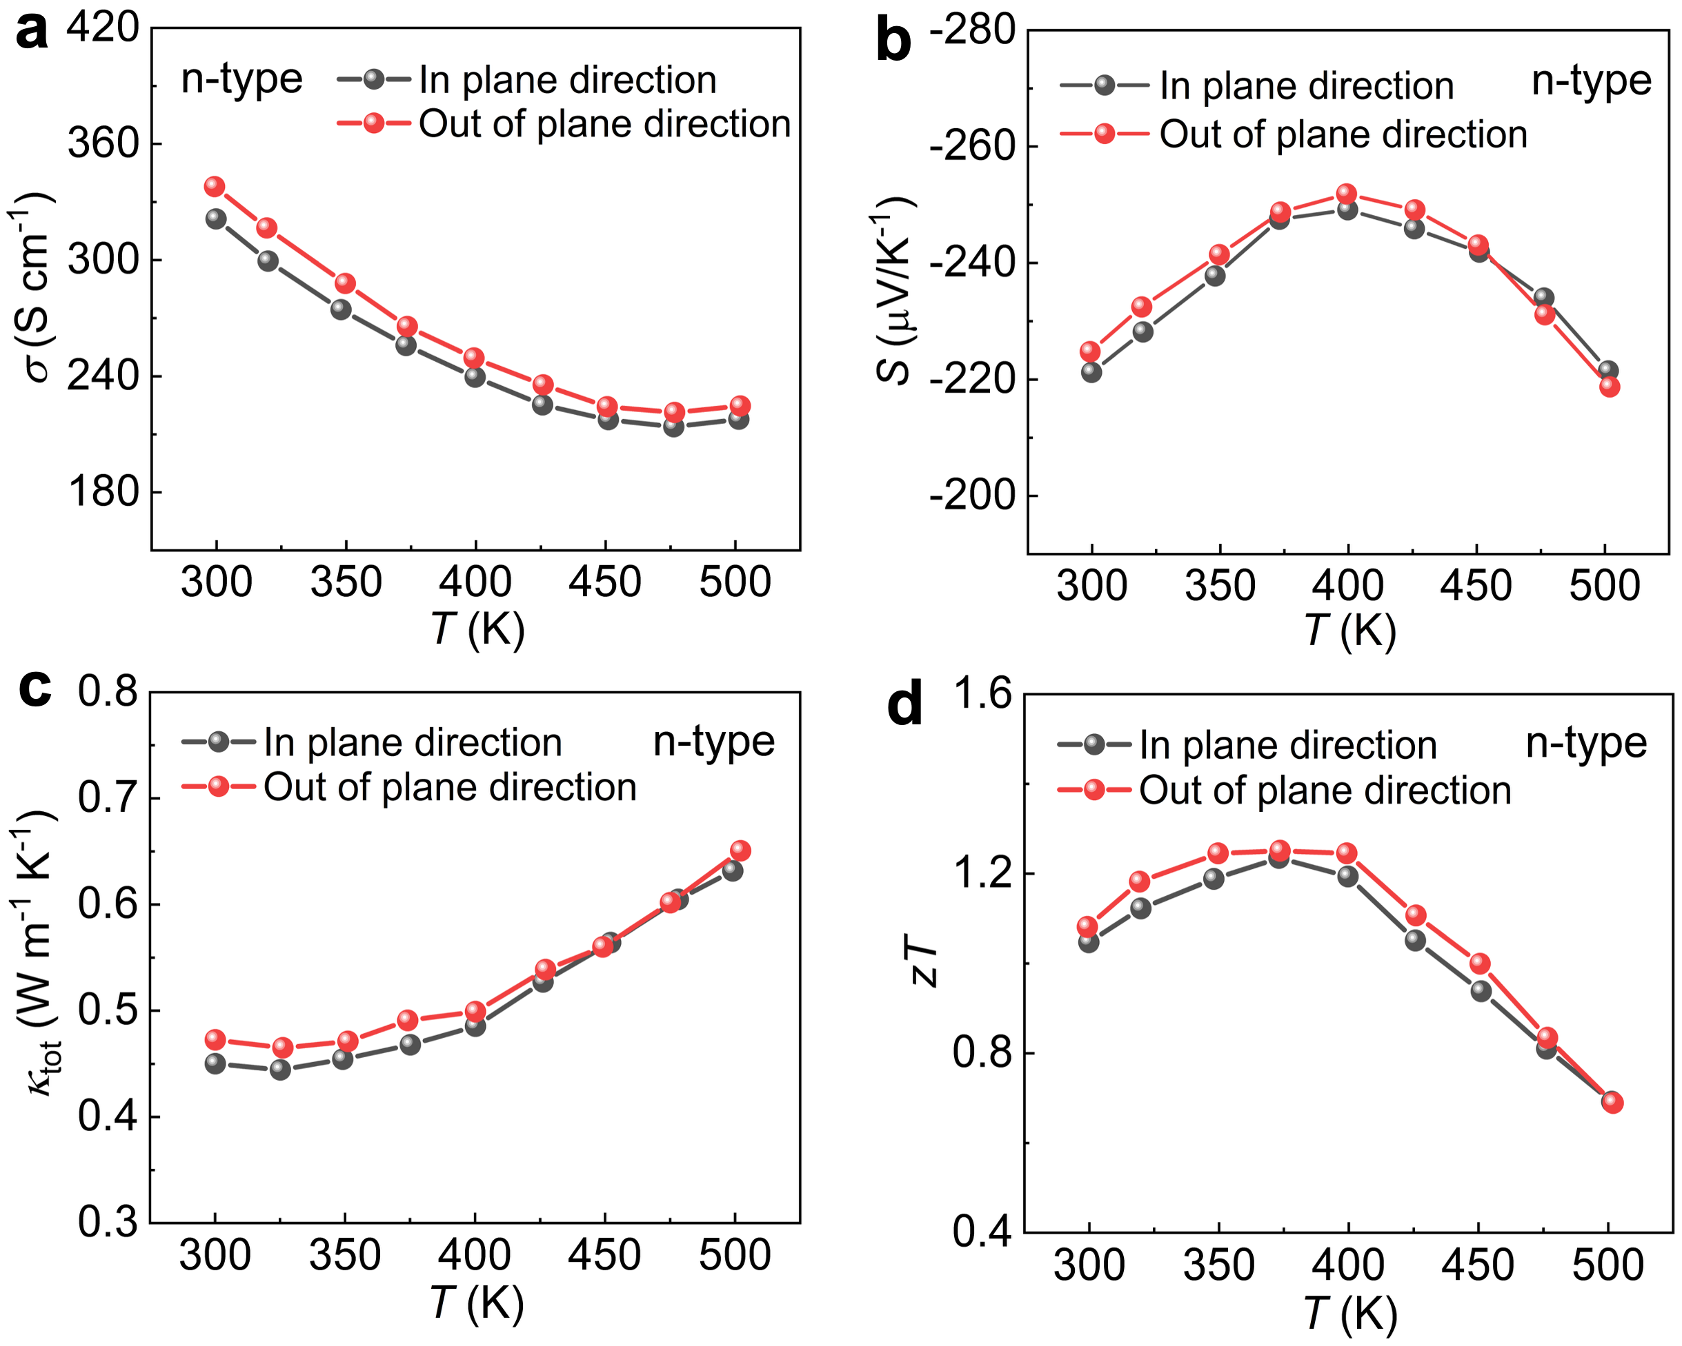
Fig. S35. Thermoelectric properties of printed n-type Bi₂Te_{2.5}Se_{0.5}Ag_{0.01} bulks along in-plane and out-of-plane directions. a-d,Temperature dependent of (a) S, (b) σ, (c) κ and (d) zT along two directions.

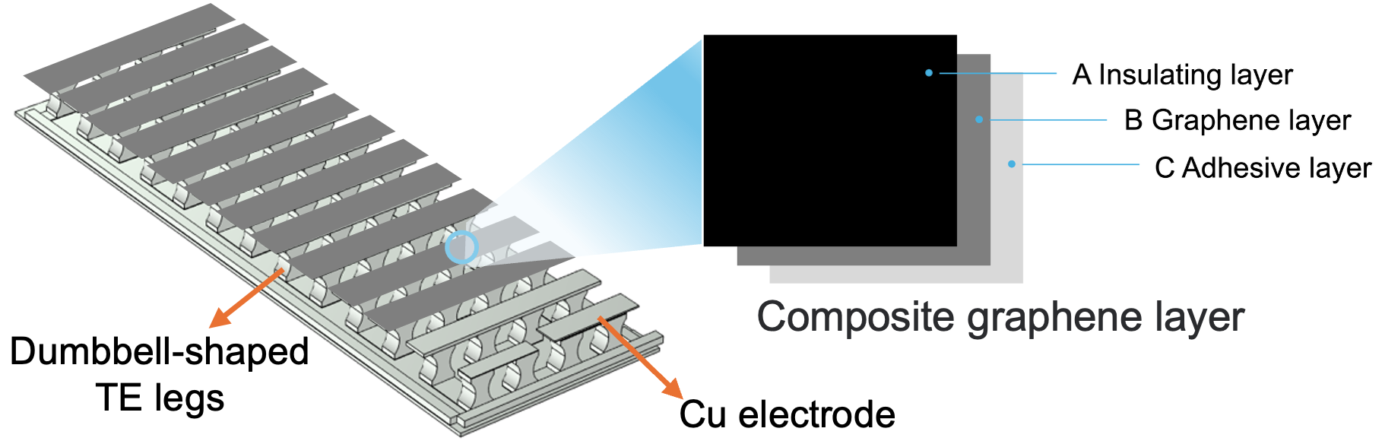
Fig. S36. Schematic diagram of a w-TEG assembled from 26 pairs of dumbbell-shaped TE legs.

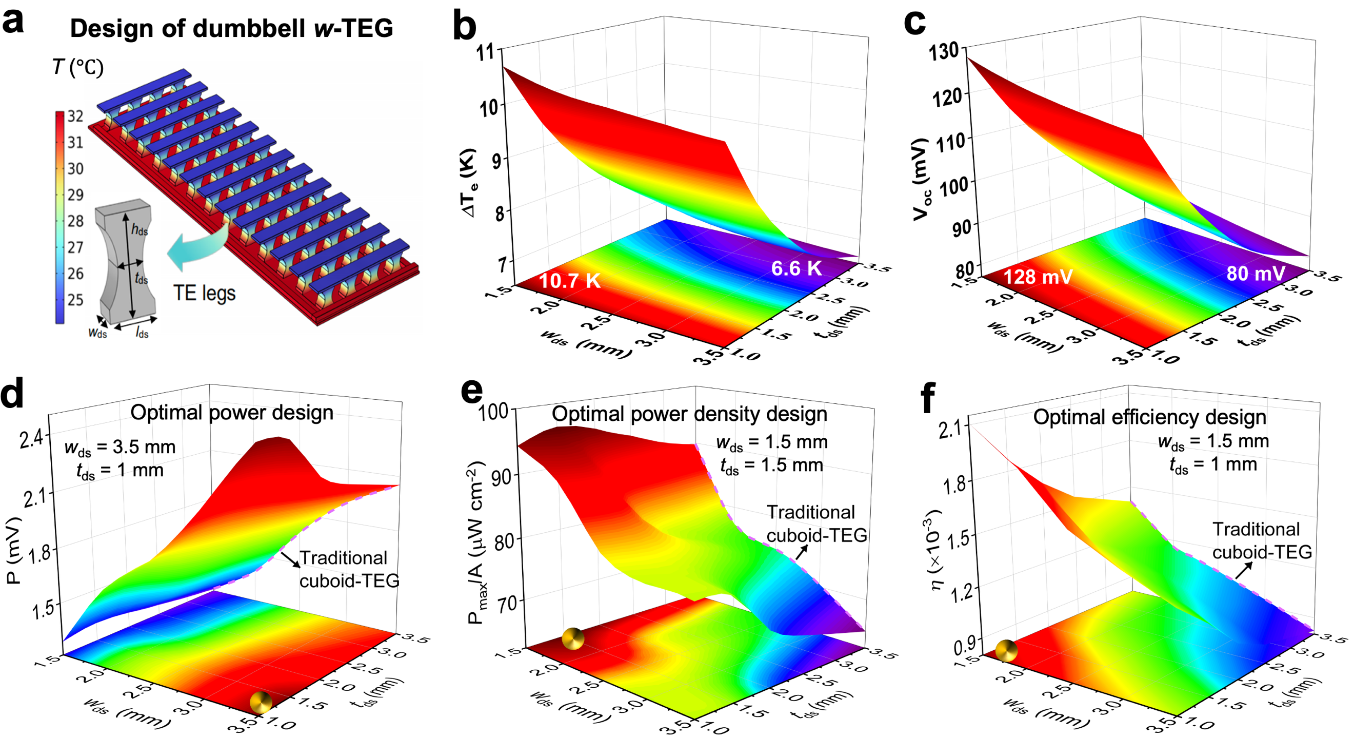
Fig. S37. Finite element simulation of the w‑TEG with dumbbell‑shaped TE legs. a, Schematic of the dumbbell-shaped w-TEG. b-f,Simulated calculation of the effect of geometric parameters of dumbbell-shaped TE legs on (b) ΔT_{e} (c) V_{oc}, (d) P, (e) P_{d} and (f) η of w-TEG. Simulated performance of the w-TEG under the conditions of ΔT = 20 K and with hot-side and cold-side heat transfer coefficients (h_{s} and h_{c}) equal to 50, for dumbbell-shaped TE legs with a H_{ds} of 5 mm and a l_{ds} of 3.5 mm.

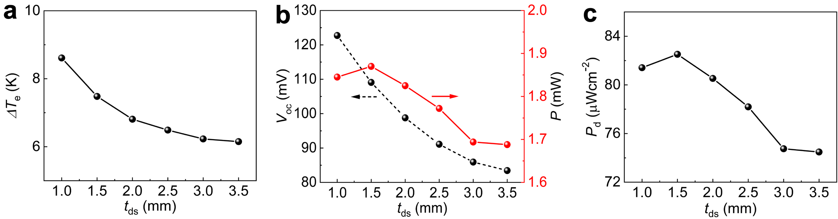
Fig. S38. Effect of waist thickness (t_{ds}) of dumbbell-shaped TE legs on w-TEG. a, Output voltage and power, b, power density and c, effective temperature (ΔT_{e}). Calculated performance of w-TEGs at ΔT = 18 K when dumbbell-shaped TE arms t_{ds} varies between 1 and 3.5mm and height (H_{ds}) of 5mm, length (l_{ds}) of 3.5mm and width (w_{ds}) of 2.5mm.

We computationally compared the effective temperature difference (ΔT_{e}) with conventional cuboid and dumbbell-shaped w-TEG geometries under identical experimental conditions. The results indicated the superior effectiveness of the dumbbell-shaped design, exhibiting enhanced heat dissipation capabilities performance.

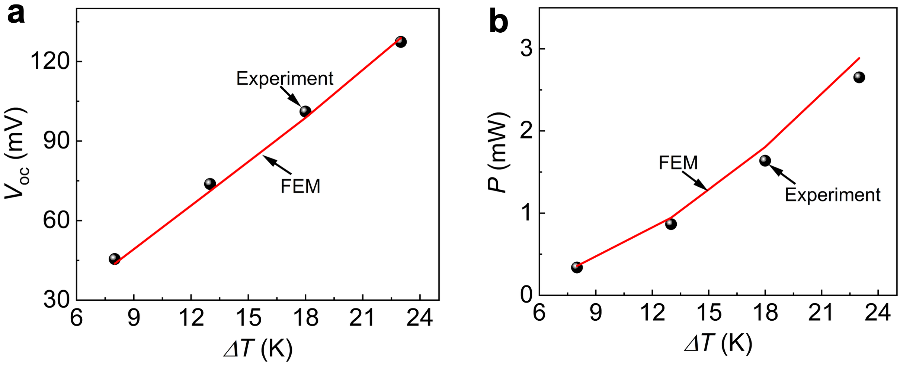
Fig. S39. Simulation and experimental comparison of the power generation performance. a, Output voltage and b, output power of the dumbbell-shaped w-TEG as a function of the temperature difference obtained by FEM (line) and experiment (symbol).

The influence of dumbbell-shaped geometric dimensions on the output performance of the w-TEG was systematically investigated using a 3D finite element model (FEM). To validate the reliability of the model, the overall output voltage and power of a 26 pair of dumbbell-shaped w-TEG was simulated under identical conditions, demonstrating good agreement between the simulated and experimental results (Fig. S39).

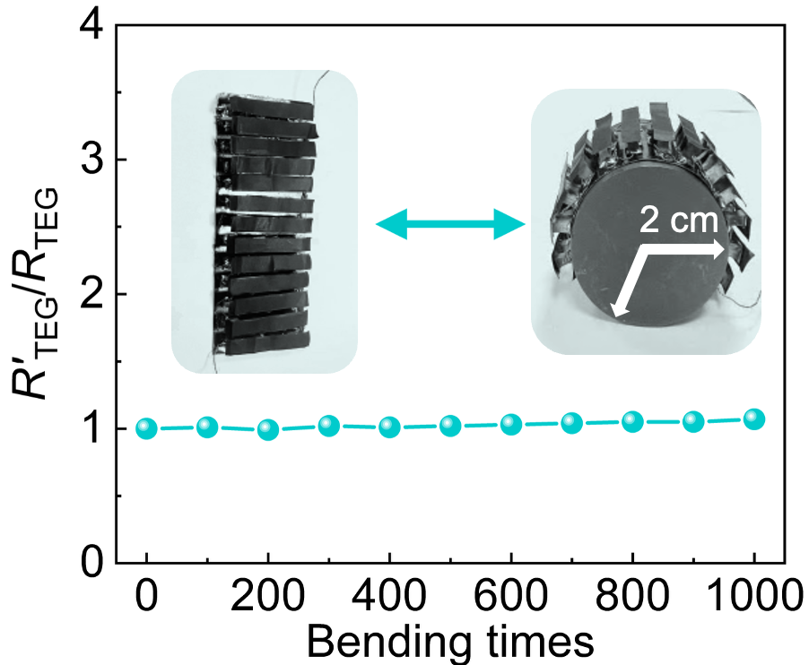
Fig. S40. Variation of the w-TEG’s internal resistance after bending (R'_{TEG}) /internal resistance before bending (R'_{TEG}) at a bending radius of r = 2 cm.

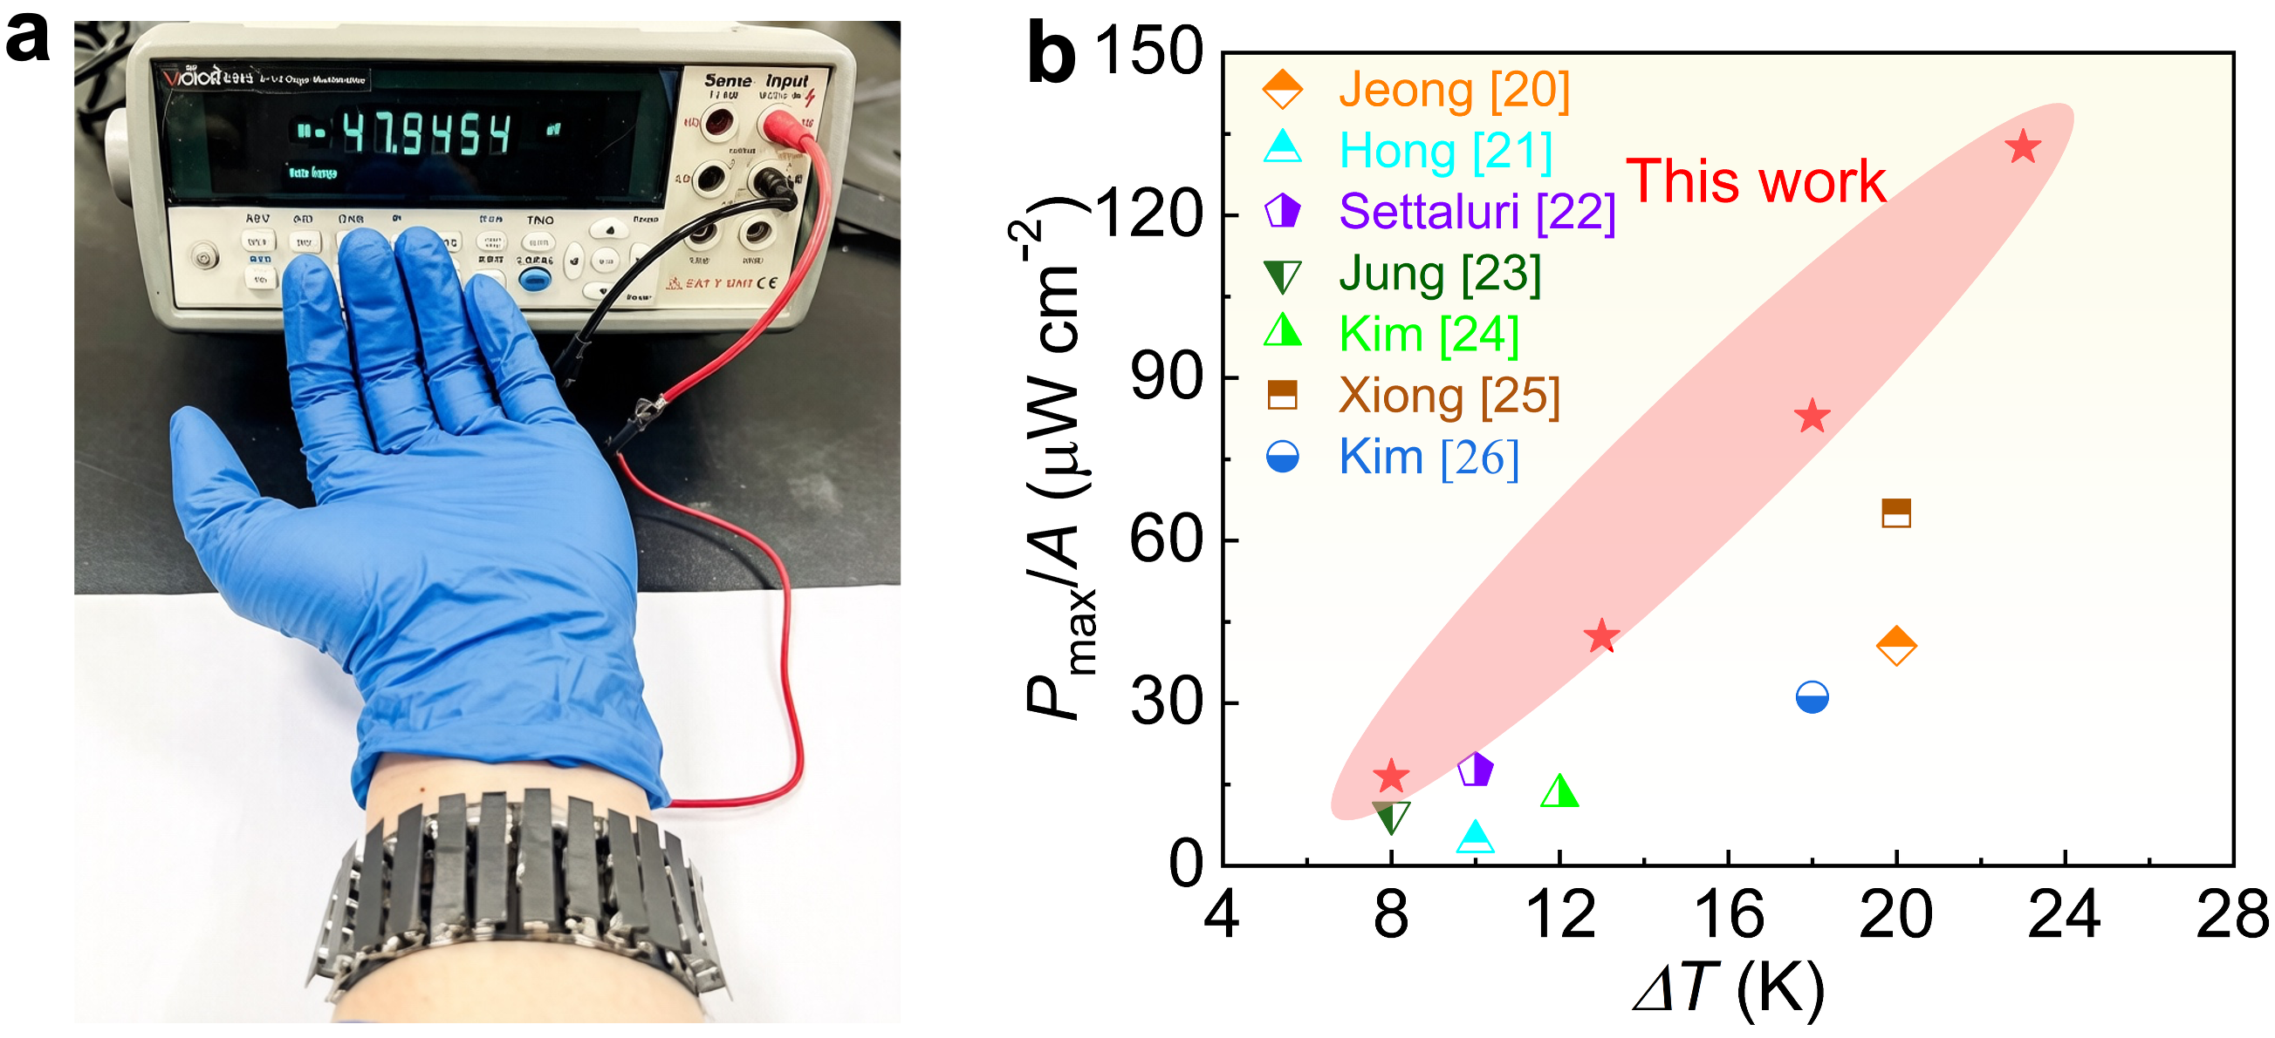

Fig. S41. Demonstration of power generation performance of the 3D-printed w-TEG. a, Photograph of a w-TEG driven by body skin heat powering an electronic watch by a voltage converter at room temperature (T_{r}) 16 ℃. b, Comparison of the power density of a 26‑pair dumbbell‑shaped TEG under different temperature differences with the performance of recent wearable devices^{15–21}.

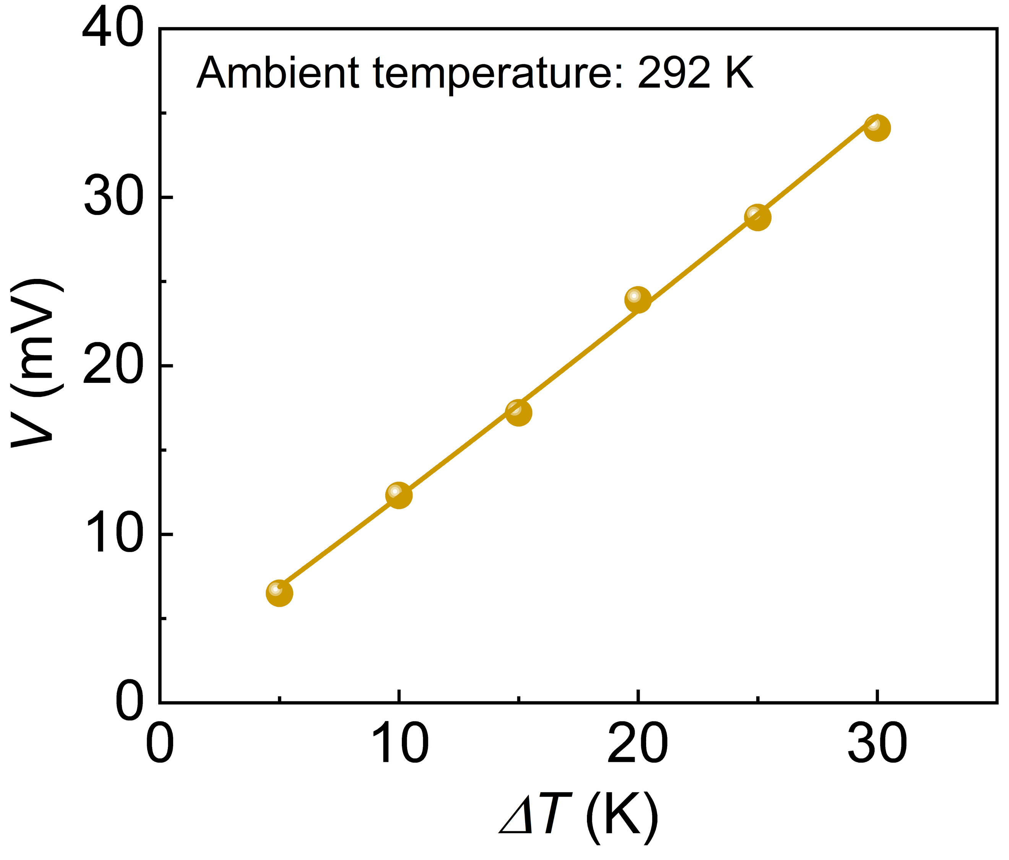
Fig. S42. Output voltage of the 2D device measured under different ΔTs.

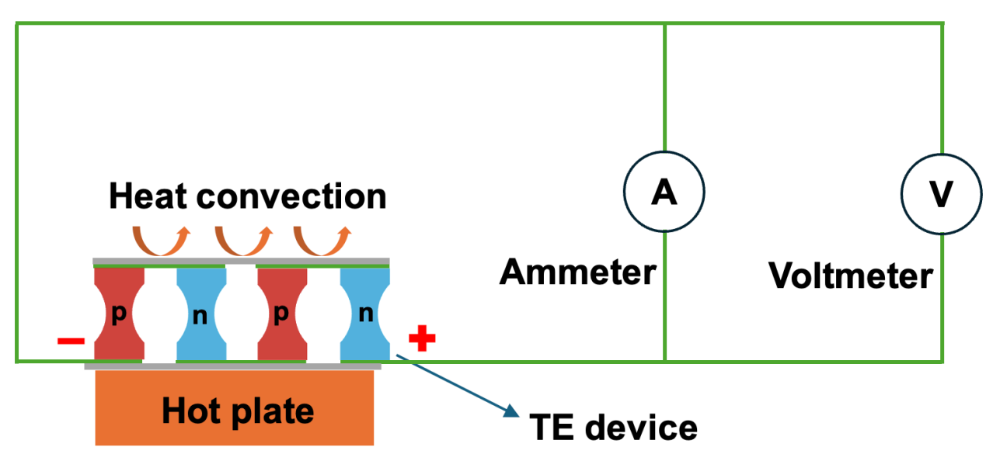
Fig. S43. Schematics of the home-made TE device test platform. The device is placed on a hot plate. The upper end of the device exchanges heat with the environment in a way of natural heat convection.

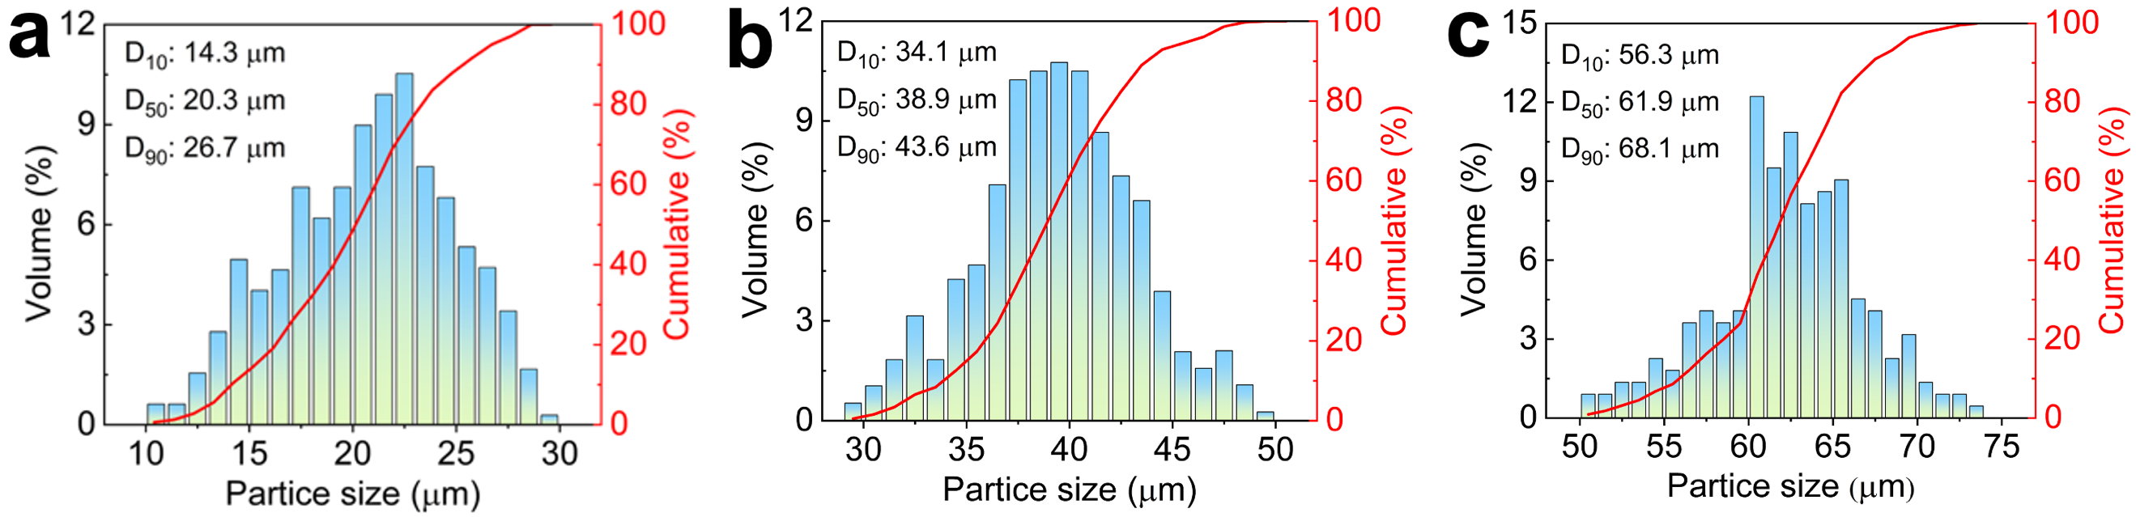
Fig. S44. Particle size distribution. a-c, Histograms of particle size distribution with (a) 10-30 μm, (b) 30-50 μm and (c) 50-75 μm particle size ranges. The Bi₂Te₃-based TE particles synthesized by the ball-milling and mechanical break-up process.

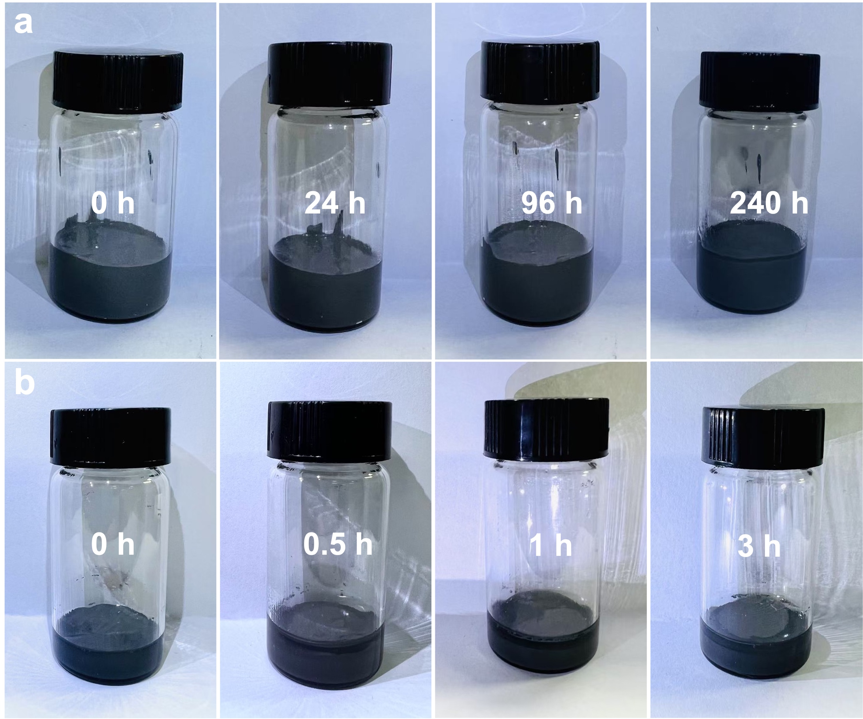
Fig. S45. Dispersion stability of n-type Bi₂Te₃-based TE inks. a,b, Photographs illustrating the time variation of the inks with (a) BST/PPM0.55 and without (b) BST/PPM0. TE inks without PPM sediment within 1 hour after dispersion, whereas the sedimentation of TE inks containing PPM is postponed to more than 240 hours.

After prolonged standing, the TE ink exhibited no particle sedimentation or water separation, demonstrating its long-term stability and homogeneous dispersion. Furthermore, a slight increase in both viscosity and storage modulus was observed in Fig. S46.

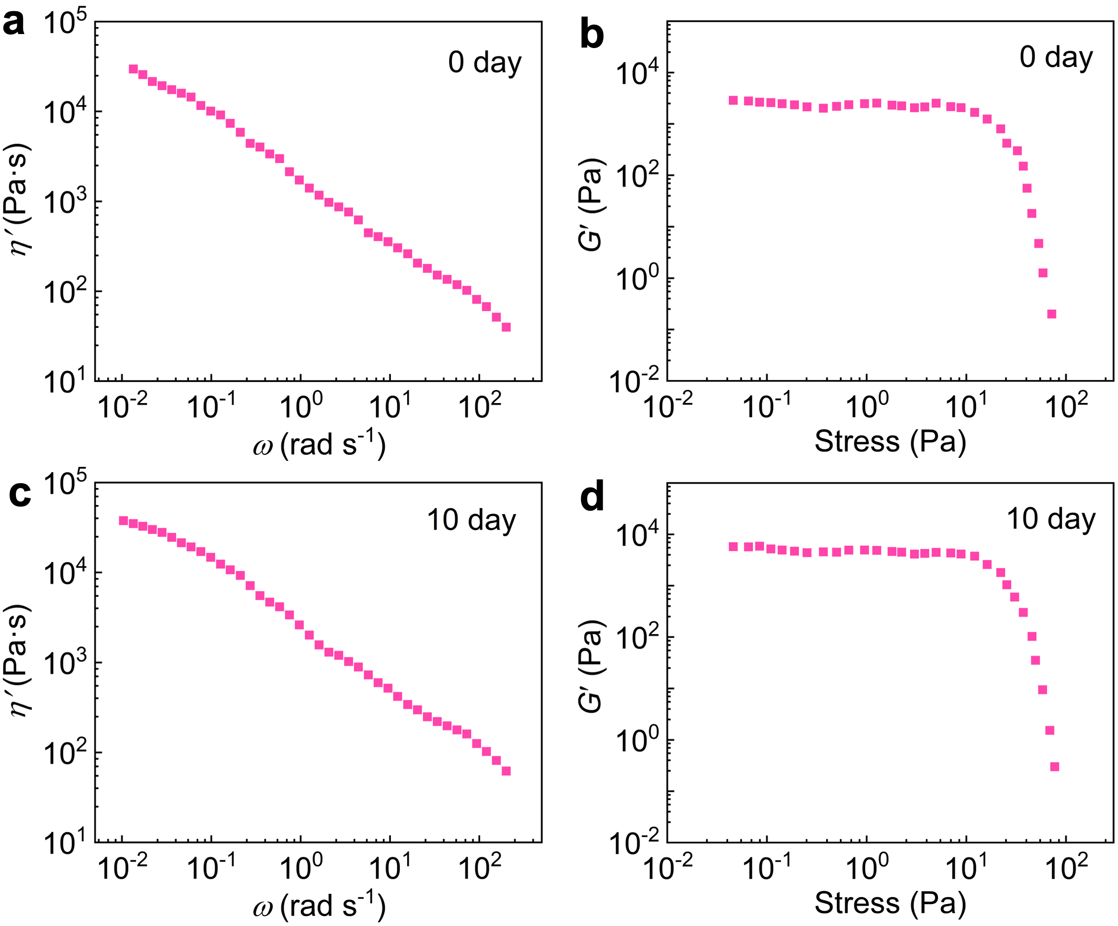
Fig. S46. Rheological properties of n-type Bi₂Te₃-based TE inks after prolonged storage. a, The viscosity and b, storage modulus curves of BST/PPM0.55 at 25 ℃ after 0 day. c, The viscosity and d, storage modulus curves of BST/PPM0.55 at 25 ℃ after 10 day.

A

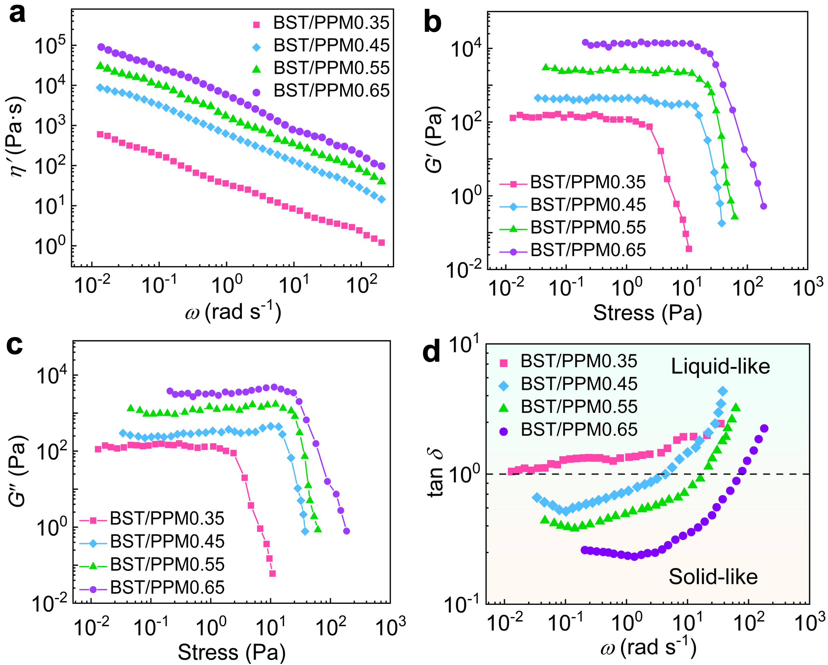
Fig. S47. The trace organic rheology modifier (PPM) enhanced the rheological properties of TE inks. a, Dynamic viscosity, η′, b, storage modulus, G', c, loss modulus, G', curves of the TE inks with the various organic contents at 25 ℃. d, tan δ curves of water-based TE ink with the various organic contents at 25 ℃.

PVP and PEI were utilized as key constituents of the binder, wherein the hydrogen atoms attached to the amino groups (-NH₂) of the highly branched PEI molecules engaged in interactions with the oxygen atoms of the carbonyl groups (C=O) within the PVP chains. The hydrogen-bonded crosslinked network formed by these two functional groups can improve the viscoelasticity of the ink²². Then, a certain amount of the polyelectrolyte methylcellulose (MC) was added, which promoted weak intramolecular and intermolecular hydrophobic interactions, increased the internal friction of the solution, and thus significantly enhanced the solution viscosity²³.
This phenomenon can be attributed to the partial evaporation of water in the inks during long-term storage. Furthermore, the tan δ curves also reflected the phase stability within the TE inks. With increasing PPM content, the tan δ values exhibited an overall continuous decrease, accompanied by an elevated critical ω value for the solid-to-liquid transition (Fig. S47D). The TE inks containing 0.35% PPM exhibited a tan δ value greater than 1, indicating that the particles within the colloidal ink displayed a liquid-like structure, which is accompanied by poor print stability.

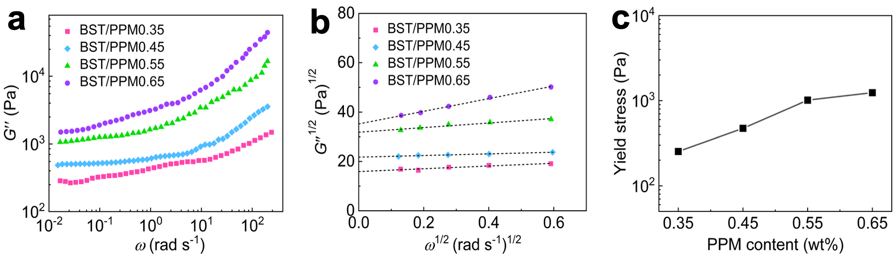
Fig. S48. Yield stress of p-type Bi₂Te₃-based TE inks at various PPM contents. a, The loss modulus (G'') from the frequency sweep test, b, Casson plots form the loss modulus and c, Yield stress (τ_{y}) from the y-axis intercept of the Casson plot. The dashed line represents the extrapolation of the G''^{1/2} curves.

As evidenced in Fig. S48C, the τ_{y} exhibited a dramatic increase from 253.1 Pa for BST/PPM0.35 to 1239 Pa for BST/PPM0.65. This suggests that the increase in PPM content facilitates the formation of a significant number of entangled network structures within the inks, necessitating higher stress to form an ordered network structure during extrusion, thereby enhancing the stability of the ink. Consequently, inks with higher PPM content generally require elevated nozzle pressure to achieve smooth extrusion during the printing process.

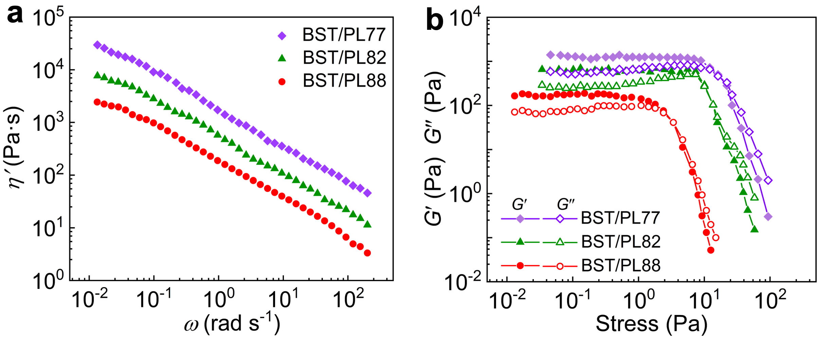
Fig. S49. Rheological properties of p-type Bi₂Te₃-based TE inks at various particle loadings (PL). a, The dynamic viscosity curves from the frequency sweep test and b, storage modulus curves from the stress sweep test with the BST with a 0.55% PPM content in the TE inks.

Notably, increasing the mass fraction of TE particles also enhances the viscoelasticity of the ink and the density of the printed material, as can be seen in Fig. S49 and Table S6. The TE ink demonstrated suitable rheological properties, exhibiting both smooth extrusion and excellent shape fidelity during printing.

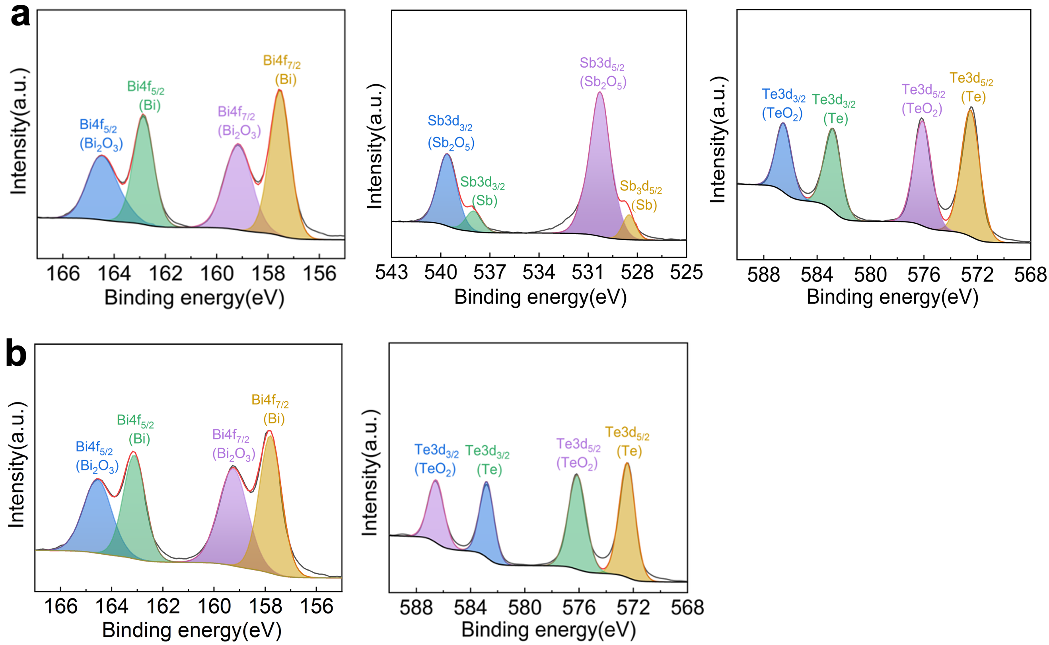
Fig. S50. X-ray Photoelectron Spectroscopy (XPS) analysis of printed materials. a, Experimental and fitted XPS spectra of the p-type samples in the regions of Bi4f, Te3d, and Sb3d. b, Experimental and fitted XPS spectra of the n-type samples in the regions of Bi4f, Te3d.

The experimental results demonstrated that the printed bismuth telluride thermoelectric samples completely eliminated residual organic components after annealing, as illustrated in Fig. S50. The appearance of the oxide peaks is attributed to the surface-sensitive nature of X-ray photoelectron spectroscopy, which provides the elemental composition and chemical states at the sample surface.

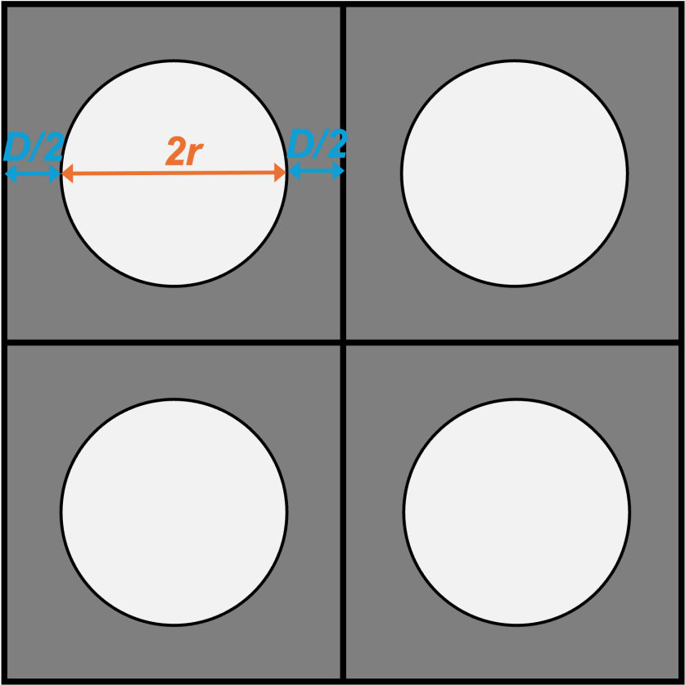
Fig. S51. Schematic illustration of pore distribution. The pores are regarded to be identical in size, and are spherical and uniformly distributed within the matrix. Here shows four squares, each one has a volume of 1/N cm⁻³.

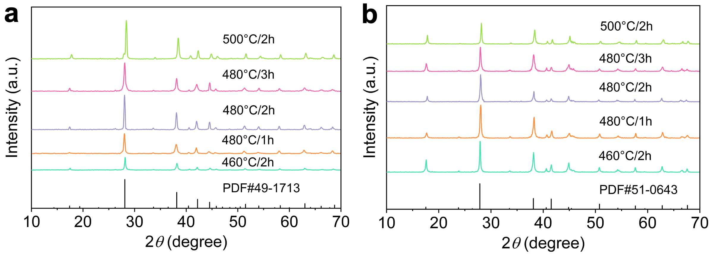
Fig. S52. The XRD patterns after annealing treatment. a, p- and b, n-type of printed materials at various annealing parameters.

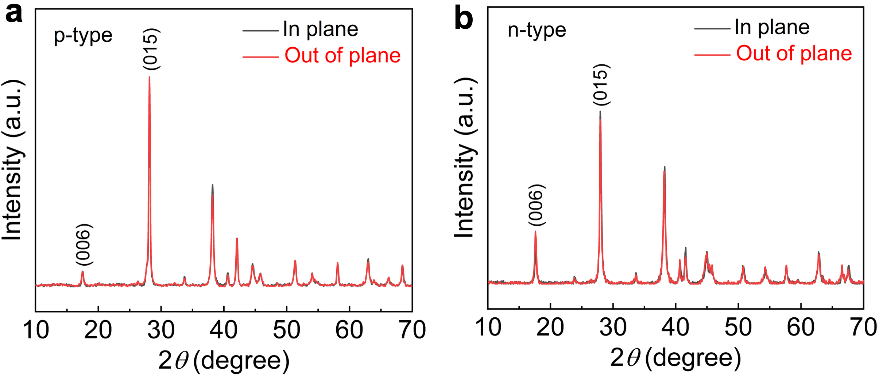
Fig. S53. XRD analysis of the printed in-plane and out-of-plane samples. a,b,The Calculation of the orientation factor using the XRD patterns of (a) p- and (b) n-type samples.

A value of F = 0 corresponds to complete random orientation (isotropic), while F = 1 indicates perfect ideal uniaxial orientation (anisotropic). The X-ray diffraction patterns of in-plane (perpendicular to the height direction) and out-of-plane (parallel to the height direction) p- or n-type samples were shown in Fig. S53. The F_{00l} values for in-plane and out-of-plane of the p-type sample are 0.063 and 0.059, respectively, whereas for the n-type sample, the F_{00l} values for in-plane and out-of-plane are 0.071 and 0.06, respectively, indicating that the printed Bi₂Te₃ samples exhibit excellent isotropy.

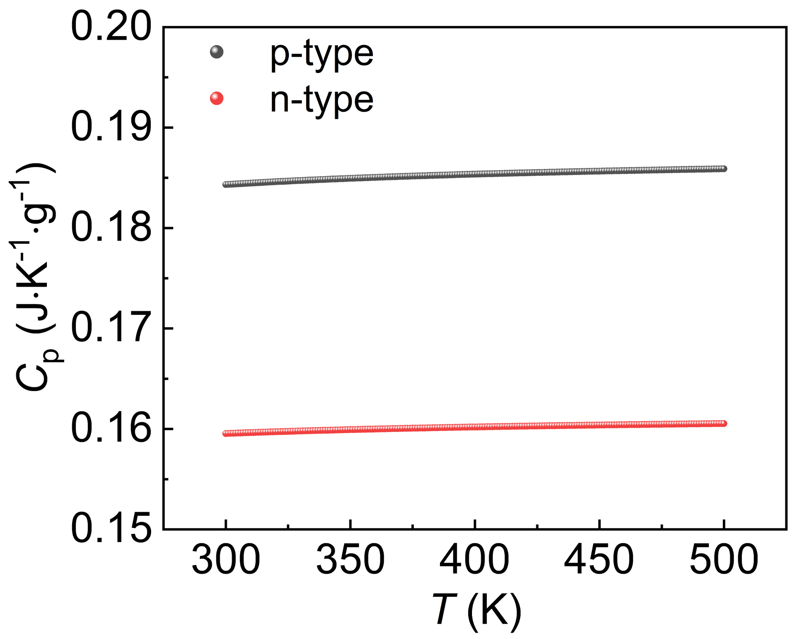
Fig. S54. Heat capacity of both p- and n-type Bi₂Te₃-based samples from 300 K to 500 K.

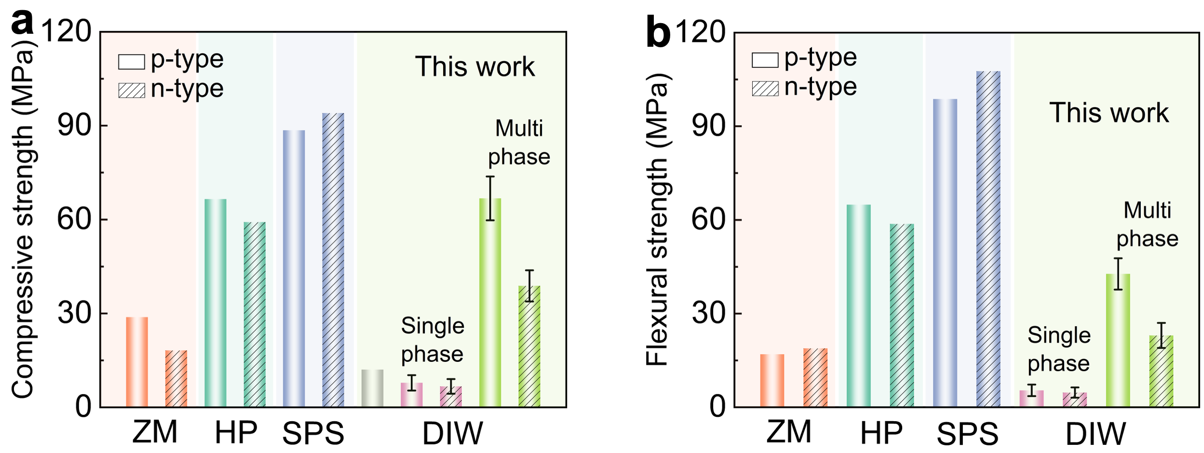
Fig. S55. Comparison of mechanical properties with Bi₂Te₃-based materials prepared by other methods^{24–29}. a, Compressive strength and b, flexural strength.

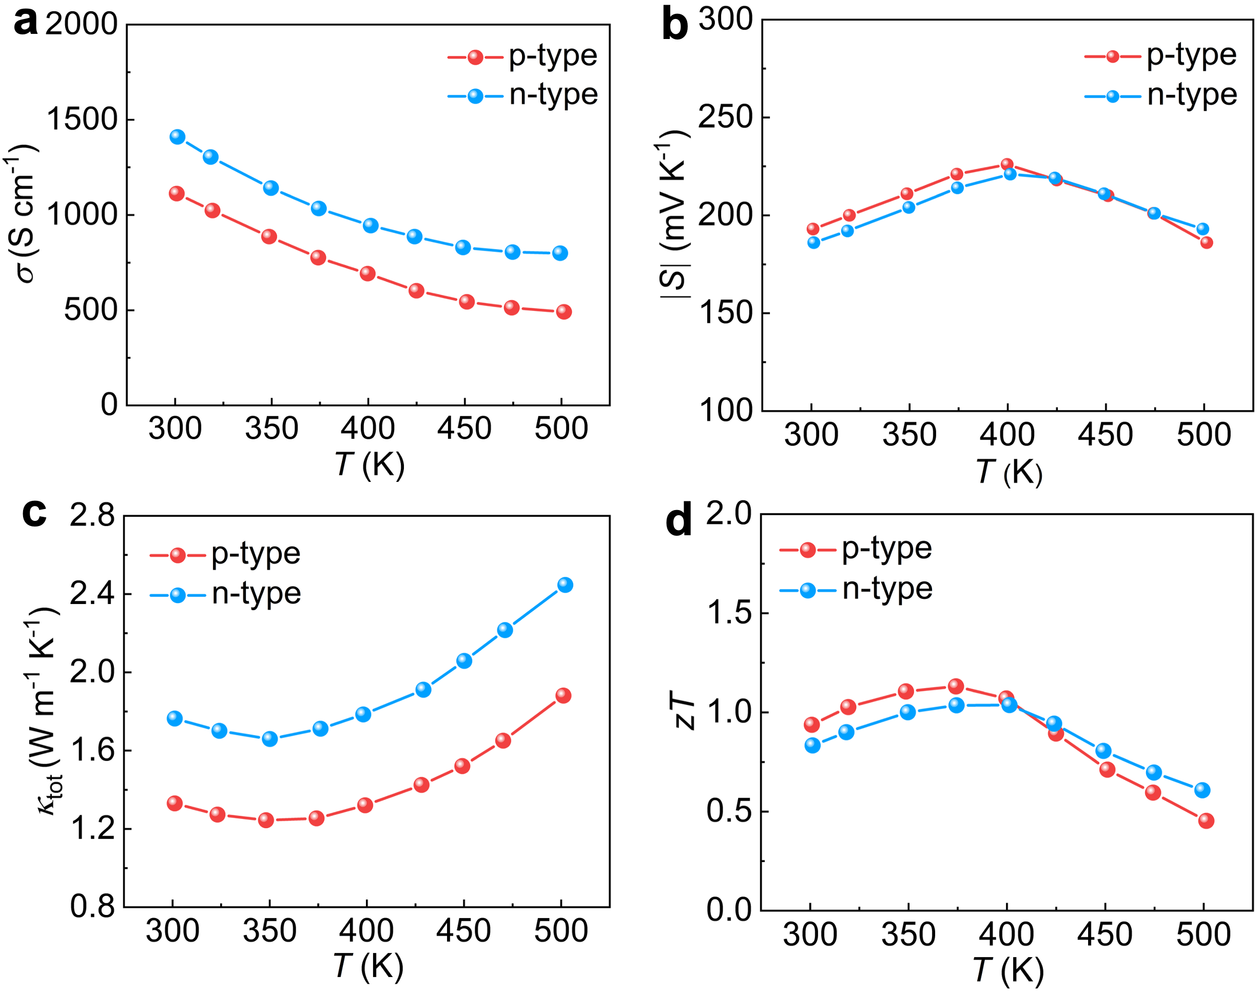Fig. S56. The TE properties of the traditional ZM materials. a-d, Temperature dependent of (a) S, (b) σ, (d) κ_{tot} and (d) zT.

Supplementary Tables

Table S1.Estimation of power consumption, preparation cycle and material costs for ZM method fabrication.
No. | Procedure/  Materials | Electric power (kW) | Time cost (hour) | Electricity (kWh) | Raw material costs ($) | Ref.
1 | Quartz tube drying* | 7.5 | 4 | 15 | / | ³⁰
2 | Tube vacuuming* | 10 | 2.5 | 12.5 | / | ³⁰
3 | Melting in tube furnaces* | 9 | 77 | 693 | / | ³⁰
4 | Zone-melting | 2.4 | 308 | 739.2 | / | ³⁰
5 | Dicing | 6 | 100 | 600 | / | ³⁰
6 | p-type powder | / | / | / | 1442.3 | #
7 | n-type powder | / | / | / | 1201.82 | #
/ | Sum electricity (kWh/kg) |  | 85.11 |  |  | Cal.
/ | Sum time costs (hour/kg) |  | 20.31 |  |  | Cal.
/ | Sum raw material costs ($/kg) |  | 66.1 |  |  | Cal.
* refers to the procedure being simultaneously performed for p- and n-type material pre-synthesis, so the energy consumption for each category was halved. Moreover, the total masses of the p- or n-type TE ingots using large-scale industrial production were 22 kg.
# The powders were purchased from Sichuan Kaiyada Semiconductor Materials Co., Ltd.

Table S2.Estimation of power consumption, preparation cycle and material costs for hot method fabrication.
No. | Procedure/  Materials | Electric power (kW) | Time cost (hour) | Electricity (kWh) | Raw material costs ($) | Ref.
1 | Quartz tube drying* | 7.5 | 4 | 15 | / | ³⁰
2 | Tube vacuuming* | 10 | 2.5 | 12.5 | / | ³⁰
3 | Melting in tube furnaces* | 9 | 77 | 693 | / | ³⁰
4 | Rod crashing | 1.5 | 1 | 1.5 | / | ³⁰
5 | Pre-milling | 1.1 | 24.2 | 26.6 | / | ³⁰
6 | Pre-milling in glove boxes | 1.2 | 24 | 28.8 | / | ³⁰
7 | Annealing | 24 | 12.5 | 300 | / | ³⁰
8 | Post-milling | 1.1 | 24.2 | 26.6 | / | ³⁰
9 | Post-milling in glove boxes | 1.2 | 24 | 28.8 | / | ³⁰
10 | Hot-pressing | 4.44 | 18.26 | 81.1 | / | ³⁰
11 | Dicing | 6 | 100 | 600 | / | ³⁰
12 | p-type powder | / | / | / | 1442.3 | #
13 | n-type powder | / | / | / | 1201.82 | #
/ | Sum electricity (kWh/kg) |  | 190.7 |  |  | Cal.
/ | Sum time costs (hour/kg) |  | 15.58 |  |  | Cal.
/ | Sum raw material costs ($/kg) |  | 66.1 |  |  | Cal.
* refers to the procedure being simultaneously performed for p- and n-type material pre-synthesis, so the energy consumption for each category was halved. Moreover, the total masses of the p- or n-type TE ingots using large-scale industrial production were 22 kg.
# The powders were purchased from Sichuan Kaiyada Semiconductor Materials Co., Ltd.

Table S3.Estimation of power consumption, preparation cycle and material costs for SPS method fabrication.
No. | Procedure/  Materials | Electric power (kW) | Time cost (hour) | Electricity (kWh) | Raw material costs ($) | Ref.
1 | Quartz tube drying* | 7.5 | 4 | 15 | / | ³⁰
2 | Tube vacuuming* | 10 | 2.5 | 12.5 | / | ³⁰
3 | Melting in tube furnaces* | 9 | 77 | 693 | / | ³⁰
4 | Rod crashing | 1.5 | 1 | 1.5 | / | ³⁰
5 | Pre-milling | 1.1 | 24.2 | 26.6 | / | ³⁰
6 | Pre-milling in glove boxes | 1.2 | 24 | 28.8 | / | ³⁰
7 | Annealing | 24 | 12.5 | 300 | / | ³⁰
8 | Post-milling | 1.1 | 24.2 | 26.6 | / | ³⁰
9 | Post-milling in glove boxes | 1.2 | 24 | 28.8 | / | ³⁰
10 | Spark Plasma Sintering | 43 | 58 | 2494 | / | #
11 | Dicing | 6 | 100 | 600 | / | ³⁰
12 | p-type powder | / | / | / | 1442.3 | #
13 | n-type powder | / | / | / | 1201.82 | #
/ | Sum electricity (kWh/kg) |  | 211.34 |  |  | Cal.
/ | Sum time costs (hour/kg) |  | 17.57 |  |  | Cal.
/ | Sum raw material costs ($/kg) |  | 66.1 |  |  | Cal.
* refers to the procedure being simultaneously performed for p- and n-type material pre-synthesis, so the energy consumption for each category was halved. Sample sizes of 30mm × 40mm cylinders were prepared each time with a preparation time of 30min. The total masses of the p- or n-type TE ingots using large-scale industrial production were 20 kg.
# The powders were purchased from Sichuan Kaiyada Semiconductor Materials Co., Ltd. The laboratory verified and provided the energy consumption parameters required for the preparation of materials by Spark Plasma Sintering (SPS).

Table S4.Estimation of power consumption, preparation cycle and material costs for 3D printing (DIW) fabrication.
No. | Procedure/  Materials | Electric power (kW) | Time cost (hour) | Electricity (kWh) | Raw material costs ($) | Ref.
1 | Vacuum drying* | 2.5 | 4 | 2.5 | / | ¹¹
2 | Ball milling* | 1.2 | 10 | 6 | / | ¹¹
3 | Synthesis of Bi NPs | 0.2 | 5957 | 1191.4 | / | ¹¹
4 | Synthesis of Sb₂Te₄ ChaM NPs | 0.03 | 3570 | 107.1 | / | ¹¹
5 | Sieving | 0.5 | 2 | 1 | / | ¹¹
6 | Synthetic TE ink | 1.2 | 1 | 1.2 | / | ¹¹
7 | DIW printing | 0.5 | 100 | 50 | / | ¹¹
8 | Annealing | 24 | 43 | 43 | / | ¹¹
9 | p-type powder | / | / | / | 1442.3 | #
10 | bismuth neodecanoate | / | / | / | 669.7 | ¹¹
11 | 1-octadecene | / | / | / | 573.78 | ¹¹
12 | DDT | / | / | / | 195.55 | ¹¹
13 | TOP | / | / | / | 4622.81 | ¹¹
14 | hexane | / | / | / | 12607.66 | ¹¹
15 | acetone | / | / | / | 3216.24 | ¹¹
16 | EtSH | / | / | / | 623.71 | ¹¹
17 | en | / | / | / | 18711.19 | ¹¹
18 | acetonitrile | / | / | / | 3838.19 | ¹¹
19 | Sb powder | / | / | / | 38.38 | ¹¹
20 | Te powder | / | / | / | 301.36 | ¹¹
/ | Sum electricity (kWh/kg) |  | 70.11 |  |  | Cal.
/ | Sum time costs (hour/kg) |  | 484.35 |  |  | Cal.
/ | Sum raw material costs ($/kg) |  | 2342.04 |  |  | Cal.
* refers to the procedure being simultaneously performed for p- and n-type material pre-synthesis, so the energy consumption for each category was halved. The total mass of p- or n-type TE material produced was calculated as 20 kg.
# The powders were purchased from Sichuan Kaiyada Semiconductor Materials Co., Ltd.

Table S5.Estimation of power consumption, preparation cycle and material costs for 3D printing fabrication in this work.
No. | Procedure/ Materials | Electric power (kW) | Time cost (hour) | Electricity (kWh) | Raw material costs ($) | Ref.
1 | Vacuum drying* | 2.5 | 4 | 2.5 | / | /
2 | Ball milling* | 1.5 | 10 | 7.5 | / | /
3 | Sieving | 1.5 | 0.5 | 0.75 | / | /
4 | Synthetic TE ink | 1.3 | 2 | 2.6 | / | /
5 | DIW printing | 0.5 | 100 | 50 | / | /
6 | Annealing | 24 | 4 | 96 | / | /
7 | p-type powder | / | / | / | 1442.3 | #
8 | n-type powder | / | / | / | 1201.82 | #
9 | PVP reagent | / | / | / | 4.32 | /
10 | PEI reagent | / | / | / | 3.69 | /
11 | MC reagent | / | / | / | 1.44 | /
/ | Sum electricity (kWh/kg) |  | 7.97 |  |  | Cal.
/ | Sum time costs (hour/kg) |  | 6.03 |  |  | Cal.
/ | Sum raw material costs ($/kg) |  | 66.58 |  |  | Cal.
* refers to the procedure being simultaneously performed for p- and n-type material pre-synthesis, so the energy consumption for each category was halved. The total mass of p- or n-type TE material produced was calculated as 20kg. The annealing times of p- and n-type were 1h and 2h, respectively.
# The powders were purchased from Sichuan Kaiyada Semiconductor Materials Co., Ltd.

Estimation of energy saving, time saving and material costs
The widespread commercialization of thermoelectric materials hinges not only on exceptional thermoelectric performance but also on cost-effectiveness, production cycle, and scalability, which serve as the decisive metrics for evaluating their practical commercial viability. In this work, we propose a 3D printing strategy based on easily synthesized and highly cost-effective TE ink, enabling the quasi-integrated fabrication with customizable topological architectures. To quantitatively evaluate the advantages of this strategy, we systematically compared the cost (raw TE materials), energy consumption (electricity consumption of TE ingot fabrication) and production cycle (from raw materials to processed TE legs) of various mainstream fabrication paradigms (Fig. 1f). Specifically, the data for zone melting (ZM) and hot pressing (HP) were estimated based on typical industrial production lines (Shenzhen Thermoelectric New Energy Co., Ltd.)³⁰, see Table S1 and S2, the parameters for spark plasma sintering (SPS) were derived from laboratory-scale syntheses, see Table S3, and the metrics for direct ink writing (DIW) were estimated based on the work by Xu et al¹¹, see Table S4. The comparison reveals that our approach drastically reduces capital costs and energy consumption (Table S5) while significantly shortening the production cycle (Fig. 1g). By breaking through the efficiency and cost bottlenecks of conventional processes, this strategy paves a transformative pathway for the scalable manufacturing and commercialization of next-generation TE technologies.

Table S6. The calculated particle loading, density, and porosity of p and n-type of Bi₂Te₃-based TE samples.
Composition | Particle loading (wt%) | Density (g/cm³) | Porosity (Φ)
p-type | 77 | 5.02 | 0.254
p-type | 82 | 5.43 | 0.194
p-type | 87 | 5.81 | 0.123
n-type | 77 | 4.73 | 0.406
n-type | 82 | 5.03 | 0.342
n-type | 87 | 5.48 | 0.265

Table S7. Comparison of ICP results between the ball-milled and the sintered bulk.
Samples | Process conditions |  | ICP results
p-type | After ball milling |  | Bi_{0.49}Sb_{1.52}Te_{2.98}
p-type | After annealing | 460 °C/1h | Bi_{0.52}Sb_{1.53}Te_{2.95}
p-type | After annealing | 460 °C/3h | Bi_{0.51}Sb_{1.56}Te_{2.93}
p-type | After annealing | 500 °C/1h | Bi_{0.48}Sb_{1.58}Te_{2.9}
n-type | After ball milling |  | Bi_{1.91}Te_{2.51}Se_{0.48}
n-type | After annealing | 460 °C/1h | Bi_{1.93}Te_{2.47}Se_{0.43}
n-type | After annealing | 460 °C/3h | Bi_{1.94}Te_{2.45}Se_{0.42}
n-type | After annealing | 500 °C/1h | Bi_{1.92}Te_{2.42}Se_{0.41}

Table S8. Density of 3D‑printed bulks prepared from powders subjected to different ball milling speeds, measured by the Archimedes drainage method.
Composition | Ball milling speeds (rpm) | ρ (g cm⁻³)
p-type | 300 | 5.38
p-type | 350 | 5.83
p-type | 400 | 5.98
p-type | 450 | 5.73
n-type | 300 | 4.38
n-type | 350 | 4.97
n-type | 400 | 5.68
n-type | 450 | 5.72

Table S9. Average sound velocity , bulk’s modulus and poisson’s ratio for several printed p- and n-type samples.
Parameters | p-type  in-plane | p-type  Out-of-plane | n-type  In-plane | n-type  Out-of-plane
ν_{L,porous} | 2638 | 2598 | 2127 | 2023
ν_{T,porous} | 1592 | 1578 | 1273 | 1264
ν_{a,porous} | 1760 | 1743 | 1409 | 1392
K | 24.18 | 24.63 | 10.07 | 10.32
r | 0.21 | 0.21 | 0.08 | 0.08

Table S10. Parameters used in Debye-Callaway model for BST samples.
Parameters | Description | Values | Ref.
ν_{a,bulk} | Out-of-plane average speed of sound in dense | 2147 m·s⁻¹ | ³¹
ν_{a,porous} | Out-of-plane average speed of sound in porous sample | 1751 m·s⁻¹ | Mea.
AN | Prefactor of Umklapp scattering time | 2.6 | ⁵
γ | Grüneisen parameter | 2.3 | ³²
D | Average distance between pores | 0.25 μm | Cal.
V | Volume of the primitive unit cell | 3.13×10⁻²⁹ m³ | ⁵
BD | Burgers vector | 1.27 nm | ⁵
r_{BST,dense} | Poisson’s ratio in dense sample | 0.24 | ⁵
r_{BST,porous} | Poisson’s ratio in porous sample | 0.16 | Mea.
f_{Bi2Te3} | Concentration of Bi₂Te₃ in Bi_{0.5}Sb_{1.5}Te₃ | 0.25 | Cal.
f_{Sb2Te3} | Concentration of Sb₂Te₃ in Bi_{0.5}Sb_{1.5}Te₃ | 0.75 | Cal.
K_{BST,dense} | bulk modulus in dense sample | 44.8 GPa | ⁵
K_{BST,porous} | bulk modulus in porous sample | 24.4 GPa | Mea.
T_{a} | sintering temperature | 733.15 K | Exp.
V_{Bi2Te3} | Average volume per atom of Bi₂Te₃ | 3.4×10⁻²⁹ m³ | ⁵
V_{Sb2Te3} | Average volume per atom of Sb₂Te₃ | 3.13×10⁻²⁹ m³ | ⁵
M_{Bi2Te3} | Average mass per atom of Bi₂Te₃ | 2.79×10⁻²⁵ kg | ⁵
M_{Sb2Te3} | Average mass per atom of Sb₂Te₃ | 2.07×10⁻²⁵ kg | ⁵
d | Grain size of Bi_{0.5}Sb_{1.5}Te₃ | 20 µm | Exp.
N_{p} | Concentration of nanoprecipitate | 3×10¹⁴ cm⁻³ | Exp.
ρ_{m,dense} | Matrix density in dense sample | 6.72×10³ kg·m⁻³ | Exp.
ρ_{m,porous} | Matrix density in porous sample | 5.98×10³ kg·m⁻³ | Exp.
𝜃_{a,dense} | Debye temperature in dense sample | 94 K | ³³
𝜃_{a,porous} | Debye temperature in porous sample | 83 K | Cal.
M_{a} | Average atomic mass of Bi_{0.5}Sb_{1.5}Te₃ | 2.22×10⁻²⁵ kg | Cal.
Table S11. Parameters used in Debye-Callaway model for BTS samples
Parameters | Description | Values | Ref.
ν_{a,bulk} | Out-of-plane average speed of sound in dense | 1778 m·s⁻¹ | ³⁴
ν_{a,porous} | Out-of-plane average speed of sound in porous sample | 1400 m·s⁻¹ | Mea.
AN | Prefactor of Umklapp scattering time | 2.5 | ³⁵
γ | Grüneisen parameter | 1.5 | ³⁶
D | Average distance between pores | 0.25 μm | Cal.
V | Volume of the primitive unit cell | 3.45×10⁻²⁹ | ⁵
BD | Burgers vector | 1.2 nm | ³⁷
r_{BTS,dense} | Poisson’s ratio in dense sample | 0.14 | ³⁸
r_{BTS,porous} | Poisson’s ratio in porous sample | 0.08 | Mea.
f_{Bi2Te3} | Concentration of Bi₂Te₃ in Bi₂Te_{2.5}Se_{0.5} | 0.87 | Cal.
f_{Bi2Se3} | Concentration of Bi₂Se₃ in Bi₂Te_{2.5}Se_{0.5} | 0.13 | Cal.
K_{BTS,dense} | bulk modulus in dense sample | 37.4 GPa | ⁵
K_{BTS,porous} | bulk modulus in porous sample | 10.2 GPa | Mea.
T_{a} | sintering temperature | 753.15 K | Exp.
V_{Bi2Te3} | Average volume per atom of Bi₂Te₃ | 3.4×10⁻²⁹ m³ | ⁵
V _{Bi2Se3} | Average volume per atom of Bi₂Se₃ | 3.19×10⁻²⁹ m³ | ⁵
M_{Bi2Te3} | Average mass per atom of Bi₂Te₃ | 2.79×10⁻²⁵ kg | ⁵
M_{Bi2Se3} | Average mass per atom of Bi₂Se₃ | 2.18×10⁻²⁵ kg | ⁵
d | Grain size of Bi₂Te_{2.5}Se_{0.5} | 10 µm | Exp.
N_{p} | Concentration of Ag nanoprecipitate | 3×10¹⁸ cm⁻³ | Exp.
ρ_{m,dense} | Matrix density in dense sample | 7.6×10³ kg·m⁻³ | Exp.
ρ_{m,porous} | Matrix density in porous sample | 5.76×10³ kg·m⁻³ | Exp.
𝜃_{a,dense} | Debye temperature in dense sample | 164 K | ³¹
𝜃_{a,porous} | Debye temperature in porous sample | 116 K | Cal.
M_{a} | Average atomic mass of Bi₂Te_{2.5}Se_{0.5} | 2.22×10⁻²⁵ kg | Cal.
ρ_{Ag} | Density of Ag nanoparticles | 10.49 kg·m⁻³ | ³⁹
d_{Ag} | Size of Ag nanoparticles | ~ 100 nm | Exp.

References
1. Deng, R. et al. Thermal conductivity in Bi_{0.5}Sb_{1.5}Te_{3+x} and the role of dense dislocation arrays at grain boundaries. Sci. Adv. 4, eaar5606 (2018).
2. Pan, Y. et al. Melt‐centrifuged (Bi,Sb)₂Te₃: engineering microstructure toward high thermoelectric efficiency. Adv. Mater. 30, 1802016 (2018).
3. Callaway, J. & Von Baeyer, H. C. Effect of point imperfections on lattice thermal conductivity. Phys. Rev. 120, 1149–1154 (1960).
4. Wu, Z. et al. Lattice strain enhances thermoelectric properties in Sb₂Te₃/Te heterostructure. Adv. Electron. Mater. 6, 1900735 (2020).
5. Kim, S. I. et al. Dense dislocation arrays embedded in grain boundaries for high-performance bulk thermoelectrics. Science 348, 109–114 (2015).
6. Mingo, N., Hauser, D., Kobayashi, N. P., Plissonnier, M. & Shakouri, A. “nanoparticle-in-alloy” approach to efficient thermoelectrics: silicides in SiGe. Nano Lett. 9, 711–715 (2009).
7. Li, L. et al. Strengthened interlayer interaction and improved room-temperature thermoelectric performance of Ag-doped n-type Bi₂Te_{2.7}Se_{0.3}. Sci. China Mater. 66, 3651–3658 (2023).
8. Hao, F. et al. High efficiency Bi₂Te₃-based materials and devices for thermoelectric power generation between 100 and 300 °C. Energy Environ. Sci. 9, 3120–3127 (2016).
9. Friedman, A. J., Chu, T. K., Klemens, P. G. & Reynolds, C. A. Lattice thermal conductivity of a neutron-irradiated copper-aluminum alloy. Phys. Rev. B 6, 356–363 (1972).
10. Swartz, E. T. & Pohl, R. O. Thermal boundary resistance. Rev. Mod. Phys. 61, 605–668 (1989).
11. Xu, S. et al. Interfacial bonding enhances thermoelectric cooling in 3D-printed materials. Science 387, 845–850 (2025).
12. Lee, H. et al. Effects of nanoscale porosity on thermoelectric properties of SiGe. J. Appl. Phys. 107, 094308 (2010).
13. Snyder, G. J. & Ursell, T. S. Thermoelectric efficiency and compatibility. Phys. Rev. Lett. 91, 148301 (2003).
14. Chiritescu, C., Mortensen, C., Cahill, D. G., Johnson, D. & Zschack, P. Lower limit to the lattice thermal conductivity of nanostructured Bi₂Te₃-based materials. J. Appl. Phys. 106, 073503 (2009).
15. Jung, S.-J. et al. Porous organic filler for high efficiency of flexible thermoelectric generator. Nano Energy 81, 105604 (2021).
16. Kim, C. S. et al. Self-powered wearable electrocardiography using a wearable thermoelectric power generator. ACS Energy Lett. 3, 501–507 (2018).
17. Zhang, X. et al. Stamp‐like energy harvester and programmable information encrypted display based on fully printable thermoelectric devices. Adv. Mater. 35, 2207723 (2023).
18. Jeong, S. H. et al. Stretchable thermoelectric generators metallized with liquid alloy. ACS Appl. Mater. Interfaces 9, 15791–15797 (2017).
19. Settaluri, K. T., Lo, H. & Ram, R. J. Thin thermoelectric generator system for body energy harvesting. J. Electron. Mater. 41, 984–988 (2012).
20. Hong, S. et al. Wearable thermoelectrics for personalized thermoregulation. Sci. Adv. 5, eaaw0536 (2019).
21. Kim, F. et al. Direct ink writing of three-dimensional thermoelectric microarchitectures. Nat. Electron. 4, 579–587 (2021).
22. Gao, R. et al. Regulating polysulfide redox kinetics on a self‐healing electrode for high‐performance flexible lithium‐sulfur batteries. Adv. Funct. Mater. 32, 2110313 (2022).
23. Desbrières, J., Hirrien, M. & Ross-Murphy, S. B. Thermogelation of methylcellulose: rheological considerations. Polymer 41, 2451–2461 (2000).
24. Qiu, J. et al. Enhancing the thermoelectric and mechanical properties of Bi_{0.5}Sb_{1.5}Te₃ modulated by the texture and dense dislocation networks. ACS Appl. Mater. Interfaces 13, 58974–58981 (2021).
25. Liu, J. et al. High-performance near-room-temperature n-type Bi₂Te₃-based thermoelectric alloys with superior mechanical properties. Sci. China Mater. 68, 920–927 (2025).
26. Zhou, J. et al. Modulation of vacancy defects and texture for high performance n‐type Bi₂Te₃ via high energy refinement. Small 19, 2300654 (2023).
27. Zhou, Y. et al. n-Bi_{2–x}Sb_{x}Te₃: a promising alternative to mainstream thermoelectric material n-Bi₂Te_{3–x}Se_{x} near room temperature. ACS Appl. Mater. Interfaces 12, 31619–31627 (2020).
28. Zhang, Q. et al. Robust Bi₂(Te,Se)₃ thermoelectrics from large shrinkage ratio extrusion drives advanced peltier microcooler and power generator. Adv. Funct. Mater. 35, 2500731 (2025).
29. Qiu, J. et al. 3D Printing of highly textured bulk thermoelectric materials: mechanically robust BiSbTe alloys with superior performance. Energy Environ. Sci. 12, 3106–3117 (2019).
30. Zhou, Y. et al. Physics-guided co-designing flexible thermoelectrics with techno-economic sustainability for low-grade heat harvesting. Sci. Adv. 9, eadf5701 (2023).
31. Yang, F., Ikeda, T., Snyder, G. J. & Dames, C. Effective thermal conductivity of polycrystalline materials with randomly oriented superlattice grains. J. Appl. Phys. 108, 034310 (2010).
32. Chen, X. et al. Thermal expansion coefficients of Bi₂Se₃ and Sb₂Te₃ crystals from 10 K to 270 K. Appl. Phys. Lett.‌ 99, 261912 (2011).
33. Bessas, D. et al. Lattice dynamics in Bi₂Se₃ and Sb₂Te₃: Te and Sb density of phonon states. Phys. Rev. B 86, 224301 (2012).
34. Jenkins, J. O., Rayne, J. A. & Ure, R. W. Elastic moduli and phonon properties of Bi₂Te₃. Phys. Rev. B 5, 3171–3184 (1972).
35. Hu, Q. et al. Realize high thermoelectric properties in n-type Bi₂Te_{2.7}Se_{0.3}/Y₂O₃ nanocomposites by constructing heterointerfaces. ACS Appl. Mater. Interfaces 13, 38526–38533 (2021).
36. Chen, X. et al. Thermal expansion coefficients of Bi₂Se₃ and Sb₂Te₃ crystals from 10 K to 270 K. Appl. Phys. Lett.‌ 99, 261912 (2011).
37. Zhu, B., Wang, W., Cui, J. & He, J. Point defect engineering: co‐doping synergy realizing superior performance in n‐type Bi₂Te₃ thermoelectric materials. Small 17, 2101328 (2021).
38. Clin, Th., Turenne, S., Vasilevskiy, D. & Masut, R. A. Numerical simulation of the thermomechanical behavior of extruded bismuth telluride alloy module. J. Electron. Mater. 38, 994–1001 (2009).
39. Smith, D. R. & Fickett, F. R. Low-temperature properties of silver. J. Res. Natl. Inst. Stand. Technol. 100, 119 (1995).

