Differential Responses of Microbial Network Stability to Post-Tobacco Crop Rotation Driven by Contrasting Soil Nutrient Conditions
Zitong Jiao¹, Tiyuan Xia¹, Chengguang Shi², Yihong Pan¹, Yingying Qian³, Yu Zhong¹, Shuo Yuan¹, Yanhong Wang¹, Zuoxin Tang^{1,*}, Quanzhen Wang^{4,*}
* Corresponding author.
E-mail address: Zuoxin Tang (tangzuo1029@126.com); Quanzhen Wang (17527156888@163.com)
¹ College of Agriculture and Life Sciences, Kunming University, Kunming 650214, Yunnan, China
² China Tobacco Hebei Industrial Co., Ltd, Shijiazhuang 050051, Hebei, China
³ Raw Material Center of China Tobacco Yunnan Industrial Co., Ltd., Kunming 650202, Yunnan, China
⁴ Qujing Branch of Yunnan Tobacco Company, Xuanwei 655400, Yunnan, China

This file includes:
Supplementary Materials and Methods
Supplementary Tables S1 to S3
Table S1. Global topological properties of bacterial–fungal co-occurrence networks in Geyi and Xize.
Table S2. Taxonomic classification of keystone taxa identified in the two study regions.
Supplementary Figures S1
Fig. S1. Relative abundance of the top 10 bacterial phyla (A, B) and the top 5 fungal phyla (C, D) across different sampling sites.

Materials and Methods

DNA extraction and high-throughput sequencing
Total soil DNA was extracted using the FastDNA® SPIN Kit for Soil (MP Biomedicals, USA) following the manufacturer’s instructions. DNA quality and concentration were assessed using a NanoDrop 2000 spectrophotometer (Thermo Scientific, USA) and verified by 1% agarose gel electrophoresis. Qualified DNA samples were stored at −20°C until further use. The V3–V4 hypervariable region of the bacterial 16S rRNA gene was amplified using primers 338F and 806R. The ITS1 region of the fungal internal transcribed spacer was amplified using primers ITS1F and ITS2R [1,2]. Each PCR reaction was performed in a 50 μL volume containing: 10× PCR buffer (5 μL), 2.5 mM dNTPs (4 μL), 5 μM forward and reverse primers (1 μL each), template DNA (2 μL, approximately 50 ng), TransStart FastPfu DNA polymerase (0.5 μL), and ddH₂O to a final volume of 50 μL. The thermal cycling conditions were: initial denaturation at 95°C for 3 min; followed by 35 cycles of denaturation at 95°C for 30 s, annealing at 55°C for 30 s, and extension at 72°C for 45 s; with a final extension at 72°C for 10 min. PCR products were verified by 2% agarose gel electrophoresis and purified using the AxyPrep DNA Gel Extraction Kit (Axygen Biosciences, USA). Purified products were quantified using the QuantiFluor™-ST fluorescence quantification system (Promega, USA) and pooled in equimolar ratios according to the sequencing requirements of each sample. Libraries were constructed and subjected to paired-end sequencing (2 × 250 bp) on the Illumina NovaSeq 6000 platform (Illumina, USA).

Supplementary Tables
Table S1. Global topological properties of bacterial–fungal co-occurrence networks in Geyi and Xize.
Treatments | Geyi | GCD | GWD | GHLB | GLB | GLF | GMC
Nodes | 3596 | 142 | 144 | 137 | 169 | 170 | 151
Edges | 71818 | 111 | 140 | 120 | 253 | 190 | 111
Average degree | 39.94 | 1.57 | 1.95 | 1.72 | 2.94 | 2.23 | 1.47
Average path length | 5.24 | 3.64 | 4.06 | 4.2 | 3.54 | 3.77 | 3.54
Diameter | 18.53 | 8.47 | 9.73 | 10.26 | 8.54 | 8.84 | 7.91
Modularity | 0.83 | 0.77 | 0.72 | 0.75 | 0.61 | 0.66 | 0.79
RM | 0.29 | 0.23 | 0.28 | 0.25 | 0.49 | 0.33 | 0.19
Average CC | 0.7 | 0.57 | 0.49 | 0.5 | 0.42 | 0.48 | 0.63
Treatments | Xize | XCD | XWD | XHLB | XLB | XLF | XMC
Nodes | 2720 | 185 | 224 | 225 | 205 | 203 | 213
Edges | 36841 | 724 | 1058 | 1156 | 577 | 903 | 989
Average degree | 27.09 | 7.77 | 9.45 | 10.25 | 5.56 | 8.92 | 9.32
Average path length | 6.88 | 3.16 | 4.24 | 4.33 | 4.58 | 2.93 | 3.56
Diameter | 18.90 | 7.33 | 9.96 | 10.84 | 11.74 | 7.04 | 8.46
Modularity | 0.94 | 0.48 | 0.41 | 0.38 | 0.6 | 0.37 | 0.42
RM | 0.84 | 0.8 | 0.84 | 0.86 | 0.74 | 0.87 | 0.84
Average CC | 0.5 | 0.53 | 0.53 | 0.55 | 0.53 | 0.63 | 0.55
RM, relative modularity; CC, clustering coefficient. LB, tobacco–radish; HLB, tobacco–carrot; WD, tobacco–pea; CD, tobacco–faba bean; MC, ryegrass; LF, smooth vetch. The prefixes G and X indicate treatments from the Geyi and Xize areas, respectively.

Table S2
Taxonomic classification of keystone taxa identified in the two study regions.
Site | OTU ID | Domain | Phylum | Class | Order | Family | Genus
Geyi | OTU1771 | Bacteria | Chloroflexi | Ktedonobacteria | Ktedonobacterales | Ktedonobacteraceae | unclassified_f__Ktedonobacteraceae
 | OTU373 | Fungi | Ascomycota | Eurotiomycetes | Eurotiales | Aspergillaceae | Penicillium
Xize | OTU9342 | Bacteria | Chloroflexi | Anaerolineae | SBR1031 | A4b | norank_f__A4b
 | OTU9010 | Bacteria | Gemmatimonadota | Gemmatimonadetes | Gemmatimonadales | Gemmatimonadaceae | norank_f__Gemmatimonadaceae
 | OTU9415 | Bacteria | Proteobacteria | Alphaproteobacteria | Rhizobiales | Hyphomicrobiaceae | Pedomicrobium
 | OTU2051 | Bacteria | Gemmatimonadota | Gemmatimonadetes | Gemmatimonadales | Gemmatimonadaceae | norank_f__Gemmatimonadaceae
 | OTU9928 | Bacteria | Acidobacteriota | Blastocatellia | 11-24 | norank_o__11-24 | norank_f__norank_o__11-24
 | OTU9123 | Bacteria | Acidobacteriota | Vicinamibacteria | Vicinamibacterales | norank_o__Vicinamibacterales | norank_f__norank_o__Vicinamibacterales
 | OTU9973 | Bacteria | Acidobacteriota | Vicinamibacteria | Vicinamibacterales | Vicinamibacteraceae | norank_f__Vicinamibacteraceae
 | OTU10402 | Bacteria | Acidobacteriota | Vicinamibacteria | Vicinamibacterales | Vicinamibacteraceae | norank_f__Vicinamibacteraceae
 | OTU3227 | Bacteria | Proteobacteria | Alphaproteobacteria | Elsterales | norank_o__Elsterales | norank_f__norank_o__Elsterales

Supplementary Figures
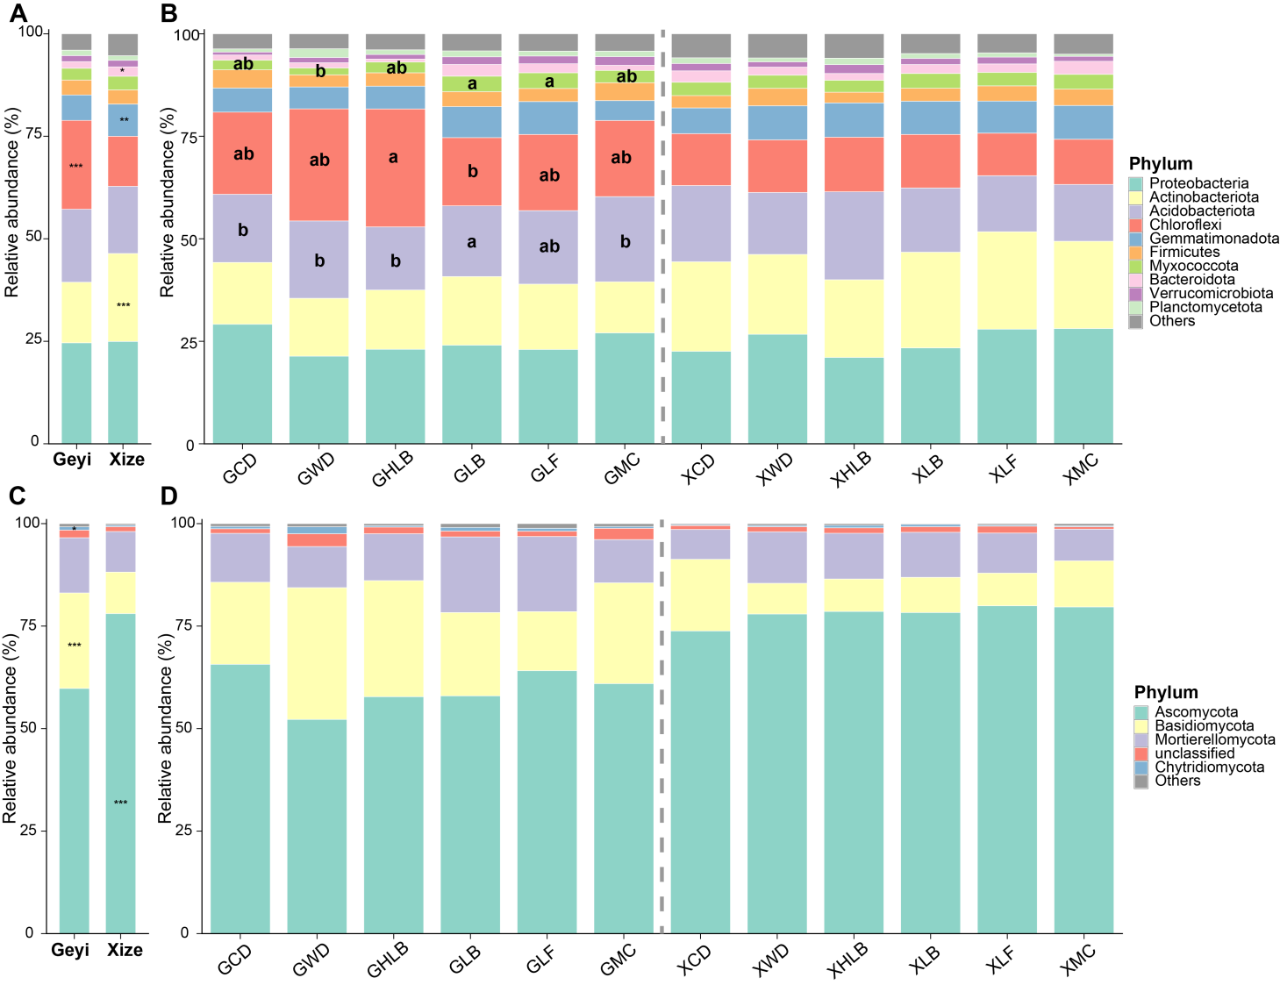
Figure. S1. Relative abundance of the top 10 bacterial phyla (A, B) and the top 5 fungal phyla (C, D) across different sampling sites. Different letters on the bars indicate statistically significant differences among sampling sites (P < 0.05). Asterisks indicate significant differences between regions (* P < 0.05,** P < 0.01, *** P < 0.001). "Others" represents the sum of all remaining phyla. LB, tobacco–radish; HLB, tobacco–carrot; WD, tobacco–pea; CD, tobacco–faba bean; MC, ryegrass; LF, smooth vetch. The prefixes G and X indicate treatments from the Geyi and Xize areas, respectively.

References
[1] Y. Qiao, T. Wang, Q. Huang, H. Guo, H. Zhang, Q. Xu, Q. Shen, N. Ling, Core species impact plant health by enhancing soil microbial cooperation and network complexity during community coalescence, Soil Biology and Biochemistry 188 (2024) 109231. https://doi.org/10.1016/j.soilbio.2023.109231.
[2] T. Yu, Y. Wen, Q. Zhang, J. Yang, H. Zang, Z. Zeng, Y. Yang, Organic management improves soil multifunctionality by enhancing soil quality and enriching key microbes in tea plantation, Applied Soil Ecology 213 (2025) 106260. https://doi.org/10.1016/j.apsoil.2025.106260.

