Supplementary Materials

Development and External Validation of a Transparent Regression-Based In-Hospital Mortality Prediction Model for Critically Ill Patients With Liver Cancer Using MIMIC-IV and eICU-CRD

Supplementary Table S1: ICD Code List and Cohort Definition

Primary liver cancer (main analysis)
Category | ICD-9-CM | ICD-10-CM | Included in
Hepatocellular carcinoma (HCC) | 155.0 | C22.0 | Main analysis
Intrahepatic cholangiocarcinoma | 155.1 | C22.1 | Main analysis
Liver malignancy NOS | 155.2 | C22.7, C22.8, C22.9 | Main analysis

Liver metastasis (sensitivity analysis only)
Category | ICD-9-CM | ICD-10-CM | Included in
Secondary malignant neoplasm of liver | 197.7 | C78.7 | SA only

Exclusion
Category | ICD-9-CM | ICD-10-CM | Action
Personal history of liver cancer | V10.07 | Z85.05 | Exclude

For eICU-CRD, the primary validation cohort used primary ICD coding plus active primary diagnosis-text evidence for current primary liver cancer; secondary-only and past-history-only liver-malignancy evidence was excluded from the primary validation cohort. Detailed eICU text-phenotype handling and diagnosis-derived variable rules are provided in Supplementary Table S8.

Supplementary Table S2: Variable Definition and Database Mapping
Variable | Definition | Time window | Aggregation | MIMIC-IV source | eICU-CRD source | Missing handling
age | Age at ICU admission (years) | T₀ | — | patients.anchor_age | patient.age | Required
sex_male | Male sex (1 = male, 0 = female) | T₀ | binary | derived from patients.gender | derived from patient.gender | Required
heart_rate_mean | Heart rate (beats/min) | 0-24h | mean | chartevents (220045) | vitalPeriodic.heartrate | MICE
sbp_mean | Systolic blood pressure (mmHg) | 0-24h | mean | chartevents (220179, 220050) | vitalPeriodic.systemicsystolic | MICE
map_mean | Mean arterial pressure (mmHg) | 0-24h | mean | chartevents (220052, 220181) | vitalPeriodic.systemicmean | MICE
respiratory_rate_mean | Respiratory rate (breaths/min) | 0-24h | mean | chartevents (220210, 224690) | vitalPeriodic.respiration | MICE
spo2_min | Oxygen saturation (%) | 0-24h | min | chartevents (220277) | vitalPeriodic.sao2 | MICE
temperature_max | Body temperature (degrees C) | 0-24h | max | chartevents (223761, 223762) | vitalPeriodic.temperature | MICE
gcs_min | Glasgow Coma Scale (points) | 0-24h | min | derived total GCS from chartevents itemids 220739, 223901, and 223900 | derived total GCS from apacheApsVar eyes + motor + verbal components | MICE
bun_max | Blood urea nitrogen (mg/dL) | 0-24h | max | labevents (51006, 52647) | lab (BUN) | MICE
creatinine_max | Serum creatinine (mg/dL) | 0-24h | max | labevents (50912, 52546) | lab (creatinine) | MICE
bilirubin_max | Total bilirubin (mg/dL) | 0-24h | max | labevents (50885, 52542) | lab (total bilirubin) | MICE
albumin_min | Serum albumin (g/dL) | 0-24h | min | labevents (50862, 52454) | lab (albumin) | Excluded from primary model (>30% missing in at least one database); exploratory SA9 only
inr_max | International normalized ratio (unitless) | 0-24h | max | labevents (51237, 52740) | lab (PT - INR) | Excluded from primary model (>30% missing in at least one database); exploratory SA9 only
lactate_max | Blood lactate (mmol/L) | 0-24h | max | labevents (50813, 52442) | lab (lactate) | Excluded from primary model (>30% missing in at least one database); exploratory SA9 only
platelet_min | Platelet count (10^3/uL) | 0-24h | min | labevents (51265) | lab (platelets x 1000) | MICE
hemoglobin_min | Hemoglobin (g/dL) | 0-24h | min | labevents (51222, 50811) | lab (Hgb) | MICE
bicarbonate_min | Serum bicarbonate (mmol/L) | 0-24h | min | labevents (50882) | lab (bicarbonate) | MICE
sodium_mean | Serum sodium (mmol/L) | 0-24h | mean | labevents (50983, 52623) | lab (sodium) | MICE
potassium_mean | Serum potassium (mmol/L) | 0-24h | mean | labevents (50971, 52610) | lab (potassium) | MICE
wbc_max | White blood cell count (10^3/uL) | 0-24h | max | labevents (51301, 52769) | lab (WBC x 1000) | MICE
vasopressor_use | Any vasopressor use | 0-24h | binary | inputevents | infusionDrug | 0 if absent
mechanical_ventilation | Invasive MV | 0-24h | binary | procedureevents / chartevents | treatment | 0 if absent
crrt | Continuous RRT | 0-24h | binary | procedureevents (225802, 225803) | treatment | 0 if absent
sepsis | Diagnosis-derived sepsis | During admission | binary | Diagnosis-derived code/text rule; see Supplementary Table S8 | Diagnosis-derived code/text rule; see Supplementary Table S8 | Secondary phenotype-enriched SA7 only
aki | Diagnosis-derived acute kidney injury | During admission | binary | Diagnosis-derived code/text rule; see Supplementary Table S8 | Diagnosis-derived code/text rule; see Supplementary Table S8 | Secondary phenotype-enriched SA7 only
hepatic_encephalopathy | Hepatic encephalopathy | During admission | binary | Diagnosis-derived code/text rule; see Supplementary Table S8 | Diagnosis-derived code/text rule; see Supplementary Table S8 | Secondary phenotype-enriched SA7 only
gi_bleeding | GI bleeding | During admission | binary | Diagnosis-derived code/text rule; see Supplementary Table S8 | Diagnosis-derived code/text rule; see Supplementary Table S8 | Secondary phenotype-enriched SA7 only
cirrhosis | Cirrhosis | Baseline / diagnosis-derived phenotype | binary | Baseline diagnosis-derived code/text rule; see Supplementary Table S8 | Baseline diagnosis-derived code/text rule; see Supplementary Table S8 | 0 if absent
diabetes | Diabetes mellitus | Baseline / diagnosis-derived phenotype | binary | Baseline diagnosis-derived code/text rule; see Supplementary Table S8 | Baseline diagnosis-derived code/text rule; see Supplementary Table S8 | 0 if absent
ckd | Chronic kidney disease | Baseline / diagnosis-derived phenotype | binary | Baseline diagnosis-derived code/text rule; see Supplementary Table S8 | Baseline diagnosis-derived code/text rule; see Supplementary Table S8 | 0 if absent
metastatic | Extrahepatic metastatic disease (1 = present, 0 = absent) | Baseline / diagnosis-derived oncologic phenotype | binary | Baseline extrahepatic metastatic disease rule; see Supplementary Table S8 | Baseline extrahepatic metastatic disease rule; see Supplementary Table S8 | 0 if absent

Supplementary Table S3: Missingness Table
Variable | MIMIC-IV N (%) missing | eICU-CRD N (%) missing | Excluded
age | 0 (0%) | 0 (0%)
sex_male | 0 (0%) | 0 (0%)
heart_rate_mean | 2 (0.3%) | 0 (0%)
sbp_mean | 4 (0.5%) | 0 (0%)
map_mean | 4 (0.5%) | 0 (0%)
respiratory_rate_mean | 3 (0.4%) | 8 (8.9%)
spo2_min | 2 (0.3%) | 0 (0%)
temperature_max | 23 (3%) | 3 (3.3%)
gcs_min | 2 (0.3%) | 4 (4.4%)
bun_max | 6 (0.8%) | 3 (3.3%)
creatinine_max | 6 (0.8%) | 3 (3.3%)
bilirubin_max | 107 (13.9%) | 26 (28.9%)
albumin_min | 309 (40.1%) | 27 (30%) | Yes
inr_max | 48 (6.2%) | 32 (35.6%) | Yes
lactate_max | 207 (26.9%) | 52 (57.8%) | Yes
platelet_min | 6 (0.8%) | 4 (4.4%)
hemoglobin_min | 5 (0.6%) | 3 (3.3%)
bicarbonate_min | 6 (0.8%) | 4 (4.4%)
sodium_mean | 5 (0.6%) | 3 (3.3%)
potassium_mean | 5 (0.6%) | 3 (3.3%)
wbc_max | 6 (0.8%) | 3 (3.3%)
vasopressor_use | 0 (0%) | 0 (0%)
mechanical_ventilation | 0 (0%) | 0 (0%)
crrt | 0 (0%) | 0 (0%)
sepsis | 0 (0%) | 0 (0%)
aki | 0 (0%) | 0 (0%)
hepatic_encephalopathy | 0 (0%) | 0 (0%)
gi_bleeding | 0 (0%) | 0 (0%)
cirrhosis | 0 (0%) | 0 (0%)
diabetes | 0 (0%) | 0 (0%)
ckd | 0 (0%) | 0 (0%)
metastatic | 0 (0%) | 0 (0%)
in_hospital_death | 0 (0%) | 0 (0%)

Variables with >30% missingness in either database were excluded from the primary candidate set.

Supplementary Table S4: Bootstrap Stability Results
Variable | Selection frequency (%) | In final model
map_mean | 100.0 | Yes
creatinine_max | 100.0 | Yes
bilirubin_max | 100.0 | Yes
metastatic | 100.0 | Yes
respiratory_rate_mean | 97.0 | Yes
gcs_min | 96.0 | Yes
heart_rate_mean | 92.5 | Yes
spo2_min | 91.0 | Yes
temperature_max | 90.0 | Yes
potassium_mean | 89.0 | Yes
bicarbonate_min | 73.0 | Yes
age | 66.0 | Yes
vasopressor_use | 25.5 | No
crrt | 18.0 | No
hemoglobin_min | 16.5 | No
wbc_max | 15.5 | No
sodium_mean | 14.0 | No

Bootstrap LASSO stability analysis was based on 200 bootstrap resamples with lambda.1se selection. Variables with >60% selection frequency that were also retained by LASSO lambda.1se were included in the final model, subject to EPV >= 10 constraint (127 events / 12 predictors = 10.6 EPV).

Supplementary Table S5: Complete-Case Analysis Results
Metric | Multiple imputation | Complete-case
MIMIC-IV N | 770 | 639
MIMIC-IV events | 127 | 113
MIMIC-IV AUROC (95% CI) | 0.874 (0.842–0.907) | 0.865 (0.829–0.901)
eICU-CRD N | 90 | 56
eICU-CRD events | 12 | 5
eICU-CRD AUROC (95% CI) | 0.707 (0.517–0.898) | 0.671 (0.331–1.000)

Supplementary Table S6: Subgroup Analysis Results
Subgroup | N | Events | AUROC (95% CI)
Age <65 | 438 | 54 | 0.871 (0.821–0.921)
Age ≥65 | 332 | 73 | 0.866 (0.821–0.911)
Male | 568 | 90 | 0.857 (0.815–0.898)
Female | 202 | 37 | 0.917 (0.874–0.961)
Cirrhosis | 388 | 67 | 0.886 (0.848–0.924)
No cirrhosis | 382 | 60 | 0.864 (0.811–0.918)
Metastatic | 136 | 46 | 0.798 (0.712–0.885)
No metastatic | 634 | 81 | 0.877 (0.838–0.916)
MV | 387 | 69 | 0.892 (0.851–0.932)
No MV | 383 | 58 | 0.855 (0.805–0.904)
Vasopressor | 244 | 56 | 0.864 (0.808–0.920)
No vasopressor | 526 | 71 | 0.873 (0.831–0.915)

All subgroup AUROCs were computed in the MIMIC-IV derivation cohort using the final model coefficients.

Supplementary Table S7: Exploratory High-Missingness Marker Model Coefficients
This exploratory model added albumin, INR, and lactate to the primary predictor set despite high missingness in at least one database. Supplementary Table S7 summarizes these additional-marker effects only; the model was exploratory and was not used to replace the primary model.
Marker | Coefficient | SE | OR (95% CI) | p-value
Albumin (min) | 0.346 | 0.272 | 1.41 (0.82-2.42) | 0.206
INR (max) | 0.477 | 0.184 | 1.61 (1.12-2.31) | 0.010
Lactate (max) | 0.096 | 0.048 | 1.10 (1.00-1.21) | 0.049

Full exploratory-model coefficients are provided in manuscript/tables/TableS_high_missingness_marker_model_coefficients.csv.

Supplementary Table S8: Diagnosis-derived variable definitions and eICU text phenotype rules
Diagnosis-derived variables were used as baseline phenotype descriptors, primary-model phenotype predictors where specified, or secondary phenotype-enriched sensitivity variables. Metastatic disease was modeled as a diagnosis-derived baseline oncologic phenotype feature rather than a first-24-hour physiologic/laboratory measurement. Secondary liver malignancy / liver-metastasis evidence was not counted as extrahepatic metastatic disease in the primary model.
Variable | MIMIC-IV code/text rule | eICU-CRD code/text rule | Use in analysis
primary_liver_cancer_phenotype | ICD-9 155.x or ICD-10 C22.x liver cancer diagnosis codes. | Primary ICD tokens 155.x/C22.x, or active primary diagnosis text containing liver cancer, hepatocellular, hepatoma, liver cell carcinoma, intrahepatic cholangiocarcinoma, or hepatic carcinoma. Secondary-only and past-history-only evidence is excluded from primary validation. | Cohort definition; eICU text-only primary evidence is allowed in the primary validation cohort.
secondary_liver_malignancy_or_liver_metastasis_phenotype | ICD-9 197.7 or ICD-10 C78.7 identifies secondary liver malignancy / liver metastasis evidence for phenotype sensitivity only. | ICD tokens 197.7/C78.7, or secondary-like text including malignant neoplasm of liver, liver/hepatic metastasis, metastasis to liver, secondary liver, or mets to liver. Used for broad phenotype sensitivity only unless concurrent primary evidence is present. | SA0 broad phenotype sensitivity; not counted as extrahepatic metastatic disease in the primary model.
metastatic | Hospital-admission diagnosis codes keyed by hadm_id: ICD-9 196.x, 197.x except 197.7, 198.x, or 199.x; ICD-10 C77.x, C78.x except C78.7, or C79.x. Secondary liver malignancy / liver metastasis codes are excluded from this predictor. | Diagnosis and pastHistory fields: ICD-9 196.x, 197.x except 197.7, 198.x, or 199.x; ICD-10 C77.x, C78.x except C78.7, or C79.x; metastatic text excluding liver-metastasis-only and secondary-liver phrases. | Primary model diagnosis-derived baseline oncologic phenotype predictor; not treated as a first-24-hour physiologic/laboratory measurement.
cirrhosis | ICD-9 571.2, 571.5, or 571.6; ICD-10 K74.x or K70.3. | ICD-9 571.2, 571.5, or 571.6; ICD-10 K74.x or K70.3; diagnosis or past-history text containing cirrhosis. | Descriptive Table 1 and candidate baseline phenotype variable.
diabetes | ICD-9 250.x; ICD-10 E10.x, E11.x, E13.x, or E14.x. | ICD-9 250.x; ICD-10 E10.x, E11.x, E13.x, or E14.x; diagnosis or past-history text containing diabetes. | Descriptive Table 1 and candidate baseline phenotype variable.
ckd | ICD-9 585.x; ICD-10 N18.x. | ICD-9 585.x; ICD-10 N18.x; diagnosis/past-history text containing chronic kidney, renal insufficiency, or CKD. | Descriptive Table 1 and candidate baseline phenotype variable.
sepsis | ICD-9 038.x, 99591, 99592, or 78552; ICD-10 A40.x, A41.x, R65.20, or R65.21. | ICD-9 038.x, 995.9x, or 785.52; ICD-10 A40.x, A41.x, R65.20, or R65.21; diagnosis text containing sepsis or septic. | Descriptive Table 1 and SA7 phenotype-enriched secondary analysis only.
aki | ICD-9 584.x; ICD-10 N17.x. | ICD-9 584.x; ICD-10 N17.x; diagnosis text containing acute kidney or acute renal. | Descriptive Table 1 and SA7 phenotype-enriched secondary analysis only.
hepatic_encephalopathy | ICD-9 572.2; ICD-10 K72.x. | ICD-9 572.2; ICD-10 K72.x; diagnosis text containing hepatic encephalopathy or hepatic coma. | Descriptive Table 1 and SA7 phenotype-enriched secondary analysis only.
gi_bleeding | ICD-9 578.x; ICD-10 K92.0, K92.1, or K92.2. | ICD-9 578.x; ICD-10 K92.0, K92.1, or K92.2; diagnosis/treatment text containing gastrointestinal bleed, GI bleed, or variceal bleed. | Descriptive Table 1 and SA7 phenotype-enriched secondary analysis only.

Supplementary Figures

eFigure 1: LASSO Variable Selection Path (lambda path)
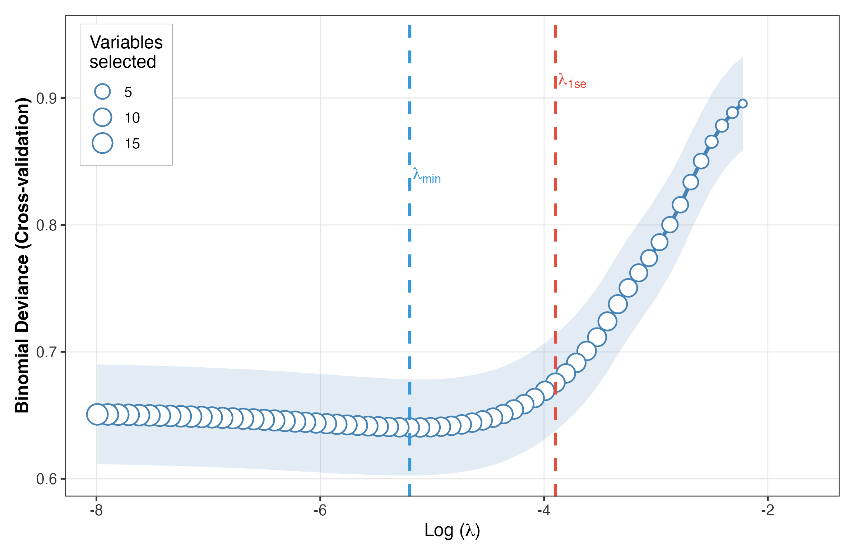
Cross-validated deviance as a function of log(lambda). Vertical dashed lines indicate lambda.min (blue) and lambda.1se (red). The lambda.1se solution retained 12 variables.

eFigure 2: Missing Data Pattern
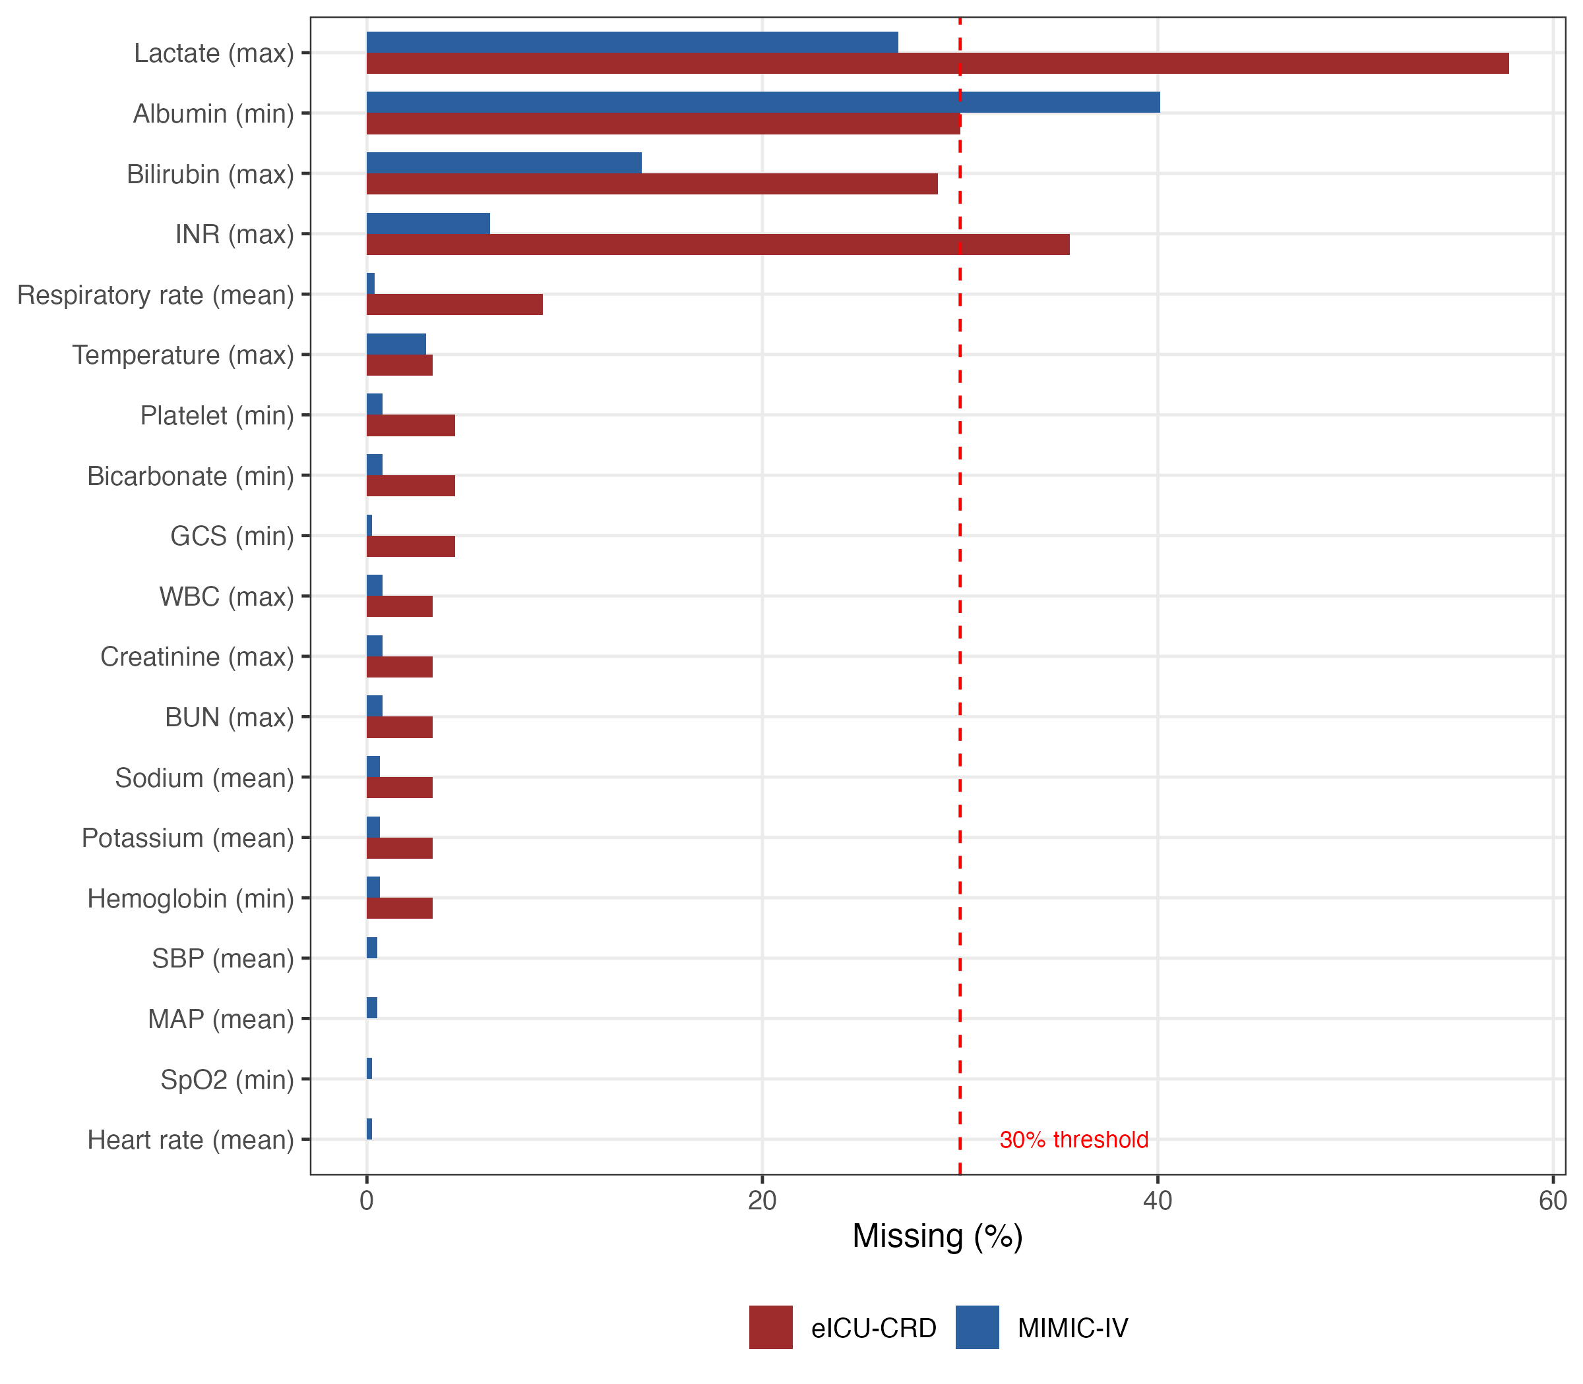
Missing data rates for candidate predictors in both cohorts. Red dashed line indicates the 30% exclusion threshold. Three variables (albumin, INR, lactate) exceeded this threshold in at least one database.

eFigure 3: Subgroup Forest Plot (AUROC by subgroup)
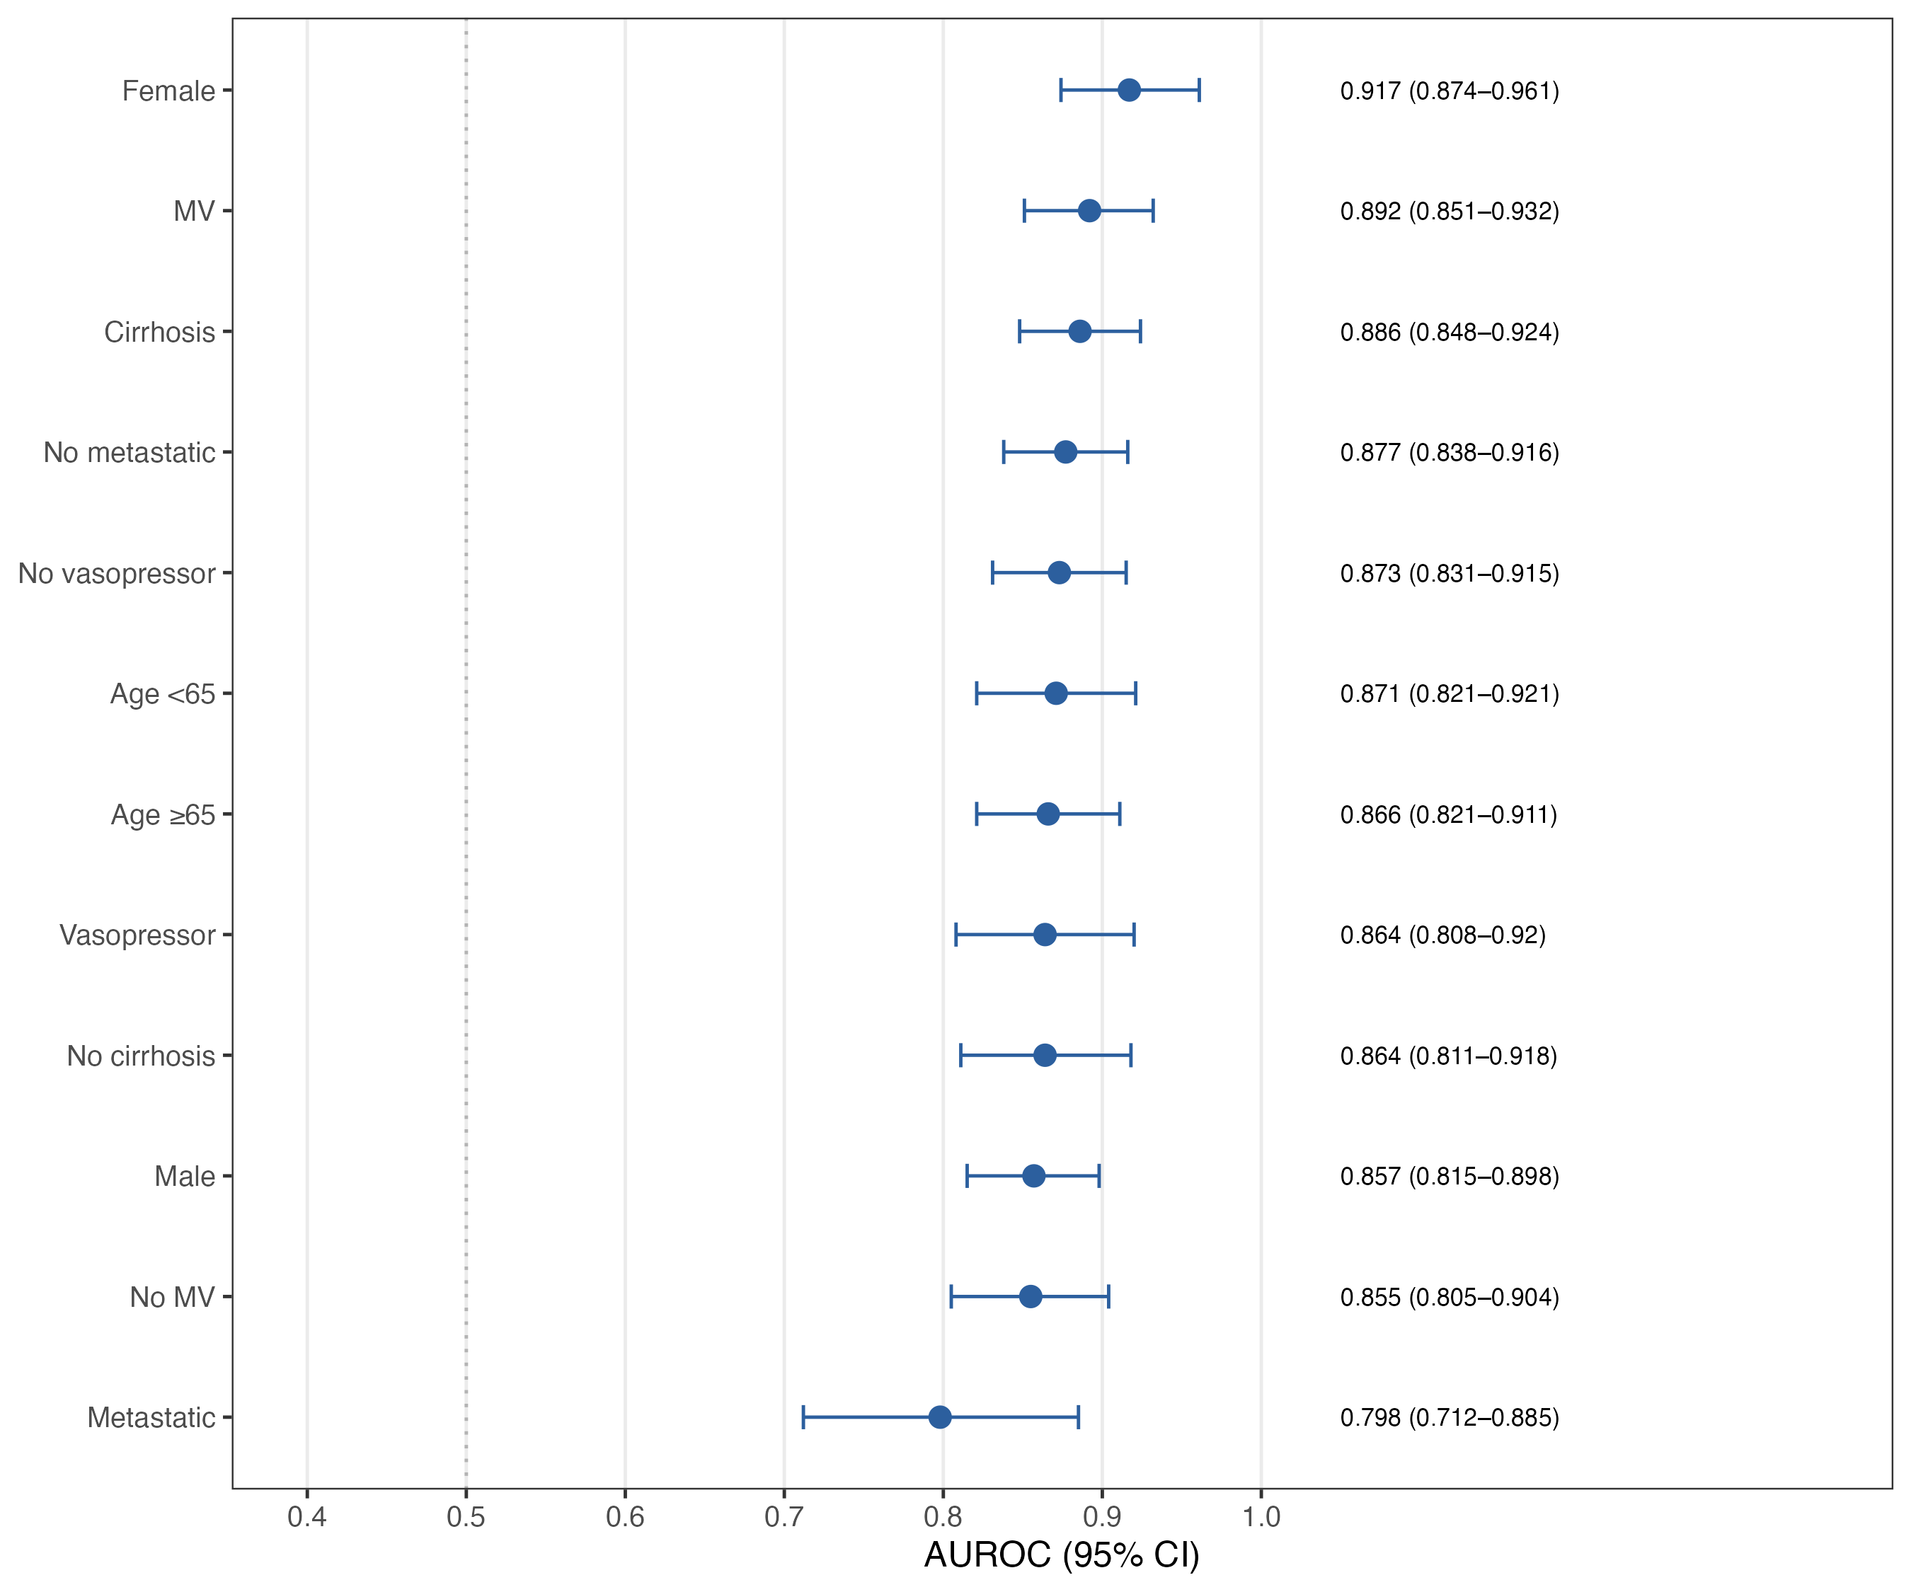
Subgroup analysis of model discrimination (AUROC) across clinically relevant subgroups in the MIMIC-IV derivation cohort.

