Table A1. Codes used for the identification of cases
HIV | B20.0, B20.1, B20.2, B20.3, B20.4, B20.5, B20.6, B20.7, B20.8, B20.9, B21.0, B21.1, B21.2, B21.3, B21.7, B21.8, B21.9,, B22.0, B22.1, B22.2, B22.7, B23.0, B23.1, B23.2, B23.8, B24, Z21, F02.4, R75
AIDS at HIV diagnosis | A02.1, A07.2, A07.3, A15, A16, A17, A18, A19, A31.8, A31.9, A81.1, A81.2,  B00.7, B20.0, B20.2, B20.3, B20.4, B20.5, B20.6, B20.7, B20.8, B20.9, B21.0, B21.1, B21.2, B21.3, B21.7, B21.8, B21.9, B22.0, B22.1, B22.2, B22.7, B23.8, B24, B25.0, B25.8, B25.9, B37.1, B37.8, B38.3, B38.4, B38.7, B38.8, B39.3, B39.4, B39.5, B45.1, B45.2, B45.3, B45.7, B45.8, B48.4, B55.9, B57.2, B57.4, B58.2, B59,  C46, C53, C82, C83, C84, C85,  D43 with subcategories,  G93 with subcategories,  J12, J13, J14, J15, J16, J17, J18

Figure A1. Overall trend of the number of PLHIV-D and the percentage of females in Poland in 2012-2024
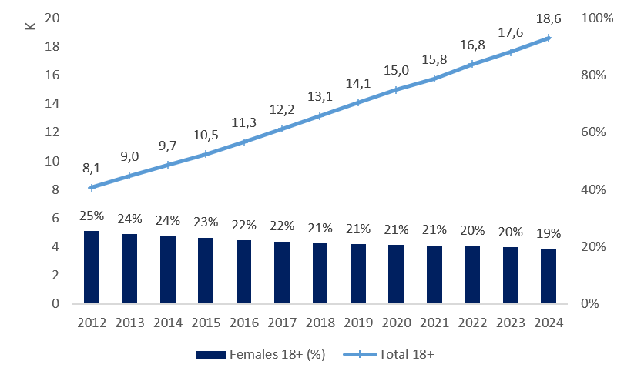
Figure A2. Age structure in males (B.) and females (A.) living with diagnosed HIV in Poland in 2012-2024
A. Females
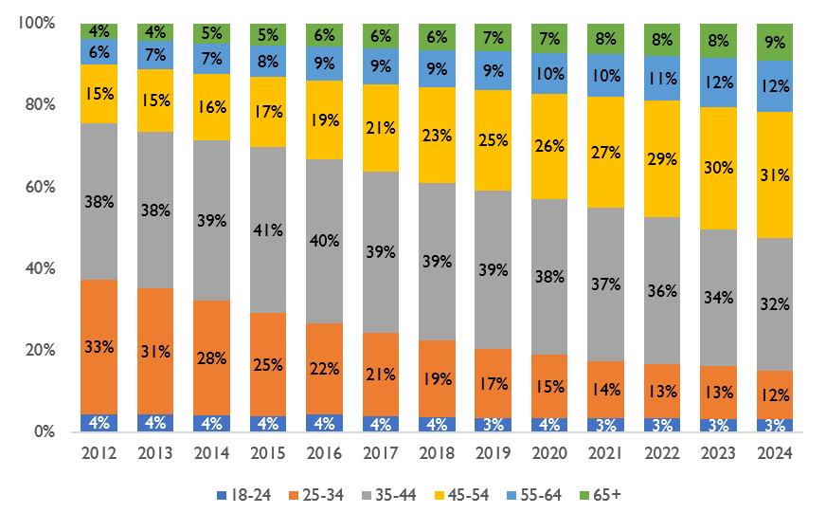
B. Males
