Supplementary Fig 1: PRISMA flowchart of literature search and selection for randomized controlled trials
Studies included in quantitative synthesis (network meta-analysis)
(n = 23)
Studies included in qualitative synthesis
(n = 23)
Articles excluded, with reasons
(n = 148):
Abstracts (n= 65)
Biomarker Studies (n= 10)
Cost effectiveness Studies (n= 3)
Non-Randomized Studies (n= 29)
Case Reports (n= 1)
Duplicates (n= 9)
Quality of Life Studies (n= 5)
Toxicity Studies (n= 2)
Updated Follow-up Studies (n= 13)
Exploratory Analysis (n= 2)
Non-Standard comparator arm (n= 6)
No Survival Outcome measure (n= 1)
No Hazard Ratio (n= 2)
Full-text articles assessed for eligibility
(n = 171)
Additional records identified through other sources:
Cochrane Central Register of Controlled Trials (CCTR)
Cochrane Database of Systematic Reviews (CDSR)
ClinicalTrials.gov
ASCO, and ESMO abstract database
(n = 201)
Records identified through database searching:
Embase
PubMed
OVID Medline
(n = 2162)
Records excluded
(n = 1,392)
Records screened
(n = 171)
Records after duplicates removed
(n = 1563)
Identification
Eligibility
Included
Screening

Supplementary Fig 2. Comparative effectiveness of different anti-angiogenic agents and standard of care chemotherapy (i.e. Carboplatin/Paclitaxel) in chemotherapy naïve setting:
- P-scores for overall survival
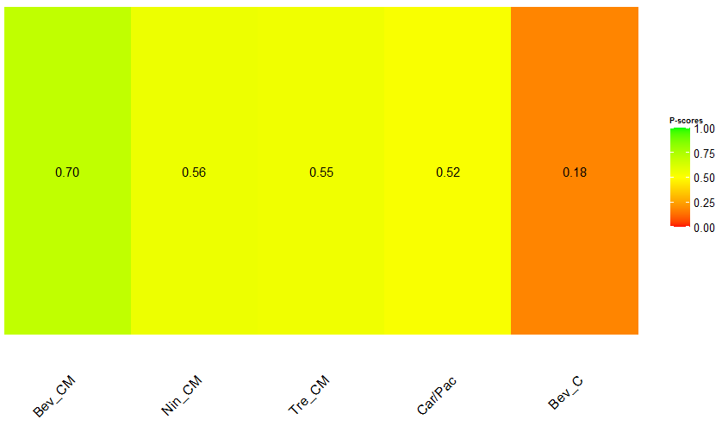

- P-scores for progression-free survival
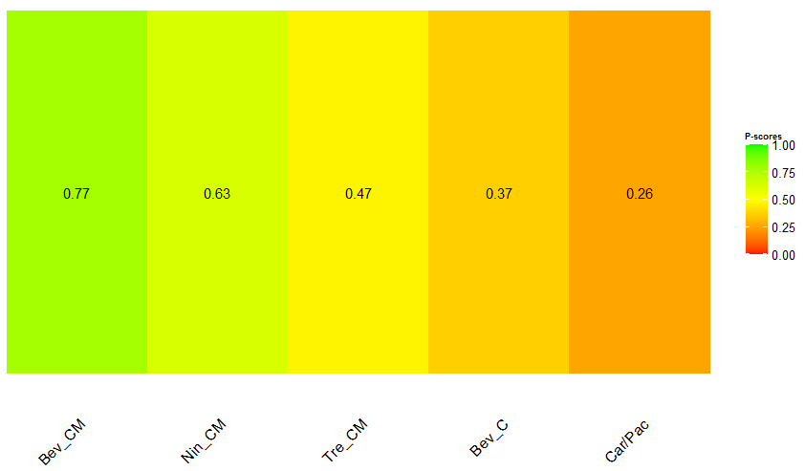
Key: Bev_C, Bevacizumab (concurrent); Bev_CM, Bevacizumab (concurrent + maintanence); Car/Pac, Carboplatin/Paclitaxel; Nin_CM, Nintedanib (concurrent + maintanence); Tre_CM, Trebananib (concurrent + maintanence)
Note: The higher the P-scores, the higher likelihood that an intervention is in the top rank or one of the top ranks.

Supplementary Fig 3. Comparison-adjusted funnel plot of 15 included RCTs on the primary outcome of OS in recurrent EOC setting
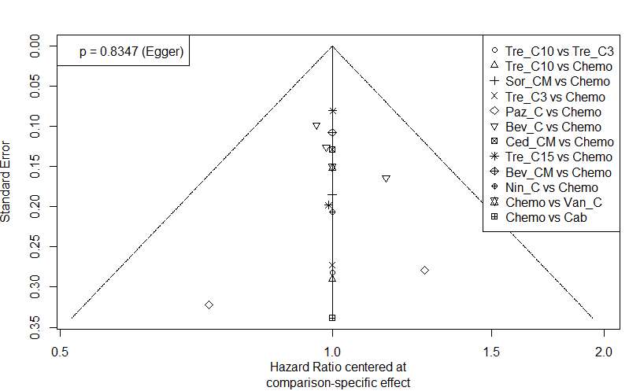

Key: Bev_C, Bevacizumab (concurrent); Bev_CM, Bevacizumab (concurrent + maintenance); Cab, Cabozantinib; Ced_CM, Cediranib (concurrent + maintenance); Chemo, Standard of care chemotherapy; Nin_C, Nintedanib (concurrent); Paz_C, Pazopanib (concurrent); Sor_CM, Sorafenib (concurrent + maintenance); Tre_C3, Trebananib (3mg/kg) (concurrent); Tre_C10, Trebananib (10mg/kg) (concurrent); Tre_C15, Trebananib (15mg/kg) (concurrent); Van_C, Vandetanib (concurrent).

Supplementary Fig 4. Flow diagram to summarize the recommendations from the observations in this network meta-analysis
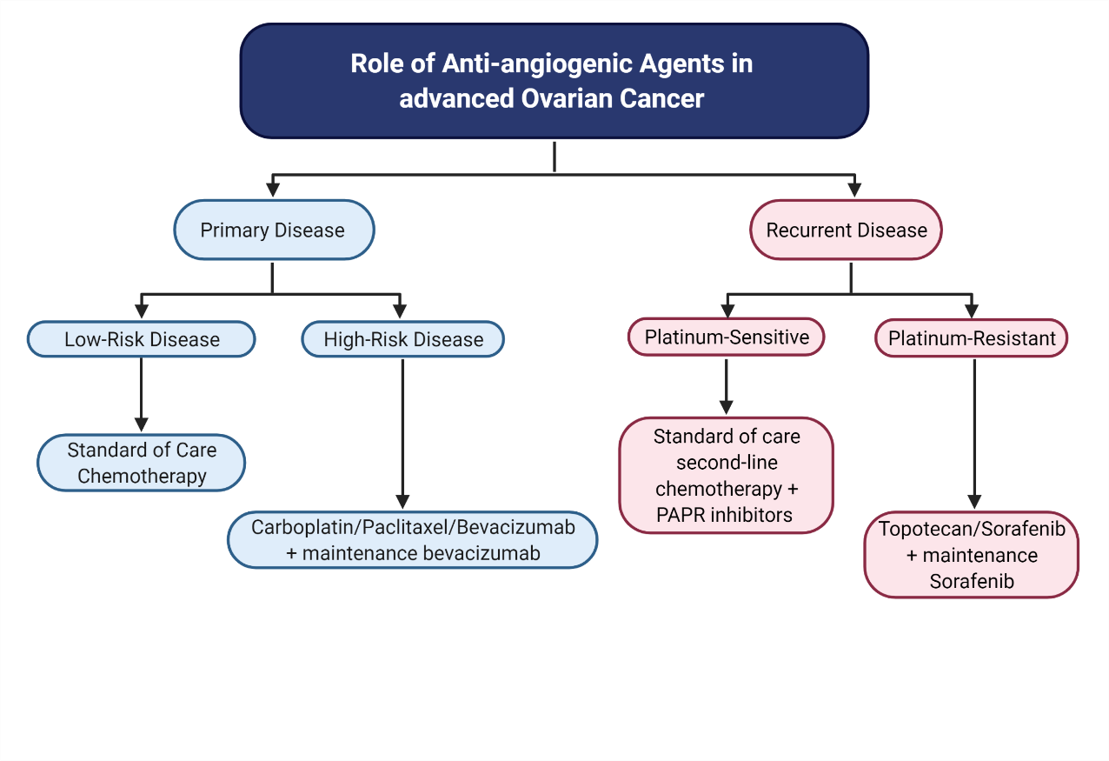

Supplementary Table 1: Systematic review demonstrating the outcome variabilities in meta-analyses performed in angiogenesis inhibitor randomized controlled trials, over time.
PMID | Authors | Journal/Book | Publication Year | Number of Clinical Trials included | Study population | Trial Outcome | PFS | OS | Front-line: PFS | Front-line: OS | High-risk: PFS | High-risk: OS | Recurrent Disease: PFS | Recurrent Disease: OS | Platinum-Sensitive Disease: PFS | Platinum-Sensitive Disease: OS | Platinum-Resistant Disease: PFS | Platinum-Resistant Disease: OS | DOI
24324725 | Zhou M et al | PLoS One | 2013 | 4 | 2 trials treatment naïve; 1 trial platinum sensitive; 1 trial platinum resistant | PFS benefit in newly diagnosed and recurrent ovarian cancer. OS benefit in newly diagnosed ovarian cancer only |  |  | HR, 0.82; 95% CI, 0.75-0.89 | HR, 0.87; 95% CI, 0.77-0.99 |  |  | HR, 0.48; 95% CI, 0.41-0.57 |  |  |  |  |  | 10.1371/journal.pone.0081858
23543268 | Ye Q et al | Arch Gynecol Obstet | 2013 | 4 | 2 trials treatment naïve; 1 trial platinum sensitive; 1 trial platinum resistant | ORR and PFS benefit | HR, 0.691; 95% CI, 0.517-0.865 | HR, 0.934; 95% CI, 0.826-1.041 |  |  |  |  |  |  |  |  |  |  | 10.1007/s00404-013-2820-1
25818743 | Wang TS et al | Indian J Cancer | 2014 | 5 | 2 trials treatment naïve; 1 trial platinum sensitive; 1 trial recurrent disease; 1 breast cancer trial | PFS benefit | HR, 0.64; 95% CI, 0.46-0.82 | HR, 0.84; 95% CI, 0.59-10.9 |  |  |  |  |  |  |  |  |  |  | 10.4103/0019-509X.154084
25990506 | Li J et al | Clin Transl Oncol | 2015 | 4 | 2 trials treatment naïve; 1 trial platinum sensitive; 1 trial platinum resistant | PFS benefit in newly diagnosed and recurrent ovarian cancer. OS benefit in newly diagnosed ovarian cancer only |  |  | HR, 0.82; 95% CI 0.75-0.89 | HR, 0.86; 95% CI 0.75-0.99 |  |  | HR, 0.48; 95% CI 0.41-0.57 | HR, 0.93; 95% CI 0.78-1.12 |  |  |  |  | 10.1007/s12094-015-1293-z
4526298 | Li J et al | J Ovarian Res | 2015 | 12 | 3 trials treatment naïve; 1 trial maintenance; 4 trials recurrent disease; 3 trials platinum sensitive; 1 trial platinum resistant | PFS and OS benefit | HR, 0.66; 95% CI, 0.58-0.75 | HR, 0.89; 95% CI, 0.82-0.97 |  |  |  |  |  |  |  |  |  |  | 10.1186/s13048-015-0181-z
26657509 | Marchetti C et al | Oncotarget | 2016 | 3 | 2 trials platinum sensitive; 1 trial platinum resistant | PFS and OS benefit in Recurrent Disease |  |  |  |  |  |  | HR, 0.53; 95% CI 0.44 − 0.63 | HR, 0.87; 95% CI, 0.77 to 0.99 |  |  |  |  | 10.18632/oncotarget.6507
26652645 | Li X et al | Curr Med Res Opin | 2016 | 12 | 4 trials treatment naïve; 2 trial maintenance; 3 trials recurrent disease; 2 trials platinum sensitive; 1 trial platinum resistant | PFS benefit | HR, 0.61; 95% CI, 0.48-0.79 |  |  |  |  |  |  |  |  |  |  |  | 10.1185/03007995.2015.1131152
27793044 | Wu YS et al | Oncotarget | 2017 | 5 | 2 trials treatment naïve; 2 trial platinum sensitive; 1 trial platinum resistant | PFS and OS benefit in High-Risk disease and Recurrent disease |  |  | HR, 0.85; 95%CI 0.70-1.02 | HR, 0.94; 95%CI 0.84-1.05 | HR, 0.76; 95%CI 0.68-0.84 | HR, 0.85; 95%CI 0.74-0.96 | HR, 0.53; 95%CI 0.45-0.63 | HR, 0.87; 95%CI 0.77-0.99 |  |  |  |  | 10.18632/oncotarget.12926
30142803 | Jiang Y et al | Medicine (Baltimore) | 2018 | 15 | 3 trials treatment naïve; 3 trials maintenance; 2 trials recurrent disease; 3 trials platinum sensitive; 3 trials platinum resistant | PFS benefit in newly diagnosed and recurrent ovarian cancer. OS benefit in Recurrent disease |  |  | HR, 0.88; 95% CI 0.79-0.98 |  |  |  | HR, 0.58; 95% CI 0.52-0.65 | HR, 0.84; 95% CI 0.76-0.92 | HR, 0.56; 95% CI 0.48-0.64 | HR, 0.86; 95% CI 0.76-0.98 | HR, 0.54; 95% CI 0.41-0.71 | HR, 0.84; 95% CI 0.71-0.98 | 10.1097/MD.0000000000011920
29561301 | Wang H et al | Int J Gynecol Cancer | 2018 | 15 | 3 trials treatment naïve; 3 trials maintenance; 2 trials recurrent disease; 3 trials platinum sensitive; 4 trials platinum resistant | PFS and OS benefit in High-Risk disease and Recurrent disease |  |  | HR, 0.83; 95% CI, 0.71-0.97 | HR, 0.95; 95% CI, 0.86-1.05 | HR, 0.72; 95% CI, 0.65-0.81 | HR, 0.84; 95%CI, 0.74-0.96 | HR, 0.58; 95% CI, 0.52-0.65 | HR, 0.86; 95% CI, 0.79-0.94 |  |  |  |  | 10.1097/IGC.0000000000001258
PFS: progression free survival; OS: overall survival; ORR: objective response rate; HR: hazard ratio; CI: confidence interval

Supplementary Table 2: Table to summarise the risk of bias assessment of trials included in the network meta-analysis

Supplementary Table 3: Risk of Bias assessment table

 | Randomization process | Deviations from intended interventions | Mising outcome data | Measurement of the outcome | Selection of the reported result | Overall Bias
Assignment to intervention (the 'intention-to-treat' effect)
Total number of study = 23
Low risk | 91.3 | 78.3 | 100 | 65.2 | 100 | 52.2
Some concerns | 8.7 | 21.7 | 0 | 34.8 | 0 | 47.8
High risk | 0 | 0 | 0 | 0 | 0 | 0

