Figure S1
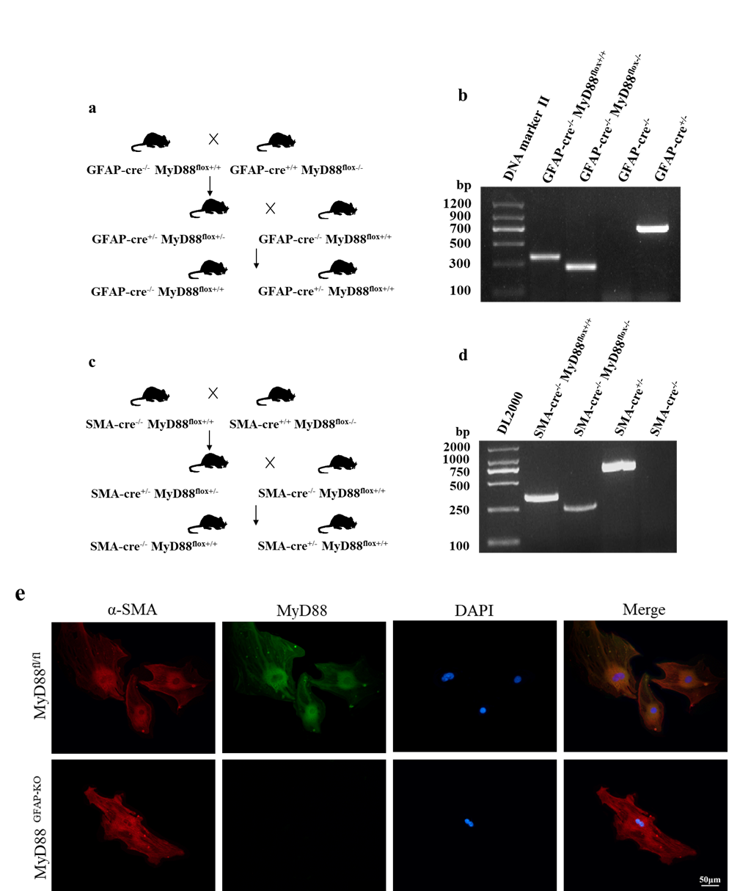
Figure S1 Generation of mice with genetic deletion of MyD88 in HSCs
a Generation of MyD88 knockout mice in quiescent HSCs. b PCR identified the genotype of mice, GFAP-cre^{-/-} MyD88^{flox+/+}: loxp locus in MyD88 gene, GFAP-cre^{-/-} MyD88^{flox-/-}: MyD88 gene, GFAP cre ^{-/-}: no cre recombinase gene, GFAP cre ^{+/-}: cre recombinase gene. c Generation of MyD88 knockout mice in activated HSCs (myofibroblasts). d PCR identified the genotype of mice. SMA-cre^{-/-} MyD88^{flox+/+}: loxp locus in MyD88 gene, SMA-cre^{-/-} MyD88^{flox-/-}: MyD88 gene, SMA cre ^{+/-}: cre recombinase gene, SMA cre ^{-/-}: no cre recombinase gene. e Immunofluorescence double staining of HSCs markers (α-SMA, red) and MyD88 (green), DAPI (blue) stained the nucleus. (Scale bar = 50 μm)

Figure S2

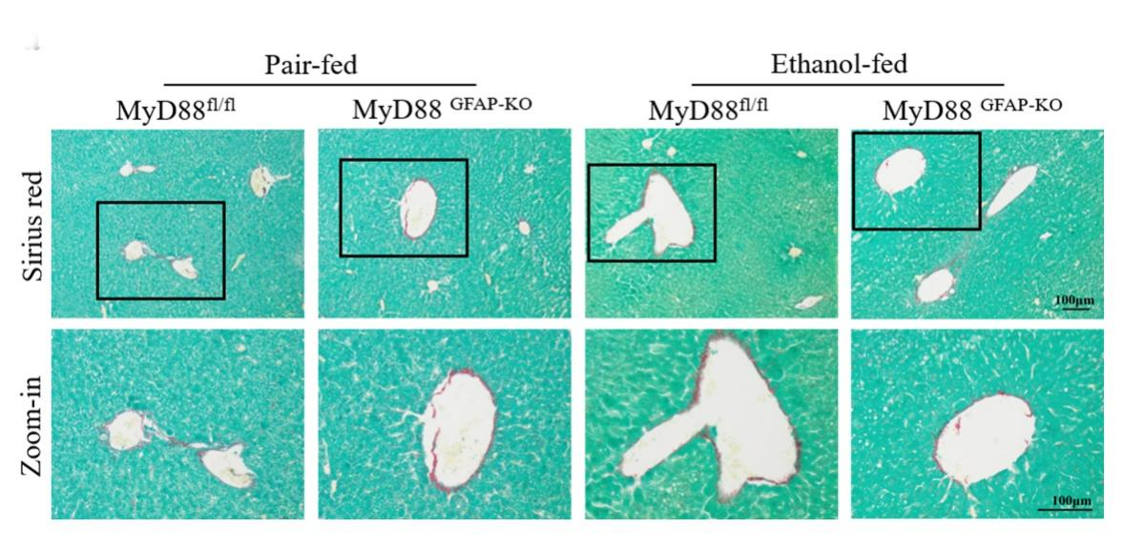
Figure S2. The effect of knocking out MyD88 in quiescent HSCs on hepatic fibrosis
Sirius red staining results showed that the alcoholic fatty liver model did not induce significant liver fibrosis, and knocking out MyD88 in quiescent HSCs had no effect on the formation of liver fibrosis in this model. (Scale bar = 100 μm)

Table S1 Primer sequences for RT-PCR
Gene | Primer | Length | Tm
GAPDH (mouse) | F: CATCACTGCCACCCAGAAGACTG | 23 | 63.28
GAPDH (mouse) | R: ATGCCAGTGAGCTTCCCGTTCAG | 23 | 65.15
IL-6 (mouse) | F: TACCACTTCACAAGTCGGAGGC | 22 | 62.24
IL-6 (mouse) | R: CTGCAAGTGCATCATCGTTGTTC | 23 | 61.21
IL-1Β (mouse) | F: TGGACCTTCCAGGATGAGGACA | 22 | 62.52
IL-1Β (mouse) | R: GTTCATCTCGGAGCCTGTAGTG | 22 | 60.48
TNF-α (mouse) | F: TGAGGTCAATCTGCCCAAGT | 20 | 58.93
TNF-α (mouse) | R: GGGGTCAGAGTAAAGGGGTC | 20 | 59.09
MCP-1 (mouse) | F: GCTACAAGAGGATCACCAGCAG | 22 | 60.74
MCP-1 (mouse) | R: GTCTGGACCCATTCCTTCTTGG | 22 | 60.62
SREBP1 (mouse) | F: CGACTACATCCGCTTCTTGCAG | 22 | 61.61
SREBP1 (mouse) | R: CCTCCATAGACACATCTGTGCC | 22 | 60.48
SCD1 (mouse) | F: GCAAGCTCTACACCTGCCTCTT | 22 | 62.57
SCD1 (mouse) | R: CGTGCCTTGTAAGTTCTGTGGC | 22 | 62.25
ACC1 (mouse) | F: GTTCTGTTGGACAACGCCTTCAC | 23 | 62.61
ACC1 (mouse) | R: GGAGTCACAGAAGCAGCCCATT | 22 | 62.85
FANS (mouse) | F: ACCTCCAGTCGTGAAACCAT | 20 | 58.94
FANS (mouse) | R: CTCAGCTGTGTCTTGGATGC | 20 | 58.91
OPN (mouse) | F: GCTTGGCTTATGGACTGAGGTC | 22 | 61.00
OPN (mouse) | R: CCTTAGACTCACCGCTCTTCATG | 23 | 60.74
GAPDH (human) | F: CCAAGGAGTAAGACCCCTGG | 20 | 59.09
GAPDH (human) | R: AGGGGAGATTCAGTGTGGTG | 20 | 59.01
SREBP1 (human) | F: ACTTCTGGAGGCATCGCAAGCA | 22 | 64.79
SREBP1 (human) | R: AGGTTCCAGAGGAGGCTACAAG | 22 | 61.16
SCD1 (human) | F: CCTGGTTTCACTTGGAGCTGTG | 22 | 61.65
SCD1 (human) | R: TGTGGTGAAGTTGATGTGCCAGC | 23 | 63.96
ACC1 (human) | F: TTCACTCCACCTTGTCAGCGGA | 22 | 63.84
ACC1 (human) | R: GTCAGAGAAGCAGCCCATCACT | 22 | 62.32
FANS (human) | F: TTCTACGGCTCCACGCTCTTCC | 22 | 64.28
 | R: GAAGAGTCTTCGTCAGCCAGGA | 22 | 61.72
OPN (human) | F: CGAGGTGATAGTGTGGTTTATGG | 23 | 58.88
 | R: GCACCATTCAACTCCTCGCTTTC | 23 | 62.50

