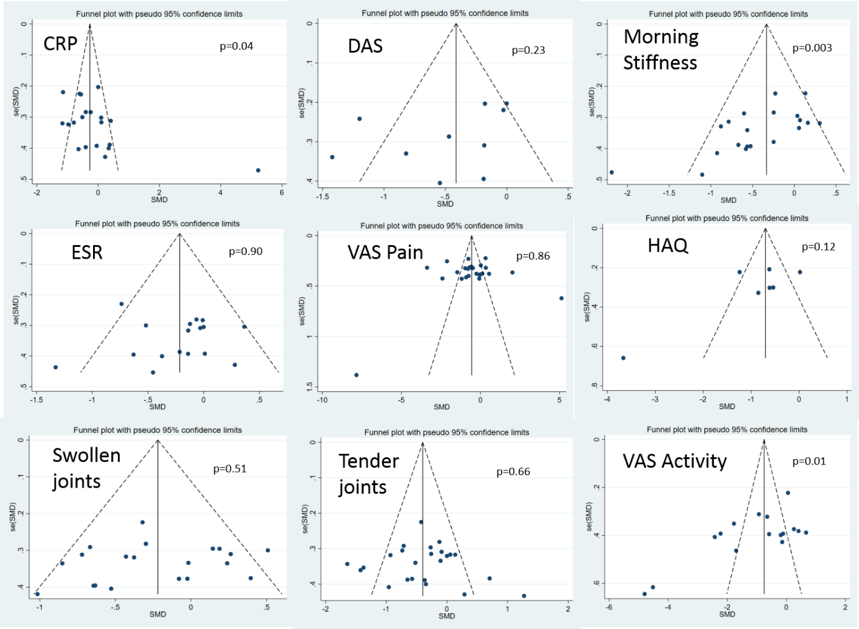

Additional file 15. Funnel plots of publication bias

