Supplements
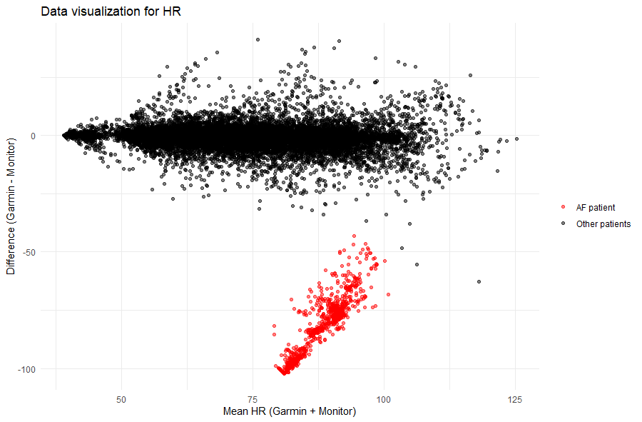
Supplemental Figure 1: Data visualization for HR. The red measurements indicate data from a patient with AF.
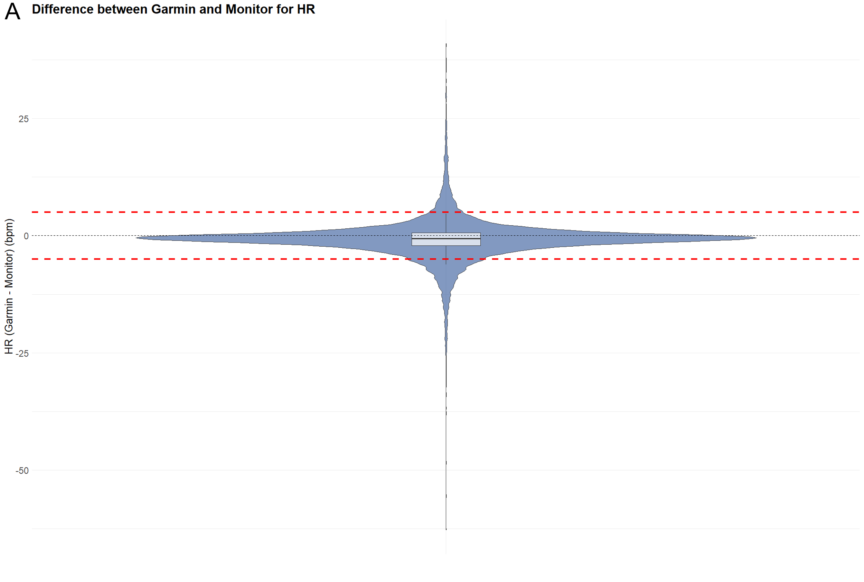

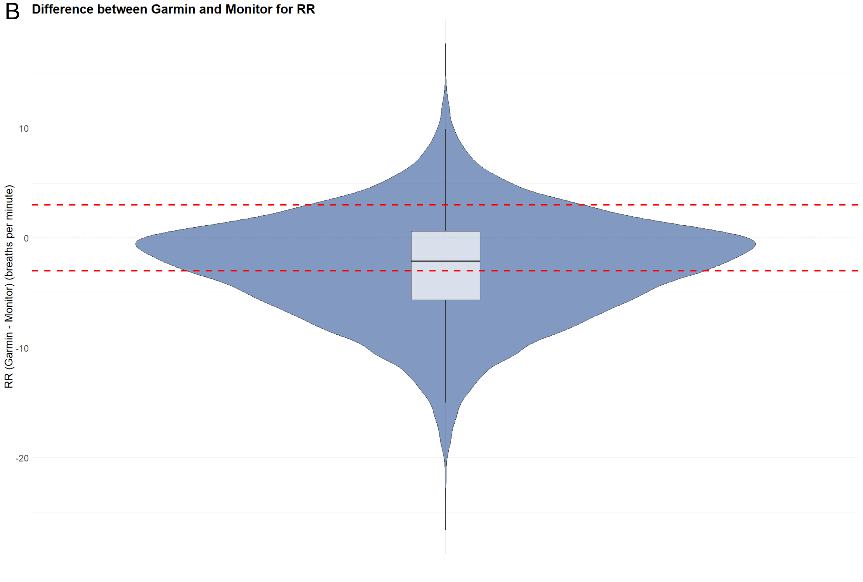

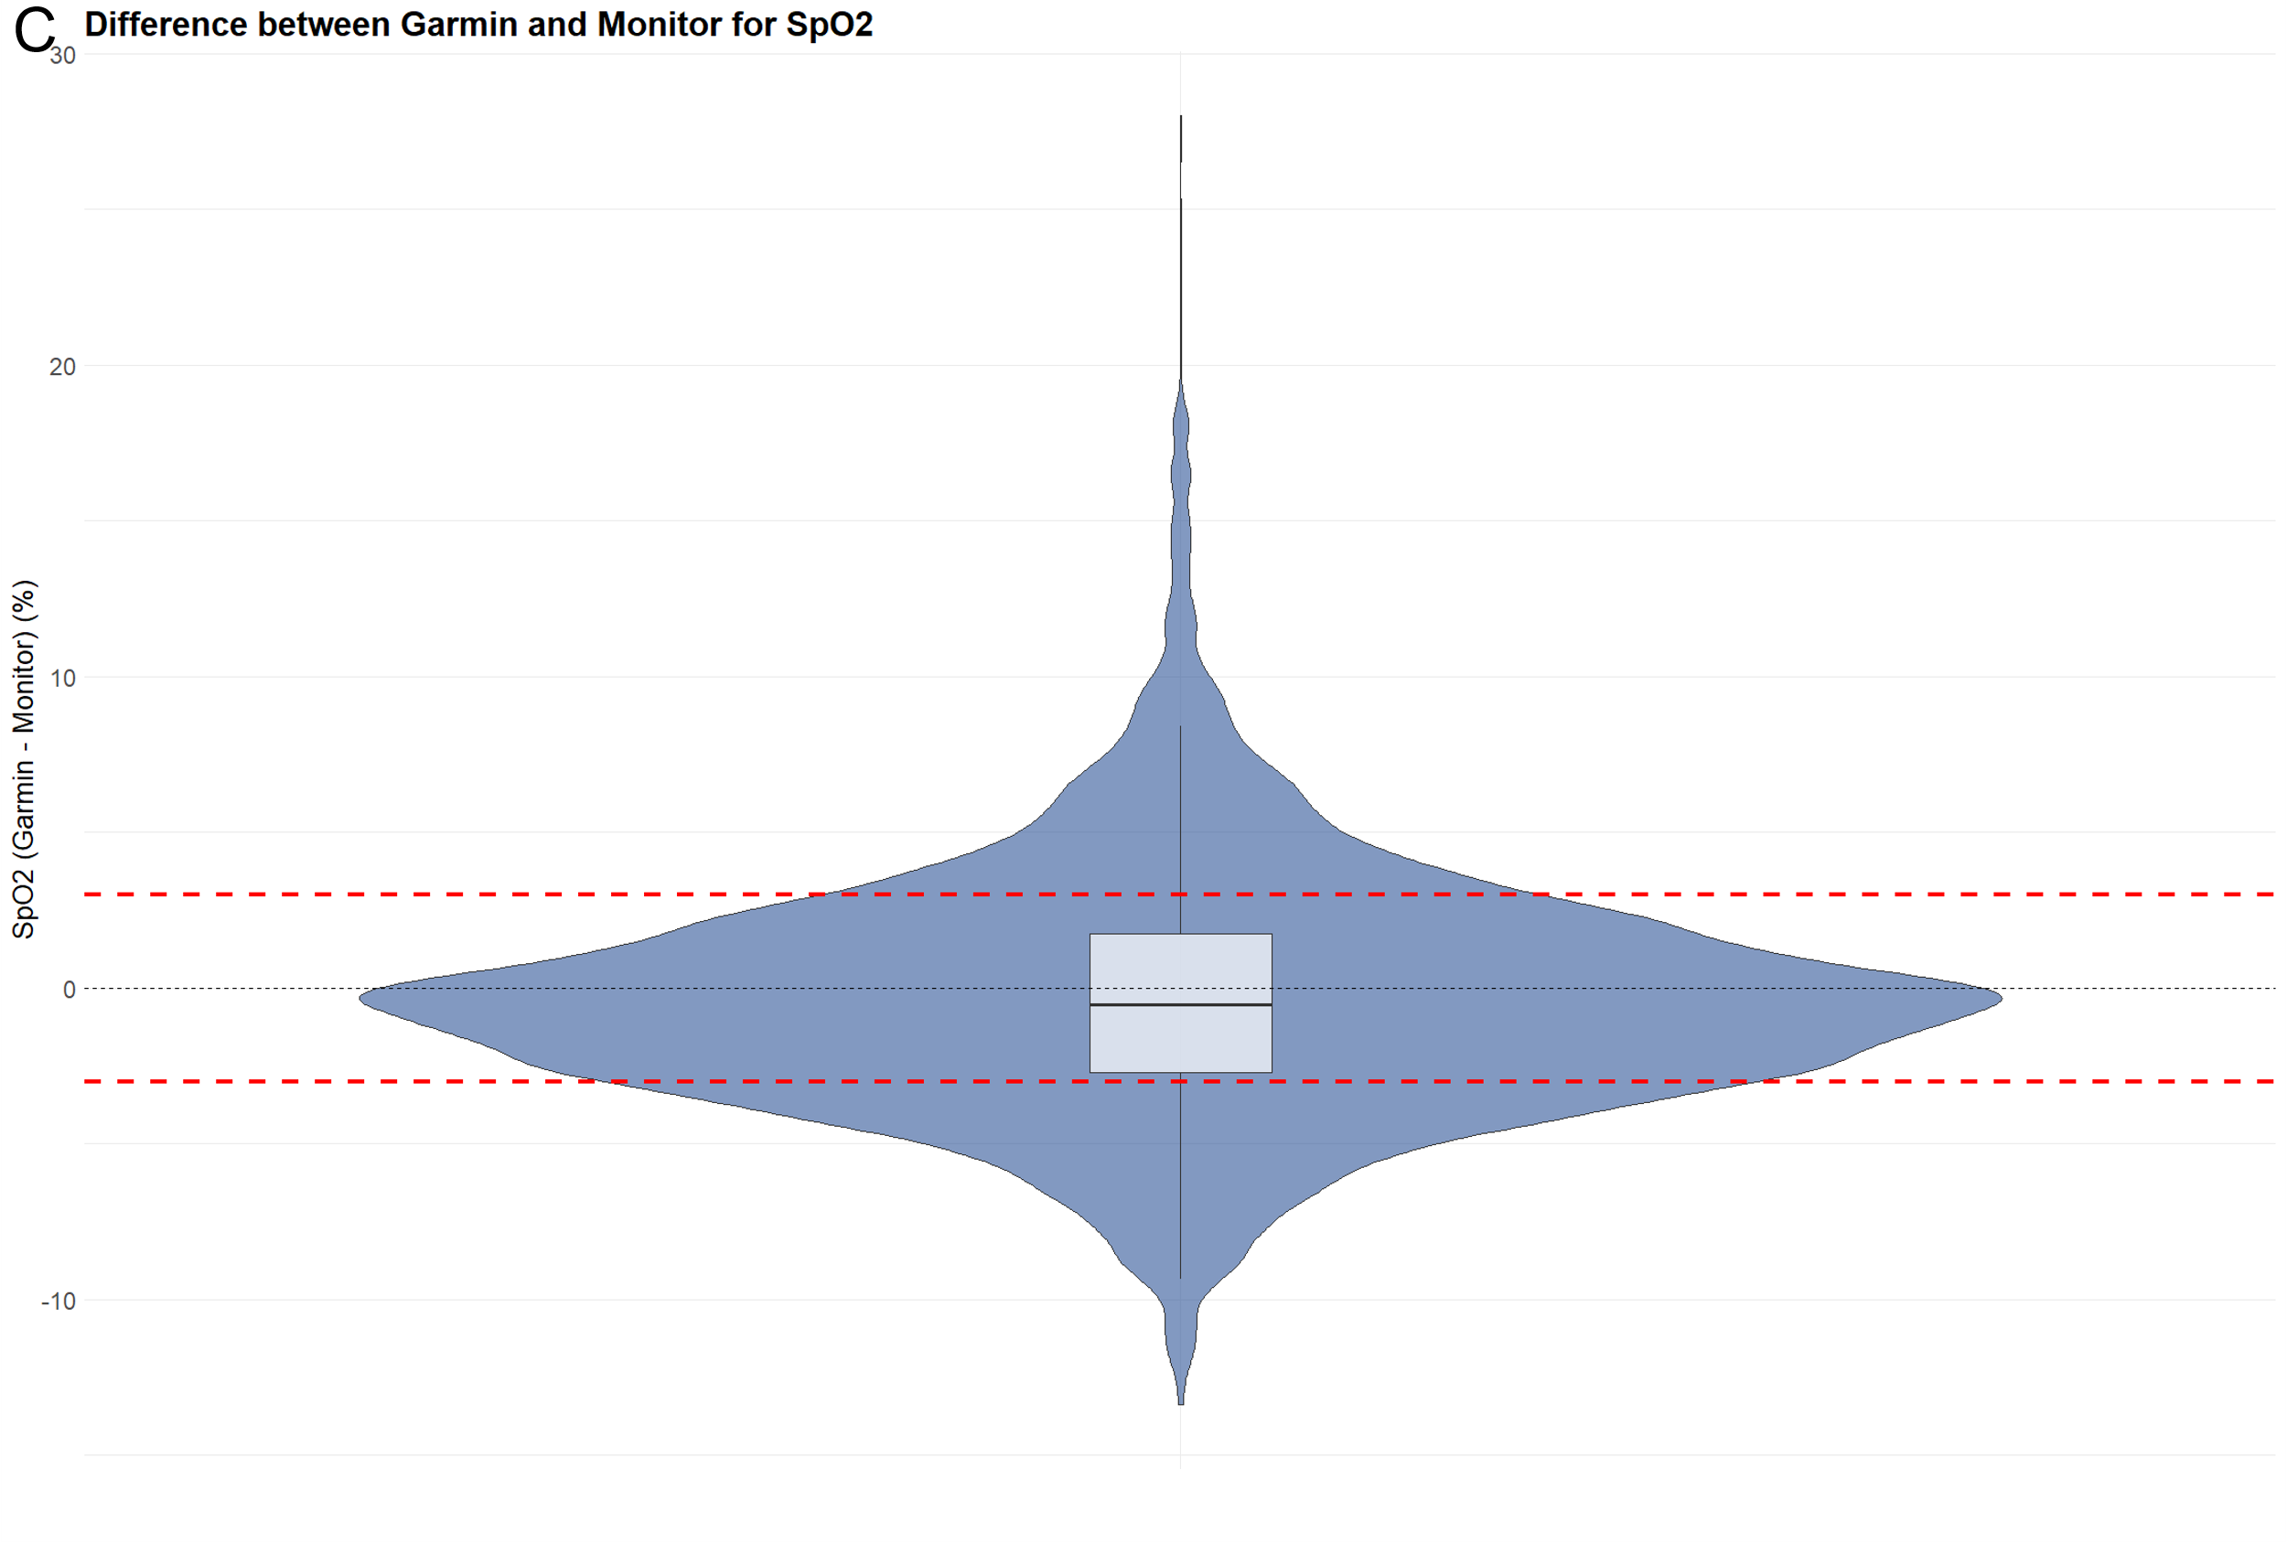
Supplemental Figure 2: Violin plots. The width of the plot represents the frequency of observations for the difference between the Garmin watch and the monitor. (A) Violin plot for HR. The red dashed line represents the ±5 bpm error margin. (B) Violin plot for RR. The red dashed line represents the ±3 breaths per minute error margin. (C) Violin plot for SpO₂. The red dashed line represents the ±3% error margin.

