Table S1: The list of Cheers 2022.
Section/topic | Item No | Guidance for reporting | Reported in section
Title | 1 | Identify the study as an economic  evaluation and specify the  interventions being compared | Page 1
Abstract | 2 | Provide a structured summary that  highlights context, key methods,  results, and alternative analyses | Page 2
Background and objectives | 3 | Give the context for the study, the  study question, and its practical relevance  for decision making in policy or practice. | Page 3-4
Methods
Health economic analysis plan | 4 | Indicate whether a health economic  analysis plan was developed and where available. | Not applicable
Study population | 5 | Describe characteristics of the  study population (such as age range,  demographics, socioeconomic, or clinical characteristics). | Page 5
Setting and location | 6 | Provide relevant contextual information  that may influence findings. | Page 5
Comparators | 7 | Describe the interventions or  strategies being compared and why chosen. | Page 5
Perspective | 8 | State the perspective(s) adopted  by the study and why chosen. | Page 5
Time horizon | 9 | State the time horizon for the  study and why appropriate. | Page 5
Discount rate | 10 | Report the discount rate(s) and  reason chosen. | Page 5
Selection of outcomes | 11 | Describe what outcomes were used  as the measure(s)of benefit(s) and harm(s). | Page 5
Measurement of outcomes | 12 | Describe how outcomes used to  capture benefit(s) and harm(s) were measured. | Page 5
Valuation of outcomes | 13 | Describe the population and methods  used to measure and value outcomes. | Page 5
Measurement and valuation  of resources and costs | 14 | Describe how costs were valued. | Page 6
Currency, price date, and Conversion | 15 | Report the dates of the estimated resource  quantities and unit costs, plus the currency  and year of conversion. | Page 6
Rationale and description of model | 16 | If modelling is used, describe in detail and  why used. Report if the model is publicly  available and where it can be accessed. | Page 5-6
Analytics and assumptions | 17 | Describe any methods for analysing or  statistically transforming data, any extrapolation  methods, and approaches for validating any model used. | Page 6
Characterizing Heterogeneity | 18 | Describe any methods used for estimating  how the results of the study vary for subgroups. | Page 6
Characterizing distributional effects | 19 | Describe how impacts are distributed across  different individuals or adjustments made  to reflect priority populations. | Not applicable
Characterizing uncertainty | 20 | Describe methods to characteristic any  sources of uncertainty in the analysis. | Not applicable
Approach to engagement with patients  and others affected by the study | 21 | Describe any approaches to engage patients  or service recipients, the general public,  communities, or stakeholders (such as clinicians  or payers) in the design of the study. | Not applicable
Results
Study parameters | 22 | Report all analytic inputs (such as values,  ranges, references) including uncertainty  or distributional assumptions. | Page 7
Summary of main Results | 23 | Report the mean values for the main categories  of costs and outcomes of interest and summarise  them in the most appropriate overall measure. | Page 7
Effect of uncertainty | 24 | Describe how uncertainty about analytic  judgments, inputs, or projections affect findings.  Report the effect of choice of discount  rate and time horizon, if applicable. | Page 7
Effect of engagement with patients  and others affected by the study | 25 | Report on any difference patient/service  recipient, general public, community, or  stakeholder involvement made to the  approach or findings of the study. | Not applicable
Discussion
Study findings, limitations,  generalizability, and current knowledge | 26 | Report key findings, limitations, ethical  or equity considerations not captured, and  how these could affect patients, policy, or practice. | Page 8-10
Other relevant information
Source of funding | 27 | Describe how the study was funded  and any role of the funder in the identification,  design, conduct, and reporting of the analysis. | Page 10
Conflicts of interest | 28 | Report authors conflicts of interest  according to journal or International Committee  of Medical Journal Editors requirements. | Page 10

Table S2: Parameters input to the model.
Name | Cost of per cycle ($) |  |  | Reference
Name | Mean | Min | Max | Reference
Ivonescimab (100mg) | 103.04 | 82.43 | 123.65 | estimate
Tislelizumab (100mg) | 175.49 | 140.39 | 210.59 | estimate
Paclitaxel (30mg) | 4.73 | 3.78 | 5.67 | estimate
Carboplatin (100mg) | 11.19 | 8.95 | 13.43 | estimate
Docetaxel (20mg) | 3.95 | 3.16 | 4.74 | estimate
Nivolumab (100mg) | 1294.99 | 1035.99 | 1553.99 | estimate
Pembrolizumab (100mg) | 2508.50 | 2006.80 | 3010.21 | estimate
Atezolizumab (1200mg) | 4591.97 | 3673.58 | 5510.37 | estimate
Afatinib (40mg) | 103.04 | 82.43 | 123.65 | estimate
Sacituzumab Tirumotecan (100mg) | 374.70 | 299.76 | 449.64 | estimate
Best supportive care | 352.69 | 282.15 | 423.23 | [1]
CT of the chest and abdomen | 168.00 | 134.40 | 201.60 | estimate
MRI | 140.00 | 112.00 | 168.00 | estimate
Bone scan | 49.00 | 39.20 | 58.80 | estimate
Laboratory | 70.00 | 56.00 | 84.00 | estimate
End of life | 8603.81 | 6883.05 | 10324.57 | [1]
Cost of Anaemia | 614.00 | 491.20 | 736.80 | [2]
Cost of Neutropenia | 749.79 | 599.83 | 899.75 | [3]
Cost of Leukopenia | 749.79 | 599.83 | 899.75 | [3]
Cost of Proteinuria | 531.97 | 425.58 | 638.36 | [1]
Anaemia of Ivonescimab | 7.14% | 5.71% | 8.57% | [4]
Neutropenia of Ivonescimab | 32.33% | 25.86% | 38.80% | [4]
Leukopenia of Ivonescimab | 10.90% | 8.72% | 13.08% | [4]
Proteinuria of Ivonescimab | 4.51% | 3.61% | 5.41% | [4]
Anaemia of Tislelizumab | 4.89% | 3.91% | 5.86% | [4]
Neutropenia of Tislelizumab | 25.94% | 20.75% | 31.13% | [4]
Leukopenia of Tislelizumab | 9.40% | 7.52% | 11.28% | [4]
Proteinuria of Tislelizumab | 0.00% | 0.00% | 0.00% | [4]
Subsequent treatment of Ivonescimab | 35.71% | 28.57% | 42.86% | [4]
Chemotherapy of Ivonescimab | 24.10% | 19.28% | 28.92% | [4]
Immunotherapy of Ivonescimab | 13.90% | 11.12% | 16.68% | [4]
Target therapy of Ivonescimab | 12.40% | 9.92% | 14.88% | [4]
Antibody-Drug Conjugate of Ivonescimab | 4.50% | 3.60% | 5.40% | [4]
Best supportive care of Ivonescimab | 45.10% | 36.08% | 54.12% | [4]
Subsequent treatment of Tislelizumab | 36.47% | 29.17% | 43.76% | [4]
Chemotherapy of Tislelizumab | 22.60% | 18.08% | 27.12% | [4]
Immunotherapy of Tislelizumab | 19.20% | 15.36% | 23.04% | [4]
Target therapy of Tislelizumab | 17.30% | 13.84% | 20.76% | [4]
Antibody-Drug Conjugate of Tislelizumab | 5.60% | 4.48% | 6.72% | [4]
Best supportive care of Ivonescimab | 45.10% | 36.08% | 54.12% | [4]
Utility of PFS | 0.88 | 0.70 | 1.05 | [5]
Utility of PD | 0.78 | 0.63 | 0.94 | [5]
Disutility of Anaemia | 0.19 | 0.15 | 0.23 | [6]
Disutility of Neutropenia | 0.20 | 0.16 | 0.24 | [7]
Disutility of Leukopenia | 0.20 | 0.16 | 0.24 | [7]
Disutility of Proteinuria | 0.05 | 0.04 | 0.06 | [1]
Discount rate | 4.50% | 0.00% | 5.00% | [8]
Body surface area | 1.68 | 1.34 | 2.02 | [9]
Patient weight | 65.00 | 52.00 | 78.00 | [9]

Table S3: The AIC and BIC for different survival distributions.
 | Exponential | Weibull | Gamma | Generalised gamma | Gompertz | Lognormal | Log-logistic
Over population | Ivo+Chemo-PFS
AIC | 776.93154 | 755.05912 | 758.50196 | 742.19389 | 748.83246 | 774.40590 | 764.15652
BIC | 780.51504 | 762.22611 | 765.66895 | 752.94438 | 755.99945 | 781.57289 | 771.32351
 | Ivo+Chemo-OS
AIC | 861.11020 | 862.78425 | 862.81191 | 864.68644 | 862.63593 | 866.87501 | 863.65023
BIC | 864.69370 | 869.95124 | 869.97891 | 875.43693 | 869.80293 | 874.04200 | 870.81722
 | Tis+Chemo-PFS
AIC | 890.63138 | 876.79099 | 872.40358 | 869.14720 | 890.11949 | 867.98223 | 863.12650
BIC | 894.21488 | 883.95798 | 879.57057 | 879.89769 | 897.28649 | 875.14922 | 870.29350
 | Tis+Chemo-OS
AIC | 1112.69034 | 1104.86159 | 1104.63364 | 1106.62994 | 1107.79785 | 1111.96001 | 1105.28533
BIC | 1116.27384 | 1112.02858 | 1111.80063 | 1117.38043 | 1114.96485 | 1119.12700 | 1112.45233
PD-L1 TPS<1% | Ivo+Chemo-PFS
AIC | 315.48030 | 311.07599 | 311.30020 | 313.07394 | 312.86021 | 315.29618 | 311.57595
BIC | 318.13426 | 316.38391 | 316.60812 | 321.03582 | 318.16813 | 320.60410 | 316.88387
 | Ivo+Chemo-OS
AIC | 374.32960 | 375.63995 | 375.67401 | 377.63478 | 375.96728 | 379.07100 | 375.69774
BIC | 376.98356 | 380.94787 | 380.98193 | 385.59666 | 381.27520 | 384.37892 | 381.00566
 | Tis+Chemo-PFS
AIC | 378.98724 | 365.79927 | 364.39978 | 366.27520 | 373.51069 | 367.76934 | 362.10377
BIC | 381.64120 | 371.10719 | 369.70770 | 374.23708 | 378.81861 | 373.07726 | 367.41169
 | Tis+Chemo-OS
AIC | 503.22752 | 500.73259 | 500.62383 | 502.62242 | 502.46640 | 505.88612 | 500.70252
BIC | 505.88148 | 506.04051 | 505.93175 | 510.58430 | 507.77432 | 511.19405 | 506.01044
PD-L1 TPS≥1% | Ivo+Chemo-PFS
AIC | 387.95899 | 384.52528 | 384.68161 | 386.49705 | 385.49890 | 387.73318 | 385.26359
BIC | 391.04039 | 390.68809 | 390.84442 | 395.74126 | 391.66171 | 393.89599 | 391.42640
 | Ivo+Chemo-OS
AIC | 448.27224 | 450.09785 | 450.08499 | 451.64975 | 450.27158 | 450.98808 | 450.57242
BIC | 451.35365 | 456.26066 | 456.24780 | 460.89396 | 456.43439 | 457.15089 | 456.73523
 | Tis+Chemo-PFS
AIC | 494.31961 | 487.74718 | 486.20556 | 487.11793 | 494.20371 | 486.84947 | 483.12545
BIC | 497.40101 | 493.90999 | 492.36837 | 496.36214 | 500.36652 | 493.01228 | 489.28826
 | Tis+Chemo-OS
AIC | 630.41889 | 625.99362 | 626.19467 | 626.91212 | 626.27267 | 630.77543 | 627.44453
BIC | 633.50029 | 632.15643 | 632.35748 | 636.15634 | 632.43548 | 636.93824 | 633.60734
PD-L1 TPS=1-49% | Ivo+Chemo-PFS
AIC | 312.63531 | 306.22722 | 307.09033 | 304.84032 | 305.04106 | 312.18044 | 308.88240
BIC | 315.35381 | 311.66421 | 312.52732 | 312.99582 | 310.47806 | 317.61744 | 314.31940
 | Ivo+Chemo-OS
AIC | 327.60937 | 329.02252 | 329.16094 | 329.48341 | 327.76474 | 327.51490 | 328.32136
BIC | 330.32787 | 334.45952 | 334.59793 | 337.63891 | 333.20173 | 332.95190 | 333.75836
 | Tis+Chemo-PFS
AIC | 331.47800 | 326.92179 | 324.63400 | 322.08818 | 332.70835 | 320.34314 | 320.72781
BIC | 334.07312 | 332.11203 | 329.82424 | 329.87354 | 337.89859 | 325.53337 | 325.91805
 | Tis+Chemo-OS
AIC | 419.06014 | 414.34527 | 414.00805 | 415.56104 | 416.09270 | 413.67972 | 414.60323
BIC | 421.65526 | 419.53551 | 419.19829 | 423.34640 | 421.28294 | 418.86996 | 419.79347
PD-L1 TPS≥50% | Ivo+Chemo-PFS
AIC | 154.34229 | 153.02240 | 153.60385 | 152.49309 | 151.28146 | 156.61455 | 154.89132
BIC | 156.23411 | 156.80604 | 157.38749 | 158.16856 | 155.06510 | 160.39819 | 158.67496
 | Ivo+Chemo-OS
AIC | 147.07386 | 149.06487 | 149.02988 | 150.12015 | 147.99192 | 150.72735 | 149.85830
BIC | 148.96568 | 152.84851 | 152.81352 | 155.79561 | 151.77557 | 154.51099 | 153.64194
 | Tis+Chemo-PFS
AIC | 161.46853 | 159.18097 | 159.51202 | 161.05555 | 159.57680 | 162.38791 | 160.08042
BIC | 163.59567 | 163.43524 | 163.76629 | 167.43695 | 163.83107 | 166.64218 | 164.33469
 | Tis+Chemo-OS
AIC | 197.02890 | 198.92044 | 198.93180 | 200.83732 | 198.87294 | 200.32440 | 199.12482
BIC | 199.15603 | 203.17471 | 203.18607 | 207.21872 | 203.12721 | 204.57867 | 203.37909
With Liver Metastasis | Ivo+Chemo-PFS
AIC | 87.58252 | 88.91556 | 88.57646 | 87.84381 | 89.58252 | 86.97283 | 87.81243
BIC | 88.91472 | 91.57997 | 91.24087 | 91.84042 | 92.24693 | 89.63724 | 90.47684
 | Ivo+Chemo-OS
AIC | 102.80967 | 104.79697 | 104.73478 | 98.44565 | 104.47544 | 102.84914 | 104.00498
BIC | 104.14187 | 107.46138 | 107.39919 | 102.44226 | 107.13985 | 105.51355 | 106.66939
 | Tis+Chemo-PFS
AIC | 151.63562 | 151.88018 | 151.47043 | 153.11897 | 153.41804 | 151.85896 | 150.54259
BIC | 153.44228 | 155.49351 | 155.08376 | 158.53896 | 157.03136 | 155.47229 | 154.15591
 | Tis+Chemo-OS
AIC | 204.68317 | 205.97933 | 206.01740 | 207.97246 | 206.11701 | 208.61754 | 206.45755
BIC | 206.48983 | 209.59266 | 209.63072 | 213.39245 | 209.73033 | 212.23087 | 210.07087
With Liver Metastasis | Ivo+Chemo-PFS
AIC | 681.34801 | 664.03429 | 667.63650 | 652.09597 | 655.77950 | 684.78616 | 673.05572
BIC | 684.82028 | 670.97883 | 674.58104 | 662.51278 | 662.72404 | 691.73070 | 680.00026
 | Ivo+Chemo-OS
AIC | 742.44823 | 744.43762 | 744.44720 | 745.83551 | 744.18335 | 749.87296 | 745.63564
BIC | 745.92050 | 751.38216 | 751.39174 | 756.25232 | 751.12790 | 756.81750 | 752.58019
 | Tis+Chemo-PFS
AIC | 743.39752 | 733.75947 | 729.44064 | 724.39608 | 744.53668 | 722.52962 | 719.67478
BIC | 746.79569 | 740.55579 | 736.23696 | 734.59057 | 751.33301 | 729.32594 | 726.47110
 | Tis+Chemo-OS
AIC | 890.12672 | 884.32218 | 884.22413 | 886.21999 | 886.49198 | 891.49005 | 884.67414
BIC | 893.52488 | 891.11850 | 891.02045 | 896.41447 | 893.28830 | 898.28637 | 891.47046
Ivo+Chemo: ivonescimab plus chemotherapy; Tis+Chemo: tislelizumab plus chemotherapy; PFS: progression-free survival; OS: overall survival; AIC: Akaike Information Criteria; BIC: Bayesian Information Criteria

Figure S1: One-way sensitivity analysis in different subgroups
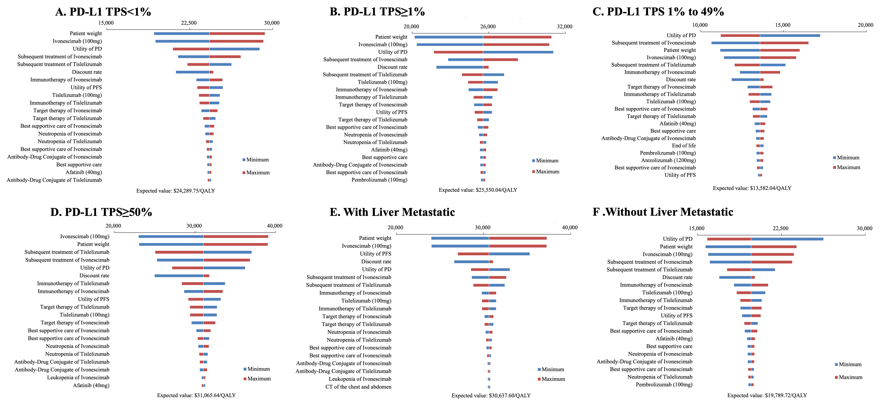

Figure S2: Probabilistic sensitivity analysis in different subgroups. Incremental cost and incremental effect incurred by 10,000 probabilistic resampling
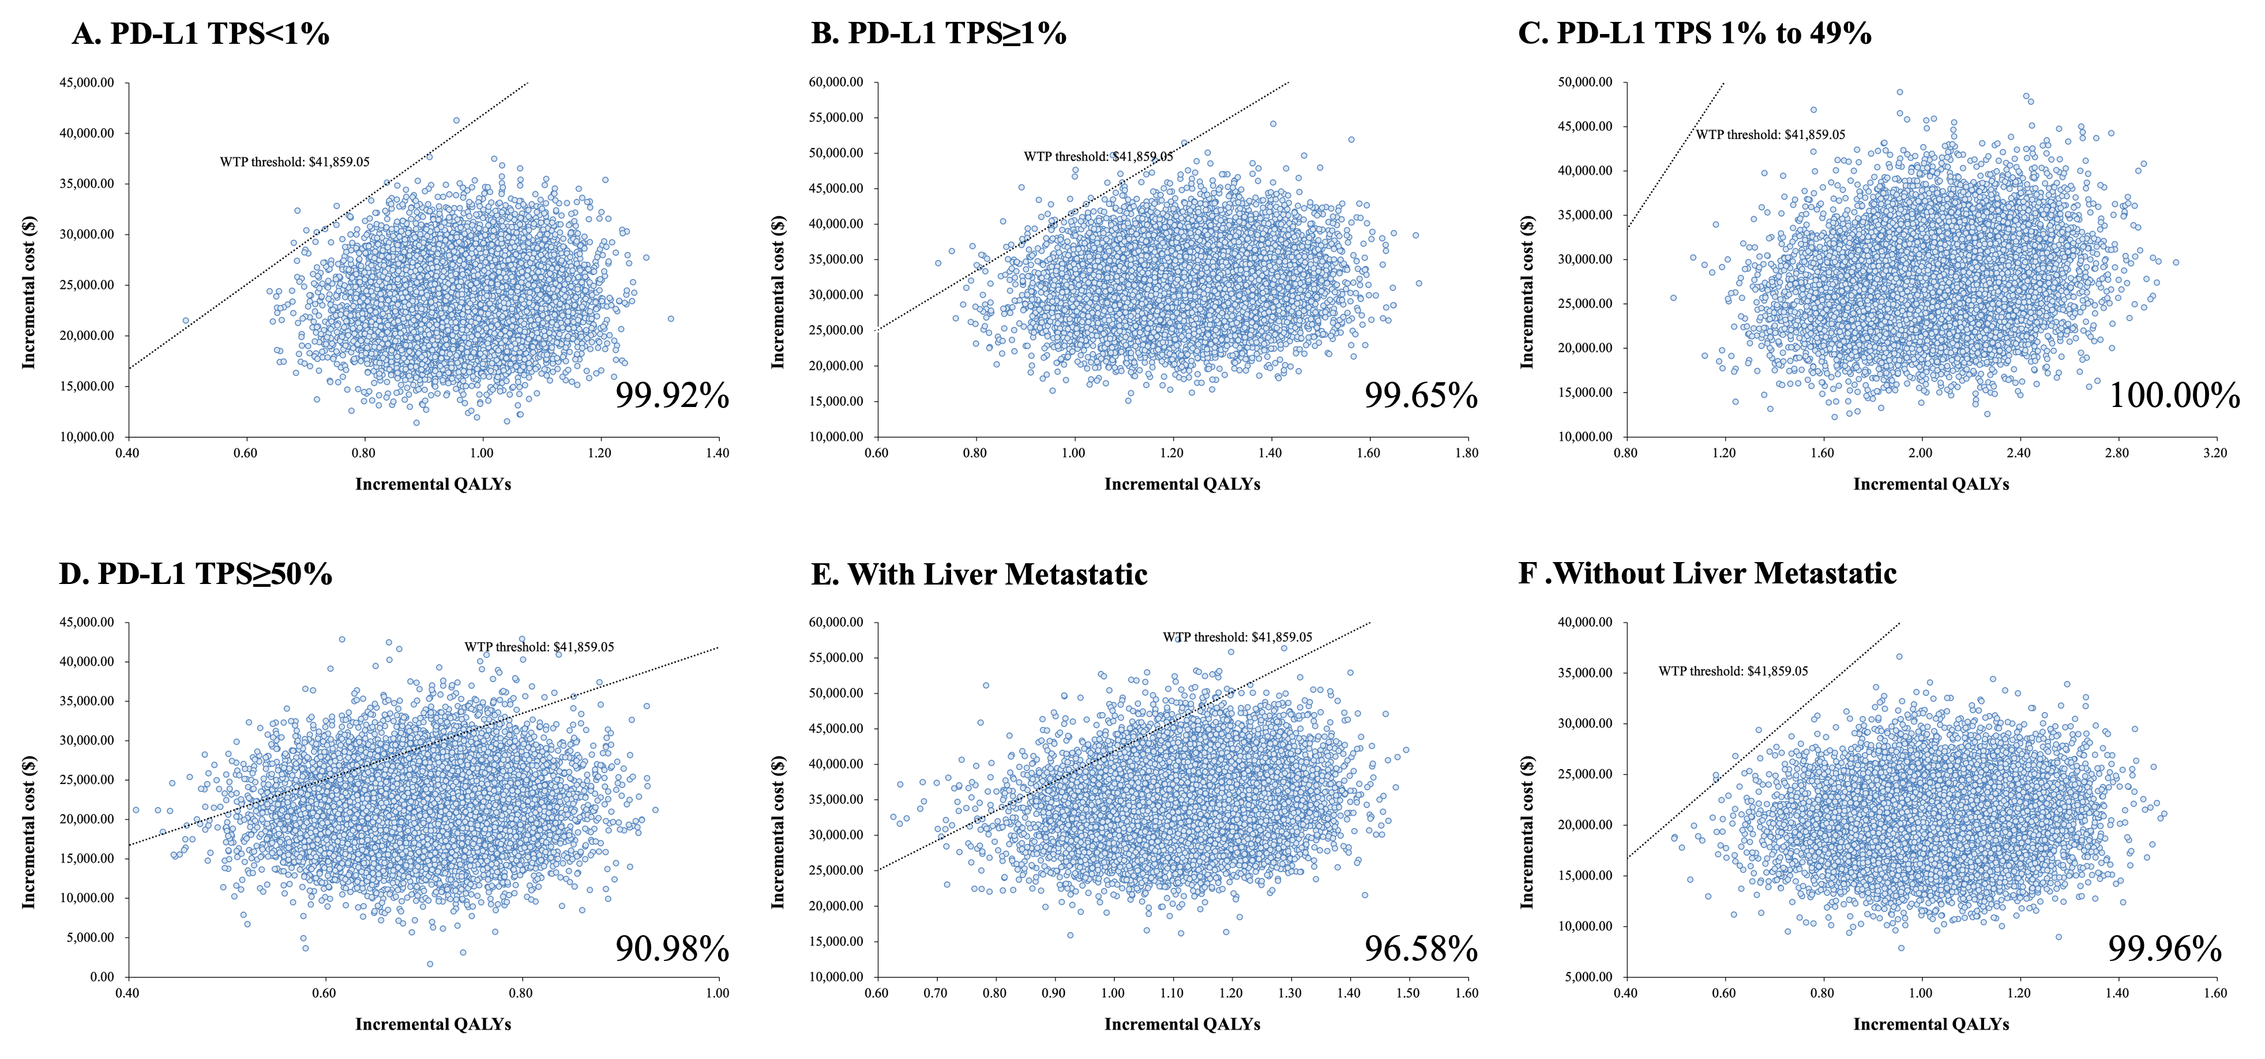

Figure S3: Probability of cost-effectiveness in different groups at varying WTP thresholds.
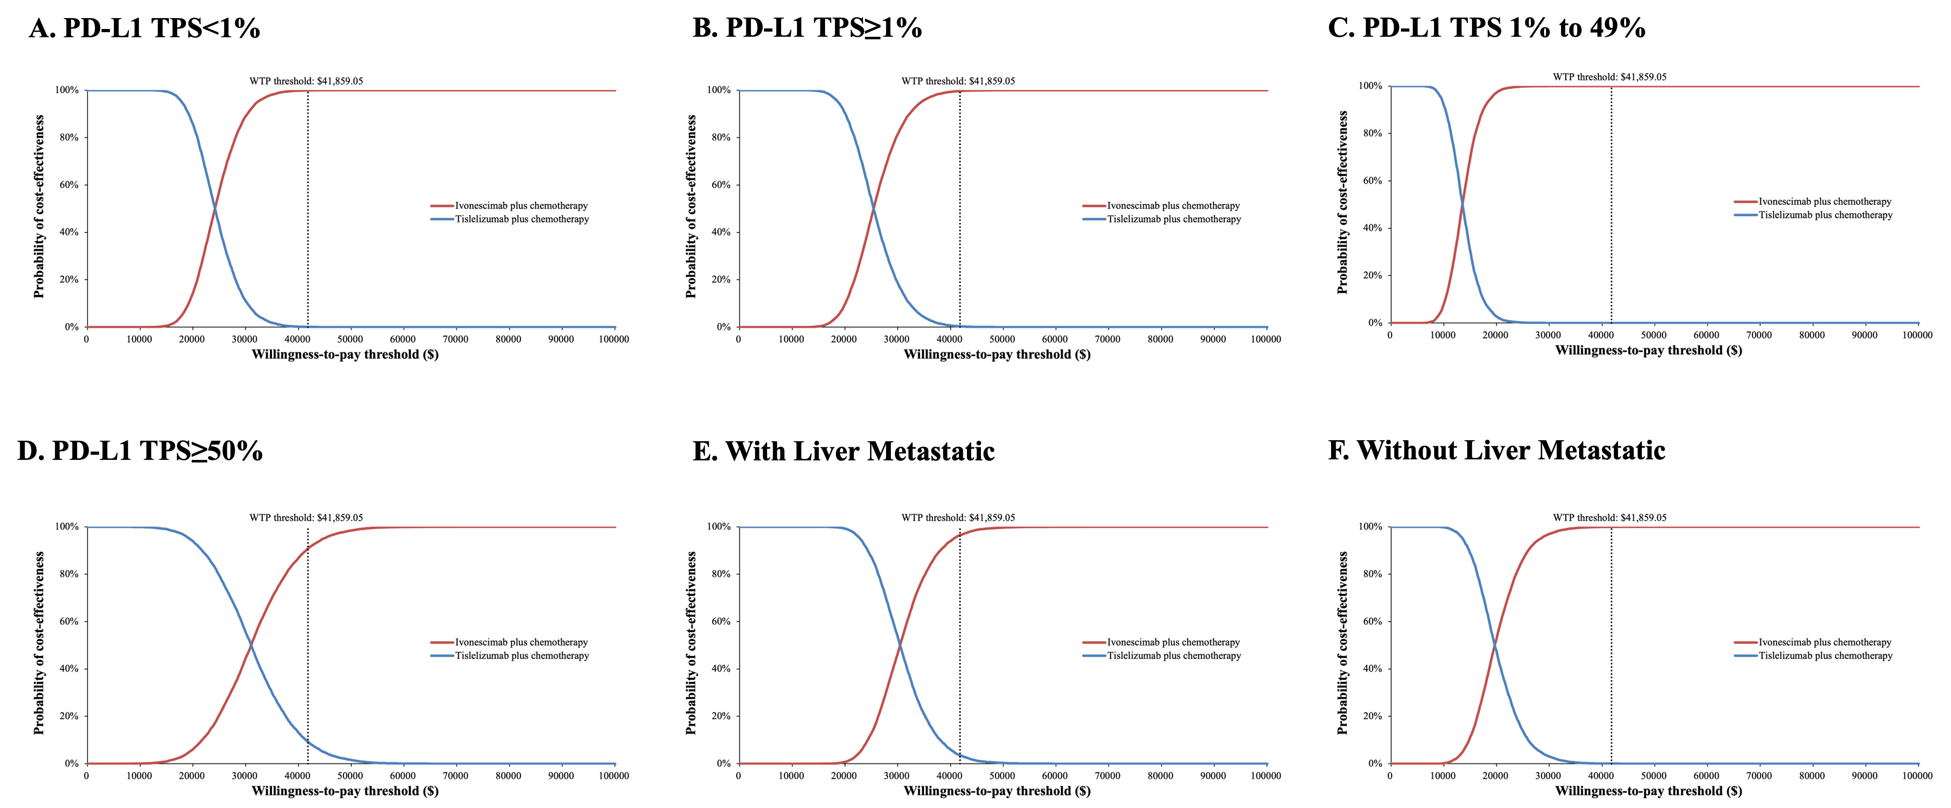
WTP: willingness to pay.

Figure S4: The individual patient data and various survival distributions (OS).
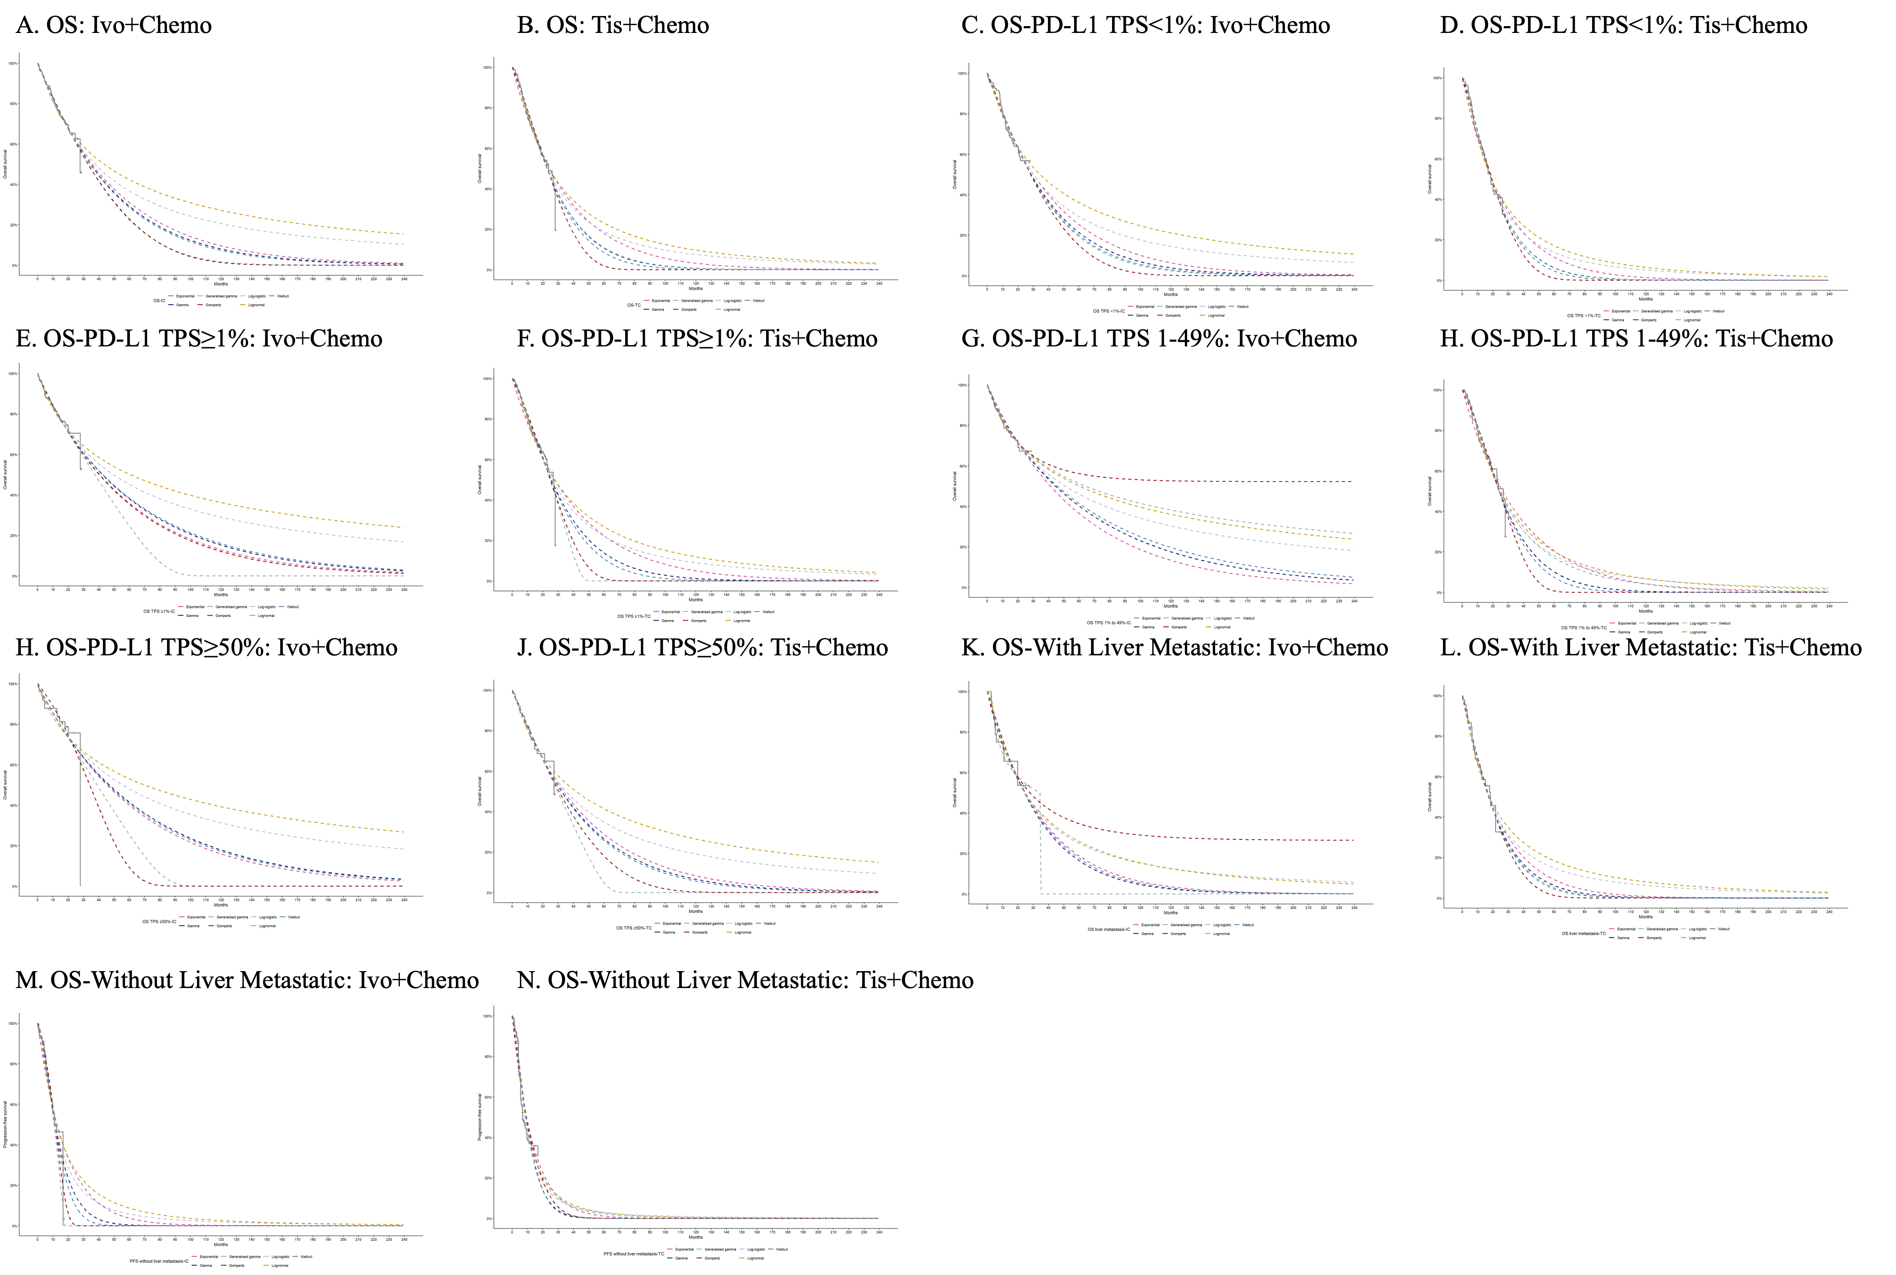
Figure S5: The individual patient data and various survival distributions (PFS).
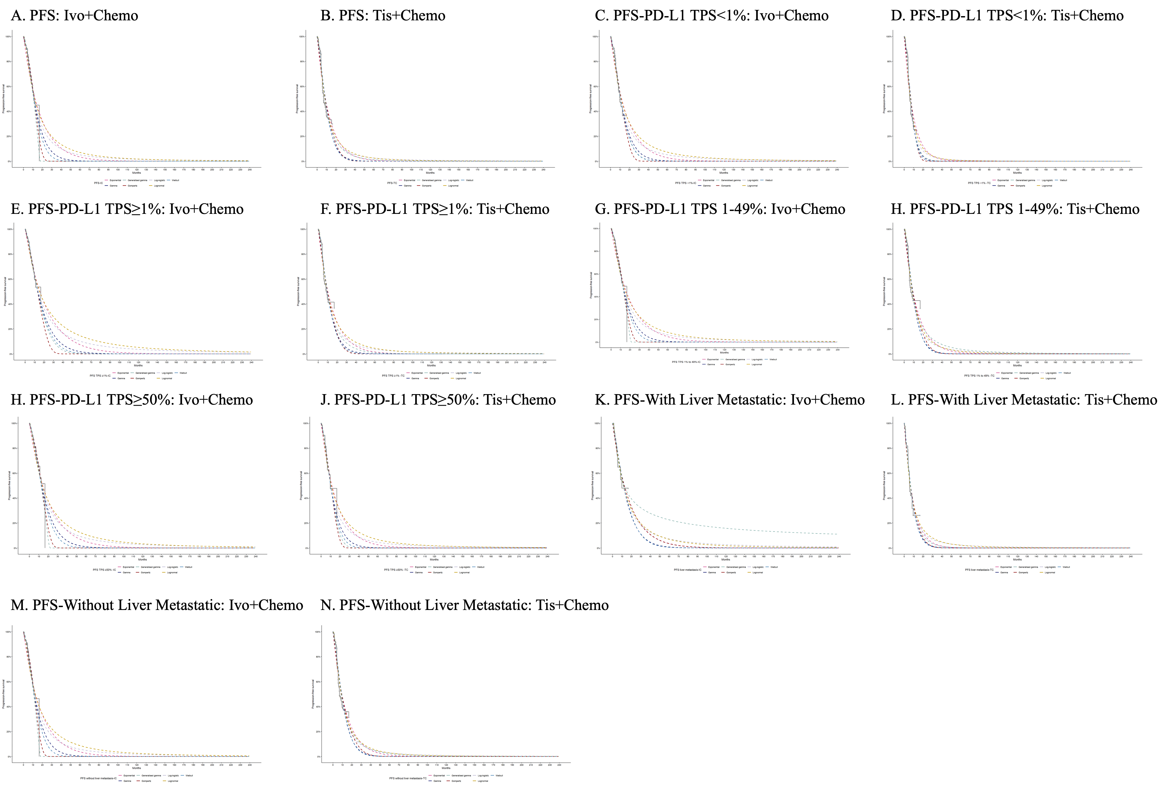
Ivo+Chemo: ivonescimab plus chemotherapy; Tis+Chemo: Tislelizumab plus chemotherapy; PFS: progression-free survival; OS: overall survival.

Reference:
1. Wu, Q., Q. Li, and Y. Qin, A cost-effectiveness analysis of amivantamab plus lazertinib versus osimertinib in the treatment of US and Chinese patients with EGFR-mutated advanced non-small cell lung cancer. Lung Cancer (Amsterdam, Netherlands), 2025. 203: p. 108533.
2. Shu, Y., et al., Cost-effectiveness of osimertinib versus standard EGFR-TKI as first-line treatment for EGFR-mutated advanced non-small-cell lung cancer in China. Frontiers In Pharmacology, 2022. 13: p. 920479.
3. Zhang, C., et al., Cost-effectiveness evaluation based on two models of first-line atezolizumab monotherapy and chemotherapy for advanced non-small cell lung cancer with high-PDL1 expression. Frontiers In Oncology, 2023. 13: p. 1093469.
4. Lu, S., et al., Ivonescimab plus chemotherapy versus tislelizumab plus chemotherapy in advanced squamous non-small-cell lung cancer (HARMONi-6): interim overall survival analysis of a randomised, double-blind, phase 3 trial in China. Lancet (London, England), 2026.
5. Shen, Y., et al., Health state utilities in patients with advanced non-small-cell lung cancer in China. Journal of Comparative Effectiveness Research, 2018. 7(5): p. 443–452.
6. Liu, S., et al., Cost-effectiveness of antibody-drug conjugates in previously treated metastatic triple-negative breast cancer in China. Health Economics Review, 2025. 15(1): p. 105.
7. Nafees, B., et al., Health state utilities in non-small cell lung cancer: An international study. Asia-Pacific Journal of Clinical Oncology, 2016. 13(5): p. e195–e203.
8. Evaluations, C.G.f.P., China Guidelines for Pharmacoeconomic Evaluations Chinese-English Version 2025.
9. Rui, M. and H. Li, Cost-effectiveness of Osimertinib vs Docetaxel-bevacizumab in Third-line Treatment in EGFR T790M Resistance Mutation Advanced Non-Small Cell Lung Cancer in China. Clinical Therapeutics, 2020. 42(11).

