Idiopathic Toe Walking Treatment Outcome
Proforma (ITW-TOP)

Parent reported measures – (Parent / carer to fill in the following questions as appropriate)

- Estimate how much time has your child spent toe walking in the last…
Day or week? (Please circle day or week and mark an X on the line)

___________________________________________________
0% 10% 20% 30% 40% 50% 60% 70% 80% 90% 100%

- How satisfied are you with this amount of toe walking? (Please mark and X on the line)

__________________________________________________
0 1 2 3 4 5 6 7 8 9 10

Totally dissatisfied Neither satisfied nor dissatisfied Totally satisfied

- How well you have been able to follow the treatment since last visit? (Please mark on the line and if more than one treatment, please mark an X and write which treatment and repeat for all treatments)

___________________________________________________
0% 10% 20% 30% 40% 50% 60% 70% 80% 90% 100%
Unable to follow at all Able to follow ½ the time Able to follow all the time

- Pain today (Mark a T on appropriate scale): Child response
Ask the child ‘What is the worst pain you get in your legs today?’

Pain on activity (Mark an A on appropriate scale): Child response
Ask the child ‘What is the worst pain you get when moving about in the last week?’
Clinician to note:
Pick either Face or VAS depending on child’s age / ability.

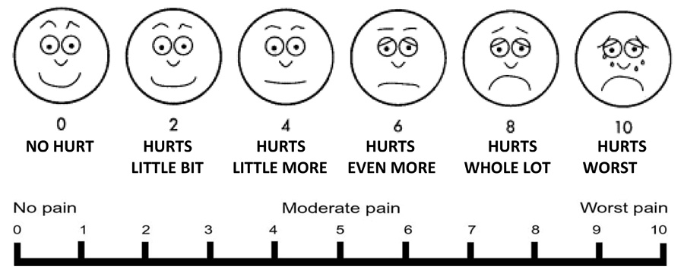

________________________________________________________________
Assessments
Ankle range of motion
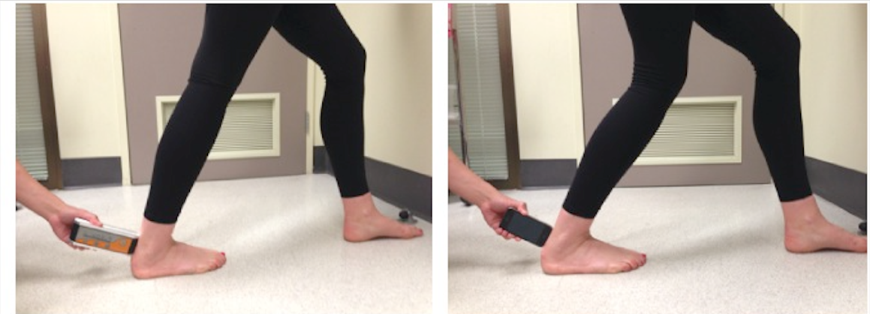
Measure range of motion either with weight bearing lunge (using digital inclinometer or measurement app) or non-weightbearing if clinically appropriate:
Reprinted from Journal of Science and Medicine in Sport, Vol 16, Iss 5, Williams C.M, et al, The TiltMeter app is a novel and accurate measurement tool for the weight bearing lunge test, Pages 392-395., Copyright (2013), with permission from Elsevier.
Circle method: | Left | Right | Circle method: | Left | Right
WBL/NWB - knee straight |  |  | WBL/NWB knee bent

Gait scale (Clinician may demonstrate as appropriate)
Ask the child ‘Can you try to walk on your heels for 10 steps with your feet in a typical distance apart and trying not to change your body position?’
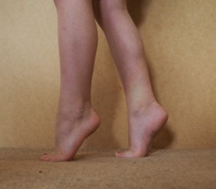 |  |  |  | 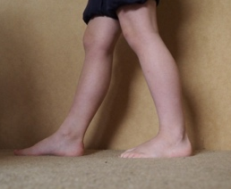 | 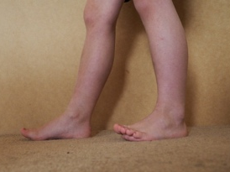 | 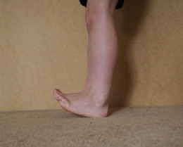
0 – Unable to get heels or midfoot to the ground | 1 - Unable to get heels to ground. Midfoot strike present. |  | 2. Able to get heels to ground. Unable to walk 10 steps with great toe dorsiflexed |  | 3. Able to get heels to ground and walk 10 steps with great toe dorsiflexed. However, plantar surface of forefoot remains on ground. | 4. Able to get heels to ground and walk 10 steps with the plantar surface of the forefoot off the ground.

Gait velocity (as appropriate)
6 MWT:
Time: 2 min (min/sec):______ Time: 4 min (min/sec):_____ Time: 6 min (min/sec):_____
Total time(min/sec):________

