Appendix Figures
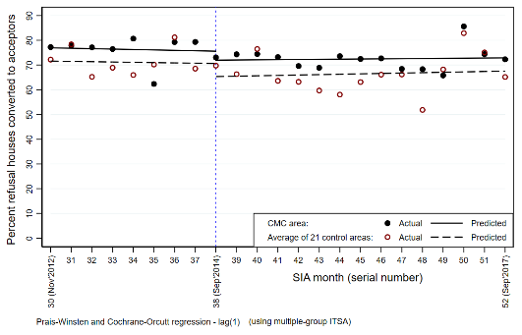
E. Refusal-to-Acceptor conversion rate of SIAs
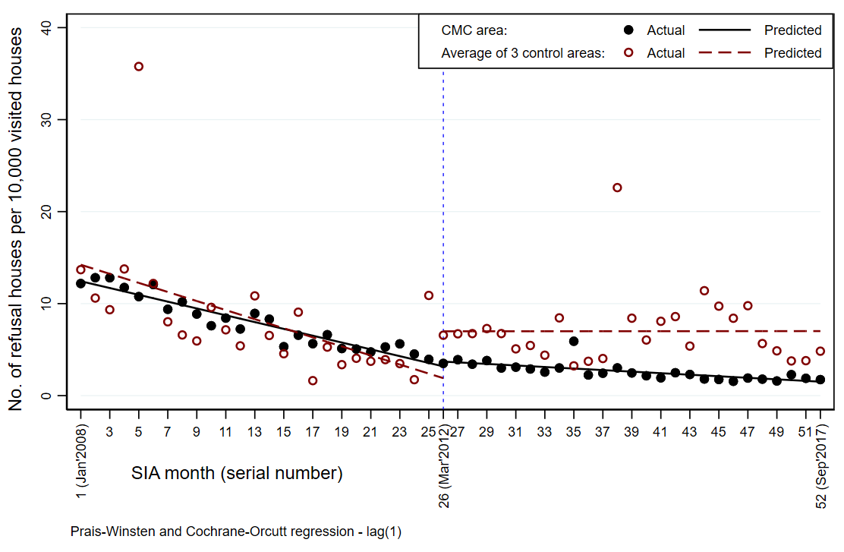
F. Refusal rate at the end of SIAs
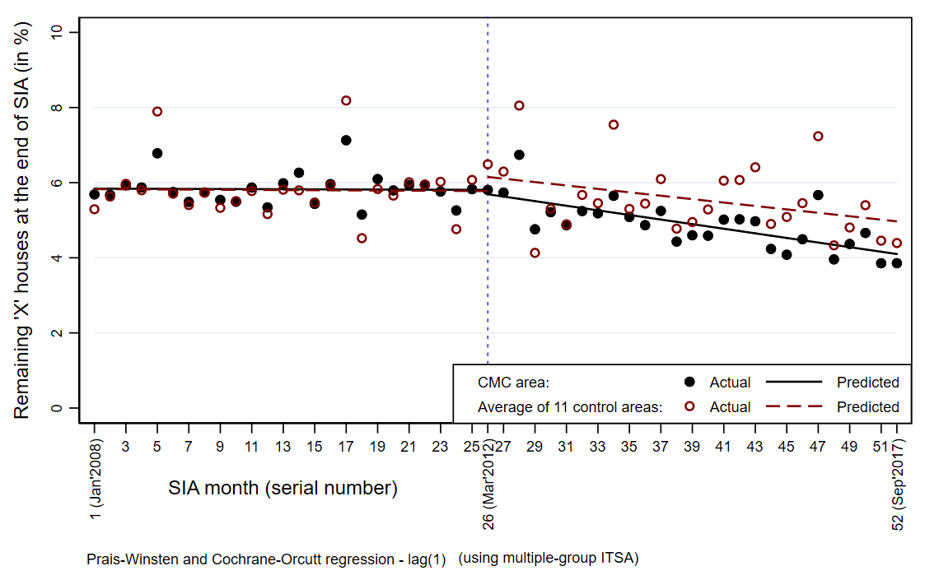
D. Rate of remaining ‘X’ houses at the end of SIAs
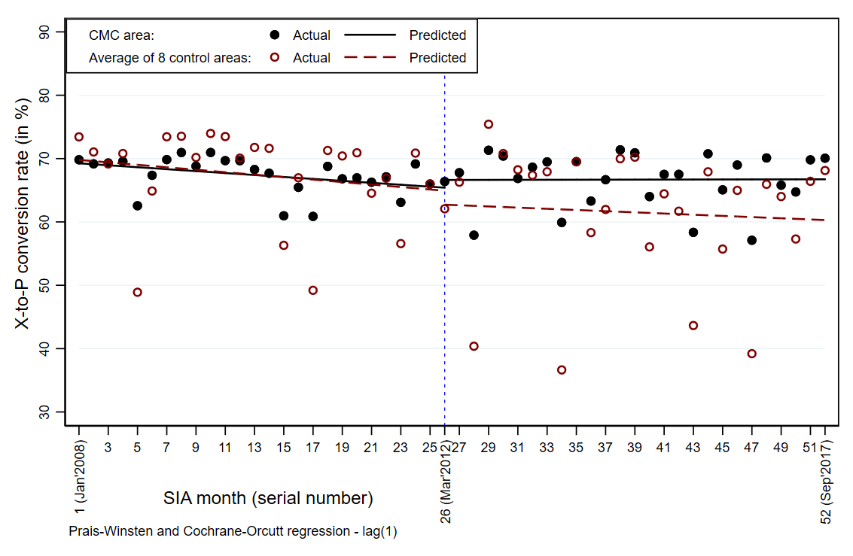
C. X-to-P conversion rate
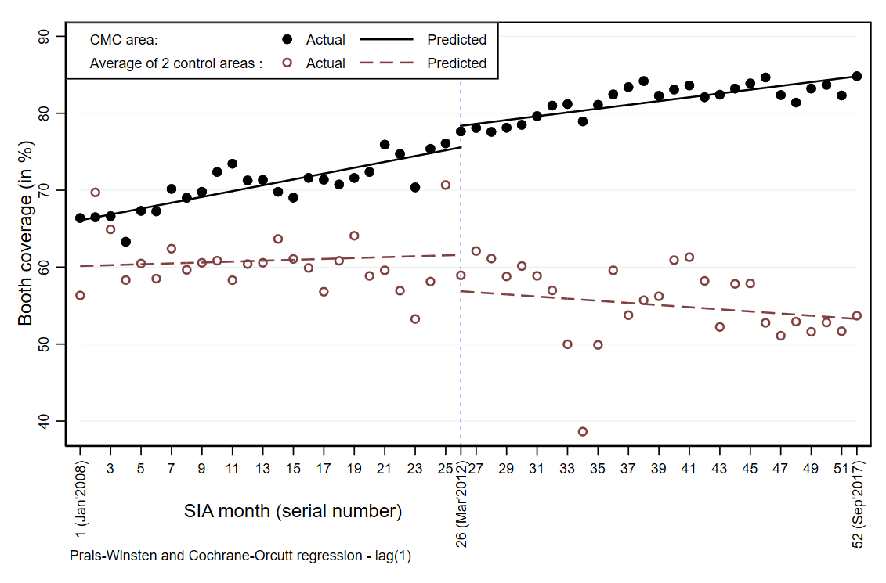
B. Booth coverage
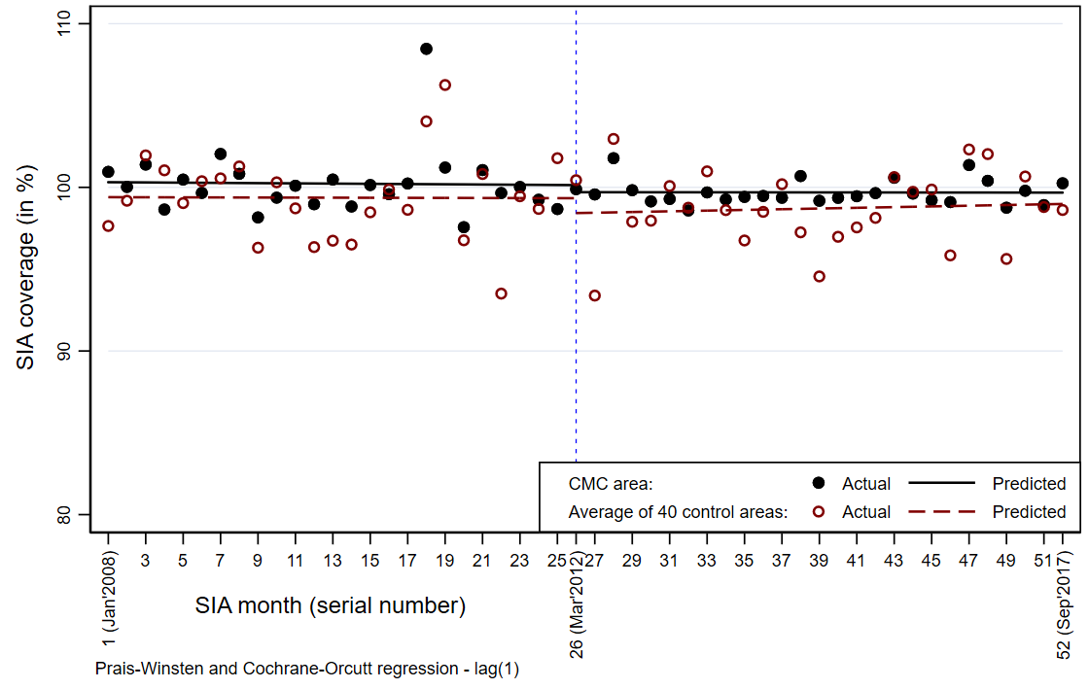
A. SIA coverage

Appendix Figure 1. Trends in actual and predicted values of seven indicators of intervention and selected non-intervention area, using two-group interrupted time-series analysis. the vertical broken blue line divides the entire study period into two periods, i.e. 1) polio-endemic period and 2) post-polio-endemic period. Each circle represents the mean value for an indicator. The Black circles and black line represent intervention areas and brown hallow circles and broken brown line represent non-intervention areas.

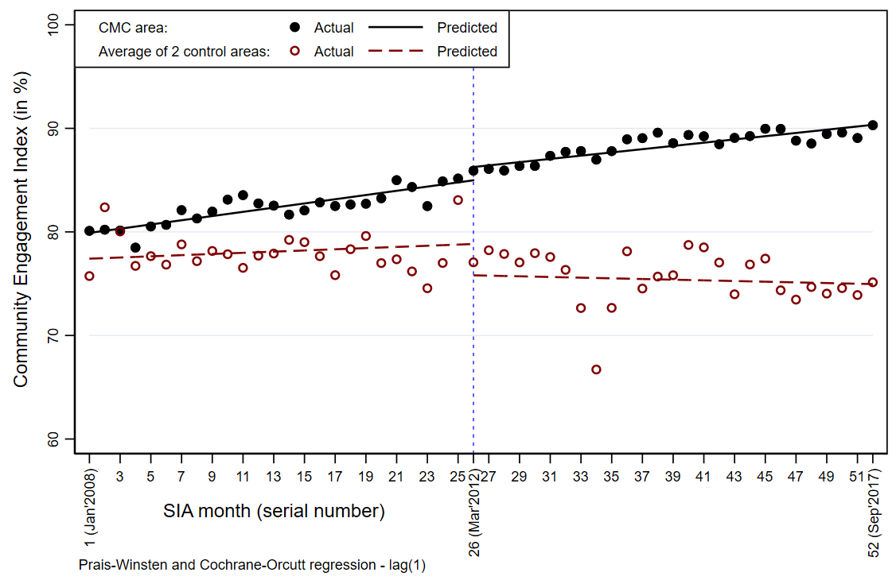
G. Community Engagement Index of SIAs

