Supplemental Material
Baseline WT1-specific immunity and immune responses to WT1-targeted immunotherapy in pediatric patients with malignant solid tumors at high risk for relapse: results from a biomarker-driven multicenter translational phase II clinical trial

Table of Contents
Eligibility criteria 2
Exclusion criteria 3
Ethical principles, referral and selection biases 3
Procedures (injection sites) 4
Efficacy assessments 4
Landmark analyses 4
Safety assessments 5
Fig. 1 6
Fig. 2 7
Fig. 3 8
Fig. 4 9
Fig. 5 10
Supplement References 11

Eligibility criteria
The eligibility criteria for RMS as defined by the Japan Rhabdomyosarcoma Study Group [JRSG]¹are as follows: pediatric patients with RMS of alveolar type (ARMS) in the high-risk group who had 1) a grade III tumor excepting the favorable sites or 2) a grade IV tumor; and pediatric patients with RMS of embryonal type (ERMS, the intermediate-risk group including the primary disease in the extremities) who had 1) a tumor in the limbs as the primary site, 2) age ≥10 years or <1 year, 3) tumor diameter ≥5 cm at onset, 4) a tumor infiltrates in the regional lymph nodes, and 5) a tumor remained pathologically or was categorized to PR or better on imaging studies after surgery. In addition, the eligibility criteria were recurrence/progression and a residual tumor after surgery (remained pathologically or was categorized to PR or better on imaging studies after surgery) for osteosarcoma and soft tissue sarcomas other than RMS and were metastatic disease for NB with no regard to metastatic disease. Conserved functions of major organs; grade ≤I according to the Common Terminology Criteria for Adverse Events (CTCAE) version 3.0 (however, the following grade ≤III hematologic toxicities were permitted: hematology—≥500/mm³ in neutrophil count, ≥6.5 g/dL in hemoglobin concentration, and ≥10,000/mm³ in platelet count; and ≥5 days after the final blood transfusion.

Exclusion criteria
A patient was excluded when falling under any of the following exclusion criteria: myelodysplastic syndrome defined by the World Health Organization² (however, complete chimera or stable mixed chimera after allo-HSCT were accepted); poorly controlled infections; serious complications (e.g., congestive heart failure and hepatic failure), and ineligibility determined by the investigator or subinvestigator

Ethical principles, as well as countermeasures for referral and selection biases
The studies were conducted in accordance with the ethical principles of the Declaration of Helsinki, the International Council Harmonised Tripartite Guideline for Good Clinical Practice, and the local IRB regulations. The IRBs reviewed and approved the protocol, investigator’s brochure, informed consent form, and other study-related documents. Referral and selection biases, as well as data missing were checked and minimized by the Data Management Committee at each medical institution. Pediatric patients, about whom recurrence/progression was not confirmed on imaging studies and who survived thereafter, were censored as of the final confirmation date of survival, while pediatric patients who became lost to follow up were censored as of the newest date of medical examination on the outpatient setting prior to turning lost to follow up.

Procedures (injection sites)
The single 0.5-mg dose was injected at 2 sites of the body (i.e., lateral peripheries of the axillary and inguinal lymph nodes). The single 1-mg dose was desirably injected at 4 different sites (right and left shoulders and thighs in consideration of regional lymph nodes) to expect its higher effects.

Efficacy assessments
The verification day of CR/PR on the first imaging studies within 21 days after the completion of conventional treatments was established as the initial day to examine the effects of the primary and secondary endpoints. Clinical responders were pediatric patients exhibiting clinical response defined as no disease progression on imaging studies until 12 months after the start day of vaccination. In contrast, clinical nonresponders showed disease progression in the relevant timespan.

Landmark analyses
Landmark analyses were made to test the impact of immunological variables (i.e., WT1-specific CTL frequency, and DTH) at week 11 on patient survival thereafter to investigate whether immune responses (WT1-specific CTL frequency and DTH) affect patient prognosis.

Safety assessments
Pediatric patients were assessed at the time of every injection for the safety of the vaccination through the following endpoints: general condition including height, body weight, body surface area, performance status, body temperature, blood pressure, pulse rate, and physical findings; peripheral blood (PB) counts including white blood cell count, differential white blood cell counts, platelet count, and hemoglobin concentration; blood chemistry including Na, K, blood urea nitrogen, creatinine, aspartate transaminase, alanine transaminase, total bilirubin concentration, differential bilirubin, total protein, albumin, and C-reactive protein; and TEAEs including date of occurrence, verification date of disappearance/continuation, causality, and reason to deny causality.

Figure 1. WT1-specific CTL frequency in 3 clinical responders (A) and 3 clinical nonresponders (B)

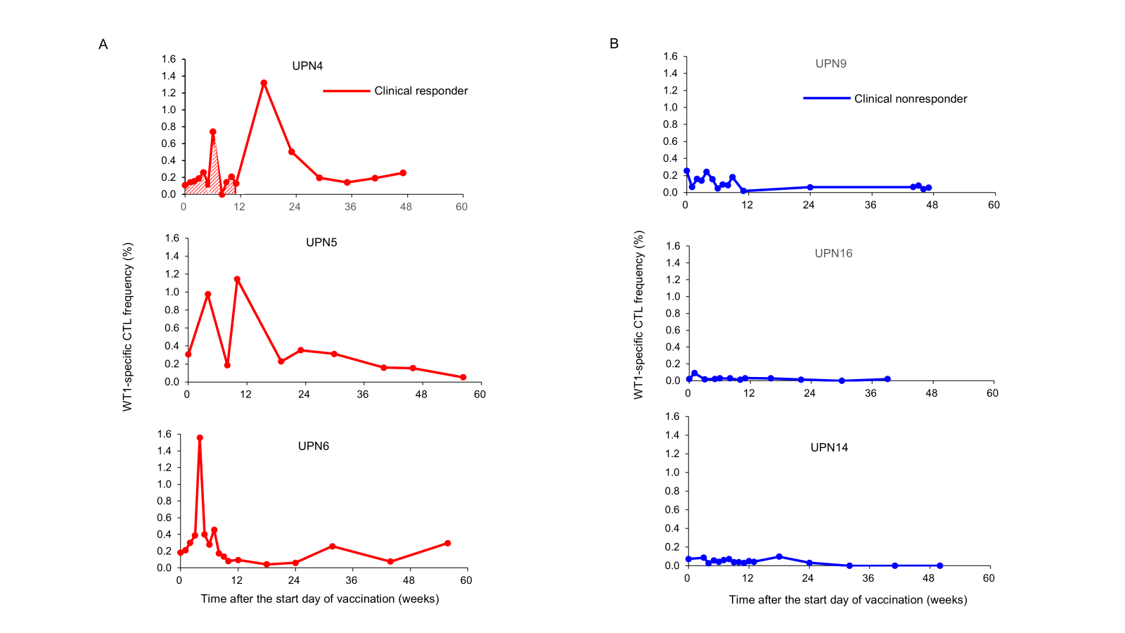
Shaded area, the area under the curve, is representatively depicted in UPN4.
WT1, Wilms tumor gene 1; CTL, cytotoxic lymphocyte; UPN, unique patient number.

Figure 2. Kaplan-Meier curves* of PFS (A) and OS (B) in DTH-positive and -negative
patients among patients who were evaluable for DTH at week 11 after the
start of vaccination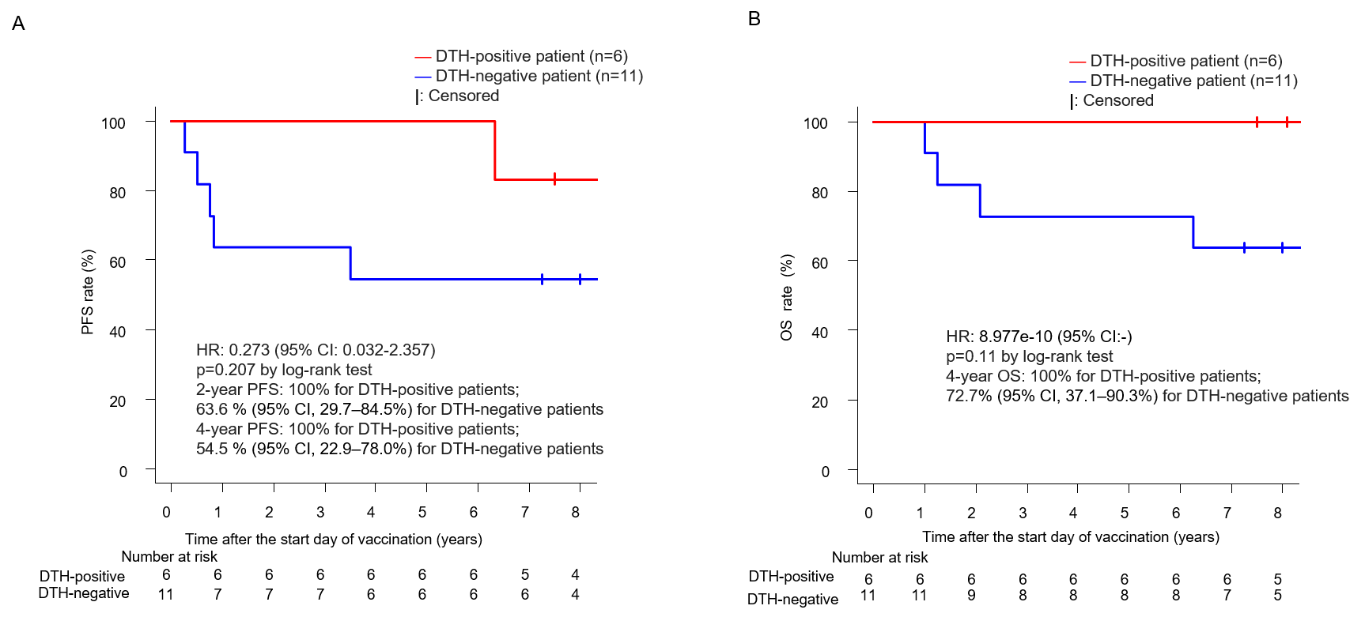
*: Drawn according to the Kaplan-Meier method including the landmark analysis at week 11 after the
start of vaccination
DTH, delayed-type hypersensitivity; PFS, progression-free survival; OS, overall survival; CI, confidence interval.

Figure 3. Typical time-course changes in anti-WT1₂₃₅ IgM- and IgG antibody titers (absorbance) among clinical responders (n=14) and nonresponders (n=7):
3 representative pediatric patients each of clinical responders (A) and
Nonresponders (B)

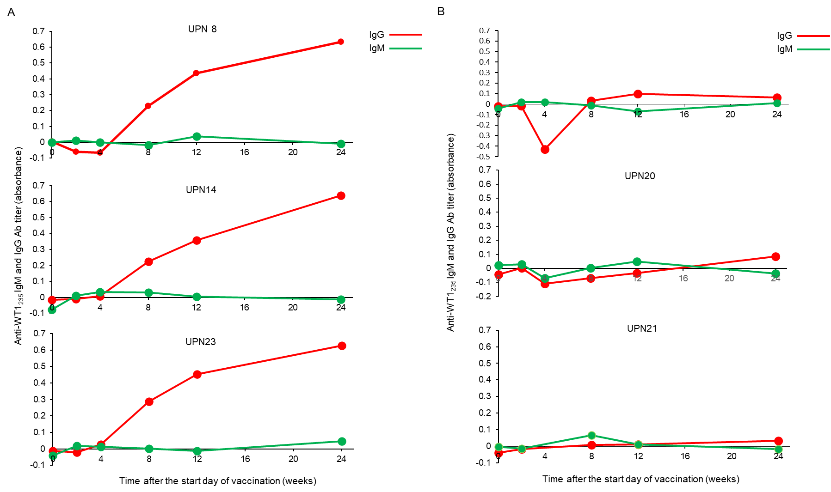
UPN, unique patient number; Ig, immunoglobulin.
Figure 4. The 2-year PFS and 4-year OS rates for all patients with RMS (A,B) or NB
(C,D)

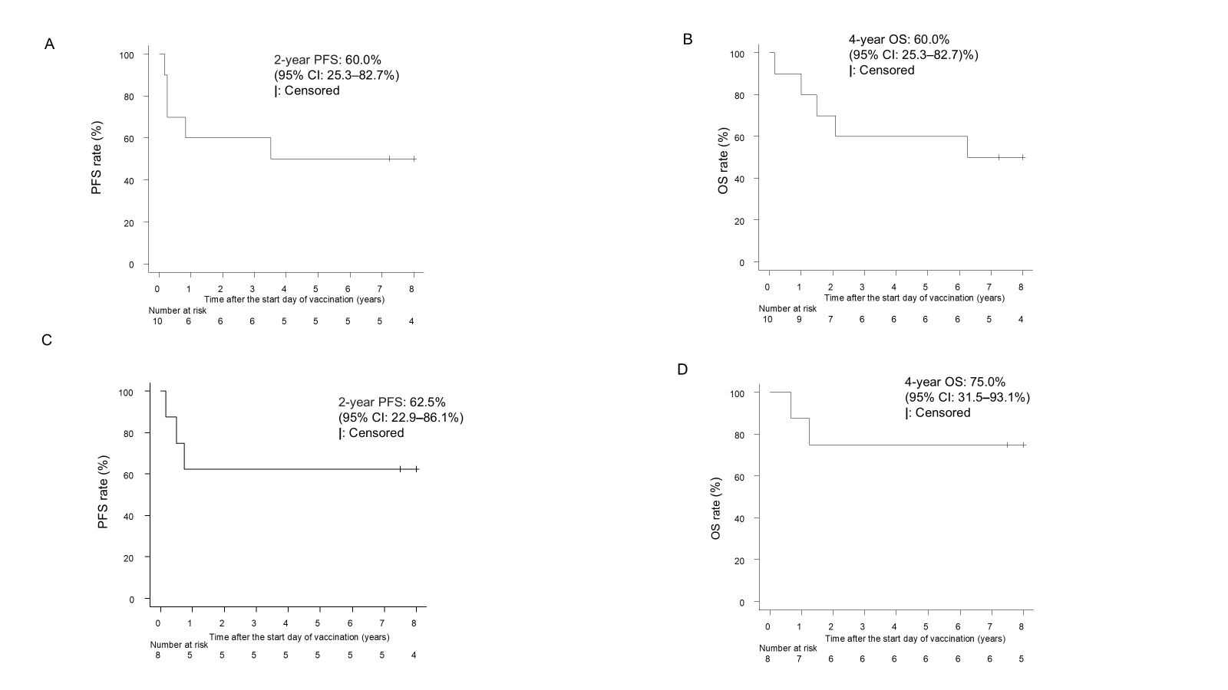
PFS, progression-free survival; CI, confidence interval; OS, overall survival; RMS, rhabdomyosarcoma; and
NB, neuroblastoma.

Figure 4. Kaplan-Meier curves* of PFS (E) and OS (F) for WT1-specific immune
responders and nonresponders among patients with RMS and of PFS (G) and
OS (H) in WT1-specific immune responders and nonresponders among patients
with NB
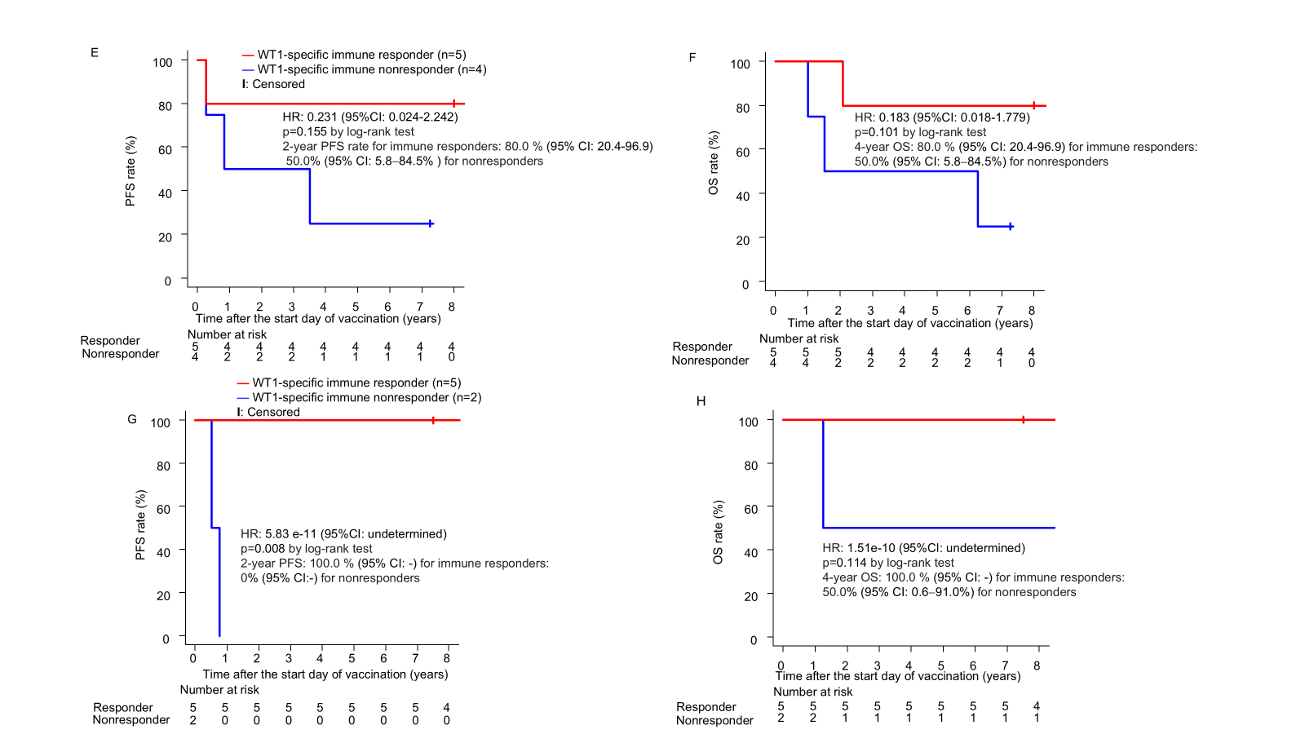

*: Drawn according to the Kaplan-Meier method including the landmark analysis at week 11 after the
of vaccination
PFS, progression-free survival; CI, confidence interval; OS, overall survival; RMS, rhabdomyosarcoma;
NB, neuroblastoma
Figure 5. Kaplan-Meier curves of PFS (A) and OS (B) for patients in PR1, CR1, or
CR2/PR2

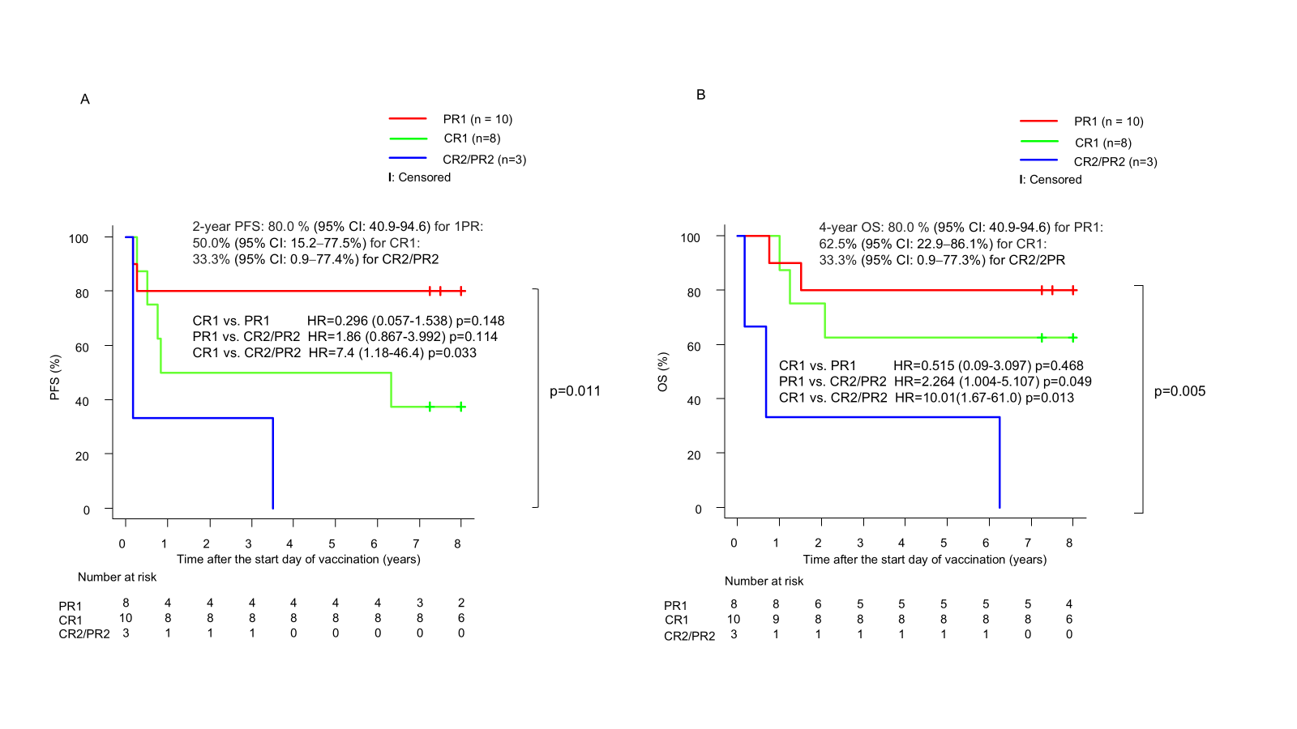
PFS, progression-free survival; OS, overall survival; CR, complete remission; PR, partial remission; WT1, Wilms tumor gene 1; CTL, cytotoxic T lymphocyte

Supplemental References
1 Hosoi H, Teramukai S, Matsumoto Y, et al. A review of 331 rhabdomyosarcoma cases in patients treated between 1991 and 2002 in Japan. Int J Clin Oncol 2007;12:137-45.
2 Oka Y, Tsuboi A, Taguchi T, et al. Induction of WT1 (Wilms' tumor gene)-specific cytotoxic T lymphocytes by WT1 peptide vaccine and the resultant cancer regression. Proc Natl Acad Sci U S A 2004;101:13885-90.
3 Koch S, Larbi A, Derhovanessian E, et al. Multiparameter flow cytometric analysis of CD4 and CD8 T cell subsets in young and old people. Immun Ageing 2008;5:6.
4 Sallusto F, Geginat J, Lanzavecchia A. Central memory and effector memory T cell subsets: function, generation, and maintenance. Annu Rev Immunol 2004;22:745-63.
5 Alzaaqi S, Naka N, Hamada K, et al. WT1 epitope-specific IgG and IgM antibodies for immune-monitoring in patients with advanced sarcoma treated with a WT1 peptide cancer vaccine. Oncol Lett 2022;23:65.
6 Oji Y, Hashimoto N, Tsuboi A, et al. Association of WT1 IgG antibody against WT1 peptide with prolonged survival in glioblastoma multiforme patients vaccinated with WT1 peptide. Int J Cancer 2016;139:1391-401.

