Supplementary Table 1 | Details of PCR protocols used for Sanger sequencing variant confirmations

Case | Primer sequence | Reaction components | Thermocycling conditions
SPAST SV 3’ breakpoint | FWD primer:  CCACAATGTCCACCAATGTGAA  REV primer:  GCTGTCAACAGCCCATTCTG | 25 µL reaction  12.5 µL 2X Platinum SuperFi Green Mastermix  1.25 µL forward primer (10 uM)  1.25 µL reverse primer (10 uM)  5 µL 5% DMSO  1 µL Target DNA (10ng/uL)  4 µL Nuclease free water
  Cycles | Temperature | Time
  1 | 95°C | 3 min
  15 | 95°C | 30 sec
  15 | 65°C  -0.5°C per cycle | 30 sec
  15 | 72°C | 1 min
  40 | 95°C | 30 sec
  40 | 57°C | 30 sec
  40 | 72°C | 1 min
  1 | 72°C | 5 min
  1 | 4°C | Hold
SPG11 SNV | FWD primer: gtaaaacgacggccagtCAGCTGAAGTAGGAGTACCAC  REV primer: ggaaacagctatgaccatgCCTCACTGTAAGATGATGCCC | 25 µl reaction  2.5 µl HotStarTaq 10X PCR Buffer (15mM MgCl₂)  1.0 µl dNTPs (5 mM)  0.5 µl forward primer (50ng/µL)  0.5 µl reverse primer (50ng/µL)  0.2µl HotStarTaq DNA Polymerase  5µl Target DNA (10ng/µL)  Nuclease free water to 25 µL
  Cycles | Temperature | Time
  1 | 95°C | 15 min
  15 | 94°C | 30 sec
  15 | 63°C  -0.5°C per cycle | 30 sec
  15 | 72°C | 1 min
  20 | 94°C | 30 sec
  20 | 55°C | 30 sec
  20 | 72°C | 1 min
  1 | 72°C | 10 min
  1 | 12°C | Hold
MFN2 SNV | FWD primer: gtaaaacgacggccagtCCAGTGGCTTGGTTTCTGGG  REV primer:  ggaaacagctatgaccatgGTGTCCTAACTGCCCAAGGC
GRN SV breakpoint | FWD primer: gtaaaacgacggccagtGCTAAGCCCAGTGAGGGGAC  REV primer: ggaaacagctatgaccatgGACCTGGTCCCTGGCCATAC

Reagent specifications:
- 2X Platinum SuperFi Green Mastermix – Invitrogen Platinum SuperFi Green PCR Master Mix (ThermoFisher Scientific Cat no. 12359010)
- HotStarTaq DNA Polymerase - HotStarTaq DNA polymerase kit (QIAGEN Cat no. 203205)
- HotStarTaq 10X PCR Buffer- HotStarTaq DNA polymerase kit (QIAGEN Cat no. 203205)
- Magnesium Chloride (25mM) - HotStarTaq DNA polymerase kit (QIAGEN Cat no. 203205)
- dNTP mix (Applied Biosystems Cat no. 362275)
Supplementary Table 2 | Details of MLPA protocols used for variant confirmations

Case | Probe/s | Reaction components | Thermocycling conditions
SPG11 SV | SALSA MLPA Probemix P306 SPG11  (Lot number: B2-0921) | Denaturation  TE Buffer to 5 µL  Hybridisation mix  0.75 µL probe mix  0.75 µL Nuclease free water  1.5 µL MLPA Buffer  Ligation mix  3 µL Ligase Buffer A  3 µL Ligase Buffer B  25 µL Nuclease free water  1 µL Ligase 65  PCR mix  2 µL PCR primer mix  7.5 µL Nuclease free water  0.5 µL Polymerase
  Cycles | Temperature | Time
  1 | 98°C | 20 min
  1 | 25°C | Hold
  Addition of hybridisation mix
  1 | 95°C | 1 min
  1 | 60°C | 16 hours
  1 | 54°C | Hold
  Addition of ligation mix
  1 | 54°C | 15 min
  1 | 98°C | 5 min
  1 | 12°C | Hold
  Addition of PCR mix
  1 | 95°C | 30 sec
  35 | 60°C | 30 sec
  35 | 72°C | 1 min
  1 | 72°C | 20 min
  1 | 12°C | Hold
SPTAN1 SV | Exon 3:  CAACAGGGAAAGCTTCAGAAGCATCAAGCATTTGAAGCTGAAGTGCAGGCCAACTCAG-GAGCCATTGTTAAGCTGGATGAAACTGGAAACCTGATGATCTCAGAAGGGCATTTTG  Exon 4:  ACCGCCAGTGGGAATTACTTTTGGAGAAGATGCGAGAAAAAGGAATCAAACTG-CTGCAGGCCCAGAAGTTGGTGCAGTACTTACGAGAATGTGAGGACGTGATGGACTGG  Exon 5:  TGAATAGGAAGCAATTGTTACTTCTGAAGAGCTGGGCCAGGATCTG-GAGCATGTAGAGGTTTTACAGAAGAAATTTGAAGAGTTTCAAACAGATATGGCTGCTCATGAAGAAAGAGTTAATGAA  Exon 6:  GTCTCTTCTCTTCCTTGTTTAGGAGCAGCACCCTGAGGAGGAACTGATCAAGACTAAG-CAGGATGAAGTCAATGCAGCCTGGCAGCGGCTGAAGGGCCTGG
MFN2 SV | SALSA MLPA Probemix P143 MFN2-MPZ  (Lot number: C3-1020)
CLN3 SV | SALSA MLPA Probemix P470 NCL (Lot number: A1-0622)
GRN SV | SALSA MLPA Probemix P275 MAPT-GRN  (Lot number: C4-0321)
Reagent specifications:
- Invitrogen TE Buffer (Cat #12090-015)
- MLPA MRC-Holland SALSA MLPA Reagent kit (CAT#EK5-FAM)
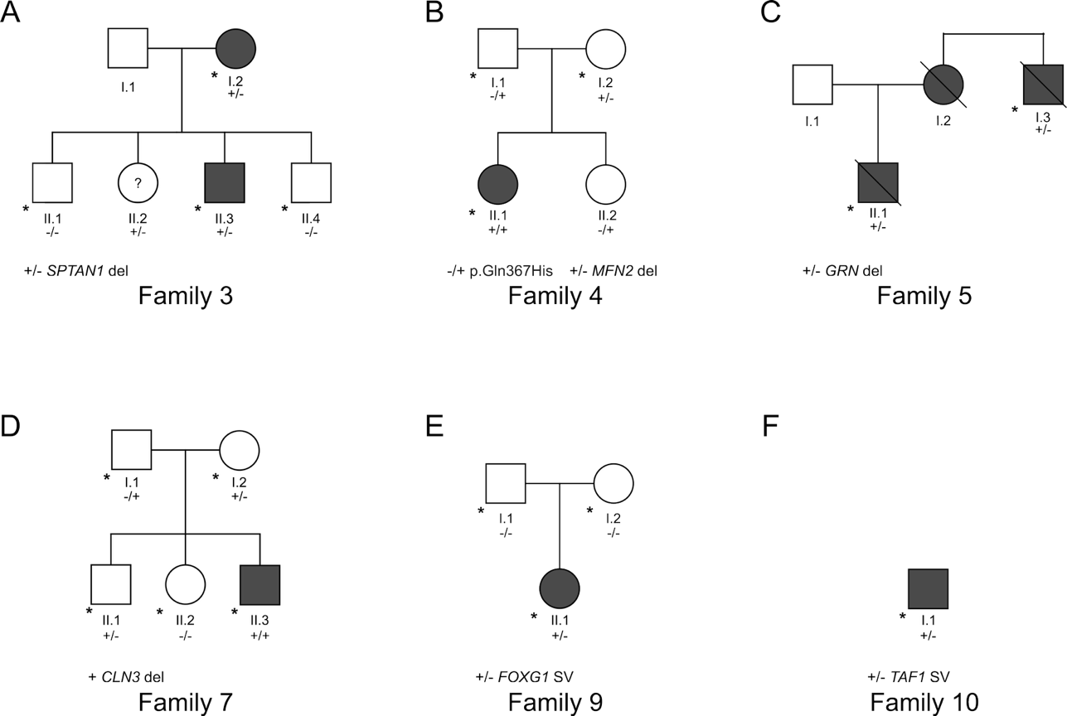

Supplementary Figure 1 | Pedigrees for families included in the study. + indicates an allele with a variant and – indicates an allele without. * donates individuals who had srGS.

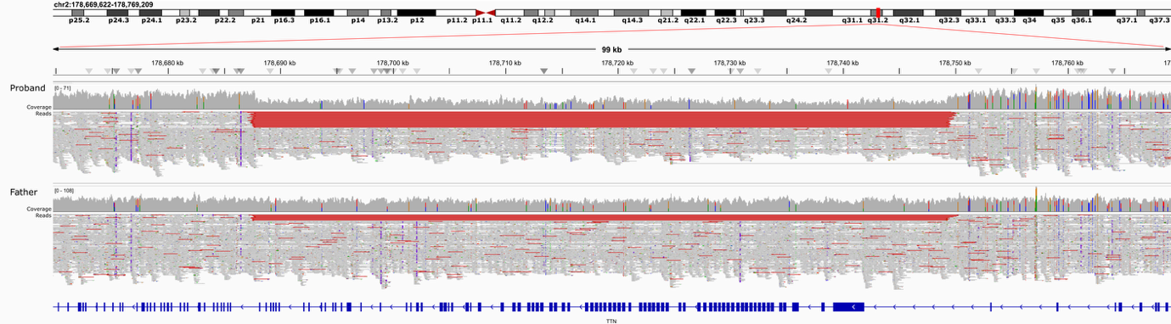

Supplementary Figure 2 | Reads supporting a large delete in TTN, inherited from a mosaic father. The deletion was called in the father by all SV callers used in this study. Reads with red lines indicate pairs with larger than expected insert size. The canonical transcript is in blue (bottom). Visualised in IGV.

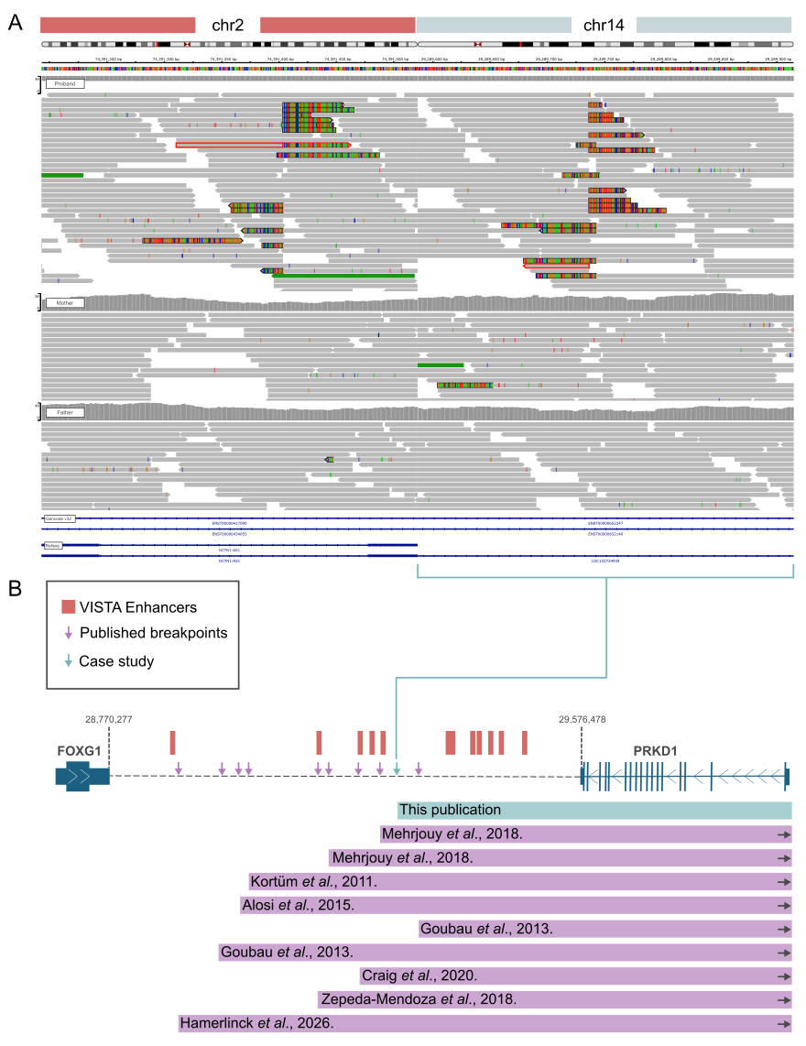
Supplementary Figure 3 | Evidence supporting a balanced translocation impacting FOXG1. A) Visualisation of srGS reads across both translocation breakpoints (chr2:74,391,403 and chr14:29,289,736). Visualised in IGV. B) Schematic depicting the location of similar translocations associated with FOXG1- syndrome in the literature.

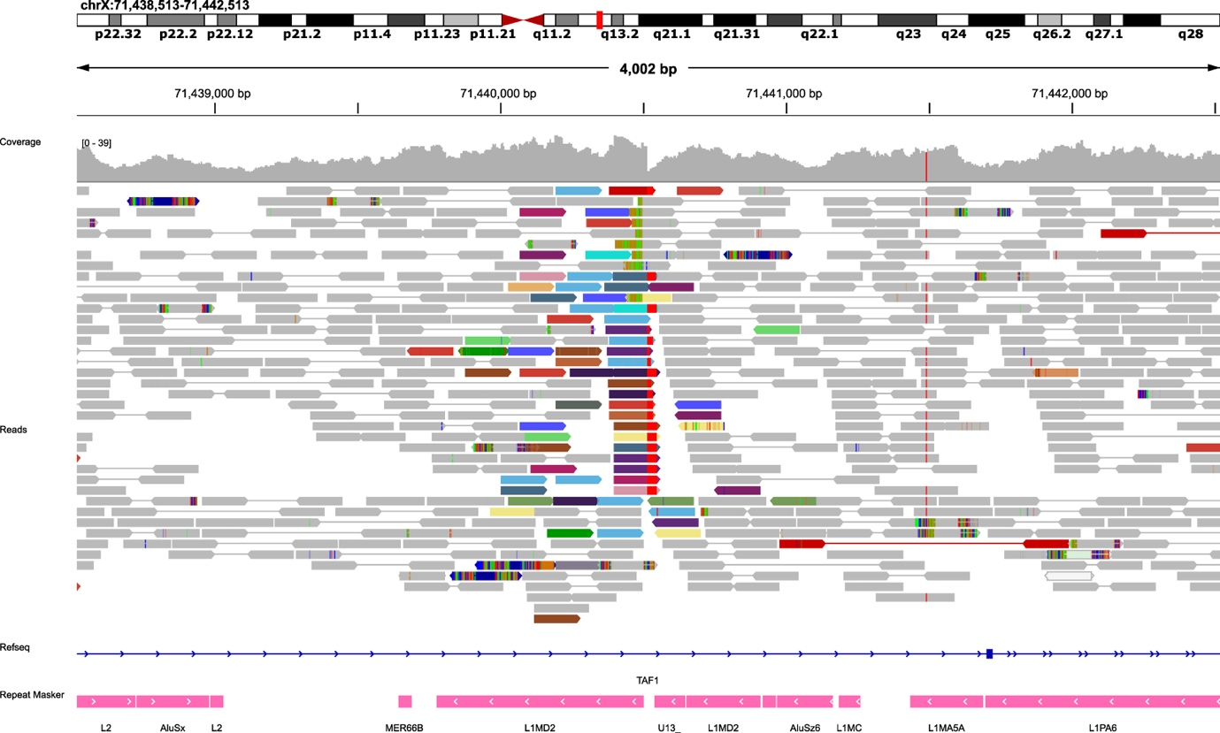
Supplementary Figure 4 | TAF1 insertion. Reads in dark red indicate pairs with a larger than expected insert size. Other colours indicate reads with pairs that align to different chromosomes, with polyT homopolymer runs seen at the ends of some of these reads in light red. This site was called as a breakend by Manta, TIDDIT, and DELLY and as a translocation by dysgu. Visualised in IGV.

