SUPPLEMENTAL MATERIAL

- Supplemental Methods

- Supplemental Tables
Table S1. Candidate predictors and data types.
Table S2. Summary of predictors by region.
Table S3. Cross-validated AUROC for local, centralized, and federated logistic regression models.
Table S4. Calibration-in-the-large of the global models before and after federated recalibration.

- Supplemental Figures
Figure S1. Convergence of the federated learning models.
Figure S2. AUROCs of local, centralized, and federated learning models using unregularized logistic regression.
Figure S3. AUROCs of local, centralized, and federated learning models using L2-regularized logistic regression.
Figure S4. AUROCs of local, centralized, and federated learning models using Elastic Net.
Figure S5. Calibration slopes of local, centralized, and federated learning models using unregularized logistic regression.
Figure S6. Calibration slopes of local, centralized, and federated learning models using L2-regularized logistic regression.
Figure S7. Calibration slopes of local, centralized, and federated learning models using Elastic Net.
Figure S8. Calibration intercepts of local, centralized, and federated learning models using unregularized logistic regression.
Figure S9. Calibration intercepts of local, centralized, and federated learning models using L2-regularized logistic regression.
Figure S10. Calibration intercepts of local, centralized, and federated learning models using Elastic Net.

- Supplemental Methods
  - Algorithms for data analysis
Analyses were performed using the Python software (version 3.13.14). Additional details about the algorithms are available on GitHub: https://github.com/kkmmmmm/Federated-learning.

- L1 regularization method
The L1 regularization method (L1), also known as the least absolute shrinkage and selection operator (LASSO), is commonly used for variable selection. By adding the sum of the absolute values of the regression coefficients to the loss function of logistic regression, L1 induces sparsity, meaning that some regression coefficients shrink to exactly zero. Consequently, it allows for both feature selection and coefficient shrinkage simultaneously.
The L1 estimator ${\hat{β}}_{L1}$ is obtained by minimizing the following objective function [23]:
$${\hat{β}}_{L1}=\arg{\min_{β}}\left\{-\sum_{i=1}^{n}{\left[Y_{i}log\left({ π}_{i}\right)+\left(1-Y_{i}\right)log\left(1-π_{i}\right)\right]}+λ\sum_{j=1}^{p}{\left|β_{j}\right|}\right\},$$
where $Y_{i}$ is the binary outcome variable for the $i$-th case, and $X_{i}={\left(X_{i1}, X_{i2}, …, X_{ip}\right)}^{T}$ represents the predictor variables for the $i$-th case. The probability of mortality given $X_{i}$ is modeled as
$$π_{i}=\frac{1}{{1+exp(-(β}_{0}+\sum_{j=1}^{p}{β_{j}}X_{ij}))},$$
where $λ>0$ is the regularization parameter that controls the complexity of the model.

- L2 regularization method
The L2 regularization method (L2), also known as Ridge regression, incorporates the sum of the squared regression coefficients into the loss function of logistic regression. Unlike L1, L2 does not perform feature selection because it shrinks the regression coefficients toward zero without making them exactly zero. Instead, it distributes the regularization effect across all features, preventing an excessive influence from any single predictor.
The L2 estimator ${\hat{β}}_{L2}$ is obtained by minimizing the following objective function [24,25]:
$${\hat{β}}_{L2}=\arg{\min_{β}\left\{-\sum_{i=1}^{n}{\left[Y_{i}log\left({ π}_{i}\right)+\left(1-Y_{i}\right)log\left(1-π_{i}\right)\right]}+λ\sum_{j=1}^{p}{β_{j}^{2}}\right\}}$$

- Elastic Net regularization method
Elastic Net constructs a loss function that combines both L1 and L2 regularization, introducing a mixing parameter $α$ that adjusts the balance between the two penalties. This approach simultaneously enables feature selection and coefficient shrinkage, mitigating the issue in which LASSO tends to select only one of a set of highly correlated variables, whereas Ridge retains all features.
The Elastic Net estimator ${\hat{β}}_{elastic}$ is obtained by minimizing the following function [26]:
$${\hat{β}}_{elastic}=\arg{\min_{β}\left\{-\sum_{i=1}^{n}{\left[Y_{i}log\left({ π}_{i}\right)+\left(1-Y_{i}\right)log\left(1-π_{i}\right)\right]}+λ\sum_{j=1}^{p}{\left(αβ_{j}^{2}+\left(1-α\right)\left|β_{j}\right|\right)}\right\}},$$
where $α∈ \left[0, 1\right]$ determines the relative contribution of L1 and L2 regularization. Setting $α=1$ corresponds to pure Ridge regression, whereas $α=0$ corresponds to pure LASSO. Intermediate values of $α$ provide a trade-off between feature selection and coefficient stability.
The regularization parameter $λ$ was selected within the range of 10⁻³ to 10³ by stratified five-fold cross-validation, using AUROC as the optimization criterion. Because the cross-validated AUROC was often nearly flat across a wide range of penalty strengths, we did not simply choose the value with the highest mean AUROC; instead, among all candidate values whose mean AUROC was within one standard error of the best mean AUROC, we selected the least-regularized one (the weakest penalty, i.e., the value closest to the unpenalized maximum-likelihood fit). For Elastic Net, in addition to the regularization parameter λ, the mixing parameter α was selected from three candidate values (0.1, 0.5, and 0.9) using the same one-standard-error rule. Furthermore, all predictor variables were standardized before being input into the models.

Federated averaging and recalibration
Federated learning (FL) used Federated Averaging (FedAvg). The procedure is summarized below.
- In each communication round, the server distributes the current global model to all participating regions (clients).
- Each client updates the global model using its respective local data and sends the updated model back to the server.
- The server aggregates the regression coefficients updated by the clients and utilizes them to generate a new global model.
The global model is updated using the following weighted aggregation formula:
$w_{t+1}←\sum_{k∈S_{t}}{\frac{n_{k}}{n}}w_{t+1}^{(k)}, n=\sum_{k∈S_{t}}{n_{k}}$,
where $t$ denotes the round number for updating the regression coefficients, $S_{t}$ represents the set of clients selected in round $t$, $n$ is the total number of samples across all clients, $n_{k}$ corresponds to the number of samples held by the $k$-th client, $w_{t+1}^{\left(k\right)}$ denotes the regression coefficients of the model updated by client $k$ using its local dataset in round $t+1$, and $w_{t+1}$ represents the regression coefficients of the global model at round $t+1$.
In each communication round, every region (client) warm-started from the current global model and performed a single bounded local optimization step on its own standardized data, using a regularization strength selected by cross-validation within that client. Because every client operated on the same reconstructed feature scale and exchanged only its coefficients, these client-specific penalties shaped each client's local coefficients without altering the aggregation step itself; the returned coefficients—both the intercept and the slopes—were then combined by the sample-size-weighted aggregation given above. Predictors were standardized on a common scale reconstructed from per-region aggregate statistics (counts, sums, and sums of squares). All available regions participated in every communication round (16 for the overall model and 15 for each leave-one-region-out model, rather than a random subset), which stabilized convergence. Each FedAvg model was trained for a fixed 60 communication rounds, and the global training log-loss—the sample-size-weighted average of the regions' local log-losses, computable from per-client aggregates—was monitored each round; it plateaued within approximately the first 10–15 rounds (Figure S1), well within the fixed 60 rounds.
- After the fixed 60 communication rounds, the global model is finalized by correcting its intercept so that the sum of the predicted probabilities matches the total number of observed events. This offset is computed by a one-parameter Newton–Raphson iteration (Algorithm S1) that exchanges only per-client scalar sums, with no patient-level data leaving a site.
Only the intercept was updated during this intercept-correction step, whereas the averaged slopes were kept fixed. This corresponds to a recalibration-in-the-large and assumes that the predictor effects estimated by FedAvg are sufficiently transportable across regions, whereas the intercept may require adjustment to match the overall event rate because of differences in baseline risk and the nonlinearity of logistic regression. Holding the slopes fixed, the shift δ is obtained by the Newton recursion δ ← δ + (∑ᵢ yᵢ − ∑ᵢ σ(ηᵢ+δ)) / ∑ᵢ σ(ηᵢ+δ)(1−σ(ηᵢ+δ)), iterated to convergence to satisfy $\sum_{i}{p_{i}(δ)}=\sum_{i}{y_{i}}$. The three per-client sums exchanged at each step are exactly the score and Fisher information required for this Newton–Raphson update, so the intercept shift is solved from aggregates alone. Unlike the classical recalibration-in-the-large, however, this shift is not an update to a new setting: it removes the calibration-in-the-large offset introduced by coefficient averaging (largest under L1 and Elastic Net; Table S4), and for each leave-one-region-out model, it is computed only from the training regions’ aggregate scalars—never from the held-out region—so that the evaluation remains free of leakage and preserves a fair comparison with the locally developed models. Throughout, FL denotes this recalibrated federated model.
Taken together, the complete federated procedure—the FedAvg coefficient recursion described above, followed by the federated recalibration—is summarized as pseudocode in Algorithm S1.
Algorithm S1. FedAvg with federated intercept correction.
Input: the K regional datasets (client k has data D_{k} of size n_{k}, with n = Σn_{k}); the number of communication rounds T (= 60) and local iterations per round E (= 1); and, for each client, a regularization penalty (none, L1, L2, or Elastic Net) whose strength is preselected by within-client cross-validation.
Output: the federated model w_{FL} = (β₀ + δ, β).
Notation: w_{t} = (β₀, β), the global intercept and slope at round t; η_{i} = β₀ + x_{i}⊤β, the linear predictor for subject i (covariate vector x_{i}, outcome y_{i}); σ(·), the logistic function; S_{p}, S_{w}, S_{y}, the per-iteration aggregate scalars defined in line 17; δ, the intercept shift; and τ (= 10⁻⁴), the log-loss tolerance used to monitor convergence (not a stopping rule; training ran for a fixed 60 rounds).
Server executes:
1: $w_{0}←0$ ▷ initialize global model
2: for $t$ = 0, 1, …, $T-1$ do
3: for each client $k$ = 1, …, $K$ in parallel do
4: $w_{t+1}^{(k)}←$ClientUpdate ($k$, $w_{t}$)
5: end for
6: $w_{t+1}←\sum_{k}{\frac{n_{k}}{n}w_{t+1}^{(k)}}$ ▷ sample-size-weighted mean of intercept and slopes
7: $L_{t+1}←$overall training log-loss of $w_{t+1}$ ▷ monitored for convergence (change in log-loss < τ over 3 rounds; Fig S1)
8: end for
9: $δ←$InterceptCorrection ($w_{T}$) ▷ slopes held fixed
10: return $w_{FL}←(β_{0}+δ,β)$ from $w_{T}$ ▷ shift only the intercept

ClientUpdate($k$, $w$): ▷ runs at region k; raw data never leave
11: warm-start the local model at $w$
12: $w_{k}←$one warm-started step minimizing the regularized logistic loss on $D_{k}$, $E$ = 1 pass; the L1/L2/elastic-net penalty strength is preselected by within-client cross-validation
13: return $w_{k}$ ▷ intercept and slopes both returned

InterceptCorrection ($w$): ▷ Newton recursion on the scalar δ
14: $η_{i}←β_{0}+x_{i}^{⊤}β$ for every subject $i$ ▷ linear predictor from the FedAvg model
15: $δ←0$
16: repeat
17: each client returns only $S_{p}=\sum_{i}{σ(η_{i}+δ)},S_{w}=\sum_{i}{σ(η_{i}+δ)[1-σ(η_{i}+δ)]},S_{y}=\sum_{i}{y_{i}}$
18: $δ←δ+\frac{S_{y}-S_{p}}{S_{w}}$
19: until $|Δδ|<{10}^{-10}$ or 50 iterations
20: return $δ$ ▷ solves ∑ σ(η+δ) = ∑ y

- Supplemental Tables
Table S1. Candidate predictors and data types.
Predictor | Data type
Age (years) | Continuous
Height (cm) | Continuous
Weight (kg) | Continuous
Number of ECG leads (count) | Continuous
Killip Classification:  Class I: No signs of heart failure  Class II: Mild to moderate heart failure  Class III: Pulmonary edema  Class IV: Cardiogenic shock | Categorical variable  (ordinal scale)
Female sex | Categorical variable  (nominal scale)
Diabetes | Categorical variable  (nominal scale)
Hypotension (systolic blood pressure < 100 mmHg) | Categorical variable  (nominal scale)
Tachycardia (pulse > 80 bpm) | Categorical variable  (nominal scale)
Anterior infarct location | Categorical variable  (nominal scale)
Previous MI | Categorical variable  (nominal scale)
Hypertension history | Categorical variable  (nominal scale)
Hypercholesterolemia | Categorical variable  (nominal scale)
Previous angina pectoris | Categorical variable  (nominal scale)
Family history of MI | Categorical variable  (nominal scale)
Time to relief of chest pain > 1 h | Categorical variable  (nominal scale)
Smoking History:  1: Never smoker  2: Former smoker  3: Current smoker | Categorical variable (ordinal scale)
Candidate predictors used for model development. Continuous variables were analyzed on their native scales; categorical variables were coded as binary (yes/no) or ordinal as indicated.

Table S2. Summary of predictors by region.
Region number | 1 | 2 | 3 | 4 | 5 | 6 | 7 | 8
No. of patients | 2,188 | 2,952 | 2,030 | 2,876 | 1,909 | 1,585 | 3,150 | 2,916
30-day mortality | 135  (6.2) | 229  (7.8) | 166  (8.2) | 217  (7.5) | 133  (7.0) | 133  (8.4) | 211  (6.7) | 188  (6.4)
Predictors
Age (years) | 60.6  (50.9–69.9) | 63.3  (54.0–71.1) | 63.8  (54.9–71.1) | 61.3  (52.0–69.9) | 61.1  (51.4–69.0) | 61.4  (52.5–68.6) | 60.5  (50.7–69.4) | 61.0  (51.4–69.3)
Height (cm) | 173  (165–180) | 170  (165–176) | 170  (165–175) | 170  (165–177) | 170  (164–175) | 170  (165–176) | 173  (165–180) | 170  (164–175)
Weight (kg) | 82  (71–92) | 75  (67–85) | 75  (66–82) | 77  (68–86) | 73  (65–82) | 76  (70–85) | 82  (71–92) | 75  (68–83)
Number of ECG leads  (count) | 3  (3–5) | 4  (3–6) | 4  (3–6) | 4  (3–5) | 4  (3–5) | 4  (3–5) | 3  (3–5) | 4  (3–6)
Killip Classification | 1  (1–1) | 1  (1–1) | 1  (1–1) | 1  (1–1) | 1  (1–1) | 1  (1–1) | 1  (1–1) | 1  (1–1)
Female sex | 544  (24.9) | 720  (24.4) | 477  (23.5) | 685  (23.8) | 311  (16.3) | 392  (24.7) | 918  (29.1) | 633  (21.7)
Diabetes | 312  (14.3) | 282  (9.6) | 202  (10.0) | 411  (14.3) | 211  (11.1) | 225  (14.2) | 521  (16.5) | 577  (19.8)
Hypotension  (SBP < 100 mmHg) | 211  (9.6) | 150  (5.1) | 179  (8.8) | 196  (6.8) | 99  (5.2) | 113  (7.1) | 314  (10.0) | 129  (4.4)
Tachycardia  (pulse > 80 bpm) | 730  (33.4) | 812  (27.5) | 624  (30.7) | 876  (30.5) | 566  (29.6) | 573  (36.2) | 1165  (37.0) | 1070  (36.7)
Anterior infarct location | 815  (37.2) | 1163  (39.4) | 802  (39.5) | 1141  (39.7) | 763  (40.0) | 621  (39.2) | 1115  (35.4) | 1382  (47.4)
Previous MI | 375  (17.1) | 500  (16.9) | 279  (13.7) | 485  (16.9) | 220  (11.5) | 262  (16.5) | 558  (17.7) | 494  (16.9)
Hypertension history | 883  (40.4) | 1073  (36.3) | 580  (28.6) | 951  (33.1) | 667  (34.9) | 635  (40.1) | 1369  (43.5) | 972  (33.3)
Hypercholesterolemia | 886  (40.5) | 1016  (34.4) | 651  (32.1) | 828  (28.8) | 722  (37.8) | 653  (41.2) | 1152  (36.6) | 671  (23.0)
Previous angina pectoris | 745  (34.0) | 1205  (40.8) | 770  (37.9) | 1102  (38.3) | 667  (34.9) | 836  (52.7) | 1178  (37.4) | 1053  (36.1)
Family history of MI | 1041  (47.6) | 1171  (39.7) | 605  (29.8) | 1313  (45.7) | 464  (24.3) | 396  (25.0) | 1671  (53.0) | 819  (28.1)
Time to relief of  chest pain > 1 h | 1332  (60.9) | 1560  (52.8) | 1312  (64.6) | 1890  (65.7) | 1221  (64.0) | 869  (54.8) | 2188  (69.5) | 1950  (66.9)
Smoking history
Never smoker | 903  (41.3) | 987  (33.4) | 840  (41.4) | 1244  (43.3) | 851  (44.6) | 789  (49.8) | 1434  (45.5) | 1218  (41.8)
Former smoker | 674  (30.8) | 1089  (36.9) | 480  (23.6) | 876  (30.5) | 496  (26.0) | 389  (24.5) | 787  (25.0) | 588  (20.2)
Current smoker | 611  (27.9) | 876  (29.7) | 710  (35.0) | 756  (26.3) | 562  (29.4) | 407  (25.7) | 929  (29.5) | 1110  (38.1)

Table S2. Summary of predictors by region (continued)
Region number | 9 | 10 | 11 | 12 | 13 | 14 | 15 | 16
No. of patients | 3,123 | 1,717 | 2,491 | 4,352 | 2,297 | 3,437 | 2,576 | 1,231
30-day mortality | 224  (7.2) | 95  (5.5) | 191  (7.7) | 294  (6.8) | 121  (5.3) | 260  (7.6) | 155  (6.0) | 99  (8.0)
Predictors
Age (years) | 61.2  (52.3–69.6) | 58.9  (49.9–67.8) | 61.8  (51.8–70.7) | 61.6  (51.9–70.2) | 62.3  (53.8–69.6) | 61.4  (52.1–69.9) | 61.2  (51.8–69.9) | 62.7  (54.3–70.3)
Height (cm) | 173  (165–180) | 173  (165–180) | 173  (165–180) | 172  (165–178) | 173  (168–178) | 173  (165–180) | 173  (165–180) | 170  (164–174)
Weight (kg) | 80  (70–91) | 81  (71–92) | 82  (72–92) | 80  (70–90) | 78  (70–85) | 80  (70–91) | 80  (70–91) | 75  (67–82)
Number of ECG leads  (count) | 3  (3–5) | 3  (3–6) | 4  (3–5) | 4  (3–5) | 4  (3–5) | 4  (3–6) | 4  (3–5) | 4  (3–6)
Killip Classification | 1  (1–1) | 1  (1–1) | 1  (1–1) | 1  (1–1) | 1  (1–1) | 1  (1–1) | 1  (1–1) | 1  (1–2)
Female sex | 894  (28.6) | 457  (26.6) | 697  (28.0) | 1197  (27.5) | 500  (21.8) | 942  (27.4) | 622  (24.1) | 289  (23.5)
Diabetes | 561  (18.0) | 290  (16.9) | 405  (16.3) | 783  (18.0) | 174  (7.6) | 574  (16.7) | 382  (14.8) | 95  (7.7)
Hypotension  (SBP < 100 mmHg) | 338  (10.8) | 164  (9.6) | 283  (11.4) | 432  (9.9) | 139  (6.1) | 351  (10.2) | 239  (9.3) | 41  (3.3)
Tachycardia  (pulse > 80 bpm) | 1104  (35.4) | 646  (37.6) | 847  (34.0) | 1423  (32.7) | 574  (25.0) | 1129  (32.8) | 853  (33.1) | 402  (32.7)
Anterior infarct location | 1171  (37.5) | 634  (36.9) | 894  (35.9) | 1683  (38.7) | 910  (39.6) | 1313  (38.2) | 963  (37.4) | 530  (43.1)
Previous MI | 549  (17.6) | 320  (18.6) | 433  (17.4) | 714  (16.4) | 341  (14.8) | 544  (15.8) | 477  (18.5) | 175  (14.2)
Hypertension history | 1372  (43.9) | 778  (45.3) | 1063  (42.7) | 1857  (42.7) | 517  (22.5) | 1473  (42.9) | 1036  (40.2) | 294  (23.9)
Hypercholesterolemia | 1221  (39.1) | 590  (34.4) | 997  (40.0) | 1684  (38.7) | 458  (19.9) | 1347  (39.2) | 938  (36.4) | 162  (13.2)
Previous angina pectoris | 1097  (35.1) | 631  (36.8) | 970  (38.9) | 1481  (34.0) | 958  (41.7) | 1171  (34.1) | 880  (34.2) | 343  (27.9)
Family history of MI | 1508  (48.3) | 895  (52.1) | 1178  (47.3) | 2148  (49.4) | 833  (36.3) | 1611  (46.9) | 1258  (48.8) | 418  (34.0)
Time to relief of  chest pain > 1 h | 2110  (67.6) | 1099  (64.0) | 1612  (64.7) | 3037  (69.8) | 1845  (80.3) | 2208  (64.2) | 1664  (64.6) | 597  (48.5)
Smoking history
Never smoker | 1333  (42.7) | 849  (49.4) | 1034  (41.5) | 1771  (40.7) | 1168  (50.8) | 1516  (44.1) | 1060  (41.1) | 546  (44.4)
Former smoker | 911  (29.2) | 428  (24.9) | 749  (30.1) | 1238  (28.4) | 489  (21.3) | 959  (27.9) | 703  (27.3) | 354  (28.8)
Current smoker | 879  (28.1) | 440  (25.6) | 708  (28.4) | 1343  (30.9) | 640  (27.9) | 962  (28.0) | 813  (31.6) | 331  (26.9)
ECG, electrocardiogram; SBP, systolic blood pressure; MI, myocardial infarction.
Data are expressed as the median (interquartile range) or n (%).
Descriptive statistics for all candidate predictors across 16 regions. Continuous variables (age [years], height [cm], weight [kg], number of ECG leads [count]) are summarized as median (IQR). Ordinal variables (Killip class I–IV; smoking history: never/former/current) are summarized as median (IQR) or n (%), as appropriate. Binary variables (female sex; diabetes; hypotension [SBP <100 mmHg]; tachycardia [pulse >80 bpm]; anterior infarct location; previous MI; hypertension history; hypercholesterolemia; previous angina pectoris; family history of MI; time to relief of chest pain >1 h) are summarized as n (%). The first row reports 30-day mortality (n, %).

Table S3. Cross-validated AUROC for local, centralized, and federated logistic regression models.
 | Without regularization | Without regularization | Without regularization |  | L1 regularization | L1 regularization | L1 regularization |  | L2 regularization | L2 regularization | L2 regularization |  | Elastic Net | Elastic Net | Elastic Net
Region | Local | Centralized | FL |  | Local | Centralized | FL |  | Local | Centralized | FL |  | Local | Centralized | FL
1 | 0.846  (0.048) | 0.844  (0.045) | 0.845  (0.045) |  | 0.846  (0.048) | 0.844  (0.045) | 0.846  (0.048) |  | 0.846  (0.048) | 0.844  (0.045) | 0.845  (0.045) |  | 0.846  (0.048) | 0.844  (0.045) | 0.841  (0.047)
2 | 0.812  (0.044) | 0.818  (0.043) | 0.818  (0.044) |  | 0.812  (0.044) | 0.818  (0.043) | 0.815  (0.043) |  | 0.812  (0.044) | 0.818  (0.043) | 0.818  (0.044) |  | 0.812  (0.044) | 0.818  (0.043) | 0.816  (0.043)
3 | 0.812  (0.037) | 0.826  (0.042) | 0.826  (0.043) |  | 0.812  (0.037) | 0.826  (0.042) | 0.827  (0.042) |  | 0.812  (0.037) | 0.826  (0.042) | 0.826  (0.043) |  | 0.812  (0.037) | 0.826  (0.042) | 0.827  (0.039)
4 | 0.833  (0.022) | 0.837  (0.023) | 0.837  (0.023) |  | 0.833  (0.022) | 0.837  (0.023) | 0.834  (0.024) |  | 0.833  (0.022) | 0.837  (0.023) | 0.837  (0.023) |  | 0.833  (0.022) | 0.837  (0.023) | 0.837  (0.023)
5 | 0.819  (0.030) | 0.824  (0.036) | 0.824  (0.036) |  | 0.819  (0.030) | 0.824  (0.035) | 0.823  (0.037) |  | 0.819  (0.030) | 0.824  (0.036) | 0.824  (0.036) |  | 0.819  (0.030) | 0.824  (0.035) | 0.824  (0.038)
6 | 0.776  (0.050) | 0.790  (0.031) | 0.788  (0.030) |  | 0.776  (0.050) | 0.790  (0.031) | 0.792  (0.034) |  | 0.776  (0.050) | 0.790  (0.031) | 0.788  (0.030) |  | 0.776  (0.050) | 0.790  (0.031) | 0.792  (0.031)
7 | 0.808  (0.039) | 0.814  (0.027) | 0.813  (0.027) |  | 0.808  (0.039) | 0.814  (0.027) | 0.814  (0.028) |  | 0.808  (0.039) | 0.814  (0.027) | 0.813  (0.027) |  | 0.808  (0.039) | 0.814  (0.027) | 0.813  (0.024)
8 | 0.826  (0.041) | 0.834  (0.047) | 0.833  (0.047) |  | 0.826  (0.041) | 0.834  (0.047) | 0.832  (0.046) |  | 0.826  (0.041) | 0.834  (0.047) | 0.833  (0.047) |  | 0.826  (0.041) | 0.834  (0.047) | 0.834  (0.047)
9 | 0.829  (0.020) | 0.828  (0.022) | 0.828  (0.022) |  | 0.829  (0.020) | 0.828  (0.022) | 0.826  (0.024) |  | 0.829  (0.020) | 0.828  (0.022) | 0.828  (0.022) |  | 0.829  (0.020) | 0.828  (0.022) | 0.827  (0.021)
10 | 0.810  (0.049) | 0.806  (0.034) | 0.804  (0.034) |  | 0.810  (0.049) | 0.806  (0.034) | 0.803  (0.036) |  | 0.810  (0.049) | 0.806  (0.034) | 0.804  (0.034) |  | 0.810  (0.049) | 0.806  (0.034) | 0.803  (0.033)
11 | 0.830  (0.033) | 0.830  (0.036) | 0.831  (0.036) |  | 0.830  (0.033) | 0.831  (0.036) | 0.830  (0.036) |  | 0.830  (0.033) | 0.830  (0.036) | 0.831  (0.036) |  | 0.830  (0.033) | 0.831  (0.036) | 0.833  (0.035)
12 | 0.826  (0.035) | 0.829  (0.032) | 0.829  (0.032) |  | 0.826  (0.035) | 0.829  (0.032) | 0.828  (0.033) |  | 0.826  (0.035) | 0.829  (0.032) | 0.829  (0.032) |  | 0.826  (0.035) | 0.829  (0.032) | 0.828  (0.031)
13 | 0.819  (0.066) | 0.834  (0.046) | 0.834  (0.045) |  | 0.819  (0.066) | 0.834  (0.046) | 0.832  (0.045) |  | 0.822  (0.065) | 0.834  (0.046) | 0.834  (0.045) |  | 0.818  (0.065) | 0.834  (0.046) | 0.831  (0.046)
14 | 0.808  (0.041) | 0.817  (0.046) | 0.817  (0.046) |  | 0.808  (0.041) | 0.817  (0.046) | 0.816  (0.046) |  | 0.808  (0.041) | 0.817  (0.046) | 0.817  (0.046) |  | 0.808  (0.041) | 0.817  (0.046) | 0.816  (0.044)
15 | 0.786  (0.036) | 0.802  (0.037) | 0.802  (0.037) |  | 0.786  (0.036) | 0.802  (0.037) | 0.799  (0.038) |  | 0.786  (0.036) | 0.802  (0.037) | 0.802  (0.037) |  | 0.786  (0.036) | 0.802  (0.037) | 0.800  (0.037)
16 | 0.732  (0.071) | 0.780  (0.081) | 0.778  (0.080) |  | 0.732  (0.071) | 0.780  (0.081) | 0.778  (0.079) |  | 0.736  (0.075) | 0.780  (0.081) | 0.778  (0.080) |  | 0.732  (0.071) | 0.780  (0.081) | 0.779  (0.082)
Data are the mean (standard deviation) of AUROC on the held-out test folds across stratified five-fold cross-validation within each region. For each penalty (none, L1 [LASSO], L2 [ridge], Elastic Net), columns report the Local, Centralized, and Federated (FL) models. Local models were trained and validated within their own development region; the Centralized and Federated global models were trained on the other 15 regions (excluding the target region) and evaluated on the target region’s held-out folds, avoiding information leakage. Federated learning used Federated Averaging (FedAvg) with all available training regions participating in each round (15 regions for each leave-one-region-out model). Because intercept correction does not affect discrimination, AUROC is identical with and without it. Higher AUROC indicates better discrimination. AUROC, area under the receiver operating characteristic curve.

Table S4. Calibration-in-the-large of the global models before and after federated recalibration.
Regularization | Centralized | FedAvg (uncorrected) | FL (corrected)
None | +0.010 | +0.014 | +0.009
L1 (LASSO) | +0.009 | +0.145 | +0.010
L2 (ridge) | +0.010 | +0.014 | +0.009
Elastic Net | +0.009 | +0.132 | +0.009
Calibration-in-the-large (mean across the 16 leave-one-region-out validations); perfect calibration-in-the-large is 0. FedAvg (uncorrected) is the global model obtained by naive coefficient averaging; FL is the same model after federated recalibration. Under L1 and Elastic Net, naive averaging leaves a positive calibration-in-the-large offset that the correction removes, restoring calibration close to that of the centralized model; under no penalty and L2 the offset is already negligible.

Figure S1. Convergence of the federated learning models.
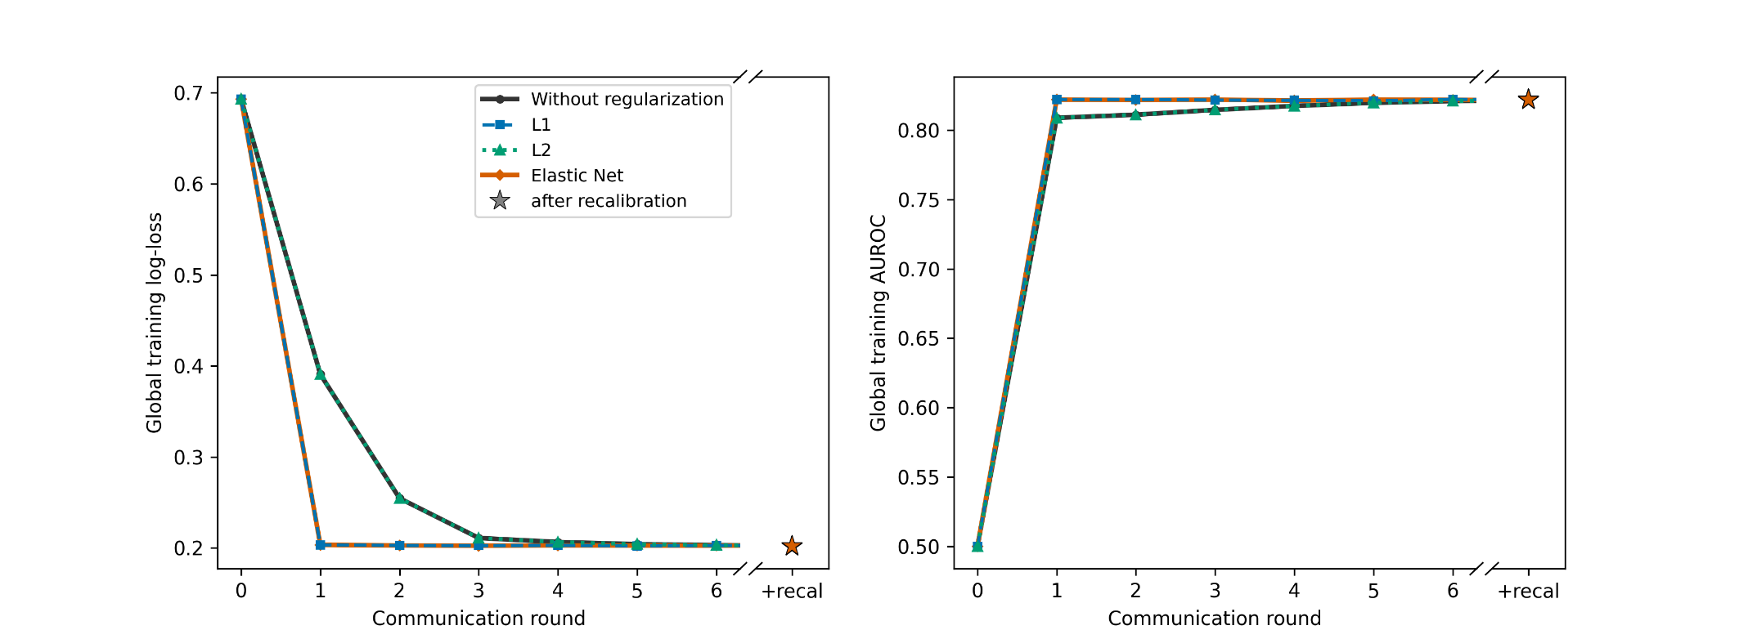
Global training log-loss (left) and AUROC (right) of the FedAvg global model versus communication round, for each regularization strategy. Federated learning used Federated Averaging with all participating regions each round (16 regions for the overall model; 15 for each leave-one-region-out model). The main axis is truncated to the first few communication rounds, where the strategies differ; the training log-loss had largely flattened within roughly the first 10–15 rounds (the near-constant values out to the fixed 60th round are omitted for clarity; approximately one second of computation). The star marks the global model after the federated recalibration step (narrow right sub-panel, across the axis break); including this step, the complete procedure took approximately 1.1-1.3 seconds. The correction left discrimination unchanged and slightly reduced the training log-loss under L1 and Elastic Net by correcting the calibration-in-the-large.

Figure S2. AUROCs of local, centralized, and federated learning models using unregularized logistic regression.
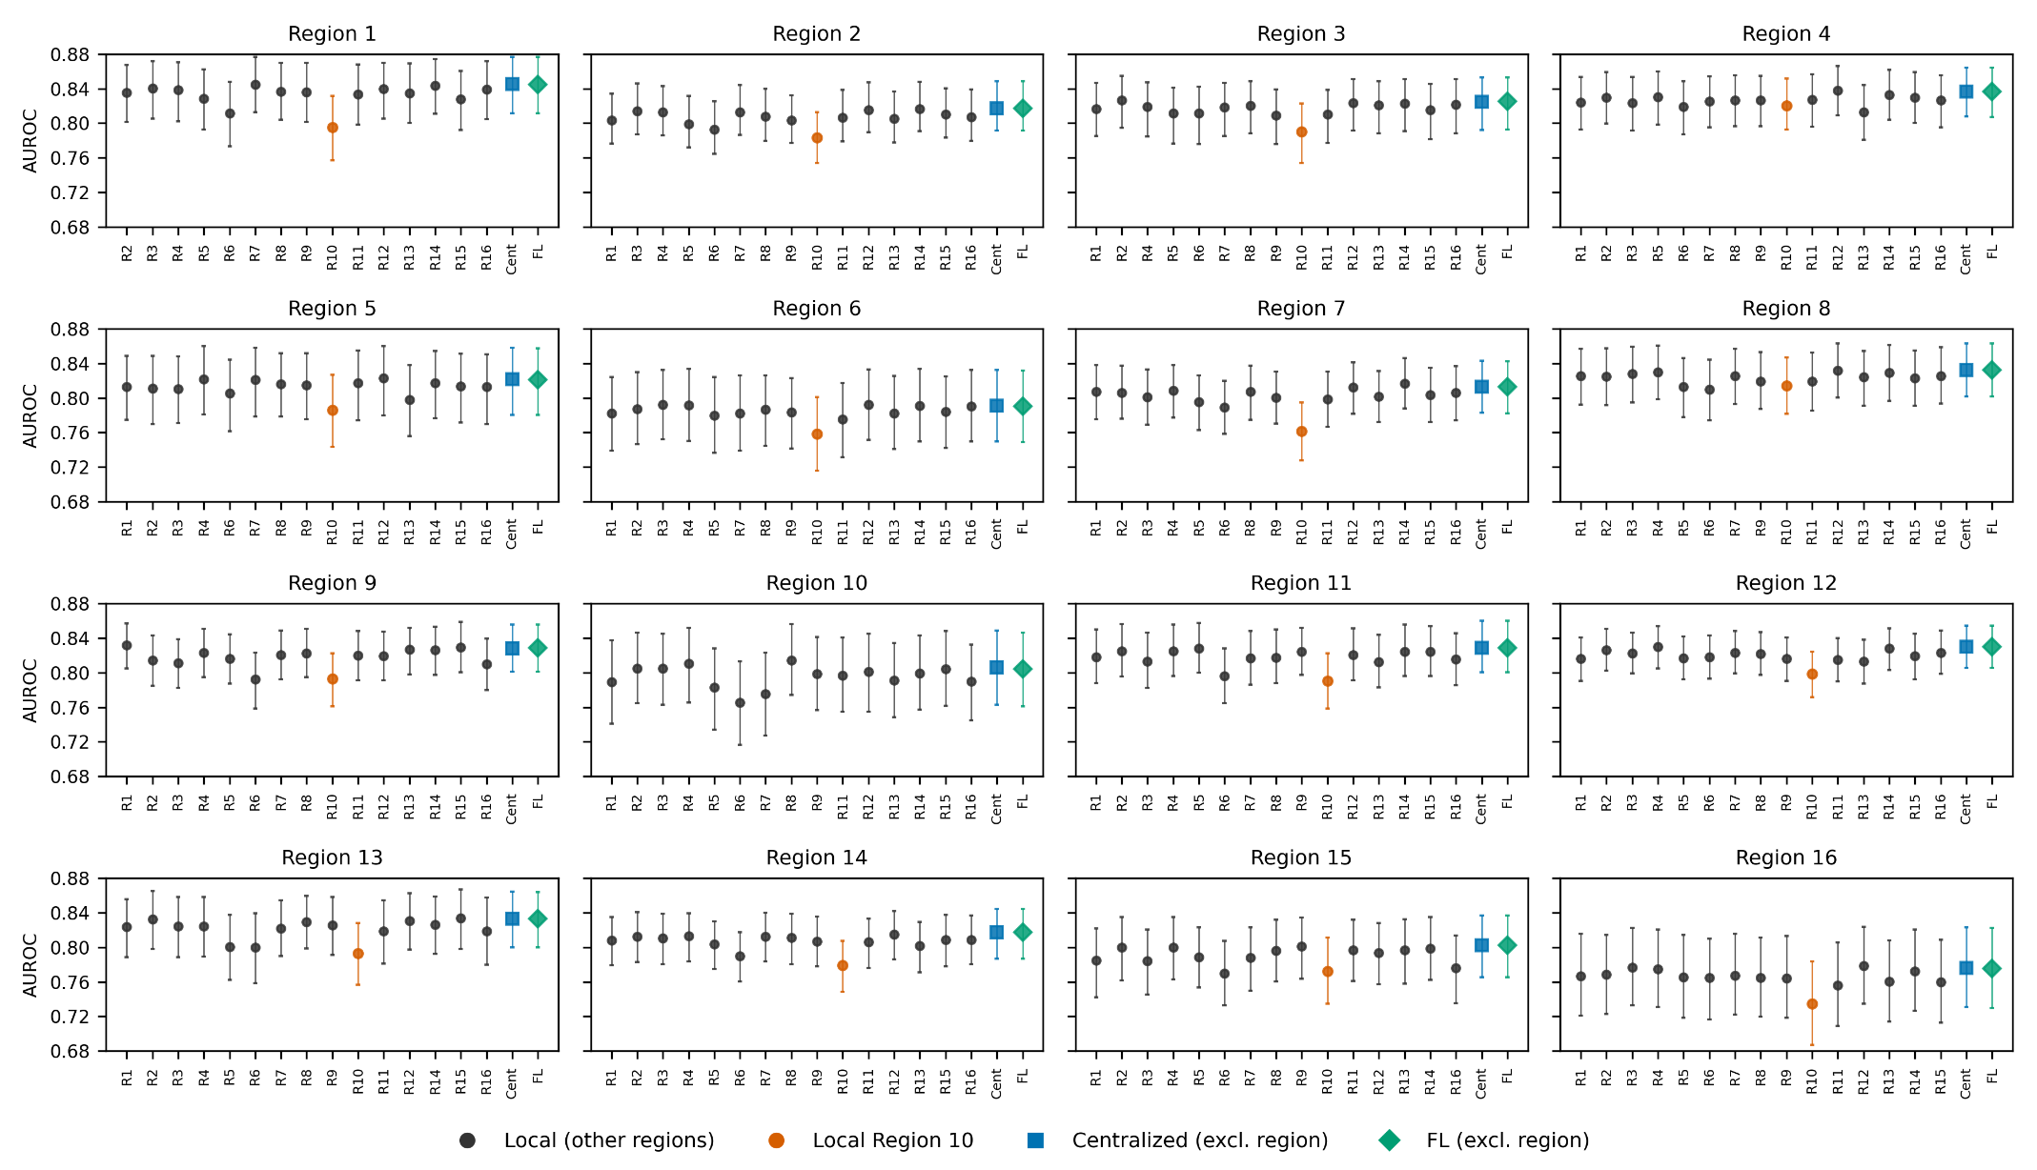
Estimates with 95% CI (1,000 bootstrap resamples); layout and abbreviations as in Figure 2 of the main text. Region 10 is shown in orange.
Figure S3. AUROCs of local, centralized, and federated learning models using L2-regularized logistic regression.
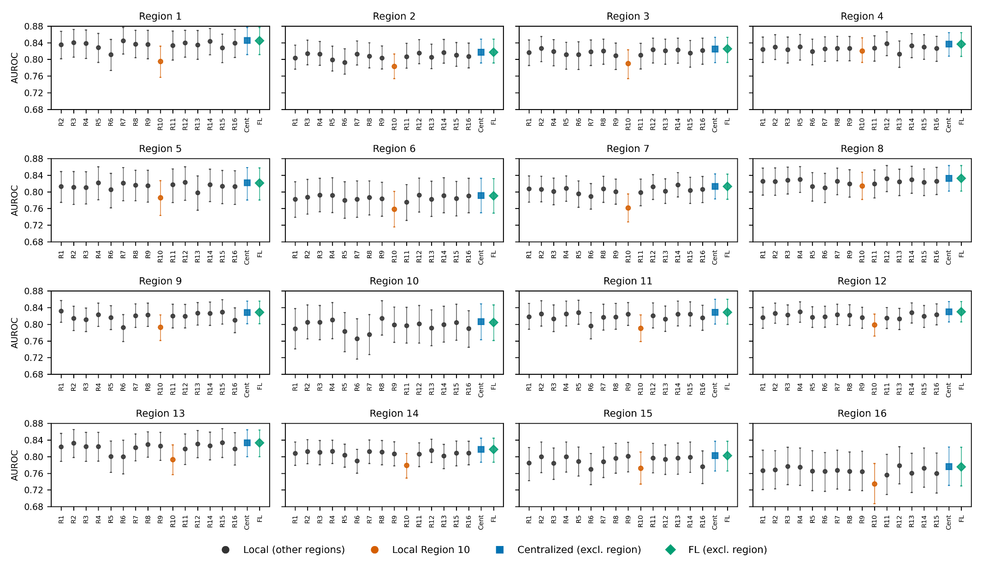
Estimates with 95% CI (1,000 bootstrap resamples); layout and abbreviations as in Figure 2 of the main text. Region 10 is shown in orange.
Figure S4. AUROCs of local, centralized, and federated learning models using Elastic Net.
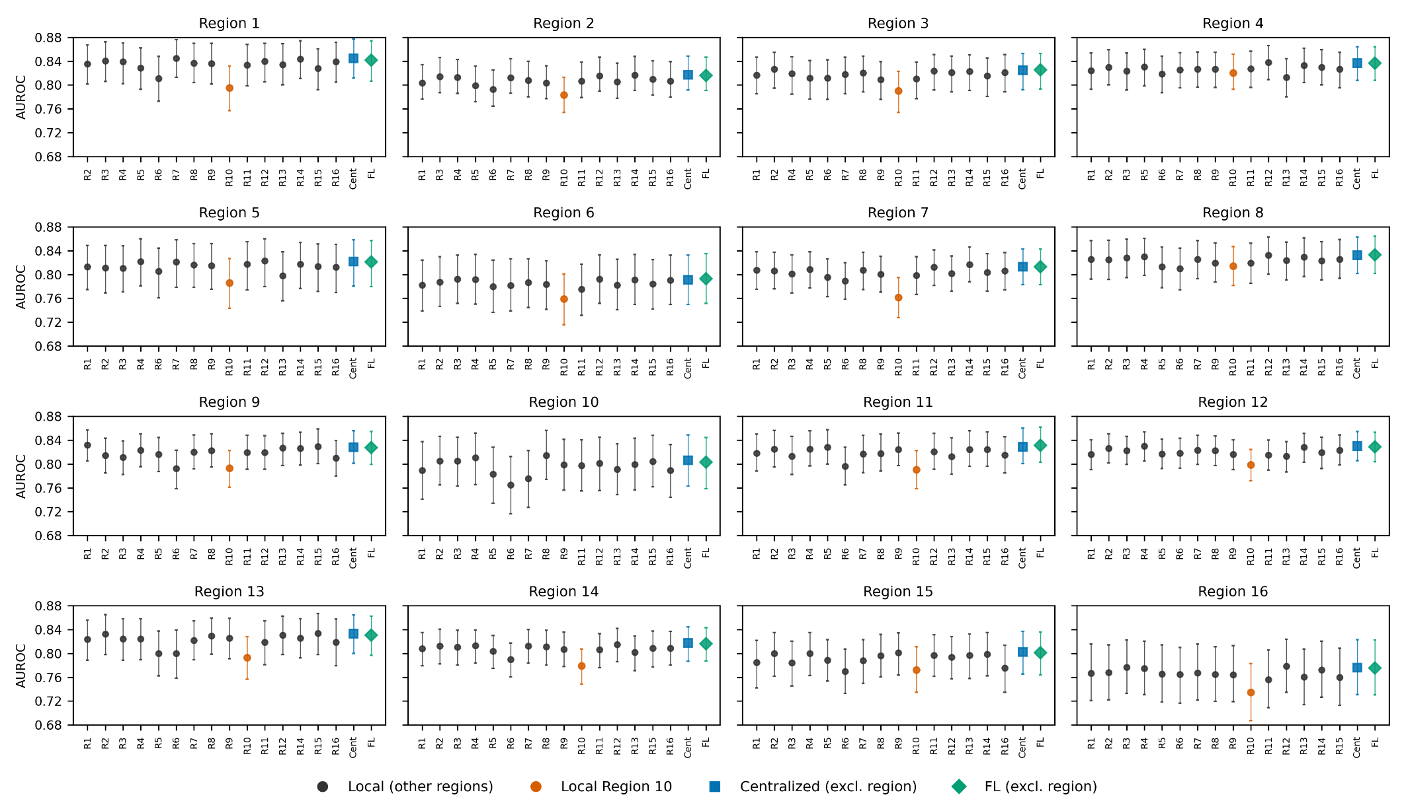
Estimates with 95% CI (1,000 bootstrap resamples); layout and abbreviations as in Figure 2 of the main text. Region 10 is shown in orange.
Figure S5. Calibration slopes of local, centralized, and federated learning models using unregularized logistic regression.
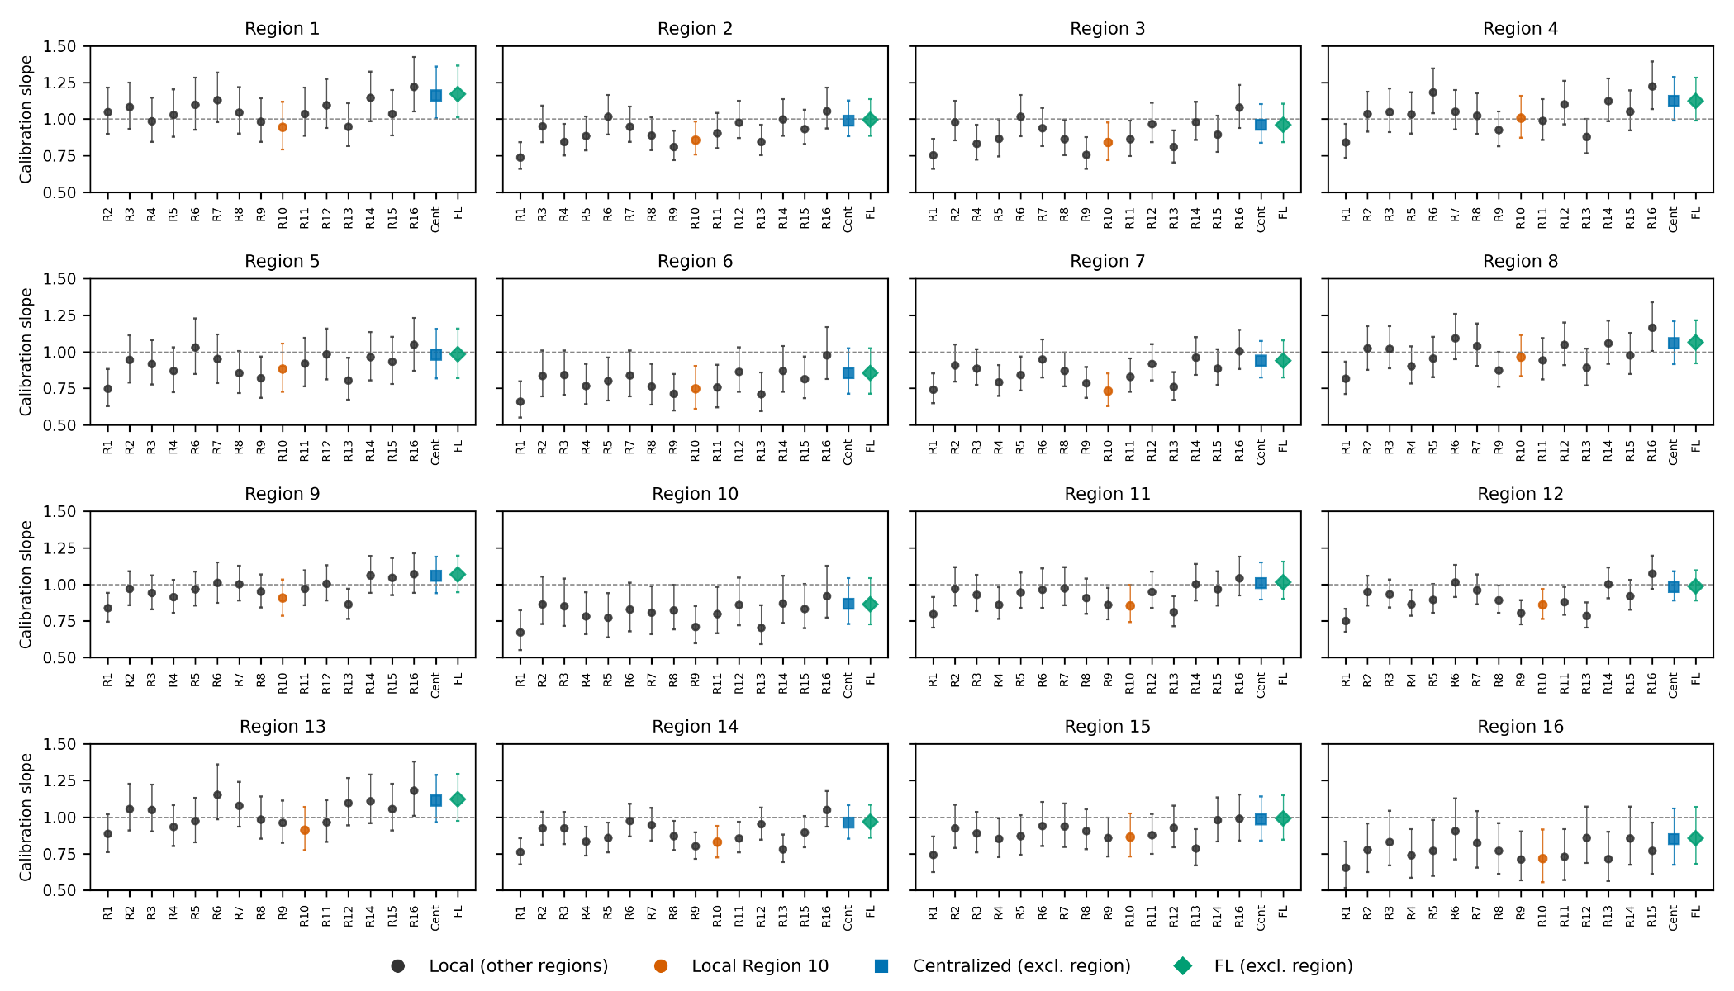
Estimates with 95% CI (1,000 bootstrap resamples); layout and abbreviations as in Figure 2 of the main text. Region 10 is shown in orange.
Figure S6. Calibration slopes of local, centralized, and federated learning models using L2-regularized logistic regression.
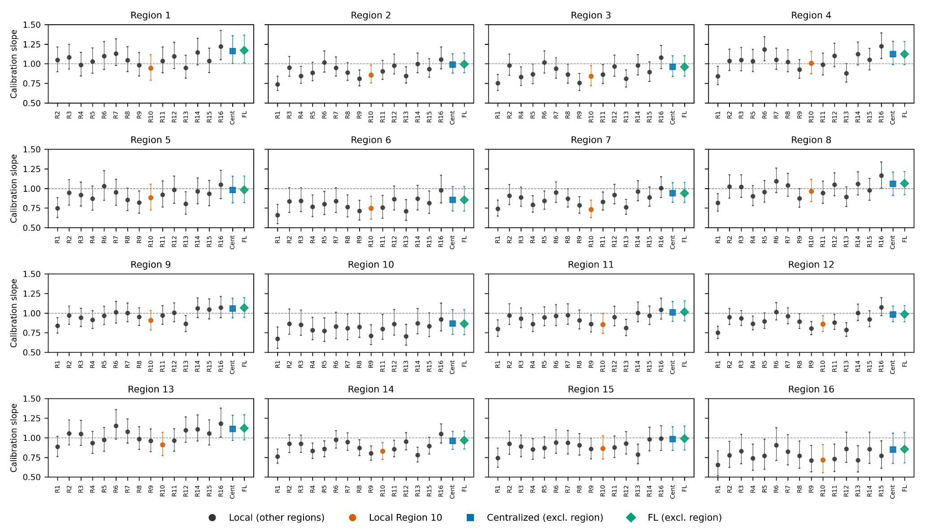
Estimates with 95% CI (1,000 bootstrap resamples); layout and abbreviations as in Figure 2 of the main text. Region 10 is shown in orange.

Figure S7. Calibration slopes of local, centralized, and federated learning models using Elastic Net.
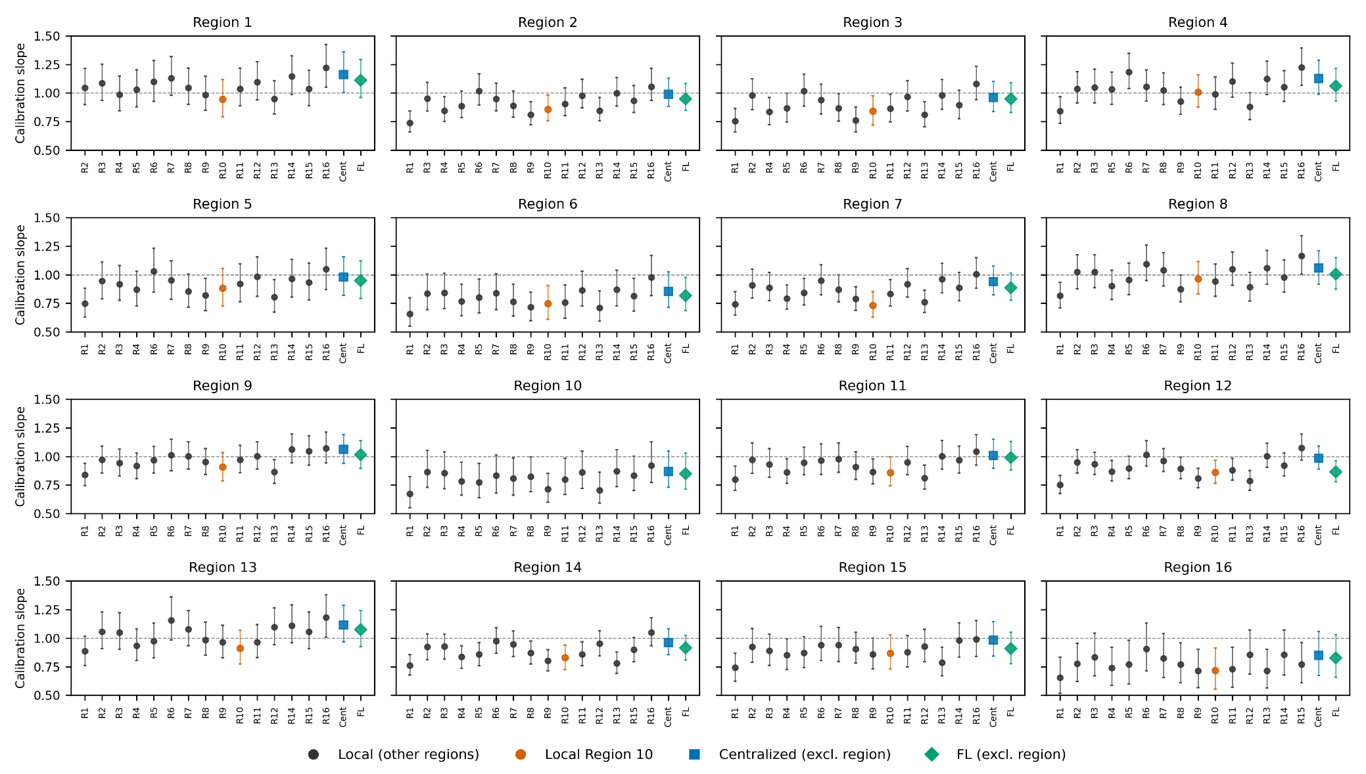
Estimates with 95% CI (1,000 bootstrap resamples); layout and abbreviations as in Figure 2 of the main text. Region 10 is shown in orange.

Figure S8. Calibration intercepts of local, centralized, and federated learning models using unregularized logistic regression.
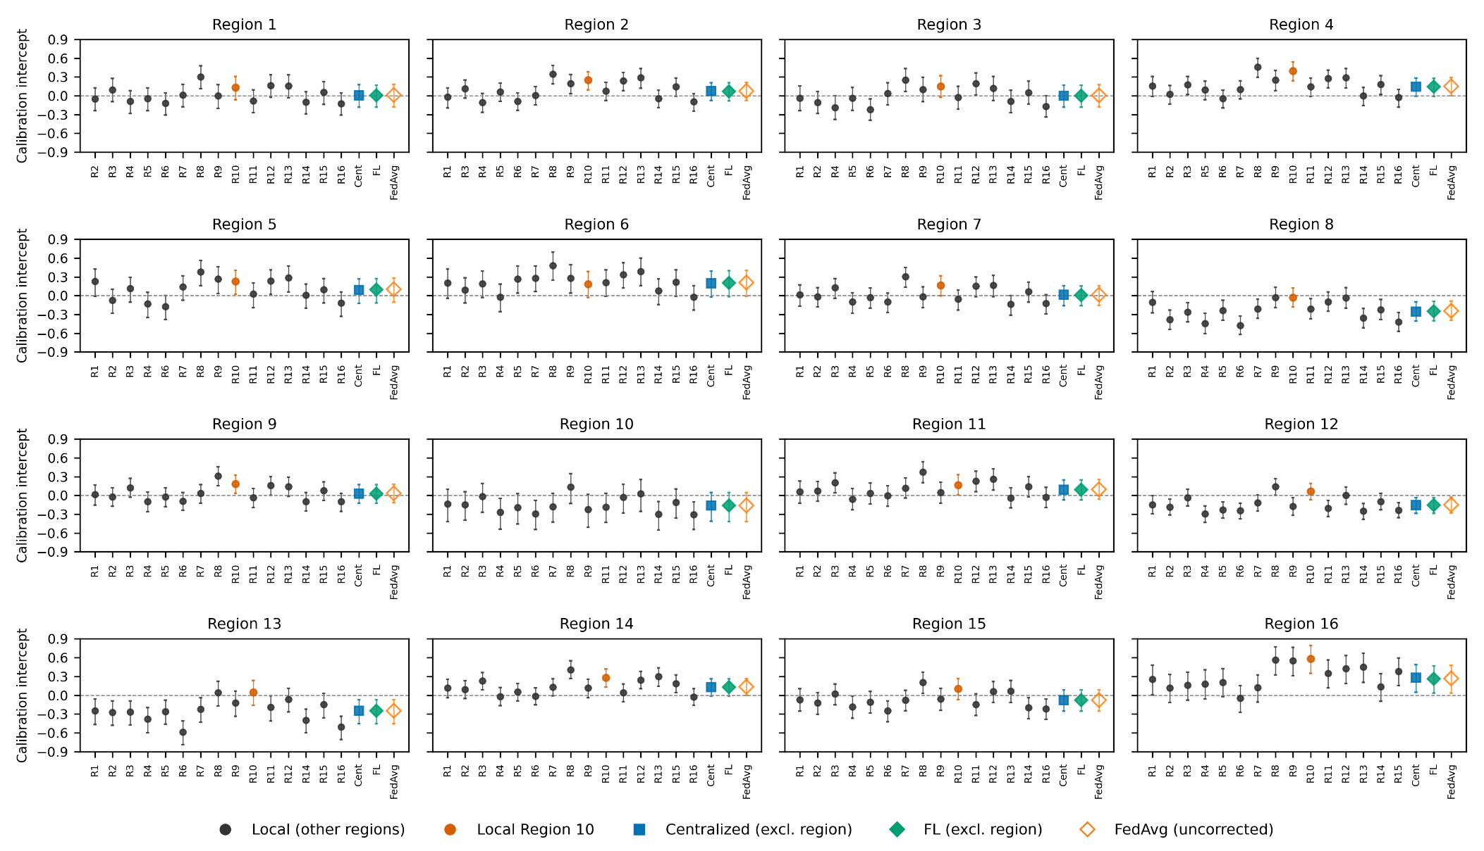
Estimates with 95% CI (1,000 bootstrap resamples); layout and abbreviations as in Figure 2 of the main text. Region 10 is shown in orange.
Figure S9. Calibration intercepts of local, centralized, and federated learning models using L2-regularized logistic regression.
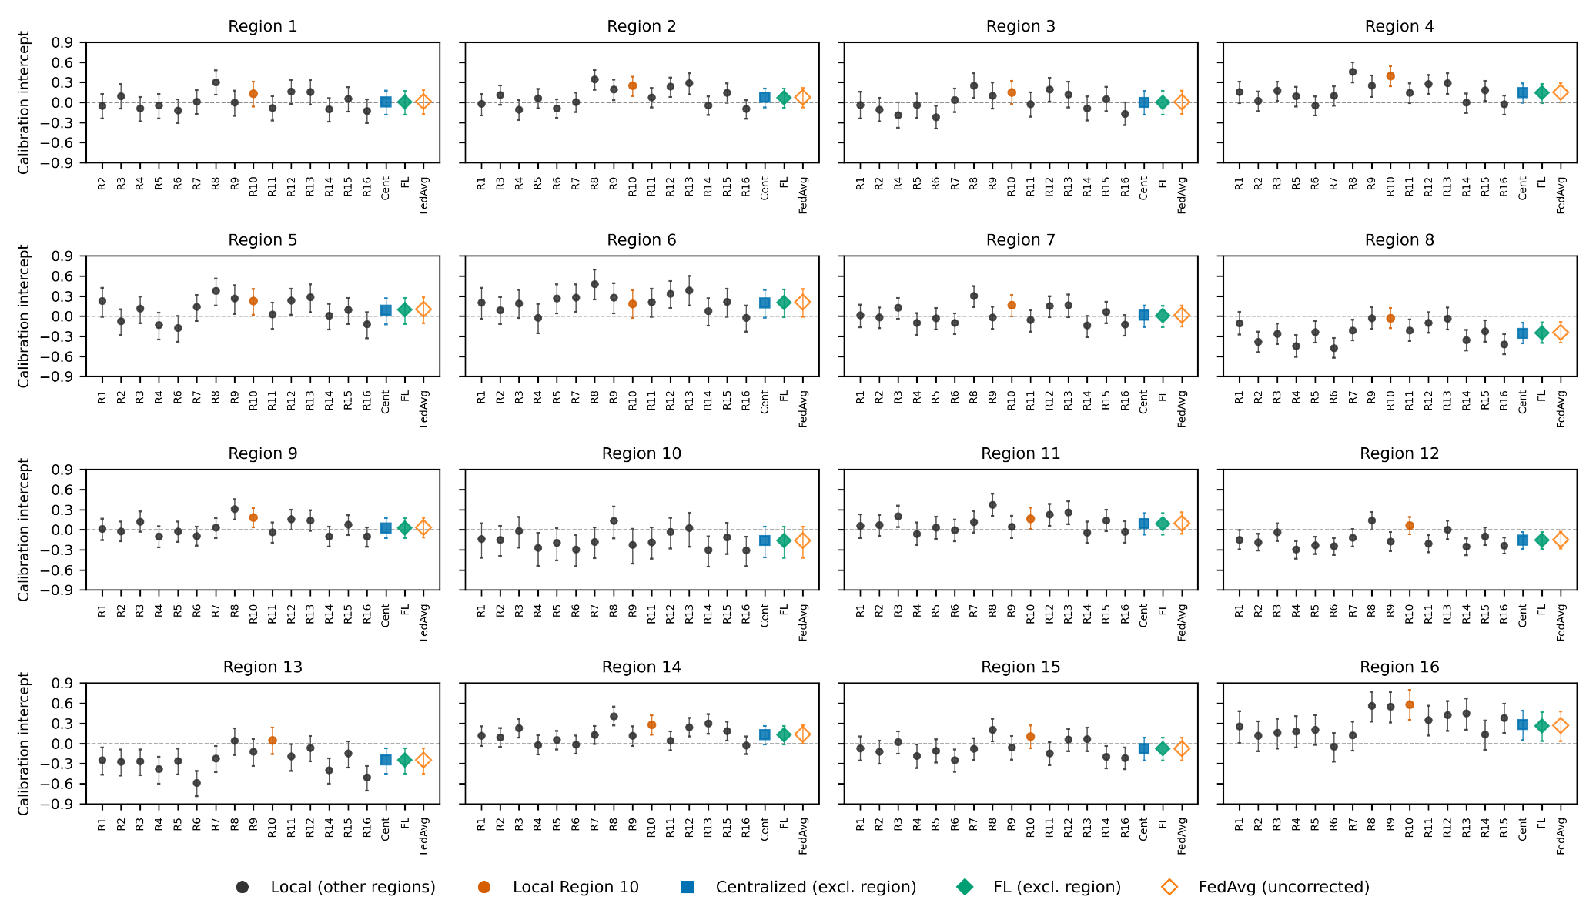
Estimates with 95% CI (1,000 bootstrap resamples); layout and abbreviations as in Figure 2 of the main text. Region 10 is shown in orange.

Figure S10. Calibration intercepts of local, centralized, and federated learning models using Elastic Net.
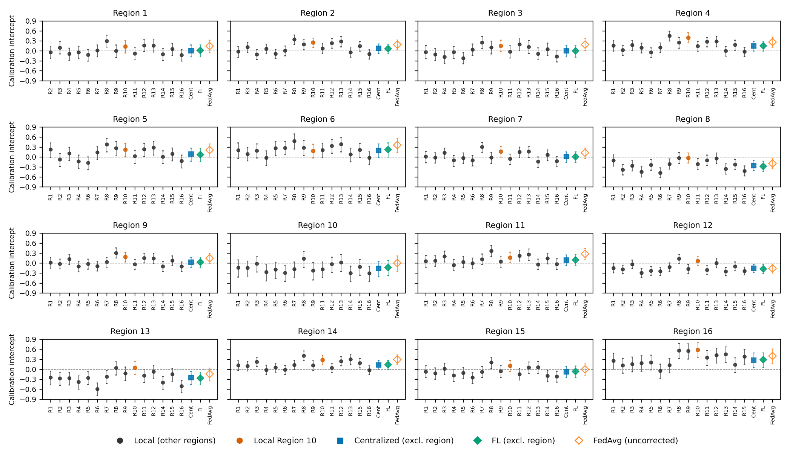
Estimates with 95% CI (1,000 bootstrap resamples); layout and abbreviations as in Figure 2 of the main text. Region 10 is shown in orange.

