Supplementary figure legends
Supplementary figure 1: 2D visualization of docking analysis of CotH3 binding with 12,28-Oxamanzamine A (A), Parsiguine (B), Haliclonacyclamine B (C), Vialinin B (D), 6-Deoxymanzamine X (E), Natamycin (F), Olorofim (G), Deoxytopsentin (H), Manzamine E (I), Fascioquinol A (J).
Supplementary figure 2: 2D visualization of docking analysis of Lanosterol 14 alpha-demethylase binding with Pramiconazole (A), 12,28-Oxamanzamine A (B), Fascioquinol D (C), Saperconazole (D), Nakadomarin A (E), Plakinamine A (F), Fascioquinol C (G), Parsiguine (H), Hesperidin (I), Epoxyazadiradione (J)
Supplementary figure 3: 2D visualization of docking analysis of Mucoricin binding with 12,28-Oxamanzamine A (A), Manzamine A (B), Parsiguine (C), Halicyclamine A (D), Tetrahydrohaliclonacyclamine A (E), Phaeosphenone (F), 6-Deoxymanzamine X (G), Goniodomin A (H), Hesperidin (I), Stelletin A (J).

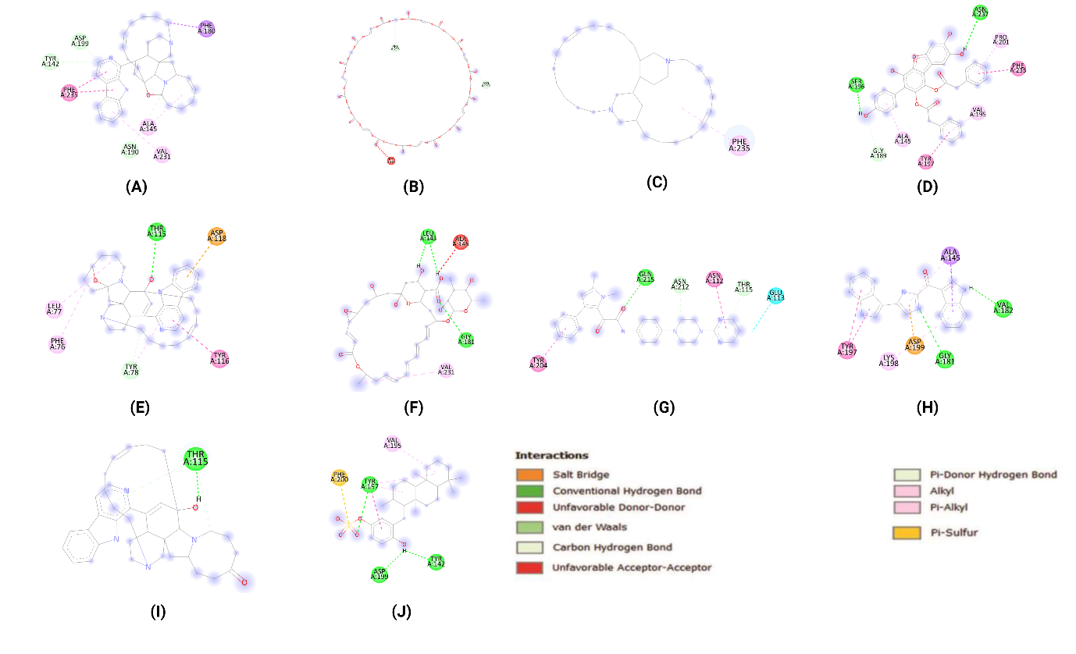
Supplementary figure 1: 2D visualization of docking analysis of CotH3 binding with 12,28-Oxamanzamine A (A), Parsiguine (B), Haliclonacyclamine B (C), Vialinin B (D), 6-Deoxymanzamine X (E), Natamycin (F), Olorofim (G), Deoxytopsentin (H), Manzamine E (I), Fascioquinol A (J).

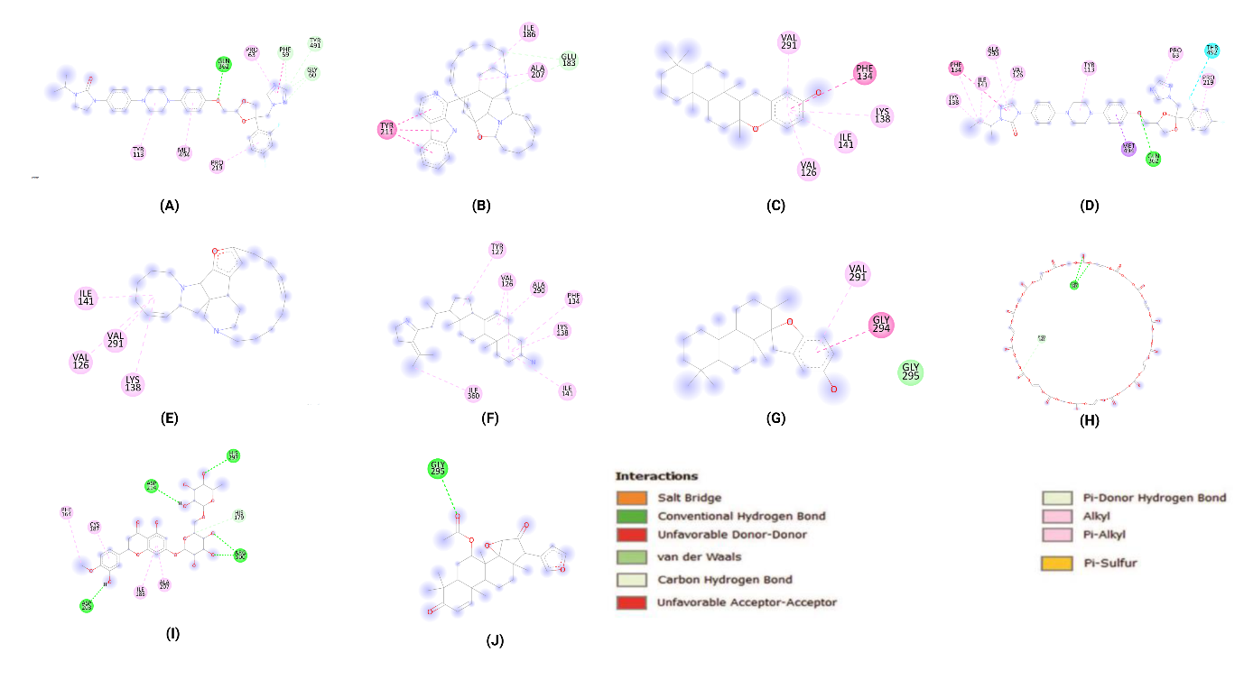
Supplementary figure 2: 2D visualization of docking analysis of Lanosterol 14 alpha-demethylase binding with Pramiconazole (A), 12,28-Oxamanzamine A (B), Fascioquinol D (C), Saperconazole (D), Nakadomarin A (E), Plakinamine A (F), Fascioquinol C (G), Parsiguine (H), Hesperidin (I), Epoxyazadiradione (J)
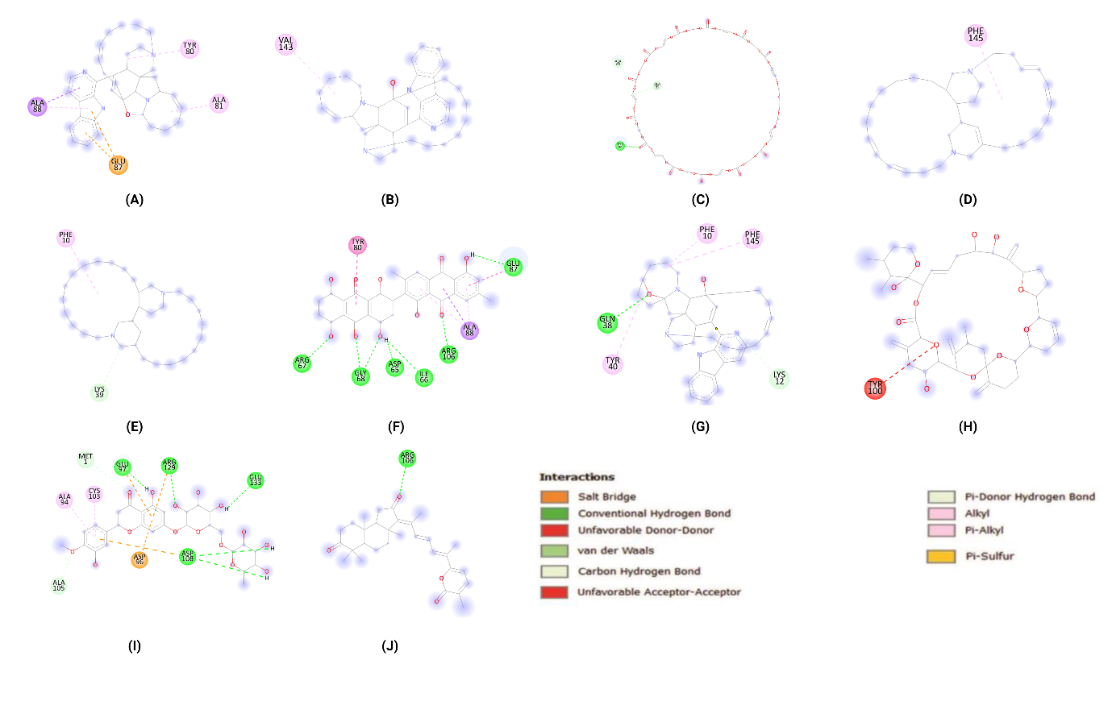
Supplementary figure 3: 2D visualization of docking analysis of Mucoricin binding with 12,28-Oxamanzamine A (A), Manzamine A (B), Parsiguine (C), Halicyclamine A (D), Tetrahydrohaliclonacyclamine A (E), Phaeosphenone (F), 6-Deoxymanzamine X (G), Goniodomin A (H), Hesperidin (I), Stelletin A (J).

