Decoupling must accelerate threefold to align national environmental footprints with planetary boundaries

Supporting Information

SI 1: Allocation of agricultural land use footprints on potential forest

Input datasets

Potential forest
Potential natural vegetation (PNV) represents the vegetation cover expected under equilibrium conditions in the absence of human influence ¹. Taking this as a baseline, agricultural land uses (including cropland and grazing pasture), can be interpreted as occupying areas where forest ecosystems could otherwise have existed. Therefore, assessing the footprints of agricultural land use appropriate to potential forest is relevant to land system and biosphere integrity changes. It quantifies how food production systems occupy land that should support ecological maintenance. Potential forest layers are derived from the PNV dataset by extracting areas corresponding to boreal, temperate, and tropical forest biomes at ~1 km resolution. It indicates probability that a given area (pixel) would be occupied by a certain forest type.

HILDA+ Land use
Historic Land Dynamics Assessment (HILDA+, ~0.01°) is a long-term dataset on land global land use (1960-2019) constructed based upon the harmonization of remote sensing, historical land use reconstruction, and statistics to generate authentic land use maps aligned with the definitions of FAO categories. It also separates natural and grazing pastures, which is appropriate for impact assessment of livestock sectors.

Time series of Crops and Livestock distribution
Spatial distribution datasets for crops and livestock provide information for attributing land use impacts of cropland and grazing pasture to specific crop and livestock categories. Spatial Production Allocation Model (SPAM) and Gridded Livestock of the World (GLW) datasets present spatial patterns of more than 40 crops and 5 grazing-relied animals, respectively. Yet, their temporal coverage is limited, with data available for only three years (2010, 2015, and 2020) at an approximate spatial resolution of 10 km. A seamless annual time series of both SPAM and GLW dataset for the period 2000-2020 was generated by combining original spatial patterns with FAOSTAT statistics, as presented by Nguyen et al.²

Allocating agricultural land use impacts on potential forests
We first estimate overall impacts of cropland and grazing pasture on potential forests. It is quantified as the total area of potential forest appropriated by cropland/pasture layer extracted from HILDA+ land use dataset (Eq. 1).
$A_{lu(i,j)}={PF}_{(i,j)} ×{LU}_{(i,j)}×a_{(i,j)}$ (1)
where Alu(i,j) is total area at pixel (i,j) appropriated by LU (cropland or pasture, 0/1) weighted by the probability of potential forest (PF), relative to the total pixel area a(i,j).
The overall impact was then allocated to each crop or livestock item by incorporating with SPAM and GLW datasets. The impact from cropland is directly allocated each crop item based on their shared proportion of physical area (Eq. 2). The allocation of pasture impact to livestock categories is not done through headcounts but the dry matter intake (DMI) by each animal group (Eq. 2). A more specific method to estimate DMI for each animal group based on GLW is presented in Nguyen et al.².
$A_{x(i,j)}=A_{lu(i,j)}×P_{x(i,j)}$ (2)
where Ax(i,j) is total impacts of cropland/pasture appropriated by crop/animal x at pixel (i,j), and Px(i,j) is the share proportion of physical area (or DMI) of crop/animal x relative to the total area (or total DMI) occupied by all other items and itself.
The spatial impacts for each crop (42/46) and animal (9) items were aggregated to the national level. Subsequently, these national impacts were transformed into relevant original sectors in Exiobase using a concordance matrix for MRIO analysis.

Technical procedure to generate annual time series of dry matter intake for livestock groups
Time series of dry matter intake for specific livestock groups was generated by combining time series of Gridded livestock of the world (GLW) ^{3–5} and reference values for total feed intake and percentage of dry matter intake (DMI) from pasture ⁶ as shown in Figure SI-1.
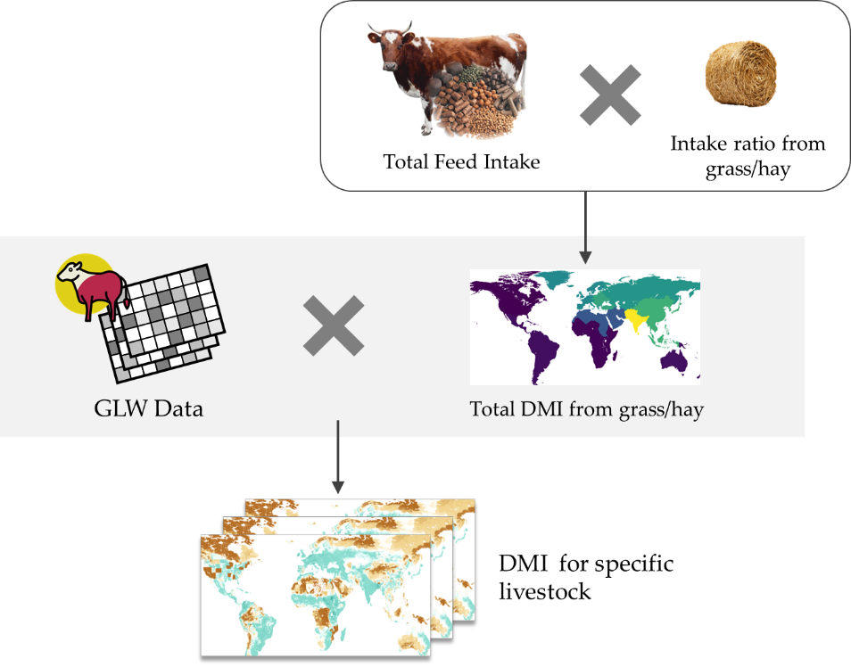
Figure SI 1.1. Overall approach generates time series DMI from grass/hay
Step 1. Data collection on dry matter intake
Mottet et al. ⁶ reported global data on livestock production systems, including feed rations feed conversion ratios across a wide range of feed materials and livestock groups (i.e., dairy cattle, beef cattle, dairy buffaloes, meat buffaloes, dairy small ruminant, and meat small ruminant). These data are disaggregated geographically using two-tier classification that distinguishes OECD (Organization for Economic Co-operation and Development) and non-OECD countries and further subdivides regions into North America, Russia, Western Europe, Eastern Europe, Near East and North Africa, East and Southeast Asia, Oceania, South Asia, Latin America and Caribbean, and Sub-Saharan Africa. We extracted and synthesized global livestock feed rations measured by total dry matter (DM) (Table SI 1.1). We adopted the dry matter intake from mixed rations rather than grazing or feedlots to better represent the dominant global livestock production and ensure consistency with national production systems, which rarely explicit differentiation between feed regimes. Based on animal body size, the total feed rations for horses are assumed to be equivalent to those of cattle and buffaloes, whiles sheep and goats are represented by small ruminants.
Table SI 1.1. Global livestock feed rations by regions and species (Unit: kg DM/head/year)
Livestock | Non-OECD | OECD
Cattle and buffaloes | 2,531 | 2,898
Small ruminants | 238 | 301
Table SI 1.2. Percentage of dry matter intake from grass and hay (Unit: %)
Region | Dairy cattle | Beef cattle | Dairy buffaloes | Meat buffaloes | Dairy small ruminant | Meat small ruminant
North America | 31.4 | 74.6 | 15.6 | - | 67.2 | 78.8
Russia | 47.6 | - | - | 68.5 | 56.6 | 67.6
Western Europe | 49.8 | 50.8 | 17.8 | - | 69.1 | 67
Eastern Europe | 45.3 | 42.9 | 64.8 | - | 57.5 | 66
Near East and North Africa | 59.2 | 61.6 | 14.1 | 66.6 | 53.4 | 57.1
East and Southeast Asia | 41.6 | 42.3 | 49.4 | 49.8 | 56.8 | 52.3
Oceania | 73.9 | 70.3 | - | - | 69.1 | 82.9
South Asia | 24.9 | 20.5 | 25.3 | 25.7 | 30.2 | 32.3
Latin America and Caribbean | 70.3 | 74.5 | 77.5 | 81.2 | 86.8 | 87.7
Sub-Saharan Africa | 74.9 | 73.7 | - | - | 63.7 | 66.7
We further extracted intake ratio from grass and hay, which directly represent pasture-related impacts, to estimate the final grazing-derived dry matter intake for each livestock group (as shown in Table SI 1.2). Overall, intake ratio is not substantially different between dairy and meat production systems. To simplify the calculation procedure, we applied averaged intake ratios for each livestock group regardless of production purposes, except for cattle in North America and buffaloes in Near East and North Africa, which were treated separately due to distinct feeding practices. Intake ratios for horses were assumed to be comparable to those of cattle, reflecting similar body size and forage requirements. Small ruminants are also presented for sheep and goats based on the same basis of body size.
Step 2. Estimation of theorical total dry matter intake from grass and hay
The next step is combination of reference values of total rations with intake ratio from pasture to generate regional theoretical estimates of dry matter intake from grass and hay for each livestock category (Eq. 3). This value
${DMI}_{x,j}^{past}={DMI}_{x,j}^{total}×R_{x,j}^{grass}$ (3)
where ${DMI}_{x,j}^{past}$ (kg/animal/year) denotes pasture-derived dry matter intake for livestock group j at region x; ${DMI}_{x,j}^{total}$ is total dry matter intake from feed for livestock group j at region x; and $R_{x,j}^{grass}$ is the intake ratio from grass and hay for livestock group j at region x.
Step 3. Estimate spatial explicit total dry matter intake from pasture for specific livestock
The total dry matter intake value estimated in Step 2 represents a per-head reference value for each livestock at a given country. To derive spatially explicit total dry matter intake from pasture at a location, this reference value was combined with gridded livestock density data from GLW data, which provides the number of livestock head per pixel (Eq. 4). The time series of dry matter intake from pasture for each livestock group was obtained by combining time series of GLW data for each livestock group and the raster of per-head reference raster, under the assumption that these values remain constant over time. Ultimately, we completed a time series of total dry matter intake from pasture for each livestock group, illustrated as an example below (Figure SI 1.2). This time series was subsequently used to calculate the share proportion of each livestock group, which served as a weighting factor to allocating biodiversity impacts of pasture to individual livestock groups.
${DMI}_{i,j}^{past}={DMI}_{x,j}^{past}×N_{i,j}$ (4)
where ${DMI}_{i,j}^{past}$ (kg/year) is total dry matter intake from pasture of livestock j at pixel i; ${DMI}_{x,j}^{past}$ pasture-derived dry matter intake for livestock group j at region x; and N_{i,j} is total number of livestock j at pixel i.

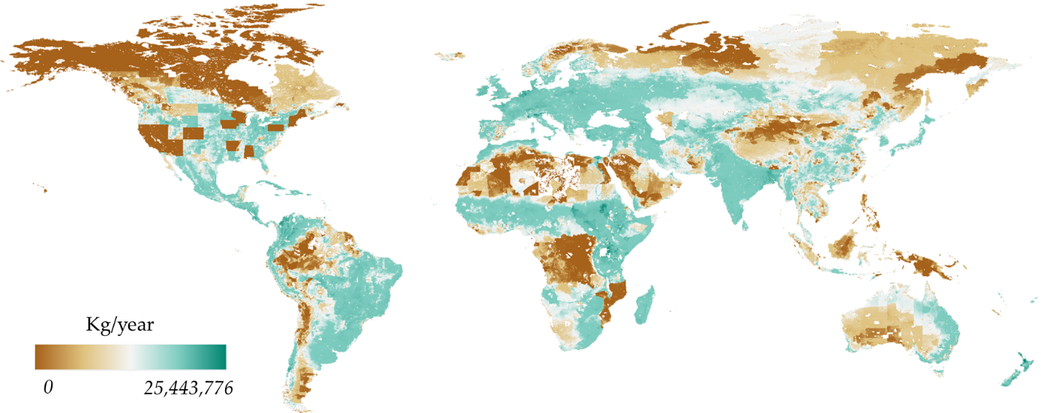
Figure SI 1.2. Example of total DMI from pasture for dairy cattle in 2000.

SI 2: Freshwater boundary normalisation and scarcity-weighted indicators
This supporting information documents the boundary comparison used for physical blue-water consumption and scarcity-weighted freshwater indicators. The main analysis retains the legacy planetary-boundary comparator for global consumptive blue-water use but reports AWARE 2.0 as the main scarcity-weighted indicator. WSI is retained as a sensitivity test.
The physical indicator compares annual global consumptive blue-water use $W_{blue}$ with the legacy freshwater-use planetary boundary. We use $PB_{phys}=4,000 km^{3} yr^{-1}$ as the reference boundary and $PB_{phys}=6,000 km^{3} yr^{-1}$ as the upper-bound sensitivity.
AWARE 2.0 characterises physical blue-water consumption by basin-level water scarcity. The raw AWARE-weighted total is:
WAWARE=i,r​Wi,r×CFi,r,AWARE
where $W_{AWARE}$ is AWARE 2.0-weighted blue-water consumption, $W_{i}$ is physical blue-water consumption in region r, sector $i$, and $CF_{i,r,AWARE}$ is the AWARE 2.0 characterisation factor for region r, sector $i$ based on a spatially explicit crop specific weighting of water use aggregated to country totals.
The global consumption-weighted AWARE factor is calculated from the same blue-water inventory:
CFAWARE=i,r​Wi,r×CFi,r,AWAREi,r​Wi,r
For the 2020 inventory used here:
$${\overline{CF}}_{AWARE}=\frac{40,766}{1,234}=33.0 m^{3} world\text{-}eq m^{-3}$$
To avoid comparing raw AWARE world-equivalent volumes directly with the physical blue-water boundary, the AWARE-weighted result is rescaled by this global factor:
$$W_{AWARE,norm}=\frac{W_{AWARE}}{{\overline{CF}}_{AWARE}}$$
where $W_{AWARE,norm}$ is AWARE-normalised blue-water consumption, expressed in global-average-scarcity-equivalent blue-water units.
This formulation preserves relative scarcity weighting while placing the result on a scale directly comparable with the physical blue-water boundary. Because ${\overline{CF}}_{AWARE}$ is calculated from the same global inventory, the global AWARE-normalised total equals the physical global total by construction; deviations are informative for sectors, countries, products, or final-demand categories that are more or less scarcity-intensive than the global average.
The Water Stress Index (WSI) is retained as an alternative scarcity-weighting sensitivity. The WSI-weighted result is:
WWSI=r,i​Wr,i×WSIr,i
where $W_{WSI}$ is WSI-weighted blue-water consumption and $WSI_{r,i}$ is the WSI characterisation factor for location r and production unit $i$. Using a global average WSI of $\overline{WSI}=0.51$, the WSI-weighted boundary reference is:
$$PB_{WSI}=PB_{phys}×\overline{WSI}$$

Table SI 2.1 AWARE global factors
Year | AWARE 2.0-weighted blue water (km³ world-eq) | Physical blue-water consumption (km³) | Implied global AWARE factor
2000 | 37,688 | 1,099 | 34.3
2010 | 38,353 | 1,163 | 33.0
2020 | 40,766 | 1,234 | 33.0
The implied global AWARE 2.0 factor is stable at approximately 33 m³ world-eq per m³ of blue water consumed across 2000-2020. This value is well above 1 because AWARE characterisation factors span 0.1-100 and because global blue-water consumption is dominated by irrigation in relatively water-scarce basins.
Table SI 2.2 Boundary comparison for 2020
Indicator | 2020 result | Boundary reference, 4,000 km³ | Upper sensitivity, 6,000 km³ | Share of reference | Share of upper
Physical blue-water consumption | 1,234 km³ yr⁻¹ | 4,000 km³ yr⁻¹ | 6,000 km³ yr⁻¹ | 31% | 21%
Raw AWARE 2.0-weighted blue-water consumption | 40,766 km³ world-eq yr⁻¹ | 132,000 km³ world-eq yr⁻¹ | 198,000 km³ world-eq yr⁻¹ | 31% | 21%
AWARE 2.0-normalised blue-water consumption | 1,234 km³ global-average-scarcity-eq yr⁻¹ | 4,000 km³ global-average-scarcity-eq yr⁻¹ | 6,000 km³ global-average-scarcity-eq yr⁻¹ | 31% | 21%
WSI-weighted blue-water consumption | 588 km³ WSI-eq yr⁻¹ | 2,040 km³ WSI-eq yr⁻¹ | 3,060 km³ WSI-eq yr⁻¹ | 29% | 19%
The raw AWARE 2.0 result is included for transparency, but the AWARE 2.0-normalised result is the preferred scarcity-weighted indicator for comparison with the legacy blue-water boundary. The normalised AWARE result preserves relative scarcity weighting while avoiding the misleading comparison of world-equivalent water directly with a physical water boundary.
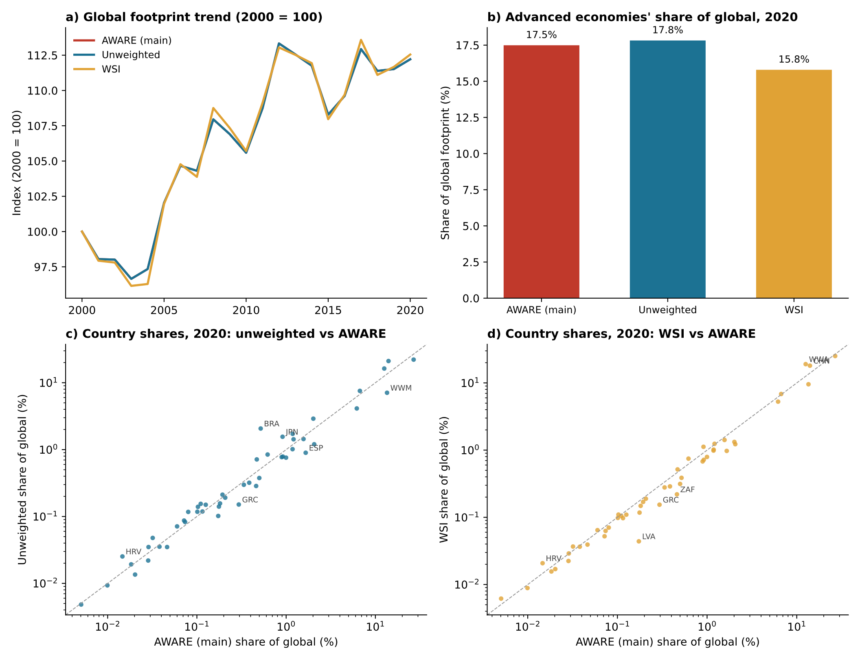
Figure SI 2.1. Comparison of results across unweighted blue water consumption, versus use of AWARE scarcity index and the original water stress index.

SI 3: Trade-channel decomposition
We isolate the contribution of trade by decomposing the total consumption-based footprint I by supply channel as I = I_{d} + I_{m}, where I_{d} and I_{m} are the within-group (d=domestic) and cross-group (m=imports) block sums of the producer-consumer impact matrix S·L·Y derived from EXIOBASE; this captures the full upstream supply chain. We write the structural identity below, in which P is population, A is affluence (GDP per capita in constant 2015 PPP) ·Y. α is the gross-output share sourced within the region group, computed from the column-block partition of L · Y: α = ∑ (L · Y)_{c,c} / ∑_{p} ∑ (L · Y)_{p,c} (where p=producing region, c=consuming region). Given α, the channel intensities t_{d} and t_{m} follow as residual definitions that satisfy the identity by construction.
I = I_{d} + I_{m}
I_{d} = P · A · α · t_{d}
I_{m} = P · A · (1 − α) · t_{m}
α = Σ (L·Y)_{c,c} / Σ_{p} Σ (L·Y)_{p,c}
α defined on direct final demand Y captures only the share of consumer-side purchases sourced domestically, and so misses intermediate-trade composition (for example, domestically assembled goods whose components were imported). Because I_{d} and I_{m} derive from S·L·Y, they include intermediate trade; defining α on the gross-output (L·Y) basis partitions the same upstream scope as the impact split, so intermediate-trade composition enters the Δα term rather than being absorbed into Δt_{d} or Δt_{m}. Empirically α on the L·Y basis is materially smaller than on the Y basis (advanced economies 0.95 vs 0.98 in 2000; emerging-developing 0.82 vs 0.90) and its 2000-2020 change is roughly twice as large.
Applying additive LMDI^{7,8} to I = I_{d} + I_{m} yields five drivers that sum exactly to ΔI: population, affluence, trade composition (α), domestic technology (t_{d}) and embodied foreign technology (t_{m}). With logarithmic-mean weights (where 0=base year, 1=end year) L(x⁰, x¹) = (x¹ − x⁰)/ln(x¹/x⁰):
ΔP = [ L(I_{d}) + L(I_{m}) ] · ln(P¹/P⁰)
ΔA = [ L(I_{d}) + L(I_{m}) ] · ln(A¹/A⁰)
Δα = L(I_{d}) · ln(α¹/α⁰) + L(I_{m}) · ln((1−α¹)/(1−α⁰))
Δt_{d} = L(I_{d}) · ln(t_{d}¹/t_{d}⁰)
Δt_{m} = L(I_{m}) · ln(t_{m}¹/t_{m}⁰)
This is an index decomposition applied to MRIO-derived aggregates (the aggregate-embodied-intensity tradition of ^{9,10}), not a structural decomposition of the Leontief inverse. The decomposition is exact (no residual), time-reversible, and computed over annual year-pairs accumulated 2000-2020 at region-group and country level.
The five-factor Δt mixes pure intensity change with supply-chain lengthening, because t = (I/X)·m with m = X/Y the output multiplier. A six-factor form isolates m:
I = P · A · m · [ α · t̃_{d} + (1−α) · t̃_{m} ]
With “direct” intensities: t̃_{d} = I_{d}/X_{d} and t̃_{m} = I_{m}/X_{m}. A multiplier term Δm = [ L(I_{d}) + L(I_{m}) ]·ln(m¹/m⁰) is added and the channel terms use the direct gross-output intensities. We report the five-factor form as headline because it captures both direct and intermediate trade changes, and Δm is small for advanced economies (m: 1.84 to 1.82, 2000 - 2020); for emerging-developing economies m rises about 8% (1.86→2.00), so part of the five-factor Δt there reflects supply-chain lengthening rather than pure intensity change. Both forms are exactly additive.
Δα captures the impact change attributable to shifts in the gross-output sourcing share. Where imports are dirtier than domestic production (t_{m} > t_{d}, typical for advanced economies), a fall in α (more imports) raises impact, so Δα > 0. Where domestic production is dirtier (t_{d} > t_{m}, typical for emerging-developing economies), a rise in α (more domestic sourcing) raises impact, so Δα > 0. Both groups show Δα > 0 over 2000-2020 for opposite mechanical reasons: advanced economies shifted toward imports while their imports were dirtier than domestic, and emerging economies shifted toward domestic production while their domestic supply was less clean than imports.

SI 4: Allocation-principle sensitivity (downscaling robustness)
The main analysis downscales each global boundary by equal per-capita share. A national boundary is the global boundary PB times a share, where exceedance_{c} = footprint_{c} / (PB x share_{c}), for country or region c.
Footprints are unchanged across principles; only the share is re-weighted, and hence exceedance varies. In the supporting information we provide results across three different principles:
• Equal per-capita (main analysis): share_{c} = population_{c} / population_{world}.
• Grandfathering: share_{c} = footprint_{c,t=0} / footprint _{world,t=0} allocation in proportion to the base-year (2000) share of the pressure, holding incumbents’ position fixed.
• Ability to pay: share_{c} proportional to pop _{c,} x (GDPpc _{world} / GDPpc _{c}), a capacity weighting giving lower-income countries a larger per-capita entitlement; one of several possible formulations.
Global exceedance is invariant to the principle, a re-allocation cannot change the global total, so the sensitivity concerns the distribution of responsibility across countries.

Table SI 4.1 reports 2020 exceedance (relative to the lower boundary) for advanced and emerging-developing aggregates and the global total under each principle; Figure SI 4.1 shows the same.

Table SI 4.1. 2020 consumption-based exceedance (× lower boundary) by allocation principle. Global rows are identical across principles.
Indicator | Region | Equal per-capita | Grandfathering | Ability to pay
Climate | Advanced | 4.83 | 1.34 | 7.17
 | Emerging | 1.8 | 3.33 | 1.7
 | Global | 2.25 | 2.25 | 2.25
Biodiversity | Advanced | 6.8 | 2.67 | 10.09
 | Emerging | 3.35 | 4.6 | 3.16
 | Global | 3.86 | 3.86 | 3.86
Phosphorus | Advanced | 5.11 | 2.07 | 7.58
 | Emerging | 3.05 | 4.1 | 2.87
 | Global | 3.35 | 3.35 | 3.35
Nitrogen | Advanced | 3.16 | 1.28 | 4.69
 | Emerging | 1.62 | 2.19 | 1.53
 | Global | 1.85 | 1.85 | 1.85
Land | Advanced | 1.77 | 0.84 | 2.63
 | Emerging | 1.02 | 1.26 | 0.96
 | Global | 1.13 | 1.13 | 1.13
Acid | Advanced | 2.45 | 0.62 | 3.63
 | Emerging | 0.8 | 1.67 | 0.75
 | Global | 1.04 | 1.04 | 1.04
Water | Advanced | 0.37 | 0.2 | 0.54
 | Emerging | 0.3 | 0.35 | 0.28
 | Global | 0.31 | 0.31 | 0.31

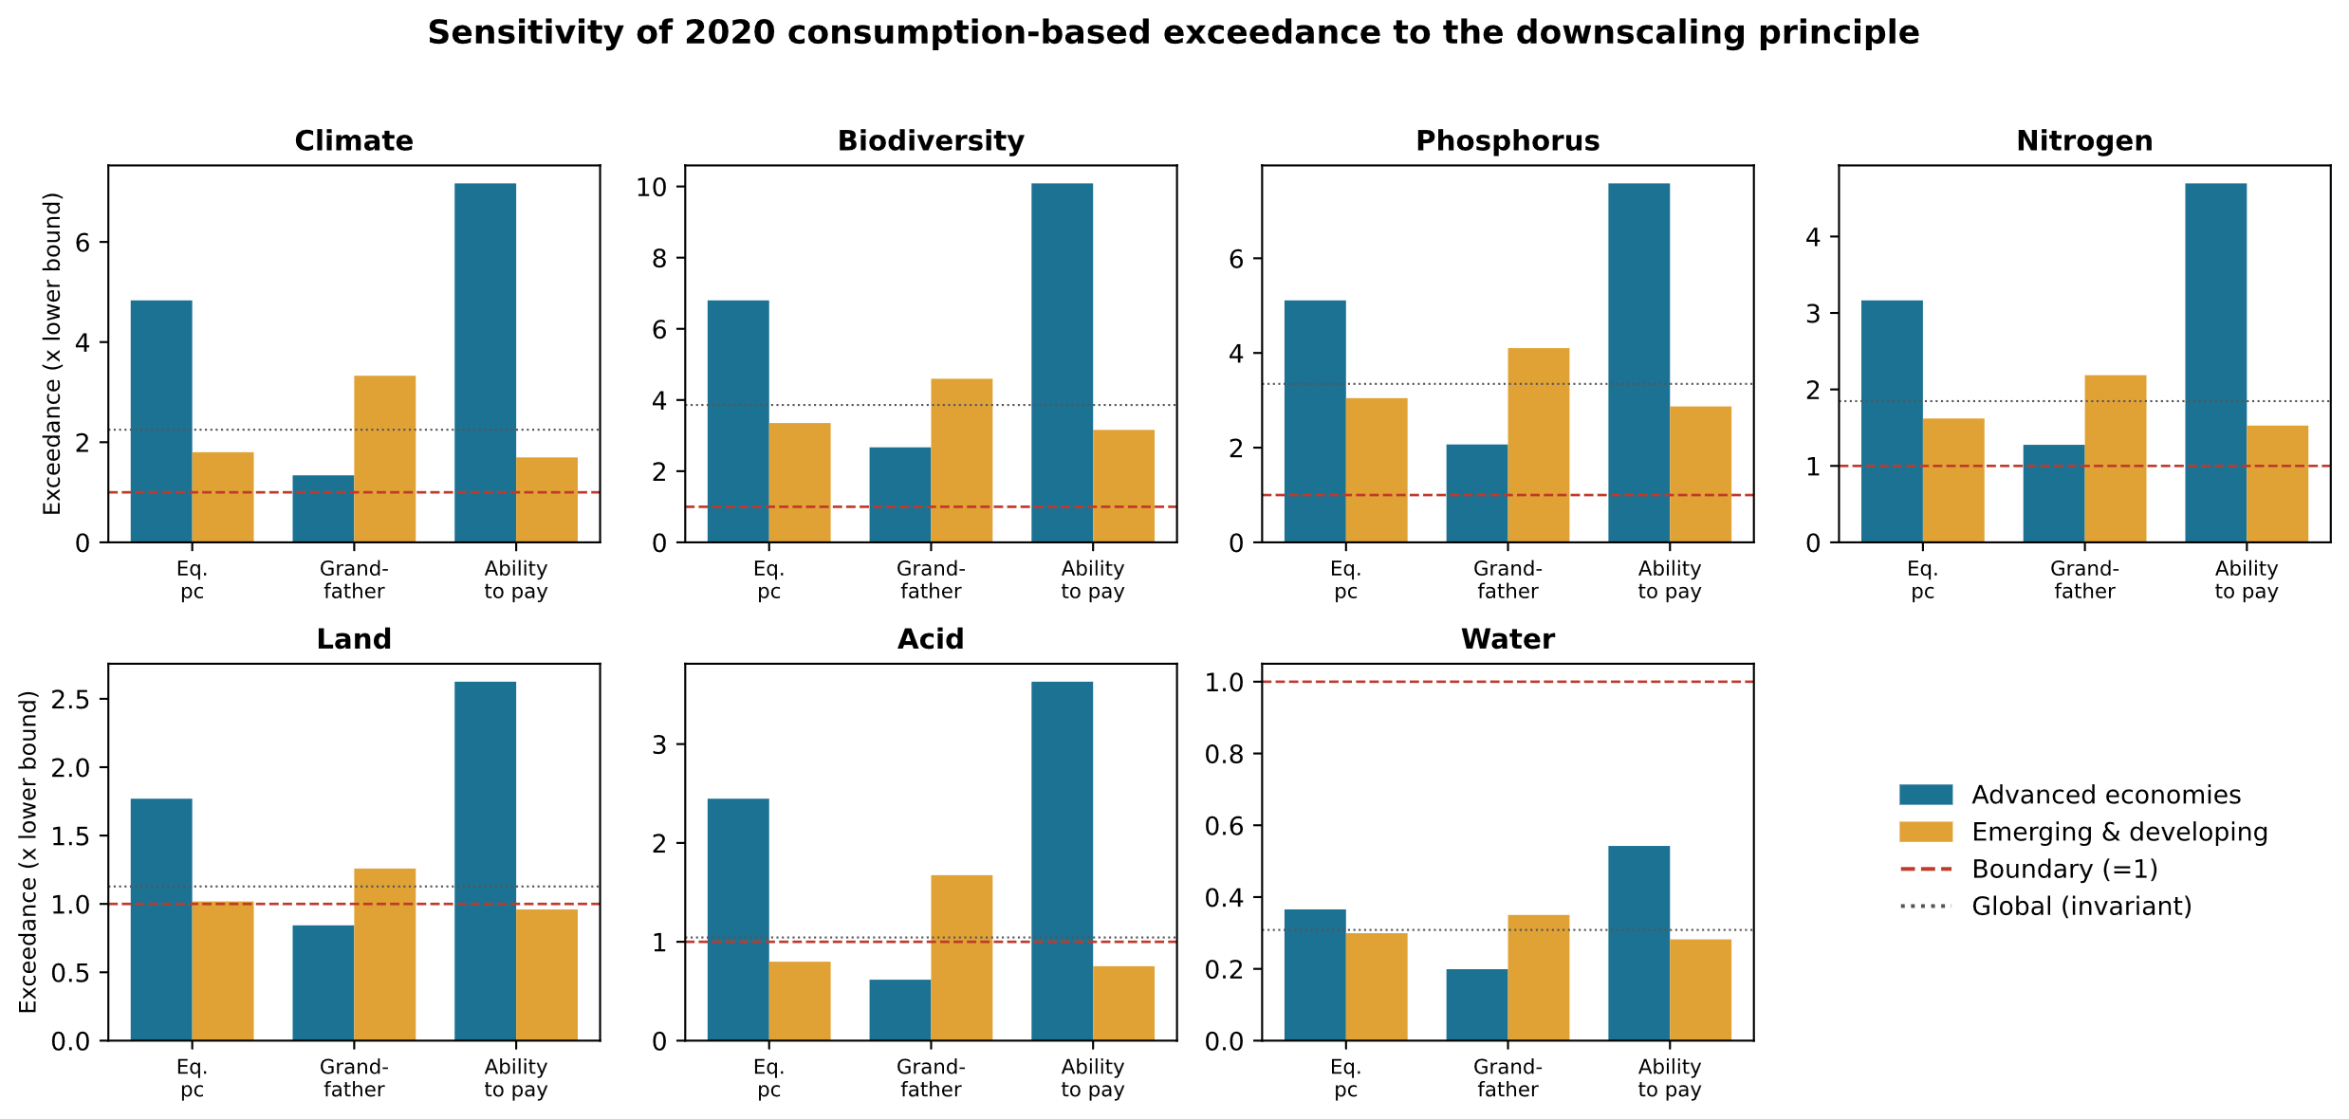
Figure SI 4.1. Sensitivity of 2020 consumption-based exceedance (× lower boundary) to the downscaling principle, for advanced (blue) and emerging-developing (orange) aggregates across seven domains. Dashed line = boundary (=1); dotted line = global exceedance, invariant to the principle.
For climate, advanced-economy exceedance moves from 4.8 times (equal per-capita) to 1.3 times (grandfathering) to 7.2 times (ability to pay), and emerging-developing in the opposite direction (1.8 times vs 3.3 times vs 1.7 times). Grandfathering entrenches historically large footprints; ability-to-pay widens advanced-economy exceedance further. The paper’s substantive conclusions, that the safe operating space is exceeded and that observed decoupling is insufficient, are unaffected by the allocation choice, but the attribution of over-shoot across country groups is not robust to it, which is why the allocation principle is treated as an explicit, reported assumption.

SI 5: Additional country and regional results
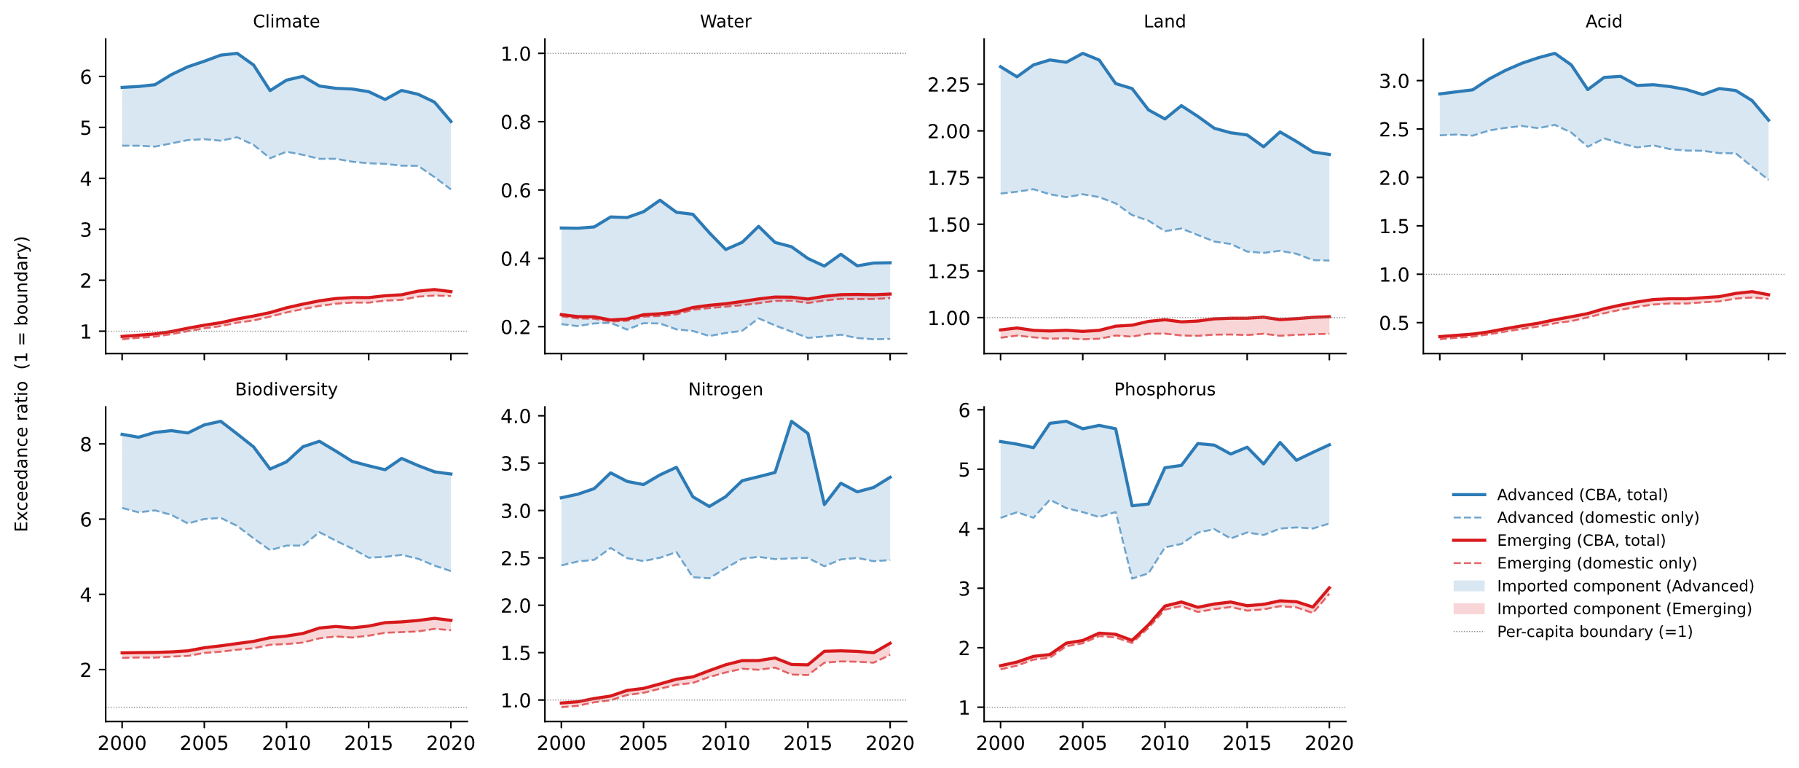
Figure SI 5.1 shows the domestic and imported shares of each indicator footprint for advanced and emerging regions.

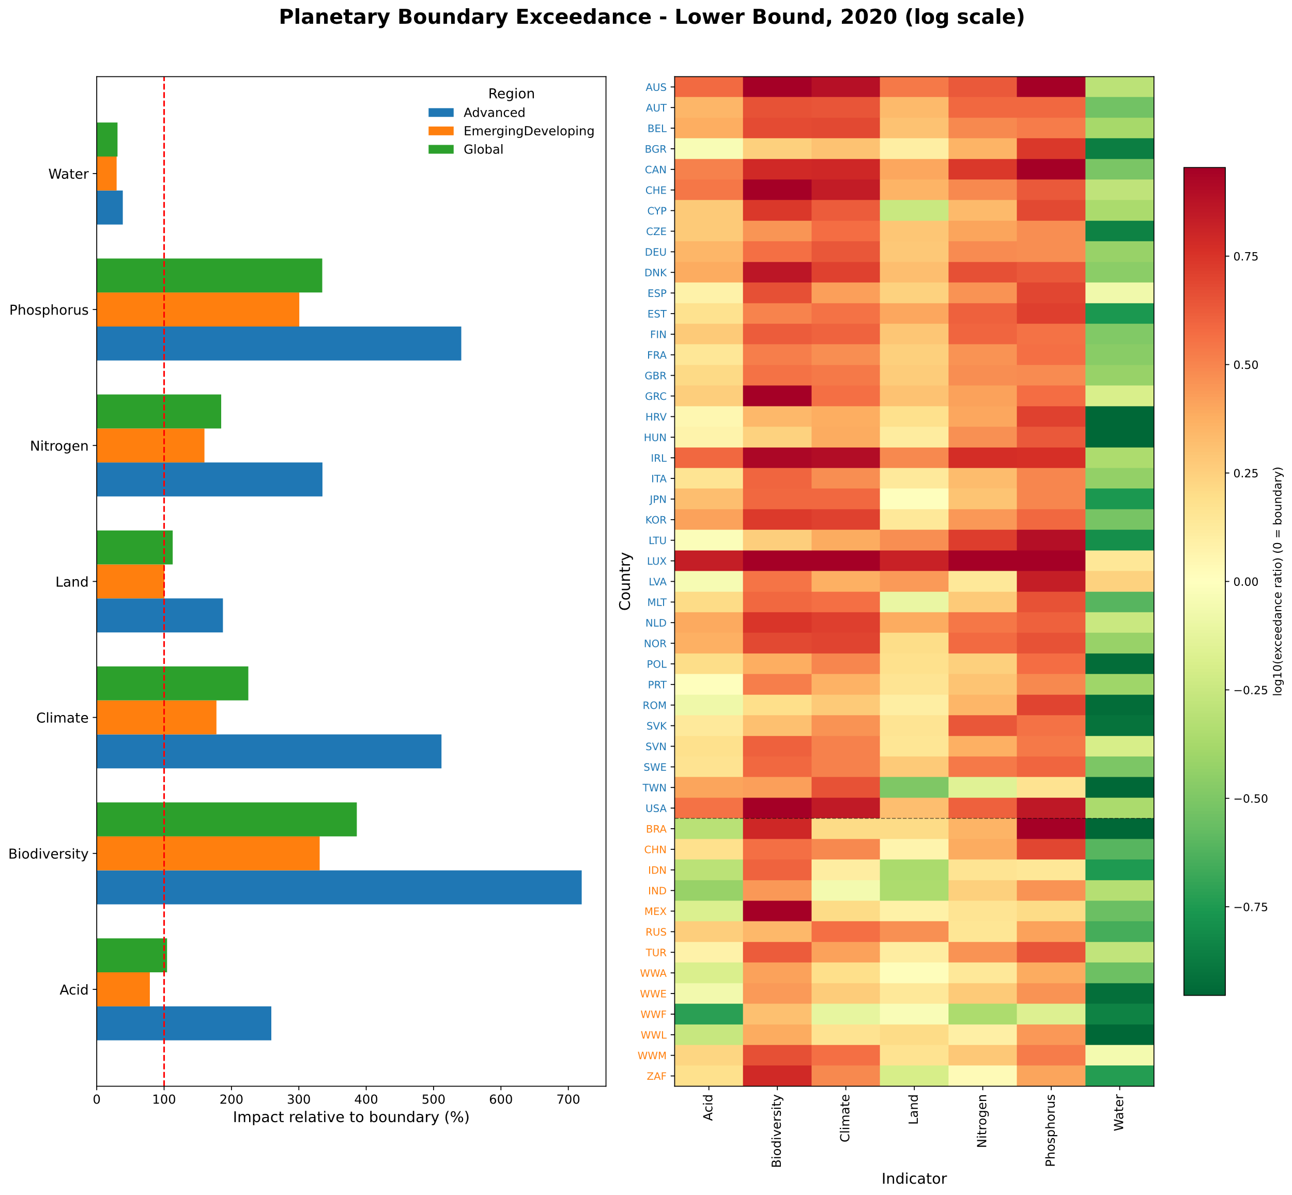
Figure SI 5.2 shows 2020 indicator levels relative to planetary boundaries. LHS shows global, advanced and emerging relative to PBs, RHS show country level results. Positive exceedance capped at 3 times in visualization.

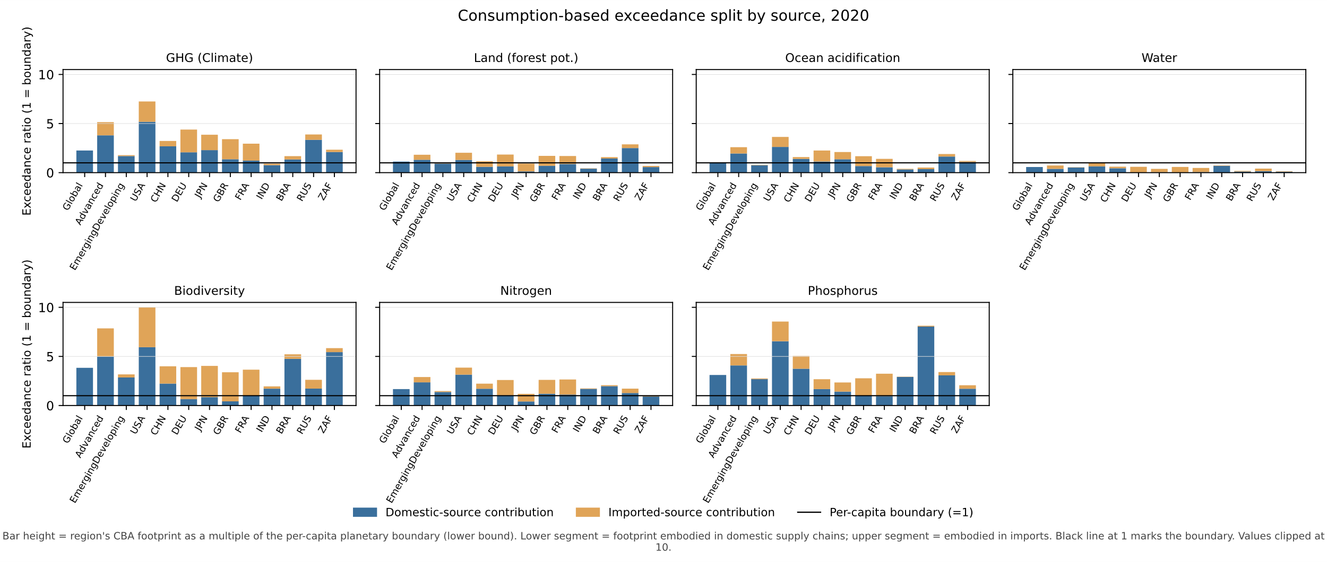 Figure SI 5.3 shows current indicator levels relative to planetary boundaries for countries and regions decomposing domestic and foreign sources.

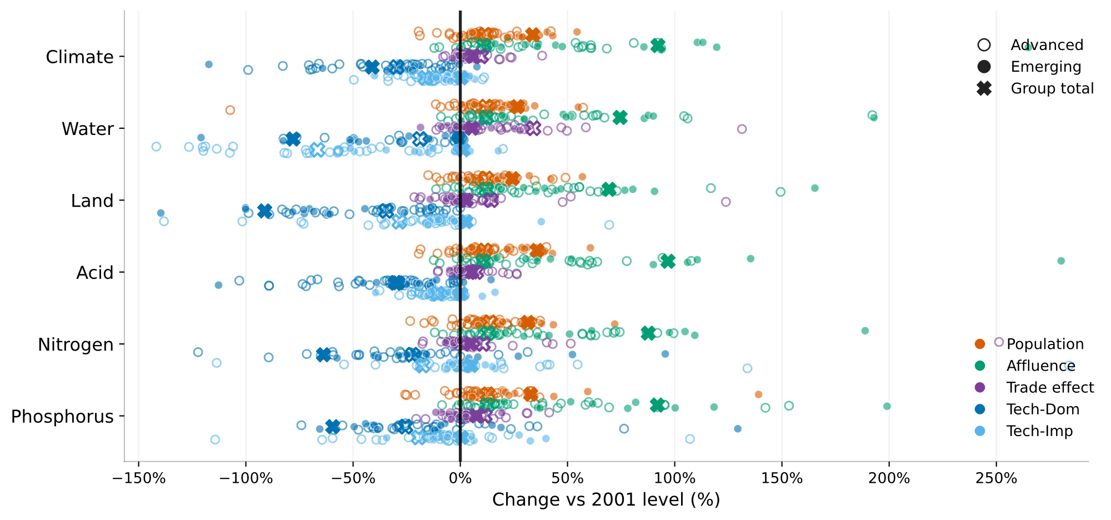 Figure SI 5.4 shows the decomposition of total footprint change into population, affluence, trade shares and domestic vs foreign technology.

Table SI 5.1 Decomposition for advanced economies
Indicator | Population | Affluence | Trade effect | Tech (combined) | Net
Climate | +13.5 | +12.9 | +11.4 | −54.1 | −16.3
Water | +12.1 | +12.3 | +34.4 | −86.1 | −27.3
Land | +12.0 | +12.0 | +14.3 | −63.0 | −24.6
Acid | +13.9 | +13.2 | +9.2 | −50.1 | −13.8
Nitrogen | +13.8 | +12.8 | +10.6 | −39.9 | −2.7
Phosphorus | +12.8 | +12.7 | +11.4 | −45.0 | −8.1
Biodiversity | +12.7 | +12.3 | +13.7 | −55.5 | −16.8

Table SI 5.2 Decomposition for emerging and developing economies
Indicator | Population | Affluence | Trade effect | Tech (combined) | Net
Climate | +37.2 | +101.5 | +6.2 | −44.8 | +100.1
Water | +27.1 | +75.9 | +5.6 | −78.1 | +30.5
Land | +24.3 | +69.4 | +2.8 | −88.6 | +7.9
Acid | +41.6 | +112.6 | +6.3 | −33.4 | +127.1
Nitrogen | +31.5 | +87.7 | +4.8 | −58.7 | +65.3
Phosphorus | +32.8 | +91.9 | +7.5 | −58.8 | +73.4
Biodiversity | +28.2 | +78.7 | +3.5 | −72.2 | +38.1

SI 6: Country level donut figures
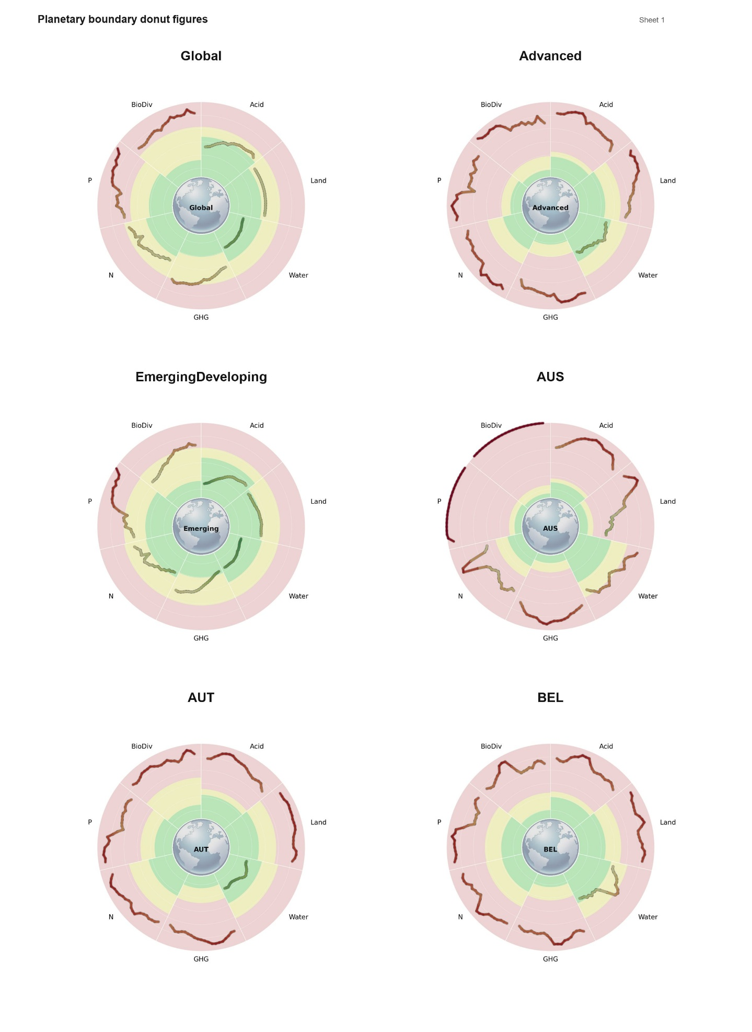
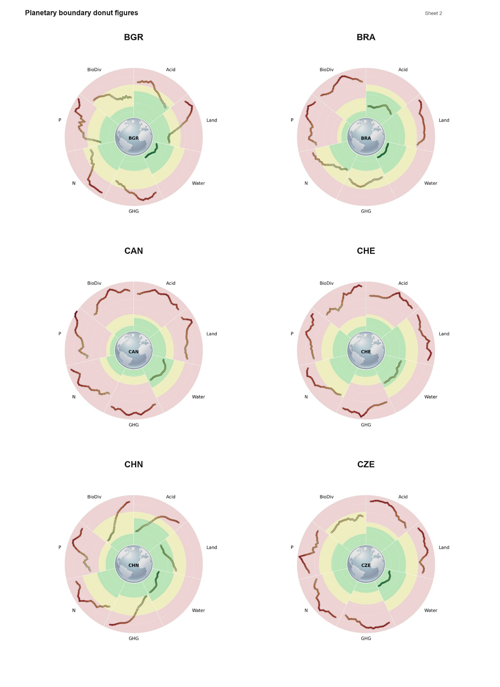
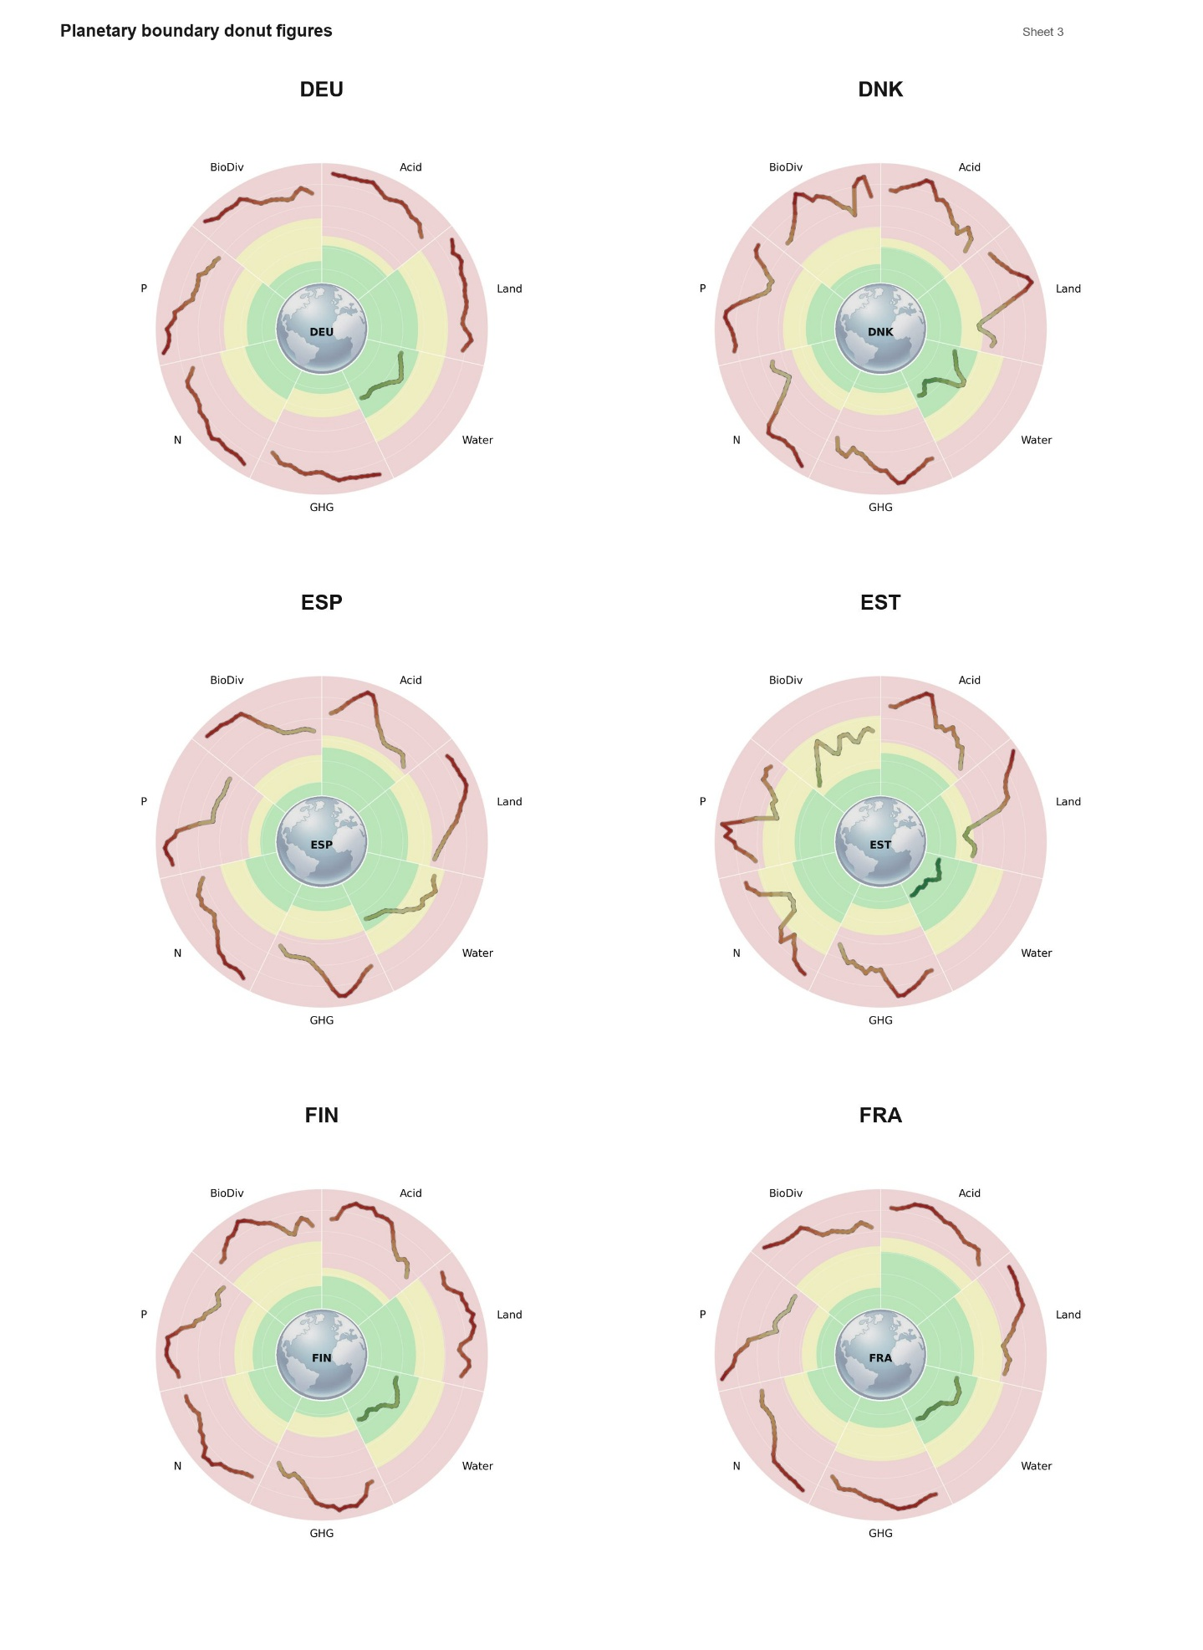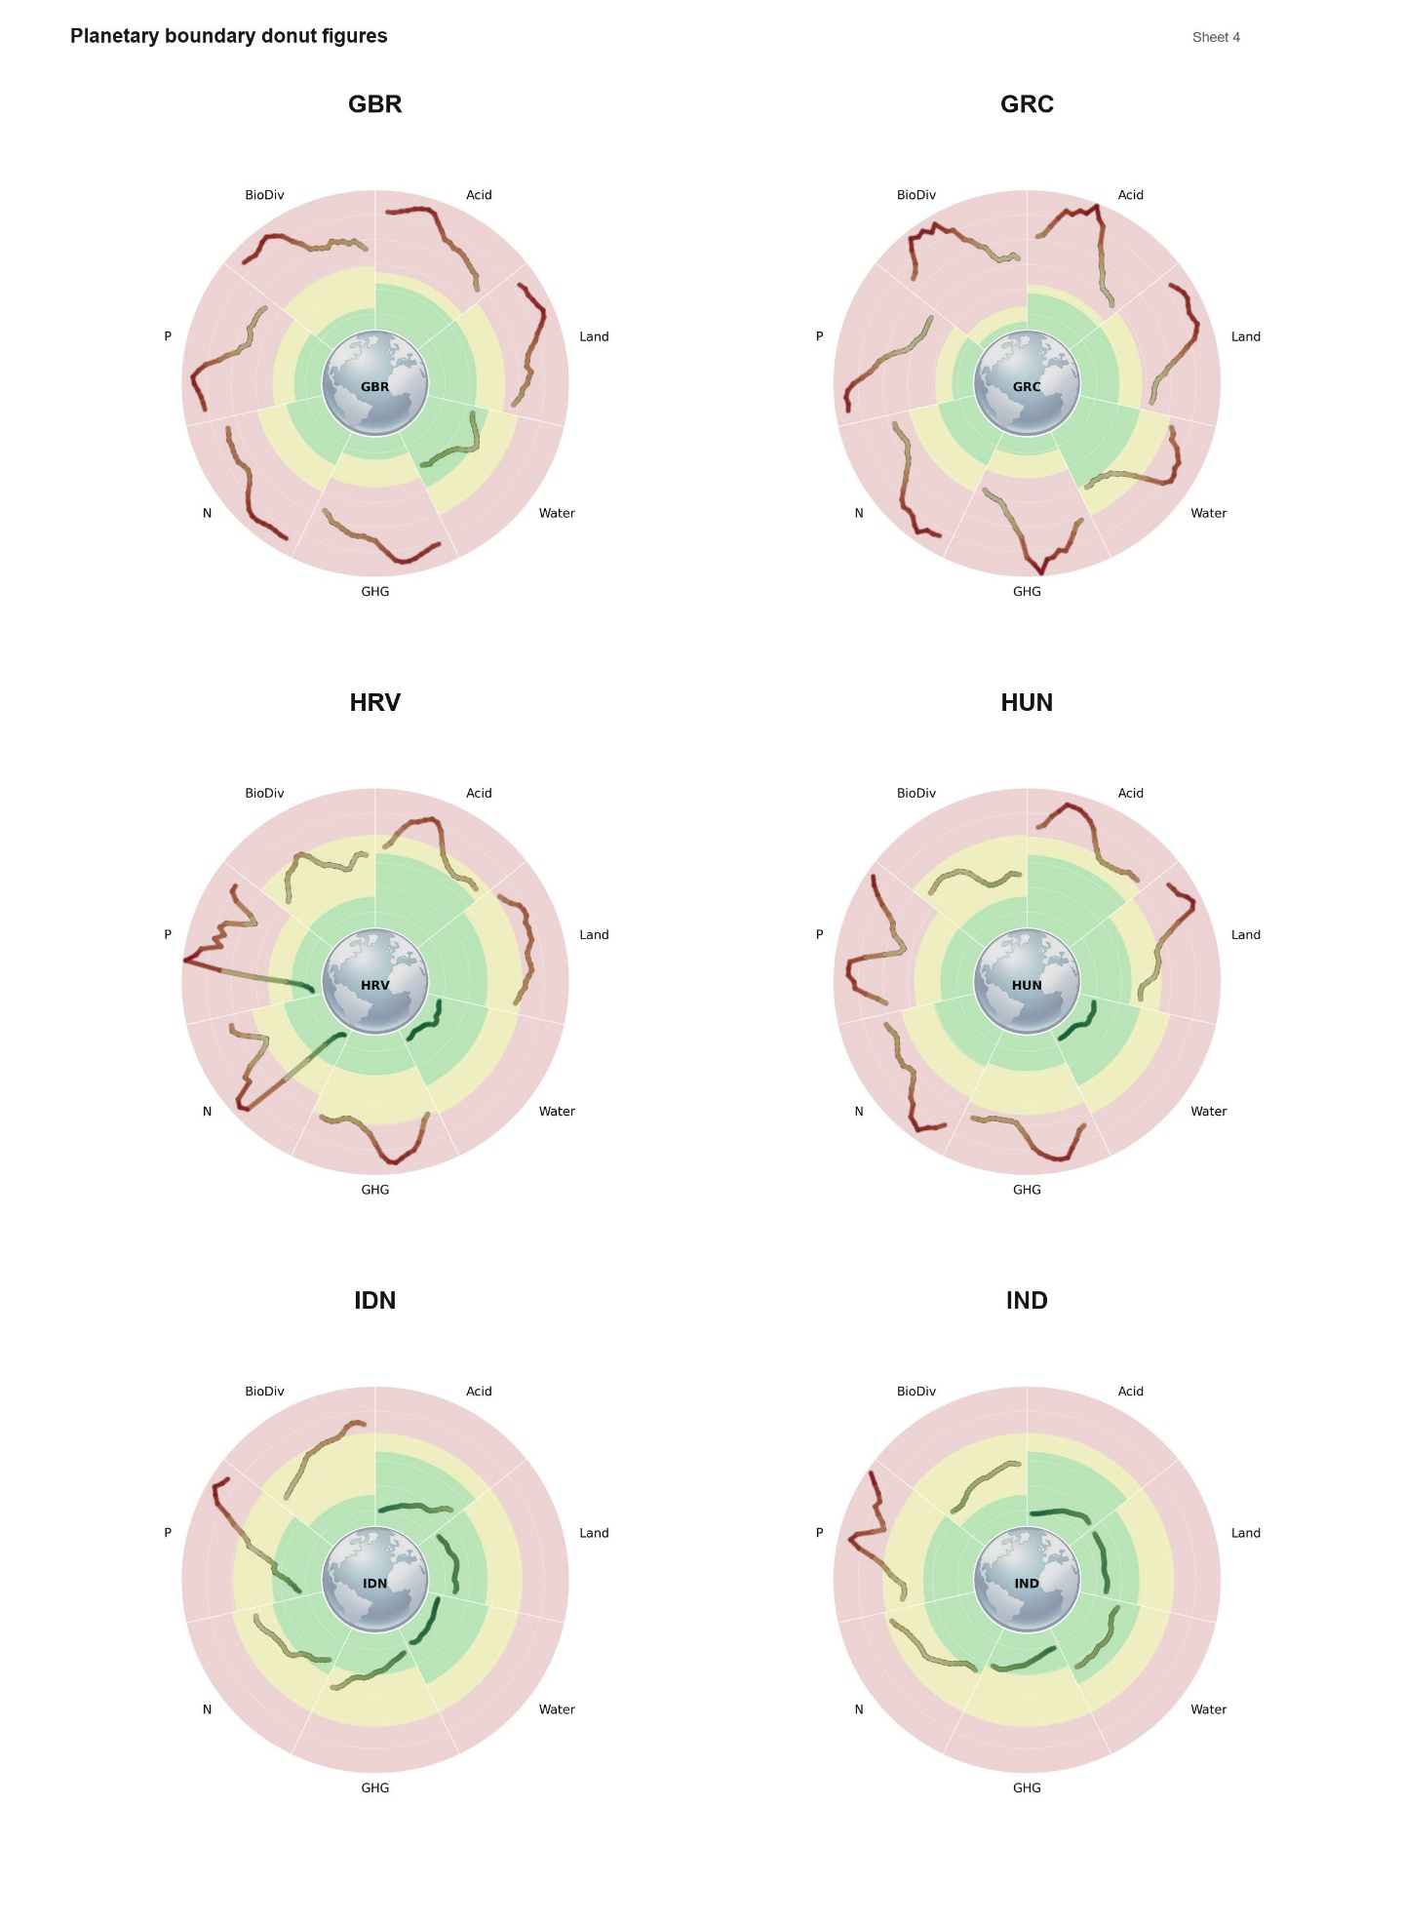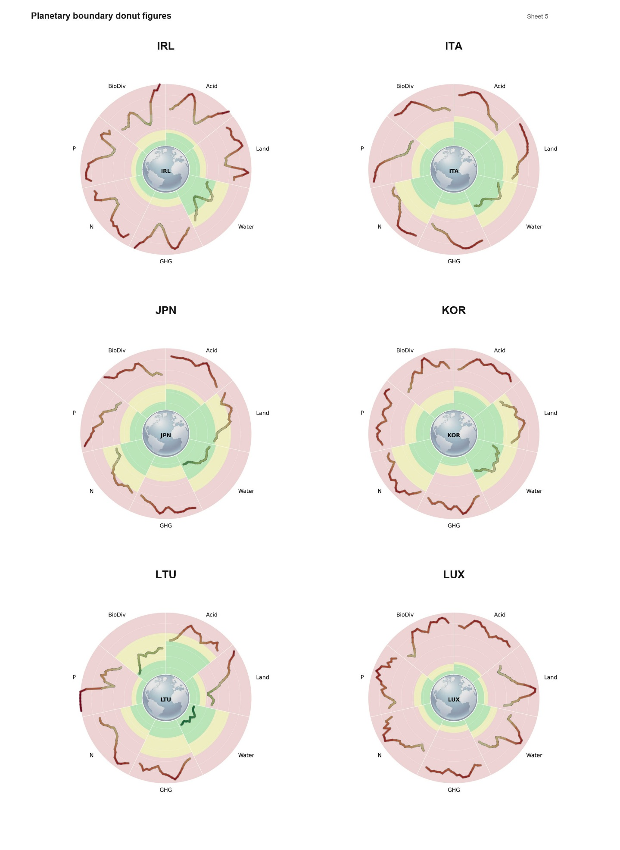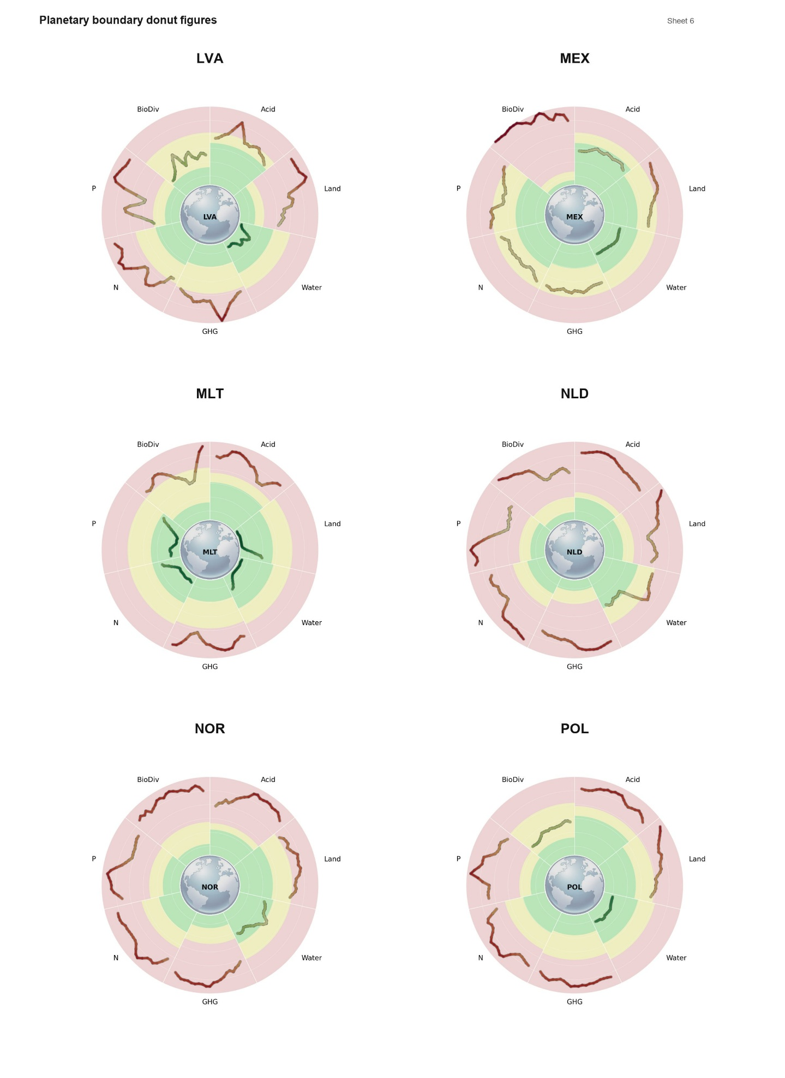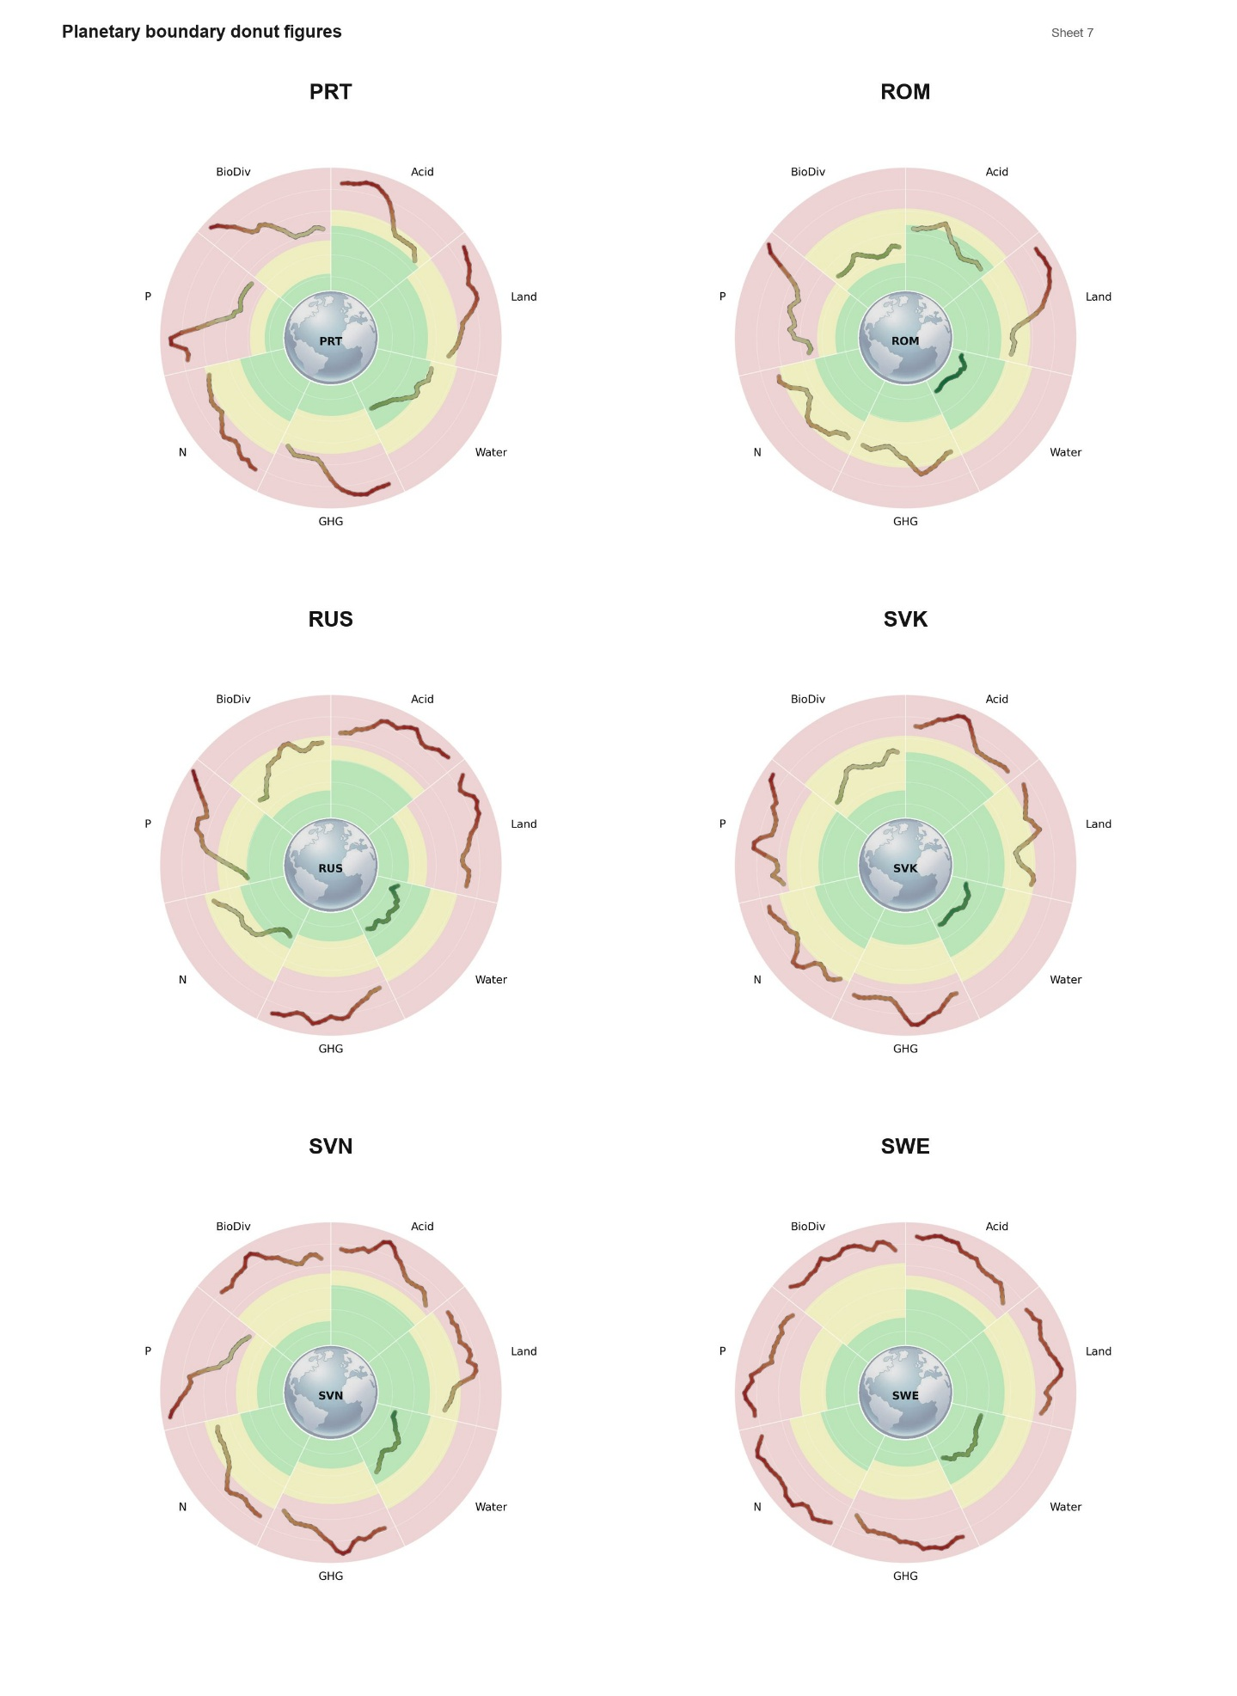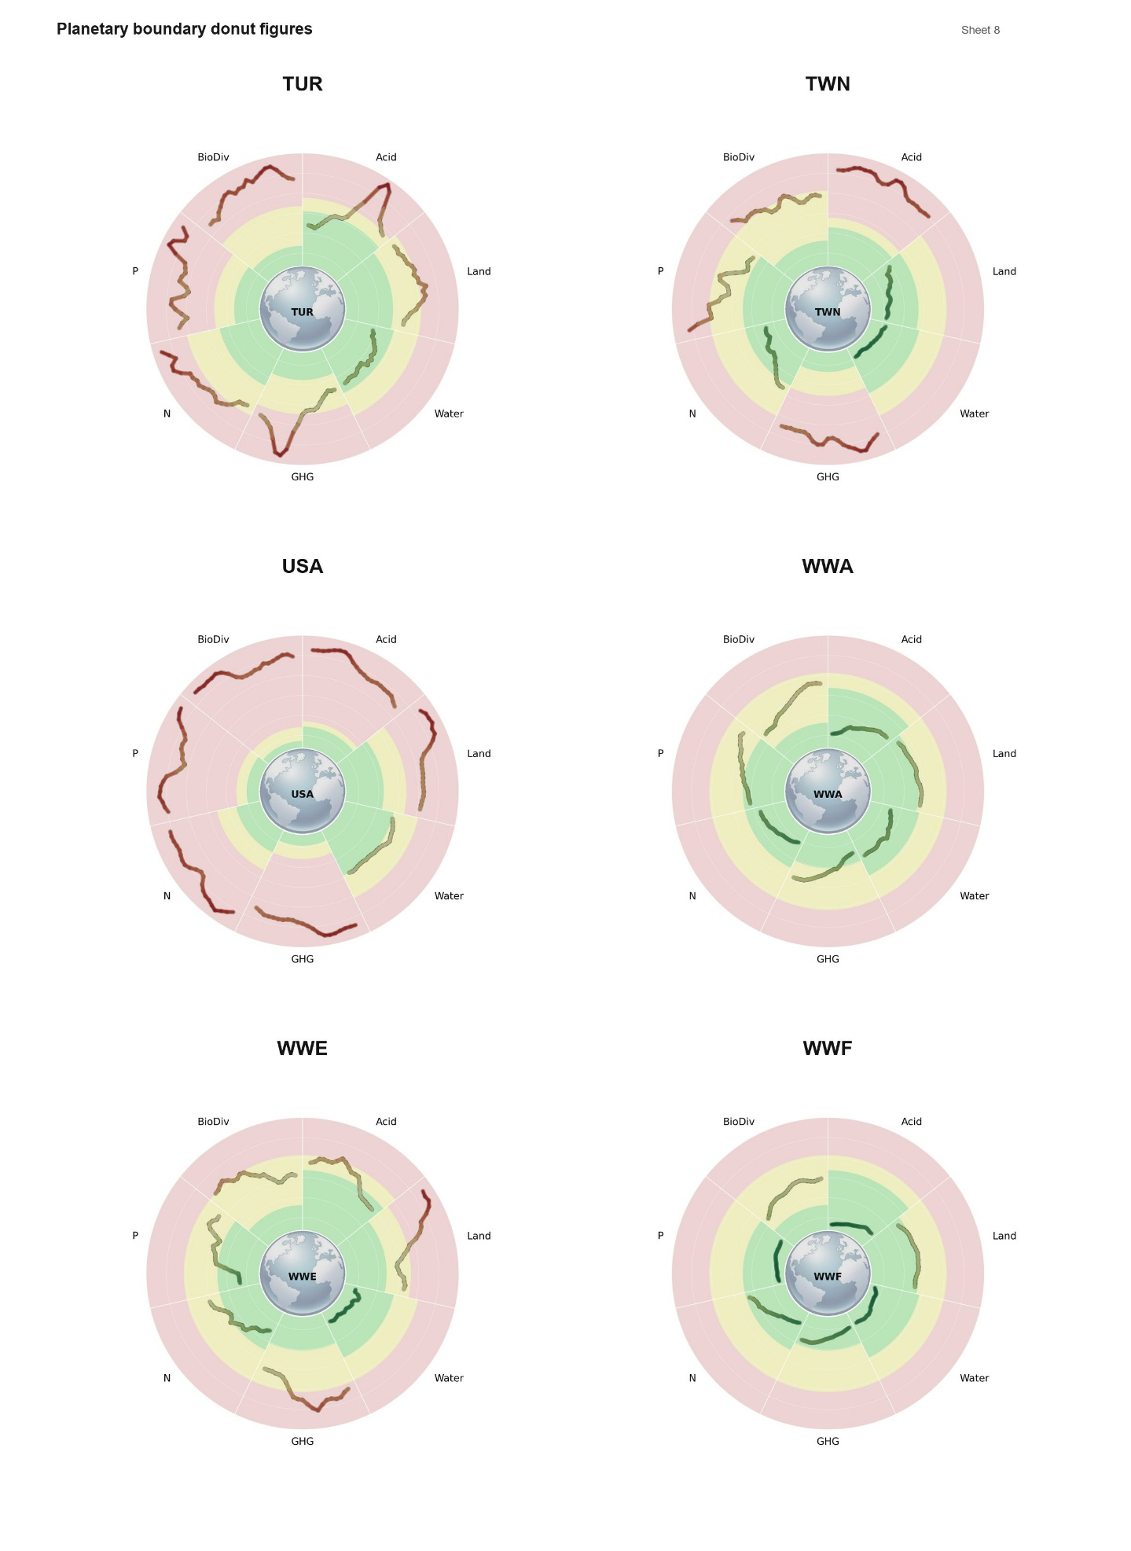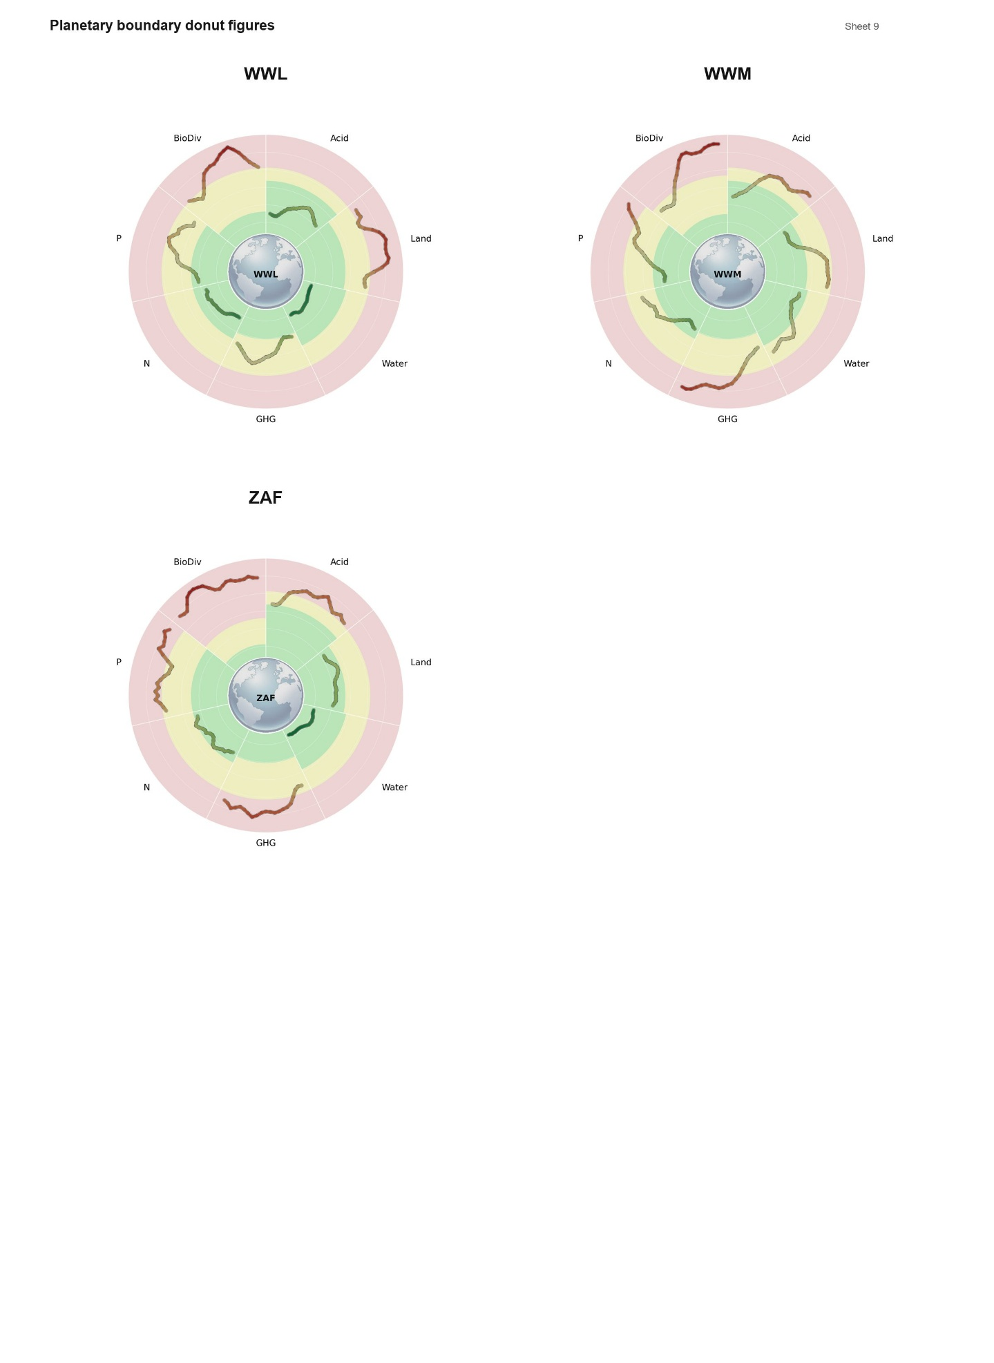

References
1. Hengl, T. et al. Global mapping of potential natural vegetation: An assessment of machine learning algorithms for estimating land potential. PeerJ 2018, 1–36 (2018).
2. Nguyen, C. T., Vačkářová, D. & Weinzettel, J. Consistent global dataset on biodiversity intactness footprint of agricultural production from 2000 to 2020. Sci Data 12, 1613 (2025).
3. Nguyen, C. T., Vačkářová, D. & Weinzettel, J. Consistent global dataset on biodiversity intactness footprint of agricultural production from 2000 to 2020. Scientific Data 12, 1613 (2025).
4. Gilbert, M. et al. Global distribution data for cattle, buffaloes, horses, sheep, goats, pigs, chickens and ducks in 2010. Scientific Data 5, 1–11 (2018).
5. Can, T. N., Vačkářová, D. & Weinzettel, J. Consistent global datasets on Land Use, Biodiversity Intactness Index, and Biodiversity Intactness Footprint of Agricultural Production from 2000 to 2020 [Data set]. Zenodo https://doi.org/10.5281/zenodo.17608318 (2025) doi:10.5281/zenodo.17608318.
6. Mottet, A. et al. Livestock: On our plates or eating at our table? A new analysis of the feed/food debate. Global Food Security 14, 1–8 (2017).
7. Ang, B. W. The LMDI approach to decomposition analysis: a practical guide. Energy Policy in–press (2004).
8. Ang, B. W. & Liu, N. Negative-value problems of the logarithmic mean Divisia index decomposition approach. Energy Policy 35, 739–742 (2007).
9. Su, B. & Ang, B. W. Multiplicative structural decomposition analysis of aggregate embodied energy and emission intensities. Energy Economics 65, 137–147 (2017).
10. Wang, Z., Su, B., Xie, R. & Long, H. China’s aggregate embodied CO2 emission intensity from 2007 to 2012: A multi-region multiplicative structural decomposition analysis. Energy Economics 85, 104568 (2020).

