Supplementary information for
Global trait patterns and the economics spectrum of wood-inhabiting fungi

Shun Liu^{1, 2}, Shengmin Zhang², Chenrui Ni¹, Mengguang Han⁴, Changlin Xu¹, Haozhi Ma⁵, Lidong Mo⁶, Mari Jönsson⁷, Claus Bässler⁸, Baokai Cui², Biao Zhu^{1, 3*}

¹ State Key Laboratory of Efficient Production of Forest Resources, School of Ecology and Nature Conservation, Beijing Forestry University, Beijing 100091, China
² State Key Laboratory of Vegetation Structure, Function and Construction (VegLab), Ministry of Education Key Laboratory of Earth Surface Processes, and College of Urban and Environmental Sciences, Peking University, Beijing 100871, China
³ Ministry of Education Key Laboratory of Ecology and Resource Use of the Mongolian Plateau, Inner Mongolia Key Laboratory of Grassland Ecology, and School of Ecology and Environment, Inner Mongolia University, Hohhot 010021, China
⁴ Ministry of Education Key Laboratory of Sustainable Forest Ecosystem Management, Northeast Asia Biodiversity Research Center, and School of Ecology, Northeast Forestry University, Harbin 150040, China
⁵ School of Life Sciences, Nanjing University, Nanjing 210046, China
⁶ College of Life Sciences, Nankai University, Tianjin 300071, China
⁷ Department of Ecology, Swedish University of Agricultural Sciences, Uppsala 75007, Sweden
⁸ Bayreuth Center of Ecology and Environmental Research (BayCEER), University of Bayreuth, Bayreuth 95440, Germany

*Corresponding author:
Biao Zhu, biaozhu@pku.edu.cn (e-mail)

This file includes:
Materials and Methods
Reference list
Figs. S1 to S24
Tabs. S1 to S9

Materials and Methods
Data collection
Taxon Sampling: This study focuses on wood-inhabiting macrofungi within the class Agaricomycetes at a global scale. To comprehensively capture the functional diversity of fungi associated with both dead and living wood, we included multiple trophic types: saprotrophs (typical wood-decay fungi), symbionts (e.g., ectomycorrhizal fungi producing fruiting bodies on dead wood), and parasites (wood-decay fungi transitioning to pathogens during the senescence phase of living trees). To ensure scientific rigor and taxonomic accuracy, our sampling was grounded in authoritative fungal classification systems and integrated the latest phylogenetic and taxonomic advances ¹. Species names and taxonomic statuses were cross-validated and dynamically updated using Index Fungorum (http://www.indexfungorum.org) and MycoBank (http://www.mycobank.org). Based on these criteria, we constructed a global checklist of 7,454 valid wood-inhabiting fungal species published before June 2025. The complete checklist is provided in the Appendix, with detailed annotations for each species regarding taxonomic status (order, family, genus) and key functional trait codes. According to the latest taxonomic system, these species belong to 22 orders, 121 families, and 759 genera, covering the major evolutionary lineages of known wood-inhabiting fungi ¹⁻³. In terms of taxonomic coverage, this scheme achieves near-complete representative sampling at the order and family levels, particularly including all major lineages known to participate in lignocellulose degradation (e.g., Polyporales Gäum., Hymenochaetales Oberw.) ⁴⁻⁵. Through multi-source data integration and taxonomic validation, this study minimizes systematic errors arising from nomenclatural confusion, taxonomic changes, or sampling biases, thereby providing a solid and traceable taxonomic foundation for subsequent macroecological analyses, biogeographic pattern inference, and comparative studies of functional groups.
Geographic Distribution Data: We integrated global distribution data of wood-inhabiting fungi, primarily sourced from the Global Biodiversity Information Facility (GBIF; https://www.gbif.org) and the Mycological Specimen Portal (MyCoPortal; https://www.mycoportal.org). Systematic searches were performed using species scientific names and synonyms as keywords, and datasets containing latitude, longitude, and collection locality information were downloaded, with all data retrieved from records published before June 2025. In addition, we incorporated approximately 32,000 distribution records accumulated over the past three decades by the authors and team members through field surveys and specimen collections conducted globally (with a particular focus on China). Each record corresponds to a physical specimen, and species identification was rigorously verified using both morphological observation and molecular data.
Trait Data: Following established studies ⁶⁻⁸, we systematically collected 26 traits and classified them into three functional categories (Table S20): (1) reproduction-related (9 traits), (2) dispersal-related (6 traits), and (3) resource acquisition and utilization-related (11 traits). The trait data were extracted primarily from taxonomic literature, mycological monographs, and scientific expedition reports, based on species type specimens or species-level mean values. Data sources were documented, and all references are listed in the Appendix. Detailed definitions and data sources for each trait are provided in Table S1.

Data Preprocessing
Fruit body size: Estimation of fruiting body size followed the method of Dawson et al. ⁸, utilizing specific geometric models corresponding to distinct morphological types. (1) Stipitate fungi: The radius of the pileus (r_{cap}) and its height (h_{cap}), as well as the radius of the stipe (r_{stipe}) and its height (h_{stipe}), were measured separately. Pileus size was calculated using the formula for a cone: $V_{\left\{cap\right\}}=\frac{1}{3}πr_{\left\{cap\right\}}^{2}h_{\left\{cap\right\}}$. Stipe size was calculated using the formula for a cylinder: $V_{\left\{stipe\right\}}= πr_{\left\{stipe\right\}}^{2}h_{\left\{stipe\right\}}$. The total fruiting body size is the sum of these two components. (2) Pileate (sessile) fungi: The major axis (a), minor axis (b), and height (c) of the fruiting body were measured. The fruiting body was approximated as an ellipsoid, and its size was calculated as: $V=\frac{4}{3}πabc$. (3) Effused-reflexed or resupinate fungi: The mean length (a), width (b), and thickness (c) were measured. The fruiting body was approximated as a cuboid, and size was calculated as: V=abc. To mitigate potential bias in subsequent statistical analyses arising from negligible values, calculated size less than 0.01 cm³ were standardized to 0.01 cm³.
Basidia length, width, shape, and size: The mean length of basidia is denoted as L, and the mean width as W; basidium morphology is characterized by the aspect ratio L/W. Basidial size is calculated using geometric models selected according to actual morphological features. Based on an observed L/W range of 1.03–21.43 in this study, basidia were classified into three morphological types, and a piecewise modeling approach was applied for size estimation. The specific schemes are as follows: (1) Subglobose to ovoid basidia (L/W≤2): The size is estimated using a prolate spheroid model, calculated as $V = \left(\frac{4}{3}\right)π\left(\frac{L}{2}\right)\left({\left(\frac{W}{2}\right)}^{2}\right)$. (2) Moderately elongate, ellipsoid-cylindrical to clavate basidia (2<L/W≤8): A composite model consisting of a central cylinder capped by two hemispherical ends is employed, as this more faithfully represents the typical basidial architecture—a cylindrical mid-region with rounded apices. The total size comprises two components: the size of the cylindrical portion, $V = π\left({\left(\frac{W}{2}\right)}^{2}\right)\left(L−W\right)$, and the size of the two hemispherical caps, which together constitute a complete sphere, $V = \left(\frac{4}{3}\right)π\left({\left(\frac{W}{2}\right)}^{3}\right)$. The combined size simplifies to $V = πW^{2}\left(\frac{L}{4}−\frac{W}{12}\right)=\frac{πW^{2}L}{4}\left(1−\left(\frac{W}{3L}\right)\right)$. (3) Highly elongate, filiform basidia (L/W>8): Given that the contribution of the terminal hemispherical caps to the total size becomes negligible, the basidium is approximated as a simple cylinder, and size is calculated as$V = π\left({\left(\frac{W}{2}\right)}^{2}\right)L$.
Spore length, width, shape, and size: Mean spore length is denoted as L and mean spore width as W; spore morphology is characterized by the aspect ratio L/W. Spore size is estimated using geometric models selected according to actual morphological features. Based on an observed L/W range of 1–6.92 in this study, basidiospores were classified into two morphological types, and a piecewise modeling approach was applied for size estimation. The specific schemes are as follows: (1) For L/W≤2: The basidiospore morphology approximates a subglobose to broadly ellipsoidal (oblate/prolate) form. Size is calculated using the formula for a prolate spheroid: $\text{V=}\frac{\text{4}}{\text{3}}\text{π}\left(\frac{\text{L}}{\text{2}}\right){\left(\frac{\text{W}}{\text{2}}\right)}^{\text{2}}\text{=}\frac{\text{πL}{\text{W}}^{\text{2}}}{\text{6}}$. (2) For L/W>2: The basidiospore morphology is prolate-ellipsoidal to cylindrical. The spore is modeled as a composite structure consisting of a central cylinder capped by two hemispherical ends. The central cylinder has length L−W and diameter W; the two hemispherical caps together form a complete sphere of diameter W. The size of the cylindrical portion is: ${\text{V}}_{\text{1}}\text{=π}{\left(\frac{\text{W}}{\text{2}}\right)}^{\text{2}}\text{(L-W)}$. The combined size of the two hemispherical ends (equivalent to one sphere) is: ${\text{V}}_{\text{2}}\text{=}\frac{\text{4}}{\text{3}}\text{π}{\left(\frac{\text{W}}{\text{2}}\right)}^{\text{3}}$. Thus, the total spore size is: $\text{V=π}\left(\frac{{\text{W}}^{\text{2}}}{\text{4}}\right)\text{(L-W) + }\frac{\text{π}{\text{W}}^{\text{3}}}{\text{6}}\text{=}\frac{\text{π}{\text{W}}^{\text{2}}\text{(3L-W)}}{\text{12}}$. Notably, spore and basidium dimensions exhibit allometric relationships, indicating that these morphological traits are not strictly independent. To address this multicollinearity issue and to mitigate the influence of skewed distributions on statistical inference, we performed a logarithmic transformation on spore length and width data in the sensitivity analysis. Subsequently, we conducted principal component analysis (PCA) and extracted the first two principal component axes as independent variables representing spore size and morphology, respectively.
Generative/Skeletal/Binding hyphae diameter: The diameters reported for all hyphae represent mean hyphal widths.

Categorical trait assignment
Numerical coding of categorical traits follows a gradient of increasing morphological and anatomical complexity (evolving from fragile, thin-walled, and simple to tough, thick-walled, and complex). All traits, including life strategy and decay type, are defined based on empirical measurements and descriptions from original literature or expert systems, without the use of unverified a priori assignments. The specific character states were defined as follows. Fruit body lifespan: (1) Annual; (2) Biennial; (3) Perennial. Fruit body texture: (1) Soft-fleshy to gelatinous; (2) Membranaceous; (3) Brittle to fragile; (4) Tough-leathery to corky; (5) Ceraceous; (6) Crustaceous to woody. Fruit body type: (1) Resupinate; (2) Effused-reflexed; (3) Pileate (sessile); (4) Stipitate. Hymenium type: (1) Smooth; (2) Denticulate; (3) Lamellate; (4) Poroid; (5) Labyrinthine; (6) Gasteroid. Hyphal system: (1) Monomitic; (2) Dimitic; (3) Trimitic. Generative hyphae type: (1) Simple-septate; (2) Clamped. Generative hyphae/Spore wall thickness: (1) Thin-walled; (2) Slightly thick-walled; (3) Thick-walled. Skeletal/Binding hyphae wall thickness: (1) Slightly thick-walled; (2) Thick-walled; (3) Solid. Spore ornamentation: (1) Smooth; (2) Verrucose; (3) Rugose; (4) Spiny/Echinulate; (5) Reticulate. Host type: (1) Gymnosperm; (2) Angiosperm and Gymnosperm; (3) Angiosperm. Life strategy: (1) Saprotrophic; (2) Symbiotic; (3) Parasitic. Decay type: (1) Non rot; (2) Brown rot; (3) White rot.

Geographic distribution data
All geographic occurrence records were subjected to a standardized data cleaning and quality control protocol ⁹ within the R programming environment (version 4.5.2). Initially, exact duplicates were identified and removed using gbifID as the unique identifier to ensure dataset singularity. Subsequently, reliable records were filtered based on spatial extent, temporal validity, and coordinate completeness. For observations lacking precise latitude and longitude but documented at broader administrative or biogeographical scales (e.g., country, province, municipality, or ecoregion), the geometric centroid of the respective spatial unit was assigned as a proxy location to facilitate quantitative spatial representation. Finally, to evaluate and correct for potential geographic sampling biases, including uneven spatial coverage and overrepresentation in biodiversity hotspots, specimen records were stratified into three latitudinal zones: tropical-subtropical (0°–30°), warm temperate-cold temperate (30°–60°), and boreal-polar (60°–80°). Sample-based rarefaction analyses were then conducted to assess latitudinal gradients in record density, ensuring that sample sizes across all zones met the robustness prerequisites for subsequent statistical analyses (see Supplementary Table S2 for details).

Statistical analyses
All statistical analyses were conducted with R version 4.5.2 ⁹.

Trait trade-off analysis
This study synthesized 26 functional traits (comprising 12 continuous and 14 categorical traits) across 7,454 wood-inhabiting fungal species to systematically disentangle the trade-offs among three functional modules. Raw trait data were first log10(x + 1)-transformed to reduce skewness and mitigate differences in magnitude among species, as well as to improve suitability for subsequent analyses. Transformed traits were then standardised using z-score scaling to ensure comparability across variables and to place all traits on a common scale prior to multivariate analyses.
Pairwise relationships among continuous traits were explored using Pearson correlation analyses applied to the standardised dataset. These analyses quantified the strength and direction of linear associations among traits. Statistical significance was assessed using two-sided Pearson correlation tests. Correlation structures were visualised using matrices in which scatter plots with fitted linear trends were presented in the upper triangle, while Pearson correlation coefficients and significance levels were displayed in the lower triangle, allowing interpretation of trade-offs and synergies among functional traits.
To examine trait differentiation across ecological and taxonomic groupings, 14 predefined grouping variables were used, while 12 continuous traits served as response variables. Group-level differences were assessed using linear models (LMs), and pairwise differences among groups were evaluated using estimated marginal means (EMMs) with Tukey-adjusted post hoc comparisons. Compact letter displays were used to summarise significant differences among groups. Boxplots combined with raw species-level observations were used to visualise trait distributions and within-group variability.
It is acknowledged that closely related species may exhibit similar trait values due to shared evolutionary history. To reduce potential non-independence among observations, relevant taxonomic structure was partially accounted for by incorporating family-level grouping information in the following analyses and interpretation. However, no phylogenetically explicit models were applied in this study.

Construction of the economic spectrum
To explore the multivariate structure of functional traits and construct the economics spectrum of wood-inhabiting fungi, we applied principal component analysis (PCA) to a set of continuous traits ^{10–12}. Prior to analysis, trait values were log10(x + 1)-transformed where appropriate and subsequently standardized using z-score transformation to ensure comparability among variables.
To reduce the influence of missing data, trait matrices were first filtered to remove variables with excessive missingness or near-zero variance. Missing values were then imputed using PCA-based imputation (missMDA), and PCA was performed on the completed dataset using singular value decomposition.
All traits were included in the PCA as continuous variables. Both raw functional traits and derived numeric trait variables were used in parallel PCA analyses to assess the robustness of the resulting trait space. Eigen-decomposition was performed using FactoMineR, and the number of dimensions retained was evaluated using scree plots and eigenvalue distributions. The ecological interpretation of principal components was based on trait loadings and variable contributions. Traits with high contributions were used to characterize the main functional axes of variation and to define the structure of the fungal economic spectrum.

Influence of environmental factors on traits
To elucidate the regulatory effects of environmental factors on functional traits of wood-inhabiting fungi, we selected seven key environmental variables: annual precipitation (pr), annual mean temperature (tmean), elevation (elev), leaf area index (LAI), slope, and the east–west (aspect_sin) and north–south (aspect_cos) components of aspect. These variables were used as predictors for analysing 12 continuous and 14 categorical traits. Environmental data were derived from ERA5-Land climate reanalysis products (Copernicus Climate Data Store, CDS), together with vegetation and topographic variables extracted using raster-based spatial methods. Topographic variables were derived from a global digital elevation model (DEM), including elevation, slope, and trigonometric transformations of aspect (sine and cosine). Leaf area index (LAI) was extracted from gridded NetCDF datasets (LAI_H and LAI_L). All environmental variables were spatially matched to species occurrence records using raster extraction.All environmental variables were Z-score standardised prior to analysis. Continuous trait response variables were log-transformed where appropriate; categorical traits were encoded as binary variables (each level versus all other levels) for logistic modelling
To assess environmental regulation of functional traits, generalized additive models including a factor-smooth random effect were fitted for continuous traits:
$$Y_{ij}=α+∑β_{k}X_{k,i}+s(\text{Family},bs="re")+ε_{ij}$$
where environmental variables (pr, tmean, LAI, elev, slope, aspect_sin, aspect_cos) were included as fixed effects, and Family was included as a random effect term to account for taxonomic structure.
To evaluate the impact of model simplification on goodness-of-fit, the full model (containing all seven environmental variables) was compared against an intercept-only null model using likelihood ratio tests. Model selection was further informed by the Akaike Information Criterion (AIC), with ΔAIC < 2 adopted as the criterion for model equivalence. Model explanatory power was assessed via marginal R² (proportion of variance explained by fixed effects alone) and conditional R² (proportion explained by both fixed and random effects). Predictive accuracy was quantified using the correlation coefficient (cor_full) and root mean square error (rmse_full) derived from leave-one-species-out cross-validation.
For each level of the 14 categorical traits, binomial logistic regression models were constructed with the presence/absence (1/0) of that level as the response variable. The model formulation was: $logit\left(P_{\left\{j,l\right\}}\right)=β_{0}+\sum_{\left\{k=1\right\}}^{7}{β_{k}X_{k}}+ε$, where Pⱼ,ₗ is the probability that species j possesses categorical level l, and Xₖ are the standardized environmental variables. Parameter estimation employed maximum likelihood, with significance assessed via Wald tests. Model goodness-of-fit was evaluated using adjusted R² and the proportion of deviance explained. For rare levels (e.g., gasteroid hymenophore, daedaleoid hymenophore) where estimation instability due to separation was encountered, Firth’s penalized likelihood method was applied as a correction. Model discrimination was assessed using the Area Under the Receiver Operating Characteristic Curve (AUC), and calibration was evaluated via logarithmic loss. Comparison between the full model and the null model was based on likelihood ratio tests to gauge the overall explanatory contribution of the environmental variables.
To evaluate the overall explanatory contribution of environmental factors to trait variation, likelihood ratio tests were performed for each trait model, comparing the full model (including all seven environmental predictors) against the intercept-only null model. Significance of individual environmental variables was reported at thresholds of p < 0.05 (*), p < 0.01 (**), and p < 0.001 (***). Given the multiplicity of hypothesis tests across multiple traits and environmental predictors, all p-values were adjusted using the Benjamini–Hochberg procedure to control the False Discovery Rate (FDR) and mitigate inflation of Type I error. The proportion of significant associations and the mean effect magnitude for each environmental factor were summarized separately for continuous and categorical traits to assess relative importance.
To assess spatial autocorrelation of model residuals, we calculated Moran’s I index for the residuals of each linear mixed model. When significant spatial autocorrelation (p < 0.05) was detected, spatial coordinates were incorporated as additional random effects (e.g., using a Gaussian process covariance structure). Furthermore, we attempted to include longitude as a covariate in the models to capture east-west spatial variation beyond the latitudinal gradient (e.g., continental effects).
Linear mixed-effects models for continuous traits were fitted using the lme4 package (version 1.1-35.1); marginal and conditional R² values were computed with the MuMIn package (version 1.47.5). Logistic regression for categorical traits employed the glm function, with Firth correction implemented via the logistf package (version 1.26.0). AUC calculations relied on the pROC package (version 1.18.5). FDR correction for multiple comparisons was performed using the base function p.adjust. Graphical visualizations were generated with ggplot2 (version 3.4.4).

Latitudinal gradient analysis
To investigate the differentiation patterns of functional traits of wood-inhabiting fungi along latitudinal gradients, the global latitudinal range was divided into three biogeographic zones: low latitudes (0°–30°), mid latitudes (30°–60°), and high latitudes (60°–80°). Based on species distribution data for 7,454 wood-inhabiting fungal species and 26 functional traits (12 continuous traits and 14 categorical traits), we analysed trends in each trait and principal component (PC) axes along the latitudinal gradient, as well as differences among zones. Species distribution data were compiled from global fungal diversity databases and published literature, comprising approximately 4.58 million occurrence points, each matched with its corresponding latitude.
For each species, trait values were aggregated at the species level prior to analysis. Continuous traits were log10(x + 1)-transformed where appropriate and standardised using z-score transformation prior to analysis. Species-level scores of the first three principal components (PC1–PC3) derived from PCA were included to represent multivariate functional trait space.
Latitudinal trends of continuous traits and PC axes were analysed using Generalized Additive Models (GAMs):
$$Y_{i}=α+s({\text{Latitude}}_{i},k=10)+ε_{i}$$
where $s(⋅)$denotes a smoothing spline function with basis dimension $k=10$, and smoothing parameters were selected using Generalized Cross Validation (GCV). Analyses were based on latitude-binned summaries, and bins with low sample size were excluded from model fitting and visualization.
Differences in categorical traits among the three latitudinal zones were assessed by comparing relative frequencies across zones. For each trait level, proportions of species were calculated within each latitudinal zone and visualized using stacked plots and smooth trend fitting across latitude bins.

Prediction of wood-inhabiting fungal traits
To assess how climate change may reshape the functional structure of wood-inhabiting fungal communities, we projected 26 fungal functional traits under two contrasting Shared Socioeconomic Pathway (SSP) scenarios: SSP1-2.6 (low-emission) and SSP5-8.5 (high-emission), representing divergent future climate trajectories. Baseline climate conditions were defined as 1970–2000, and future conditions as 2071–2100 (30-year climatological means) ¹³. Climate predictors were derived from the UKESM1.0-LL Earth system model and included temperature, precipitation, and leaf area index, together with topographic variables.
Species–environment relationships were first reconstructed by linking GBIF-based occurrence records with gridded environmental layers. To reduce spatial sampling bias, species-level environmental conditions were estimated using an inverse-distance weighted (IDW) approach applied to all occurrence records, ensuring that geographically clustered observations did not disproportionately influence climatic estimates.
Species distributions were then modelled for 7,454 wood-inhabiting fungal species using an ensemble modelling framework combining random forests, generalized additive models, and maximum entropy models. Individual model outputs were combined using weighted averaging to generate continuous species occurrence probability maps. Model transferability was evaluated using spatial block cross-validation, and performance was assessed using AUC and TSS metrics to ensure robustness under spatially structured data.
Community-level functional structure was derived using probability-weighted species assembly rather than binary presence–absence data. For continuous traits, community weighted means (CWM) were calculated by weighting species trait values by their predicted occurrence probabilities within each grid cell, ensuring that common and rare species contributed proportionally to community-level estimates. For categorical traits, community composition was expressed as probability-weighted proportions of each trait state, allowing consistent estimation of functional composition in a continuous probability space.
Future trait distributions were generated by projecting species–environment relationships onto climate scenarios and propagating predicted species occurrence probabilities into trait space. Changes in trait structure were quantified as the difference between future and baseline projections for each grid cell, allowing spatially explicit estimation of climate-driven functional turnover. For continuous traits, changes were expressed in standardized trait units, whereas for categorical traits they represented shifts in probability distributions of trait states.
To evaluate uncertainty associated with environmental extrapolation, we quantified model novelty using two complementary approaches. First, univariate extrapolation was assessed by comparing future environmental conditions with the range of values observed in the training dataset, identifying grid cells outside the calibration domain. Second, multivariate environmental novelty was quantified using Mahalanobis distance in environmental space, measuring the dissimilarity between future conditions and the centroid of the training environment. Higher values indicate stronger extrapolation and reduced model reliability.

References
- Hyde, K. D. et al. The 2024 outline of fungi and fungus-like taxa. Mycosphere 15, 5146–6239 (2024).
- He, M. Q. et al. Notes, outline and divergence times of Basidiomycota. Fungal Divers. 99, 105–367 (2019).
- He, M. Q. et al. Phylogenomics, divergence times and notes of orders in Basidiomycota. Fungal Divers. 126, 127–406 (2024).
- Wang, X. W., Varga, T., Li, Q. S., Nagy, L. G. & Zhou, L. W. Complex evolutionary history of the fungal order Hymenochaetales revealed by analyses of trait evolution and diversification. Mycosphere 16, 517–535 (2025).
- Liu, S. et al. Systematic classification and phylogenetic relationships of the brown-rot fungi within the Polyporales. Fungal Divers. 118, 1–94 (2023).
- Abrego, N., Norberg, A. & Ovaskainen, O. Measuring and predicting the influence of traits on the assembly processes of wood-inhabiting fungi. J. Ecol. 105, 1070–1081 (2017).
- Abrego, N., Bassler, C., Christensen, M. & Heilmann-Clausen, J. Traits and phylogenies modulate the environmental responses of wood-inhabiting fungal communities across spatial scales. J. Ecol. 110, 784–798 (2022).
- Dawson, S. K. et al. Handbook for the measurement of macrofungal functional traits: A start with basidiomycete wood fungi. Funct. Ecol. 33, 372–387 (2019).
- R Core Team. R: A Language and Environment for Statistical Computing. (2025), Deposited 2026.
- Díaz, S. et al. The global spectrum of plant form and function. Nature 529, 167–171 (2016).
- Carmona, C. P. et al. Fine-root traits in the global spectrum of plant form and function. Nature 597, 683–687 (2021).
- Camenzind, T. et al. Towards establishing a fungal economics spectrum in soil saprobic fungi. Nat. Commun. 15, 3321 (2024).
- Ma, H. et al. The global biogeography of tree leaf form and habit. Nat. Plants 9, 1795–1809 (2023).

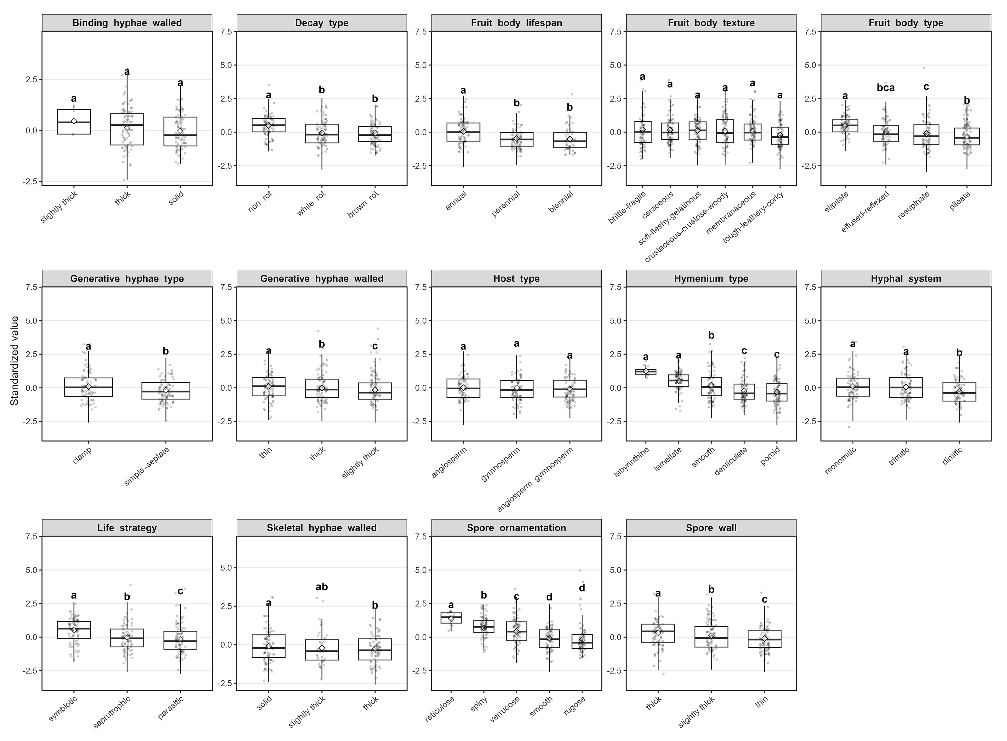
Fig. S1 Differences in standardized basidia size of wood-inhabiting fungi grouped by 14 categorical traits. Boxplots show the distribution of standardized basidia size across categories of 14 categorical variables. Each subpanel corresponds to one categorical trait, and lowercase letters indicate significant differences in basidia size among groups within each categorical trait.
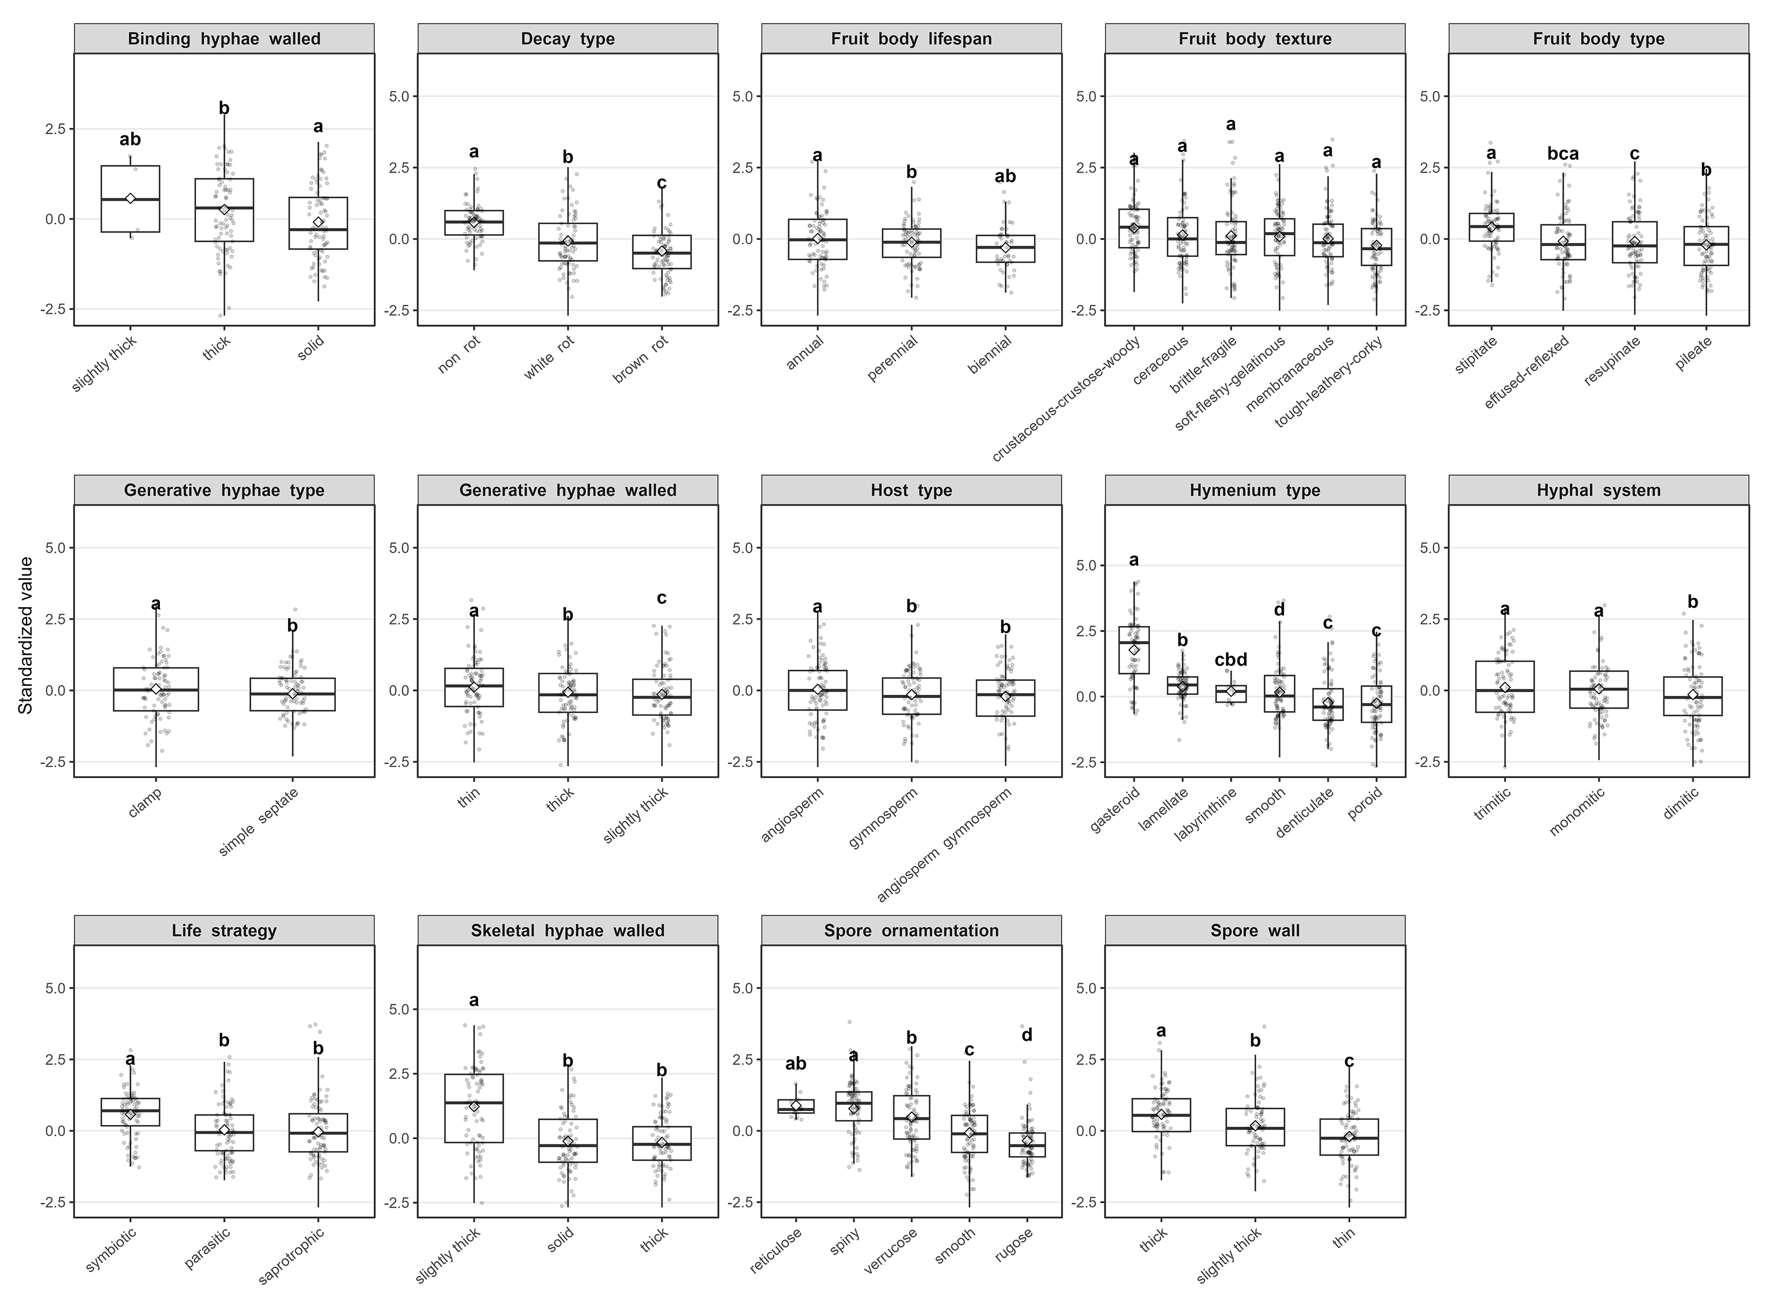
Fig. S2 Differences in standardized spore size of wood-inhabiting fungi grouped by 14 categorical traits. Boxplots show the distribution of standardized spore size across categories of 14 categorical variables. Each subpanel corresponds to one categorical trait, and lowercase letters indicate significant differences in spore size among groups within each categorical trait.
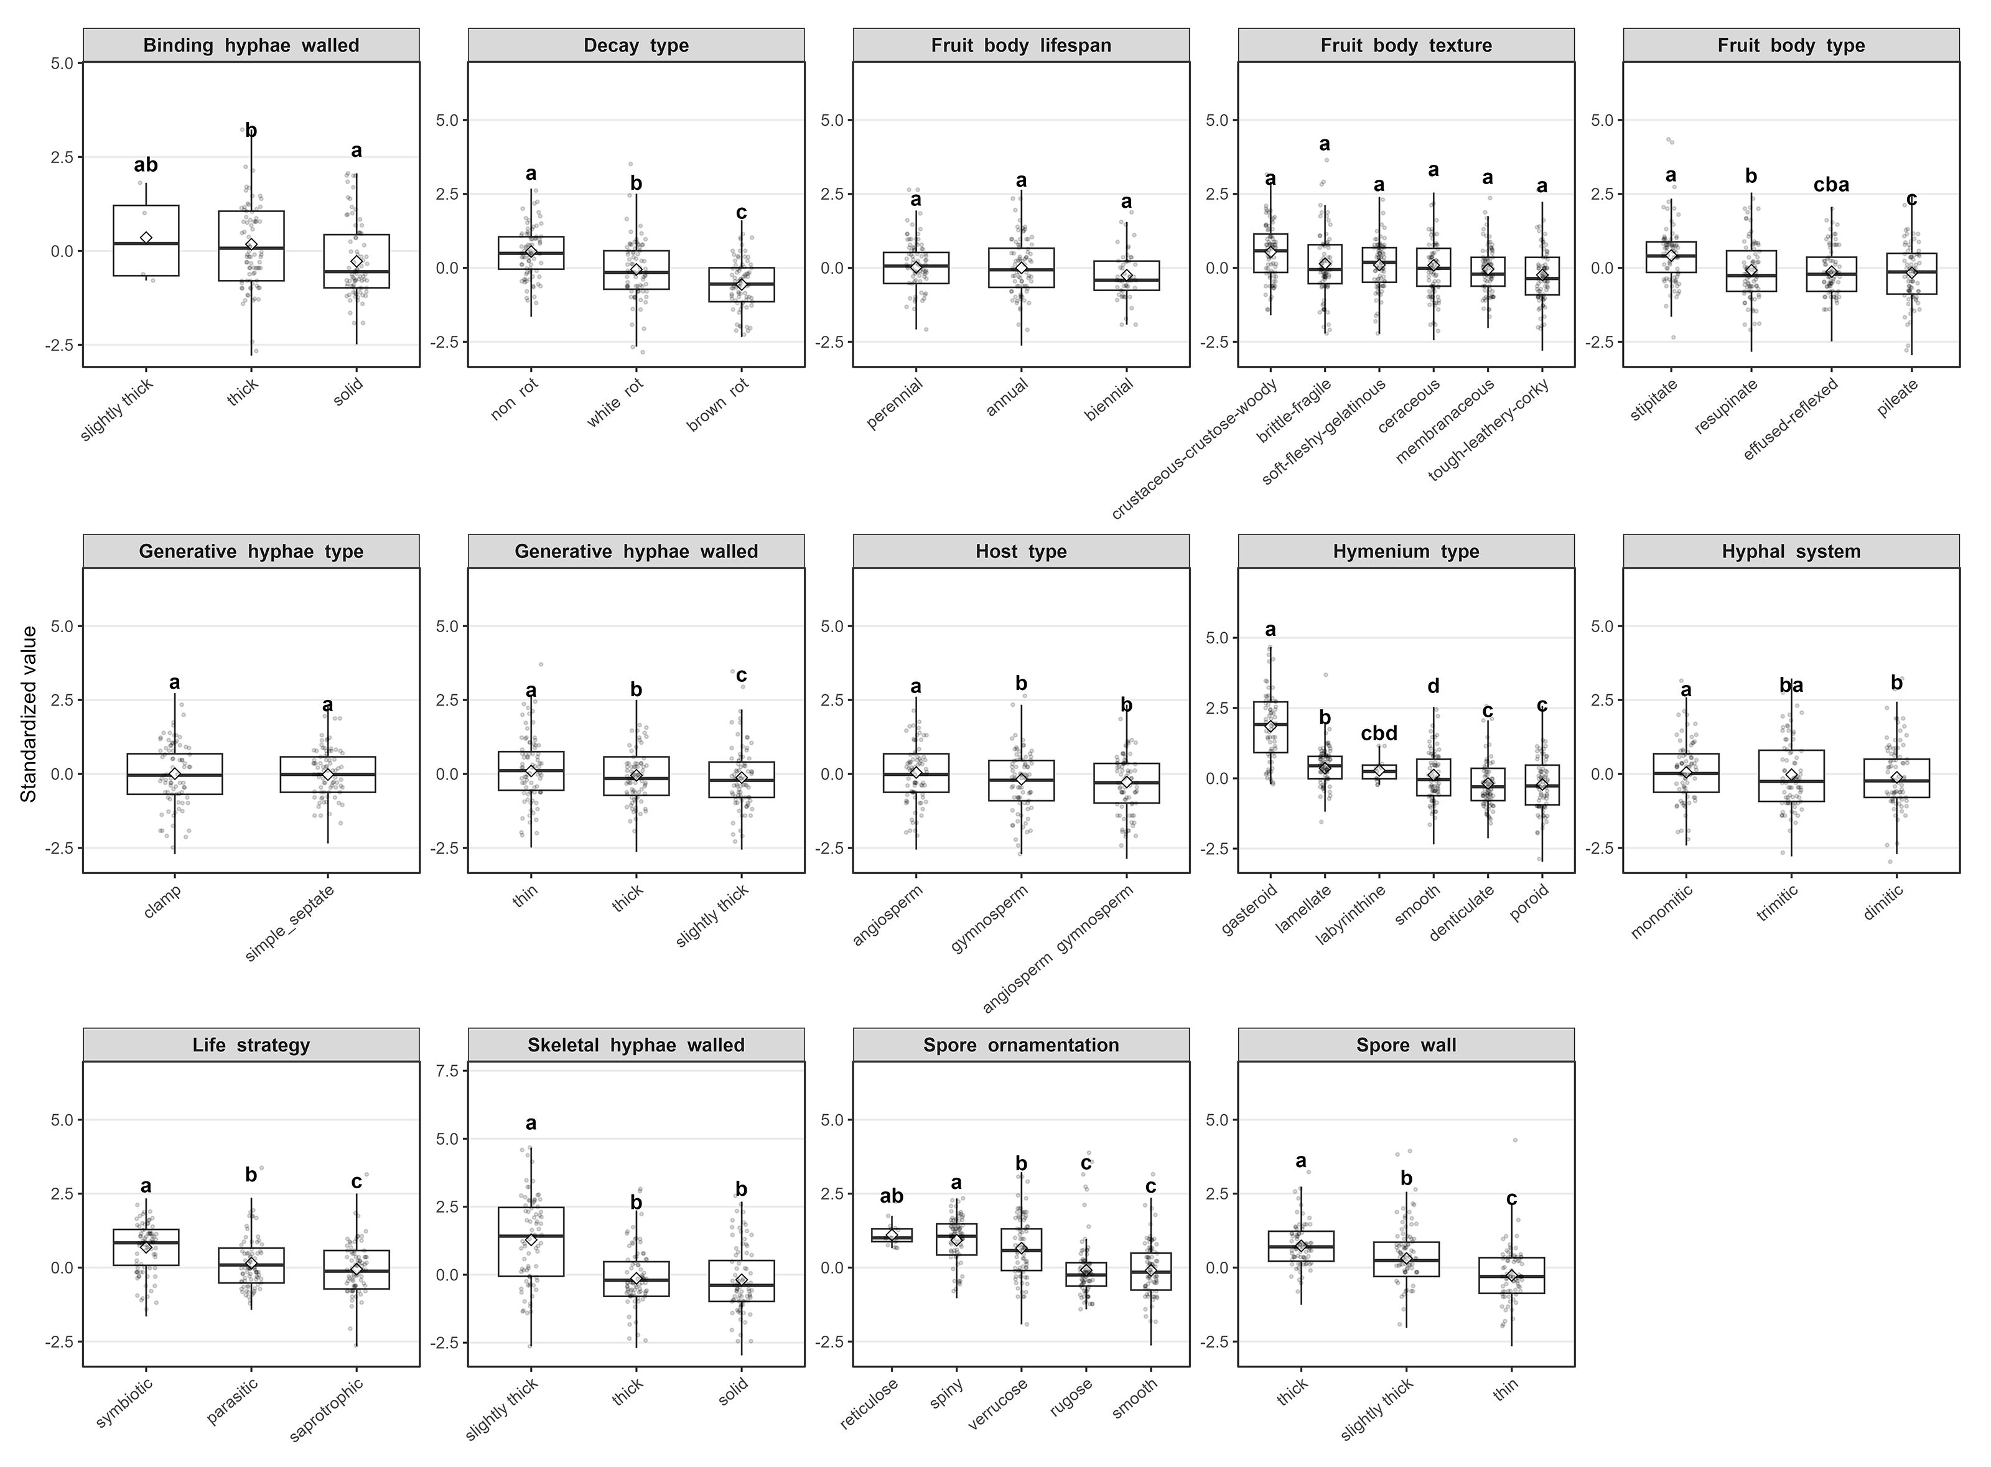
Fig. S3 Differences in standardized spore width of wood-inhabiting fungi grouped by 14 categorical traits. Boxplots show the distribution of standardized spore width across categories of 14 categorical variables. Each subpanel corresponds to one categorical trait, and lowercase letters indicate significant differences in spore width among groups within each categorical trait.
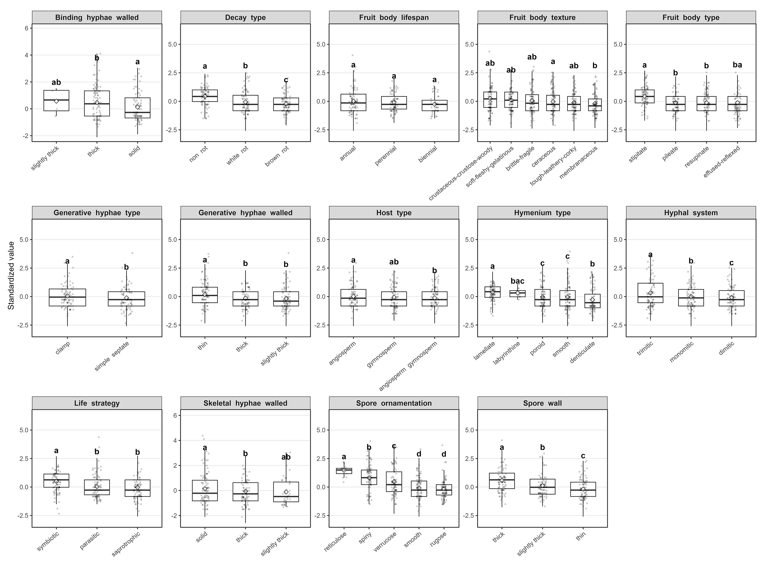
Fig. S4 Differences in standardized basidia width of wood-inhabiting fungi grouped by 14 categorical traits. Boxplots show the distribution of standardized basidia width across categories of 14 categorical variables. Each subpanel corresponds to one categorical trait, and lowercase letters indicate significant differences in basidia width among groups within each categorical trait.
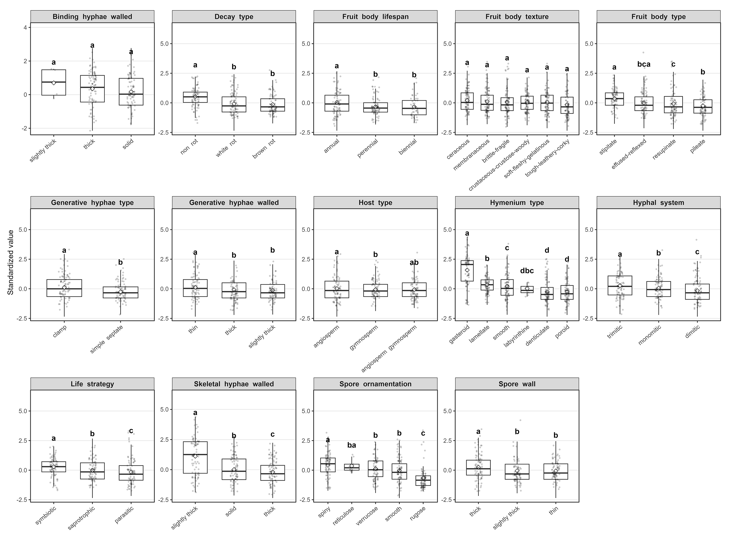
Fig. S5 Differences in standardized spore length of wood-inhabiting fungi grouped by 14 categorical traits. Boxplots show the distribution of standardized spore length across categories of 14 categorical variables. Each subpanel corresponds to one categorical trait, and lowercase letters indicate significant differences in spore length among groups within each categorical trait.
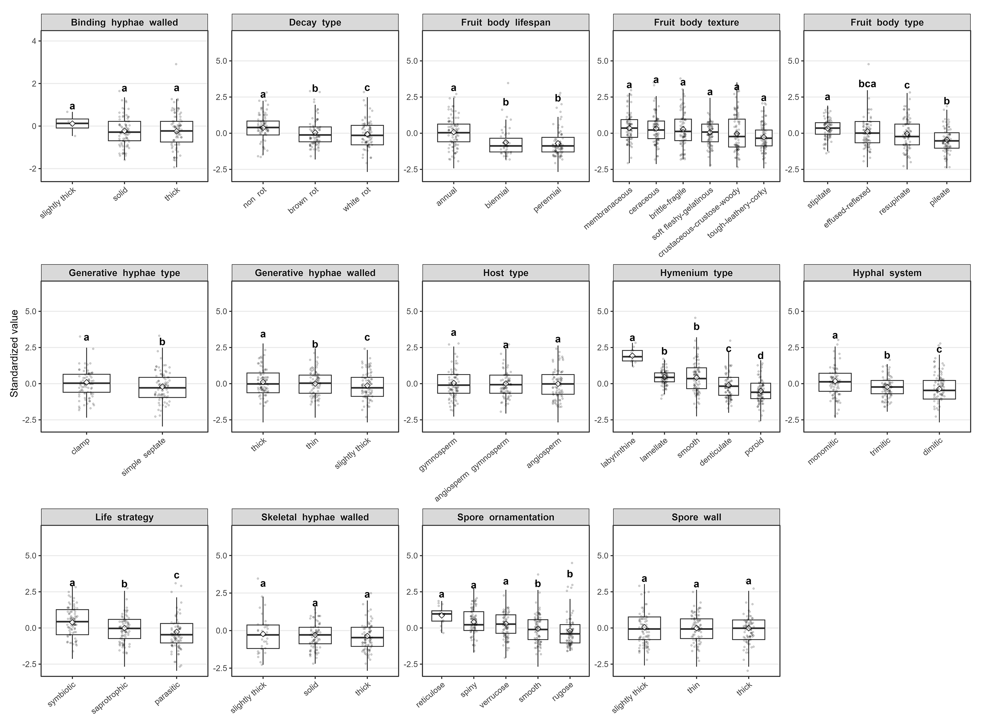
Fig. S6 Differences in standardized basidia length of wood-inhabiting fungi grouped by 14 categorical traits. Boxplots show the distribution of standardized basidia length across categories of 14 categorical variables. Each subpanel corresponds to one categorical trait, and lowercase letters indicate significant differences in basidia length among groups within each categorical trait.
Fig. S7 Differences in standardized basidia shape of wood-inhabiting fungi grouped by 14 categorical traits. Boxplots show the distribution of standardized basidia shape across categories of 14 categorical variables. Each subpanel corresponds to one categorical trait, and lowercase letters indicate significant differences in basidia shape among groups within each categorical trait.
Fig. S8 Differences in standardized spore shape of wood-inhabiting fungi grouped by 14 categorical traits. Boxplots show the distribution of standardized spore shape across categories of 14 categorical variables. Each subpanel corresponds to one categorical trait, and lowercase letters indicate significant differences in spore shape among groups within each categorical trait.
Fig. S9 Differences in standardized fruit body size of wood-inhabiting fungi grouped by 14 categorical traits. Boxplots show the distribution of standardized fruit body size across categories of 14 categorical variables. Each subpanel corresponds to one categorical trait, and lowercase letters indicate significant differences in fruit body size among groups within each categorical trait.
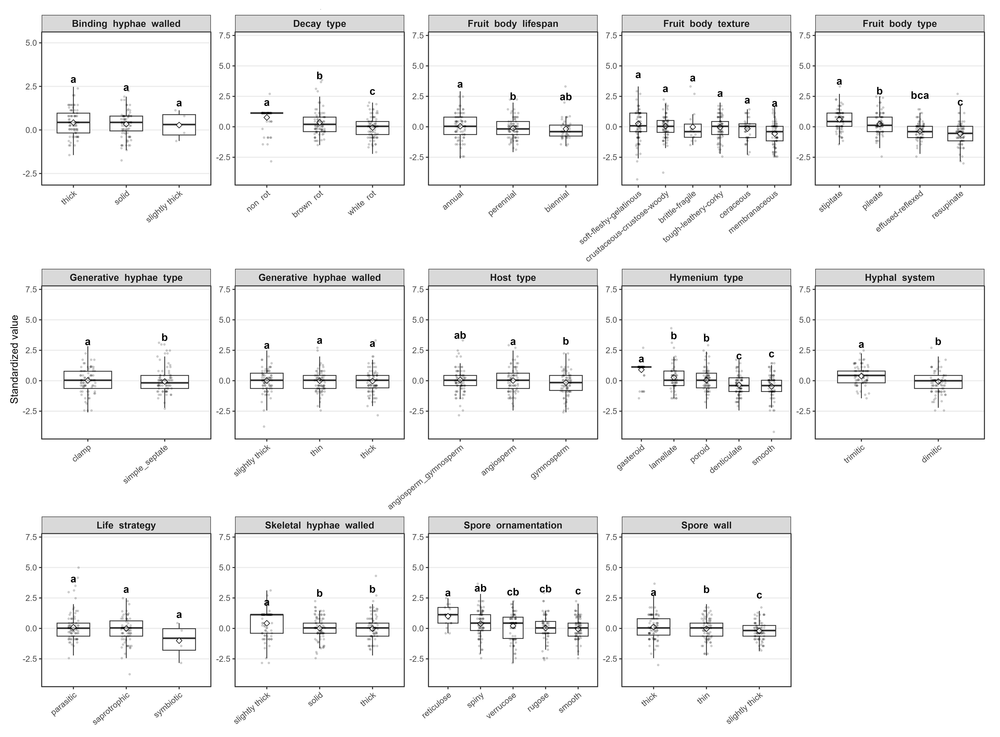
Fig. S10 Differences in standardized skeletal hyphae diameter of wood-inhabiting fungi grouped by 14 categorical traits. Boxplots show the distribution of standardized skeletal hyphae diameter across categories of 14 categorical variables. Each subpanel corresponds to one categorical trait, and lowercase letters indicate significant differences in skeletal hyphae diameter among groups within each categorical trait.
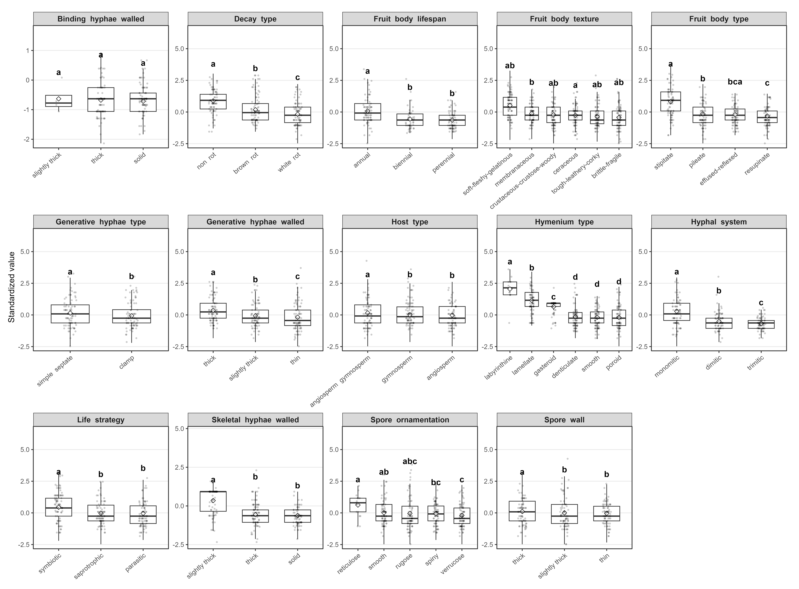
Fig. S11 Differences in standardized generative hyphae diameter of wood-inhabiting fungi grouped by 14 categorical traits. Boxplots show the distribution of standardized generative hyphae diameter across categories of 14 categorical variables. Each subpanel corresponds to one categorical trait, and lowercase letters indicate significant differences in generative hyphae diameter among groups within each categorical trait.
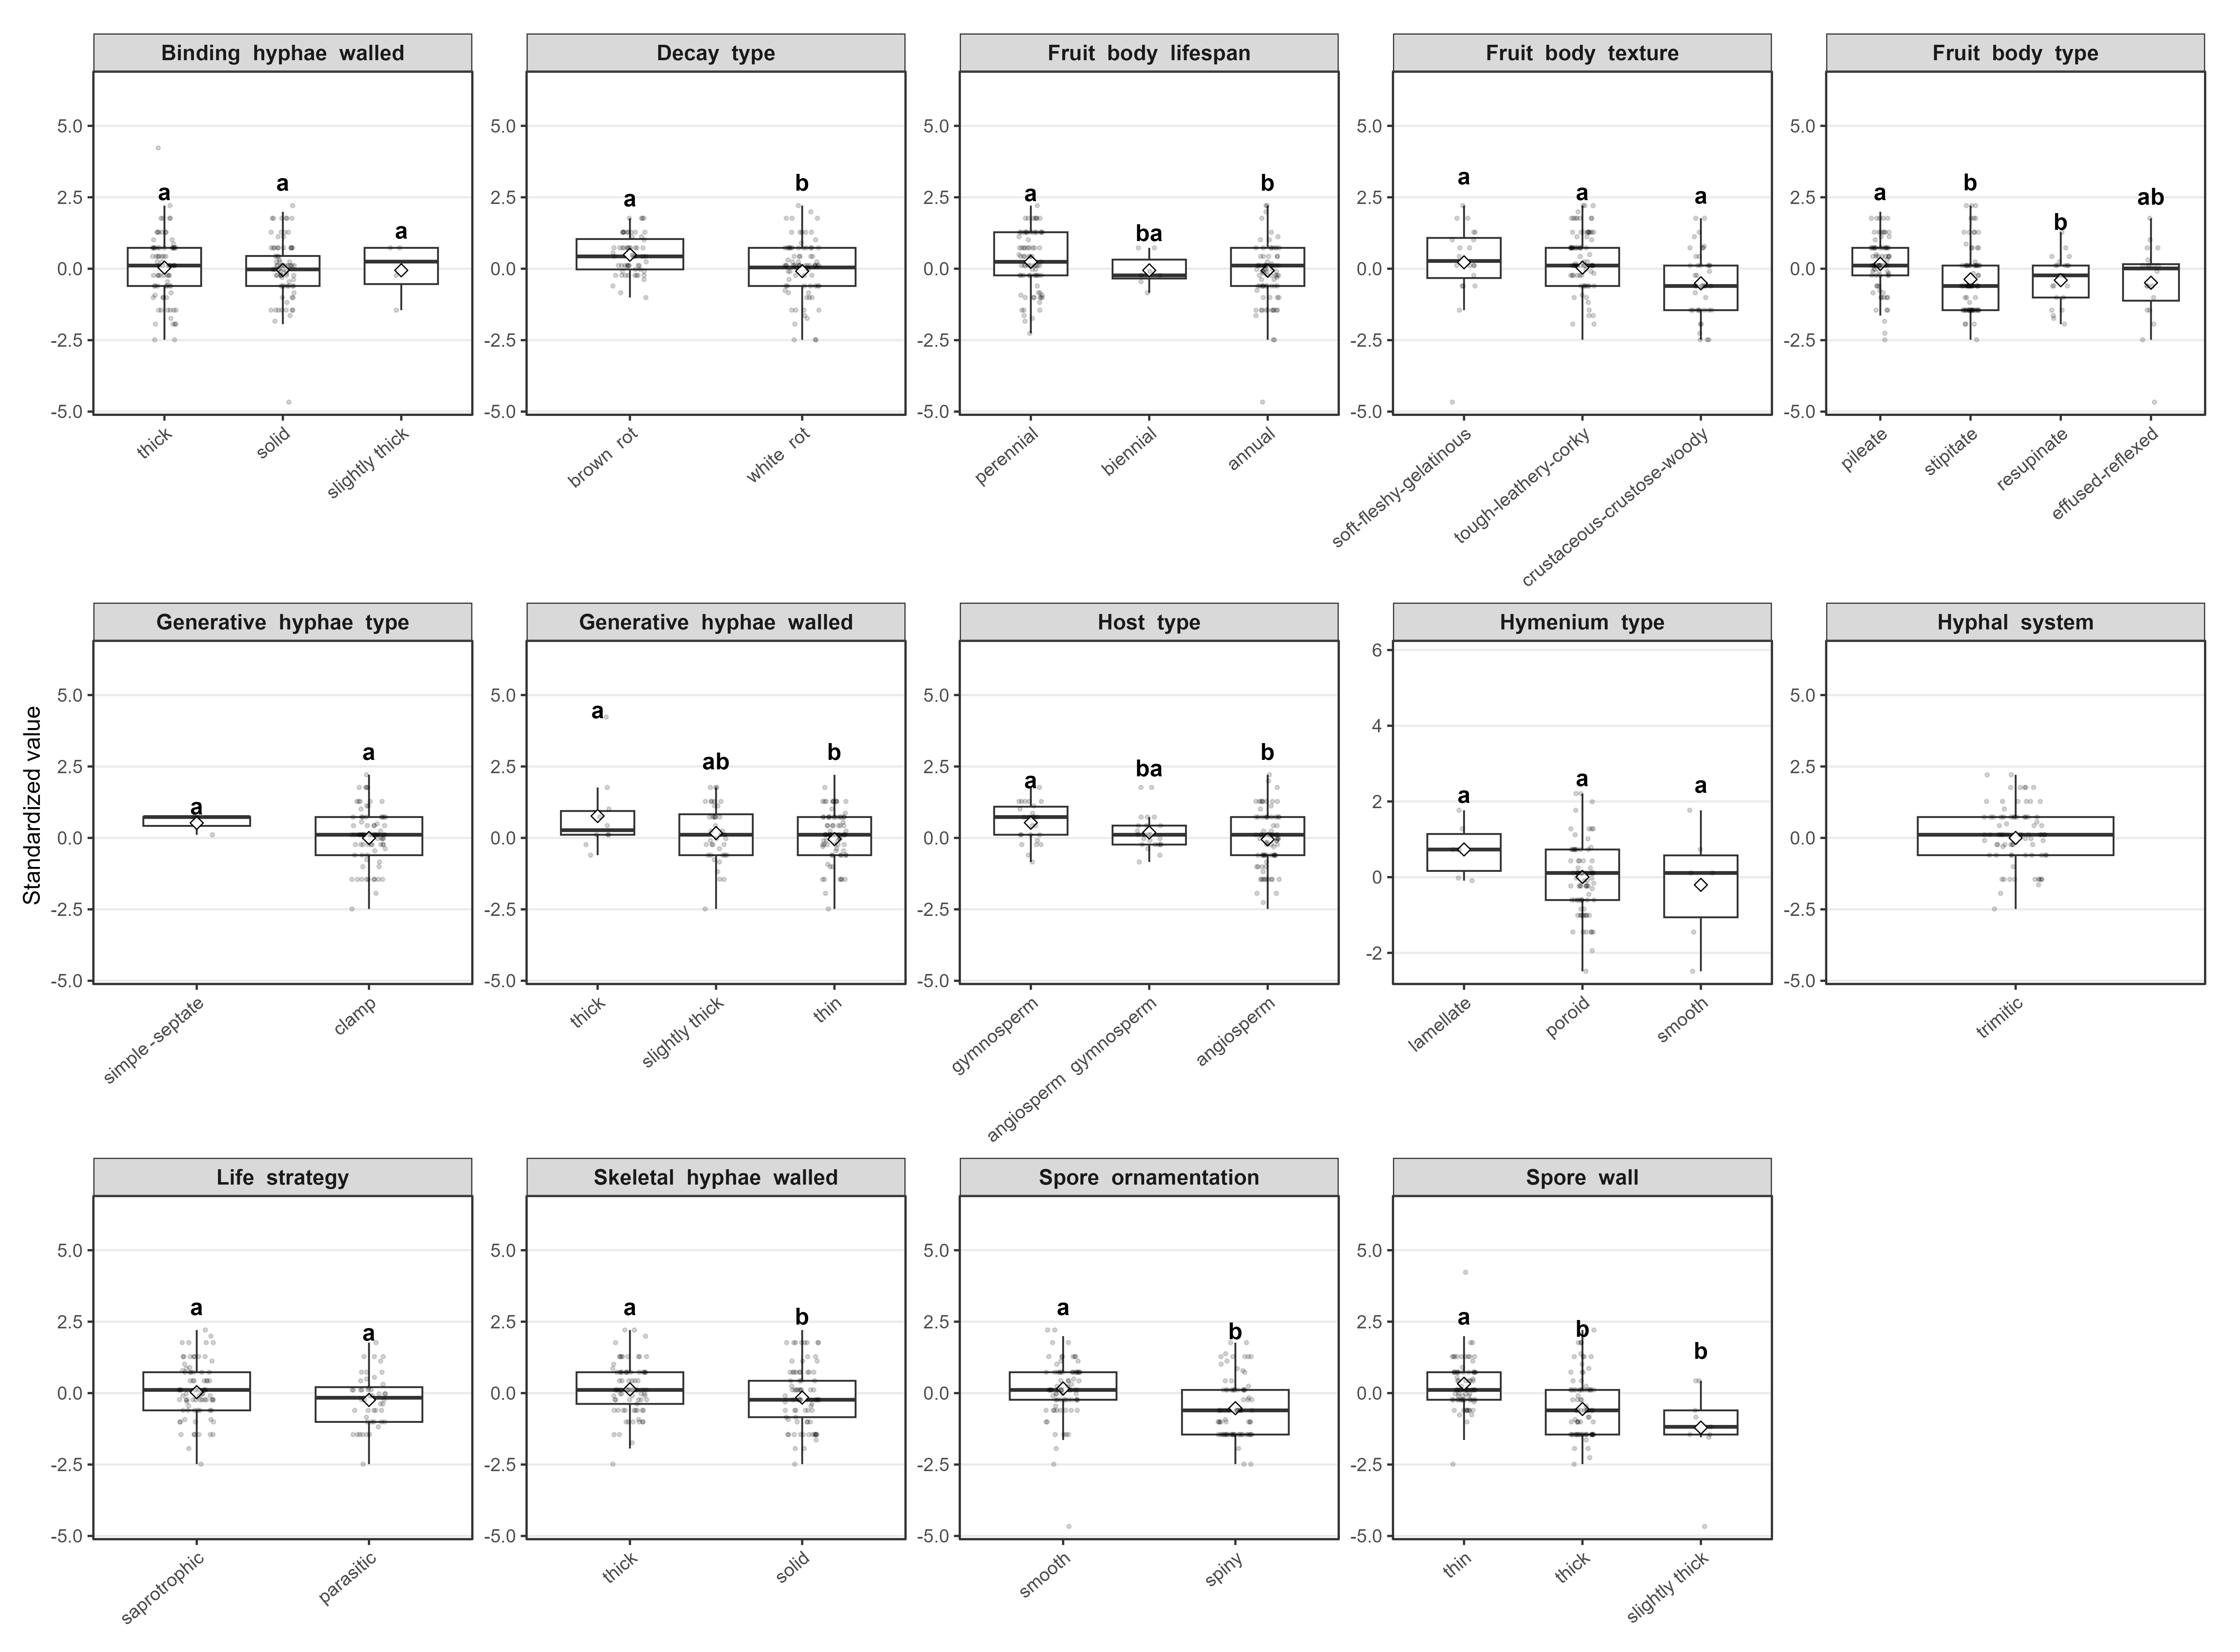
Fig. S12 Differences in standardized binding hyphae diameter of wood-inhabiting fungi grouped by 14 categorical traits. Boxplots show the distribution of standardized binding hyphae diameter across categories of 14 categorical variables. Each subpanel corresponds to one categorical trait, and lowercase letters indicate significant differences in binding hyphae diameter among groups within each categorical trait.
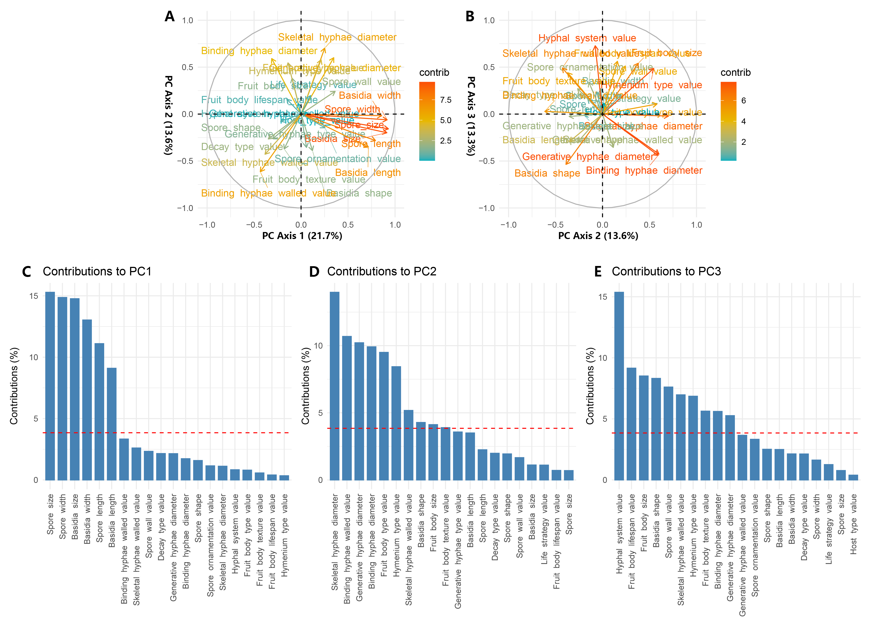
Fig. S13 Principal component analysis (PCA) of wood-inhabiting fungi based on 26 functional traits (including 14 categorical traits that were numerically coded). A. Biplot of PC1 vs. PC2 showing trait loadings in principal component space. B. Biplot of PC2 vs. PC3 showing trait loadings; C–E. Contributions of individual traits to PC1, PC2, and PC3 (measured as contribution percentages), with bar lengths indicating the relative importance of each trait to the corresponding principal component.
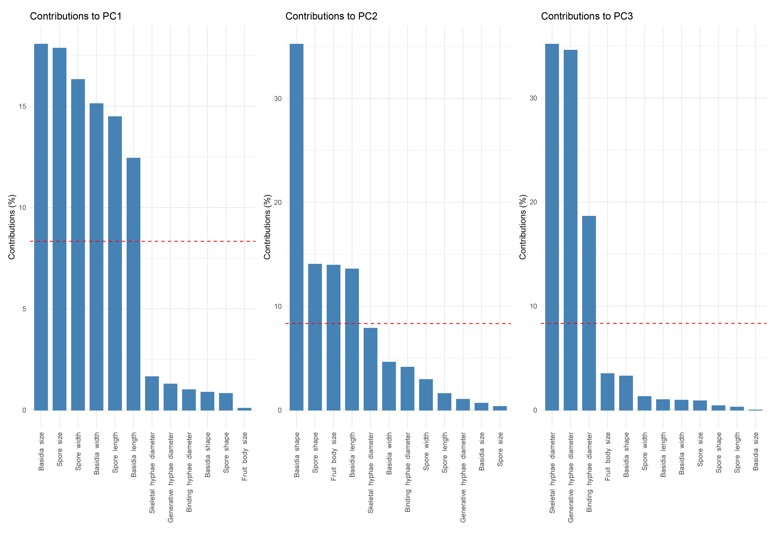
Fig. S14 Principal component analysis (PCA) of wood-inhabiting fungi based on 12 continuous morphological traits, showing the relative contribution percentages of individual traits to the first three principal component axes (PC1, PC2, and PC3). The red dashed line indicates the threshold for identifying high-contribution traits. A-C panels correspond to the contribution percentages of traits to PC1, PC2, and PC3, respectively.
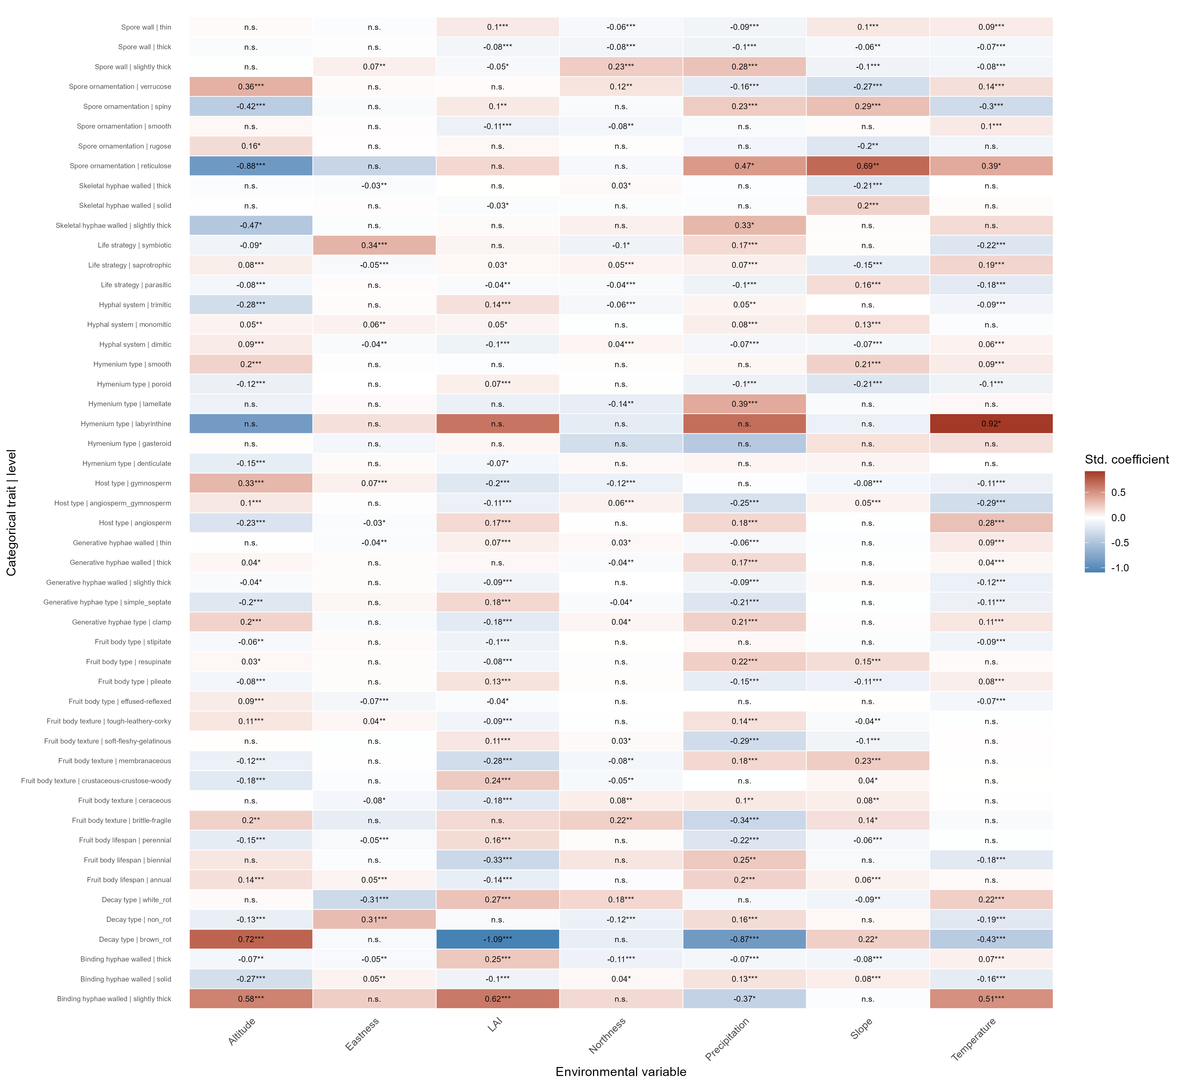
Fig. S15 Heatmap analysis of the effects of environmental factors on each category within 14 categorical traits. Each cell in the matrix represents the response coefficient (standardized regression coefficient) of a given categorical trait category to a given environmental factor. * or “n.s.” indicate significance levels (* p < 0.05, ** p < 0.01, *** p < 0.001; n.s. denotes non-significant).
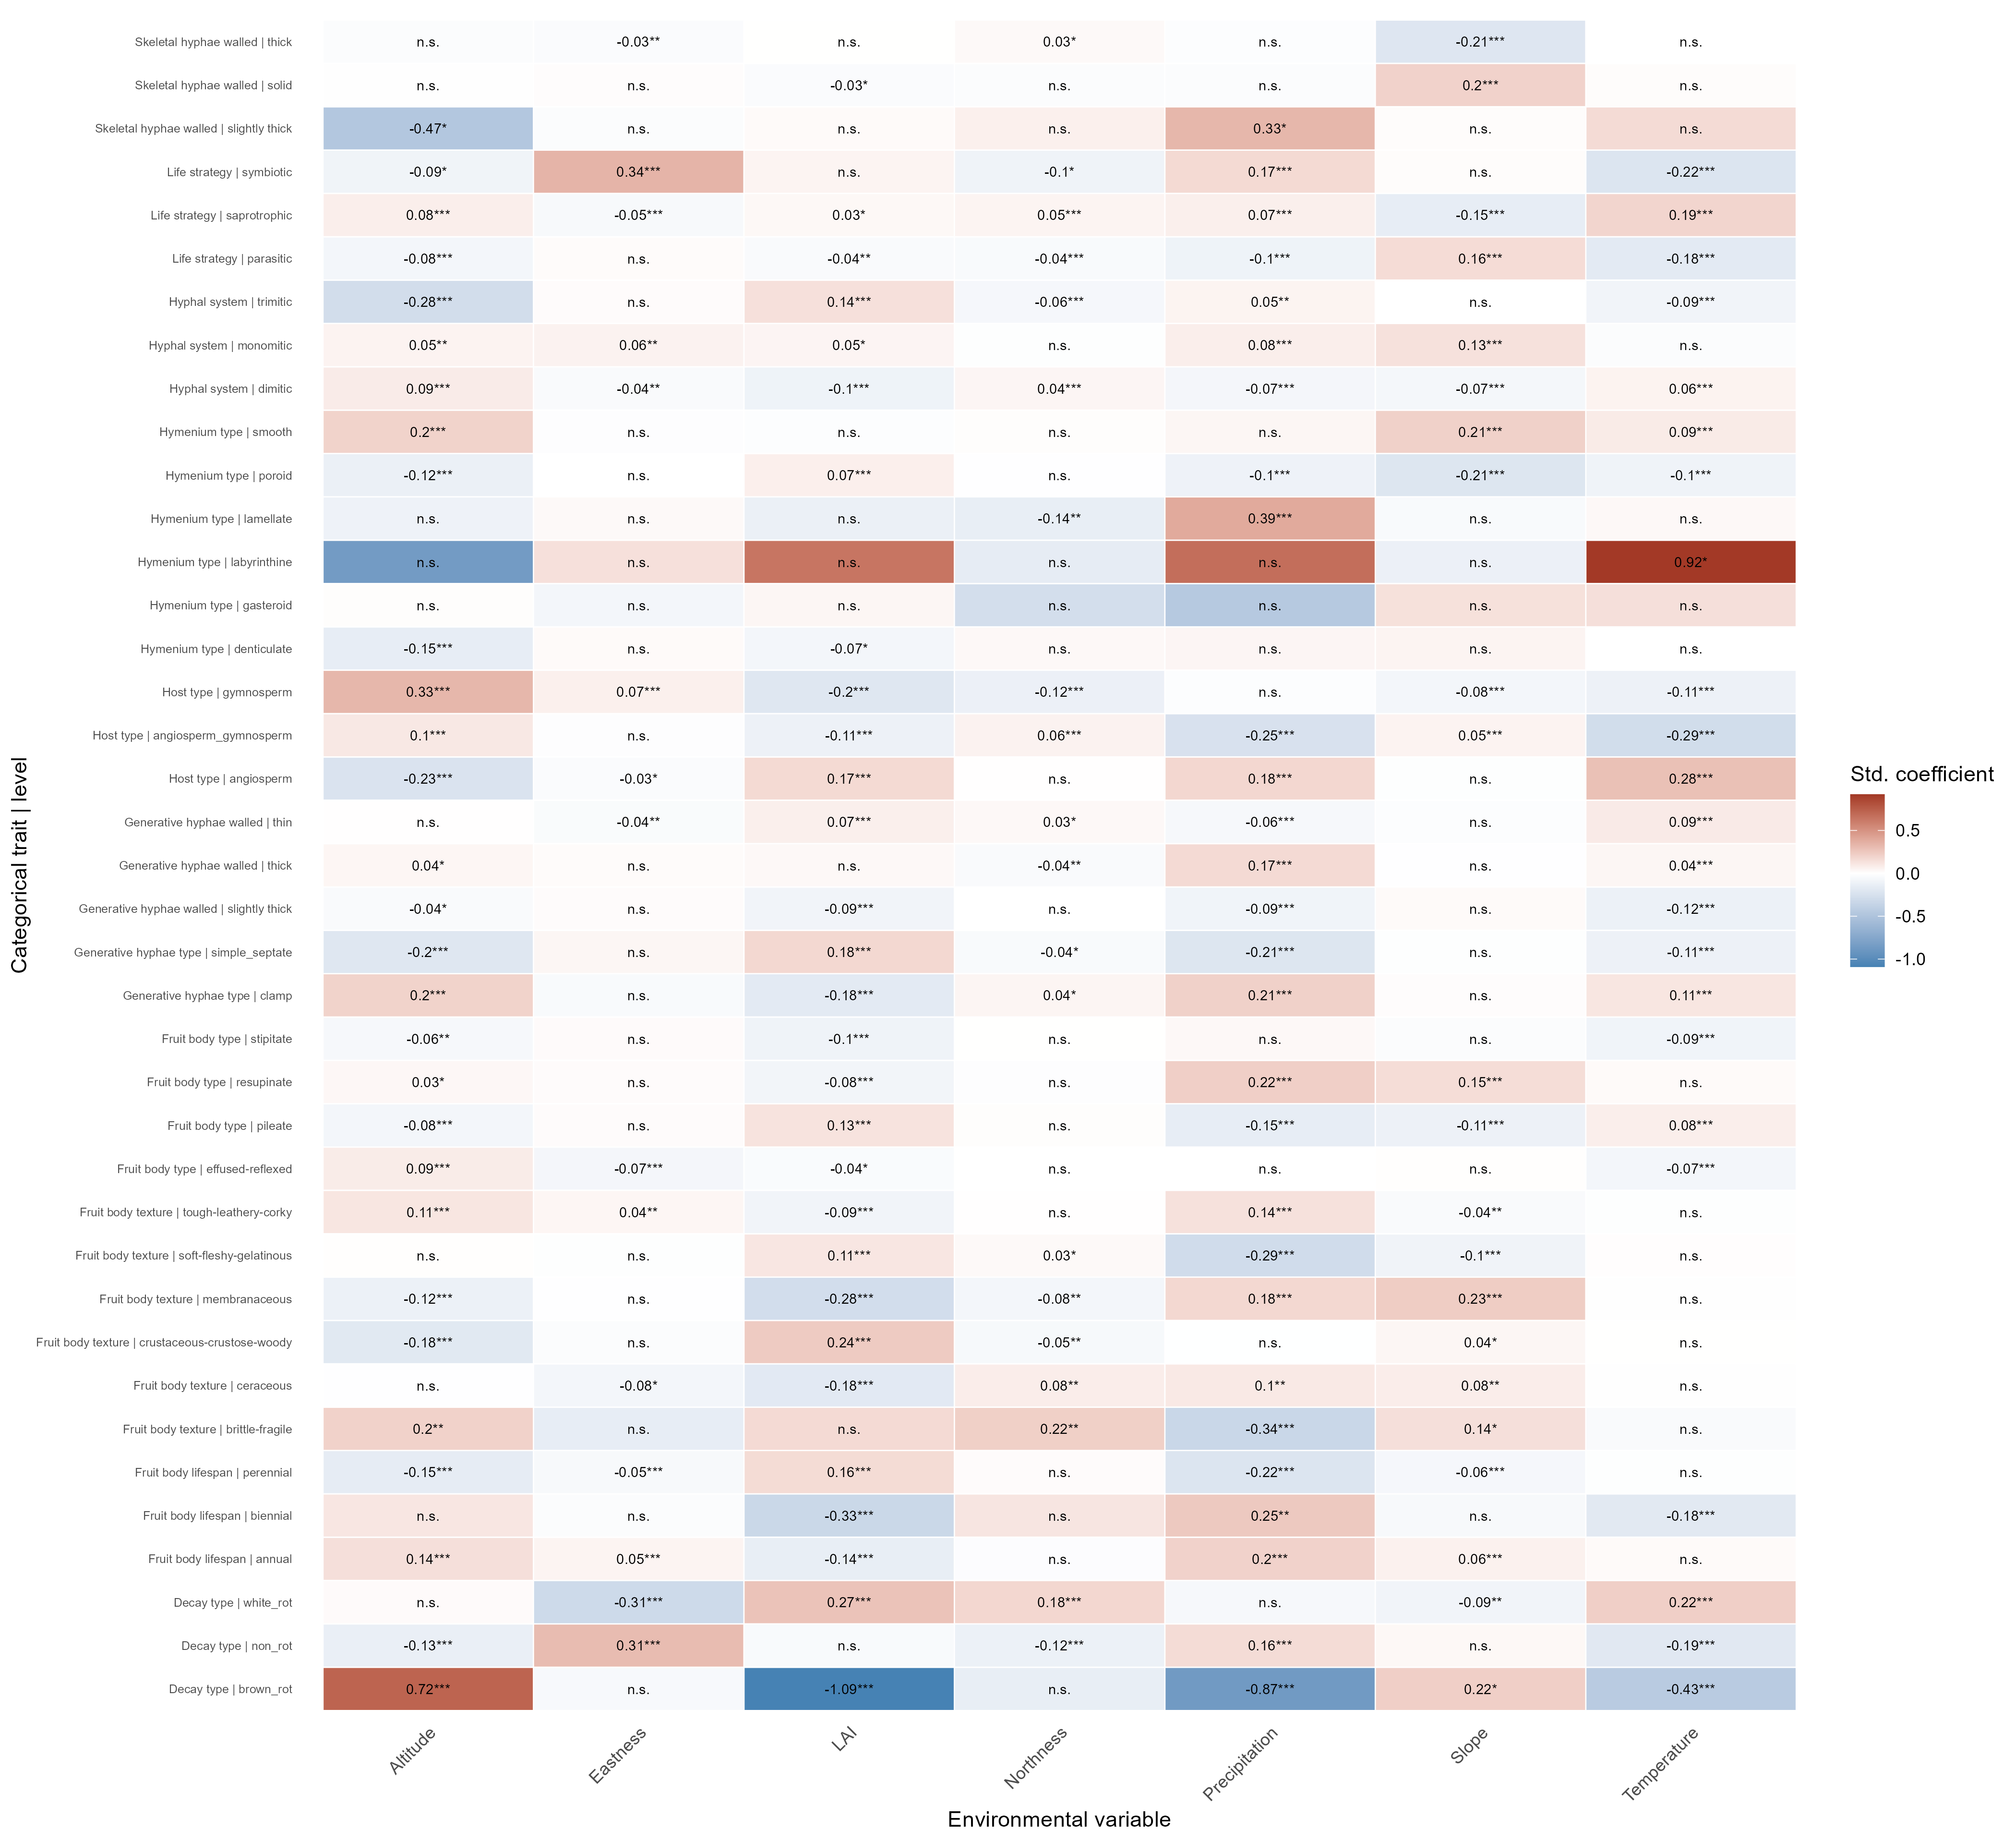Fig. S16 Heatmap analysis of the effects of environmental factors on each category within 14 categorical traits. Each cell in the matrix represents the response coefficient (standardized regression coefficient) of a given categorical trait category to a given environmental factor. “*” or “n.s.” indicate significance levels (* p < 0.05, ** p < 0.01, *** p < 0.001; n.s. denotes non-significant).
Fig. S17 Latitudinal pattern analysis of wood-inhabiting fungi based on 14 categorical traits. Each subpanel shows the relative abundance variation of different categories (distinguished by colors) of each categorical trait along the latitudinal gradient, reflecting their latitudinal differentiation characteristics.
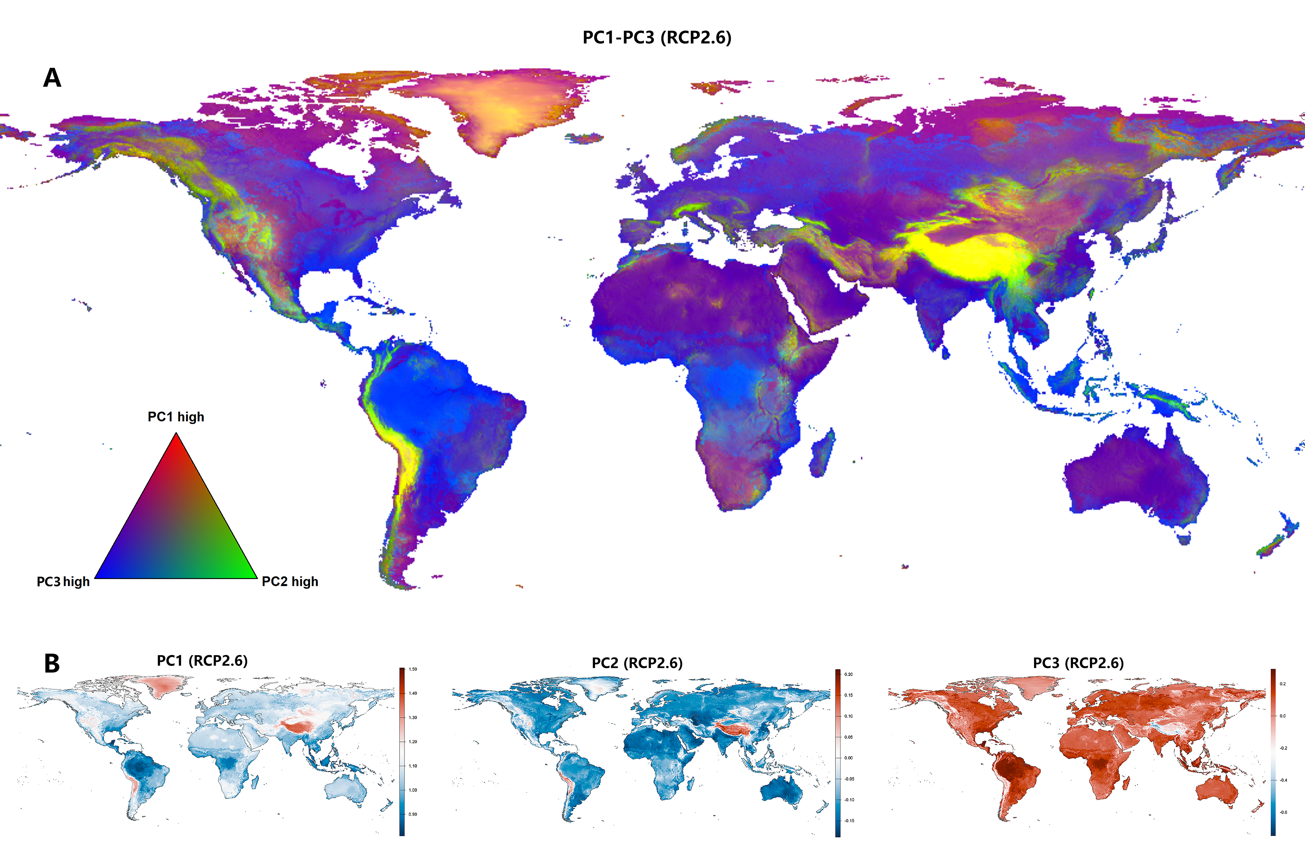
Fig. S18 Future predictions of core functional trait principal component axes (PC1–PC3) in wood-inhabiting fungi under the SSP1–RCP2.6 climate scenario. A. Combined prediction of the three principal component axes (PC1: basidia/spore size; PC2: basidia/spore shape and fruit body size; PC3: hyphal diameter), displayed as an RGB composite map. B. Individual predicted spatial distributions of PC1, PC2, and PC3 under the SSP1–RCP2.6 scenario.
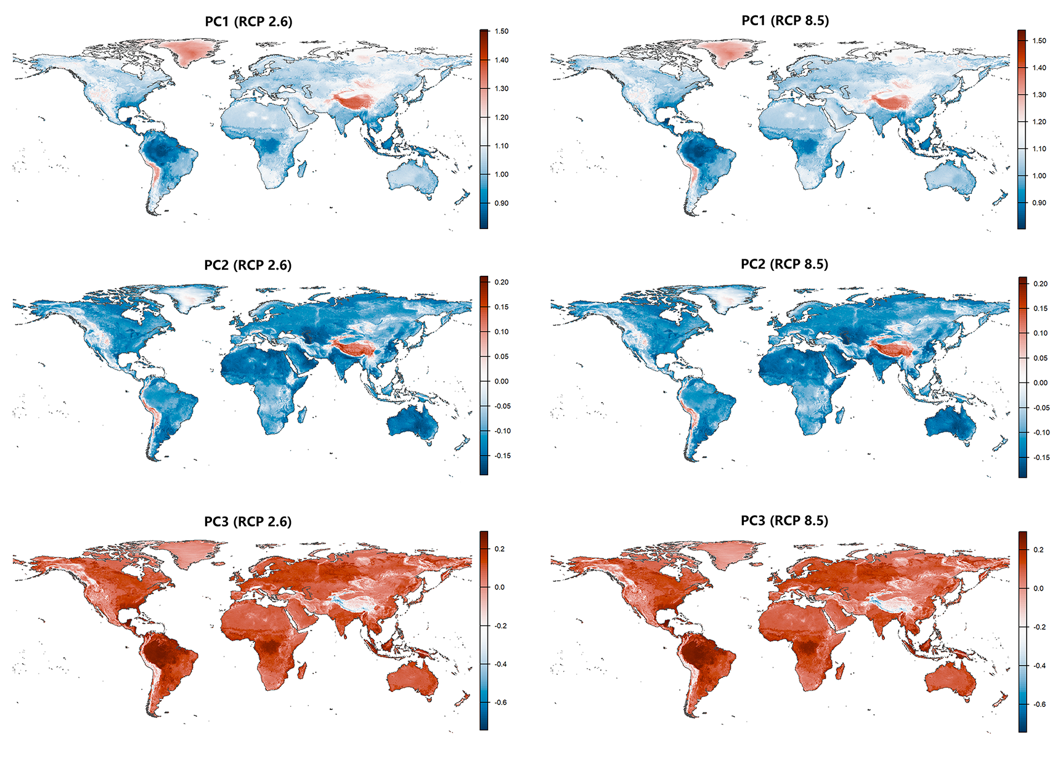
Fig. S19 Predicted spatial distributions of three functional trait principal component axes (PC1–PC3) in wood-inhabiting fungi under SSP1–RCP2.6 and SSP5–RCP8.5 climate scenarios. Each row corresponds to one PC axis (PC1, PC2, PC3), each column corresponds to one climate scenario, and color gradients indicate predicted scores of each PC axis.
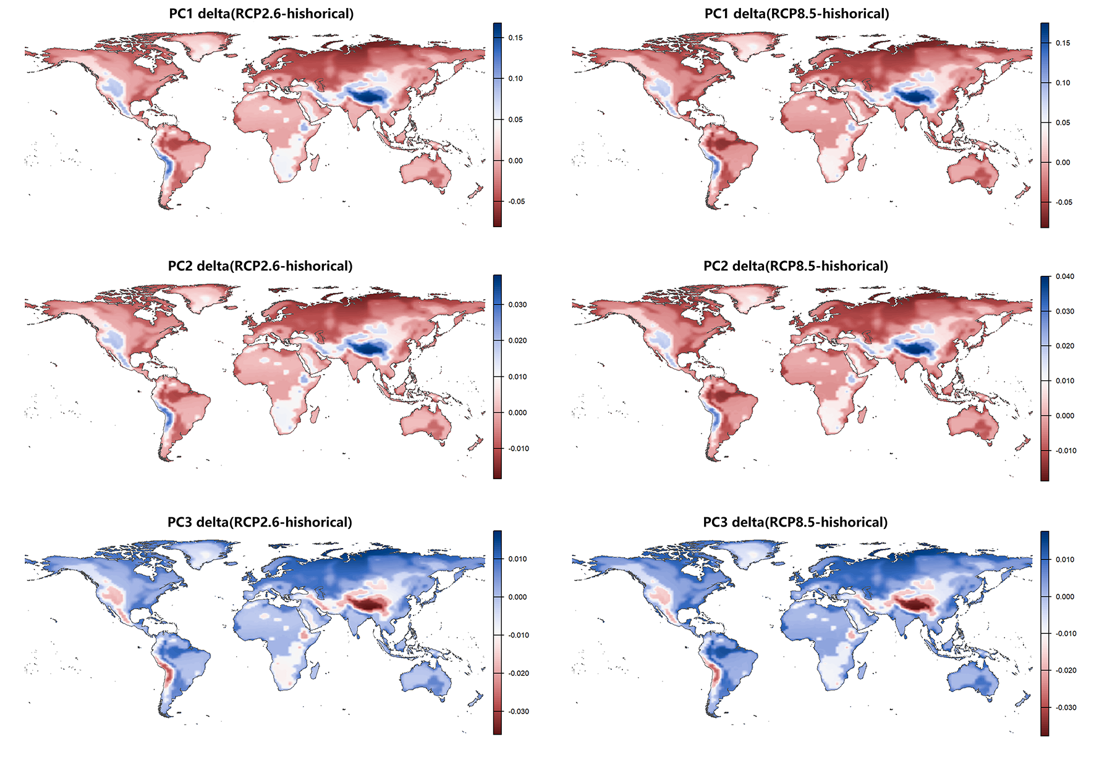
Fig. S20 Differences (Δ) between predicted and current distributions of three functional trait principal component axes (PC1–PC3) in wood-inhabiting fungi under SSP1–RCP2.6 and SSP5–RCP8.5 climate scenarios. Each row corresponds to one PC axis (PC1, PC2, PC3), each column corresponds to one climate scenario, and color gradients indicate the predicted score changes (interpolated differences) of each PC axis between future scenarios and the current condition.
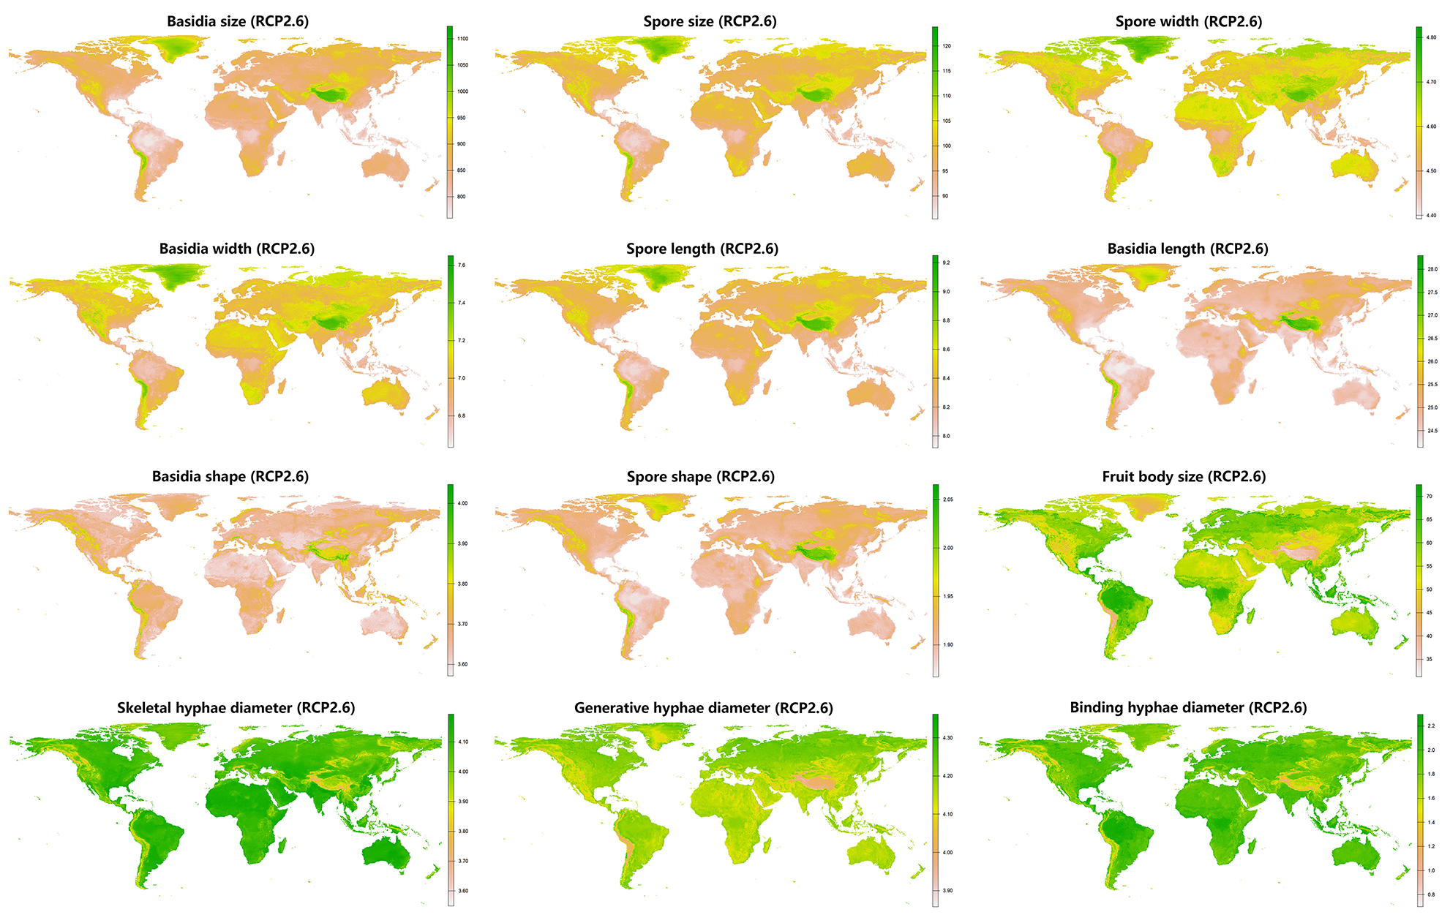
Fig. S21 Predicted spatial distributions of 12 functional traits in wood-inhabiting fungi under the SSP1–RCP2.6 climate scenario. Each subpanel corresponds to one trait, with color gradients indicating predicted values of each trait under the SSP1–RCP2.6 scenario.
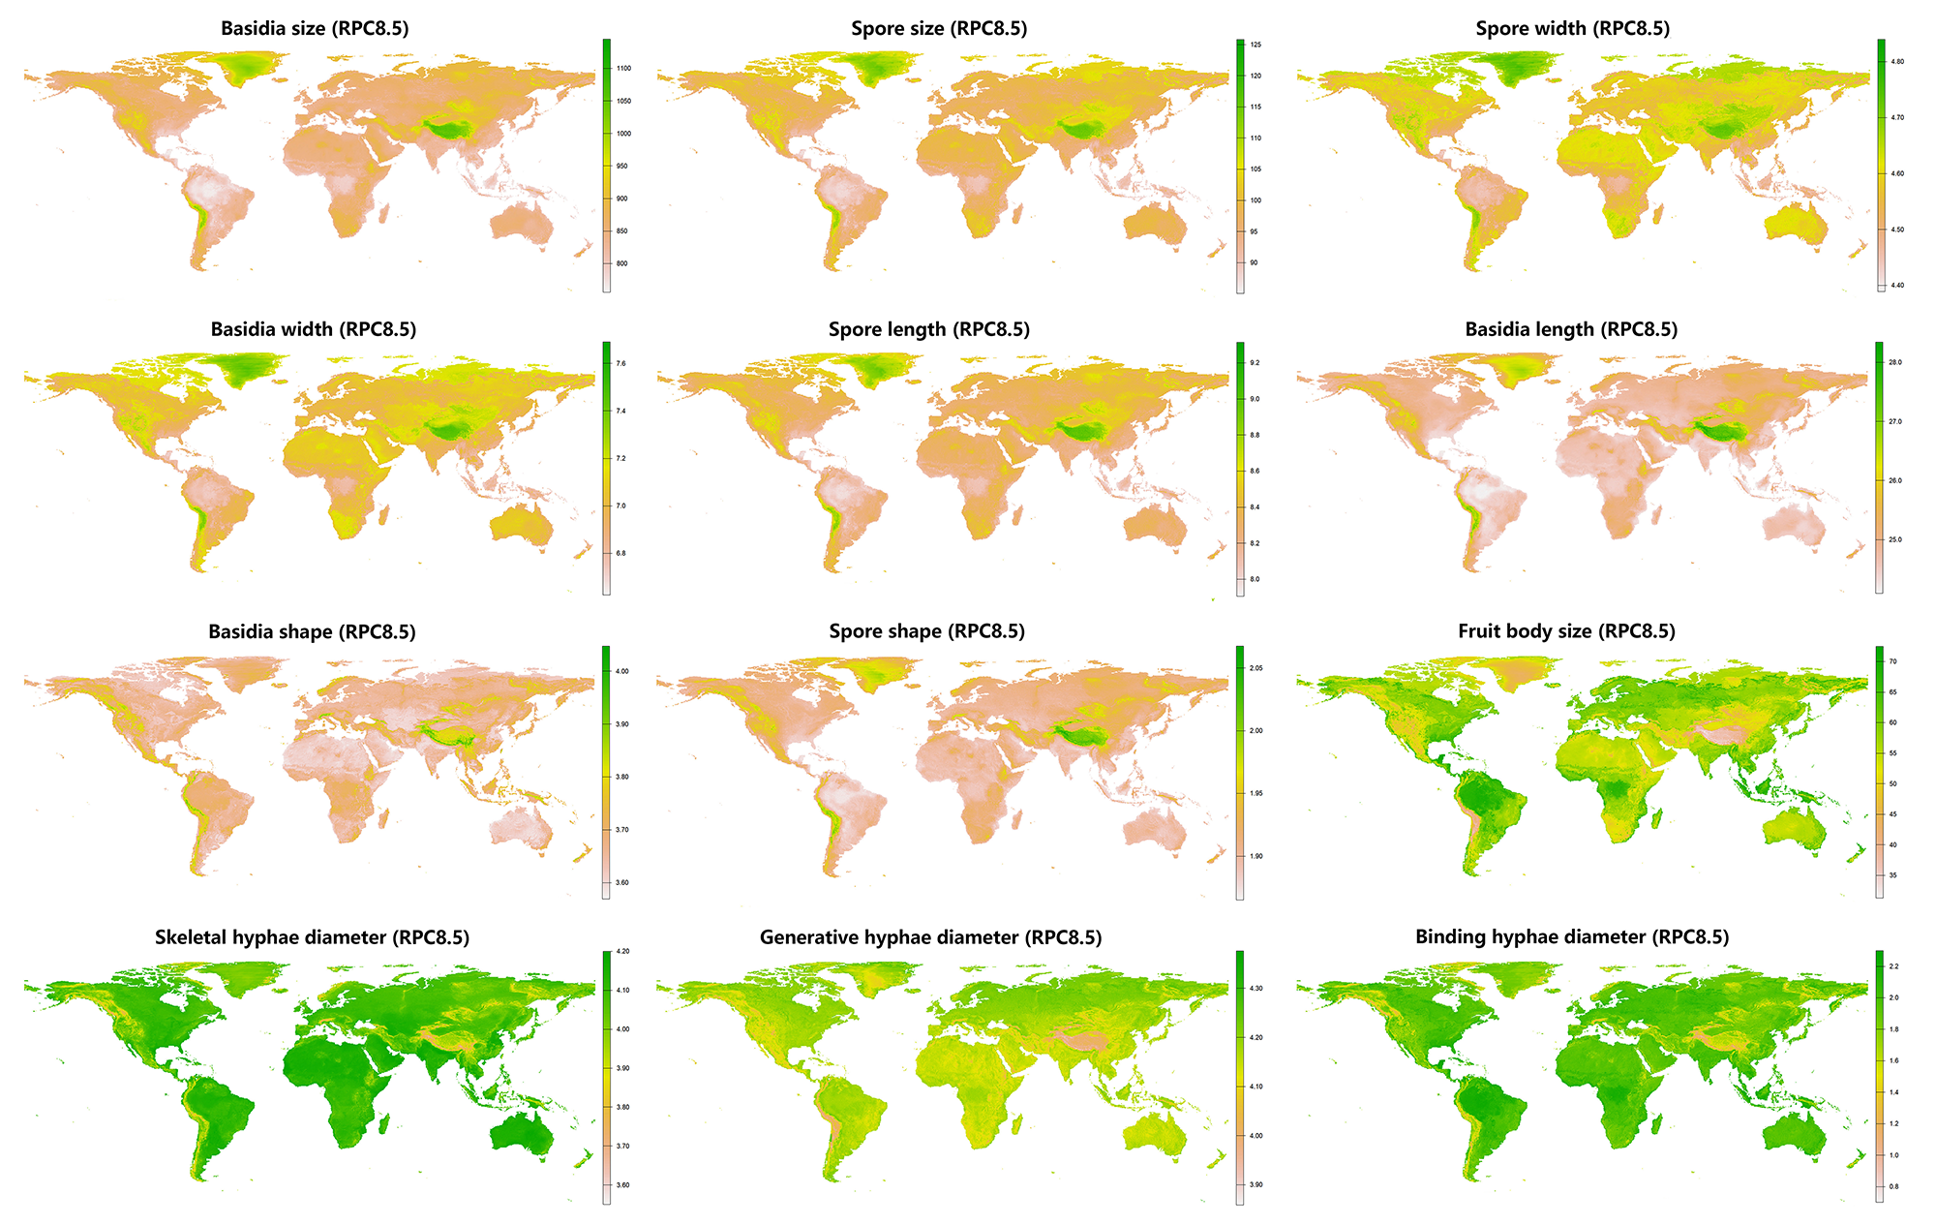
Fig. S22 Predicted spatial distributions of 12 functional traits in wood-inhabiting fungi under the SSP5–RCP8.5 climate scenario. Each subpanel corresponds to one trait, with color gradients indicating predicted values of each trait under the SSP5–RCP8.5 scenario.
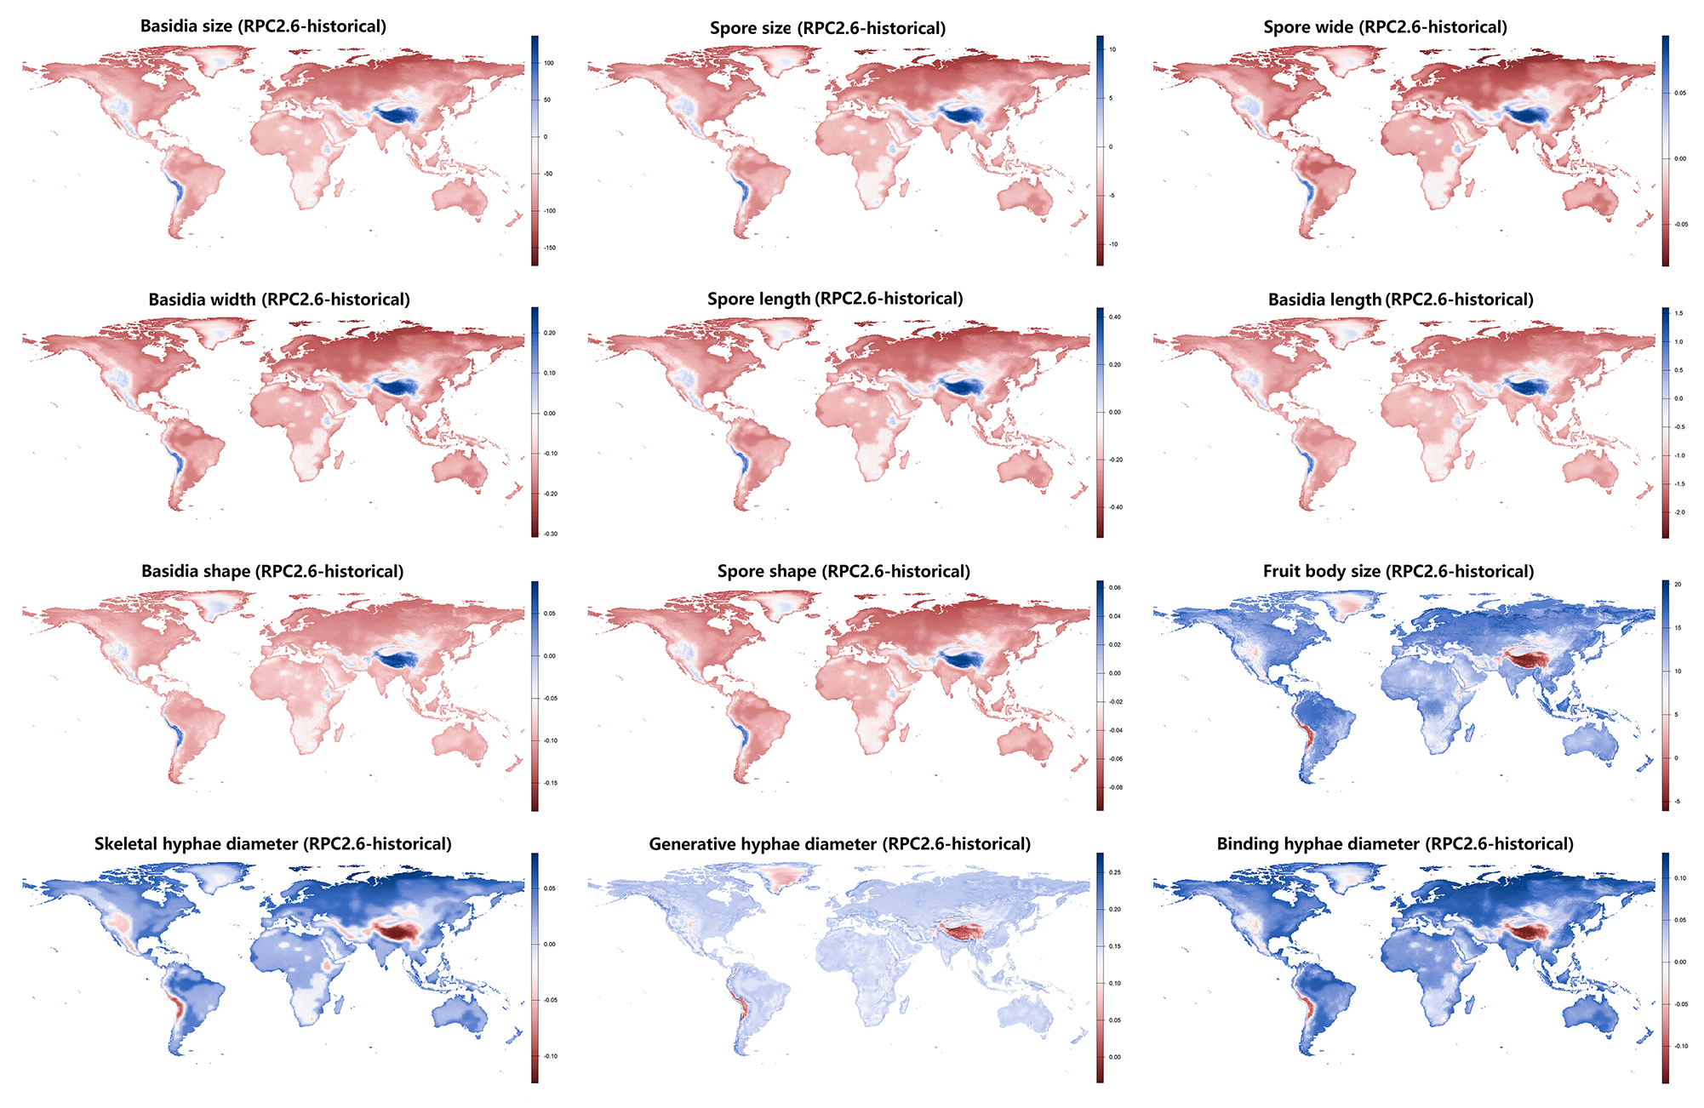
Fig. S23 Differences (Δ) between predicted and current distributions of 12 functional traits in wood-inhabiting fungi under the SSP1–RCP2.6 climate scenario. Each subpanel corresponds to one trait, with color gradients indicating the magnitude of change between predicted and current values for each trait under the SSP1–RCP2.6 scenario.
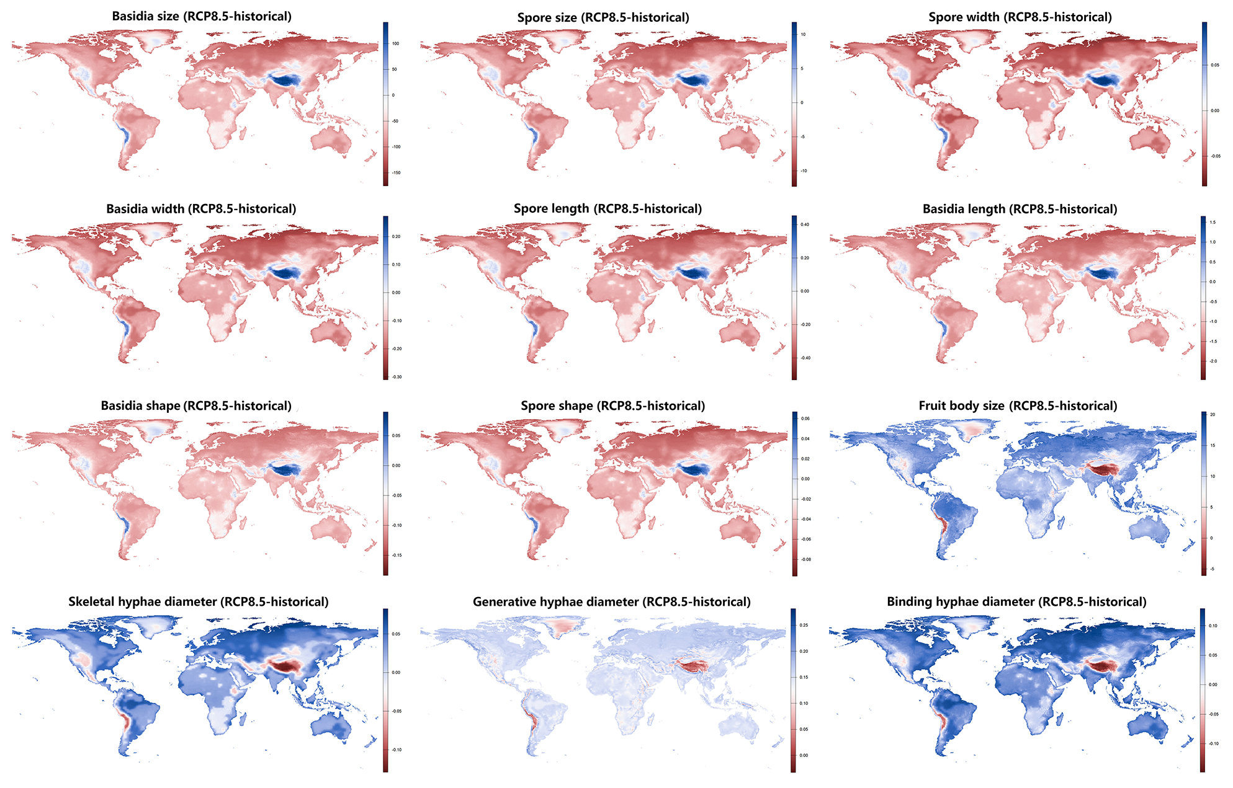
Fig. S24 Differences (Δ) between predicted and current distributions of 12 functional traits in wood-inhabiting fungi under the SSP5–RCP8.5 climate scenario. Each subpanel corresponds to one trait, with color gradients indicating the magnitude of change between predicted and current values for each trait under the SSP5–RCP8.5 scenario.

Table S1. Generalized additive model (GAM) coefficients for the three principal component axes of the wood‑inhabiting fungi functional economics spectrum against environmental predictors, “*” or “n.s.” indicate significance levels (** p < 0.01, *** p < 0.001; n.s. denotes non-significant).
PC axis | Variable | Estimate | Std. Error | t value | Pr(>|t|) | Significance
PC1 | Precipitation | -0.099 | 0.006 | -15.285 | 0.000 | ***
PC1 | Temperature | -0.055 | 0.005 | -10.908 | 0.000 | ***
PC1 | LAI | -0.051 | 0.006 | -8.021 | 0.000 | ***
PC1 | Slope | 0.006 | 0.006 | 0.926 | 0.355 | n.s.
PC1 | Altitude | 0.021 | 0.007 | 3.009 | 0.003 | **
PC1 | Eastness | -0.010 | 0.006 | -1.827 | 0.068 | n.s.
PC1 | Northness | 0.001 | 0.005 | 0.125 | 0.901 | n.s.
PC2 | Precipitation | 0.029 | 0.005 | 5.923 | 0.000 | ***
PC2 | Temperature | -0.013 | 0.004 | -3.358 | 0.001 | ***
PC2 | LAI | 0.018 | 0.005 | 3.830 | 0.000 | ***
PC2 | Slope | 0.015 | 0.005 | 3.167 | 0.002 | **
PC2 | Altitude | 0.035 | 0.005 | 6.632 | 0.000 | ***
PC2 | Eastness | -0.011 | 0.004 | -2.736 | 0.006 | **
PC2 | Northness | -0.006 | 0.004 | -1.503 | 0.133 | n.s.
PC3 | Precipitation | -0.016 | 0.005 | -2.906 | 0.004 | **
PC3 | Temperature | 0.012 | 0.004 | 2.841 | 0.004 | **
PC3 | LAI | 0.047 | 0.005 | 8.939 | 0.000 | ***
PC3 | Slope | -0.092 | 0.005 | -17.489 | 0.000 | ***
PC3 | Altitude | -0.023 | 0.006 | -3.864 | 0.000 | ***
PC3 | Eastness | 0.002 | 0.005 | 0.334 | 0.738 | n.s.
PC3 | Northness | 0.012 | 0.004 | 2.611 | 0.009 | **

Table S2. Goodness-of-fit statistics for generalized additive models (GAMs) of the three principal component axes of the wood-inhabiting fungi functional economics spectrum.
Response | cor full | cor fixed | rmse full | rmse fixed | marginal R2 | conditional R2
PC1 | 0.807 | 0.060 | 1.293 | 2.195 | 0.651 | 0.651
PC2 | 0.821 | 0.056 | 0.958 | 1.714 | 0.673 | 0.673
PC3 | 0.574 | 0.140 | 1.070 | 1.313 | 0.328 | 0.328

Table S3. Generalized additive model (GAM) coefficients for the three principal component axes of the wood‑inhabiting fungi functional economics spectrum against environmental predictors, “*” or “n.s.” indicate significance levels (** p < 0.01, *** p < 0.001; n.s. denotes non-significant).
Response ID | Variable | Estimate | Std. Error | t value | Pr(>|t|) | Significance
Fruit body size | Precitation | -0.051 | 0.003 | -15.115 | 0.000 | ***
Fruit body size | Temperature | -0.001 | 0.003 | -0.315 | 0.753 | n.s.
Fruit body size | LAI | 0.025 | 0.003 | 7.521 | 0.000 | ***
Fruit body size | Slope | -0.009 | 0.003 | -2.794 | 0.005 | **
Fruit body size | Altitude | -0.022 | 0.004 | -6.198 | 0.000 | ***
Fruit body size | Eastness | 0.002 | 0.003 | 0.759 | 0.448 | n.s.
Fruit body size | Northness | 0.003 | 0.003 | 1.057 | 0.290 | n.s.
Generative hyphae diameter | Precitation | 0.002 | 0.003 | 0.680 | 0.497 | n.s.
Generative hyphae diameter | Temperature | -0.021 | 0.003 | -7.741 | 0.000 | ***
Generative hyphae diameter | LAI | 0.009 | 0.003 | 2.540 | 0.011 | *
Generative hyphae diameter | Slope | -0.011 | 0.003 | -3.353 | 0.001 | ***
Generative hyphae diameter | Altitude | -0.024 | 0.004 | -6.594 | 0.000 | ***
Generative hyphae diameter | Eastness | 0.016 | 0.003 | 5.545 | 0.000 | ***
Generative hyphae diameter | Northness | 0.003 | 0.003 | 1.181 | 0.238 | n.s.
Skeletal hyphae diameter | Precitation | -0.087 | 0.006 | -15.555 | 0.000 | ***
Skeletal hyphae diameter | Temperature | 0.033 | 0.004 | 7.715 | 0.000 | ***
Skeletal hyphae diameter | LAI | -0.012 | 0.005 | -2.139 | 0.032 | *
Skeletal hyphae diameter | Slope | -0.060 | 0.006 | -10.569 | 0.000 | ***
Skeletal hyphae diameter | Altitude | -0.005 | 0.006 | -0.834 | 0.404 | n.s.
Skeletal hyphae diameter | Eastness | 0.006 | 0.005 | 1.230 | 0.219 | n.s.
Skeletal hyphae diameter | Northness | -0.007 | 0.005 | -1.619 | 0.106 | n.s.
Binding hyphae diameter | Precitation | 0.091 | 0.010 | 9.408 | 0.000 | ***
Binding hyphae diameter | Temperature | 0.038 | 0.008 | 4.504 | 0.000 | ***
Binding hyphae diameter | LAI | 0.104 | 0.010 | 10.750 | 0.000 | ***
Binding hyphae diameter | Slope | -0.263 | 0.011 | -24.129 | 0.000 | ***
Binding hyphae diameter | Altitude | -0.033 | 0.014 | -2.437 | 0.015 | *
Binding hyphae diameter | Eastness | -0.070 | 0.009 | -7.606 | 0.000 | ***
Binding hyphae diameter | Northness | 0.031 | 0.008 | 3.743 | 0.000 | ***
Basidia length | Precitation | -0.031 | 0.003 | -10.172 | 0.000 | ***
Basidia length | Temperature | -0.023 | 0.002 | -9.622 | 0.000 | ***
Basidia length | LAI | -0.004 | 0.003 | -1.488 | 0.137 | n.s.
Basidia length | Slope | 0.012 | 0.003 | 4.121 | 0.000 | ***
Basidia length | Altitude | 0.020 | 0.003 | 6.184 | 0.000 | ***
Basidia length | Eastness | 0.000 | 0.003 | -0.054 | 0.957 | n.s.
Basidia length | Northness | -0.003 | 0.003 | -1.264 | 0.206 | n.s.
Basidia width | Precitation | -0.003 | 0.004 | -0.748 | 0.455 | n.s.
Basidia width | Temperature | -0.026 | 0.003 | -9.117 | 0.000 | ***
Basidia width | LAI | -0.038 | 0.004 | -10.407 | 0.000 | ***
Basidia width | Slope | -0.012 | 0.004 | -3.293 | 0.001 | ***
Basidia width | Altitude | 0.013 | 0.004 | 3.155 | 0.002 | **
Basidia width | Eastness | -0.007 | 0.003 | -2.197 | 0.028 | *
Basidia width | Northness | 0.009 | 0.003 | 2.785 | 0.005 | **
Basidia size | Precitation | -0.021 | 0.003 | -6.008 | 0.000 | ***
Basidia size | Temperature | -0.032 | 0.003 | -11.601 | 0.000 | ***
Basidia size | LAI | -0.022 | 0.003 | -6.500 | 0.000 | ***
Basidia size | Slope | 0.001 | 0.003 | 0.380 | 0.704 | n.s.
Basidia size | Altitude | 0.019 | 0.004 | 4.887 | 0.000 | ***
Basidia size | Eastness | -0.004 | 0.003 | -1.224 | 0.221 | n.s.
Basidia size | Northness | 0.001 | 0.003 | 0.297 | 0.767 | n.s.
Basidia shape | Precitation | -0.029 | 0.003 | -9.935 | 0.000 | ***
Basidia shape | Temperature | -0.006 | 0.002 | -2.470 | 0.014 | *
Basidia shape | LAI | 0.016 | 0.003 | 5.574 | 0.000 | ***
Basidia shape | Slope | 0.018 | 0.003 | 6.440 | 0.000 | ***
Basidia shape | Altitude | 0.011 | 0.003 | 3.514 | 0.000 | ***
Basidia shape | Eastness | 0.005 | 0.003 | 1.794 | 0.073 | n.s.
Basidia shape | Northness | -0.007 | 0.002 | -2.964 | 0.003 | **
Spore length | Precitation | -0.048 | 0.003 | -15.402 | 0.000 | ***
Spore length | Temperature | -0.028 | 0.002 | -11.737 | 0.000 | ***
Spore length | LAI | -0.020 | 0.003 | -6.689 | 0.000 | ***
Spore length | Slope | 0.004 | 0.003 | 1.386 | 0.166 | n.s.
Spore length | Altitude | 0.014 | 0.003 | 4.210 | 0.000 | ***
Spore length | Eastness | -0.016 | 0.003 | -5.888 | 0.000 | ***
Spore length | Northness | -0.001 | 0.003 | -0.277 | 0.782 | n.s.
Spore width | Precitation | -0.051 | 0.003 | -16.222 | 0.000 | ***
Spore width | Temperature | -0.012 | 0.002 | -4.761 | 0.000 | ***
Spore width | LAI | -0.020 | 0.003 | -6.425 | 0.000 | ***
Spore width | Slope | -0.006 | 0.003 | -1.909 | 0.056 | n.s.
Spore width | Altitude | 0.003 | 0.003 | 0.843 | 0.399 | n.s.
Spore width | Eastness | -0.007 | 0.003 | -2.573 | 0.010 | *
Spore width | Northness | 0.005 | 0.003 | 1.796 | 0.073 | n.s.
Spore size | Precitation | -0.054 | 0.003 | -17.297 | 0.000 | ***
Spore size | Temperature | -0.020 | 0.002 | -8.452 | 0.000 | ***
Spore size | LAI | -0.023 | 0.003 | -7.426 | 0.000 | ***
Spore size | Slope | -0.002 | 0.003 | -0.666 | 0.505 | n.s.
Spore size | Altitude | 0.008 | 0.003 | 2.322 | 0.020 | *
Spore size | Eastness | -0.010 | 0.003 | -3.865 | 0.000 | ***
Spore size | Northness | 0.002 | 0.003 | 0.950 | 0.342 | n.s.
Spore shape | Precitation | 0.009 | 0.003 | 2.708 | 0.007 | **
Spore shape | Temperature | -0.018 | 0.003 | -7.243 | 0.000 | ***
Spore shape | LAI | -0.004 | 0.003 | -1.291 | 0.197 | n.s.
Spore shape | Slope | 0.014 | 0.003 | 4.523 | 0.000 | ***
Spore shape | Altitude | 0.015 | 0.004 | 4.257 | 0.000 | ***
Spore shape | Eastness | -0.009 | 0.003 | -3.163 | 0.002 | **
Spore shape | Northness | -0.008 | 0.003 | -2.864 | 0.004 | **

Table S4. Goodness‑of‑fit statistics for mixed‑effects models of continuous functional traits of wood‑inhabiting fungi (marginal and conditional R², and correlation and RMSE for full and fixed‑effect models).
Response | cor full | cor fixed | rmse full | rmse fixed | marginal R2 | conditional R2
Basidia size | 0.772 | 0.041 | 0.683 | 1.074 | 0.595 | 0.595
Spore size | 0.806 | 0.063 | 0.618 | 1.058 | 0.649 | 0.649
Spore width | 0.808 | 0.054 | 0.623 | 1.068 | 0.652 | 0.652
Basidia width | 0.733 | -0.031 | 0.716 | 1.066 | 0.537 | 0.537
Spore length | 0.780 | 0.069 | 0.618 | 1.002 | 0.607 | 0.607
Basidia length | 0.822 | 0.126 | 0.589 | 1.031 | 0.676 | 0.676
Basidia shape | 0.815 | 0.118 | 0.572 | 0.994 | 0.663 | 0.663
Spore shape | 0.747 | 0.111 | 0.648 | 0.970 | 0.557 | 0.557
Fruit body size | 0.780 | 0.055 | 0.665 | 1.151 | 0.607 | 0.607
Generative hyphae diameter | 0.731 | 0.040 | 0.682 | 1.074 | 0.533 | 0.533
Skeletal hyphae diameter | 0.601 | 0.126 | 0.827 | 1.057 | 0.360 | 0.360
Binding hyphae diameter | 0.479 | 0.175 | 1.018 | 1.234 | 0.228 | 0.228

Table S5. Summary statistics of projected values for the three principal component axes under SSP1–RCP2.6 and SSP5–RCP8.5 scenarios (family‑weighted predictions).
scenario | PC axis | min | q05 | mean | median | q95 | max | sd
ssp126 | PC1 | 0.803 | 0.922 | 1.160 | 1.106 | 1.455 | 1.506 | 0.172
ssp126 | PC2 | -0.189 | -0.154 | -0.069 | -0.094 | 0.065 | 0.222 | 0.072
ssp126 | PC3 | -0.746 | -0.103 | 0.042 | 0.055 | 0.194 | 0.296 | 0.099
ssp585 | PC1 | 0.795 | 0.913 | 1.164 | 1.103 | 1.487 | 1.539 | 0.186
ssp585 | PC2 | -0.191 | -0.156 | -0.068 | -0.094 | 0.072 | 0.224 | 0.075
ssp585 | PC3 | -0.745 | -0.107 | 0.041 | 0.055 | 0.195 | 0.297 | 0.101

Table S6. Summary statistics of changes (delta) in the three principal component axes under SSP1–RCP2.6 and SSP5–RCP8.5 scenarios relative to the historical baseline (family‑weighted predictions).
scenario | PC axis | min | q05 | mean | median | q95 | max | sd
ssp126 | PC1 | -0.081 | -0.051 | -0.009 | -0.012 | 0.051 | 0.168 | 0.034
ssp126 | PC2 | -0.018 | -0.012 | -0.002 | -0.003 | 0.012 | 0.038 | 0.008
ssp126 | PC3 | -0.036 | -0.011 | 0.002 | 0.003 | 0.011 | 0.017 | 0.007
ssp585 | PC1 | -0.082 | -0.054 | -0.005 | -0.008 | 0.049 | 0.175 | 0.036
ssp585 | PC2 | -0.019 | -0.012 | -0.001 | -0.002 | 0.011 | 0.040 | 0.008
ssp585 | PC3 | -0.038 | -0.011 | 0.001 | 0.002 | 0.012 | 0.018 | 0.008

Table S7. Summary statistics of projected values for continuous functional traits of wood‑inhabiting fungi under SSP1–RCP2.6 and SSP5–RCP8.5 climate scenarios (family‑weighted predictions).
scenario | trait | min | max | mean | sd
ssp126 | Basidia size | 756.589 | 1124.269 | 914.436 | 93.730
ssp126 | Spore size | 84.959 | 123.844 | 104.013 | 9.144
ssp126 | Spore width | 4.371 | 4.825 | 4.637 | 0.094
ssp126 | Basidia width | 6.605 | 7.651 | 7.174 | 0.230
ssp126 | Spore length | 7.901 | 9.253 | 8.534 | 0.318
ssp126 | Basidia length | 24.114 | 28.364 | 25.549 | 0.982
ssp126 | Basidia shape | 3.571 | 4.047 | 3.684 | 0.054
ssp126 | Spore shape | 1.864 | 2.070 | 1.935 | 0.041
ssp126 | Fruit body size | 30.854 | 72.812 | 54.206 | 6.789
ssp126 | Generative hyphae diameter | 3.848 | 4.365 | 4.184 | 0.047
ssp126 | Skeletal hyphae diameter | 3.549 | 4.200 | 4.036 | 0.084
ssp126 | Binding hyphae diameter | 0.699 | 2.316 | 1.867 | 0.154
ssp585 | Basidia size | 753.436 | 1145.504 | 917.328 | 101.733
ssp585 | Spore size | 84.655 | 125.850 | 104.283 | 9.896
ssp585 | Spore width | 4.368 | 4.841 | 4.639 | 0.101
ssp585 | Basidia width | 6.598 | 7.691 | 7.179 | 0.245
ssp585 | Spore length | 7.888 | 9.316 | 8.542 | 0.345
ssp585 | Basidia length | 24.077 | 28.409 | 25.574 | 1.057
ssp585 | Basidia shape | 3.569 | 4.048 | 3.685 | 0.056
ssp585 | Spore shape | 1.862 | 2.072 | 1.936 | 0.044
ssp585 | Fruit body size | 30.863 | 72.791 | 54.212 | 6.768
ssp585 | Generative hyphae diameter | 3.849 | 4.380 | 4.186 | 0.051
ssp585 | Skeletal hyphae diameter | 3.550 | 4.205 | 4.033 | 0.091
ssp585 | Binding hyphae diameter | 0.700 | 2.326 | 1.866 | 0.158

Table S8. Summary statistics of changes (delta) in continuous functional traits of wood‑inhabiting fungi under SSP1–RCP2.6 and SSP5–RCP8.5 climate scenarios (family‑weighted predictions).
scenario | trait | min | max | mean | sd | positive fraction | negative fraction
ssp126 | Basidia size | -188.191 | 137.893 | -71.288 | 35.180 | 0.028 | 0.972
ssp126 | Spore size | -12.733 | 11.444 | -4.595 | 2.756 | 0.044 | 0.956
ssp126 | Spore width | -0.086 | 0.094 | -0.029 | 0.022 | 0.081 | 0.919
ssp126 | Basidia width | -0.328 | 0.266 | -0.128 | 0.068 | 0.034 | 0.966
ssp126 | Spore length | -0.562 | 0.442 | -0.214 | 0.114 | 0.034 | 0.966
ssp126 | Basidia length | -2.699 | 1.617 | -1.079 | 0.463 | 0.018 | 0.982
ssp126 | Basidia shape | -0.196 | 0.093 | -0.083 | 0.031 | 0.014 | 0.986
ssp126 | Spore shape | -0.104 | 0.066 | -0.042 | 0.019 | 0.020 | 0.980
ssp126 | Fruit body size | -6.862 | 20.908 | 11.556 | 4.175 | 0.989 | 0.011
ssp126 | Generative hyphae diameter | -0.046 | 0.290 | 0.141 | 0.038 | 1.000 | 0.000
ssp126 | Skeletal hyphae diameter | -0.124 | 0.084 | 0.024 | 0.027 | 0.863 | 0.137
ssp126 | Binding hyphae diameter | -0.145 | 0.130 | 0.058 | 0.039 | 0.929 | 0.071
ssp585 | Basidia size | -189.517 | 142.640 | -68.397 | 37.226 | 0.030 | 0.970
ssp585 | Spore size | -12.820 | 11.904 | -4.325 | 2.945 | 0.066 | 0.934
ssp585 | Spore width | -0.088 | 0.097 | -0.027 | 0.024 | 0.117 | 0.883
ssp585 | Basidia width | -0.331 | 0.275 | -0.123 | 0.074 | 0.043 | 0.957
ssp585 | Spore length | -0.567 | 0.457 | -0.206 | 0.122 | 0.042 | 0.958
ssp585 | Basidia length | -2.714 | 1.663 | -1.054 | 0.493 | 0.018 | 0.982
ssp585 | Basidia shape | -0.197 | 0.095 | -0.083 | 0.032 | 0.014 | 0.986
ssp585 | Spore shape | -0.105 | 0.068 | -0.041 | 0.020 | 0.020 | 0.980
ssp585 | Fruit body size | -6.854 | 20.904 | 11.562 | 4.158 | 0.989 | 0.011
ssp585 | Generative hyphae diameter | -0.043 | 0.305 | 0.143 | 0.033 | 1.000 | 0.000
ssp585 | Skeletal hyphae diameter | -0.129 | 0.086 | 0.022 | 0.029 | 0.770 | 0.230
ssp585 | Binding hyphae diameter | -0.149 | 0.130 | 0.057 | 0.042 | 0.897 | 0.103

Table S9. Reproductive, dispersal and resource utilization and acquisition functional traits included in this study. The second column lists the category or unit of each trait, as well as the number of species within each trait category.
Traits related to reproduction | Categories or unit type (number of species)
Fruit body lifespan | Annual (6675), biennial (49), perennial (730)
Fruit body type | Resupinate (2165), effused-reflexed (1960), pileate (1663), stipitate (1666)
Fruit body size | Continuous
Hymenium type | Smooth (2661), lamellate (965), denticulate (518), poroid (3227), gasteroid (70), labyrinthine (13)
Fruit body texture | soft-fleshy-gelatinous (2668), tough-leathery-corky (2596), ceraceous (689), membranaceous (810), brittle-fragile (88), crustaceous-crustose-woody (603)
Basidia size | Continuous
Basidia shape | Continuous
Basidia length | Continuous
Basidia width | Continuous
Traits related to dispersal | Categories or unit type (number of species)
Spore size | Continuous
Spore shape | Continuous
Spore length | Continuous
Spore width | Continuous
Spore wall | Thin (5154), slight thick (752), thick (1548)
Spore ornamentation | smooth (6589), verrucose (273), rugose (112), spiny (463), reticuloses (17)
Traits related to resource utilization and acquisition | Categories or unit type (number of species)
Host type | angiosperm (6050), gymnosperm (926), angiosperm and gymnosperm (478)
Life strategy | saprotrophic (6540), parasitic (523), symbiotic (391)
Decay type | white-rot (5892), brown-rot (500), non-rot (1062)
Hyphal system | monomitic (4854), dimitic (2199), trimitic (401)
Generative hyphae type | clamp (5142), simple-septate (2312)
Generative hyphae diameter | Continuous
Skeletal hyphae diameter | Continuous
Binding hyphae diameter | Continuous
Generative hyphae walled | thin (3402), slight thick (2019), thick (2033)
Skeletal hyphae walled | slight thick (1844), thick (669), solid (87)
Binding hyphae walled | slight thick (4), thick (217), solid (180)

