Supplementary Analyses
This appendix presents supplementary analyses conducted to describe spike IgG II and spike IgM results and to further examine biomarker elevation, to assess whether the main patterns observed in the primary analyses were also seen across these additional approaches.

- Supplementary Methods
Supplementary analyses included alternative serologic characterization, mutually adjusted logistic regression model with nucleocapsid IgG positivity at either baseline or 6-month follow-up and all baseline covariates entered simultaneously, as well as analyses of incident biomarker elevation and Cox proportional hazards models for time to biomarker elevation. All tests were two-sided, with p < 0.05 considered statistically significant. Analyses were performed using R version 4.3.

- Supplementary Results

2.1 Alternative Serologic Characterization
As supplementary serologic characterization, spike IgG II and spike IgM results are presented in Supplementary Tables S1 and S2. Spike IgG II targets antibodies to the spike protein and may reflect immune responses related to prior infection or vaccination, whereas spike IgM is often interpreted as a marker of more recent immune response, although antibody kinetics can vary over time. Spike IgG II was classified as positive at ≥50 AU/mL, and spike IgM was classified as positive at ≥1.0 (S/C). Baseline biomarker distributions by alternative serology definitions are shown in Supplementary Figure S1.
Table S1. Baseline Characteristics of Study Participants (N = 607), Overall and by SARS-CoV-2 IgG II–Defined COVID-19 Status
Characteristic | Total (N = 607) | IgG II Positive* (n = 568) | IgG II Negative (n = 39) | p-value
Demographics
Age, years (mean ± SD) | 50.6 ± 16.8 | 51.3 ± 16.4 | 40.8 ± 19.2 | 0.002 *
Sex at birth, n (%) |  |  |  | 0.412
Male | 221 (36.4) | 210 (37.0) | 11 (28.2)
Female | 385 (63.4) | 358 (63.0) | 27 (69.2)
Missing | 1 (0.2) | 0 (0.0) | 1 (2.6)
Race/Ethnicity, n (%) |  |  |  | 0.534
Black or African American | 240 (39.5) | 224 (39.4) | 16 (41.0)
White | 333 (54.9) | 312 (54.9) | 21 (53.8)
Asian | 25 (4.1) | 24 (4.2) | 1 (2.6)
American Indian or Alaska Native | 1 (0.2) | 1 (0.2) | 0 (0.0)
Some other race | 17 (2.8) | 15 (2.6) | 2 (5.1%)
Multiracial | 15 (2.5) | 13 (2.3) | 2 (5.1%)
Body mass index
BMI, kg/m² (mean ± SD) | 28.9 ± 7.7 | 29.0 ± 7.7 | 27.1 ± 7.3 | 0.169
Obesity (BMI ≥ 30), n (%) | 205 (33.8) | 195 (34.3) | 10 (25.6) | 0.745
Pre-existing conditions, n (%)
Hypertension | 186 (30.6) | 181 (31.9) | 5 (12.8) | 0.150
Diabetes | 71 (11.7) | 71 (12.5) | 0 (0.0) | 0.023*
Cardiovascular disease | 38 (6.3) | 37 (6.5) | 1 (2.6) | 1.000
Chronic kidney disease | 19 (3.1) | 17 (3.0) | 2 (5.1) | 0.224
Chronic lung disease | 10 (1.6) | 8 (1.4) | 2 (5.1) | 0.078
Immunocompromised stateª | 26 (4.3) | 22 (3.9) | 4 (10.3) | 0.041*
Cancer | 13 (2.1) | 12 (2.1) | 1 (2.6) | 0.527
Cardiac and inflammatory biomarkers (median [IQR])^{b}
hs-cTnI, ng/L* | 2.70 (2.70, 3.65) | 2.70 (2.70, 3.70) | 2.70 (2.70, 3.40) | 0.823
NT-proBNP, pg/mL | 47.60 (25.10, 93.10) | 49.70 (25.40, 94.47) | 38.60 (22.60, 73.60) | 0.191
Galectin-3, ng/mL | 14.30 (11.40, 17.90) | 14.30 (11.40, 17.90) | 14.00 (12.10, 18.20) | 0.573
C-reactive protein, mg/L | 1.58 (0.68, 4.33) | 1.58 (0.67, 4.32) | 1.43 (0.69, 4.41) | 0.915
Laboratory measurements (median [IQR])*
Creatinine (0.76–1.27 mg/dL) | 0.83 (0.71, 0.97) | 0.83 (0.72, 0.97) | 0.77 (0.65, 0.96) | 0.114
eGFR (mL/min/1.73 m²) | 90 (74, 105) | 90 (75, 104) | 86 (67, 107) | 0.406
WBC (3.4–10.8 ×10³/L) | 6.00 (5.00, 7.40) | 6.00 (5.00, 7.40) | 5.90 (5.05, 7.45) | 0.555
RBC (3.77–5.28 ×10⁶/L) | 4.65 (4.40, 5.02) | 4.66 (4.40, 5.04) | 4.51 (4.27, 4.77) | 0.024*
Hemoglobin (11.1–15.9 g/dL) | 13.90 (13.03, 14.80) | 13.90 (13.10, 14.80) | 13.10 (12.30, 14.10) | 0.009*
Platelets (150–450 ×10³/L) | 259.00 (218.00, 301.00) | 258.00 (215.50, 298.75) | 265.00 (226.00, 323.50) | 0.217
Neutrophils (1.4–7.0 ×10³/L) | 3.30 (2.60, 4.40) | 3.30 (2.60, 4.40) | 3.20 (2.60, 4.15) | 0.631
Lymphocytes (0.7–3.1 ×10³/L) | 1.90 (1.60, 2.30) | 1.90 (1.60, 2.30) | 1.80 (1.50, 2.30) | 0.468
Monocytes (0.1–0.9 ×10³/L) | 0.50 (0.40, 0.60) | 0.50 (0.40, 0.60) | 0.50 (0.40, 0.65) | 0.364
Eosinophils (0.0–0.4 ×10³/L) | 0.10 (0.10, 0.20) | 0.10 (0.10, 0.20) | 0.10 (0.10, 0.20) | 0.420
Basophils (0.0–0.2 ×10³/L) | 0.00 (0.00, 0.10) | 0.00 (0.00, 0.10) | 0.00 (0.00, 0.00) | 0.033*
AST (0–40 IU/L) | 21.00 (17.00, 25.00) | 21.00 (17.00, 25.00) | 20.50 (19.00, 27.75) | 0.434
ALT (0–44 IU/L) | 17.00 (13.00, 24.00) | 17.00 (13.00, 24.75) | 14.50 (12.00, 18.50) | 0.090
Alkaline phosphatase (39–117 IU/L) | 78.00 (62.00, 97.00) | 78.00 (62.00, 97.00) | 86.00 (70.75, 114.00) | 0.039 *
LDH (M: 118–273 IU/L) | 215.00 (194.00, 244.50) | 215.00 (194.00, 243.00) | 232.00 (191.00, 272.50) | 0.380
Albumin (3.5–5.5 g/dL) | 4.50 (4.30, 4.80) | 4.50 (4.30, 4.80) | 4.50 (4.38, 4.90) | 0.370
Note:
*COVID-19 infection was defined as positive or negative SARS-CoV-2 IgG II antibody (detecting Nucleocapsid protein)
Continuous variables are presented as mean ± standard deviation (SD) or median (interquartile range, IQR), as appropriate. Categorical variables are presented as n (%). p-values were obtained using Student’s t-test or Wilcoxon rank-sum test for continuous variables and χ² or Fisher’s exact test for categorical variables.
* hs-cTnI, high sensitivity Troponin I; NT-proBNP, N-terminal pro-B-type natriuretic peptide; Gal-3, Galectin-3; eGFR, estimated glomerular filtration rate; WBC, White Blood Cell; RBC, Red Blood Cell; AST, Aspartate transaminase; ALT, Alanine transaminase; LDH, Lactate Dehydrogenase.
*Race/ethnicity was collected as a multi-response variable; participants selecting ≥2 categories were classified as multiracial, and race percentages may exceed 100%.
*For hs-cTnI, values reported below the assay’s lower limit of detection (e.g., “< 2.7 ng/L”) were imputed as the detection limit (2.7 ng/L).
* Reference ranges shown reflect general adult reference intervals; LDH, male reference range (118-273IU/L))
ªIncludes autoimmune conditions
^{b}Risk thresholds: hs-cTnI (≥2.7ng/mL); NT-proBNP (≥125pg/mL); Gal-3 (≥20.8ng/mL).
* Statistically significant at p < 0.05.

Table S2. Baseline Characteristics of Study Participants (N = 607), Overall and by SARS-CoV-2 IgM–Defined COVID-19 Status
Characteristic | Total (N = 607) | IgM Positive* (n = 84) | IgM Negative (n = 523) | p-value
Demographics
Age, years (mean ± SD) | 50.6 ± 16.8 | 54.8 ± 15.6 | 49.9 ± 16.9 | 0.010 *
Sex at birth, n (%) |  |  |  | 0.782
Male | 221 (36.4) | 29 (34.5) | 192 (36.7)
Female | 385 (63.4) | 55 (65.5) | 330 (63.1)
Missing | 1 (0.2) | 0 (0.0) | 1 (0.2)
Race/Ethnicity, n (%) |  |  |  | 0.212
Black or African American | 240 (39.5) | 40 (47.6) | 200 (38.2)
White | 333 (54.9) | 38 (45.2) | 295 (56.4)
Asian | 25 (4.1) | 5 (6.0) | 20 (3.8)
American Indian or Alaska Native | 1 (0.2) | 0 (0.0) | 1 (0.2)
Some other race | 17 (2.8) | 3 (3.6) | 14 (2.7)
Multiracial | 15 (2.5) | 2 (2.4) | 13 (2.5)
Body mass index
BMI, kg/m² (mean ± SD) | 28.9 ± 7.7 | 28.7 ± 6.6 | 28.9 ± 7.9 | 0.813
Obesity (BMI ≥ 30), n (%) | 205 (33.8) | 30 (35.7) | 175 (33.5%) | 1.000
Pre-existing conditions, n (%)
Hypertension | 186 (30.6) | 32 (38.1) | 154 (29.4) | 0.231
Diabetes | 71 (11.7) | 15 (17.9) | 56 (10.7) | 0.091
Cardiovascular disease | 38 (6.3) | 9 (10.7) | 29 (5.5) | 0.126
Chronic kidney disease | 19 (3.1) | 4 (4.8) | 15 (2.9) | 0.334
Chronic lung disease | 10 (1.6) | 2 (2.4) | 8 (1.5) | 0.644
Immunocompromised stateª | 26 (4.3) | 3 (3.6) | 23 (4.4) | 1.000
Cancer | 13 (2.1) | 2 (2.4) | 11 (2.1) | 1.000
Cardiac and inflammatory biomarkers (median [IQR])^{b}
hs-cTnI, ng/L* | 2.70 (2.70, 3.65) | 2.70 (2.70, 3.82) | 2.70 (2.70, 3.60) | 0.496
NT-proBNP, pg/mL | 47.60 (25.10, 93.10) | 51.15 (28.33, 119.35) | 47.60 (24.50, 91.10) | 0.330
Galectin-3, ng/mL | 14.30 (11.40, 17.90) | 15.30 (11.78, 19.10) | 14.20 (11.30, 17.85) | 0.124
C-reactive protein, mg/L | 1.58 (0.68, 4.33) | 1.31 (0.88, 3.19) | 1.61 (0.66, 4.42) | 0.718
Laboratory measurements (median [IQR]) *
Creatinine (0.76–1.27 mg/dL) | 0.83 (0.71, 0.97) | 0.83 (0.74, 0.96) | 0.83 (0.71, 0.97) | 0.925
eGFR (mL/min/1.73 m²) | 90 (74, 105) | 92.5 (74.75, 104.5) | 89 (74.5, 104.5) | 0.687
WBC (3.4–10.8 ×10³/L) | 6.00 (5.00, 7.40) | 5.90 (5.00, 7.05) | 6.00 (5.10, 7.50) | 0.349
RBC (3.77–5.28 ×10⁶/L) | 4.65 (4.40, 5.02) | 4.74 (4.40, 5.13) | 4.65 (4.40, 4.99) | 0.404
Hemoglobin (11.1–15.9 g/dL) | 13.90 (13.03, 14.80) | 13.90 (12.95, 15.10) | 13.90 (13.10, 14.70) | 0.441
Platelets (150–450 ×10³/L) | 259.00 (218.00, 301.00) | 242.00 (204.00, 282.50) | 262.50 (220.25, 302.75) | 0.031*
Neutrophils (1.4–7.0 ×10³/L) | 3.30 (2.60, 4.40) | 3.20 (2.70, 4.00) | 3.30 (2.60, 4.40) | 0.420
Lymphocytes (0.7–3.1 ×10³/L) | 1.90 (1.60, 2.30) | 1.90 (1.60, 2.30) | 1.90 (1.60, 2.30) | 0.990
Monocytes (0.1–0.9 ×10³/L) | 0.50 (0.40, 0.60) | 0.50 (0.40, 0.50) | 0.50 (0.40, 0.60) | 0.345
Eosinophils (0.0–0.4 ×10³/L) | 0.10 (0.10, 0.20) | 0.10 (0.10, 0.20) | 0.10 (0.10, 0.20) | 0.520
Basophils (0.0–0.2 ×10³/L) | 0.00 (0.00, 0.10) | 0.00 (0.00, 0.10) | 0.00 (0.00, 0.10) | 0.184
AST (0–40 IU/L) | 21.00 (17.00, 25.00) | 21.00 (17.00, 25.00) | 21.00 (17.00, 25.00) | 0.843
ALT (0–44 IU/L) | 17.00 (13.00, 24.00) | 17.00 (14.00, 22.50) | 17.00 (12.75, 24.00) | 0.915
Alkaline phosphatase (39–117 IU/L) | 78.00 (62.00, 97.00) | 82.50 (66.00, 99.00) | 78.00 (61.25, 97.00) | 0.282
LDH (M: 118–273 IU/L) | 215.00 (194.00, 244.50) | 218.00 (203.25, 246.25) | 215.00 (192.00, 244.00) | 0.329
Albumin (3.5–5.5 g/dL) | 4.50 (4.30, 4.80) | 4.40 (4.30, 4.70) | 4.60 (4.40, 4.80) | 0.006 *
Note:
*COVID-19 infection was defined as positive or negative SARS-CoV-2 IgM antibody (detecting Nucleocapsid protein)
Continuous variables are presented as mean ± standard deviation (SD) or median (interquartile range, IQR), as appropriate. Categorical variables are presented as n (%). p-values were obtained using Student’s t-test or Wilcoxon rank-sum test for continuous variables and χ² or Fisher’s exact test for categorical variables.
* hs-cTnI, high sensitivity Troponin I; NT-proBNP, N-terminal pro-B-type natriuretic peptide; Gal-3, Galectin-3; eGFR, estimated glomerular filtration rate; WBC, White Blood Cell; RBC, Red Blood Cell; AST, Aspartate transaminase; ALT, Alanine transaminase; LDH, Lactate Dehydrogenase.
*Race/ethnicity was collected as a multi-response variable; participants selecting ≥2 categories were classified as multiracial, and race percentages may exceed 100%.
*For hs-cTnI, values reported below the assay’s lower limit of detection (e.g., “< 2.7 ng/L”) were imputed as the detection limit (2.7 ng/L).
* Reference ranges shown reflect general adult reference intervals; LDH, male reference range (118-273IU/L))
aIncludes autoimmune conditions
bRisk thresholds: hs-cTnI (≥2.7ng/mL); NT-proBNP (≥125pg/mL); Gal-3 (≥20.8ng/mL).
* Statistically significant at p < 0.05.

Figure S1 shows baseline distributions of NT proBNP, hs cTnI, Gal 3, and CRP stratified by antibody positivity using three serology definitions (nucleocapsid IgG, IgG II, and IgM). Across all three definitions, the overall shapes and medians are broadly similar between antibody positive and antibody negative participants, indicating limited separation in baseline biomarker levels by serostatus. As in the main figure, NT proBNP and CRP display right skew with a small number of higher values in both groups, while hs cTnI is concentrated near the lower end of the measurement range.
Figure S1. Baseline Cardiac and Inflammatory Biomarkers by SARS-CoV-2 Serology Status
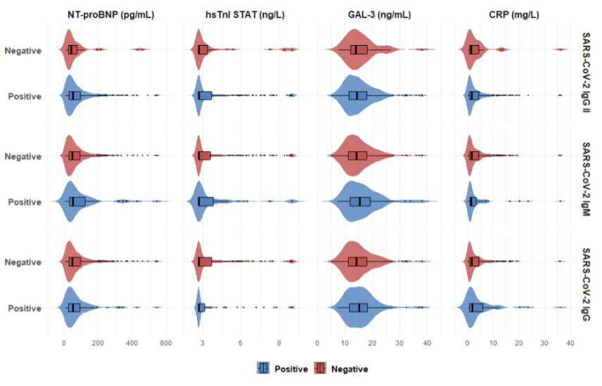Note: Violin plots showing the distribution of biomarker levels at baseline stratified by SARS-CoV-2 antibody status. Top row: SARS-CoV-2 IgG II (spike protein, receptor-binding domain); Middle row: SARS-CoV-2 IgM (spike protein); Bottom row: SARS-CoV-2 IgG (nucleocapsid protein). A, NT-proBNP levels (pg/mL). B, hs-cTnI levels (ng/L). C, Galectin-3 levels (ng/mL). D, CRP levels (mg/L). Blue violin plots represent antibody-positive participants; red violin plots represent antibody-negative participants. Box plots within violins show median (center line), interquartile range (box), and 1.5× interquartile range (whiskers). Individual data points are shown as dots for outliers.

2.2 Baseline Biomarker Distributions
Figure S1. Distribution of cardiac and inflammatory biomarker levels among study participants.
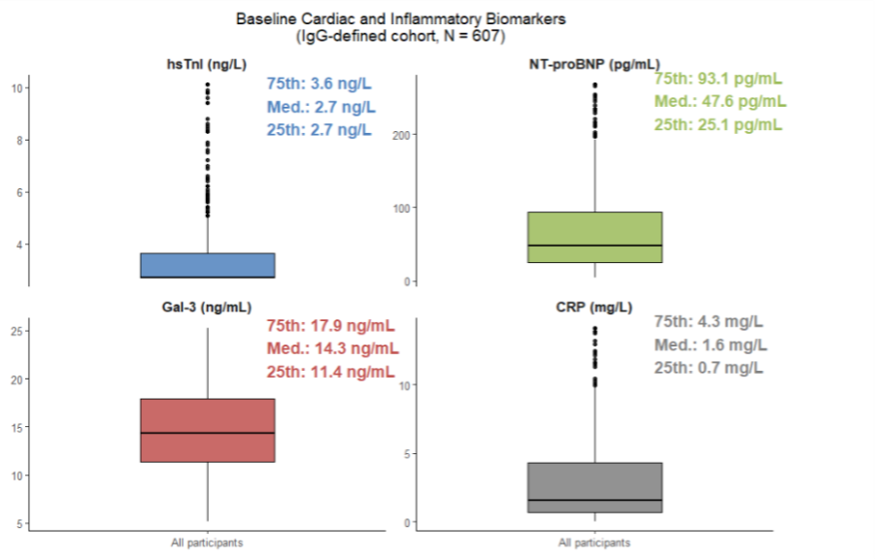
A, hs-cTnI levels. B, NT-proBNP levels. C, Gal-3 levels. D, CRP levels. All biomarker values were winsorized at 1st and 99th percentiles. Baseline Cardiac and Inflammatory Biomarkers by SARS-CoV-2 Serology IgG Status
2.3 Overall Biomarker Means and Trajectories in the Paired Sample
Supplementary Figure S3 shows overall mean biomarker levels among the 312 participants with paired measurements at baseline and 6-month follow-up. Overall mean hs-cTnI and NT-proBNP decreased over time, while Galectin-3 and CRP were largely unchanged. Supplementary Figure S4 shows heterogeneity in biomarker trajectories by nucleocapsid IgG group. Persistently IgG-positive participants had increases in CRP and Galectin-3 with modest declines in hs-cTnI and NT-proBNP, whereas participants who seroreverted from positive to negative showed increases in CRP, Galectin-3, hs-cTnI, and NT-proBNP. Participants who seroconverted from negative to positive generally had declines in CRP, hs-cTnI, and NT-proBNP, with a modest increase in Galectin-3. Persistently IgG-negative participants showed slight increases in CRP, stable Galectin-3 levels, and declines in hs-cTnI and NT-proBNP.

Figure S2. Overall Biomarker Means at Baseline and 6-Month Follow-up
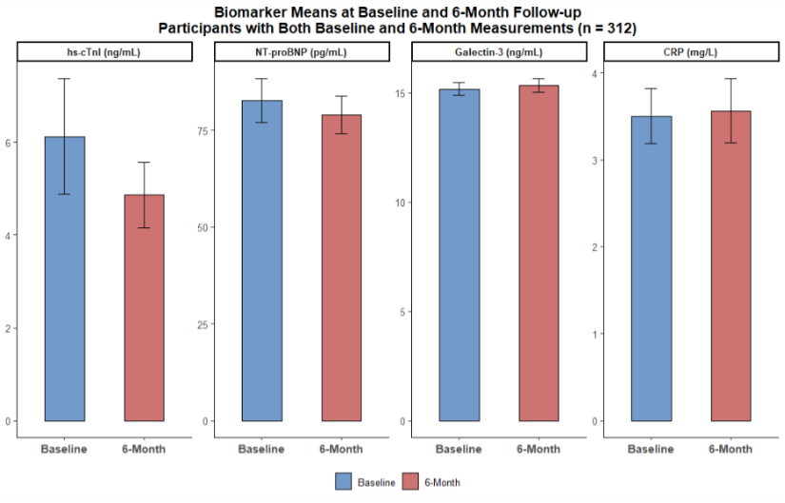
Bar plots showing mean biomarker levels with 95% confidence intervals (error bars) at baseline (blue) and 6-month follow-up (red) for all participants with measurements at both timepoints (n = 312). A, hs-cTnI levels (ng/mL). B, NT-proBNP levels (pg/mL). C, Galectin-3 levels (ng/mL). D, CRP levels (mg/L).

Figure S3. Biomarker Trajectories by SARS-CoV-2 IgG Antibody Trajectory Groups
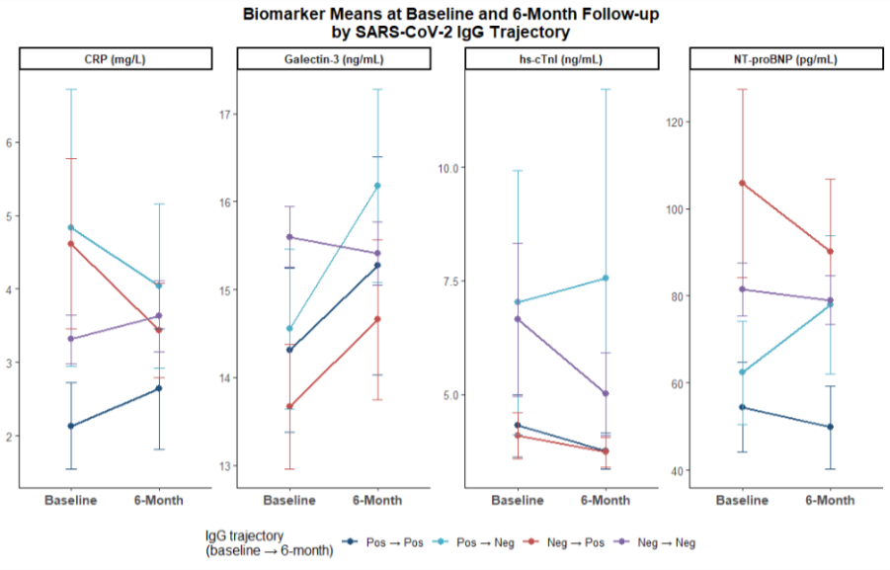Line plots showing mean biomarker levels with 95% confidence intervals from baseline to 6-month follow-up, stratified by SARS-CoV-2 nucleocapsid IgG antibody trajectory pattern. A, CRP levels (mg/L). B, Galectin-3 levels (ng/mL). C, hs-cTnI levels (ng/mL). D, NT-proBNP levels (pg/mL). Four mutually exclusive trajectory groups are shown: persistently positive (Pos to Pos, dark blue), seroconverted from positive to negative (Pos to Neg, light blue), seroconverted from negative to positive (Neg to Pos, red), and persistently negative (Neg to Neg, purple). Error bars are 95% confidence intervals.

2.4 Incident biomarker elevation sensitivity analysis

In a supplementary Incident Biomarker Elevation sensitivity analysis focused specifically on new-onset elevation by follow-up among participants not elevated at baseline, baseline IgG positivity was not significantly associated with incident elevation of hs-cTnI, NT-proBNP, Galectin-3, or CRP (Supplementary Table S3). Although the adjusted association with incident NT-proBNP elevation increased in magnitude (Model 3 OR 5.30, 95% CI 0.78 to 35.81), estimates were imprecise due to small event counts and should be interpreted cautiously.

Table S3. Incident Biomarker Elevation at Follow-up Among Participants Not Elevated at Baseline, by Baseline SARS-CoV-2 Nucleocapsid IgG Status
Outcome | N at risk | Events | Unadjusted OR (95% CI), p value | Model 1 OR (95% CI), p value | Model 2 OR (95% CI), p value | Model 3 OR (95% CI), p value
Incident hs-cTnI elevation at follow-up (baseline not elevated) | 163 | 49 | 1.00 (0.36, 2.77), p=0.995 | 0.93 (0.33, 2.62), p=0.884 | 0.79 (0.25, 2.43), p=0.676 | 0.81 (0.25, 2.59), p=0.722
Incident NT-proBNP elevation at follow-up (baseline not elevated) | 232 | 17 | 1.63 (0.44, 6.07), p=0.467 | 1.85 (0.47, 7.32), p=0.382 | 3.44 (0.69, 17.26), p=0.133 | 5.30 (0.78, 35.81), p=0.087
Incident Galectin-3 elevation at follow-up (baseline not elevated) | 221 | 24 | 1.99 (0.68, 5.84), p=0.210 | 1.97 (0.66, 5.85), p=0.223 | 2.09 (0.66, 6.60), p=0.210 | 1.41 (0.39, 5.10), p=0.605
Incident CRP elevation at follow-up (baseline not elevated) | 77 | 16 | 0.44 (0.05, 3.82), p=0.458 | 0.38 (0.04, 3.25), p=0.373 | 0.24 (0.02, 2.58), p=0.239 | 0.22 (0.02, 2.71), p=0.238
Bold, p<0.05; 95% CI, 95% confidence interval.
*Model 1: adjusted for pre-existing cardiovascular disease.
‡Model 2: Model 1 variables plus age, biological sex, race, and BMI.
§Model 3: Model 2 variables plus hypertension, chronic lung disease, diabetes, chronic kidney disease, cancer, and immunocompromised (immune) conditions.
Elevated hs-cTnI, high-sensitivity troponin I (> 2.7 ng/L); elevated NT-proBNP, N-terminal pro–B-type natriuretic peptide (≥125 pg/mL); Gal-3, galectin-3 (≥18.5 ng/mL); CRP, C-reactive protein (≥0.9 mg/L).

2.5 Additional Covariate-adjusted Models of Elevated Follow-up Biomarkers

To further characterize covariate-adjusted relationships, Table S4 presents a more detailed set of unadjusted and mutually adjusted models for IgG Positivity at Either Baseline or 6-Month Follow-up and other baseline characteristics. In adjusted models, older age was associated with 44% higher odds of elevated hs-cTnI, 96% higher odds of elevated NT-proBNP, and 44% higher odds of elevated Galectin-3 per 10-year increase (ORs 1.44, 1.96, and 1.44, respectively). Higher BMI was associated with 6% higher odds of elevated Galectin-3 and 17% higher odds of elevated CRP per 1 kg/m² (ORs 1.06 and 1.17). Pre-existing cardiovascular disease was strongly associated with elevated NT proBNP (OR 22.50), and chronic kidney disease and immunocompromised status were associated with elevated Galectin 3 (ORs 6.24 and 5.74), with chronic kidney disease also associated with elevated NT proBNP (OR 7.94).

Table S4. Associations Between IgG Positivity at Either Baseline or 6-Month Follow-up and Odds of Elevated Biomarkers at Follow up
Exposure variables | hs cTnI > 2.7 ng/L OR (95% CI) p value | NT proBNP ≥ 125 pg/mL OR (95% CI) p value | Galectin 3 ≥ 18.5 ng/mL OR (95% CI) p value | CRP ≥ 0.9 mg/L OR (95% CI) p value
Unadjusted models*
COVID 19 positive (at Either Baseline or 6-Month Follow-up) | 0.78 (0.44, 1.37), p=0.389 | 1.62 (0.83, 3.15), p=0.157 | 0.88 (0.44, 1.73), p=0.703 | 1.06 (0.60, 1.86), p=0.846
Age (per 10-year increase) | 1.61 (1.36, 1.90), p=0.000 | 1.96 (1.52, 2.53), p=0.000 | 1.49 (1.22, 1.82), p=0.000 | 1.06 (0.91, 1.22), p=0.476
Female sex | 0.79 (0.48, 1.32), p=0.375 | 0.89 (0.47, 1.68), p=0.717 | 1.19 (0.64, 2.21), p=0.584 | 1.47 (0.88, 2.46), p=0.140
Black race (vs White) | 2.89 (1.71, 4.89), p=0.000 | 1.33 (0.71, 2.50), p=0.376 | 1.43 (0.79, 2.59), p=0.242 | 1.91 (1.13, 3.24), p=0.016
BMI | 1.05 (1.01, 1.08), p=0.010 | 1.02 (0.98, 1.07), p=0.241 | 1.06 (1.02, 1.10), p=0.004 | 1.15 (1.09, 1.20), p=0.000
Pre-existing cardiovascular disease | 11.33 (2.56, 50.16), p=0.001 | 15.71 (5.33, 46.31), p=0.000 | 3.47 (1.34, 9.01), p=0.011 | 1.31 (0.50, 3.44), p=0.586
Hypertension | 2.85 (1.64, 4.94), p=0.000 | 2.12 (1.12, 4.01), p=0.021 | 3.06 (1.67, 5.62), p=0.000 | 1.29 (0.75, 2.23), p=0.354
Diabetes | 2.71 (1.12, 6.53), p=0.026 | 1.71 (0.67, 4.35), p=0.260 | 3.73 (1.60, 8.72), p=0.002 | 1.37 (0.58, 3.23), p=0.471
Chronic kidney disease | 2.81 (0.71, 11.13), p=0.141 | 6.92 (1.87, 25.56), p=0.004 | 8.97 (2.24, 35.90), p=0.002 | 1.13 (0.31, 4.10), p=0.855
Chronic lung disease | 6969983.99 (0.00, Inf), p=0.981 | 17.91 (1.96, 164.03), p=0.011 | 5.37 (0.88, 32.96), p=0.069 | 4460277.57 (0.00, Inf), p=0.981
Immunocompromised state | 3.24 (0.84, 12.52), p=0.088 | 0.92 (0.19, 4.38), p=0.913 | 4.48 (1.31, 15.25), p=0.017 | 3.52 (0.75, 16.63), p=0.112
Cancer | 4.77 (0.53, 43.19), p=0.165 | 1.04 (0.11, 9.47), p=0.975 | 0.86 (0.09, 7.81), p=0.890 | 4460277.57 (0.00, Inf), p=0.981
Adjusted model§
COVID 19 positive (at Either Baseline or 6-Month Follow-up) | 0.76 (0.39, 1.48), p=0.426 | 2.87 (1.17, 7.07), p=0.022 | 1.11 (0.51, 2.45), p=0.787 | 1.02 (0.53, 1.95), p=0.962
Age (per 10 -year increase) | 1.44 (1.19, 1.73), p=0.000 | 1.96 (1.46, 2.64), p=0.000 | 1.44 (1.13, 1.83), p=0.003 | 1.01 (0.84, 1.21), p=0.905
Female sex | 0.83 (0.46, 1.49), p=0.534 | 1.54 (0.67, 3.52), p=0.306 | 1.43 (0.70, 2.94), p=0.325 | 1.53 (0.85, 2.77), p=0.156
Black race (vs White) | 1.93 (1.00, 3.72), p=0.051 | 0.39 (0.15, 1.05), p=0.063 | 0.43 (0.19, 0.99), p=0.048 | 1.36 (0.68, 2.71), p=0.383
BMI | 1.03 (0.98, 1.07), p=0.224 | 1.03 (0.97, 1.08), p=0.346 | 1.06 (1.01, 1.11), p=0.019 | 1.17 (1.11, 1.24), p=0.000
Pre-existing cardiovascular disease | 4.37 (0.91, 21.10), p=0.066 | 22.50 (4.92, 102.99), p=0.000 | 1.88 (0.58, 6.11), p=0.293 | 1.02 (0.29, 3.61), p=0.981
Hypertension | 1.22 (0.59, 2.50), p=0.591 | 1.11 (0.44, 2.85), p=0.820 | 1.80 (0.80, 4.06), p=0.153 | 0.69 (0.32, 1.50), p=0.345
Diabetes | 0.73 (0.24, 2.23), p=0.576 | 0.37 (0.08, 1.67), p=0.197 | 1.43 (0.47, 4.38), p=0.533 | 0.39 (0.12, 1.30), p=0.125
Chronic kidney disease | 1.17 (0.23, 5.88), p=0.848 | 7.94 (1.38, 45.75), p=0.020 | 6.24 (1.27, 30.74), p=0.024 | 0.68 (0.13, 3.41), p=0.634
Chronic lung disease | 6645760.60 (0.00, Inf), p=0.987 | 4.32 (0.22, 84.47), p=0.334 | 1.15 (0.14, 9.38), p=0.897 | 8221322.01 (0.00, Inf), p=0.987
Immunocompromised state | 2.09 (0.47, 9.29), p=0.331 | 0.39 (0.04, 4.16), p=0.432 | 5.74 (1.39, 23.74), p=0.016 | 3.56 (0.66, 19.24), p=0.140
Cancer | 4.43 (0.41, 47.49), p=0.219 | 0.40 (0.02, 10.20), p=0.576 | 0.32 (0.02, 4.38), p=0.391 | 13118493.00 (0.00, Inf), p=0.986
Note:
Bold indicates p < 0.05. OR indicates odds ratio; CI indicates confidence interval. SARS CoV 2 exposure was defined as ever nucleocapsid IgG positive at baseline or follow up.
Models are restricted to participants identifying as Black or White; Black race is compared with White as the reference group.
Elevated biomarkers at follow up were defined as hs cTnI > 2.7 ng/L, NT proBNP ≥ 125 pg/mL, Galectin 3 ≥ 18.5 ng/mL, and CRP ≥ 0.9 mg/L. Values reported as “<2.7” for hs cTnI treated as not elevated.
Unadjusted models include each exposure variable separately.
The adjusted model is a multivariable logistic regression including all exposure variables listed in the left column simultaneously (mutually adjusted). Very large OR estimates (0.00 to Inf) indicate sparse data or quasi separation and should be interpreted cautiously.

2.6 Cox Proportional Hazard Analysis by IgG Positivity at Either Baseline or 6-Month Follow-up
In Supplementary Table S5, IgG Positivity at Either Baseline or 6-Month Follow-up was associated with a 428% higher hazard of NT-proBNP elevation in the adjusted model (HR 5.28, 95% CI 1.44–19.35; p=0.012). Age was also associated with a higher hazard of NT-proBNP elevation (64% higher per 10-year increase; HR 1.64, 95% CI 1.15–2.35; p=0.007). Several comorbidities additionally showed strong associations with NT-proBNP elevation (notably pre-existing CVD and chronic kidney disease (see Table S5). For CRP, the Black (vs White) race was associated with a 384% higher hazard of elevation in the adjusted model (HR 4.84, 95% CI 1.14–20.61; p=0.033), and cancer was also associated with higher hazard (HR 20.81, 95% CI 2.15–201.67; p=0.009).
Table S5. Cox Proportional Hazards Analysis for Biomarker Elevation by Follow Up Visit (N = 312)
Exposure Variables | hs-cTnI > 2.7 ng/L HR (95% CI) | NT-proBNP ≥ 125 pg/mL HR (95% CI) | Galectin-3 ≥ 18.5 ng/mL HR (95% CI) | CRP ≥ 0.9 mg/L HR (95% CI)
Unadjusted Models*
COVID-19 Positive* | 0.93 (0.33–2.61), p=0.888 | 2.48 (0.69–8.89), p=0.163 | 2.56 (0.94–6.94), p=0.065 | 0.48 (0.06–3.60), p=0.471
Age (per 10-year increase) | 1.21 (0.99–1.47), p=0.060 | 1.61 (1.09–2.38), p=0.017 | 1.34 (1.02–1.76), p=0.039 | 1.08 (0.82–1.41), p=0.584
Female sex | 0.87 (0.45–1.68), p=0.686 | 1.35 (0.42–4.29), p=0.615 | 1.49 (0.58–3.81), p=0.404 | 0.68 (0.26–1.82), p=0.447
Black race (vs White) | 1.36 (0.71–2.61), p=0.358 | 0.97 (0.32–2.89), p=0.955 | 1.10 (0.46–2.63), p=0.824 | 1.98 (0.72–5.46), p=0.185
BMI | 1.03 (1.00–1.07), p=0.084 | 1.05 (0.99–1.12), p=0.097 | 0.99 (0.93–1.06), p=0.812 | 1.10 (1.00–1.22), p=0.058
Pre-existing CVD* | 2.46 (0.76–8.01), p=0.135 | 8.63 (2.37–31.41), p=0.001 | 1.15 (0.15–8.60), p=0.889 | 0.00 (0.00–Inf), p=0.998
Hypertension | 1.33 (0.64–2.75), p=0.440 | 3.16 (1.10–9.12), p=0.033 | 2.02 (0.84–4.87), p=0.118 | 0.63 (0.18–2.20), p=0.466
Diabetes | 1.40 (0.50–3.93), p=0.527 | 1.60 (0.35–7.20), p=0.543 | 2.05 (0.60–7.00), p=0.252 | 0.00 (0.00–Inf), p=0.998
Chronic kidney disease | 1.86 (0.45–7.74), p=0.392 | 8.73 (2.40–31.81), p=0.001 | 0.00 (0.00–Inf), p=0.997 | 2.77 (0.37–20.97), p=0.325
Chronic lung disease | 5.85 (1.39–24.51), p=0.016 | 9.01 (1.17–69.46), p=0.035 | 3.05 (0.41–22.73), p=0.277 | NA (NA–NA), p=NA
Immunocompromised state | 1.88 (0.45–7.81), p=0.385 | 0.00 (0.00–Inf), p=0.998 | 1.70 (0.23–12.65), p=0.605 | 2.85 (0.38–21.63), p=0.310
Cancer | 0.00 (0.00–Inf), p=0.997 | 3.02 (0.39–23.25), p=0.288 | 0.00 (0.00–Inf), p=0.997 | 8.68 (1.13–66.77), p=0.038
Adjusted Models§
COVID-19 Positive* | 0.78 (0.23–2.64), p=0.689 | 5.28 (1.44–19.35), p=0.012 | 1.83 (0.55–6.10), p=0.327 | 0.27 (0.03–2.39), p=0.241
Age (per 10-year increase) | 1.25 (0.97–1.61), p=0.086 | 1.64 (1.15–2.35), p=0.007 | 1.23 (0.90–1.68), p=0.203 | 1.07 (0.73–1.55), p=0.729
Female sex | 0.96 (0.45–2.07), p=0.920 | 12.05 (3.30–43.95), p=<0.001 | 2.35 (0.68–8.13), p=0.176 | 0.61 (0.17–2.17), p=0.444
Black race (vs White) | 1.12 (0.48–2.58), p=0.797 | 0.07 (0.02–0.23), p=<0.001 | 0.56 (0.15–2.11), p=0.392 | 4.84 (1.14–20.61), p=0.033
BMI | 1.06 (1.01–1.11), p=0.019 | 1.01 (0.96–1.07), p=0.663 | 0.98 (0.91–1.06), p=0.570 | 1.12 (0.97–1.30), p=0.117
Pre-existing CVD* | 0.40 (0.04–3.59), p=0.410 | 178.10 (48.51–653.87), p=<0.001 | 1.16 (0.10–13.96), p=0.905 | 0.00 (0.00–Inf), p=0.998
Hypertension | 0.86 (0.35–2.10), p=0.734 | 2.39 (0.80–7.14), p=0.118 | 1.89 (0.53–6.71), p=0.324 | 0.18 (0.03–1.12), p=0.066
Diabetes | 1.76 (0.47–6.64), p=0.401 | 0.09 (0.02–0.40), p=0.002 | 2.46 (0.49–12.25), p=0.272 | 0.00 (0.00–Inf), p=0.999
Chronic kidney disease | 1.11 (0.17–7.31), p=0.915 | 81.73 (22.30–299.53), p=<0.001 | 0.00 (0.00–Inf), p=0.998 | 2.89 (0.25–32.69), p=0.392
Chronic lung disease | 9.67 (0.48–196.36), p=0.140 | 3.79 (0.49–29.43), p=0.203 | 2.43 (0.23–26.05), p=0.463 | NA (NA–NA), p=NA
Immunocompromised state | 0.77 (0.11–5.24), p=0.786 | 0.00 (0.00–Inf), p=0.995 | 1.13 (0.13–10.13), p=0.916 | 0.64 (0.05–8.51), p=0.739
Cancer | 0.00 (0.00–Inf), p=0.997 | 0.70 (0.09–5.38), p=0.729 | 0.00 (0.00–Inf), p=0.998 | 20.81 (2.15–201.67), p=0.009
Note:
Bold indicates p < 0.05. HR indicates hazard ratio; CI indicates confidence interval. SARS CoV 2 exposure was defined as ever nucleocapsid IgG positive at baseline or follow up.
Models are restricted to participants identifying as Black or White; Black race is compared with White as the reference group.
Elevated biomarkers at follow up were defined as hs cTnI > 2.7 ng/L, NT proBNP ≥ 125 pg/mL, Galectin 3 ≥ 18.5 ng/mL, and CRP ≥ 0.9 mg/L. Values reported as “<2.7” for hs cTnI treated as not elevated.
Unadjusted models include each exposure variable separately.
The adjusted model is a multivariable Cox proportional hazards model including all exposure variables listed in the left column simultaneously (mutually adjusted). Very large HR estimates (0.00 to Inf) indicate sparse data or quasi-separation and should be interpreted cautiously.

- Summary of Supplementary Findings
Overall, the supplementary analyses provided the strongest additional support for an association between seropositivity and NT-proBNP elevation. Several clinical factors, including older age, higher BMI, pre-existing cardiovascular disease, chronic kidney disease, and immunocompromised status, were also associated with selected elevated biomarker outcomes, whereas findings for hs-cTnI, Galectin-3, and CRP were less consistent.

