Supplementary Material (Online Resources)
for
Endogenous Ca-driven phosphorus immobilization by sugarcane filter mud biochar: 21-month evidence from an acidic citrus soil
Huang Shizhe, Tang Xiaohui, Hu Chunfeng, Wei Huijiao, Cheng Xiran, Li Suli, Li Zhigang
College of Agriculture, Guangxi University, Nanning 530004, China
Corresponding authors: Li Zhigang, E-mail: lizhigangnn@163.com; Li Suli, E-mail: lisuli88@163.com

Online Resource 1
FTIR spectra of (a) raw SFM, (b) SFM-derived biochar (pyrolyzed at 500°C), and (c–f) BCAs with biochar substitution ratios of 20%, 40%, 60%, and 80%, respectively.
Characteristic absorption peaks are observed at 775 cm⁻¹ (aromatic C–H), 1157 cm⁻¹ (C–O–C), 1368 cm⁻¹ (aromatic O–H), 1591 cm⁻¹ (aromatic C=C), 2796 cm⁻¹ (aliphatic CH₂), 3247 cm⁻¹ and 3680 cm⁻¹ (associated –OH). Enhanced –OH and aliphatic CH₂ peaks after pyrolysis, and reduction of the 1157 cm⁻¹ peak in BCAs suggest interactions with fertilizer components.
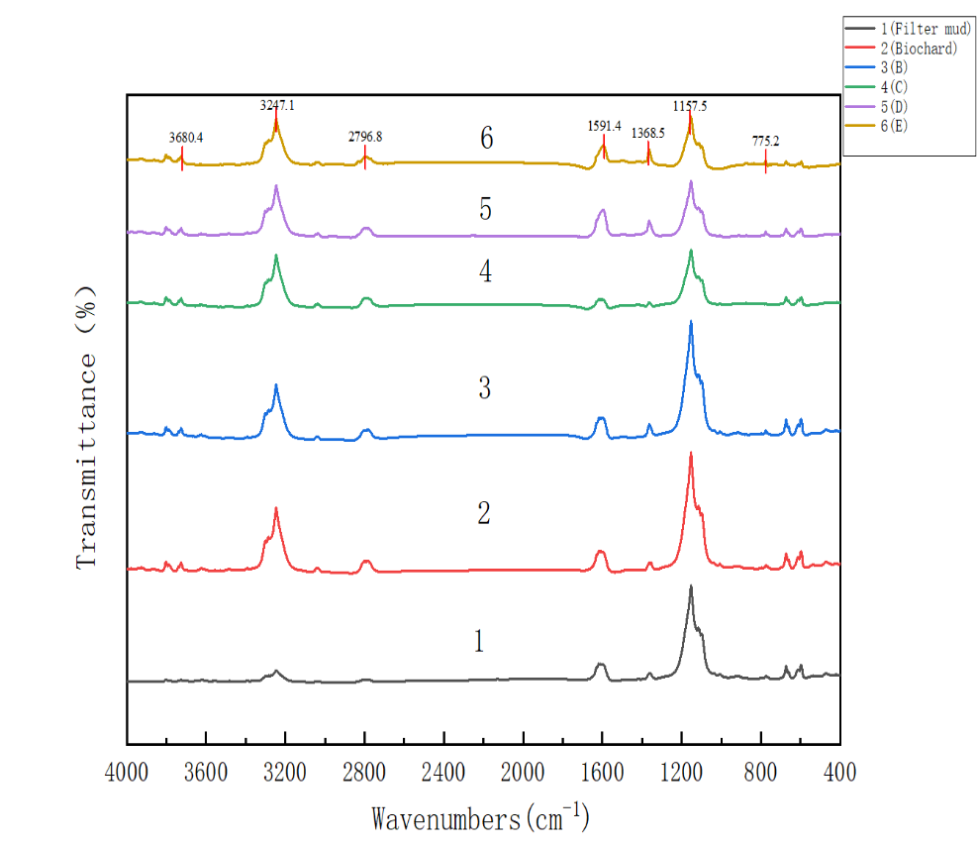
Fig. OR1 FTIR spectra of raw SFM, biochar, and BCAs (BCA-20%, BCA-40%, BCA-60%, BCA-80%).

Online Resource 2
EDS atomic fractions (%) of raw SFM, biochar, and BCAs.
Element | Raw SFM | Biochar | BCA-20% | BCA-40% | BCA-60% | BCA-80%
C | 17.58 | 21.25 | 20.26 | 26.90 | 27.50 | 28.26
N | 27.80 | 26.01 | 30.10 | 28.42 | 20.60 | 22.72
O | 36.08 | 36.06 | 37.18 | 29.49 | 33.80 | 32.80
P | 0.59 | 1.88 | 5.26 | 4.28 | 4.23 | 2.02
K | 2.06 | 0.32 | 1.60 | 1.72 | 1.56 | 0.47
Ca | 0.40 | 3.79 | 3.18 | 4.63 | 4.62 | 4.29
Note: Magnesium (Mg) was present in the raw SFM feedstock (1.83 g kg⁻¹), but its concentration was below the EDS detection limit in all analysed samples. Summation of atomic fractions does not equal 100% because hydrogen and other light elements are not detected by EDS.

Online Resource 3
EDS elemental mapping of the optimized BCA granule surface (Treatment C, 40% biochar substitution), showing spatial co-localization of P with Ca within the granule matrix, consistent with the formation of Ca-associated phosphate phases during the granulation process.
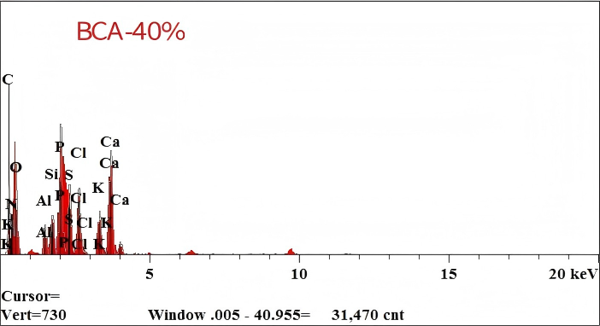
Fig. OR3 EDS elemental mapping of BCA granule surface (Treatment C, 40% biochar substitution), showing co-localization of P and Ca.

Online Resource 4
Temporal dynamics of soil available P (mg kg⁻¹) over the 21-month pot experiment.
Treatment | Sep 2023 | Nov 2023 | Jan 2024 | Mar 2024 | May 2024 | Jul 2024
T | 12.90 ± 1.01 a | 15.92 ± 1.61 ab | 22.30 ± 2.11 ab | 21.69 ± 3.95 bc | 29.54 ± 4.64 ab | 30.98 ± 4.35 abc
A | 11.52 ± 0.61 b | 13.60 ± 3.72 abc | 18.40 ± 2.81 c | 20.48 ± 3.24 b | 25.77 ± 3.64 bc | 28.30 ± 3.82 abc
B | 12.62 ± 0.93 a | 13.30 ± 3.63 abc | 19.16 ± 1.86 bc | 17.76 ± 2.08 cd | 25.38 ± 3.11 bc | 29.06 ± 7.94 abc
C | 12.30 ± 0.74 ab | 16.98 ± 1.30 a | 23.53 ± 3.66 a | 26.36 ± 1.34 a | 34.35 ± 6.75 a | 39.26 ± 6.33 a
D | 10.22 ± 0.98 c | 12.84 ± 2.84 bc | 20.29 ± 2.78 abc | 23.64 ± 2.48 ab | 29.88 ± 3.46 ab | 35.58 ± 8.47 ab
E | 8.90 ± 0.62 d | 10.52 ± 2.31 c | 20.90 ± 1.75 abc | 16.79 ± 3.08 d | 20.31 ± 3.04 cd | 26.86 ± 6.68 bc
F | 7.44 ± 0.40 e | 10.70 ± 3.65 bc | 13.28 ± 3.16 d | 12.16 ± 1.08 e | 17.27 ± 4.18 d | 20.22 ± 5.57 c
Values are means ± SD (n = 5). Different lowercase letters within the same column indicate significant differences among treatments at that time point (P < 0.05, Duncan's multiple range test). This table provides the complete dataset corresponding to Fig. 4 in the main text. Treatment codes are defined in Table 1 of the main text.

Online Resource 5
Total P and total N concentrations in leachate and total P leaching concentration ratio (TP-LCR) under different treatments (pot experiment, March, May, and July 2024).
Treatment | Leachate TP (mg L⁻¹) |  |  | Leachate TN (mg L⁻¹) |  |  | TP-LCR (%)
 | Mar | May | Jul | Mar | May | Jul | Mar | May | Jul
T(Conventional) | 0.244 ± 0.020 a | 0.268 ± 0.015 a | 0.279 ± 0.015 a | 1.519 ± 0.064 a | 1.634 ± 0.076 a | 1.711 ± 0.023 a | 0.016 ± 0.001 a | 0.013 ± 0.001 ab | 0.015 ± 0.001 a
A (Reduced) | 0.214 ± 0.021 b | 0.249 ± 0.013 b | 0.270 ± 0.017 a | 1.449 ± 0.091 a | 1.509 ± 0.032 b | 1.488 ± 0.027 b | 0.016 ± 0.002 a | 0.016 ± 0.001 a | 0.020 ± 0.003 a
B (BCA-20%) | 0.178 ± 0.025 c | 0.216 ± 0.007 c | 0.258 ± 0.019 ab | 1.308 ± 0.143 b | 1.402 ± 0.122 b | 1.440 ± 0.080 b | 0.009 ± 0.001 b | 0.016 ± 0.001 a | 0.013 ± 0.001 ab
C (BCA-40%) | 0.152 ± 0.013 d | 0.209 ± 0.005 c | 0.238 ± 0.017 b | 1.138 ± 0.105 c | 1.251 ± 0.118 c | 1.212 ± 0.081 c | 0.009 ± 0.001 b | 0.010 ± 0.001 b | 0.011 ± 0.001 b
D (BCA-60%) | 0.134 ± 0.023 d | 0.181 ± 0.009 d | 0.178 ± 0.027 c | 1.066 ± 0.092 c | 1.159 ± 0.084 c | 1.169 ± 0.046 c | 0.009 ± 0.002 b | 0.012 ± 0.001 ab | 0.010 ± 0.002 b
E (BCA-80%) | 0.144 ± 0.008 d | 0.175 ± 0.005 d | 0.174 ± 0.024 c | 0.761 ± 0.113 e | 0.769 ± 0.058 d | 0.957 ± 0.037 d | 0.015 ± 0.001 a | 0.018 ± 0.001 a | 0.014 ± 0.002 ab
F (BCA-100%) | 0.132 ± 0.015 d | 0.172 ± 0.012 d | 0.167 ± 0.008 c | 0.777 ± 0.086 e | 0.706 ± 0.047 d | 0.959 ± 0.067 d | 0.026 ± 0.005 a | 0.023 ± 0.003 a | 0.033 ± 0.004 a
Values are means ± SD (n = 5). Different lowercase letters within the same column denote significant differences among treatments at that time point (P < 0.05, Duncan's multiple range test). TP-LCR = total P leaching concentration ratio, calculated as: (leachate TP concentration × leachate volume) / (soil total P content × soil mass in pot) × 100%. This table provides the complete dataset corresponding to Fig. 5 in the main text. Treatment codes are defined in Table 1 of the main text.

Online Resource 6
Soil enzyme activities (urease, sucrase, and acid phosphatase) under different treatments over the 21-month pot experiment.
Treatment | Time | Urease (μg NH₃-N g⁻¹ h⁻¹) | Sucrase (μg g⁻¹ h⁻¹) | Acid phosphatase (U g⁻¹)
T | Sep 2023 | 711.02 ± 61.93 bc | 53.35 ± 1.19 b | 22.93 ± 1.87 a
T | Nov 2023 | 789.40 ± 88.62 c | 68.89 ± 1.33 a | 35.50 ± 1.84 b
T | Jan 2024 | 890.19 ± 97.81 b | 109.27 ± 11.62 a | 43.92 ± 0.41 a
T | Mar 2024 | 1114.15 ± 41.13 a | 148.64 ± 2.80 a | 47.14 ± 4.27 bc
T | May 2024 | 962.98 ± 54.57 b | 160.04 ± 10.79 b | 53.97 ± 1.67 a
T | Jul 2024 | 1128.92 ± 109.22 b | 182.85 ± 8.12 a | 59.36 ± 3.56 bc
A | Sep 2023 | 786.60 ± 110.17 b | 50.46 ± 1.69 c | 17.20 ± 1.53 bc
A | Nov 2023 | 814.60 ± 64.26 c | 55.14 ± 1.28 d | 30.76 ± 2.09 c
A | Jan 2024 | 866.39 ± 77.37 b | 80.61 ± 4.48 c | 45.04 ± 0.80 a
A | Mar 2024 | 1001.15 ± 68.69 b | 120.67 ± 6.65 c | 43.44 ± 2.30 cd
A | May 2024 | 955.98 ± 82.60 b | 127.63 ± 4.72 e | 51.07 ± 0.71 b
A | Jul 2024 | 906.35 ± 89.68 c | 147.86 ± 5.60 b | 64.29 ± 2.73 a
B | Sep 2023 | 1137.95 ± 160.56 a | 56.52 ± 2.74 a | 14.73 ± 1.30 c
B | Nov 2023 | 1214.94 ± 67.96 a | 60.77 ± 2.90 b | 35.11 ± 2.40 b
B | Jan 2024 | 1366.11 ± 100.31 a | 97.48 ± 6.34 b | 41.92 ± 0.24 b
B | Mar 2024 | 1067.96 ± 50.13 ab | 149.03 ± 2.40 a | 54.12 ± 0.77 a
B | May 2024 | 1156.15 ± 77.21 a | 170.51 ± 4.89 a | 50.81 ± 1.35 b
B | Jul 2024 | 1208.71 ± 76.28 a | 195.33 ± 5.44 a | 60.66 ± 2.26 ab
C | Sep 2023 | 737.61 ± 77.40 bc | 43.43 ± 1.31 d | 19.89 ± 1.50 ab
C | Nov 2023 | 807.60 ± 84.80 c | 51.55 ± 1.19 e | 30.96 ± 0.76 c
C | Jan 2024 | 885.99 ± 116.96 b | 92.09 ± 5.02 b | 43.77 ± 2.43 a
C | Mar 2024 | 881.79 ± 88.12 c | 113.41 ± 4.64 d | 45.19 ± 3.23 bcd
C | May 2024 | 727.81 ± 101.91 d | 132.39 ± 4.25 d | 49.96 ± 0.96 b
C | Jul 2024 | 1124.72 ± 31.14 b | 147.39 ± 14.11 b | 60.94 ± 3.50 ab
D | Sep 2023 | 593.44 ± 119.02 c | 50.07 ± 2.25 c | 18.23 ± 1.40 bc
D | Nov 2023 | 1104.35 ± 141.23 ab | 57.18 ± 4.83 c | 38.27 ± 1.27 a
D | Jan 2024 | 827.20 ± 43.54 b | 98.18 ± 5.13 b | 36.66 ± 1.10 c
D | Mar 2024 | 839.80 ± 110.22 c | 132.24 ± 4.48 b | 42.31 ± 2.48 d
D | May 2024 | 937.78 ± 111.59 bc | 151.06 ± 1.13 c | 40.92 ± 0.90 c
D | Jul 2024 | 1212.91 ± 58.43 a | 158.65 ± 12.56 b | 62.63 ± 0.56 ab
E | Sep 2023 | 641.03 ± 49.14 c | 35.31 ± 1.30 f | 18.97 ± 1.18 ab
E | Nov 2023 | 1014.77 ± 98.61 b | 43.28 ± 5.98 g | 28.99 ± 1.03 c
E | Jan 2024 | 839.80 ± 99.10 b | 54.68 ± 6.18 d | 32.53 ± 0.72 d
E | Mar 2024 | 899.99 ± 94.50 c | 87.09 ± 2.09 e | 48.18 ± 2.57 b
E | May 2024 | 874.79 ± 100.68 bc | 93.73 ± 2.99 f | 41.03 ± 0.79 c
E | Jul 2024 | 1203.11 ± 106.65 a | 107.79 ± 10.31 c | 56.66 ± 0.41 c
F | Sep 2023 | 792.20 ± 87.36 b | 40.93 ± 3.05 e | 10.74 ± 1.50 d
F | Nov 2023 | 1028.77 ± 94.94 b | 46.63 ± 1.67 f | 29.90 ± 1.65 c
F | Jan 2024 | 832.80 ± 94.29 b | 49.91 ± 5.01 d | 29.46 ± 1.41 e
F | Mar 2024 | 866.39 ± 80.93 c | 70.61 ± 6.94 f | 33.46 ± 3.05 e
F | May 2024 | 804.80 ± 79.34 cd | 84.82 ± 1.77 g | 40.23 ± 0.83 c
F | Jul 2024 | 1355.68 ± 78.83 a | 97.87 ± 5.83 c | 50.20 ± 4.30 d
Values are means ± SD (n = 5). Different lowercase letters within the same column and time point indicate significant differences among treatments (P < 0.05, Duncan's multiple range test). This table provides the complete dataset corresponding to Fig. 6 in the main text. Treatment codes are defined in Table 1 of the main text.

