Table S1. Bacterial strains used in this study
Strain | Relevant characteristics | Reference
Rhodococcus sp.
RDE2 | Wild type; natural rubber degrader | (Gibu et al. 2022)
DR082 | ΔLPH33_RS08240 derivative of RDE2 | This study
DR179 | ΔLPH33_RS17900 derivative of RDE2 | This study
DR0817 | ΔLPH33_RS08240 ΔLPH33_RS17900 derivative of RDE2 | This study
Escherichia coli
NEB Turbo | F′ proA⁺B⁺ lacI^{q} ΔlacZM15 / fhuA2 Δ(lac-proAB) glnV galK16 galE15 R(zgb-210::Tn10) Tet^{S} endA1 thi-1 Δ(hsdS-mcrB)5 | New England Biolabs
BL21(DE3) | F– ompT hsdS_{B} (r_{B}– m_{B}–) gal dcm (DE3) | Novagen
S17-1 | pro hsdR hsdM⁺ thi recA; RP4-2-Tc::Mu Km::Tn7 | (Simon et al. 1983)

Table S2. Plasmids used in this study
Plasmid | Relevant characteristicsª | Reference
Expression plasmids
pCold I | Cold-shock expression vector; Ap^{r} | Takara
pColdI_02580_VH2 | pCold I carrying a 1.5-kb NdeI fragment of GPOL_c02580 (ALDH gene) of G. polyisoprenivorans VH2; Ap^{r} | This study
pColdI_08770_RDE2 | pCold I carrying a 1.2-kb NdeI fragment of LPH33_RS04445 (lcp gene) of RDE2; Ap^{r} | This study
pCRD041 | pCold I carrying a 1.5-kb NdeI fragment of LPH33_RS04160; Ap^{r} | This study
pCRD082 | pCold I carrying a 1.4-kb NdeI fragment of LPH33_RS08240; Ap^{r} | This study
pCRD179 | pCold I carrying a 1.6-kb NdeI fragment of LPH33_RS17900; Ap^{r} | This study
pCRD212 | pCold I carrying a 1.5-kb NdeI fragment of LPH33_RS21215; Ap^{r} | This study
pCRD217 | pCold I carrying a 1.5-kb NdeI fragment of LPH33_RS21770; Ap^{r} | This study
pCRD230 | pCold I carrying a 1.4-kb NdeI fragment of LPH33_RS23090; Ap^{r} | This study
Gene-knockout plasmids
pK18mobsacB | Mobilizable suicide vector for allelic replacement (sacB); Km^{r} | (Schäfer et al. 1994)
pKDR082 | pK18mobsacB carrying ~1.0-kb upstream and ~1.0-kb downstream regions flanking LPH33_RS08240; Km^{r} | This study
pKDR179 | pK18mobsacB carrying ~1.0-kb upstream and ~1.0-kb downstream regions flanking LPH33_RS17900; Km^{r} | This study
ª Ap^{r}, Km^{r}, resistance to ampicillin and kanamycin, respectively. Locus tags follow the current RefSeq annotation (LPH33_RS…). lcp = LPH33_RS04445.

Table S3. Primers used in this study
Primer | Sequence (5′ to 3′)
qRT-PCR analysis
LPH33_RS04160_F  LPH33_RS04160_R  LPH33_RS08240_F  LPH33_RS08240_R  LPH33_RS17900_F  LPH33_RS17900_R  LPH33_RS21215_F  LPH33_RS21215_R  LPH33_RS21770_F  LPH33_RS21770_R  LPH33_RS23090_F  LPH33_RS23090_R  recA_F  recA_R | AGCTTGGCGAAGTTGATCTG  GCACCGCTATCTGCTCAAG  GGATGCCGCTGAAGAACATC  ATCTCCTGGTCGTCGAAGTC  ATTCTTCGTCTGCTGGTAGTGG  TCGGTGGTTACAAGCAGTCC  CAAGGCAGCAAAGCTCATCG  AGCCCCGCATAGTAGTTGATTG  TGTGCTCGGCGATGATCTC  ATCGTCGCGTACAACTATCCG  AGTAGTTCACTCCCACGGTTC  ACGACACACCATTCGGTTTG  CGCGATCTTCATCAACCAGC  ACCGAGGCGTAGAACTTCAG
Construction of ALDH gene expression plasmids
LPH33_RS04160IF_F  LPH33_RS04160IF_R  LPH33_RS08240IF_F  LPH33_RS08240IF_R  LPH33_RS17900IF_F  LPH33_RS17900IF_R  LPH33_RS21215IF_F  LPH33_RS21215IF_R  LPH33_RS21770IF_F  LPH33_RS21770IF_R  LPH33_RS23090IF_F  LPH33_RS23090IF_R | TCGAAGGTAGGCATATGACACTTCGCCCCACC  GTACCGAGCTCCATATCAGCTCGCGGGCTCGGC  TCGAAGGTAGGCATATGACCGACATTCTCGACC  GTACCGAGCTCCATATCAGCGCAGTATCGTCTTG  TCGAAGGTAGGCATATGACCGTGTACGCCCGT  GTACCGAGCTCCATATCAGAAGAAGCCCTGTGC  TCGAAGGTAGGCATATGACCGACTACGACAAGT  GTACCGAGCTCCATATCAGCCCTCGTAACCGAG  TCGAAGGTAGGCATATGTCAGTGCAGGAGAACG  GTACCGAGCTCCATATCACGAGGTCACCGCCTT  TCGAAGGTAGGCATATGCCTGTCATCAACAGCA  GTACCGAGCTCCATACTAGACGTATATCGACTTGT
Construction of gene-knockout plasmids
LPH33_RS08240_up_F  LPH33_RS08240_up_R  LPH33_RS08240_dn_F  LPH33_RS08240_dn_R  LPH33_RS17900_up_F  LPH33_RS17900_up_R  LPH33_RS17900_dn_F  LPH33_RS17900_dn_R | TCGGTACCCGGGATCCTGAGCGAGAGGGGGTACAG  GGCGACGACCTCTTCGGTCG  GAAGAGGTCGTCGCCGGCGCCTTCAACACCGACGC  CGACTCTAGAGGATCGACAGGAGCAGCATGGATCT  CGGTACCCGGGGATCCACGAATGGAGTTGTTCGGC  GCCGCGAGCGACCTCGGTGA  GAGGTCGCTCGCGGCGTGTGGACGAACACCTACCA  CGACTCTAGAGGATCTGCGCGGCGATCACCTCGGC
Confirmation of ALDH gene deletion
LPH33_RS08240CP_F  LPH33_RS08240CP_R  LPH33_RS17900CP_F  LPH33_RS17900CP_R | GCGATCGGTGTTCAGTTCGC  GAGGAAATGGCCGTCCTGGG  CGCCGTCACCGACGGTCAG  GTCGAGCGGGAGGAACTGGTC

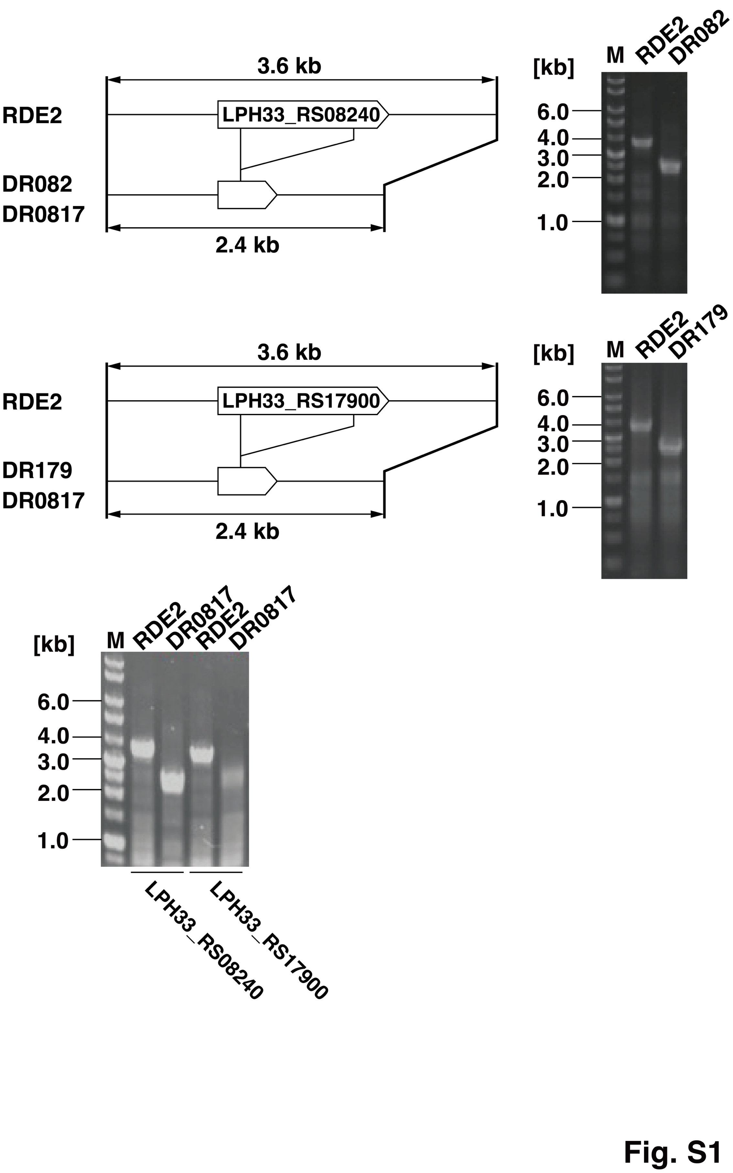
Fig. S1. Confirmation of ALDH gene deletions in RDE2 by genomic PCR. For each target locus, the chromosomal region spanning the gene was amplified with a primer pair annealing to the flanking sequences, and the products were resolved by agarose gel electrophoresis. Allelic replacement of the ~1.2-kb internal coding region reduces the amplicon from 3.6 kb (intact locus) to 2.4 kb (deleted locus), as depicted in the schematic to the left of each gel. (Top) LPH33_RS08240 locus in wild-type RDE2 and the single mutant DR082; (Middle) LPH33_RS17900 locus in wild-type RDE2 and the single mutant DR179; (Bottom) both loci in wild-type RDE2 and the double mutant DR0817 (left two lanes, LPH33_RS08240; right two lanes, LPH33_RS17900). In every case, the wild type yielded the 3.6-kb product, whereas the corresponding deletion mutant yielded the 2.4-kb product, confirming replacement of each intact gene by the deleted allele. M, molecular size marker (sizes in kb shown on the left).
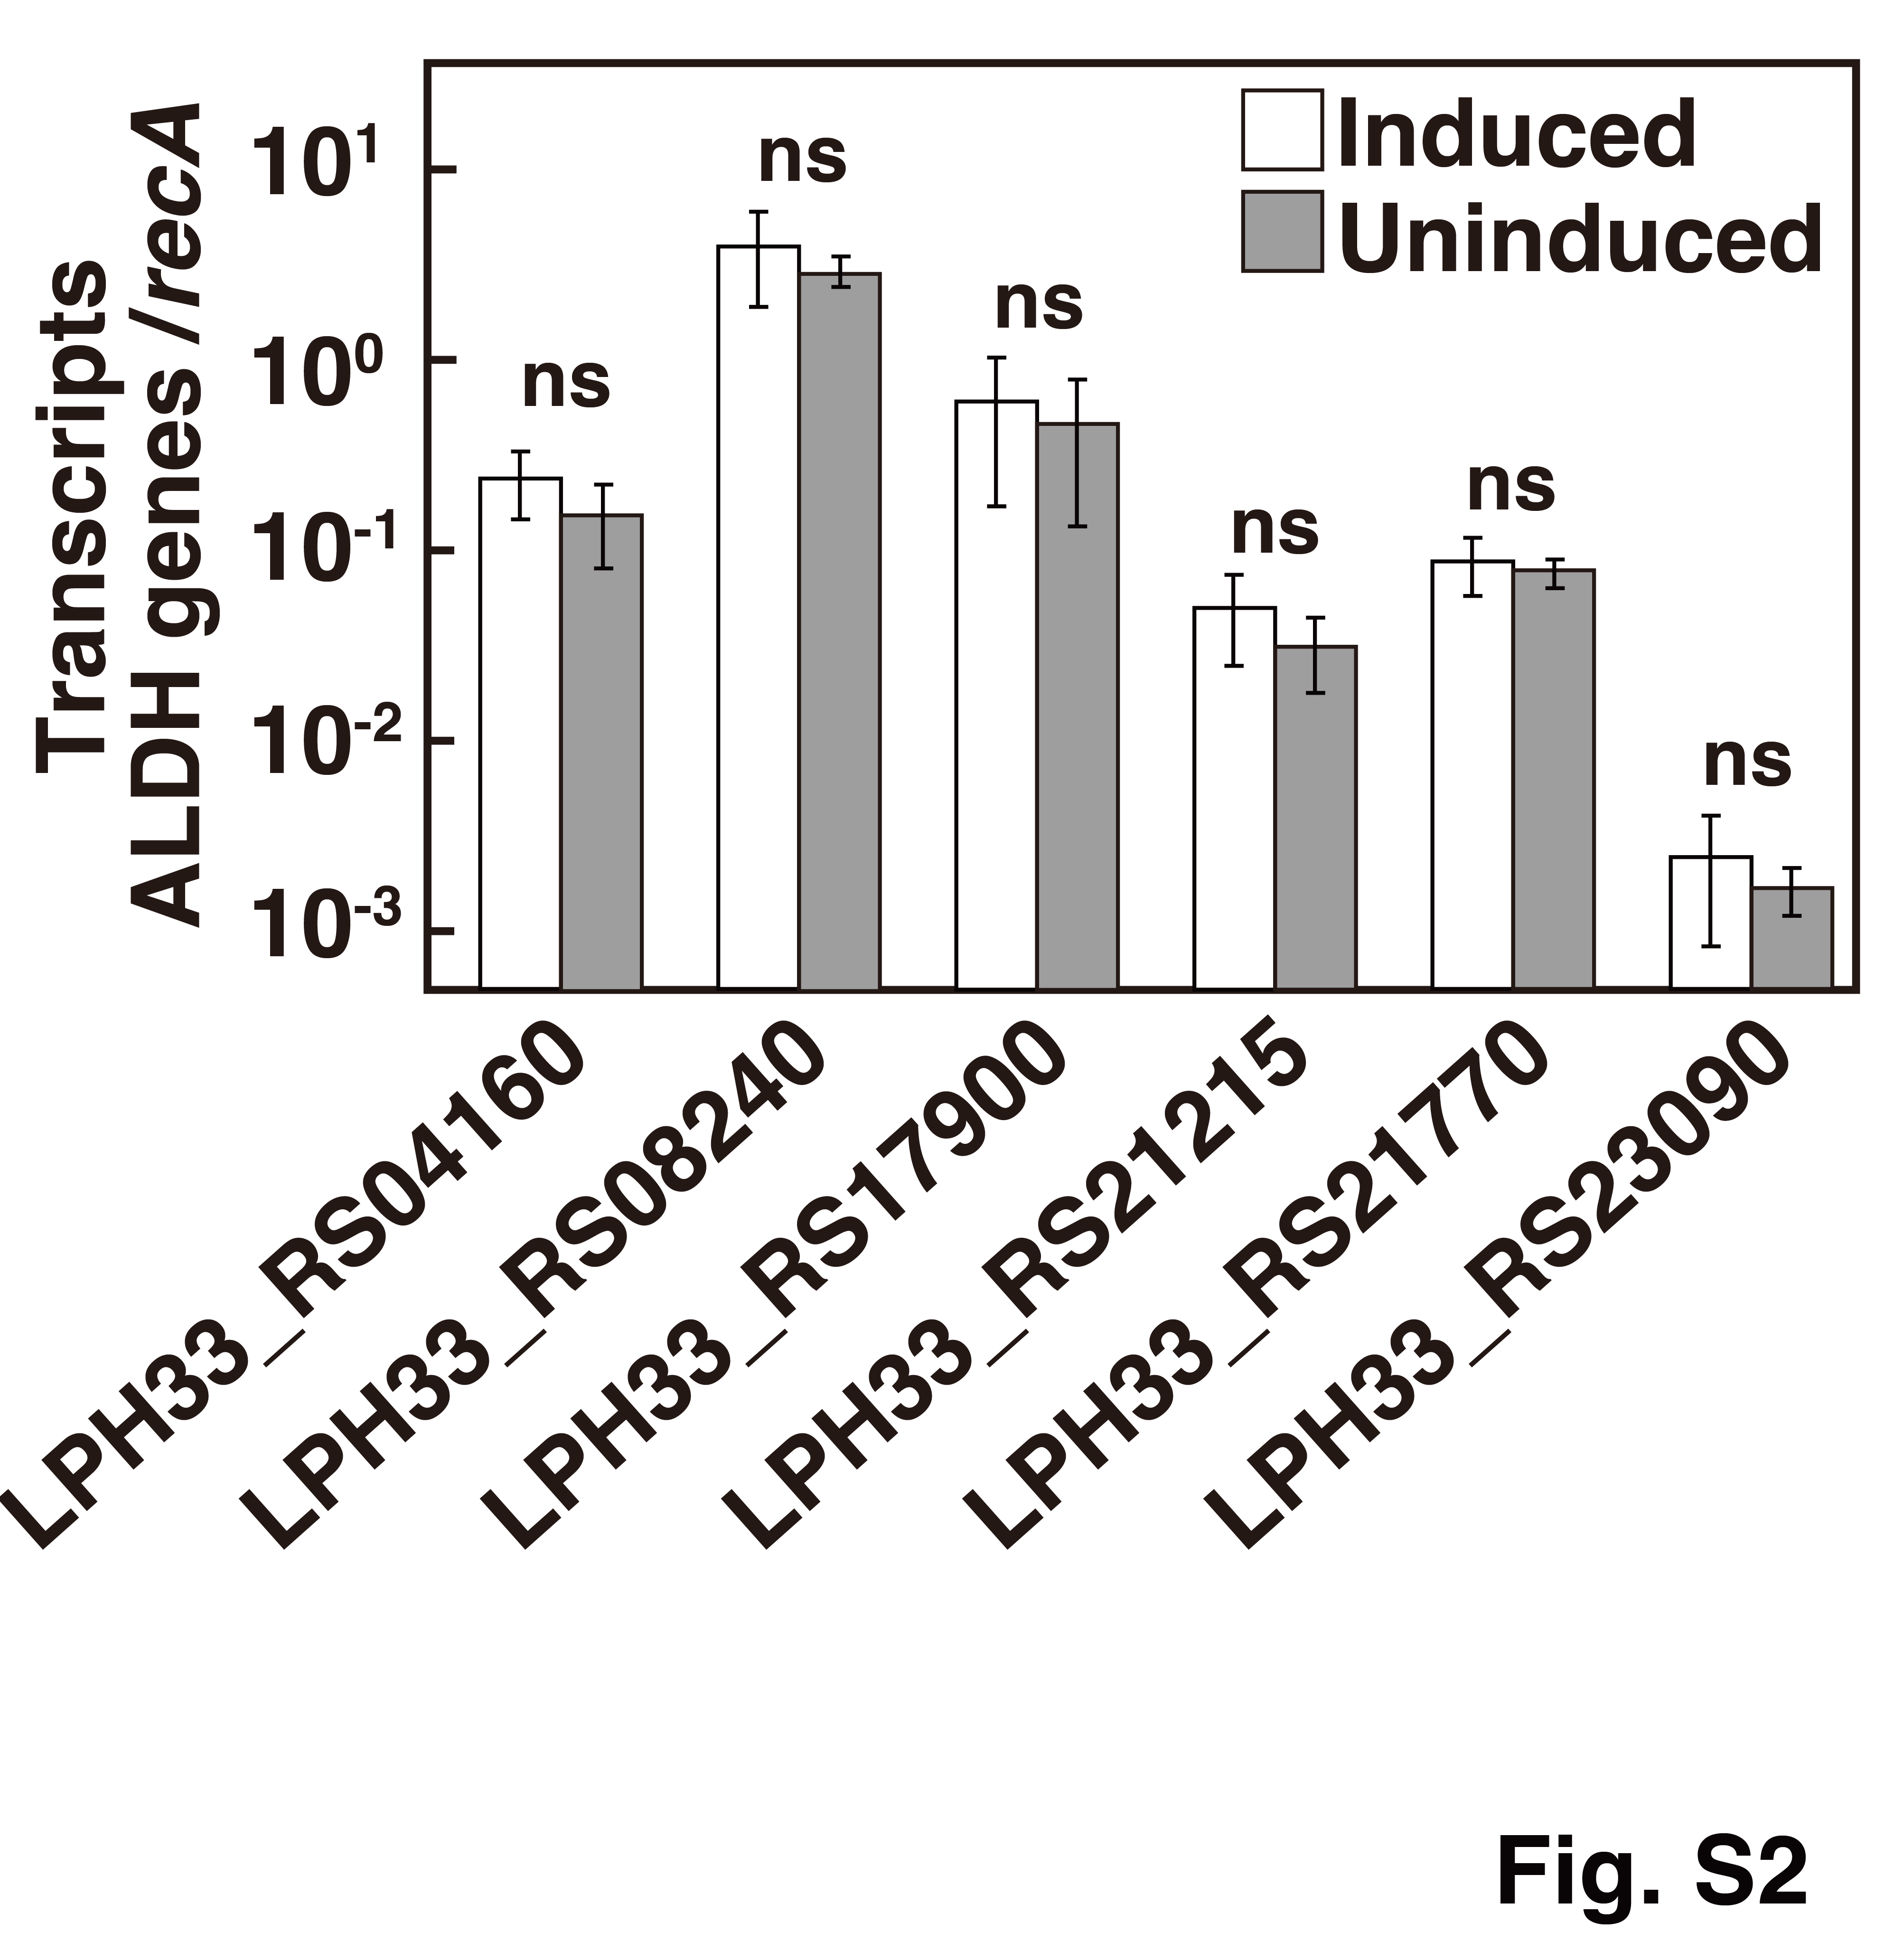
Fig. S2. Transcript levels of the six candidate ALDH genes in RDE2, as determined by quantitative reverse-transcription PCR (qRT-PCR). W medium containing 10 mM pyruvate alone (gray bars, uninduced) or 10 mM pyruvate plus 0.2% (w/v) DPNR (white bars, induced). Transcript levels of each candidate ALDH gene were normalized to that of recA (shown on a logarithmic scale). Values represent the mean ± standard deviation from n = 5 biological replicates. No significant differences were detected between conditions for any candidate (p > 0.05 by two-tailed Student's t-test); ns, not significant.
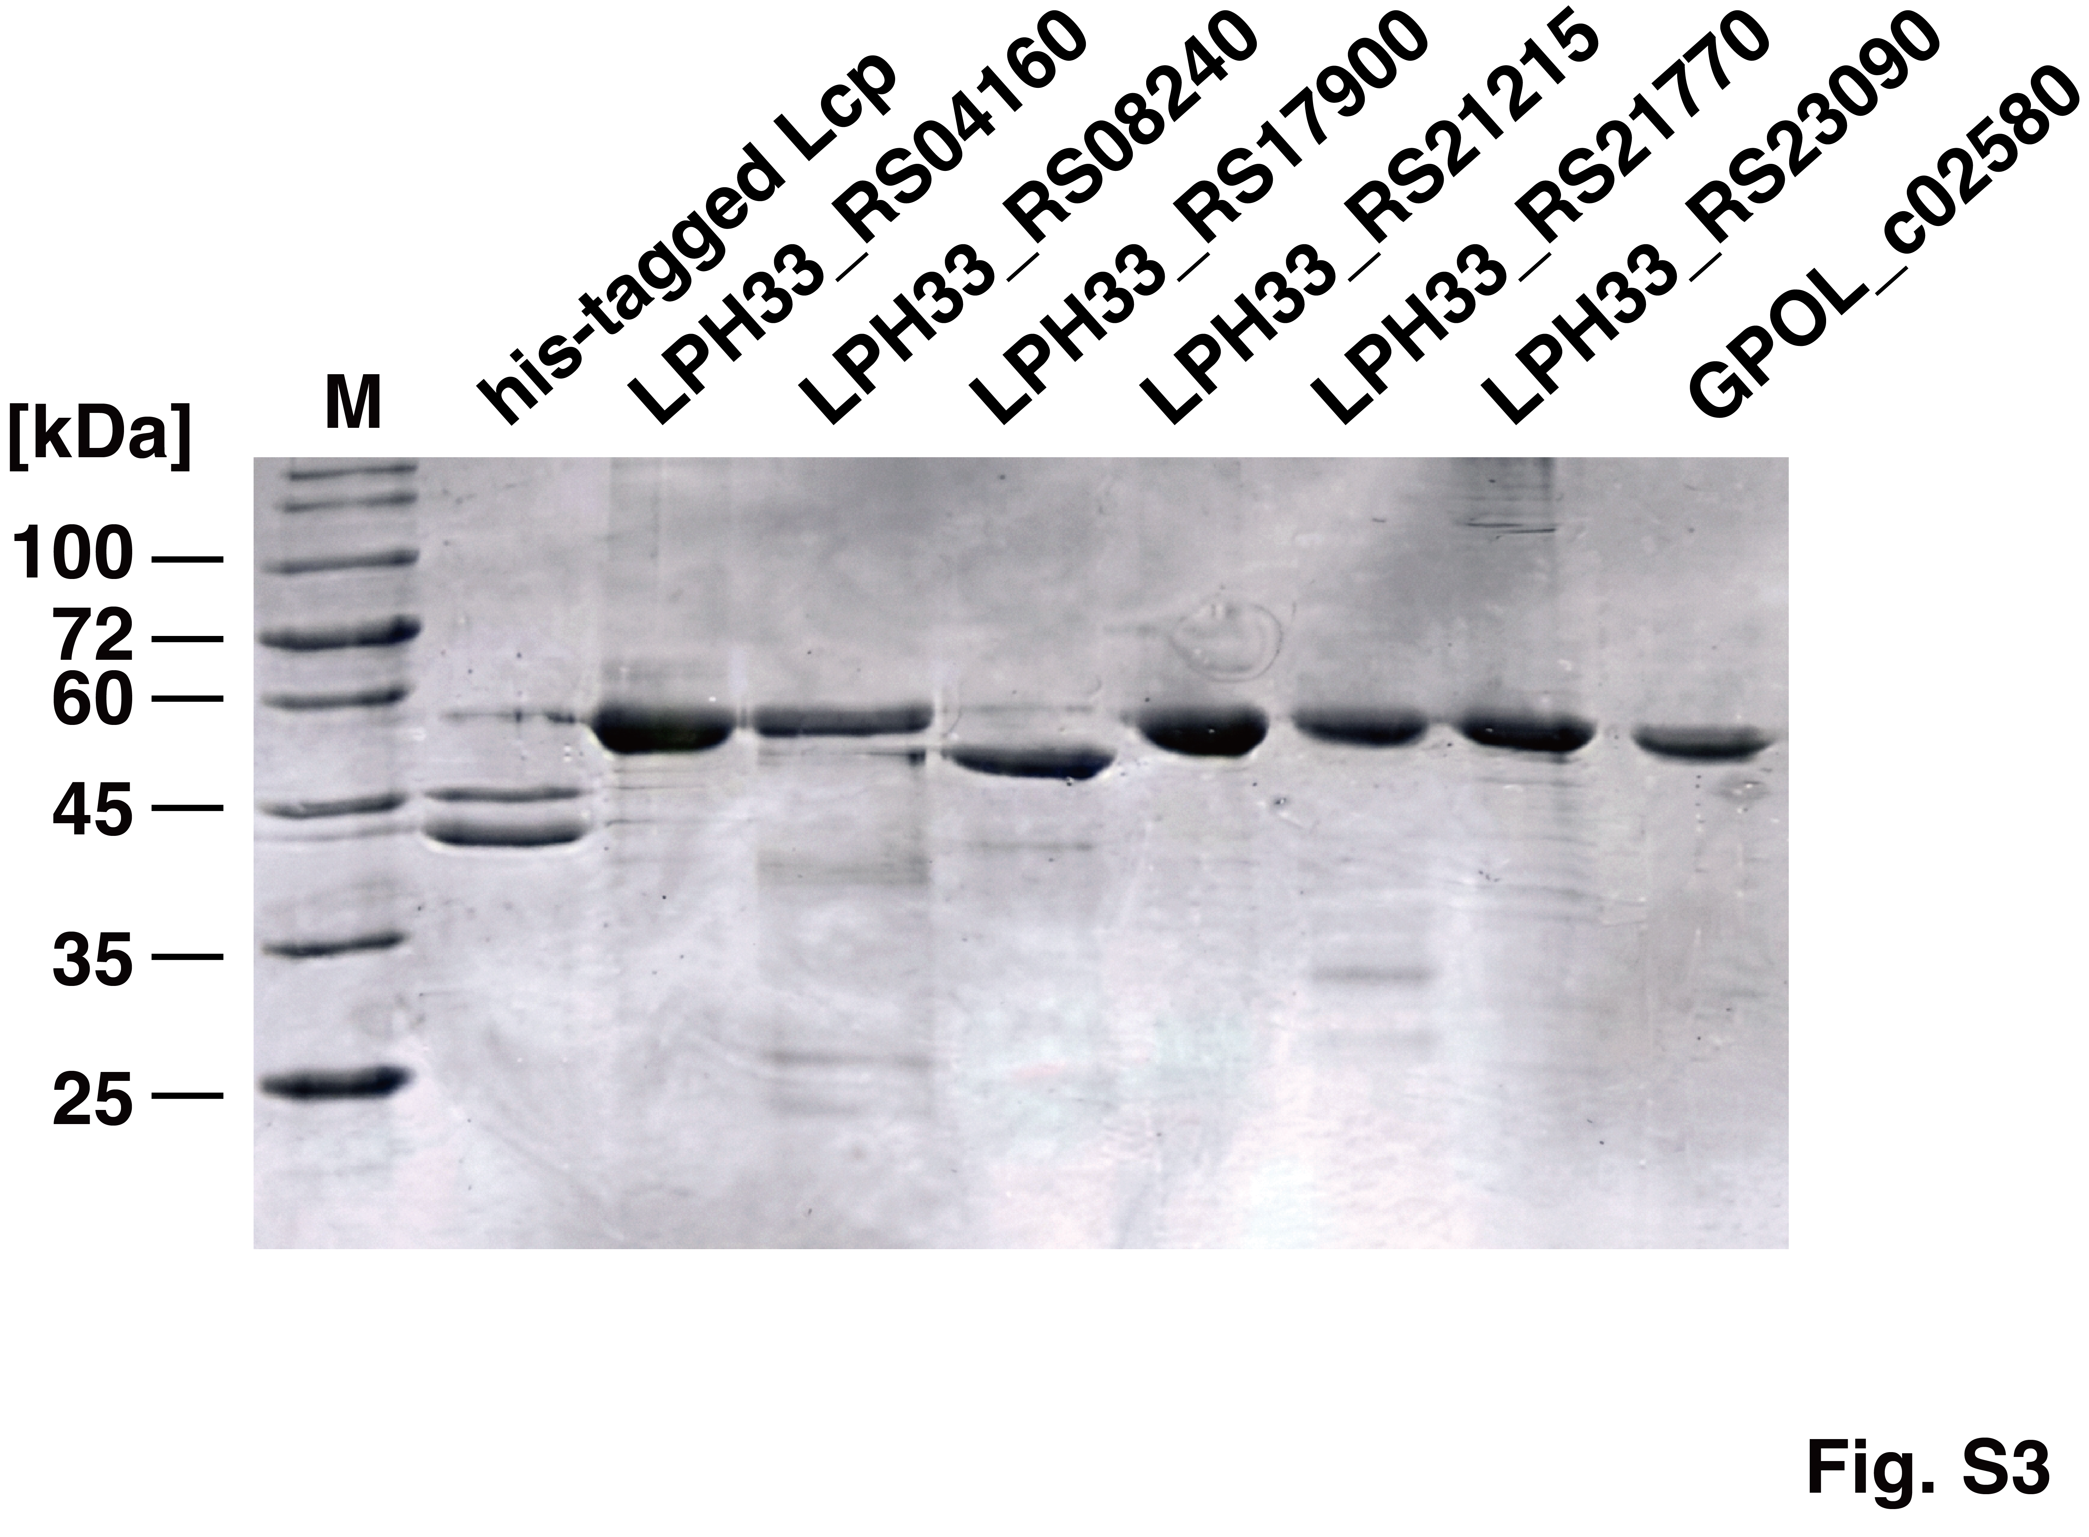
Fig. S3. SDS-PAGE analysis of the purified hexa-histidine-tagged Lcp and recombinant ALDHs used in this study. Each protein was heterologously expressed in Escherichia coli and purified by immobilized-metal affinity chromatography. Lane M, molecular mass markers (kDa). Each sample was loaded at 3 µg per lane. Proteins were separated on a 12% SDS-polyacrylamide gel and stained with Coomassie Brilliant Blue R-250.
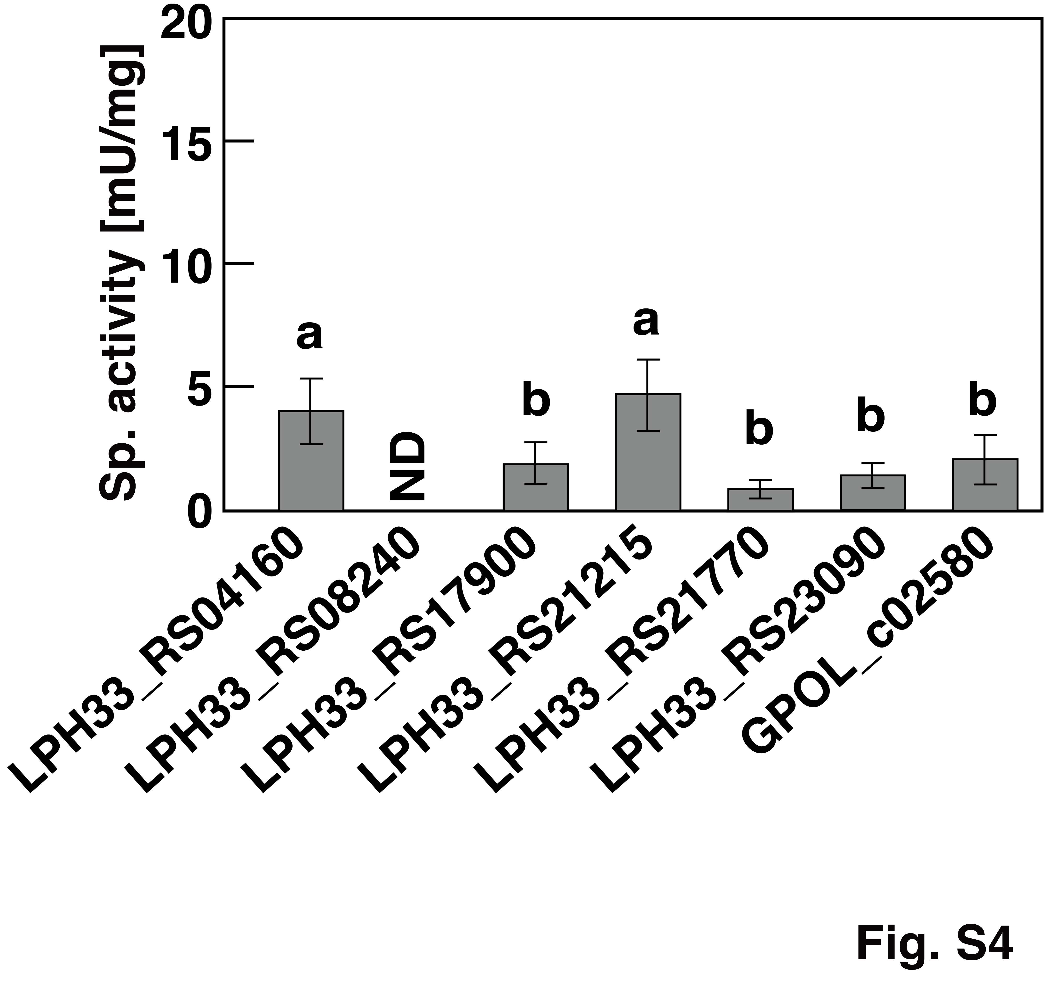
Fig. S4. ALDH activities of the six ALDH candidates from Rhodococcus sp. RDE2 and AldhGPOL_c02580 (from G. polyisoprenivorans VH2) toward OIA in the presence of 200 µM NADP⁺. Reactions were performed in 50 mM Tris-HCl (pH 7.0). ND, not detected. Data are presented as the mean ± standard deviation of n = 5 independent experiments. Different letters above the bars denote groups that are significantly different (p < 0.05) by one-way ANOVA followed by Tukey's HSD test. The LPH33_RS08240 sample (ND) was excluded from the statistical analysis.
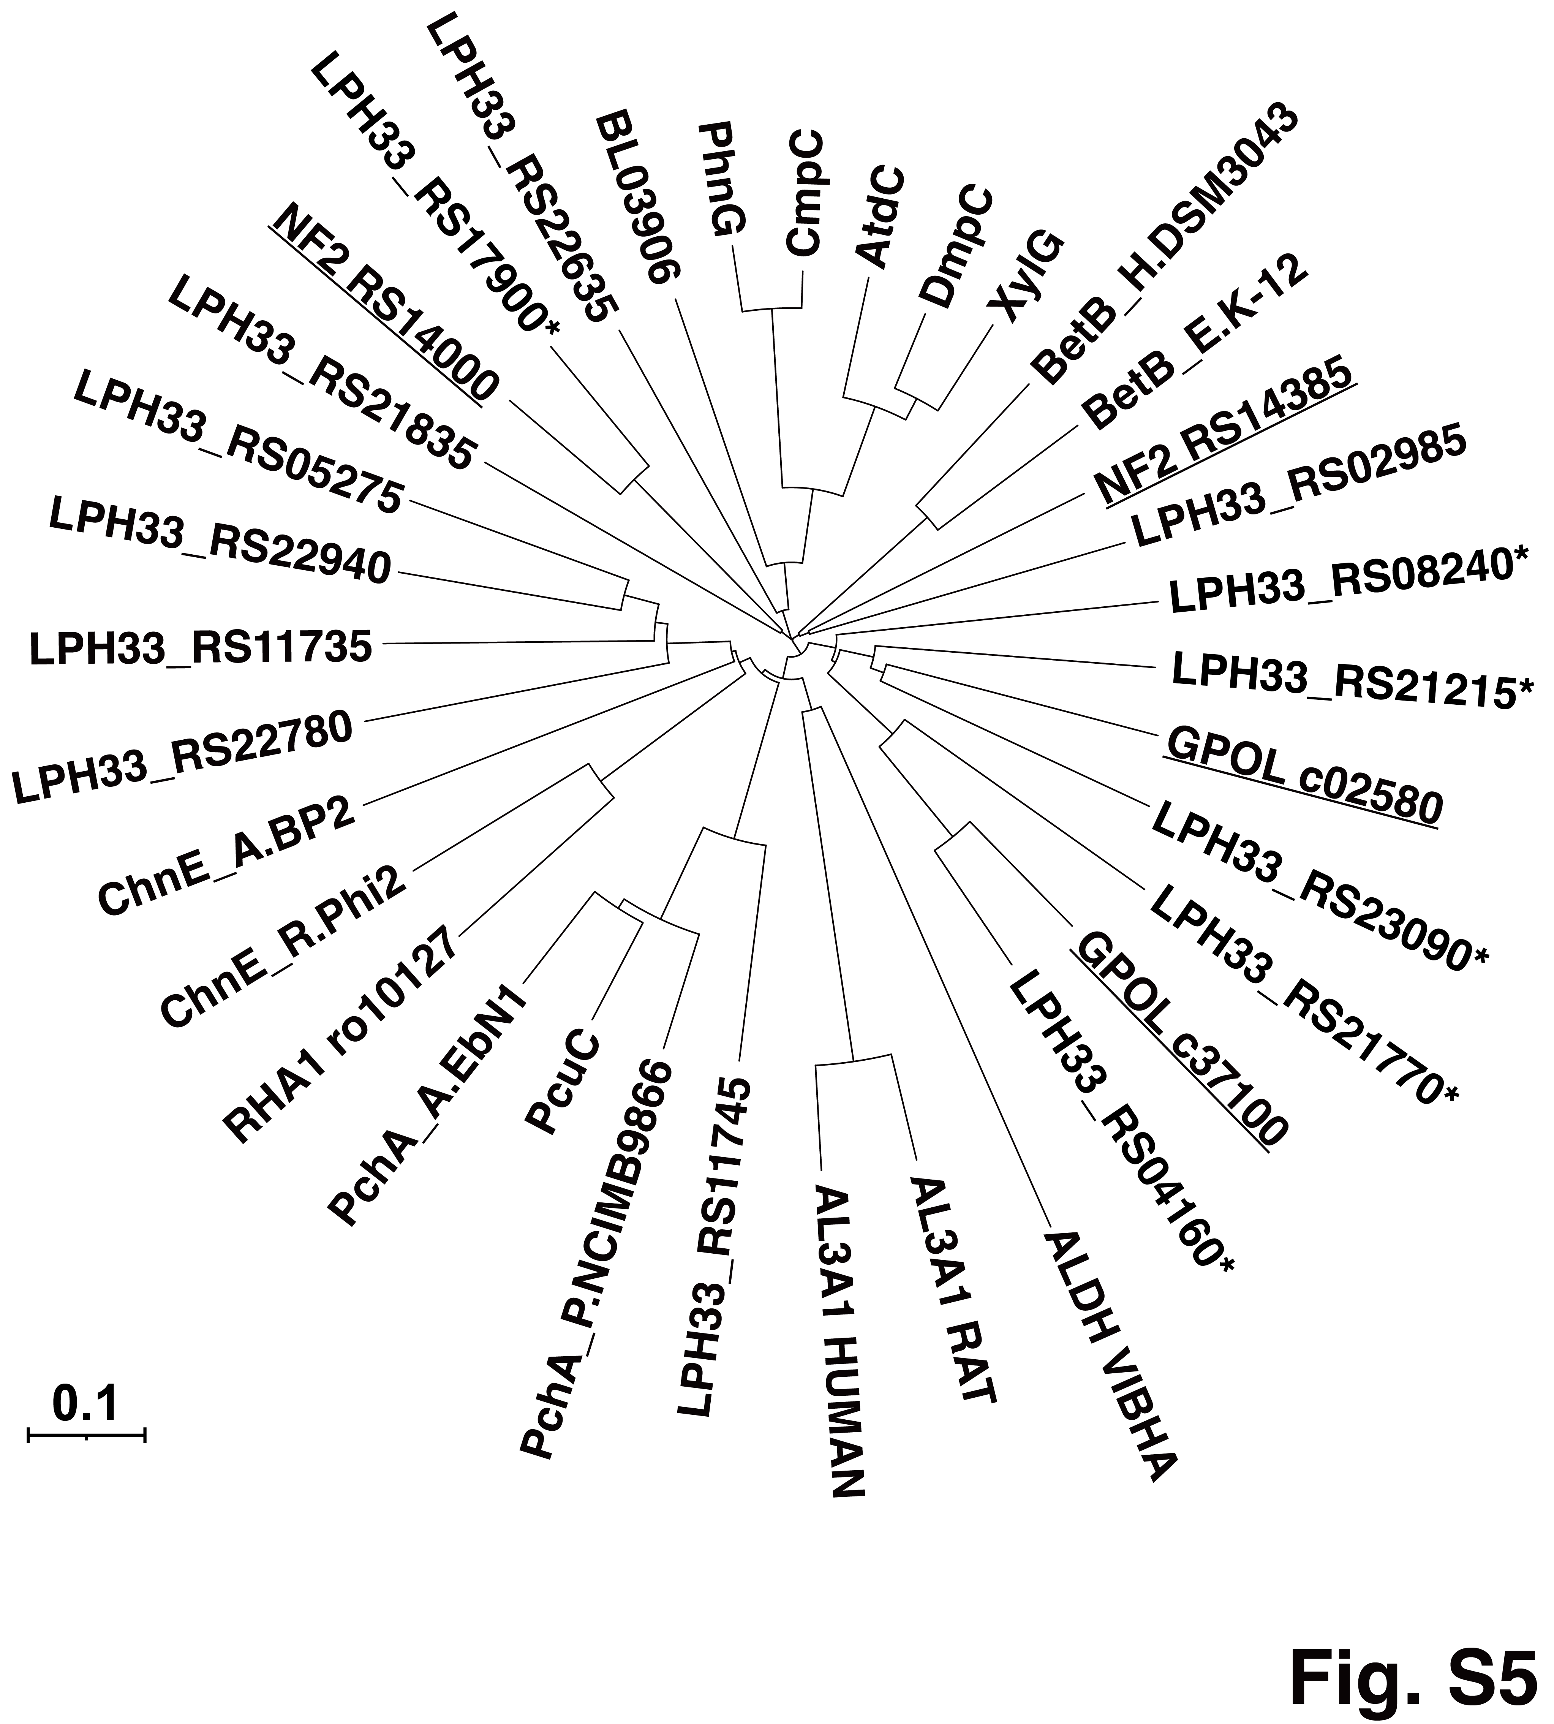
Fig. S5. Phylogenetic tree of the putative ALDHs of strain RDE2 with characterized bacterial and eukaryotic ALDHs. The scale corresponds to a genetic distance of 0.1 substitution per position (10% difference). Asterisks indicate the ALDHs of strain RDE2 (LPH33_RS locus tags) analyzed in this study; underlined entries indicate ALDHs that have previously been shown to be involved in PI degradation. Enzymes: GPOL_c02580 and GPOL_c37100, OIA dehydrogenases of G. polyisoprenivorans VH2 (AFA71331 and AFA74722, respectively); NF2_RS14000 and NF2_RS14385, OIA dehydrogenases of N. farcinica NBRC 15532 (WP_011209527 and WP_060593491); BL03906, putative ALDH of Bacillus licheniformis ATCC 14580 (AAU25432); PhnG, 2-hydroxymuconic semialdehyde dehydrogenase (HMSDH) of Pseudomonas sp. DJ77 (AAC45993); CmpC, HMSDH of Sphingomonas sp. HV3 (CAB06615); AtdC, HMSDH of Acinetobacter sp. YAA (BAA23556); DmpC, HMSDH of Pseudomonas sp. CF600 (BAP28474); XylG, HMSDH encoded on TOL plasmid pWW0 of Pseudomonas putida (CAC86805); BetB_H.DSM3043, betaine ALDH of Halomonas elongata DSM 3043 (CAB77175); BetB_E.K-12, betaine ALDH of E. coli K-12 (NP_414846); ChnE_A.BP2, 6-oxohexanoate dehydrogenase of Arthrobacter sp. BP2 (AAG10022); ChnE_R.Phi2, 6-oxohexanoate dehydrogenase of Rhodococcus sp. Phi2 (AAN37492); RHA1_ro10127, putative ALDH of Rhodococcus jostii RHA1 (ABH00320); PchA_P.NCIMB9866, p-hydroxybenzaldehyde dehydrogenase of Pseudomonas putida NCIMB 9866 (AGO01127); PchA_A.EbN1, ALDH of Aromatoleum aromaticum EbN1 (CAI07900); PcuC, p-hydroxybenzaldehyde dehydrogenase of Ectopseudomonas mendocina (AAM92190); AL3A1_HUMAN, ALDH of Homo sapiens (P30838); AL3A1_RAT, ALDH of Rattus norvegicus (P11883); and ALDH_VIBHA, ALDH of Vibrio harveyi (P42040).
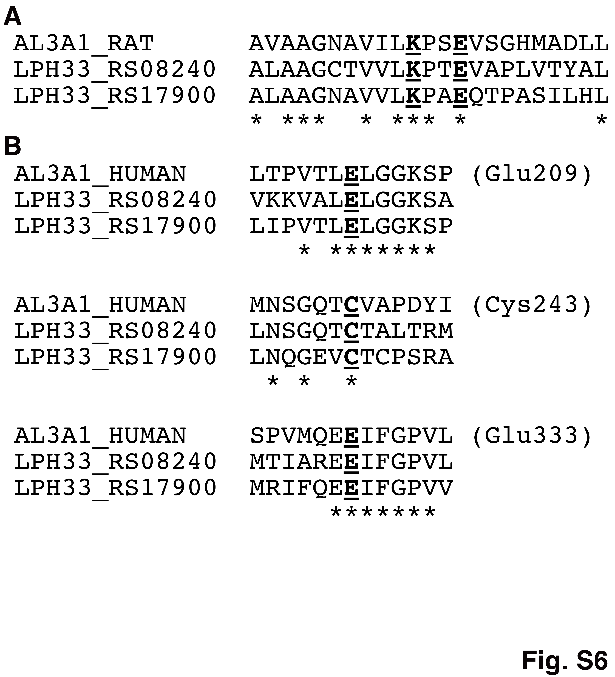
Fig. S6. Multiple sequence alignment of conserved catalytic and cofactor-binding residues of LPH33_RS08240 and LPH33_RS17900 with reference class 3 aldehyde dehydrogenases. (A) Alignment of the cofactor-discriminating region containing the conserved Lys and Glu residues corresponding to Lys137 and Glu140 of rat class 3 aldehyde dehydrogenase (AL3A1_RAT; UniProt P11883). (B) Alignment of three conserved catalytic regions: the region containing the activating Glu residue corresponding to Glu209 of human class 3 aldehyde dehydrogenase (AL3A1_HUMAN; UniProt P30838) (upper panel); the region containing the catalytic Cys residue corresponding to Cys243 of AL3A1_HUMAN (middle panel); and the region containing the second activating Glu residue corresponding to Glu333 of AL3A1_HUMAN (lower panel). Residues important for catalysis and cofactor binding are shown in bold and underlined. Asterisks below the alignments indicate identical residues across all sequences.
References
Gibu N, Linh DV, Suzuki N, et al. Identification and transcriptional analysis of poly(cis-1,4-isoprene) degradation gene in Rhodococcus sp. strain RDE2. J Biosci Bioeng. 2022 May;133(5):452–458.
Schäfer A, Tauch A, Jäger W, et al. Small mobilizable multi-purpose cloning vectors derived from the Escherichia coli plasmids pK18 and pK19: selection of defined deletions in the chromosome of Corynebacterium glutamicum. Gene. 1994 145(1):69-73.
Simon R, Priefer U, Pühler A. A broad host range mobilization system for in vivo genetic engineering: Transposon mutagenesis in gram negative bacteria. Nat Biotechnol. 1983 1:784-791.

