Supplementary Information to
“Isotopic Evidence for Modification of Column Water Vapor by Cities”
Martin Velez-Pardo¹, David C. Noone², Richard P. Fiorella¹
1: Earth and Environmental Sciences Division, Los Alamos National Laboratory, Los Alamos, NM, USA
2: School of Geography, Earth and Atmospheric Sciences, University of Melbourne, Melbourne, Victoria, Australia

Uncertainty estimates and sensitivity tests

Supplementary Figure 1 shows the uncertainty context for the three city-season examples in the main Figure 1. The anomaly maps and signal-to-uncertainty maps indicate that the plotted spatial structures are not dominated by isolated low-precision pixels, and that the strongest δD and H₂O anomalies are spatially coherent within the urban footprints. The settlement-bin median intervals are estimated with a spatial-block bootstrap, so that neighboring urban pixels are not treated as fully independent when summarizing the paired ΔH₂O–ΔδD distributions. The δD and H₂O signal-to-uncertainty patterns are not identical; for example, regions with stronger H₂O support do not always coincide with the strongest δD support. This reinforces the interpretation that isotope and humidity anomalies provide complementary information on the urban vapor perturbation. The stippling and signal-to-uncertainty maps are used as visual uncertainty diagnostics rather than as formal pixel-level detection tests.

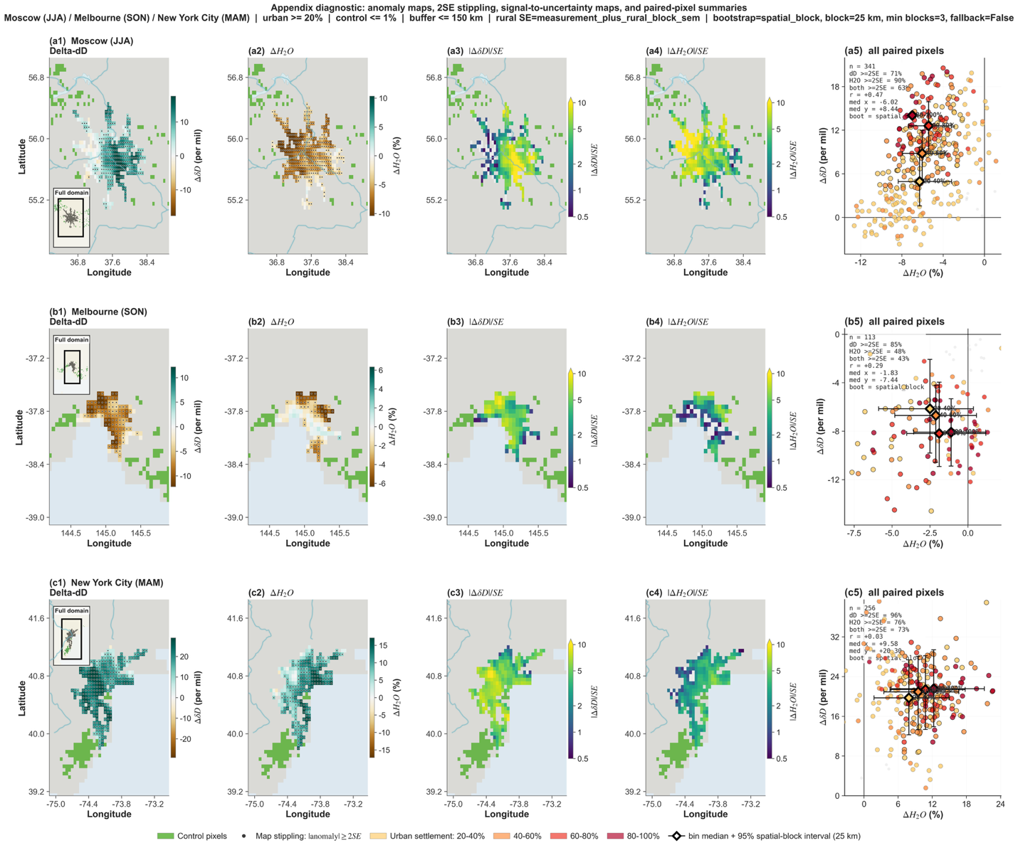
Supplementary Figure 1. Uncertainty diagnostics for example city-season urban–rural vapor anomalies. Rows show the same three high-signal city-seasons as Fig. 1: Moscow, Russia, in JJA; Melbourne, Australia, in SON; and New York City, USA, in MAM. Columns show ΔδD anomaly maps, ΔH₂O anomaly maps, |ΔδD|/SE maps, |ΔH₂O|/SE maps, and paired ΔH₂O–ΔδD urban-pixel anomalies. Stippling in the anomaly maps marks pixels where the absolute mapped anomaly exceeds twice its propagated standard error, evaluated separately for δD and H₂O. Signal-to-uncertainty maps show |mapped anomaly|/SE using propagated pixel-level uncertainty, including retrieval precision and rural-baseline uncertainty; values are plotted on a logarithmic scale capped at 10. In the paired panels, points show valid paired urban pixels, colored by settlement-fraction bin. Gray points have neither ΔδD nor ΔH₂O exceeding 2SE, colored points have at least one variable exceeding 2SE, and black-outlined points have both variables exceeding 2SE. Diamonds show settlement-bin medians computed from all valid paired pixels, with bars showing 95% spatial-block bootstrap intervals using 25 km blocks. The panels are intended as uncertainty and spatial-coherence diagnostics, not formal per-pixel detection tests. The contrast between δD and H₂O signal-to-uncertainty patterns illustrates that isotope and humidity anomalies provide complementary constraints on the urban vapor perturbation.

Sensitivity of individual city examples to analysis choices. To test whether the example city-season phase-space positions depended strongly on arbitrary threshold choices, we recomputed the city-level median anomalies under a targeted set of alternative configurations. Rather than testing all possible parameter combinations, we varied coherent analysis choices: stricter and looser rural-control matching tolerances, more restrictive and more permissive rural-control settlement thresholds, broader and stricter urban-footprint definitions, a moderate seasonal total-observation threshold, and an alternative OLS rural baseline using elevation and distance to coast (see more details below). For each scenario, we report both the number of valid paired urban pixels and the number of matched rural-control pixels, because changes in the rural reference pool can affect the inferred urban anomaly.
OLS: For each city and variable, the selected rural control pixels were used to fit an unweighted linear model in which the rural δD or H₂O field was expressed as a function of an intercept, elevation and distance to coast, with latitude and longitude optionally included when sufficient rural samples were available. This model was then evaluated at the elevation, coastal distance and, where applicable, coordinate values of each urban pixel, to estimate a local rural “background” that would be expected at that urban pixel. This is an alternative to the use of the mean value of surrounding rural pixels as control for the urban signal. Urban anomalies were calculated relative to this predicted rural background, as urban minus predicted rural δD for isotope composition and as 100 × (urban − predicted rural) / predicted rural for H₂O. This OLS correction tests whether the inferred urban anomalies are sensitive to residual linear gradients in topography, coastal proximity or large-scale position within the rural control domain, rather than assuming a spatially uniform rural mean. It was used an
Across the reported sensitivity scenarios, the phase-space classification of the three illustrative city-seasons is unchanged: Moscow, Melbourne, and New York City remain drier–enriched, drier–depleted, and wetter–enriched respectively. Median anomaly magnitudes vary across scenarios, as expected when the rural baseline or urban footprint is altered, but the qualitative quadrant positions are stable under the tested alternatives. These results support the use of the three city-seasons as illustrative examples of contrasting ΔH₂O–ΔδD regimes, while emphasizing that the exact median values should be interpreted as conditional on the specified sampling and matching design rather than as uniquely determined city constants.
For each example city, Supplementary Table 1 reports all paired urban pixel median anomalies in ΔH₂O and ΔδD under the base configuration and targeted alternative analysis choices. Values are shown together with shifts relative to the base case, the number of paired urban pixels, the number of matched rural-control pixels, and the resulting ΔH₂O–ΔδD phase-space quadrant. The base configuration defines the urban footprint as the connected component of pixels with settlement fraction ≥20%, uses rural controls with settlement fraction ≤1% within 150 km of the urban footprint and matched within 50 m elevation and 50 km distance to coast, and uses the bulk mean of the matched rural-control pool as the rural baseline. Alternative scenarios perturb the matching tolerances, rural-control threshold, urban-footprint definition, rural-baseline model, or seasonal sampling requirement. ΔH₂O is reported as a percentage difference relative to the rural baseline; ΔδD is reported in per mil. A test to determine whether the sign combination of median ΔH₂O and median ΔδD differs from the base configuration is reported as “Quadrant changed?”.

Supplementary Table 1. Sensitivity of example city-season median anomalies to analysis choices.

Scenario | City-season | n paired urban px | n rural controls | Median dH2O (%) | Shift dH2O from base (%) | Median ddD (per mil) | Shift ddD from base (per mil) | Quadrant | Quadrant changed?
Base: ctrl dist. <=150 km; |elev. diff.| <=50 m; |coast diff.| <=50 km | Moscow (JJA) | 341 | 228 | -6.0 | — | +8.4 | — | drier-enriched | No
Base: ctrl dist. <=150 km; |elev. diff.| <=50 m; |coast diff.| <=50 km | Melbourne (SON) | 113 | 139 | -1.8 | — | -7.4 | — | drier-depleted | No
Base: ctrl dist. <=150 km; |elev. diff.| <=50 m; |coast diff.| <=50 km | New York City (MAM) | 256 | 76 | +9.6 | — | +20.3 | — | wetter-enriched | No
Stricter matching: ctrl dist. <=100 km; |elev. diff.| <=30 m; |coast diff.| <=30 km | Moscow (JJA) | 341 | 11 | -5.0 | +1.0 | +10.1 | +1.7 | drier-enriched | No
Stricter matching: ctrl dist. <=100 km; |elev. diff.| <=30 m; |coast diff.| <=30 km | Melbourne (SON) | 113 | 36 | -1.4 | +0.4 | -5.7 | +1.7 | drier-depleted | No
Stricter matching: ctrl dist. <=100 km; |elev. diff.| <=30 m; |coast diff.| <=30 km | New York City (MAM) | 256 | 23 | +16.5 | +6.9 | +23.9 | +3.6 | wetter-enriched | No
Looser matching: ctrl dist. <=200 km; |elev. diff.| <=100 m; |coast diff.| <=100 km | Moscow (JJA) | 341 | 1328 | -5.8 | +0.2 | +8.3 | -0.2 | drier-enriched | No
Looser matching: ctrl dist. <=200 km; |elev. diff.| <=100 m; |coast diff.| <=100 km | Melbourne (SON) | 113 | 612 | -0.9 | +0.9 | -6.4 | +1.0 | drier-depleted | No
Looser matching: ctrl dist. <=200 km; |elev. diff.| <=100 m; |coast diff.| <=100 km | New York City (MAM) | 256 | 188 | +1.1 | -8.5 | +7.6 | -12.7 | wetter-enriched | No
Rural controls <=5% | Moscow (JJA) | 341 | 639 | -5.4 | +0.6 | +7.4 | -1.1 | drier-enriched | No
Rural controls <=5% | Melbourne (SON) | 113 | 239 | -2.0 | -0.1 | -7.7 | -0.2 | drier-depleted | No
Rural controls <=5% | New York City (MAM) | 256 | 158 | +4.5 | -5.1 | +11.4 | -8.9 | wetter-enriched | No
Rural controls <=0.5% | Moscow (JJA) | 341 | 166 | -6.5 | -0.5 | +8.4 | -0.0 | drier-enriched | No
Rural controls <=0.5% | Melbourne (SON) | 113 | 93 | -1.5 | +0.3 | -6.6 | +0.8 | drier-depleted | No
Rural controls <=0.5% | New York City (MAM) | 256 | 57 | +10.5 | +0.9 | +22.4 | +2.1 | wetter-enriched | No
Urban footprint >=10% | Moscow (JJA) | 408 | 225 | -5.8 | +0.2 | +7.2 | -1.2 | drier-enriched | No
Urban footprint >=10% | Melbourne (SON) | 113 | 139 | -1.8 | +0.0 | -7.4 | +0.0 | drier-depleted | No
Urban footprint >=10% | New York City (MAM) | 558 | 87 | +7.8 | -1.8 | +18.0 | -2.3 | wetter-enriched | No
Urban footprint >=30% | Moscow (JJA) | 188 | 231 | -6.0 | +0.0 | +10.4 | +1.9 | drier-enriched | No
Urban footprint >=30% | Melbourne (SON) | 94 | 129 | -1.5 | +0.3 | -7.9 | -0.4 | drier-depleted | No
Urban footprint >=30% | New York City (MAM) | 195 | 79 | +9.3 | -0.3 | +20.5 | +0.2 | wetter-enriched | No
Seasonal obs. >=20 and >=2 supported months | Moscow (JJA) | 250 | 52 | -3.7 | +2.3 | +3.6 | -4.9 | drier-enriched | No
Seasonal obs. >=20 and >=2 supported months | Melbourne (SON) | 113 | 139 | -1.8 | +0.0 | -7.4 | +0.0 | drier-depleted | No
Seasonal obs. >=20 and >=2 supported months | New York City (MAM) | 256 | 72 | +9.2 | -0.4 | +19.5 | -0.8 | wetter-enriched | No
OLS rural baseline: elevation + coast | Moscow (JJA) | 341 | 228 | -4.8 | +1.3 | +9.0 | +0.5 | drier-enriched | No
OLS rural baseline: elevation + coast | Melbourne (SON) | 113 | 139 | -2.6 | -0.7 | -6.6 | +0.8 | drier-depleted | No
OLS rural baseline: elevation + coast | New York City (MAM) | 256 | 76 | +13.0 | +3.4 | +22.7 | +2.4 | wetter-enriched | No

Supplementary Table 2. Bootstrap stability of city-season placement by model regime

Group | n city-seasons | Same quadrant median [IQR] | Same quadrant >=80% | Same regime median [IQR] | Same regime >=80% | Median pixels urban/rural | Median blocks urban/rural
R1 | 241 | 97% [70-100%] | 68% | 95% [70-100%] | 67% | 13/86 | 2/22
R2 | 356 | 94% [77-100%] | 70% | 96% [81-100%] | 77% | 13/74 | 3/20
R3 | 40 | 99% [90-100%] | 82% | 65% [44-81%] | 28% | 16/58 | 4/22
outside/unsupported | 10 | 100% [93-100%] | 80% |  | 0% | 11/112 | 2/26

Supplementary Table 3. Bootstrap stability of city-season placement by quadrant
Group | n city-seasons | Same quadrant median [IQR] | Same quadrant >=80% | Same regime median [IQR] | Same regime >=80% | Median pixels urban/rural | Median blocks urban/rural
wetter-enriched | 209 | 99% [80-100%] | 75% | 98% [79-100%] | 72% | 12/95 | 2/22
drier-enriched | 181 | 91% [72-100%] | 66% | 88% [64-98%] | 60% | 14/62 | 3/20
drier-depleted | 164 | 96% [78-100%] | 73% | 99% [91-100%] | 83% | 13/76 | 3/22
wetter-depleted | 93 | 92% [68-99%] | 62% | 85% [66-98%] | 54% | 13/74 | 3/22

Bootstrap stability of city-season phase-space placement. To assess whether city-season placement in the ΔH₂O–ΔδD phase space is sensitive to finite pixel sampling, we repeated the city-scale anomaly calculation under bootstrap resampling of the urban footprint and matched rural-control pool. Bootstrap estimates were then assigned to the same quadrant and model-regime grid used in main Figure 2. Spatial-block resampling with 25 km blocks was used when both the urban footprint and rural-control pool contained at least five populated blocks; otherwise, pixel bootstrap resampling was used and flagged as a fallback. We retained the fallback cases rather than excluding them because many urban footprints span only a few 0.05° pixels or fewer than five 25 km blocks, so enforcing block bootstrap everywhere would preferentially remove smaller cities. The “same quadrant” and “same regime” fractions report the fraction of bootstrap estimates that retained the point-estimate classification. The ≥80% columns provide a compact summary of high-retention classifications and are not interpreted as formal hypothesis tests.
The bootstrap results indicate that quadrant placement is generally robust. Median same-quadrant fractions range from 91% to 99% across the four ΔH₂O–ΔδD quadrants, showing that the sign-based interpretation of whether a city-season is wetter or drier and enriched or depleted is usually stable under resampling. Regime placement is also stable for the dominant model regimes R1 and R2, with median same-regime fractions of 95–96%. Regime R3 has lower same-regime retention, with a median of 65%, despite high same-quadrant retention. This behavior is consistent with R3 occupying a relatively small region of the model phase space and lying near a neighboring mixed-regime region (R2), so modest bootstrap displacement can recategorize a city across the regime boundary without implying a transition to a physically opposite quadrant or a strongly dissimilar regime. We therefore use the model-regime background primarily as physical context for interpreting city-season locations, while treating individual regime labels near regime boundaries as approximate rather than categorical.

Threshold-sensitivity analysis for multi-city scatterplot. To assess whether the assignment of individual city anomalies to particular phase-space patterns depend on arbitrary threshold choices in the urban-footprint and rural-control definitions, we repeated the city-season analysis under a set of targeted sensitivity scenarios. Starting from the base configuration, we varied the rural matching tolerances jointly, using stricter matching thresholds of 100 km distance, 30 m elevation difference and 30 km distance-to-coast difference, and looser thresholds of 200 km, 100 m, and 100 km. We also varied the rural-control settlement threshold from ≤1% to ≤0.5% and ≤2%, and varied the urban-footprint threshold from ≥50% settlement to broader and stricter definitions of ≥30% and ≥70%. For each scenario, we recomputed the city-season urban and matched-rural means, the resulting ΔH2O and ΔδD anomalies, the phase-space quadrant, and the model-regime assignment. We then compared each scenario against the base case using only overlapping city entries, reporting the median absolute displacement in ΔH2O and ΔδD, the fraction of entries remaining in the same quadrant, and the fraction remaining in the same model regime. Median shifts are reported as the signed median displacement relative to the base configuration, with the median absolute displacement shown in brackets (Supplementary Table 4)
Across these targeted sensitivity tests, the city phase-space structure was broadly stable. Changes to the rural control settlement threshold produced especially small median shifts, about 0.30% in ΔH₂O and 0.31–0.32 ‰ in ΔδD, while preserving the same quadrant for 91–93% of overlapping city and the same model regime for 89%. Changing the urban threshold also produced modest median displacements, below 0.6% in ΔH₂O and below 0.7 ‰ in ΔδD, while retaining quadrant and regime assignments for most overlapping cases. The strictest and loosest rural-matching scenarios produced larger shifts, around 1.1–1.4% in ΔH₂O and 1.0–1.3 ‰ in ΔδD, and lower but still substantial quadrant and regime stability. These larger changes are expected because these scenarios alter not only uncertainty but also the set and composition of the matched rural controls. Overall, the sensitivity tests indicate that the qualitative phase-space organization is not driven by a single threshold choice, although exact city-level coordinates and membership vary when the matching criteria are made substantially stricter or looser.
Supplementary Table 4. Parameter sensitivity test scenarios for city-season scatterplot distribution
Scenario | Changed thresholds | n | Overlap with base | Median H2O shift signed [abs.] | Median deltaD shift signed [abs.] | Same quadrant | Same regime | Median px urban/rural
Base | urban>=50; ctrl<=1; dist<=150; elev<=50; coast<=50 | 630 | 630/630 (100%) | +0.00% [0.00%] | +0.00‰ [0.00‰] | 100% | 100% | 13/76
Stricter matching | dist<=100; elev<=30; coast<=30 | 418 | 418/630 (66%) | -0.23% [1.15%] | -0.25‰ [1.04‰] | 78% | 80% | 13/34
Looser matching | dist<=200; elev<=100; coast<=100 | 729 | 630/630 (100%) | +0.62% [1.41%] | +0.38‰ [1.30‰] | 73% | 77% | 12/276
Very rural controls | ctrl<=0.5 | 576 | 576/630 (91%) | +0.03% [0.30%] | +0.09‰ [0.32‰] | 93% | 89% | 13/56
Expanded rural controls | ctrl<=2 | 667 | 630/630 (100%) | +0.02% [0.30%] | -0.12‰ [0.31‰] | 91% | 89% | 12/99
Broader urban footprint | urban>=30 | 803 | 600/630 (95%) | +0.01% [0.49%] | +0.03‰ [0.56‰] | 88% | 82% | 20/74
Stricter urban footprint | urban>=70 | 424 | 399/630 (63%) | +0.03% [0.43%] | -0.04‰ [0.63‰] | 87% | 86% | 9/76

Regional pixel-level sensitivity analysis
To assess whether the regional settlement-fraction patterns in main text Figure 4 depend on specific matching choices, we repeated the pixel-level urban–rural paired analysis under a set of alternative configurations. The base configuration used rural controls with settlement fraction ≤1%, a maximum urban–rural great-circle distance of 150 km, and matching tolerances of ±50 m elevation and ±50 km distance to coast. Sensitivity scenarios then perturbed one coherent aspect of the design at a time: stricter matching, looser matching, a stricter rural-control threshold, a looser rural-control threshold, and a stricter seasonal coverage requirement. For each scenario, we recomputed the urban–rural mean anomaly and the corresponding sample-size-matched rural–rural null benchmark for each variable, season, region, and settlement-fraction bin.
The comparison was made relative to the base configuration using the null-corrected observed mean anomaly, defined as the observed urban minus rural mean, minus the center of the corresponding rural-rural null distribution. This choice focuses the sensitivity test on the quantity most relevant to main text Figure 4: the urban signal after accounting for any residual offset introduced by the matching procedure. For the scenario-resolved heatmaps, we retained the sensitivity scenario, region, and settlement-fraction bin dimensions, and summarized across seasons using the median signed shift from the base configuration. Positive values indicate that the alternative configuration makes the null-corrected urban anomaly more positive than in the base case, whereas negative values indicate a more negative anomaly. This produces a compact diagnostic of where the Figure 4 results are stable, and where they are more sensitive to the definition of the rural reference or the strictness of the matching criteria.
The scenario-resolved results (in Supplementary Figure 2) show that the sensitivity is structured rather than random. For ΔδD, changes to the rural control settlement threshold produce the clearest and most physically interpretable shifts. The stricter rural control scenario, rural ≤0.5%, tends to shift ΔδD anomalies positive across several regions, including North America, Europe, Southeast Asia, Australia, East Asia, and the Global aggregate. In contrast, the looser rural-control scenario, rural ≤2%, often shifts ΔδD anomalies negative, especially across Europe, Southeast Asia, Australia, East Asia, and the Global row. This indicates that the isotope signal is partly sensitive to the isotopic character of the rural baseline, as expected: changing which low-settlement pixels are allowed into the reference pool modifies the urban-minus-rural isotope contrast. However, most shifts remain modest, and their direction is consistent with the intended perturbation rather than suggesting arbitrary instability. The main exceptions occur in a few region–settlement bins, such as high-settlement Southeast Asia and East Asia, where stricter matching, rural-threshold changes or stricter coverage requirements can produce larger signed shifts.
For ΔH₂O, the sensitivity pattern is less coherent and more region-specific. Strict matching produces large negative shifts in Southeast Asia across several settlement bins, while loose matching tends to shift some Southeast Asia, East Asia, and Global high-settlement bins more positive. Rural threshold perturbations also affect ΔH₂O, but the response is less systematic than for ΔδD. Overall, the sensitivity analysis supports using main text Figure 4as evidence for a settlement-fraction-associated isotope signal.
Supplementary Figure 2. Scenario-resolved sensitivity of regional settlement-fraction anomalies to matched-pairs design choices. Median signed shifts in null-corrected urban–rural anomalies are shown for ΔδD and ΔH₂O after perturbing the matching and rural-control definitions used in Fig. 4. Columns within each panel show settlement-fraction bins, rows show regions including the Global aggregate, and panel groups show alternative sensitivity scenarios: stricter geographic/topographic matching, looser matching, stricter rural controls with settlement fraction ≤0.5%, looser rural controls with settlement fraction ≤2%, and a stricter seasonal coverage requirement of three supported months (all months within the season). Values are computed relative to the base configuration and summarized as the median across seasons for each scenario × region × settlement-bin cell. Positive values indicate that the alternative scenario shifts the null-corrected urban anomaly more positive than the base case; negative values indicate a more negative anomaly. ΔδD shifts are reported in per mil and ΔH₂O shifts in percent. The results show that most cells remain close to the base configuration, while the largest and most coherent ΔδD sensitivities arise from changing the rural-control threshold, and ΔH₂O sensitivities are more region-specific, especially in Southeast and East Asia.

Two-layer budget model regime identification

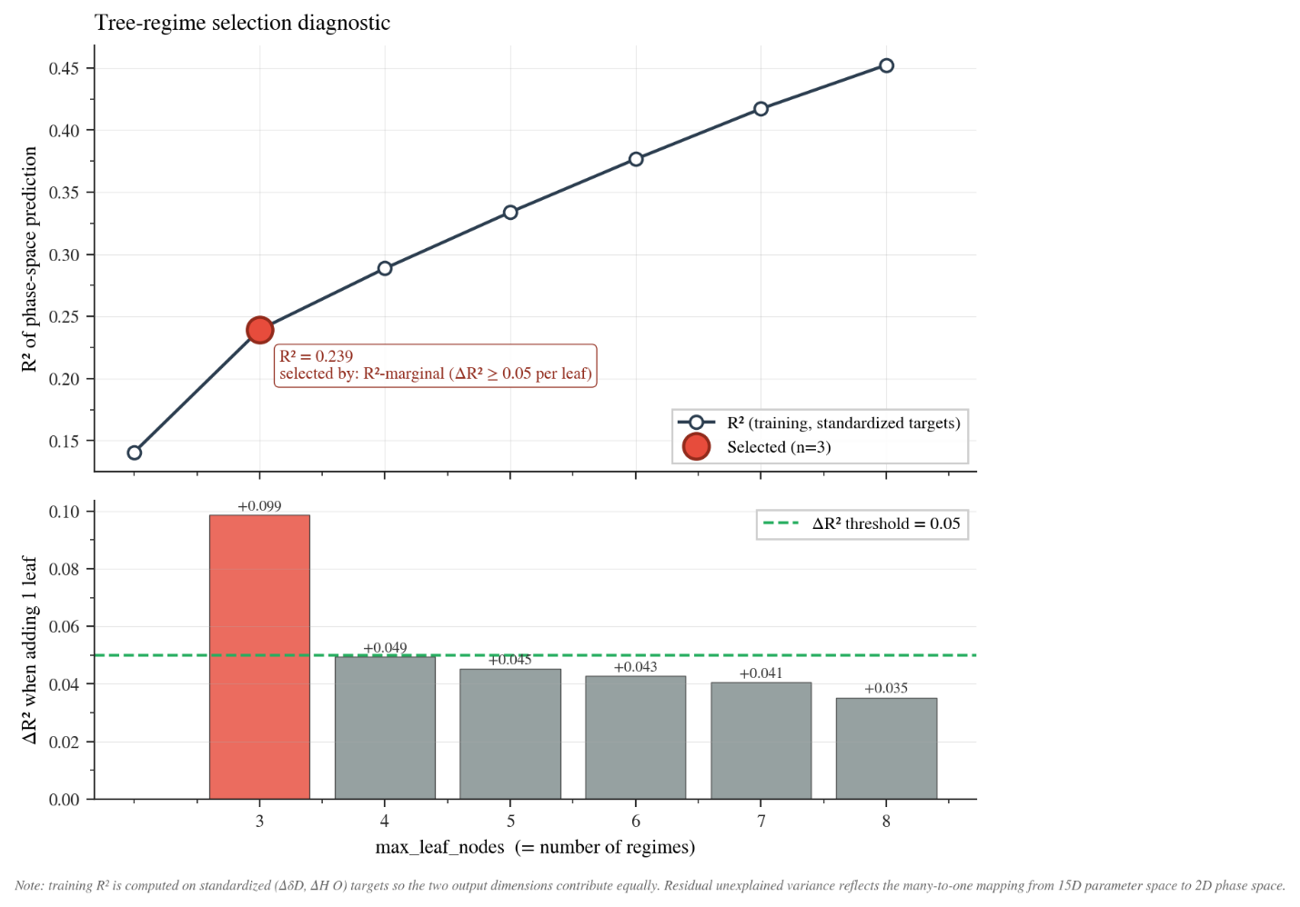
Supplementary Figure 3. Decision-tree diagnostic for selecting the decision-tree regime model partition.
Diagnostic used to choose the number of model regimes shown in main text Figure 2. A multi-output decision-tree regressor was trained to predict the standardized model phase-space coordinates, ΔδD and ΔH₂O, from the 15 sampled physical parameters in the two-layer model. The upper panel shows the training R² as the maximum number of tree leaves, equivalent to the maximum number of regimes, is increased. The lower panel shows the marginal gain in R² from adding one additional leaf. The three-regime partition was selected because the increase from two to three leaves produced a substantial improvement in phase-space prediction, ΔR² = 0.099, exceeding the predefined marginal-gain threshold of 0.05, whereas subsequent additions produced smaller gains below the threshold. This supports the use of three regimes as a parsimonious representation of the modeled isotope–moisture envelope: finer partitions improve the fit only incrementally, while the residual unexplained variance reflects the many-to-one mapping from the 15-dimensional parameter space to the two-dimensional ΔH₂O–ΔδD phase space.

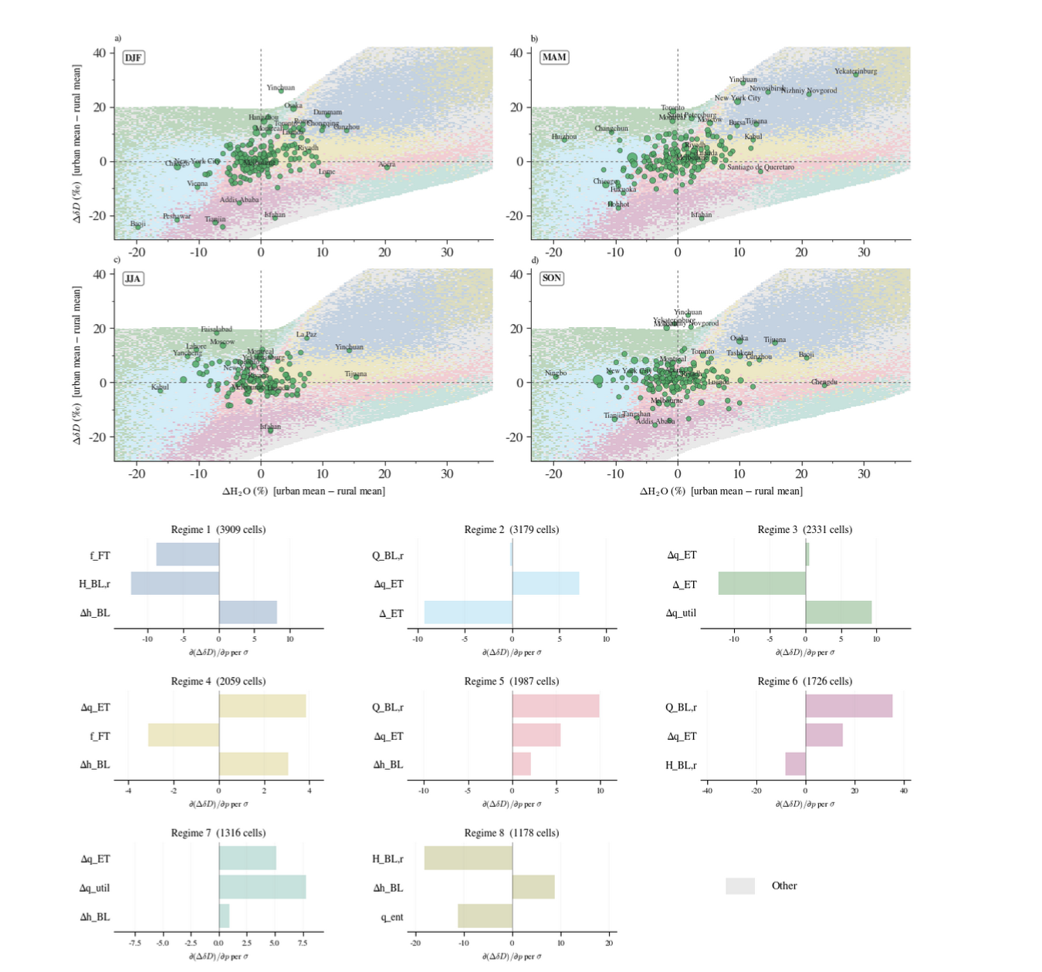
Supplementary Figure 4. Sensitivity-based decomposition of the model-supported isotope–moisture phase space.
Observed city-season urban–rural anomalies in ΔH₂O and ΔδD are shown for each season as in main text Figure 2, overlaid on the phase-space envelope populated by the idealized two-layer isotope–moisture model. Background colors denote sensitivity regimes identified independently from the main decision-tree regime partition: for each supported grid cell, nearby valid Monte Carlo model draws were locally perturbed, and the cell was assigned according to the three parameters with the largest combined sensitivity to ΔH₂O and ΔδD. Bar plots show the mean signed sensitivity of ΔδD to those dominant parameters within each regime, expressed per ensemble-standard-deviation perturbation. Boundary-layer controls, including rural boundary-layer depth, urban boundary-layer deepening and free-tropospheric filling fraction, dominate parts of the wetter/enriched phase space, especially regimes 1 and 8. In contrast, the enriched/drier sector is strongly influenced by source-contrast terms such as the managed-water humidity anomaly, Δq_util, and the ET isotope offset, Δ_ET, particularly in regime 3. Other regimes show mixed surface-flux and boundary-layer controls.

Supplementary Figure 4 was generated as an independent decomposition of the modeled ΔH₂O–ΔδD envelope. We first sampled the idealized two-layer model across the same broad Monte Carlo prior ranges used for the main model analysis, including background boundary-layer and free-tropospheric state variables, boundary-layer deepening and filling terms, and independently sampled source-equivalent humidity anomalies from evapotranspiration, managed water and combustion. Simulations were retained only when the implied total boundary-layer humidity perturbation fell within the observationally anchored urban–rural humidity range and when all modeled layer masses and isotope-number terms remained physically valid. The valid model ensemble was then projected into ΔH₂O–ΔδD phase space and used to define local neighborhoods around each supported grid cell.
Within each supported phase-space grid cell, local sensitivities were estimated by selecting nearby valid Monte Carlo samples, perturbing each model parameter by ±0.5 ensemble standard deviations, and recalculating the model response by central differences. For each parameter, we computed its local sensitivity to both ΔδD and ΔH₂O, and ranked parameters by the combined two-dimensional sensitivity norm. Each grid cell was then assigned a regime label based on the unordered set of the three most influential parameters. The colored regions in Supplementary Figure 4 correspond to the most common top three sensitivity combinations across the supported model envelope, with less frequent combinations grouped as “Other.” This procedure differs from the coarser regime partition used in the main text: it summarizes which physical parameters most strongly control the model output locally in phase space. This is consistent with the framing of the model as a process envelope and interpretation tool rather than a city-specific attribution framework.
The resulting finer decomposition supports the robustness of the main model interpretation. Even when the model envelope is allowed to split into multiple sensitivity regimes, the same broad physical controls re-emerge. Regions of wetter and generally enriched model response are dominated by boundary-layer structure and mixing terms, especially rural boundary-layer depth, urban boundary-layer deepening and the fraction of added boundary layer volume filled by free-tropospheric or lower-tropospheric air. In contrast, portions of the dry or isotope-decoupled phase space show stronger influence from surface source-contrast terms, including the evapotranspiration-related humidity residual, managed-water humidity anomaly and the isotope composition assigned to the ET-related source. The intermediate regimes combine boundary-layer and surface-source controls, reinforcing that the model phase space is many-to-one: similar ΔH₂O–ΔδD positions can arise from different but physically related process balances. This alternative definition shows that the three regime structure used in the main Figure 2 is a parsimonious coarse-graining of a more detailed sensitivity landscape, rather than an artifact of a specific regime-identification method.

Idealized two-layer budget model for urban atmospheric column water vapor and deuterium vapor – Technical details

To interpret observed urban-rural anomalies in total-column water vapor and isotopic composition, we used an idealized two-layer column model consisting of a boundary layer (BL) and a free-tropospheric (FT) layer. The model predicts the urban perturbation in column $δD$ and column water vapor relative to a rural reference state. It is intended as a bounding/plausibility tool: the goal is to ask whether physically defensible meteorological, evapotranspiration, managed-water, and combustion perturbations can populate the regions of $\left(ΔδD_{col},ΔH_{2}O\right)$ phase space occupied by the observations, rather than to infer city-specific flux partitions.

The isotope ratio is defined as
$$R=R_{VSMOW}\left(\frac{δD}{1000}+1\right), δD=1000 \left(R/R_{VSMOW}-1\right),$$
and all isotope mixing is performed in ratio space. Subscripts $r$ and $u$ denote rural and urban columns, respectively; subscripts $BL$, $FT$, and $col$ denote the boundary layer, the free troposphere, and the total column, respectively. We define the water partial column mass, and matching heavy isotope number as
$$M=Hq, N=MR.$$
The column-mean isotope ratio is therefore
$$R_{col}=\frac{N_{col}}{M_{col}}.$$
$N$ is related to the mass of HDO by ratio of molecular weights and the proportion half accounting for the number of D substitutions in $H_{2}O$.

Rural reference state
The rural BL is specified by its mean specific humidity $Q_{BL,r}$ and depth $H_{BL,r}$. Its isotopic composition is anchored to a reference Rayleigh-like curve with effective exponent $α_{eff}$:
$$δD_{BL,r}=δD_{ref}+1000\left[{\left(\frac{Q_{BL,r}}{Q_{ref}}\right)}^{α_{eff}-1}-1\right]+ε_{BL}.$$
Here $ε_{BL}$ absorbs departures from a single-stage Rayleigh trajectory, including mixing-line effects, source variability, and seasonal recharge. The composition of entrained air is defined analogously from the entrainment-layer humidity, $q_{ent}$.
The FT column is taken to be more depleted than the entrained layer by a Rayleigh/mixing depletion term:
$$δD_{FT,col}=δD_{ent}-ΔδD_{grad}.$$
This parameterization follows the common use of Rayleigh distillation and mixing frameworks to describe the humidity-isotope structure of atmospheric water vapor (Dansgaard, 1964; Galewsky et al., 2016; Risi et al., 2019).
The FT column-mean humidity follows from an exponential vertical profile $q\left(z\right)=Q_{BL,r}exp\left(-z/H_{q}\right)$ integrated from $H_{BL,r}$ to the column top $z_{top}$:
$$Q_{FT,col}=\frac{Q_{BL,r}H_{q}}{z_{top}-H_{BL,r}}\left[exp\left(-\frac{H_{BL,r}}{H_{q}}\right)-exp\left(-\frac{z_{top}}{H_{q}}\right)\right].$$
The same background $Q_{FT,col}$ is applied to the rural and urban columns before the explicit BL-deepening entrainment perturbation, reflecting the assumption that the background FT is horizontally smoother than the urban-rural contrast scale.
Rural mass and isotope-number budgets are thus
$$M_{BL,r}=H_{BL,r}Q_{BL,r}, N_{BL,r}=M_{BL,r}r_{BL,r}.$$
$$M_{FT,r}=\left(Z_{top}-H_{BL,r}\right)Q_{FT,col}, N_{FT,r}=M_{FT,r}r_{FT,col}.$$
The rural column totals are
$$M_{col,r}=M_{BL,r}+M_{FT,r}, N_{col,r}=N_{BL,r}+N_{FT,r}.$$

Urban perturbations
The urban column is built from the rural state through six process terms: (i) BL deepening by $Δh_{BL}$; (ii) entrainment of FT or lower-FT air into the deepened volume; (iii) convective or low-level import of rural-BL-like air into the same volume; (iv) combustion-derived water vapor at composition $δD_{comb}$; (v) utilized or managed-water vapor from irrigation, cooling, or leakage composition $δD_{util}$; and (vi) a signed net ET residual at composition
$$δD_{ET}=δD_{BL,r}+Δ_{ET}.$$
The convective fractional volume “fill” represents low-level horizontal convergence or mixing of BL-like air carrying the rural BL composition; no separate horizontal-advection term is included. Note that $f_{FT}=0$ corresponds to filling the deepened boundary layer entirely with BL-like air, whereas $f_{FT}=1$ corresponds to entrained free-tropospheric moisture accounting for all changes in BL moisture.
The two BL-fill channels contribute
$$M_{fill,ent}=Δh_{BL}f_{FT}q_{ent}, N_{fill,ent}=M_{fill,ent}r_{ent}.$$
$$M_{fill,conv}=Δh_{BL}\left(1-f_{FT}\right)Q_{BL,r}, N_{fill,conv}=M_{fill,conv}r_{BL,r}.$$
The source-equivalent humidity anomaly channels contribute signed water mass and isotope number
$$M_{k}=H_{BL,r}Δq_{k}, N_{k}=M_{k}r_{k}, k∈\{comb,util,ET\}.$$
The “source-equivalent humidity anomaly” is used deliberately to differentiate it from partial column mass. That is, $Δq_{k}$ has units of g kg⁻¹, not kg m⁻² s⁻¹. It is the BL-mean specific-humidity perturbation that would be produced by the source or sink after dilution into the idealized BL.

Relative anomaly convention
All $Δq_{k}$ terms are urban-minus-rural anomalies. A positive $Δq_{util}$ means that the city contributes more managed-water vapor than the rural control region through processes such as cooling towers, irrigation, leakage, pavement washing, or artificial water dissipation. A negative $Δq_{util}$ case represents cases where the rural comparison region is more irrigated or otherwise more water-dissipative than the urban footprint. The same signed-anomaly interpretation applies to $Δq_{ET}$: negative values represent urban ET suppression relative to the rural surroundings, while positive values represent enhanced urban ET or urban greening relative to the rural background.
The urban BL and FT budgets close as
$$M_{BL,u}=M_{BL,r}+M_{fill,ent}+M_{fill,conv}+M_{ET}+M_{comb}+M_{util}.$$
$$N_{BL,u}=N_{BL,r}+N_{fill,ent}+N_{fill,conv}+N_{ET}+N_{comb}+N_{util}.$$
$$M_{FT,u}=M_{FT,r}-M_{fill,ent}, N_{FT,u}=N_{FT,r}-N_{fill,ent}.$$
Only the entrained portion of the deepened volume is removed from the FT reservoir. This simplification assumes that there is no intrinsic difference in free-tropospheric water vapor composition between urban and rural regions. The convective channel imports BL-like vapor, and the three source-equivalent humidity-anomaly channels add or subtract urban-minus-rural BL vapor contributions.

Model output
With
$$M_{col,u}=M_{BL,u}+M_{FT,u}, N_{col,u}=N_{BL,u}+N_{FT,u},$$
the modeled urban-rural anomalies are
$$ΔδD_{col}=δD_{col,u}-δD_{col,r}, ΔH_{2}O \left(\%\right)=100×\frac{M_{col,u}-M_{col,r}}{M_{col,r}},$$

Water source anomalies and Hao et al. (2023)-based constraints
The three moisture-source channels are sampled as independent absolute urban-minus-rural humidity anomalies: $Δq_{comb}$, $Δq_{util}$, and $Δq_{ET}$. Combustion water production is set by fuel burn rate, and cooling-tower or irrigation/managed-water vapor is controlled by installed capacity, water use, and meteorological demand. The dilution physics by which a fixed source produces a larger fractional humidity perturbation in a dry column emerges automatically from the linear mass and isotope-number accumulation in the source-channel equations above.
The source-equivalent anomalies are sampled independently, and their net local source/sink residual is
$$Δq_{local}=Δq_{ET}+Δq_{util}+Δq_{comb}.$$
This derived quantity is constrained by rejection sampling to lie within the urban–rural near-surface specific-humidity envelope adapted from Hao et al.⁵ This constraint anchors the magnitude of local source/sink humidity perturbations without implying an observed partition among ET, managed water, and combustion. It is not imposed on the full modeled column-water anomaly, which also reflects boundary-layer deepening, entrainment, and low-level convergence.
This derived quantity is constrained by rejection sampling to lie within the observed urban-rural near-surface specific-humidity envelope reported by Hao et al. (2023) for large urban agglomerations: $\text{valid}⇔\left(Δq_{local}∈\left[-2.5,+1.0\right] g kg^{-1}\right) \text{and}\text{ (physical-validity checks pass).}$
It should not be interpreted as an observed partition among ET, combustion, cooling, irrigation, and other sources. The ET residual prior is allowed to span this envelope because ET suppression or enhancement may, in principle, dominate the net anomaly when the anthropogenic terms are small; the final retained ensemble is nevertheless constrained by the total $Δq_{total}$ rejection criterion.
In the model, the low-level convergence term supplies BL-like air to fill part of the additional urban boundary-layer volume and therefore can increase column water mass without imposing an independent near-surface specific-humidity anomaly. Additional validity checks require positive water mass and isotope number in each layer of the urban column.

Monte Carlo execution
We drew ${10}^{7}$ samples from the joint prior, evaluated the forward model on each, and retained those satisfying the Hao-scale rejection criterion. The valid subsample was used to construct the $\left(ΔδD_{col},ΔH_{2}O\right)$ phase-space density and the local sensitivities $∂ΔδD_{col}/∂p$ and $∂ΔH_{2}O/∂p$ on a regular grid. Sensitivities were computed by central-difference perturbations of each parameter $p$ by half a standard deviation around 20 randomly chosen central vectors per grid cell, drawn with weights proportional to $exp\left(-d^{2}/2\right)$, where $d$ is the bandwidth-normalized distance to the cell. The dominant three parameters at each cell define a “regime,” visualized as a colored background in the model figure. These regimes are diagnostic local sensitivities of the forward model; they are not posterior source attributions.

References for model
Aemisegger, F., Pfahl, S., Sodemann, H., Lehner, I., Seneviratne, S. I., & Wernli, H. (2014). Deuterium excess as a proxy for continental moisture recycling and plant transpiration. Atmospheric Chemistry and Physics, 14(8), 4029–4054. https://doi.org/10.5194/acp-14-4029-2014
Bowen, G. J., Ehleringer, J. R., Chesson, L. A., Stange, E., & Cerling, T. E. (2007). Stable isotope ratios of tap water in the contiguous united states. Water Resources Research, 43(3), W03419. https://doi.org/10.1029/2006WR005186
Craig, H., & Gordon, L. I. (1965). Deuterium and oxygen-18 variations in the ocean and the marine atmosphere. In E. Tongiorgi (Ed.), Stable isotopes in oceanographic studies and paleotemperatures (pp. 9–130). Laboratorio di Geologia Nucleare.
Dai, A. (2024). The diurnal cycle from observations and ERA5 in precipitation, clouds, boundary layer height, buoyancy, and surface fluxes. Climate Dynamics, 62(7), 5879–5908. https://doi.org/10.1007/s00382-024-07182-6
Dansgaard, W. (1964). Stable isotopes in precipitation. Tellus, 16(4), 436–468. https://doi.org/10.3402/tellusa.v16i4.8993
Fiorella, R. P., Bares, R., Lin, J. C., Ehleringer, J. R., & Bowen, G. J. (2018). Detection and variability of combustion-derived vapor in an urban basin. Atmospheric Chemistry and Physics, 18(12), 8529–8547. https://doi.org/10.5194/acp-18-8529-2018
Galewsky, J., Steen-Larsen, H. C., Field, R. D., Worden, J., Risi, C., & Schneider, M. (2016). Stable isotopes in atmospheric water vapor and applications to the hydrologic cycle. Reviews of Geophysics, 54(4), 809–865. https://doi.org/10.1002/2015RG000512
Glazer, R. H., Grimmond, S., Blunn, L., Fenner, D., Lean, H., Christen, A., Morrison, W., Looschelders, D., & Shonk, J. K. P. (2025). Hectometric-scale modelling of the mixed layer in an urban region evaluated with a dense LiDAR-ceilometer network. Weather and Climate Dynamics, 6(4), 1723–1742. https://doi.org/10.5194/wcd-6-1723-2025
Gorski, G., Strong, C., Good, S. P., Bares, R., Ehleringer, J. R., & Bowen, G. J. (2015). Vapor hydrogen and oxygen isotopes reflect water of combustion in the urban atmosphere. Proceedings of the National Academy of Sciences, 112(11), 3247–3252. https://doi.org/10.1073/pnas.1424728112
Guo, J., Zhang, J., Yang, K., Liao, H., Zhang, S., Huang, K., Lv, Y., Shao, J., Yu, T., Tong, B., Li, J., Su, T., Yim, S. H. L., Stoffelen, A., Zhai, P., & Xu, X. (2021). Investigation of near-global daytime boundary layer height using high-resolution radiosondes: First results and comparison with ERA5, MERRA-2, JRA-55, and NCEP-2 reanalyses. Atmospheric Chemistry and Physics, 21(22), 17079–17097. https://doi.org/10.5194/acp-21-17079-2021
Hao, L., Sun, G., Huang, X., Tang, R., Jin, K., Lai, Y., Chen, D., Zhang, Y., Zhou, D., Yang, Z.-L., Wang, L., Dong, G., & Li, W. (2023). Urbanization alters atmospheric dryness through land evapotranspiration. Npj Climate and Atmospheric Science, 6, 149. https://doi.org/10.1038/s41612-023-00479-z
International Telecommunication Union Radiocommunication Sector. (2017). Recommendation ITU-r p.835-6: Reference standard atmospheres. International Telecommunication Union.
Jameel, Y., Brewer, S., Good, S. P., Tipple, B. J., Ehleringer, J. R., & Bowen, G. J. (2016). Tap water isotope ratios reflect urban water system structure and dynamics across a semiarid metropolitan area. Water Resources Research, 52(8), 5891–5910. https://doi.org/10.1002/2016WR019104
Luo, Z., Liu, J., Zhang, Y., Zhou, J., Shao, W., Yu, Y., & Jia, R. (2021). Seasonal variation of dry and wet islands in beijing considering urban artificial water dissipation. Npj Climate and Atmospheric Science, 4, 58. https://doi.org/10.1038/s41612-021-00216-4
Risi, C., Galewsky, J., Reverdin, G., & Brient, F. (2019). Controls on the water vapor isotopic composition near the surface of tropical oceans and role of boundary layer mixing processes. Atmospheric Chemistry and Physics, 19(19), 12235–12260. https://doi.org/10.5194/acp-19-12235-2019
Salmon, O. E., Shepson, P. B., Ren, X., Marquardt Collow, A. B., Miller, M. A., Carlton, A. G., Cambaliza, M. O. L., Heimburger, A. M. F., Morgan, K. L., Fuentes, J. D., Stirm, B. H., Grundman, R., & Dickerson, R. R. (2017). Urban emissions of water vapor in winter. Journal of Geophysical Research: Atmospheres, 122(17), 9467–9484. https://doi.org/10.1002/2016JD026074
Wallace, J. M., & Hobbs, P. V. (2006). Atmospheric science: An introductory survey (2nd ed.). Academic Press.
Welp, L. R., Lee, X., Kim, K., Griffis, T. J., Billmark, K. A., & Baker, J. M. (2008). $δ^{18}$O of water vapour, evapotranspiration and the sites of leaf water evaporation in a soybean canopy. Plant, Cell & Environment, 31(9), 1214–1228. https://doi.org/10.1111/j.1365-3040.2008.01826.x
Worden, J., Noone, D., Bowman, K., & Tropospheric Emission Spectrometer Science Team and Data Contributors. (2007). Importance of rain evaporation and continental convection in the tropical water cycle. Nature, 445(7127), 528–532. https://doi.org/10.1038/nature05508

