Supplementary Data:
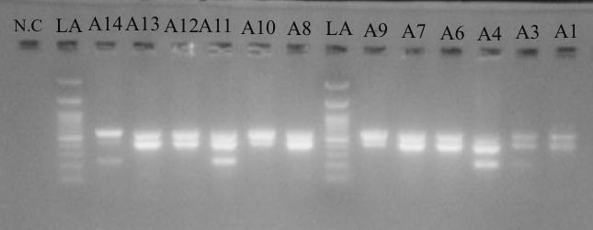

Fig.1S. Representative agarose gel electrophoresis of multiplex PCR amplicons for ESβL resistance genes. Lanes marked LA contain a 100 bp DNA molecular weight ladder. N.C designates the negative control (distilled water, D.W.) lacking template DNA. The distinct bands in the sample wells correspond to the targeted amplicon sizes for the detected resistance determinants: bla_{CTX-M}, bla_{TEM}, and bla_{SHV} across the selected clinical isolates.

