Supporting information for
Comprehensive analysis of cyanotoxins distribution and toxicity in Taihu Lake of China
Haitao Sha^{a*}, Jinjin Qiuª, Shuping Zhangª, Jianguo Zhangª

ª Research Center of Secondary Resources and Environment, School of Chemical Engineering and Materials, Changzhou Institute of Technology, Changzhou 213032, China

*Corresponding author.
E-mail address: 101232727@czu.cn

Table of contents
Table S1. The list of standard cyanotoxins S3
Figure S1. Map of sampling points. S5
Table S2. The detailed mobile phase gradient for acquisition method for HPLC-QTOF-MS system S6
Table S3. The detailed mobile phase gradient for acquisition method for HPLC-QQQ-MS system S6
Table S4. The MS/MS parameters of cyanotoxins S7
Figure S2. The structure of self-made SPE column S8
Table S5. The parameters for flexible cube S9
Table S6. The types of cyanotoxins around Taihu Lake S10
Table S7. The types of cyanotoxins from the different cyanobacterial S12
Figure S3. The values of LC₅₀ of cyanotoxins S13

Table S1. The list of standard cyanotoxins
NO. | Cyanotoxins | m/z | Origin | Purity
1 | MC-WR | 1068.55 | Alfa Aesar, UK | Analytical standard, purity > 98%
2 | MC-HtyR | 1059.55 | Weikeqi Biotech, China | Analytical standard, purity > 98%
3 | MC-YR | 1045.54 | Simris Biologics, Germany | Analytical standard, purity > 95%
4 | MC-LW | 1025.54 | Cyano Biotech GmbH,  Germany | Analytical standard, purity > 95%
5 | MC-DRR | 1024.56 | Cyano Biotech GmbH,  Germany | Analytical standard, purity > 95%
6 | MC-HilR | 1009.57 | Weikeqi Biotech, China | Analytical standard, purity > 98%
7 | MC-LY | 1002.52 | Cyano Biotech GmbH,  Germany | Analytical standard, purity > 95%
8 | MC-LF | 986.52 | Simris Biologics, Germany | Analytical standard, purity > 95%
9 | MC-DLR | 981.54 | Aladdin, China | Analytical standard, purity > 94%
10 | MC-LA | 910.49 | Aladdin, China | Analytical standard  purity > 95%
11 | MC-RR | 1040 | Simris Biologics, Germany | Analytical standard, purity > 95%
12 | ANTX | 166.24 | Simris Biologics, Germany | Analytical standard, purity > 95%
13 | Anabaenopeptin A | 844.43 | Cyano Biotech GmbH,  Germany | Bioreagent from cyanobacteria
14 | Anabaenopeptin B | 837.46 | Cyano Biotech GmbH,  Germany | Bioreagent from cyanobacteria
15 | Anabaenopeptin C | 809.46 | Cyano Biotech GmbH,  Germany | Bioreagent from cyanobacteria
16 | Microginin 713 | 714.41 | Cyano Biotech GmbH,  Germany | Analytical standard, purity > 95%
17 | Nodularin | 825.45 | Simris Biologics, Germany | Analytical standard, purity > 95%
18 | Aeruginosin 98A | 689.28 | Cyano Biotech GmbH,  Germany | Bioreagent from cyanobacteria
19 | Aeruginosin 98B | 677.29 | Cyano Biotech GmbH,  Germany | Bioreagent from cyanobacteria
20 | Aerginoguanidine 98A | 491.7 | Cyano Biotech GmbH,  Germany | Bioreagent from cyanobacteria

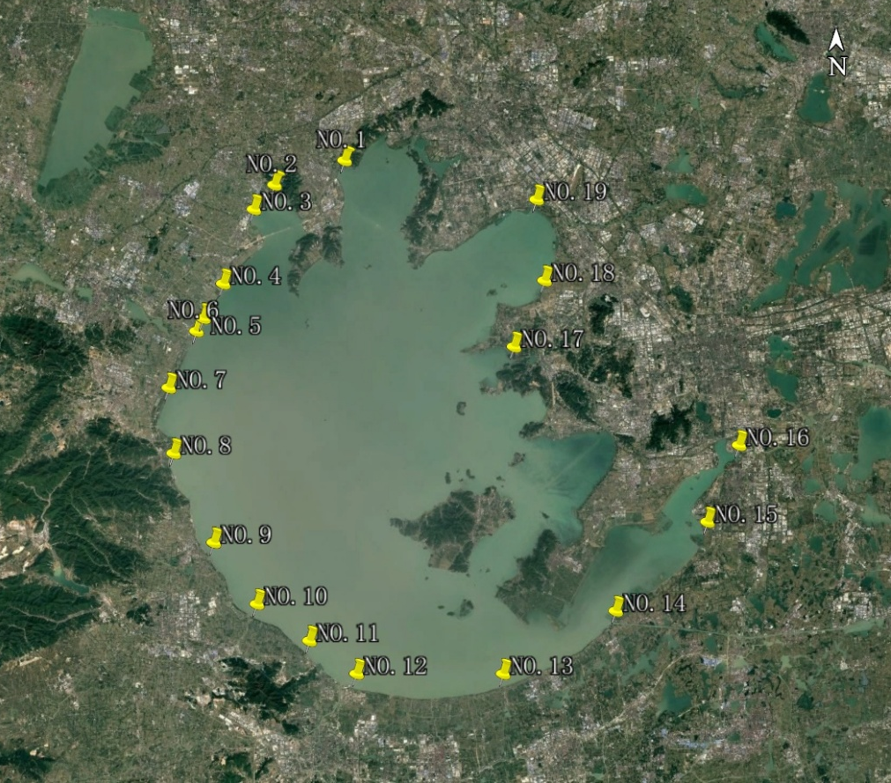
Figure S1. Map of sampling points

Table S2. The detailed mobile phase gradient for acquisition method for HPLC-Q-TOF-MS system.

Time (min) | Acetonitrile (%) | DI (0.1% formic acid)
0.00 | 5 | 95
2.00 | 5 | 95
8.00 | 100 | 0
13.00 | 100 | 0
13.05 | 5 | 95

Table S3. The detailed mobile phase gradient for acquisition method for HPLC-QQQ-MS system.

Time (min) | Acetonitrile (%) | DI (0.1% formic acid)
0.00 | 5 | 95
2.60 | 5 | 95
6.60 | 100 | 0
9.60 | 100 | 0
9.61 | 5 | 95
15.00 | 5 | 95

+

Table S4. The MS/MS parameters of cyanotoxins
No | Compounds | Precursor ion (m/z) | Product ion  (m/z) | Fragmentor  (V) | CE  (eV) | MS Mode
1 | MC-WR | 1068.55 | 135 | 150 | 60 | +
2 | MC-HtyR | 1059.55 | 135 | 150 | 80 | +
3 | MC-YR | 1045.54 | 213 | 150 | 80 | +
4 | MC-LW | 1025.54 | 135 | 150 | 80 | +
5 | MC-DRR | 1024.56 | 103 | 140 | 80 | +
6 | MC-HilR | 1009.57 | 135 | 200 | 69 | +
7 | MC-LY | 1002.52 | 134 | 155 | 81 | +
8 | MC-LR | 995.56 | 135 | 200 | 77 | +
9 | MC-LF | 986.52 | 135 | 165 | 77 | +
10 | MC-DLR | 981.54 | 135 | 205 | 76 | +
11 | MC-LA | 910.49 | 135 | 160 | 64 | +
12 | MC-RR | 1040 | 135 | 150 | 60 | +
13 | ANTX | 166.24 | 131 | 90 | 16 | +
14 | CYN | 416 | 194 | 185 | 44 | +
15 | Anabaenopeptin A | 844.43 | 84 | 190 | 60 | +
16 | Anabaenopeptin B | 837.46 | 200 | 215 | 40 | +
17 | Anabaenopeptin C | 809.46 | 84 | 220 | 100 | +
18 | Microginin 713 | 714.41 | 150 | 160 | 48 | +
19 | Nodularin | 825.45 | 135 | 230 | 60 | +
20 | Aeruginosin 98A | 689.28 | 140 | 155 | 56 | +
21 | Aeruginosin 98B | 677.29 | 39 | 190 | 72 | +
22 | Aerginoguanidine 98A | 491.7 | 85 | 155 | 44 | +
23 | Aerucyclamide A | 557.21 | 472 | 185 | 40 | +

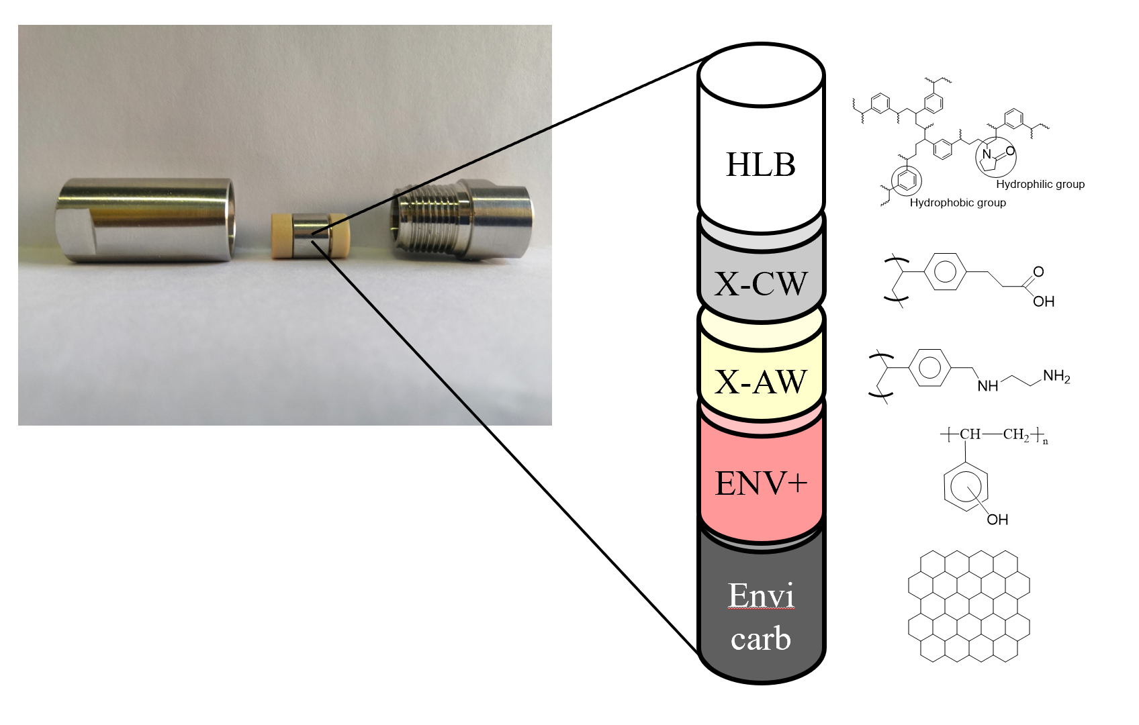
Figure S2. The structure of self-made SPE column

Table S5. The parameters for flexible cube
Time (min) | Function | Parameter
0.0 | Pump Volume | Pump 5.7 mL DI-H₂O, Flow:1.5 mL min⁻¹
3.8 | Left Valve Change Position | Change Value Position
8.2 | Pump volume | Pump 6.6 mL acetonitrile, Flow: 1.5 mL min⁻¹
15.0 | Pump volume | Pump 10.2 mL DI-H₂O, Flow: 1.5 mL min⁻¹

Table S6. The types of cyanotoxins around Taihu Lake
Sample | Types
Sample-1 | Tanikolide | Koshikalide | 2,5-dimethyldodecanoic acid
Sample-1 | Takinolide seco-acid | Malyngolide | (-)-7-methoxydodec-4(E)-enoic acid
Sample-1 | Serinolamide A | Lyngbic acid | N-butyryl-L-homoserine lactone
Sample-1 | Dragonamide C
Sample-2 | Ulongamide F | Tanikolide | CyanoMetDB_1749
Sample-2 | Tumonoic acid F | Anaephene A | (-)-7-methoxydodec-4(E)-enoic acid
Sample-2 | Microginin 578A | MC-YA | Microginin 91C
Sample-2 | Takinolide seco-acid | Malyngolide | 11-Carboxyanatoxin-a
Sample-2 | Microginin KR638 | Lyngbic acid | 2,5-dimethyldodecanoic acid
Sample-2 | Dragonamide C | Koshikalide
Sample-3 | Ulongamide F | Tanikolide | 2,5-dimethyldodecanoic acid
Sample-3 | Microcarbonin A | Sacrolide A | Anabaenopeptin 908
Sample-3 | Takinolide seco-acid | Anaephene A | Mirabilene A isonitrile
Sample-3 | Semiplenamide C | Malyngolide | Micropeptin SF909
Sample-3 | Dragonamide C | Dysinosin A | [Asp3, Dha7]MC\LY
Sample-3 | Aeruginosin 98B | Schizokinen | Cyanopeptolin CP985
Sample-4 | Tanikolide | Malyngolide | 4-hydroxy-7-methyl-1-indanone
Sample-4 | Takinolide seco-acid | Hapalosin | 2,5-dimethyldodecanoic acid
Sample-4 | Serinolamide A | Gloeolactone | [D-Asp,DMAdda5]MC-LA
Sample-4 | Koshikalide | Sacrolide A | [Asp3]MC-LR
Sample-4 | Nakienone A | Deoxygadusol | [ADMAdda5]MC\LR
Sample-4 | Micropeptin 88Y | Hermitamide A | Dragonamide C
Sample-4 | Malyngamide E
Sample-5 | Tanikolide | Malyngolide | (-)-7-methoxydodec-4(E)-enoic acid
Sample-5 | Takinolide seco-acid | Lyngbic acid | 7-Deoxy-desulfo-12-acetylcylindrospermopsin
Sample-5 | Schizokinen | Koshikalide | 11-Carboxyanatoxin-a
Sample-5 | Microginin 91C | Gloeolactone | [Asp3, Dha7]MC\LY
Sample-5 | Microginin 578A | Dragonamide C | [Asp3]MC\HilY
Sample-5 | Anaephene A
Sample-6 | Tanikolide | Schizokinen | 1-ethenoxy-2-methylbenzene
Sample-6 | Takinolide seco-acid | Anaephene A | Decarbamoylsaxitoxin
Sample-6 | Takinolide dimer | Malyngolide | 7-Deoxy-desulfo-12-acetylcylindrospermopsin
Sample-6 | Serinolamide A | Dragonamide C | Microginin 739B
Sample-6 | Cyanostatin B | Carmabin A
Sample-7 | Tanikolide | Malyngolide | CyanoMetDB_1749
Sample-7 | Takinolide seco-acid | Dysinosin A | Microginin 739B
Sample-7 | Anaephene A | Comnostin B | 2,5-dimethyldodecanoic acid
Sample-7 | [DAsp1]nodularin | Asterina-330 | (-)-7-methoxydodec-4(E)-enoic acid
Sample-8 | Ulongamide F | MC-FL | 4,8-dimethyl-6-hydroxyquinoline
Sample-8 | Takinolide seco-acid | Malyngolide | Nakitriol
Sample-8 | Semiplenamide C | Dragonamide C | Nakienone A
Sample-8 | Pitipeptolide C | Anaephene A
Sample-9 | Takinolide seco-acid | Dragonamide C | Anaephene A
Sample-9 | Malyngolide
Sample-10 | Koshikalide | Anaephene A | Takinolide seco-acid
Sample-10 | Deoxygadusol | Malyngolide | Malyngolide
Sample-11 | Tanikolide | Asterina-330 | Takinolide seco-acid
Sample-11 | Malyngolide | Anaephene A | [Mdha3] MC-LR
Sample-11 | Deoxygadusol | Comnostin A
Sample-12 | Takinolide dimer | Dragonamide C | Takinolide seco-acid
Sample-12 | Malyngolide | Anaephene A | Ambiguine N isonitrile
Sample-12 | Lyngbic acid |  | (-)-7-methoxydodec-4(E)-enoic acid
Sample-13 | Sanctolide A | Malyngolide | Takinolide seco-acid
Sample-13 | Microcarbonin A | Deoxygadusol | Anaephene A
Sample-14 | Serinolamide A | Nakienone A | Takinolide seco-acid
Sample-14 | Nakitriol | MC-LE | 2,5-dimethyldodecanoic acid
Sample-14 | Koshikalide | Malyngolide | [NMe-Ser7]MC-(H4)YR
Sample-14 | Anaephene A
Sample-15 | Serinolamide A | Lyngbioic acid | 2,5-dimethyldodecanoic acid
Sample-15 | Malyngolide | Anaephene A | 7-Deoxy-desulfo-12-acetylcylindrospermopsin
Sample-15 | Takinolide seco-acid
Sample-16 | Malyngolide | Deoxygadusol | Takinolide seco-acid
Sample-16 | Koshikalide | Anaephene A | Serinolamide A
Sample-16 | Dragonamide C
Sample-17 | Malyngolide | Dragonamide C | Takinolide seco-acid
Sample-17 | Malyngic acid | Comnostin A | Aeruginosin NOL6
Sample-17 | Koshikalide | Anaephene A | Gloeolactone
Sample-18 | [Asp3]MC-LR | Dragonamide C | Takinolide seco-acid
Sample-18 | Microginin 534 | Malyngolide | 2,5-dimethyldodecanoic acid
Sample-18 | [Asp3, Dha7]MC\LY | Tanikolide | [D-Asp,Dha7]MC\YA
Sample-18 | Micropeptin SF909 | Namalide E | [NMe-Ser7]MC-(H4)YR
Sample-18 | Anabaenopeptin MM823 | Cyanopeptolin CP985 | 7-Deoxy-desulfo-12-acetylcylindrospermopsin
Sample-19 | Malyngolide | Tanikolide | Takinolide seco-acid
Sample-19 | Anaephene A

Table S7. The types of cyanotoxins from the different cyanobacterial
Cyanobacterial from Taihu Lake |  | Microcystis aeruginosa 905
Shinorine | Aeruginosin 865 | Phycoerythrobilin
Serinolamide A | Aerucyclamide D | Nostopeptolide 1052
Punauic acid | Aerucyclamide A | Mozamide A
Pukeleimide E | [NMe-Ser7]MC-(H4)YR | MC-(H2)YA
Porphyra-334 | [epoxyAdda5]MC-LR | Malyngolide
Phycoerythrobilin | [d-Asp3 MSer7]MC-HilR | Koshikalide
Nostopeptolide 1052 | MC-LR | Homodolastatin 16
Mozamide A | [Asp3]MC(H4)YR | Gloeolactone
Microginin T2 | [(6Z)-Adda5]MC-RR | Dragonamide C
Microcystbiopterin D | (E)-[Dhb7]MC-HilR | Aerucyclamide A
Microcystbiopterin A | Cyanopeptolin C | Aerucyclamide C
MC-(H2)YA | Cyanopeptolin B | Aeruginoguanidin 98A
Malyngolide | Cyanopeptolin A | Cyanopeptolin 1011
Koshikalide | Cyanopeptolin 963A | Tiglicamide C
Homodolastatin 16 | Cyanopeptolin 1048 | (E)-[Dhb7]MC-HilR
Gloeolactone | Anabaenopeptin 906B1 | [NMe-Ser7]MC-(H4)YR
Dudawalamide B |  | [epoxyAdda5]MC-LR
Dragonamide C |  | [d-Asp3MSer7]MC-HilR
Dolastatin 16 |  | MC-LR
Anabaenopeptin MM823 |  | [Asp3]MC(H4)YR

Figure S3. The values of LC₅₀ of cyanotoxins

