Supplementary materials

Turbid coastal reefs act as paradoxical climate refugia for corals

Rafael Menezes, Carolina F. Schlosser, Mariana M. Couto, Ericka O.C. Coni, Camilo M. Ferreira, Pedro M. Meirelles, Andreia C.C. Barbosa, Marcelo V. Kitahara, Miguel Mies, Samuel C. Faria, Ronaldo B. Francini-Filho*

Centro de Biologia Marinha, Universidade de São Paulo. Rodovia Manuel Hypólito do Rego, km 131,5 – 11612-109 São Sebastião, SP, Brazil; Instituto Coral Vivo. Rua dos Coqueiros, 87 – 45807-000 Santa Cruz Cabrália, BA, Brazil.
*Corresponding author. E-mail: francinifilho@usp.br; +55 83 999528622

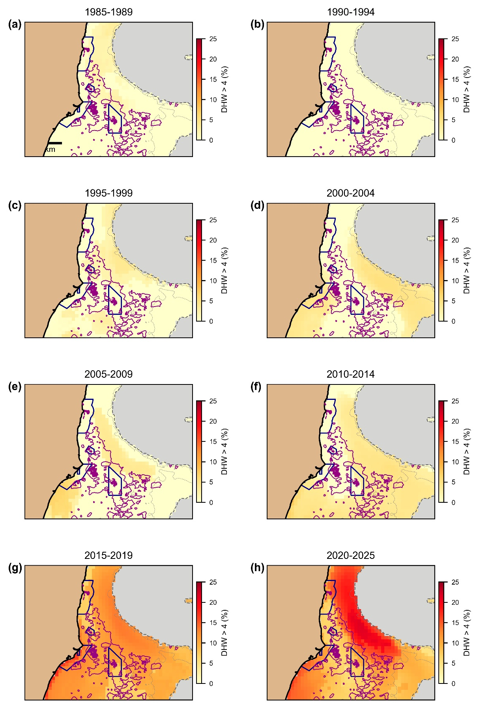
Fig. S1 Spatiotemporal distribution of thermal stress events in the Abrolhos Bank, Brazil (1985-2025). Maps show the frequency of Degree Heating Week (DHW) values exceeding 4°C-weeks, the typical thermal stress threshold triggering coral bleaching. Yearly data are aggregated across 5-year periods and expressed as the percentage of time each pixel experienced DHW > 4.

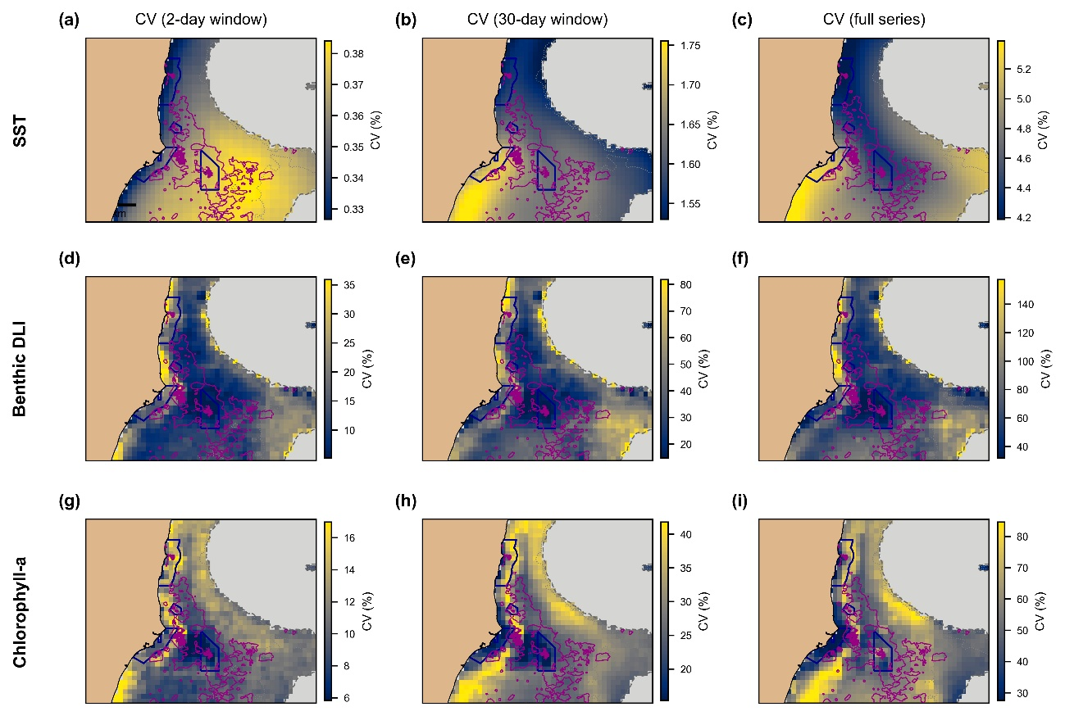
Fig. S2 Spatial patterns of environmental variability in the Abrolhos Bank, Brazil. Coefficient of Variation (CV) maps quantify temporal variability for sea surface temperature (SST; top row), benthic daily light integral (DLI; middle row), and chlorophyll-a concentration (bottom row) across three temporal windows: 2-day (short-term), 30-day (medium-term), and full time series (long-term). CV values are expressed as percentages, with higher values indicating greater temporal instability.

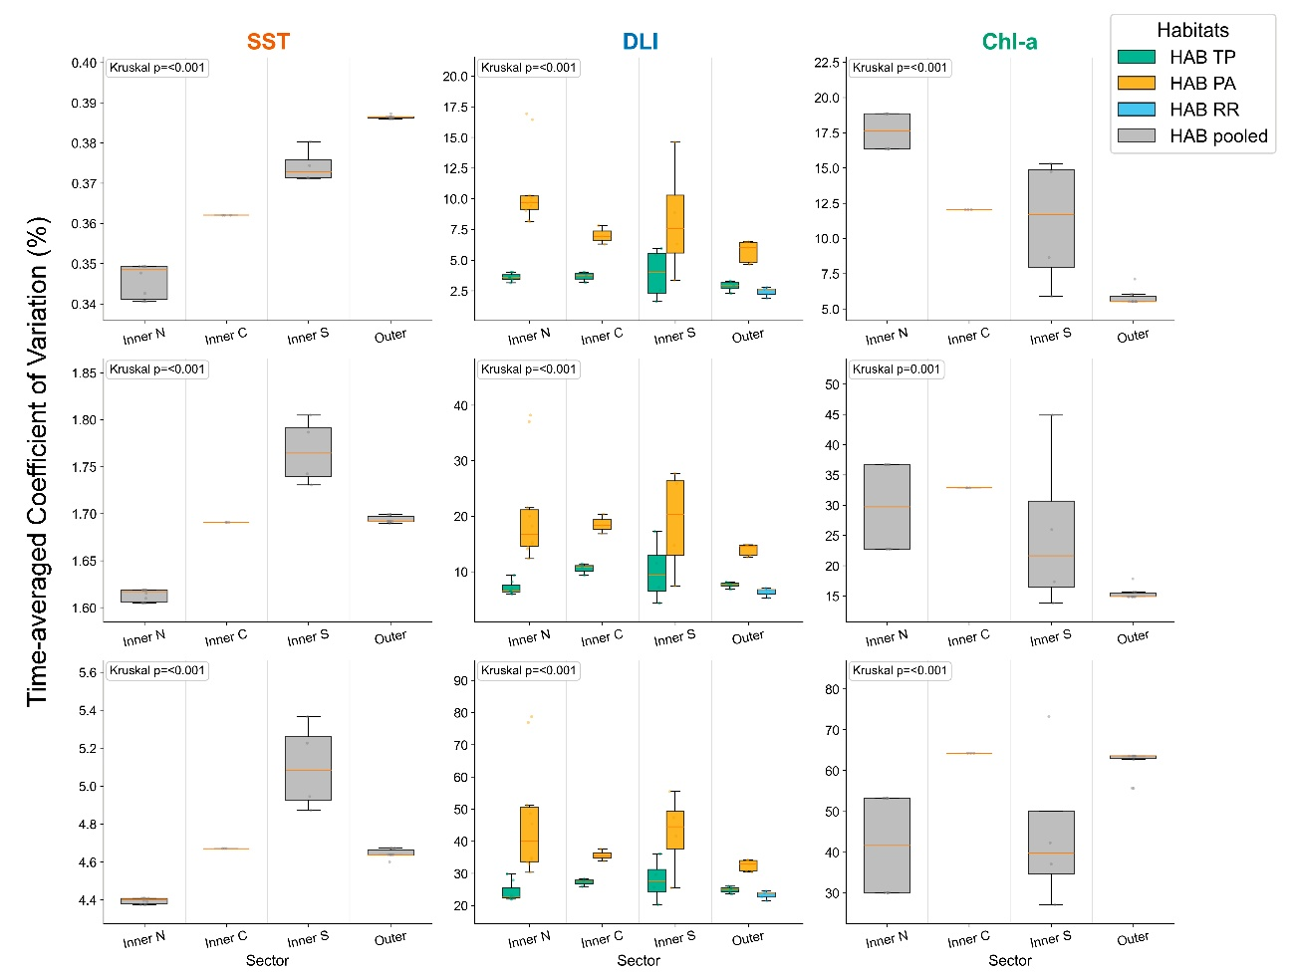
Fig. S3 Coefficient of Variation (CV) of environmental conditions across temporal windows, arcs (inner vs outer), and habitats. Boxplots summarize the coefficient of variation (CV, %) for SST, benthic daily light integral (DLI), and chlorophyll-a (Chl-a) across four cross-shelf sectors (Inner North, Inner Central, Inner South, and Outer). Rows correspond to three CV estimators: 2-day and 30-day rolling-window CV averaged over time (CV_2 and CV_30), and whole-series CV computed over the full record (CV_ALL). For DLI, distributions are shown separately by habitat (TP = reef top, PA = reef wall, RR = rocky reef); for SST and Chl-a, values are pooled across habitats within site (gray) because they are extracted from the same satellite pixel. Points indicate individual site-level values; boxplots show the median (center line), interquartile range (box), and 1.5×IQR whiskers. Kruskal–Wallis p-values (inset) test for differences among sector × habitat groups within each panel.

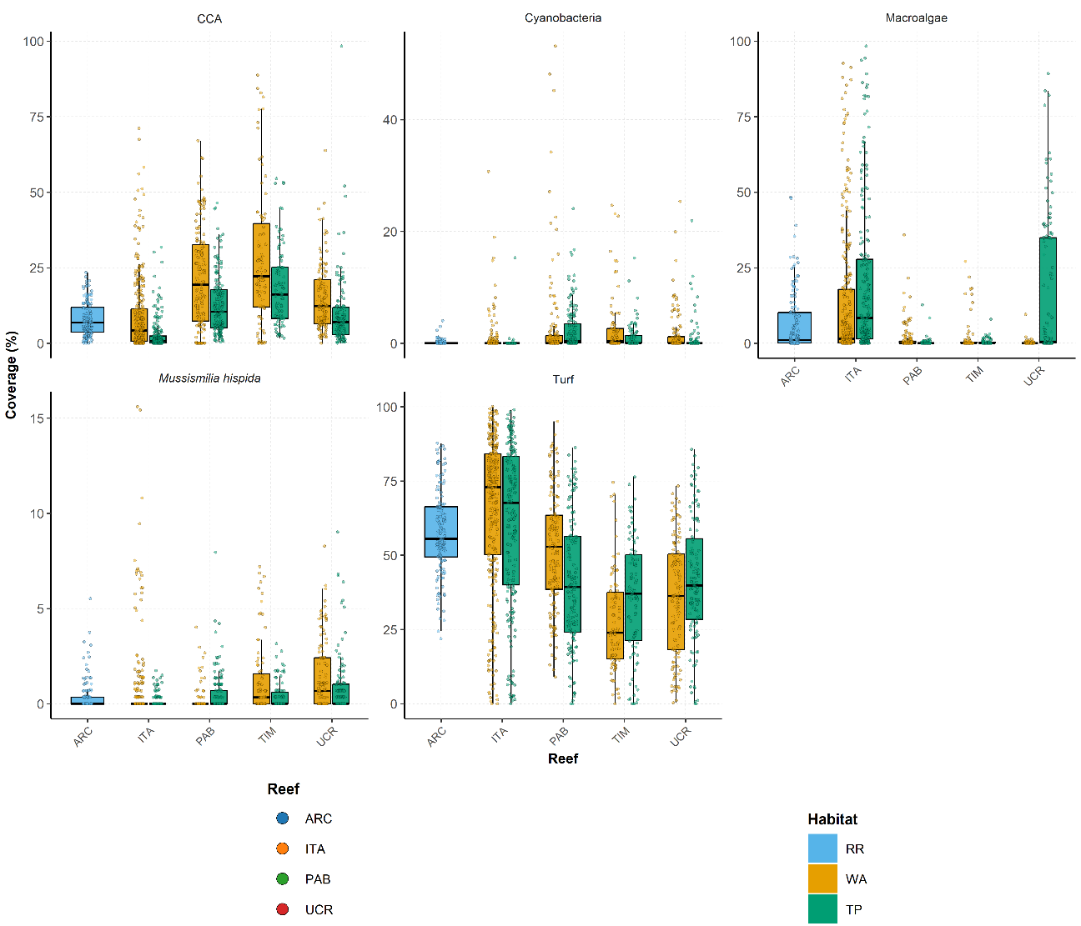
Fig. S4 Benthic cover (%) of Mussismilia hispida, cyanobacterial mats, turf algae, and fleshy macroalgae across reefs and habitats in the Abrolhos Bank, Brazil. Boxplots display median (solid line), interquartile range (box), and 1.5×IQR (whiskers), with individual photo-quadrat measurements shown as points (n = 6,720). Reefs: ARC – Archipelago, ITA – Itacolomis, PAB – Parcel dos Abrolhos, UCR – Unprotected Coastal Reefs, and TIM – Timbebas. Habitats: WA – reef walls, RR – rocky reefs, TP – reef tops.

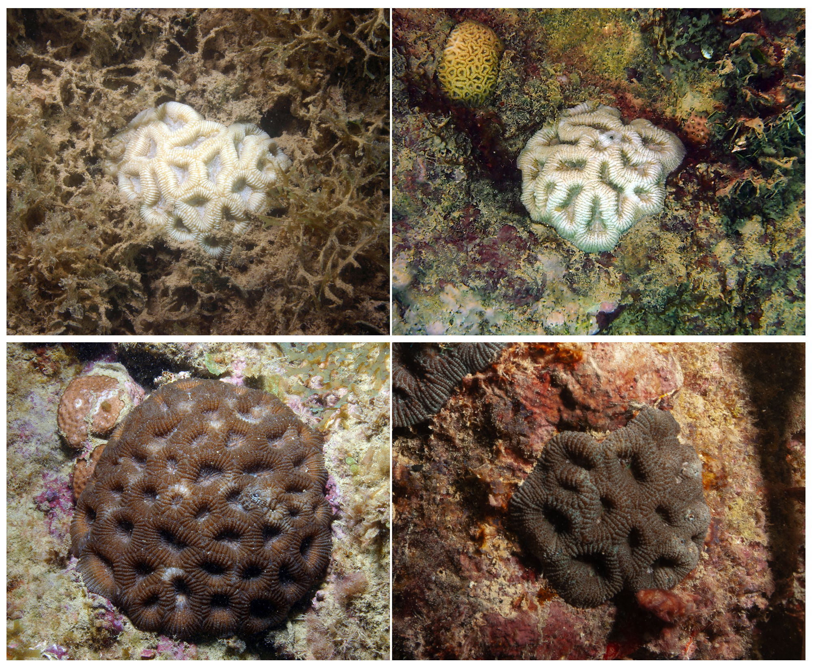
Fig. S5 Photos os Mussismilia hispida colonies at reef tops (top) and walls (bottom) (RB Francini-Filho).

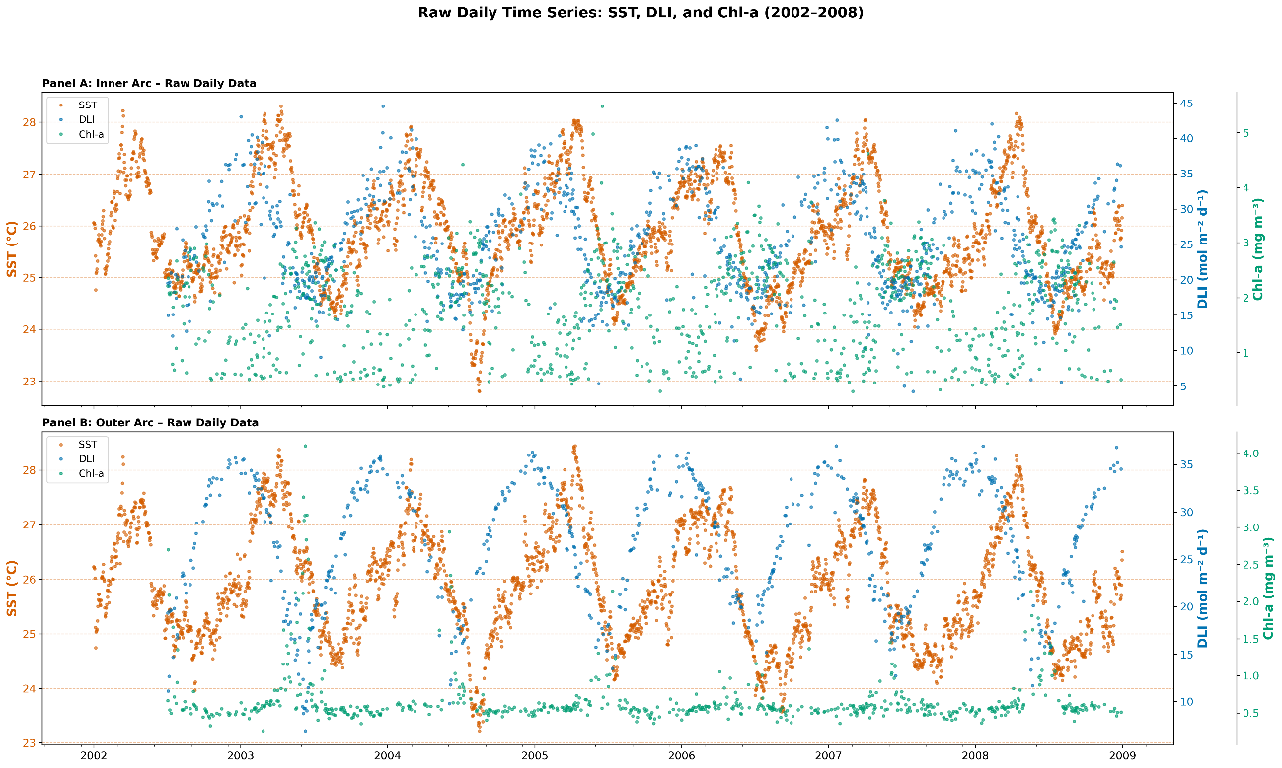
Fig. S6 Raw daily time series of sea surface temperature (SST), daily light integral (DLI), and chlorophyll-a concentration (Chl-a) across the Abrolhos Bank (2002–2008). Each point represents a daily observation averaged across all sites within (A) the inner arc and (B) the outer arc.

Table S1: Effective temporal coverage of variability metrics based on segment_count (per site-habitat), summarized by arc. Coverage_Pct is computed as segment_count / SST_timepoints * 100, where SST_timepoints is the SST segment_count for the same scenario (constant within scenario). For CV_02 and CV_30, segment_count is the number of rolling-window positions yielding a valid CV estimate (given min_periods). For CV_all, segment_count is the number of valid daily observations contributing to the full-series CV.
Scenario | Arc | Variable | N_site_hab | Denominator_timepoints_SST | Coverage_Pct_p50 | Coverage_Pct_p05 | Coverage_Pct_p95
CV_02 | inner | SST | 31 | 7383 | 100.00 | 100.00 | 100.00
CV_02 | inner | DLI | 31 | 7383 | 2.22 | 1.58 | 2.68
CV_02 | inner | CHL | 31 | 7383 | 2.23 | 1.61 | 2.71
CV_02 | outer | SST | 15 | 7383 | 100.00 | 100.00 | 100.00
CV_02 | outer | DLI | 15 | 7383 | 1.64 | 1.64 | 2.22
CV_02 | outer | CHL | 15 | 7383 | 1.61 | 1.61 | 2.19
CV_30 | inner | SST | 31 | 7384 | 100.00 | 100.00 | 100.00
CV_30 | inner | DLI | 31 | 7384 | 20.57 | 11.36 | 23.52
CV_30 | inner | CHL | 31 | 7384 | 20.79 | 11.39 | 23.62
CV_30 | outer | SST | 15 | 7384 | 100.00 | 100.00 | 100.00
CV_30 | outer | DLI | 15 | 7384 | 16.59 | 16.59 | 20.22
CV_30 | outer | CHL | 15 | 7384 | 16.52 | 16.52 | 20.26
CV_all | inner | SST | 31 | 7384 | 100.00 | 100.00 | 100.00
CV_all | inner | DLI | 31 | 7384 | 8.68 | 6.11 | 9.44
CV_all | inner | CHL | 31 | 7384 | 8.71 | 6.14 | 9.47
CV_all | outer | SST | 15 | 7384 | 100.00 | 100.00 | 100.00
CV_all | outer | DLI | 15 | 7384 | 7.18 | 7.18 | 8.41
CV_all | outer | CHL | 15 | 7384 | 7.18 | 7.18 | 8.42

Table S2: Model parameters
Model | Iterations | Warmup | Chains | adapt_delta | max_treedepth
Gaussian (Health) | 6,000 | 2,000 | 6 | 0.98 | 12
Gaussian (RGR) | 6,000 | 2,000 | 6 | 0.98 | 12
JSDM (Dirichlet) | 8,000 | 3,000 | 6 | 0.99 | 15

Table S3: Winner model performance and key credible effects (global winners).
Endpoint | Winner (family; structure; CV) | N | Bayesian R^2 (mean) | 95% CrI | Key credible effects (95% CrI excludes zero)
HEALTH_PC1 | Gaussian; FULL; CV_30 | 306 | 0.532 | 0.472 to 0.582 | HABMERGEDRR_TP; PC1VARIABILITY_1
HEALTH_PC2 | Gaussian; FULL; CV_02 | 306 | 0.249 | 0.171 to 0.322 | HABMERGEDRR_TP
RGR | Gaussian; NODEPTH_INTERACTION; CV_30 | 102 | 0.294 | 0.175 to 0.404 | None
JSDM | Dirichlet; NOHABITAT_INTERACTION; CV_ALL | 138 | NA | NA | MACROALGAE x PC1MAGNITUDE; MACROALGAE x PC2MAGNITUDE; MACROALGAE x DEPTHM; MACROALGAE x PC2VARIABILITY; CCA x PC1VARIABILITY

